What Does “Mind-Wandering” Mean To the Folk? An Empirical Investigation

Abstract

Although mind-wandering research is rapidly progressing, stark disagreements are emerging about what the term “mind-wandering” means. Four prominent views define mind-wandering as 1) task-unrelated thought, 2) stimulus-independent thought, 3) unintentional thought, or 4) dynamically unguided thought. Although theorists claim to capture the ordinary understanding of mind-wandering, no systematic studies have assessed these claims. Two large factorial studies present participants (n=545) with vignettes that describe someone’s thoughts and ask whether her mind was wandering, while systematically manipulating features relevant to the four major accounts of mind-wandering. Dynamics explains between four and twenty times more variance in participants’ mind-wandering judgments than other features. Our third study (n=153) tests and supports a unique prediction of the dynamic framework—obsessive rumination contrasts with mind-wandering. Our final study (n=277) used vignettes that resemble mind-wandering experiments. Dynamics had significant and large effects, while task-unrelatedness was insignificant. These results strongly align with the dynamic conception of mind-wandering.

Introduction

Mind-wandering science has expanded so rapidly that researchers dubbed this “the era of the wandering mind” (Callard, Smallwood, Golchert, & Margulies, 2013). Yet stark disagreements are emerging within philosophy and cognitive science about what the term “mind-wandering” means. Until recently, leading researchers defined mind-wandering as task-unrelated thought – thought disengaged from one’s primary task – and/or stimulus-independent thought – thought decoupled from perception (Smallwood & Schooler, 2006, 2015).

Researchers recently questioned this standard approach because it lumps together disparate phenomena (Christoff, Irving, Fox, Spreng, & Andrews-Hanna, 2016; Irving, 2016; Irving & Thompson, 2018; Mills, Raffaelli, Irving, Stan, & Christoff, 2017; Seli, Kane, Smallwood, et al., 2018; Sripada, 2016, 2018). Consider the diverse experiences a student may have when she disengages from lecture. Her mind might wander from a show she’s been watching, to a party next weekend, to a joke she heard yesterday. Or she might reason through a math proof in her head. The standard approach classifies both experiences as mind-wandering, since the student’s thoughts are about neither lecture nor perception (and thus are task-unrelated and stimulus-independent). But solving a proof seems antithetical to mind-wandering.

These challenges have generated disagreement about what “mind-wandering” means. Four views loom large. We have seen two, on which mind-wandering is task-unrelated or stimulus-independent thought. The third classifies mind-wandering as unintentional thought: thought that arises independent of conscious intentions (McVay & Kane, 2010; Watzl, 2017). On the fourth, mind-wandering is dynamically unguided thought: thought that meanders between topics (Christoff et al., 2016; Irving, 2016; Irving & Thompson, 2018; Mills et al., 2017; Sripada, 2018).

This debate is partly empirical: Which theory best explains existing psychological and neuroscientific findings and which will best generate future research? However, “mind-wandering” is also a folk term that researchers introduced to capture a “phenomenon… familiar to the lay person” (Smallwood & Schooler, 2006). This raises a question: What does “mind-wandering” mean to ordinary people? This question hasn’t been systematically investigated and is important for two reasons. First, because “mind-wandering” tracks introspective experiences, everyday intuitions may suggest distinctions and generalizations that are scientifically relevant. Second, we can avoid confusions in scientific communication by using terms that track common usage. For example, claims about the prevalence and function of mind-wandering may be misinterpreted if scientific and everyday conceptions of mind-wandering are incongruent.

In two large factorial studies, we present participants (n=722) with vignettes that describe someone’s thoughts and systematically manipulate features relevant to the four major accounts of mind-wandering (a fifth “family resemblance” view predicts that all features are equally relevant; see Discussion). We find that dynamic guidance explains between four and twenty times more variance in participants’ mind-wandering judgments than other features. Our third study (n=153) uses vignettes to test a unique prediction of the dynamic framework—that obsessive, ruminative, thought contrasts with mind-wandering—and supports this prediction. Our final study (n=277) used vignettes that resemble mind-wandering experiments. Dynamics had significant and large effects in this study, while task-unrelatedness was not significant. These results strongly align with the dynamic conception of mind-wandering.

Study 1: Experimental Manipulation of Task-Relatedness, Intentionality, and Dynamic Guidance

Methods

A priori sample-size calculations with the software G*power (Faul, Erdfelder, Lang, & Buchner, 2007) indicated that we required at least 341 participants, given a power of .95 and effect sizes of at least $η^{2}= .027$ in a pilot study. For an equal number of participants in our 24 groups, we therefore requested 360 participants from Amazon Mechanical Turk (MTurk). 363 participants (Gender: 210 men, 153 women, 1 other; Median age group: 24–35; Median education: some college or bachelors) were eventually recruited because three participants completed the experiment without reporting to MTurk.

In a between-subjects factorial design, each subject read a single vignette in which a character named Susan has three thoughts. Participants were then asked “How much do you agree with the following statement: Susan’s mind is wandering” and answered on a seven-point Likert scale (1=strongly disagree; 7 = strongly agree). Eight participants were excluded from the analysis because they failed (at least) one of two attention checks.

Vignettes varied along three dimensions: (1) task-relatedness – off-task vs. no-task; (2) intentionality – unintentional vs. intentional; and (3) dynamic guidance – meandering vs guided. Task-relatedness and intentionality were manipulated by altering how Susan’s thoughts are initiated (Table 1). Vignettes also varied with respect to their dynamics: whether Susan’s thoughts were guided towards a single topic or meandered from one topic to another (Figure 1). Focused vignettes contain three sentences, each of which describes a thought about the same topic: grocery shopping, planning a camping trip, or planning a reception for work. Meandering vignettes contain one sentence from each focused vignette, to describe a case where Susan’s thoughts meander between three topics (groceries, camping, and a reception). This technique yielded an overall 2x2x2x3 design, where focused and meandering vignettes varied in their dynamics but were matched on the contents of Susan’s thoughts. This allowed us to control for the potential effects of content on mind-wandering judgments, while ensuring that our results were generalizable across topics. Instructions for how to create each vignette are included in an online appendix.

 | Off-task | No-task
Unintentional | Susan is supposed to be doing her homework when she finds herself thinking about something else… | Susan is lounging around, not doing anything in particular, when she finds herself thinking about something else…
Intentional | Susan is supposed to be doing her homework when she intentionally decides to think about something else… | Susan is lounging around, not doing anything in particular, when she intentionally decides to think about something else…
Table 1: Manipulating Task-Relatedness and Intentionality. Examples of stimuli from Study 1.
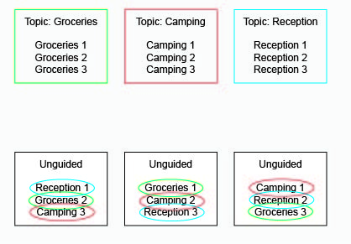

Figure 1: Manipulating Dynamic Guidance. We created vignettes in which a character engages in “guided” thinking that stays focused on a single topic (top row) or “unguided” thinking that meanders from topic to topic (bottom row). To avoid content effects, the unguided vignettes employed sentences drawn from the guided vignettes.

Results

Collapsing across content domains, a three-way ANOVA (task-relatedness X guidance X intention) was conducted to predict mind-wandering ratings. While all three dimensions of thought were significant ($p< .05$) (Figure 2; Table 2), dynamic guidance (${ η}^{2}= .168$) explained approximately four times more variance than task-relatedness ($η^{2}= .044$) and ten times more variance than intentionality ($η^{2}= .017$) (Table 2; Figure 2).

Visual inspection of Figure 2 suggests a possible three-way interaction in which off task, unintentional thought specifically yields high mind wandering ratings even when thought dynamics are guided. However, the three-way interaction did not reach statistical significance (p=0.26) indicating that the right-most grey bar does not statistically differ when compared to the other three grey bars. The task-relatedness by intentionality interaction was significant (p<0.03), indicating that being off task boosted mind wandering ratings slightly more in the unintentional condition (mean task-relatedness effect = 1.11$)$ than the intentional condition (mean task-relatedness effect = 0.27). The task-relatedness by dynamics interaction was also significant (p<0.002) indicating being off task had a modestly larger effect on mind wandering ratings when thought was guided (mean task-relatedness effect = 1.26) versus unguided (mean task-relatedness effect = 0.25).

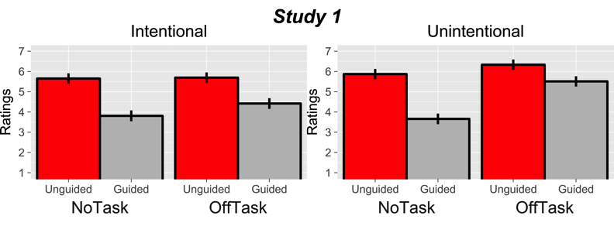
Figure 2: Mind-Wandering Ratings by Dynamic Guidance, Task-Relatedness, and Intentionality. Subjects were presented with vignettes that manipulated three factors relevant to three leading theories of mind-wandering. Dynamic guidance was a strong predictor of mind-wandering ratings with unguided thinking (red bar) earning higher mind-wandering ratings than guided thinking across all conditions. Error bars represent standard errors.

Dimension | F | p | $$η^{2}$$
Dynamic Guidance | F(1,352)=71.21 | 0.00001 | 0.168
Task-Relatedness | F(1,352)=16.52 | 0.0001 | 0.044
Intentionality | F(1,352)=6.09 | 0.014 | 0.017
Table 2: ANOVA to predict mind-wandering ratings using dynamics, task-relatedness, and intentionality (*=si)

Study 2: Manipulation of Stimulus-Independence and Dynamic Guidance

Study 2 used the matched vignettes method to test whether stimulus-independence or dynamic guidance best predicts mind-wandering judgments. To do so, we used new vignettes where Susan could consider the same topic (e.g. packing for a trip) by either thinking about (stimulus-independent) or looking at (stimulus-dependent) objects in her home.

Methods

A new group of 182 participants were recruited through Amazon’s MTurk (Gender: 98 men, 82 women, 2 other; Median age group: 24–35; Median education: some college or bachelors). As in Study 1, we requested 15 participants per group. Four participants were excluded from the analysis because they failed (at least) one of two attention checks.

Each participant rated a vignette describing Susan’s experiences, as in Study 1. Vignettes varied with along two dimensions: dynamic guidance and stimulus-dependence. In all vignettes, Susan was performing no task and her mind began to wander unintentionally. Vignettes were about three new topics to ensure that our results generalized across content domains.

Stimulus-dependence was manipulated by varying whether Susan thought about (stimulus-independent) or looked at (stimulus-dependent) objects in her house, as illustrated in Table 3 (left column). During focused vignettes, Susan thought about or looked at things in order to prepare for a task (packing for a trip, cooking dinner, or painting).

Study 2: Stimulus-Independent (bold) vs stimulus-dependent (italics) | Study 3: Deliberately guided (bold) vs ruminative (italics)
Susan is lounging around, not doing anything in particular, when she finds herself [thinking about/ looking at] what she needs to pack for her upcoming trip to Europe. She [remembers/ looks at] her passport, which she needs to pack in her carry-on luggage. Then she [imagines/ looks at] some clothes that she needs put in her suitcase. Then she [thinks about/ looks at] the umbrella that she wants to bring in case it rains. Susan is trying to focus on what she needs to pack and if she gets distracted, she makes sure to return to this topic. | Susan is lounging around, not doing anything in particular, when [she finds herself thinking about/ her thoughts turn obsessively to] what classes to take next year. She [nervously] remembers a list of her required courses – “Math, Biology, English.” Then she [anxiously] imagines how she can fit a biology lab into her schedule. Then she [thinks/ worries] about taking advanced physics, and whether she can handle all the equations. Susan [is trying to focus on/ can’t help but fixate on] what classes to take, and [if she gets distracted, she makes sure to return to this topic/ she’s drawn back to this topic whenever she tries to think about something else.]
Table 3: Examples of Vignettes from Studies 2 and 3.

The procedure from Study 1 was used to manipulate the dynamics of internal and external vignettes, yielding a 2x2x3 design that varied dynamics and stimulus-dependence, but was matched for topics.

Results

Collapsing across content domains, a two-way ANOVA (dynamic guidance X stimulus-dependence) was conducted to predict mind-wandering ratings. As in Study 1, both thought dimensions were significant ($p< .05)$, although stimulus-dependence was only marginally significant (Figure 3; Table 4). However, guidance ($η^{2}= .483)$ explained approximately twenty times more variance than stimulus-independence ($η^{2}= .022)$ (Table 4; Figure 3). Interactions were insignificant ($p=0.67)$.

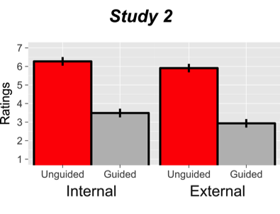
Figure 3: Mind-Wandering Ratings by Dynamic Guidance and Perceptual Orientation. Subjects were presented with vignettes that factorially manipulated dynamically guided versus dynamically unguided thinking and external versus internal perceptual orientation. Mind-wandering ratings were substantially higher for unguided thinking (red bar) irrespective of perceptual orientation. Error bars represent standard errors.

Dimension | F | p | $$η^{2}$$
Dynamic Guidance | F(1,173)=157.26 | 0.00001 | .483***
Stimulus-Dependence | F(1,173)=3.98 | 0.048 | .022*
Table 4: ANOVA to predict mind-wandering ratings using dynamic guidance and stimulus-dependence

Study 3: Manipulating Rumination

Folk judgments so far cohere with the dynamic view of mind-wandering. However, we have not assessed a unique prediction of the dynamic view: because mind-wandering meanders between topics, it contrasts with obsessive, ruminative, thought that is “stuck” on an affectively salient topic (Christoff et al., 2016; Irving, 2016). Opponents of the dynamic view object that rumination is a type of mind-wandering (Metzinger, 2017; Seli, Kane, Smallwood, et al., 2018). We therefore tested whether ordinary people classify rumination as mind-wandering.

Methods
A new group of 145 participants were recruited through Amazon’s MTurk (Gender: 102 men, 41 women, 2 other; Median age: 29; Median education: some college or bachelors). As in Study 1, we requested 15 participants per group. 46 participants were excluded from the analysis because they failed at least one of two attention checks.

Similar to Studies 1 and 2, each participant rated a vignette describing Susan’s thoughts. As in Study 2, Susan was not performing a task and began thinking unintentionally. Vignettes were in one of three conditions: dynamically unguided (meandering) vs dynamically guided (deliberative thinking) vs ruminative. Ruminative vignettes were focused on the same thoughts as deliberately guided ones, but varied with respect to their obsessiveness and affective tone, as illustrated in Table 3 (right column, italics).

The procedure from Study 1 and 2 was used to manipulate dynamic guidance, yielding a 3X3 design on which dynamically guided, dynamically unguided, and ruminative vignettes were matched for topics.

Results

Two-sample t-tests revealed that mind-wandering judgments were significantly higher for dynamically unguided vignettes than either dynamically guided vignettes t(63)=3.64, p=0.0005 or ruminative vignettes t(60)=3.103, p=0.0029. Both effects were large, with a Cohen’s d of 0.91 and 0.79, respectively. In contrast, mind-wandering judgments did not differ between dynamically guided vignettes and ruminative vignettes (p=0.85; Figure 4).

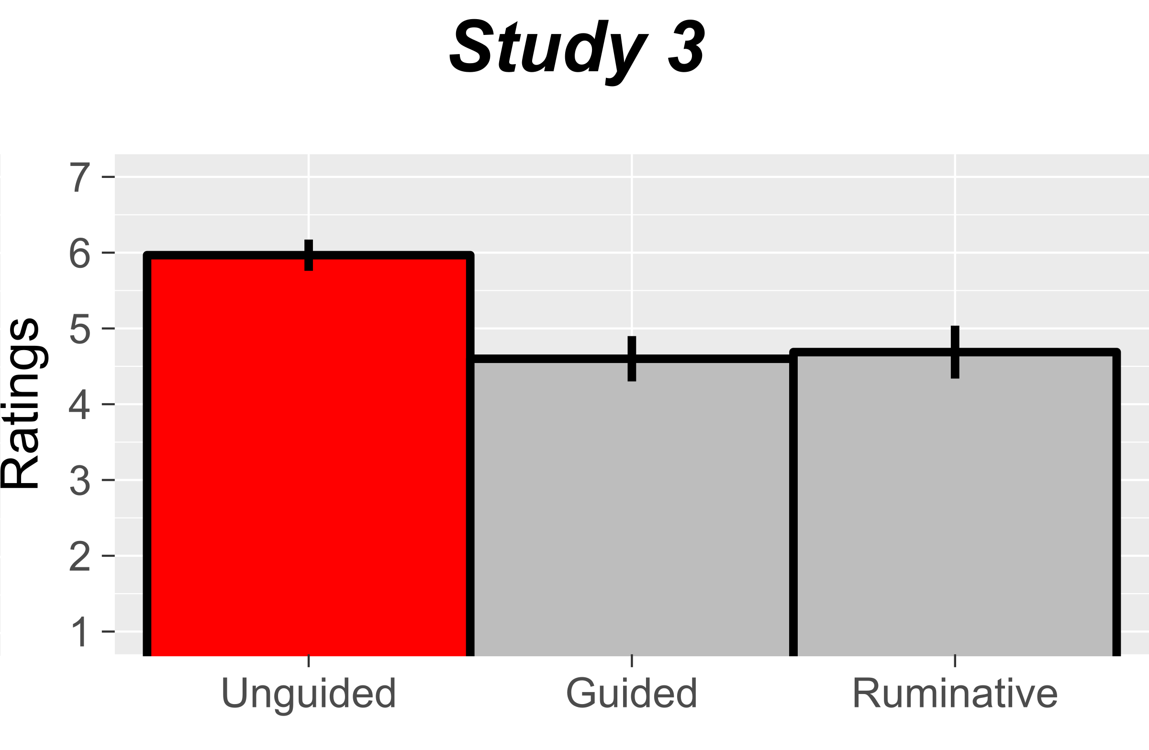
Figure 4: Mind-wandering ratings for unguided, deliberately guided, and ruminative thought. Unguided thought (red bar) received significantly higher ratings than either deliberatively guided or ruminative thought, which were not significantly different from each other. Error bars represent standard errors.

Study 4: On-Task Thought

Study 1 manipulated task-relatedness by contrasting cases where Susan was off-task and had no-task. We used this manipulation because the standard view arguably entails that mind-wandering cannot occur without a task. If mind-wandering is task-unrelated thought, the wanderer must have some task to wander away from (see similar arguments in Irving, 2016 ; Seli, Kane, Smallwood, et al., 2018). This assumption undergirds influential mind-wandering experiments. For example, Baird and colleagues (2012) infer that mind-wandering aids creativity because easy tasks (which induce task-unrelated thoughts) facilitate creativity more than rest (i.e. no task). Baird’s inference is valid only if off-task mind-wandering is distinct from no-task rest. Similarly, studies of everyday mind-wandering ask participants “are you thinking about something other than what you were doing” (Killingsworth & Gilbert, 2010) or “my mind had wandered to something other than what I was doing” (Kane et al., 2007, emphasis added). These questions assume that mind-wandering occurs only when participants are doing something (i.e. performing a task) that their minds wander away from.

However, laboratory mind-wandering studies typically contrast off-task thought (e.g. Susan’s mind wanders from homework) with on-task thought (e.g. Susan focuses on homework). Task-relatedness may therefore predict mind-wandering ratings better if we contrast off-task and on-task thought. We tested this hypothesis in Study 4.

Methods

A new group of 260 participants were recruited through Amazon’s MTurk (Gender: 167 men, 93 women, 0 other; Median age: 36; Median education: Bachelor’s degree). As in Study 1, we requested 15 participants per group. We recruited MTurk Masters who had above 90% reputation to ensure data quality (Peer, Vosgerau, & Acquisti, 2014). 17 participants were dropped because they incorrectly answered one of two catch trials.

Similar to Studies 1 through 4, each participant rated a vignette describing Susan’s experiences. Vignettes varied along two dimensions (Table 5): dynamic guidance (guided vs unguided) and task-relatedness (off-task vs no-task vs on-task). Task-relatedness was manipulated according to the procedure in Table 5. The procedure from Study 1 was used to manipulate the dynamics of thought, yielding a 3x2 design that varied task-relatedness and dynamics, but was matched for topics. Because our goal was to mirror laboratory conditions where subjects intentionally engage in on-task thought (i.e. intentionally perform the experimental task), all vignettes were intentional. Our on-task condition was designed to mirror laboratory conditions where one intentionally performs a task such as pressing a button or, in our case, planning a camping trip. Given this, on-task vignettes had to be intentional. To match vignettes across conditions, all vignettes were therefore intentional.

 | Off-Task | No-Task | On-Task
Guided | Susan is doing her homework when she intentionally decides to think about her camping trip... | Susan is lounging around, not doing anything in particular, when she intentionally decides to think about her camping trip... | Susan intentionally decides to think about her upcoming camping trip, when she has the following thoughts...
Unguided | Susan is doing her homework when she intentionally decides to think about various things... | Susan is lounging around, not doing anything in particular, when she intentionally decides to think about various things... | Susan intentionally decides to think about her plans for the next few weeks, when she has the following thoughts...
Table 5: Procedure used to manipulate stimulus-dependence and guidance. Each guided vignette is followed by three thoughts about the same topic (in this example, a camping trip). Each unguided vignette is followed by three thoughts about Susan’s plans for the next few weeks (her camping trip, job interview, and groceries).

Results

Collapsing across content domains, a two-way ANOVA (dynamic guidance X task-relatedness) was conducted to predict mind-wandering ratings. As in previous studies, the effect of dynamic guidance on ratings was significant, $F\left(1,255\right)=150.48, p<0.00001,$and large, $η^{2}=0.17$. Task-relatedness did not significantly predict mind-wandering ratings, although there was a trend in that direction ($p= 0.06)$. Visual inspection of Figure 5 suggests a possible two-way interaction in which the effect of task-relatedness is significant when thought is guided. However, the interaction between dynamics and task-relatedness was insignificant ($p=0.44$). Our results strongly speak against the hypothesis that task-relatedness is closely linked to mind-wandering in contexts that mirror the experimental distinction between on-task and off-task thought.

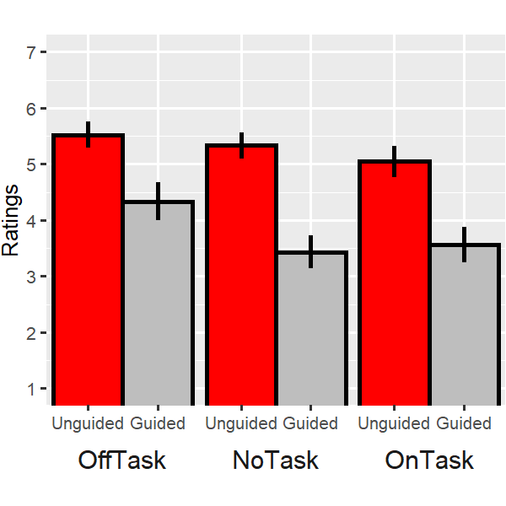
Figure 5: Mind-wandering ratings by task-relatedness and dynamics. Subjects were presented with vignettes that factorially manipulated dynamically guidance (guided vs unguided) and task-relatedness (on-task vs off-task vs no task). Mind-wandering ratings were significantly higher for unguided (red bars) versus guided (grey bars) thought. Task-relatedness had no significant effect on ratings. Error bars represent standard errors.

Study 5: Linguistic Analysis of Intentionality and Mind-Wandering

Study 1 found that intentionality weakly predicts mind-wandering, whereas many predict a stronger relationship (McVay & Kane, 2010; Watzl, 2017) or even that intentional mind-wandering is impossible (Murray & Krasich, n.d.). Study 5 therefore used linguistic analysis to probe the folk’s understanding of intentionality and mind-wandering.

Methods

One way to shed light on a term’s meaning is to examine its collocates: that is, words that are commonly juxtaposed with that term. We therefore examined collocates for terms that refer to mind-wandering in two English-language corpora: The Corpus of Contemporary American English (Davies, 2008), the largest genre-balanced corpora, and The Intelligent Web Based Corpus (Davies, 2017), the largest online corpus where websites were chosen in a systematic way (to ensure that they were popular amongst users from English-speaking countries, for example).

Results

In both corpora, by far the most common collocate for mind-wandering terms is “let”, as in “Susan let her mind wander on purpose” (Davies, 2008, 2017; Table 6). These constructions describe cases of intentional mind-wandering, where someone consents to their mind’s wandering, rather than cases where someone’s mind wanders unintentionally. Linguistic data therefore lends additional support to the view, already supported by our experimental evidence, that ordinary people consider intentional mind-wandering to be a typical form of mind-wandering.

 | COCA | iWeb
1 | Let (19.0%) | Let (29.4%)
2 | Back (9.7%) | Letting (7.4%)
3 | Letting (3.5%) | Gently (1.5%)
4 | Lets (2.4%) | Distracted (0.4%)
5 | Wondered (1.4%) | Refocus (0.2%)

Table 6: The five most common collocates of phrases that describe mind-wandering, excluding pronouns. Results are from The Corpus of Contemporary American English (COCA) and The Intelligent Web Based Corpus (iWeb). The percentage of all phrases that include this collocate is represented in brackets.

Discussion

Mind-wandering is standardly defined as task-unrelated or stimulus-independent thought (Smallwood & Schooler, 2015). A third research program contrasts unintentional and intentional mind-wandering (Seli, Risko, Smilek, & Schacter, 2016). A fourth approach defines mind-wandering as dynamically unguided thought (Christoff et al., 2016; Irving, 2016; Irving & Thompson, 2018; Mills et al., 2017; Sripada, 2018).

We investigated whether these theories cohere with ordinary people’s understanding of mind-wandering. Studies one and two found that the dynamic view explained by far the most variance in folk mind-wandering judgments. Study three found that ordinary people agree with a unique prediction of the dynamic view—obsessive rumination contrasts with mind-wandering. Study four used vignettes designed to mirror experimental mind-wandering research. Here, the effect of dynamics remained significant and large, whereas task-relatedness became insignificant. These studies represent the first empirical investigation into what ordinary people mean by “mind-wandering”.

Our results are concerning because confusions can arise when scientific terminology diverges from ordinary meaning. Scientists who define “mind-wandering” as task-unrelated, stimulus-independent, or unintentional thought may talk past their lay audiences and colleagues, who centrally understand mind-wandering in dynamic terms. Such crosstalk may invite audiences to draw unwarranted inferences. Researchers have drawn fascinating conclusions about task-unrelated thought. Because researchers call task-unrelated thought “mind-wandering”, however, audiences may inappropriately generalize the conclusions to dynamically unguided thought. Consider the following cases:

- Researchers routinely claim that people spend 30–50% of their waking lives “mind-wandering” because task-unrelated thought is this pervasive (Kane et al., 2007; Killingsworth & Gilbert, 2010; Klinger & and Cox, 1987). Yet many task-unrelated thoughts are likely goal-directed or ruminative, categories that lay people contrast with mind-wandering.

- Researchers hotly debated evidence that “mind-wandering" recruits the executive network (Christoff, Gordon, Smallwood, Smith, & Schooler, 2009; K. C. R. Fox, Spreng, Ellamil, Andrews-Hanna, & Christoff, 2015; McVay & Kane, 2010; Smallwood, 2010; Smallwood & Schooler, 2006). The executive–mind-wandering connection may surprise audiences who endorse the dynamic/folk view, since the executive typically supports focused, goal-directed, thought (Owen, McMillan, Laird, & Bullmore, 2005; Rottschy et al., 2012). One explanation of this connection is that the executive supports goal-directed task-unrelated thought, not dynamically unguided thought, which ordinary people associate with mind-wandering.

Our studies suggests that the dynamic theory of mind-wandering has an advantage: It tracks ordinary usage. The dynamic theory also has scientific advantages (Christoff et al., 2016; Irving, 2016). Recall that standard theories of mind-wandering bundle together disparate phenomena. When someone is “off-task”, she may meander between topics, concentrate on a goal, or endlessly ruminate. These experiences have contrary phenomenology, costs and benefits, psychological and neural mechanisms, and so on.

In contrast, dynamically unguided thought has relatively cohesive attributes. Unguided thought is linked to specific forms of agency (Irving, 2016) and creativity (Christoff et al., 2016; Sripada, 2018). It is closely associated with the default network. And it is elevated in disorders such as Attention Deficit Disorder (Andrews-Hanna, Irving, Fox, Spreng, & Christoff, 2018; Christoff et al., 2016). If we understand mind-wandering as dynamically unguided thought, it may prove considerably more unified, philosophically defensible, and empirically tractable.

It may be no coincidence that the commonsense theory of mind-wandering has substantive philosophical and scientific advantages. Philosophers regularly rely on common sense intuitions when we theorize about psychological entities such as perception, attention, memory, imagination, emotion, or mind-wandering. Consider how philosophers appeal to intuitions about what cases do (and don’t) fall under psychological categories. Such intuitions are ultimately grounded in one’s grasp of folk psychology, albeit filtered through philosophical training. Our vignette-based experiments complement this armchair case method, since experiments give us empirical evidence about the boundaries of folk-psychological concepts. Similarly, our linguistic corpora analysis provides evidence about how the folk speak, and is therefore a rigorous alternative to ordinary language philosophy of psychology. Our empirical conceptual analysis is thus an extension of orthodox commonsense methods in the philosophy of psychology. And commonsense aligns most closely with the dynamic theory of mind-wandering.

Finally, our results bear upon whether mind-wandering is a “family resemblance” concept (Christoff et al., 2018; Irving & Glasser, 2019; Metzinger, 2018; Seli, Kane, Smallwood, et al., 2018). Seli and colleagues (2018) characterize mind-wandering in terms of a cluster of (at least) four features: whether one’s thoughts are 1) task-unrelated, 2) stimulus-independent, 3) unintentional, and 4) dynamically unguided. Although prototypical instances of mind-wandering have all these features, they argue that none are necessary.

Regardless of whether mind-wandering has necessary features (see Christoff et al., 2018; Seli, Kane, Smallwood, et al., 2018 for a debate), we are skeptical of Seli and colleagues’ version of the family resemblance approach. Their framework is based on Rosch and Mervis (1975), who propose a formal family resemblance model where all features are equally weighted and prototypicality depends on the number of features an instance exhibits. Our data do not support this “equal-weighting” model. Instead, the lay concept of mind-wandering has one central feature–its dynamics–that explains between four and twenty times more variance in folk judgments than other features. This observation suggests that we should not use Rosch and Mervis’s equal-weighting to analyze “mind-wandering”, and favors alternative formalisms that allow differences in feature salience (e.g. Gad & Tversky, 2004).

Seli and colleagues also base their family resemblance framework on somewhat stipulative scientific definitions of mind-wandering, rather than folk judgments. For example, they propose that perseverative task-unrelated thought (i.e., rumination) is “commonly recognized as mind-wandering” (Seli et al., p. 481, p. 483). But our data suggest that rumination is actually predictive of lower folk mind wandering judgments. Our findings underscore the need to systematically collect data on folk judgments to better align theoretical and everyday conceptions of mind-wandering.

A final problem concerns what Seli and colleagues consider “perhaps [the] most important” implication of the family resemblance framework: it “allows researchers the freedom to study whatever features of mind-wandering they wish” (2018, p. 488). Why? Because “conceptual clarity will simply require” that researchers explicitly state how they “conceptualize… and operationally define” mind-wandering (Seli, Kane, Smallwood, et al., 2018, p. 488). On the contrary, our data suggests that explicitness may not be enough to ensure conceptual clarity, at least when communicating with lay audiences. Scientists may also have to consider whether their explicit definitions conflict with the folk’s preconceptions. In such cases, stipulation may be unwise, and an alternative term may be the better course.

Over the past decade, the science of mind-wandering has seen a whirlwind of progress. Yet our studies suggest that the folk concept of mind-wandering has been partly lost in the dust. Our empirical conceptual analysis reveals that laypeople prioritize a feature of mind-wandering that researchers have neglected until recently: its dynamics. This disconnect is troubling. To avoid confusions and effectively communicate with our scientific colleagues and the public, researchers should take the preexisting meaning of “mind-wandering” into account.

Bibliography

Andrews-Hanna, J. R., Irving, Z. C., Fox, K. C. R., Spreng, N., & Christoff, K. (2018). The Neuroscience of Spontaneous Thought: An Evolving, Interdisciplinary Field. In K. Fox & K. Christoff (Eds.), Oxford Handbook of Spontaneous Thought and Creativity. Oxford University Press.
Baird, B., Smallwood, J., Mrazek, M. D., Kam, J. W. Y., Franklin, M. S., & Schooler, J. W. (2012). Inspired by Distraction: Mind Wandering Facilitates Creative Incubation. Psychological Science, 23(10), 1117–1122.
Callard, F., Smallwood, J., Golchert, J., & Margulies, D. S. (2013). The era of the wandering mind? Twenty-first century research on self-generated mental activity. Frontiers in Psychology, 4(Article 891).
Christoff, K., Gordon, A. M., Smallwood, J., Smith, R., & Schooler, J. W. (2009). Experience sampling during fMRI reveals default network and executive system contributions to mind wandering. Proceedings of the National Academy of Sciences, 106(21), 8719–8724.
Christoff, K., Irving, Z. C., Fox, K. C. R., Spreng, R. N., & Andrews-Hanna, J. R. (2016). Mind-wandering as spontaneous thought: A dynamic framework. Nature Reviews Neuroscience, 17(11). https://doi.org/10.1038/nrn.2016.113
Christoff, K., Mills, C., Andrews-Hanna, J. R., Irving, Z. C., Thompson, E., Fox, K. C. R., & Kam, J. W. Y. (2018). Mind-wandering as a scientific concept: Cutting through the definitional haze. Trends in Cognitive Science.
Davies, M. (2008). The corpus of contemporary American English (COCA): 560+ million words, 1990-present. Retrieved from http://www.americancorpus.org
Davies, M. (2017). The intelligent web based corpus (iWeb). Retrieved from https://corpus.byu.edu/iWeb/
Faul, F., Erdfelder, E., Lang, A.-G., & Buchner, A. (2007). G* Power 3: A flexible statistical power analysis program for the social, behavioral, and biomedical sciences. Behavior Research Methods, 39(2), 175–191.
Fox, K. C. R., Spreng, R. N., Ellamil, M., Andrews-Hanna, J. R., & Christoff, K. (2015). The wandering brain: Meta-analysis of functional neuroimaging studies of mind-wandering and related spontaneous thought processes. NeuroImage, 111, 611–621.
Gad, I., & Tversky, A. (2004). Weighting common and distinctive features in perceptual and conceptual judgments. Preference, Belief, and Similarity: Selected Writings, 97.
Irving, Z. C. (2016). Mind-wandering is unguided attention: accounting for the “purposeful” wanderer. Philosophical Studies, 173(2), 547–571.
Irving, Z. C., & Glasser, A. (2019). Mind-Wandering: A Guide For Philosophers. Philosophy Compass.
Irving, Z. C., & Thompson, E. (2018). The Philosophy of Mind-Wandering. In Oxford Handbook of Spontaneous Thought. Oxford University Press.
Kane, M. J., Brown, L. H., McVay, J. C., Silvia, P. J., Myin-Germeys, I., & and Thomas R. Kwapil. (2007). For whom the mind wanders, and when: An experience-sampling study of working memory and executive control in daily life. Psychological Science, 18(7), 614–621.
Killingsworth, M. A., & Gilbert, D. T. (2010). A wandering mind is an unhappy mind. Science, 330(6006), 932–932.
Klinger, E., & and Cox, W. M. (1987). Dimensions of thought flow in everyday life. Imagination, Cognition and Personality, 7(2), 105–128.
McVay, J. C., & Kane, M. J. (2010). Does mind wandering reflect executive function or executive failure? Comment on Smallwood and Schooler (2006) and Watkins (2008). Psychological Bulletin, 136(2), 188–197.
Metzinger, T. (2017). Why is mind wandering interesting for philosophers. The Oxford Handbook of Spontaneous Thought.
Metzinger, T. (2018). Why is mind wandering interesting for philosophers. The Oxford Handbook of Spontaneous Thought.
Mills, C., Raffaelli, Q., Irving, Z. C., Stan, D., & Christoff, K. (2017). Is an off-task mind a freely-moving mind? Examining the relationship between different dimensions of thought. Consciousness and Cognition.
Murray, S., & Krasich, K. (n.d.). Can the Mind Wander Intentionally.
Owen, A. M., McMillan, K. M., Laird, A. R., & Bullmore, E. (2005). N-back working memory paradigm: A meta-analysis of normative functional neuroimaging studies. Human Brain Mapping, 25(1), 46–59.
Peer, E., Vosgerau, J., & Acquisti, A. (2014). Reputation as a sufficient condition for data quality on Amazon Mechanical Turk. Behavior Research Methods, 46(4), 1023–1031.
Rottschy, C., Langner, R., Dogan, I., Reetz, K., Laird, a. R., Schulz, J. B., … Eickhoff, S. B. (2012). Modelling neural correlates of working memory: A coordinate-based meta-analysis. NeuroImage, 60(1), 830–846. https://doi.org/10.1016/j.neuroimage.2011.11.050
Seli, P., Kane, M. J., Metzinger, T., Smallwood, J., Schacter, D. L., Maillet, D., … Smilek, D. (2018). The family resemblance framework for mind-wandering remains well clad. Trends in Cognitive Science.
Seli, P., Kane, M. J., Smallwood, J., Schacter, D. L., Maillet, D., Schooler, J., & Smilek, D. (2018). Mind-wandering as a natural kind: A family-resemblances view. Trends in Cognitive Sciences.
Seli, P., Risko, E. F., Smilek, D., & Schacter, D. L. (2016). Mind-wandering with and without intention. Trends in Cognitive Sciences, 20(8), 605–617.
Smallwood, J. (2010). Why the global availability of mind wandering necessitates resource competition: Reply to McVay and Kane (2010). Psychological Bulletin, 136(2), 202–207.
Smallwood, J., & Schooler, J. W. (2006). The restless mind. Psychological Bulletin, 132(6), 946–958.
Smallwood, J., & Schooler, J. W. (2015). The science of mind wandering: empirically navigating the stream of consciousness. Annual Review of Psychology, 66, 487–518.
Sripada, C. (2016). Imaginative Guidance: A Mind Forever Wandering. In B. M. E. P. Seligman, P. Railton, R. F. Baumeister, & C. Sripada (Eds.), Homo Prospectus (pp. 103–132). Oxford University Press.
Sripada, C. (2018). An Exploration/Exploitation Tradeoff Between Mind Wandering and Task-Directed Thinking. In K. C. R. Fox & K. Christoff (Eds.), Oxford Handbook of Spontaneous Thought and Creativity. Oxford University Press.
Watzl, S. (2017). Structuring mind: The nature of attention and how it shapes consciousness. Oxford University Press.

McVay and Kane (2010) and Watzl (2017) argue that mind-wandering is unintentional because it reflects control failure and akrasia, respectively. Contrarily, our Studies 1 and 4 show that the folk accept Seli and colleagues (2016) thesis that mind-wandering can be intentional.
We used a between-subjects design where each participant rated one vignette to reduce demand characteristics, which is standard practice in vignette-based experiments. If participants had rated more than one vignette, they may have explicitly compared them to guess which one the experimenter considers mind-wandering.
Across both corpora, speakers use almost exclusively “non-agentive” (Irving, 2016) constructions to refer to mind-wandering. Non-agentive constructions are those where the grammatical subject of the sentence is a person’s mind (e.g. “Susan’s mind was wandering”), rather than the person herself (e.g. “Susan was mind-wandering”). Although scientists sometimes use agentive constructions to refer to mind-wandering (e.g. “subjects mind-wander in 50% of trials”), this is a neologism that is almost entirely absent from the English language corpora we reviewed. In the genre-balanced COCA, there were 0 non-agentive constructions describing mind-wandering compared to 249 non-agentive constructions. In the online iWEB, there were 4 non-agentive constructions describing mind-wandering compared to 3443 non-agentive constructions. Furthermore, 3 of the 4 agentive constructions in iWEB were from popular science publications. We therefore restricted our collocates analysis to non-agentive constructions, as doing otherwise would not change our results. According to Irving (2016), non-agentive constructions are philosophically interesting because they suggest that we are passive recipients of mind-wandering: our mind is what wanders, not us (Irving, 2016). The present linguistic analysis shows that these interesting constructions are pervasive in ordinary English.
While Seli and colleagues present Rosch and Mervis (1975) as the empirical basis for their view, they may wish to remain neural about formalisms. If so, our first “critique” is a friendly suggestion about how to make the family resemblance model formally precise.
In general, explicit definitions cannot remove all terminological confusions. By analogy, imagine that canine researchers defined “dog” as any four-legged creature. Even if researchers explicitly stated their definition of “dog”, they would still invite confusion by departing from the term’s pre-existing meaning. Our results raise an analogous worry about confusion in mind-wandering research.

