“Take the left stream to the Lake house for a workshop in Herculeum portofino fonts with Geoffroy de Lindeman’s” she said.
“And here you will find a Universal in a glass-house by a river during the rapid-eye movement of a man in [ stiletto heals ] whilst the world goes-by and not goes-by to non- ) where as can be seen by stroboscopic lights on an evening by a bridge when the Queen was, and was not, born, to the power of the N^{th} time.”
But what I found in real time and real space was the oddest art exhibit ever. A man — an artist, no doubt — had put his real life on exhibit. Or rather it might be more true to say that he had put the outer world on exhibit. He had built a glass house by the river Thames on a luxurious campus which was decorated with tables as this park was also a 3-star Michelin restaurant, but with a catch: on an impromptu evening the artist would open the curtains of his house — sometimes with the lights off as if to solicit and challenge the curiosity and night vision of the diners who would squint as they struggled to see inside and perhaps catch a glimpse of the naked artist or his naked model…
But at other times the lights would din outside as the artist turned the tables on the diners, as it were, by postponing their dinner and drinks indefinitely as the lights flared inside the house where a drinking party gathered to stare at the diners some selected by a spotlight operated from the roof of the house.
And sometimes a psychodrama would ensue as the waiters stripped bare the waiting diners at one select table under the spotlight as if to cascade the attention of the prime seers ( inside the lake-glass house ) onto a secondary and even tertiary perspective by drawing in the attention of surrounding diners.
At other times the artist who was also a poet and a philosopher and a theologian and a psychologist and a biologist and maybe more things would stare at the visitors and guests who milled around in the late afternoon sipping coffee ( as the restaurant only opened in the evenings ); But the mornings were a special time, when the guard would let in guests, by invitation only, to pose for the artist from the south side who remained unseen behind a set of mirrored windows — but of course no guarantee could be given of having inspired the artist to produce a work. The guest would only later receive a post-card later by mail with a price tag ( often in six figures ) inviting a purchase.
The house had a glass dome, so the curtains were often drawn and was situated on the border of the river facing a private sunset and a small quay from which the artist would ferry into town, as he didn’t keep a motor vehicle on this property ( which was part museum, alfresco theatre, library and studio ).
Once, he held an in-house for public-view-private-party of naked ladies that was all the rage in the papers and news media the next day. Lawyers struggled to detangle the legalities of such a spectacle that fell in between the cracks of the law and our rational divisions of esoteric and exoteric ( in this case also exotic ). But a loophole was found and no tax was paid on the million dollar take for the rights to film and snap.
Photo of model Lydia Gelato

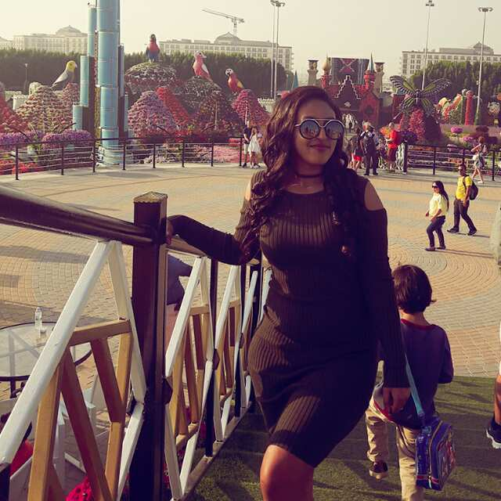

ARGUMENTs FOR integrating THE LOOPHOLE into the spotlight

Welcome to a guest house in glass where, one day, you will be invited to check into your life and actually see who you are in real time — more formally known as sidereal time — which is not "real" at all, given the malleability and often porous nature of consciousness as it contracts and expands in response to stresses derived from things that sort of exist in a binary world populated with one version of "object" which is tangible and its corollary version which is intangible ( the safest way to talk about something that exists in a grey zone of the mind in the form of an abstraction that nevertheless has the power to stack bricks upon one another to construct an edifice with a signpost that reads: "Allan Memorial Institute" where putative "psychiatrists" study, diagnose and label — for the benefit of the pharmaceutical industry — these grey-zone-intangible-symbols that both exist and don't exist at the same and not the same time, even though we don't know if or that time "exists" (( whatever this latter word in quotation marks means ))).
But glass walls can take the form of many surfaces from frosted, microscopy, telescopy, coke-bottle-bottom-scopy, crystalline, tinted and mirrored to mention just a few for the unsuspecting spectator for whom the "glass," like the cornea is too close for proprioception and remains as hidden as water must be to a fish... Leaving the poor spectator vulnerable to the after-effects of his own jaundiced mind which then pulls him into a self-perpetuating loop that so intimately winds forward and backward feedback into the positive lane creating a sort of eternal palindrome ( depending on how many incarnations one has un-earned ) whose exit even Zeus could not fully achieve — let alone the poor little flea prophesised in Nietzsche's Zarathustra — ; How then will a Last man ever find his life? Supposing that it is not just a word... That there was even something to find beyond the Blue and Brown books of the putatively "greatest" philosopher of the twentieth century...

2.
How does a fragment find a whole life? It would be the other way around, n'est-ce pas? Can light find a shadow or can a shadow find a light? If they don't even overlap but only illuminate or conceal subsidiary elements within their purview, do they form two parts of one world or two worlds?
These and other paradoxes have baffled humanity since time immemorial and only recently have we set them aside by declaiming metaphor as a fully legitimate trope while turning a blind eye to the phantom nature of many a scientific concept ( energy, quanta, dark matter, infinitely regressing particles, infinitely disappearing horizons, "time" beginning with itself, etc...)
These matters perhaps have never troubled poets or musicians or pre-Socratic natural scientists but they certainly do trouble moderns who are obsessed with a tidy separation between "excluded middle space" —
Or at least they did, until their children who were raised on television and computer games gave up on logic altogether and learned to accept their damaged minds as a norm, bolstered as it is by pharmaceuticals prescribed by doctors of medicine legitimated by the same techniques of branding as the televised drugs themselves.

3.
And sometimes a white lab coat doubles as a raincoat repelling drops from collecting into primordial waters lest they remind us of a long lost insight harking back to Thales or — God forbid — the book of Genesis. Where did these waters come from? If "time" began tautologically in the beginning, did the primal waters begin in the "river"? Was it the river above or below the firmament? And how about the firmament? Did it begin out of its own space? Was its beginning topological or temporal? Do space and time ( since Einstein ) relate like light and darkness? Which darkness? The one which came with sidereal time on the fourth day? Or the one that divided with/from the day created by the theurgic light on the first day? If dark matter can really be dark matter to a scientist, is the divine light of the first day any less "real" to a prophet?
Does mathematics really isolate us from the "problems" created by lexical metaphor, or have we divided numbers into those that only compute and those that only enjoin ( tautological proofs to create an insulated system )? Is mathematics any more "grounded" than God's spirit which hovered over the waters of the deep when he uttered: Let there be light!"
Where is this 98% of dark matter? Can a Pink Panther cut open a door in the shape of a "black whole" and walk into it? Not even by quantum experiment? And what kind of chemistry or alchemy rather between dark matter and theurgic light created the negative image on the shroud of Turin? Is it a chemistry only expressible in imaginary numbers? Or Pythagorean ones? Or are both of these hallucinogenic thoughts left over from the primordial memories of cave men's paintings?

4.
What will save us? Who will offer salvation to whom: Will the cave man save the accountant from his infinitesimal mathematics breakdown? Or will the insurance underwriter save the “hivernal” artist from resorting to a paint-by-number set?
Will such a set design be used to refit the world into a jigsaw demographic? And will such a demographic be unifiable by a singular image? A prophet? A buddha? A christ-figure? Or an extraterrestrial being seen only by tele-vision?
Will any other vision be possible, or will they rewire the rooms we live and work in to run on manufactured images feeding forwards and backwards via the lenses on screens and goggles at first and lenses sutured to the eyeball later?
And if we fail to make of a man into a machine, what will be the alternative? Who really believes he is an ape as a result of a direct line of development not compromised by the staccato images presented to himself by stroboscopic consciousness? Will we not one day wake up to inhabit a world with only a memory of animals and a fear of machines run amok? In whose image then will we be proud to have been made? If we can even distinguish the maker from the product...
Will the fear of the machine be any different from the fear of the apple and the ( "sabre-toothed" ) tiger? Are they not both the result of doubt, which shares the same root as "double" as in being of two minds? Hence, a mitosis of the mind ushered in prima facie fear by introducing the gap-of-time ( involving birth, change and death ).
Over and against this stood the virgin. The alternative route to sexuality which was responsible for birth, change and death and which stood in the same relation to virginity ( purity ) as light to darkness. But here most mystics know that the virgin contains in potentia and in repository form all the life-energy that will be dissipated through sexuality during the course of one's life and that this life energy, paradoxically, can be conserved through a measured coitus that homologates ( as the opposite of "simulates" ) and pre-empts dissipation, relatively speaking. Only to recover it later in life, if the "gross-body" can indeed de-crystallise and revert back into the original "light."

5.
The recovery of a rounded virginity ( even though the word means stick instead of ball ) stands in contrast to the flat disc or face — which, because the prima facie version is the only one you will ever get functions more like a mask — for which the greatest symbol is Pluto / Hades, both the god and the planet who hide from us their back, flip or in-sides. The virgin by contrast wears his heart on his sleeve and a well powered thermo-nuclear heart it is, compared to the icy-cold clock of that most distant planet whose breath condenses in the cold air of winter where his psyche crystallises into an ice-pack...
One can do this literally with an infant by refrigerating the child — freezing the heart cryogenically until it thaws one day and a blessure becomes a blossom, or a tumour becomes a blessing and the heart returns to life under the warm blankets of a multi-layered flat universe in mimicry of the flat earth ( theory ) of yore... Which is perhaps what post-partum mothers have in their depressed minds when they refrigerate their children. The word for this is Myeloma which means spine, brain and tumour ( the latter of which means injury and blessing at the same time ).
So that the blossom is part of the brain or the cranium as depicted metaphorically in Buddhist images, but it isn't purely symbolic; it has something of the concrete in it for which a new word ( imaginal ) has been coined in contradistinction to the old one ( imaginary ) which denoted something false.
So that one may see the evolution of the brain — not the stroboscopic evolution, but the actual one — as a change from within for the purpose of broadcasting the mind from without. This type of evolution almost nobody believes in ( any more than they believe in a mind ) because the time exposure required to "see" it is far too long for the attention and life span of the Last man. Imagine living eight hundred years!

Friedrich Nietzsche, Thus Spoke Zarathustra, Thomas Common ( Trans. ); New York: Dover Publications, 1999, page 5.

