Imagining
Reality

A THEORY OF KNOWLEDGE FOR
THE ARTS & SCIENCES

C. DOUGLAS JONES
Copyright © 2014 C. Douglas Jones
All rights reserved.
ISBN-10: 1495331881
ISBN-13: 978-1495331886
DEDICATION

Dr. Wynn Kenyon.
Fearless philosopher, tireless listener, and patient friend.
&
My family, especially my parents and my church, who have sustained me with the love to make this book possible.

CONTENTS

ACKNOWLEDGMENTS i
PREFACE 1
INTRODUCTION 2
Science & Religion 5
THE LIGHT OF REALITY 7
THE INTELLIGIBILITY OF REALITY 13
THE IMAGINATION OF REALITY 17
Conclusion 19
INDEX 21

ACKNOWLEDGMENTS

I wish to acknowledge the influence and inspiration of the following philosophers, artists, teachers, theologians, scientists, musicians, writers and friends, both living and deceased, in cloud format:

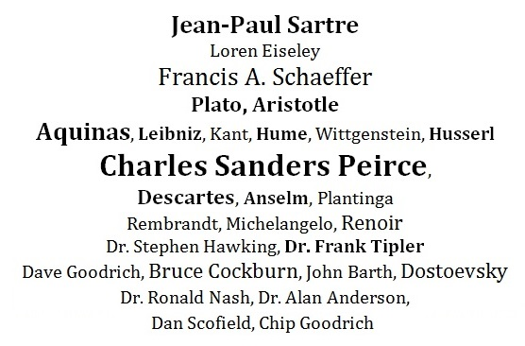

Special thanks to Noel Horn, whose scientific background and constructive criticism saved this book from promoting grievous errors and from being too tedious and esoteric.
, .

PREFACE

The field of Philosophy is one in which there are no laboratories for testing theories. It might be assumed that peer review, academic credentials, and the rules of logic are sufficient to inform the writer of the accuracy and relevance of his or her views, but there are subjective realities that are often ignored. For instance, it is assumed, or at least hoped for, that the History of Philosophy is a history of progress, as in other sciences. It is taken for granted that the mere passage of time contains within it something like a principle of natural selection that ensures progress. It does not. Therefore, I ask the reader to rely solely on the clear definition of terms, the rules of logic, and their own informed judgment in deciding the veracity of this small book. Imagine that all of the relevant philosophers from all of history were resurrected, provided with identical vocabularies, and asked to sit in judgment upon any new philosophy book. Now imagine all "peer-reviewers” joining them. This would be ideal, since History would become irrelevant and the pitfalls of the genetic fallacy would no longer be in play.
This book is intended for those with a background in philosophy, with some interest in epistemology. However, anyone with an interest in the current conflict between science and religion should find the main thesis and arguments to be challenging, interesting, and beneficial.

INTRODUCTION

“Enter your skiff of Musement, push off into the lake of thought, and leave the breath of heaven to swell your sail. With your eyes open, awake to what is about and within you, and open conversation with yourself; for such is all meditation…not…in words alone, but with diagrams and with experiments."- - C. S. Peirce (Collected Papers 6.461)
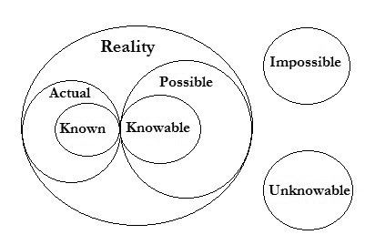

The realm of reality includes the actual as well as the possible. As such, it also includes the known and the knowable. For example, the existence of the Higgs Boson particle is actual, possible, known, and knowable; i.e., intelligible and reliable. A square circle is neither actual, possible, known, nor knowable. All of inquiry is a mental process moving from the known to the knowable within the realm of reality. This process uses the mental faculties of perception, conception, and abstraction, all fueled by information . These faculties have corollaries in Science, Philosophy, History, Religion, Literature, and the Arts. It is the thesis of this book that if these faculties are considered intelligible and reliable in Science, they should be considered intelligible and reliable in any field of inquiry.
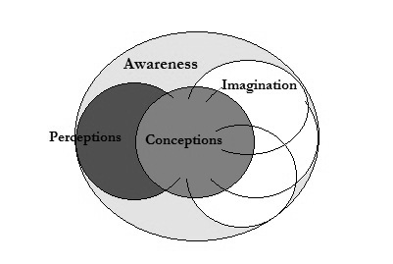
In deliberately considering the fundamental mental faculties, my first encounter is with awareness. Awareness is first of all the immediate intuition of perceptions and conceptions. Perceptions are sensory impressions and conceptions are mental impressions. Examples of sensory impressions are my awareness of the chair I am sitting on, and the computer I am typing on. Examples of mental impressions are logic, mathematics, and language. Reflection upon these impressions either falsifies or verifies and strengthens them. This happens when experience (a posteriori) is used to reflect upon my conceptions and conceptions (a priori) are used to reflect upon my perceptions.
Conceptions and perceptions are thus on equal footing epistemologically, instead of in competition for epistemic status, and reflection upon them serves to validate and strengthen them, instead of imposing artificial categories upon them.
Upon reflection, I realize that sensory perceptions are of temporal objects, while rational conceptions are seemingly eternal or unchangeable. Further reflection leads to the realization that temporal objects are dependent upon something eternal, while rational conceptions are not.
I am aware of having conceptions of my perceptions, as when I consider that individually perceived chairs participate in the concept of “chairness”, e.g., having four legs and a platform to sit upon, etc. And, I am aware of having conceptions of conceptions, e.g., when my concept of the number 1 is added to my concept of the number 2 to get my concept of the number 3, or when my concepts of cold and wet are conceived in the concept of snow.
Sooner or later, I may reflect upon my own temporal existence long enough to realize that I am dependent upon something non-temporal, perhaps something that is not discontinuous with my rational conceptions of logic, mathematics, language, truth, beauty, goodness, and the like.
In thinking further about the meaning of “conceptions of conceptions” I suggest the term abstraction. However, I believe it is wrong to think of abstractions as being less real than perceptions. The idea of extrapolation, a more cumbersome word, captures both the concrete and the abstract, as when I think of a building as an extrapolation of bricks (concrete) or as an extrapolation of architectural drawings (abstract). The reader should therefore understand that by “abstraction” I include the meaning of “extrapolation”.

Science & Religion

“‘It is not the business of science to search for origins![This maxim] is a masterpiece, since no timid soul, in dread of being thought naive would dare inquire what 'origins' were, albeit the secret confession within his breast compelled the awful self-acknowledgment of his having no idea what else than "origins" of phenomena (in some sense of the word) man can inquire."- - C. S. Peirce (Collected Papers 6.458)
A surprising fact is that the mental faculties of perception, conception, and abstraction, seem to correlate nicely with the process of natural science on the one hand and the process of philosophy of religion on the other. In science there faculties are specified as observation, falsification, and hypothesis. In philosophy of religion, these terms correspond to the three classic categories of arguments namely, the teleological, cosmological, and ontological arguments for the existence of God. I have long thought that the design (teleological) argument relied upon the causal (cosmological) argument for its soundness, but now I realize there is a process among all three arguments beginning with design, moving to the necessity of a cause, and culminating with a Supreme Being (Designer). Interestingly, these faculties also seem to fit nicely with the logical terms induction, deduction, and abduction.
Conveying these terms in ordinary language, I suggest observation, explanation, and imagination.The following table shows the terms and their corollaries:

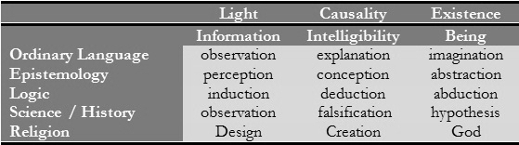

Philosophy deals with and ideas, Science deals with objects, History deals with events, Literature deals with words, and Religion deals with ultimate reality. Art includes all of these, while also adding colors, shapes, sounds, movements, and emotions. Thus Art should be considered a very important endeavor.
The focus of this book is on Science and Religion, which I consider to be the beginning and end (respectively) of all inquiry (other fields falling somewhere in between).
My thesis is that the mental faculties used in science and philosophy of religion are the same. That is, they both depend upon the reliability of the aforementioned faculties. Again, this means that if they are intelligible and reliable in science, they are intelligible and reliable in any field of inquiry. And the opposite is true. The remainder of this booklet will use science and religion to prove this thesis.
Furthermore, I observe that the objects and ends of both science and philosophy of religion are the same. Both begin by looking at design and depending upon deduction/falsification for proof, and end with an ultimate concept or hypothesis. This study of mental faculties therefore will proceed with the assumption that there is no strict line of demarcation between science and religion.

THE LIGHT OF REALITY

“Let there be light, and there was light.” – Genesis
“One word of truth outweighs the world.” – Alexander Solzhenitsyn

Considering vertical relationships, perception, observation, and induction are primarily information-gathering faculties. I might also observe that the light of reality is information and its end is design.

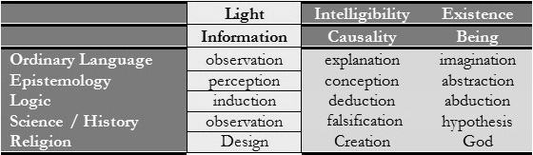

Information, remarkably, is increasingly recognized as being more fundamental than matter, energy, or light. The fiber-optic cable is an example of matter delivering energy, light, and information.
Information is made up of data, symbols, and words. Like a raging river it carves canyons in the mountains of ideas, waters the fields of contemplation, and quenches the thirst of minds.
In the creation and evolution of the universe, information communicates design and functional instructions. Teleology (design) may be defined as something that is structured toward a purpose or function; a harmonizing and organizing influence with a goal in view. The design argument basically states:

An objection to this basic argument, made famous by David Hume , attempted to marry the concepts of anthropomorphism and analogy. Hume’s criticisms seem to carry with them the implication that what is in part wrong with such reasoning is that it relies upon what we already know in attempting to gain knowledge of what we don’t know. Anthropomorphism may be defined (insofar as these arguments are concerned) as the arrogant assumption that the cause of the universe must turn out to be just like us. I gather from Hume that analogical reasoning is defined as the arrogant assumption that what we know about one thing may be the key to understanding some unknown thing. And yet what other way is there to gain knowledge if not by moving from the known to the unknown?
The controversy surrounding this argument is how to define the term design in such a way as to remove its anthropomorphic implications. In order to remove the anthropomorphic implications of a “designer” being typically thought of as a human, I prefer to state the design argument as follows:

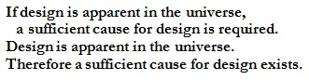

A different approach is taken by modern science. Scientists often suppose a purpose or design for the objects of their research not in order to discover the cause of purpose or design, but in order to help shed light on what things are and how things function. They are usually quick to point out that the design or purpose isn’t real, but only supposed.
Consider the following parable about a fictitious town. Near the entrance to a certain town there is an unusual rock formation made up of large rocks on a hillside. It seems unusual because there are few other large rocks in the area. By supposing that the rocks were placed there by design, it soon becomes apparent that the rocks spell the former name of the town, which was “Ark”. Some townsfolk argue that since their homes were often identified by displaying the name of the family in a way that they know was designed, the spelling of the town’s name in the rock formation therefore must have come about by design. Scientists are quick to remind everyone that since the design was supposed and only apparent, the spelling of the town’s name is therefore only apparent and in fact meaningless. The spelling of the town’s name did not prove that the rocks were placed there by design. The scientists did not therefore pursue the possibility of actual design.
To the point, supposing apparent design did help the scientists shed light on how things function by discovering how such rocks might have been moved from place to place during that period of history.
The Intelligent Design concepts of irreducible complexity and specified complexity can be understood as attempts to expand upon the concept of design to provide a distinctly philosophical and scientific definition of design applicable to modern theories of biological origins. In my view, they also succeed in removing the anthropomorphic implications of a “designer”.
For example, if mouse trap (A),

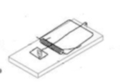A

has irreducible complexity, an irreducible number of parts (no more, no less) are required for its structure; and if it is complex, the number of parts required is greater than one; and if it is mouse trap (A) the parts are structured according to the design instructions for mouse trap (A). Mouse trap (A) is only irreducibly complex when it is structured according to the design instructions for mouse trap (A). One can imagine a complex pile of parts for mouse trap (A) being reducible by removing one or more parts from the pile, but one cannot imagine such a reduced pile of parts being structured according to the design instructions for mouse trap (A).
If mouse trap (A), has specified complexity, it is structured according to the design instructions for mouse trap (A); and if it is complex, the number of parts required is greater than one. Mouse trap (A) is only specifically complex when it is structured according to the design instructions for mouse trap (A). One can imagine a complex pile of parts for mouse trap (A) being unspecified, but one cannot imagine such a pile of parts structured according to the design instructions for mouse trap (A). Described in this way, irreducibility and specificity are qualitative, not merely quantitative aspects of mechanical things, perhaps overcoming a popular objection to these concepts.
It appears that success at removing the anthropomorphic implications has also been accomplished by using these definitions.
Thus a distinction is made between anthropomorphic analogy and what might be called epistemic analogy. The next step is to remove the need for anthropomorphic analogy from the argument, leaving epistemic analogy.
Before doing so, let’s take a look at two more examples involving anthropomorphic analogy.
There is a classic argument for the existence of God called the Watchmaker argument, made famous by William Paley. The argument goes something like this:



Suppose we are walking through a forest and come upon a watch lying on the ground. Considering the intricacy of its obvious design, and being familiar with other watches, we wouldn’t conclude that it had evolved, would we? Rather, we would no doubt conclude that this watch must have a designer/maker, just like all other watches. The argument concludes that in the same way, the universe exhibits characteristics of design. Therefore, it too must have a designer.
Antony Flew, the British atheist, told a parable that takes a half step away from anthropomorphic analogy. It goes something like this:
Two explorers traveling through a remote, unexplored jungle came upon a clearing with a flourishing garden in its midst. They immediately assumed that there must be a gardener to care for this garden, but they could not find one. As darkness fell, they rigged strings and tin cans around the garden, reasoning that the gardener might be caring for the garden at night, when they could not see. After several days and nights the strings and cans remained undisturbed, while the garden continued to appear cared for. Flew concluded that there is no difference between an invisible gardener and no gardener at all. But there is a difference – the GARDEN is the difference.
I believe there is a problem with understanding these two arguments. The problem is that we know that objects made by man exhibit characteristics of design because we already know that they have a maker. We only think we see characteristics of this kind of design in the universe because things made by us exhibit characteristics of this kind of human design. Suppose everything man-made exhibited the color yellow. Would we conclude that yellow flowers must have been made by man? Of course not. In the same way, simply because everything man-made is designed does not logically argue that everything not made by man must also have a designer. But consider what happens if we remove man-made objects from the argument, thus removing the need for anthropomorphic analogy.
Suppose we are walking through a junk yard one day and happen to see a wild flower growing there.



It would look so out of place that we might wonder how it got there. We might marvel at its beauty and intricate design without having to compare it to man-made designs. We might even suppose that it must have a designer of a different sort than that of man-made objects – a sort that accounts for its kind of design, which is not identical with human design.
The recognition of the need for design instructions and the successful removal of anthropomorphism suggest a further clarification of the argument in a form that is scientifically falsifiable:

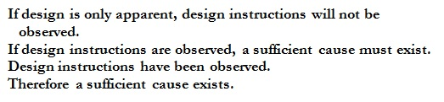

THE INTELLIGIBILITY OF REALITY

Again, considering vertical relationships, conception, explanation, and deduction are primarily causality-processing faculties. And again I might observe that the intelligibility of reality is causality and its end is creation.

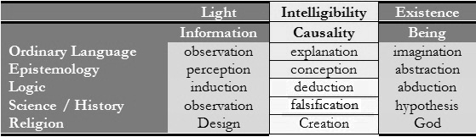

The heart of the causal argument is this:

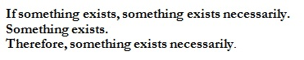

Suppose only one thing exists, e.g., the universe considered as a whole. Why does it exist as opposed to not existing? It is either temporal or eternal. If it is temporal, it requires a cause. If the cause is temporal, that cause also requires a cause, etc., ad infinitum. In that case, the universe could not exist. The universe could not exist because an infinite number of causes would need to precede it. If an actual infinite number of temporal causes preceded it, there would never come a time or be a place for its existence. But the universe does exist. Therefore the cause must be eternal – it must be the cause of temporal (spacetime) existence itself. To illustrate this point, think of watching a slideshow on a tablet device. If you are able to pause the slideshow, to view a single slide, it is because there are a finite number of slides in the slideshow. If the slideshow somehow contained an infinite number of slides, you would never be able to pause it, since an infinite number of slides would need to appear before the appearance of the slides you wish to pause. Or, consider that your train car has arrived at the station. If that train had an infinite number of cars, your car could never arrive, since an infinite number of cars would have to arrive before the arrival of your car.
We also know from experience that the universe contains temporal things, and we know from modern science that the universe is temporal; that is to say, it had a beginning at the Big Bang, the original singularity. We know this from the tested physics of the Standard Model, General Relativity, and Quantum Mechanics.
I have found it useful therefore to present the cosmological argument as follows:

Singularity Argument:

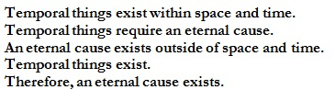

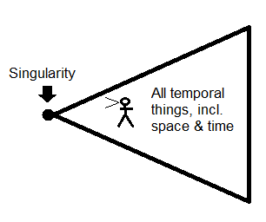

When we look back in space and time, we see a singularity that appears to come out of nothing because space and time were created in the beginning along with other temporal things. But since nothing comes from nothing, a cause must exist for these things. A cause that is outside of space and time is thus considered eternal, and thus, uncaused.
In recent online discussions about the Cosmological argument for the existence of God, there are two objections that caught my attention because they both touch upon key points of the classical argument that need new clarification, and because I realized that if I were an atheist or agnostic, I would consider these objections to be great stumbling blocks to becoming a believer
The first objection, the “temporal realm” objection is that the terms exist and cause are not applicable beyond the temporal realm. Part of the problem has to do with the fact that these terms have more than one meaning or connotation. Exist has the technical meaning within our experience of “interact with like things in a temporal environment”. It also has the meaning of “having reality” as in the example of mathematical concepts such as the concept of a number having reality. Cause likewise has the technical meaning within our experience of “being part of a chain of causes and effects in a temporal environment”. But it also has the meaning of “explanation” as in the example of my scooter being black. It is black not because I painted it black, but because I purchased it black. “[P]ainted it black” has the first meaning of the term cause and “purchased it black” has the second meaning.
Beyond semantics, the term cause seems to require special further explanation, since we are dealing with the cosmological argument, the key concept of which is cause. I am impressed by two answers to the objection that cause is not applicable beyond the temporal realm. Consider the first “thing” that ever existed in the temporal realm. Since the first thing is clearly part of the temporal realm, it is appropriate to speak of its being a cause or having a cause. But as soon as I begin to think about the cause of the first temporal thing, I realize at once that it must have a cause, and that the cause cannot be temporal, since that would mean having a temporal thing before the first temporal thing. Therefore, if the first temporal thing is to have a cause, which it must, that cause must be eternal. But suppose we have instead an infinite chain of things (causes and effects)? In that case you cannot have a first thing, but you cannot have any present things either, since there would need to be an infinite number of previous things before the present things, in which case the present things never become present!
The second objection, the “ex nihilo” objection, states that since something cannot come from nothing, God cannot create something from nothing. If something coming from nothing is inconceivable, then it is inconceivable for God to create something from nothing. But God did not create something from nothing. God was there. And it is conceivable that God created the universe using information – ideas contained in the mind of God). This would be in keeping with the gospel of John chapter 1:1-3, where it states, “In the beginning was the Word, and the Word was with God, and the Word was God. He was with God in the beginning. Through him all things were made; without him nothing was made that has been made.” So now we have God creating using information (ideas contained in the mind of God). Now those who believe in the transcendence of God (I am among them) might object that this reduces to pantheism, since it makes creation a part of God. Actually, it makes information (ideas contained in the mind of God) part of God’s creation. God remains transcendent, since the mind is transcendent and independent of its ideas. Also, if information (ideas contained in the mind of God) is part of God’s creation, this is in keeping with Acts 17:28, where it states, “…in him we live and move and have our being.” And, Colossians 1:17 where it states, “…in Him all things hold together. Christians have always maintained that the universe did not come from nothing, since God was there. This is the true understanding of creation “ex nihilo”.

THE IMAGINATION OF REALITY

Considering vertical relationships one last time, abstraction, imagination and abduction are primarily hypothesis-generating faculties. And I might observe that the existence of reality is being and its end is God.

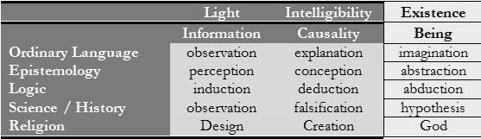

There is an argument that uses the imagination to prove the existence of a supreme being called the ontological (from being).argument. The ontological argument goes something like this:

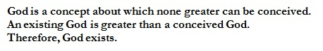

There are three important objections to this argument. The first is that this argument can be applied to anything, for example, a “maximally perfect island”. The second objection is that this argument is only about conceptions and doesn’t necessarily say anything about reality. The third is that the argument above might also be used to prove that God is evil.
This argument seems to rely upon the following implication of the cosmological argument:

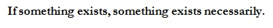

Applying this along with insights from the singularity argument to help us understand the meaning of necessary existence yields this formulation:

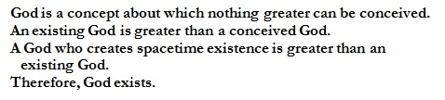

In response to the first objection, a “maximally perfect island”, it may be conceivable that such an island could exist within spacetime, but it is inconceivable that it could exist outside of spacetime, since even a “maximally perfect island” remains a finite and temporal object. And, a finite and temporal object is utterly inconceivable as the creator of spacetime existence.
In response to the second objection, that this argument is only about conceptions, the premise “A God who creates spacetime existence is greater than an existing God” is inconceivable as anything other than a statement about reality.
In response to the third objection, that it might also be used to prove that God is evil, the first thing to notice is that there can be only one creator of spacetime existence “about which none greater can be conceived”. This is because presumably “infinite” would be one the attributes of such an entity. It is impossible to conceive of more than one infinite entity without using spatial and temporal delimiters. So, if we have more than one “maximally perfect” entity, many may be finite, eternal, and sometimes invisible, but only one can be infinite.
Is goodness greater than evil on the earth? Arguably, the most important fact about Earth is that it is life-sustaining. It is difficult to conceive of a maximally evil entity creating a life-sustaining Earth. Therefore, the God “about which none greater can be conceived” must be infinite and good.

Conclusion

“… [T]he hypothesis of God’s Reality is…so connected with a theory of the nature of thinking that if this be proved so is that.”
- C. S. Peirce (Collected Papers 6.491)

I have shown that the mental faculties of perception, conception, and abstraction have corollaries in Science and Religion. I have suggested that if these faculties are considered intelligible and reliable in Science, they must be considered so in all fields of inquiry. This can be seen in the scientifically falsifiable argument form below:



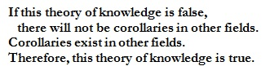

I have also called attention to the fact that since the discovery of design information in nature (DNA for example), the following scientifically falsifiable argument form is apparently sound:

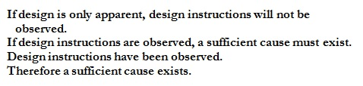

INDEX

a posteriori - Latin for "after experience"., 3
a priori - Latin for "before experience"., 3
abduction - logical process of hypothesis formulation., 5
abstraction – combining of ideas., 3
abstraction – reduction of something to its essential elements., 4
actual – having existence or reality., 2
ad infinitum, 13
agnostic, 15
analogy, 8
anthropomorphic - attribution of human form to anything non-human, 8
anthropomorphic analogy, 10
anthropomorphism, 8
atheist, 15
Awareness – consciousness., 3

Big Bang, 14
biological origins, 9

characteristics of design, 10
conception – awareness of an idea., 3
cosmological, 5
creation, 7

deduction, 5
design instructions, 9, 12
designer, 10
designer of a different sort, 11

energy, 7
epistemic analogy, 10
epistemic status – granting intelligibility or reliability, 3
epistemologically - pertaining to a theory of knowledge., 3
epistemology - philosophy of knowledge., 1
eternal, 13
eternal - unbound by space or time., 3
evolution, 7
ex nihilo objection, 16
explanation, 5
extrapolation – the combining of parts to make a whole., 4

falsifiable argument, 19
falsification, 5
falsifies – disproves., 3
Flew, Antony, 10
functional instructions, 7

garden, 11
General Relativity, 14
genetic fallacy - using source or history as a pro or con in an argument., 1

Hume, David, 8
hypothesis, 5

imagination, 5
immediate intuition – direct perception or conception., 3
imposing artificial categories - view of epistemology that says the mind imposes upon reality rather than corresponding to reality., 3
induction, 5
infinite, 14
information, 3
intelligible – understandable., 3
irreducible complexity, 9

light, 7

matter, 7
McDonald, 10
mental faculties - processes/capabilities of the mind., 3
mouse trap, 9

objections, 15
observation, 5
ontological, 5, 17
ontological argument, 17

Paley, William, 10
pantheism, 16
Peirce, C. S., 5
perception – awareness using the senses., 3
physics, 14
possible – having logical/conceivable potential for actuality., 2

qualitative, 10
quantitative, 10
Quantum Mechanics, 14

reality, 5, 15
Reflection – process of thinking., 3
reliable, 3
rock formation, 8

singularity, 14
Singularity Argument, 14
slideshow, 14
Solzhenitsyn, Alexander, 7
spacetime, 14
specified complexity, 9
Standard Model, 14

tablet device, 14
teleological, 5
Teleology (design), 7
temporal, 13
temporal – bound by space or time., 3
temporal realm objection, 15
train car, 14
transcendence, 16

universe, 13

verifies – proves., 3

Watchmaker, 10

See Index for definitions of technical terms. Also, if using Kindle, activate dictionary by selecting words.
http://www.insidescience.org/content/physicists-detect-new-heavy-particle/724?track=AW
“In Search of a Road to Reality”, http://www.evolutionnews.org/2014/01/is_there_a_road080961.html.
Phenomenology of Perception, Maurice Merleau-Ponty, p. vii.
Kant and the Claims of Knowledge, Paul Guyer , p. 27.
Cf. Peirce, Collected Papers, 7.202.
Cf. Ibid., 6.491.
David Hume, Dialogues Concerning Natural Religion, ed., N. K. Smith (New York: Bibbs-Merrill Co., 1947) p.143.
Cf. McDonald, http://udel.edu/~mcdonald/mousetrap.html.
William Paley, Natural Theology; Selections, (New York: Bobbs-Merrill, 1963).
Antony Flew- Proceedings of the Aristotelian Society, 1944-5, reprinted as Chap. X of Antony Flew, ed., Essays in Logic and Language, First Series (Blackwell, 1951), and in Wisdom's own Philosophy and Psychoanalysis (Blackwell, 1953).
http://cdouglasjones.com/2013/07/29/human-versus-non-human-design/
Popper, Karl, The Logic of Scientific Discovery, Basic Books, New York, NY, 1959.
http://cdouglasjones.com/2013/09/12/singularity-argument-for-the-existence-of-god/
http://cdouglasjones.com/2013/10/30/in-defense-of-causality-and-creation-ex-notia/
Gaunilo of Marmoutiers, On Behalf of the Fool.
Everlasting in the future direction, e.g., created entities; I dare say angels.
Dahm R (2008). "Discovering DNA: Friedrich Miescher and the early years of nucleic acid research". Hum. Genet. 122 (6): 565–81.

