An investigation of the Business-Level Strategies in Zimbabwe Food Manufacturing Sector (2006 -2013)
Emmanuel Katsvamutima *1, S Jeevananda 2
1 Christ University Bangalore– India
2 Christ University, Bangalore- India.
A R T I C L E I N F ORMATION
Key words:
Conceptual model as an intervention measure to challenges on the food industry.
Competitive advantage, Capacity utilization, Cost-related strategies, Differentiation strategies, Focus strategies
Food manufacturing industry in Zimbabwe, Strategy Formulation and Strategy Implementation

A B S T R A C T
This paper examines business level strategies and the impact of strategy formulation, strategy content and strategy implementation on competitive performance, all within the food manufacturing sector in Zimbabwe. As far as the author was able to establish by examining the previous studies, none of the previous studies have looked into strategic formulation, business-level strategy and strategy implementation simultaneously in a single study. The objective of this research study is premised on establishing cause and remedies to gain competitiveness in the food manufacturing sector in Zimbabwe. Survey data affecting manufacturing sector competiveness like corruption, finance, technology, labour force, uncompetitive exports, unreliable and high cost electricity were analysed. Furthermore this study considers the moderating effects of environment on the relationship between strategy formulation and competitive performance and strategy content and implementation. The paper also assesses the moderating effect of business level structure on the relationship between strategy formulation content and competitive implementation performance. This study also addresses some of the methodological shortcomings of the previous studies by clearly defining the food manufacturing industry in Zimbabwe, using a good sample size and by using properly validated constructs. The sample size of this research paper consisted of 150 Chief Executive Officers located in Harare, Bulawayo, Mutare, Gweru and Masvingo in Zimbabwean. The research instrument used was the self – administered questionnaire. Data collected was analyzed using both inferential and descriptive statistical tools. The structural model indicates that some of the bivariate relationships become insignificant when strategy formulation is studied along with business-level strategy and strategy implementation simultaneously. Results obtained from the study revealed that strategy formulation and implementation if fully practiced in food manufacturing organisations enhances efficiency, profitability and competitive advantage in a dynamic environments. The paper recommended a conceptual model for Strategy formulation and implementation for competitive advantage in the food manufacturing industry in Zimbabwe.

1. Introduction
The study of Business-Level Strategies analyses the competitive factors affecting business operations and growth in Zimbabwe Food Manufacturing Sector between 2006 and 2013. The scope of the study covers the performance of the manufacturing sector, analyses how competitive the sector is and what factors need to be addressed to deal with enhancing competitiveness of the food manufacturing sector. The performance of the manufacturing sector is closely linked to competitiveness. The competitive performance of industry is influenced by the business environment within which industry operates. This paper tales a closer look at the Zimbabwe food manufacturing sector is the following areas: business operations and strategy, technology and innovation, infrastructure, human capital and foreign trade, investment and financial environment. The food manufacturing sector environment was characterised by a lack of working capital support, a shrinking domestic market, high utility tariffs, higher than regional tax structures, high wages, credit and liquidity crunch, and a variety of supply-side bottlenecks that included fuel, electric power, imported inputs and skills. Demand for local products has also declined as a result of a possible shift in consumption patterns in favour of cheaper imported goods.

Business level strategies in Zimbabwe’s food manufacturing sector examines the impact of strategy formulation, strategy content and strategy implementation on organisational performance, all within a single study. Furthermore this study considers the moderating effects of environment on the relationship between strategy formulation and performance and strategy content and performance. At business level competitive performance was measured using two constructs namely objective fulfilment and relative competitive performance. A differentiation strategy is helpful in improving relative competitive performance in highly hostile environments as well as highly dynamic environments as in Zimbabwe’s food manufacturing industry.

2. Literature Background
Market liberalization has become a reality for Zimbabwe food manufacturing industry as this along opportunities and threats to the fore. Zimbabwe food manufacturing industries is facing increasing competitive pressure and is struggling to cope with competitiveness of its exports and to compete with imports. According to Karim (2009), “there are unprecedented pressures on the companies in the food manufacturing sector to improve their operational efficiency for enhanced competitiveness and business performance”. This pressure includes competition from foreign products (imports), new products introduced by competitors, rapid technological improvements and shorter product life cycles, unanticipated customer shifts, and advances in manufacturing and information technology.
To survive these challenges and to benefit from the opportunities that come along with globalisation, Zimbabwean food manufacturing companies need to become internationally competitive through improving operational efficiency and management practice. In addition, is important that Zimbabwe’s domestic policies create an environment that allows local businesses to grow and to elevate the level of manufacturing superiority to attain international competitiveness. Zimbabwe’s economy is at its crossroads where it can now recover from over a decade of contraction and regain regional competitiveness it once enjoyed.
The competitiveness of the local manufacturing sector in the new economic setting of a more liberal international and domestic environment will be critical to its long term prosperity and growth. An internationally competitive Zimbabwean manufacturing sector will create and contribute more towards attainment of a more sustainable and stable economy and this would in turn encourage both foreign and domestic investments.

Based on the literature review a conceptual model of strategy formulation and implementation was proposed and the hypotheses to be tested were derived. These hypotheses were classified into two groups namely (i) hypotheses for validating the findings of previous studies and (ii) hypotheses which have not been tested in previous studies. Hypotheses in the first group have examined the impact of strategy formulation, business-level strategy and strategy implementation on organisational performance. Hypotheses in the second group have examined the interrelationships between strategy formulation, business-level strategy and strategy implementation.
Appropriate analytical techniques were used to test the hypotheses and Partial least squares (PLS), which is a structural equation modelling technique was used to test the conceptual model, Food manufacturing organisational in Zimbabwe performance was measured using two constructs namely objective fulfilment and relative competitive performance.

3. Business-Level Strategy – relates to the actions and approaches crafted by management to produce successful performance in one specific line of business, the central business strategy issue is how to build a stronger long term competitive position. Business-level strategy employed by food manufacturing organisations in Zimbabwe is defined as the competitive methods which are derived on the basis of rational-comprehensive strategy formulation enabling them to accomplish one of the following tasks:
• minimise the operational costs;
• differentiate their products from other competitors;
• minimise the operational costs and differentiate their products from other competitors.

4. The Most Problematic Factors for Doing Business in Food Manufacturing Industries in Zimbabwe
Business Operations And Strategy in Zimbabwe Food Manufacturing
- State of Infrastructure
The state of infrastructure in Zimbabwean economy has a significant bearing on the operating environment of business and ultimately affects the level of competitiveness in the food manufacturing sector. The absence of adequate provision of infrastructure is usually an added cost to doing business and is impeding economic growth or not promoting economic growth, and firms have to seek alternatives.
Figure 1: State of Infrastructure

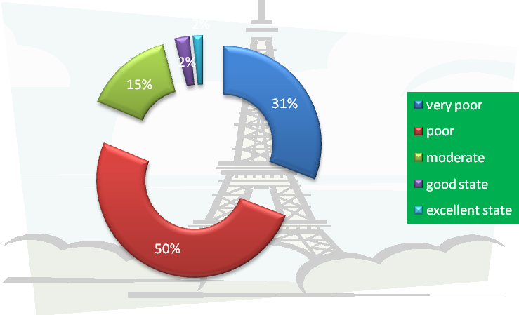

Figure 2: Infrastructure's Ability to Sustain Economic Growth
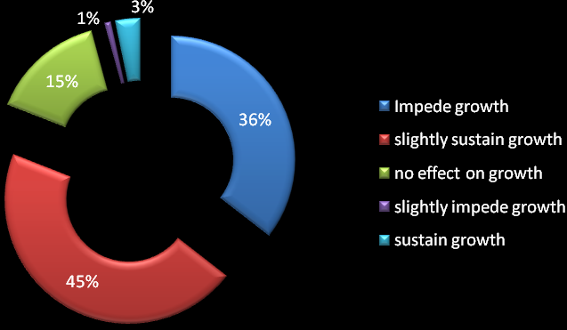
Respondents in Zimbabwe food manufacturin sector were as follows: 3% said that it was sustainin growth, 45% said is was sightly sustaining growth, 15% said it did not have any effect, 1% said it was slightly impeding growth, 3% said it was sustaining grwoth and 36% sai it was impeding growth.
- Human Capital – The Labour Phenomenon at Business Level
This paper stressed the importance of education, market experience and training cannot be undermined when dealing with human capital. The level of skills and experience of human capital at a firm is expected to have a direct bearing on productivity. This study sought to investigate various aspects of human capital and how they have impacted on business. The findings were that only 22% of the respondents indicated having changed the number of working hours. In the case of a decrease in working hours, this was mainly necessitated by a drop in product demand and power outages. Only 1% indicated an increase in working hours as a direct result of an increase in workload due to increased product demand. The graph below shows highlights reasons for changes in working hours.
Figure 3
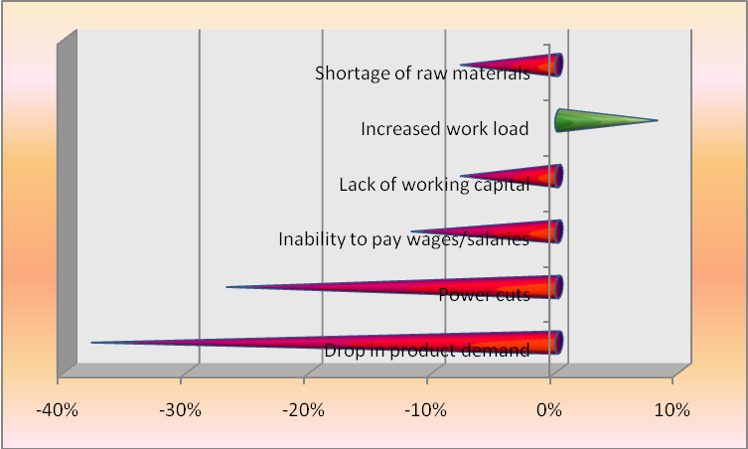
- In terms of retrenchments, 14% of the respondents indicated that they had retrenched permanent staff and reasons cited were mainly due to rationalisation following a downturn in business, and introduction of new technologies (automation).
- The issue of labour costs and the negative impact on business viability remains a challenge for the food manufacturing industry. A total of 77% of the respondents indicated that their wage bill had increased in 2013 compared to 2012 with the major reason cited being wage negotiations (78%) and staff recruitment (12%). The average labour cost as a percentage of total inputs for the manufacturing sector is 24% whilst the total employee costs as a percentage of total input costs is 33%.
- Labour remains a key ingredient into the production process as the country is not highly mechanised. The relationship between the labour force and the employer is key in ensuring productivity. Findings in this study indicate that 58% of the respondents view labour-employer relations as generally cooperative whilst 10% view relations as generally confrontational and slightly cooperative. The remainder in the findings insist on a moderately cooperative relationship between employer and employee.

- Foreign Trade, Investment and Financial Environment
Export Markets
The survey results show that there was no significant change in terms of export destinations and the respective market shares, with the exception of South Africa. Over the years South Africa had continued to lose market share of Zimbabwean exports, but this year market share has increased from 12% in 2012 to 18% in 2013. The table below shows the various export destinations and their respective market share.
Table 1: Leading Export Destinations in the food manufacturing industry in Zimbabwe
 | Market Share in 2012 | Market Share n 2013
Zambia | 30% | 31%
Malawi | 17% | 19%
Mozambique | 13% | 13%
South Africa | 12% | 18%
Botswana | 11% | 4%
Rest of Africa | 9% | 7%
Europe | 5% | 5%
Other | 0.0% | 3.0%
Companies that had not exported in the past two years stated the following as the major reasons for not exporting:
1. Their product could not compete on the international markets particularly with products
coming from South Africa and China;
2. Shortage of working capital which has resulted in most firms focusing on meeting local demand; and
3. High cost of production which is rendering the product expensive.

- Pricing Mechanism
Most companies in the food manufacturing sector in Zimbabwe use more than one pricing mechanism. The most popular pricing mechanism amongst the food manufacturers remains the mark up over cost, with 71% of the respondents indicating that they use this method. 24% of the respondents are market price takers, whilst it is worth noting that since market liberalisation, Government of Zimbabwe is playing a dormant role in product pricing, with less than one percent of the respondents (0.8%) indicating that their prices are set by government. 18% of the respondents indicated that they negotiate with the buyer whilst 14% base their prices in line with imports. The results show that most companies in food manufacturing in Zimbabwe have more than one pricing mechanism depending on the target market.

- Capacity Utilisation
Capacity utilisation is the percentage of the firm’s total possible production capacity that is actually being used. Thus, it refers to the relationship between actual output that 'is' actually produced with the installed equipment, and the potential output which 'could' be produced with it, if capacity was fully used. The global capacity utilization for the manufacturing sector for 2013 is 39.6%. From the respondents only 35.7% recorded capacity utilisations of above 50%, with only two firms recording a capacity of 100%. The average capacity utilisation of 39.6% would imply a decline of 5.3 percentage points from last year’s average of 44.9%.
Major Capacity Constraints
The factors affecting the food manufacturing sector in Zimbabwe remain largely that of working capital constraints. The issue of working capacity constraints was further compounded by tight liquidity conditions and non-performance of creditors which was greatly affecting business level cash flows. Working capital constraints 40.2%, low local demand 17.6%, competition from imports 12.5%, antiquated machinery and machinery breakdown 9.8%, power and water shortage 8.8%, shortage of raw materials 5.9%, and high cost of doing business 5.2%. Business level funding was mainly profit plough back at 54%, Direct Foreign Investment (FDI) at 5% and loans from banks at 41%. Companies in the food manufacturing industries in Zimbabawe carried out new capital investment increased by 11% in 2011. Of these, 93% invested in machinery and equipment whilst 7% invested in land and buildings. The major reason for investment was to replace worn out machinery and equipment (46%) whilst 44% indicated that they wanted to expand their operations.

- Business Level Innovation and Technology- Views on the Tertiary Education System
Collaboration with tertiary institutions ensures that tertiary institutions produce the right products (human capital) for the market. The use of Virtual Social Networks in marketing is also limited in Zimbawe’s food manufacturing industry. In this environment where globally people are advocating for online buying and selling there is need for companies to embrace technology and increase the usage of internet as a marketing gimmick. Only 10% use internet in marketing significantly whilst 5% use virtual social networks significantly e.g. Facebook, twitter. The results are provided in figure 4 below.
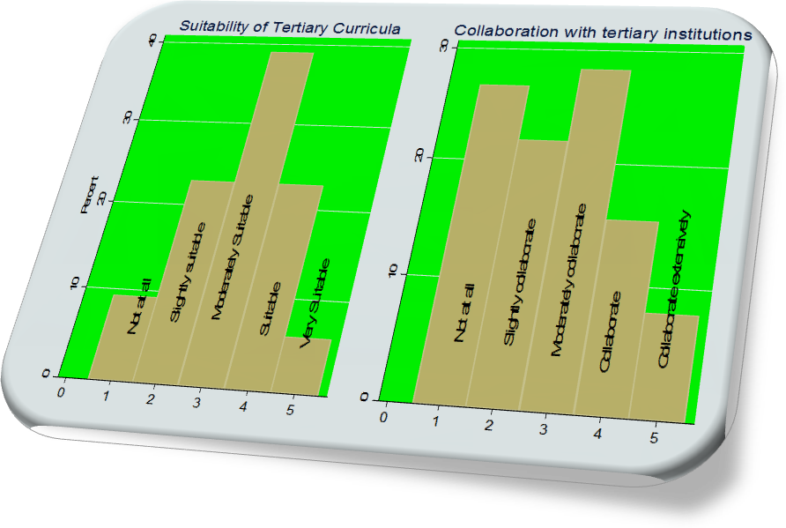
The findings survey indicates that the research and development being undertaken by research firms is not effective. The responses are presented in the pie chart below:
Figure 5: Effectiveness of Research & Development
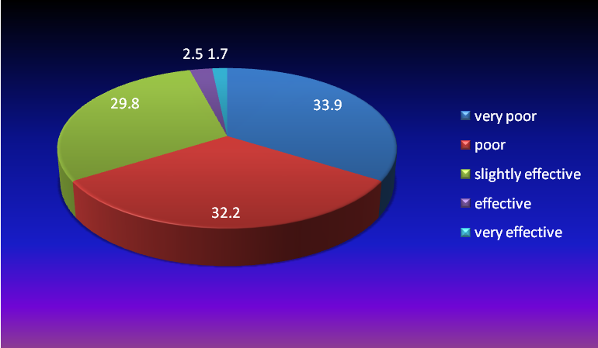
The survey results indicate that most companies in the food manufacturing sector are yet to use the internet as a tool for buying and selling their products. This is indicated by a 50% response rate of those who slightly use on do not use internet at all in marketing their products. Most respondents note that internet service providers are moderately providing the right speeds and connectivity required for their business. The results are presented below.
Figure 6: Use of Technology at Business Level
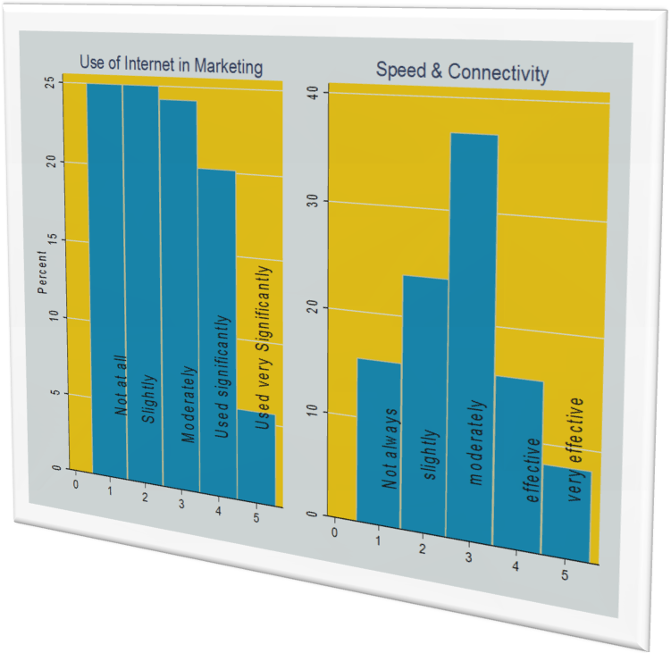

Investment & Financial Environment
The economic environment in Zimbabwe’s food manufacturing sector is not conducive for foreign direct investment as shown by the bar chart below. Only 0.8% of the respondents indicated that the environment is conducive for FDI whilst half of the respondents indicated that the environment is largely deterrent.
Figure 7: Economic Environment & Foreign Direct Investment
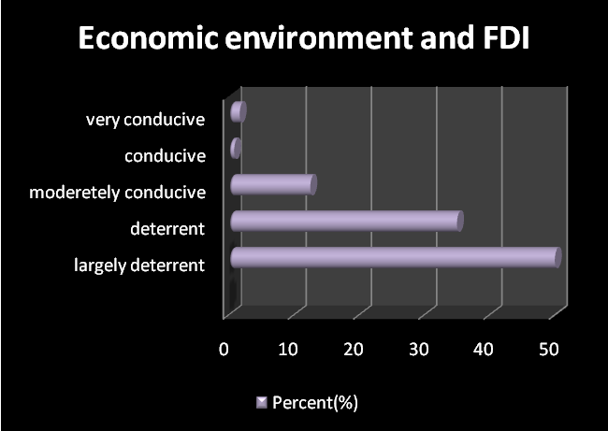
With the introduction of multicurrency in 2009, it seems the financial sector has not lived up to the expectations of the food manufacturing sector in Zimbabwe. More than 50% of the respondents indicated that it is difficult to access financing from the local banks and the choice of financial products is limited. The economic environment is not conducive for foreign direct investment as shown by the bar chart above. Only 0.7% of the respondents indicated that the environment is conducive for FDI whilst 60% of the respondents indicated that the environment is largely deterrent.
Figure 8: Financial Environment

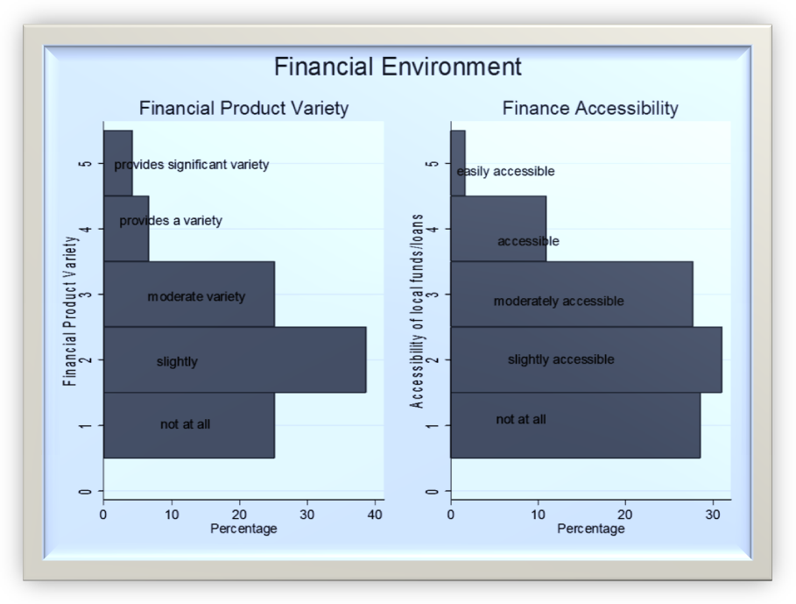
Table 2 Business –Level Challenges Summary
Factor | Very Positive | Positive | No Effect | Negative | Very Negative
Minimum wages | 2% | 9% | 36% | 40% | 13%
Restrictive Labour Regulations | 2% | 4% | 37% | 39% | 18%
Policy Instability | 2% | 9% | 36% | 40% | 13%
Corruption | 2% | 3% | 14% | 44% | 38%
Power Cuts | 2% | 9% | 36% | 40% | 13%
Electricity Charges | 1% | 4% | 4% | 46% | 44%
Access to financing | 2% | 9% | 36% | 40% | 13%
Domestic Demand | 2% | 26% | 7% | 38% | 27%
Public Sector Bureaucracy | 2% | 9% | 36% | 40% | 13%
EMA Requirements | 2% | 10% | 48% | 22% | 18%
Interest Rates | 2% | 9% | 36% | 40% | 13%
Exchange Rate | 2% | 9% | 54% | 22% | 13%
Insufficient capacity to innovate | 2% | 9% | 36% | 40% | 13%
Ageing  Equipment | 1% | 2% | 13% | 44% | 39%
competition from Imports | 2% | 9% | 36% | 40% | 13%
Cash Shortages | 2% | 3% | 41% | 41% | 15%
Bank System Instability | 2% | 10% | 29% | 45% | 14%
From the table above, electricity charges, ageing equipment, corruption and domestic demand are seen as factors having the greatest negative impact on doing business in Zimbabwe. The tight liquidity situation has further exasperated the situation for most companies affecting cash flow positions thus affecting operations. It was the general view that there is a need in shift in policies to ensure investor confidence to bring in the much needed financial investment.

5. Aims of The Study
The two systematic literature reviews examining studies on strategy formulation and implementation while applying the system to business-level strategy and a review of strategy implementation literature suggest that the following issues need to be addressed:
• Can performance heterogeneity in food manufacturing organisations in Zimbabwe be explained in terms of their emphasis on rational strategy formulation?
• What factors affect the success of strategy implementation? To what extent have
organisations in the food manufacturing in Zimbabwe been successful in implementing their formulated strategies? Does the emphasis on strategy implementation lead to superior performance?
• Does the environment moderate the relationship between strategy formulation, implementation and organisational performance?
• Does the environment have a moderating effect on the relationship between business-level
strategy and performance?
This study makes a significant contribution to the literature by addressing the above issues.
6. Research Methodology
The basic approach followed in this study is that of theory testing through empirical research. A set of testable hypotheses have been formulated on the basis of theoretical underpinnings and the findings of previous studies. These hypotheses have been tested using survey data and conclusions have been derived. The attributes of this study closely match the methodological position outlined by post-positivism. A quantitative research strategy was followed in this study. The scales for measuring the constructs used in this study were adapted from previous studies and they have been validated. A sample of manufacturing organisations belonging to the food manufacturing sector in Zimbabwe was generated and the survey was executed according to the specifications. The analytical techniques used to test all the hypotheses were identified and the data analyses procedure followed was explained. The homogeneity of the sample was assessed and it was found that there was no significant difference in the measures between the groups. The Statistical tests indicated that common method variance problem is unlikely to distort the interpretations of the results.

7. VARIABLES OF THE STUDY
The variables under investigation in this study are classified as dependent variables or endogenous variables which includes, business strategy, objective fulfilment, competitive implementation performance and Implementation Strategy. Independent Variables or exogenous variable includes the following:
Cost-Related (production capacity utilisation, operating efficiency, cost reduction, efficiency of securing raw materials cost cutting on administrative expenses and price competition )
Differentiation Variables (Rate of new product introduction to market, Emphasis on the number of new products offered to the market, Emphasis on new product development or existing product adaptation to better serve customers, Intensity of a business’s advertising and marketing, Emphasis on building strong brand identification, Developing and utilising sales force, Emphasis on producing high quality products, Prompt response to customer enquiries and orders)
Focus Variables and Environment Variables(targeting identified segments in the food manufacturing sector, offering specialty products and uniqueness of the form’s products)
Environment Variables (rate of innovation, research and development (R&D) activity in the food manufacturing industry, competitor activity in the market, growth opportunities in the overall food manufacturing industry, legal, political and economic constraints in Zimbabwe’s food manufacturing sector)
A draft of the questionnaire instrument was formed by using these scales. The content and face validity of the measures used were ascertained by seeking expert opinion. The draft of the survey instrument was sent to a panel of strategy scholars and to the Manufacturing Policy Advisor of the Confederation of Zimbabwe Industry (CZI) and based on their feedback it was modified. The modified survey instrument was piloted using a small sample of CEOs belonging to the sampling frame. A feedback form was also attached with the instrument and based on the feedback obtained from the CEOs the instrument was modified further.
Sample Selection and Survey Execution
The companies having more than 50 employees belonging to the food manufacturing industries in Zimbabwe were included in the sample. A sample consisting of 300 companies was selected and telephone calls were made to all these 300 companies to verify the names of the Chief Executives and the addresses of the organisations. After excluding the inactive companies and the ones which were not interested in taking part in the survey, a sample consisting of 190 organisations was formed. Finally a sample consisting of 190 organisations in food manufacturing was obtained. Questionnaires were mailed to the Chief Executives of these 190 organisations with a covering letter and business reply envelopes The questionnaire was mailed to all 190 companies and the strategies suggested by Salant & Dillman (1994) were employed to increase the response rate. One hundred and twenty four usable responses were received and 11 questionnaires were undeliverable. The response rate calculated using the formula suggested by De Vaus (2002) was 22.22%.
8. Sampling Technique
Single stage cluster random sampling; a probability sampling technique, was undertaken for selection of the sample from the population, in order to obtain a representative sample. The population (190 C.E.O and Business Executive) was divided into sub population of 32 individual industries and the cluster were numbered from 1-32. The next step was to determine the sample size by using the rule of thump found in the literature. Sample size (N) formula suggested by Tabachnick and Fidell (2001) was used. Tabachnick and Fidell (2001) explained that the adequate sample size should be: N> (Number of items in the Questionnaire x8)+50. Using the Excel application RANDBETWEEN (.) function, random numbers were generated to select the clusters. Sequence of random numbers obtained in ascending order were: 2, 3,4,5, 6, 7, 8, 9, 10, 11, 12, 13, 14, 15, 16, 17, 18, 19, 20, 21, 22, 23,, 24, 25, 26, 27,28,29,30,31,32). Once the random sample of clusters was selected, all the members of the clusters (sampling elements) were surveyed. All C.E.Os and Business Executives in all the manufacturing sectors were selected randomly for data collection and surveyed and as such the sample size requirement was met for the study.
9. Reliability and Validity of the Measures
Using Cronbach's alpha the reliability of the measures was assessed. The composite reliability, convergent validity and discriminant validity of the measures have been assessed using PLS. The measures have construct validity if they have both convergent validity and discriminant validity.
Analytical Techniques used for Analysis
Based on the nature of the dependent and independent variables involved in the hypotheses, appropriate analytical techniques were selected to carry out the analysis.
The analytical techniques chosen were correlation analysis, regression analysis, moderated regression analysis, analysis of variance and logistic regression analysis.
Assessing the Homogeneity of the Sample and Non-response Bias
In order to assess the homogeneity of the sample, the organisations were classified into four different groups based on the industry sectors to which they belong, and means of the measures used in the study were compared between these four groups using ANOVA. The results indicated no significant difference between the means of the measures corresponding to the four groups.
The procedure adopted by Ghobadian and O'Regan (2006) was used to assess non-response bias. Means of the measures used in the study were compared between early respondents and late respondents using t-tests and no significant difference was found between the two groups. Some of the non-respondents were contacted and were requested to answer a few questions relating to strategy formulation, business-level strategy and strategy implementation. The difference between the means of these variables of the main sample and that of 190 respondents who answered a small number of questions was statistically compared by doing a t-test. There was no significant difference in the means between these two groups. The following analytical techniques were used in the following sequences and times, Correlation Analysis (24), Regression Analysis (14), Logistic Regression (1), Moderated Regression Analysis (1), t-test (23), Chi-Square test (15), Percentage Comparisons (8), Cross Tabulations (4), ANOVA (13), ANCOVA (1), Discriminant Analysis (6), Canonical Correlation Analysis (4), Kendall Tau Rank Correlation (1) and Structural Equation Modelling (2). The most widely used analytical methods in examining the relationship between strategy formulation and implementation are correlation analysis, regression analysis, t-test, Chi-Square test and ANOVA. Regression analysis and correlation analysis were used to determine the relationship between strategy formulation on implementation in Zimbabwe food manufacturing industry. The t-test, ANOVA and Chi-Square test are mainly used to compare the implementation of strategy formulators and non-formulators. Most of the studies have examined bivariate relationships and this could be one of the main drawbacks of the studies. The relationships may change if more variables are studied together. Structural equation modelling technique which could be used to examine multivariate causal relationships was used only twice. In this study, multivariate relationships are examined using partial least squares (PLS) which is a structural equation modelling technique.
Research Strategy
The two types of research strategies commonly employed while conducting research are quantitative and qualitative strategies. This study involves the deduction of hypotheses from the existing theory and testing those hypotheses using primary data. It also operationalises the concepts used in this study such as strategy formulation, business-level strategy and strategy implementation using measurable constructs. A simple random sample of 190 manufacturing organisations was selected for this study and the findings are generalised. Because of the above reasons a quantitative research strategy is appropriate for this study. The hypothesised relationships between the variables are tested using appropriate statistical techniques in order to assess and model the relationships in Zimbabwe’s food manufacturing industry.
Table 4 Sample Size for the 95% Confidence Level
Population Size | Sample Size
10 | 49
25 | 70
50 | 81
75 | 85
100 | 88
250 | 93
500 | 94
1000 | 95
2500 | 96
5000 | 96
10,000 | 96
100,000 | 96
Source: Salant & Dillman (1994)
The sample of the food manufacturing companies for the survey was selected from the Confederation of Zimbabwe Industries (CZI commercial database).
Altogether there were 190 food manufacturing companies having more than 50 employees were selected in the sampling frame. The minimum sample size required for this study was calculated following the guidelines provided by Salant & Dillman (1994). The minimum sample sizes necessary for différent population sizes at 95% confidence level and +/- 10% sampling error are shown in Table 4. The sample sizes shown in the table are based on the conservative assumption that the population is relatively varied (50/50 split).

10. SURVEY RESULTS
The next section of this report will cover the results from the survey. It is imperative to state that all results given below are based on views given by respondents are a taken as a proxy of what is happening in industry. This section sought to ascertain basic information on company operations, this information included products being manufactured, number of years in existence and ownership structures. Responses received were classified and grouped into 16 sub-sectors of food manufacturing sector in Zimbabwe. In terms of number of years that these firms have been in existence was diverse, with new enterprises that have been operating for as little as a year to firms that have been in existence since 1912.
Reliability Analyses of the Scales
The Cronbach's alpha values obtained for each of the scales and the values reported in Zimbabwe’s food manufacturing study from which these scales were adapted are shown in Table 5

Table 5 Reliability of the Scales
Section in the Questionnaire | Constructs Measured | Value of Cronbach's Alpha in this Study | Value of Cronbach's Alpha in the Original Study
Business-level Strategy | Cost-related  Differentiation  Focus | 0.823  0.732  0.532 | 0.75  0.72  0.73
External Business Environment | Dynamism Hostility Heterogeneity | 0.680  0.433  0.283 | Not  available
Strategy Formulation | Extent of Rationality in Strategy Formulation | 0.836 | 0.85
Strategy implementation | Planned Option Prioritised Option | 0.867  0.817 | Not  available
Structure | Organic and Mechanistic  Structure | 0.587 | 0.82
Organisational Implementation Performance | Objective Fulfilment  Relative Competitive Implementation  Performance | 0.750  0.916 | 0.748  0.953

All the measures except focus, hostility, heterogeneity and structure have acceptable Cronbach's alpha values. The data reduction process carried out for those measures which do not have acceptable levels of Cronbach's alpha are explained in the subsequent sections. It can also be noted that the Cronbach's alpha values of cost related, differentiation, strategy formulation and the two measures of organisational performance are very close to the values reported in studies from which these scales were selected.
Fig 9. Model with Path Coefficients, 't' Values and R 2 Values
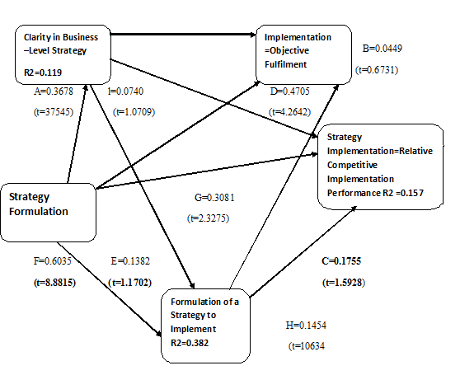
The path names, path coefficients and 't ' values are shown for each path. For significant paths, the path coefficients are shown in bold letters. The significance levels (one-tailed) are
interpreted as: t>64, significant at p<0.05 level (*); t>.96, significant at p<0.025 level (**); t>58, significant at p<0.005
The variable representing clarity in business-level strategy is defined as:
If business strategy type = Cost-related OR Differentiation OR Integrated Strategy, then clarity in strategy = l (Clear strategy) ff business strategy type = Stuck-in-the-middle, then clarity in strategy = 0 (Unclear strategy) The path names, path coefficients and 't ' values are shown for each path. For significant paths, the path coefficients are shown in bold letters. The significance levels (one-tailed) are interpreted as: t>64, significant at p<0.05 level (*); t>96, significant at p<0.025 level (**); t>.58, significant at p<0.005 level (***).

11. Achievements of Objectives
The study indicated that strategy formulation has a strong positive relationship with objective fulfilment and its relationship with relative competitive performance is not very strong. It was found that strategy formulation helps organisations to improve their relative competitive performance in highly dynamic as well as highly hostile environments. The results indicated that organisations that had a clear business-level strategy by adopting one of the strategies namely cost-related, differentiation or integrated strategies performed better than stuck-in-the-middle companies both in terms of objective fulfilment and relative competitive performance. It was also found that external environment moderates the relationship between business-level strategy and performance to some extent. A cost-related strategy helps organisations to improve their performance in environments with low levels of hostility. A differentiation strategy is helpful in improving relative competitive performance in highly hostile environments as well as highly dynamic environments. It was found that an organic structure is helpful for organisations having a clear strategy to improve their performance. The planning of strategy implementation had a significant positive relationship with both the performance measures.
When the conceptual model was tested using PLS it was found that some of the relationships in the model were not statistically significant. The model indicated that it is not possible to effectively predict relative competitive performance using the variables used in this study. However, the model indicated that objective fulfilment can be predicted using strategy formulation and the planning of strategy implementation. Most of the previous studies have examined bivariate relationships. The structural model indicates that some of the bivariate relationships become insignificant when strategy formulation is studied along with business-level strategy and strategy implementation simultaneously.

12. Results and Discussion of Findings
The findings of this study are immensely useful to the CEOs and senior managers. This study emphasises the need for carrying out formal strategy formulation in food manufacturing organisations in Zimbabwe. This needs to be carried out by systematically searching the external environment for opportunities and threats, generating strategic options and by using the tools and techniques. This study indicates that strategy formulation and implementation helps organisations in both dynamic and hostile environments. The results of this study clearly establish the importance of strategy implementation. Managers need to pay careful attention to properly plan and prioritise the implementation of strategies for enhancing the organisational competitive performance.
The findings indicate the need for having a clear strategic orientation and managers must ensure that the organisation does not go to a stuck-in-the-middle condition. Integrated strategies are useful for enhancing organisational performance and hence CEOs and senior managers could assess the feasibility of implementing integrated strategies in their organisations. The implementation of integrated strategies necessitates careful planning and consideration of costs and benefits. Reconfiguration of the value chain may be necessary in such a situation. This study indicates that an organic structure is favourable for implementing both integrated strategies and a differentiation strategy.
The findings concerning the relationship between environment and strategy are immensely useful to managers. When an organisation operates in either a highly dynamic or hostile environment a differentiation strategy is more appropriate. Due to unfavourable environmental conditions and hostile activities of competitors it may be difficult to maintain a low-cost position in the food manufacturing industry in Zimbabwe. The firm needs to offer differentiated products and features to its customers for sustaining and improving its competitive position. However in a low-hostility environment an organisation can maintain its low-cost position and improve its performance. Overall, this study suggests that organisations need to give high emphasis to strategy formulation and strategy implementation. It also needs to have a clearly defined strategy for improving performance.

- STRUCTURAL MODEL DEVELOPED
Based on the results, a structural model was developed and is presented in figure 10 and further elaborated in figure 11
The two figures shows the interplay between exogenous and endogenous variables
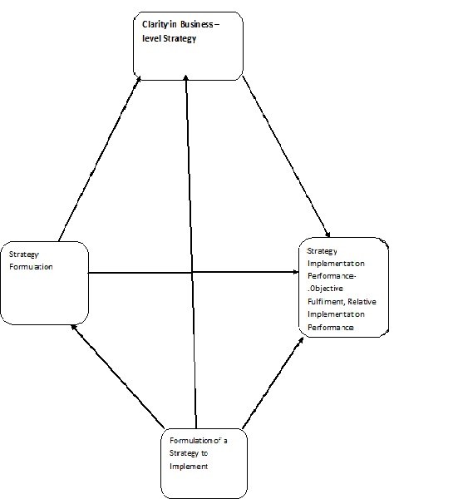

Fig 11 Conceptual Model
Recommendations for Competitive Advantage in Food Manufacturing industry in Zimbabwe

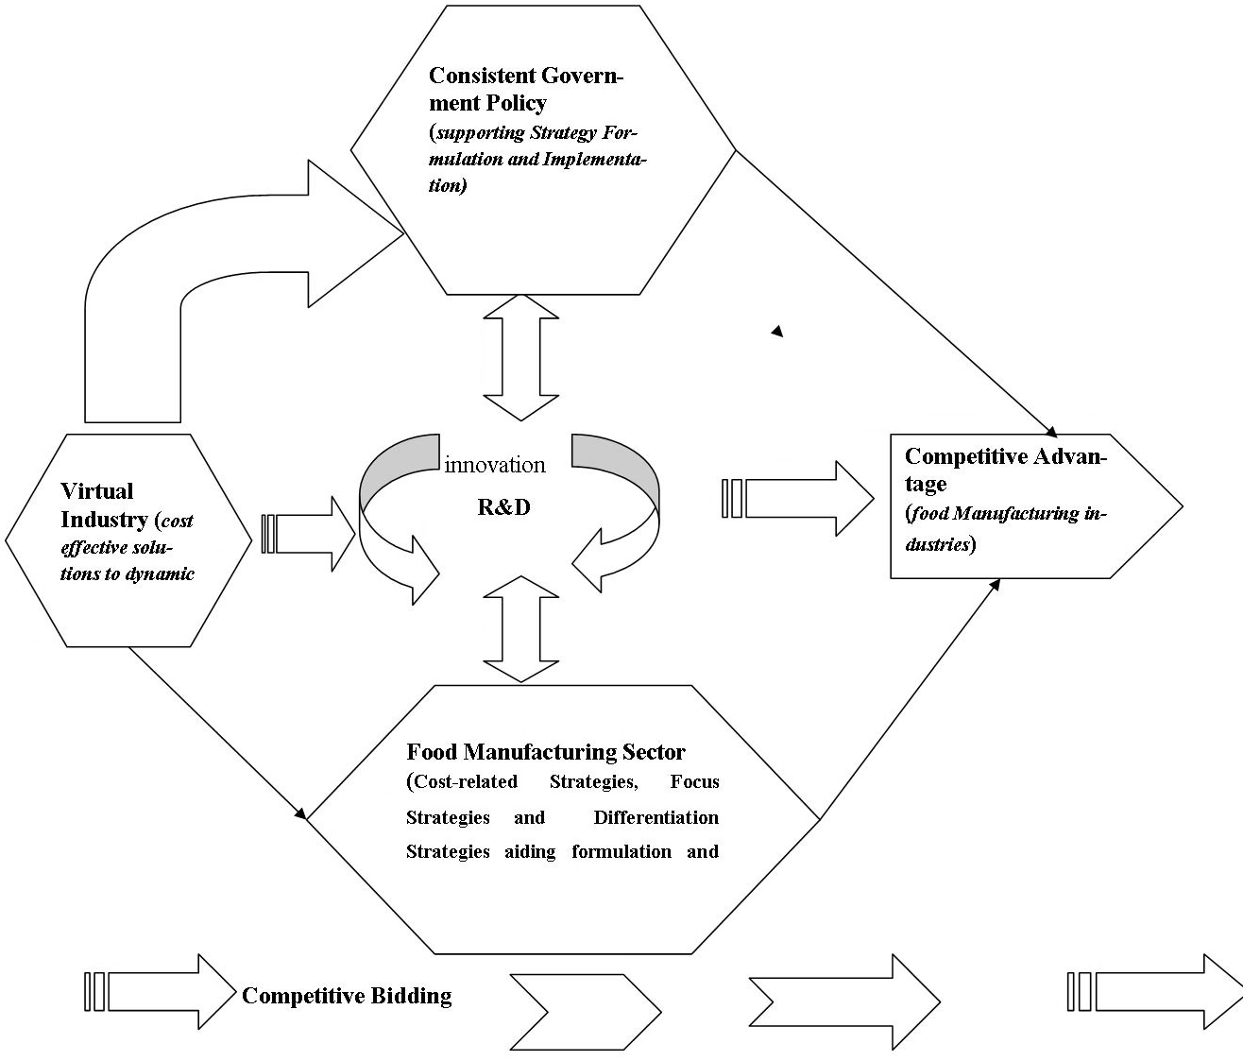
Analysing this conceptual model exposes the following recomendations:
- The need to have consistent Government policies that promote strategy formulation and implementation while creating enabling environment for competitive advantage.
- The need to embrace virtual industry to aid efficient business level strategies for competitive advantage in the food manufacturing industry.
- The need to take advantage of the virtual industry to promote innovation through research and development towards competitive advantage in the food manufacturing industry.
- Virtual industry helps the development of efficient and competitive business level strategies (cost-related strategies, focus strategies and differentiation strategies) for competitive advantage through strategy formulation and implementation in the food manufacturing industry in Zimbabwe.

Embracing this conceptual model of competitive bidding through careful strategy formulation and implementation will facilitates the resulted following:
- avoided company closures due to high cost of borrowing;
- stimulated employment creation through support of new and expansion of food manufacturing projects and providing funds for capital expenditure;
- stimulated additional export earnings through a competitive food manufacturing industry driven by innovation;
- provided low cost production to targeted primary producers in the food manufacturing sector;
- enhanced capacity utilisation, infrastructure development and output; and
- ensured competitive product range food and import substitution across the manufacturing sector.

- Conclusion
Based on the present empirical study following conclusions can be made.
The results establish the relationships between strategy formulation, clarity in business-level strategy and strategy implementation and highlight their importance in enhancing organisational performance in the food manufacturing industry in Zimbabwe. The findings of this study indicate that environment moderates the relationships between strategy formulation and performance and business-level strategy and performance to some extent. Perceived measures have been used to measure environment in this study. The moderating effect need to be assessed using objective measures of environment in future research to confirm the findings.
The study suggested that organisational structure has a significant role to play in the relationship between business-level strategy and competitive performance. It was found that an organic structure is strongly associated with differentiation and integrated strategies for improving organisational performance.
There is a need for developing good measurement scales for strategy formulation, business-level strategy and strategy implementation.
This study gives insight into the understanding of the antecedents and mediators of strategy formulation and implementation. This can help policy makers in enhancing strategy formulation and implementation. Exploratory factor analysis and confirmatory factors analysis prove that all the tools used to measure the nine constructs (cost-related, differentiation, degree of emphasis given to strategy formulation while implementing strategies, dynamism, hostility, organic structure, mechanistic structure, objective fulfilment, and relative competitive performance) were reliable and valid. Strategy formulation used such dimensions as: formality, sophistication, effectiveness, comprehensiveness, extensiveness, completeness, importance, rationality, analysis, goal setting, scanning and analysis, process, factors, systems, openness, innovativeness, characteristics, capabilities and strategy.
The food manufacturing industries in Zimbabwe need to rapidly adapt to the new economic dispensation while policy consistency and implementation will be key if Zimbabwe is to become one of the greatest economic success stories in Africa after the economy had gone through serious structural changes in the past 15 years.
The challenge in the food manufacturing industries is that companies continued to borrow from financial institutions to fund old models which were no longer relevant to the current economy.
Businesses needs to adapt to the ever-changing micro and macro-economic environment, identifying technologies relevant and suitable for the current market would be an advantage to any organisation that is serious about production. But many companies in the food manufacturing sectors have failed to move with the times owing to lack of funding for acquiring new machinery, consequently, they have continued operating with outdated equipment which has negatively impacted on production, innovation and efficiency.
Findings of this study concludes labour costs in the food manufacturing sector are contradicting capacity utilization and productivity that the Government of Zimbabwe needs to consider reviewing labour laws to suit modern-day business trends, the economy and avoid eroding capitalization of finances. The current environment is characterized by unending labour disputes with labour laws which are not flexible and do not link remuneration to productivity. These are largely centered on wages and general mistrust among key players and labour issues remain a huge constraint to economic growth among other factors. Labour costs which accounts for over 50 percent of company expenses and
capacity utilization which has dropped to 39 percent poses a challenge which the policy makers should address as they set the food manufacturing sector on a path of return to competitiveness.

- References
Armstrong, M. 2006. Strategic Human Recourses Management: A Guide to Action 3rd Edition.
Analoui, F.1997. Senior Managers and Their Increased Effectiveness, Averbury, Aldershot, UK
Bowman, C.1998. Strategy in Practice Hall Inc., London
Bracker, J. 1980. The Historical Development of the Strategic Concept Academy of Learning: Oxford (U.K)
Bryson, J.M. 1995. Strategic Planning for Public and Non –profit Organizations, Josey-Brass Publishers.
Burnes, B. 1996.Managing Change: A Strategic Approach to Organisational Change, Clays Ltd. St. Ives Plc.
Cumminns, T. G. and Huse E.F 1989: Orgazational Development and Change Minn.West, St. Paul; Minn.
De-Wit, B. and Meyer. R 1998 Strategy Process Content, Context, Second Edition, Thompson Business Press, UK.
Drucker, P.F. 1990. Managing the Non – Profit Organisation Principles and Practices: Prentice Hall.
Drucker, P.F, 1995. The Practice of Management: Butterworth Heinemann.
Grant, R.M 2005.Contemporary Strategic Analysis 5th Edition, Blackwell Publishing Limited, USA.
Hambrick, D.C. 1981. Specialisation of Environmental Scanning Activities Among Upper Level Executives, Journal of Management Studies, 18.
Hannagan, T. 2002. Mastering Strategic Management, Palgrave, UK
Heracleous, L. 2003. Strategy and Organisation: Realizing Strategic Management: Cambridge University Press: UK.
Injety, V.R. 2003.Financial Management for NGOs: Access Info Publishing.
Katsioloudes, M. I. 2002. Global Strategic Planning: Perspectives for profit and Non-Profit Organisations. Butterworth- Heinemman.
MacMillan, H. &Tampoe. M. 2000. Strategic Management. Oxford (U.K)
Mintzberg, H. 1994. The Rise and of Strategic Planning, Free Press, NY
Pearce, 1.1. & Robinson, R.B. 2005. Strategic Management, Formulation & Implementation AITBS Publishers & Distributors
Stahl, J. and Grisby, D.W. 1997. Strategic Management: Total Quality and Global Competition. U.S.A Blackwell Business.
Thompson, J.L. 1995. Strategy in Action, 6th Edition Chapman Hall Publications, London
Thompson, A.A. & Strickland, A.J. 2003.Strategic Management Concepts and cases: Tata McGraw Hill.
Wheelen, T. L. & Hunger, J. D. 2003. Concepts in Strategic Management and Business Policy: Pearson Education.
Wheelen, T.L. and Hunger, J.D. 1998. Strategic Management and Business Policy, Addison, Wesley Reading M.A.
Whittington, R. 2001. What is Strategy and Does it Matter, Thomson Learning, London.

Emmanuel Katsvamutima is an Exports & Business Development Executive with Straitia Beverages responsible to SADC region. He is Ph.D Scholar in Strategic Management at the Centre For Research Christ University, Bangalore, India. He is a holder of MBA from Midlands State University (Zimbabwe), MPhil (Christ University, India) and Master of Commerce in Strategic Management from Great Zimbabwe
University (Zimbabwe) 312 Samora Machel /Glenara Avenue, Eastlea, Harare, Zimbabwe. Cell: +263 772 808 618, +263 777 808 618 India +919916266873.
E-mail:vakatsva@yahoo.com/ vakatsva@gmail.com.
Skype ID:Emmanuel.katsvamutima

Dr. S. Jeevananda
Campus Coordinator and Guide for Emmanuel Katsvamutima Christ University, Institute of Management,
Kengeri Campus,
Bangalore, India
Ph: 91 80 40129815
e-mail: jeevananda.s@christuniversity.in
Website :www.christuniversity.in
Skype Name: jeevan.s99

