Picture-Reading in Comics, Prose, and Poetry
Hannah H. Kim
University of Arizona

* This is the penultimate draft; please cite the published version in The Canadian Journal of Philosophy

Abstract: Comic is one of the paradigmatic forms of hybrid media, and coming up with a satisfactory definition for it has been difficult. Sam Cowling and Ley Cray (2022) take a functional approach and offer an Intentional Picture-Reading View which defines comics as something that is “aptly intended to be picture-read.” I show that the view is extensionally inadequate as is because formally ambitious prose and concrete poetry, too, are aptly intended to be picture-read. The way forward, I argue, is to look at more medium-specific non-depictive images (such as speech balloons and panels) to set comics apart from other hybrid media.
Key Words: comics; picture-reading; hybrid media; poetry; fiction

- Introduction
One aim of philosophizing about a topic is to learn what it is. Philosophy of mathematics asks what numbers are; philosophy of music asks whether music is pure sonic structure; philosophy of time asks whether time is a dimension (like space). One aim of philosophy of comics, then, is to learn what comics are.
As we’ll see below, several definitions have been proposed around comic’s “preponderance of image over text” (McCloud 1993), “equal priority” of text and image (Wartenburg 2012), panels (Abbott 1986), speech balloons (Carrier 2000) and more. These definitions focus on the formal or historical features of comics, and Meskin (2007, 2016) is skeptical that such definitions of comics are likely provide real insight. Cowling and Cray are sympathetic to Meskin’s worry, but they point out that what is valuable about the search isn’t the definition we arrive at, but the focus on the shared or essential features that make certain works comics (2022, 24). Though they do go on to offer a definition of comics, I agree that careful attention to traits shared by artifacts we consider comics—and artifacts that are nearly-but-not-quite-comics—will clarify what comics are.
An important feature of understanding what something is involves knowing its medium. To know what literature is involves knowing how the formal, material, and social features of texts constitute literature and what interpretive schemes are needed to engage with them properly. Similar questions arise for comics. Comics in general are composed of both image and text, so in a sense, comics are a combination of images and texts. What common or essential features of text and image do comics exhibit? Though Smith and Duncan (2009, 3) argue that “there is no distinct medium known as comics,” we might still ask what formal, material, and social features are common to comics.
Cowling and Cray ultimately offer a functional account of comics, suggesting that what makes something comics is the fact that the work is created to be picture-read. I’ll argue that the account as is doesn’t differentiate enough. Comics can’t be defined as work that is meant to be picture-read because there are other media meant to be picture-read that aren’t comics. Inviting picture-reading cannot be an essential functional feature of comics because joint attention to visual and textual features is something that is invited across prose and poetry, too. I agree that the foremost aim of philosophy of comics should be to develop a theory of picture reading (Cowling and Cray 2022, 144). To do so, we should focus on the standard ways in which comics invite us to picture-read. I will argue that this will involve specifying standard non-depictive images in comics, and that doing so will allow us to better understand the boundary among text-image hybrid media in general.
In the next section, I'll discuss prominent formal considerations of comics and review previous attempts to define comics by requiring them to tell a narrative or feature a particular element (panel, speech balloon, sequence, etc.). Cowling and Cray’s new functional definition of comics—the Intentional Picture-Reading View—will be introduced, and I’ll provide trouble-raising examples from prose and poetry to show that the view is extensionally inadequate. Section 3 considers the upshots, namely that picture-reading cannot define comics on its own, and that definitions that give visual and textual elements equal priority, or give visual features priority, might handle the counterexamples better. Section 4 shows how to keep the Intentional Picture-Reading View. We can further specify the nature of picture-reading that is invited by each medium, and the best way to do this, I argue, is to focus on standard non-depictive images or formal features.
One clarificatory note: comics aren’t always fiction. There are memoir, history, and biography in the form of comics, so comics’ text-image combo can also communicate nonfictional content. So, while I’ll focus on fictional truth generated by comics’ visual-verbal blend, what we find out about text-and-picture reading will be applicable to content generation more generally. The same applies to prose and poetry works, too. The question is how text and image can jointly contribute to what is true according to a work, whether that’s fiction or nonfiction, across all hybrid media.

- Defining Comics and Picture-Reading
There is a special relationship between visual form and comics. We shouldn’t, of course, force any conclusions from etymology, but it’s striking that many European words for comics point to comics’ formal features. Comics are fumetti in Italian (“puffs of smoke,” apparently describing speech bubbles), quadrinhos in Portugese (“little boxes,” likely describing panels), and bandes dessinée in French (“drawn strips”) (Cowling and Cray 2022, 29). To add my own examples from East Asia: the Chinese, Korean and Japanese words for comics (mànhuà, manhwa, manga) come from漫画, the first character translatable to “diffuse,” “overflow,” “long,” “endless,” “free,” “casual,” or “unrestrained” and the second character, “painting.” We have a cross-cultural etymological pattern that identifies comics by formal aspects of its medium (English is the outlier here since it focuses on a particular emotional tone).
The paradigmatic comic is a hybrid medium, composed of text and image. “Reading” comics, then, requires more than reading text; visual processing is crucial, too. Text has tended to be prioritized in comics studies in part because most academics studying comics had been housed in English departments (Cowling and Cray 2022, 12). But it matters that we understand comics as a visual-verbal blend because characterizing comics as such explains, and further shapes, our authorly, readerly, and critical norms. Not only does an adequate reading of comics require sensitivity to both text and image, but the best examples of comics feature visual-verbal blends that produce something that either of the two alone would not have (Harvey 2005, 22).
Formal features in comics guide the reading experience. Panels organizes images, and speech balloons, “the most easily identifiable common features of comics and possibly the most interesting piece of ‘visual technology’,” have even been considered a necessary feature of comics (Carrier 2000, 74). But formal features also directly affect what’s true in the fiction. A cloud-like bubble, for example, indicates that some proposition was thought, not uttered.
As a hybrid medium, comics bring an interesting consideration to the generation of fictional truth. Both text-reading and picture-reading jointly contribute to readers’ cognition of what is true according to the fiction. But more needs to be said since movies with open captions aren’t considered comics. What else is necessary?
Some theorists, like Harvey (2005), Kunzle (1973), and Carrier (2000), have argued that comics must form a narrative, i.e., represent two or more states of affairs that are temporally or causally related. But given abstract comics and poetry comics, narrative doesn’t seem a necessary feature (Meskin 2007, 371). Do other features fare better? Nearly all formal aspects of comics have been pointed to as the fundamental or necessary element: the panel (Abbott 1986); speech balloon (Carrier 2000); juxtaposed images in sequence (McCloud 1993); sequence and “preponderance of image over text” (Kunzle 1973); and verbal content (Harvey 2005).
One problem with this general approach is the ready supply of counterexamples (e.g., illustrations, children’s literature, animation, silent comics), which suggests that many of the features singled out for consideration are standard features, not essential features (Walton 1970; Meskin 2007, 370). They also ignore the historical context in which comics are produced. Theorists point to the Bayeux Tapestry, Pre-Columbian manuscripts in the 11th century, and pictures from Hogarth and other 18th century writers as artifacts that meet the above criteria, but it’d be “perverse” to call them comics since our routine comics reading and critical practices don’t include those artifacts (Meskin 2007, 373).
Looking for what’s intrinsically common among works we routinely consider comics hasn’t gone well, so Cook (2011) suggests that whether something is a comic or not might depend on extrinsic features of an artifact, such as membership in a serial installment. Cook might be right that extrinsic features such as intention or historical context might play an important role in deeming some artifacts comics, but another promising approach is to focus on how comics work. “Just as tickets are to be redeemed,” Cowling and Cray write, “comics are to be ‘read.’ If that’s correct, then comics are ultimately a functional artifact rather than one that can be defined formally or historically” (2022, 56).
Providing a functional account where comics are understood by the way we ought to engage with them has the benefit of focusing on shared or usual features of comics without making them essential. Besides, when we talk about formal features, our interest tends not to be in their literal form, but in what they do and how they do what they do in virtue of their form. A discussion of panels or layouts, for instance, are incomplete without their capacity to guide attention (Cowling and Cray 2022, 35) or generate fictional truth (Duncan and Smith 2023, 109). Investigating whether artifacts we routinely consider comics share a function also has a built-in answer for why the investigation matters: it tells us how comics can be used, invites study of how its form contributes to its function, and suggests what might make them distinct from other artifacts.
A functional approach to defining comics treats comics as a medium that invites a special kind of reading. A central feature of reading comics is giving both texts and images consideration in figuring out what’s going on. Accordingly, Wartenberg (2012) defines comics as works where text and image have “equal priority” in determining what is true according to the story. Comics is different from illustration where text doesn’t take priority in fixing what’s fictionally true, and comics is also different from children’s literature where images don’t take priority in fixing what’s fictionally true (89ff). We might think of a spectrum where text and image work together to determine what’s fictionally true with comics somewhere in the middle; illustrations would be on one end of the spectrum since images tend to be beholden to content generated by text, and children’s literature or paintings with titles would be on the other spectrum since texts tend to play a complementary role while images fix the content of the works in children’s books and paintings. Comics is unique in that both text and image are given equal priority, neither one more important than the other in generating content.
Cowling and Cray (2022) worry that the equal priority view is extensionally inadequate as it leaves out non-narrative comics (e.g. abstract comics) and silent comics (i.e. comics without text). So, they provide an alternative: the intentional picture-reading view. The term ‘picture-reading’ comes from Wertham (1954), and it highlights the fact that reading comics is a specialized reading that differs from the way one would read a novel. One must learn how to read a comic, and the new skill involves sensitivity to the visual aspects of comics. In Cowling and Cray’s words:
When picture-reading, we are open to incorporating one or more images into our unified attention. We’re open to taking juxtaposed images as components of a narrative. We’re open to finding closure among panels. We’re open to taking text (or a solitary image) as determining what’s true according to the narrative. Importantly, this openness isn’t the same thing as expectation… the activity of picture-reading isn’t defined by what it attends to but by what it is open to attending to (2022, 56-7).
Picture reading is “a learned mode of engagement that involves sensitivity to sequential panel layout, closure, and various means of quasi-compositional interplay between text and image” (57). And with picture-reading, we get a new definition of comics (58):
Intentional Picture-Reading View: x is a comic if and only if x is aptly intended to be picture-read.

Since picture-reading is defined by the kind of attentional openness it invites of the reader, comics without text or image or narrative world don’t form a challenge to the view. We can be open to examining both images and texts even if the comic at hand doesn’t have images or texts.
I agree that picture-reading is a distinct mode of reading, but the problem with using the practice to define comics is that there are invitations to picture-read in other media too. Depictive and non-depictive images are also found in prose fictions and poems, and in formally ambitious prose fiction and poetry, visual features work with texts—or on their own—to complement and even wholesale generate fictional truths (Kim 2022). What this shows is that the intentional picture-reading view might also be extensionally inadequate, at least as is. But something like the picture-reading view is necessary because we need an account of how text and image work together in comics.
To make progress, we need to be more specific about what kind of picture-reading comics are in the function of inviting. Towards that end, let me survey how text and image work together in prose fiction and poetry before I examine what’s unique in comics picture-reading.

  - Picture-reading in Prose
A novel is paradigmatic prose fiction, and some novels feature visual depictions that accompany the text making up the work. Some of the depictions are illustrations, and we already discussed illustration as something that ought to be separated from comics, but visual elements in prose fictions go beyond that of illustration. For example, insofar as epistolary novels rely on layouts to communicate that the texts form letters, the novels’ contents might be seen as visual “pictures” of letters (Holbo 2012). Epistolary novels, then, are meant to be picture-read in a sense, but we wouldn’t consider them comics. The example can be multiplied with novels that aren’t as genre-specific.
In Laurence Sterne’s Tristram Shandy, a page-sized figure depicts the way Tristram’s father waves his walking stick to provide a visual metaphor for freedom:
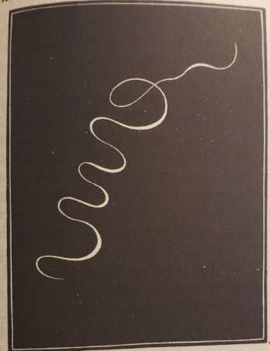

The loop picture makes it true in the story that he waved his stick in the manner depicted, providing a detail that we would not have had otherwise because there is no verbal description of how he moves his stick. So sometimes, visual accompaniment in prose fiction goes beyond merely illustrating some pre-established fact. More generative work can be done by images in a novel, including creating new fictional facts of the matter. Pictures or visual features that accompany texts can be direct, and unique, sources of fictional content. Wartenburg writes that it is impossible to determine what a comic’s story world is like without referring to both text and image (2012, 101), but notice how the same can be said for the story world created by Tristram Shandy. Full knowledge of what the world is like, including how a character waved his cane, is unavailable without appeal to both text and image.
Beyond depictive images, we can look at picture-like aspects of the text to see how they enable picture-reading. For example, in Louis Aragon’s Paris Peasant, the fact that someone had yelled the protagonist’s name is conveyed visually by changes in typographical features. It happens while the protagonist, Louis, is observing a bath house:

In any case, I have sniffed out the real purpose of this basement: it is a
laboratory devoted to calorimetry. The male and female attendants, who are,
in fact, a couple of distinguished physicians in disguise, soak the volunteers
in their calorimeters and then lose themselves in fascinating calculations
about the dissipation of energy. They hope, one fine day, to take Carnet’s
principles by surprise. Meanwhile, he stands gaping, while she reads detective
stories.
LOUIS !
I’m coming out, I’m coming out: now who can that be calling me?
The crowd is still strolling to and fro outside. No one I know… (58).
This passage shows a simple way in which the visual arrangements of a word can convey, first, that the word was uttered, and second, how the word was uttered. Text size indicates the volume in which the voice is heard; the visual feature of the text contributes to the fictional truth that there is variation in loudness. Though it’s the imagistic or formal feature of the text doing the work here, there’s a text-first feel in the sense that font size modifies the effect of the lexical meaning of the text, adding or further specifying what the utterance was like. Still, typography is a kind of graphic design insofar as it requires thoughtful deliberation over the imagistic or formal elements of the text (Holbo 2012).
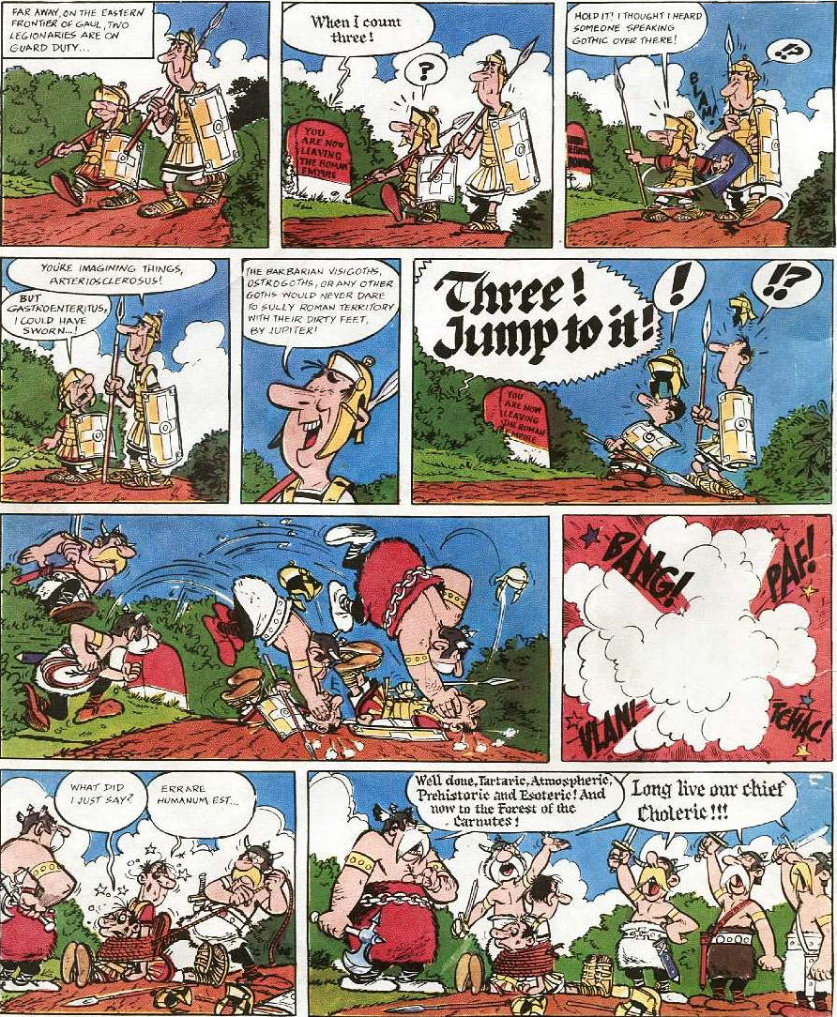
Just as text size can indicate utterance volume in prose fiction, type face variation can indicate the fact that different languages are spoken. See, for instance, the following from the French comic Asterix:

On this page, we see a pair of Lain-speaking guards getting ambushed by Gothic-speaking invaders—and since the text is in a different third language (originally French, but here translated into English), the fact that different languages are spoken by different groups of people is shown through typography, the neater, sans-serif font indicating Latin and the clunkier old-school serif font indicating Gothic.
How do we know whether we’re interpreting the visual features correctly? This is a good and complicated question, but we can begin to answer this by appealing to local conventions. The kind of convention that is involved must be local in nature because formal features like italics can serve many different kinds of functions (e.g., conveying inner mode of thought or indexing an event to the past) depending on the work and context. So instead of looking to apply a more universal convention, the reader must deduce what the genre-specific or work-specific conventions are when it comes to formal features. Intention recognition can also help. When we see a surprising variation in the visual presentation of the text, we might ask what the author might have meant to convey with the variation. A way of communicating that doesn’t seem as “orderly” or “plain” is in violation of Grice’s Manner maxim, for example, and recognizing the violation can be the first step in understanding the role played by formal features.

  - Picture-reading in poetry
Cowling and Cray rightfully say that simply stapling a poem onto a portrait doesn’t give us a comic (2022, 33). Holbo (2012) writes that emblem poems, too, don’t quite count as comics even though they feature images and explanatory text side-by-side. The Intentional Picture-Reading view, which asks whether a work is aptly intended to be picture-read, might not render them comics since the stapled product doesn’t quite feature text and image as an aesthetically unified work, and text take priority in emblem literature, accompanying pictures being interchangeable or absent (Lyons 2011). However, concrete poetry where texts form an image, or poetry where visual features play some other prominent role, seems to pass the intentional picture-reading test since properly engaging with them involves recognizing the interplay of text and image, and their creators likely created them to be engaged with in such a manner.
People unfamiliar with comics express puzzlement or confusion about how to “read them properly,” and this shows us that the practice of reading comics is sufficiently different from reading novels (Cowling and Cray 2022, 56). Readers show puzzlement and even hesitance when it comes to reading poems “properly,” too. I think this has to do with the fact that when reading poems, we’re invited, and even expected, to pay attention to features that go beyond the lexical meaning of the texts involved. For example, an adequate reader of poetry must know how to attend to the visual (and sonic) features of the poem. Just as one must learn how to read poems by gaining sensitivity for meter, rhyme, and enjambment, one must also learn how to read comics by gaining sensitivity to panel layout, closure, and other means of “quasi-compositional interplay between text and image” (Cowling and Cray 2022, 57).
Sometimes, a poem’s imagistic feature doesn’t generate any fictional content. The visual element might be more of an accompaniment to the text like an illustration in a novel. Here’s an example from 1633 titled “Easter Wings” from George Herbert:
Lord, who createdst man in wealth and store,
Though foolishly he lost the same,
Decaying more and more,
Till he became
Most poore:
With thee
O let me rise
As larks, harmoniously,
And sing this day thy victories:
Then shall the fall further the flight in me.

My tender age in sorrow did beginne
And still with sicknesses and shame.
Thou didst so punish sinne,
That I became
Most thinne.
With thee
Let me combine,
And feel thy victorie:
For, if I imp my wing on thine,
Affliction shall advance the flight in me.
Though we might see aesthetic merit in the congruity between the text and layout (e.g., “most poore” occurs at the smallest portion of the wing, and lines talking about ‘losing’ or ‘decaying’ continue to decrease in size), there’s no fictional truth that is generated through the wing-like structure. It would be inappropriate to conclude that there are two pairs of wings in the fictional world of the poem due to the visual layout.
Here’s another example from e.e. cummings (1958):
l(a
le
af
fa
ll
s)
one
l
iness
In this poem, a descriptive statement (“a leaf falls”) is embedded within a word (“loneliness”), and the vertical orientation of the text, as well as the textual sparseness, complement the mood set by the overarching word. However, this isn’t to say that the shape of the poem generates the fictional truth that there is a leaf falling. Poems can feature shapes without (necessarily) generating any new fictional content.
But like in the prose fiction case, formal features can and do sometimes create fictional truths in poems. For example, a portion of Bao Phi’s “Kids” makes use of white space to generate a fictional truth that we would not have gotten without it. The speaker is an Asian-American man with hopes and fears for his daughter, and towards the end we find:

How much energy will I spend trying to defend her against men not at all like me
and exactly like me

Here, the conspicuous space in the middle of the sentence is significant because it conveys the speaker mentally processing—and coming to doubt—what he had just thought. The space injects emotional conflict. The resulting tone, and the new fictional truth regarding the speaker’s mental and emotional states, would not have been generated without the space.
Across text-image hybrid media, some images will be there solely for aesthetic effects or thematic punctuation (i.e., fails to generate new fictional truths), while other images will be crucial in creating fictional truths that could not have been gotten otherwise. Concrete poetry’s shape that does not generate distinct fictional content, like in the cummings example, might be analogous to the background texts in the following example from Cowling and Cray (2022):
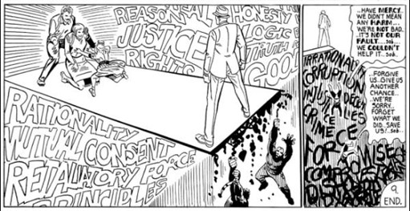
This page from Mr.A doesn’t state, but suggests, the ways in which we might label two groups of people or states of affairs. The stylized texts here are good examples where text-images are used to suggest a theme or set the tone, and not to generate some fictional truth.

- Revisiting Equal Priority View and Picture Reading
Holbo describes the Sistine chapel in rather comic-esque fashion– “panels, separated by gutters, populated by persons of human and superhuman nature… eye is invited to take in the whole page while the panels narrate an origin story” (2012, 6) – to argue that any formal or functional analysis of comics will tend towards expansive revisionism. Though my examples are perhaps less surprising, I agree with Holbo that it’s eye-opening to observe how things that aren’t classified as comics work like comics.
The examples from prose and poetry are significant for two reasons. First, it shows that picture reading is too broad a function to try to define comics with. Recall that on the Intentional Picture-Reading View, comics are distinguished from other image-text hybrid media by the fact that their creator “aptly intended them to be regarded with a certain kind of attention,” namely, picture-reading (Cowling and Cray 2022, 59). Having gone through several unsuccessful attempts to define comics by formal means, Cowling and Cray take it as an advantage that this view is fully functional: “when it comes to the job of explaining why something is a comic,” they write, “its function, effects, or sociocultural role seem to provide a better explanation of its status than highly specific formal features” (62). But the problem is that we have ready examples where novelists and poets also create works whose function, effects, or sociocultural role revolve around picture-reading. The Intentional Picture-Reading View doesn’t adequately define comics because it extends to hybrid works that we don’t consider comics.
However, I don’t think all is lost with picture-reading. If we were to maintain the view, we just need to be more specific about what’s unique to comics and spell out attention-directing mechanisms that are standard in comics. We might distinguish a more general sense of picture-reading (attention to both pictorial and textual features) from the narrower picture-reading that incorporate more medium-specific tendencies. Another way to think about the distinction is to think about the universal activity of pictorial story telling apart from the more historically specific activity of picture-reading (Cowling and Cray 2022, 60). I’ll take this task up in the next section and argue that what sets comics apart from other hybrid media are local conventions such as panels, speech bubbles, and speed lines.
I promised two upshots of the prose and poetry examples. The second is that now we have a reason to revisit, and even favor, the Equal Priority View since the view does a better job than the Intentional Picture-Reading View in handling the examples. As a brief reminder, the Equal-Priority View from Wartenburg (2012) argues that comics can be defined by the equal priority texts and images enjoy in determining the work’s content. The view isn’t challenged by the examples since formally ambitious prose and poetry don’t feature images and texts that have equal priority in determining content. Text still takes priority in that it does most of the work, and most of the work is composed of text. The examples lack images that take up equal priority, so the equal priority view can rightfully exclude formally ambitious novels and poems from the comics category.
Cowling and Cray (2022) had given independent reasons to doubt the Equal Priority View. They consider it extensionally inadequate since it leaves out non-narrative comics (e.g., abstract comics) and silent comics (i.e., comics without text). But I don’t think abstract comics and silent comics are necessarily challenges to the Equal Priority view. Wartenberg’s claim isn’t that both text and image have to equally determine content, but that one isn’t beholden to the other as a check on accuracy or appropriateness. He acknowledges that image and text are generally present in comics—which leaves open that comics can lack text or image—and the equal priority claim stipulates that neither text nor image serve as an “independent constraint upon the other” (2012, 87-8). In silent comics, images are still free from text’s constraint since it isn’t meant to be an illustration of content that is already fixed by the text. The absence of text can be one way the text doesn’t act as a constraint. In this sense, even silent comics might be said to exhibit equal priority relations between image and text.
As for abstract comics, a sufficiently broad understanding of “narrative world” might alleviate the worry. Abstract comics seems to challenge the Equal Priority View since text and image are meant to be equally authoritative in constructing the narrative world—and if there is no narrative world conveyed by the comics (because there is no ‘story’ being told), then neither text nor image nor the combination of the two can have priority in determining what the fictional world is like. But perhaps we can take the “narrative world” more generally here to mean something like “work content” and not “story world.” Abstract comics may not tell a fictional story or communicate a nonfictional experience, but it can depict states of affairs or otherwise create content that is attributed to the work. For example, Cowling and Cray (2022, 43) provide “I was Just” as an example of a comic that doesn’t convey a story and thereby fails to generate a bona fide story-world:
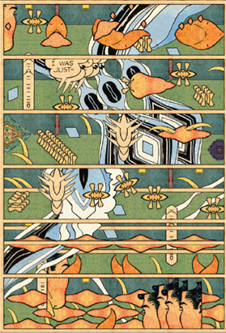
But reading with a broader notion of “work content” shows that the above page from “I was Just” manages to generate fictional content just fine. Recurring images and their changing placements give us a sense of what kinds of objects are in this fictional world and how they’re moving. We even get an utterance! Of course, “I was Just” doesn’t construct a narrative world in the way more standard comics do, but if we were already willing to jettison narrative as a necessary criterion for comics, then abstract comics can be seen as an instance where image and text enjoy equal priority in determining what content is generated.
In addition to the Equal Priority View, another promising attempt to define comics might be to fix it foremost as a visual medium and to require verbal contribution. Holbo takes McCloud’s definition to pick out not comics, but the broader category “the graphical work” (2012, 24). Harvey (2005, 19) argues that comics are a subset of static pictorial narratives, one that is unique among the broader category given the incorporation of verbal content. Approaches like these that try to define comics by beginning with, or requiring, pictorial elements can resist the prose and poetry examples since they tend not to be graphical works.
I’ve shown that Equal Priority view or visual-medium-first-approaches might handle the prose and poetry cases better than the Intentional Picture-Reading View since these examples all feature text taking priority. But only pursuing these avenues, as mentioned, leave open how text and image come together in a comic. So, a theory of picture-reading is still needed. In the next section, I’ll discuss how picture-reading is a capacity to show sensitivity to features that direct our attention, and how being more specific about the features might give us a way to systematically distinguish comics among other hybrid media.

- Towards Medium-Specific Picture-Readings
Picture-reading is something we do with novels, poems, comics and more, and it’s done on a spectrum. In some contexts, texts take priority in dictating what’s fictionally true and pictures serve supplementary roles (like in a novel or a poem); in other contexts, pictures do the bulk, if not all, of the work in establishing what is true (like in comics with sparse or no text). Since creators of each of these media intend their works to be picture-read, the general or broad notion of picture-reading won’t give us what’s unique about comics. We must provide more medium-specific details about picture-reading if we wish to use the function or attentional invitation to define comics apart from other hybrid media.
My suggestion is to focus on non-depictive images or forms of each medium. These are conventional features that direct our attention, and these can determine the boundary among prose, poetry, and comics. Because conventions develop and change, paying attention to conventional features will bring with it sensitivity to the history of the medium. History would be relevant not as an extrinsic, imperceptible feature, but as a feature that develops alongside a medium’s conventions (Meskin 2007, 52). This way of understanding and incorporating history is better than priorizing history as an important feature per se since the latter approach leaves out other similar objects like manga. Tracing the evolution of a medium’s non-depictive images is a way to track the history of what features of a medium were standard, contra-standard, and variable.
Each of the media and examples we looked at have both depictive and non-depictive images. When an image is meant to show us what something looks like in the fictional world, it is depictive. An image of a character is depictive since what we see shows us what a character looks like in the fictional world. When an image doesn’t aim to depict something in the world—for instance, because it isn’t meant to be a part of the fictional world—it is non-depictive. Speech bubbles are non-depictive in this sense since they are not meant to convey that there are floating shapes above characters’ heads in the fictional world. Usually these features are “invisible,” and we tend not to pick them out as objects worthy of special attention (Duncan and Smith, 119). Non-depictive images are attention-directing, setting up the default form against which deviations are meaningful. Non-depictive pictures might also be thought of as directive pictures, images meant to show us how to do things (Lopes 2004). Their function isn’t to describe anything, but to guide our mental actions.
In prose fiction and poetry, non-depictive “images” or forms include page formatting, line spacing, justification, chapter or stanza divisions, and the standard typeface that the text is set in. Though they are visual, these features don’t show or otherwise contribute to what is fictionally true. However, atypical typography that is large, indented, italicized, or of a different style can and do generate distinct fictional content. The spacing in “Kids” and large font in Paris Peasant contribute to the work’s content and specify facts about the world of the fiction. Images or forms that tend to be non-depictive, then, can serve depictive functions where they convey what is fictionally true, not necessarily by showing us what something looks like, but by inviting interpretations that generate new fictional content. And, of course, novels and poems can also have straightforward depictive images too (recall the loop from Tristram Shandy).
Comics, too, utilize images and forms that are non-depictive, and some theorists have considered them significant enough to form necessary and sufficient conditions for something’s being a comic. As frequently noted, speech balloons or thought bubbles in comics are non-depictive since they don’t show (directly) what the fictional world looks like. Rather, they indicate how some other feature—text or image meant to convey the content of utterance or thought—is to be interpreted, and finer details concerning the bubble or balloon’s edge, direction of tail, and color specify further interpretations regarding how the utterance is made and who speaks.
Panels are another paradigmatic non-depictive image in comics. The way panels are laid out on the page tend to control the order in which we scan the page, but sometimes layouts go beyond this basic organizing function when they go from being discreet to ostentatious (Groensteen 2007). A rhetorical layout allows the panels’ arrangements to play a more active role in shaping the narrative (Duncan and Smith 2023, 108ff). Layouts tend to be invisible when they’re conventional, but they can vary as to evoke cultures, genres, or sensations and even generate fictional truths. For example, in Watchmen, the fact that Dr. Manhattan appears in tall panels that fracture the classic nine-panel grid suggests that he transcends humanity and has a large ego. Given all their different shape, size, and relationships to image and text, panels might be best understood functionally, as “the things that we, as readers, are intended to pay primary sequential attention to” (Cowling and Cray 2022, 36). This understanding of panels makes them an essential feature of comics.
Given that prose fictions, poetry, and comics tend to have their own sets of non-depictive forms, my suggestion is to begin to separate the various image-text hybrid media by appealing the default non-depictive forms that direct our attention while we’re engaging with them. The fact that readers need to know the conventions surrounding non-depictive images to grasp their effect suggests that picture-reading is not to be defined psychologically (what’s going on at the neurological level?) but socioculturally (what activities are taken to constitute the practice of picture-reading?) (Cray and Cowling 2022). It is unintuitive, but learnable, that enjambment ought not to introduce a break in the sentence when a poem is read out loud even if there is a visual break in the sentence. It is also not immediately obvious, but learnable, that a straight-edged bubble indicates a spoken utterance while a cloud-like bubble indicates a thought. An important part of being a competent picture-reader is knowing how to follow non-depictive images’ directions, and we ought to draw the distinction among prose, poetry, and comics along the lines of standard non-depictive images that are utilized in paradigmatic works.
My suggestion shows that the Library of Congress’s definition is surprisingly robust. They define comics and cartoons as “entities consisting primarily of one or more distinct illustrations (panels), which tell a story or convey an (often humorous) situation, often with the aid of text captions and/or dialogue balloons.” The definition rightfully focuses on key non-depictive images such as panels, text captions, and balloons. Other theorists, such as Abbott (1986) and Carrier (2000) who put forward the panel or the speech balloon as necessary conditions for being a comic, could be given more credit. Of course, there are examples of comics that don’t feature these non-depictive images, but it remains the case that the standard comic will have them, and that the standard prose and poetry will not have them. Even if concrete poetry, for example, is intended to be picture-read, they’re unlikely to incorporate panels or speech bubbles. What links concrete poetry to comics is the weaker “reflect on the imagistic form and its role in appreciation,” which is loose enough to be applied to nearly all (hybrid) works requiring interpretation. The medium-specific picture-reading approach allows us to categorize works in ways we find intuitive and consistent with practice.

References
Abbott, Lawrence. 1986. “Comic Art: Characteristics and Potentialities of a Narrative Medium.” Journal of Popular Culture 19 (4): 155–76.
Aragon, Louis. 1994. Paris Peasant. Translated by Simon Watson Taylor. Cambridge: Exact Change.
Carrier, David. 2000. The Aesthetics of Comics. University Park: Penn State University Press.
Cook, Roy T. 2011. “Do Comics Require Pictures? Or Why Batman #663 Is a Comic.” Journal of Aesthetics and Art Criticism 69 (3): 285–96.
Cowling, Sam and Wesley D. Cray. 2022. Philosophy of Comics: An Introduction. New York: Bloomsbury.
cummings, e.e. 1958. "Leaf" in 95 Poems. New York: Liveright.
Duncan, Randy, Matthew J. Smith, and Paul Levitz. 2023. The Power of Comics and Graphic Novels. New York: Bloomsbury.
Goscinny, René. 1961. Asterix and the Goths. London: Hodder & Stoughton.
Groensteen, Thierry. 2007. The System of Comics. Translated by Bart Beaty and Nick Nguyen. Jackson: University Press of Mississippi.
Harvey, R. C. 2005. “Describing and Discarding ‘Comics’ as an Impotent Act of Philosophical Rigor.” In Comics as Philosophy, edited by Jeff McLaughlin, 14–26. Jackson: University Press of Mississippi.
Herbert, George. 1633. "Easter Wings" In The Temple.
Holbo, John. 2012. “Redefining Comics.” In The Art of Comics: A Philosophical Approach, edited by Aaron Meskin and Roy T. Cook, 3–30. London: Wiley- Blackwell.
Kim, Hannah H. 2022. “A New Class of Fictional Truths.” The Philosophical Quarterly 72 (1): 90–107.
---. Draft. “Against Using Gricean Pragmatics for Fictional Truth”.
Kunzle, David. 1973. The Early Comic Strip: Narrative Strips and Picture Stories in the European Broadsheet from c. 1450 to 1825. Berkeley: University of California Press.
Lamarque, Peter and Stein Haugom Olsen. 1994. Truth, Fiction, and Literature: A Philosophical Perspective. Oxford: Oxford University Press.
Lopes, Dominic. 2004. “Directive Pictures.” The Journal of Aesthetics and Art Criticism 62 (2): 189–196.
Lyons, Martyn. 2011. Books: A Living History. Los Angeles: The J. Paul Getty Museum.
McCloud, Scott. 1993. Understanding Comics: The Invisible Art. New York: Harper Collins.
Meskin, Aaron. 2007. “Defining Comics?” Journal of Aesthetics and Art Criticism 65 (4): 369–79.
Meskin, Aaron. 2016. “Defining Comics.” In The Routledge Companion to Comics, edited by Frank Bramlett, Roy T. Cook and Aaron Meskin, 221–9. London: Routledge.
Phi, Bao. 2017. “Kids.” In Thousand Star Hotel, 16. Minneapolis: Coffee House Press.
Prince, Gerald. 1982. Narratology: The Form and Functioning of Narrative. The Hague: LC Perelman.
Smith, Matthew and Randy Duncan. 2009. The Power of Comics: History, Form, and Culture. London: Bloomsbury.
Sterne, Laurence. 1929. The Life and Opinions of Tristram Shandy, Gentleman. London: Everyman’s Library.
Walton, Kendall. 1970. “Categories of Art.” Philosophical Review 79 (3): 334–67.
Wartenberg, Thomas. 2012. “Wordy Pictures: Theorizing the Relationship between Image and Text in Comics.” In The Art of Comics: A Philosophical Approach, edited by Aaron Meskin and Roy T. Cook, 87–104. London: Wiley-Blackwell.
Wertham, Fredric. 1954. The Seduction of the Innocent. New York: Rinehart and Company.

Literary scholars argue that a story must represent two or more events in a time sequence; see Prince 1982, p. 4 and Lamarque and Olsen 1994, p. 225.
See Meskin 2007, 2016 and Cowling and Cray 2022 for a more in-depth overview of previous attempts to define comics.
See Kim 2022 section 4 for a discussion of what it takes for something to be a formal feature.
Though I have reservations about using Gricean pragmatics to determine fictional truth in general. See Kim (draft).
Thanks to Monte Ebbesen for the example.
Thanks to Kyle Kirby for help in preparing the manuscript for submission.
Thanks to Sam Cowling for this point.

