Exploring Arbitrariness Objections to Time-Biases

Word count: 9676

None of the authors have any conflicts of competing interests that might impact the content of this paper.

Abstract

There are two kinds of time-bias: near-bias and future-bias. While philosophers typically hold that near-bias is rationally impermissible, many hold that future-bias is rationally permissible. Call this normative hybridism. According to arbitrariness objections, certain patterns of preference are rationally impermissible because they are arbitrary. While arbitrariness objections have been levelled against both near-bias and future-bias, the kind of arbitrariness in question has been different. In this paper we investigate whether there are forms of arbitrariness that are common to both kinds of preferences, and hence whether there are versions of the arbitrariness objection that are objections both to near-bias and future-bias. If there are, then this might go some way towards undermining normative hybridism and to defending a thorough-going time-neutralism.

1. Introduction

We mortals have time-biases. A person is biased towards the future (i.e., “future-biased”) when, all else being equal, they prefer positively valanced events to be future rather than past, or negatively valanced events to be past rather than future. Imagine waking up in a hospital bed, dazed and amnesic, knowing only that one of the following two conditions obtains: you are about to have a painful operation, or you have just had an equally painful operation. Research shows you probably prefer the operation to be past. In fact, you probably still prefer the past operation even if it is much more painful than the future one (Lee, Hoerl, Burns, Fernandes, O’Connor & McCormack 2020; Greene, Latham, Miller and Norton 2021b).

On the other hand, a person is biased towards the near (i.e., “near-biased”) when, all else being equal, they prefer positive events to be near rather than distant, or negative events to be distant rather than near. Suppose you are offered some dessert you like, which you can either eat now or tomorrow. If, all else being equal, you prefer to eat it now, you are near-biased.

In each case the “all else being equal” qualification is important. Suppose you prefer to eat the dessert now because (say) you happen to be very hungry now and you do not expect yourself to be equally hungry tomorrow, or because you are worried that the dessert might go bad tomorrow: then you are merely apparently near-biased. Likewise, if you prefer the past operation because (say) you believe the sooner the operation is done, the likelier your illness will be cured, then you are merely apparently future-biased. On the contrary, you are genuinely future/near-biased only when your preferences are sensitive to the temporal locations of the events themselves, as opposed to variations in uncertainty, intrinsic values, etc., which result from variations in temporal locations. In what follows, we will focus on genuine time-biases and hence drop the “genuine” locution except where qualification is necessary. (However, In Section 4, we will question whether our experiments, though intended to uncover our patterns of genuine time-biases, in fact track merely apparent time-biases.)

Time-biases come in various strengths. It is helpful to think of both near-bias and future-bias as forms of discounting subjective (expected) utility along the temporal dimension, as it unites situations of “equal payoff” and “unequal payoff” (prior to discounting) into one model. The aforementioned case of past or future operations, the two of which are equally painful, is one of equal payoff; whereas an alternative version of the case, in which the past operation is more painful than the future one, is one of unequal payoff. If I am only slightly future-biased towards surgical pain, I might prefer the past operation in the original case but not in the alternative version; but if I am strongly future-biased, or even absolutely future-biased (if I do not regard past pain as of any value at all), then I might well prefer the past operation in both scenarios.

Studies in psychology, behavioural economics, and philosophy have found considerable intrapersonal and interpersonal variation in the presence or absence of future- and near-bias, as well as their strengths. Notably, for the present purposes, both future- and near-bias have been shown to be sensitive to the type of goods/events in question, and future-bias has been shown to be sensitive to the valence (positive or negative) of the goods/events in question.

At least some of this variation has been fodder for philosophical arguments regarding the normative status of these time-biases. We will call arguments that appeal to factors such as these arbitrariness arguments. These arguments seek to show that the preferences in question are arbitrary, and hence rationally impermissible. These kinds of arguments can be distinguished from what we might call upshot arguments, which seek to show that the preferences are ones that can make agents worse off in some way.

There is, of course, a perfectly general arbitrariness argument against both near-bias and future-bias: namely that it is arbitrary to discount the expected utility of some person-stage simply in virtue of where in time that stage is located. Temporal location, one might think, is not normatively significant, and hence any such discounting is arbitrary. Arguments of this kind against near-bias can be traced back at least as far as Sidgwick (1884) and have been taken up by many authors. Imagine someone who is otherwise normal but is indifferent to pleasures or pains on future Tuesdays, while knowing perfectly well that there is nothing special about Tuesdays (Parfit 1984: 124). It seems that this preference is groundless, arbitrary, and hence irrational. Near-bias, in virtue of giving more weight to temporal locations that are merely closer, seems arbitrary in much the same way.

While arguments of this kind have been persuasive when it comes to near-bias, they have been much less persuasive in the case of future-bias. That is because many philosophers have thought that there is some important asymmetry between past and future which means that future-biased preferences are not arbitrary at all. So, while near-bias is not rationally permissible, future-bias is rationally permissible or even obligatory. We call this view normative hybridism.

This orthodoxy has recently been challenged by time-neutralists who argue that future-biased preferences are arbitrary. These authors seek to locate the source of the arbitrariness not simply in the fact that the preferences are sensitive to temporal location (past vs future), but rather in other features of those preferences. Interestingly, though, although some research suggests that there is a connection between near-bias and future-bias, there has been no attempt to see whether there might be a common sort of arbitrariness to both preferences. In this paper we aim to determine whether this is so. In section 2 we discuss current relevant research, before in section 3 outlining our methodology and results. In section 4 we discuss the implications of these results for arbitrariness objections to near- and future-bias, and, in turn, the implications for arguments against normative hybridism.

2. Near-bias and Future-bias

It has long been observed that near-bias does not have a uniform pattern; rather, the discount rates for different types of goods/events vary considerably, both interpersonally and intrapersonally. This variation in preferences might easily lead one to suppose that they are arbitrary. Interestingly, though, philosophers have rarely argued against the rational permissibility of near-bias by citing the wide variation in discounting rates across goods (perhaps because they take it that such arguments are redundant).
By contrast, appeals to arbitrariness of this kind have been pursued when it comes to evaluating the normative status of future-bias. For instance, time-neutralists have argued that future-biased preferences are arbitrary insofar as people only show those preferences in a limited range of cases. In particular, it has been thought that people are only future-biased when it comes to hedonic events and not non-hedonic ones (Brink 2011, Greene and Sullivan 2015: 96, and Dougherty 2015: 3) and have those preferences only in first-person conditions and not in third-person conditions (Parfit 1984: 181, Greene and Sullivan 2015: 968, and Dougherty 2015: 3). Time-neutralists have argued that these patterns of preferences are arbitrary (Brink 2011: 378–9, Greene and Sullivan 2015: 968, and Dougherty 2015: 3). Unfortunately for time-neutralists, however, not all of these predictions have been borne out by empirical investigation. Recent empirical work has failed to find any asymmetry between first and third-person preferences (Greene et al 2021a) or between hedonic and non-hedonic preferences (Greene et al 2021a).

Nevertheless, that research has suggested that time-neutralists might appeal to other sources of arbitrariness. Greene, Latham, Miller and Norton (2021b, forthcoming) recently found that people are sensitive to the valence of events: they are more future-biased when it comes to negative events than positive ones. Call this the valence factor. We also know that when it comes to near-bias, people are sensitive to the kind of good/event in question. Call this the event factor.

Since there is some recent evidence of an association between near-bias and future-bias, it might be that both kinds of preference are sensitive to either the valence factor or the event factor. Suppose they are. Then the case may be made that rational preferences would not be sensitive to these factors. If so, a single arbitrariness argument could be levelled against the rationality of both near- and future-bias, thus going some way towards undermining normative hybridism. This paper aims to empirically investigate whether this is so.

Given prior research in this area, we had three very broad hypotheses. The first is that people’s near-biased and future-biased preferences will be sensitive to the event factor. Since there are many ways in which events can vary, we focussed on two dimensions of variation. First, we focussed on the distinction between sensations and moods. Second, we focussed on the distinction between kinds of sensations. Our first experiment tests the kind of hedonic event hypothesis. According to this hypothesis, both near- and future-biased preferences are sensitive to whether the hedonic event in question is a sensation or a mood. Our second experiment tests the kind of sensation hypothesis. According to this hypothesis, both near- and future-biased preferences are sensitive to the kind of sensation (touch, taste, smell, sight).

Our second broad hypothesis is that people’s near-biased and future-biased preferences will be sensitive to the valence factor. There are various ways in which people’s preferences might be sensitive to valence. Given that previous research shows that people are more future-biased when it comes to negative than to positive events (Greene et al 2021b, forthcoming) we tested the negative valence hypothesis, according to which people will be more future-biased and more near-biased with regard to negative events than positive ones. Both our first and second experiments test the negative valence hypothesis.

Our third broad hypothesis made based on prior research by Latham, Miller, and Norton (ms) is that we would find an association between future-biased and near-biased preferences.

Thus, we made the following specific predictions.

H1: [Experiment 1] There will be differences in future-bias across different hedonic events of sensation and mood (kind of hedonic event hypothesis).
H2: [Experiment 1] There will be differences in near-bias across different hedonic events of sensation and mood (kind of hedonic event hypothesis).
H3: [Experiment 2] There will be differences in future-bias across different kinds of sensation (kind of sensation hypothesis).
H4: [Experiment 2] There will be differences in near-bias across different kinds of sensation (kind of sensation hypothesis).

H5: [Experiments 1 and 2] There will be an association between future-biased and near-biased preferences (association hypothesis).
H6: [Experiments 1 and 2] People will be more future-biased about negative events than positive ones (negative valence hypothesis).
H7: [Experiments 1 and 2] People will be more near-biased about negative events than positive ones (negative valence hypothesis).

3. Methodology and Results

3.1 Experiment 1 Methodology
3.1.1 Participants
583 people participated in the study. Participants were U.S. residents, recruited and tested online using Amazon Mechanical Turk, and compensated $1 for their time. MTurk participants had a HIT (task) approval rate of at least 95% and had their HITs (tasks) approved at least 1000 times. 342 participants were excluded for failing to either to follow instructions or correctly answer all the attentional check and comprehension questions. The remaining sample was composed of 241 participants (103 female; 4 trans/non-binary; mean age 41.97 (SD = 12.25; range 21-75)). Ethics approval for these studies was obtained from the [blanked] Human Research Ethics Committee. Informed consent was obtained from all participants prior to testing. The survey was conducted online using Qualtrics.

3.1.2 Materials and Procedure

Participants were randomly assigned to one of four conditions, which include every combination of valence (positive vs negative) and kind of hedonic event (sensation vs mood). Since the positive and negative vignettes differ only minimally, we can present them together:

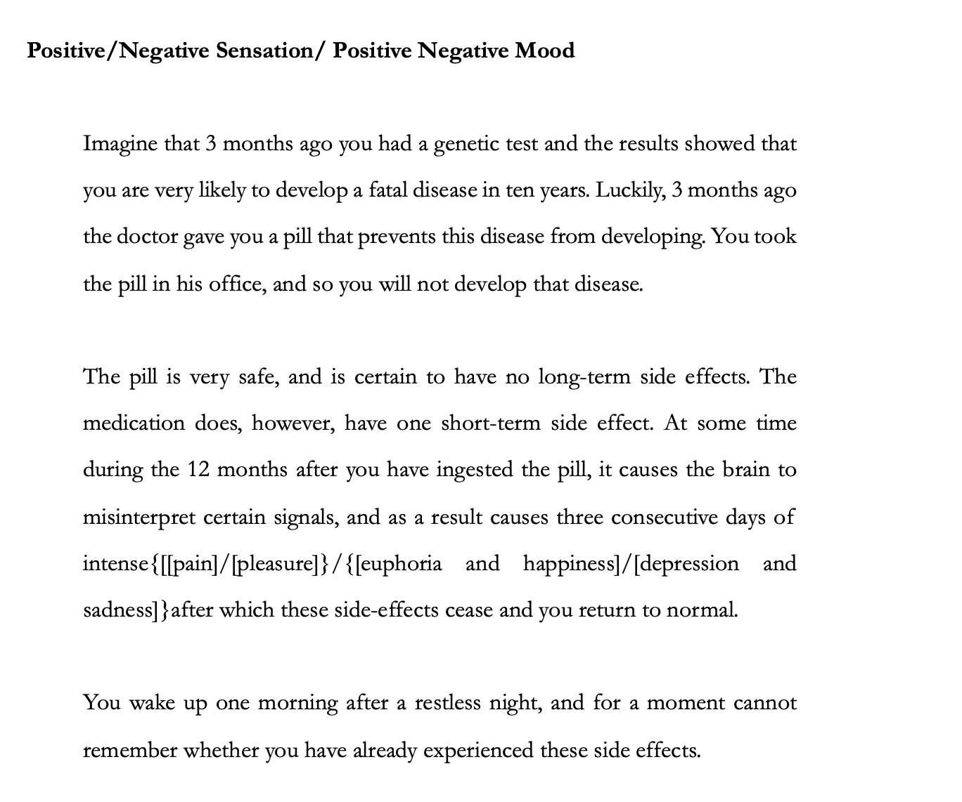

After reading the vignette, participants responded to four comprehension questions and offered a choice of (a) True or (b) False.

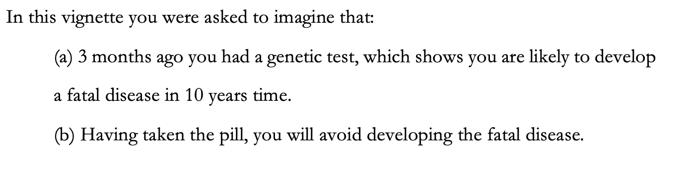
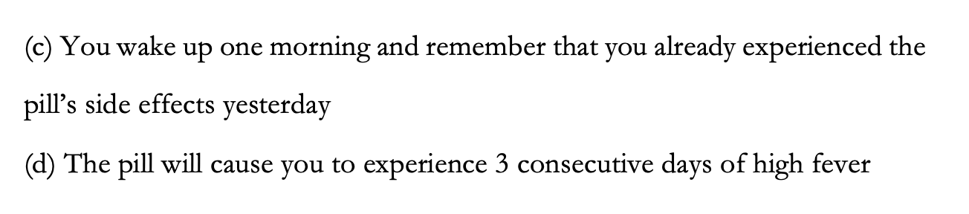

Participants who failed correctly to answer these questions were excluded from the analysis.

Participants then saw two sets of questions, one probing whether, and the extent to which, they have prospective near-biased preferences, and one probing whether, and the extent to which, they have future-biased preferences. The order in which they saw these questions was randomised.
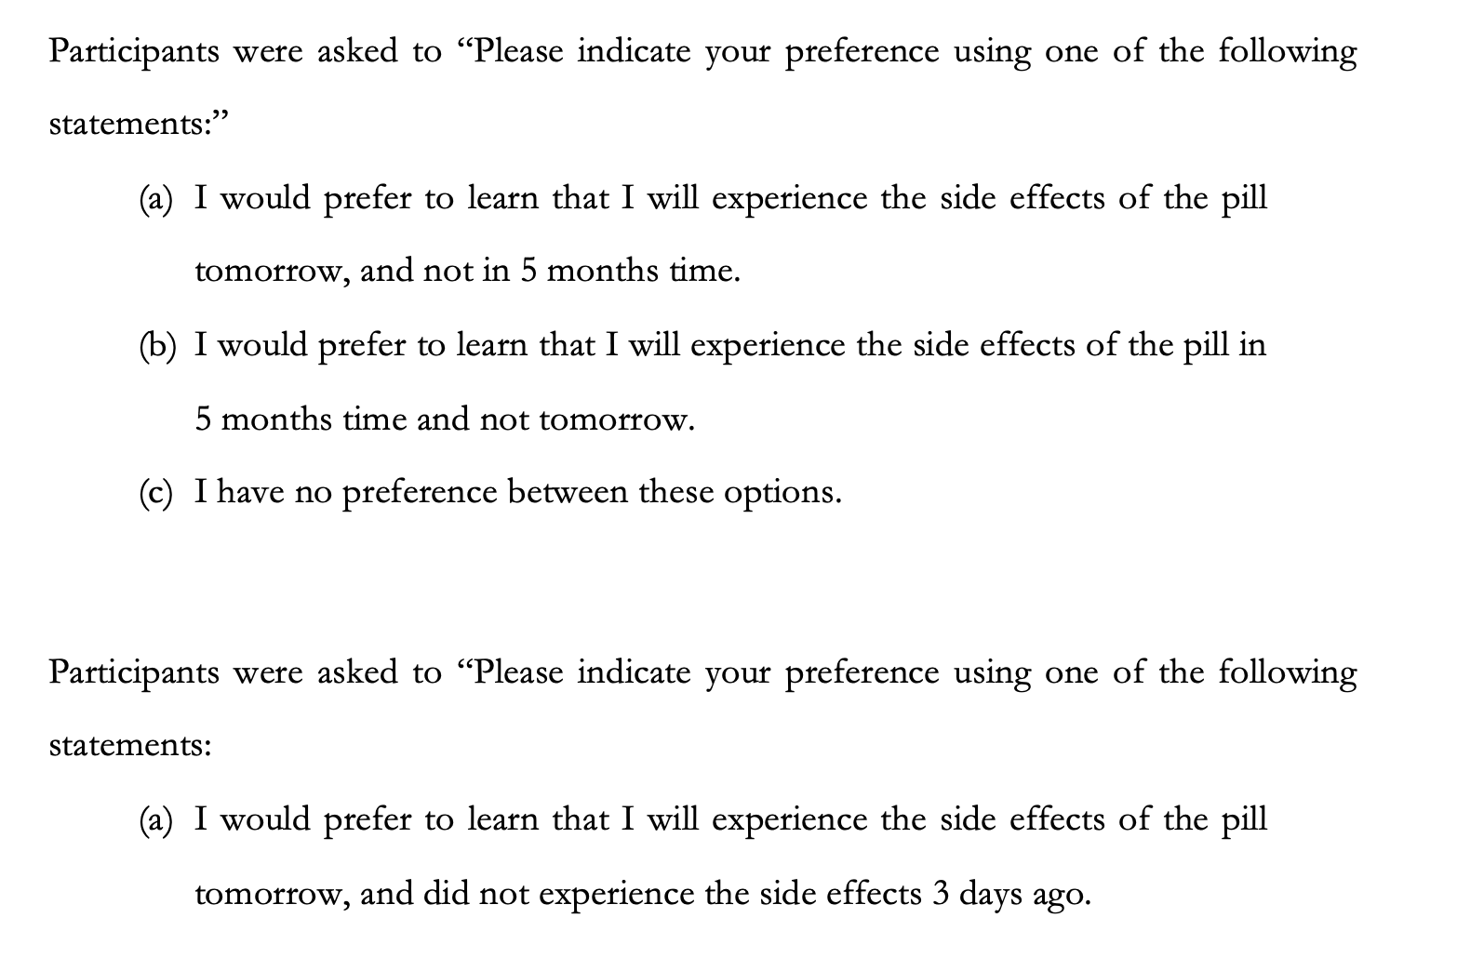

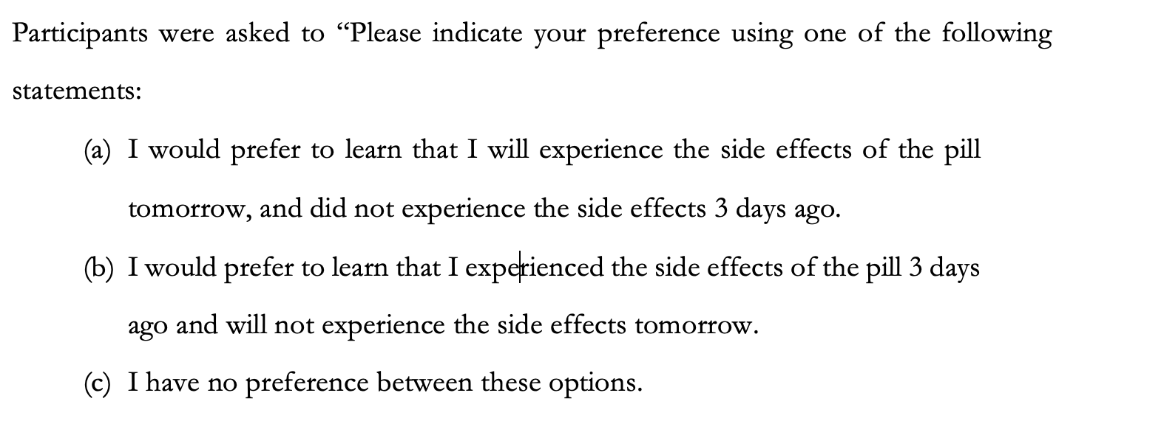

3.2 Experiment 2 Methodology

3.2.2 Participants

1171 people participated in the study. Participants were U.S. residents, recruited and tested online using Amazon Mechanical Turk, and compensated $1 for their time. Again, we used those MTurk participants who have a HIT (task) approval rate of at least 95% and who have had their HITs (tasks) approved at least 1000 times. 668 participants had to be excluded for failing to answer the questions or failed one of the attentional check or comprehension questions. The remaining sample was composed of 503 participants (212 female; 4 trans/non-binary; mean age 41.16 (SD = 11.79; range 19-76)). Ethics approval for these studies was obtained from the [blanked] Human Research Ethics Committee. Informed consent was obtained from all participants prior to testing. The survey was conducted online using Qualtrics.

3.2.2 Materials and Procedure

Participants were randomly assigned to one of eight conditions, which include every combination of valence (positive vs negative) and kind of hedonic event (smell vs taste vs touch vs sight). Since the positive and negative vignettes differ only minimally, we can present them together:

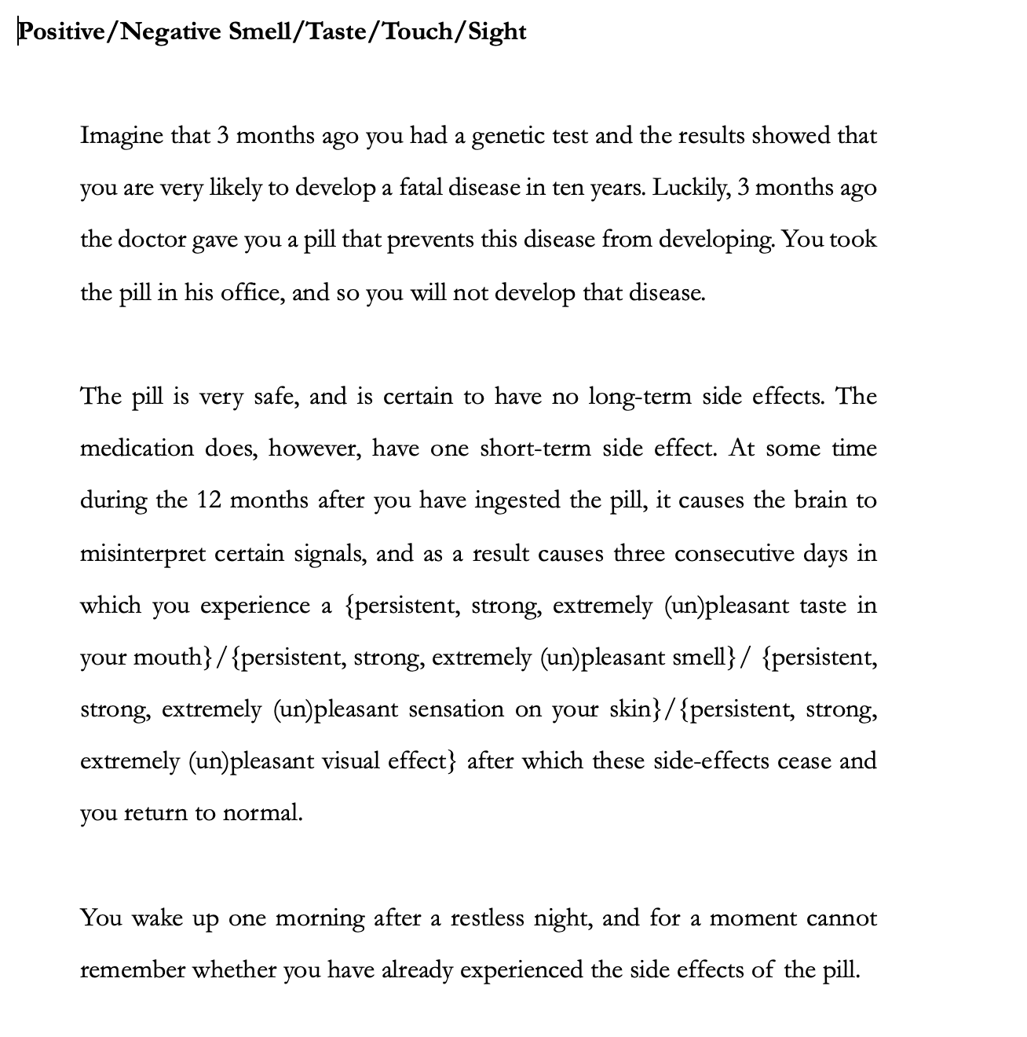

After reading the vignette, participants responded to the same comprehension questions as in experiment 1. Participants who failed correctly to answer these questions were excluded from the analyses.

Participants then saw the same set of two probe questions as they saw in experiment, one probing whether, and the extent to which, they have prospective near-biased preferences, and one probing whether, and the extent to which, they have future-biased preferences.

3.2.3 Results

3.2.3.1 Experiment 1 Results

Before reporting the statistics, we will first summarize our major findings with respect to our hypotheses. First, consider the kind of hedonic event hypothesis, according to which there would be differences in future-bias (H1) and near-bias (H2) across different hedonic events of sensation and mood. Neither hypothesis was supported. We found that people’s future-biased preferences and near-biased preferences were not significantly different across different hedonic event of sensation and mood. Next consider the negative valence hypothesis, according to which people will be more future-biased (H6) and more near-biased (H7) about negative events than positive ones. We found evidence for H6: more people had future-biased preferences when it came to negative events compared to positive ones. In contrast, H7 was not supported. Contrary to what we predicted, we found that when it came to negative events more people had far-biased rather than near-biased preferences. Finally, consider the association hypothesis, (H5) according to which there will be an association between future-biased and near-biased preferences. This hypothesis was not supported. We did not find robust evidence of an association between people’s future-biased and near-biased preferences.

Table 1 below presents descriptive data of participants’ responses regarding their future-biased preferences across all conditions. The ‘FB’ column represents the number of participants who reported future-biased preferences. The ‘PB’ column represents the number of participants who reported past-biased preferences. The ‘NP’ column represents the number of participants who reported a time-neutral preferences.

Table 1. Descriptive data of participants’ responses to the future-biased prompt in Experiment 1.
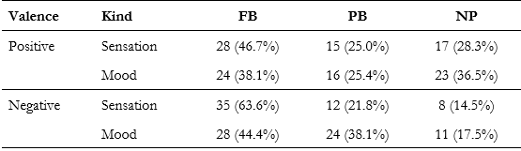

To investigate whether there were any differences in future-biased preferences across the conditions, we ran a chi-squared test of homogeneity. This test showed that there was a significant difference in people’s future-biased preferences across our conditions, 𝜒² (6, N = 241) = 15.281, p = .018.

To identify the source of this effect we ran separate chi-square tests of homogeneity for valence (positive; negative) and kind (sensation; mood). The results of these tests found a significant effect of valence, 𝜒² (2, N = 241) = 8.800, p = .012, and no significant effect of kind, 𝜒² (2, N = 241) = 4.455, p = .108, on people’s future-biased preferences. Post-hoc comparisons with a Bonferroni correction showed that people differed in their future-preferences in negative conditions. Standardized residuals showed that more people reported having a future-biased preference (z = 4.622, p < .001) and fewer people reported having a time-neutral preference (z = -3.971, p < .001) in negative conditions.

Table 2 below summarises the descriptive data of participants’ responses regarding their near-biased preferences across all conditions. The ‘NB’ column represents the number of participants who reported near-biased preferences. The ‘FrB’ column represents the number of participants who reported far-biased preferences. The ‘NP’ column represents the number of participants who reported a time-neutral preference.

Table 2. Descriptive data of participants’ responses to the near-biased prompt in Experiment 1.
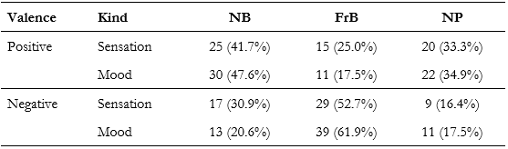

To investigate whether there was any difference of near-biased preferences across the conditions, we ran a chi-square test of homogeneity. The test showed that there was a significant difference in near-biased preferences across our conditions, 𝜒² (6, N = 241) = 36.150, p < .001.

Once again, to identify the source of this effect we ran separate chi-square tests of homogeneity for valence and kind. The results of these tests found a significant effect of valence, 𝜒² (2, N = 241) = 33.836, p < .001, and no significant effect of kind, 𝜒² (2, N = 241) = 0.151, p = .927. Post-hoc comparisons with a Bonferroni correction showed that people differed in their near-biased preferences in both negative and positive conditions. Standardized residuals showed that more people reported having a far-biased preference (z = 5.598, p < .001) and fewer people reported having a time-neutral preference (z = -3.775, p < .001) in negative conditions. In contrast, fewer people reported having a far-biased preference (z = -2.869, p = .004) and more people reported having a near-biased preference in positive conditions (z = 2.678, p = .007).

Finally, we ran a chi-square test of independence to test whether there was an association between people’s future-biased and near-biased preferences. This test revealed that there was a significant association, 𝜒² (4, N = 241) = 162.245, p < .001. However, this significant association disappears if we exclude people that report having a time-neutral preference, 𝜒² (1, N = 172) = 1.781, p = .182. This suggests that the original association is being driven by the fact that people who report having a time-neutral preference to future-biased prompts also tend to report having a time-neutral preference to near-biased prompts.

3.2.3.2 Experiment 2 Results

We will begin by summarizing our major findings with respect to our hypotheses. Consider, first, the kind of sensation hypothesis, according to which there will be differences in future-bias (H3) and near-bias (H4) across different kinds of sensation. Neither H3 nor H4 was supported. We found no evidence that future-biased or near-biased preferences were different across different kinds of sensation. Next, consider the negative valence hypothesis, according to which people will be more future-biased (H6) and more near-biased (H7) about negative events than positive ones. Unlike Experiment 1, we found no evidence in support of H6, that more people have future-biased preferences regarding negative events than positive ones. In contrast, just like Experiment 1, H7 was again not supported, with more people having far-biased preferences than near-biased preferences regarding negative events. Finally, consider the association hypothesis (H5) according to which there will be an association between future-biased and near-biased preferences. Once again, we found no robust evidence of such an association.

Table 3 below presents descriptive data of participants’ responses regarding their future-biased preferences across all conditions in Experiment 2. The ‘FB’ column represents the number of participants who reported future-biased preferences. The ‘PB’ column represents the number of participants who reported past-biased preferences. The ‘NP’ column represents the number of participants who reported time-neutral preferences.

Table 3. Descriptive data of participants’ responses to the future-biased prompt in Experiment 2.
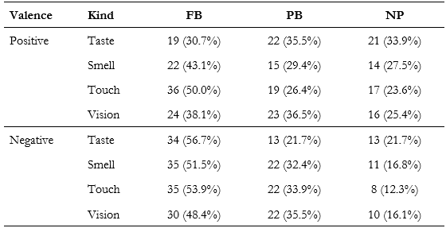

To investigate whether there was any difference in future-biased preferences across the conditions in Experiment 2, we ran a chi-squared test of homogeneity. This test found no evidence that people’s future-biased preferences differed across our conditions, 𝜒² (14, N = 503) = 20.784, p = .107.

Table 4 below summarises the descriptive data of participants’ responses regarding their near-biased preferences across all conditions. The ‘NB’ column represents the number of participants who reported near-biased preferences. The ‘FrB’ column represents the number of participants who reported far-biased preferences. The ‘NP’ column represents the number of participants who reported a time-neutral preference.

Table 4. Descriptive data of participants’ responses to the near-biased prompt in Experiment 2.
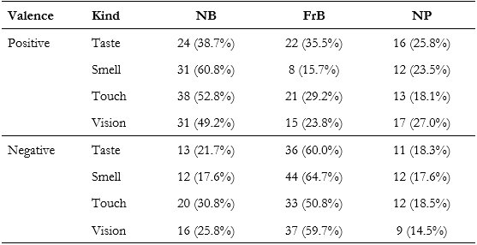

To investigate whether there was any difference of near-biased preferences across the conditions, we ran a chi-square test of homogeneity. The test showed that there was a significant difference in near-biased preferences across our conditions, 𝜒² (14, N = 503) = 67.823, p < .001.

To identify the source of this effect we ran separate chi-square tests of homogeneity for valence and kind. The results of these tests found a significant effect of valence, 𝜒² (2, N = 503) = 55.956, p < .001, and no significant effect of kind, 𝜒² (6, N = 503) = 4.135, p = .658. Post-hoc comparisons with a Bonferroni correction showed that people differed in their near-biased preferences in both negative and positive conditions. Standardized residuals showed that more people reported having a far-biased preference (z = 8.635, p < .001) and less people reported having a near-biased preference (z = -3.188, p = .001) or a time-neutral preference (z = -5.447, p < .001) in negative conditions. In contrast, less people reported having a time-neutral preference (z = -3.323, p = .001) and more people reported having a near-biased preference (z = 5.568, p < .001) in positive conditions.

Finally, we ran a chi-square test of independence to test whether there was an association between people’s future-biased and near-biased preferences. This test revealed that there was a significant association, 𝜒² (4, N = 503) = 190.886, p < .001. However, once again, this significant association disappeared if we exclude people that report having a time-neutral preference, 𝜒² (1, N = 364) = 1.459, p = .227. This suggests that the original association is being driven by the fact that people who report having a time-neutral preference to future-biased prompts also tend to report having a time-neutral preference to near-biased prompts.

4. Discussion

We had three broad hypotheses. First, that people’s future- and near-biased preferences would be sensitive to the event factor. In particular, we tested the kind of hedonic event hypothesis, according to which both near- and future-biased preferences are sensitive to whether the hedonic event in question is a sensation or a mood, and the kind of sensation hypothesis, according to which both near- and future-biased preferences are sensitive to the kind of sensation. Neither hypothesis was supported by our data.

Our second broad hypothesis was that people’s near-biased and future-biased preferences will be sensitive to the valence factor. In particular, we tested the negative valence hypothesis, according to which people will be more future-biased and more near-biased with regard to negative events than positive ones. That hypothesis was vindicated in the case of future-bias (H6) where, in line with previous findings regarding future-bias, (Greene, Latham, Miller and Norton 2021b, Greene, Latham, Miller and Norton 2022), across both experiments we found that future-biased preferences were stronger in the negative valence condition than the positive one. We found the converse when it came to near-biased preferences, where it was far-biased preferences that were stronger in the negative valence condition. This, too, partially replicates previous findings of Latham, Miller, and Norton (ms) who found that people were more near-biased and less far-biased in positive conditions than in negative ones.

Our third broad hypothesis, made based on prior research by Latham, Miller, and Norton (ms), was that we would find an association between future-biased and near-biased preferences. This hypothesis was not supported. We failed to replicate the earlier findings of Latham, Miller and Norton who found a moderate association between future-biased and near-biased preferences in both positive and negative conditions.

These results have implications for two current debates. But before we turn to these, we first want to draw attention to a limitation of the studies we ran. Our vignettes describe positive and negative experiences (sensations and moods in Experiment 1 and four kinds of sensations in Experiment 2) at the most general level without specifying the representational content or the specific qualia of these experiences. For instance, the participants were only told that they would experience a “persistent, strong, extremely unpleasant visual effect.” This was deliberate, because there may be variation in which particular visual effects are perceived as pleasant or unpleasant, and we wanted to eliminate misleading data resulting from individual idiosyncrasies. But the generality also invites a worry, namely that when filling in the details of the (un)pleasant experiences, participants might have done so differently across the different valences.

For instance, perhaps participants were inclined to imagine negative experiences to be of greater absolute value than positive events, even when the descriptions are symmetric (“persistent, strong, extremely (un)pleasant”). Some might, for instance, imagine the positive visual experience to be one that lacks any visual anomalies (such as blurriness, short sightedness, flashes, floaters and so on) and which has additional clarity and perhaps richness of colour, but imagine the negative experience to be one that contains all of the visual anomalies just listed and then some. In other words, while the “extremely pleasant” visual experience might have been perceived as somewhat better than neutral, the “extremely unpleasant” experience might have been perceived as much worse than neutral.

This potential confound could be obscuring the real role of valence. The possibility casts some doubt on our results regarding H6. However, while this hypothesis could explain why people were more future-biased about negative events than positive ones even if they are not in fact sensitive to valence, it could not explain our results regarding H7. Indeed, if this were the explanation for our results regarding H6, we would expect H7 to be vindicated: people would be more near-biased about negative events than positive ones. There should be no asymmetry between the perceived values of the experiences at the population level in conditions of near-bias and of future-bias. So, we set this concern aside.

Let’s return to the implications of our finding for two current debates. First, our results do not support the idea that there may be another kind of arbitrariness objection that can be levelled against future- (and perhaps near-) bias, which appeals to differences in future- and near-biased preferences across different kinds of hedonic events or different kinds of sensation. For we found no such difference. Of course, this does not show that such preferences are not sensitive to the event factor. It might be that there is some other way in which these preferences are sensitive to event, which we did not test.

Having said that, we did find that people’s preferences (both near-biased and future-biased) are sensitive to valence. This suggests that there may be scope for advocates of time-neutrality to argue that these preferences are arbitrary because valence is normatively irrelevant. Such an argument would provide a reason to think that both near-bias and future-bias are rationally impermissible, and, in turn, some reason to doubt normative hybridism.

Even if this kind of arbitrariness objection succeeds, though, it does not follow that normative hybridism is false, since it could still turn out that there are other reasons for concluding that near-bias is rationally impermissible, and future-bias permissible. Nevertheless, such an argument would go some way towards undermining normative hybridism, or would at least require its defender to locate the source of the normative difference between the two preferences. Our aim is not to take up that issue, but to focus on the prior question of whether there is a plausible general argument from valence-sensitivity to arbitrariness.

We do think there is some scope to make this case. Consider the following pair of examples. In the first of them, you are asked to have a preference between either having 20 units of disutility yesterday, or 10 tomorrow. In the second you are asked to have a preference between either having 20 units of utility yesterday, or 10 tomorrow. Here, and crucially, we assume that disutility and utility are comparable, such that 1 unit of disutility is just as bad as 1 unit of utility is good. (A life with 20 units of disutility and 20 of utility is a life with zero net utility.) This may be controversial, but suppose it is so. Now suppose further that you are future-biased in both cases, but that you are more strongly future-biased in the first case than the second. It is very hard to see why the strength of your preference is not arbitrary in that case. Why should the fact that it is disutility in one case, and utility in the other, make any relevant difference here?

Of course, it is not so easy to be sure that people are sensitive to valence in this manner. It is consistent with our results that 3 hours of pain seems more bad to many people than 3 hours of pleasure seems good. So, while people’s preference might be sensitive to valence, this could be because negatively valenced events are (or are regarded as being) more disutilitous than positively valenced ones are utilitous.

Thus, we think, there is scope for the time-neutralist to argue that being sensitive to valence is arbitrary, and hence that the resulting preferences are rationally impermissible.

The second debate with respect to which our results are relevant concerns the explanation for future- and near-biased preferences. Latham, Miller and Norton (ms) argue that because there is an association between the two kinds of time-bias, there is a shared partial explanation for both. They then argue that this shared explanation gives us some (albeit defeasible) reason (alongside other considerations) to suspect that the normative status of both biases stands or falls together.

In this study, however, we found no association between near- and future-biased preferences. It could be that there is no association. However, it may be that differences between the vignettes used in the two studies explains why there was an association found in one study, but not in the other. Understanding which differences are responsible for the presence or absence of this association would help us to identify the mechanism that grounds it, as well as to examine the normative status of time-biases.

We begin by noticing that studies in this area have sought to control for various factors, including the probability of the relevant events, their subjective value to the self that receives them, and so on. But no studies have aimed to diminish negative or positive anticipation or retrospection, where by “anticipation” we mean the conscious state of imagining and entertaining oneself undergoing certain future events, and by “retrospection” we mean the conscious state of imagining and entertaining oneself having undergone certain past events. Then positive anticipation is the anticipation of a positive event, and negative anticipation is the anticipation of a negative event, and mutatis mutandis for positive/negative retrospection.

To be sure, many of these studies appeal to amnesia (though the Lee et al 2020 study does not mention any amnesia). In Parfit’s original thought experiment you wake up in hospital and cannot remember whether you just had a painful operation or are still to have it. In Greene et al’s (2021a) experiment you wake up and for a moment cannot remember whether you already ate your favourite/most disliked meal. In most of these experiments while there is no retrospection of the event in question at the time the preference is being adduced, there is likely anticipation of the event (if it will be future) and there may also be anticipation of retrospection at a later time.

Even if we can construct realistic cases in which anticipation and retrospection are stipulated to be absent, it might still be unavoidable that anticipation and retrospection motivate our preferences. To take an example, recall that in Parfit’s My Past and Future Operations, it’s stipulated that the memory of a past operation would be removed such that retrospection is absent, but there’s no parallel stipulation that the reader would not anticipate the future operation. To “make all else equal,” Brink suggests one way to modify the case: to ﻿“change the example so that it involves administration of a drug that blocks anticipation of future pain, much as the doctors induce amnesia to block recollection of the pain of the operation” (2011: 379).

There are two reasons to suspect that this modification will not work as intended. First, it seems impossible to form a temporal preference involving future events without anticipating the future event at all. In this example, you must have to learn the alternatives and entertain how good or bad they are for you, without which there would be no preference, meaning that even if subsequent anticipation (that is, anticipation after the preference has been formed) can be removed, some anticipation must be present on pain of rendering the example unintelligible. (Likewise, it might be suggested that you must imagine having a painful memory in order to evaluate whether a past surgery is preferable.) Second, there is a subtle difference between forming a preference being in that scenario and forming a surrogate preference regarding an imagined scenario. Although the imagined “you” is supposed to lack anticipation, the “you” who is reading the vignette would still be inclined to anticipate the future operation, as this is what we do in ordinary scenarios. In other words, surrogate anticipation would contaminate the formation of your preference. (And a similar case can be made for surrogate retrospection as well.)

In light of this, one may suggest that we instead make anticipation and retrospection equally present and let them “cancel out” each other. Brink considers this alternative: “﻿we must change the example so that the past suffering is something that one can recollect, just as prospective pain can be anticipated” (2011: 379). While this way of making “all else equal” sounds more promising, as we have observed, it’s difficult to make anticipation and retrospection to be of equal emotional intensity, since (1) people tend to experience stronger emotions when anticipating; (2) their intensity also depends on the temporal distances of the events and many other factors.

So for all we know, in the absence of valenced anticipatory or retrospective states, people would not exhibit future-bias. It is not easy to see how one would empirically test this, however. Although it is relatively easy to describe scenarios in which there is no retrospection, it is less clear how to describe scenarios in which there is no positive or negative anticipation of events that are positively or negatively valenced, and it’s not clear whether people can even form preferences over the temporal locations of events that they do not anticipate.

There are really two concerns here. One is a concern about whether we could ever isolate and test for genuine near- and future-bias (which are only sensitive to the temporal locations of the alternatives). If we cannot isolate genuine near- or future-bias, then we cannot even be sure that people exhibit such biases. Another concern, though, is that perhaps talk of genuine future-bias or near-bias makes little sense. Callender (forthcoming) articulates this kind of worry when it comes to near-bias. He notes that a whole range of properties, from aging, memory, thermodynamic properties, and so on, are connected to temporal locations. He thinks that not only is it very difficult in experimental practice to determine whether it is these factors, or temporal location itself, that is driving peoples’ preferences, but, in addition, he is not sure whether it really makes good conceptual sense to think of our having preferences that are sensitive to temporal location itself, rather than to these properties of temporal locations. The worry is that there is no sense to be made of our having such preferences “holding all else equal” because it’s not even clear that we can have preferences at all if we hold all else equal. And the same is true of anticipation. It’s not clear what sorts of creatures we would need to be in order for our anticipatory states to play no role in guiding our preferences. So it’s not clear whether we can make sense of genuine near- or future-bias understood as a preference we have holding all else equal, where the “all else” here includes retrospective and anticipatory states.

We take no stance on whether the “all else being equal” should include facts about anticipation and retrospection. But whichever stance one takes, there remain interesting questions about the normative status of the resulting preferences, and in particular, whether positive and negative anticipation/retrospection give us normative reason to have apparently time-biased preferences (i.e., preferences that are either merely apparently or genuinely time-biased).

We hypothesize that the effects of positive/negative anticipation/retrospection is what partially explains our failure to vindicate (1) the association hypothesis vindicated by Latham, Miller, and Norton (ms) and (2) the negative valence hypothesis in apparent near-biases. States of anticipation/retrospection tend to be valenced. For instance, the experience of anticipating a negative event may be unpleasant, and mutatis mutandis for a positive event. It could also be that states of anticipation or retrospection generate, or are associated with, further valenced mental states. For instance, anticipating a negative event may generate anxiety. Imagine Freddie, who is sitting in the dentist’s waiting room waiting for a procedure. Freddie feels anxiety: he paces the room, his heartrate quickens, his palms are sweaty, his stomach is upset. The retrospection of negative events may similarly generate additional valenced mental states (such as fear, mortification, anxiety, and so on). As with anticipation, research shows that recollection can itself be more or less pleasurable (Elster & Loewenstein, 1992; Morewedge, 2015). However, the net utility of anticipation or retrospection need not be congruent with that of the objects of anticipation or retrospection, for there are also ways in which positive/negative anticipation/retrospection can give rise to negative/positive present emotions.

The consumption effect occurs when pleasant experiences are derived from positive anticipation/retrospection or unpleasant experiences are derived from negative anticipation/ retrospection (Elster & Loewenstein 1992: 216-7; Lowenstein 1987). When anticipating a positive or negative event, especially when the imagination is vivid and emotionally intense, pleasant or unpleasant feelings tend to be present as if the event is experienced in advance. When recollecting or imagining having undergone a positive or negative event, likewise, the states of recollection and imagination can also be pleasant or unpleasant.

The contrast effect (Elster & Loewenstein 1992: 216-7) occurs when a comparison between a current state and some other state (of your own or someone else’s) leads to positive/negative experiences, such as for instance when your pleasant anticipation of a trip is reduced upon your comparing it with a fancier trip that you are not taking.

Suppose that only the consumption effect is present in positive/negative anticipation/retrospection. Then the anticipation of positive/negative events is in itself pleasant/unpleasant. In such a case the consumption effect decreases apparent (prospective) near-biased preferences. We will call a reason for preferences that’s generated in this way a simple motivational reason.

There is another way in which the consumption effect decreases apparent near-biased preferences. When forming a temporal preference, one may take into consideration the expected utility of anticipation – that is, savouring and dread (in the case of positive events and negative events, respectively) – in addition to the (subjective) utilities of the future events in question. (Lowenstein 1987). If one is motivated to have certain temporal preferences in part due to considerations arising from the consumption effect, one has a considered motivational reason.

What about positive/negative retrospection? First consider the consumption effect of retrospection taken in isolation. Again, there are two ways in which the consumption effect of retrospection leads to decreases in apparent future-biased preferences. When one recalls a positive/negative event in the past or imagines that a positive/negative event has happened, the retrospection is pleasant/unpleasant. Consider a pleasant retrospection. One might react to the pleasant retrospection by desiring that it be present rather than absent (and mutatis mutandis a negative retrospection). Alternatively, one might factor in the utility/disutility of pleasant/unpleasant retrospections when one determines the overall utilities of the alternatives in forming the temporal preference. Regardless of whether one is motivated by the simple reason or the considered reason, then, the consumption effect of retrospection leads to decreases in apparent future-biases.

Since, for parallel reasons, the consumption effect of anticipation results in increases in apparent future-biased preferences, it might be expected that the motivational forces of anticipation and retrospection simply cancel out each other and result in past/future-neutral preferences. We know, however, that all else being equal, people tend to experience more intense emotions during anticipation than during retrospection of the same experience (Caruso et al. 2008; D’Argembeau & Van der Linden 2004; Van Boven & Ashworth 2007), and our emotional reactions to consideration of past experiences are less extreme than our reactions to consideration of future experiences (Van Boven, Kane & McGraw 2009). Given this, we should predict that, on balance, the preference for the positive/negative future event to be present/absent rather than absent/present would outweigh the preference for the positive/negative past event to be present/absent rather than absent/present. And we should also expect that in cases in which we find higher levels of positive and negative anticipation and retrospection, we should find increases in apparent future-biases due to greater unbalance of emotional intensity.

The contrast effect, on the other hand, results in increases in apparent (prospective) near-biases. Suppose that only the contrast effect is operative in anticipation of future events. When one anticipates a pleasant/unpleasant future event, the utility/disutility at the present is derived from the states of anticipation because the cross-temporal comparison leads one’s present condition to be perceived as more/less satisfactory. A notable feature of the contrast effect in anticipation, is that although it’s well documented in positive anticipation, it’s rarely observed in negative anticipation (Hardisty & Weber 2020: 610; Molouki et al. 2019: 1676; Liberman et al. 2009; ﻿Affleck et al. 2000; Brickman et al. 1978).

Taking all these factors into account, anticipation tends to result in a mix of increases and decreases in apparent near-biases for positive events due to both effects working in tandem, whereas in negative conditions, since the consumption effect dominates the contrast effect, anticipation almost uniformly leads to decreases in apparent near-biases.

This asymmetry between positive and negative anticipation, we hypothesize, is what explains the following results in our experiments. First, the negative valence hypothesis was not vindicated in the case of apparently near-biased preferences. Second, the converse was true: we found more apparently far-biased preferences with regard to negative events.

We have suggested that when it comes to negative events the consumption effect dominates, whereas the consumption effect and the contrast effect are both efficacious with regard to positive events. This means that when positive and negative anticipation are strong, we should expect a larger decrease in apparently near-biased preferences for negative events. Since we do not know the relative weights of the consumption and contrast effects in the positive condition, all we can say is that holding the increased strength of anticipation fixed, the variation in (either increases or decreases) apparent near-biases for positive events would be significantly less than the decreases in apparent near-biases for negative events. Even so, this stills leaves it mysterious that when anticipation is plausibly quite weak (as in the Greene, Latham, Miller and Norton study) apparent near-biased preference is stronger in negative than in positive conditions.

Here we will offer two alternative hypotheses. First, it may be that other factors are at play: perhaps in general we discount future negatives more than future positives because, for example, we feel temporally more distant from future selves who are worse off than those who are better off, such that when anticipation is weak, the negative valence hypothesis would be vindicated but when anticipation is strong, the contrast effect in positive anticipation tips the scale. Or, alternatively, perhaps there are some differences between their vignettes and ours that drive people to be more apparently near-biased in their study but more apparently far-biased in our in negative conditions. We not sure what those factors might be, and further work could profitably be directed at this question.

To sum up then, we have suggested that the consumption effect in anticipation/retrospection leads to increases /decreases in apparently future-biased preferences, and since anticipation tends to be emotionally more intense than retrospection, on balance, the consumption effect tends to result in increases in apparently future-biased preferences. We have also seen that the contrast effect is salient in positive anticipation but rarely observed in negative anticipation. So, taken in isolation it leads to increases in apparent near biases. For similar reasons, the contrast effect leads to decreases in apparent future biases. The contrast effect in positive and negative retrospection, on the other hand, leads to increases in apparent future biases. However, the contrast effect in retrospection and anticipation do not simply cancel out each other in both negative and positive conditions. While the contrast effect in retrospection for both positive events and negative events is found to be a usual occurrence, the contrast effect is barely existent in negative anticipation. On balance, we should expect that the contrast effect, taken in isolation, leads to substantial increases in apparently future-biased preferences for negative events, whereas its effect on future-biased preferences for positive events should be relatively small. And this, we hypothesize, is what explains the vindication of the negative valence hypothesis in apparently future-biased preferences.

All this suggests that further work could profitably be undertaken separating out these effects to determine their relative importance, and perhaps also comparing those effects in different conditions (such as first versus third person and hedonic versus non-hedonic conditions). It also suggests that further work could be directed at thinking about the normative role of these two kinds of effects.

Finally, we should consider whether there is an asymmetry between anticipation and retrospection when it comes to grounding the rational permissibility of time-biases. Interestingly, many philosophers seem to have thought that, holding all else equal, the fact that we do not anticipate past events is a reason to discount their value relative to future events, despite the fact that we do retrospect those events; while also thinking that the fact that we less strongly anticipate events that are further into the future, compared to those that are nearer, is not reason to discount their value relative to nearer events. But it’s not obvious what could ground this asymmetry. Perhaps some of these philosophers have thought that we should not anticipate past events (and we don’t), and that this is why future-bias is rationally permissible (or obligatory). But it is also the case that we more strongly anticipate temporally near events over temporally further away events. So, it seems that those who defend normative hybridism would either need to argue that (a) anticipation does not play a role in grounding the normative status of near-bias, although it does play such a role in grounding the normative status of future-bias, or (b) that we should equally strongly anticipate far future events and nearer ones, or (c) that reasons arising from the nature of anticipation afford near- and future-bias the same normative status, but that in the case of near-bias there are other countervailing reasons that show that near-bias is in fact rationally impermissible. For instance, defenders of normative hybridism might take option (c) and argue that, as Moller (2002, 77) points out, one key difference between the two biases is that while it is obvious that we can trade between the near and distant future, it is not obvious that we can trade between the future and the past. So, if the rational status of these biases is tied to the extent to which having these preferences can affect our choices, or the outcomes thereof, this may be reason to think that near-bias is irrational and future-bias is not.

Before concluding, it is worth considering some limitations of these studies. Some readers might worry that the vignettes and questions were too cognitively demanding for non-philosophers to understand, and so our results may not indicate much about people’s temporal preferences. To address this concern, we included both attention checks and comprehension check questions. These questions served two purposes. First, they weeded out bots, and people selecting answers at random or without thought to quickly receive payment, something that needs to be guarded against when running studies online (Ahler, Roush, and Sood 2020). Second, they enabled us to achieve a sample composed of people who understood both the vignettes and questions being asked.

Some readers might then worry, that even if our current results are informative, they might only be narrowly so because the remaining sample is not representative. After all, a little over the half the sample had to be excluded from the analyses in each experiment. It is worth noting that high exclusions are not uncommon in experimental philosophy studies which include comprehension check questions. For example, Bruno and Nichols (201) found that 33% and 44% of students in a University of Arizona undergraduate philosophy class failed to adequately understand a personal identity thought experiment. More recently, Nadelhoffer, Murray, and Fykhuis (forthcoming) investigated the level of comprehension people have for determinism and found that 81% of people fail to correctly understand it. However, perhaps those who pass the comprehension checks are more reflective, thoughtful, and so on, than those who do not. Maybe that’s right, but even if is (and we have no reason to think that it is), we have no reason at present to think that such people have different temporal preferences than others.

5 Conclusion

We think that future work in this area could profitably be directed at answering four questions. First, are near- and future-bias genuine only if “all else being equal” includes facts about anticipation and retrospection? Second, what role do anticipation and retrospection play in our having near- and future-biased preferences? Third, what normative status do these states of anticipation and retrospection tend to confer on these preferences? And, fourth, is there some asymmetry in the normative status that anticipation affords that retrospection does not, which could ground its being rationally permissible to be future-biased but not near-biased and hence ground normative hybridism?

References

﻿Affleck, G., Tennen, H., Urrows, S., Higgins, P., & Abeles, M. (2000). Downward comparisons in daily life with chronic pain: Dynamic relations with pain and mood. Journal of Social and Clinical Psychology, 19, 499–518.
Ahler, D., Roush, C., & Sood, G. The micro-task market for lemons: data quality on Amazon’s Mechanical Turk. Unpublished manuscript, 22 January 2020. URL: http://gsood.com/research/papers/turk.pdf
Baumeister, Roy & Bratslavsky, Ellen & Finkenauer, Catrin & Vohs, K.. (2001). Bad Is Stronger than Good. Review of General Psychology. 5. 10.1037/1089-2680.5.4.323.
Bickel, W. K., Yi, R., Kowell, B. P., and Gatchalian, K. M. (2008). “Cigarette smokers discount past and future rewards symmetrically and more than controls: Is discounting a measure of impulsivity”. Drug and Alcohol Dependence 96: 256–262.
﻿Brickman, P., Coates, D., & Janoff-Bulman, R. (1978). Lottery winners and accident victims: Is happiness relative? Journal of Personality and Social Psychology, 36, 917–927.
Brink, D. O. 2011. Prospects for Temporal Neutrality, in The Oxford Handbook of Philosophy of Time, ed. C. Callender, Oxford University Press: 353–81.
Callender. C. (forthcoming). The normative standard for future discounting. Australasian Philosophical Review.
Caruso, E.M., D.T. Gilbert, and T.D. Wilson. 2008. A Wrinkle in Time: Asymmetric Valuation of Past and Future Events, Psychological Science 19/8: 796–801.
Craig, W.L. (1999). ‘Tensed time and our differential experience of the past and future.’ Southern Journal of Philosophy 37: 515–37.
Dorsey, D. (2018). ‘Prudence and Past Selves.’ Philosophical Studies 175(8): 1901–1925.
Dougherty, T. (2011). ‘On Whether to Prefer Pain to Pass.’ Ethics 121: 521–37.
Dougherty, Tom. (2015). Future-Bias and Practical Reason. Philosophers' Imprint 15(30).
Ekman, G., & Lundberg, U. (1971). Emotional reaction to past and future events as a function of temporal distance. Acta Psychologica, 35(6), 430-441.
Elster, J., & Loewenstein, G. (1992). Utility from memory and anticipation. In G. Loewenstein & J. Elster (Eds.), Choice over time (pp. 213–234). Russell Sage Foundation
Frederick, S., Loewenstein, G., & O'Donoghue, T. (2002). Time discounting and time preference: A critical review. Journal of economic literature, 40(2), 351-401.
Greene, Preston (forthcoming). ‘Pure’ Time Preferences Are Irrelevant to the Debate over Time Bias: A Plea for Zero Time Discounting as the Normative Standard. Australasian Philosophical Review.
Greene, P. and M Sullivan, (2015). “Against Time Bias.” Ethics (125)5: 947-970.
Greene, P., Latham, A. J., Miller, K., and Norton, J. (2021a). ‘Hedonic and Non-hedonic Bias Towards the Future.’ Australasian Journal of Philosophy, 99:1, 148-163. DOI: 10.1080/00048402.2019.1703017
Greene, P., Latham, A.J., Miller, K. and Norton, J. (2021b), On Preferring that Overall, Things are Worse: Future-Bias and Unequal Payoffs. Philos Phenomenol Res. https://doi.org/10.1111/phpr.12819
Greene, P., Latham, A. J., Miller, K., and Norton, J. (2021c). Capacity for simulation and mitigation drives hedonic and non-hedonic time biases, Philosophical Psychology, DOI: 10.1080/09515089.2021.1960299
Greene, P., Holcombe, A., Latham, A. J., Miller, K., and Norton, J. (2021). “The Rationality of Near Bias towards both Future and Past Events”. Review of Philosophy and Psychology. DOI: 10.1007/s13164-020-00518-1.
Greene, P., Latham, A. J., Miller, K, & Norton, J. (forthcoming). “How much do we discount past pleasures?” American Philosophical Quarterly.
Greene, P., Latham., A. J., Miller., K, Norton, J., Tarsney, C., and Tierney, H (2022). “Bias towards the future” Philosophy Compass
https://doi.org/10.1111/phc3.12859
Greenspan, P. (2011). Craving the right: Emotions and moral reasons. In C. Bagnoli (Ed.), Morality and the Emotions (pp. 39–60). Oxford: Oxford University Press.
Heathwood, C. (2008). ‘Fitting Attitudes and Welfare.’ Oxford Studies in Metaethics 3: 47–73.Hare, C. 2013. Time–The Emotional Asymmetry, in A Companion to the Philosophy of Time, ed. H. Dyke and A. Bardon, Malden, MA: Wiley Blackwell: 507–20.
Hardisty, D. J., & Weber, E. U. (2020). Impatience and savoring vs. dread: Asymmetries in anticipation explain consumer time preferences for positive vs. negative events. Journal of Consumer Psychology, 30(4), 598-613.
Kauppinen, Antti (2018). Agency, Experience, and Future Bias. Thought: A Journal of Philosophy 7 (4):237-245.
Latham, A. J., Miller, K., Norton, J., & Tarsney, C. (2020). Future bias in action: Does the past matter more when you can affect it? Synthese. https://doi.org/10.1007/s11229-020-02791-0
Latham, A. J., Miller, K. & Norton, J. (ms) “Against a normative asymmetry between near- and future-bias” Downloaded from https://philpapers.org/rec/MILAAN-3.
Lee, R, Shardlow, J., O'Connor, P., Hotson, L, Hotson, R., Hoerl, C., & McCormack, T. (2022): Past-future preferences for hedonic goods and the utility of experiential memories, Philosophical Psychology, DOI: 10.1080/09515089.2022.2038784
Lee, R., Hoerl, C., Burns, P., Fernandes, A. S., O’Connor, P. A., and McCormack, T. (2020) Pain in the Past and Pleasure in the Future: The Development of Past–Future Preferences for Hedonic Goods. Cognitive Science, 44, e12887. https://doi.org/10.1111/cogs.12887
Liberman, V., Boehm, J. K., Lyubomirsky, S., & Ross, L. D. (2009). Happiness and memory: Affective significance of endowment and contrast. Emotion, 9(5), 666.
Loewenstein, G. (1987). Anticipation and the valuation of delayed consumption. The Economic Journal, 97(387), 666-684.Lowry, R., & Peterson, M. (2011). Pure Time Preference. Pacific Philosophical Quarterly, 92(4), 490–508. https://doi.org/10.1111/j.1468-0114.2011.01408.x
Metcalfe, J., & Mischel, W. (1999). A hot/cool-system analysis of delay of gratification: dynamics of willpower. Psychological review, 106(1), 3.
Molouki, S., Hardisty, D. J., & Caruso, E. M. (2019). The sign effect in past and future discounting. Psychological science, 30(12), 1674-1695
Morewedge, C. K. (2015). Utility: Anticipated, Experienced, and Remembered. In G. Keren & G. Wu (Eds.), The Wiley Blackwell Handbook of Judgment and Decision Making (pp. 295–330). Blackwell Press. https://doi.org/10.1002/9781118468333.ch10
Nadelhoffer, T., Murray, S., & Dykhuis, E. (forthcoming). Intuitions about Free Will and the Failure to Comprehend Determinism. Erkenntnis.
Nagel, Thomas (1970). The Possibility of Altruism. Oxford Clarendon Press.
Nichols, S., & Bruno, M. (2010). Intuitions about Personal Identity: An Empirical Study. Philosophical Psychology 23(3): 293-312.
Parfit, Derek. (1984). Reasons and Persons. Oxford: Oxford University Press.
Pearson, O. (2018). ‘Appropriate Emotions and the Metaphysics of Time.’ Philosophical Studies 175(8): 1945–1961.
Phillips, Callie K. (2021). Why future-bias isn't rationally evaluable. Res Philosophica 98 (4):573-596.
Prior, A. N. (1959). “Thank Goodness That's Over.” Philosophy 34(128): 12–17., doi:10.1017/S0031819100029685.
Rawls, J. 1971. A Theory of Justice. Cambridge, MA: Belknap
Schlesinger, G. (1976). ‘The Stillness of Time and Philosophical Equanimity.’ Philosophical Studies 30: 145–59.
Sidgwick, H. 1884. The Methods of Ethics. London: Macmillan
Smith, Q. (1994). ‘The Phenomenology of A-Time,’ in L. Nathan Oaklander and Quentin Smith, eds., The New Theory of Time. New Haven: Yale University Press: 351–59.
Smith, R. H., Turner, T. J., Garonzik, R., Leach, C. W., Urch-Druskat, V., & Weston, C. M. (1996). Envy and schadenfreude. Personality and Social Psychology Bulletin, 22(2), 158-168.
Sullivan, M. (2018). Time biases. Oxford: Oxford University Press.
Trout, J. D. (2007) “The Psychology of Discounting; A Policy of Balancing Biases.” Public Affairs Quarterly 21(2): 201-220
Velleman, J. D. (2000). Well-being and time. In J. D. Velleman (ed.), The possibility of practical reason. Oxford: Clarendon Press: 56–8.
Yi, R., K.M. Gatchalian, and W.K. Bickel. 2006. Discounting of past outcomes. Experimental and Clinical Psychopharmacology 14 (3): 311–317.
Callender, Craig. 2021. The normative standard for future discounting. Australasian Philosophical Review.

Although the term “bias” may indicate that such preferences are irrational, we intend to use it in a purely descriptive way.
A similar case is presented by Parfit (1984: 165-6).
See Caruso, Gilbert and Wilson 2008 and Greene, Latham, Miller, and Norton 2021a.
For more formal definitions of future-bias and near-bias, see Greene & Sullivan (2015: 948-9).
Near-bias can be directed towards future events or past events. There has been substantial empirical investigation of prospective near-bias (i.e. the preference for positive events to be in the near rather than far future, and negative events to be in the far future rather than the near future). For instance, Thaler (1981) showed that people prefer less given money now to more money given later, and Hausman (1979) found that people were willing to buy cheaper air conditioners with higher operating costs down the line. For overviews see Soman et al. (2005), Frederick et al. (2002), Ainslie & Haslam (1992) and Hardisty et al. (2012). While prospective near-bias (as in the dessert case) has been extensively studied by both philosophers and economists, retrospective near-bias has been largely overlooked. Yi et al. (2006), Bickel et al. (2008), and Greene, Holcombe, Latham, Miller, and Norton (2021) investigate the correlation of prospective and retrospective near-biases.
See also Lowry & Peterson (2011: 490).
See Frederick et al. (2002) for an informative meta-analysis.
For near-bias, see Frederick et al. (2002), for future-bias, see Greene, Latham, Miller, and Norton (2021a).
See Greene, Latham, Miller, and Norton (2021a; 2021b, forthcoming).
For arguments of this kind see Trout (2007) regarding near-bias (though the idea that near-bias is rationally impermissible because of its negative upshots can be found throughout the psychological literature). When it comes to future-bias it has been suggested that although we cannot change the past, future-bias can, in combination with other rational principles or tendencies, guide future actions and make things worse off. (Dougherty 2011, 2015; Greene & Sullivan 2015). In response, Kauppinen (2018) argues that future-bias is irrational only when it is action-guiding. Moreover, it could be said that what is problematic is not the actual outcomes, but the imprudent preference that life be worse off overall itself. Even if we cannot act upon future-bias, such preferences are still in themselves irrational, as they would bring about tragic outcomes in some possible situations.
Lowry & Peterson (2011: 493); Rawls (1971); Parfit (1984: 124).
Philosophers such as Prior 1959; Schlesinger 1976; Craig 1999 and Pearson 2018 have thought that there is some metaphysical asymmetry between past and future which grounds the permissibility of this preference.
See Hedden (2015) and Heathwood (2008).
Prior 1959; Schlesinger 1976; Craig 1999 and Pearson 2018.
Latham, Miller and Norton (ms).
See Frederick et al. (2002) for an informative meta-analysis.
Economists argue for the rational impermissibility of certain forms of discounting: namely discounting that is hyperbolic. This is not on the grounds of arbitrariness, but because it leads to people being able to be money pumped.
That is, sensations including pains and pleasures.
Events that are not sensations.
Conditions in which one has a preference over where in time one’s own hedonic or non-hedonic events will be located.
Conditions in which one has preferences over where in time someone else’s hedonic or non-hedonic events will be located.
Though see Caruso et al (2008) for some evidence to the contrary.
Talk of sensitivity to valence comes from Greene et al (2021b) and Greene, Latham, Miller, Norton, Tarnsey and Tierney (2022). In psychology this is also known as the sign effect, which refers to the phenomenon that “people discount future positives more than future negatives” (Molouki et al. 2019: 1674).
Experimental data, hypotheses, and materials can be found at https://osf.io/pjznb/. This link is disabled during the refereeing processes to prevent de-anonymization.
Given the significant effect that valence exerts on people’s future-biased and near-biased preferences, you might think that any potential association between these preferences might itself be associated with valence. To explore this possibility, we ran a Breslow-Day test. To perform this test, we had to combined past-biased and time-neutral preferences into a single new category: non-future biased; and had to combine far-biased and time-neutral preferences into a single new category: non-near biased. The results of this test found that there was a significant difference in the association between future-biased and near-biased preferences across valences, 𝜒² (1, N = 241) = 9.577, p = .002. Importantly, the result persisted even when we excluded people who reported having time-neutral preferences, 𝜒² (1, N = 172) = 5.614, p = .018. Future-biased and near-biased preferences are associated in positive conditions (p < .011), but not in negative conditions (p > .650).
Given the significant effect that valence exerts on people’s near-biased preferences, you might think that any potential association between these preferences might itself be associated with valence. To explore this possibility, we ran a Breslow-Day test. To perform this test, we had to combined past-biased and time-neutral preferences into a single new category: non-future biased; and had to combine far-biased and time-neutral preferences into a single new category: non-near biased. The results of this test found no evidence that the association between future-biased and near-biased preferences differed across valences, 𝜒² (1, N = 503) = 2.087, p = .149. This result does not change when we exclude people who report having time-neutral preferences, 𝜒² (1, N = 364) = 0.01, p = .919.
Or it might go the other way around; but we think it’s unlikely.
Our suggestion is similar to the explanation for the sign effect proposed by Molouki et al. (2019) and ﻿Hardisty & Weber (2020), where the sign effect refers to the phenomenon that “people discount future positives more than future negatives” (Molouki et al. 2019: 1674); the sign effect is exactly what we have found in the present experiments.
Though having said that, recent work from a number of quarters has attempted to show that future-biased preferences do have an impact on our choices and outcomes (see Tarsney 2017, Dougherty 2011, Greene and Sullivan 2015) and so it remains unclear whether this move will, alone, preserve any such asymmetry.

