Locating Temporal Passage in a Block World

Abstract
This paper aims to determine whether we can locate temporal passage in a non-dynamical (block universe) world. In particular, we seek to determine both whether temporal passage can be located somewhere in our world if it is non-dynamical, and also to home in on where in such a world temporal passage can be located, if it can be located anywhere. We investigate this question by seeking to determine, across three experiments, whether the folk concept of temporal passage can be satisfied in our world if it is non-dynamical, and, if it can, what sort of thing in our world satisfies that concept. In particular, we focus on the question of whether that concept (if satisfied) is satisfied by something mind-dependent or something mind-independent. In other words, we ask, is temporal passage something that is at least partially in the mind, or is it entirely external to the mind? We find, contrary to what is often assumed by dynamists and non-dynamists alike, that the folk concept of temporal passage is satisfied in our world conditional on it being non-dynamical, and that the concept is satisfied by something mind-independent. This provides further ammunition for recent deflationary accounts of temporal passage that attempt to locate passage somewhere in our non-dynamical world.

Introduction
Dynamical theories, sometimes called A-theories, are views according to which time robustly passes. By robust passage we mean temporal passage that essentially involves a constant change of objective fact about which time is (or which events are) present. By contrast, non-dynamical theories are those on which time does not robustly pass. On such views (which include both B-theoretic and C-theoretic views) there is no objective fact as to which time is, or which events are, present. Instead, events bear static relations of earlier-than, later-than, and simultaneous with, to one another, and ‘past’,’ present’ and ‘future’ are relational terms that pick out the locations of some events relative to others.
Although non-dynamical models of time do not posit robust passage, a question nevertheless arises regarding whether or not our ordinary, or as we will say ‘folk’ concept of temporal passage is satisfied if our world turns out to be non-dynamical. Amongst philosophers who are dynamists (those who think that our world is dynamical), it has typically been supposed that nothing would satisfy our folk concept of temporal passage if our world were a non-dynamical world. Presumably, this is because they hold that our folk concept of temporal passage is what we might call a dynamical concept: it is satisfied iff our world contains robust passage.
Until recently, non-dynamists (those who think our world is non-dynamical) seemed to concede that this was so. Indeed, non-dynamical theories are often described as being ones according to which time does not pass. Recently, however, a number of non-dynamists have argued that although our world is non-dynamical, it is nevertheless the case that something in our world deserves the name ‘temporal passage’. One interpretation of these authors is that they are arguing that something like the folk concept of temporal passage is satisfied in our non-dynamical world. These authors can then be seen to take up the question not only of whether our folk concept of passage is satisfied in our non-dynamical world, but also of proving an account of what it is in our world that satisfies that concept.
If it could be shown that something does indeed satisfy our concept of temporal passage in our world, conditional on its being non-dynamical, then this would put non-dynamical theories on a firmer footing. Dynamists offer various arguments for dynamism that appeal to various (purported) facts about how we think about and experience the world. Sometimes these arguments appeal to how things seem to us to be, in experience (to our temporal phenomenology). Sometimes they appeal to how we intuitively or pre-theoretically take things to be, or to a certain folk concept or concepts.
In all three cases the rough idea is that it seems to us (in some very broad sense of that term) as though our world contains robust passage, and that is a reason to suppose it does.
A good deal of recent work in this area has focussed on the first sort of question—what we will call the phenomenological question—namely, on whether it really does seem to us, in experience, as though time robustly passes. Some non-dynamists have responded to such arguments by conceding that it does seem as though time robustly passes and then proceeding to explain why things seem this way even though they are not (so-called passage illusionists). Others have denied that it does seem to us as though time robustly passes (so-called deflationists).
Deflationary non-dynamists, who suppose that the relevant experience has phenomenal content (i.e. represents that the world is some particular way), usually hold that the experience veridically represents certain aspects of the non-dynamical world, and often it is thought that they represent what has become known as anodyne temporal passage. Anodyne passage is, very roughly, the succession of events that occurs in a non-dynamical world. That there are such deflationists might give us some reason to suspect, or at least wonder, whether the folk concept of temporal passage might be satisfied by anodyne passage.
Recent attention has also been given to the question of whether we pre-theoretically represent time as dynamical—the representation question—and to the question of whether our concept of time is a concept of something that is dynamical—the temporal concept question. Work in this area also suggests that it is time to turn our attention to the question of whether the folk concept of temporal passage could be satisfied in a non-dynamical world.
One reason to suspect that the folk concept of temporal passage cannot be satisfied in a non-dynamical world would be if one thought that the folk concept of time itself cannot be satisfied in such a world. Recent work by Latham, Miller and Norton (2020a), found that many dynamists think that counterfactual non-dynamical worlds (containing B-relations) contain time. This opens up the possibility that our concept of temporal passage could be one that is satisfied in a non-dynamical world.
In this paper, we take up the temporal passage concept question: the question of whether our folk concept of temporal passage can be satisfied in a non-dynamical world. We distinguish two broad questions here. First, the question of whether the concept can be satisfied, and, second, the question of what sort of thing satisfies that concept. In answering these questions we take ourselves to be trying to solve what is sometimes known as a location problem.
Solving a location problem is the task of finding a place in our preferred theoretical ontology for some phenomenon that otherwise does not seem to have a place there. Consider the folk term ‘solid’. This term does not appear in fundamental physics. We now know that tables are made up of molecules that are bound together in a certain sort of way. But this scientific fact alone doesn’t tell us anything about solidness. In solving the location problem for solidness, the thought goes, we ‘located’ solidness in our physical and chemical theories. The fact that the molecules of certain objects like tables are in close proximity entails the fact that the table is solid, it does not replace it (Jackson 1998, pp. 1-3).
There are several ways one might conceive of the project of solving any particular location problem.
One approach aims to solve location problems by analysing the concept that is associated with the term or expression in question, and then determining whether anything in the world falls under (that is, satisfies) that concept. On this view we first investigate the concept of temporal passage (most likely by investigating the conditions under which we take the concept to be satisfied) and we see if anything in our world satisfies that concept (given that our world is non-dynamical).
It is this strategy we employ. Many, of course, think that determining whether a term/expression refers, and if so to what, does not go via any consideration of our concepts. Semantic externalists hold that we simply look directly to the world itself to see whether, say, ‘temporal passage’ refers without interrogating our (folk) concept of passage. Notably though, even externalists hold that folk concepts (or something similar) play a subject-setting or reference-fixing role. This role is not semantic, it’s not part of the meaning of the terms; it is meta-semantic: it is the thing that allows us to pick out samples in the world whose nature we can investigate, in order to determine what it is to which the term in question refers. In order to know whether ‘temporal passage’ refers (even if it’s a semantically externalist matter to what it refers), if our world is non-dynamical, then, we need to know something about the content of what plays this meta-semantic role. In what follows we can be seen as taking on this question by seeking to ascertain something about the content of the folk concept of temporal passage, though we will often frame matters in terms of the former, rather than the latter, approach to solving the location problem.
Accordingly, our experiments consider two questions.
The first is whether what satisfies the folk concept of temporal passage is locatable in our world conditional on our world being non-dynamical, and, relatedly, whether anything satisfies that concept in counterfactual non-dynamical worlds (regardless of whether the actual world is dynamical or not). The second is where in the non-dynamical ontology what satisfies the folk concept of passage is located. We cannot hope fully to answer this second question, so we focus only on whether what satisfies the folk concept is something mind-dependent or mind-independent (more on this shortly). The former will give us an indication of whether what we might call ‘B-passage views’ are worthwhile, while the latter will give us an indication of which kind of B-passage view better captures the content of our folk concept.
We begin, in section 2, by outlining relevant research in this area. In section 3 we outline our methodology for several experiments, and in section 4 we discuss our results.
2. Background to the Question
The idea that we can locate temporal passage in our world even on the assumption that it is non-dynamical has been defended by a number of authors. These authors not only seek to answer the question: ‘is there temporal passage in our non-dynamical world?’ with a ‘yes’, but they also seek to locate temporal passage in our world. As such, we can use these accounts to inform our theorising about where we should try to locate something that satisfies the folk concept of temporal passage in our non-dynamical world, assuming something does. Before we turn to these accounts, though, several clarifications are in order.
Firstly, what exactly do we mean by ‘concept’? Different people in the literature mean different things by concept – some think they are Fregean senses, others think they are mental representations. In this paper we have something more like a Fregean view of concepts in mind: we assume that there is a tight connection between the expression ‘temporal passage’ and our concept of temporal passage, such that the latter is satisfied iff the former refers (and is satisfied by to what it is that the expression refers). We also assume a broadly internalist view of concepts. We assume that what people are (perhaps tacitly) disposed to judge about the circumstances under which a concept is satisfied (or not) provides defeasible evidence about the content of that concept. (One might also think that those dispositions exhaust the content of the concept, but nothing we say relies on this being so). Hence, we do not assume that people are, in general, able to articulate the necessary and sufficient conditions for their concept to be satisfied (that is to provide an analysis of the concept). We only suppose that people are able to use their concepts. So our experimental methodology aims to determine whether or not the folk concept of temporal passage is satisfied (and by what) in various scenarios by getting participants to use their concept in those scenarios. Further, we suppose that what people say about whether their concept is satisfied when they consider a certain scenario is defeasible evidence regarding the content of their concept. That is because, for all we know, what people say they would say in that scenario, and what they would in fact say, might come apart.
Secondly, who exactly do we mean by ‘the folk’? That is, whose concept of temporal passage are we investigating? There are cultural differences in the way people think about time. That is, there is some evidence suggesting that different populations have different concepts in regard to time, or, at least, make different theoretical assumptions. Additionally, it is known that the way we speak, write, and read about time is connected to the way we conceptualise and represent time and that there are cross-cultural differences in regards to the gestures that are used to convey information about time. It remains controversial whether this reflects a deep difference in the way we represent time, or merely a difference in the way we communicate.
We will not take a stand on these issues. Our data is drawn from U.S. residents. So we can only speak to the question of whether the population from which our sample is drawn, is such that it has a concept of temporal passage that can be satisfied in a non-dynamical world. Similar results may be attained from other populations, but we cannot speak to this issue.
Further, we do not assume that all of our participants (or the population from which they are drawn) share the same folk concept of temporal passage. They may not. Their concepts may differ in ways that our studies do not detect. Indeed, our studies do not aim to reveal the entire content of the folk concept, or concepts, of temporal passage. That is a job that is beyond the scope of this paper. Rather, we simply aim to ascertain, first, whether participants have a folk concept of temporal passage that is satisfied in our world, if it is non-dynamical, and, second, where in our non-dynamical world we should look for something that satisfies that concept.
Many philosophers have thought that dynamical theories of time best align with our folk views on this matter. Until recently there was little experimental work that sought to evaluate this claim. Recent work, however, has focussed on relevant phenomenological, representational, and conceptual questions.
Latham, Miller and Norton (2019) sought to answer the representational question: do the folk represent time as dynamical? They found that ~70% of participants were dynamists. While interesting, even if most people are dynamists, this tells us nothing about whether the folk concept of passage can be satisfied in our world if it is non-dynamical.
Relatedly, Latham, Miller and Norton (2020a) explored the question of whether our concept of time is dynamical: that is, whether it is a concept that is only satisfied in a dynamical world. Interestingly, they found that this was not the case. While most people think our world is dynamical, they still judge that counterfactual non-dynamical worlds contain time. This finding is consistent with the folk concept of temporal passage being satisfied if our world is non-dynamical, but does not tell us whether this is so. After all, even if people are inclined to judge that non-dynamical worlds contain time, they may not judge that non-dynamical worlds (including our own) contain temporal passage.
Finally, Latham, Miller and Norton (2020b), and Shardlow, Lee, Hoerl, McCormack, Burns & Fernandes (2020) attempt to answer the phenomenological question, by determining whether it seems to people as though time robustly passes. While both studies find roughly the same results, the two sets of authors draw somewhat different conclusions from that data, with Latham et al. concluding that it does not seem this way, and Shardlow et al. concluding that it does.
However, determining the content of this experience does not automatically answer our conceptual question. Of course, there might be important connections between these two questions. For instance, our concept of temporal passage might be a concept that is satisfied iff ‘things are like this’ where the ‘this’ demonstratively points to a particular temporal experience (namely the one whose content is disputed).
But at this point we have no reason to think this is so. It could be, for instance, that we have a phenomenology that represents that time robustly passes, and that we represent time as dynamical, and yet our concept of temporal passage could still be satisfied if our world is, (pace our representation of it) non-dynamical. Compare: we might once have represented dolphins as being fish, and we might even have had phenomenology whose content was as of dolphins being fish (we are not suggesting this is true, but let’s suppose it was) and yet our concept of dolphin be one in which that concept will still be satisfied even if it’s discovered that the grey guys in the water with fins are in fact mammals.
That is why, in what follows, we aim to directly answer the temporal passage concept question rather than going via investigation of our phenomenology or other aspects of our representation of actual time.
We want to answer a number of questions about our folk concept of temporal passage. First: if our world is non-dynamical, is the folk concept of temporal passage satisfied in our world? Second: is the folk concept of temporal passage satisfied in counterfactual non-dynamical worlds, and, especially, is it satisfied even if our world is taken to be dynamical? Third: if the folk concept of time is satisfied in our world if it is non-dynamical, by what is that concept satisfied: in particular, is it satisfied by something mind-dependent or mind-independent?
How might we go about determining whether the folk concept of passage is satisfied in a world? We suppose that the satisfaction of the folk concept is intimately tied to a range of sorts of everyday descriptions being true. One of these, and the most minimal at that, is that the expression ‘time passes’ is taken to be true at a world. So several of our experiments aim to probe whether the folk concept is satisfied, by probing whether people are inclined to judge that ‘time passes’ is true at certain worlds. Even if we find that people are inclined to make that judgement, however, one might think that in order for the concept to be satisfied, more is required; namely, people must also judge that a range of other sorts of descriptions—the sorts of descriptions that philosophers typically associate with temporal passage—are true at a world.
We begin, in experiment 1(a) by determining whether people judge that time passes in our world, if our world is non-dynamical. To do so we present participants with a vignette that describes a non-dynamical world. Then we ask participants to imagine that it has been discovered that our world is just like this world. We then ask participants whether time passes in the world in question. This is a proxy for asking whether, if our world is non-dynamical, time passes in our world. We hypothesised:
H1 People will judge that time passes in the non-dynamical world that is stipulated to be just like our world.
In experiment 1(b) we are interested in whether people judge that time passes in a counterfactual non-dynamical world. We present participants with four vignettes that describe three dynamical worlds and one non-dynamical world. We then ask participants whether time passes in each of these worlds, as well as asking which of these worlds participants think is like the actual world. This allows us to see whether there is a difference in people’s judgments about whether time passes in these worlds and whether that difference is a function of whether people think that the actual world is dynamical or not.
It’s important to pull apart people’s judgements about a counterfactual non-dynamical world, from their judgments about the actual world, conditional on finding out that it is dynamical. That is because people could have what is known as a conditional concept of temporal passage: a concept that is satisfied only in worlds containing robust passage, conditional on our world in fact containing robust passage, and is otherwise satisfied by something like anodyne passage. Since in experiment 1(b) we ask people which world they think is like the actual world, if people have a conditional concept we would expect that non-dynamists will tend to say that time passes in the counterfactual non-dynamical world, while dynamists will tend to say that it does not. That later judgement, of course, is consistent with dynamists holding that time does pass actually, if in fact our world is non-dynamical.
Since previous empirical work found no evidence that people’s concept of time is conditional (see Latham, Miller and Norton 2020a), we have no reason to suppose that their concept of temporal passage is conditional. So we hypothesised:
H2 People will judge that time passes in a counterfactual non-dynamical world, and will make that judgement regardless of whether they judged the actual world to be dynamical or not.
We also hypothesised:
H3 Non-dynamists will be more inclined to judge that time passes in the counterfactual non-dynamical world than will dynamists.
That is, believing that our world is dynamical is more likely to be associated with judging that the counterfactual non-dynamical world fails to contain temporal passage, than judging that our world is non-dynamical.
In experiment 2 we focussed on a broader range of expressions that philosophers take to be associated with the concept of temporal passage. We generated a vignette we call ‘the description’ which included a range of such expressions. Participants were split into two conditions, one that saw a dynamical world (dynamical condition) and one that saw a non-dynamical world (non-dynamical condition). Participants in each condition were then asked whether, if they were told that the description was of the dynamical or non-dynamical world respectively, they would judge that what they were told is true. We hypothesised:
H4 People will judge that what they were told (i.e. that the description is of the dynamical/non-dynamical world) is true in both the dynamical and non-dynamical condition.
Further, we hypothesised:
H5 People will be more inclined to judge that what they are told is true when they are told that the description is a description of a dynamical world, than when they are told that it is of a non-dynamical world.
Finally, we wanted to speak to the question of what sort of structure is required in order for the folk concept of temporal passage to be satisfied. There are various questions one might have in this regard. One might wonder whether the presence of B-relations is sufficient for the folk concept of temporal passage to be satisfied, or whether some additional metaphysical or physical structure, such as the presence of asymmetric causal relations, asymmetric records/epistemic asymmetry, the presence of increasing entropy, or some such, is required. We do not aim to target these questions here. Rather, we are interested in the prior question of whether what satisfies the folk concept of temporal passage is something entirely mind-independent—some metaphysical structure in the world—or instead is satisfied by something mind-dependent. We call the former the mind-independent view, and the latter the mind-dependent view. In what follows we will take something to be mind-dependent iff its existence at least partially supervenes on the existence of minds/mental states, and mind-independent otherwise. So if temporal passage is mind-dependent, this leaves open that temporal passage might be identified with mental states, or with the mental states in conjunction with the appropriate metaphysical structure.
Leininger (2021) defends a mind-independent view. She explicitly aims to establish “a place for the mind-independence of temporal becoming in the B-theory/blockworld” (p 138). It is somewhat less clear whether other accounts of temporal passage in a block universe are mind-dependent or independent.
In their discussion of locating temporal passage in our world, both Deng (2013a, 2013b, 2019) and Ismael (2012, 2017) talk a lot about how we are, as creatures. On one interpretation both authors, like Leininger, identify temporal passage with something external in the world, but then appeal to facts about creatures like us to explain why we have certain experiences. On another interpretation, that Ismael (2017) in particular might be seen as holding, is that temporal passage is in fact something mind-dependent. On this interpretation she defends the idea that temporal passage should be identified as time from a specific temporal perspective. On that view ‘time passes from the evolving point of view of an IGUS [a system that uses what it senses in its environment to navigate in that environment] in the same way that rows of houses pass by the passengers on a train. It is an illusion only if we think that it is time itself, rather than our perspective on time, that changes over a life’ (Ismael 2017, p. 34).
In experiment 3 we aim to determine whether the folk concept of temporal passage better aligns with the mind-independent or the mind-dependent view. We hypthesised:
H6 People will judge that there is temporal passage in both the mind-dependent and the mind-independent condition.
Further, we hypothesised:
H7 People will be more inclined to judge that there is temporal passage in the mind-dependent condition compared to the mind-independent condition.

3. Methodology and Results

3.1 Experiment 1 Methodology
3.2.1 Participants
191 people participated in experiment 1(a). 1019 people participated in experiment 1(b). Participants in both experiments were U.S. residents, recruited and tested online using Amazon Mechanical Turk. Participants in experiment 1(a) compensated $0.50 for a maximum of 10 minutes of their time. Participants in experiment 1(b) were compensated $0.75 for a maximum of 15 minutes of their time. Given recent worries about the quality of data collected through MTurk, concerning both the quality of human responders and the presence of bots, we adopted a number of quality control measures. First, we used only those MTurk participants who have a HIT (task) approval rate of at least 95% and who have had their HITs (tasks) approved at least 1000 times. That means that all our participants had already successfully completed at least 1000 other studies, and received at least a 95% approval rating on these tasks, a standard that can be expected to eliminate most bots. Second, our study included both attentional checks and comprehension checks. We excluded participants who failed either to follow task instructions or correctly answer attentional and comprehension check questions. In experiment 1(a) 116 participants had to be excluded for failing to follow task instructions or vignette comprehension. This means that they failed to answer the questions or failed one of the attentional check questions (48) or failed to correctly answer 3 out of 4 comprehension questions (68). In experiment 1(b) 696 participants had to be excluded for failing to follow task instructions or vignette comprehension. This means that they failed to answer the questions or failed one of the attentional check questions (248) or that they failed to correctly answer 3 out of 4 comprehension questions (448). The remaining sample of experiment 1(a) was composed of 75 participants (23 female; aged 22-60, mean age 37.52 (SD = 9.42)). The remaining sample of experiment 1(b) was composed of 323 participants (135 female; aged 20-75, mean age 39.35 (SD = 11.46)). Ethics approval for these studies was obtained from the [blanked] Human Research Ethics Committee. Informed consent was obtained from all participants prior to testing. The survey was conducted online using Qualtrics.

3.1.2 Materials and Procedure
Experiment 1(a)
Participants saw a single vignette, which is as follows:
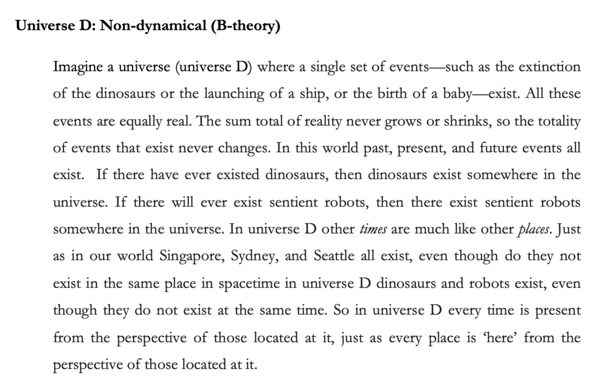
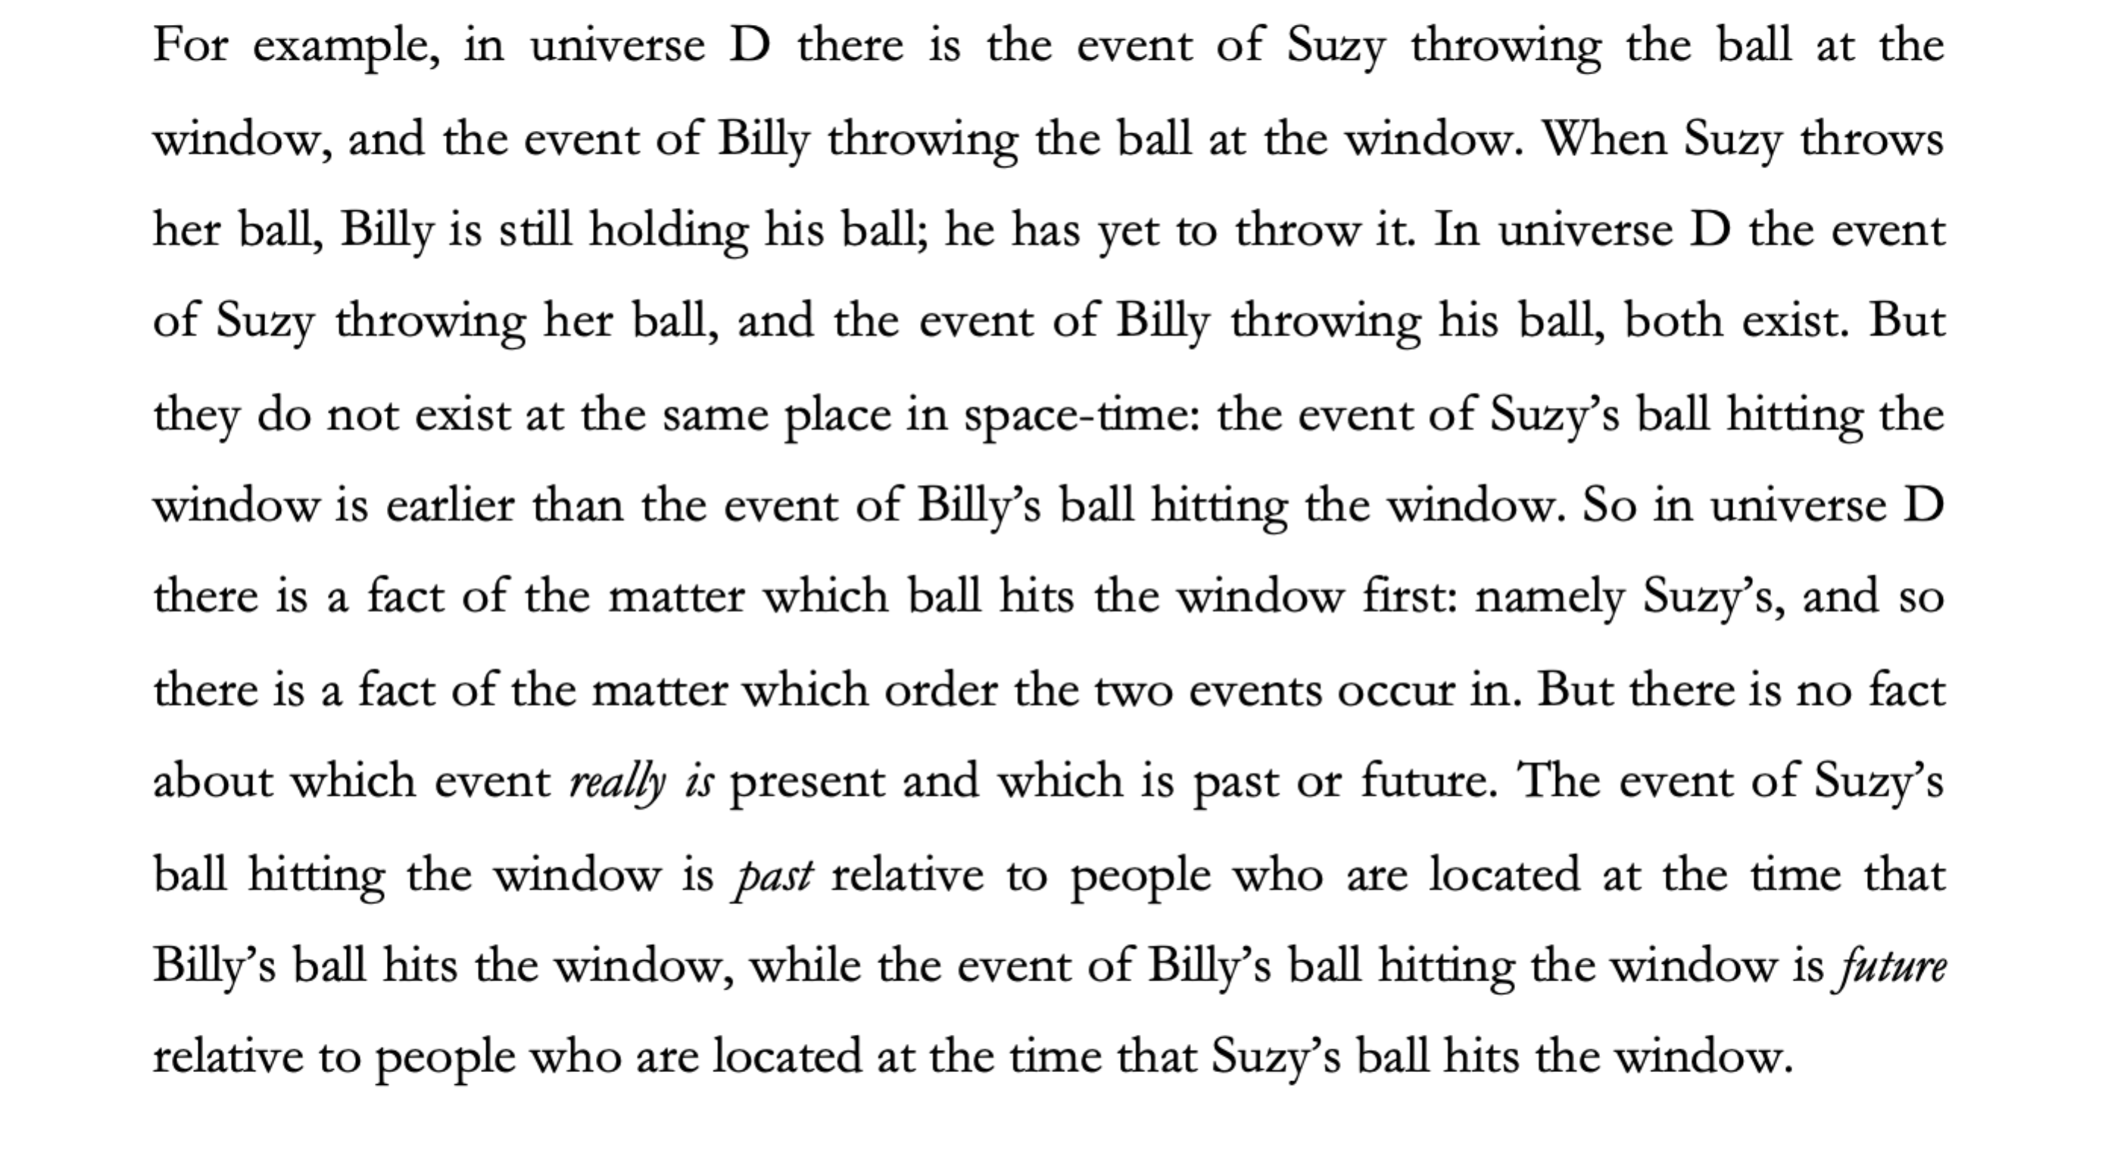
Participants were then presented with four comprehension/attention check questions to which they were given a forced choice between true and false. Participants who failed correctly to answer these questions were excluded from the study.
- In Universe [D] the past and present exist, but the future does not.
- In Universe [D] the past, present, and future exist.
- In Universe [D] there is an objective fact as to which events are present.
- In Universe [D] events are always only past or future relative to other events.

Participants were then told the following:
“It has been discovered that our universe, the one that you and I live in, is just like Universe D, in fact, our universe could be Universe D.”
Participants then saw the statement “In Universe D, time passes’ and responded on a Likert scale that ran from 1 (definitely agree) to 7 (definitely disagree) (where the orientation of the Likert scale was randomised).
Experiment 1(b)
In experiment 1(b) participants saw four vignettes. The non-dynamical vignette is the same as the one used in experiment 1(a), the other three vignettes are below. Participants were then asked “which universe do you think is most like the universe we live in?” and were given a forced choice option of (a) Universe A (b) Universe B, (c) Universe C (e) Universe D.
They were then presented with the same four comprehension/attention check questions from experiment 1(a) (amended to mention the relevant universe).
They then responded to the following statement:
“In Universe [A/B/C/D] time passes” on a Likert scale that ran from 1 (definitely agree) to 7 (definitely disagree) (where the orientation of the Likert scale was randomised.
All participants, regardless of which universe they thought was most like our own, then saw the non-dynamical vignette (universe D). They were presented with the same four comprehension/attention check questions from experiment 1(a), and were then asked to respond to the following statement:
“In Universe D, time passes” on a Likert scale that ran from 1 (definitely agree) to 7 (definitely disagree) (where the orientation of the Likert scale was randomised.

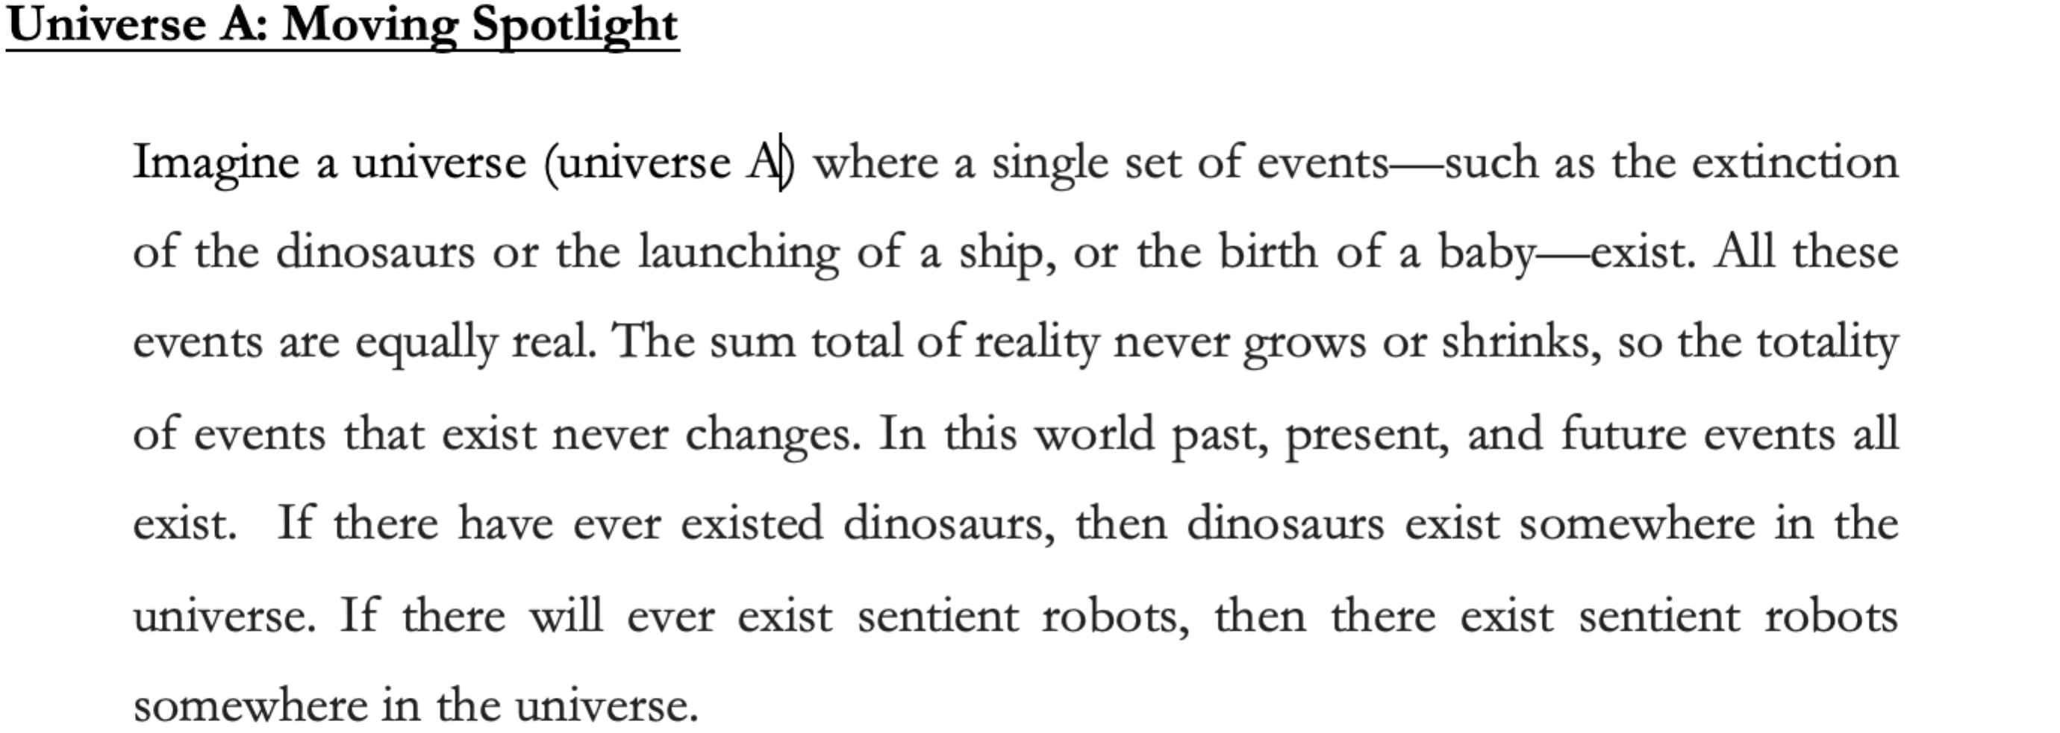
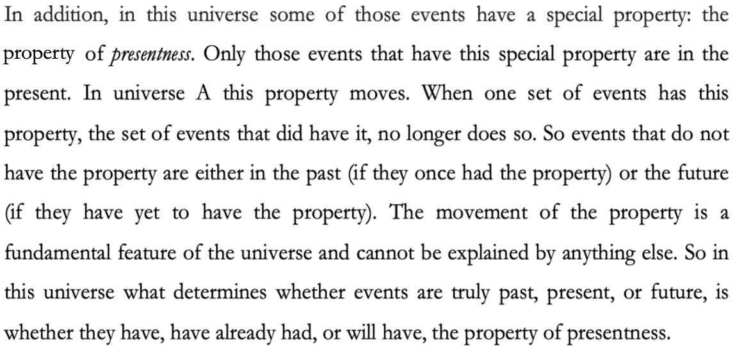
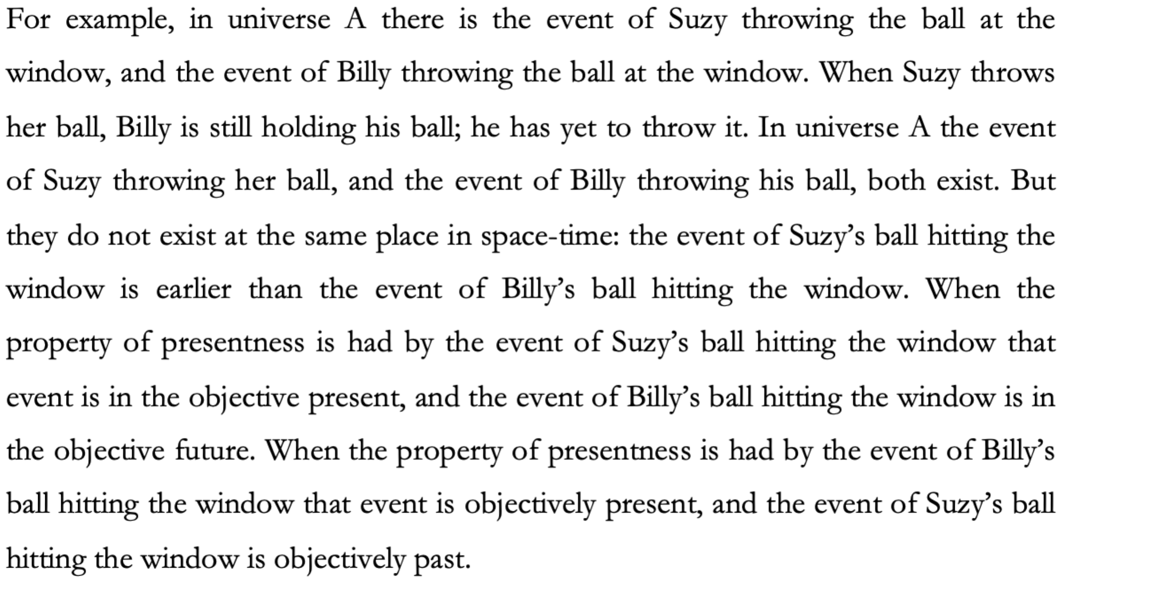
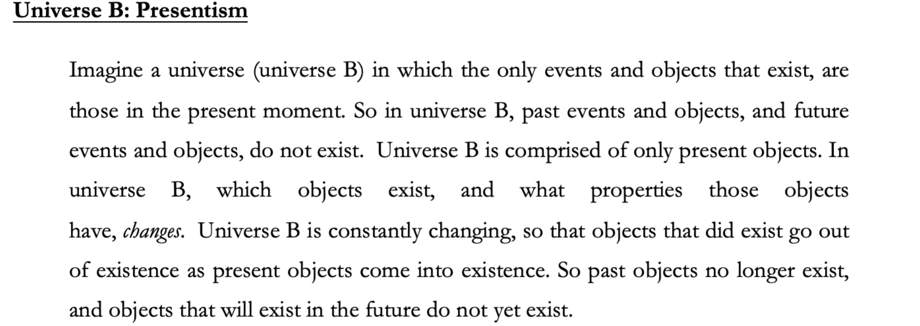
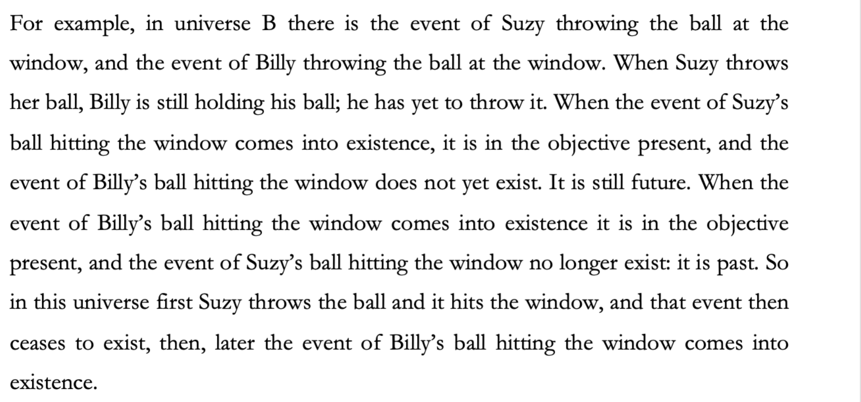
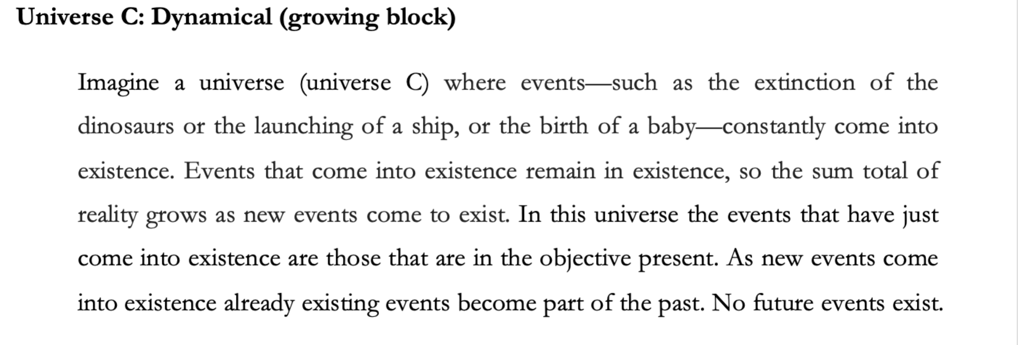
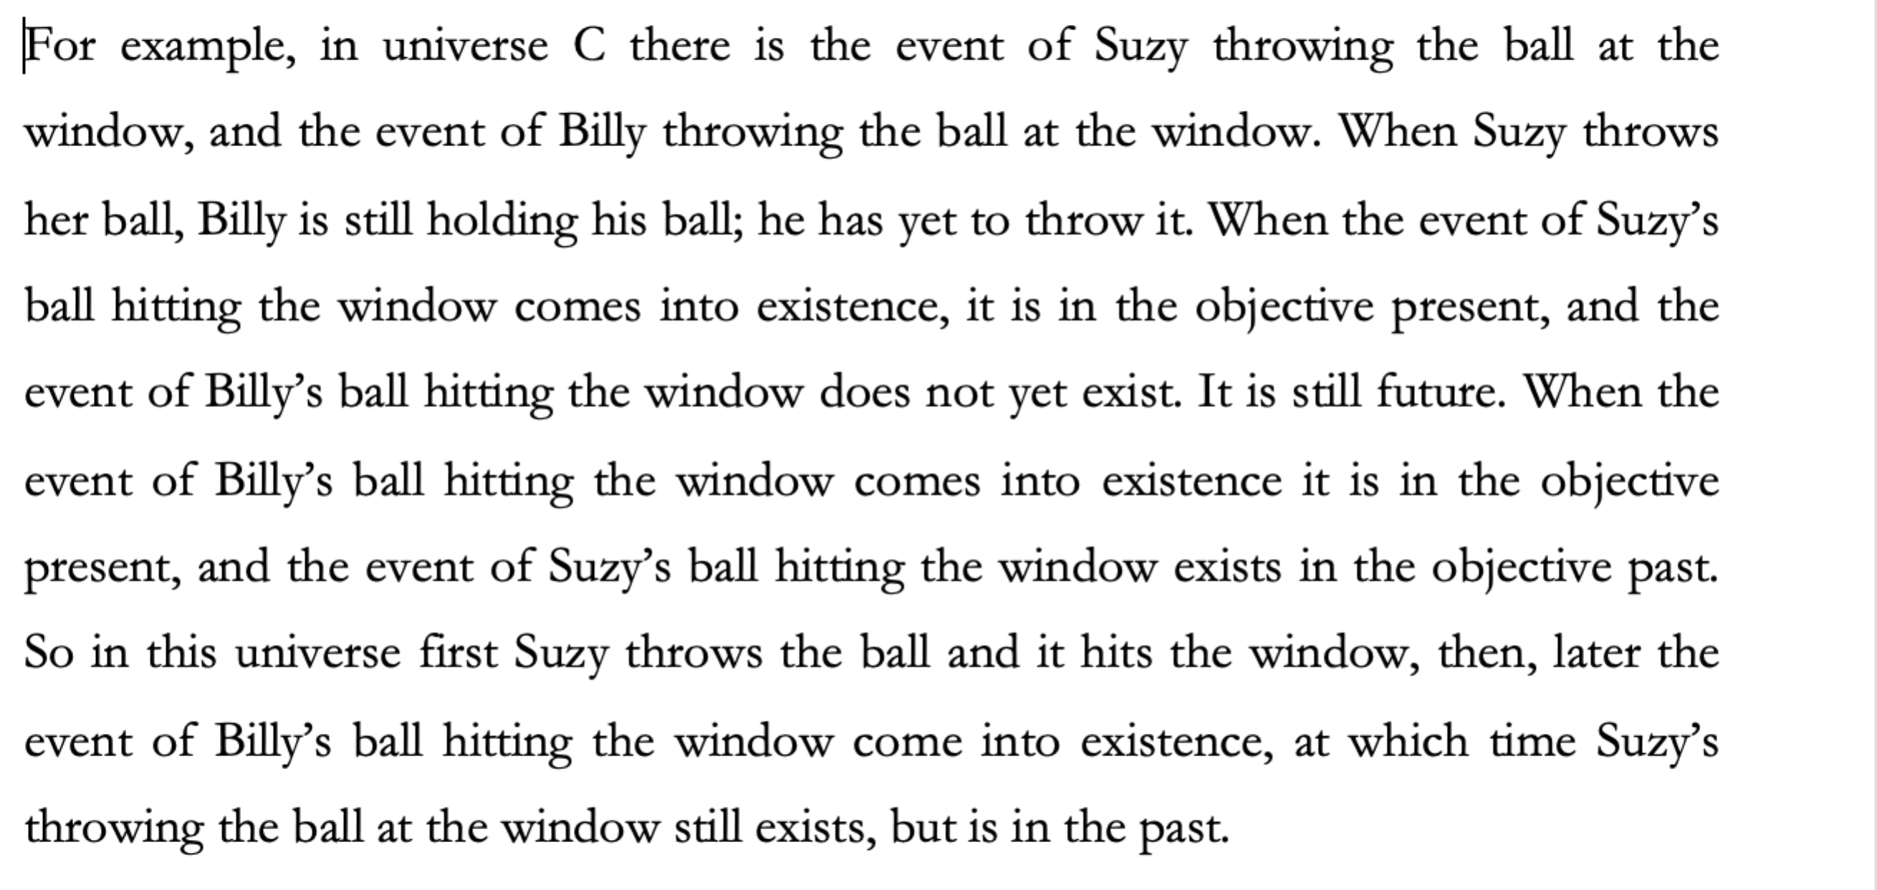
3.1.3 Results
Before reporting statistics, we will summarise our main findings. We hypothesised that (H1) people will judge that time passes in the non-dynamical world that is stipulated to be just like our world. This hypothesis was vindicated. Overall, participants judged that time passes in the block universe stipulated to be actual. In experiment 1(b) we had two hypotheses. First, that (H2) people will judge that time passes in a counterfactual non-dynamical world, and will make that judgement regardless of whether they judged the actual world to be dynamical or not. Second, that (H3) non-dynamists will be more inclined to judge that time passes in the counterfactual non-dynamical world than will dynamists. H2 was not vindicated. While participants who think that the moving spotlight is most like our world judge that time passes in a counterfactual block universe, participants who think that either presentism or the growing block is most like our world do not. H3, however, was vindicated. Non-dynamists gave significantly higher passage judgments (i.e. judgements that time passes) than dynamists to the counterfactual block universe.
Table 1 below summarises the descriptive results for passage judgments in experiment 1(a). The %Yes column represents the proportion of participants who agree that time passes in a non-dynamical world that is stipulated to be just like our world (5, 6, 7). The %No column represents the proportion of participants who disagree that time passes that time passes in a non-dynamical world that is stipulated to be just like our world (1, 2, 3). The %4 column represents the proportion of participants who neither agree nor disagree. A one-sample t-test was run to test whether the mean passage judgment significantly differed from 4 (indifference). The result of that test below (two right-hand columns) shows that, overall, participants judged that time passes in the non-dynamical world that is stipulated to be just like our world.
Table 1. Descriptive results for passage judgments in experiment 1(a).
Actual World | %Yes | %No | %4 | Mean | SD | t-value | p-value
Block Universe (n = 75) | 82.7 | 5.3 | 12 | 5.59 | 1.26 | 10.873 | <.001

Table 2 below summarises the descriptive results for passage judgments to the world that participants judged to be most like our own. For instance, the first row of the table represents the passage judgments of participants who judged that the moving spotlight world is most like our world, the second row of the table represents the passage judgments of participants who judged that the presentist world is most like our world, and so on. The %Yes column represents the proportion of participants who agree that time passes in the world that they judge to be most like our world (5, 6, 7). The %No column represents the proportion of participants who disagree that time passes in the world that they judge to be most like our world (1, 2, 3). The %4 column represents the proportion of participants who neither agree nor disagree. Separate one-sample t-tests were run for each group to test whether the mean passage judgment significantly differed from 4 (indifference). The results of those tests below (two right-hand columns) show that, overall, participants judged that time passes in the world that they judged to be most like our world.
Table 2. Descriptive results for passage judgments to world taken to be actual in experiment 1(b).
Actual World | %Yes | %No | %4 | Mean | SD | t-value | p-value
Moving Spotlight (n = 80) | 85.0 | 7.5 | 7.5 | 5.86 | 1.44 | 11.580 | <.001
Presentism (n = 71) | 81.6 | 9.9 | 8.5 | 5.48 | 1.62 | 7.692 | <.001
Growing Block (n = 55) | 85.4 | 7.3 | 7.3 | 6.02 | 1.47 | 10.169 | <.001
Block Universe (n = 117) | 80.4 | 8.5 | 11.1 | 5.59 | 1.39 | 12.366 | <.001

Table 3 below summarises the descriptive results for passage judgments regarding the counterfactual non-dynamical world. For instance, the first row of the table represents passage judgments regarding the block universe, of participants who judged that the moving spotlight world is most like our world, the second row of the table represents the passage judgments regarding the block universe, of participants who judged that presentism is most like our world, and so on. The %Yes column represents the proportion of participants who agree that time passes in the counterfactual block universe (5, 6, 7). The %No column represents the proportion of participants who disagree that time passes in the counterfactual block universe (1, 2, 3). The %4 column represents the proportion of participants who neither agree nor disagree. Separate one-sample t-tests were run for each group to test whether the mean passage judgment significantly differed from 4 (indifference). Results of those tests below (two right-hand columns) are mixed. Participants who judge that the moving spotlight is most like our world, overall, judge that time passes in a counterfactual block universe. Participants who judge that presentism or the growing block is most like our world do not.
Table 3. Descriptive results for passage judgments to counterfactual non-dynamical world in experiment 1(b).
Actual World | %Yes | %No | %4 | Mean | SD | t-value | p-value
Moving Spotlight | 57.4 | 23.8 | 18.8 | 4.75 | 1.82 | 3.691 | <.001
Presentism | 42.2 | 32.4 | 25.4 | 4.13 | 1.79 | 0.597 | .552
Growing Block | 43.6 | 30.9 | 25.5 | 4.11 | 1.84 | 0.439 | .662

To test whether non-dynamists (participants who judged that the block universe is most like our own) were more inclined to judge that time passes in the counterfactual non-dynamical world than dynamists (participants who judged that either the moving spotlight, presentism, or growing block is most like our own) we ran a one-way ANOVA on passage judgments made regarding the block universe. This test revealed that there was a significant effect of what universe people judge to be like our own on their passage judgments regarding the block universe, F(3, 319) = 15.677, p < .001. Simple effects tests with Bonferroni correction revealed that non-dynamists gave significantly higher passage judgments regarding the block universe than dynamists (Moving Spotlight: p = .004; Presentism: p < .001; Growing Block: p < .001). There was no significant difference in passage judgements regarding the block universe between participants who judged that either the moving spotlight, presentism, or growing block to be most like our own (p > .138).

3.2 Experiment 2 Methodology
3.2.1 Participants
460 people participated in the study. Participants were U.S. residents, recruited and tested online using Amazon Mechanical Turk, and compensated $0.50 for a maximum 10 minutes of their time. Again, we used only those MTurk participants who have a HIT (task) approval rate of at least 95% and who have had their HITs (tasks) approved at least 1000 times and included both task instructions and attentional checks that doubled as comprehension checks. We excluded participants who failed either to follow task instructions or correctly answer attentional and comprehension check questions. 343 participants had to be excluded for failing to follow task instructions or vignette comprehension. This means that they failed to answer the questions or failed one of the attentional check questions (138) or failed to correctly answer 3 out of 4 comprehension questions (205). The remaining sample was composed of 117 participants (58 female; aged 21-62, mean age 37.03 (SD = 9.93)). Ethics approval for these studies was obtained from the [blanked] Human Research Ethics Committee. Informed consent was obtained from all participants prior to testing. The survey was conducted online using Qualtrics.

3.2.2 Materials and Procedure
In this experiment participants were divided into two conditions: non-dynamical and dynamical. Participants saw one of two vignettes. They either saw the non-dynamical vignette from experiment 1a/b, or the dynamical moving spotlight vignette from experiment 1b. The moving spotlight vignette was used for this experiment as, out of the three dynamical universes, more participants thought that the moving spotlight universe was most like our world. After having seen the vignettes, participants were presented with the same four comprehension/attention check questions, and participants who failed to answer correctly were eliminated from further analysis.
Participants in both conditions then read the following description:
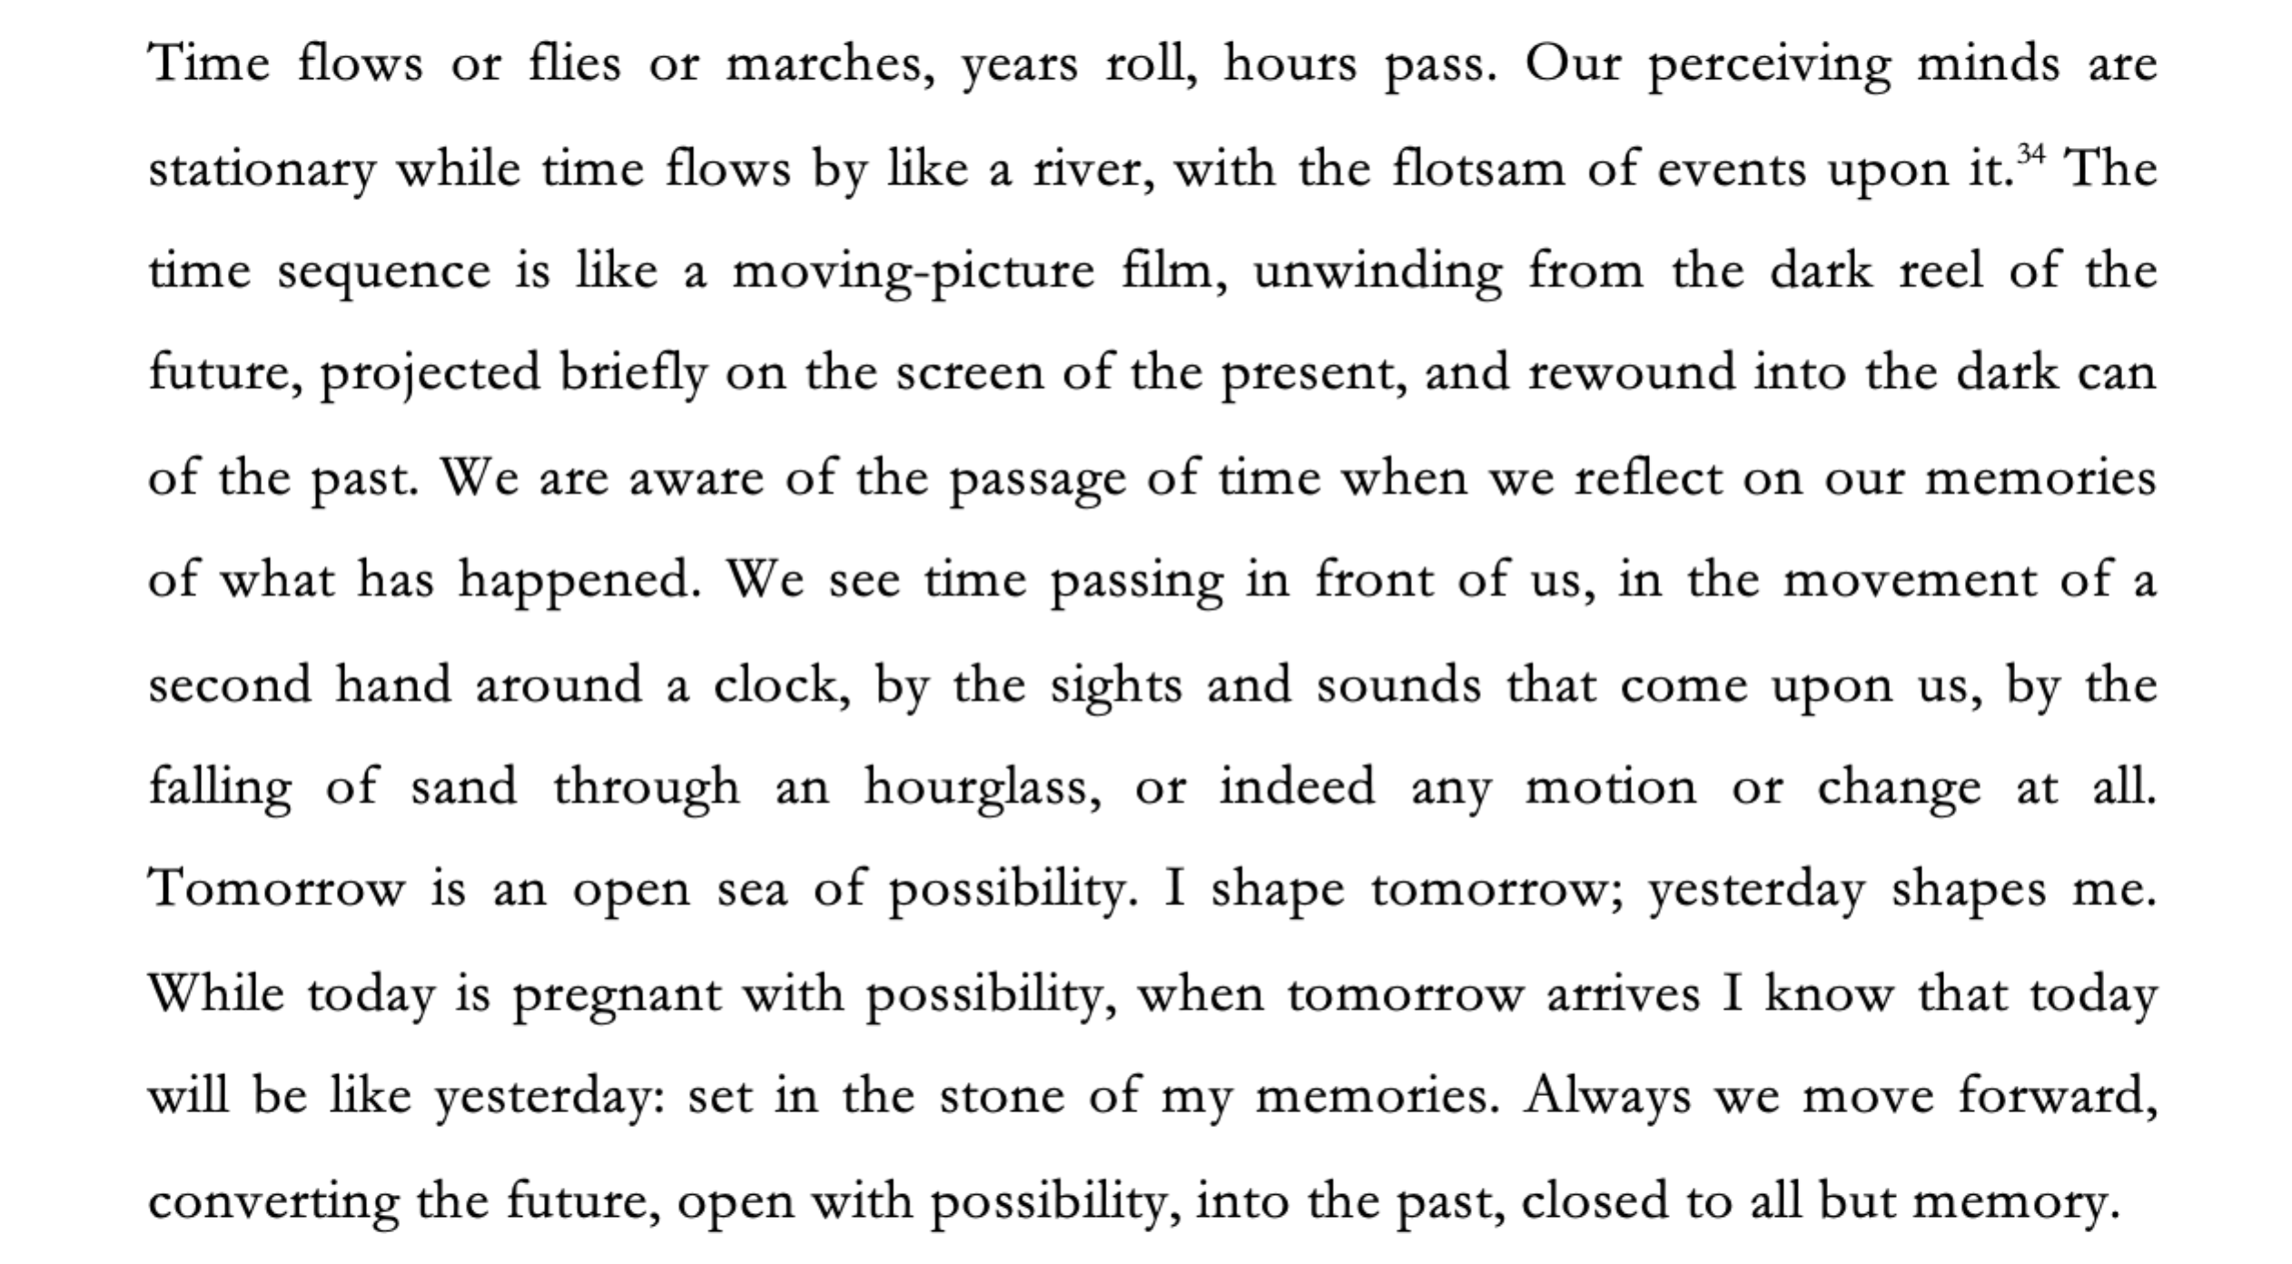
They then responded to the following statement:
“If you are told that this description is a description of Universe [D/C], how likely do you think it is that what you are told is true?” and responded on a Likert scale from (1) completely likely to (7) completely unlikely.

3.2.3 Results
First we will summarise our main findings. We hypothesised that (H4) people will judge that what they were told is true in both the dynamical and non-dynamical condition. This hypothesis was vindicated. Overall, participants judged that the description they were told is true in both the case of the moving spotlight and the block universe. We also hypothesised that (H5) people will be more inclined to judge that what they are told is true when they are told that the description is a description of a dynamical world, then when they are told that it is of a non-dynamical world. This hypothesis was not vindicated. We found no evidence of any difference between participants likelihood judgments between these two cases.
Table 4 below summarises the descriptive results for participants likelihood judgments in both the dynamical and non-dynamical world condition. The %Yes column represents the proportion of participants who agree that the description is likely true (5, 6, 7). The %No column represents the proportion of participants who disagree that the description is likely not true (1, 2, 3). The %4 column represents the proportion of participants who neither agree nor disagree. Separate one-sample t-tests were run for each condition to test whether the mean likelihood judgment significantly differed from 4 (indifference). The results of those two tests below (two right-hand columns) show that, overall, participants judged that the description is likely true of both the moving spotlight and the block universe.
Table 4. Descriptive results for likelihood judgments of the description to both a dynamical and non-dynamical world.
Condition | %Yes | %No | %4 | Mean | SD | t-value | p-value
Moving Spotlight (n = 54) | 83.3 | 3.7 | 13.0 | 5.19 | 0.48 | 10.266 | <.001
Block Universe (n = 63) | 81.0 | 6.3 | 12.7 | 5.29 | 1.24 | 8.250 | <.001

To test whether participants were more inclined to judge that what they are told is true when they are told that the description is a description of a dynamical world, than when they are told that it is of a non-dynamical world, we compared the mean likelihood judgments between conditions using a between subjects t-test. This test found no evidence of a difference in likelihood judgments between the moving spotlight condition and block universe condition, t(109.979) = -0.518, p = .605.

3.3 Experiment 3 Methodology
3.3.1 Participants
679 people participated in the study. Participants were U.S. residents, recruited and tested online using Amazon Mechanical Turk, and compensated $0.50 for a maximum 10 minutes of their time. We used only those MTurk participants who have a HIT (task) approval rate of at least 95% and who have had their HITs (tasks) approved at least 1000 times and included both task instructions and attentional checks that doubled as comprehension checks. We excluded participants who failed either to follow task instructions or correctly answer attentional and comprehension check questions. 556 participants had to be excluded for failing to follow task instructions or vignette comprehension. This means that they failed to answer the questions or failed one of the attentional check questions (295) or failed to correctly answer 3 out of 4 comprehension questions (261). The remaining sample was composed of 123 participants (64 female; aged 21-66, mean age 38.86 (SD = 10.73)). Ethics approval for these studies was obtained from the [blanked] Human Research Ethics Committee. Informed consent was obtained from all participants prior to testing. The survey was conducted online using Qualtrics.

3.3.2 Materials and Procedure

In this experiment participants were divided into two conditions: mind-independent and mind-dependent. Participants saw one of two vignettes.
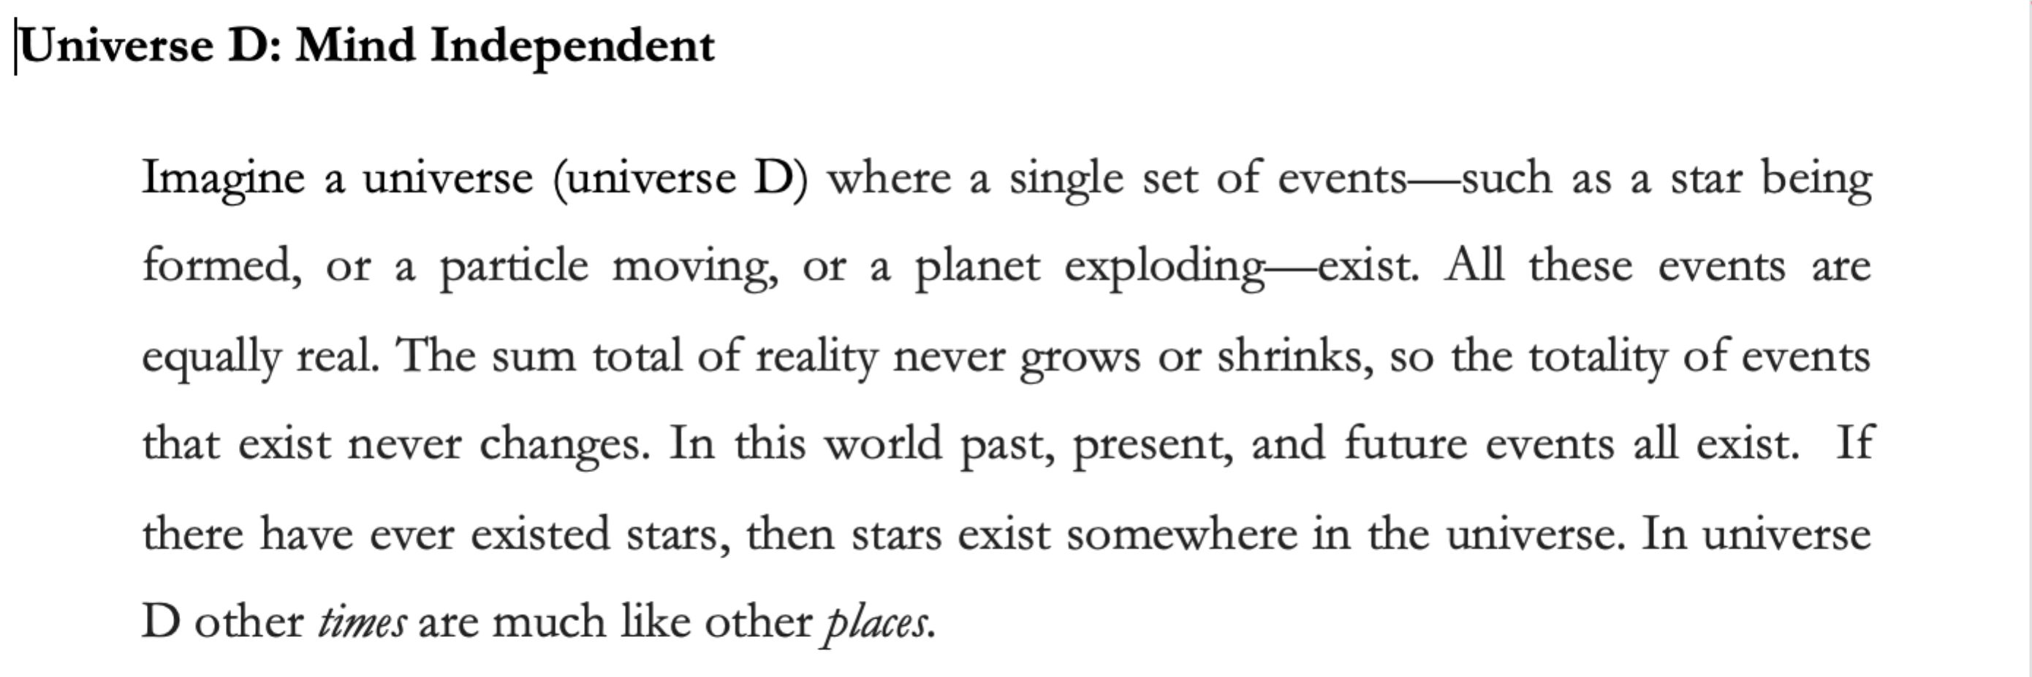
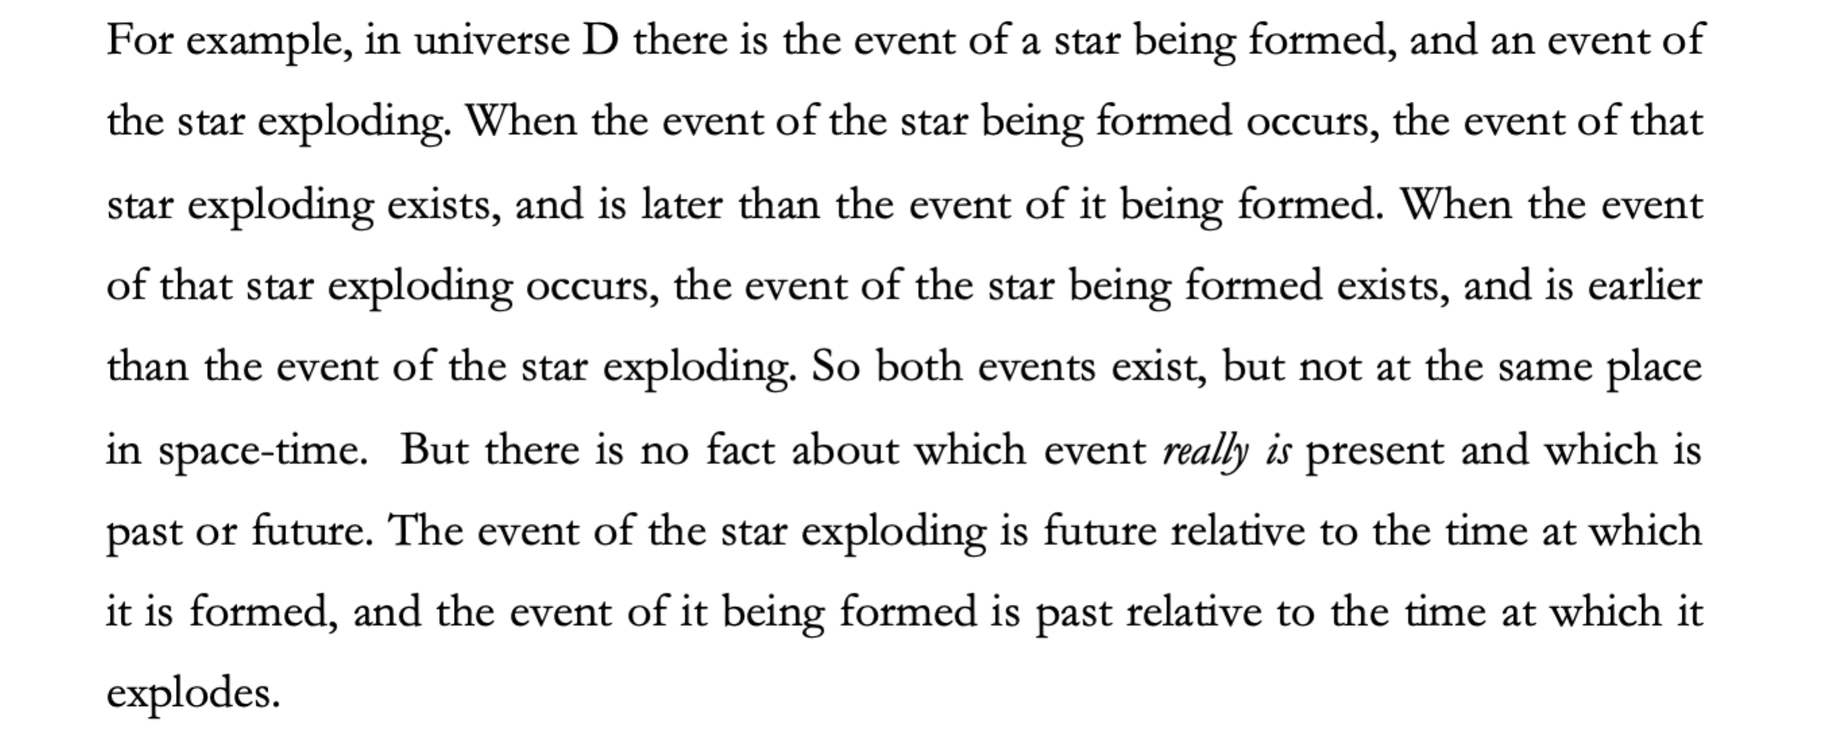
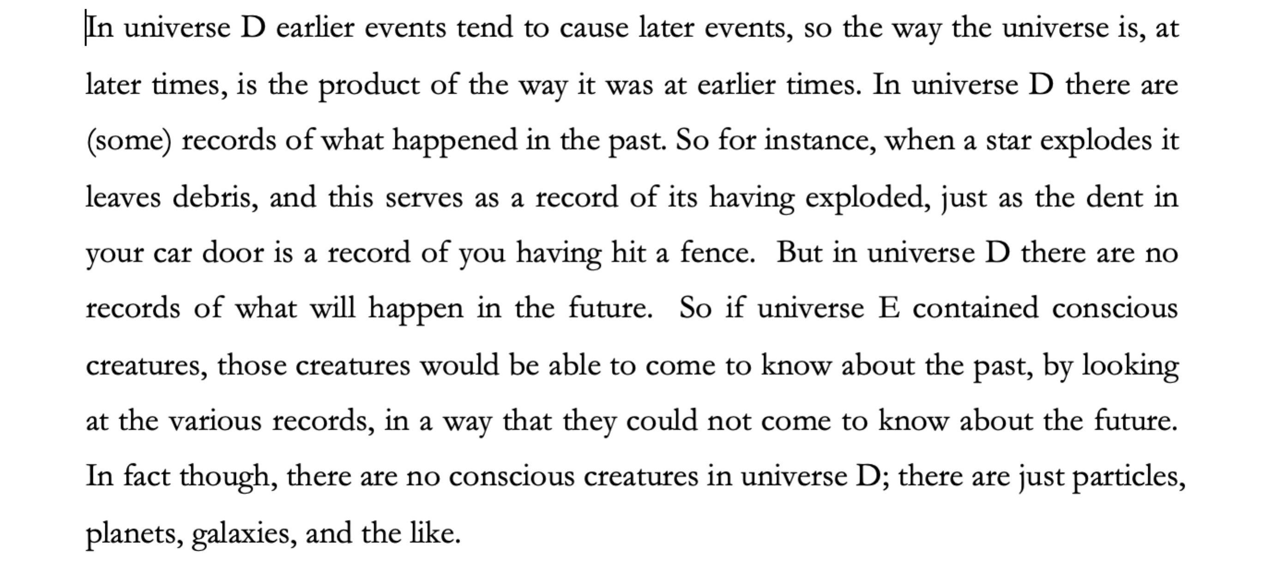
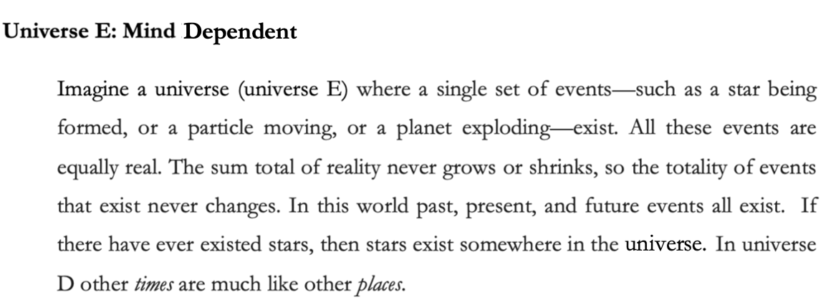
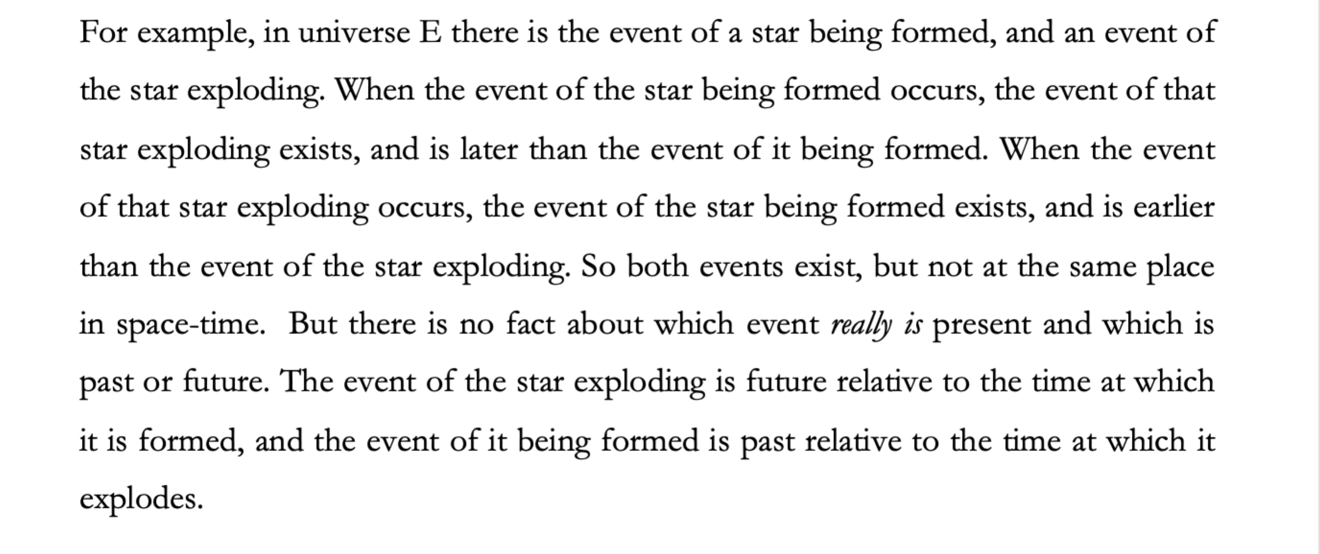
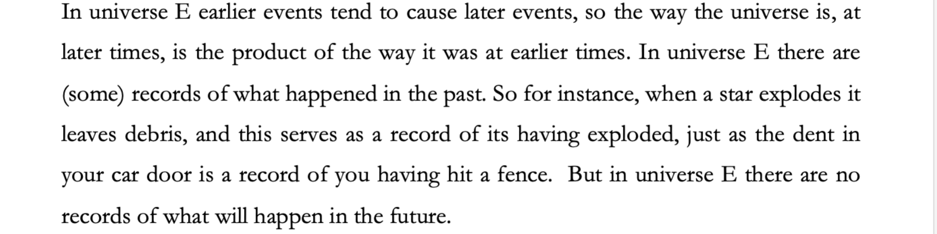
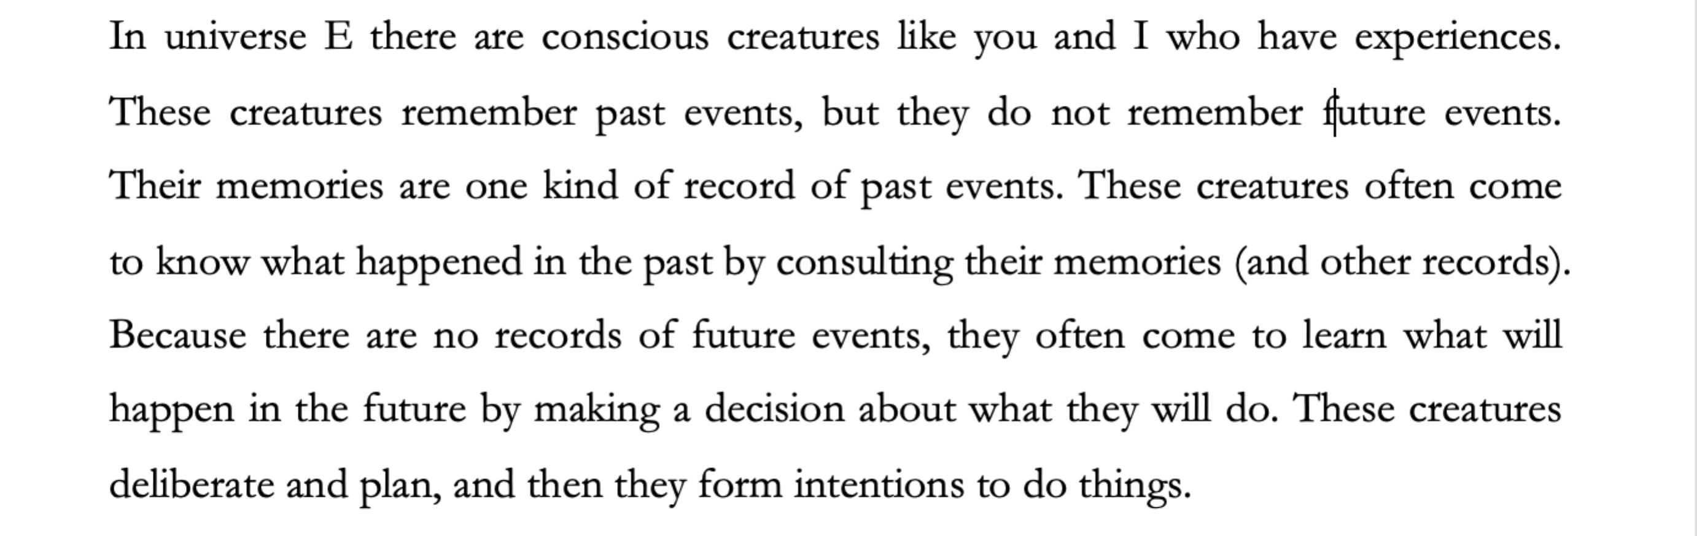
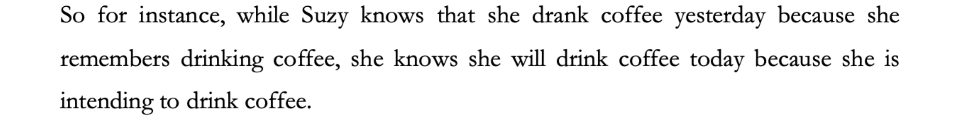
Participants were presented with four comprehension/attention check questions to which they were given a forced choice between true and false.
- In Universe [D/E] the past and present exist, but the future does not.
- In Universe [D/E] future events are caused by past events.
- In Universe [D/E] conscious creatures have memories of future events, but no memories of past events.
- In Universe [D/E] conscious creatures learn about the past by remembering what happened, but they learn about the future by deciding what will happen.

Participants who failed correctly to answer these questions were excluded from the study.
‘In Universe [D/E] time passes” and responded on a Likert scale that ran from 1 (definitely agree) to 7 (definitely disagree) (where the orientation of the Likert scale was randomised.)

3.3.4 Results
We will begin by summarising our main findings. We hypothesised that (H6) people will judge that there is temporal passage in both the mind-dependent and mind-independent condition. This hypothesis was vindicated. Overall, participants judged that time passes in both conditions. Finally, we hypothesised that (H7) people will be more inclined to judge that there is temporal passage in the mind-dependent condition compared to the mind-independent condition. This hypothesis too was vindicated. Participants in the mind-dependent condition gave significantly higher passage judgments than participants in the mind-independent condition.
Table 5 below summarises the descriptive results for passage judgments in both the mind-independent and mind-dependent condition. The %Yes column represents the proportion of participants who agree that time passes (5, 6, 7). The %No column represents the proportion of participants who disagree that time passes (1, 2, 3). The %4 column represents the proportion of participants who neither agree nor disagree. Separate one-sample t-tests were run to test whether the mean passage judgment significantly differed from 4 (indifference). The results of those two tests below (two right-hand columns) show that, overall, participants judged that time passes in both the mind-independent and mind dependent condition.
Table 5. Descriptive results for passage judgments in the mind-independent and mind-dependent condition.
Condition | %Yes | %No | %4 | Mean | SD | t-value | p-value
Mind-Independent (n = 49) | 79.6 | 8.2 | 12.2 | 5.10 | 1.28 | 6.033 | <.001
Mind-Dependent (n = 74) | 87.8 | 4.1 | 8.1 | 5.57 | 1.14 | 11.873 | <.001

To test whether participants were more inclined to judge that there is temporal passage in the mind-dependent condition relative to the mind-independent condition, we compared the mean passage judgments between conditions using a between subjects t-test. The result of this test showed that participants in the mind-dependent condition gave significantly higher passage judgments than participants in the mind-independent condition, t(121) = -2.116, p = .036.

4. Discussion
There are two central questions that we aimed to address in this paper. First, is the folk concept of temporal passage satisfied in our world if our world is non-dynamical (i.e. a block universe)? Second, insofar as the folk concept of temporal passage is satisfied if it is a block universe, is that concept satisfied by something that is mind-independent, or mind-dependent? Let’s take each question in turn.
Overall, our results suggest that (in the population we sampled) people’s folk concept of temporal passage is satisfied if our world is a block universe. First, people judged that time passes in our world if it’s a block universe (H1 is vindicated). Second, when presented with the description, most people judged that if someone tells them that description is of a non-dynamical world, that they are being told the truth (H4 was vindicated). These two findings support the idea that the folk concept of temporal passage is satisfied if actually our world is non-dynamical. Indeed, there was no significant difference between the number of people who thought that this description is true of a non-dynamical world and those who thought it was true of a dynamical (moving spotlight) world (H5 was not vindicated).
This latter finding is especially interesting. One might have thought that even if people judge that the description is one that can be true in a non-dynamical world, that they would be more inclined to think that it is true in a dynamical world as compared to a non-dynamical world. In fact, though, we found no significant difference between people’s judgements in these cases.
That might be taken to suggest that people’s folk concept of temporal passage is one that it not only satisfied in the actual non-dynamical world, but, in addition, that dynamical worlds do not even ‘better satisfy’ that concept than do non-dynamical worlds. Interestingly, even non-dynamists who hold that we can find passage in our non-dynamical world have not attempted to argue that our concept of passage is not in some way better satisfied by dynamical worlds. H5 suggests that even the comparative betterness of dynamical over non-dynamical worlds for satisfying our concept of passage is not supported.
In fact, though, while H5 does seem to point to this being so, we think that the results regarding H2 and H3 tend to undermine this idea. Recall that we hypothesised people would judge that time passes in a counterfactual non-dynamical world, and will make that judgement regardless of whether they judged the actual world to be dynamical or not (H2) but that non-dynamists will be more inclined to judge that time passes in the counterfactual non-dynamical world than are dynamists (H3).
Given the results regarding H1, it should be no surprise that people who judged that the actual world is non-dynamical went on to judge that time passes in the counterfactual non-dynamical world. But amongst those who judged that our world was dynamical most did not judge that time passes in the counterfactual non-dynamical world (except, perhaps, in the case of those who judge that our world is a moving spotlight world). Rather, people were divided between those who judged that time passes in the counterfactual world and those who judged that it does not. Thus H3 was vindicated and H2 was not.
These results are consistent with it being the case that amongst those who think our world is dynamical, a dynamical world does better satisfy their concept of temporal passage. It’s important to be a bit careful here. Even if it’s true that dynamists have a concept of temporal passage that is better satisfied at a dynamical world than a non-dynamical one (as H3 suggests might be the case) this is a much weaker claim than dynamists (and some non-dynamists) typically make. For it is consistent with this being so that even dynamists have a concept of temporal passage that is satisfied if our world is non-dynamical. And indeed, the results of H1 and H5 strongly suggest that this is so.
Should we, though, conclude that (many) dynamists have such a concept? Well, our results are consistent with some dynamists having a sort of conditional concept of temporal passage. In fact, our concept of temporal passage could be conditional in several ways (that is, it could be conditional on several different features of the actual world). Its satisfaction at counterfactual worlds could be conditional on the dynamical/non-dynamical nature of the actual world. Equally, its satisfaction at counterfactual worlds could be conditional on the actual world containing, or failing to contain, minds. Or both. Let us say that the (or a) folk concept of temporal passage is dynamically conditional if it is a concept that is satisfied in a counterfactual non-dynamical world, conditional on our world being non-dynamical, and is not satisfied in such a world conditional on our world being dynamical. Let us say that the (or a) folk concept of temporal passage is mind-dependently conditional if it is a concept that is satisfied in a counterfactual mindless world, conditional on our world being mindless, and is not satisfied in such a world conditional on our world containing minds.
Dynamists who have a dynamically conditional concept could be expected to judge that there is temporal passage in our world if it is dynamical and also if it is non-dynamical, but to judge that there is no temporal passage in a counterfactual non-dynamical world conditional on our world being dynamical. If (some) dynamists do have a dynamically conditional concept, then it’s fair to say that they have a concept that is better satisfied in a dynamical compared to a non-dynamical world in at least the following sense: if our world is dynamical, then the concept will not be satisfied at any non-dynamical world, but the converse is not the case (if our world is non-dynamical, the concept will still be satisfied at dynamical worlds).
Could we explain our results by supposing that dynamists have a dynamically conditional concept? Well we could, if only around 50% of dynamists have a dynamically conditional concept and the other 50% of dynamists had a concept of temporal passage that is straightforwardly satisfied at any non-dynamical world regardless of the nature of our world.
Our results are, however, also consistent with dynamists failing to have a dynamically conditional concept. It could simply be that dynamists are very unsure whether or not their concept is satisfied in a counterfactual non-dynamical world, and they end up being split down the middle in this regard. This could be because their concept is entirely determinate, but they are unable to work out whether it is satisfied in such a world (perhaps because they cannot fully imagine the world). Alternatively, it could be because their concept is actually gappy/indeterminate in some ways, such that some people simply have no judgements about whether it is satisfied in some conditions. Follow up work could profitably be undertaken in this regard.
Regardless of what the right thing is to say about whether, amongst dynamists, dynamical worlds better satisfy their concept of temporal passage, it is very clear that conditional on our world in fact being discovered to be non-dynamical, overall, most people have a concept of temporal passage that is satisfied in our world. So we can locate temporal passage in a non-dynamical world. The folk concept of temporal passage is not a concept that is only satisfied if the actual world is dynamical. This is important news.
On the one hand, it’s good news for those such as Leininger, Deng and Savitt, who argue that non-dynamical worlds contain something that deserves the name ‘temporal passage’. Although they have not typically framed their claims in terms of a folk concept of passage, their claims are surely all the more plausible if our folk concept of passage is satisfied in the actual non-dynamical world.
This is also good news for other non-dynamists. Even if there is good reason to allow dynamists to use ‘temporal passage’ as a technical term to pick out A-theoretic change in which events are objectively present, it is nevertheless noteworthy that A-theoretic passage is not the only thing that satisfies the folk concept of temporal passage. Insofar as non-dynamists have sometimes conceded that versions of the dynamical theory better accord with our folk view of the world (in some regard or other) it may well be that they have conceded too much in this regard.
That brings us to our second question. Insofar as the folk concept of temporal passage is satisfied in the actual non-dynamical world, is what satisfies our concept mind-dependent or mind-independent? Our results suggest that it is something mind-independent. People judge that there is temporal passage present in the non-dynamical world even when it does not contain any minds (H6). This makes it very unlikely that people think that the folk concept of temporal passage is a concept of something that is satisfied in a world only if there are mental states in that world that are appropriately connected to some kind of metaphysical structure.
Indeed, and rather interestingly, our results seem to even rule out a weaker view on which the folk concept of temporal passage is mind-dependently conditional. If this were so, it would be a concept that is satisfied in a counterfactual mindless world, conditional on our world being mindless, and is not satisfied in such a world conditional on our world containing minds. To put it another way, on this view temporal passage is mind-dependent just in case actually, there are minds (perhaps connected to metaphysical structure in a certain way), and is mind-independent otherwise.
In fact though, our results undermine this idea. There surely are actual minds and, we assume, people take them to be connected to some kind of structure (dynamical or non-dynamical). So, if people had a concept like this they should judge that there is no temporal passage in counterfactual worlds that lack minds. They do not make this judgement. Thus we can rule out that people have a mind-dependently conditional concept. Instead, it seems right to say that they simply have a concept whose satisfaction in counterfactual worlds is not conditional on whether there are actually minds or not.
It is, however, worth remembering that people’s judgements were stronger in the mind-dependent condition compared to the mind-independent condition. H7 was vindicated. This suggests that people are more certain that time passes in worlds containing minds as compared to world containing no minds. While this does not suggest that people have a concept of temporal passage that is a mind-dependently conditional, it may suggest that they take the presence of mental states of a certain sort to be evidence of the presence of temporal passage.
- Conclusion
Our results indicate that the folk concept of temporal passage is one that is satisfied in an actual non-dynamical, block universe, world and that it is satisfied in (counterfactual) non-dynamical worlds that lack minds. This suggests, first, that we can ‘locate’ temporal passage in our world if it is non-dynamical and, second, that we should probably be attempting to locate it in something mind-independent rather than something mind-dependent. These results suggest that dynamists may need to abandon arguments for dynamism that proceed via the claim that dynamism is the only view that can accommodate the folk concept of temporal passage. In turn, they suggest that rather than needing to explain why non-dynamism is attractive despite failing to satisfy our concept or passage, the non-dynamist can instead argue that non-dynamism can straightforwardly satisfy that concept.

References
Ahler, D., Roush, C., & Sood, G. The micro-task market for lemons: data quality on Amazon’s Mechanical Turk. Unpublished manuscript, 22 January 2020. URL: http://gsood.com/research/papers/turk.pdf

Albert, David (2000). Time and Chance, Harvard University Press.
Bardon, A. (2013). A Brief History of the Philosophy of Time, OUP.
Baron, S. Cusbert, J. Farr, M, Kon, M, and Miller, K (2015) “Temporal Experience, Temporal Passage and the Cognitive Sciences” Philosophy Compass. 10 (8): 56—571. https://doi.org/10.1111/phc3.12244
Baron, S and Miller, K. (2015b). ‘What is temporal error theory?’ Philosophical Studies, 172(9):2427-2444.
Baron, S. and Miller, K. (2015a). ‘Our Concept of Time.’ In Philosophy and Psychology of Time edited by B. Mölder, V. Arstila, P. Ohrstrom. Springer. pp 29-52.
Boroditsky, L., Fuhrman, O., & McCormick, K. (2011). ‘Do English and Mandarin speakers think about time differently?’, Cognition, 118(1): 123–129.
Braddon-Mitchell, D. (2003). ‘Qualia and Analytical Conditionals’, Journal of Philosophy, 100(3): 111-135.
Braddon-Mitchell, D. (2004a). Masters of our Meanings’, Philosophical Studies, 118(1-2): 133-52.
Braddon-Mitchell, D. (2004b). ‘Folk Theories of the Third Kind’, Ratio 17(3): 277-293.
Braddon-Mitchell, D. (2005). ‘The Subsumption of Reference’, British Journal for the Philosophy of Science 56 (1):157-178.
Braddon-Mitchell, David (2009). ‘Naturalistic Analysis and the A Priori’, in: D. Braddon-Mitchell & R. Nola (eds.), Conceptual Analysis and Philosophical Naturalism, MIT Press: 349-361.
Buckwalter, W. & Stich, S. (2014), ‘Gender and Philosophical Intuition’, in: J. Knobe and S. Nichols (eds.), Experimental Philosophy, vol. 2, New York: OUP.
Callender, C. (2017). What Makes Time Special?, Oxford University Press.
Cameron, R. P. (2015). The Moving Spotlight: An Essay on Time and Ontology.,Oxford University Press.
Casasanto, D., & Bottini, R. (2014). ‘Mirror reading can reverse the flow of time’, Journal of Experimental Psychology: General, 143(1): 473–479.
Chalmers, D. (2004). ‘Epistemic Two Dimensional Semantics’, Philosophical Studies, 118(1-2): 153-226.
Chalmers, David (2006). ‘Perception and the Fall from Eden’, in: T. Gendler & J. Hawthorne (eds.), Perceptual Experience, Oxford University Press: 49-125.
Craig, W. L. (2000). The Tensed Theory of Time: A Critical Examination, Dordrecht: Kluwer Academic Publishers.
Deng, Natalja (2013a). 'Fine's McTaggart, temporal passage, and the A versus B-debate', Ratio, 26(1): 19–34.
Deng, Natalja (2013b). 'Our Experience of Passage on the B-Theory', Erkenntnis, 78(4): 713-726.
Deng, Natalja (2019). ‘One Thing After Another: Why the Passage of Time is Not an Illusion’, in: A. Bardon, V. Arstila, S. Power & A. Vatakis (eds.), The Illusions of Time: Philosophical and Psychological Essays on Timing and Time Perception, Palgrave Macmillan.
Farr, Matt (2012). ‘Towards a C Theory of Time: An Appraisal of the Physics and Metaphysics of Time Direction’, PhD Thesis, University of Bristol.
Farr, Matt (2020). ‘C-Theories of Time: On the Adirectionality of Time’, Philosophy Compass, 12(1): 1-17.
Frischhut, A. (2015). “What Experience cannot Tech us About Time. Topoi 34 (1):143-155

Fuhrman, O., & Boroditsky, L. (2010). ‘Cross-cultural differences in mental representations of time: Evidence from an implicit non-linguistic task’, Cognitive Science, 34(1): 1430–1451.
Gödel, Kurt (1949). An Example of a New Type of Cosmological Solutions of Einstein’s Field Equations of Gravitation. Reviews of Modern Physics 21 (3):447–450.
Hawthorne, John (2002). ‘Practical Realism?’, Philosophy and Phenomenological Research, 64(1): 169-178.
Hoerl, C. (2014), ‘Do we (seem to) perceive passage?’, Philosophical Explorations, 17(1): 188–202.
Ismael, J. (2012). Decision and the Open Future. In: The Future of the Philosophy of Time, A Bardon, Routledge: 149-169.
Ismael, Jenann (2017). ‘Passage, Flow, and the Logic of Temporal Perspectives’, in: C. Bouton & P. Huneman (eds.), Time of Nature and the Nature of Time, Springer Verlag.
Jackson, F. (2004). ‘Why we need A-intensions’, Philosophical Studies, 118(1-2): 257-277
Jackson, F. (2009). ‘A Priori Biconditionals and Metaphysics’, in: David Braddon-Mitchell & Robert Nola (eds.), Conceptual Analysis and Philosophical Naturalism, MIT Press.
Jackson, Frank (1998). From Metaphysics to Ethics: A Defence of Conceptual Analysis, Oxford University Press.
Jackson. F. (2007). ‘Reference and Description from the Descriptivists’ Corner’, Philosophical Books 48 (1):17-26.
Kim, M. & Yuan, Y. (2015). ‘No Cross-Cultural Differences in the Gettier Car Case Intuition: A Replication Study of Weinberg et al. 2001’, Episteme, 12(3): 355-361.
Kripke, Saul (1980). Naming and Necessity, Harvard University Press.
Latham, A. J., Miller, K and Norton, J. (2019) “Is Our Naïve Theory of Time Dynamical?”. Synthese. DOI: 10.1007/s11229-019-02340-4 (2021 198:4251-4271)
Latham, A. J., Miller, K. and Norton, J. (2020a). ‘Do the Folk Represent Time as Essentially Dynamical?’, Inquiry.
Latham, A. J., Miller, K. & Norton, J. (2020b), ‘An Empirical Investigation of Purported Passage Phenomenology’, Journal of Philosophy, 117(7): 353-386.
Leininger, Lisa Judith (2013). ‘B-coming: Time's Passage in the B-theory Blockworld’, PhD Thesis, College Park: University of Maryland.
Leininger, Lisa (2021). ‘Temporal B-Coming: Passage Without Presentness’, Australasian Journal of Philosophy, 99(1): 1-17.
Le Poidevin, Robin (1991). Change, Cause and Contradiction: A Defence of the Tenseless Theory of Time, St. Martin’s Press.
Le Poidevin, Robin (2007). The Images of Time: An Essay on Temporal Representation, Oxford University Press.
Lewis, David (1995). ‘Should a Materialist Believe in Qualia?’, Australasian Journal of Philosophy, 73(1): 140-144.
McTaggart, J. M. E. (1908). ‘The Unreality of Time.’ Mind, 17(68):457–474.
Machery, E., Mallon, R., Nichols, S., & Stephen, S. (2004). ‘Semantics, cross-cultural style’, Cognition, 92(3): 1-12.
Maudlin, T. (2007). The Metaphysics Within Physics, Oxford: Clarendon Press
Mellor, Hugh (1998). Real Time II, Taylor and Francis, London.
Miller, K. (2019). ‘The Cresting Wave: A New Moving Spotlight Theory’ Canadian Journal of Philosophy. 49(1): 94-122.
Miller, K., Holcombe, A., & Latham, A. J. (2020). ‘Temporal Phenomenology: Phenomenological Illusion versus Cognitive Error’, Synthese, 197(2): 751-771.
Nagel, J., Valerie S. J., & Mar, R. A. (2013). ‘Lay Denial of Knowledge for Justified True Beliefs’, Cognition, 129(3): 652–661.
Norton, John (2010). ‘Time Really Passes’, Humana. Mente: Journal of Philosophical Studies, 13(1): 23-36.
Núñez, R, Cooperrider, K., Doan, D. & Wassmann, J. (2012). ‘Contours of time: Topographic construals of past, present, and future in the Yupno valley of Papua New Guinea’, Cognition, 124(1): 25-35.
Oaklander, L. Nathan (2012). ‘A-, B and R-theories of Time: A Debate’, in: A. Bardon (ed.), The Future of the Philosophy of Time, Routledge: 1-24.
Paul, L. A. (2010). ‘Temporal Experience’, The Journal of Philosophy, 107(7): 333-359.
Pettit, P. (2004). ‘Descriptivism, Rigidified and Anchored’, Philosophical Studies, 118 (1-2): 323-338.
Price, Huw (1996). Time’s Arrow and Archimedes’ Point: New Directions for the Physics of Time, Oup Usa.
Price, Huw (2009). ‘The Semantic Foundations of Metaphysics’, in: I. Ravenscroft (ed.), Minds, Ethics, and Conditionals: Themes from the Philosophy of Frank Jackson, Oxford University Press: 111-140.
Prosser, S. (2007). “Could we experience the passage of time?” Ratio, xx:75–90.
Prosser, S. (2012). “Why does time seem to pass?” Philosophy and Phenomenological Research, lxxxv: 92–116.
Russell, Bertrand (1915). ‘On the Experience of Time’, The Monist, 25(2): 212-233.
Salmon, Nathan (1981). Reference and Essence, Princeton University Press.
Savitt, Steven F. (1996). ‘The Direction of Time’,_British Journal for the Philosophy of Science, 47(3): 347-370.
Savitt, Steven F. (2002). ‘On Absolute Becoming and the Myth of Passage’, Royal Institute of Philosophy Supplement, 50(1): 153-167.
Schlesinger G. (1994). ‘Temporal Becoming’, in: N Oakland and Q Smith (eds.), The New Theory of Time, New Haven CT: Yale University Press.
Seyedsayamdost, H. (2015). ‘On normativity and epistemic intuitions: Failure of replication’, Episteme, 12(1): 95-116.
Skow, Bradford (2015). Objective Becoming, Oxford Scholarship Online.
Smart, J. J. C. (1949). ‘The River of Time’, Mind, 58(1): 483-94.
Smith, Quentin (1994). ‘Introduction: the old and new tenseless theory of time’, in: L. N. Oaklander & Q. Smith (eds.), The New Theory of Time, New Haven: Yale University Press: 17–22.
Soames, Scott (2002). Beyond Rigidity: The Unfinished Semantic Agenda of Naming and Necessity, Oxford University Press.
Stich, S. 1990, The Fragmentation of Reason: Preface to a Pragmatic Theory of Cognitive Evaluation, Cambridge, MA: MIT Press.
Tallant, J. (2012). ‘(Existence) Presentism and the A-theory’, Analysis 72 (4):673-681.
Tegtmeier, E. (1996). ‘Direction of Time: A Problem of Ontology, not of Physics’, in: J. Faye, U. Scheffler & M. Urchs (eds.), Perspectives on Time. Dordrecht: 183-191.
Tegtmeier, E. (2009). ‘Ontology of Time and Hyperdynamism’, Metaphysica, 10(2): 185-198.
Tegtmeier, E. (2016). ‘Time and Order’, Manuscrito, 39(4): 157-168.
Tooley, M. (1997). Time, Tense, and Causation, Oxford University Press.
Weinberg, J. M., Nichols, S., & Stich, S. (2001). ‘Normativity and Epistemic Intuitions’, Philosophical Topics, 29(1-2): 429–460.
Williams, C. (1998). ‘B-time transition.’ Philosophical Inquiry, 20(3/4):59-63.
Williams, C. (2003). ‘Beyond A- and B-time.’ Philosophia, 31(1):75-91.
Williams. D. C. (1951). “The Myth of Passage.” Journal of Philosophy 48 (15):457-472.
Zimmerman, D. W. (2008). ‘The Privileged Present: Defending an “A-Theory” of Time.’ In Contemporary Debates in Metaphysics, Sider, T., Hawthorne, J & Zimmerman, D. W. (eds.), 211–225 (Oxford: Blackwell).

To distinguish this kind of temporal passage from what Skow (2015) calls anodyne passage
See Maudlin (2007); Oaklander (2012); Mellor (1998); Le Poidevin (1991).
See Price (1996); Farr (2012, 2020).
That is, whether something falls under that concept at a world.
For a defense of various versions of dynamism see Cameron (2015); Tallant (2012); Tooley (1997).
See Smith (1994); Schlesinger (1994).
See Savitt (2002); Deng; (2013a, 2013b, 2019); Leininger (2018, 2021); Ismael (2017).
We don’t claim that this is the right interpretation of all of these authors. Perhaps some are better thought of as proposing to engineer a concept of temporal passage, and arguing that the resulting concept deserves the name because what satisfies that concept plays a certain role. In turn, they then argue, that concept is satisfied in our non-dynamical world.
See Smith (1994); Craig (2000); Schlesinger (1994). For discussion of this kind of argument see Baron, Cusbert, Farr, Kon and Miller (2015).
See for instance (arguably) McTaggart (1908), Gödel (1949), Williams (1998; 2003) and Zimmerman (2008). Callender (2017) also talks of the manifest image of time, and seems to think that certain aspects of this image are closer to a dynamical than a non-dynamical view of time.
See for instance Le Poidevin (2007) and Paul (2010) It remains unclear whether some other non-dynamists such as Norton (2010) and Savitt (1996) are rightly characterized as passage illusionists or not. Prosser (2007, 2012) is an illusionist, but he thinks the illusory state represents an enduring self rather than robust passage.
See Frischhut (2015), Deng (2013b; 2019), Bardon (2013), Hoerl (2014), Miller, Holcombe and Latham (2018) and Miller (2019).
See for instance Latham, Miller and Norton (2019).
Baron & Miller (2015a 2015b); Latham, Miller and Norton (2020a).
More carefully, in one experiment they found that a (significant) majority of dynamists judged this, and in the other they found that about 50% of dynamists judged this.
See Jackson (1998).
This is sometimes known as the Canberra Plan. See for instance Jackson (1998); Braddon-Mitchell (2009); Chalmers (2006).
See for instance Kripke (1980), Soames (2002); Salmon (1981).
See for instance Savitt (2002), Deng (2013a, 2013b, 2019) and Leininger (2018, 2021).
See Jackson (1998, 2004, 2007, 2009); Chalmers (2004); Braddon-Mitchell (2004a, 2004b, 2005, 2009); Pettit (2004) for defences of this kind of internalism.
Although there is disagreement concerning the extent to which this is the case (see, for example, Nagel et al. (2013); Kim & Yuan (2015); Seyedsayamdost (2015).
See Stich (1990); Weinberg et al. (2001); Machery et al. (2004); Buckwalter & Stich (2014).
Boroditsky (2001); Boroditsky, Fuhrman & McCormick (2011). See also Fuhrman & Boroditsky (2010); Casasanto & Bottini (2014).
Núñez et al., (2012).
Callender (2017) has argued that the folk view of time does not differ very substantially across cultures.
See Smart (1949), Norton (2010) and Callender (2017).
Each hypothesis was preregistered at https://osf.io/4t3cn/. [The link has been disabled during the review process so as to not unblind the authors.]
See, for instance, Braddon-Mitchell (2004a); Hawthorne (2002).
In general, conditional concepts are those which are such that what satisfies them in counterfactual worlds depends on what satisfies them actually.
Assuming you think that the former can exist in the absence of the latter. While Savitt (2002), Deng (2013a, 2013b, 2019) and Leininger (2018, 2021) in some sense all identify temporal passage with the presence of succession (what for Deng and Savitt are really just B-relations) Leininger (2021) takes the presence of succession to be intimately connected with causality (and the light-cone structure), and it may be that many of these other authors are reductionists about B-relations, so that they take these relations to be reducible to facts about causation (Mellor 1998; Le Poidevin 1991) or the global entropic gradient (Albert 2000) rather than being primitive (Maudlin (2007); Oaklander (2012); Tegtmeier (1996; 2009; 2016) and hence able to come apart from these other asymmetries.
Hence we distinguish mind-dependence from response dependence, where we take something to be response dependent if what it is to be that thing, is to be the something that is disposed to generate certain mental states, but where that thing might be entirely mind-independent.
This distinguishes mind-dependent views from what we might call mind-sensitive views. On the latter kind of view, temporal passage is to be identified with that mind-independent phenomenon which is disposed to create in us certain mental states. Thus which thing in the world is temporal passage might be intimately connected to our having certain mental states, insofar as temporal passage just is that thing in the world that is disposed to create certain such mental states. But that thing in the world is nevertheless mind-independent.
See Ahler, Roush & Soud (ms) for a discussion of some of the problems associated with collecting data using MTurk and the prevalence thereof.
Though to be clear, we are not suggesting that defenders of B-passage think that dynamical worlds do better satisfy our concept of temporal passage; only that their view is consistent with that being the case.
This is consistent with what Latham, Miller and Norton (2020a) found in their experiment 1 with regard to the folk concept of time itself. They found that dynamists were split 50/50 between those who thought there was time in a counterfactual non-dynamical world, and those who thought there was not. (Their experiment 2 found that a majority of dynamists judged that there was time in a counterfactual non-dynamical world.) If there is a tight connection between dynamist’s concept of time, and concept of temporal passage, then this result is just what we would expect.
See Lewis (1995) and Braddon-Mitchell (2003) for discussion and application of conditional concepts.
Or indeed, it could be conditional on other factors, but we have no evidence regarding this.

