Time in a One-instant World

Abstract

Many philosophers hold that ‘one-instant worlds’—worlds that contain a single instant—fail to contain time. We experimentally investigate whether these worlds satisfy the folk concept of time. We found that ~50% of participants hold that there is time in such worlds. We argue that this suggests one of two possibilities. First, the population disagree about whether at least one of the A-, B-, or C-series is necessary for time, with there being a substantial sub-population for whom the presence of neither an A-, B-, nor C-series, is necessary for time, and hence those folk have a radically more minimal concept of time than has been attributed to them by philosophers. Or, second, the population do not disagree about whether at least one of the A-, B-, or C-series is necessary for time, but disagree about what it takes for a world to fail to contain even a C-series.

1. Introduction

What we will call a one-instant world is a world that contains a single instant. Perhaps better, it contains a single ‘slice’ of reality, where events/objects located on that slice bear spatial, but not temporal, relations to one another, and where that slice does not undergo dynamical change (i.e. change in the total set of facts). One way to conceptualise such a world is a ‘stopped presentist’ world: an unchanging three-dimensional slice of reality.
Typically, in the philosophical literature, one-instant worlds are appealed to as examples of timeless worlds. For instance, in debates about whether persisting objects endure or perdure, Sider (2001), and Effingham and Melia (2007), take one-instant worlds to be paradigmatic examples of timeless worlds.
It’s easy to see why. Such worlds lack dynamical change and hence lack an A-series. They also appear to lack both a B-series and a C-series. In what follows, contra McTaggart (1908), we will understand a C-series ordering of events to be a temporal ordering of events, ordered by by C-relations: undirected, asymmetric, transitive, ordering relations that are both necessary and sufficient for the existence of time (Farr (2012, 2018)). This distinguishes C-relations from B-relations, which we will suppose to be directed, asymmetric, transitive, ordering relations of earlier-than, later-than and simultaneous-with. Thus the A-series is a dynamical directed ordering, the B-series is a non-dynamical directed ordering, and the C-series is an undirected ordering. On this way of carving up the territory, the B-theory is the view on which there is a block universe with a built in temporal direction: there is fact of the matter as to which boundary is really the first, and which the last. By contrast, as we construe it, the C-theory is the view that there is a block universe, and there is no such fact of the matter.
If one thinks that the presence of either an A-series, a B-series or a C-series, is necessary and sufficient for there to be time, as almost all philosophers of time do, then the one-instant world appears to be a world that lacks time, since it lacks any such series.
Given recent interest in the folk concept of time, and, in particular, the conditions under which that concept fails actually to be satisfied, arising from various physical theories that claim to dispense with time altogether, we decided to test the philosophical assumption that one-instant worlds are, by the lights of the folk, timeless. For if they are not, then this suggests that the folk have a more metaphysically minimal concept of time than has been assumed, and as a result, conclusions about under what circumstances temporal error theory is true, are very likely mistaken.
In order to speak to this issue we undertook an empirical investigation of certain aspects of the folk concept of time. In §2 we present relevant background, and in §3 we describe a study we undertook, and present its results. In §4 we discuss the implication of these results.

2. The Folk Concept of Time

In what follows when we talk of a folk concept we mean a contentful mental state that can be a constituent of a thought. We take no stand on the correct philosophical account of concepts, beyond supposing that we can gain some insight into certain aspects of their content by asking people to use those concepts by judging whether certain scenarios are ones in which there is (in this case) time.
There has been a good deal of research into the ways in which people represent time through metaphorical language (especially using spatial metaphors), through diagrams (representations of a time-line) and through gestures (pointing in a particular direction to point towards the future, or the past) and into the cross-cultural variability of the ways that people do all these things (see Evans, 2003, 14; Sinha and Gardenfors 2014; Boroditsky, Fuhrman, McCormick 2010; Fuhrman, McCormick, Chen, Jiang, Shu, Mao, & Boroditsky 2011; Chen 2007; Boroditsky 2001; Casasanto & Bottini, 2014).For simplicity, for now we will talk of ‘the’ folk concept, but given the cross-cultural variation in aspects of the folk representation of time, we make no assumption that there is a single, shared, such concept either amongst the population we tested (US residents) or between populations (which we did not test). Further, we make no claims that our results generalise to populations outside those tested.
Despite considerable research into the ways people represent time, there has been little investigation into whether the folk concept is one on which the presence of an A-, B-, or C-series is necessary for that concept to be satisfied. Latham, Miller and Norton (2019) recently empirically investigated what the folk think actual time is like, (most of them think it is dynamical) but that does not tell us what they take to be necessary for there to be time, and hence does not tell us the conditions under which a world is timeless.
Given the prevalence of the view that the one-instant world is a timeless world, investigating whether the folk judge it to be so is one important step towards determining what is necessary for the folk concept of time to be satisfied. Doing so also allows us to investigate a recent attempt to spell out folk temporal error theory due to Tallant (2018). Tallant argues that folk temporal thought (and discourse) is error theoretic just in case it is truth-apt and false, and that it is false just in case there are no present-tensed truths. If there are present-tensed truths in a one-instant world, then his account predicts that the folk will judge that such a world contains time, and if not, not.
The following study aims to determine both (a) whether the folk judge that there is time in a one-instant world and (b) whether their judgments about whether there is time in such a world are sensitive to whether or not they believe that world to contain present-tensed truths.

3. Experimental Design and Results
3.1 Method
3.1.1 Participants

512 people participated in the study. Participants were U.S. residents, recruited and tested online using Amazon Mechanical Turk, and compensated $2 for approximately 20 minutes of their time. 53 participants had to be excluded for failing to follow task instructions. This means that they failed to answer the questions (42) or failed an attentional check question (11). 240 participants were excluded from the final analysis for failing to correctly answer two or more comprehension questions. The remaining sample was composed of 219 participants (aged 20-67; (84 female). Mean age 32.84 (SD = 9.58). Ethics approval for this study was obtained from the [blanked] Human Research Ethics Committee. Informed consent was obtained from all participants prior to testing. The survey was conducted online using Qualtrics.

3.1.2 Materials and Procedure

In this study we described three one-instant worlds—A, B and C— each of which is stipulated to be a world that is not our own. Hence participants evaluated counterfactual one-instant worlds. Participants were randomly assigned to one of three conditions: present-tensed truths (universe B) no present-tensed truths (universe C) and uncertainty regarding whether there are present-tensed truths (universe A). All participants saw the following base vignette (which either mentions universe A, B, or C).

Base Vignette

Scientists in our universe have a discovered a universe (universe A/B/C) in which the distance relations between objects are purely spatial. Spatial relations are relations such as Mike being two feet from Lily, or Boston being 16000kms from Sydney. In this world any two objects are separated by some spatial distance, and no two objects are separated by any other distance relations. Since in universe A there are only three spatial dimensions, Universe A/B/C is a giant, unchanging, three dimensional object. In fact, this three-dimensional object is an exact physical duplicate of the entirety of the way our universe is at a single instant in 1914. So universe A/B/C is like a single, static, snapshot of our universe at that instant in 1914. In our universe, at that instant in 1914, there exists a physics. Since universe A/B/C is a physical duplicate of everything at that instant, it contains a physical duplicate of the book as it is at that instant in our universe. Many sentences appear in the duplicate book, but three are of particular interest to scientists, philosophers and theologians in our universe. These are the sentences (a) there were physical properties, (b) there will be physical properties and (c) there are physical properties.

After having read the same base vignette, participants in the uncertainty condition (universe A) then saw:

While all the scientists, philosophers and theologians in our universe agree that sentences (a) and (b) found in the duplicate book are false in universe A, there is widespread disagreement about whether sentence (c) is true in universe A.

Participants in the present-tensed truths condition (universe B) saw:

While all the scientists, philosophers and theologians in our universe agree that sentences (a) and (b) found in the duplicate book are false in universe B, there is widespread agreement that sentence (c) is true in universe B.

Participants in the no present-tensed truths condition (universe C) saw:

All the scientists, philosophers and theologians in our universe agree that sentences (a), (b) and (c) found in the duplicate book, are false in universe C.

Participants were then asked to indicate their level of agreement, on a Likert scale of 1 (complete disagree) to 7 (completely agree) with the following statements or the vignette that they saw.

- There is time in universe A/B/C
- Sentence (c), ‘presently, there are physical properties,’ is true in universe A/B/C.

They were then asked to indicate their level of confidence in their previous judgement, on a Likert scale of 1 to 7.

Participants then completed a series of three comprehension questions. Those who answered two or more of the comprehension questions incorrectly, about the vignette they received, were excluded from all of the analyses, as were participants who failed the attentional check question. At no point could participants return to a previous screen.

3.2 Analyses

Before reporting the statistics and details, let’s begin with a summary of our main findings. Our first aim was to determine whether the folk judge that there is time in a one-instant world. We found that people are roughly divided in half between those who think there is time, and those that disagree or are uncertain whether there is time in universes A, B, or C.
Our second aim was to determine whether people’s judgments about whether there is time in universe A, B, or C, is sensitive to whether they believe that world to contain present-tensed truths. We found people’s judgements regarding present-tensed truths were insensitive to their judgements regarding time. People strongly agreed that there are present tensed truths in universe A and B. Interestingly, in universe C, despite being told that all the scientists, philosophers, and theologians agree that all present tensed truths are false, people are still roughly divided in half between those that agree, and those that disagree or are uncertain whether there are present tensed truths in that world. Importantly, in the universe A and B conditions there was no association between people’s judgements regarding whether there are present tensed truths in those universes, and whether there is time. However, in the universe C condition there was a weak positive association.
Table 1 summarizes the descriptive data from the experiment. The ‘Yes’ column is the proportion of participant’s who responded with either 5, 6, 7 when asked their level of agreement to either of the statement: there is time in universe A/B/C, or there are present tensed truths in universe A.B.C. The ‘No’ column is the proportion of participant’s who responded with either 1, 2, or 3, when asked their level of agreement to those same statements. The ‘4’ column is the proportion of people who neither agree nor disagree with those statements. Remember that here we are only considering those participants that correctly answered two ore more comprehension question.

Table 1. Levels of agreement to “there is time in universe A/B/ C” and to “there are present tensed truths in A/B/C”
Question and Condition | %Yes | %No | %4 | Mean | SD
“There is time in universe A/B/C.”
Universe A (N = 73) | 53.4 | 42.5 | 4.1 | 3.99 | 1.95
Universe B (N = 74) | 60.8 | 33.8 | 5.4 | 4.28 | 2.08
Universe C (N = 72) | 48.6 | 43.1 | 8.3 | 4.06 | 1.86
“Sentence (c), ‘presently, there are physical properties,’ is true in universe A/B/C.”
Universe A (N = 73) | 82.2 | 12.3 | 5.5 | 5.41 | 1.32
Universe B (N = 74) | 97.2 | 1.4 | 1.4 | 5.97 | 0.89
Universe C (N = 72) | 57.0 | 33.3 | 9.7 | 4.24 | 2.05

Beginning first with people’s judgments about time in each universe. Table 1 shows that people’s mean judgment regarding whether there is time is around 4. However, that is not because people are uncertain about whether there is time in universe A, B, or C. Rather, it’s because they are divided between those that think there is time, and those that think there is no time or are uncertain whether there is time (see Figure 1 below).
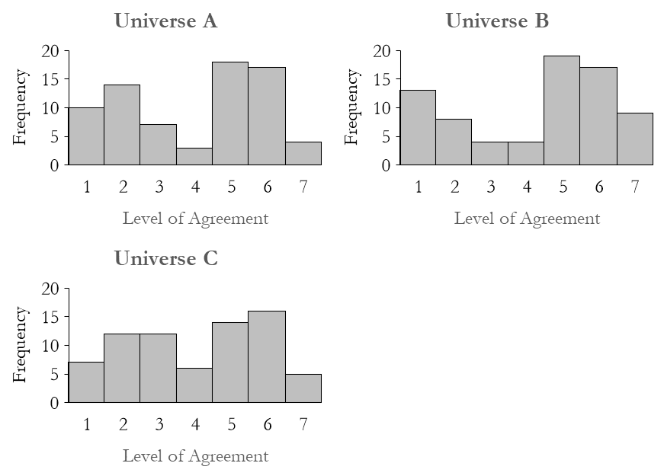Figure 1. Histograms showing people’s levels of agreement for the statement “There is time in universe A/B/C.” in the three experimental conditions (universe A, B, and C).

Due to an apparent bimodal distribution in people’s judgments about time in all three conditions we decided to run tests comparing the proportions of people who judged that there was time—call this a yes response, to those who judged there was no time—call this a no response, or to those who were uncertain (i.e. chose 4)—call that an uncertain response
In order to test whether people were divided between a yes response and no or uncertain response, we ran three separate one-way chi-square tests comparing the observed proportion between yes, and no or uncertain in universe A, B, and C, to a theoretical 50/50 split. The results of these tests showed the proportion of people that responded yes, and those who responded no or uncertain did not differ significantly from a theoretical 50/50 split in universe A, X² (1, N = 73) = .342, p = .558, universe B, X² (1, N = 74) = 3.459, p = .063, or universe C condition, X² (1, N = 72) = .056, p = .814.
Table 1 also shows that the majority of people in the universe A and universe B condition judge there are present-tensed truths. However, in the universe C condition people are roughly divided in half between those that judge yes and those that judge no or uncertain. In order to see whether there was any significant difference in people’s present tensed truth judgments we performed a Kruskal-Wallis test to compare people’s judgments across universe A, B, and C. The result of this test showed that there was a significant difference between people’s present tensed truth judgments and which universe condition they were in X² (2, N = 219) = 31.444, p < .001. Follow-up Mann-Whitney U tests with a Bonferroni correction showed that while people’s present tensed truth judgments, were significantly higher in universe A relative to universe C (p = .003), and universe B relative to universe C (p < .001), there was no significant difference between levels of agreement in universe A and universe B (p = .075). So, levels of agreement regarding present-tensed truths were, larger in universe A and universe B, relative to universe C, and there was no difference between universe A and B.
In order to test whether people were divided between judging yes and judging no or uncertain to there being present-tensed truths in universe C, we ran a one-way chi-square test comparing the observed proportion, to a theoretical 50/50 split. The result of this test showed that the proportion of people that judged yes and no or uncertain did not differ significantly from a theoretical 50/50 split in universe C (X² (1, N = 72) = 1.389, p = .239; see Figure 2).

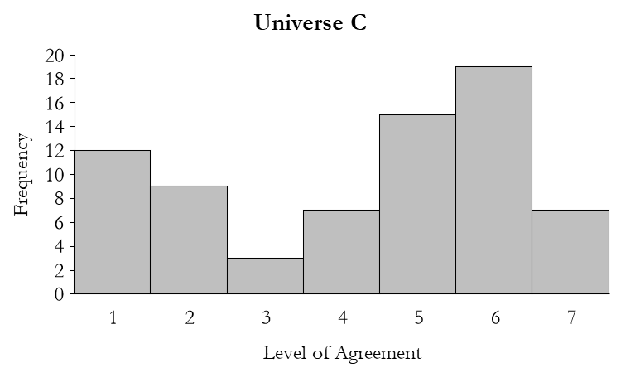
Figure 2. Histogram showing people’s level of agreement for the statement “Sentence (c), ‘presently there are physical properties’, is true in universe A/B/C.” in the universe C experimental condition.

Finally, in order to test for any association between people’s present-tensed truth judgments and their judgments about whether there is time in the universe in question, we calculated separate Spearman rank-order correlation coefficients for each universe condition. The results of these tests showed there was no significant association between people’s present-tensed truth judgments and time judgments in the universe A condition (r_{s} (71) = .127, p = .284) and the universe B condition (r_{s} (72) = -.001, p = .992). However, there was a weak positive monotonic association between people’s present-tensed truth judgments and time judgments in the universe C condition (r_{s} (70) = .286, p = .015).

4. Discussion

First, in all three conditions roughly 50% (53.4% uncertainty condition; 60.8% present-truths condition; 48.6% no present-tensed truths) judged that there was time. In all three conditions the mean level of agreement that there was time was around 4 (the mean varied from 3.99 to 4.28). But, as noted, this was not the result of a large number of participants being unsure whether or not there was time in the condition in question. Instead, we found a bi-modal distribution, with only 5.9% of participants giving a response of 4 (neither agreeing, nor disagreeing, that there was time in the condition in question). As we can see from the histograms, the population is split into two across each condition: those who judge there is time in that condition, and those who judge that there is not.
This suggests two possibilities, each of which locates the source of the disagreement in a somewhat different place. In both cases we will hold that the folk are roughly evenly spit about whether it is necessary for there to be time, that there are events that bear (at least) C-relations to one another. But on one view the source of this disagreement lies directly in the folk concept of time itself: the folk have a conceptual disagreement about what counts as time. On the second view they also have a conceptual disagreement, but it’s not directly a disagreement about the concept of time, but rather, it’s a disagreement about what it takes for there to be (at least) a C-series in a world.
On the first view there are at least two sub-populations who deploy two different concepts of time: one on which an A-, B-, or C-series ordering of events is necessary for there to be time, and one on which no such series is necessary. The former judge that there is no time in the one-instant world, the latter judge that there is time in the one-instant world. Notably, if this is the right account then the concepts deployed by these two sub-populations seem to be very different in content, even holding fixed that we can’t (from this data) spell out the content of either concept. (Indeed it leaves a big question unanswered, which is what the 50% of people who do not think even a C-series is necessary for time, do think is necessary for time). Moreover, if this is the right account of the data, then we can predict that ~50% of the population will conclude that there is time even in worlds that contain multiple instants, but in which no events at any of those instants bear C-relations to one another. If so, that is notable, particularly in light of recent accounts of quantum gravity which suggest something like this picture, but conclude that it is timeless . In addition, this finding goes against philosophical orthodoxy that at least a C-series is necessary for time, and perhaps something more than a C-series is required.
On the second view there are not at least two sub-populations who deploy two different concepts of time, one on which (at least) a C-series is necessary, and one on which it is not. Rather, it is consistent with the data that all (or most) participants agree that there must obtain at least a C-series, but where there is disagreement amongst participants regarding the conditions under which there is (at least) a C-series.
To see how this could be, consider: is it only way for a world, w, to lack a C-series, that w contain multiple instants, and no two events located at different instants in w bear a C-relation to one another, or, is it sufficient for w to lack a C-series, that w fails to contain multiple instants, and a fortiori that there are no two events located at different instants that bear a C-relation to one another? Philosophers who think the one-instant world is a timeless world presumably think that the latter is the case. These philosophers think there are two ways a world can lack a C-series: to fail to have multiple instants, and to have multiple instants, none of which have events located at them, which bear C-relations to one another.
What this second interpretation of our results suggests, is that roughly half of the folk agree with philosophical orthodoxy that there are two ways a world can lack a C-series—by failing to have multiple instants, and by having multiple instants none of which have events located at them, which bear C-relations to one another—and roughly half hold that only the second of these is a way for a world to fail to have a C-series.
On this way of interpreting our results, there is no conceptual disagreement about whether a world must contain an A-, B- or C-series in order to contain time, but rather, a disagreement about whether a one-instant world does contain any such series, and hence, a disagreement (possibly itself conceptual) about the sufficient conditions for a world to lack a C-series.
In either case, there are important lessons here. Either a large percentage of folk have a concept of time that is much more minimal than has been previously attributed to them, because they don’t think that even a C-series is necessary for there to be time, or the folk are drawing a distinction that philosophers are not, between two ways in which a world can fail to have a C-series. In either case, further investigation is required, given the variety of roles that the folk concept of time plays in metaphysical debates.
That brings us to the second key finding. We found no statistically significant difference in participants’ strength of agreement that there was time, across any of the three conditions. This was despite the fact that there was a robust correlation between participants being in a particular condition, and believing that the vignette described is one in which that condition obtains. So although the experimental condition—present-tensed truth, uncertainty, or absence of present-tensed truth—had an effect on participants’ judgments about whether present-tensed statements were true in the vignette they evaluated, it had no effect on their view about whether or not there is time in that vignette. These findings undermine Tallant’s (2018) view that the folk concept of time is sensitive to whether there are present-tensed truths in a world. For whether or not participants believe that a one-instant world contains present-tensed truths has no affect on whether they think that it contains time.

5. Conclusion

This study does not tell us what some, or all, of the folk think is necessary for time. But it does suggest that philosophical assumptions about what the folk take to be necessary are mistaken, at least for ~50% of the folk. Either many of the folk have a much more minimal concept of time than we have attributed to them, or they disagree (amongst themselves, and with philosophers) about what it is for a C-series to obtain at a world. In either case, this suggests that follow up work to plumb other aspects of the folk concept is required if we are to be able better to say something about the conditions under which the folk would be error theorists about time, either actually, or counterfactually.

References

Anderson, E. (2006) Relational Particle Models: 1. Reconciliation with Standard Classical and Quantum Theory. Classical and Quantum Gravity, 23(7), 2469–2490.
Barbour, J. (1999). The End of Time. (Oxford; New York: Oxford University Press).
_______. (1994a) The Timelessness of Quantum Gravity: I. The Evidence from the Classical Theory. Classical Quantum Gravity, 11(12), 2853–2873.
_______. (1994b) The Timelessness of Quantum Gravity: Ii. The Appearance of Dynamics in Static Configurations. Classical Quantum Gravity, 11(12), 2875–2897.
Baron, S. Evans, P and Miller, K. (2010). “From timeless physical theory to timelessness” “Physics and Metaphysics, special edition of Humana.mente edited by Claudio Calosi 13: 35-61.
Baron, S and K Miller (2015a) “What is temporal error theory?” Philosophical Studies. 172 (9): 2427-2444.
Baron, S. and K. Miller (2015b). “Our Concept of Time” in Philosophy and Psychology of Time edited by B. Mölder, V. Arstila, P. Ohrstrom. Springer. Pp 29-52
Boltzmann, L. (1964). Lectures on gas theory 1896-1898 (S. G. Brush, Trans.). Berkeley: University of California Press.
Boroditsky L. (2001). Does language shape thought? English and Mandarin speakers’ conceptions of time. Cognitive Psychology, 43, 1–22.
Boroditsky, L., Fuhrman, O., & McCormick, K. (2011). Do English and Mandarin speakers think about time differently? Cognition, 118, 123–129.
Braddon-Mitchell, D and K Miller (2019). "Quantum Gravity, Timelessness, and the Contents of Thought". Philosophical Studies. 176 (07): 1807-1829
Callender, C. (2017). What Makes Time Special? OUP.
Casasanto, D., & Bottini, R. (2014). Mirror reading can reverse the flow of time. Journal of Experimental Psychology: General, 143, 473–479.
Chen, J. Y. (2007). Do Chinese and English speakers think about time differently? Failure of replicating Boroditsky (2001). Cognition, 104, 427–436.
Deutsch, D. (1997) The Fabric of Reality: The Science of Parallel Universes and Its Implications. Penguin.
Effingham, N. and Melia, J. (2007). “Endurantism and Timeless Worlds”. Analysis 67(2): 140-147.
Evans. V. (2003). The structure of time: Language, meaning and temporal cognition John Benjamins Publishing.
Farr, M. (2012). On A- and B-theoretic elements of branching spacetimes. Synthese, 188(1), 85-116.
Farr, M. (2018). Causation and Time Reversal. British Journal for the Philosophy of Science.
Gödel, Kurt (1949). An Example of a New Type of Cosmological Solutions of Einstein’s Field Equations of Gravitation. Reviews of Modern Physics 21 (3):447–450.
Fuhrman, O., McCormick, K., Chen, E., Jiang, H., Shu, D., Mao, S., et al. (2011). How linguistic and cultural forces shape conceptions of time: English and Mandarin time in 3D. Cognitive Science, 35, 1305–1328.
Latham, A. J., Miller, K and Norton, J. (2019) “Is Our Naïve Theory of Time Dynamical?” Synthese. DOI: 10.1007/s11229-019-02340-4
Maudlin, T. (2007). The metaphysics within physics. Oxford: Clarendon Press
McTaggart, J. M. E. (1908) The Unreality of Time. Mind, 17(68), 457–474.
Oaklander, L. N. (2012). A-, B-, and R-theories of time: A debate. In B. Adrian (Ed.), The Future of the Philosophy of Time (pp. 1-24). NewYork: Routledge
Price, H. (1996). Time's arrow & Archimedes' point: new directions for the physics of time. New York: Oxford University Press.
Price, H. (2007). Causal perspectivalism In H. Price & R. Corry (Eds.), Causation, physics, and the constitution of reality: Russell's republic revisited. Oxford: Clarendon Press.
Rovelli, C. (1995) Analysis of the Distinct Meanings of the Notion of Time in Different Physical Theories. Il Nuovo Cimento, 110 B(1), 81–93.
_______. (2007). The Disappearance of Space and Time. In The Ontology of Spacetime. Dennis Dieks (Ed.), 25–36. (Amsterdam: Elsevier).
_______. (2004). Quantum Gravity. (Cambridge: Cambridge University Press).
Sider, T. (2001). Four-dimensionalism: an ontology of persistence and time. Oxford University Press.
Sinha, C and P Gardenfors (2014). “Time, space, and events in language and cognition: a comparative view” Annals of the New York Academy of Sciences. Issue: Flow of Time 40: 1-10.
Tallant, J. (2018). “An Error in Temporal Error Theory”. Journal of the American Philosophical Association 4(1): 14-32
Tegtmeier, E. (1996). The Direction of Time: A Problem of Ontology, not of Physics, in: J.Faye (Hrsg.) Perspectives on Time. Dordrecht

Tegtmeier, E. (2009). ‘Ontology of Time and Hyperdynamism.’ Metaphysica 10(2):185-198.

While C-theorists think that the C-relations have these formal features, and necessarily so, they don’t think that having these formal features is sufficient for something to be a C-relation: clearly many other non-temporal ordering relations have these formal features.
Some use ‘B-theory’ as roughly synonymous with ‘block universe theory’. So long as the latter is silent on whether or not time has a direction, this usage is different from ours, according to which the B-theory is a theory on which time has a direction, and the C-theory is the view on which it does not.
On this characterization Price (1996; 2007) counts as a C-theorist, since he denies that time has any direction.
McTaggart (1908) and Gödel (1959) hold that the A-series is necessary for time.
Maudlin (2007), Oaklander (2012) and Tegtmeier (1996; 2009).
Price (1996); Farr 2012; 2018); Boltzmann (1964).
Baron and Miller (2015b); Latham, Miller and Norton (2019); Callender (2017).
See Baron and Miller (2015a); Tallant (2018); Baron, Miller and Evans (2010); Braddon-Mitchell and Miller (2019)
Anderson (2006); Barbour (1999; 1994a; 1994b); Deutsch (1997); Rovelli (1995; 2004; 2007).
In the vignettes we use the term ‘universe’ not ‘world’.
People were confident in their judgements (M = 5.06, SD = 1.47). There were no significant differences between people’s confidence in their judgments and which universe condition they were in.
This was done due to violations to the assumption of normality and homogeneity of variance. However, rerunning the analyses with a one-way ANOVA with follow-up pairwise comparisons using a Bonferroni correction does not change the reported results.
There might be disagreement, here, about which of these orderings is necessary. This population might be split between those for whom an A-series is necessary for time, those for whom a B-series, but no A-series, is necessary, and those for whom a C-series, but neither a B-series nor an A-series, is necessary.
This is the kind of timeless picture that is presented by some quantum gravity models, such as the Machian approach of Barbour (1994a, 1994b, 1999).

