AESTHETIC OBJECT, MIND AND JUDGMENT

Dr. Derya Ölcener

introduction

It has always been a matter of curiosity what kind of information art, which is far from ordinary and untouchable, provides people. Confronting a person with an art object means looking at the window of a world different from the world of daily routines, with his head stuck out. We can describe this world as magical in a romantic way. This magic arises from the difference in the functioning of perception, interpretation and judgment processes, which the person confronted with an art object has difficulty in explaining to himself from time to time. Because the acquisition of perception in the world of routines and the acquisition of perception from the art object are different in terms of the functioning of mental processes. In ancient times, people made objects of worship, danced, made wishes and prayed in front of them. Hundreds of them knelt before the statue deity, which was made by one person. In those days, the gods, which are art objects, which we consider as a work of art today, were evaluating and judging us humans, unlike today. The people of that period must have appeared before the gods, whom we go to see, wearing a tracksuit or a casual casual outfit like today, in a meticulous manner as required by the ritual… Again at that time, the object that came out of human hands, combined with technical skills and creativity, was far from an instrumental object, but also an object of worship from the soul bar. In this state, the art object has also appeared as a mystical object, which is not widely commented on, but perhaps interprets its audience. In this respect, only a superior latent power could only make a judgment about a person in front of it. In this case, the power of human-made objects on humans is undeniable. From the art period, which we describe as primitive, to the present, there is a bond between man and the objects he produces, including emotions. It is considered normal for a person standing in front of a statue of a god of war to feel or invoke emotions such as fear, trembling, or someone standing in front of a god of love, love and desire. Objects, on the other hand, can be easily turned into symbols of events, situations and experiences. Especially the objects that we describe as primitive objects are quite far from today's understanding of art. The reason for this is “not the history of developing technical competence, but the history of changing thinking and rules” (Gombrich, 1992, p. 44). What we need to focus on here is how these thought processes take place, in addition to this changing and ever-changing way of thinking, which is decisive on art. Art and objects co-existing with man are one of the tools through which we can easily observe these features. Today, many disciplines come together to investigate how people's perception, interpretation and analysis processes take place, how they can reveal the act of artistic creativity, and how they can reveal a scientific theory. Man is a being who examines himself with his own hand. He seeks answers to his questions by taking himself as the subject of his research through the science and technique he produces. Until now, no other living thing other than humans has been able to conduct research by producing art, technique and science. Man's testing of what he produces and what he produces and the adventure of reproducing in the light of this constitutes the entire content of the history of philosophy. Aesthetics and mind research has set out on this journey again to trace this adventure and to investigate the human mind today. Especially aesthetics and philosophy of art is one of the sources of this research. Alexander Baumgarten (1714-1762) “refers to the theory of sensibility, of aesthetics as a gnoseological faculty, that is, to the competence that produces a certain type of knowledge” (Hammermeister, 2002, p. 4). Sensitivity includes sensation and perception processes. Thus, thanks to Baumgarten, aesthetics expands into philosophy as a unique field of research. If we are investigating how sensation, perception and judgment processes take place, the processes of the formation of an art object and how those processes are resolved by the other and others, or rather how they correspond perceptually, can be possible by considering and re-examining the concepts mentioned in all these processes one by one. Such a view of art and its objects necessitates an analytical view that is far beyond a conventional and ordinary view. Many artists, such as Wasilly Kandinsky (1866-1944), who think that art is "about spirituality", are against such an approach. However, leaving art with its mystical side just as it was in primitive times is no different than locking the door on one's own, so as not to leave the world of fairy tales. This key advises him to miss reality. We need to look for the answer to this question, including those that seem mystical to us, not in another world, but in those who have sufficient resources to analyze the relationship between aesthetics and mind with the phenomena that can be thought of this world and related concepts.

The Relationship between Perception and Aesthetic Form
The concept of perception is a very complex phenomenon that includes mental processes that need to be explained one by one. In his Charmides dialogue, Plato asks the question of whether there is a sense that does not perceive anything that both himself and others perceive, by considering all the senses, and makes sure that there is no such thing (Platon, 2010, p. 315). Leaving aside all the complex processes related to perception for now, it is accepted that the perceived is common if the subjects do not have a pathological disorder, as defined in this dialogue. Now, if we examine the concepts in the dialogue a little more closely, we will see that the concept of sense is also involved. Our senses of sight, hearing, taste, smell, and touch provide for us the first determination of what is in the world. Sensation is related to the physical states of the subjects. Perception “involves a higher cognition for the interpretation of sensory information” (Solso, K. MacLin, H. MacLin, 2016, p. 86). Perception is thus a process that starts the interpretation process after sensation. However, sensation and perception cannot be separated from each other or considered separately. Therefore, these two concepts are considered together.
Perception begins with a stimulus such as sound or light. (...) Input, sound or light wave is converted into neural activity. It is sent to the brain for processing by the sense organ. Sensation refers to ongoing early processing. The mental representation of this original stimulus, whether or not the results from various processing events reflect the stimulus or not, is called perception. Thus, perception is the process of constructing perception (Gazzaniga, Ivry, Mangun, 2009, p. 164).
Thus, sensation and our perception, which serves to define what things are, provide the first step for us to continue our lives consciously in daily life. Accordingly, in daily life, for example, we can use a bicycle by collecting and perceiving the sensations from environmental running or we can understand whether a danger is approaching. However, this is not as simple as it seems. Each person's sense of power may be different from each other. Thus, the functioning of the information received from the senses may differ. This difference can be advantageous or not. For example, the difference in sensation between a person with impaired eyesight and a person with normal eyesight may lead to a difference in perception. On the other hand, it is certain that the previously learned information affects the perception processes. As a common example, a child who approaches the stove without knowing that it is hot learns not to approach it a second time when his hand is burned. After that, the child who sees the stove object in front of him will include the knowledge that it may be hot immediately after sensing it in the perception process. After that, the child will question whether the stove is on with this information, try to make sense of the situation he is in, and finally make a judgment about whether the stove is hot or not. “Perception is affected by the information learned in the past, the hypotheses we have established in the past, prejudices and sensory signals” (Solso, K. MacLin, H. MacLin, 2016, p. 88). In the light of scientific determinations, we can say that perception is a construction process, it is affected by the information learned, and within this framework, subjects make a judgment about things. Currently, Aristotle (384 BC - 322 BC) says that perception is "a type of perception that happens in memory, however, this experience is for learning" (Aristotle, 2018, p. 16). Here, we are no longer talking about an empty perception, but also about making sense of the construction process. When we look at it in the light of aesthetic knowledge, it is possible to say that the subject who comes face to face with an art object constructs the object, not the pure form, in this construction process. Here we have a question. Do we construct our own reality when faced with an art object? Or do we reach the reality of that art object itself? In fact, it seems quite difficult to answer these questions, but it is not impossible. An art object also bears the signs of another's mental processes. It is quite difficult for people to read each other's intentions when confronted. However, we have a slight chance here, which is; It is the obviousness of the object standing in front of us in the realm of reality. Aesthetic object judgment differs from the judgment given in linguistic expression in terms of its processes. The basis for this is, as Socrates says, “the number of perceptions that have no names is endless” (Platon, 2010, p. 469). The meaning of this phrase is the inadequacy of things and the concepts that overlap with them in our minds. We think and express things under a concept while thinking and speaking. If we cannot find a suitable concept for something we encounter for the first time, we make an effort to evaluate it in a concept category in the light of the information we have obtained before. Here, as Kant expressed for concepts and visible things in his work titled Critique of Pure Reason (1781), "concepts without sense are empty, senses without concepts are blind" (Kant, 1998). The effort to make the art object look like something, is actually an innocent search for a category for the subject in front of the art object. Its concepts will either match or not match that object. As Socrates said, if the number of unnamed perceptions is infinite, then it can be accepted as a criticism of the judgment to what extent it is based on reality to make a judgment over an object. From here, we can get an idea of how the general judgment ability of the subject works. Moreover, according to Kant in his Critique of Judgment (1790), “The power of judgment has no principles on which the concepts of things are grounded. This is not autonomy. Because only under certain laws or understandably they are accepted as principles ... in this case, the judicial power "could not fall into discord with itself" (Kant, 2009, p. 293). Although the ability to judge, which does not fall into discord with itself, can be thought of as the comfort zone of the mind, in reality, a mind that criticizes the judgment power, just like Kant did, is quite far from this comfort zone. Although a reflective judgment tries to get out of this comfort zone, Kant states the following, since according to Kant, this again cannot correspond to a principle: “Reflective jurisdiction should serve itself as a principle in such cases, since without principles no use of knowledge would be permitted (...) It carries the possibility that an antinomy may occur as well as a conflict between the obligatory maxims of the reflective judgment power” (Kant, 2009, p. 294-295). Not only when making a judgment about an aesthetic object, but also talking about the existence of such an antinomy peculiar to Kant's philosophy suggests that we also question our judgments about other things. Every step starting from the stage of interpretation to the final judgment and its adequacy with that object is a matter of debate. So what can I know about an aesthetic object on the ground of reality independent of all my subjectivity? The question is important.
There is also a phenomenological process between an aesthetic subject and an object. Considering the artist's mind and the viewer's mind, unlike the classical understanding of an object and a subject, will also offer us a different perspective apart from the classical view of the art object. Georg Wilhelm Friedrich Hegel (1770-1831), “Truth is the whole. The whole is the essence that completes itself only through its own development. What needs to be said about the Absolute is that it is the result in essence, it is what it really is only in the end” says in his Phenomenology of Spirit (1807) (Hegel, 2018, p. 13). Absolute, self-existing, not dependent on anything, is the result of itself. “However contradictory it may seem that the absolute should be conceived as an essential result, a little reflection will suffice to put this appearance of contradiction in the right place” (Hegel, 2018, p. 13). Subjectively, apart from the subject of taste, it is an aesthetic object that already contains a judgment/result in itself, and which we need to make a judgment about. Here, first of all, we are faced with an object embodied by the artist's thought and has a result in itself. Hegel's determinations on perception years ago can be considered together with the information processing model of the cognitive psychology field today. Hegel defines knowing as “the point at which the concept corresponds to the object and the object to the concept”. (Hegel, 2018, p. 54). Here, it is possible to criticize knowing with the following question; What kind of information is information that does not correspond to an object and a concept, does not provide identity? Shall we ignore objects that do not correspond to our concepts? When we think that we are in front of an aesthetic object, we distinguish the aspects of it that overlap with our concepts. However, the parts that are beyond our concepts or that we cannot name remain in the dark. Aesthetic subjects will tend to define this dark side with the expression of like or dislike. Beyond the vicious circle of subjective conditions of liking, the desire to analyze the aspects of that aesthetic object that do not coincide with our concepts requires a special effort. Although the mind cannot explain the aspects of the aesthetic object that do not overlap with the concepts, it at least becomes aware of the parts that remain in the dark and cannot be named, and avoids sloppy judgments. This awareness is awareness of the unknown. The hypothetical scheme showing the Information-processing stages of cognitive psychology is as follows.

Figure 1. Information processing stages
Stimulating Energy
Sensory
System
Transformation
Sensory diagnostics/im-age storage
Central nervous system and coding
Memory and conversion
Observable Activity

External event
Internal Processes
(Solso, K. MacLin, H. MacLin, 2016, p. 85)

Contrary to what we see in the table, in the analysis of aesthetic objects, we look for the traces of the mental processes of the aesthetic subject, moving back from the observable activity. The reason for this is that the aesthetic object is an object that bears the traces of the artist's mental processes, as we have mentioned before. In this case, in the process of creating an artist, there is a return in the form of stimulating energy, observable activity, and stimulating energy from observable activity. In simpler terms, the audience is faced with the observable activity of the artist, and this activity is the stimulating energy of the audience. Thus, a process of mental interpretation and judgment begins in the viewer through the observable activity of the artist. From here, we are now investigating the reality of an aesthetic object and what the reality of that object in us is in itself, again with Hegel's point of view. “If we call knowledge in terms of Concept, its essence or reality, existent or object, then the test consists of seeing whether the concept corresponds to the object” (Hegel, 2018, p. 55). Then, as our concepts will be incomplete in terms of their relevance with the object, as we have stated before, we will be able to “investigate as the object is in and for itself” (Hegel, 2018, p. 55). An object has many properties. “The rich variety of sensory knowledge belongs to perception, not to direct certainty; for this certainty its rich variety was the source of mere examples; because it is only perception that carries negation, distinction or diversity in its essence” (Hegel, 2018, p. 68). When we consider the information processing stages, the subject in front of an object creates this richness of perception independently of external objects, especially in the stages of translation, memory and transformation. From the perspective of the thinker, the subject carries the possibility of being wrong while perceiving the object and may not perceive the Object as exactly identical to itself. Perception can make reductions or duplications over the features that it does not have or have in the face of the object. Since the object is real and universal, identical to itself, and consciousness itself is changeable and non-essential, it is not impossible for consciousness to perceive the object incorrectly and to deceive itself” (Hegel, 2018, p, 71). So, if consciousness is wrong in its struggle with perception, “if an identity reveals itself in comparison, then this is not an unreality of the object, because the object is identical to itself but a unreality of the perceiver” (Hegel, 2018, p. 71). Within the framework of these discourses, it is difficult to say that the objects we encounter, the sensation we get from them, and that the object is exactly similar to itself. Cognitive science also recognizes the difference between sensations and the interpretations that emerge from these sensations, that is, the difference between what our sensory system perceives and what the mind infers from these perceptions. (Solso, K. MacLin, H. MacLin, 2016, p. 86). Even if this disidentity between objects and subject creates a problem of distrust about a reality philosophically, it is also important for the subject to mentally understand his own position in the face of reality. With Hegel's discourse, the perceiver's knowledge of his own unreality makes him more careful when interpreting things. Here, as opposed to a helplessness, there is actually an effort to make sense of ordinary objects or art objects appropriately. This effort, on the other hand, is an effort to approach the real thing, as opposed to arbitrary interpretations or glosses.
Artists are people who interpret the world with different ways of seeing. The world is full of artists as well as non-artists. The only common point is the world and its objects. If a person who speaks two different languages and does not know each other's language speaks from the name of an object without pointing to that object, the other cannot understand which object he or she is talking about. But the world of objects encompasses everyone. A glass itself is a glass regardless of language. The quantitative and qualitative structure of objects precedes its name. An artist is a person who can adapt this world to the language of his instrument with his different way of seeing. Artists collect and process the details that subjects see in the world. “In order to evoke the visual world revealed by the eye and the brain, they look for artificial keys that will unlock the locks of recognition (...) Art is a self-conscious seeing, a completely human endeavor” (Zeman, 2004, pp. 245-246).

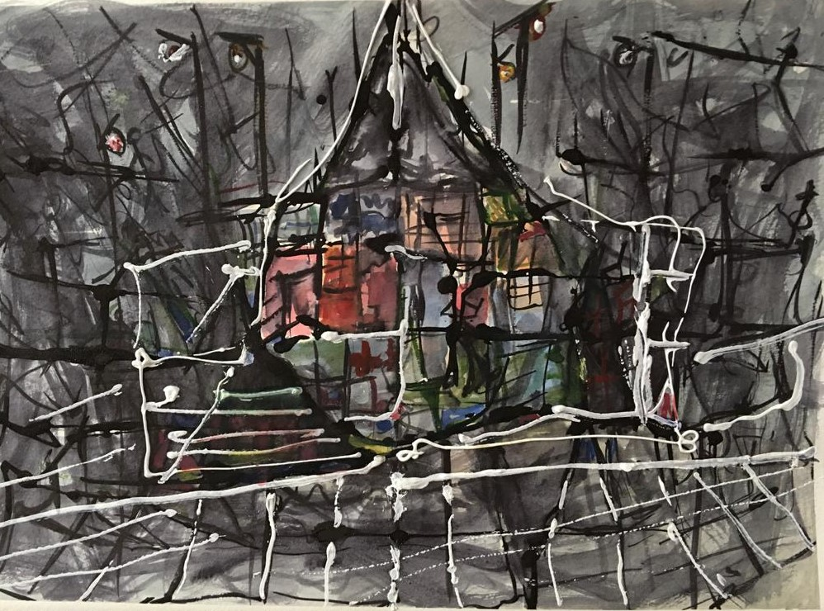
Artist: Vildan Asil, 2020, 40*30 Watercolor

The watercolor work above shows us many metaphors, objects, situations and movements that we are familiar with in nature. Here, beyond my interpretation or someone else's interpretation, it is quite exciting to follow how the artist interprets the quantitative and qualitative features that are already in my mind. Whether I like or dislike this painting as the watching subject is not the subject of this painting or a reality that reflects this situation, but a problem of my culturally subjective aesthetic perception. The world of quantity and quality of the elements of the painting, on the other hand, prompts me to analyze as a subject the problem of how the quantities and qualities in my mental space correspond to and interpret the world of perception. It is primarily the quantitative features of the painting, and secondarily the qualitative features of the painting, on which I can speak with certainty about what I see in the painting. The world of quantities is measurable. Attributes are the distinctive features of the object. These distinguishing features are color, tone of voice, etc. it could be. However, the color red has more than one shade and it varies with the subjects, but the name is still red. The question of whether the red I see is the same as the red that someone else sees has been the subject of philosophy of mind for years.

The World of Quantitatives and the Mind
We seek the objective reality of what we encounter in the world, independent of all subjective opinions. Our aim is to avoid a state of chaos as much as possible, to get closer to the real thing. In fact, it is the reality that we cannot agree on the source of many things that underlie most of our problems today. Even in the judgment of a subject or an art object or a simple landscape, the changing realities according to different subjects lead us to conflict. Human perception is often limited in making judgments about things, as we have mentioned. However, knowing this limit is necessary in order to evaluate and judge the object by taking a distance from its own reality. Thus, the arbitrary is avoided. Likewise, science strives to search for what is appropriate for the object's own reality. For this reason, it continues its journey towards the unknown parts, starting from the knowable aspects of whatever the research subject is. We are also trying to evaluate an art object in accordance with its own reality. In fact, in this evaluation, this time, we are dealing with an art object that will be examined from two aspects, unlike an object that will be examined scientifically from one side. Both the mind that turns to the art object and the mind of the artist who turns to our mind through the art object. “The effect of an object on its capacity for representation is sensation, insofar as we are affected by it. "This intuition, which is associated with the object through sensation, is called empirical. The undetermined object is called an experimental intuition aspect" (Kant, 1998, p. 155). The design capacity of the object is related to our sensation and phenomenal experiences. “Philosophers use the concept of “qualia” (singular “qualitative” [quale] especially to express the simplest and most basic form of phenomenal consciousness’ (Revonsuo, 2016, p. 130). The systematic organization of the qualifiers in the phenomenal consciousness so that we can define things seems to be related to the organized system of qualifiers, apart from Kant's intuition, which we understand literally. “Because the phenomenal consciousness is nothing but the brain-mind system in which the attributes are embedded, or perhaps a comprehensive organized nervous system made up of attributes (Revonsuo, 2016, p. 130). Quantitative and qualitative information we gain from situations or things we encounter are traces in our memory that will enable us to make sense of things in our next encounters. For example, the experience of the quantities and qualities of a dreamer when there is no object or situation in front of him is a result of the experiences recorded in the memory. Quantitative and qualitative features that we encounter and accumulate throughout life are very important in our encounters with objects. “How much experience we gain in a short time is called the perceptual span, which is one of the first steps of information processing. We know that the world is full of many stimuli, most of which are within the range of sensory detection” (Solso, K. MacLin, H. MacLin, 2016, p. 91). There are many quantitative properties of things in our perceptual space. For example, the sound of a horse walking, the sound of a train crossing the tracks, the dimensions of a chair, etc. Quantity can be expressed mathematically. Since colors are not measurable, they are determined as a quality by many artists and thinkers. Today, qualities such as color can now be converted into quantitative data, and thus various applications and programs can be developed. However, knowing the attributes without any digital tool can lead to different information between subjects. Since we are investigating the relationship of quantity and quality between the human being and his perception, and the art object, we consider quantities here as first-order definite knowable properties. The world of quantities and qualities is here not only peculiar to the subject judging the art object, but also belongs to the world of the artist.

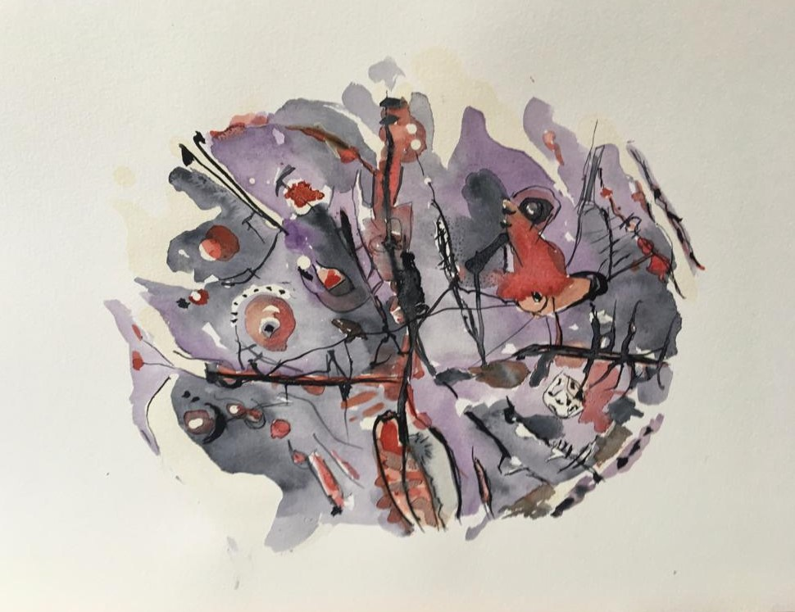
Artist: Vildan Asil, 2020, 40*30, Watercolor

The knowledge of form, the quantitative features that the artist reflects on his object, is one of the first sentences the artist tells us. Thanks to this sentence, our perceptual experience is activated and the subject tries to identify his own experiences with the art object. Here, rather than the viewer, the artist reflects a piece he has chosen from the world of quantities to his object by transforming it and looks for it in the mind of his audience. In the same way, the situation is the same in music, unlike the visual arts. Sometimes a classic rock band like The Doobie Brothers takes us on a train journey with the composition Long Train Running, sometimes Rimsky-Korsakovi puts us among the bees flying around with Flight Of The Bumblebee. If we had not experienced these quantities before, we would not have been able to make sense of what the artists wanted to express and point to us. . The transfer of quantity and qualities of the artist to the object of each branch of art, including the creation processes of those objects, is different from each other. But at the same time, thanks to these features, they can be converted into each other. For example, we can turn the rhythm of a movement we heard in a piece of music into a painting, or we can fix a dance figure that we quickly caught in a time flow in a sculpture in a space. We can do all this thanks to the mathematical structure of objects. “In the face of an aesthetic object, the subject should be able to grasp what the message conveyed by that object is. The accuracy and comprehensiveness of this understanding depends on having the most competent knowledge of the form of the object” (Ölcener, 2020, p. 15). Here, a rich mind experiencing phenomena can easily access this information. “At the center of consciousness, different qualities of experience are consistently linked together to form complex spatio-temporal patterns that correspond to perceptual objects” (Revonsuo, 2016, p. 132). In this way, subjects can perform the perception process. On the other hand, the “phenomenal background is very broad; It contains a mass of fuzzy images that surround consciousness both spatially and temporally. Every image is embedded in a spatial context, that is, a background that it experiences” (Revonsuo, 2016, p. 133). In the light of this knowledge of our day, we witness the following statements when we return to what Kant said, who lived years ago. “The imagination goes on forever, with nothing hindering it in the unification necessary for the design of magnitude; but the mind guides it through the number concepts that it has to provide for them” (Kant, 2005, p. 178) In this way, we can make logical calculations. Thus, the mind can first evaluate the quantitative properties when encountering an object. Thus, subsequent judgments, liking, pleasure, etc. They are the result of subjective experiences.

Is it the Watching Subject that makes the Aesthetic Judgment? Artist?
The majority will answer this question as the following subject. A theater play, a painting, a piece of music, a dance show, a movie, is in the position of an object standing in front of the watching subject. That is, he cannot breathe, physically cannot speak. It is the subject who watches it and evaluates it at once whether it is beautiful or ugly, or even whether it is useful or not. This issue has been a problem of the concepts of beauty and taste throughout the history of philosophy, and it has brought with it an effort to put the determination of these concepts into a reality. What is beautiful? What is like? and how should it be? Problems such as these have been tried to be explained by various standards by most people. The mental pleasures that the watching subjects have developed throughout their lives, just like their taste buds, have had an impact on these determinations. However, since the differences are diverse, no consensus could be reached on them, and the behavior of respecting individual tastes was developed with the slogan 'tastes and colors are indisputable', which we often hear. Today it is precisely this form of respect that is a source of the problem of 'I think' over a fact. Post-truth, which is considered as a problem of post-modernism, is to analyze a situation, an event, by missing its own reality in the face of that situation and event, with the decisions of "I think" and not to accept anything other than this analysis. While not discussing tastes and colors is a simple matter of pleasure, it actually shows us the dire state of our risk of missing reality every time. As of our subject, it can be questioned what relevance the judgment of an aesthetic object has on such a subject. It is important for its inferences to examine the judgment ability through an aesthetic object and to understand and comprehend these data by the mind. When we see a painting, a sculpture, listen to a piece of music, or read a poem, we must learn to guide our process of making sense and analyzing as a mind that tries to evaluate them in terms of their own reality and message, rather than judging them by the judgment of simple classifications. Only with this analysis ability of the mind can we approach the thing itself step by step. Minds that cannot approach this ability of analysis may try to destroy aesthetic objects, as we have witnessed in our age. Destroying an aesthetic object by making it an object of hatred is proof that it is not seen as an ordinary object. The desire to destroy an aesthetic object that contains all mental processes such as culture, emotion, perception and judgment is an attack not only on an object but also on a culture. Because this mind in the art object is the mind of the other who is in front of the viewer. The subject watching, encountering the eyes of the sculpture gods of the first age, almost also encounters the gaze of the artist. A painting offers the viewing subject a brand new space and can take him on a journey in this space. Or a piece of music can bring together many sensory experiences, enabling a subject to bring together sensory memories. The art object can bring together the experiences in different times and places by reminding the subject or invite him to the space of different cultures. At the same time, the experiences of the artists can create new compositions in mental time and space. The watching subject is faced with these compositions. Both the artist and the watching subject perform their own interpretation and analysis processes in line with their long-term memory experiences. Our long-term memory, unlike short-term memory, has the feature of "diversifying in coding, information abstraction, structure, capacity and continuity" (Solso, K. MacLin, H. MacLin, 2016, p. 219). At this point, the creative ability of the artist is to transfer the information in the long-term memory life to the object by abstracting it. The following subjects attempt to make sense of and interpret the quantitative and qualitative structure of this information with the information obtained from their own long-term memory. When we examine the picture below, we see that many quantitative and qualitative structures of various objects are abstracted. “The visual cortex is where the brain begins to process signals passing through the eyes through very small, specialized areas. Some of these areas respond to color, some to shape, and some to motion. However, when we think of objects, we remember all of these features” (Solso, K. MacLin, H. MacLin, 2016, p. 223).
Artist: Vildan Asil, 2020, 42*30, Watercolor

In the same way, the sounds of various movements, objects and objects take place in our memory. This is how we make sense of sounds or associate them with subjects.
The artist, who presents them to us again on an object with what he has acquired from the world of common objects with everyone, strives to identify with the traces of this common world of objects and the traces that exist in the watching subjects. Whether the artist is aware of this effort or not, he structures his object like a language that deals with objects and presents it to his audience. Of course, this language may not be easily understood or clear. The analysis of this language is closely related to the way in which all sensations such as seeing, hearing, touching, tasting and smelling the object make sense of the object. Being insensitive to this language or making random judgments about art objects without trying to learn this language will not reflect the expression of that art object itself. Thus, it is inevitable that we encounter the problem of whether the work is valuable or not, not with its own expression. However, valuing an object or an object without knowing its expression will be a completely subjective behavior. Here, the value of an art object will never reflect its reality. For example, an interpretation made without understanding how a sculpture or a painting expresses itself is an incomplete and wrong interpretation. “There is neither a science of beauty nor can there be, and the judgment of taste cannot be determined by principles” (Kant, 2005, p. 325). Here, Kant put forward his view on whether subjective taste can be considered as a definite judgment, and in this respect, he stated that the beautiful is not a science. There is an ambiguity of taste here. However, it may be possible to make sense of the reality of the object and to approach its own appearance in this way, from the field of vague judgment of taste. A mind that can make and learn to make such inferences will be individuals who can think critically, not only in the field of arts, but also in all other subjects. Judicial ability and power are important for people to survive and exist, even to be a society and to maintain their social relations in a healthy way. Accurate perception, interpretation and analysis of art objects, which are and will be carriers of societies and cultures specific to them, will also suit the purpose of art's existence. Because an artist desires to understand the language he constructs with his object. Thus, the artist seeks the minds that can give him the most correct judgment for his work. In this respect, an art object is the watcher, not the watched. Only a watching artist can build societies and cultures.

Resources
-Aristoteles (2018) Metaphysik Das Grundlegende aller Wirklichkeit, ISBN 978-80-268-2529-6, E-artnow.
-Gazzaniga, S. M., Irvy, B. R, Mangun, R. G (2009) Cognitive Neurosicience The Biology of the Mind, Newyork: W.W. Norton&Company
-Gombrich, E. H (1992) Art and Illusion, trans: A. Cemal, Istanbul: Remzi-Hammermeister, K. (2020) The German Aesthetic Tradition, Cambridge University Press.
-Hegel, F. G. W (2018) The Phenomenology of Sprit, Translated and Edited, T. Pinkard, Cambridge University Press
-Kant, I (2005) Critique of Judgement, Translated by J. H.Bernard., USA: Dover philosophical classics
-Kant, I. (1998) Critique of Pure Reason, çev. P. Guyer ve A.W. Wood, Cambridge: Cambridge University Press,
-Kant, I (2009) Kritik der Urteilskraft, Hamburg: Felix Meiner Verlag
-Ölçener, (2020) Aesthetic Mind, Editor, M. Ö. Küçük, ISBN 978-605-06365-8-, Istanbul: Article Publishing.
-Plato (2010) Platon Dialogues, Istanbul: Remzi Bookstore-Revonsuo, A. The Science of Consciousness and Subjectivity, Trans: S. Değirmenci, Istanbul: Küre, 2010.-Solso, R &Mclin, K. M. & Mclin, O, H. (2016) Bilişsel Psikoloji, Çev: A. Ayçiçeği- Dinn, İstanbul: Bilge Kültür Sanat,
-Zeman, A. (2004) Consciousness User Manual, Translator, G. Koca, Istanbul: Metis

This article was published in the special art issue of Syllable magazine. Olcener, (2021) Aesthetic Objec, Mind and Judgment, editör, U. Polat, p. 317., İstanbul.
Gnoseology (or gnosiology). A word for "knowledge" from the Greek gnosis. Solving problems about the nature and probability of knowledge, or any philosophy or branch of philosophy ... (10.02.2021, https://www.oxfordreference.com/view/10.1093/oi/authority.20110803095856873)
Wasilly Kandinsky “The art Of Spiritual Harmony” (1914)

