The Relatedness of YiJing and Quantum Physics

by Dr David Leong, PhD

- INTRODUCTION

From Albert Einstein, Werner Heisenberg, Erwin Schrödinger, David Bohm, Richard Feynman and other propagators in quantum physics, many were captivated by Chinese and Indian thoughts and ancient wisdom.

Einstein quoted: “When I read the Bhagavad-Gita and reflect about how God created this universe everything else seems so superfluous.” (Schweber, 2008) Schrödinger’s work was strongly influenced by the Vedas. (Raina, 2015) Danish physicist Niels Bohr, one of was intrigued by the Chinese notion of Tao. (Chin et al., 2018) Bohr is the father of the complementarity principle stating that objects have certain pairs of complementary properties which cannot all be observed or measured simultaneously. (Holton, 1970) Examples of complementary properties that Bohr considered: Position and momentum. (Wootters and Zurek, 1979) Another key tenet in quantum physics by Bohr stated that a complete knowledge of phenomena on atomic scale requires a description of both wave and particle properties. It is impossible to observe both the wave and particle aspects simultaneously. (Zinkernagel, 2016) When Bohr was knighted he used the yin-yang symbol in his coat of arms and inscribed within it with these words “Contraria sunt complementa” which mean opposites are complementary. This aligns with Yijing principle of duality and wave. Yijing is a body of knowledge derived at least five thousand years ago and dealt in the subject of quantum physics but in far lesser words and scientific rigor.

﻿One could take a species perspective as evolutionary biology does, a cultural perspective as anthropology does, a language group as linguistics does, a social systems perspective as sociology does, even a spiritual ontology as religions do. Whichever perspective, I contend that individuals contain in their worldviews from the filtered (interpret) “reality” and thus constitute their decision-making logic. Yijing is that body of knowledge distilled by the ancient sages to interpret the reality thousands of years ago by the Chinese. The interpretation of the Yin-Yang lines is possibility of the play. Life is like play and possibility. Carse’s (Carse, 1986) comparative theory of games fuses Confucian role ethics beyond foundational liberal individualism and constructed an alternative world cultural order.

Yijing evolves over time and was formulated in phases. In the beginning, it comprised of the basic 8 trigrams and 64 hexagrams originated by the mythical figure, Fu Xi. (T.-K. Hon, 2019) The second substantive encapsulation was written by King Wen and the Duke of Zhou during the 11th century BCE. (Lee, 1970) The third intellectual addition and augmentation incorporates seven pieces of writings composed from 5th to 2nd century BCE. Divided into ten segments (hence, the name “Ten Wings”), presumably by Confucius and his disciples, these writings used the hexagrams to discuss cosmic patterns, the relations between humanity and nature, and the interpretations of the complexity of human lives. (T. Hon, 2019)

The ancient sages did not contemplate electrons, protons, neutrons, and photons but they envisaged dancing particles with polarities in a flux-plasma. These thinkers had a grasp on the invisible realm that underlies appearances – the realm laid bare by particle physics which showed that matter, whether animate or inanimate, is energy known as Qi. (Alvino, 1996)

The work in this paper is presented with this spirit to draw the relatedness of Yijing to quantum physics and seek to express the continuity between the ancient sages and contemporary scientific thought. Yijing is abstract philosophical and can provide an excellent method for generating, structuring and exploring quantum fields relevant to our present level of scientific knowledge. Further, the view of reality that science emphasizes as a seamless, continuous field is the same as Yijing where ‘self’ as particle is deeply integrated into the basic fabric of reality through their consciousness. It is this consciousness that interacts and co-relates to that field of interconnectedness. (Schöter, 2011) The wholeness of realities, in Yijing, are layer of fields interacting, changing, extending into possibilities and uncertainties. Compare with theoretical physics quantum field theory (QFT) which is a theoretical framework that combines classical field theory, special relativity, special relativity, and quantum mechanics there are many similiarities. QFT is used in particle physics to construct physical models of subatomic particles and in condensed matter physics to construct models of quasiparticles. (McMahon, 2008)

QFT treats particles as excited states (also called quanta) of their underlying fields which are more fundamental than the particles. Interactions between particles are described by interaction terms involving their corresponding fields. (McMahon, 2008) Each interaction can be visually represented by Feynman diagrams according to perturbation theory in quantum mechanics.

Yijing forms a powerful notational system for exploring the manner in which the implicate order unfolds into the explicate, from the internal to the external, for exploring the manifestation of consciousness within pattern and matter.

The general background to the discussion in this paper is the study of the relatedness of Yijing and quantum physics bringing a mystical abstraction through precise formal scientific language and constructs, at the least, an analogue of the transcendent reality in an understandable coherent framework. In short, to express in the vernacular of science which offers contemporary perspective and relatedness to Yijing.

- THEORETICAL BACKGROUND

  - YIJING
    - Identity of Chinese philosophy

Understanding Yijing must start from the theoretical construction of Yijing from its ontological origin conversing with the new trends of Western thought emerging from similarities in thought streams and looking for the commonalities in the indeterminism propounded in Yijing and quantum science. The Western philosophical ontology or the “science of Being” starts with Yijing as ‘a-theistic’, independent, transcendent Dao as the source of order.” (Huang et al., 2017a) Contemporary genetics, social psychology, sociology and for that matter political science are a lot closer to the Chinese correlative paradigm than dualist thinking. Meanwhile, the thinking of the early philosophers of China might well correspond to the efforts of some postmodernists after the failure of modernism, particularly in the quantum physics study of the particles science. Physicists hope that the Large Hadron Collider (LHC) at CERN in Switzerland, in 2012, found evidence for the elusive Higgs boson particle, which explains why other particles have mass, and for a phenomenon known as supersymmetry. (Fan et al., 2016) Particles are smashed together at velocities approaching the speed of light with resulting collisions revealing information about the way the universe is built. The discovery has been phenomenal that appears to prove the existence of the Higgs boson also known as “the God Particle” because it determines the mass of all things. (Launius, 2014) It took nearly 50 years from Nobel laureate physicist Peter Higgs predicting the existence of the particle to scientists in CERN claiming to have discovered it in 2012. In Yijing, supersymmetry is the core of its paradigm. Yin-Yang is the super-symmetrical emanations of all things and being in the perspective of Yijing. In the 100 years since the quantum revolution, the fascinations of the Chinese thoughts are slowly being understood. Today’s physicists still struggle to interpret the findings of particle physics, among them the wave-particle duality. Despite a century of trying, physicists have yet to reconcile the standard atomic model with Einstein’s Relativity Theory. The former deals with the micro-cosmos (subatomic particles), the latter deals with the macro-cosmos (gravity). Their integration would ostensibly provide a Theory of Everything. In the sense of such scientific predicaments, Yijing’s value in its indeterminism theory has convergence with current study of quantum physics. Its beliefs has universal assertions of values and principles alignment with modern science. The Yijing’s correlative worldview, thinking modality, and value systems has the capacity of responding to issues of modernity and the various problems troubling mankind in the postmodern era. This provides people with alternative perspectives to understanding their way ahead in a new world.

There is no China and Western dualism or dichotomy since it is unlikely that any culture can reign supreme and perfect in interpreting the reality of the world. It is not about asserting superiority in any of the thoughts, whether Chinese or Western, but to find similarities, commonalities and relatedness of the disciplines of thinking or as the title suggests, the relatedness of Yijing and Quantum Physics. The differences between the classical Chinese world view and those classical Greek, Roman, and Judeo-Christian assumptions that dominate and ground Western traditions are fundamental. Generalizations come first; then, with further study, one discovers the exceptions, the nuances, and the qualifications. Without the generalization, however, people cannot proceed in their quest for understanding any more than they can use most databases without first defining the fields of entry. Generalization is a common, necessary, and inevitable aspect of our learning. Therefore, the major question is not about the exceptions, but whether the comparisons and comparable do indeed catch the main drift of the cultural and relevant theoretical differences.

The ancient Chinese book "Yijing" (otherwise known as "I-Ching," the Book of Changes) is an ancient Chinese classic that dates back at least four thousand years. (circa 2000 B.C.E). (Secter, 1998) The Yijing provides not only a primordial strand of philosophy of Dao for most of the schools of thought in the Chinese tradition, but also a summary of yin-yang correlative cosmology that is shared by most classical Chinese thinkers such as Confucians, Taoists, Legalists, Mohists, and Militarists, who generally believe that the Dao is like the fields permeating through the space and human responds these charges (measured in terms of positive and negative charge or in the Yin-Yang oscillations). (Zhang, 2012) The human experience are continuous and mutually acting and reacting to the field. The description of such fields are very similar to how quantum field theory defines fields. Quantum Field Theory (QFT) is the mathematical and conceptual framework for contemporary elementary particle physics. It is also a framework used in other areas of theoretical physics, such as condensed matter physics and statistical mechanics. In a rather informal sense QFT is the extension of quantum mechanics (QM), dealing with particles, over to fields, i.e. systems with an infinite number of degrees of freedom. In the last decade QFT has become a more widely discussed topic in philosophy of science, with questions ranging from methodology and semantics to ontology. (Wallace, 2011) QFT taken seriously in its metaphysical implications seems to give a picture of the world which is at variance with central classical conceptions of particles and fields, and even with some features of QM.
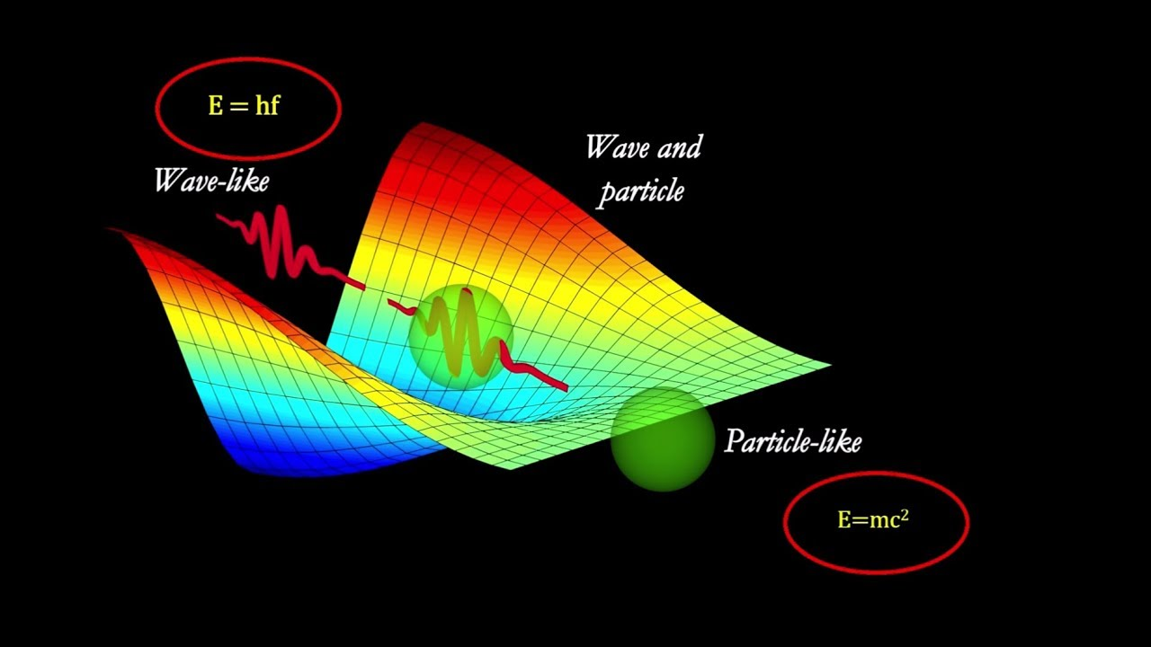
Diagram 1, Wave-particle duality
Diagram 1 shows how QFT describes fundamental physics and what the status of QFT is among other theories of physics. (Wallace, 2011) Since there is a strong emphasis on those aspects of the theory that are particularly important for interpretive inquiries, it does not replace an introduction to QFT as such. One main group of target readers are philosophers who want to get a first impression of some issues that may be of interest for their own work, another target group are physicists who are interested in a philosophical view upon QFT. Laozi, expressed wave properties through his observation of water. Historical Daoism traces its origins to Laozi, an extraordinary thinker who flourished during the sixth century B.C.E., according to Chinese sources. Laozi, in his Daodejing, chapter 8 expressed “A person of great virtue is like the flowing water. Water benefits all things and contends not with them. It puts itself in a place that no one wishes to be and thus is closest to Tao. A virtuous person is like water which adapts itself to the perfect place. His mind is like the deep water that is calm and peaceful. His heart is kind like water that benefits all. His words are sincere like the constant flow of water. His governing is natural without desire which is like the softness of water that penetrates through hard rocks. His work is of talent like the free flow of water. His movement is of right timing like water that flows smoothly. A virtuous person never forces his way and hence will not make faults.” (Wang, 2018) Such texts are interpreted and contextualized to the human affairs but within the text, it is quite clear that from a philosophical standpoint, Laozi saw the need to use wave to define a social phenomenon.

Among schools of thought in the Chinese tradition, the differences between the classical Chinese world view and those classical Greek, Roman, and Judeo-Christian assumptions that dominate and ground Western traditions are much more fundamental as they see the world in flux, polarities and constant change expressed in flowy poetic rendering making them abstract and hard to understand for the uninitiated. Yijing philosophy including the Chinese yin-yang correlative worldview of tianxia (all under heaven and earth) has not been paid enough attention by scholars on their correlation to science. The Yijing contains most of the fundamental principles in the world, including the correlative relationship between yin and yang, or two opposing forces, which themselves include polarities such as bright and dark, moving and static, weak and strong, hidden and visible, and so forth. (Secter, 1998) When applied to human society, the relations between different polities are also in the network of such changes and interactions. This ancient book as a philosophical expression of tradition and transformation of the world as the book contains philosophical thinking on the cosmos and its development. The coverage span from nature, science, human, and civilization, cosmology, space-time and even to divination of the state of probabilities, forecasting the many world-possibilities in its mathematical formulation. The uninitiated see this as superstition but for those trained in the art of Yijing mathematical structure, it is a forecasting tool with deep dimensionalities.

    - Yijing and Yi-Yang way of thinking

The Chinese way of thinking, making decisions, and producing knowledge is encapsulated in “correlativity” (Huang, 2019) (continuity through change, or in plain terms, processual and relational), which inevitably renders a diversified harmonious culture. Yijing, which has had a powerful influence on Chinese ancient understanding of world order. (Huang, 2019)

In ancient Chinese philosophy, correlativity presents an image of two things being tied to each other, each of which constitutes continuity with the other, and being seen associated with a change from one thing into the other and/or transforming into yet something else. Correlativity consists of three key ideas in the Yijing: polarity, continuity, and changes. (Qin, 2014) In the Yijing the world is viewed as a world of correlations (of any type, loose or tight, multilevel, multidimensional, multi-fold, and multicategory). In such a world, as Hall and Ames (Huang et al., 2017a) point out, there is no element or aspect that in the strictest sense transcends the rest: Every element is related to one another, and all elements are correlative, a style which is distinctly Chinese, but not necessarily uniquely Chinese. Formulated in Chinese ancient philosophical literature such as the Yijing, it has a powerful influence on the Chinese culture. (Huang et al., 2017b) Even the term “something” implies a tendency to think in terms of essences (substance ontology vs. procedural metaphysics). As Yijing is fully expressed within Dao, the Dao is fully expressed with Ying-Yang oscillation, the emanation of all things under heaven and earth. (Zhang, 2011) The salient feature of the Yijing philosophy is that the complementary and contradictory interactions of the two basic elements of a polarity like yin-yang constitute the forces, and produce change. With no transcendence, every element is relative to every other and all elements are thus "correlative." Each particular is both self-determinate and determined by every other. An explanation of relationships requires a contexualist interpretation of the world in which events are strictly interdependent. "Polarity" implies a relationship of two events, each constituting a necessary condition for the other. Yin always morph becoming-yang, and vice versa. Any two events constantly alternate each another, change into each other, exchange with each other, and displace each other, and so on. (Zhang, 2011) To be concrete, there is no sense of dualism and transcendence associated with ancient Greek’s philosophy compared in Yijing philosophy. The sky, earth, and ten thousand events mutually correlate with each other. It is interactions of the two basic elements of a polarity like yin-yang that constitute the forces, and produce change. (Chen, 2008) From vacuity, the expansionary force or Qi creates 1 to 2 which is primordially Yin-Yang and it grow from 2 to 4 to 8 in a binary growth patterns to form “the ten thousand events” meaning all observable lives, objects and phenomena under heaven and earth. (Sellmann and Graham, 1988) The Confucian "polarity" implies a relationship of two events for example, each of which constitutes a necessary condition for the other. Each particular element is both self-determinate and determined by every other particular element. A polar explanation of relationships requires a contextualist interpretation of the world in which events are strictly from the interactions of the Yin-Yang. (Huang et al., 2017a) Such correlative polar metaphysics precludes all dualistic, absolute, and essentialist conceptions such as self/other, identity, human nature, all under the heaven and earth literally, or all in a world of correlations and harmony which reflects Chinese correlative Yin-Yang cosmology. Thus, a correlative thinking and scheme of contextualization replaced ontological and dualistic assumptions that have accompanied Western concepts. (Huang et al., 2017b) To understand correlativity in Chinese tradition, we may look into theory in the field of quantum theory. All the connections and correlations are stitched into a fabric or field equilibrating at all time and at any time, it is in a state of non-equilibrium like a construction of non-equilibrium steady states in one-dimensional quantum critical systems carrying energy and charge fluxes. The energy described in QED is the Qi in Yijing and charge fluxes are the clouds of Yin-Yang permeating in the system. The driving force of the system is the Qi that are in differing phases of composition and decomposition through the play of Yin-Yang. The force of the dynamical system can be decomposed into the gradient of a potential landscape and curl flux (current). The fluctuation-dissipation theorem (FDT) is often applied to near equilibrium systems with detailed balance. The response due to a small perturbation can be expressed by a spontaneous fluctuation. (Feng and Wang, 2011)

    - Yijing as a Philosophy

Way of Observing Reality and World View from the perspective of Western Thinking and Yijing.

 | Western Thinking Philosophical Paradigm | Yijing Philosophical Paradigm
World View | Cosmology  Cosmogony  Cosmo: the totality of things constitutes a single ordered world/ antithesis between chaos (nonrational, unprincipled, anarchic and lawless) and Cosmos.  What is a transcendental being? | Acosmology (a natural cosmology)  Acosmogony  Acosmos: Absence of belief in a single ordered world and the employment of aesthetic over logical senses of order/ all under heaven and earth and the ten thousand events mutually corelating to each other, interlocking and interlacing in a pattern of relationships.  How? Yi-Yang’s correlativitism – continuity through change in relations between persons and among the myriad of things and events between heaven and earth.
Mode of Thinking | Rational thinking  Causal thinking/ linear and single phase thinking/analytical thinking/ logo-centrism/ individualism other than holism. Part and whole: atomism and holism. | Correlative thinking  Correlative thinking including rational thinking/ process thinking/ analogical thinking/ a holographic understanding of world systems, recognition that each and every unique phenomenon is continuous with every other phenomenon within one’s own field of experience.  Field and their environment- intrinsic and constitutive nature of relations. Field can be as small as a person to person field or family or as extensive as the entire world or universe. This permeating field is a notional idea like the wave-field where all points are connected and vibrating in tandem.
Values | “God” oriented values  Human as most fundamentally free, rational and self-interested autonomous individuals  Competition  Individualism. Individual interest as final goal of economy, politics and social life.  Government, corporation, collectives are extension of concepts of individuals. | Harmony expressed as zhonghe. The continuity between the natural context and the human experience. “zhong” meaning centerness; “he” meaning togetherness. Harmony of differences, assimilating differences, harmony but not without differences.  Social fabric constituting a field-wave concept where the social with inter-relatedness of person, communities where freedom is not given but achieved through the community.  Harmonious relationship supersede all other relationship forming.  Collectivism.  The self as a unit is based on the correlativity or interrelatedness, interdependence, appropriateness. Actions are expected to be properly and particularly situated within roles and relations. Appropriateness is fitting within specific circumstances.  Confucian role ethics,  No trancedental one or God.  No competition (competition is a play of finite game with win-loss situation) as against infinite games with win-win context.  No individualism but collectivism with continuity and correlation; any individual as correlative and a continuity with any other individual.
Games | Finite game is played in order to be won when they end. The purpose of play is to arrive at a decisive conclusion about triumph and defeat. Finite games include chess, or traditional wars, or any contest in which opponents understand the rules and agree on a winner and loser.  Finite games may offer wealth and status, power and glory.  The boundaries of contest -- date, place, and membership -- of each finite game are externally defined. The rules of a finite game are the contractual terms by which the players can agree who has won. The rules must be published before play, and the players must agree to them before the beginning of the play. | Infinite game is played for the purpose of continuing the play and bringing as many people as possible into the play. The rules, boundaries and participants may change, as long as the game keeps going,  to come to an end. The rules are changed when the players of an infinite game agree that the play is imperiled by a finite outcome--that is, the victory of some players and the defeat of others.  Infinite players regard their wins and losses in whatever finite games they play as but moments within a larger field of continuing play that extends beyond the finite game. That is, infinite games offer something far more subtle and far grander, because the goal is to keep everybody in play. What is your future, and mine, becomes ours. We prepare each other for co-creative surprise.  A finite player seeks power; the infinite one displays self-sufficient strength.  Infinite Game is not bounded by time, space, or eligibility. Infinite games are internally defined, because each play of an infinite game eliminates boundaries, it opens to players a new horizon of time. Finite players play within externally defined boundaries, while infinite players play with internally or co-creatively defined boundaries.
Adapted (Huang et al., 2017b), with modifications.

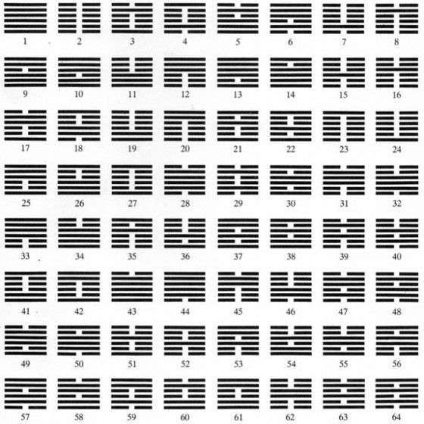
Diagram 2, 64 Hexgrams
The symbols, shown in Diagram 2, from Yijing or the Book of Change encapsulate the possible permutation of changes through Yin-Yang, represented by broken and solid lines.Yijing hexgrams and trigram (gua) is a binary number system. Both binary numbers and Yijing trigrams and hexagrams use sequence of elements with two possible values – 0 and 1 or broken and solid respectively. Their origins lie deep in China’s past, born from the divinatory practices of the Zhou dynasty – but the patterns of open and closed lines originated from Fuxi. It is said that the emergence of Fuxi is around 2600 BC and this broken and solid lines representation of changes of realities resonate down through the millennia to the present day. (Secter, 1998)
The Chinese language and the Yijing’s hexagrams should be seen as an abstract representational pictorial thinking. Imagistic thinking based on the movement of from the strokes in Chinese characters or the broken and solid lines in the trigrams/ hexagrams is a dialectical concept of action. The Chinese characters, trigrams/ hexagrams are flat and two-dimensional but within the form of the words, trigrams/ hexgrams lies movement and action explaining the Yijing’s dialectical 3-dimension representation with movement. This dialectical dimension as a mathematical ordering principle lead to the divination aspects of the future states known to many but because such deep philosophical concepts and understandings are unknown to the uninitiated, such divination, can also be called forecasting in management terminology, is looked upon as superstition. It is therefore regrettable that Yijing is seen by many as only a divination tool. Yijing, with its plurality with order and features is a living logic, a pragmatic hermeneutical logic of nature and life. (Huang et al., 2017a)

Yijing’s hexagram is a stack of 6 lines piled upward from bottom to top by either broken line (Yin) or solid line (Yang). The progression from bottom to time signifies the flow of time. An abstract time but describes the dynamic temporality of the living moment (shi). Yijing is a system of representation with the stack of 6 lines, and because of its unique structure and principle of signification, it forms an open hermeneutic space with infinite possibilities of interpretation.” The Yijing is an open semiotics in relation to a changing world, indicating an interpretive model for forecasting or reading changes in the moments. (Nelson, 2011)

The Yijing system has 64 hexagrams (gua) each with 6 lines (broken or solid known as yao) producing 384 (64 x 6) yao. Each yao tells people in one specific situation how one can seek propitiousness (ji 吉) and avoid unpropitiousness (xiong 凶). This is a simplistic treatment of the looking at progression of change through time each with change producing a certain outcome. There actually 4 enumerated outcomes – ji (吉)= propitiousness, xiong (凶) = unpropitiousness, hui （悔）= regret, lin （吝）= unfulfillment. Each of this outcome actually pivot on (zhong 中, or translated as appropriateness/ centredness) –centred (得中)or not centred不得中. This lines changes through the stages by from Line 1 to Line 6 (bottom to top) and each changes arise from the flow of Qi. (Huang et al., 2017a) The concept is similar to energy excitation orbit jumps.

A quantum mechanical system or particle that is bound—that is, confined spatially—can only take on certain discrete values of energy, called energy levels. (Zicovich-Wilson, Planelles and Jaskóalski, 1994) This contrasts with classical particles, which can have any amount of energy. The term is commonly used for the energy levels of the electrons in atoms, ions, or molecules, which are bound by the electric field of the nucleus, but can also refer to energy levels of nuclei or vibrational or rotational energy levels in molecules. The energy spectrum of a system with such discrete energy levels is said to be quantized. (von Klitzing, 1986)

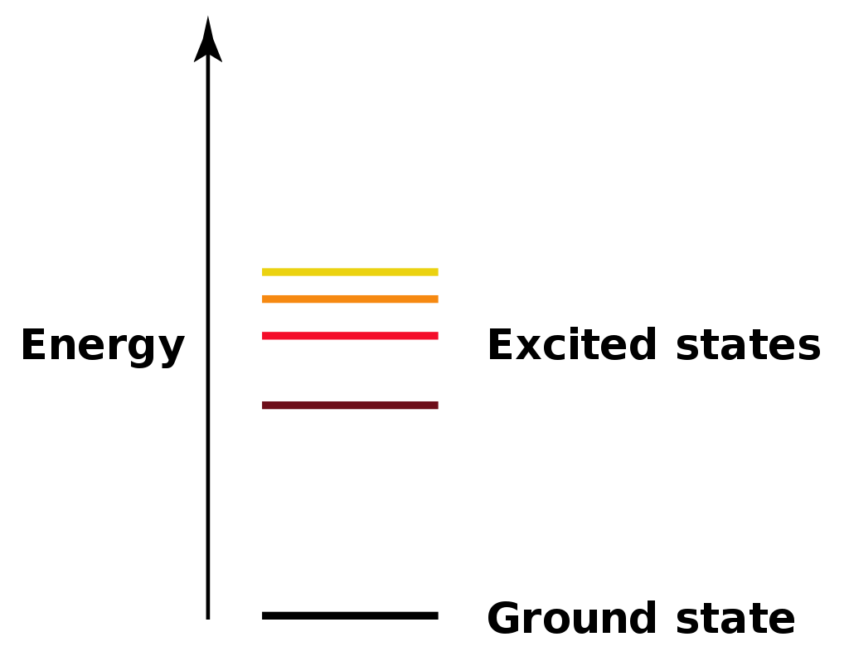
Diagram 3 Diagram 4

A simple example of this concept comes by considering the hydrogen atom. The ground state of the hydrogen atom corresponds to having the atom's single electron in the lowest possible orbit (Pople and Nesbet, 1954) (See Diagram 3) (that is, the spherically symmetric “1s” wave function which, so far, has demonstrated to have the lowest possible quantum numbers. By giving the atom additional energy (for example, by the absorption of a photon of an appropriate energy), the electron is able to move into an excited state (one with one or more quantum numbers greater than the minimum possible). If the photon has too much energy, the electron will cease to be bound to the atom, and the atom will become ionized. After excitation the atom may return to the ground state or a lower excited state, by emitting a photon with a characteristic energy. (Kojevnikov, 1999) Emission of photons from atoms in various excited states leads to an electromagnetic spectrum showing a series of characteristic emission lines. An atom in a high excited state is termed a Rydberg atom. A system of highly excited atoms can form a long-lived condensed excited state e.g. a condensed phase made completely of excited atoms: Rydberg matter. Hydrogen can also be excited by heat or electricity. (Pauli, 1994)

Hence the movement of the lines in the hexagram (see Diagram 4) from the bottom will move up depending on the Qi fluctuation in its differing state of excitation becoming either Yin or Yang as it progresses through time and whether as it comes to each stage (6 stages) or orbit, they are appropriate or centred. This way of thinking about appropriateness and specific situations is called shi-hong (时中 situational appropriateness, or equilibrium), which is the central idea of the Book of Changes, telling us about how to seek propitiousness and avoid unpropitiousness (qu hi bi xiong 趋吉避凶) fitting within specific circumstances, as time changes and circumstance varies. Shi-zhong (situational appropriateness) and harmony are considered as a correlative yin-yang paring: “Without zhong, harmony cannot be achieved; without harmony, zhong is pointless.” “‘shi 时’ in ‘shi-zhong’ here means ‘he shi 合时’ or ‘ying shi 应 时,’ namely ‘opportune’ or ‘appropriately timed’. (Chang, 2009) When the situation is right and a favorable tendency is formed, one should seize the opportunity and forge ahead. Good timing takes place in the entire context of an action.” Since “zhong 中” “takes into consideration multiple factors in a specific situation, including timing.” “Harmony implies being well adjusted and balanced.” Zhong stands for (taking) the unright, unbiased, and balanced way, (making) the right choice, or (doing) the right thing, which actually goes over the finite game’s logic of wins and losses. (Chang, 2009) To be more concrete, actions are required to be appropriate (yi 义), which means doing what is fitting in a proper and in a fitting manner, given the specific situation. Within a tradition in which person is an actor thus is required to accommodate the interests of all concerned, rather than being only self- interested (li 利), and at the same time required to take into account of both means and ends, and also both longer term and larger scale. Appropriateness (yi 义) and self-interest (li 利) are also considered as a correlative yin-yang paring. Chinese people tend to consider both yi 义 and li 利, and take a appropriately timed way (a way to situational appropriateness) in order to pursuit holistic harmony (he). Appropriate interest (yi-li义利, balance between appropriateness and self-interest) is generally viewed as viewed as irreducibly social, and the “I” and the social context are reflexive and mutually entailing, propitiousness (ji 吉) in the yijing. Strictly speaking, Book of Changes is an incomplete translation of the “Yijing,” since the “Yijing” not only literally means Book of “Changes,” but also tells people about what should be “unchanged”: (situational) appropriateness. All timely actions of changes should be taken to pursuit (situational) appropriateness; otherwise actions might be unright, biased, or unbalanced, and certainly unpropitious. (Huang et al., 2017a)

﻿Yijing, as it developed over time, was that these hexagrams represented the basic circumstances of change in the universe and essentially it is employing the use of a multi-dimensional hexgram to equate to a certain space-time. By selecting a particular hexagram and correctly interpreting the various symbolic elements of insight into the patterns of cosmic change can be made and subsequently devising a strategy for dealing with problems or uncertainties concerning the present and the future. (Smith, 2013)

﻿The overall meaning of the hexagram—in particular its powers and possibilities of interpretation depends very much on the observer and state of mind at the point of observation. For the uninitiated, looking at the hexagram is utterly baffling and perplexing. The six lines of each hexagram represent an evolving situation in time and space, a “field of action with multiple actors or factors,” all of which are in constant, dynamic play. (Matthews, 2016)

﻿The lines reading from the bottom to the top, represent the development of this situation and/or the major players involved. The first, second, and third lines constitute a “lower” trigram and the fourth, fifth, and sixth lines comprise an “upper” trigram, each having its own set of primary and secondary symbolic attributes. The lower trigram depicts the thoughts arising from the inner self and the upper trigram represents the state of externalities. Interpretation involves an understanding of the relationship between the lines, line statements, and trigrams of the chosen hexagram, and often an appreciation of the way that the selected hexagram is related to other hexagrams. Commentaries of every conceivable sort have historically provided guidance in negotiating a path to understanding.

﻿It is important to remember, however, that despite Yijing’s unchallenged scriptural status and canonical authority, the 64 hexagrams offers an enormous amount of interpretive flexibility based on the permutations of yin/yang lines in the 64 hexagrams. By nature it remains an extraordinarily open-ended, versatile, and virtually inexhaustible intellectual resource and pool of inspirations.

The Yijing’s eight trigrams (bagua) are analogies or symbols of something coming from nothing. There are two arrangement of the bagua.

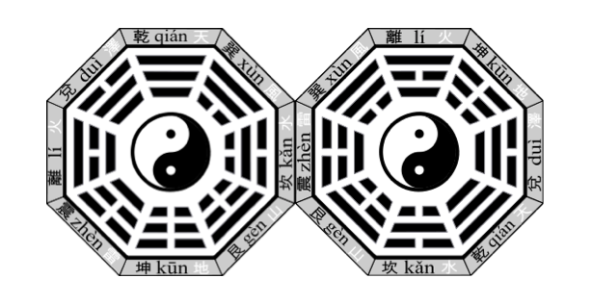
Pre-heaven Gua Post-Heaven Gua
Diagram 5

Diagram 5 shows the Pre-Heaven gua arrangement which is the primordial orientation, the first origination arising from nothingness, with the infusion of Qi to form the first pair of Yin-Yang which is described as Qian (Yang) and Ku (Yin) and growing from 2-4-8. The sequence is as such: From nothingness to the singularity (1), splitting into 2, then 4, then 8. Organic growth of living cells is fashioned after this number series. (See Diagram 6). Diagram 7 shows the binary growth of the gua dividing like the cell proliferation/ division pattern.

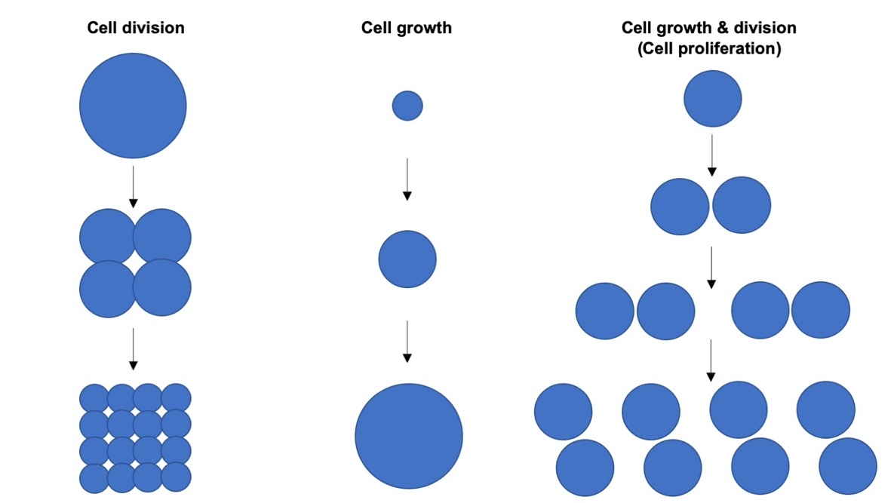
Diagram 6

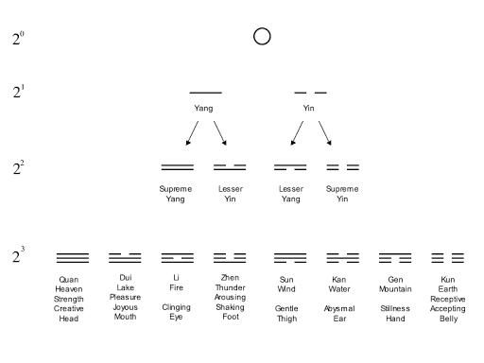
Diagram 7

This first configuration of Pre-Heaven has the following pair of Yin-Yang that emanate from Qian and Ku.

Qian (Yang/ +) -Kun (Yin/ -)
Zhen (Yang/ +) -Xun (Yin/ -)
Kan (Yang/ +) -Li (Yin/ -)
Gen (Yang/ +) -Dui (Yin/ -)

These pairs of Yin-Yang follows the complementarity principle and in Diagram 5, each of these pairs are opposite each other, annihilating each other with their opposite charge achieving equilibrium with the balance of charges or Yin-Yang.

In modern physics, antimatter is defined as matter which is composed of the antiparticles (or "partners") of the corresponding particles of "ordinary" matter (Dine and Kusenko, 2003) similar to the gua pairs as shown above.

There is another interesting perspective in the 8 trigrams that need emphasis. Qian (Heaven, Yang/ +) -Kun (Earth, Yin/ -), Zhen (Thunder, Yang/ +) -Xun (Wind, Yin/ -), Kan (Water, Yang/ +) -Li (Fire, Yin/ -), Gen (Mountain, Yang/ +) -Dui (Lake, Yin/ -). Each of this trigram has a representation – Qian being heaven and Kun being earth. Prima facie, these looks like fool’s rendering. What has lake to do with mountains? What has water to do with fire as complementary pair? These are metaphors and these representations connote similar values. Names are just ascriptions given to objects and in Yijing, names given are therefore convenient references not particularly referring it to mountain, lake, thunder or wind.

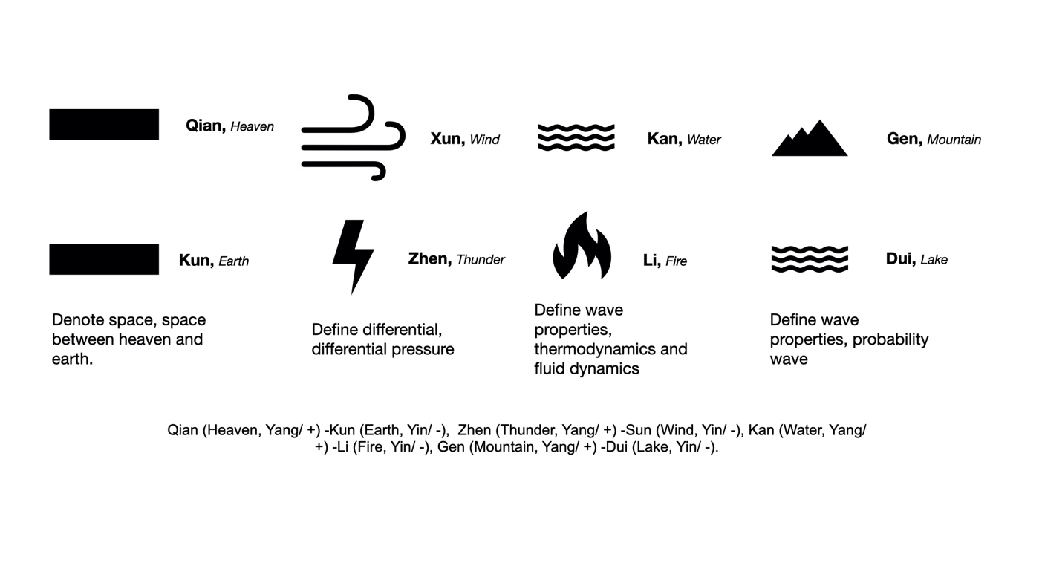
Diagram 8

In theory, a particle and its anti-particle (for example, a proton and an antiproton) have the same mass, but opposite electric charge and other differences in quantum numbers. (Dine and Kusenko, 2003) For example, a proton has positive charge while an antiproton has negative charge; similar to the 4 pairs of gua bearing opposite charges to each other. A collision between any particle and its anti-particle partner leads to their mutual annihilation, giving rise to various proportions of intense photons and neutrinos and sometimes less-massive particle–antiparticle pairs. The majority of the total energy of annihilation emerges in the form of ionizing radiation. If surrounding matter is present, the energy content of this radiation will be absorbed and converted into other forms of energy, such as heat or light. The amount of energy released is usually proportional to the total mass of the collided matter and antimatter, in accordance with the mass-energy equivalence equation equation, E=mc².

There is strong evidence that the observable universe is composed almost entirely of ordinary matter, as opposed to an equal mixture of matter and antimatter. This asymmetry of matter and antimatter in the visible universe create the disequilibrium that necessitate continuous agitation to reach the state of balance and equilibrium. This is where the Post-Heaven bagua shall arise out of the imbalance and disequilibrium. The process by which this inequality between matter and antimatter particles developed is called barygenesis. (Zhuridov, 2016)

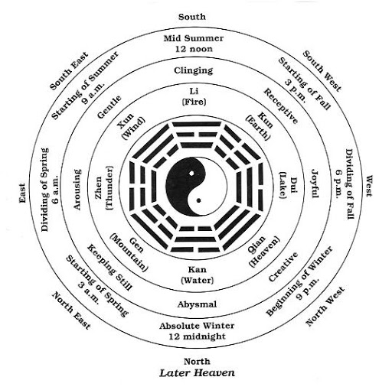
Diagram 9

The Post-Heaven bagua, shown in Diagram 9, emerges from the Pre-Heaven bagua which is symmetrical and balanced by symmetry breaking that favour the creation of normal matter (as opposed to antimatter). The matter referred is the same as the all things under heaven and earth. The north-south axis in the Pre-Heaven is heaven (Qian) and earth (Kun) is replaced with Fire (Li) and Water (Kan). With water, and its circulation, all lives under heaven and earth arise.

In physical cosmology, baryogenesis (Fukugita and Yanagida, 1986) is the physical process that is hypothesized to have taken place during the early universe to produce baryonic asymmetry, i.e. the imbalance of matter (baryons) and antimatter (antibaryons) in the observed universe. Quantum field theory and statistical physics are used to describe such possible mechanisms.

Therefore, the imbalance between matter and antimatter is a result of symmetry breaking from the symmetrical Pre-Heaven bagua.

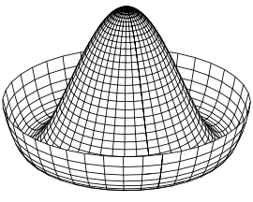
Diagram 10

Diagram 10 is a depiction of a “Mexican hat” potential function (Giacosa, 2009). For both the bagua, Pre-Heaven and Post-Heaven, some imagination is needed to visualize the bagua into 3 dimensional perspective where their individual centre is a dome.

Consider a symmetric upward dome with a trough circling the bottom. If a ball is put at the very peak of the dome, the system is symmetric (Pre-Heaven state) with respect to a rotation around the centre axis. But the ball may spontaneously break this symmetry by rolling down the dome into the trough, a point of lowest energy. Afterward, the ball has come to a rest at some fixed point on the perimeter. The dome and the ball retain their individual symmetry, but the system does not. In the simplest idealized relativistic model, the spontaneously broken symmetry is a play of energy in the system in kinetic and potential energy terms.

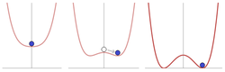

Diagram 11

Spontaneous symmetry breaking illustrated: At high energy levels (left) the ball settles in the center, and the result is symmetric. At lower energy levels (right), the overall "rules" remain symmetric, but the symmetric "Mexican hat" enforces an asymmetric outcome, since eventually the ball must rest at some random spot on the bottom, "spontaneously", and not all others. (Giacosa, 2009)

Yijing is thus a universal symbolic language aimed to interpret the phenomena of the world through the binary dyadic of Yin-Yang mathematical model which provides a principle for appropriately ordering, arranging, and systematizing knowledge and the world in its variability and transience. In Yijing binaries are not static, as shown in the Mexican hat example as the asymmetric produces energy movement between potential energy (Yin) and kinetic energy (Yang). Yin-Yang is dualistic but encompasses contrary and complementary relations of mutuality and differentiation. Yijing’s logic is simple oscillation of the Yin-Yang to create the ten thousand things under heaven; through that movement shift potential energy, in a state of equilibrium, to kinetic energy. A series of iterative perturbations/ disturbances of the field will cause an interplay of potential and kinetic energy.

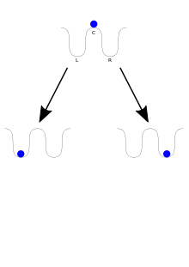  Diagram 12 | A ball is initially located at the top of the central hill (C). This position is an unstable equilibrium: a very small perturbation will cause it to fall to one of the two stable wells left (L) or right (R). Even if the hill is symmetric and there is no reason for the ball to fall on either side, the observed final state is not symmetric.
The Yijing’s pragmatic probabilistic rationality with the “twists and turns” possibilities interprets and responds to worldly phenomena. (Nelson, 2011) The Yijing is therefore an open semiotics in relation to a changing world, indicating an interpretive material logic with reference to nature. It is using the binary symbol to construct the world of possible changes.

Yijing, in its simpliest reductionist conclusion is about nothingness to creation to the singularity, then to harmony, disharmony, destruction to state of nothingness and to creation again. The harmony of the Yijing itself, does not proceed by subsuming a particular under a universal or mediating it within a totality. Rather a plurality of singulars in an unforced harmony in the most perfect multiplicity.
The entire philosophy is about maintaining that immanent significance and singularity of things with the unforced harmony in the most perfect multiplicity; each thing has its own meaning, measure, and natural spontaneity. This is the best explained and encapsulated in Chinese as 道法自然 (dao fa zi ran) (Yang, 2019)

The Construction of the Hexagram

A hexagram is defined by its six line- places, which can be either solid or broken. Thus there 64 hexagrams. These constitute a self-contained sign-system with bifurcation probability (Yin or Yang) at every of the 6 stages. Every gua is a system of 6 lines. These signs are partially integrated into the Chinese language. Qian and Kun, the first two hexagrams are the doors to all other permutations. Qian and Kun are known as the beginning of the spin and the doors to new possibilities. Hexagrams are considered an alternative sign-system, one that offers more potent means for expressing otherwise hidden meaning through their super-linguistic clarity.

Relationships Between Hexagrams

The relationship between any two hexagram configurations is simply a matter of the play of the yin/yang lines and they can morph from one hexagram to the next through transformation over time. These relationships may be close or distant, and rely on criteria as simple as shared lines and inversions or as complex as serial transformations (guabian), nuclear trigrams, etc. One significant relationship between hexagrams is the sequential ordering of the sixty-four. The current sequence is structured as thirty-two pairs. Twenty-eight of these pairs are the inversion of each other, as with #23 ! and #15 6. Hence of the 28 pairs will be equal to 56 hexagrams (guas). The remaining 8 hexagrams (guas), the hexagram remains unchanged on inversion. These 8 hexagrams (guas) are:

@aRjv1r3

We can best explain his sequence if we invoke the system of binary mathematics. Treating the solid and broken lines as if they were 1's and 0's, Qian, with six solid lines, becomes the number 111111. Among other things, each hexagram is correlated with a time period, and each time period is envisioned as a stage in an universal unfolding. The hexagram is therefore used to define space-time moment and as the time unfolds, hexagram changes to represent the following moment.

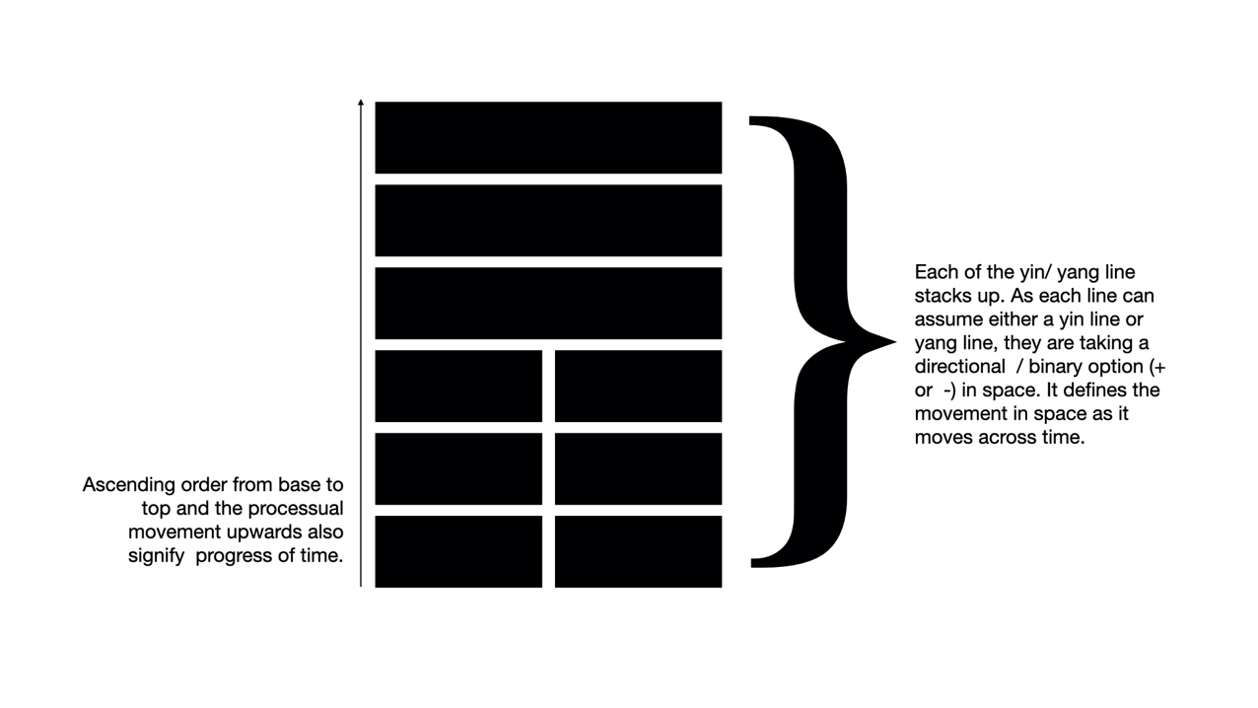
Diagram 13

Thus the Yijing marks the rhythms of a coherent, unified cosmos. (Smith, 1993) The hexagrams are revealed as both constant and invariable depending on the contexts, systematically predictable, and in precisely defined relationship with one another. The hexagrams in Yijing have achieved the pure power of mathematical signs.

    - Yijing as a Mathematical metaphysics
There is a mathematical way of looking at the hexagrams by mapping and representing multiple perspectives of reality. Reality is multi-faceted and too complex to be grasped without a handle and the hexagram presents such a handle. Due to the complexity of space with the presence of many elements, agencies, risks, opportunities, resources each of which are inter-related and interacting with each other within the space, it is hard to get a holistic view of any reality and perspectives remain idiosyncratic to the observer. The hexagram, itself, is therefore a mathematical representative and perspective of the reality in that space-time. The hexagram will change moment by moment in space and the hexagram’s form and structure will also change with different abstractions and perspectives as reality unfolds. This idea is given a precise formal presentation, by showing how the Yijing can be seen as a symbolic language, and then exploring the algebraic properties of that language. (Schöter, 2005)
Yijing is deeply rooted in the tradition of the image, symmetry and balance. To this end, modern mathematical techniques are applied to analyse the structures of the trigrams and hexagrams. The philosophical implications of the formalism are discussed and the structures are then interpreted in a cosmological context, using ideas and language borrowed from quantum physics and logic, to provide rich metaphors for describing the structure of reality. (Schöter, 2005)
Abstraction, Notation, and Representation
Before diving into the mathematics of the matter we should first explore what is meant, in this context, by the terms abstraction and symbolic language and how they are applied to the Yijing. We can understand the symbols of the Yijing as representing abstract concepts that can be applied to novel situations as they are encountered. The symbols give us a set of categories that we can use to organize and interpret our experience.
Binary Representation
In today’s digital world, bit-wise representation has become the dominant means of recording and processing information. The word “bit” is a contraction of the phrase “binary digit” and a bit, which is 0 and 1, between nothing and something, is the smallest possible unit of information. The distinction between 0 and 1 is to be taken as conceptually fundamental. This is no different from the Yin/ Yang representations in Yijing and Yin/Yang is conceptually fundamental as well.
Binary representation provides the basic formalism for computer programs and their rich algorithmic possibilities. It is the very fundamentality of the binary notation that provides such possibilities of representational versatility. This same binary representation follow the same principles in Yin/ Yang as each change in the layer of hexagram provide a certain algorithmic possibility and the development into the future follows the play of Yin/Yang through time and space. (Chang, 2009)
Symbolic Language
The hexagrams themselves are taken to have meaning, where this meaning comes about by virtue of reference to objects in the domain being symbolized. Hence, the reality of the situation is mapped on the symbols or the 6 Yin/Yang lines stacked to form the hexagram. Each line defines a stage in the evolution and stage of change. The roots of binary encoding, in the symbols of the Yijing, go back many millennia in China. (Schöter, 2005)
Enumerating all the possible combinations of open and closed lines over six places in a single hexagram stack, the 64 hexagrams can be seen as the a systematic, symbolic language for relativity. The reality for the moment in a specific space-time can be encapsulated in a line interpretation within the hexagram and the development of the subsequent events can be depicted in the progressive lines stacked upwards. The hexagrams themselves are the symbols of the language. The way to look at the symbols is that the symbols are miniatured reality described in a puzzle. The traditional method of representing changing lines, which generates relationships between pairs of symbols, is one example of a rule of symbol transformation and on explanation of the evolution on the state of affairs. Other traditional elements of the Yijing which provide the transformation rules include the extraction of nuclear hexagrams, and the various methods of deriving opposite hexagrams.
The traditional domain of application for the notation in the Yijing could be described as the study of the interaction between human intuitiveness and its environment. That is, the hexagrams provide us with a binary notation for describing the interactions of the various forces that are at work in the universe, and its relativity to the observer and the observed. (Schöter, 1998) The narratives that is associated to the symbols are the traditional interpretations of those interactions which can be abstractions in generalization, but the trigrams and hexagrams themselves are also taken to provide a direct, iconic image of the forces at work.
Mathematics is a language of universal truth, and Yijing is really about the probability wave.
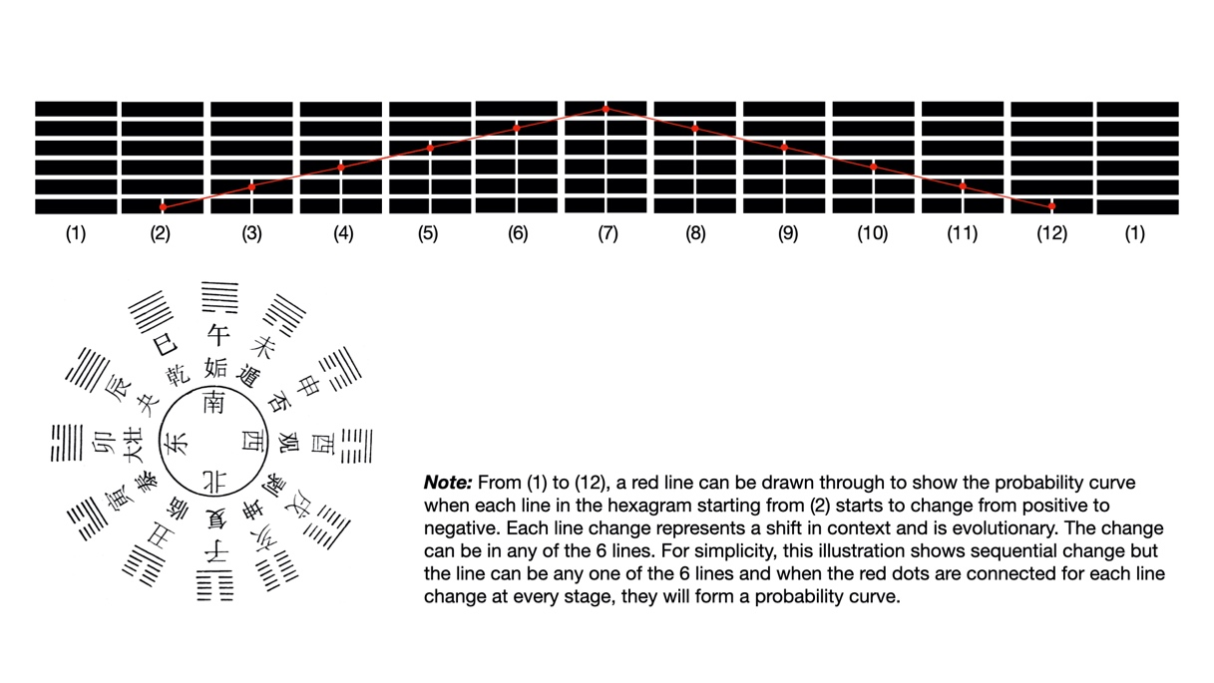
Diagram 14

It allows us to make explicit some of the structures and relationships between the symbols that would otherwise not be obvious. As the hexagram forms a different symbol as it evolves, the structures then provide us with a rich source of metaphor to explore and to interpret. In short, it is therefore interpreting reality through a system of symbols and their interactions. Reality consists of situations – observers standing in relations at various spatiotemporal locations are in situations where the interactions between the observer, observed object or reality and the space-time events are distinct – interdependent and interacting. Each hexagram can be seen as representing an abstract situation and as the situation change, the hexagram will take another structure. As an abstract situation, each hexagram details moment by moment development of actual situations with the relationship of each hexagram being linked to a probability wave. The meaning of the hexagram can be interpreted by generalizing certain key properties of situations in terms of the interactions within the situation, where those interactions are described by relating the different components of the whole to each other. As earlier mentioned, the linked hexagrams when stringed together to form the probability wave. When there is no observer, the stringed hexagrams will be a wave. When there is an observer, the frozen moment of observation will be the particle which is the hexagram that represent that point in the spatiotemporal location. Wave–particle duality is the concept in quantum mechanics that every particle or quantum entity may be described as either a particle or a wave. (Wendt, 2005) It expresses the inability of the classical concepts "particle" or "wave" to fully describe the behaviour of quantum-scale objects. As Albert Einstein wrote: “It seems as though we must use sometimes the one theory and sometimes the other, while at times we may use either. We are faced with a new kind of difficulty. We have two contradictory pictures of reality; separately neither of them fully explains the phenomena of light, but together they do.” Similarly in Yijing, when we observe in a particular spatiotemporal moment, we are looking at a particular hexagram which becomes a particle. However, when we are not observing, it becomes a wave with the stringed hexagrams.
Although the use of the wave-particle duality has worked well in physics, the meaning or interpretation has not been satisfactorily resolved. Niels Bohr regarded the "duality paradox" as a fundamental or metaphysical fact of nature. A given kind of quantum object will exhibit sometimes wave, sometimes particle, character, in respectively different physical settings. He saw such duality as one aspect of the concept of complementarity. Bohr regarded renunciation of the cause-effect relation, or complementarity (Wendt, 2005), of the space-time picture, as essential to the quantum mechanical account. Werner Heisenberg considered the question further. He saw the duality as present for all quantic entities, but not quite in the usual quantum mechanical account considered by Bohr. He saw it in what is called second quantization (Robinson and Haven, 2015), which generates an entirely new concept of fields that exist in ordinary space-time, causality still being visualizable. Classical field values (e.g. the electric and magnetic field strengths of Maxwell) are replaced by an entirely new kind of field value, as considered in quantum field theory. Turning the reasoning around, ordinary quantum mechanics can be deduced as a specialized consequence of quantum field theory. In response to a number of problems with the theory of quantum mechanics, the physicist David Bohm developed a theory explaining physical causality and the structure of reality using two domains which he called the explicate order and the implicate order. (Schöter, 2005) The explicate order is the everyday reality, observable which is revealed to our senses and our measuring instruments. In contrast, the implicate order is the deep, underlying aspect of reality which “unfolds” to give expression to the explicate order. Manifestations and any observable phenomenon is revealed in the explicate world because of the patterns in the implicate order. The physical causality in of the phenomenon, the explicate order, becomes a secondary phenomenon, subordinate to the unfolding activity of the implicate order. This bears a striking similarity to the relation between Heaven and Earth in the Yijing: the implicate order is Heaven and the explicate order is Earth. Activity in the former determines events in the latter.
Bohm further suggests that consciousness arises as an interaction between the implicate and the explicate orders. This happens because, just as the implicate order unfolds to give rise to the explicate reality, so our mind enfolds the explicate order back into the implicate order of consciousness. (Schöter, 2005) It has the iterative effect. The mind has a certain pattern of thoughts and see the realities according to its pattern construct which is the implicate order. Hence as the implicate order unfolds to give rise to the explicate reality our mind enfolds the explicate order back into the implicate order into the conscious mind thus rendering the following sequences- implicate order- explicate reality- implicate order- explicate reality and this sequence perpetuate ad infinitum. Bohm also uses our perception of music and melody as an example. As we hear each note, it is not experienced in isolation as just that one note (a particular hexagram or a particle) but in terms of the context of all the notes that have come before it in the piece, which is the stringed hexagrams concept (represented by a wave). As each new note is heard, it is enfolded into the ongoing consciousness of the music, building up a mental structure which creates expectations reaching forward into the future. The implicate order drives the reverse of this process: each moment of explicate reality is enfolded within the implicate order, becoming manifested as a physical phenomenon as it is unfolded.
The parallel with the Yijing is clear: just as consciousness emerges as the interaction between the implicate and explicate orders, so consciousness of the realities or any physical manifestations. The interactivities and interdependence between particles in the space under heaven and earth- between the observer (with implicate order in the consciousness) and the object/ reality (being the explicate reality) in the spatiotemporal moment. This is very similar to the concept of quantum field theory. There is also a striking parallel between the continual unfolding and enfolding of the implicate and explicate orders. From the perspective of arrow of time, the past is flowing with and into the current and the future is counter current that will roll into the present to be re-defined as the next moment of the future as the current moment is enfolded to become the past.
By combining the ideas discussed above, it is possible to describe the internal structure of hexagrams using a different language, which is nonetheless in accord with the cosmology of the Yijing. We start with the idea of a hexagram representing an abstract situation, with contributing spirits/energies arranged from most implicate order from the bottom line to most explicate reality at the top line. These 6-line stack represents the explicate and the implicate order. Consciousness, from the mind and heart, arises through the interaction of these two trigrams at the nexus at the third and fourth lines.
This leads to the following attribution of individual lines for a situation: at the most explicate end of the spectrum at the upper trigram is matter, the materialization of matter that allows the patterns at the lower trigram to become manifested; then, the body is the level at which actual things are individuated, the initial separation into discrete beings or beings coming into realities. Hence, the lower trigram is where all the imagination and visualization take place – as the implicate order in the lower trigram unfolds, mediated with the consciousness through the mind/ heart, the explicate enfolds. The fifth layer defines the nature of what is actually enfolded; as the implicate equivalent of the explicate body, it is what connects the manifestations from the purely abstract spirit/ energy at the lower trigram. Where the energy abounds and thoughts are formed from the lower trigram, materialization takes place and eventually lead to the actual manifestation in the explicate order. Hence when it is commonly known now that E=mc² , the spirit/ energy at the lower trigram forms pattern and then materializes to form physical body and matter with mass. Hence within mass lies energy. Mass with the speed of light squared is energy, in short.
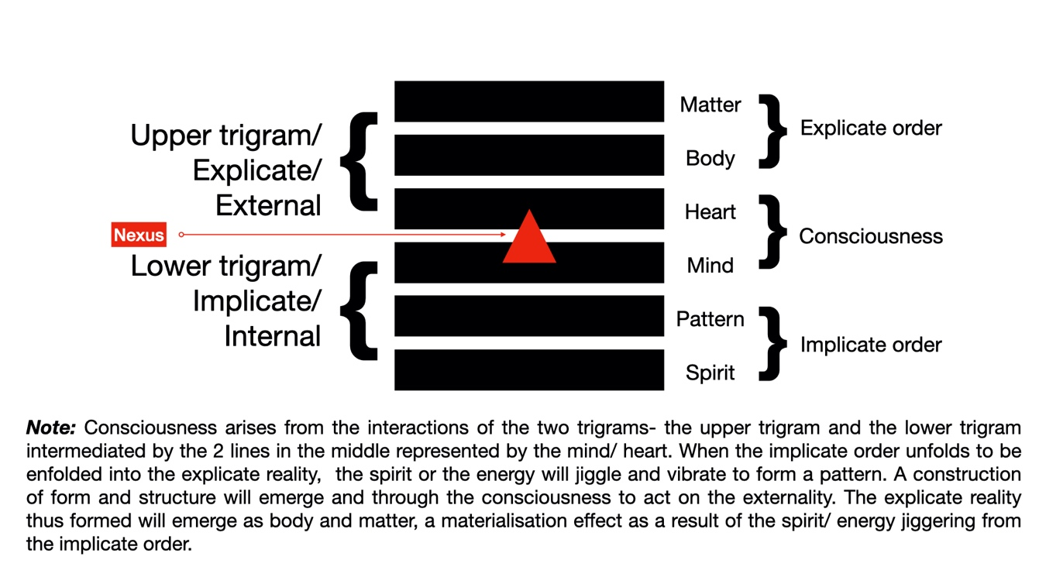
Diagram 15
Lattices, Trigrams and Hexagrams
One-Dimensional Lattices
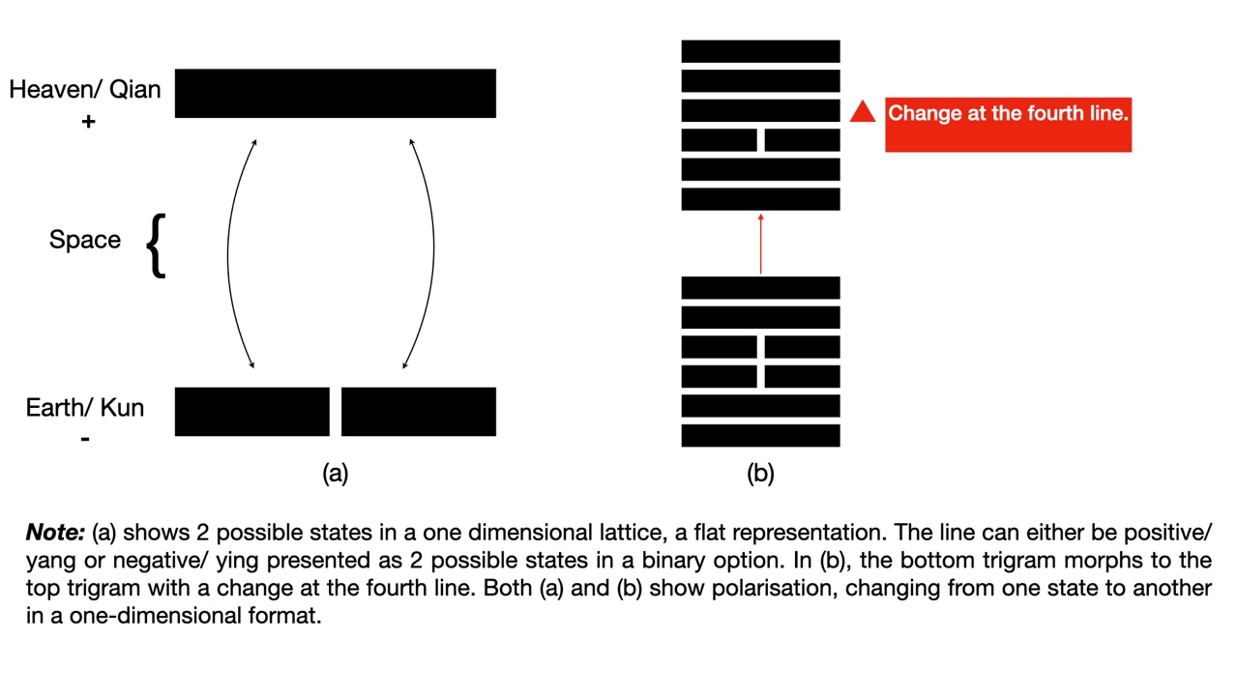
Diagram 16

This shows the two possible states that a single line may be in. A line may be either yin or yang in a binary option situation.
Two-Dimensional Lattices
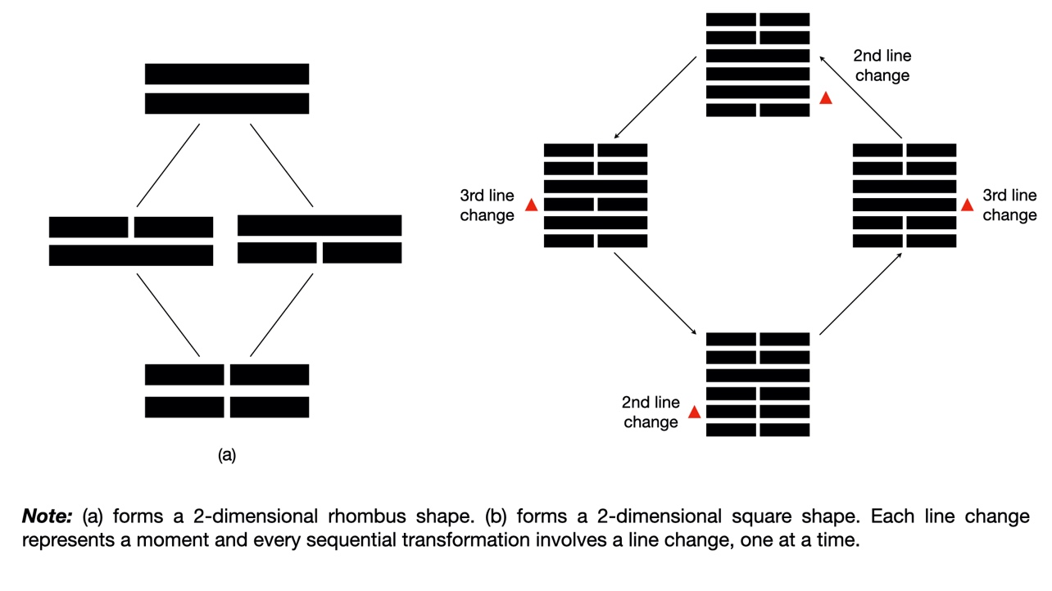
Diagram 17
When we consider pairs of lines, the lattice shown in Figure 2(a) below is generated. This shows the relationships between the four possible states that can arise from two lines. At the bottom of (a) is the pure yin bigram with the lowest energy level; and at the top of (a) is pure yang, Creative with the maximum energy level. On the left, analogous to Thunder is a yang line bursting forth beneath yin, beginning the cycle around the lattice. On the right, analogous to Mountain, is a yang line resting above yin, ending the cycle around the lattice. During transformation from one state to another, only a single line of energy changes. Thus, to borrow a term from physics, each edge of the lattice describes a minimal quantum state change between two situations.
Consider the two-dimensional structure shown as Figure 2(b) above, this is created as the result of the change in polarity in the second and third lines of the hexagrams:
Three-Dimensional Lattices
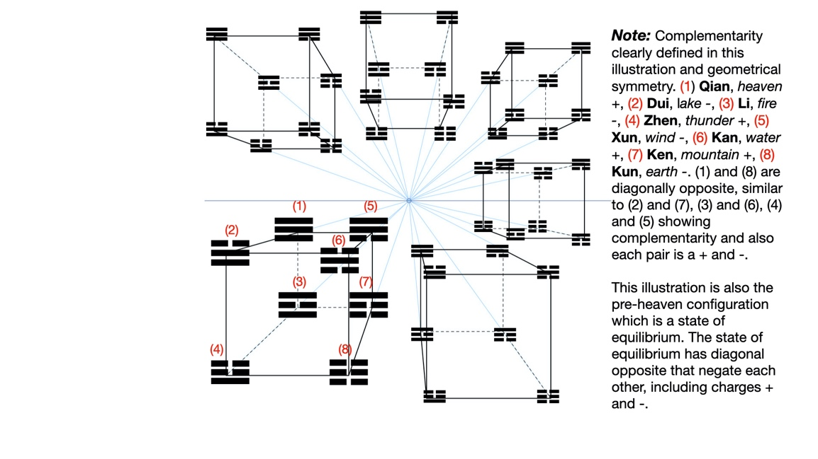
Diagram 18
The cubical lattice for trigrams shown in Diagram 18 above. The interpretation of the structure in terms of energy state is interesting in this configuration. Complementarity is shown here where the diagonally opposite trigrams are pair that negative each other in terms of polarities ( + and -, or positive and negative spin) The trigram “earth” is at the bottom, with no yang energy where the trigram “heaven” is at the top, with maximum yang energy. The other six trigrams are arranged in layers between, with first one line of yang energy, and then two. The lattice represents the various states of the situations, defining the field of quantum potential for trigrams, and the connections within the lattice show the transitions from one state to another through the changing of a single line. This configuration is the pre-heaven configuration that defines state of equilibrium
Geometrically, the trigram lattice is a three-dimensional structure, with each trigram connected to others through the changes of its lines and the structure is a stable and balanced.
Each of these structures, whether its one-dimensional, two-dimensional, three-dimensional or even with higher dimensionalities, they describe the many possibilities arising from a point. In Diagram 18, it is only an illustration that all the different cubical lattices originating from a single point to branch out to many possible futures. The unpredictable quantum universe, everything eventually falls into the realm of probabilities like the changing of the lines in the hexagrams that will form the probability waves when all the hexagrams are linked together. Refer to Diagram 14 for the emphasis on this – each of the hexagram, on its own is granular and particulate. Each on its own is part of the great fabric – interconnected and interdependent in a connected wave (visualization of a 3-dimensional probability wave).

For the better part of the last century starting in 1900 with Max Planck, the most accepted explanation for why the same quantum particle may behave in different ways was the Copenhagen interpretation. (Zalta, 2019) Scientists and researchers only move away from the deterministic Newtonian science into indeterministic quantum uncertainties in the 1900s. Yijing has at least two and a half millennia’s worth of commentaries and interpretations on its probabilistic nature. The Copenhagen interpretation was first propositioned by physicist Niels Bohr in 1920. It says that a quantum particle does not exist in one state or another, but in all of its possible states at once. (Pauli, 1994) It is only when we make an observation of its state that a quantum particle essentially shows an outcome. In Yijing terms, it can be paraphrased to state that a hexagram does not exist as one structure or another (with 64 different hexagram possibilities) but in all of its 64 possible structures at once. It is only when we make an observation of its state that a hexagram is isolated and identified that will show its outcome.

This state of existing in all possible states at once is called an object's coherent superposition. (Gerry and Knight, 1997) The total of all possible states in which an object can exist -- for example, in a wave or particle form for photons that travel in both directions at once -- makes up the object's wave function. When we observe an object, the superposition collapses and the object is forced into one of the states of its wave function; in the terms of Yijing, the superposition collapses into a specific hexagram. See Diagram 19.

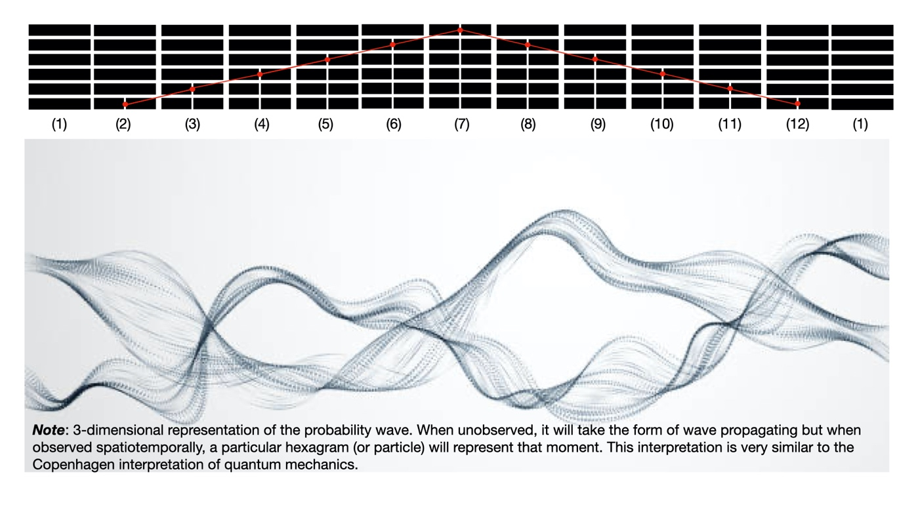
Diagram 19
Copenhagen interpretation of quantum mechanics was propounded by Bohr and Werner Heisenberg in the 1920s, this theory holds that physical systems have only probabilities, rather than specific properties, until they are measured. (Skibba, 2018)

Where Bohr proposed that entities (such as electrons) had only probabilities if they were not observed, Einstein argued that they had independent reality, prompting his famous claim that “God does not play dice”. Years later, he added a gloss: “What we call science has the sole purpose of determining what is.” Suddenly, scientific realism — the idea that confirmed scientific theories roughly reflect reality — was at stake and this indeterminism in science bothered Einstein’s in the later part of his life. Quantum phenomena were phenomenally baffling to many. First was wave–particle duality, in which light can act as particles and particles such as electrons interfere like light waves. Such phenomena are similar to Yijing where the unobserved life cycle will be wave-like, with hexagram changing from moment to moment with the change of each line (one hexagram after another) when stringed together. These observations challenge locality, causality and determinism.
The fractal repetitions of the three-dimensional trigrams can be scaled up to the higher dimensional space of hexagrams. (Foster, 2020) The idea that reality consists of more than the three-dimensional space that our senses reveal to us can be understood in many different ways. It is a conjecture explored in contemporary physics through the topic of string theory. This theory postulates that there are additional dimensions of reality, folded up within the normal three that we are used to experiencing. Most versions of string theory postulate 10 or 11 dimensions in total; however, the exact number of dimensions is of less interest and concern than the idea itself and the fact that in Yijing, the possibility that.
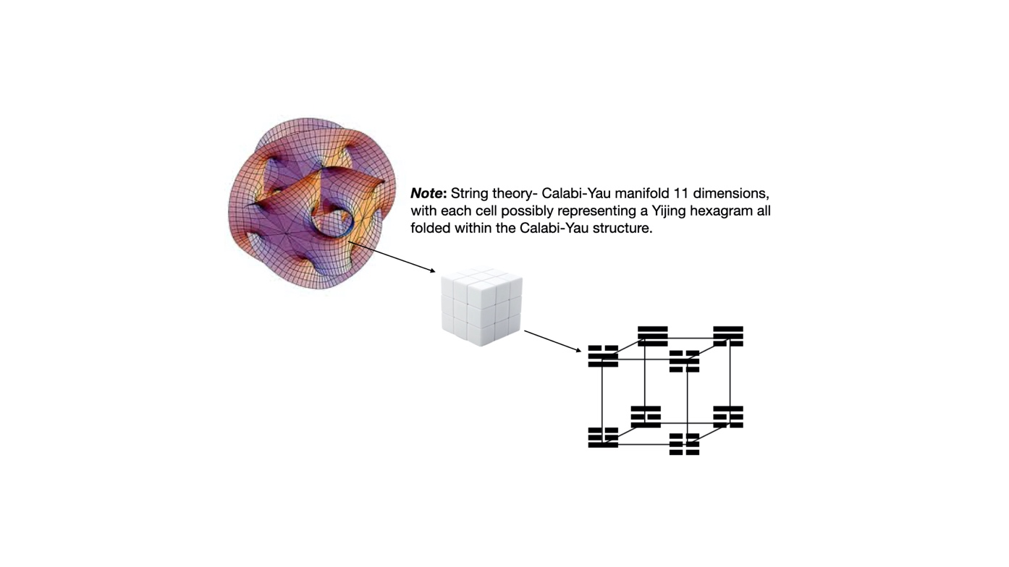
Diagram 20
In the case of the Yijing, the dimensions that we are representing are not only literal physical dimensions, but also dimensions of experience, emotional and psychological dimensions, dimensions of thought and abstraction. (Schöter, 2005)

Conclusion
The hexagrams of the Yijing represent the yin-yang fluctuations reflecting moment by moment changes and transformations. Yijing as a symbol system assumes the predictive feature through the suggestion of probabilities in events/ life cycle by representing natural pattern in graphical form, making it easier to comprehend.
Yijing forms a powerful notational system for exploring the manner in which the implicate order unfolds into the explicate, for exploring the manifestation of consciousness within pattern and matter. As all matter arises out of patterns in energy.
We should approach Yijing’s worldview not so much in deep mystical amusement but with a scientific understanding based on real life context. The work in this paper is presented in this spirit, and seeks to express the continuity of idea between Yijing and the contemporary thoughts in Quantum Physics.
Yijing, both as a source of abstract philosophical study and as a practical tool for prediction of probabilities is no difference in scenario building in management theories except that in Yijing, there are multiple dimensionalities which are all interconnected and are interdependent, provides an excellent method for generating, structuring and exploring “original perception relevant to our present condition”.
The relatedness of Yijing and Quantum Physics is deeper than we can all imagine.

REFERENCES:
Alvino, G. (1996) ‘The human energy field in relation to science, consciousness and health.’, 21st Link.
Carse, J. P. (1986) Finite and infinite games. Free Press.
Chang, W. (2009) ‘Reflections on time and related ideas in the Yijing’, Philosophy East and West, pp. 216–229. doi: 10.1353/pew.0.0047.
Chen, G.-M. (2008) Bian (Change): A Perpetual Discourse of I Ching, Intercultural Communication Studies.
Chin, T. et al. (2018) ‘Chinese strategic thinking on competitive conflict: insights from Yin-Yang harmony cognition’, International Journal of Conflict Management, 29(5), pp. 683–704. doi: 10.1108/IJCMA-09-2017-0101.
Dine, M. and Kusenko, A. (2003) ‘Origin of the matter-antimatter asymmetry’, Reviews of Modern Physics, 76(1), pp. 1–30. doi: 10.1103/RevModPhys.76.1.
Fan, J. et al. (2016) ‘Stealth Supersymmetry simplified’, Journal of High Energy Physics, 2016(7), p. 16. doi: 10.1007/JHEP07(2016)016.
Feng, H. and Wang, J. (2011) ‘Potential and Flux Decomposition for Dynamical Systems and Non-Equilibrium Thermodynamics: Curvature, Gauge Field and Generalized Fluctuation-Dissipation Theorem’. doi: 10.1063/1.3669448.
Foster, J. (2020) Sacred Geometry: How to use cosmic patterns to power up your life., Hachette UK.
Fukugita, M. and Yanagida, T. (1986) BARYOGENESIS WITHOUT GRAND UNIFICATION.
Gerry, C. C. and Knight, P. L. (1997) ‘Quantum superpositions and Schrödinger cat states in quantum optics’, American Journal of Physics, 65(10), pp. 964–974. doi: 10.1119/1.18698.
Giacosa, F. (2009) ‘Spontaneous breaking of chiral symmetry, and eventually of parity, in a model with two Mexican hats’. doi: 10.1140/epjc/s10052-009-1199-4.
Holton, G. (1970) ‘The Roots of Complementarity.’, Daedalus, 99(4), pp. 1015–1055.
Hon, T.-K. (2019) ‘Chinese Philosophy of Change (Yijing)’, he Stanford Encyclopedia of Philosophy (Summer 2019 Edition), Edward N. Zalta (ed.).
Hon, T. (2019) ‘Coping with Contingency and Uncertainty: The Yijing Hexagrams on Decay and Discordance.’, Sungkyun Journal of East Asian Studies, 19(1), pp. 1–17.
Huang, T. et al. (2017a) Situational Appropriateness in Global Politics: A Yijing Correlative Theory of Infinite Games.
Huang, T. et al. (2017b) Situational Appropriateness in Global Politics: A Yijing Correlative Theory of Infinite Games.
Huang, T. (2019) ‘The Chinese Correlative Worldview: From Yijing to Modeling of Confucian Decision-making.’, International Journal of Social Science and Business, 4(1).
von Klitzing, K. (1986) ‘The quantized Hall effect’, Reviews of Modern Physics, 58(3), pp. 519–531. doi: 10.1103/RevModPhys.58.519.
Kojevnikov, A. (1999) ‘Freedom, collectivism, and quasiparticles: Social metaphors in quantum physics’, Historical Studies in the Physical and Biological Sciences. University of California Press, pp. 294–331. doi: 10.2307/27757812.
Launius, R. D. (2014) ‘Beyond the God Particle.’, Space Times: The Magazine of the American Astronautical Society.
Lee, J. Y. (1970) ‘Some Reflections On the Authorship of the i cHing’, Numen, 17(3), pp. 200–210. doi: 10.1163/156852770X00045.
Matthews, W. E. (2016) The Homological Cosmos. University College London (University of London).
McMahon, D. (2008) ‘Quantum Field Theory Demystified’, New York, NY : McGraw-Hill,.
Nelson, E. S. (2011) ‘The Yijing and philosophy: From leibniz to derrida’, Journal of Chinese Philosophy, 38(3), pp. 377–396. doi: 10.1111/j.1540-6253.2011.01661.x.
Pauli, W. (1994) Writings on Physics and Philosophy. Edited by C. P. Enz and K. von Meyenn. Berlin, Heidelberg: Springer Berlin Heidelberg. doi: 10.1007/978-3-662-02994-7.
Pople, J. A. and Nesbet, R. K. (1954) ‘Self‐Consistent Orbitals for Radicals’, The Journal of Chemical Physics, 22(3), pp. 571–572. doi: 10.1063/1.1740120.
Qin, Y. (2014) ‘Continuity through Change: Background Knowledge and China’s International Strategy’, The Chinese Journal of International Politics, 7(3), pp. 285–314. doi: 10.1093/cjip/pou034.
Raina, M. (2015) ‘The character of creativity: The vedic perspective.’, The Humanistic Psychologist, 43(1), pp. 54–69. doi: 10.1080/08873267.2014.993066.
Robinson, T. R. and Haven, E. (2015) ‘Quantization and Quantum-Like Phenomena: A Number Amplitude Approach’, International Journal of Theoretical Physics, 54(12), pp. 4576–4590. doi: 10.1007/s10773-015-2726-8.
Schöter, A. (1998) Boolean Algebra and the Yijing *.
Schöter, A. (2005) ‘The Yijing as a Symbolic Language for Abstraction’, in The 2nd International Conference on I-Ching (Yijing) Studies and Contemporary Civilization, pp. 291–305. Available at: http://www.yijing.co.uk.
Schöter, A. (2011) The Yijing: Metaphysics and physics, Journal of Chinese Philosophy. doi: 10.1111/j.1540-6253.2011.01663.x.
Schweber, S. S. (2008) ‘Einstein and Oppenheimer: The Meaning of Genius’, Cambridge, Massachusetts, Harvard University Press, xiv, p. 412.
Secter, M. (1998) THE YIN-YANG SYSTEM OF ANCIENT CHINA: THE YIJING-BOOK OF CHANGES AS A PRAGMATIC METAPHOR FOR CHANGE THEORY, Paideusis-Journal for Interdisciplinary and Cross-Cultural Studies.
Sellmann, J. and Graham, A. C. (1988) ‘Yin-Yang and the Nature of Correlative Thinking’, Philosophy East and West, 38(2), p. 203. doi: 10.2307/1398705.
Skibba, R. (2018) ‘Einstein, Bohr and the war over quantum theory’, Nature, 555(7698), pp. 582–584. doi: 10.1038/d41586-018-03793-2.
Smith, K. (1993) ‘The Difficulty of the Yijing’, Chinese Literature: Essays, Articles, Reviews (CLEAR), 15, p. 1. doi: 10.2307/495370.
Smith, R. J. (2013) ‘Fathoming the Changes : The Evolution of some Technical Terms and Interpretive Strategies in Yijing Exegesis’, Journal of Chinese Philosophy, 40, pp. 146–170. doi: 10.1111/1540-6253.12071.
Wallace, D. (2011) ‘Taking particle physics seriously: A critique of the algebraic approach to quantum field theory’, Studies in History and Philosophy of Science Part B: Studies in History and Philosophy of Modern Physics, 42(2), pp. 116–125. doi: 10.1016/j.shpsb.2010.12.001.
Wang, S. (2018) ‘The “Dao” of Laozi and “Xiang Thinking”’, in Returning to Primordially Creative Thinking. Singapore: Springer Singapore, pp. 65–125. doi: 10.1007/978-981-10-9048-6_3.
Wendt, A. (2005) AN AUTO-CRITIQUE FROM A QUANTUM PERSPECTIVE.
Wootters, W. K. and Zurek, W. H. (1979) ‘Complementarity in the double-slit experiment: Quantum nonseparability and a quantitative statement of Bohr’s principle’, Physical Review D, 19(2), pp. 473–484. doi: 10.1103/PhysRevD.19.473.
Yang, G. (2019) ‘Metaphysical Principle and Principle of Value: the Way (Dao 道) and Natural Spontaneity (Ziran 自然) in the Philosophy of the Laozi’, in Philosophical Horizons. BRILL, pp. 238–255. doi: 10.1163/9789004396302_019.
Zalta, E. N. (2019) ‘Copenhagen Interpretation of Quantum Mechanics’, Metaphysics Research Lab, Stanford University.
Zhang, W.-R. (2011) YinYang Bipolar Relativity. IGI Global. doi: 10.4018/978-1-60960-525-4.
Zhang, W.-R. (2012) ‘YinYang Bipolar Atom—An Eastern Road toward Quantum Gravity’, Journal of Modern Physics, 03(09), pp. 1261–1271. doi: 10.4236/jmp.2012.329163.
Zhuridov, D. (2016) ‘Baryogenesis from leptomesons’, Physical Review D, 94(3), p. 035007. doi: 10.1103/PhysRevD.94.035007.
Zicovich-Wilson, C., Planelles, J. H. and Jaskóalski, W. (1994) ‘Spatially confined simple quantum mechanical systems’, International Journal of Quantum Chemistry, 50(6), pp. 429–444. doi: 10.1002/qua.560500606.
Zinkernagel, H. (2016) ‘Niels Bohr on the wave function and the classical/quantum divide’, Studies in History and Philosophy of Science Part B: Studies in History and Philosophy of Modern Physics, 53, pp. 9–19. doi: 10.1016/j.shpsb.2015.11.001.

