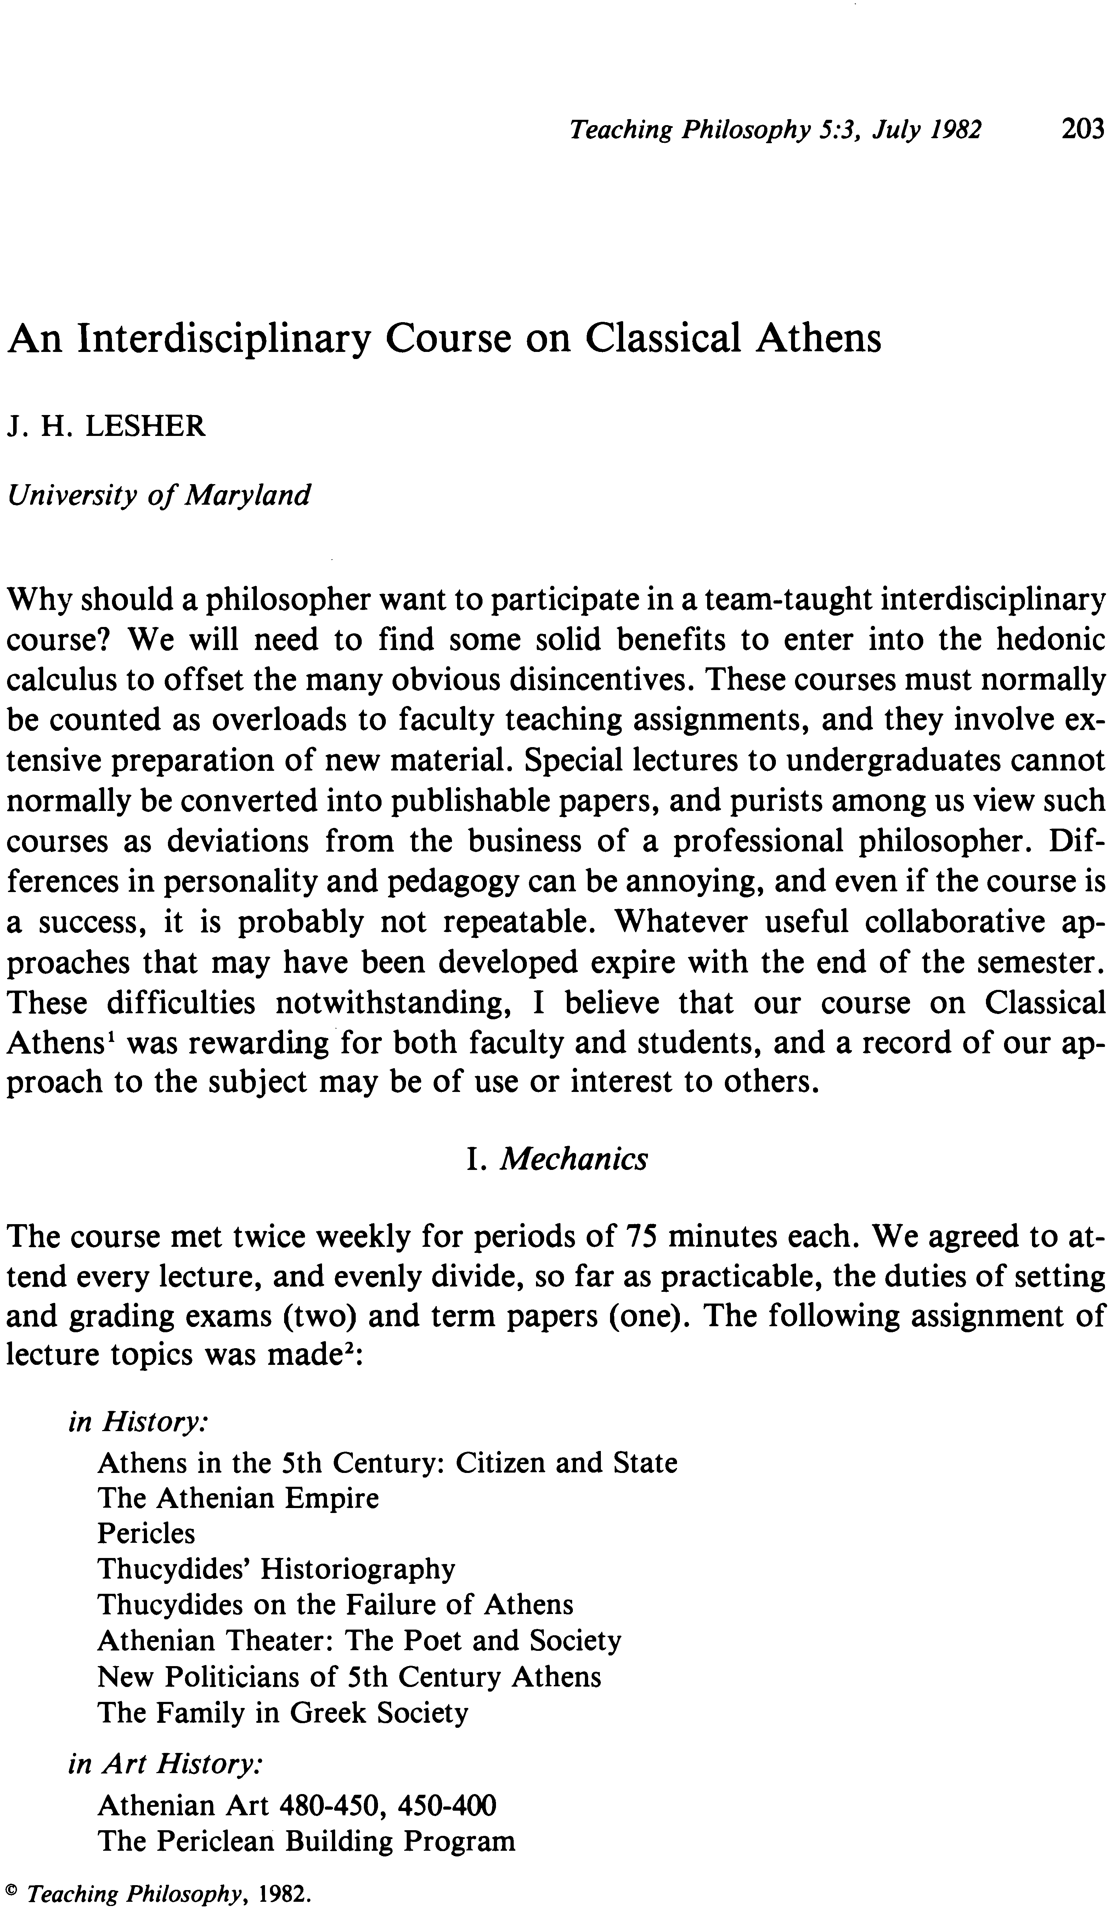
An Interdisciplinary Course on Classical Athens J. H. LESHER
University ofMaryland
Why should a philosopher want to participate in a team-taught interdisciplinary course? We will need to find some solid benefits to enter into the hedonic calculus to offset the many obvious disincentives. These courses must normally be counted as overloads to faculty teaching assignments, and they involve ex- tensive preparation of new material. Special lectures to undergraduates cannot normally be converted into publishable papers, and purists among us view such courses as deviations from the business of a professional philosopher. Dif- ferences in personality and pedagogy can be annoying, and even if the course is a success, it is probably not repeatable. Whatever useful collaborative ap- proaches that may have been developed expire with the end of the semester. These difficulties notwithstanding, I believe that our course on Classical Athens 1 was rewarding· for both faculty and students, and a record of our ap- proach to the subject may be of use or interest to others.
1. Mechanics
The course met twice weekly for periods of 75 minutes each. We agreed to at- tend every lecture, and evenly divide, so far as practicable, the duties of setting and grading exams (two) and term papers (one). The following assignment of lecture topics was made2 :
in History:
Athens in the 5th Century: Citizen and State The Athenian Empire
Pericles
Thucydides' Historiography
Thucydides on the Failure of Athens Athenian Theater: The Poet and Society New Politicians of 5th Century Athens The Family in Greek Society
in Art History:
Athenian Art 480-450, 450-400 The Periclean Building Program
© Teaching Philosophy. 1982.
Teaching Philosophy 5:3, July 1982 203
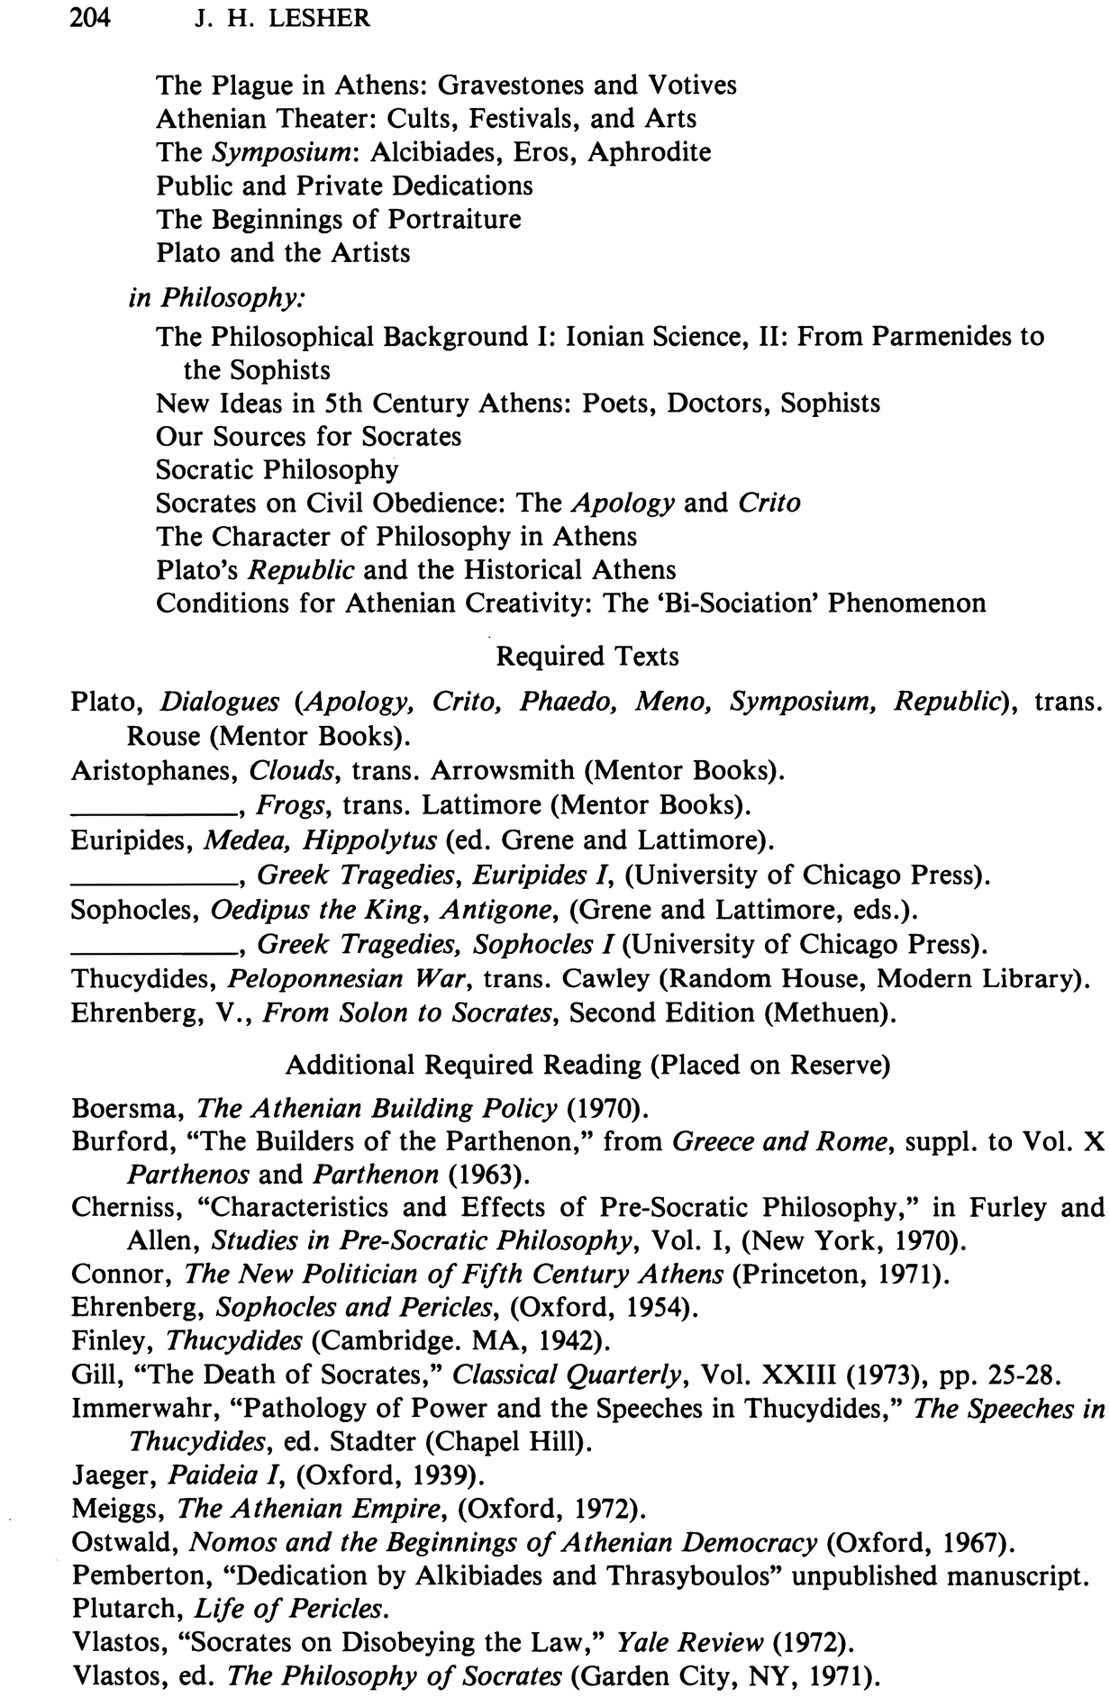
204
J. H. LESHER
The Plague in Athens: Gravestones and Votives Athenian Theater: Cults, Festivals, and Arts The Symposium: Alcibiades, Eros, Aphrodite Public and Private Dedications
The Beginnings of Portraiture Plato and the Artists
in Philosophy:
The Philosophical Background I: Ionian Science, II: From Parmenides to the Sophists
New Ideas in 5th Century Athens: Poets, Doctors, Sophists Our Sources for Socrates
Socratic Philosophy
Socrates on Civil Obedience: The Apology and Crito
The Character of Philosophy in Athens
Plato's Republic and the Historical Athens
Conditions for Athenian Creativity: The 'Bi-Sociation' Phenomenon
Required Texts
Plato, Dialogues (Apology, Crito, Phaedo, Men0, Symposium, Republic), trans. Rouse (Mentor Books).
Aristophanes, Clouds, trans. Arrowsmith (Mentor Books).
_ _ _ _ _ , Frogs, trans. Lattimore (Mentor Books).
Euripides, Medea, Hippolytus (ed. Grene and Lattimore).
_ _ _ _ _ , Greek Tragedies, Euripides I, (University of Chicago Press). Sophocles, Oedipus the King, Antigone, (Grene and Lattimore, eds.).
_ _ _ _ _ , Greek Tragedies, Sophocles I (University of Chicago Press). Thucydides, Peloponnesian War, trans. Cawley (Random House, Modern Library). Ehrenberg, V., From Solon to Socrates, Second Edition (Methuen).
Additional Required Reading (Placed on Reserve)
Boersma, The Athenian Building Policy (1970).
Burford, "The Builders of the Parthenon," from Greece and Rome, suppl. to Vol. X
Parthenos and Parthenon (1963).
Cherniss, "Characteristics and Effects of Pre-Socratic Philosophy," in Furley and
Allen, Studies in Pre-Socratic Philosophy, Vol. I, (New York, 1970). Connor, The New Politician o f Fifth Century Athens (Princeton, 1971). Ehrenberg, Sophocles and Pericles, (Oxford, 1954).
Finley, Thucydides (Cambridge. MA, 1942).
Gill, "The Death of Socrates," Classical Quarterly, Vol. XXIII (1973), pp. 25-28. Immerwahr, "Pathology of Power and the Speeches in Thucydides," The Speeches in
Thucydides, ed. Stadter (Chapel Hill).
Jaeger, Paideia I, (Oxford, 1939).
Meiggs, The Athenian Empire, (Oxford, 1972).
Ostwald, Nomos and the Beginnings o f Athenian Democracy (Oxford, 1967). Pemberton, "Dedication by Alkibiades and Thrasyboulos" unpublished manuscript. Plutarch, Life of Pericles.
Vlastos, "Socrates on Disobeying the Law," Yale Review (1972).
Vlastos, ed. The Philosophy of Socrates (Garden City, NY, 1971).
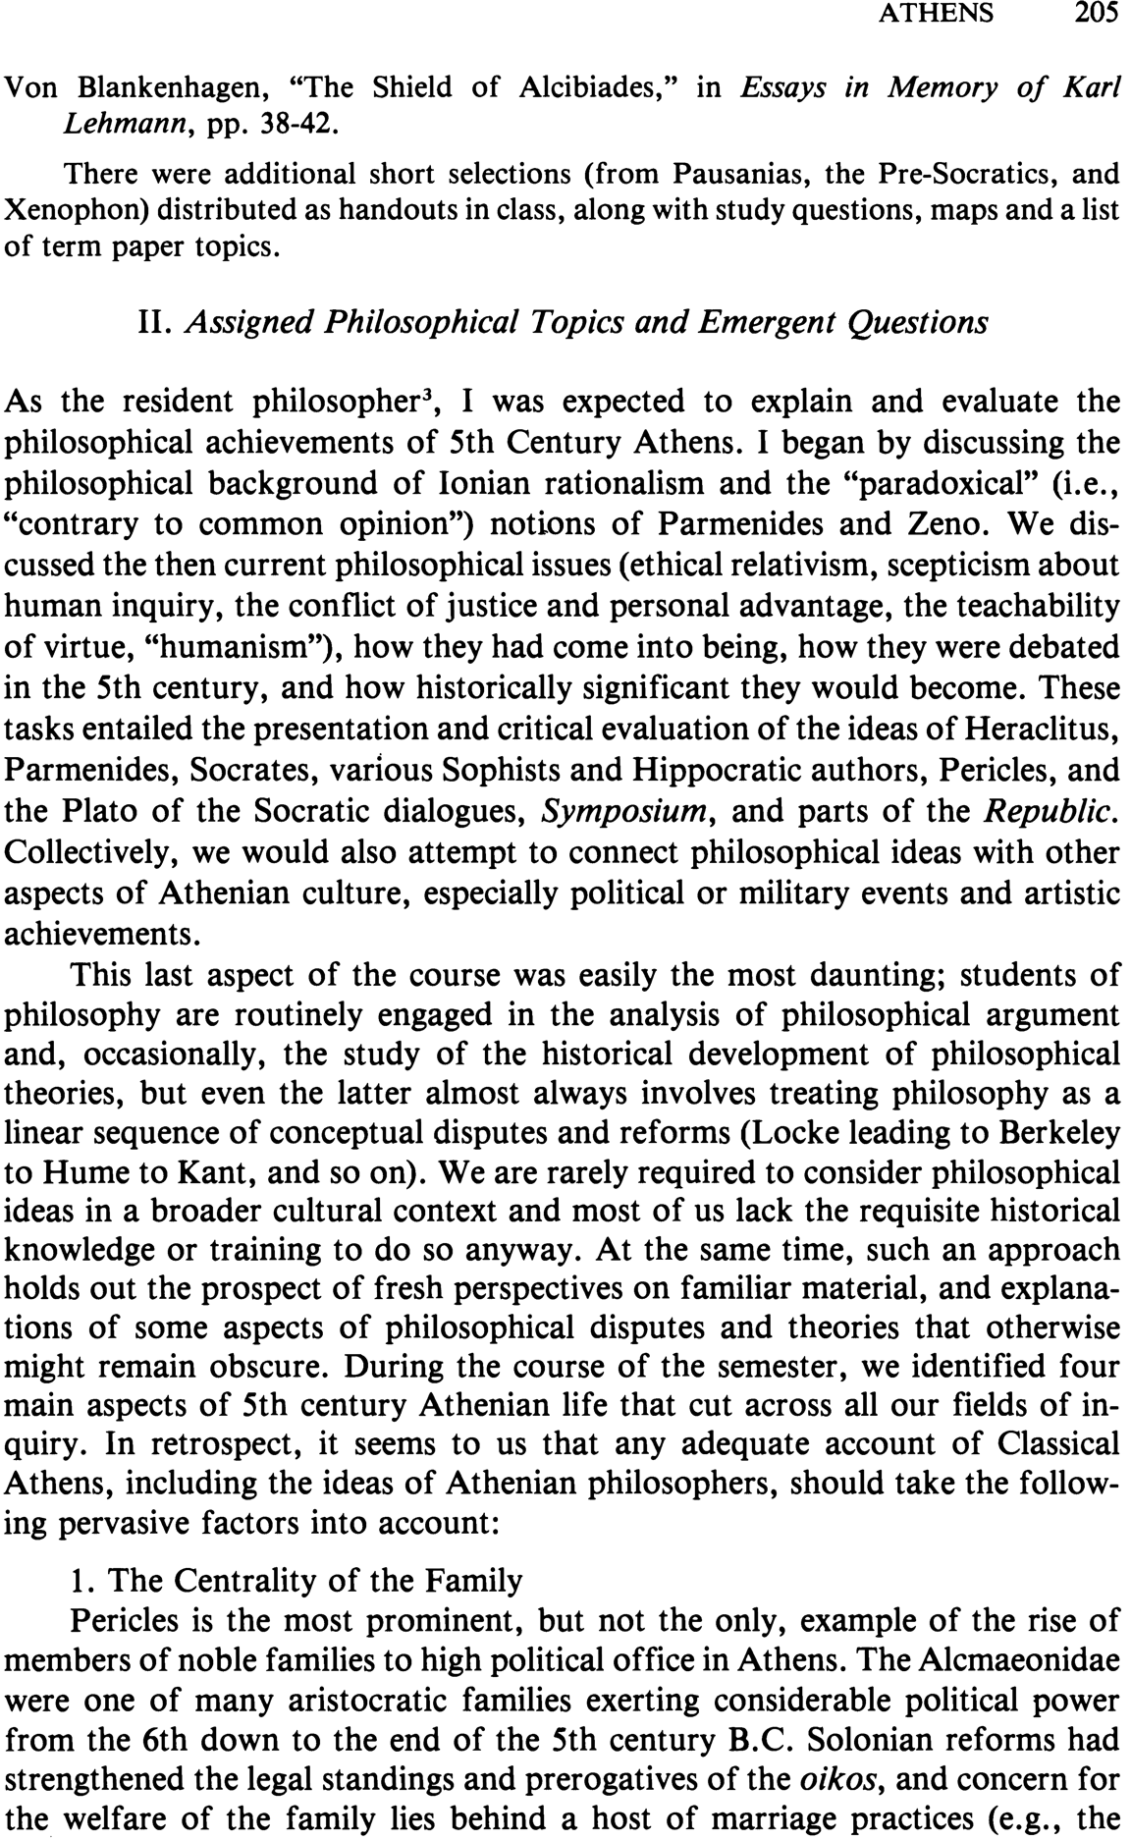
A THENS 205 Von Blankenhagen, "The Shield of Alcibiades," in Essays in Memory of Karl
Lehmann, pp. 38-42.
There were additional short selections (from Pausanias, the Pre-Socratics, and Xenophon) distributed as handouts in class, along with study questions, maps and a list of term paper topics.
II. Assigned Philosophical Topics and Emergent Questions
As the resident philosopher3, I was expected to explain and evaluate the philosophical achievements of 5th Century Athens. I began by discussing the philosophical background of Ionian rationalism and the "paradoxical" (i.e., "contrary to common opinion") notions of Parmenides and Zeno. We dis- cussed the then current philosophical issues (ethical relativism, scepticism about human inquiry, the conflict of justice and personal advantage, the teachability of virtue, "humanism"), how they had come into being, how they were debated in the 5th century, and how historically significant they would become. These tasks entailed the presentation and critical evaluation of the ideas of Heraclitus, Parmenides, Socrates, various Sophists and Hippocratic authors, Pericles, and the Plato of the Socratic dialogues, Symposium, and parts of the Republic. Collectively, we would also attempt to connect philosophical ideas with other aspects of Athenian culture, especially political or military events and artistic achievements.
This last aspect of the course was easily the most daunting; students of philosophy are routinely engaged in the analysis of philosophical argument and, occasionally, the study of the historical development of philosophical theories, but even the latter almost always involves treating philosophy as a linear sequence of conceptual disputes and reforms (Locke leading to Berkeley to Hume to Kant, and so on). We are rarely required to consider philosophical ideas in a broader cultural context and most of us lack the requisite historical knowledge or training to do so anyway. At the same time, such an approach holds out the prospect of fresh perspectives on familiar material, and explana- tions of some aspects of philosophical disputes and theories that otherwise might remain obscure. During the course of the semester, we identified four main aspects of 5th century Athenian life that cut across all our fields of in- quiry. In retrospect, it seems to us that any adequate account of Classical Athens, including the ideas of Athenian philosophers, should take the follow- ing pervasive factors into account:
1. The Centrality of the Family
Pericles is the most prominent, but not the only, example of the rise of members of noble families to high political office in Athens. The Alcmaeonidae were one of many aristocratic families exerting considerable political power from the 6th down to the end of the 5th century B.C. Solonian reforms had strengthened the legal standings and prerogatives of the oikos, and concern for the welfare of the family lies behind a host of marriage practices (e.g., the
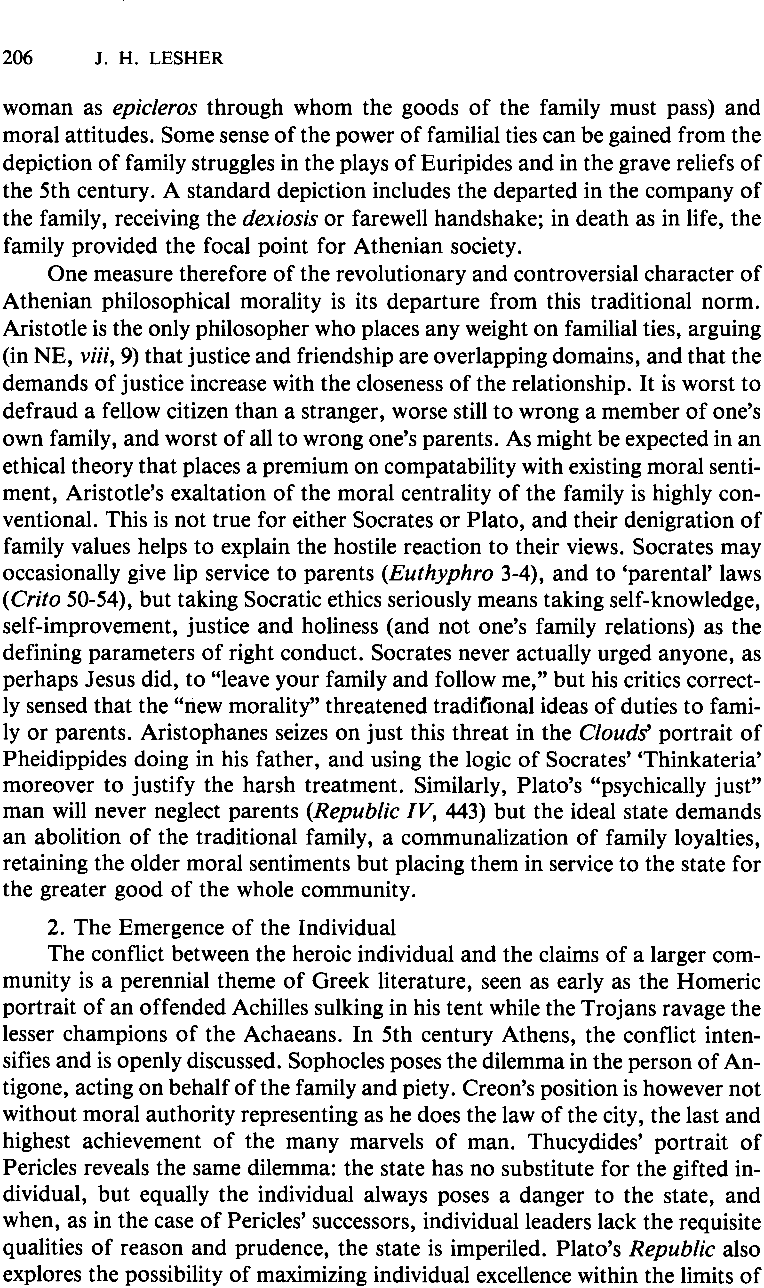
206 J. H. LESHER
woman as epic/eros through whom the goods of the family must pass) and moral attitudes. Some sense of the power of familial ties can be gained from the depiction of family struggles in the plays of Euripides and in the grave reliefs of the 5th century. A standard depiction includes the departed in the company of the family, receiving the dexiosis or farewell handshake; in death as in life, the family provided the focal point for Athenian society.
One measure therefore of the revolutionary and controversial character of Athenian philosophical morality is its departure from this traditional norm. Aristotle is the only philosopher who places any weight on familial ties, arguing (in NE, viii, 9) that justice and friendship are overlapping domains, and that the demands of justice increase with the closeness of the relationship. It is worst to defraud a fellow citizen than a stranger, worse still to wrong a member of one's own family, and worst of all to wrong one's parents. As might be expected in an ethical theory that places a premium on compatability with existing moral senti- ment, Aristotle's exaltation of the moral centrality of the family is highly con- ventional. This is not true for either Socrates or Plato, and their denigration of family values helps to explain the hostile reaction to their views. Socrates may occasionally give lip service to parents (Euthyphro 3-4), and to 'parental' laws (Crito 50-54), but taking Socratic ethics seriously means taking self-knowledge, self-improvement, justice and holiness (and not one's family relations) as the defining parameters of right conduct. Socrates never actually urged anyone, as perhaps Jesus did, to "leave your family and follow me," but his critics correct- ly sensed that the "new morality" threatened traditional ideas of duties to fami- ly or parents. Aristophanes seizes on just this threat in the Clouds portrait of Pheidippides doing in his father, and using the logic of Socrates' 'Thinkateria' moreover to justify the harsh treatment. Similarly, Plato's "psychically just" man will never neglect parents (Republic IV, 443) but the ideal state demands an abolition of the traditional family, a communalization of family loyalties, retaining the older moral sentiments but placing them in service to the state for the greater good of the whole community.
2. The Emergence of the Individual
The conflict between the heroic individual and the claims of a larger com- munity is a perennial theme of Greek literature, seen as early as the Homeric portrait of an offended Achilles sulking in his tent while the Trojans ravage the lesser champions of the Achaeans. In 5th century Athens, the conflict inten- sifies and is openly discussed. Sophocles poses the dilemma in the person of An- tigone, acting on behalf of the family and piety. Creon's position is however not without moral authority representing as he does the law of the city, the last and highest achievement of the many marvels of man. Thucydides' portrait of Pericles reveals the same dilemma: the state has no substitute for the gifted in- dividual, but equally the individual always poses a danger to the state, and when, as in the case of Pericles' successors, individual leaders lack the requisite qualities of reason and prudence, the state is imperiled. Plato's Republic also explores the possibility of maximizing individual excellence within the limits of
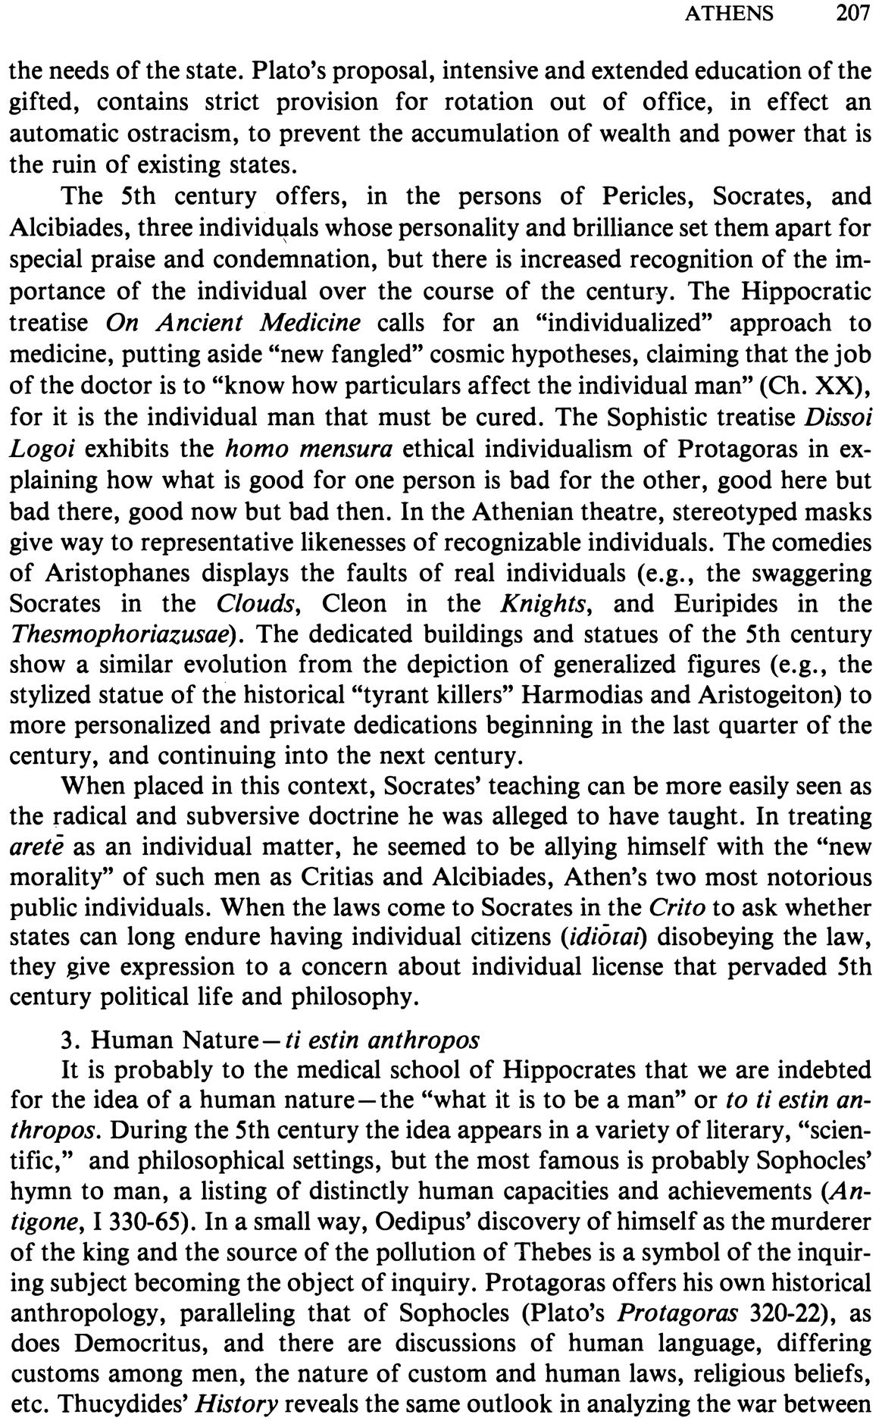
the needs of the state. Plato's proposal, intensive and extended education of the gifted, contains strict provision for rotation out of office, in effect an automatic ostracism, to prevent the accumulation of wealth and power that is the ruin of existing states.
The 5th century offers, in the persons of Pericles, Socrates, and Alcibiades, three individ~als whose personality and brilliance set them apart for special praise and condemnation, but there is increased recognition of the im- portance of the individual over the course of the century. The Hippocratic treatise On Ancient Medicine calls for an "individualized" approach to medicine, putting aside "new fangled" cosmic hypotheses, claiming that the job of the doctor is to "know how particulars affect the individual man" (Ch. XX), for it is the individual man that must be cured. The Sophistic treatise Dissoi Logoi exhibits the homo mensura ethical individualism of Protagoras in ex- plaining how what is good for one person is bad for the other, good here but bad there, good now but bad then. In the Athenian theatre, stereotyped masks give way to representative likenesses of recognizable individuals. The comedies of Aristophanes displays the faults of real individuals (e.g., the swaggering Socrates in the Clouds, Cleon in the Knights, and Euripides in the Thesmophoriazusae). The dedicated buildings and statues of the 5th century show a similar evolution from the depiction of generalized figures (e.g., the stylized statue of the historical "tyrant killers" Harmodias and Aristogeiton) to more personalized and private dedications beginning in the last quarter of the century, and continuing into the next century.
When placed in this context, Socrates' teaching can be more easily seen as the radical and subversive doctrine he was alleged to have taught. In treating arete as an individual matter, he seemed to be allying himself with the "new morality" of such men as Critias and Alcibiades, Athen's two most notorious public individuals. When the laws come to Socrates in the CrUo to ask whether states can long endure having individual citizens (idiolal) disobeying the law, they give expression to a concern about individual license that pervaded 5th century political life and philosophy.
3. Human Nature- ti estin anthropos
It is probably to the medical school of Hippocrates that we are indebted for the idea of a human nature-the "what it is to be a man" or to ti estin an- thropos. During the 5th century the idea appears in a variety of literary, "scien- tific," and philosophical settings, but the most famous is probably Sophocles' hymn to man, a listing of distinctly human capacities and achievements (An- tigone, 1330-65). In a small way, Oedipus' discovery of himself as the murderer of the king and the source of the pollution of Thebes is a symbol of the inquir- ing subject becoming the object of inquiry. Protagoras offers his own historical anthropology, paralleling that of Sophocles (Plato'S Protagoras 320-22), as does Democritus, and there are discussions of human language, differing customs among men, the nature of custom and human laws, religious beliefs, etc. Thucydides' History reveals the same outlook in analyzing the war between
A THENS 207
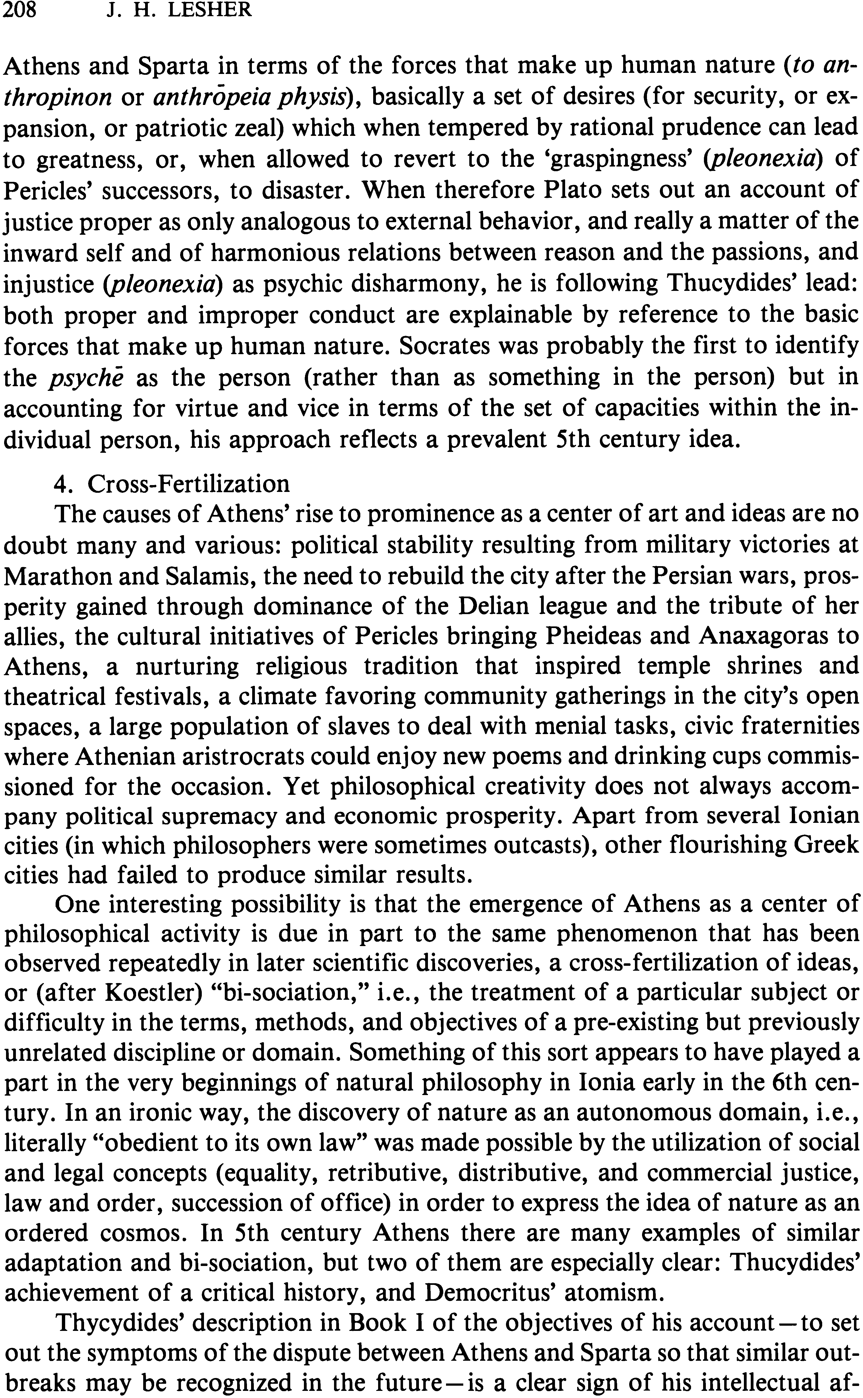
208 J. H. LESHER
Athens and Sparta in terms of the forces that make up human nature (to an- thropinon or anthropeia physis), basically a set of desires (for security, or ex- pansion, or patriotic zeal) which when tempered by rational prudence can lead to greatness, or, when allowed to revert to the 'graspingness' (pleonexia) of Pericles' successors, to disaster. When therefore Plato sets out an account of justice proper as only analogous to external behavior, and really a matter of the inward self and of harmonious relations between reason and the passions, and injustice (pleonexia) as psychic disharmony, he is following Thucydides' lead: both proper and improper conduct are explainable by reference to the basic forces that make up human nature. Socrates was probably the first to identify the psyche as the person (rather than as something in the person) but in accounting for virtue and vice in terms of the set of capacities within the in- dividual person, his approach reflects a prevalent 5th century idea.
4. Cross-Fertilization
The causes of Athens' rise to prominence as a center of art and ideas are no doubt many and various: political stability resulting from military victories at Marathon and Salamis, the need to rebuild the city after the Persian wars, pros- perity gained through dominance of the Delian league and the tribute of her allies, the cultural initiatives of Pericles bringing Pheideas and Anaxagoras to Athens, a nurturing religious tradition that inspired temple shrines and theatrical festivals, a climate favoring community gatherings in the city's open spaces, a large population of slaves to deal with menial tasks, civic fraternities where Athenian aristrocrats could enjoy new poems and drinking cups commis- sioned for the occasion. Yet philosophical creativity does not always accom- pany political supremacy and economic prosperity. Apart from several Ionian cities (in which philosophers were sometimes outcasts), other flourishing Greek cities had failed to produce similar results.
One interesting possibility is that the emergence of Athens as a center of philosophical activity is due in part to the same phenomenon that has been observed repeatedly in later scientific discoveries, a cross-fertilization of ideas, or (after Koestler) "bi-sociation," i.e., the treatment of a particular subject or difficulty in the terms, methods, and objectives of a pre-existing but previously unrelated discipline or domain. Something of this sort appears to have played a part in the very beginnings of natural philosophy in Ionia early in the 6th cen- tury. In an ironic way, the discovery of nature as an autonomous domain, i.e., literally "obedient to its own law" was made possible by the utilization of social and legal concepts (equality, retributive, distributive, and commercial justice, law and order, succession of office) in order to express the idea of nature as an ordered cosmos. In 5th century Athens there are many examples of similar adaptation and bi-sociation, but two of them are especially clear: Thucydides' achievement of a critical history, and Democritus' atomism.
Thycydides' description in Book I of the objectives of his account - to set out the symptoms of the dispute between Athens and Sparta so that similar out- breaks may be recognized in the future - is a clear sign of his intellectual af-
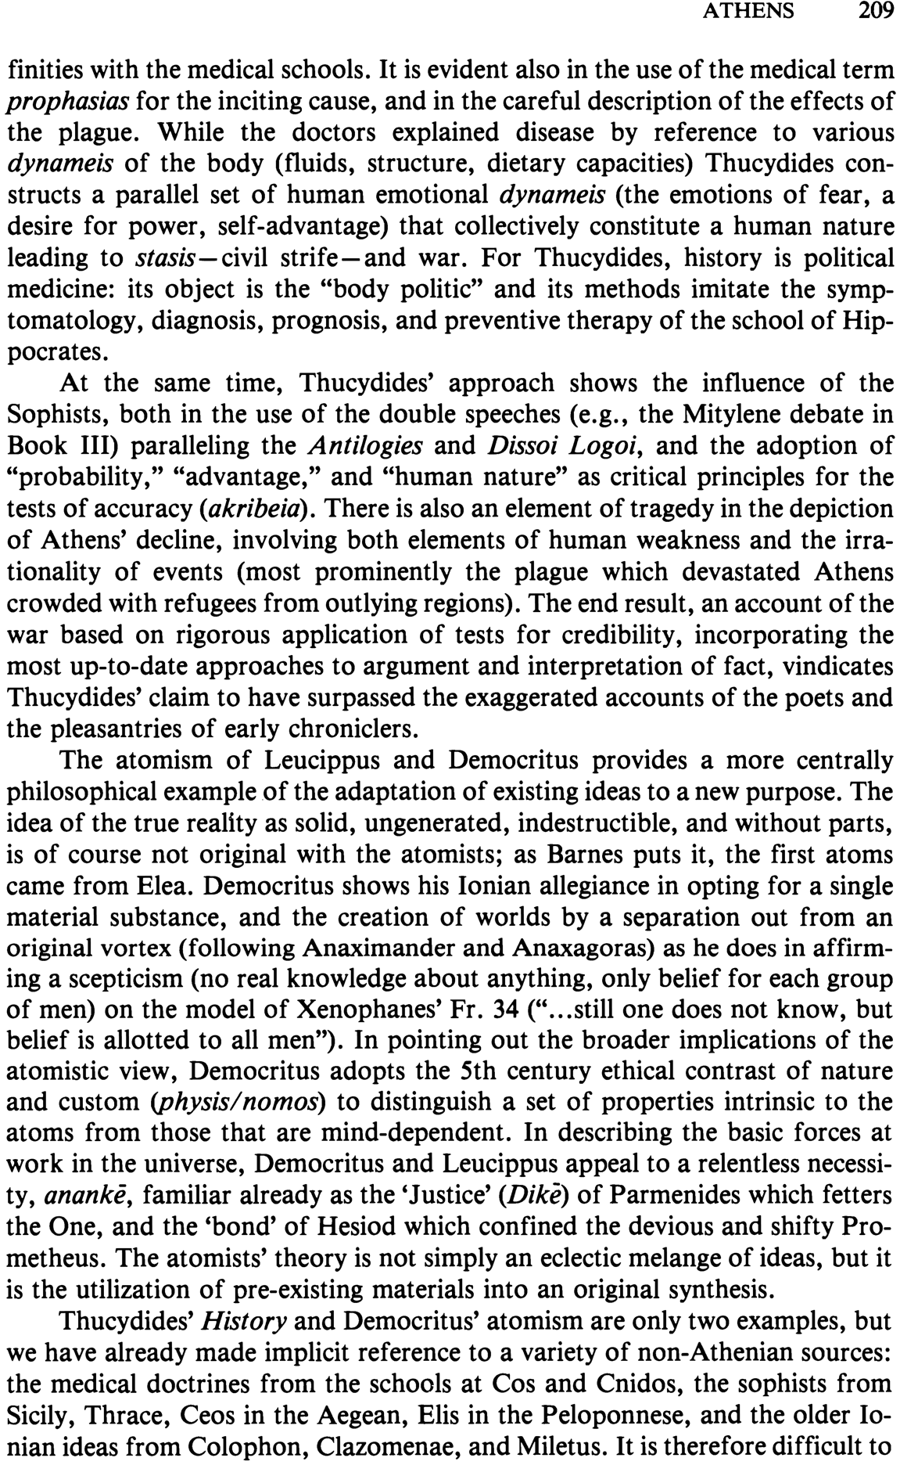
finities with the medical schools. It is evident also in the use of the medical term prophasias for the inciting cause, and in the careful description of the effects of the plague. While the doctors explained disease by reference to various dynameis of the body (fluids, structure, dietary capacities) Thucydides con- structs a parallel set of human emotional dynameis (the emotions of fear, a desire for power, self-advantage) that collectively constitute a human nature leading to stasis-civil strife-and war. For Thucydides, history is political medicine: its object is the "body politic" and its methods imitate the symp- tomatology, diagnosis, prognosis, and preventive therapy of the school of Hip- pocrates.
At the same time, Thucydides' approach shows the influence of the Sophists, both in the use of the double speeches (e.g., the Mitylene debate in Book III) paralleling the Antilogies and Dissoi Logoi, and the adoption of "probability," "advantage," and "human nature" as critical principles for the tests of accuracy (akribeia). There is also an element of tragedy in the depiction of Athens' decline, involving both elements of human weakness and the irra- tionality of events (most prominently the plague which devastated Athens crowded with refugees from outlying regions). The end result, an account of the war based on rigorous application of tests for credibility, incorporating the most up-to-date approaches to argument and interpretation of fact, vindicates Thucydides' claim to have surpassed the exaggerated accounts of the poets and the pleasantries of early chroniclers.
The atomism of Leucippus and Democritus provides a more centrally philosophical example of the adaptation of existing ideas to a new purpose. The idea of the true reality as solid, ungenerated, indestructible, and without parts, is of course not original with the atomists; as Barnes puts it, the first atoms came from Elea. Democritus shows his Ionian allegiance in opting for a single material substance, and the creation of worlds by a separation out from an original vortex (following Anaximander and Anaxagoras) as he does in affirm- ing a scepticism (no real knowledge about anything, only belief for each group of men) on the model of Xenophanes' Fr. 34 (u•..still one does not know, but belief is allotted to all men"). In pointing out the broader implications of the atomistic view, Democritus adopts the 5th century ethical contrast of nature and custom (physis/nomos) to distinguish a set of properties intrinsic to the atoms from those that are mind-dependent. In describing the basic forces at work in the universe, Democritus and Leucippus appeal to a relentless necessi- ty, ananke, familiar already as the 'Justice' (Dike) of Parmenides which fetters the One, and the 'bond' of Hesiod which confined the devious and shifty Pro- metheus. The atomists' theory is not simply an eclectic melange of ideas, but it is the utilization of pre-existing materials into an original synthesis.
Thucydides' History and Democritus' atomism are only two examples, but we have already made implicit reference to a variety of non-Athenian sources: the medical doctrines from the schools at Cos and Cnidos, the sophists from Sicily, Thrace, Ceos in the Aegean, Elis in the Peloponnese, and the older Io- nian ideas from Colophon, Clazomenae, and Miletus. It is therefore difficult to
A THENS 209
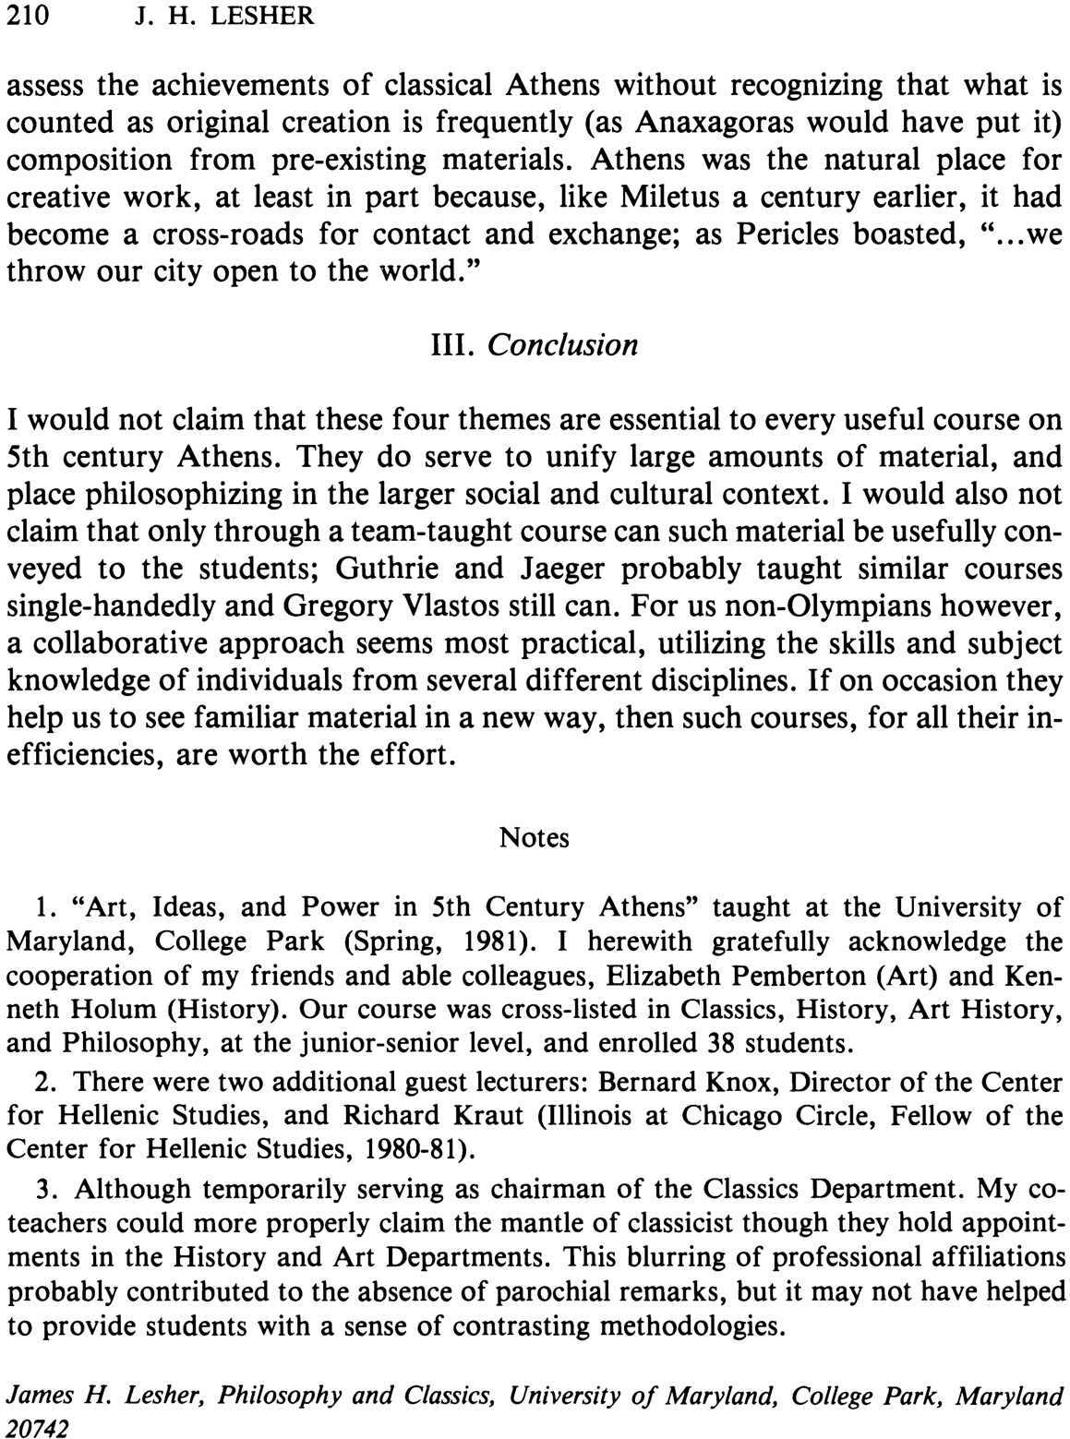
210 J. H. LESHER
assess the achievements of classical Athens without recognizing that what is counted as original creation is frequently (as Anaxagoras would have put it) composition from pre-existing materials. Athens was the natural place for creative work, at least in part because, like Miletus a century earlier, it had become a cross-roads for contact and exchange; as Pericles boasted, "...we throw our city open to the world."
III. Conclusion
I would not claim that these four themes are essential to every useful course on 5th century Athens. They do serve to unify large amounts of material, and place philosophizing in the larger social and cultural context. I would also not claim that only through a team-taught course can such material be usefully con- veyed to the students; Guthrie and Jaeger probably taught similar courses single-handedly and Gregory Vlastos still can. For us non-Olympians however, a collaborative approach seems most practical, utilizing the skills and subject knowledge of individuals from several different disciplines. If on occasion they help us to see familiar material in a new way, then such courses, for all their in- efficiencies, are worth the effort.
Notes
1. "Art, Ideas, and Power in 5th Century Athens" taught at the University of Maryland, College Park (Spring, 1981). I herewith gratefully acknowledge the cooperation of my friends and able colleagues, Elizabeth Pemberton (Art) and Ken- neth Holum (History). Our course was cross-listed in Classics, History, Art History, and Philosophy, at the junior-senior level, and enrolled 38 students.
2. There were two additional guest lecturers: Bernard Knox, Director of the Center for Hellenic Studies, and Richard Kraut (Illinois at Chicago Circle, Fellow of the Center for Hellenic Studies, 1980-81).
3. Although temporarily serving as chairman of the Classics Department. My co- teachers could more properly claim the mantle of classicist though they hold appoint- ments in the History and Art Departments. This blurring of professional affiliations probably contributed to the absence of parochial remarks, but it may not have helped to provide students with a sense of contrasting methodologies.
James H. Lesher, Philosophy and Classics, University of Maryland, College Park, Maryland 20742

