7.b The Engel Curve:

The Engel Curve tracks the consumption of a Good X as an individual’s income changes. Income is plotted on the x-axis and the quantity of Good X consumed is plotted on the y-axis. The curve that follows the amount of Good X consumed as income increases plots the Engel Curve.
The slope of the Engel Curve also tells us whether or not the good is a normal good or inferior good. If the slope of the curve is positive, the good is a normal good because consumption increases as income is increased. If the slope of the curve is negative, the good is an inferior good because consumption decreases as income is increased.
The Engel Curve can be derived from the Income Expansion Path. Each budget constraint in the Income Expansion Path provides the income. The amounts of Good X consumed at the points of consumers’ optimum on the budget constraint provide the quantity of Good X consumed at those income levels.

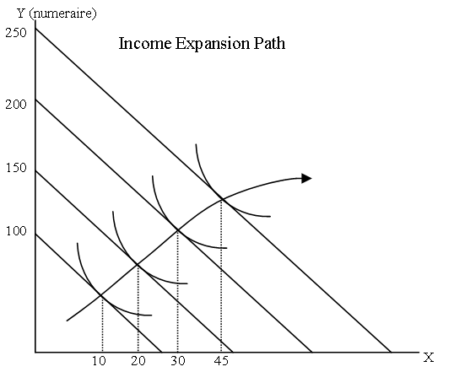
Income | Quantity  Of Good X
100 | 10
150 | 20
200 | 30
250 | 45

Figure 7.b.1: This shows an Income Expansion Path for goods X and Y with four points of consumer’s optimum shown. Good Y is a numeraire (priced at 1) and the relevant points for forming an Engel Curve are in the table to the right of the Income Expansion Path.

The information from the Income Expansion Path (IEP) can produce two different Engel Curves, one for Good X and one for Good Y. Each would use the income values provided by the budget constraints, and the variables respective quantity values.
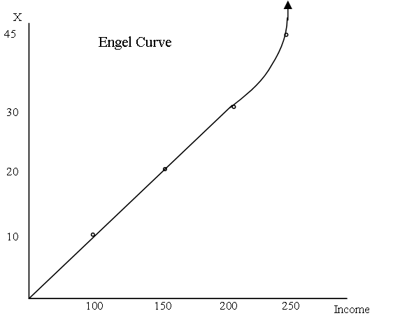

Figure 7.b.2: The Engel Curve is formed plotting the quantities of Good X consumed at the varying incomes presented in the Income Expansion Path in figure 7.b.1. As income increases, the quantity of Good X continues to increase. Good X is a normal good.

An example of a good that has an Engel curve with both normal good and inferior good segments is a grilled cheese sandwich. At lower quantities, an average low-income consumer would want to consume more as their income increases, but eventually, the consumer will reach an income where grilled cheese becomes an inferior good. The consumer’s income would then be at a level where they desire less grilled cheese as their income increases. A possible explanation would be that the consumer has replaced low-cost grilled cheese sandwiches with a higher cost food because their income reached a point where they could afford a more diverse diet.

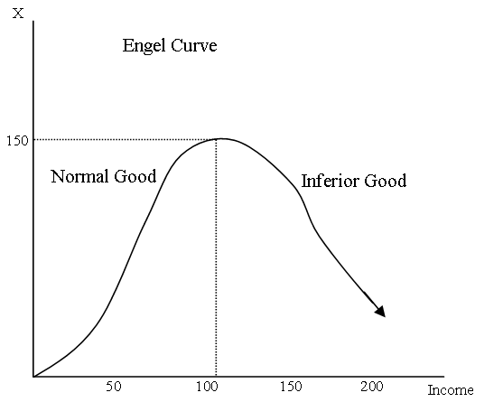

Figure 7.b.3: An example of an Engel Curve with both normal good and inferior good segments. After income increases pass 100, Good X shifts to being an inferior good.

