07/30/26
The puzzle of entanglement in quantum theory
Alan Macdonald
Professor Emeritus of Mathematics
Luther College
Decorah, IA 52101

macdonal@luther.edu
I. Action at a Distance. Imagine a table with a tablecloth draping to the floor. There is a vase on the table. Suddenly, for no apparent reason, the vase moves. What would be your reaction? My guess is that you would wonder what was the cause of the movement. Perhaps there is a motor under the table connected by a hidden wire to the next room where someone flipped a switch. Perhaps the motor is battery operated and was activated by a radio signal from across campus. Perhaps someone threw a ball hidden from your line of sight at the vase.
There is a limit to how fast a causal agent, be it electricity flowing in a wire, a radio signal, or a hidden ball, can propagate. A fundamental principle of modern physics is the principle of relativistic causality: Causal influences cannot propagate faster than the speed of light. Less precisely: There is no action at a distance. For example, light takes eight minutes to travel from the Sun to the Earth. Thus, any causal influence from the Sun on the movement of the vase had to occur at least eight minutes before it moved.
Atomic and subatomic particles can come within a hairsbreadth of violating the principle. This occurs when two or more particles are entangled. Entangled particles which are in different places are connected in a mysterious way that seems impossible. Einstein was much disturbed by it. Entanglement is the topic of this lecture.
Before looking at entanglement, let us take a quick tour of the fundamental theories of physics to see what they say about action at a distance.
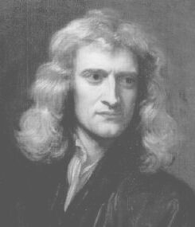
Isaac Newton
Newtonian gravity. In 1687 Isaac Newton published his Principia, which contains his laws of mechanics and his law of gravity. According to his law of gravity, every object in the universe attracts every other object in the universe. The Earth attracts an apple on a tree, causing it to fall if its stem breaks. The Earth attracts the moon, causing it to orbit the Earth. The Sun attracts the Earth, causing it to orbit the Sun. A book on a table attracts another book next to it, but the attraction is so weak that we do not notice it. According to Newton’s theory, the attraction of gravity acts directly and instantaneously between two objects. Newton was not happy with this:
That gravity should be innate, inherent and essential to matter, so that one body may act upon another at a distance through a vacuum, without the mediation of any thing else, by and through which their action and force may be conveyed from one to the other, is to me so great an absurdity, that I believe no man who has in philosophical matters a competent faculty of thinking, can ever fall into it.
If the Sun should suddenly break apart, the Earth’s orbit would, according to Newton’s theory, be affected instantaneously. There is instantaneous action at a distance in Newton’s theory. The theory violates relativistic causality.
Electromagnetism. Around 1864, James Clerk Maxwell formulated a theory of electromagnetism. This theory considers electricity, magnetism, and electromagnetic waves (e.g., light, radio waves, and X-rays) to be different aspects of a single phenomenon: electromagnetism. According to the theory, all electromagnetic waves travel at the speed of light. There is no action at a distance in Maxwell’s theory.
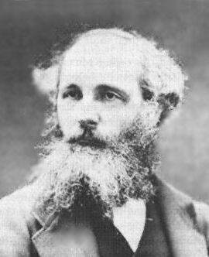
James Clerk Maxwell
Relativity. In 1905 Albert Einstein published his special theory of relativity. It is a theory of space and time. The theory does not allow a violation of the principle of relativistic causality. In fact, this is the theory which brought attention to the limiting character of the speed of light. Thus special relativity is in conflict with Newton’s theory of gravity.
The conflict was intolerable to Einstein. He thus sought a theory of gravity which does not violate relativistic causality. In 1915 Einstein published his general theory of relativity. It is a better (more accurate) theory of gravity than Newton’s. According to general relativity, gravitational influences travel at the speed of light, in accord with relativistic causality. Instantaneous action at a distance was thus eliminated from physics. If the Sun should suddenly break apart, the Earth’s orbit would, according to Einstein’s theory, not be affected until 8 minutes later.
The table summarizes the status of action at a distance in the theories we have discussed. We are about to investigate the “No” under quantum theory, where, due to entanglement, the situation is subtle.
Action at a distance
Newtonian  theory  1687 | Electromagnetic  theory  1864 | Relativity  theory  1905/15 | Quantum  theory  1925-27
Yes | No | No | No

II. The GHZ Experiment. After a long gestation, the years 1925-27 saw the birth of quantum theory. Several physicists were involved, including Werner Heisenberg, Erwin Schrödinger, Max Born, and Paul Dirac. Quantum theory is our theory of atomic and subatomic phenomena. “Quantum theory is the most precisely tested and most successful theory in the history of science. Quantum mechanics provides essential tools for all of the sciences and for every advanced technology.” (From an article published in August 2000 in Science magazine commemorating the centenary of the origin of the theory.)

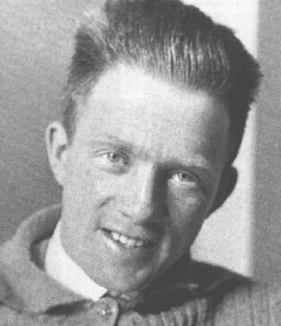
Werner Heisenberg
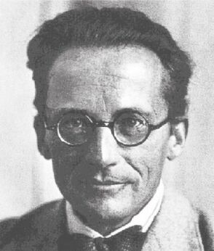
Erwin Schrödinger
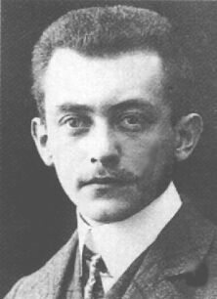
Max Born
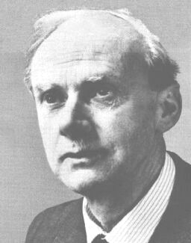
Paul Dirac

Nevertheless, Einstein was never happy with quantum theory. In 1935, he, with colleagues Boris Podolsky and Nathan Rosen (EPR), argued that entanglement shows that the theory is incomplete: quantum theory does not describe everything in the atomic world. In 1964 John Bell demolished EPR’s argument. I will tell this story in more detail later. But first I will present an improved version of Bell's argument, given by Daniel Greenberger, Michael Horne, and Anton Zeilinger (GHZ) in 1989. Their work is the centerpiece of this lecture.
GHZ proposed an experiment. In the experiment, three sub-atomic particles are emitted from a central place. Each particle enters a detector. A detector consists of a setting, H or T, con-trolled by a switch, and a light bulb. The setting has been chosen randomly, perhaps by tossing a coin. When a particle enters a detector, the bulb lights ( in the figure), or it does not. Details about how the particles are emitted and how the detector works are irrelevant for us.
Consider the two rules:

Rule 1
If only one detector is set to H,
then one or three bulbs must light.
Rule 2
If all three detectors are set to H,
then zero or two bulbs must light.

The figure above obeys Rule 1: Only one detector is set to H (#2), and one bulb is lit (#3). Rule 1 would be violated if Bulb 2 were also lit.
The rules require that the lit bulbs be correlated. For example, suppose that only one detector is set to H, so that Rule 1 applies. If neither Light 1 nor Light 2 lights, then Light 3 must light. If Light 1 lights and Light 2 does not, then Light 3 must not light.
The rules seem unexceptional, but in fact they are quite interesting. To see this, we ask the BIG question: Can the particles obey the rules? Put differently: Can the particles achieve the correlations demanded by the rules? For a given setting of a detector, it is possible to send a particle into the detector which will certainly light the bulb or certainly not light the bulb, as desired. Thus, you say, it is easy to obey the rules: the emitter need only “read” the settings of the detectors and emit the particles accordingly. For example, if the settings are as in the figure, one possibility is to emit the particles so that only Particle 3 will light its bulb.
I'm sorry, that plan won't work; I forgot to tell you something about the setup. The emitter is not allowed to have any information about the settings. Moreover, there cannot be any communication between the particles or the detectors. With these restrictions it is not clear that the particles can achieve the correlations given by the rules. But it is clear that if they can, then when the particles are emitted, it must already be determined how each particle will respond to both of the possible settings it can encounter at its detector. I'll call this a contract. For example, according to Detector 3’s portion of the contract below at the left, Particle 3 will not light the bulb if detector’s setting is H, and will light the bulb if the setting is T. (Contracts are called hidden variables in the physics literature.)
Restrict attention to Rule 1 for now. If the particles follow the contract, Rule 1 will always be obeyed. For example, if only Detector 2 is set to H, then Particles 1 and 2 will not light their bulbs, and Detector 3 will light its bulb. This coincides with the GHZ figure above and is in accord with Rule 1. If only Detector 1 is set to H, then all three particles will light their bulb (boxes H1, T2, T3). This is again in accord with Rule 1. If only Detector 3 is set to H, then only Bulb 2 will light (boxes T1, T2, H3). The contract provides the particles a way to obey Rule 1 no matter which setting turns out to be H.

 | Detector 1 | Detector 2 | Detector 3
H | ✴
T |  | ✴ | ✴
 | Detector 1 | Detector 2 | Detector 3
H | ✴ | ✴
T |  | ✴ | ✴

The only imaginable way for the particles to achieve the correlations demanded by the rules is for there to be a contract before they leave. You must understand this to feel the force of the BIG surprise below. Therefore, before proceeding I urge you to try to provide a different way to obey the rules.
Not all contracts obey Rule 1 for all settings. In the contract above at the right, if only Detector 2 is set to H, Bulbs 2 and 3 light, violating Rule 1. There are two possibilities for each box in a contract: a star or empty. Thus there are 2 x 2 x 2 x 2 x 2 x 2 = 64 possible contracts in all. But only eight of them obey Rule 1 for all settings. They are shown below. So long as the particles are emitted with one of the eight contracts, Rule 1 will be obeyed, no matter what the settings are. In each run of the experiment, one of the eight contracts could be chosen randomly.

 | 1 | 2 | 3
H | ✴ | ✴ | ✴
T | ✴ | ✴ | ✴

 | 1 | 2 | 3
H | ✴ | ✴ | ✴
T

 | 1 | 2 | 3
H | ✴
T | ✴

 | 1 | 2 | 3
H | ✴
T |  | ✴ | ✴

 | 1 | 2 | 3
H |  | ✴
T |  | ✴

 | 1 | 2 | 3
H |  | ✴
T | ✴ |  | ✴

 | 1 | 2 | 3
H |  |  | ✴
T |  |  | ✴

 | 1 | 2 | 3
H |  |  | ✴
T | ✴ | ✴

Now the bad news: None of the eight contracts also obeys Rule 2. This is easy to see. Rule 2 states that if all three receiving devices are set to H, then 0 or 2 bulbs must light. This means that there must be 0 or 2 lit bulbs in the H row of a contract. But all eight of the contracts above have 1 or 3 bulbs lit in the H row. No contract obeys both rules for every setting. We conclude that it is impossible to obey the rules for every setting.
Here is a summary of the argument yielding this conclusion:
1. Contracts provide the only imaginable way to obey the rules for every setting.
2. No contract obeys both rules for every setting.
3. Therefore, it is impossible to obey both rules for every setting.
And now, the BIG surprise. According to quantum theory, if the particles are emitted as specified by GHZ, then the rules will be obeyed for every setting. The GHZ experiment has recently been performed, as described in the paper Experimental test of quantum nonlocality in three-photon Greenberger-Horne-Zeilinger entanglement, which appeared in the 3 February, 2000 issue of Nature. The lights obeyed the rules!
Our three step argument above purported to show that it is impossible to obey the rules for every setting. How, then, do the particles obey the rules? Where is the flaw in the argument? The flaw is in Step 1: “Contracts provide the only imaginable way … ”. Nature is evidently not bound by our imaginations, which, after all, are not familiar with the behavior of subatomic particles. Somehow the particles light their bulbs in the correlated manner of the rules, even though it is not determined ahead of time how they individually will light their bulb. This is an example of entanglement. It is quite mysterious. I hope that you are duly impressed with the wonder of it all.
The mystery of entanglement becomes especially vivid if we imagine the detectors so far apart that light takes an hour to travel between them, and that the detector settings are made, randomly, one second before the particles arrive at their detector. Then two seconds before the particles arrive, it is not determined how they will respond to an H or T setting. For this would be a contract, and we know that no contract will obey the rules for every possible (future) setting of the detectors. And it is too late for communication among the particles, or among the detectors, or between a particle and detectors other than its own, before the particles arrive at the detectors. For any such communication would violate relativistic causality. Nevertheless, the particles will light the bulbs in the correlated manner of the rules.
Are you asking yourself how the entangled particles achieve the correlations predicted by quantum theory? Don’t. Richard Feynman, who won a Nobel Prize for fundamental contributions to quantum theory, warned “Do not keep saying to yourself, if you can possibly avoid it, ‘But how can [quantum theory] be like that?’ because you will get ‘down the drain,’ into a blind alley from which nobody has yet escaped. Nobody knows how it can be like that.”
Does all this mean that entanglement provides instantaneous action at a distance? Not in a way that violates relativistic causality. It is impossible to use the correlations to violate causality. It is impossible to transmit information using the correlations. Entangled particles do not violate relativistic causality − but it is close. People speak of the peaceful coexistence between quantum theory and relativity theory.
III. Past, Present, and Future. When we fooled ourselves into believing that a contract is required to achieve the correlations of the GHZ experiment, we were in good company. In 1935, only a decade after quantum theory was created, Einstein, with Podolsky and Rosen, argued similarly. The title of their paper is Can Quantum-Mechanical Description of Physical Reality Be Considered Complete? EPR analyzed an experiment which has correlations similar to those in the GHZ experiment. They argued that contracts are the only way to account for the correlations. EPR then observed that there are no contracts in quantum theory. Therefore, they claimed, the theory does not describe everything in the atomic world. Thus according to EPR, the answer to the question posed in their title is no; quantum theory is incomplete.
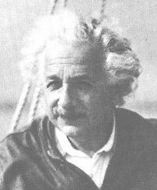
Albert Einstein
The EPR paper was (and is) much discussed. But the issue it raised was not resolved for nearly three decades, because no one was able to suggest a way to decide whether contracts exist. The decisive step came in 1964, when John Bell published his highly original paper On the Einstein-Podolsky-Rosen paradox. Bell analyzed an experiment similar to the EPR and GHZ experiments, in which spatially separated particles exhibit correlations. He showed that despite the correlations, no contracts exist, proving EPR wrong, and revealing the mysterious nature of entanglement. Bell’s proof involves the famous Bell’s inequalities. His paper has been cited many hundreds of times. It single handedly caused the revival of interest in the foundations of quantum theory that continues today.
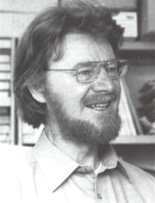
John Bell
Interest in entanglement is not limited to nonpractical types like me interested in the foundations of quantum theory for its own sake. Entanglement is likely to become extremely important technologically. Entanglement is forbidden by pre-quantum physics; it is impossible to understand from Newton's, Maxwell's, or Einstein's physics. Neither people nor baseballs can be entangled. Entanglement was a newly discovered physical effect, unimagined before quantum theory. Whenever there is a newly discovered physical effect, the possibility exists to put it to use technologically for purposes previously unimagined. For example, before Maxwell’s electromagnetic theory no one imagined the possibility of radio waves and thus of radio. There are many such examples.
Entanglement is crucial to the emerging technologies of quantum communication, quantum cryptography, and quantum computing. There is increasing confidence that these technologies will be practical, but no one is sure. If they do become practical, the consequences will be profound. Quantum computers provide one example.
No computer today uses entanglement. This opens the possibility that a quantum computer exploiting entanglement could do things that today’s computers cannot. This is indeed the case.
Consider the problem of factoring numbers. For example, 15 can be factored as 3 x 5. That was easy. But there is no known way to factor efficiently large numbers, say of two hundred digits length, on today’s computers, or any computer whose logic is based on pre-quantum ideas. (Computer scientists call such machines Turing machines.) This is important because coding schemes used to provide security for digital information are often based on our inability to efficiently factor large numbers. For example, the security features in your web browser are based on this.
In 1997, Peter Shor of AT&T Labs published a paper Polynomial-time algorithm for prime factorization … on a quantum computer. The paper showed that a quantum computer can factor large numbers efficiently. It caused a sensation. As a result of Shor’s discovery and a few others, the race to build quantum computers is on. If they are built, information transmitted on the internet will become insecure.

Peter Shor

Peter Shor 1Peter Shor

Peter Shor
Unless, of course, new ways of encoding information are invented. The competition between code makers and code breakers has been never ending. Entanglement to the rescue! In 2000 three groups of researchers demonstrated prototype encoding and decoding devices using entanglement. It has been proved mathematically that the codes cannot be broken. One headline read Exploiting Quantum “Spookiness” to Create Secret Codes. The article continues “Entanglement-based quantum cryptography has unique features …”.
I close with two remarks. The creators of quantum theory were not aware of entanglement as they created the theory; it was not “put into” the theory. Rather, it was “discovered” in the mathematics of the theory. And it was discovered decades before it was actually observed experimentally. This is but one example of a physical theory giving back more than was put in, which is one of the wonders of science. Nobel Prize winning physicist Eugene Wigner was moved to write an essay The Unreasonable Effectiveness of Mathematics in the Natural Sciences. And according to physicist J. M. Lévy-Leblond, “The fearful efficiency of its [mathematical] formalism constitutes the strength of physics.”
Finally, there is the incredible physical insight of Einstein, who sixty-five years ago focused attention on entanglement, which is now recognized as one of the most fundamental, perhaps the most fundamental, aspect of quantum theory, and which is emerging today as a key to future technologies.

