The CNS-independent consciousness system

Jin Ma (Email: jasonma@depontech.com ) with critiques from an anonymous discussant in Phoenix, AZ, USA
Postal address: 13B, 288 South Zhongshan Rd, Nanjing 210005, China

Abstract

While vitally critical, the relationship between conscious system and the central nervous system (CNS) is least interested to the scientific community, and often regarded as abstractly conceptual in philosophy or religion. We argue that the existence of consciousness system is parallel to, and independent of, CNS. First and foremost, all sciences are based on logic, not any existing theories, so does neuroscience. So, neuroscience shall start from some theory-independent logic, not some neural or molecular hypotheses, or count on modern physics which is neither completed nor physically deep enough. It shall hypothesize the brain has a CNS (central nervous system) independent consciousness system. Then, we have explained why this hypothesis is theory-independent from the view of methodology, philosophy and physics; what a strong experimental logic this hypothesis can produce; how the logic can measure consciousness. In short, sciences are based on logic, and it is serious for neuroscience to hypothesize there is a CNS-independent consciousness system.

Keywords
Science is based on logic; divide-and-conquer policy; Neutral Monism; the “well-sealed logic”; consciousness system; pattern of thinking (POT); the “real” neural correlated consciousness (NCC) effect; consciousness-carried information;

- Introduction

People feel that it is their mind that leads their body, not their body leads their mind. Yoga and other meditation practices tell people clearly about this, and many mental diseases such as depression and AD have no clear neural-related problems. Simple living creatures without neurons or without central nervous system looks with consciousness too (Dexter, Prabakaran, & Gunawardena, 2019). An earthworm is cut off CNS can produce CNS for a new life. Consciousness seems independent of neurons and CNS apparently (de Haan et al., 2020).

However, our neuroscience believes it is CNS and the brain circuits that produce consciousness. There are interesting theories, such as the information integration theory (IIT) (Crick & Koch, 2003), the global neuronal workspace theory (GNW) (Baars, 2005; Dehaene & Changeux, 2011), and the Orch OR theory (orchestrated objective reduction) (2021; S. R. Hameroff, Craddock, & Tuszynski, 2014). But a general agreed-theory of conscious mental processes of feel, act, learn, and remember, is far away.

So, we see that neuroscience might be totally wrong on assuming neuron of producing consciousness (Hill, 2018; Kincaid, 1990), and wrong on assuming uncompleted or physically deep enough modern physics is good enough for its use (Peat, 1988). Neuroscience shall start from some pure logic (Asok, Leroy, Rayman, & Kandel, 2019) (Warne, Golightly, & Black, 2021), because all sciences are based on logic, not any appealing hypotheses.

In this article, we have explained how neuroscience can get its theory-independent logic and what it is, from the views of methodology, philosophy, physics, and experiment. Obviously, we should assume the brain has a CNS-independent consciousness system and consciousness is independent of neurons.

- How to get the theory-independent logic in studying consciousness

  - Methodology

Methodologically, we should assume consciousness has its independent ID and the brain has a CNS-independent consciousness system. And this is just to follow that divide-and-conquer policy in studying consciousness. This logic is theory-independent and just has provided neuroscience a more serious scientific basis.

  - Philosophy and physics

Philosophically, we should transfer from Physicalism to Neutral Monism to get philosophy-independent logic in studying consciousness. Let us explain why.

The philosophy of mind has explained the relationship of Matter and Mind only in four patterns. Three patterns of monism and one pattern as Dualism.

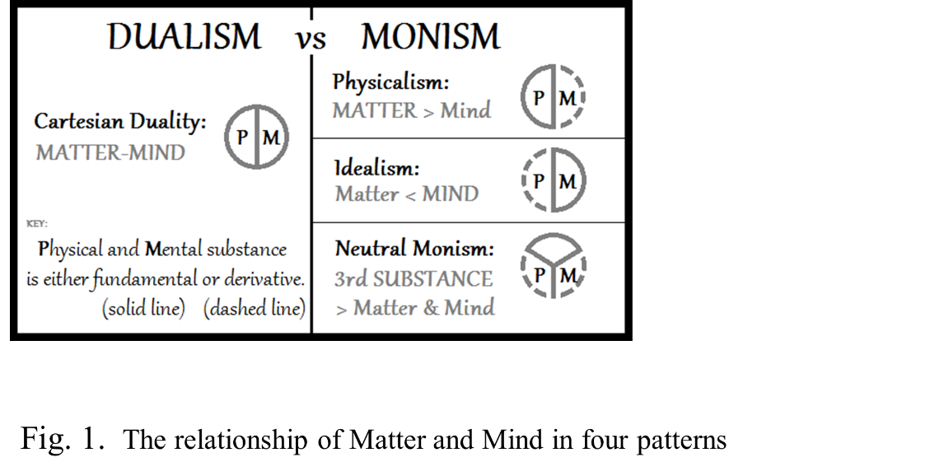

- Monism one, Physicalism: Only Matter is real, and Mind is illusion based on Matter;
- Monism two, Idealism: Only Mind is real, and Matter is illusion based on Mind;
- Monism three, Neutral Monism: Both Matter and Mind are real, but they are both derived from a neutral substrate;
- Dualism: Both Matter and Mind are real, and they are independent.

We see that Physicalism has neglected the possible independence of the mind; Idealism has rejected the possible independence of matter; Dualism has neglected the possible existence of a common neutral substrate. Only Neutral Monism has covered all probabilities on the origin of consciousness.

In sum, transfer from Physicalism to Neutral Monism is essential for neuroscience to get its theory-independent logic in studying consciousness; neuroscience shall follow the Neutral Monism model and hypothesize a CNS-independent consciousness system (Dexter et al., 2019; Nieder, 2021).

In physics, modern physics has not been unified and completed, that is why the logic of Physicalism may not be physically deep enough (Demarin & MOROVIĆ, 2014). So, to cover all physical probabilities on the origin of consciousness, neuroscience has to transfer from Physicalism to Neutral Monism (Silberstein & Stuckey, 2020) (Goni-Saez & Tirapu-Ustarroz, 2016).

2.3 Experiment

To avoid our experiments on a wrong theoretical basis, getting the theory-independent logic to measure consciousness is critical in studying consciousness. Let us explain how in three steps: the principle of modeling, modeling the mental processing, and the logic of measure.

    - The principle of modeling— the “well-sealed logic” principle

If there is a principle of modeling that is purely based on logic, this is critical in studying consciousness because we know so little about consciousness. Luckily, our answer is yes. Let us explain what it is.

We have been studying vast types of natural phenomena and see all entities are theoretically in “three aspects”: its structure, its running mechanism, and its behaviors. We see a pure logical equation: “Structure x Running Mechanism= Behaviors”, and this equation shall logically stand right in all aspects. This means the entity’s behaviors shall be matched with its structure and its running mechanism, with any outside influences and under any inside situations. So, we have defined this everlasting logical correspondence the “well-sealed logic” principle and used it to model the mental processing. This is a universal principle of modeling in any research projects, we could always model the targeted entity’s structure and mechanism from 1-3 of its distinct behaviors, then double-check and improve that postulated model from any other aspects, from any inside situations or under any outside influences, and as critical as possible. Any obvious logical contradiction will say that is only a wrong model.

So, we have used this “well-sealed logic” principle as the principle of modeling in our consciousness studies. This principle has followed the theory-independent basis, and it is universal, foundational, and nonspeculative in science.

    - Modeling the mental processing

Let us briefly introduce how we have developed six models for getting the essential logic of the mental processing to measure consciousness. The six models are as below:

- Brain’s information processing model;
- Brain’s physical model;
- Brain’s neural correlates of consciousness (NCC) model;
- Memory’s physical model;
- Consciousness system’s physical model;
- Consciousness system’s psychological model;

Brain’s information processing model

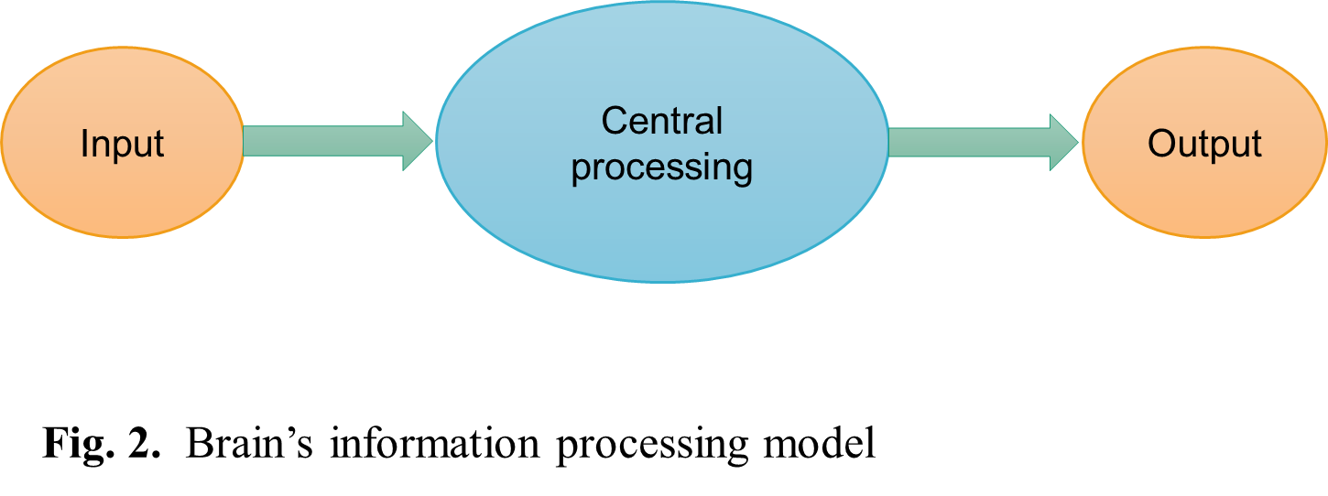

We see humans or the brain as an intelligent system of processing information. We can see its processes are always under three procedures: input, output, and central processing. This logical definition has putted neuroscience more specialized by distinguished the input of perception signals from the central processing of information. Consciousness studies shall distinguish the consciousness processing from the neural sensory processing clearly, such as avoid thinking the input and output procedures of the brain-computer interface has anything to do with the central processing.

In short, we have divided brain’s information processing into three parts to distinguish neural sensory function from consciousness processing, and to emphasize the filtration of the input and output data in measuring consciousness.

Brain’s physical model

The brain is in two subsystems: the CNS and the consciousness system, and the consciousness system is beyond space (This is to match conscious behaviors are beyond space). These two subsystems’ running and interacting have produced mental processing. So, brain science is divided into three theories: the theory of the CNS, the theory of the consciousness system, and the theory of their interaction which is also called the theory of NCC (neural correlates of consciousness).

Based on anatomy, peoples’ laws of CNS are generally the same because people have generally same brain structure; based on psychology, peoples’ laws of consciousness systems are vast varied because people behave with vast varied personalities; so logically, peoples’ law of NCC cannot be the same unless their kinds of consciousness systems are the same, however, we can only count on this to measure consciousness.

In sum, we see that brain science is in three theories and “the hard problem” of consciousness is about two of them: the theory of consciousness system and the theory of NCC.

Brain’s neural correlates of consciousness (NCC) model

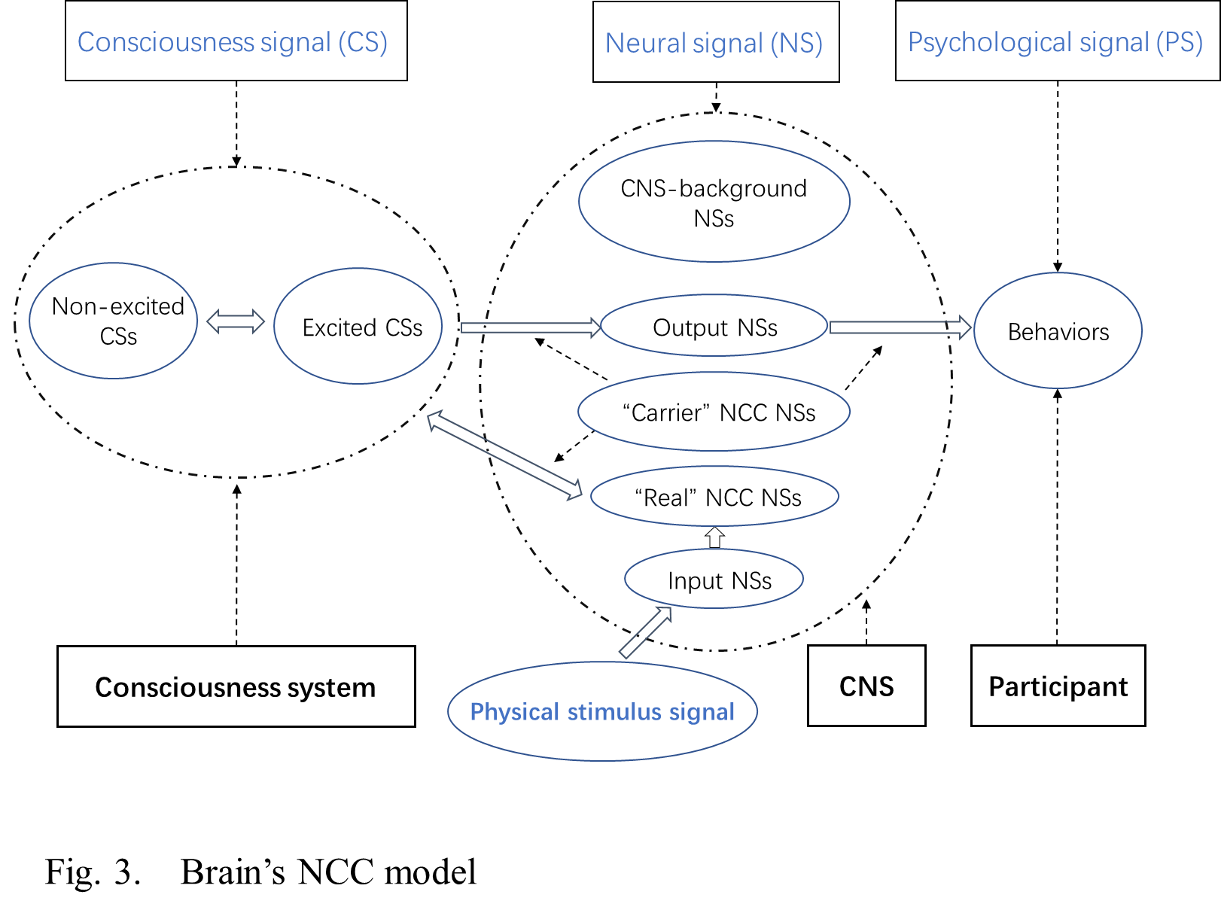

Brain’s NCC model is to specify the flowchart of mental processing. We have defined that mental processing has involved four types of signals: a) Physical stimulus signal (SS); b) Neural signal (NS); c) Consciousness signal (CS); d) Psychological signal (PS).

Then, we have divided the neural signals (NSs) into 5 groups: ① the input NSs; ② the output NSs; ③ the CNS-background NSs; ④ the “carrier” NCC NSs; ⑤ the “real” NCC NSs.

This modeling is understandable about the first three groups, but we have still assumed the “carrier” NCC group besides the “real” NCC group, which only relates to the content of consciousness as the consciousness-carried information. This assumed modulated NCC way is only to cover all possible logic of NCC, because we do not see the consciousness-carried information has behaved any overlapping effects.

The “carrier” NCC can keep the information stable. It is like the “carrier wave” in the radio signal, the carrier’s intensity should be at a higher level than the information signals’ intensity. So, filtrating out the “carrier” NCC NSs will be the main task of measuring the content of consciousness (Nani et al., 2019).

In sum, this logical model of NCC has specified neural signals in groups, especially emphasizing the possible existence of the “carrier” NCC group. This holistic view of the neural activities has emphasized we may only study consciousness in the lab by examining the “real” NCC group neural activities.

Memory’s physical model

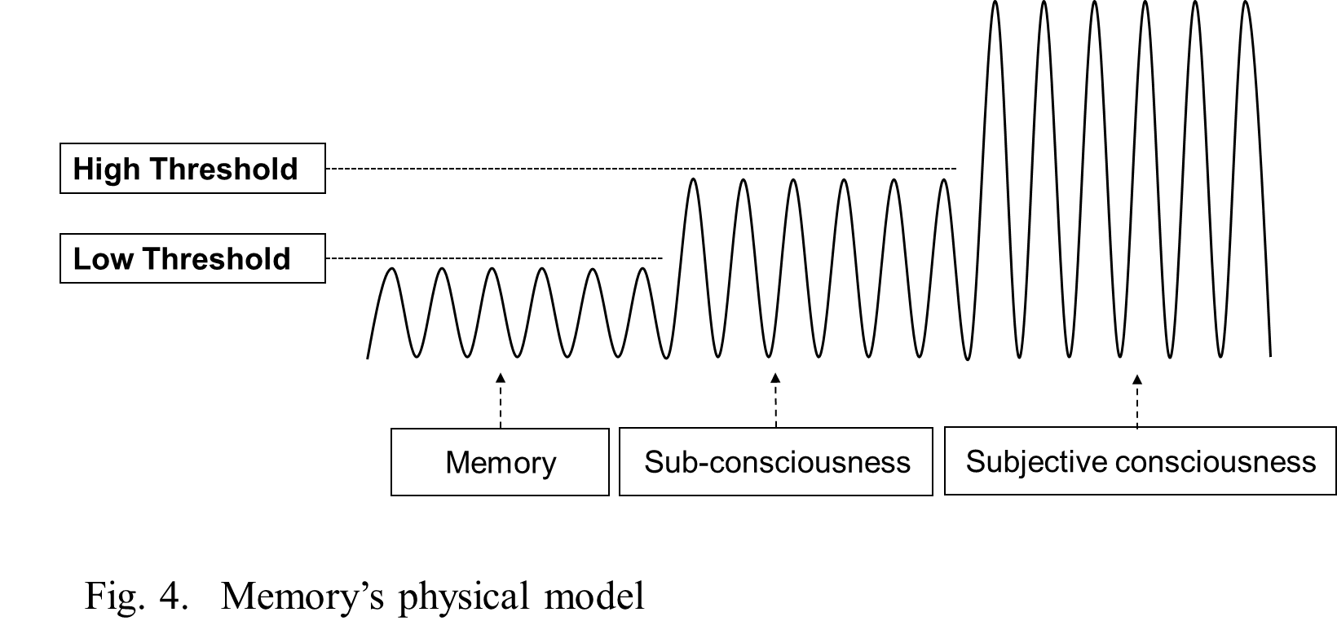

We assume memories are in coupling (beyond space), and the couplings are with two thresholds and under three physical excitation levels, which correspond to three psychological states: the static memory, subconsciousness, and subjective consciousness. This assumption sounds like the three excitation levels of water molecules have behaved as solid ice, liquid water, and gaseous steam.

In short, this modeling is to materialize psychology logically, so we could measure consciousness psychologically.

Consciousness system’s physical model

The consciousness system is physically a TC (Thinking-coupling) that consists of millions of mini-TCs. Each mini-TC corresponds to one memory. When a mini-TC couples beyond its low threshold, the memory that it carries is in its static storage state. When that mini-TC couples above its low threshold, that memory that it carries can join the thinking process as part of subconsciousness, that you cannot aware of. When that mini-TC couples above its high threshold, that memory that it carries can join the thinking process as part of subjective consciousness, that you can aware of. But one mini-TC is not indeed physically independent, rather only literally. This is because its coupling factor can be considered literally as a group of mini-coupling factors in quite a number, and one mini-coupling factor can either stand-alone or synergize with any other one from its own group or other groups to be a "new" mini-TC.

In the spatial view, as both mini-TCs’ size and running are beyond space, they are paralleled in space instead of overlapping, and their interactions are determined by their coupling factors’ types and grades instead of a force in any form.

Mini-TCs’ groups can be classified in a psychological way, and the hierarchy of the groups is similar to what knowledge does in library science.

The general coupling pattern (GCP) of TC is determined by those groups’ couplings themselves and the couplings between those groups. It produces one’s pattern of thinking (POT) that reflects his personality and intelligent traits. One’s GCP is innate and generally unchanged in people’s adulthood. One’s experience and education basically can only affect the volume of each group, that is why peoples’ kinds of consciousness systems are quite stable during their adulthood.

In sum, this modeling is to identify each consciousness signal pieces, so it will be possible to measure the consciousness-carried information in the experiments. This sophisticated model has found no contradiction to the “well-sealed logic” principle yet.

Consciousness system’s psychological model

Peoples’ consciousness systems determine their patterns of thinking (POT). So, we have defined consciousness system’s virtual operation factors with some distinct psychological traits. The primary psychological model is based on people’s linear thinking traits in four elements: linear, nonlinear, divergent, and convergent. This linear model and other psychological model are to help us choose participants with the same POT, which means participants with the same kind of consciousness system. We see the same kind of consciousness system will mean the same NCC laws among participants. We logically depend on this to filter the “carrier” NCC and get the “real” NCC.

In sum, only psychological behaviors relate to consciousness, so we need model to touch consciousness in reality and touch technically in the experiments.

    - The logic of measuring consciousness— measure the consciousness-carried information

These six models, that have been developed on the “well-sealed logic” principle, have provided us the mental processing with complete logic, and the logic is independent of any theories. It has pointed out we need to find out participants of the same kinds of consciousness systems for filtering out the “carrier” NCC and get the “real” NCC. This is to measure the consciousness-carried information as the content of consciousness, and this is to avoid only measuring some consciousness-related neural side-effects (Dehaene & Changeux, 2011; Frohlich, Toker, & Monti, 2021; Hales & Ericson, 2022). And the possible chance of consciousness-related neural side-effects is very high (Bayne, Hohwy, & Owen, 2016).

Only paralleled NCC effects among people of the same kinds of consciousness can provide the logic to filter the “carrier” NCC and get the “real” NCC, and this is the only way to measure consciousness with neural activities.

In sum, we need the theory-independent logic to measure consciousness, and the most critical point is to filter out the “carrier” NCC as the “noise” NCC for getting the “real” NCC that can represent the consciousness-carried information. This shall be the basis of studying consciousness in the experiments.

- Conclusions

Science shall follow logic on any aspects. We assume that neuroscience shall double-check its neuron-and-molecule theoretical basis, and transfer to a theory-independent logic basis by hypothesizing there is a CNS-independent consciousness system.

Acknowledgments
I thank my respected discussant Dr. K.C, and also thank Lian Wang, Bernard Baars, Randal Koene, Pim Van Lommel, Biao Zhao, Xiaohan Tang, Yue Wang, Wenwei Yuan, Guihua Yao, Patrizio E. Tressoldi, Philip Goff, James B.Glattfelder, and Robert Karl Stonjek for their critiques and supports.

Conflict of Interests
We declare no conflict of interests.

References

Asok, A., Leroy, F., Rayman, J. B., & Kandel, E. R. (2019). Molecular Mechanisms of the Memory Trace. Trends Neurosci, 42(1), 14-22. doi: 10.1016/j.tins.2018.10.005
Baars, B. J. (2005). Global workspace theory of consciousness: toward a cognitive neuroscience of human experience. Progress in brain research, 150, 45-53.
Bayne, T., Hohwy, J., & Owen, A. M. (2016). Are there levels of consciousness? Trends in cognitive sciences, 20(6), 405-413.
Crick, F., & Koch, C. (2003). A framework for consciousness. Nature neuroscience, 6(2), 119-126.
de Haan, E. H. F., Corballis, P. M., Hillyard, S. A., Marzi, C. A., Seth, A., Lamme, V. A. F., . . . Pinto, Y. (2020). Split-Brain: What We Know Now and Why This is Important for Understanding Consciousness. Neuropsychol Rev, 30(2), 224-233. doi: 10.1007/s11065-020-09439-3
Dehaene, S., & Changeux, J.-P. (2011). Experimental and theoretical approaches to conscious processing. Neuron, 70(2), 200-227.
Demarin, V., & MOROVIĆ, S. (2014). Neuroplasticity. Periodicum biologorum, 116(2), 209-211.
Dexter, J. P., Prabakaran, S., & Gunawardena, J. (2019). A complex hierarchy of avoidance behaviors in a single-cell eukaryote. Current biology, 29(24), 4323-4329. e4322.
Frohlich, J., Toker, D., & Monti, M. M. (2021). Consciousness among delta waves: a paradox? Brain, 144(8), 2257-2277. doi: 10.1093/brain/awab095
Goni-Saez, F., & Tirapu-Ustarroz, J. (2016). [The mind-brain problem (I): onto-epistemological foundations]. Rev Neurol, 63(3), 130-139.
Hales, C. G., & Ericson, M. (2022). Electromagnetism's Bridge Across the Explanatory Gap: How a Neuroscience/Physics Collaboration Delivers Explanation Into All Theories of Consciousness. Front Hum Neurosci, 16, 836046. doi: 10.3389/fnhum.2022.836046
Hameroff, S. (2021). 'Orch OR' is the most complete, and most easily falsifiable theory of consciousness. Cogn Neurosci, 12(2), 74-76. doi: 10.1080/17588928.2020.1839037
Hameroff, S. R., Craddock, T. J., & Tuszynski, J. A. (2014). Quantum effects in the understanding of consciousness. J Integr Neurosci, 13(2), 229-252. doi: 10.1142/s0219635214400093
Hill, C. S. (2018). Unity of consciousness. Wiley Interdiscip Rev Cogn Sci, 9(5), e1465. doi: 10.1002/wcs.1465
Kincaid, H. (1990). Molecular biology and the unity of science. Philosophy of Science, 57(4), 575-593.
Nani, A., Manuello, J., Mancuso, L., Liloia, D., Costa, T., & Cauda, F. (2019). The Neural Correlates of Consciousness and Attention: Two Sister Processes of the Brain. Front Neurosci, 13, 1169. doi: 10.3389/fnins.2019.01169
Nieder, A. (2021). Consciousness without cortex. Curr Opin Neurobiol, 71, 69-76. doi: 10.1016/j.conb.2021.09.010
Peat, D. (1988). Superstrings and the search for the theory of everything.
Silberstein, M., & Stuckey, W. (2020). Re-Thinking the World with Neutral Monism:Removing the Boundaries Between Mind, Matter, and Spacetime. Entropy (Basel), 22(5). doi: 10.3390/e22050551
Warne, R. T., Golightly, S., & Black, M. (2021). Factor structure of intelligence and divergent thinking subtests: A registered report. PLoS One, 16(5), e0251268. doi: 10.1371/journal.pone.0251268

This policy is theoretically explained in the “architect of everything” as the “alienation” in our paper The Unity of Science.
We have given more theoretical explanation of this principle in our paper The Unity of Science about the architect of everything.
This article is only to argue the necessity of assuming a CNS-independent consciousness system, so we only have explained the full details of those models in our paper The Coupling Theory of Consciousness.
Neural activities are very unstable, but mental processing is quite stable, we need model to explain this weird phenomenon well.
Consciousness studies shall study neural signal processing, conscious processing, and information processing independently.
This property is to match why memory is not overlapping psychologically.
This is also to match the “structure” to the “behaviors”.
GCP reflects the general “structure” of the consciousness system, and it must conform to the “behavior” of the consciousness system naturally. Otherwise, all relevant models are wrong.
The filtration of input, output, and background noise has been explained in our article The Coupling Theory of Consciousness, so does the filtration of the “carrier” NCC.

