How Universities Can Help Humanity Learn How to Resolve the Crises of Our Times - From Knowledge to Wisdom: The University College London Experience
Nicholas Maxwell
Published in Handbook on the Knowledge Economy, vol. 2, ed. D. Rooney et al., Edward Elgar Publishing Ltd., Cheltenham, pp. 158-179.
Introduction
We are in a state of impending crisis. And the fault lies in part with academia. For two centuries or so, academia has been devoted to the pursuit of knowledge and technological know-how. This has enormously increased our power to act which has, in turn, brought us both all the great benefits of the modern world and the crises we now face. Modern science and technology have made possible modern industry and agriculture, the explosive growth of the world’s population, global warming, modern armaments and the lethal character of modern warfare, destruction of natural habitats and rapid extinction of species, immense inequalities of wealth and power across the globe, pollution of earth, sea and air, even the aids epidemic (aids being spread by modern travel). All these global problems have arisen because some of us have acquired unprecedented powers to act, via science and technology, without also acquiring the capacity to act wisely.
We urgently need to bring about a revolution in universities so that the basic intellectual aim becomes, not knowledge merely, but rather wisdom – wisdom being the capacity to realize what is of value in life, for oneself and others, thus including knowledge and technological know-how, but much else besides. This is an argument I have propounded during the last three decades in six books, over forty papers, and countless lectures delivered in universities and conferences all over the UK, Europe and north America. Despite this effort, the argument has so far, by and large, been ignored. What is really surprising is that philosophers have paid so little attention, despite the fact that that this body of work claims to solve the profoundly important, ancient philosophical problem: What kind of inquiry best helps us make progress towards a civilized, wise world?
There are, nevertheless, indications that some scientists and university administrators are beginning to become aware of the urgent need for science, and universities, to change. This is prompted, partly by growing awareness of the seriousness of environmental problems, especially global warming, and partly by a concern to improve the relationship between science and the public. So far, however, these changes have been small-scale, scattered and piecemeal. What we require is for academics and non-academics alike to wake up to the urgent need for change so that we may come to possess what we so strikingly and disastrously lack at present: a kind of inquiry rationally devoted to helping humanity make progress towards as good a world as possible.

The Two Arguments
A proper, basic aim of academic inquiry, let us assume, is to help promote human welfare. It has been almost universally taken for granted, for the last century or so that, in order to do this, universities must, in the first instance, pursue the intellectual aim of acquiring knowledge. First, knowledge is to be acquired; then it can be applied to help solve social problems. If academia is to be of genuine human value, it is vital that authentic, objective, factual knowledge is acquired, untainted by prejudice or ideology. Values, political ideas and aspirations, social considerations, expressions of feelings and desires must all be excluded ruthlessly from the intellectual domain of inquiry, so that worthwhile, reliable factual knowledge may be acquired. Let us call this orthodox view knowledge-inquiry. This is the view that has shaped the way universities have developed for the last century or so. It is still massively influential (although not everyone agrees with it).
Judged from the standpoint of helping to promote human welfare, knowledge-inquiry is, however, damagingly irrational in a wholesale, structural way. I have two arguments to establish this point. The first appeals to a problem-solving conception of rationality, the second to an aim-pursuing conception.
What ought we to mean by “rationality” in the present context? The notion we require appeals to the idea that there are general methods or strategies which, if put into practice, give us our best chances of solving our problems or realizing our aims, other things being equal. These methods, no doubt somewhat ill-defined, tell us what we must attempt to do. They do not specify precisely what actions we must take, and do not guarantee success. They will turn out to be meta-methods: they assume we can already successfully put many methods into practice in order to solve problems or realize aims, and tell us how to marshal our pre-existing resources in order to solve new problems.
My first argument appeals to problem-solving rationality: specifically, to the following four elementary, almost banal, and entirely uncontroversial methods of rational problem-solving.
(1) Articulate, and try to improve the articulation of, the problem to be solved.
(2) Propose and critically assess possible solutions.
(3) If a problem proves intractable, break it up into simpler, preliminary, specialized problems (to be tackled in accordance with (1) and (2)).
(4) When this is done, ensure that basic and specialized problem-solving interact, so that each may influence the other.
Any problem-solving endeavour which persistently violates just one of these methods must be judged irrational, and will suffer adverse features as a result.
Knowledge-inquiry violates, not just one, but three of these four elementary methods. Granted that academia has, as its basic task, to help promote human welfare, then the problems it seeks to help solve are fundamentally problems of living, problems of action, not problems of knowledge. It is what we do (or refrain from doing) that enables us to realize what is of value in life, not what we know (except when knowledge is itself of value). Even when new knowledge is required, as it is in medicine or agriculture for example, it is always what this knowledge enables us to do that promotes human welfare. Thus, the primary rational task of academia is to (1) articulate problems of living, and (2) propose and critically assess possible solutions – possible and actual actions, deeds, policies, political programmes, philosophies of life. But knowledge-inquiry, restricted to (or giving priority to) the pursuit of knowledge, cannot do this. Methods (1) and (2) are violated. Method (3) is put into practice with almost baroque splendour: this accounts for the maze of ever more specialized disciplines of modern academic inquiry. But method (4) is violated; it can only be implemented if (1) and (2) are implemented as well.
The gross structural irrationality incurred as a result of violating three of the four most elementary rules of rational problem-solving conceivable has had long-term, dire consequences. Violation of (1) and (2) means that universities have failed to do what most needs to be done if they are to help humanity make progress towards a better world, namely imaginatively explore and critically assess possible and actual cooperative resolutions of global problems. Violation of (4) means that specialized research has been in danger of becoming unrelated to the most urgent needs and problems of humanity. When one considers the vast sums devoted to military research, and research into the diseases of the wealthy rather than the poor, one may well conclude that the institutionalized violation of (4) has indeed had the bad consequences that are to be expected.
It is this long-standing irrationality of universities which is responsible for our failure to learn how to resolve our grave global problems indicated above – problems made possible by the successful pursuit of scientific knowledge dissociated from a more fundamental concern with problems of living. We are victims of the institutionalization of a bad philosophy of inquiry – namely knowledge-inquiry.
But is it true that universities put knowledge-inquiry into practice? Does not much policy research go on in universities today? And is it not, in any case, right to give priority to the pursuit of knowledge? How could policy research proceed without prior knowledge of relevant facts?
Policy studies do of course exist in universities today, but only on the fringes of academe, not as the central intellectual concern. Economics, sociology, anthropology, and the other social sciences are still pursued and conceived of as sciences, as disciplines devoted to the pursuit of knowledge, and not as disciplines that give intellectual priority to problems of living. As for the argument that policy research requires prior knowledge, my response is that we only know what knowledge it is relevant to try to acquire if we have some initial idea about what we want in life. A slight shift in the way we conceive our problems may dramatically change the kind of knowledge we need to try to acquire. In moving from curative to preventive medicine we change dramatically the kind of knowledge and technological know-how it is relevant to acquire. Policy exploration needs to play a vital role in stimulating and directing scientific research.
I turn now to my second argument. This appeals to aim-pursuing rationality.
Whether we are individuals, groups, or institutions, basic aims, in all sorts of contexts, are all too likely to be problematic, either because they conflict with other aims we hold dear, or because what we seek has all sorts of unforeseen undesirable consequences, or because the aim, as conceived, cannot be realized, or because all these hold. In these circumstances it is more than likely that the aim we seek is not the one that is in our best interests. It may even be highly undesirable, unrealizable, or both. We may even misrepresent what it is we seek. In these circumstances, the more rationally – the more successfully – we pursue our official, acknowledged aim, the worse off we are from the standpoint of achieving what is in our best interests, what is of most value, or our real aim, as we may say. Rationality becomes, not a help but a hindrance, an enemy. It takes us away from what is genuinely in our best interests. It prompts us to solve the wrong problems.
If reason is not to lead us systematically astray in this way (and thus not be reason at all), it must include methods designed to help us discover inadequacies in the aims we pursue, so that we can improve our aims as we act, as we live. These methods include the following:
(a) As you act, subject basic aims to sustained critical scrutiny; develop imaginatively and critically assess alternative possible aims.
(b) Ask why the aim is being pursued, both in the historical sense of what first led the aim to be pursued, and in the rationalistic sense of for what further aim this one is sought, in the hope of discovering ways in which the current aim can be improved.
(c) Represent the current aim in the form of a hierarchy of aims, and associated methods, aims becoming less and less specific and substantial, and so less and less problematic, as one goes up the hierarchy, in this way a framework of relatively unproblematic aims and methods (high up in the hierarchy) being created within which much more problematic aims and methods (low down in the hierarchy) can be critically assessed and improved, partly in the light of which seem to lead to the greatest success, partly in the light of the unspecific aims that are sought.
All our current global problems have arisen because of our failure to put (a), (b) and (c) into practice in our individual, social and institutional lives. We strive to achieve economic progress, and fail to appreciate that this, as conducted up till now, creates global warming, depletion of natural resources, destruction of natural habitats and extinction of species. We go to war against terrorism, and thereby provoke the very thing we seek to combat. We strive for profit, and provoke global financial meltdown, as in 2008, and a world-wide recession.
A basic task for a kind of academia rationally devoted to promoting human welfare must be to help humanity put (a), (b) and (c) into practice in individual, social, institutional and global life. This it has failed to do so far. Not only that: knowledge-inquiry fails itself to put aim-pursuing rationality, in the form of (a) to (c), into practice. Even natural science fails to do this. Indeed, up till now, we have not even conceived of the need to do this. Despite my long-standing work on the subject, aim-pursuing rationality is not as yet recognized to be a vital component of rationality in general.
At the nub of knowledge-inquiry there is an influential philosophy of science, taken for granted by almost all scientists, which I shall call standard empiricism (SE). According to SE, the basic intellectual aim of science is to improve knowledge of factual truth, the basic method being to assess claims to knowledge impartially with respect to evidence. Considerations of the simplicity, unifying or explanatory power, of a theory may be taken into account, but not in such a way that nature herself is assumed to be simple, unified or comprehensible. No thesis about the nature of the universe can be accepted as a part of scientific knowledge independently of, let alone in violation of, evidence.
But this misrepresents the actual basic aim of science, and constitutes an untenable view. Physics only ever accepts unified theories – theories that assert that the same laws govern the phenomena to which the theory applies – even though endlessly many empirically more successful disunified rivals can always be concocted. Any accepted fundamental dynamical physical theory, T (Newtonian theory, classical electrodynamics, quantum theory or general relativity) successfully predicts phenomena A, fails to predict phenomena B, because the equations of T cannot be solved, and fails to predict phenomena C, because they lie beyond the scope of T. A disunified rival, T*, can easily be concocted which successfully predicts A, B and C. T* asserts that everything occurs as T predicts, except for B and C, where the empirically discovered laws govern the phenomena. T* is empirically much more successful than T but would never be considered in practice for a moment because of its horribly ad hoc, complex, disunified character.
Physics thus persistently ignores empirically more successful disunified rivals to the theories it accepts. In doing this, physics accepts, as a part of theoretical scientific knowledge, a basic assumption about the nature of the universe, to the effect, at least, that it is such that no disunified theory is true. SE, which denies this, is thus false. Physics presupposes that the universe has some kind of underlying unified dynamic structure independent of evidence, even, in a sense, in violation of evidence. But this is a highly problematic assumption. Even though untestable (or metaphysical), it needs to be made explicit within physics, so that it may be criticized and, we may hope, improved.
Put another way, the basic aim of physics is not truth per se, but rather truth presupposed to be unified or explanatory. Because of the problematic character of this aim, it needs to be represented in the form of a hierarchy, in accordance with aim-pursuing rationality: see figure 1. We are led to a new conception of science, and of scientific method, which I have called aim-oriented empiricism.
But it is not just that there is an unacknowledged, deeply problematic metaphysical assumption inherent in the intellectual aim of science. There are as problematic value assumptions, and assumptions concerning the human use of science, as well. The search for explanatory truth is a special case of the more general aim of seeking important truth – truth that is of use or of value in some way or other. And this aim is sought so that such truth may be used by people in their lives, ideally to enhance the quality of life. Here, too, because of the profoundly problematic character of these aims, the hierarchical meta-methodology of aim-pursuing rationality needs to be put into practice.
Science as it exists at present fails to do this, fails to implement methodological machinery designed to facilitate good choice of research aims and, as a result, fails to pursue aims that are in the best interests of humanity (as the volume of research devoted to military needs illustrates). Science suffers; and humanity suffers as well.
Natural science is not alone in misrepresenting its aims. The social sciences do it in an even more radical fashion. The proper basic intellectual aim of social inquiry, as I have already indicated, ought to be help people realize what is of value in life. It ought not to be, in the first instance, to acquire knowledge of social phenomena, although this ought to be a vital, secondary aim, pursued in order to facilitate people realizing what is of value in life. Social inquiry ought not even to be, primarily, science. It ought to have the character, rather, of social methodology or social philosophy. Not only ought social inquiry and the humanities themselves to put aim-pursuing rationality into academic practice. They have the fundamental, long-term task of helping humanity put aim-pursuing rationality into practice in individual, social, institutional and global life, so that
humanity may make progress towards the highly problematic goal of a good world – or at least as good a world as possible.
In short, according to this second argument, physics, natural science, social science, the humanities, and academic inquiry as a whole, are all damagingly irrational, as at present conducted, more or less in accordance with the edicts of knowledge-inquiry, because of a failure to put aim-pursuing rationality into practice, and a failure to help humanity put aim-pursuing rationality into practice in individual, social and global life.

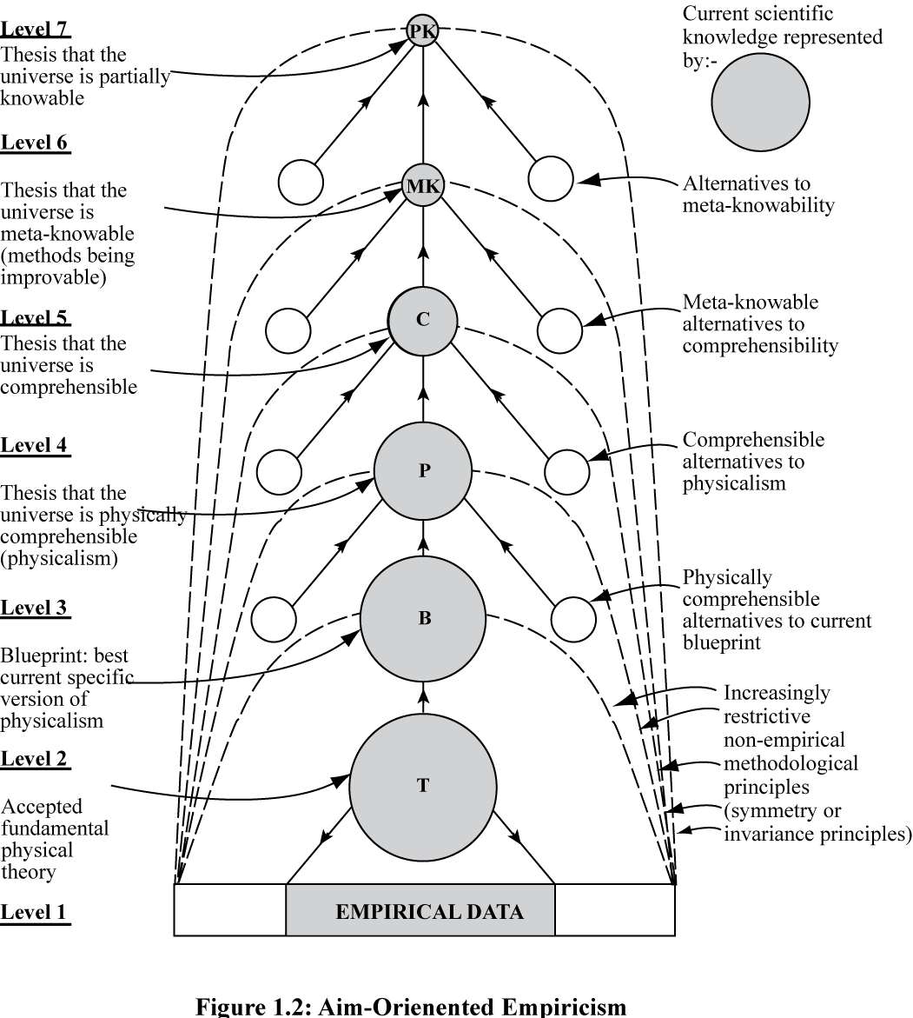

Figure 1: Aim-Oriented Empiricism

What Needs to Change?
What needs to be done? The answer is easy to state. Knowledge-inquiry needs to be modified just sufficiently to ensure that problem-solving rationality, and aim-pursuing
rationality are put into practice in pursuit of the aim of helping humanity realize what is of value in life. The outcome may be called wisdom-inquiry. The basic intellectual aim of inquiry becomes to seek and promote wisdom – wisdom being the capacity (and perhaps the active desire) to realize what is of value in life, for oneself and others, wisdom including knowledge, technological know-how and understanding, but much else besides. Wisdom, like knowledge, may be construed to be something possessed by institutions and societies, as well as individuals. Wisdom-inquiry does better justice, I claim, to both aspects of inquiry – the intellectual as well as the practical. “Realize what is of value” means both “apprehend or be aware of what is of value” as well as “make real or create what is of value”.

Figure 2: Wisdom-Inquiry Implementing Problem-Solving Rationality
[Please Enlarge to Read]
What emerges when knowledge-inquiry is modified to ensure that problem-solving rationality is implemented has already been indicated. The outcome is illustrated in figure 2. At the heart of problem-solving wisdom-inquiry there is the basic intellectual activity of articulating problems of living, and proposing and critically assessing possible solutions, possible and actual actions. Not only is this done within universities: it is actively promoted by wisdom-inquiry to take place in the great social world beyond academe. As we move from knowledge-inquiry to wisdom-inquiry, almost every aspect of academia is affected. Social science becomes social methodology or philosophy. Social inquiry, so transformed, becomes intellectually more fundamental and central than natural science. The latter is transformed so that it is made up, not of two, but of three levels of discussion: (1) observation and experiment, (2) theory, and (3) aims. Academia as a whole takes public education, by means of discussion and debate, to be a fundamental task. Academia has just sufficient power to retain its independence from

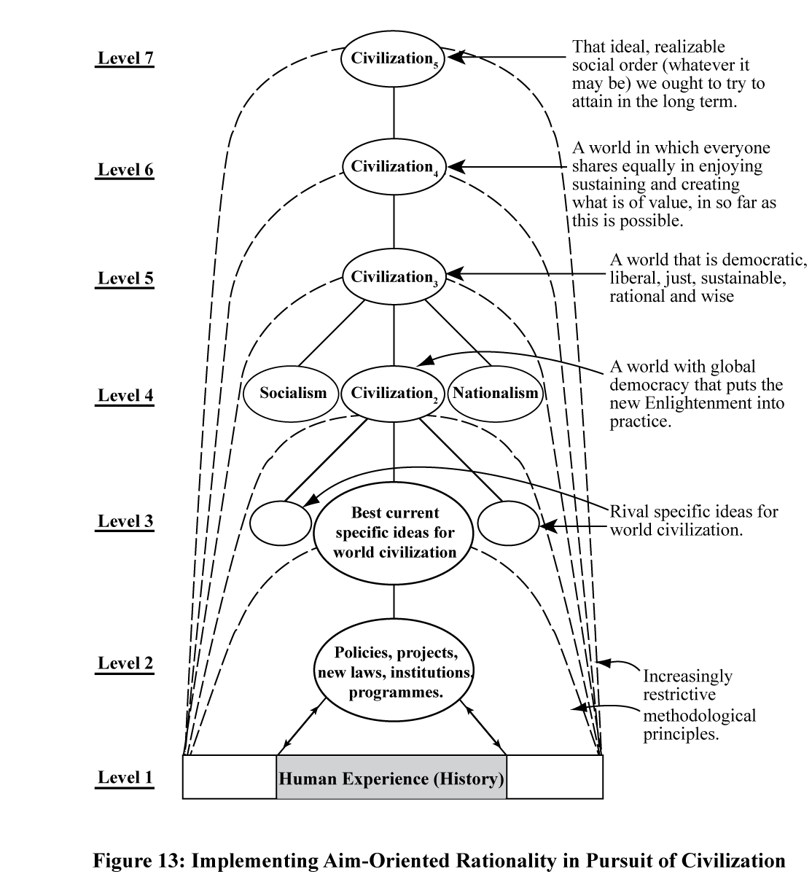
Figure 3: Aim-Pursuing Rationality devoted to Helping Humanity Make Progress Towards as Good a World as Possible

government, public opinion, the media, industry and other centres of influence, but no more. Academia does openly for the public what civil services are supposed to do in secret for governments.
The outcome of implementing aim-pursuing rationality has already been illustrated as far as physics is concerned, in figure 1. A basic task of social inquiry and the humanities, and indeed academia as a whole, is to help humanity put aim-pursuing rationality into practice in social life in order to facilitate social progress towards as good a world as possible. Something of what this might mean is illustrated in figure 3.
To summarize the discussion so far, here is a list of fifteen changes that need to be made if knowledge-inquiry is to become wisdom-inquiry. They all arise from the simple demand that inquiry should put problem-solving and aim-pursuing rationality into practice in seeking to help humanity realize what is of value in life.

1. There needs to be a change in the basic intellectual aim of inquiry, from the growth of knowledge to the growth of wisdom — wisdom being taken to be the capacity to realize what is of value in life, for oneself and others, and thus including knowledge, understanding and technological know-how. (Whereas knowledge-inquiry sharply distinguishes the intellectual and social aims of academia, wisdom-inquiry holds them to be one and the same: wisdom.)
2. There needs to be a change in the nature of academic problems, so that problems of living are included, as well as problems of knowledge. Furthermore, problems of living need to be treated as intellectually more fundamental than problems of knowledge.
3. There needs to be a change in the nature of academic ideas, so that proposals for action are included as well as claims to knowledge. Furthermore, proposals for action need to be treated as intellectually more fundamental than claims to knowledge.
4. There needs to be a change in what constitutes intellectual progress, so that progress-in-ideas-relevant-to-achieving-a-more-civilized-world is included as well as progress in knowledge, the former being indeed intellectually fundamental.
5. There needs to be a change in the idea as to where inquiry, at its most fundamental, is located. It is not esoteric theoretical physics, but rather the thinking we engage in as we seek to achieve what is of value in life.
6. There needs to be a dramatic change in the nature of social inquiry (reflecting points 1 to 5). Economics, politics, sociology, and so on, are not, fundamentally, sciences, and do not, fundamentally, have the task of improving knowledge about social phenomena. Instead, their task is threefold. First, it is to articulate problems of living, and propose and critically assess possible solutions, possible actions or policies, from the standpoint of their capacity, if implemented, to promote wiser ways of living. Second, it is to promote such cooperatively rational tackling of problems of living throughout the social world. And third, at a more basic and long-term level, it is to help build the hierarchical structure of aims and methods of aim-pursuing rationality into personal, institutional and global life, thus creating frameworks within which progressive improvement of personal and social life aims-and-methods becomes possible. These three tasks are undertaken in order to promote cooperative tackling of problems of living — but also in order to enhance empathic or “personalistic” understanding between people as something of value in its own right. Acquiring knowledge of social phenomena is a subordinate activity, engaged in to facilitate the above three fundamental pursuits.
7. Natural science needs to change, so that it includes at least three levels of discussion: evidence, theory, and research aims. Discussion of aims needs to bring together scientific, metaphysical and evaluative consideration in an attempt to discover the most desirable and realizable research aims. It needs to influence, and be influenced by, exploration of problems of living undertaken by social inquiry and the humanities, and the public.
8. There needs to be a dramatic change in the relationship between social inquiry and natural science, so that social inquiry becomes intellectually more fundamental from the standpoint of tackling problems of living, promoting wisdom.
9. The way in which academic inquiry as a whole is related to the rest of the human world needs to change dramatically. Instead of being intellectually dissociated from the rest of society, academic inquiry needs to be communicating with, learning from, teaching and arguing with the rest of society — in such a way as to promote cooperative rationality and social wisdom. Academia needs to have just sufficient power to retain its independence from the pressures of government, industry, the military, and public opinion, but no more. Academia becomes a kind of civil service for the public, doing openly and independently what actual civil services are supposed to do in secret for governments.
10. There needs to be a change in the role that political and religious ideas, works of art, expressions of feelings, desires and values have within rational inquiry. Instead of being excluded, they need to be explicitly included and critically assessed, as possible indications and revelations of what is of value, and as unmasking of fraudulent values in satire and parody, vital ingredients of wisdom.
11. There need to be changes in education so that, for example, seminars devoted to the cooperative, imaginative and critical discussion of problems of living are at the heart of all education from five-year-olds onwards. Politics, which cannot be taught by knowledge-inquiry, becomes central to wisdom-inquiry, political creeds and actions being subjected to imaginative and critical scrutiny.
12. There need to be changes in the aims, priorities and character of pure science and scholarship, so that it is the curiosity, the seeing and searching, the knowing and understanding of individual persons that ultimately matters, the more impersonal, esoteric, purely intellectual aspects of science and scholarship being means to this end. Social inquiry needs to give intellectual priority to helping empathic understanding between people to flourish (as indicated in 6 above).
13. There need to be changes in the way mathematics is understood, pursued and taught. Mathematics is not a branch of knowledge at all. Rather, it is concerned to explore problematic possibilities, and to develop, systematize and unify problem-solving methods.
14. Literature needs to be put close to the heart of rational inquiry, in that it explores imaginatively our most profound problems of living and aids personalistic understanding in life by enhancing our ability to enter imaginatively into the problems and lives of others.
15. Philosophy needs to change so that it ceases to be just another specialized discipline and becomes instead that aspect of inquiry as a whole that is concerned with our most general and fundamental problems — those problems that cut across all disciplinary boundaries. Philosophy needs to become again what it was for Socrates: the attempt to devote reason to the growth of wisdom in life.

The following four institutional innovations ought also to be made to help wisdom-inquiry to flourish.

16. Natural science needs to create committees, in the public eye, and manned by scientists and non-scientists alike, concerned to highlight and discuss failures of the priorities of research to respond to the interests of those whose needs are the greatest – the poor of the earth – as a result of the inevitable tendency of research priorities to reflect the interests of those who pay for science, and the interests of scientists themselves.
17. Every university needs to create a seminar or symposium devoted to the sustained discussion of fundamental problems that cut across all conventional academic boundaries, global problems of living being included as well as problems of knowledge and understanding.
18. Every national university system needs to include a national shadow government, seeking to do, virtually, free of the constraints of power, what the actual national government ought to be doing. The hope would be that virtual and actual governments would learn from each other.
19. The world’s universities need to include a virtual world government which seeks to do what an actual elected world government ought to do, if it existed. The virtual world government would also have the task of working out how an actual democratically elected world government might be created.

The Revolution is Already Underway: First Steps Towards Wisdom-Inquiry at UCL
During the last ten to twenty years, a number of developments have taken place in universities in the UK that can be regarded as the first steps towards putting wisdom-inquiry into academic practice.
Among the most significant of these are the creation of departments, institutions and research centres concerned with social policy, with problems of environmental degradation, climate change, poverty, injustice and war, and with such matters as medical ethics and community health. New institutional structures have been created to bring together different specialized disciplines to tackle problems associated with global warming and other environmental issues, and to interact with politicians, industry, the media and the public. This has been done at Oxford and Cambridge Universities. Somewhat similar institutions have been created that have links with many universities, for example the John Tyndall Centre for Climate Change, and the UK Energy Research Centre.
Let me now describe in a little more detail developments that have taken place at my own university, University College London. Here, as elsewhere, in recent years a considerable number of institutions and research centres concerned with policy issues and interdisciplinary research have been created during the last twenty years. More recently, since 2008, under the heading “UCL Grand Challenges”. David Price, vice-provost for research at UCL, has been instrumental in creating four broad areas of research – global health, sustainable cities, human wellbeing, intercultural interaction – which bring together specialists from diverse fields to develop ideas, techniques and policies capable of helping humanity tackle our current grave global problems. That UCL was put fourth in a recent ranking of universities world-wide may have had something to do with the success of the Grand Challenges Programme after less than two years. On its website, under the heading Grand Challenges, UCL puts the matter like this:

The world is in crisis. Billions of us suffer from illness and disease, despite applicable preventions and cures. Life in our cities is under threat from dysfunctionality and climate change. The prospect of global peace and cooperation remains under assault from tensions between our nations, faiths and cultures. Our quality of life – actual and perceived – diminishes despite technological advances. These are global problems, and we must resolve them if future generations are to be provided with the opportunity to flourish.

David Rooney, editor of this book, asked me to ask David Price and his team how they had done it. I met them on the 7th June 2010. Here are the questions I asked, and a summary of the replies I received.

Question: What did you do to get the process of changing the research model at UCL started?
David Price: It is less changing the model than adding an extra component to it. At UCL we have 4,000 research staff, most of whom are pursuing specialized knowledge. Rather than stop them doing that, what we have done is to bring some of them together to challenge them with a bigger question, so that they bring knowledge from different specialities to try to produce judicious applications for the good of humanity – which is our shorthand for wisdom.
So, we’ve created this extra dimension of research to raise people’s awareness beyond the parapet of their particular expertise, so that they are challenged by a bigger question. At any time, any one big question might attract somewhere between 20 to 50 people. But that’s fine; if you can get 50 people from different disciplines to look at a big problem, that means that, at a place like UCL, you’ve got a fantastic intellectual capability to make a contribution to a wise solution to the problem.
What we have done, then, is to enable additional research activity, and that’s been done by funding Grand Challenge research coordinators who help find questions and identify communities. And then the Provost’s discretionary fund has paid for certain activities, such as facilitating meetings by providing wine and cheese, or coffee and biscuits; or on some cases when we have got bigger challenges it has been used to pay for a research assistant to do a bit of writing or background research in cross disciplinary areas; or we use it to buy out a specific academic’s time for a period to enable him to focus on a project. So it’s very practical ways of enabling the talent that’s out there to be more fruitfully engaged. What we have done is to enable, rather than change, research activity.
Question: What were the main barriers to change at UCL?
Price: The Grand Challenges programme has been underway for two and a half years, now, with Ian Scott as the research facilitator, and Nicholas Tyndale in communications. Not everyone understands the bigger picture, so to begin with we’ve had to do a lot of hearts and minds explaining what the vision is. That required me to spend the first nine months selling it, first to the Provost, then to the senior management team, and then to heads of departments, so that they understood that what we’re trying to do was not direct people’s research but rather harvest it. And I think it’s still a matter of getting down to some of the individual scholars who still feel that they’re driven by many of the imperatives of the research assessment processes, and appraisal, and promotion, which rely heavily on things like papers and grants. They sometimes think that they haven’t got the time to think of the bigger picture.
Question: Have you encountered people who think it is all a lot of hot air?
Price: We’ve found some people who are less than enthusiastic about it. But with 4,000 people, if there are one or two who don’t really get it, then I can look elsewhere for my enthusiasm. There are more than enough people who are enthusiastic.
Question: So there haven’t really been major difficulties?
Price: No. It helps, I think, if you look at the different disciplines. People who work in the medical sciences, the life sciences, and even the physical sciences are more temperamentally predisposed to work with groups of individuals. They came together with the idea of collaboration on bigger projects relatively easily. So the Grand Challenge of Global Health, for example, which was the first, didn’t have a problem of people working together. Those who are in the arts and humanities, where it is more traditional to engage in individual monastic scholarly activity, find it more difficult to understand what’s in it for them to talk to other people in complex areas. But we are making significant headway now in arts and humanities and history and subjects which have not traditionally engaged in collaborative dialogue. At UCL we are quite a collegiate institution, and therefore people are more open to the general idea.
It is also true to say that it was colleagues who were more established who were more willing to be more engaged with Grand Challenge activities. Those who are very early in their career have been more reluctant to become involved. For two reasons really. If you are very early in your career you have to establish yourself as an expert. But also wisdom requires you not only to be an expert in your field, but also to know the shortcomings of that, and I think that is something that comes with academic maturity. And so it’s very difficult for someone who is just learning the discipline to see cross disciplinary issues.
Question: And may be you need some self-confidence as well?
Price: Very good point. One of the things we have done is The Lancet Commission on Managing the Health Effects of Climate Change – Nicholas Tyndale did an analysis of it afterwards - and I think a lot of the people who were involved were on the edge of, or beyond, their comfort zone, and it was said that it took time to grow confidence among the group, so that if you asked a foolish question, or what you thought might be a foolish question, it was only subsequently that you realized it might be quite profound.
Question: Looking back at your experience in bringing about change, what is the most important advice you would give to managers at other universities wishing to move to a similar research model?
Price: First of all, the most important thing is to celebrate the research excellence of the individuals. It is important not to threaten them by telling them that they shouldn’t be doing what they are doing, they should be doing something else. That I believe is fundamental to what we hold. We are in a position to harvest the activity that is going on – use some of the excellence that is going on rather than say you should be doing this or that. In every university community you have to have the confidence that they are the experts in their area, but you also have to have a body able to pose challenging questions. So you need to be able, not to direct, but to challenge in a very positive way. And then to facilitate, by recognizing that everybody is very busy, so that if you are asking a senior academic to spend an afternoon, or sometimes longer, addressing a problem, they have to be compensated, and it’s usually more than a glass of wine. They have to see that something is in it for them. Only later do they actually see the process itself was of value – and I think this came out in The Lancet Commission on Climate Change.
Question: What kind of things are the compensations?
Price: The compensation was their individual intellectual enrichment from actually being outside their comfort zone and actually learning and growing during the study –
Question: But that came later. What did you offer them at the time?
Price: At that time we had very little money, it was really just making the meetings as easy as possible. And then there was the prospect of a significant output, which was The Lancet Report.
Nicholas Tyndale: It was quite something for a civil engineer, for example, to have a paper published in The Lancet.
Sarah Chaytor: And I think it’s worth saying that that was a very good example you can float to other academics so that people are much more willing now, I think, to give up their time if you can say to them ‘this is an example of the kind of thing we can produce’ they can see a point to it. And now we have people who are very keen, they really get this ‘let’s come together and pool our different types of knowledge’.
Price: So it’s a snowball effect. Once you have the first output, people can see the value of it.
Question: And that’s happened?
Price: Since then we have been commissioned for a second Lancet report on healthy cities, we’ve triggered our own commission on London in 50 years time, and global health activity is going from strength to strength. We have just produced a report on the Grand Challenges Events that have happened in the last 18 months – over 75 meetings, lectures or launches of new institutions or research ventures.
Question: How successful has the change been and how do you evaluate its success?
Price: I think it has been very successful. We can evaluate it by means of the number of events, and the fact that people want to keep coming to them. But there are two things for the institution. One is that we’re doing this because we think it is the right thing to do. But secondly we are doing it because we want to make sure that UCL has its institutional impact as maximized as possible. In order to assess this, two years ago UCL employed MORI – opinion poll people – to do a survey of 500 so-called stakeholders, from academia, business, government, and so on. They were asked a number of questions about UCL. And this survey has just been repeated, two years later, after Grand Challenges and other wisdom related approaches have been developed. Initially, two years ago, in answer to the question “Is UCL a world leading university?”, from a scale of 1 to 9 (1 = agree strongly, 9 = disagree strongly), those answering 1 to 3 represented 49% of the respondents. Two years later, that has gone up to 68%. A second question asked in the survey is “Is UCL carrying out the research that is relevant to global problems?” Two years ago, 48% of the respondents agreed in the 1 to 3 category. Now it’s 74%. So you can see there has been a measurable impact. The stakeholders in the two sessions were randomly chosen and not the same people, so it’s not that the same people were asked again. So I think we are having a quantifiable effect on the profile of the institution. People recognize what we are doing. It’s affecting people working within UCL – as indicated by the numbers attending the many Grand Challenges events. But it’s also having an effect on the outside world. The final test, of course, will be what positive changes we have brought about in the world.
That brings me to a final word about our strategy. I have already indicated what we do. First, UCL does research, which produces specialized knowledge. Then we bring specialists together to tackle some big, global problem, and in the process hope to produce wisdom. But there is a further stage. Having produced wisdom, there are three things that you can do with it. You can translate it into the enterprise economy, and know how to produce something new. You can use it in public engagement, in an attempt to educate and stimulate the world. And you can translate it into the public policy arena and try, if not to influence government, at least to give them the opportunity to improve things. It’s that that we are working on right now. Next September, we will be leading our public policy campaign whereby we will take the knowledge and wisdom we have developed at UCL, and try to translate them into examples of public policy, and try to influence government action for the better. So that’s, if you like, the research through from specialized research, via wisdom, to public policy.

I have myself taken part in a number of the meetings convened to get the Grand Challenges programme underway, and I can confirm that the programme has generated much enthusiasm and support from both graduate students and staff at UCL, and it continues to be supported and actively engaged with, two and a half years after its inception. I was even consulted by David Price’s team at an early stage, although I must emphasize that the initial impetus for the programme comes from David Price, quite independently of my work, and it is Price and his team who have been responsible for the
subsequent development of the programme.

In October, 2010, the programme initiated two further steps. First, it put a new page on the UCL website, under “Research”, called “The Wisdom Agenda”. This tells us that “UCL has both the opportunity and the obligation to marshal the breadth of its intellectual expertise and to focus on contributing to the resolution of the world’s major problems. The university will achieve this through the development of a culture of wisdom.” A document spelling out more details, called “Developing a culture of wisdom at UCL” can be downloaded: see www.ucl.ac.uk/research/wisdom-agenda (accessed 22 October 2010). Second, the programme has introduced a Public Policy Strategy designed, in a number of ways, to coordinate and promote policy thinking at UCL, and to strengthen the policy impact of UCL research. Wisdom-inquiry requires that policy thinking is at the heart of the academic enterprise.
This Grand Challenges programme does constitute, in my view, the first steps towards putting wisdom-inquiry into practice at UCL. There is of course still much to be done, as becomes apparent if one glances at the 19 changes, listed in the previous section, that need to be made if knowledge-inquiry is to be transformed into wisdom-inquiry. There is, for example, as yet at UCL no all-inclusive seminar devoted to the sustained discussion of fundamental problems that cut across all conventional academic boundaries (point 17) – although there is a symposium on global health, which meets regularly and partly performs the function of such a seminar. No attempt has been made, as yet, to transform individual disciplines, physics say, or economics, in the ways that are required by the “knowledge to wisdom” argument, something that it is essential to do if wisdom-inquiry is to be implemented. It would, indeed, be all-but impossible for an individual university to do such a thing on its own. A first step in this direction would be to initiate discussion of the question: How can diverse disciplines, and universities as a whole, best contribute to what is of value in life, by cultural, intellectual, educational and practical means? What kind of academic inquiry can best help humanity make progress towards as good a world as feasible? An intellectual and institutional revolution in one university is not enough. What we need is a comprehensive revolution in all universities, and other educational and research institutions, throughout the world. And for that to occur, we need a very active and vocal campaign for wisdom-inquiry, supported by leading scientists, scholars and others, in the public arena, shouting from the rooftops about the urgent need to transform our institutions of learning so that they become rationally designed and devoted to helping us make progress towards a good, civilized world.

Conclusion
Our only hope of solving our problems successfully lies in tackling them democratically. This in turn requires that a majority of people on earth have a good understanding of what our problems are, and what we need to do about them. Democratically elected governments are unlikely to be able to do what is required if the people who elect them do not understand what our problems are, and what we need to do to resolve them. This in turn requires that we have in existence institutions of learning rationally devoted to helping humanity come to understand what our problems are, and what needs to be done. It is just this that we do not have at present. Instead we have institutions of learning devoted to the pursuit of knowledge. But it is knowledge and technological know-how, and the power that these engender, in the absence of wisdom, that have made possible the creation of our current global problems.
We urgently need to bring about a revolution in our schools and universities so that they come to seek and promote wisdom by rational means. Almost every branch and aspect of academic inquiry needs to change.
This revolution – intellectual, institutional and cultural – if it ever comes about, will be comparable in its long-term impact to that of the Renaissance, the scientific revolution, or the Enlightenment. The outcome will be traditions and institutions of learning rationally designed to help us realize what is of value in life. There are a few scattered signs that this intellectual revolution, from knowledge to wisdom, is already under way. It will need, however, much wider cooperative support – from scientists, scholars, students, research councils, university administrators, vice chancellors, teachers, the media and the general public – if it is to become anything more than what it is at present, a fragmentary and often impotent movement of protest and opposition, often at odds with itself, exercising little influence on the main body of academic work. I can hardly imagine any more important work for anyone associated with academia than, in teaching, learning and research, to help promote this revolution.

References
Barnett, R. and N. Maxwell, eds., 2008, Wisdom in the University, Routledge, London.
Iredale, M., 2007, From knowledge-inquiry to wisdom-inquiry: is the revolution
underway?, London Review of Education, 5, 117-129 (reprinted in Barnett and
Maxwell, 2008, pp. 21-33).
Macdonald, C., 2009, Nicholas Maxwell in Context: The Relationship of His Wisdom
Theses to the Contemporary Global Interest in Wisdom, in McHenry (2009), pp. 61-
81.
Maxwell, N., 1974, The Rationality of Scientific Discovery, Philosophy of Science, 41,
pp. 123-53 and 247-95.
______, 1976, What’s Wrong With Science? Bran’s Head Books, Hayes (2nd ed.,
Pentire Press, London, 2009).
______, 1980, Science, Reason, Knowledge and Wisdom: A Critique of Specialism,
Inquiry 23, pp. 19-81.
______, 1984, From Knowledge to Wisdom, Blackwell, Oxford (2nd revised and extended
edition, Pentire Press, London, 2007).
______, 1992, What Kind of Inquiry Can Best Help Us Create a Good World?, Science,
Technology and Human Values 17, pp. 205-27.
______, 1998, The Comprehensibility of the Universe: A New Conception of Science,
Oxford University Press, Oxford.
______, 2000, Can Humanity Learn to become Civilized? The Crisis of Science without
Civilization, Journal of Applied Philosophy 17, pp. 29-44.
______, 2001, The Human World in the Physical Universe: Consciousness, Free Will
and Evolution, Rowman and Littlefield, Lanham, Maryland.
______, 2004, Is Science Neurotic?, Imperial College Press, London.
______, 2005a Popper, Kuhn, Lakatos and Aim-Oriented Empiricism, Philosophia 32,
nos. 1-4, pp. 181-239.
______, 2005b, Philosophy Seminars for Five-Year-Olds, Learning for Democracy, Vol.
1, No. 2, pp. 71-77 (reprinted in Gifted Education International, Vol. 22, No. 2/3, pp.
122-7
______, 2007a, Can the World Learn Wisdom?, Solidarity, Sustainability, and Non-
Violence, vol. 3, no. 4.
______, 2007b, From Knowledge to Wisdom: The Need for an Academic Revolution,
London Review of Education, vol. 5, no. 2, pp. 97-115 (reprinted in Barnett and
Maxwell, 2008, pp. 1-33).
______, 2008, Do We Need a Scientific Revolution?, Journal for Biological Physics and
Chemistry, vol. 8, no. 3, pp. 95-105.
______, 2009a, Are Universities Undergoing an Intellectual Revolution?, Oxford
Magazine, No. 290, Eighth Week, Trinity Term, June, pp. 13-16.
______, 2009b, From Knowledge to Wisdom, in D. Cayley, ed., Ideas on the Nature of
Science, Goose Lane Editions, Fredericton, New Brunswick, 2009, pp. 360-78 (text of
broadcast on the Ideas Programme, Canadian Broadcasting Coorporation,18 June
2008: see www.cbc.ca/ideas/features/science/#episode24).
______, 2009c, Wisdom Mathematics, in Friends of Wisdom Newsletter, 6th edition,
pp. 1-6, www.knowledgetowisdom.org/Newsletter%206.pdf .
______, 2010a, Cutting God in Half – And Putting the Pieces Together Again: A New
Approach to Philosophy, Pentire Press, London.
______, 2010b, Popper’s Paradoxical Pursuit of Natural Philosophy, in Cambridge
Companion to Popper, edited by Jeremy Shearmur and Geoffrey Stokes, Cambridge
University Press, Cambridge.
McHenry, L., 2009, Science and the Pursuit of Wisdom: Studies in the Philosophy of
Nicholas Maxwell, Ontos Verlag, Frankfurt.
Popper, K., 1959, The Logic of Scientific Discovery, Hutchinson, London.
Rogers, P. F., 2006, Peace Studies, in A. Collins, ed., Contemporary Security Studies,
Oxford University Press, Oxford, ch. 3.
Tyndall Centre, ed., 2006, Truly Useful, (UK, Tyndall Centre).
Wilsdon, J. and R. Willis, 2004, See-through Science, Demos, London.

Notes

Maxwell (1976; 1984; 1998; 2001; 2004; 2010a).
See: www.nick-maxwell.demon.co.uk/Publ_List.htm. I recommend especially Maxwell (1980; 1992; 2000; 2007a; 2007b; 2008; 2009a; 2009b). See L. McHenry (2009) for a discussion of my work by eleven scholars.
For a more detailed exposition of knowledge-inquiry see my (1984), ch. 2.
For evidence for holding that knowledge-inquiry does inform the intellectual/institutional structure of academia, see my (1984), ch. 6 – brought up to date in the 2007 edition of the book.
For a somewhat more detailed discussion of rationality see my (1984), chs. 4 and 5.
The first two of these rules generalize Karl Popper’s conception of scientific method. Thus Popper refers to “the one method of all rational discussion, and therefore of the natural sciences as well as philosophy. The method I have in mind is that of stating one’s problem clearly and of examining its various proposed solutions critically (Popper, 1959, p. 16). Popper was too vehemently against specialization to appeal to rule (3). He did not appreciate that the undesirable aspects of specialization could be eliminated by putting rule (4) into practice. For a discussion, see my (2010b).
For a much more detailed critique of knowledge-inquiry see my (1984), ch. 3.
See my (2000), pp. 37-8, and the 2007 edition of my (2004), ch. 6.
For the demonstration that action, and policy, is more fundamental intellectually than knowledge, see my (2000), p. 38-9, and my (1984), ch. 8.
All problem-solving is also aim-pursuing, and vice versa – except that much of the problem-solving done when we pursue our aims is performed instinctively and spontaneously for us, by our brilliant brains, without us even being aware of it.
The methods of reason, when implemented, give us our best chances of solving our problems, realizing our aims, other things being equal. If methods M lead us systematically astray, whereas methods M + M* do not, then M alone do not embody reason (since they do not give us our best chances of realizing our aims). M* need to be included in the list of the methods of reason.
For earlier, and more detailed, expositions of aim-oriented empiricism see my (1974; 1984, ch. 9, and the 2007 edition, ch. 14; 1998; 2004, chs. 1, 2 and the appendix; 2005a.
See, for example, my (2007b, pp. 110-12).
For wisdom-inquiry for five-year olds, see my (2005b).
For a sketch of wisdom-inquiry mathematics see my (2009c).
See especially my (1980 and 2010a)
For further discussion of changes that would need to be made for universities to implement wisdom-inquiry, see my (1984; 2004; 2010a, especially ch. 9.
See Iredale (2007) and Macdonald (2009) for developments of this point.
See www.cei.group.cam.ac.uk/
See www.tyndall.ac.uk/general /about.shtml.
See www.ukerc.ac.uk/.
See www.ucl.ac.uk/grand-challenges/.
See http://www.thelancet.com/climate-change.
A. Costello et al., 2009, Managing the health effects of climate change, The Lancet, vol. 373, issue 9676, pp. 1693-1733, May 2009.

