The Urgent Need for an Academic Revolution
(M. Levene, R. Johnson and P. Roberts, eds., 2010, History at the End of the World?, Humanities-Ebooks, ch. 5, pp. 80-93)

Nicholas Maxwell

Two great problems of learning confront humanity: first, learning about the nature of the universe and about ourselves as a part of the universe, and second, learning how to live wisely – learning how to make progress towards as good a world as possible.
The first problem was solved, in essence, in the 17th century, with the creation of modern science. A method was discovered for progressively improving knowledge and understanding of the natural world, the famous empirical method of science. There is of course much that we still do not know and understand, three or four centuries after the birth of modern science. Nevertheless, during this time, science has immensely increased our knowledge and understanding, at an ever accelerating rate. And with this unprecedented increase in scientific knowledge and understanding has come a cascade of technological discoveries and developments which have transformed the human condition.
But the second great problem of learning has not yet been solved. And this puts us in a situation of unprecedented danger. Indeed, all our current global problems can be traced back, in one way or another, to this source. Global warming, the lethal character of modern war and terrorism, stockpiling of modern armaments, pollution of sea, air and earth, vast inequalities of wealth and power round the globe, rapid increase in population, destruction of tropical rain forests and rapid extinction of species, and even the AIDS epidemic: all these crises have been made possible by modern science and technology.
Solving the first great problem of learning enormously increases our power to act, via the increase of scientific knowledge and technological know-how. But without wisdom – without a solution to the second problem of learning – our immensely increased power to act may have good consequences, but will as often as not have all sorts of harmful consequences as well, whether intended or not. Just this is an all too apparent feature of our world. Science and technology have been used in endless ways for human benefit, but have also been used to wreak havoc, whether intentionally, in war and acts of terror, or unintentionally (initially, at least) in long-term environmental damage – global warming, destruction of tropical rainforests, rapid extinction of species – a consequence of growth of population, industry and agriculture, made possible by growth of technology. Even the AIDS epidemic would not have occurred without modern methods of travel, made possible by modern technology. As long as humanity's power to act was limited, lack of wisdom did not matter too much: we lacked the means to inflict too much damage on ourselves or on the planet. But with the immense increase in our powers to act that we have achieved in the last century or so, our powers to destroy have become unprecedented and terrifying: global wisdom has become, not a luxury, but a necessity. Solving the second great problem of learning, now that we have solved the first one, has become our most urgent priority.
But how can we solve this second great problem, the problem of learning to live wisely, create a better world? Can it be solved at all?
We can at least improve our ability to solve the second problem. But in order to do this, there is one vital step that we need to take. We need to learn from our solution to the first problem how to solve the second. That is, we need to learn from scientific progress how to make better social progress towards a wiser world.
The Enlightenment
This is not a new idea. It goes back to the French Enlightenment of the 18th century. That was, indeed, the basic idea of the Enlightenment: to learn from scientific progress how to make social progress towards world enlightenment.
Unfortunately, in developing and implementing this profoundly important idea, the philosophes of the Enlightenment blundered. They botched the job. They developed the idea in a seriously defective form, and it is this immensely influential, defective version of the idea, inherited from the 18th century that is built into the institutions of inquiry that we possess today. Our current traditions and institutions of learning, when judged from the standpoint of helping us learn how to become more enlightened, are defective and irrational in a wholesale and structural way, and it is this which, in the long term, sabotages our efforts to create a wiser world, and prevents us from avoiding the kind of horrors we have been exposed to during the 20th century.
The philosophes of the 18th century - Voltaire, Diderot, Condorcet and the rest - assumed, understandably enough, that the proper way to implement the Enlightenment idea was to develop social science alongside natural science. Francis Bacon had already stressed the importance of improving knowledge of the natural world in order to achieve social progress. The philosophes generalized this, holding that it is just as important to improve knowledge of the social world. Thus they set about creating the social sciences: history, anthropology, political economy, psychology, sociology.
This had an immense impact. Throughout the 19th century the diverse social sciences were developed, often by non-academics, in accordance with the Enlightenment idea. Gradually, universities took notice of these developments until, by the mid 20th century, all the diverse branches of the social sciences, as conceived of by the Enlightenment, were built into the institutional structure of universities as recognized academic disciplines.
But, from the standpoint of creating a kind of inquiry designed to help humanity learn how to live wisely, all this amounts to a series of monumental blunders.
In order to implement properly the basic Enlightenment idea of learning from scientific progress how to achieve social progress towards a wise world, it is essential to get the following three things right.

1. The progress-achieving methods of science need to be correctly identified.
2. These methods need to be correctly generalized so that they become fruitfully applicable to any worthwhile, problematic human endeavour, whatever the aims may be, and not just applicable to the scientific endeavour of improving knowledge.
3. The correctly generalized progress-achieving methods then need to be exploited correctly in the great human endeavour of trying to make social progress towards an enlightened, wise world.

Unfortunately, the Enlightenment got all three points wrong – the third point disastrously wrong. That the philosophes made these blunders in the 18th century is forgivable; what is unforgivable is that these blunders still remain unrecognized and uncorrected today, over two centuries later. Instead of correcting them, we have allowed our institutions of learning to be shaped by them as they have developed throughout the 19th and 20th centuries, so that now the blunders are an all-pervasive feature of our world.
First Blunder: Scientific Method
The first blunder concerns the nature of the progress-achieving methods of science. Scientists and philosophers of science today make the assumption, inherited from the Enlightenment, that science makes progress because, in science, theories are assessed impartially on the basis of evidence alone, no permanent assumption being made about the nature of the universe independent of evidence. But this orthodox, standard empiricist conception of science is untenable, as the following simple argument demonstrates. Physics only ever accepts theories that are (more or less) unified, even though endlessly many empirically more successful disunified rivals can always be concocted. Such a theory, T (Newtonian theory, quantum theory, general relativity or the standard model), almost always faces some empirical difficulties, and is thus, on the face of it, refuted (by phenomena A). There are phenomena, B, which come within the scope of the theory but which cannot be predicted because the equations of the theory cannot (as yet) be solved. And there are other phenomena (C) that fall outside the scope of the theory altogether. We can now artificially concoct a disunified, "patchwork quilt" rival, T*, which asserts that everything occurs as T predicts except for phenomena A, B and C: here T* asserts, in a grossly ad hoc way, that the phenomena occur in accordance with empirically established laws, L_{A}, L_{B} and L_{C}.
Even though T* is more successful empirically than T, it and all analogous rival theories are, quite correctly, ignored by physics because they are all horribly disunified. They postulate different laws for different phenomena, and are just assumed to be false. But this means physics makes a big, implicit assumption about the universe: it is such that all such "patchwork quilt" theories are false.
If physicists only ever accepted theories that postulate atoms even though empirically more successful rival theories are available that postulate other entities such as fields, it would surely be quite clear: physicists implicitly assume that the universe is such that all theories that postulate entities other than atoms are false. Just the same holds in connection with unified theories. That physicists only ever accept unified theories even though empirically more successful rival theories are available that are disunified means that physicists implicitly assume that the universe is such that all disunified theories are false.
The orthodox standard empiricist view is, in other words, untenable. Physics makes a big implicit assumption about the nature of the universe, upheld independently of empirical considerations – even, in a certain sense, in violation of such considerations: the universe is physically comprehensible, in the sense that it possesses some kind of underlying dynamic unity, to the extent at least that it is such that all disunified physical theories are false. This is a secure tenet of scientific knowledge, to the extent that empirically successful theories that clash with it are not even considered for acceptance.
At once it is clear that science is confronted by a fundamental dilemma. In order to proceed at all science must assume, even if only implicitly, that the universe is comprehensible in some way, to some extent at least (since otherwise science would be overwhelmed by endlessly many empirically successful, disunified, non-explanatory theories). But it is just here, concerning the ultimate nature of the universe, that we are most ignorant, and most likely to get things entirely wrong. Science both must, and cannot, assume knowledge about the ultimate nature of the universe.
The solution to this dilemma is to construe science as making a hierarchy of assumptions concerning the comprehensibility and knowability of the universe, less and less being assumed as one goes up the hierarchy. At the top of the hierarchy no more is assumed than that the universe is such that some knowledge can be acquired. This assumption is legitimately a permanent item of knowledge since, if false, knowledge cannot be acquired whatever is assumed. Lower down in the hierarchy, those assumptions are adopted which seem to lead to the greatest growth of empirical knowledge. These assumptions are revised in the light of the empirical success and failure of the scientific research programmes to which they give rise.
This hierarchical view, in stark contrast to the current orthodox conception of science, inherited from the Enlightenment, is the key to the success of modern science. The basic aim of science of discovering how, and to what extent, the universe is physically comprehensible is profoundly problematic; because of this, it is essential that we try to improve the aim, and associated methods,
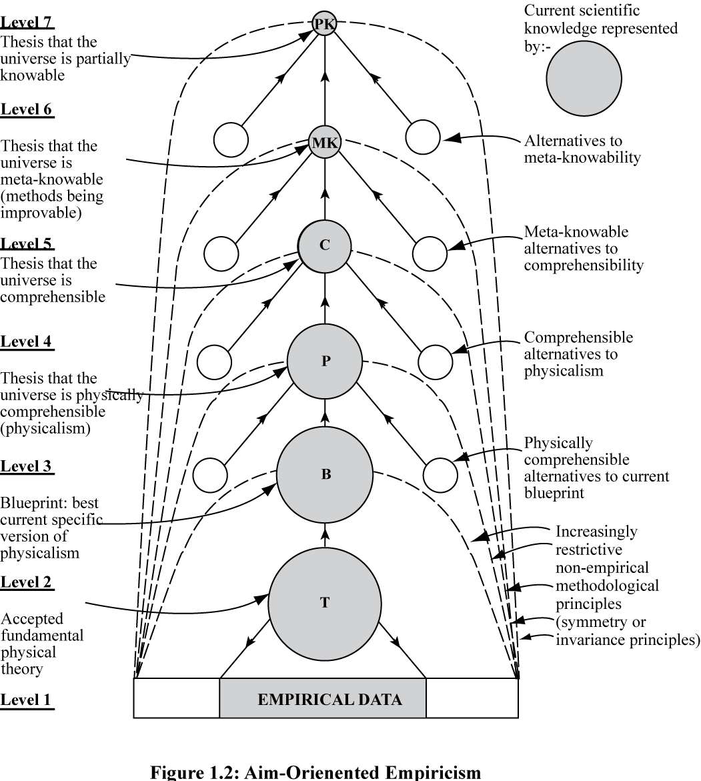

Diagram 1: Hierarchical Conception of Science

as we proceed, in the light of apparent scientific success and failure. In order to do this in the best possible way we need to represent our aim at a number of levels, from the specific and problematic, low down in the hierarchy, to the highly unspecific and unproblematic, high up in the hierarchy, thus creating a framework of relatively unproblematic, fixed aims and methods within which much more specific and problematic aims and methods of science may be progressively improved in the light of apparent empirical success and failure. The result is that, as we improve our knowledge about the world we are able to improve our knowledge about how to improve knowledge, the methodological key to the rapid progress of modern science: see diagram 1.
The adoption and explicit implementation of this hierarchical view by the scientific community as the official, orthodox conception of science would correct the first blunder of the Enlightenment.
Second Blunder: Rationality
The second blunder arises in connection with generalizing the progress-achieving methods of science. The task, here, is to generalize correctly the progress-achieving methods of science to arrive at a conception of progress-achieving rationality, fruitfully applicable to any problematic, worthwhile human endeavour (science being just a special case).
Needless to say, having failed to specify the methods of science properly, scientists and philosophers have also failed to arrive at the proper generalization of these methods. What we need to do in order to correct this second blunder is to take the above hierarchical conception of the progress-achieving methods of science as our starting point, and generalize that.
It is not just in science that aims are problematic; this is the case in life too, either because different aims conflict, or because what we believe to be desirable and realizable lacks one or other of these features, or both. Above all, the aim of creating a wiser world is inherently and profoundly problematic. Quite generally, then, and not just in science, whenever we pursue a problematic aim we need to represent the aim as a hierarchy of aims, from the specific and problematic at the bottom of the hierarchy, to the general and unproblematic at the top. In this way we provide ourselves with a framework within which we may improve more or less specific and problematic aims and methods as we proceed, learning from success and failure in practice what it is that is both of most value and realizable. Such a hierarchical conception of rationality is the proper generalization of the hierarchical conception of science.
Third Blunder: Social Inquiry and the Humanities
So much for the second blunder, and how it is to be put right. We come now to the third blunder. This concerns, not what the methods of science are, but to what they should be applied, when appropriately generalized.
This is by far the most serious of the three blunders made by the Enlightenment. The basic Enlightenment idea, after all, is to learn from our solution to the first great problem of learning how to solve the second problem – to learn, that is, from scientific progress how to make social progress towards an enlightened world. Putting this idea into practice involves getting appropriately generalized progress-achieving methods of science into social life itself! It involves getting progress-achieving methods into our institutions and ways of life, into government, industry, agriculture, commerce, international relations, the media, the arts, education. But in sharp contrast to all this, the Enlightenment sought to apply (misconstrued) generalized scientific method, not to social life, but merely to social science! Instead of helping humanity learn how to become wiser by rational means, the Enlightenment sought merely to help social scientists improve knowledge of social phenomena. The outcome is that today academic inquiry devotes itself to acquiring knowledge of natural and social phenomena, but does not attempt to help humanity learn how to live more wisely. This is the blunder that is at the root of our current failure to have solved the second great problem of learning. It is at the root of the crisis of our times: possessing science without wisdom.
In order to correct this third, monumental and disastrous blunder, we need, as a first step, to bring about a revolution in the nature of academic inquiry, beginning with social inquiry and the humanities. Properly implemented, the Enlightenment idea of learning from scientific progress how to achieve social progress towards an enlightened world would involve developing social inquiry, not as social science, but as social methodology, or social philosophy. A basic task would be to get into personal and social life, and into other institutions besides that of science – into government, industry, agriculture, commerce, the media, law, education, international relations – hierarchical, progress-achieving methods (designed to improve problematic aims) arrived at by generalizing the methods of science. A basic task for academic inquiry as a whole would be to help humanity learn how to resolve its conflicts and problems of living in more just, cooperatively rational ways than at present. This task would be intellectually more fundamental than the scientific task of acquiring knowledge. Social inquiry would be intellectually more fundamental than physics. Academia would be a kind of people’s civil service, doing openly for the public what actual civil services are supposed to do in secret for governments. Academia would have just sufficient power (but no more) to retain its independence from government, industry, the press, public opinion, and other centres of power and influence in the social world. It would seek to learn from, educate, and argue with the great social world beyond, but would not dictate. Academic thought would be pursued as a specialized, subordinate part of what is really important and fundamental: the thinking that goes on, individually, socially and institutionally, in the social world, guiding individual, social and institutional actions and life. The fundamental intellectual and humanitarian aim of inquiry would be to help humanity acquire wisdom – wisdom being the capacity to realize (apprehend and create) what is of value in life, for oneself and others, wisdom thus including knowledge and technological know-how but much else besides.
One outcome of getting into social and institutional life the kind of aim-evolving, hierarchical methodology indicated above, generalized from science, is that it becomes possible for us to develop and assess rival philosophies of life as a part of social life, somewhat as theories are developed and assessed within science. Such a hierarchical methodology provides a framework within which competing views about what our aims and methods in life should be – competing religious, political and moral views – may be cooperatively assessed and tested against broadly agreed, unspecific aims (high up in the hierarchy of aims) and the experience of personal and social life. There is the possibility of cooperatively and progressively improving such philosophies of life (views about what is of value in life and how it is to be achieved) much as theories are cooperatively and progressively improved in science. In science, ideally, theories are critically assessed with respect to each other, with respect to metaphysical ideas concerning the comprehensibility of the universe, and with respect to experience (observational and experimental results). In a somewhat analogous way, diverse philosophies of life may be critically assessed with respect to each other, with respect to relatively uncontroversial, agreed ideas about aims and what is of value, and with respect to experience – what we do, achieve, fail to achieve, enjoy and suffer – the aim being to improve philosophies of life (and more specific philosophies of more specific enterprises within life such as government, education or art) so that they offer greater help with the realization of what is of value in life. This hierarchical methodology is especially relevant to the task of resolving conflicts about aims and ideals, as it helps disentangle agreement (high up in the hierarchy) and disagreement (more likely to be low down in the hierarchy): see diagram 2.
Wisdom-inquiry, because of its greater rigour, has intellectual standards that are, in important respects, different from those of knowledge-inquiry. Whereas knowledge-inquiry demands that emotions and desires, values, human ideals and aspirations, philosophies of life be excluded from the intellectual domain of inquiry, wisdom-inquiry requires that they be included. In order to discover what is of value in life it is essential that we attend to our
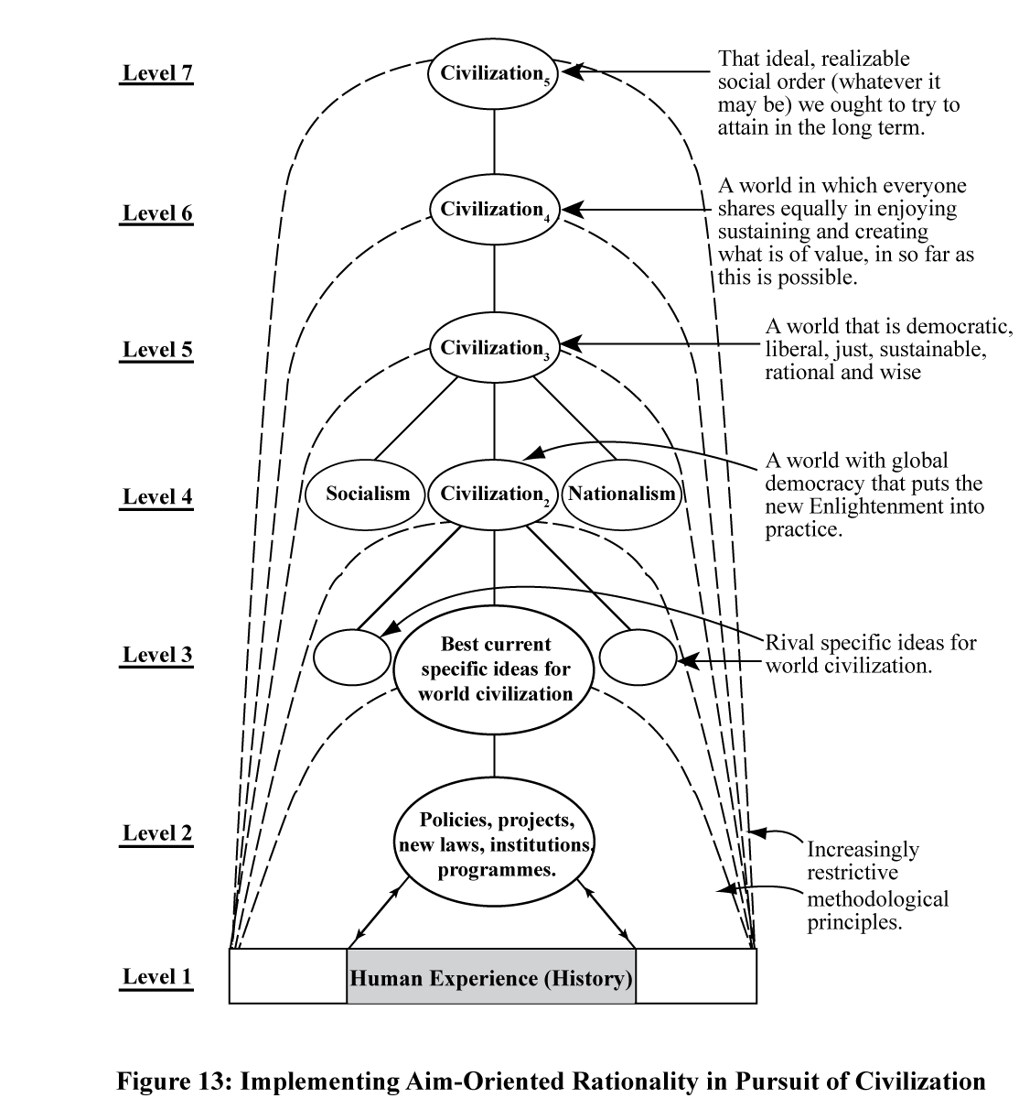

Diagram 2: Implementing Generalization of Hierarchical Conception of Scientific Method in Pursuit of Civilization

feelings and desires. But not everything we desire is desirable, and not everything that feels good is good. Feelings, desires and values need to be subjected to critical scrutiny. And of course feelings, desires and values must not be permitted to influence judgements of factual truth and falsity. Wisdom-inquiry embodies
a synthesis of traditional rationalism and romanticism. It includes elements from both, and it improves on both. It incorporates romantic ideals of integrity, having to do with motivational and emotional honesty, honesty about desires and aims; and at the same time it incorporates traditional rationalist ideals of integrity, having to do with respect for objective fact, knowledge, and valid argument. Traditional rationalism takes its inspiration from science and method; romanticism takes its inspiration from art, from imagination, and from passion. Wisdom-inquiry holds art to have a fundamental rational role in inquiry, in revealing what is of value, and unmasking false values; but science, too, is of fundamental importance. What we need, for wisdom, is an interplay of sceptical rationality and emotion, an interplay of mind and heart, so that we may develop mindful hearts and heartfelt minds. It is time we healed the great rift in our culture, so graphically depicted by C. P. Snow.
Conclusion
Humanity is in deep trouble. We urgently need to learn how to make progress towards a wiser, more civilized world. This in turn requires that we possess traditions and institutions of learning rationally designed – well designed – to help us achieve this end. It is just this that we do not have at present. What we have instead is natural science and, more broadly, inquiry devoted to acquiring knowledge. Judged from the standpoint of helping us create a better world, knowledge-inquiry of this type is dangerously and damagingly irrational. We need to bring about a major intellectual and institutional revolution in the aims and methods of inquiry, from knowledge-inquiry to wisdom-inquiry. Almost every branch and aspect of academic inquiry needs to change.
A basic intellectual task of academic inquiry would be to articulate our problems of living (personal, social and global) and propose and critically assess possible solutions, possible actions. This would be the task of social inquiry and the humanities. Tackling problems of knowledge would be secondary. Social inquiry would be at the heart of the academic enterprise, intellectually more fundamental than natural science. On a rather more long-term basis, social inquiry would be concerned to help humanity build hierarchical methods of problem-solving into the fabric of social and political life so that we may gradually acquire the capacity to resolve our conflicts and problems of living in more cooperatively rational ways than at present. Natural science would change to include three domains of discussion: evidence, theory, and aims - the latter including discussion of metaphysics, values and politics. Academia would actively seek to educate the public by means of discussion and debate, and would not just study the public.
This revolution – intellectual, institutional and cultural – if it ever comes about, would be comparable in its long-term impact to that of the Renaissance, the scientific revolution, or the Enlightenment. The outcome would be traditions and institutions of learning rationally designed to help us acquire wisdom. There are a few scattered signs that this intellectual revolution, from knowledge to wisdom, is already under way. It will need, however, much wider cooperative support – from scientists, scholars, students, research councils, university administrators, vice chancellors, teachers, the media and the general public – if it is to become anything more than what it is at present, a fragmentary and often impotent movement of protest and opposition, often at odds with itself, exercising little influence on the main body of academic work. I can hardly imagine any more important work for anyone associated with academia than, in teaching, learning and research, to help promote this revolution.

P. Gay, The Enlightenment: An Interpretation (Wildwood House, 1973).
N. Maxwell, From Knowledge to Wisdom: A Revolution for Science and the Humanities (Blackwell, 1984; 2nd enlarged edition, Pentire Press, 2007).
R. Aron, Main Currents in Sociological Thought, vol. 2 (Penguin, 1970); F. A. Hayek, The Counter-Revolution of Science (Liberty Pres, 1979); J. Farganis, ed. Readings in Social Theory, Introduction (McGraw-Hill, 1993).
N. Maxwell, Phil. Sci. 41, 123-153 and 247-295; The Comprehensibility of the Universe, ch. 2 (Oxford University Press, 1998).
See note 2, 2nd ed., ch. 14, and note 4.
Note 2, 1st ed., p. 66; 2nd ed., p. 79.
C. P. Snow, The Two Cultures: And a Second Look (Cambridge University Press, 1986).

