Wisdom: Object of Study or Basic Aim of Inquiry?
Nicholas Maxwell
(To be published in Personal Wisdom, ed. Michel Ferrari, Springer.)

Abstract
We face severe global problems, many that we have inadvertently created ourselves. It is clear that there is an urgent need for more wisdom. One response is to improve knowledge about wisdom. This, I argue, is an inadequate response to the problems we face. Our global problems arise, in part, from a damagingly irrational kind of academic enterprise, devoted as it is to the pursuit of knowledge. We need to bring about a revolution in academic inquiry so that its basic aim becomes to seek and promote wisdom.

The Need for Wisdom
That the world urgently needs more wisdom can hardly be doubted the moment one considers recent history and the global crises we face. There is the George Bush led “war on terrorism”, and the excesses to which that led: Guantanamo Bay, the Afghanistan war and the Iraq war. Bin Laden no doubt hoped the attack on the twin towers in New York would provoke the USA and its allies to over-react. What actually happened must have exceeded his wildest hopes. Then again there is the credit crunch of 2008, and the world-wide recession it caused. A few voices warned of the lunacy of over-extended credit of banks, but they were ignored. The great army of bankers and economists round the world saw no impending disaster, even though it was all but bound to occur, sooner or later. As the population of the earth continues to grow, and more and more countries industrialize, so the global consumption of oil and coal steeply rises. The world will not soon run out of coal, but oil is another matter. Many experts estimate that we have already used up half the world’s supply of oil, and what remains will be increasingly difficult to extract.
As demand for oil increases, and supply decreases, oil will become increasingly expensive, partly because demand exceeds supply, partly because oil becomes increasingly difficult to extract. The world’s industry, transport and economy will face a crisis of epic proportions – one which stares us in the face, but for which we have done little to prepare. In the meantime, increasing consumption of oil and coal leads to increasing emissions of CO₂ into the atmosphere – aided by burning of vast tracts of forests so that the land may be used for agriculture. We know we are rapidly increasing the amount of CO₂ in the atmosphere, we know that this will tend to lead to a warmer climate as CO₂ is a greenhouse gas, and we know the average temperature of the earth is increasing. We know that this will lead to disaster: melting glaciers and ice at the poles, rising sea levels and flooding of densely populated land, increasingly frequent and intense storms, floods and drought, vast tracts of the earth eventually becoming uninhabitable. Millions, possibly billions, will die as a result unless we rapidly decrease CO₂ emissions globally. All this is known – and yet, so far, we have been unable to act effectively on this knowledge, and a fifth or more of the populations of economically advanced countries deny that there is a problem. On the one hand we strive to promote industrial and economic development even though we know, on the other hand that, as conducted at present, this will lead to catastrophe.
These, no doubt, are the kind of considerations that led Robert Sternberg to say recently “If there is anything the world needs, it is wisdom. Without it, I exaggerate not at all in saying that very soon, there may be no world.” And these, no doubt, are the considerations that have led Sternberg and others, recently, to initiate and develop the scientific study of wisdom. If the world is to acquire vitally needed wisdom – so it is implicitly assumed – we first need to know what wisdom is, and how it is to be acquired. We need more scientific knowledge about wisdom.
I first became aware of this new field of the scientific study of wisdom as a result of the publication of Sternberg’s book Wisdom: Its Nature, Origins, and Development in 1990, to which nineteen researchers contributed, including Sternberg himself. Since then, there has been an upsurge in scientific research into wisdom. Allied to this, no doubt, is the University of Chicago’s Arete Initiative, a $2 million research program on “the nature and benefits of wisdom” which seeks in part to arrive at a definition of wisdom.
Does this upsurge in scientific research into wisdom constitute an adequate response to the global crises we face? The rationale behind the research is clear. If we are to manage our planetary affairs in wiser ways than we have done in the recent past, we urgently need more wisdom in the world. In order to discover how we might achieve this, what we need, it would seem, is more knowledge and understanding about the nature of wisdom, what it is, what its origins are, how it is to be acquired and developed. Hence the growth in research that seeks to define wisdom and improve our scientific knowledge and understanding of it.
All this seems reasonable enough, and yet, I shall argue, it represents a seriously inadequate response to the crises we face. Something far more radical is required than an increase in knowledge about wisdom. What we need is a radical transformation in the aims and methods, the whole character, of science, and of academic inquiry more generally, so that the basic aim of academia becomes to seek and promote wisdom. Instead of seeking more knowledge about wisdom, all of rational inquiry needs to become devoted to acquiring and promoting wisdom.

The Irrationality of Academic Inquiry
What the approach that seeks to improve knowledge about wisdom overlooks is the profound, structural irrationality of academic inquiry as at present constituted. It is this structural irrationality of our institutions of learning and research that is in part responsible for the creation of our current global problems, and our current incapacity to resolve them intelligently, effectively and humanely. More precisely, these failures stem from the immense success of science and technology allied to their being embedded in a kind of academic enterprise that violates the most elementary requirements for rationality conceivable. It is this situation which demands that we bring about a revolution in our universities to cure them of their wholesale damaging irrationality. Academic inquiry needs to be transformed so that the basic aim becomes, not just to acquire knowledge, but rather to seek and promote wisdom – wisdom being the capacity to realize what is of value in life, for oneself and others, wisdom thus including knowledge and technological know-how, but much else besides. Improving knowledge about wisdom is not enough.
It is not always appreciated that almost all of our current global problems have been made possible by the immense success of modern scientific and technological research. It is this success which makes possible modern industry and agriculture, modern hygiene and medicine; these in turn lead to population growth, to destruction of natural habitats and rapid extinction of species, to modern armaments and the horrific lethal character of modern war and terrorism, to immense differences in wealth and power around the globe, to pollution of earth, sea and air, and above all, of course, to global warming. All these dire features of our modern world have been made possible by the rapid growth of science and technology since the birth of modern science in the 17th century. Science and technology are even implicated in the rapid spread of Aids, Aids being spread by modern travel.
There are those who blame science, or scientific rationality, for our problems, but that profoundly misses the point. It is not science that is the problem, but rather science dissociated from a more fundamental concern to help humanity resolve problems of living in increasingly cooperatively rational ways. Again, the problem is not too much reason, but not enough. Scientific rationality, so-called, is actually a species of damaging irrationality masquerading as rationality. Academic inquiry as it mostly exists at present, devoted to the growth of knowledge and technological know-how – knowledge-inquiry as I shall call it – is actually profoundly irrational when judged from the standpoint of contributing to human welfare. Judged from this all-important standpoint, knowledge-inquiry violates three of the four most elementary, uncontroversial rules of reason that one can conceive of (to be indicated in a moment). And that knowledge-inquiry is grossly irrational in this way has everything to do with its tendency to generate the kind of global problems considered above. Instead of false simulacra of reason, what we so urgently need is authentic reason devoted to the growth of wisdom.
Knowledge-inquiry demands that a sharp split be made between the social or humanitarian aims of inquiry and the intellectual aim. The intellectual aim is to acquire knowledge of truth, nothing being presupposed about the truth. Only those considerations may enter into the intellectual domain of inquiry relevant to the determination of truth – claims to knowledge, results of observation and experiment, arguments designed to establish truth or falsity. Feelings and desires, values, ideals, political and religious views, expressions of hopes and fears, cries of pain, articulation of problems of living: all these must be ruthlessly excluded from the intellectual domain of inquiry as having no relevance to the pursuit of knowledge – although of course inquiry can seek to develop factual knowledge about these things, within psychology, sociology or anthropology. Within natural science, an even more severe censorship system operates: an idea, in order to enter into the intellectual domain of science, must be an empirically testable claim to factual knowledge.
The basic idea of knowledge-inquiry, then, is this. First, knowledge is to be acquired; then it can be applied to help solve social problems. For this to work, authentic objective knowledge must be acquired. Almost paradoxically, human values and aspirations must be excluded from the intellectual domain of inquiry so that genuine factual knowledge is acquired and inquiry can be of genuine human value, and can be capable of helping us realize our human aspirations.
This is the conception of inquiry which, I claim, violates reason in a wholesale, structural and damaging manner, and as a result has an inherent tendency to help generate new problems of living.
What do I mean by "reason"? As I use the term here, rationality appeals to the idea that there are general methods, rules or strategies which, if put into practice, give us our best chance, other things being equal, of solving our problems, realizing our aims. Rationality is an aid to success, but does not guarantee success, and does not determine what needs to be done.
Four elementary rules of reason, alluded to above, are:
(1) Articulate and seek to improve the articulation of the basic problem(s) to be solved.
(2) Propose and critically assess alternative possible solutions.
(3) When necessary, break up the basic problem to be solved into a number of specialized problems – preliminary, simpler, analogous, subordinate problems – (to be tackled in accordance with rules (1) and (2)), in an attempt to work gradually toward a solution to the basic problem to be solved.
(4) Inter-connect attempts to solve the basic problem and specialized problems, so that basic problem-solving may guide, and be guided by, specialized problem-solving.
Two preliminary points now need to be made.
First, granted that academic inquiry has, as its fundamental aim, to help promote human welfare by intellectual and educational means, then the problems that inquiry fundamentally ought to try to help solve are problems of living, problems of action. From the standpoint of achieving what is of value in life, it is what we do, or refrain from doing, that ultimately matters. Even where new knowledge and technological know-how are relevant to the achievement of what is of value – as it is in medicine or agriculture, for example – it is always what this new knowledge or technological know-how enables us to do that matters. All the global problems discussed above require, for their resolution, not merely new knowledge, but rather new policies, new institutions, new ways of living. Scientific knowledge, and associated technological know-how have, if anything, as we have seen, contributed to the creation of these problems in the first place. Thus problems of living – problems of poverty, ill-health, injustice, deprivation – are solved by what we do, or refrain from doing; they are not solved by the mere provision of knowledge (except when a problem of living is a problem of knowledge).
Second, in order to achieve what is of value in life more successfully than we do at present, we need to discover how to resolve conflicts and problems of living in more cooperatively rational ways than we do at present. There is a spectrum of ways in which conflicts can be resolved, from murder or all out war at the violent end of the spectrum, via enslavement, threat of murder or war, threats of a less extreme kind, manipulation, bargaining, voting, to cooperative rationality at the other end of the spectrum, those involved seeking, by rational means, to arrive at that course of action which does the best justice to the interests of all those involved. A basic task for a kind of academic inquiry that seeks to help promote human welfare must be to discover how conflict resolution can be moved away from the violent end of the spectrum towards the cooperatively rational end.
Granted this, and granted that the above four rules of reason are put into practice then, at the most fundamental level, academic inquiry needs to:
(1) Articulate, and seek to improve the articulation of, personal, social and global problems of living that need to be solved if the quality of human life is to be enhanced (including those indicated above);
(2) Propose and critically assess alternative possible solutions – alternative possible actions, policies, political programmes, legislative proposals, ideologies, philosophies of life.
In addition, of course, academic inquiry must:
(3) Break up the basic problems of living into subordinate, specialized problems – in particular, specialized problems of knowledge and technology.
(4) Inter-connect basic and specialized problem-solving.
Academic inquiry as it mostly exists at present puts (3) into practice to splendid effect. The intricate maze of specialized disciplines devoted to improving knowledge and technological know-how that go to make up current academic inquiry is the result. But, disastrously, what we have at present, academic inquiry devoted primarily to improving knowledge, fails to put (1), (2) and (4) into practice. In pursuing knowledge, academic inquiry may articulate problems of knowledge, and propose and critically assess possible solutions, possible claims to knowledge – factual theses, observational and experimental results, theories. But, as we have seen, problems of knowledge are not (in general) problems of living; and solutions to problems of knowledge are not (in general) solutions to problems of living. In so far as academia does at present put (1) and (2) into practice, in departments of social science and policy studies, it does so only at the periphery, and not as its central, fundamental intellectual task.
In short, academic inquiry devoted primarily to the pursuit of knowledge, when construed as having the basic humanitarian aim of helping to enhance the quality of human life by intellectual means, fails to put the two most elementary rules of reason into practice (rules (1) and (2)). Academic inquiry fails to do (at a fundamental level) what it most needs to do, namely (1) articulate problems of living, and (2) propose and critically assess possible solutions. And furthermore, as a result of failing to explore the basic problems that need to be solved, academic inquiry cannot put the fourth rule of rational problem-solving into practice either, namely (4) inter-connect basic and specialized problem-solving. As I have remarked, three of the four most elementary rules of rational problem-solving are violated. (For a more detailed development of this argument see Maxwell, 1980, 1984 or 2007, 2004, 2010.)
This gross structural irrationality of contemporary academic inquiry has profoundly damaging consequences for humanity. As I have pointed out above, granted that our aim is to contribute to human welfare by intellectual means, the basic problems we need to solve are problems of living, problems of action, not problems of knowledge. In failing to give intellectual priority to problems of living, knowledge-inquiry fails to tackle what most needs to be tackled in order to contribute to human welfare. Furthermore, in devoting itself to acquiring knowledge in a way that is unrelated to sustained concern about what humanity's most urgent problems are, as a result of failing to put (1) and (2) into practice, and thus failing to put (4) into practice as well, the danger is that scientific and technological research will respond to the interests of the powerful and the wealthy, rather than to the interests of the poor, of those most in need. Scientists, officially seeking knowledge of truth per se, have no official grounds for objecting if those who fund research – governments and industry – decide that the truth to be sought will reflect their interests, rather than the interests of the world’s poor. And priorities of scientific research, globally, do indeed reflect the interests of the first world, rather than those of the third world.
Knowledge and technology successfully pursued in a way that is not rationally subordinated to the tackling of more fundamental problems of living, through the failure to put (1), (2) and (4) into practice, is bound to lead to the kind of global problems discussed above, problems that arise as a result of newly acquired powers to act being divorced from the ability to act wisely. The creation of our current global problems, and our inability to respond adequately to these problems, has much to do, in other words, with the long-standing, rarely noticed, structural irrationality of our institutions and traditions of learning, devoted as they are to acquiring knowledge dissociated from learning how to tackle our problems of living in more cooperatively rational ways. Knowledge-inquiry, because of its irrationality, is designed to intensify, not help solve, our current global problems.

Figure 1: Wisdom-Inquiry Implementing Problem-Solving Rationality

Wisdom-Inquiry
At once the question arises: What would a kind of inquiry be like that is devoted, in a genuinely rational way, to promoting human welfare by intellectual means? I shall call such a hypothetical kind of inquiry wisdom-inquiry, to stand in contrast to knowledge-inquiry.
As a first step at characterizing wisdom-inquiry, we may take knowledge-inquiry (at its best) and modify it just sufficiently to ensure that all four elementary rules of rational problem-solving, indicated above, are built into its intellectual and institutional structure: see Figure 1.
The primary change that needs to be made is to ensure that academic inquiry implements rules (1) and (2). It becomes the fundamental task of social inquiry and the humanities (1) to articulate, and seek to improve the articulation of, our problems of living, and (2) to propose and critically assess possible solutions, from the standpoint of their practicality and desirability. In particular, social inquiry has the task of discovering how conflicts may be resolved in less violent, more cooperatively rational ways. It also has the task of promoting such tackling of problems of living in the social world beyond
academe. Social inquiry is, thus, not primarily social science, nor, primarily, concerned to acquire knowledge of the social world; its primary task is to promote more cooperatively rational tackling of problems of living in the social world. Pursued in this way, social inquiry is intellectually more fundamental than the natural and technological sciences, which tackle subordinate problems of knowledge, understanding and technology, in accordance with rule (3). In Figure 1, implementation of rule (3) is
represented by the specialized problem-solving of the natural, technological and formal sciences, and more specialized aspects of social inquiry and the humanities. Rule (4) is
represented by the two-way arrows linking fundamental and specialized problem-solving, each influencing the other.
One can go further. According to this view, the thinking that we engage in as we live, in seeking to realize what is of value to us, is intellectually more fundamental than the whole of academic inquiry (which has, as its basic purpose, to help cooperatively rational thinking and problem-solving in life to flourish). Academic thought emerges as a kind of specialization of personal and social thinking in life, the result of implementing rule (3); this means there needs to be a two-way interplay of ideas, arguments and experiences between the social world and academia, in accordance with rule (4). This is represented, in figure 1, by the two-way arrows linking academic inquiry and the social world.
The natural and technological sciences need to recognize three domains of discussion: evidence, theory, and aims. Discussion of aims seeks to identify that highly problematic region of overlap between that which is discoverable, and that which it is of value to discover. Discussion of what it is of value to discover interacts with social inquiry, in accordance with rule (4).

The Enlightenment Programme
So much for my first argument in support of wisdom-inquiry. I come now to my second argument, which appeals to, and modifies, the Enlightenment programme of learning from scientific progress how to achieve social progress towards an enlightened world.
In order to implement this programme properly, it is essential to get the following three steps right.
1. The progress-achieving methods of science need to be correctly identified.
2. These methods need to be correctly generalized so that they become fruitfully
applicable to any human endeavour, whatever the aims may be, and not just applicable
to the endeavour of improving knowledge.
3. The correctly generalized progress-achieving methods then need to be exploited
correctly in the great human endeavour of trying to make social progress towards an
enlightened, wise, civilized world.
Unfortunately, the philosophes of the Enlightenment got all three points wrong. And as a result these blunders, undetected and uncorrected, are built into the intellectual-institutional structure of academia as it exists today.
First, the philosophes failed to capture correctly the progress-achieving methods of natural science. From D’Alembert in the 18th century to Popper in the 20th (Popper, 1959, 1963), the widely held view, amongst both scientists and philosophers, has been (and continues to be) that science proceeds by assessing theories impartially in the light of evidence, no permanent assumption being accepted by science about the universe independently of evidence. But this standard empiricist view is untenable. If taken literally, it would instantly bring science to a standstill. For, given any accepted theory of physics, T, Newtonian theory say, or quantum theory, endlessly many empirically more successful rivals can be concocted which agree with T about observed phenomena but disagree arbitrarily about some unobserved phenomena. Physics would be drowned in an ocean of such empirically more successful rival theories.
In practice, these rivals are excluded because they are disastrously disunified. Two considerations govern acceptance of theories in physics: empirical success and unity. But in persistently accepting unified theories, to the extent of rejecting disunified rivals that are just as, or even more, empirically successful, physics makes a big persistent assumption about the universe. The universe is such that all disunified theories are false. It has some kind of unified dynamic structure. It is physically comprehensible in the sense that explanations for phenomena exist to be discovered.
But this untestable (and thus metaphysical) assumption that the universe is comprehensible is profoundly problematic. Science is obliged to assume, but does not know, that the universe is comprehensible. Much less does it know that the universe is comprehensible in this or that way. A glance at the history of physics reveals that ideas have changed dramatically over time. In the 17th century there was the idea that the universe consists of corpuscles, minute billiard balls, which interact only by contact. This gave way to the idea that the universe consists of point-particles surrounded by rigid, spherically symmetrical fields of force, which in turn gave way to the idea that there is one unified self-interacting field, varying smoothly throughout space and time. Nowadays we have the idea that everything is made up of minute quantum strings embedded in ten or eleven dimensions of space-time. Some kind of assumption along these lines must be made but, given the historical record, and given that any such assumption concerns the ultimate nature of the universe, that of which we are most ignorant, it is only reasonable to conclude that it is almost bound to be false.
The way to overcome this fundamental dilemma inherent in the scientific enterprise is to construe physics as making a hierarchy of metaphysical assumptions concerning the comprehensibility and knowability of the universe, these assumptions asserting less and less as one goes up the hierarchy, and thus becoming more and more likely to be true: see figure 2. In this way a framework of relatively insubstantial, unproblematic, fixed assumptions and associated methods is created within which much more substantial and
problematic assumptions and associated methods can be changed, and indeed improved, as scientific knowledge improves. Put another way, a framework of relatively unspecific,
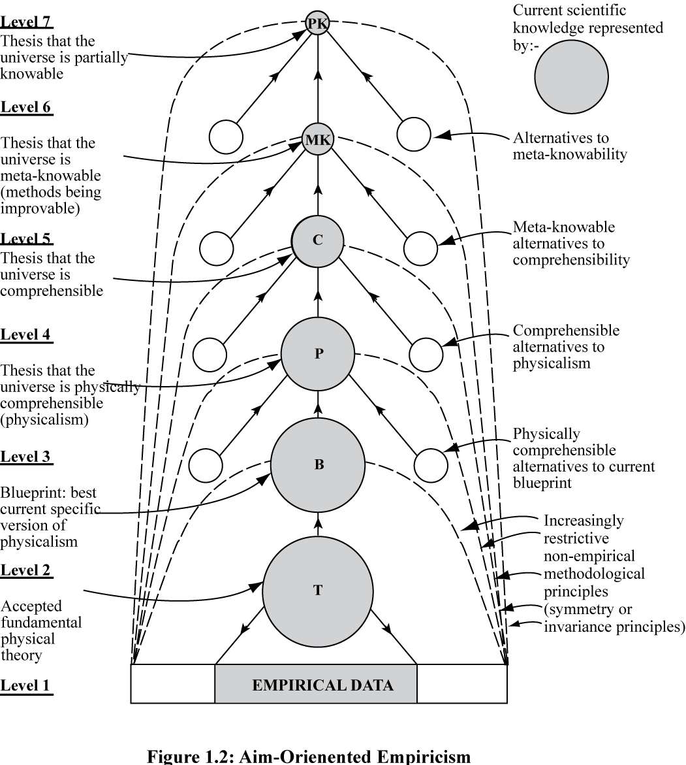
Figure 2: Hierarchical Conception of Science
unproblematic, fixed aims and methods is created within which much more specific and problematic aims and methods evolve as scientific knowledge evolves. (A basic aim of science is to discover in what precise way the universe is comprehensible, this aim evolving as assumptions about comprehensibility evolve.) There is positive feedback between improving knowledge, and improving aims-and-methods, improving knowledge-about-how-to-improve-knowledge. This is the nub of scientific rationality, the methodological key to the unprecedented success of science. Science adapts its nature to what it discovers about the nature of the universe (see Maxwell, 1974, 1976, 1984 or 2007, 1998, 2004, 2005).
So much for the first blunder of the traditional Enlightenment, and how to put it right.
Second, having failed to identify the methods of science correctly, the philosophes naturally failed to generalize these methods properly. They failed to appreciate that the idea of representing the problematic aims (and associated methods) of science in the form of a hierarchy can be generalized and applied fruitfully to other worthwhile enterprises besides science. Many other enterprises have problematic aims – problematic because aims conflict, and because what we seek may be unrealizable, undesirable, or both. Such enterprises, with problematic aims, would benefit from employing a hierarchical methodology, generalized from that of science, thus making it possible to improve aims and methods as the enterprise proceeds. There is the hope that, as a result of exploiting in life methods generalized from those employed with such success in science, some of the
astonishing success of science might be exported into other worthwhile human endeavours, with problematic aims quite different from those of science.
Third, and most disastrously of all, the philosophes failed completely to try to apply such generalized, hierarchical progress-achieving methods to the immense, and profoundly problematic enterprise of making social progress towards an enlightened, wise world. The aim of such an enterprise is notoriously problematic. For all sorts of reasons, what constitutes a good world, an enlightened, wise or civilized world, attainable and genuinely desirable, must be inherently and permanently problematic. Here, above all, it is essential to employ the generalized version of the hierarchical, progress-achieving methods of science, designed specifically to facilitate progress when basic aims
are problematic: see Figure 3. It is just this that the philosophes failed to do. Instead of applying the hierarchical methodology to social life, the philosophes sought to apply a seriously defective conception of scientific method to social science, to the task of making progress towards, not a better world, but to better knowledge of social phenomena. And this ancient blunder is still built into the institutional and intellectual structure of academia today, inherent in the current character of social science (Maxwell, 1984 or 2007, chapters 3, 6 and 7; 2004, chapters 3 and 4).
Properly implemented, in short, the Enlightenment idea of learning from scientific progress how to achieve social progress towards an enlightened world would involve developing social inquiry, not primarily as social science, but as social methodology, or social philosophy. A basic task would be to get into personal and social life, and into other institutions besides that of science – into government, industry, agriculture, commerce, the media, law, education, international relations – hierarchical, progress-achieving methods (designed to improve problematic aims) arrived at by generalizing the methods of science. A basic task for academic inquiry as a whole would be to help humanity learn how to resolve its conflicts and problems of living in more just, cooperatively rational ways than at present. This task would be intellectually more fundamental than the scientific task of acquiring knowledge. Social inquiry would be intellectually more fundamental than physics. Academia would be a kind of people’s civil service, doing openly for the public what actual civil services are supposed to do in secret for governments. Academia would have just sufficient power (but no more) to retain its independence from government, industry, the press, public opinion, and other centres of power and influence in the social world. It would seek to learn from, educate, and argue with the great social world beyond, but would not dictate. Academic thought would be pursued as a specialized, subordinate part of what is really important
and fundamental: the thinking that goes on, individually, socially and institutionally, in the social world, guiding individual, social and institutional actions and life. The fundamental intellectual and humanitarian aim of inquiry would be to help humanity acquire wisdom – wisdom being the capacity to realize (apprehend and create) what is of value in life, for oneself and others, wisdom thus including knowledge and technological know-how but much else besides.
One outcome of getting into social and institutional life the kind of aim-evolving, hierarchical methodology indicated above, generalized from science, is that it becomes possible for us to develop and assess rival philosophies of life as a part of social life, somewhat as theories are developed and assessed within science. Such a hierarchical methodology provides a framework within which competing views about what our aims and methods in life should be – competing religious, political and moral views – may be cooperatively assessed and tested against broadly agreed, unspecific aims (high up in the hierarchy of aims) and the experience of personal and social life. There is the possibility of cooperatively and progressively improving such philosophies of life (views about what is of value in life and how it is to be achieved) much as theories are cooperatively and progressively improved in science. In science, ideally, theories are critically assessed with respect to each other, with respect to metaphysical ideas concerning the comprehensibility of the universe, and with respect to experience (observational and experimental results). In a somewhat analogous way, diverse philosophies of life may be critically assessed with respect to each other, with respect to relatively uncontroversial, agreed ideas about aims and what is of value, and with respect to experience – what we do, achieve, fail to achieve, enjoy and suffer – the aim being to improve philosophies of life (and more specific philosophies of more specific enterprises within life such as government, education or art) so that they offer greater help with the realization of what is of value in life. This hierarchical methodology is especially relevant to the task of resolving conflicts about aims and ideals, as it helps disentangle agreement (high up in the hierarchy) and disagreement (more likely to be low down in the hierarchy).
Wisdom-inquiry, because of its greater rigour, has intellectual standards that are, in important respects, different from those of knowledge-inquiry. Whereas knowledge-inquiry demands that emotions and desires, values, human ideals and aspirations, philosophies of life be excluded from the intellectual domain of inquiry, wisdom-inquiry requires that they be included. In order to discover what is of value in life it is essential that we attend to our feelings and desires. But not everything we desire is desirable, and not everything that feels good is good. Feelings, desires and values need to be subjected to critical scrutiny. And of course feelings, desires and values must not be permitted to influence judgements of factual truth and falsity. Wisdom-inquiry embodies a synthesis of traditional Rationalism and Romanticism. It includes elements from both, and it improves on both. It incorporates Romantic ideals of integrity, having to do with motivational and emotional honesty, honesty about desires and aims; and at the same time
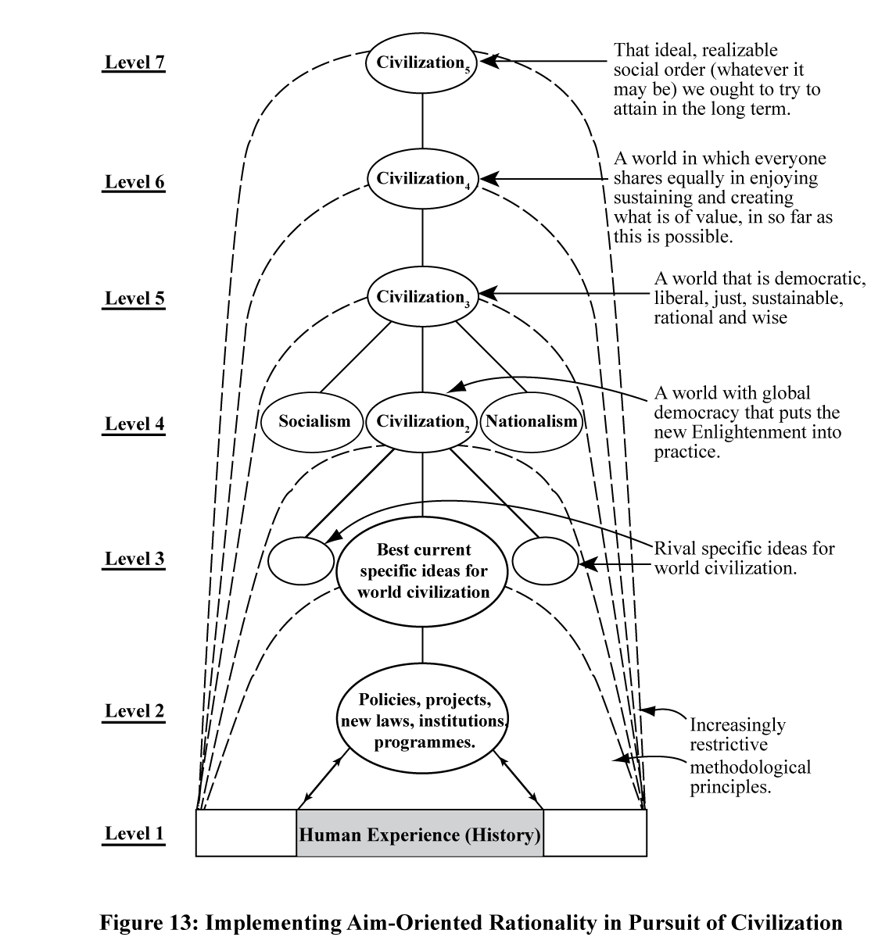
Figure 3: Hierarchical Social Methodology Generalized from Science

it incorporates traditional Rationalist ideals of integrity, having to do with respect for objective fact, knowledge, and valid argument. Traditional Rationalism takes its inspiration from science and method; Romanticism takes its inspiration from art, from imagination, and from passion. Wisdom-inquiry holds art to have a fundamental rational role in inquiry, in revealing what is of value, and unmasking false values; but science, too, is of fundamental importance. What we need, for wisdom, is an interplay of sceptical rationality and emotion, an interplay of mind and heart, so that we may develop mindful hearts and heartfelt minds. It is time we healed the great rift in our culture, so graphically depicted by Snow (1986).
All in all, if the Enlightenment revolution had been carried through properly, the three steps indicated above being correctly implemented, the outcome would have been a kind of academic inquiry very different from what we have at present, inquiry devoted primarily to the intellectual aim of acquiring knowledge.
Transforming universities so that they put wisdom-inquiry into practice is, potentially, vastly more effective in helping us create a wise world than is the current programme of improving knowledge about wisdom within existing knowledge-inquiry, discussed above. For wisdom-inquiry dedicates the whole of academia to the task of creating a wiser world. Not only does wisdom-inquiry transform education so that it helps individuals acquire wisdom; perhaps even more important, wisdom-inquiry devotes itself to transforming other institutions – government, industry, agriculture, the law, the media, and so on – so that they become wiser in their aims and actions, and at the same time provides the methodological means to achieve this, namely the hierarchical methodology depicted in figure 3. Research that seeks to improve knowledge about the nature of wisdom should of course continue but, judged as a response to the problem of the lack of wisdom in the world, it is no substitute for, and does not stand comparison with, the vital task of transforming academia so that it puts wisdom-inquiry into practice.

Conclusion
Humanity is in deep trouble. We urgently need to learn how to make progress towards a wiser, more civilized world. This in turn requires that we possess traditions and institutions of learning rationally designed – well designed – to help us achieve this end. It is just this that we do not have at present. What we have instead is natural science and, more broadly, inquiry devoted to acquiring knowledge. Judged from the standpoint of helping us create a better world, knowledge-inquiry of this type is dangerously and damagingly irrational. We need to bring about a major intellectual and institutional revolution in the aims and methods of inquiry, from knowledge-inquiry to wisdom-inquiry. Almost every branch and aspect of academic inquiry needs to change.
This revolution – intellectual, institutional and cultural – if it ever comes about, will be comparable in its long-term impact to that of the Renaissance, the scientific revolution, or the Enlightenment. The outcome will be traditions and institutions of learning rationally designed to help us acquire wisdom. There are a few scattered signs that this intellectual revolution, from knowledge to wisdom, is already under way. It will need, however, much wider cooperative support – from scientists, scholars, students, research councils, university administrators, vice chancellors, teachers, the media and the general public – if it is to become anything more than what it is at present, a fragmentary and often impotent movement of protest and opposition, often at odds with itself, exercising little influence on the main body of academic work. I can hardly imagine any more important work for anyone associated with academia than, in teaching, learning and research, to help promote this revolution.

References
Baltes, P.B. and U.M. Staudinger, 1993, The Search for a Psychology of Wisdom,
Current Directions in Psychological Science, Vol. 2, No. 3, pp. 75-80.
Baltes, P.B. and U.M. Staudinger, 2000, Wisdom: A metaheuristic (pragmatic) to
orchestrate mind and virtue toward excellence, American Psychologist, vol. 55, pp.
122-136.
Barnett, R. and N. Maxwell, eds., 2008, Wisdom in the University, Routledge, London.
Berlin, I., 1980, Against the Current, Hogarth Press, London.
Kunzmann, U. and P.B. Baltes, 2003, Wisdom-related knowledge: Affective, motivational, and interpersonal correlates, Personality and Social Psychology Bulletin,
vol. 29, no. 9, pp. 1104-1119.
Langley, C., 2005, Soldiers in the Laboratory, Scientists for Global Responsibility,
Folkstone.
Le, T. N., 2008, Cultural values, life experiences, and wisdom, International Journal of Aging & Human Development, vol. 66, no. 4, pp. 259-281.
Maxwell, N., 1974, ‘The Rationality of Scientific Discovery’, Philosophy of Science 41,
1974, pp. 123-53 and 247-95.
_______, 1976, What’s Wrong With Science?, Bran’s Head Books, Frome, England (2nd
edition, 2009, Pentire Press, London). _______, 1980, ‘Science, Reason, Knowledge and Wisdom: A Critique of Specialism’,
Inquiry 23, pp. 19-81.
_______, 1984, From Knowledge to Wisdom, Blackwell, Oxford.
_______, 1998, The Comprehensibility of the Universe (Oxford University Press,
Oxford, pbk. 2003).
_______, 2000, Can Humanity Learn to become Civilized? The Crisis of Science
without Civilization, Journal of Applied Philosophy 17, pp. 29-44.
_______, 2004, Is Science Neurotic?, Imperial College Press, London.
_______, 2005, ‘Popper, Kuhn, Lakatos and Aim-Oriented Empiricism’, Philosophia 32,
pp. 181-239.
_______, 2007, From Knowledge to Wisdom: A Revolution for Science and the
Humanities, Pentire Press, London (2nd edition of Maxwell, 1984, revised and
enlarged).
_______, 2009, Are Universities Undergoing an Intellectual Revolution?, Oxford
Magazine, No. 290, pp. 13-16.
_______, 2010, Cutting God in Half – And Putting the Pieces Together Again: A New
Approach to Philosophy, Pentire Press, London.
Popper, K. R., 1959, The Logic of Scientific Discovery, Hutchinson, London.
_______, 1961, The Poverty of Historicism, Routledge and Kegan Paul, London.
_______, 1962, The Open Society and Its Enemies, Routledge and Kegan Paul, London.
_______, 1963, Conjectures and Refutations, Routledge and Kegan Paul, London.
Smith, D., 2003, The Atlas of War and Peace, Earthscan, London.
Smith, J., and P.B. Baltes, 1990, A study of wisdom-related knowledge: Age/cohort
differences in response to life-planning problems, Developmental Psychology, vol. 26,
no. 3, pp. 494-505.
Snow, C. P., 1986, The Two Cultures: And a Second Look, Cambridge University Press,
Cambridge.
Staudinger, U. M., and P.B. Baltes, 1996, Interactive minds: A facilitative setting for
wisdom-related performance?, Journal of Personality and Social Psychology, vol. 71,
no. 4, pp. 746-762.
Sternberg, R. J., ed., 1990, Wisdom: Its Nature, Origins and Development, Cambridge
University Press, New York.
_______, 1998, A balance theory of wisdom, Review of General Psychology, vol. 2, pp.
347-365.
Sternberg, R. J., A. Reznitskaya and L. Jarvin, 2008, Teaching for wisdom: what matters
is not just what students know, but how they use it, in Barnett and Maxwell (2008),
pp. 47-62.
Trowbridge, R.H., 2008, Wisdom and lifelong learning in the twenty-first century, in
Barnett and Maxwell (2008), pp. 63-76.
Yang, S.-Y., 2008a, Real-life contextual manifestations of wisdom, International Journal
of Aging and Human Development, vol. 67, no. 4, pp. 273-303
_______, 2008b, A process view of wisdom, Journal of Adult Development, vol. 15, no.
2, pp. 62-75.

Notes

Sternberg (1990).
See, for example, Smith and Baltes (1990); Baltes and Staudinger (1993); Staudinger and Baltes (1996); Sternberg (1998); Baltes and Staudinger, (2000); Kunzmann and Baltes (2003); Le (2008); Trowbridge (2008); Yang (2008a; 2008b). See also works referred to by these papers. I am grateful to Richard Trowbridge for drawing my attention to many of these papers.
See http://wisdomresearch.org/. This website has a long list of publications on wisdom that have appeared since Sternberg (1990).
For a much more detailed exposition of knowledge-inquiry, or “the philosophy of knowledge”, see Maxwell (1984 or 2007, chapter 2). For evidence that knowledge-inquiry prevails in academia, see Maxwell (1984 or 2007, chapter 6; 2000). I do not claim that everything in academia accords with the edicts of knowledge-inquiry. My claim is, rather, that this is the only candidate for rational inquiry in the public arena; it is the dominant view, exercising an all-pervasive influence over academe. Work that does not conform to its edicts has to struggle to survive.
This assumption may be challenged. Does not academic inquiry seek knowledge for its own sake – it may be asked – whether it helps promote human welfare or not? Elsewhere (Maxwell, 2007, pp. 17-19, 70-5, 205-13) I have argued that wisdom-inquiry does better justice than knowledge-inquiry to both aspects of inquiry, pure and applied. The basic aim of inquiry, according to wisdom-inquiry, is to help us realize what is of value in life, “realize” meaning both “apprehend” and “make real”. “Realize” thus accommodates both aspects of inquiry, “pure” research or “knowledge pursued for its own sake” on the one hand, and technological or “mission-oriented” research on the other – both, ideally, seeking to contribute to what is of value in human life. Wisdom-inquiry, like sight, is there to help us find our way around. And like sight, wisdom-inquiry is of value to us in two ways: for its intrinsic value, and for practical purposes. The first is almost more precious than the second.
Funds devoted to military research, in the USA, UK and some other wealthy countries, are especially disturbing: see Langley (2005) and Smith (2003).
See Maxwell (1984 or 2007, chapter 3) for a much more detailed discussion of the damaging social repercussions of knowledge-inquiry.
See also my (1980; 1984 or 2007, chs. 4 and 7; 2004, chs. 3 and 4; 2010, chs. 2, 6 and 9).
The blunders of the philosophes are not entirely undetected. Karl Popper, in his first four works, makes substantial improvements to the traditional Enlightenment programme (although Popper does not himself present his work in this fashion). Popper first improves traditional conceptions of the progress-achieving methods of science (Popper, 1959). This conception, falsificationism, is then generalized to become critical rationalism. This is then applied to social, political and philosophical problems (Popper, 1961, 1962, 1963). The version of the Enlightenment programme about to be outlined here can be regarded as a radical improvement of Popper’s version: see Maxwell (2004, chapter 3).
Natural science has made such astonishing progress in improving knowledge and understanding of nature because it has put something like the hierarchical methodology, indicated here, into scientific practice. Officially, however, scientists continue to hold the standard empiricist view that no untestable metaphysical theses concerning the comprehensibility and knowability of the universe are accepted as a part of scientific knowledge. As I have argued elsewhere (Maxwell, 2004, chapter 2), science would be even more successful, in a number of ways, if scientists adopted and explicitly implemented the hierarchical methodology indicated here.
There are a number of ways of highlighting the inherently problematic character of the aim of creating civilization. People have very different ideas as to what does constitute civilization. Most views about what constitutes Utopia, an ideally civilized society, have been unrealizable and profoundly undesirable. People's interests, values and ideals clash. Even values that, one may hold, ought to be a part of civilization may clash. Thus freedom and equality, even though inter-related, may nevertheless clash. It would be an odd notion of individual freedom which held that freedom was for some, and not for others; and yet if equality is pursued too single-mindedly this will undermine individual freedom, and will even undermine equality, in that a privileged class will be required to enforce equality on the rest, as in the old Soviet Union. A basic aim of legislation for civilization, we may well hold, ought to be increase freedom by restricting it: this brings out the inherently problematic, paradoxical character of the aim of achieving civilization. One thinker who has stressed the inherently problematic, contradictory character of the idea of civilization is Isaiah Berlin; see, for example, Berlin (1980, pp. 74-9). Berlin thought the problem could not be solved; I, on the contrary, hold that the hierarchical methodology indicated here provides us with the means to learn how to improve our solution to it in real life.
For further details about wisdom-inquiry see my (1976; 1980; 2000; 2004, chs. 3 and 4; 2010, chs. 2, 6 and 9; and, above all, 1984 or 2007).
The two endeavours overlap in the field of education: see, for example, Sternberg et al. (2008).
See Maxwell (2009).

