HAS SCIENCE ESTABLISHED THAT THE UNIVERSE IS COMPREHENSIBLE?

Nicholas Maxwell

Published in Cogito 13, No. 2, 1999, pp. 139-145.

Many scientists, if pushed, may be inclined to hazard the guess that the universe is comprehensible, even physically comprehensible. Almost all, however, would vehemently deny that science has already established that the universe is comprehensible. It is, nevertheless, just this that I claim to be the case. Once one gets the nature of science properly into perspective, it becomes clear that the comprehensibility of the universe is as secure an item of current scientific knowledge as anything theoretical in science can be, more secure, indeed, than the most firmly established fundamental theories of physics, such as quantum theory or Einstein's general theory of relativity.
What does it mean to assert that the universe is comprehensible? It means that the universe is such that there is something (God, tribe of gods, cosmic goal, pattern of physical law, cosmic programme or whatever), which exists everywhere in an unchanging form and which, in some sense, determines or is responsible for everything that changes (all change and diversity in the world in principle being explicable and understandable in terms of the underlying unchanging something).
If the something that determines all change is what corresponds out there in the world to a unified pattern of physical law, then the universe is physically comprehensible. The universe is physically comprehensible, in other words, if and only if some yet-to-be-discovered unified physical "theory of everything" or "final theory" is true. I shall call the thesis that the universe is physically comprehensible in this sense physicalism.
There is an obvious objection to the claim that physicalism is a part of current scientific knowledge. Physicalism is a metaphysical thesis. It is too vague to be empirically testable and hence cannot be a part of scientific knowledge (only that which is empirically testable being scientific). Furthermore, far from being implied by current theoretical knowledge in physics, physicalism is incompatible with such knowledge. Whereas physicalism asserts that there is an unchanging, unified, physical something underlying all change and diversity, current physical theory is made of two incompatible parts, Einstein's general theory of relativity, on the one hand, a classical theory of gravitation, and the so-called "standard model", made up of quantum field theories of fundamental particles and the forces between them that go to make up matter. One day a unified, physical "theory of everything" may be discovered and confirmed experimentally; when that happens, physicalism may be said to be a part of scientific knowledge. But until that happens, physicalism cannot possibly be a part of scientific knowledge.
This objection depends on the adoption of a widely held conception of science - which I shall call standard empiricism - which is, as it happens, untenable. The moment standard empiricism is rejected, and a more reasonable conception of science is adopted, it becomes clear that the above objection is invalid. It becomes clear that physicalism is a part of current theoretical knowledge in physics. It becomes clear that science has established that the universe is physically comprehensible!

STANDARD EMPIRICISM
Standard Empiricism is the doctrine that in science laws and theories are accepted impartially on the basis of empirical success and failure, no substantial thesis about the world being accepted as a permanent part of scientific knowledge independent of the evidence, and certainly not in violation of the evidence. In so far as factors other than evidence are appealed to in assessing the acceptability of theories - factors such as the simplicity, unity or explanatory capacity of a theory - this must be done in such a way that no assumption about the nature of the world is permanently upheld, explicitly or implicitly, in science, as a part of knowledge, entirely independently of evidence. Physicalism, not being itself testable, and being incompatible with current experimentally confirmed physical theories, cannot, according to standard empiricism, be a part of scientific knowledge.
But standard empiricism is untenable! Given any scientific theory, however well verified empirically, there will always be infinitely many rival theories which fit the available evidence just as well, but which make different predictions, in an arbitrary way, for phenomena not yet observed. Thus, given Newtonian theory (NT), one rival theory might assert: everything occurs as NT asserts up till midnight tonight when, abruptly, an inverse cube law of gravitation comes into operation. A second rival theory might assert: everything occurs as NT asserts, except for the case of any two solid gold spheres, each having a mass of a thousand tons, moving in otherwise empty space up to a mile apart, in which case the spheres attract each other by means of an inverse cube law of gravitation. A third rival theory asserts that everything occurs as NT asserts until three kilograms of gold dust and three kilograms of diamond dust are heated in a platinum flask to a temperature of 450ºC, in which case gravitation will instantly become a repulsive force everywhere. And so on. There is no limit to the number of rivals to NT that can be concocted in this way, each of which has all the predictive success of NT as far as observed phenomena are concerned but which makes different predictions for some as yet unobserved phenomena. Such theories can even be concocted which are more empirically successful than NT, by arbitrarily modifying NT, in just this entirely ad hoc fashion, so that the theories yield correct predictions where NT does not, as in the case of the orbit of Mercury for example (which very slightly conflicts with NT).
One can set out to refute these rival theories by making the relevant observations or experiments, but this needs an infinitely long time to complete as there are infinitely many rival theories to be refuted in this way. Thus, if science really did take seriously the idea that evidence alone decides what theories are to be accepted and rejected, scientific knowledge would be drowned in an infinite ocean of rival theories, all just as empirically successful as currently accepted theories, or actually even more successful empirically. Science would come to an end.
Why does this not happen in scientific practice? Because in practice two considerations govern acceptance and rejection of theories in science: (1) considerations of empirical success and failure; and (2) considerations that have to do with the simplicity, unity or explanatory power of the theories in question. In order to be accepted as a part of scientific knowledge, a theory must satisfy both considerations. It must be both empirically successful and simple, unified, or explanatory in character.
Scientific theories that are accepted as a part of scientific knowledge, NT let us say, classical electromagnetism, quantum theory or Einstein's theories of special and general relativity, do (more or less adequately) satisfy both considerations. They are both amazingly successful in their capacity to predict observable phenomena, and astonishingly simple, unified, explanatory.
But the infinitely many empirically successful rivals to these accepted theories all fail to satisfy the second consideration. They may fit all available evidence just as well as Newton's theory does, or Einstein's theories do: but they fail, quite drastically, to be simple, unified, explanatory. For these rival theories all assert that, for some as yet unobserved kind of phenomenon, something entirely peculiar and arbitrary occurs. Where NT assures us that gravitation obeys an inverse square law and is attractive uniformly everywhere, for all time, the aberrant rivals to NT assert that for some specific kind of phenomenon or range of phenomena gravitation obeys a quite different law, an inverse cube law perhaps, or one that asserts that gravitation is a repulsive rather than attractive force.
We can of course set out to refute such rivals by observing the disputed phenomena in question; but unfortunately, there are infinitely many more such theories with further arbitrary predictions for other as yet unobserved phenomena. These aberrant rivals to NT, that have not as yet been refuted empirically, are rejected out of hand, not on empirical grounds at all, but because they are grotesquely ad hoc, grotesquely lacking in simplicity, unity, explanatory power.
This, then, is why in practice science is not buried beneath an infinite mountain of rival theories, all of which fit all available evidence equally well, if not better. Almost all the rivals are horribly complex, disunified, non-explanatory.
But now comes the decisive point. In persistently rejecting infinitely many such empirically successful but grotesquely ad hoc theories, science in effect makes a big permanent assumption about the nature of the universe, to the effect that it is such that no grotesquely ad hoc theory is true, however empirically successful it may appear to be for a time. Without some such big assumption as this, the empirical method of science collapses. Science is drowned in an infinite ocean of empirically successful ad hoc theories.
The orthodox conception of science is, in short, untenable.

AIM-ORIENTED EMPIRICISM
At once the question arises: Granted that science must make some kind of big assumption about the nature of the universe if it is to be possible at all, what precisely ought this assumption to be, and on what basis is it to be made? We must make some assumption about the ultimate nature of the universe before science can proceed at all; if science is to proceed successfully we must make an assumption that is near enough correct: and yet it is just here that we are most ignorant, and are almost bound to get things hopelessly wrong.
The solution to this basic dilemma confronting the scientific endeavour can be put like this. Cosmological speculation about the ultimate nature of the universe, being necessary for science to be possible at all, must be regarded as a part of scientific knowledge itself, however epistemologically unsound it may be in other respects. The best such speculation available is that the universe is comprehensible in some way or other and, more specifically, in the light of the immense apparent success of modern natural science, that it is physically comprehensible. But both these speculations may be false; in order to take this possibility into account, we need to adopt a hierarchy of increasingly insubstantial cosmological conjectures concerning the comprehensibility and knowability of the universe until we arrive at the highly insubstantial conjecture that the universe is such that it is possible for us to acquire some knowledge of something. This is a conjecture about the ultimate nature of the universe which it will always be rational to accept as a part of knowledge: accepting it cannot, in any circumstances, imperil
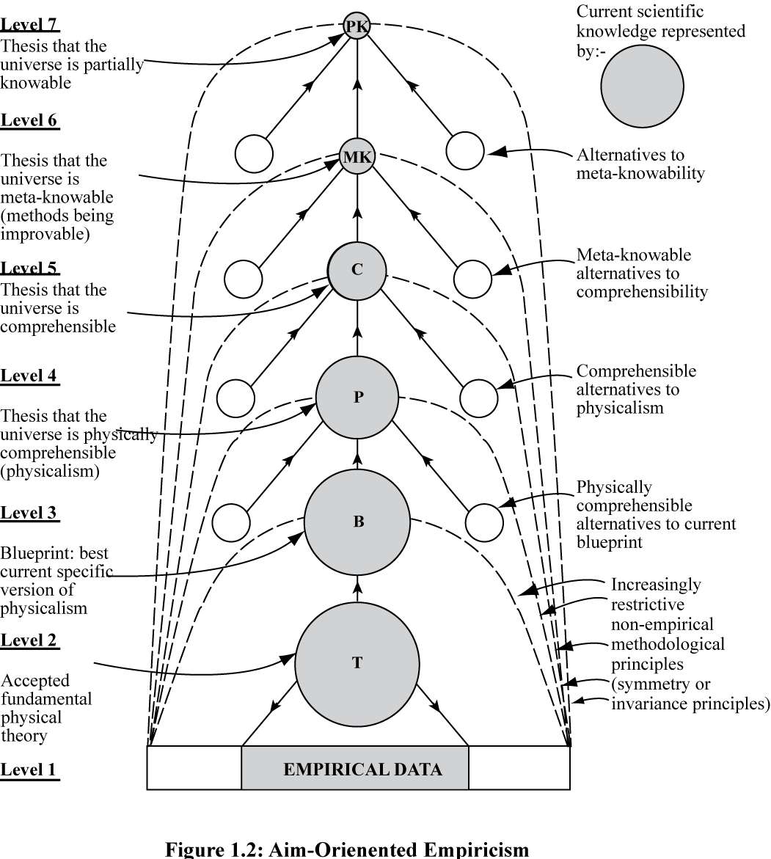
Aim-Oriented Empiricism

Aim-Oriented Empiricism

the pursuit of knowledge of truth.
As a result of adopting such a hierarchy of increasingly insubstantial, increasingly secure cosmological conjectures in this way, we maximize our chances of adopting conjectures that promote the growth of knowledge, and minimize our chances of taking some cosmological assumption for granted that is false and impedes the growth of knowledge. The hope is that as we increase our knowledge about the world we improve (lower level) cosmological assumptions implicit in our methods, and thus in turn improve our methods. As a result of improving our knowledge we improve our knowledge about how to improve knowledge. Science adapts its own nature to what it learns about the nature of the universe, thus increasing its capacity to make progress in knowledge about the world: see diagram.
This aim-oriented empiricist methodology, in stark contrast to current orthodoxy, is the key to the success of modern science. The basic aim of science of discovering how, and to what extent, the universe is comprehensible is deeply problematic; it is essential that we try to improve the aim, and associated methods, as we proceed, in the light of apparent success and failure. In order to do this in the best possible way we need to represent our aim at a number of levels, from the specific and problematic to the highly unspecific and unproblematic, thus creating a framework of fixed aims and meta-methods within which the (more or less specific) aims and methods of science may be progressively improved in the light of apparent empirical success and failure. The result is that, as we improve our knowledge about the world we are able to improve our knowledge about how to improve knowledge, the methodological key to the rapid progress of modern science.

IMPLICATIONS
What are the implications of the scientific revolution that I have indicated, the revolution involved in rejecting the current orthodox conception of science of standard empiricism and accepting aim-oriented empiricism as the new orthodoxy in its stead?
First, there is a dramatic change in the whole relationship between science on the one hand, and metaphysics and philosophy on the other. Given standard empiricism, metaphysics and philosophy are excluded from science, in accordance with Popper's criterion of demarcation: metaphysical theories (such as that the universe is physically comprehensible), being experimentally untestable, are unscientific. But granted aim-oriented empiricism it is clear that untestable metaphysical or philosophical ideas are absolutely basic to scientific knowledge. Metaphysical theses at levels 4 to 7 in the diagram are more firmly established than currently accepted theories of physics, such as general relativity or quantum theory. No longer can philosophy be a forbidden subject for undergraduate physicists: on the contrary, it must be an important part of the curriculum!
But before it becomes a standard part of science in this way, philosophy must itself undergo a revolution. According to aim-oriented empiricism, the proper way to assess metaphysical theories about the nature of the universe is in terms of their fruitfulness for science. This is not the way philosophers assess such theories at present.
A second implication of adopting the new conception of science is that fundamental problems in the philosophy of science, unsolved for centuries, become readily resolved.
Take, for example, Hume's notorious problem of induction - the problem of how scientific theories can be verified, or at least selected, on the basis of evidence. As we have in effect seen, this cannot be solved within the framework of standard empiricism. Either there are infinitely many rival theories all equally successful empirically; or, if simplicity considerations are invoked to rule out the infinitely many complex, ad hoc theories, standard empiricism is violated. But accept aim-oriented empiricism, and the problem all but disappears. Metaphysical theses at levels 10 to 3 are accepted as a part of knowledge, either because in accepting such theses we have nothing to lose, or because the theses accepted appear to promote the growth of empirical knowledge better than any rival. Testable theories at level 2 are accepted because they accord the best with (1) the evidence, and (2) the best available theses at levels 3, 4 and above.
Another famous unsolved problem within the philosophy of science is the problem of simplicity - the problem of what the simplicity (or complexity) of a theory is, and the problem of why preference should persistently be given to simple theories in science. Long-standing attempts to solve this problem within the framework of standard empiricism have all failed. Even Einstein acknowledged that he was baffled by the problem. The main difficulty is that whether a theory is simple or complex seems to depend on how the theory is formulated. A simple theory can always be made grotesquely complicated by a change of formulation, and vice versa. But granted aim-oriented empiricism, the problem is readily solved. What matters is the extent to which the totality of fundamental physical theory exemplifies physicalism. The more nearly it is a precise version of physicalism, the simpler, that is the more unified, the corresponding body of theory is. What matters here is that which all of fundamental physical theory asserts about the world exemplifies physicalism. Formulation is, in the first instance at least, irrelevant; it is content that matters. Note that standard empiricism cannot avail itself of this solution to the problem of simplicity, since to do so involves acknowledging that physicalism is a part of scientific knowledge, which contradicts the basic idea of standard empiricism.
A third implication of adopting the new conception of science is that science acquires a rational, if fallible and non-mechanical method for the discovery of fundamental new theories. Viewed from the perspective of standard empiricism, is has always been somewhat of a mystery as to how physicists have been able to dream up radically new theories, such as relativity theory, quantum theory or quantum field theory, that contradict predecessor theories and subsequently turn out to achieve extraordinary empirical success. Given aim-oriented empiricism, much of the mystery is dispelled. In order to discover radically new theories physicists must seek
to modify existing level 3 ideas so that they accord better with physicalism, at the same time making these ideas more precise until they become new testable theories. Something of this process can be discerned in Einstein's development of special and general relativity.
A fourth implication of adopting the new conception of science is that there is a change in the whole conception of scientific method. Instead of theories being assessed impartially with respect to evidence, they are assessed with respect to two considerations: (1) evidence, and (2) compatibility with the thesis that the universe is physically comprehensible. As we pursue the problematic aim of discovering in what precise way the universe is comprehensible, our knowledge and understanding improve; our aim improves, and with it the methods we employ to assess theories. There is positive feedback, as I have already indicated, between improving knowledge and improving knowledge-about-how-to-improve-knowledge. Science adapts its nature to what it finds out about the nature of the universe - a vital feature of scientific method which helps explain the explosive growth of scientific knowledge.
This new conception of scientific method has far reaching implications for rationality in general. For it is not just science that has problematic aims; our aims in life, whether individual, institutional or social, are problematic. Above all, the aim of creating a better world is inherently and profoundly problematic. In these diverse fields, too, we need to put a generalized version of the progress-achieving methods of science into practice, designed to help us improve aims and methods as we proceed, as we live.
But finally, perhaps the most dramatic consequence of adopting the new conception of science is the one with which we began. Granted standard empiricism, the thesis that the universe is physically comprehensible is definitely not a part of current scientific knowledge. But granted aim-oriented empiricism, this thesis is a central component of current theoretical knowledge in science, more firmly established, as I have said, than any accepted physical theory. This is implicitly, but not explicitly, recognized by physicists today when they concede that general relativity and the standard model, which do not form a unified theory, cannot be correct. In holding that unity is a necessary condition for fundamental physical theory to be correct, physicists all but acknowledge that physicalism is a part of current knowledge.
They are prevented from acknowledging this explicitly by token allegiance to standard empiricism. The time has come to push through a revolution in our whole understanding of science. We need to reject standard empiricism in all its forms, and adopt aim-oriented empiricism in its stead as the new orthodoxy.

REFERENCES
A. Einstein (1949), "Autobiographical Notes", in P. A. Schilpp (ed) Albert Einstein: Philosopher-Scientist, vol. 1, Open Court, pp. 1-94.
A. Einstein (1973), Ideas and Opinions, Souvenir Press.
N. Goodman (1054), Fact, Fiction and Forecast, Athlone Press.
N. Maxwell (1984), From Knowledge to Wisdom, Basil Blackwell.
N. Maxwell (1993), "Induction and Scientific Realism: Einstein, Aim-oriented Empiricism and the Discovery of Special and General Relativity", British Journal for the Philosophy of Science 44, pp. 275-305.
N. Maxwell (1998) The Comprehensibility of the Universe, Oxford University Press.
K. R. Popper (1959), The Logic of Scientific Discovery, Hutchinson.
W. Salmon (1989), Four Decades of Scientific Explanation, University of Minnesota Press.
J. J. C. Smart 1963), Philosophy and Scientific Realism, Routledge and Kegan Paul.
S. Weinberg (1993), Dreams of a Final Theory, Hutchinson.

NOTES

. Typical in this respect is Steven Weinberg who has declared "My own guess is that there is a final theory, and we are capable of discovering it" (Weinberg, p. 188). (The existence of a true final theory for physics is equivalent to the universe being physically comprehensible, as we shall see in a moment.) Weinberg makes it clear that this is his guess, and not a part of current scientific knowledge. The 20th century physicist who has come closest to holding that science presupposes that the universe is comprehensible is the most famous of all: Albert Einstein. He once declared "One may say 'the eternal mystery of the world is its comprehensibility'. It is one of the great realizations of Immanuel Kant that the postulation of a real external world would be senseless without this comprehensibility" (Einstein, p. 292). On the other hand Einstein elsewhere declares that the thesis that the universe is comprehensible is "an article of faith" (p. 357), a remark which puts Einstein into the same camp as Weinberg. For a discussion of Einstein's ambivalent attitude, see Maxwell (1993, pp. 297-303).
. For a more detailed discussion of this notion of comprehensibility, see Maxwell (1998).
. J. J. C. Smart has used the term 'physicalism' to stand for the view that the world is made up entirely of physical entities of the kind postulated by fundamental physical theories - electrons, quarks and so on: see Smart (1963). As I am using the term, 'physicalism' stands for the much stronger doctrine that the universe is physically comprehensible, that it is such that some yet-to-be-discovered, unified "theory of everything" is true.
. I use the term 'metaphysical' here in the sense employed by Karl Popper, to refer to theses that cannot be falsified empirically: see Popper (1959, pp. 34-42).
. This argument generalizes Nelson Goodman's argument concerning green and grue: see Goodman (1954). Two rival theories considered by Goodman are "All emeralds are green" and "All emeralds are grue", where an emerald is grue if it is examined before time t and green or not examined before t and blue. Before time t, available evidence appears to support both theories equally well. The argument given here improves on Goodman's argument, in my view, in that it makes closer contact with science. Ad hoc theories, admittedly not quite as bizarre as the rivals to NT that I have indicated, can be a serious issue in science. It is important to appreciate that the problem of why such theories deserve to be rejected is a serious problem for science, and not merely a weird philosophical puzzle.
. For further discussion of this claim see Maxwell (1998, ch. 5).
. For a critical survey of some of these attempts see W. Salmon (1989).
. See A. Einstein (1949, p. 23).
. For further discussion see Maxwell (1998, ch. 4).
. See Maxwell (1993).
. See Maxwell (1984).

