Can time flow at different rates? The differential passage of A-ness

Abstract
According to the No Alternate Possibilities (NAP) argument, (1) if time passes then the rate at which it passes could be different but (2) time cannot pass at different rates, and hence (3) time cannot pass. Typically, defenders of the NAP argument have focussed on defending premise (1), and have taken the truth of (2) for granted: they accept the orthodox view of rate necessitarianism. In this paper we argue that the defender of the NAP argument needs to turn her attention to (2). We describe a series of worlds that appear to contain differential passage: worlds where time passes at different rates in different subregions. If the NAP argument is to succeed, rate necessitarians must show that each of these worlds is either metaphysically impossible, or does not contain differential passage.

1. Introduction
Let us say that a world, w, contains temporal passage iff (a) there is some fact of the matter in w as to which properties, events and entities are objectively present and (b) which properties, events and entities is objectively present, changes. Thus on this view temporal passage consists in, as Leininger (2018) puts it, “moving A-ness”. Then presentism, the growing block theory, the dropping branches theory, and the moving spotlight theory are all ways of modelling temporal passage, though each account has a different kind of moving A-ness.
Two objections to the very possibility of temporal passage focus seek to problematise the idea that if time passes, it must pass at a rate. We call these the rate objections. Following Tallant, (2016) let us call the two rate objections the ‘no rate argument’ (NRA) and the ‘no alternate possibilities’ (NAP) argument.
According to the NRA, if time passes it must pass at a rate. But it seems that the only sensible answer to the question, ‘at what rate does time pass?’, is that it passes at one second per second. But, according to the NRA, that is not a rate at all (Smart, 1949; Price, 1996). For a rate requires that what sits in the numerator position is distinct from what sits in the denominator position. A dollar per dollar is not a rate; a second per second is not a rate. Thus time does not pass at any rate, and hence does not pass. We will put the NRA aside, and simply assume in what follows that 1s/s is a rate. Our focus, instead, is the NAP argument.
According to the NAP argument, if time passes then it passes at some rate, and if it passes at some rate, then the rate at which it passes could be different. But the rate at which time passes cannot be different. Hence time cannot pass, and hence does not pass.
Tallant (2016:36) sets the NAP argument out as follows:

1. If x passes, then the rate at which x passes could be different
2. Time cannot pass at a rate other than 1s/s
Therefore,
3. Time does not pass

We take (1) to entail that if time passes, then there are metaphysically possible worlds in which the rate at which time passes varies. Contemporary discussion of the NAP argument has focussed on evaluating the plausibility of (1).
By contrast, (2) has received little attention because, as Tallant notes, it “seems (relatively) uncontroversial” (2016:36). We will call the orthodox position that if time passes at a rate, it passes at the same rate everywhere, rate necessitarianism. This lack of controversy likely stems from the thought that in order to deny (2) one would need to make the case that there are two worlds with temporal passage, such that time passes at a different rate in each world: perhaps for every second that passes in w₁, two seconds pass in w₂. It is hard to see how one would make that case: the rate of time’s passage in each of these worlds seems incommensurable since there is no metric by which to make this comparison.
This paper focuses on a different kind of counterexample to (2). To show that there is work to do in defending this premise, we outline a series of worlds in which there is differential passage: worlds in which time passes at different rates in different subregions within a single world. To our knowledge, this idea has only been considered, from a rather different perspective, by Forrest (2008). Like Forrest, we focus on growing block worlds. However, we think that some of what we say can be extended to cover worlds in which temporal passage is modelled in other ways. In order for the advocate of the NAP argument to defend rate necessitarianism, she must make the case that none of these worlds are metaphysically possible.
The paper proceeds as follows. §2 describes several worlds in which time is discrete and there is differential passage, while §3 outlines several worlds in which time is continuous and there is differential passage.
We concede that the worlds containing differential passage are, to put it kindly, weird in various ways. Indeed, as we describe each, we will suggest some ways in which the rate necessitarian might argue against its metaphysical possibility. However, we only need one of the worlds we describe to be metaphysically possible in order for the NAP argument to fail. In other words, the rate necessitarian must show that every world we describe is metaphysically impossible. Since the worlds in question are all quite different from one another, in order to deny that differential passage is metaphysically possible the rate necessitarian must argue for, and be committed to, the metaphysical impossibility of a surprisingly broad range of kinds of worlds. Perhaps most tellingly, we think that the only way to object to the possibility of the final world we describe is to argue against the possibility that the temporal dimension is continuous. No mean feat. All in all, we hope to show that rate necessitarianism is far from controversial, and thus that in order to advocate for the NAP argument much must be said in its defence.

2. Discrete Time and Differential Passage
Throughout §2, we will be focussed on a particular class of worlds containing differential passage: worlds where time is discrete and temporal passage is modelled by the accrual of new events, or new slices of being (i.e. they are all growing block worlds). We call these discrete differential accretion worlds.
We begin by describing a basic discrete world (§2.1), and show that in such a world there can be differential passage (§2.1.1). We then explore a range of worlds that differ from that basic discrete world in various ways (§2.2-2.5). Along the way we suggest why one might deny that the world thus described is metaphysically possible. Our aim will be to show that the range of discrete worlds containing differential passage is broad, and that the task of showing that all of them are impossible, is substantial.

2.1. Basic Discrete Worlds
Basic discrete worlds are growing block worlds in which the totality of reality grows as new entities come into existence at one end of the block. Call the totality of co-present things—objects, properties and relations—that come into existence a time. Then temporal passage consists in the accretion of new times.
In a basic discrete world, space-time is discrete (i.e. quantized). The smallest units of space-time are space-time atoms, which are four-dimensional chunks of space-time that are indivisible into spatial, temporal, or spatio-temporal parts. As the block grows, space-time atoms come into existence. They come into existence in their entirety, since they have no proper parts some of which can come into existence before others. So when a space-time atom comes into existence, the entirety of that space-time atom is objectively present.
We make no claim that the actual world is a basic discrete world. But since we will ultimately be presenting the rate necessitarian with the task of denying the metaphysical possibility of some such worlds, it is worth noting that so far, this class of worlds is very much like the way some physicists suppose our world to be. The causal sets approach to modelling quantum gravity combines all of the claims just outlined above. So far then, we have at least weak reason to think that given what have so far said, basic discrete worlds are metaphysically possible. In what follows, however, we go on to say more about basic discrete worlds and there, our characterisation will depart from aspects of the causal sets approach, and thus may provide the rate necessitarian with reasons to deny that such worlds are metaphysically possible. Here are our further assumptions about basic discrete worlds.
First, we assume that in such worlds any space-time atom that is at the outermost ‘growing’ edge of the block—a space-time atom that ‘looks out’ into nothingness in virtue of there being no spatio-temporally contiguous space-time atom that is later-than that atom—is objectively present. We call this assumption presentness. It is motivated by the thought that what it is for a space-time atom to be present is for there to be no later space-time atom.
Second, we assume that the present time is the mereological fusion of all the space-time atoms at the outermost edge of the block. This is a natural assumption given presentness. The present time is the time composed of all the space-time atoms that are, themselves, objectively present. If what it is for a space-time atom to be objectively present is to be outermost on the block, then the present time ought to be the fusion of all the space-time atoms that are, presently, outermost on the block. We call this assumption present time.
Third, we assume that what it is to be a time is to be, or to have once been, a present time. Hence we suppose that t is a time iff t is a mereological fusion of space-time atoms all of which are present, or all of which were co-present. We call this assumption times.
Fourth, we assume that the past is fixed. That is, we suppose that the intrinsic properties at time has, when it is objectively present, are the same as its intrinsic properties when it is objectively past. We call this assumption past fixity.
Fifth, we assume that all the space-time atoms in a world are the same size. We call this assumption size constancy.
Sixth, we assume that the block grows by accreting single space-time atoms along the edge of the block: it does not, at any location along the block, grow by accreting multiple co-present space-time atoms. We call this assumption gradual accretion.
Finally, it is natural to assume that no space-time atom is part of more than one time. We call this assumption uniqueness. We list these assumptions below:

Presentness: any space-time atom that is at the outermost edge of the block is objectively present.
Present Time: The present time is the mereological fusion of all space-time atoms at the outermost edge of the block.
Times: t is a time iff t is a mereological fusion of space-time atoms all of which are, or were, co-present.
Simultaneity: Events e and e* are simultaneous iff they occur at the same time.
Past Fixity: When t is present, t has intrinsic property P iff when t is past, it is the case that t had intrinsic property P.
Size Constancy: All space-time atoms are the same size.
Gradual Accretion: At each location along the edge of the block, space-time atoms accrete one a time.
Uniqueness: No space-time atom is part of more than one time.

Any world that meets all these assumptions is a basic discrete world. §2.1.1 shows how we can model differential passage while upholding all of these assumptions. If such a world is metaphysically possible, then rate necessitarianism is false.

2.1.1. The Island World
One kind of basic discrete world is the island world. The island world can be exhaustively divided into two sub-portions, which we call Slow and Fast. Slow is the fusion of one set of space-time atoms, S, where every member of S is contiguous with some other member of S, and Fast is the mereological fusion of a disjoint set of space-time atoms, S*, where every member of S* is contiguous with some other member of S*. Importantly for our purposes, Slow and Fast are ‘islands’ within their world: there is no spatio-temporal connection between Slow and Fast. Thus, the island world is best imagined as a world containing two growing blocks that are spatio-temporally isolated from one another.
Call the set of space-time atoms that compose Slow at a time, an S-part, and those which compose Fast at a time, an F-part. Now suppose that as the two blocks grow, for every S-part that is added to Slow, there are two F-parts added to Fast. It is natural to say that each S-part corresponds to a time in Slow, and each F-part corresponds to a time in Fast, and that since temporal passage is modelled by the accretion of times, time passes twice as fast in Fast, as it does in Slow. Hence the island world is a world with differential passage. See figure 1, below.

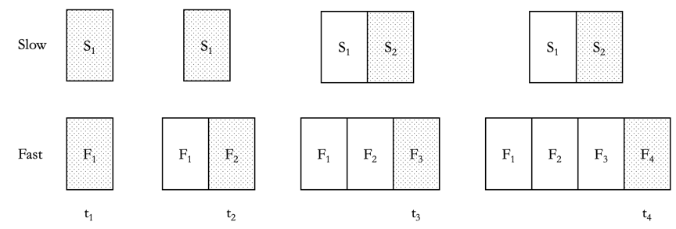Figure 1. The island world. The shaded S-parts and F-parts are objectively present.

We think there are several avenues by which might resist the claim that the island world is both metaphysically possible and contains differential passage.
The first is to argue that island worlds are metaphysically impossible. For example, one might follow Lewis (1986) in thinking that what makes a bunch of concrete things part of the same world is that they are spatio-temporally connected to another. However, there are some compelling recent defences of the possibility of island worlds (see Bricker, 1996, 2001; Baron & Tallant 2016); making the case for their impossibility is no simple matter.
Alternatively, one might allow that the island world is metaphysically possible, but deny that it is a world in which there is differential passage. Figure 1 represents which portion of each block is on the outermost edge, and hence objectively present, by the use of shading. The diagram makes it appear that when t₂ is present, say, F₂ and S₁ are both objectively present, and hence that there is a time, t₂, which is composed of F₂ and S₁. If that is true, then it seems that time in Slow passes are half the rate of time in Fast. One might argue however, that thus understood the diagram is misleading.
Since Fast and Slow are spatio-temporally disconnected, it is not clear what licenses us supposing that F₂ and S₁ are co-present, and hence what licenses us supposing that Fast grows at twice the rate as Slow. As noted in §1, it is difficult to make the case that time passes at different rates in different possible worlds, since there is no metric by which to make this comparison. Similarly, one might make the case that the same issues arise when attempting to compare the rates of temporal passage of spatio-temporally isolated islands within a world. If one thinks this, then one will not think that the island world contains differential passage.
One way to clarify the sense in which time passes at comparable rates in Fast and Slow, and thus defuse this objection, is to suppose that there exists a second temporal dimension: hypertime. At each subsequent hypertime, one F-part accretes in fast, and at every second hypertime, one S-part accretes in Slow. See figure 2, below.

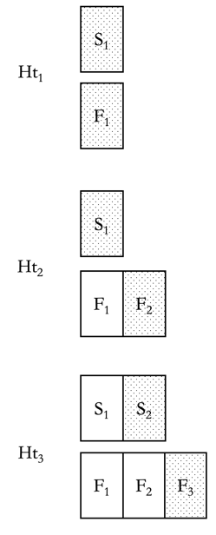
Figure 2. The island world with a hypertemporal dimension.

If the island world has a hypertemporal dimension, then we can say that time passes in Fast at twice the rate it passes in Slow. For the passage of time can be measured as a rate of seconds per successive hypertime, thus rendering these rates commensurable. Fast grows at twice the rate of Slow, for twice as many seconds elapse in Fast per each successive hypertime. Then we can say that time passes in Fast at twice the rate it passes in Slow.
We think there is little basis on which the rate necessitarian can deny that the island world with hypertime contains differential passage. However, by adding a hypertemporal dimension to the model we have provided a new and plausible avenue through which one can argue against its metaphysical possibility, for it is not uncommon to suppose hypertime to be metaphysically impossible. However, not everyone holds this view. Indeed, some have thought that hypertime is necessary to understand temporal passage at all.
Those who countenance hypertime ought think the world just described is one in which time passes are two different rates. Indeed, once hypertime is countenanced we can make sense of time passing at different rates in different worlds: we can suppose that w₁ is a growing block that grows at (say) one nanosecond of time per successive hypertime, and w₂ is a growing block that grows at two nanoseconds of time per successive hypertime. If these two worlds are metaphysically possible, then time can pass at different rates, rate necessitarianism is false, and the NAP argument fails.
Given what we can said thus far, the rate necessitarian must insist (1) that there is no differential passage in the island world without hypertime, because the two blocks are not spatio-temporally connected, and (2) that hypertime is metaphysically impossible. If we can describe a world in which Slow and Fast are spatio-temporally connected and there is no hypertime but there is, plausibly, differential passage, then she will need to find some other reason to suppose that world to be metaphysically impossible. That is what we do next.

2.2. Rejecting Uniqueness: The Temporally Overlapping World
The temporally overlapping world (TOW) is much like the island world except that Slow and Fast are spatio-temporally connected. The TOW is not a basic discrete world because it rejects the following assumption:

Uniqueness: No space-time atom is part of more than one time.

Slow and Fast are spatio-temporally connected in the TOW and Uniqueness is false. So whichever time is objectively present, that time can be exhaustively divided into two non-overlapping proper parts, one of which overlaps all of Slow (at a time), but none of Fast, and one of which overlaps all of Fast (at a time) but none of Slow. See figure 3 below.

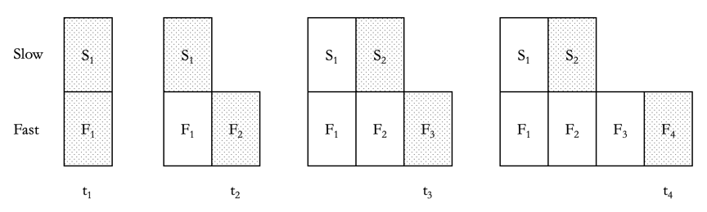

Figure 3. The temporally overlapping world. The shaded S-parts and F-parts are objectively present.

Observe that in the TOW there are space-time atoms that are part of more than one time. In particular, while each F-part is a part of only one time, each S-part is part of two times. So t₁ is the fusion of S₁ and F₁, and t₂ is the fusion of S₁ and F₂. T₅ will then be the fusion of S₃ and F₅, and so on. As S₁ is a part of both t₁ and t₂, Fast ‘grows’ at twice the rate of Slow. If time’s passage is modelled by the accretion of new space-time atoms, and if in some regions space-time atoms accrete faster than in other regions, it is at least prima facie plausible to say that time passes at different rates in the two subregions of the TOW.
A couple of clarifications are in order here. Consider two times, t₂ and t₄. Since times are defined globally, regardless of whether one is located in Fast or Slow it will be the case that the same number of times has elapsed (i.e. come into existence) between when t₂ is present and when t₄ is present. In this sense, time passes at the same rate everywhere: that is, when t₄ is present, 4 times have elapsed everywhere.
What is true is that in Fast, twice as many space-time atoms are accreted for the same number of times, as are accreted in Slow. One way to see why this is important is to notice that it is only because times are defined globally that S₂ is part of t₄. For if space-time atoms accreted in Fast at the same rate as in Slow, then it would be the case that the very same intrinsic way things are in Slow, (i.e. the very same number of space-time atoms having accreted in Slow) would be a way that would make it true that S₂ is part of t₂.
Since temporal passage consists in the accretion of space-time atoms, it is plausible that their differential accretion is sufficient for the differential passage of time. If so, then to make sense of there being two rates of passage in the TOW, we need to say that time passes more quickly in sub-region R than in R* iff, very roughly, the rate of accretion of space-time atoms in R is greater than that in R*. In the simplest case, this will be true when we can map every space-time atom in R to one time, and we can map every space-time atom in R* to two (or more) times, in such a way that the mapping preserves the parthood relation between space-time atoms and times. Of course, in a world with three regions, R, R* and R**, it can be that both R and R* are composed of space-time atoms that are parts of more than one time, despite it being the case that time passes more quickly in R than in R*. To capture this level of generality we can say the following:

In a world in which time is discrete, time passes more quickly in R than in R* =_{df} (a) any space-time atom in R is part of n times, and (b) any space-time atom in R* is part of n* times, and (c) n<n*.

This allows us to say that although the same number of times have elapsed in both R and R*, nevertheless time passes faster in one location than another. Looking at our definition above of what it is for time to pass more quickly in one region than above, we can see that we can derive relative rates of passage from that definition by looking at the ratio between n and n*. If n* is twice n, then time passes at twice the rate in R than it does in R*. If n* is thrice n, then time passes at three times the rate in R than it does in R*, and so on. From this it follows that time passes at twice the rate in Fast as it does in Slow. Hence the TOW is a world in with differential passage.
How does this link back to the question of whether time can pass at a rate other than 1s/s? If time passes at twice the rate in Fast than it does in Slow, then it cannot be that time passes at 1s/s at every location in the TOW. If time passes at 1s/s in Slow, then time passes at 2s/s in Fast; if time passes at 1s/s in Fast, then time passes at 0.5s/s in Slow. The point is that if we stipulate that time passes at 1s/s in one proper part of the universe, it follows that time does not pass at 1s/s elsewhere. Thus if worlds with differential passage are metaphysically possible, premise 2 of the NAP argument is false.

However, as a result of the supposition that Slow and Fast are spatio-temporally connected, some new concerns emerge which the rate necessitarian might press in order to argue against the metaphysical possibility of the TOW.

Firstly, it is worth noting that the TOW may well be nomologically impossible. This will be so on the assumption that it is nomically necessary that spatio-temporal distances between events are invariant. When t₂ is present, the shortest distance between the top right corner of S₁, and the top right corner of F₂, is the path down the side of S₁, and along the top of F₂. When t₃ is present, however, the shortest distance between these two locations is a straight line through S₂ (see figure 4 below). Since the latter is a shorter distance than the former, it follows that space-time distances between events are not invariant.

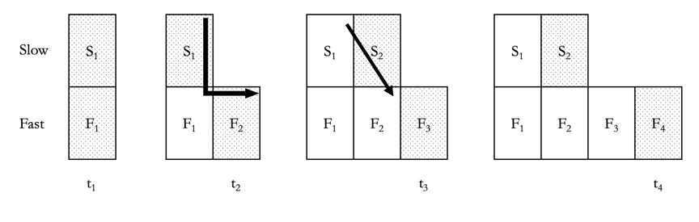Figure 4. Non-invariant spatio-temporal distances between events in the TOW.

That said, the nomological impossibility of the TOW is of little use to the rate necessitarian: as long as the model is metaphysically possible, so is differential passage.
Nevertheless, one might worry that in order to accommodate this variance in spatio-temporal distance we must reject past fixity.

Past Fixity: When t is present, t has intrinsic property P iff when t is past, it is the case that t had intrinsic property P.

Why would that matter? Well, following Lewis (1976), Smith (1997) and Baron (2017) one might think that in the absence of a hypertemporal dimension it is impossible for a time to be one intrinsic way, and later to be some other intrinsic way since there is no dimension along which said time can change (i.e. the time does not have hypertemporal parts some of which are one way, and some of which are another way). Hence it is metaphysically necessary that past fixity is true in worlds that lack hypertime. Since the TOW lacks hypertime, if past fixity can be shown to be false in TOW this would provide the rate necessitarian with a good reason to think that the TOW is metaphysically impossible.
That said, it is not clear that past fixity is false in the TOW. To be sure, if distances to other locations are intrinsic properties of locations, then past fixity looks to be false. When t₂ is present, location L in S₁ has the present tensed property of n-being-the-shortest-distance-to-location-L*-in-F₂. But when t₃ is present, location L in S₁ does not have the past-tensed property of n-being-the-shortest-distance-to-location-L*-in-F₂. It is not, however, clear that we should say that the property of shortest-distance-to-some-location is intrinsic in this way. Furthermore, it is only shortest distances that change in this way: if L is ever n distance from L* via path P, then it is always that distance from L* via P. When space-time grows, we should expect that at least sometimes, shortest distances between locations change, as new paths between those locations become available. As such, we don’t think that the TOW is a world in which past fixity is false. But, of course, the rate necessitarian might make the case otherwise.
Secondly, the rate necessitarian might argue that uniqueness is metaphysically necessary, and thus that the TOW is metaphysically impossible. She might point out that it follows from the falsity of uniqueness that the relations of simultaneity and co-presence are not transitive. When t₁ is present, S₁ is simultaneous with, and co-present with F₁, and when t₂ is present, S₁ is simultaneous with, and co-present with F₂. Yet F₁ is not simultaneous with or co-present with F₂: F₁ is earlier-than F₂. If one thinks that simultaneity must be transitive in worlds with genuine temporal passage—worlds in which there is a preferred foliation of the block into times—then one might conclude that a failure of transitivity is impossible in these worlds.
We call the third problem for the TOW the travel problem. Suppose that the objectively present time, t₁₄, is composed of S₇ and F₁₄ (as shown in figure 5).
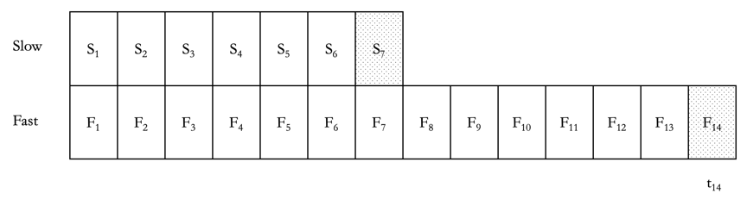

Figure 5. The TOW at t₁₄.

Now consider Freddie, who is located at S₇ at the border between Slow and Fast. Freddie’s worldline shows that he has been walking across Slow, heading for Fast. If he continues to walk (and he will) he will pass into Fast in the next instant. But where should we expect to see Freddie appear?
There are two possibilities. The first is that Freddie will be located at F₈, following the natural extension of his worldline. The second is that Freddie will be located somewhere in the next objectively present moment of time: the fusion of S₈ and F₁₅. Hence given his trajectory, we should expect to find him at on the very edge of F₁₅ when that piece of space-time comes into existence. In what follows we will see that neither option is appealing.
Suppose we say that in the TOW the first possibility obtains. Then we must say that when F₈ was a part of the objectively present moment (i.e. when the present time was t₈), the relevant temporal part of Freddie existed at F₈. If we do not say this, we are committed to denying past fixity: for we must say that when t₈ was objectively present, Freddie’s temporal part did not exist at F₈, and when t₁₅ is objectively present, Freddie’s temporal part does exist at F₈. It follows that Freddie both is, and is not, located at F₈: F₈ changes. When any time prior to t₁₅ is the present time, it is not true that Freddie is located at F₈. However, when (and after) t₁₅ is the present time, it is true that Freddie is located at F₈. In effect, this means that Freddie has travelled to F₈ when it is past, (i.e. when t₁₅ is present) despite never having been located there when F₈ is present (i.e. when t₈ is present). See figure 6 below.

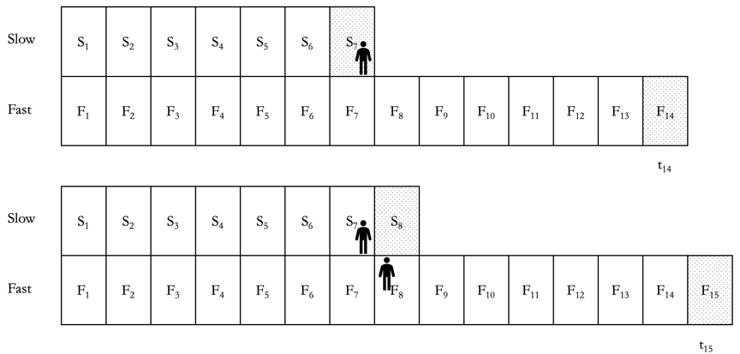Figure 6. Freddie travelling to F₈ when it is in the objective past. When t₁₄ is present, Freddie does not exist at F₈, but when t₁₅ is present, Freddie exists at F₈.

But we have already suggested that for many, past fixity (at least in the absence of hypertime) is a metaphysical necessity. Hence this account of Freddie’s travels is metaphysically impossible.
Even if one does not think that past fixity is metaphysically necessary, one might still think that this account of Freddie’s travels is metaphysically impossible. On this proposal Freddie, located in the objective present (at t₇) and persisting and moving in the usual manner, somehow manages to end up backwards time travelling when he moves from Slow to Fast.
Many growing block theorists, however, think that because causation occurs at the edge of reality, and only at the edge of reality, that there are no processes in the past. If there are no processes in the past (in the sense the growing block theorist intends) then it’s not possible for Freddie to move in the past, and so not possible to travel to F₈ when it is past. Irrespective of what one thinks about past fixity, then, many growing block theorists will take themselves to have independent reason to think that the TOW is metaphysically impossible if this is how Freddie must travel between S₇ and F₈.
Fortunately, this is not the only way to conceive of the first possibility. Suppose, instead, we say that Freddie travels from S₇ to F₈, but that Freddie exists at F₈ when t₈ is present. This is consistent with past fixity. Nevertheless, as we will see, this option results in us positing significant discontinuities in Freddie’s worldline, and these discontinuities might themselves be sufficient for some to think that if that is how Freddie travels in the TOW, then the TOW is not metaphysically possible. Here is why.
The reason growing block theorists typically deny the possibility of time travel in growing block worlds is that they think that an effect, E, exists, only if the cause of E, C, exists. It is not sufficient that C will come to exist. In general, on such views, there is no backwards causation because causation is a forwards dynamical process that occurs at the edge of the growing block and nowhere else. But, in effect, by travelling from Slow to Fast Freddie will have travelled in time. For Freddie will exist at F₈, (and hence t₈) well before the location from which Freddie travels (i.e. S₇) comes into existence, as shown by figure 7 below.

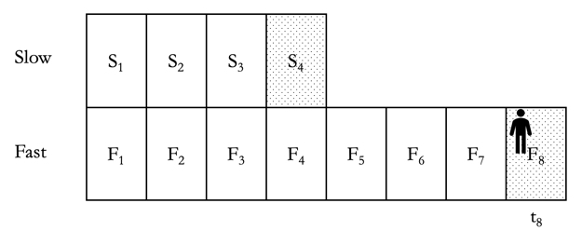
Figure 7. When t₈ is present, (t₈ is composed of F₈ and S₄) Freddie already exists at F₈, but does not yet exist at S₇.

To put things another way, on the assumption that causation is dynamical and is what occurs at the edge of the block, the causal antecedents of Freddie’s being located at F₈ (by having a temporal part thus located) do not include anything about what occurs at S₇, since the former comes into existence before the latter. So Freddie’s deciding to travel towards Fast is no part of the cause of him arriving there. Hence, the rate necessitarian might maintain, the TOW is metaphysically impossible because the scenario just described is metaphysically impossible.
One need not, however, suppose that Freddie will travel to F₈. The second possibility is that we will find Freddie located somewhere in the objectively next moment of time and hence to find him at on the very edge of F₁₅ as per figure 8, below. There, we see one of Freddie’s temporal parts, located at S₇, (which is now the objective past) and his next temporal part, located at F₁₅, which is in the objective present.

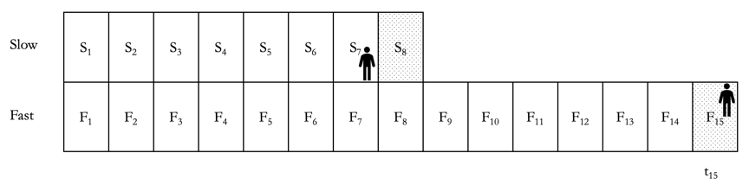

Figure 8. Freddie travelling to F₁₅ when it is in the objective present (t₁₅ is composed of F₁₅ and S₈).

It is, however, hard to make sense of this proposal on the assumption that we are conceptualising the growing block as a growing block of space-time. On such a view the world is extended along four dimensions, such that it grows along the fourth, temporal, dimension. Such a view accepts times, the assumption that t is a time iff t is a mereological fusion of space-time atoms all of which are co-present. Hence on this view times are arrayed along the temporal axis (represented as the horizontal axis in our figures).
When we look at figure 8, above, we see a large ‘gap’ between S₇ and F₁₅. If the block is growing space-time, then this gap is genuinely temporal, since it is a gap along the fourth, temporal, dimension. So if Freddie is located at S₇ and then F₁₅ then in the shortest period of time that can elapse—the temporal width of a space-time atom—he has traversed a considerable duration of time. Again, the rate necessitarian might think that this is metaphysically impossible, and hence that the TOW is metaphysically impossible.
The problem, to which the two options above are putative solutions, arises because in the TOW, time is conceived both as a dynamical quantity—the accretion of space-time atoms—as well a dimension along which those space-time atoms are arrayed. Let us call the former A-time, and the latter B-time. If A-time is modelled by the accretion of new space-time atoms, and if in some regions space-time atoms are accreted faster than in other regions it is natural to say that A-time passes at different rates even if the same number of A-times elapse during any temporal interval. We can then say that two events are at the same B-time iff they are the same location along the fourth dimension.
When there is differential passage, A-time ‘comes apart’ from B-time. Two events can be at the same time in A-time and yet be at different times in B-time. Events on S₈ and F₁₅ are a case in point. Such events are at the same time in A-time, but at different times in B-time. When we think of Freddie traversing from Slow into Fast, we have to suppose him to have a gappy path in B-time (either as per figure 8, or as per figure 7 where he appears at F₈ in A-time before he leaves from S₇). Hence, the rate necessitarian might argue, regardless of how one attempts to deal with this problem, one ought conclude that the TOW is not a metaphysically possible world.
We think these arguments are inconclusive. There are ways to argue in favour of the metaphysical possibility of either of the options countenanced above. One might reject the view of causation that undermines option 1, for instance, or one might reject the notion that gappy travel is metaphysically impossible. Nonetheless, having outlined the way in which one might object to the metaphysical possibility of the TOW, in what follows we proceed to consider a range of other options for modelling differential passage, by rejecting different assumptions of the basic discrete model.

2.3. Rejecting Past Fixity: The Past Misalignment World
There is a class of worlds that is like the class of basic discrete worlds, except that this class of worlds jettisons past fixity and uniqueness.

Past Fixity: When t is present, t has intrinsic property P iff when t is past, it is the case that t had intrinsic property P.

Recall that the travel problem that we encountered in the TOW arises because for some pairs of locations at a time, there are no non-gappy paths between those locations. Or, as we will put it, the proper parts of times (in the case of Freddie’s travel problem, the proper parts of t₁₅) become misaligned. That is what happens in the TOW.
Since past fixity is true in the TOW, it follows that since the block grows from the ‘bleeding edge’ of reality, if some regions of the world accrete more space-time atoms than other regions, this will result in a misalignment of the proper parts of the present time. But this need not be so. In worlds we call past misalignment worlds past fixity is false, and there is no misalignment of the parts of the present time: instead, it is the proper parts of past times that come to misalign.
Let’s return to consider Slow and Fast. As before, suppose that S₁ and F₁ come into existence, and their fusion is time t₁. Slow grows at half the rate of Fast, so t₂ is composed of S₁ and F₂. When t₁ is present, S₁ and F₁ are aligned. But—unlike in the TOW—when t₂ is present, S₁ and F₂ are aligned, meaning that S₁ and F₁ are no longer aligned. That is, it is no longer the case that the proper parts of t₁ are aligned. The past, then, is not fixed. A property t₁ had, when it was present—having its parts aligned—is a property it comes to lack once it is past. Indeed, the parts of the past gradually become more and more misaligned as one region of the world grows faster than the other, but the present remains aligned. (See figure 9 below).

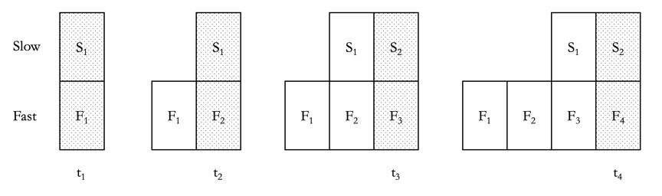
Figure 9. The past misalignment world.

We noted above that the rate necessitarian might make the case that a world in which past fixity is false, and in which there is no hypertime, is metaphysically impossible. The availability of the past misalignment model shows that it is incumbent upon her to do so, for past misalignment worlds do not face the travel problem.

2.4. Rejecting Presentness: The Crenelated World
Another class of worlds is like the class of basic discrete worlds except that in this class of worlds presentness is false.

Presentness: any space-time atom that is at the outermost edge of the block is objectively present.

Consider, again, figure 3 (reproduced below).

Figure 3. The TOW. The shaded S-parts and F-parts are objectively present.

When S₁ and F₂ are at the outermost edge of the block, presentness entails that the present time (t₂) is the fusion of S₁ and F₂. However, in a world in which presentness is false, it can be that t₂ is the fusion of only F₁ (hence uniqueness is also true). The idea is that when space-time atoms accrete at different rates at different locations, the question we ought ask is not which set of space-time atoms are on the outermost edge of the block, but rather, which space-time atoms were most recently added to the block. When we look to figure 3, we see that, for instance, S₁ is added to the block simultaneously with F₁, but F₂ comes into existence after S₁ does. So the most recent space-time atoms to come into existence are those that compose F₂. Hence, t₂ is composed of F₂, and only F₂. S₁ exists, but is in the objective past, despite being located at the outermost edge of the block.
On this view, reality is crenelated, so we call worlds like this crenelated worlds (see figure 10 below). In the crenelated world in question, Slow is effectively ‘gappy’. No matter what time is present, it is tenselessly the case that Slow exists. But sometimes there is no part of Slow that is part of the present. On a tensed reading of ‘exists’, then, it will often be true to say ‘Slow does not exist’.
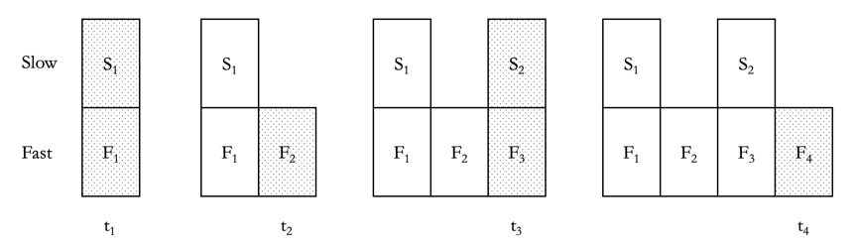
Figure 10. The crenelated world. The shaded S-parts and F-parts are objectively present. When t₂ and t₄ are present, no part of Slow is present.

In the crenelated world there is no travel problem because Slow and Fast do not misalign. That is because if Freddie is, say, at S₂ when t₃ is present and we ask, ‘where will Freddie travel to, if he travels towards Fast?’, the answer is that he will arrive at F₄ when t₄ is present. In general, any location in Slow from which Freddie can depart at one time, and be able to reach Fast at the next time, will be such that said location is spatio-temporally contiguous with some location in Fast. There will always be some perfectly ordinary non-gappy path that Freddie can take between Slow and Fast that does not involve Freddie traversing time in anything other than the ordinary way in which persisting objects traverse time.
Moreover, we need not say, of a crenelated world, that at each time the same number of A-times have elapsed in Slow as in Fast. In a crenelated world we can model temporal passage in terms of the number of times that have elapsed relative to different locations.
To see this, consider t₂, which is composed only of F₂. It is natural to say, in the crenelated world, that an additional time (t₂) accretes in Fast, which does not accrete in Slow. Figure 10, above, depicts the passage of half as many times in Slow, as in Fast. That is because, unlike in the TOW, since there is no overlap of times there is a one-to-one mapping between times and sets of space-time atoms. So more time passes in Fast then in Slow, both in that more times come into existence in Fast than in slow, and in that more space-time atoms accrete in Fast than in Slow. The nice consequence of this is that it follows from the fact that time passes more quickly at one region, that more times have passed, in that region. In the TOW this is not so.
How might the rate necessitarian make the case that the crenelated world is metaphysically impossible? She might point to the presence of ‘gaps’ in Slow as a reason to think crenelated worlds are impossible. She might think that the presence of such gaps raises a new, arguably worse, travel problem, and she might think that the presence of such gaps is inconsistent with her preferred view of causation. Let’s consider each in turn.
Here is the new travel problem. While in the crenelated world Freddie can travel a non-gappy path from Slow to Fast, some paths from Fast to Slow are gappy, and likewise for paths from one S-part to the next. For example, if Freddie is at the edge of F₁ closest to S₁, and intends to travel to Slow, he will presumably end up at S₂. As his path will not go via F₂, it is gappy: F₁ and S₂ are not contiguous. Likewise for Freddie’s path from S₁ to S₂.
The very same gappiness threatens causation in crenelated worlds. New space-time atoms come into existence at Slow, which appear not to be generated by the earlier set of space-time atoms that exist in Slow. Insofar as one thinks that causation is local, and hence there cannot be a ‘gap’ between cause and effect, it is difficult to see how S₂ comes into existence from nothing. As we noted earlier, however, many growing block theorists think that what generates the growth of the block is the causal frisson at the edge of being. So the rate necessitarian may have an easy time convincing those growing block theorists that the crenelated world is metaphysically impossible.
One might respond to both these worries by arguing that there really is no gap there at all—not between S₁ and S₂, or between Freddie at F₁ and Freddie at S₂. Since in Slow there simply is no time that corresponds to t₂ in Fast, there is merely the appearance as of there being a gap. But since there is no time that has passed in Slow, it is not as though there is a temporal gap in Slow during which there is nothing, (no part of Slow) and then, at the next time, there is some part of Slow. Instead, in the Slow region of the world time goes from t₁ to t₃ (t₃ is the second time to occur), and at t₃, S₂ comes into existence, immediately after S₁ and F₁. There is merely a gap from the perspective of Fast. If that is right, then there is no true travel problem here, and nor is there the kind of gappiness that ought prove problematic for certain dynamical theories of causation. S₂ is caused by S₁, and straightforwardly so, for there is no gap between these.
To show that crenelated worlds are impossible, the rate necessitarian must show that this response fails: there really is a problematic gap here which renders these worlds metaphysically impossible.

2.5 Rejecting Size Constancy: The Size Inconstant World
There is a class of worlds that is like the class of basic discrete worlds, except that this class of worlds jettisons size constancy and uniqueness.

Size Constancy: All space-time atoms are the same size.

Call worlds like this size inconstant worlds. Size inconstant worlds once again find a pre-emption in Forrest (2008:246), who suggests that “the thickness of the layers is the rate at which Time passes […] Time passes uniformly, then, if the temporal thickness of successive layers is the same at all places and times.”. In size inconstant worlds, the thickness of successive layers is not the same at all places and times, and thus time does not pass uniformly: there is differential passage. The advantage of size inconstant worlds is that in at least some of them, the travel problem does not arise. Consider a particular size inconstant world in which the size of the space-time atoms in Slow is different from the size of the space-time atoms in Fast. In particular, the space-time atoms in Slow are twice as wide, along the fourth dimension, as those in Fast (see figure 11 below).

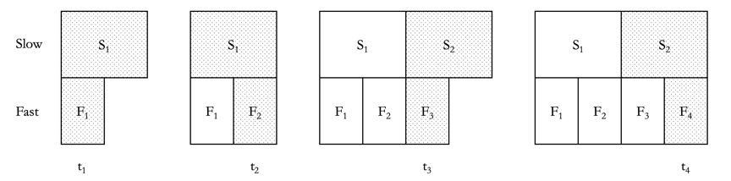
Figure 11. The size inconstant world.

As we see from figure 11, there are no ‘gaps’ between locations in Slow, and locations in Fast, and so the travel problem cannot arise. The present, in Slow, takes up more temporal width than the present in Fast. In the size inconstant world S₁ is part of both t₁ and t₂, and hence uniqueness is false. When t₁ is present, S₁ is present, and when t₂ is present, S₁ is present. In size inconstant worlds although the same number of times elapse in each region, time passes more slowly in Slow than in Fast because fewer space-time atoms accrete in Slow in the same period of elapsed time, as accrete in Fast.
How might the rate necessitarian argue against the metaphysical possibility of size inconstant worlds? Well, if space-time atoms are the smallest units of space-time, and if the units of space-time in Fast have volume V, then it unclear why the units of space-time in Slow, which have volume larger than V, are really space-time atoms at all. Why don’t the space-time atoms in Slow have proper temporal parts given that they are twice the temporal width as the space-time atoms in Fast? These are the lines along which, we think, one might argue that size inconstant worlds are metaphysically impossible.
Before moving on, let’s take stock of the commitments the rate necessitarian has accrued thus far. She must argue that there is no differential passage in an island world without hypertime, that hypertime is metaphysically impossible, that neither of Freddie’s potential journeys are metaphysically possible, that past fixity is necessary, that the gappiness of the crenelated world is metaphysically impossible, and that size constancy is metaphysically necessary. While this is a substantial task, so far we think there is hope for the rate necessitarian. If, of necessity, time is discrete, then we think that the rate necessitarian might be able to argue that time cannot pass at different rates. In what follows, however, we consider what happens if we suppose space-time to be continuous.

3. Continuous Time and Differential Passage
In what follows we suppose that space-time is continuous, and argue that some metaphysically possible continuous worlds are such that there is differential passage.
In worlds in which space-time is continuous, times will be three-dimensional slices of reality: no time will have any temporal width. Let us call the maximal three-dimensional object that is the growing block when it first comes into existence, a privileged hyper-plane. Then the block grows by the accretion of privileged hyper-planes at the ‘growing’ end of the block, and temporal flow is the accretion of these hyper-planes. Further, let us identify privileged hyper-planes with times. Then the objectively present time is the ‘outermost’ privileged hyper-plane at the growing end of the block. Let us call the privileged hyper-plane on the outermost edge of the block the present hyper-plane. All (and only) those events, properties, and objects located on the present hyper-plane are objectively present, and every privileged hyper-plane either is or was once the present hyper-plane.
Once the block is four-dimensional, there will be non-privileged hyper-planes: hyper-planes that cut through the block at various angles. These represent different ways of foliating space-time. Only one such foliation is the ‘correct’ one: namely the foliation that foliates spacetime into privileged hyper-planes. Then there is what we might call a privileged t-coordinate, which specifies the ‘true’ temporal distance between events on distinct privileged hyper-planes. This is the distance as measured from a privileged frame of reference: that reference relative to which space-time is foliated into privileged hyper-planes. The one proposal for modelling differential passage is to suppose that the rate of flow of time is the ratio of time elapsed along the privileged t-coordinate—what we will call true time—with respect to proper time. Proper time is time as measured by a clock travelling along a worldline.
Consider two privileged hyper-planes H₁ and H₁₁ that are separated by a temporal distance of, say, 10 days as measured on the privileged t-coordinate system. Now consider Freddie and Annie. Annie is not in motion relative to the privileged frame of reference: her worldline is a straight line from H₁ to H₁₁. If Annie carries a clock with her, she will say that 10 days of proper time have elapsed. The ratio of true time to proper time along Annie’s worldline is 1/1.
Now consider Freddie. Freddie’s worldline is not straight. Freddie accelerates away from his location (call it Sydney, Australia) at H₁, and then half way through his journey he accelerates back towards Sydney to arrive there at H₁₁. He effectively travels two sides of a triangle (out and back, as it were). Surprisingly, in Minkowski geometry the sum of the length of the two sides of the triangle that Freddie traverses, is shorter than the length of the one side of the triangle that Annie traverses. That is why when Freddie arrives at H₁₁, his elapsed proper time will be less than 10 days (let’s say it is 7 days). So the ratio of true time to proper time along Freddie’s worldline will be 1/0.7. For every second of true time that elapses, only 0.7 seconds of proper time elapses.
Is this a case of differential passage? We think there can be legitimate disagreement here. One might complain that time is not really flowing at different rates at different locations in the world: time is passing uniformly everywhere, it’s just that some trajectories through spacetime yield different measures of elapsed proper time. To put the point somewhat differently, this is a case in which Annie’s proper time passes at the same rate at which pure time—time itself—passes, but Freddie’s proper time does not. There is thus a difference in the rates at which their respective proper times pass. However, in order for there to be differential passage of time itself, we need true time to pass at different rates at different sub-regions of a world. Differential passage of proper time does nothing to rescue the allegedly problematic necessity of the rate at which true time passes.
So we are not inclined to think that this counts as differential passage. But if we are wrong about that, the conclusion of this paper is easily defended. For if this is an example of differential passage, then we have an easy proof that such differential passage is not only metaphysically possible, but probably nomologically possible too (if the actual world is a growing block world, then this kind of differential passage is actual: that leaves open that if our world is, say, a block universe world, then this kind of differential passage might not be nomologically possible, insofar as it may not be nomologically possible that there is a correct foliation of hyper-planes into privileged hyper-planes).
For those who, like us, are reticent to conclude that this is really an account of differential passage, however, in what follows we provide a very different example of differential passage in a world where time is continuous.
In order to do so, we must imagine a world in continuum-many privileged hyper-planes are ‘arranged’ in such a way that the ‘block’ is not ‘block-shaped’ at all. To get an intuitive sense of such a world, imagine God smoothly ‘plastering’ new hyper-planes onto the block. On the standard growing block view, God plasters each ‘successive hyper-plane’ (loosely speaking: if there are continuum-many hyper-planes it makes no sense to talk of one hyper-plane being the successor of another) such that it is parallel to ‘its predecessor’. Imagine instead that God plasters each hyper-plane at a slight angle to ‘its predecessor’. The resulting block will not be block-shaped, but will grow with a curve.
Moreover, despite the privileged hyper-planes not being parallel, there will not be any gaps between them. Note that in order for God to build such a curved shape without continuum-many times, each time would have to be wedge-shaped, rather than being a hyper-plane of zero temporal width (i.e. times would have to be four-dimensional at one end, and three-dimensional at the other). However, an interesting feature of continuous topology is that God can build a non-gappy block out of non-parallel privileged hyper-planes of zero temporal width.
For the reader who does not find the God metaphor illuminating, let us present another. Imagine a pendulum. Suppose we hold the pendulum so that it is horizontal, and then we let it go. It traces a continuous path from one side to the other, yielding a shape that is a sector. Translated into the growing block view, we can imagine each location of the pendulum as corresponding to a privileged hyper-plane, and the movement of the pendulum as corresponding to the accretion of these privileged hyper-planes. The present hyper-plane then corresponds to the very last location of the pendulum. The pendulum is not wedge-shaped, and yet there are no gaps in its continuous path. The world modelled by the path of the pendulum is not so much a growing block world, but a growing sector world. See figure 12 below.
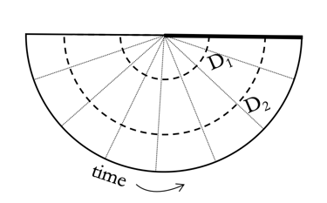

Figure 12. The growing sector world. The bold line represents the present hyper-plane.

The curved part of the sector represents the temporal dimension. As new hyper-planes accrete (from left to right) new times come to be arrayed along the temporal dimension. Using the terminology introduced earlier, we can think of this dimension as B-time. The differential passage of time is then constituted by the fact that the temporal distance between the first and last moment of time at the top of the sector, is very much shorter than the temporal distance between the first and last moment of time at the bottom of the sector. Thus the distance through B-time for an object traversing D₁ is much shorter than the distance through B-time for an object traversing D₂, and hence more B-time passes for the object traversing D₂ as D₁. In fact on this model there are infinitely many A-times that come apart from B-time. Any two objects that are co-present, but spatially separated, will be located at the same A-time, but at two different B-times, and any two objects located at the same B-time will be located at two different A-times.
Nevertheless, because the rate at which time passes changes continuously across the sector, the travel problem does not arise. For any two objects that are located at the same A-time, there will be a continuous path between those objects in B-time.
We are not sure how the rate necessitarian might argue against the metaphysical possibility of the growing sector world. Perhaps she will complain that in this world the temporal dimension is curved rather than straight. We are not sure how compelling an objection this is, but we don’t need to make this case, for the curved temporal dimension is not a necessary feature of continuous worlds with differential passage. To ensure that the temporal dimension remains straight, we need only suppose that as time passes, the universe itself expands along the spatial dimensions, so that later privileged hyper-planes are spatially larger than earlier ones. There is nothing strange about this. Indeed, the actual world is expanding along its spatial dimensions. Then, with continuum many hyper-planes, we can model continuous differential accretion in terms of a growing triangle world. See figure 13 below.

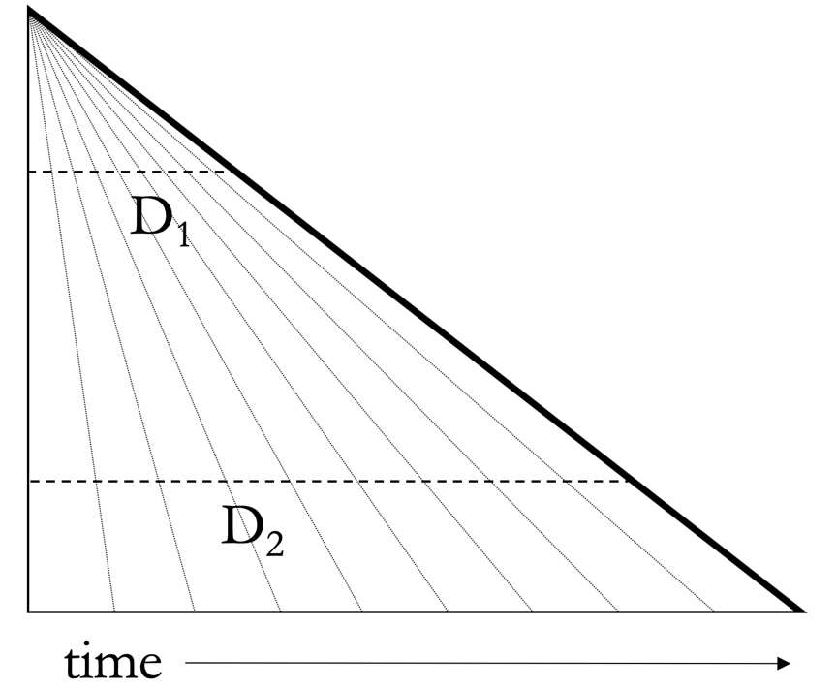

Figure 13. The growing triangle world.

Again, we see that the distance in B-time between the first and last time is very small near the top of the triangle, and is much larger at the bottom of the triangle—D₁ is much shorter than D₂. Hence time passes more quickly towards the bottom of the triangle than towards the top. And, as before, time’s rate of passage changes continuously, so the travel problem does not arise.
At this point, the rate necessitarian might object that at the very top of the triangle there is no temporal passage at all since all the hyper-planes intersect at that point. Moreover, it is highly implausible that there is a point that is part of every time. Once again, however, this is not a necessary feature of continuous worlds with differential passage: there are worlds in which the top of the triangle is ‘cut off’ (see figure 14 below).

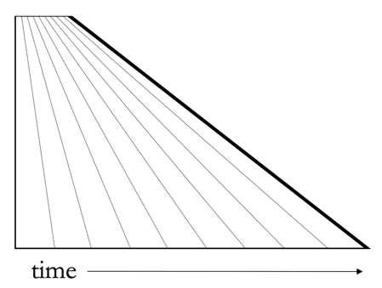

Figure 14. The growing cut-off triangle world.

As far as we can see, there is no clear avenue via which the rate necessitarian can deny that the growing cut-off triangle world is a world in which there is differential passage. There are, however, two avenues by which she might argue that such a world is metaphysically impossible. The first is to argue that it is metaphysically necessary that time is discrete, but that is not an easy case to make. The second is to argue that it is metaphysically necessary that, in a continuous growing block world, all privileged hyper-planes must be parallel. Perhaps such a case can be made, but we think the ball is squarely in the court of the rate necessitarian to make it.

4. Conclusion
We have not attempted to argue that every world we have introduced both contains differential passage and is metaphysically possible. Rather, we aim to show that there is a good deal of work to do in defending rate necessitarianism, and hence in defending the NAP argument. While there are relatively clear avenues by which the rate necessitarian can argue against the possibility of the discrete models we have offered, it is far less clear how she might argue against the continuous models. At any rate (if you will excuse the pun), until the case is made otherwise, there are reasons to think that if it is possible for time to pass at a rate, it is possible for time to pass at different rates in different sub-regions of a world.

References:
Baron, S (2017). ‘Back to the Unchanging Past.’ Pacific Philosophical Quarterly 98 (1):129-147.
Baron, S. and Tallant, J. (2016). Monism: The Islands of Plurality. Philosophy and Phenomenological Research 93 (3):583-606.
Bernstein, S. (2017). ‘Time Travel and the Movable Present.’ In John Keller (ed.), Being, Freedom, and Method: Themes from the Philosophy of Peter van Inwagen. pp. 80-94.
Bricker, P. (1996). ‘Isolation and Unification: The Realist Analysis of Possible Worlds’, Philosophical Studies, 84(2), 225–238.
Bricker, P. (2001). ‘Island Universes and the Analysis of Modality’, in G. Preyer and F. Siebelt, eds., Reality and Humean Supervenience: Essays on the Philosophy of David Lewis. New York: Rowman and Littlefield, 27–56.
Broad, C.D. (1938). Examination of McTaggart’s Philosophy. Cambridge: Cambridge University Press.
Correia, F & Rosenkranz, S. (2013). ‘Living on the Brink, or Welcome Back, Growing Block!’ Oxford Studies in Metaphysics 8:333. DOI: 10.1093/acprof:oso/9780199682904.001.0001
Crisp, T. M. (2003). ‘Presentism.’ In Michael J. Loux & Dean W. Zimmerman (eds.), The Oxford Handbook of Metaphysics. Oxford University Press.
Dowker, F. (2006). ‘Causal sets and the deep structure of space-time.’ General Relativity and Quantum Cosmology; arXiv:gr-qc/0508109
Forbes, G. (2016). ‘The Growing Block’s Past Problems.’ Philosophical Studies 173(3):699-709.
Forrest, P. (2004). ‘The Real but Dead Past: A Reply to Braddon-Mitchell.’ Analysis 64 (4):358–362.
Forrest, P. (2006). ‘Uniform Grounding of Truth and the Growing Block Theory: A Reply to Heathwood.’ Analysis 66(2):161–163.
Forrest, P. (2008). ‘Relativity, the passage of time and the cosmic clock.’ Philosophy and Foundations of Physics, 4:245-253.
Hudson, H. & Wasserman, R. (2010), ‘Van Inwagen on Time Travel and Changing the Past’, in D. Zimmerman (ed.), Oxford Studies in Metaphysics, v.5 (Oxford University Press).
Leininger, L. (2018). “Objective becoming: in search of A-ness”. Analysis 78 (1):108-117
Lewis, D. (1976). ‘The Paradoxes of Time Travel.’ American Philosophical Quarterly 13 (2):145-152.
Lewis, D. K. (1986). On the Plurality of Worlds. Wiley-Blackwell.
Markosian, N. (1993). ‘How Fast Does Time Pass?’ Philosophy and Phenomenological Research, 53:829-844.
Maudlin, T. (2002). ‘Remarks on the Passing of Time.’ Proceedings of the Aristotelian Society 102(3):260–74.
Maudlin, T. (2007). The metaphysics within physics. Oxford: Clarendon Press.
McTaggart, J.E. (1908). ‘The Unreality of Time.’ Mind 17(68): 457-474.
Miller, K. (2006). ‘Time Travel and the Open Future.’ Disputatio 19(1):197-206.
Olson, E. T. (2009). ‘The Rate of Time’s Passage.’ Analysis 69(1):3–8.
Phillips, I. (2009). ‘Rate Abuse: A Reply to Olson.’ Analysis 69(3): 503–5.
Price, H. (1996). Time’s Arrow and Archimedes’ Point, Oxford: OUP.
Raven, M. (2010). ‘Can time pass at the rate of 1 second per second?’ Australasian Journal of Philosophy 89(3):459-65.
Savitt, S. (2001). ‘A Limited Defense of Passage.’ American Philosophical Quarterly 38 (3):261 - 270.
Savitt, S. (2002). ‘On Absolute Becoming and the Myth of Passage.’ In Craig Callender (ed.), Time, Reality & Experience. pp. 153-169.
Skow, B. (2011). ‘On the Meaning of the Question ‘How Fast Does Time Pass?’’ Philosophical Studies, 155:325-44.
Skow, B. (2015). Objective Becoming. OUP.
Smart, J. J. C. (1949). ‘The river of time.’ Mind 58(232):483-494.
Smith (1997). ‘Bananas Enough for Time Travel?’ British Journal for the Philosophy of Science 48(3):363-389.
Sorkin, R. (1990). ‘Space-time and causal sets.’ In J.C. D’Olivio, E. Nahmad-Achar, M. Rosenbaum, M. P. Ryan, L. F. Urrutia and F. Zertuche (eds.). Relativity and Gravitation: Classical and Quantum. Proceedings of the SILARG VII Conference pp 150-173.
Tallant, J. (2010). ‘Sketch of a Presentist Theory of Passage.’ Erkenntnis 73:133-40.
Tallant, J. (2012). ‘(Existence) Presentism and the A-theory.’ Analysis 72(4); 673-681
Tallant, J. (2016). ‘Temporal passage and the ‘no alternate possibilities’ argument.’ Manuscrito 39(4):35-47.
Van Inwagen, P. (2010). ‘Changing the Past’, in D. Zimmerman (ed.), Oxford Studies in Metaphysics, v.5 (Oxford).
Williams, D.C (1951). ‘The myth of passage’, Journal of Philosophy 48: 457-472.

Hence, by temporal passage here we mean roughly what Skow (2015) means by robust (rather than anemic) temporal passage. Both these are to be contrasted with more recent deflationary views of passage which take passage to be something compatible with the truth of the B-theory. For instance, , Savitt (2001; 2002) defends the view that temporal passage consists there being a sequence of temporally ordered events, and Maudlin (2007) defends the view that temporal passage consists in there being an intrinsic asymmetry in the temporal structure of the world. Leininger (2018) argues, contra Skow, that moving A-ness—i.e. robust passage, rather than anemic passage is the kind of passage that A-theorists ought want (though Leininger herself thinks that deflationary passage of the sort consistent with the B-theory deserves the name temporal passage).
Notably, not all presentists subscribe to there being temporal passage. Tallant (2012) for instance, defends a version of presentism that does not posit temporal passage.
This idea can be found as early as Williams (1951:463-4), who writes that “as soon as we say that time or the present or we move in the odd extra way which the doctrine of passage requires, we have no recourse but to suppose that this movement in turn takes time of a special sort: time₁ move at a certain rate in time₂, perhaps one second₁ per one second₂, perhaps slower, perhaps faster. Or, conversely, the moving present slides over so many seconds of time₁ in so many seconds of time₂.”
Or some equivalent rate such as 60 seconds per minute.
For further discussion of the NRA see Olson (2009), Philips (2009), Skow (2011), and Tallant (2010).
See also Raven (2010:464): “The necessity of the rate of time’s passage entails that there are no possible alternative rates, hence (allegedly) entailing the incoherence of the rate itself”. This argument also appears in Maudlin (2002), Markosian (1993), Price (1996).
We take metaphysical possibility to be the widest genuine kind of possibility (i.e. possibility that is not merely doxastic or epistemic).
See for instance Raven (2010).
For instance one can, in many cases, translate talk of the differential growth of the block into talk of the differential movement of the spotlight, to get similar results for the moving spotlight theory. Or, in the context of a dropping branches model, one could have branches dropping off the tree at different rates in different parts of the tree. We won’t speak to the issue of whether that is also true given a presentist model.
Perhaps there could be space-time atoms that have internal mereological structure without having temporal extension. But if so, the space-time atoms in the worlds we consider are not like this.
According to causal set theory space-time atoms progressively come into existence, and this constitutes the passage of time. The view is known as the causal sets approach because on this view the causal structure of space-time—i.e. the light-cone structure of space time—which entails that at any space-time point, we can partially order all other points into the absolute past, absolute future or absolute elsewhere of the point in question is paramount. It is this partial ordering of points, at a space-time point, which allows us to model the ‘causal sets’, and which, in turn, generates the order of accretion of space-time atoms. See Dowker (2006) and Sorkin (1990).
This seems in keeping with what many growing block theorists want to say. Forrest, (2004:358) for instance, says that for no-futurists ‘nowb’ refers to times on the boundary of reality. Forbes (2015) says that present events are succeeded by nothing.
While it is not our aim to do so here, we note that positing the existence of hypertime provides a ready response to the NRA: time passes not at 1 second of time per 1 second of time, but at 1 second of time per 1 second of hypertime. As the numerator and denominator are different, there seems to be no issue in saying that this is a rate, and thus that it is possible for time to pass at some rate in worlds with hypertime.
Something like this idea, though not framed in terms of hypertime, can be found in Forrest (2008:§1), who suggests that the passage of time can be measured in terms of ‘seconds per layer’ or (as he prefers) ‘layers per second’.
See for instance Skow (2015); Correia & Rosenkrantz (2013); Van Inwagen (2010); Bernstein (2017); Hudson & Wasserman (2010).
See for instance Smart (1949); McTaggart (1908); Broad (1938); Crisp (2003).
Perhaps thinking of rates of passage in terms of s/s is infelicitous. Instead, perhaps we ought measure temporal passage in terms of something like average elapsed time per new time, or per next (thanks to an anonymous referee for this suggestion). While we have not specified the temporal width of the temporal atoms in our models, suppose for the sake of this thought that they are a nanosecond long. Then we can say that time passes at 1 nanosecond per next in Fast and 0.5 nanoseconds per next in Slow. Nevertheless, the NAP is framed in terms of s/s, and we think the below succeeds in responding to it on its own terms.
There is a third option. Freddie might depart S₇ when t₁₃ is present, and arrive at F₁₄ when t₁₄ is present. This option is unattractive because when t₁₄ is present, S₇ is still present. Thus Freddie’s arrival and departure will be co-present!
See Forrest (2004; 2006) and Forbes (2016).
See for instance Forbes (2016).
For discussion of this issue see Miller (2006).
To reframe this in terms of the idea we floated in footnote 17, we could talk of the number of nexts between next_{n} and next_{n+}, per some temporal interval as defined by the distance between events on next_{n} and next_{n+}
With thanks to an anonymous referee for pressing us to consider this possibility.
The idea that non-parallel hyper-planes will result in differential passage appears in Forrest (2008:247), who notes that “If the Absolute Foliation consists of hyperplanes, that is flat hypersurfaces, then Time passes uniformly with respect to one frame of reference if and only if it passes uniformly with respect to every other and this occurs if and only if the hyperplanes are parallel.”
Moreover, in this model (and those we subsequently consider) the transitivity of simultaneity and co-presence is preserved.

