BAKUNIN

E. MORATA
Bakunin wanted a World without tyrannies.

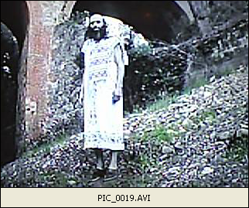
Bakunin meant by “tyranny” a situation caused by other men that forces you to do what you don´t want to do,
and that causes you a harm in your body, mind or way of life.
Bakunin craved for total freedom of each individual and because it he was against the existence of a Machiavelian State that forces its citizens to do this and that duties to keep the State operational.
Bakunin believed that when each person enjoys total freedom , his mind is pure and naturally good and his body is healthy.

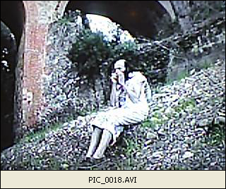

Each person knows better what suit best to him for his personal progress and well being.

When other men force the person to work, act or think as they want to , this person debases himself and looses goodness and health.

Bakunin loved Nature as she has created Man and we cannot live outside Nature.

Anarchists turned primitivists , coming back to a primeval way of life in touch with Nature, believing as Rousseau did , that the natural Man is a good Man . happy and healthy.
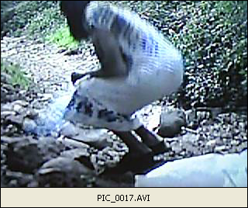

Bakunin was a leveller, an equalitarian, desiring that all men be equal , without aristocracies of any kind, without bosses ,without employers, without individuals with privileges by their physique, their talent or their social class.

Bakunin wanted to recreate Mankind , this time making all men as similar as twins
so nobody falls in the temptation of ruling or impossing his will to another man.

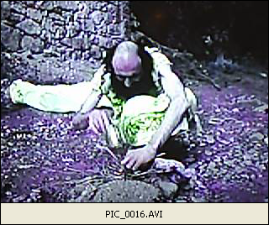
But Bakunin didn´t realize that Nature has created all Men different from each other,
for its own reasons, unknown to Men.

Bakunin´s World could be against Nature, as she decided long time ago she needed millions of men ,differents in stature, colour of eyes, weight, talent, habilities, race and body frame.
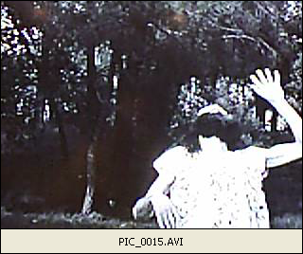

Because his appeal to a natural life, Bakunin´s ideas led to a primitivist movement , craving to come back to a more authentic way of life , far away from civilization and close to the way of life of the primitive man.

Bakunin believed that men corrupts himself when he becomes a tyrant, debasing thus his human condition.
For Bakunin, gorillas-men have crushed other persons since ever and still do .
Gorillas-men are those men that force other men to obey them, to serve them, to work for them as the gorillas-men are stronger, smarter, bigger or think of themselves they must fill the best places and positions in society and workplaces because “they are the best and deserve it”.

The same gorilla-man of the Prehistory is still here , using other men for his interests:
he is now a politician, an employer, a chairman at the University, a member of the ruling class.

Bakunin hated employers because he saw them as tyrans ,
gorilla-men that by the explotation of other men become rich.
Employers are the most debased of men, using other persons as machines and treating them with scorn or with false paternalism.

Employers were the “Devil” for anarchists, the worst of Mankind, a punishment for the working-class people.
Most of the Bakunin´s ideas are related to the situation of the working-class people in the XIX century.
Today, Welfare State can be understood as the Utopia that Bakunin wanted for all men, with all the basic needs of each citizen assured by the State :
food, shelter, education, health and a job.

However, a plenty Welfare State has not come yet.

There are still large segments of population that hurdle the coming of a full Welfare State, by the argumentations that each individual is different and that the State shouldn´t rule every aspect of the citizen´s life .

For an anarchist, such way of thinking hides the will to persist on the tyrannical system that has ruled our societies since many centuries ago.

There is no reason for a man stronger than others must stand above them . There is no reason why men must fight each minute to demonstrate they are stronger or better than others. No natural law forces nobody to act that way.

It is a very human law which forces men to compare each minute with what the others do , are or have,
and to rivalise against them : it is the Darwin´s law of the survival of the stronger and it is not a natural law but a very sadistic human law by which men must hurt other men each minute,
by exposing their titles, their physique, their money, their properties, their position, their achievements to the public eye.
It is the survival of the tyrannical system , the ruling of the gorilla-men .
The World could be other way if men wish. There is no natural reason why men´s affairs must be managed forever the way they are actually.
Bakunin believed that the future of Mankind should be the ruling by uplifted human beings that had succeeded on leaving back their passions of gorilla-men.

Only Time will say if Bakunin´s omen must be the future .

Bakunin´s view works as a sort of “Bakunin´s razor”:
as the “Occham´s razor” it cuts merciless all the endless political and philosophical discussions on the role of the State and on the happiness of the citizens,
to reduce all the problem to a conflict between two kind of men : the tyrans or gorilla-men and the average men . By this “Bakunin´s razor”, all the problems of Mankind will cease when there will not be more tyrannies of any kind , be inside the family, the factory, the State or in the streetlife.

Men will turn good and healthy by then .

By this “Bakunin´s razor”, all the powerful men fall into suspiction of being “gorilla-men” and are forced to revise their lives and behaviours to purge them of everything that could be understood as “a tyranny” in any way.
Bakunin works thus as a leveller of men and he thinks there is a psychological effect on men when they suffer no more tyrannies or despises : they improve as persons and their health improves too.

Critics have often said that Bakunin´s Utopia would bring an anarchist dictatorship where the overendowed and the best would be prosecuted and sent to ostracism.

They are right as all the tryings to level society in Ancient Greece or in XVI century England have brought an overshadowing of the best men.

The purpose of Bakunin was to forbid the keeping of power by any individual. If you reduce the power that a person can enjoy , you increase the freedom that other people enjoys.
Bakunin understood by liberty the unfolding of all the natural faculties of each individual , without any kind of hurdle that could stop it.

Tyrans have used brute force and authority to assure their own growth and the diminishment of the others´growth.
The only limit to each individual freedom should be his own mental and physical constitution .

Bakunin insisted that on a World were everybody is free, nobody limit the liberty of any individual as each man feels himself free if he sees the other men are free too.

An employer is the boss of a bunch of slaves and therefore he is not a man but a boss as he ignores his own humanity when treating his slaves as not-human goods.

Man is free when he gazes in the others´eyes the reflection of his own humanity , in the others´conscience the reflection of his own Human Rights observance. Freedom only works when it is shared by everybody.

The destiny of Mankind is to become more and more free by realising the humanity inside us , acting by it towards the others with respect for our rights and others´rights ,recognizing all together our humanity conquered against our primitive beast-like condition.

Bakunin´s message talks on levelling the society, on fighting the beast we got inside us and on fighting the tendency towards selfishness of each man .
This selfishness arises from the fact each man is different and enjoys some kind of strength the others have not ;physique, talent, dexterity, education, class privileges or whatever other detail of excellence.

Selfishness is fighted by the Anarchists and the Christians alike as the worst of all evils ,causing most of the unhappiness and toxic everyday life of our days .

There is no reason why men must be selfish .

In fact, the selfish behaviour reveals an ignorant person, prey of this capitalist, positivist, utilitarist and darwinist System that forces him to act that way .

A man is increasingly wise when he knows the epoch where he lives in , with all the political, philosophical and scientific theories that determine his conduct. The man of our time is a stupid conducted by forces that he doesn´t know and that turn him into a beast , for our current System needs millions of beasts to keep working its own machinery.

A World where selfishness, tyranny and animality were put under control , banned or educated to restrain , was the goal of Bakunin the leveller.

