Moralization and self-control strategy selection

Samuel Murray^{a,b}, Juan Pablo Bermúdez^{c,d}, and Felipe De Brigard^{e,f}

ª Department of Philosophy, Providence College, Providence, RI, USA
^{b} Neuroscience Program, Providence College, Providence, RI, USA
^{c} Dyson School of Design Engineering, Imperial College London. London, UK
^{d} Programa de Filosofía & Área de Investigación Salud, Conocimiento Médico y Sociedad, Universidad Externado de Colombia, Bogotá, Colombia
^{e} Department of Philosophy, Duke University, Durham, NC, USA
^{f} Center for Cognitive Neuroscience, Duke University, Durham, NC, USA

Author Note
Correspondence may be addressed to Samuel Murray (smurray7@providence.edu), 1 Cunningham Sq., 105 Siena Hall, Providence, RI, 02918. SM and JPB designed all experiments. SM conducted and analyzed data for all experiments and wrote the first draft of the manuscript. SM, JPB, and FDB edited and approved the final version of the manuscript. Materials, data, preregistrations, and analysis scripts can be found at the OSF repository for the project: https://osf.io/vez4c/.

Abstract
To manage conflicts between temptation and commitment, people use self-control. The process model of self-control outlines different strategies for managing the onset and experience of temptation. However, little is known about the decision-making factors underlying strategy selection. Across three experiments (N = 317), we tested whether the moral valence of a commitment predicts how people advise attentional self-control strategies. In Experiments 1 and 2, people rated attentional focus strategies as significantly more effective for people tempted to break moral relative to immoral commitments, even when controlling for perceived temptation and trait self-control. Experiment 3 showed that as people perceived commitments to have more positive moral valence, they judged attentional focus strategies to be significantly more effective relative to attentional distraction strategies. Moreover, this effect was partly mediated by perceived differences in motivation. These results indicate that moralization informs decision-making processes related to self-control strategy selection.

Statement of Relevance
We often experience conflicts between our immediate desires and our long-term goals. Self-control is a process for aligning behavior with long-term goals and resisting temptation. For this reason, it is a core feature of autonomy and well-being. Recent empirical work on self-control has outlined different strategies that people can use to exercise control. Some of these strategies involve managing attention. People can resist temptation either by distracting themselves or by focusing on the reasons they made the commitment. While this work has had important clinical and educational implications, little is understood about how people decide to use different self-control strategies. Here, we focus on one aspect of this decision-making process and show that morality plays a role in how to exercise self-control. As the perceived morality of a commitment increases, there is a greater tendency to focus attention to resist temptation rather than distract oneself.

Keywords: self-control; strategy; attention; distraction; moralization

Introduction

Sometimes, desires conflict with long-term goals. People can plan to save money or quit smoking yet find themselves occasionally drawn to over-spend or indulge a cigarette. Self-control is a process that manages intrapsychic conflicts between commitments and temptations (Kotabe & Hoffman, 2015). While researchers have historically characterized self-control as an effortful inhibition of temptation (Inzlicht et al., 2018; Kool & Botvinick, 2018), recent work has identified diverse strategies that constitute different forms of self-control (Duckworth, Gendler et al., 2016).
According to the process model of self-control (Duckworth & Gross, 2014), intrapsychic conflict arises from encountering a situation that prompts attention toward some feature that generates a positive appraisal, thereby eliciting a response (Milyavskaya et al., 2021). For example, a person who has resolved to quit smoking might attend a party (situation) and notice others smoking (attention) which prompts the thought that a cigarette would be pleasant right now (appraisal) and results in asking for a cigarette (response). The process model identifies five different strategy types for exercising self-control (Duckworth et al., 2018). Situation selection and situation modification strategies target the situational stage. A person can avoid tempting situations, by e.g. not attending the party, or modify aspects of the situation to pre-empt the temptation’s occurrence. Attentional modification strategies require shifting attention away from the tempting stimulus, such as looking at one’s phone. Cognitive reappraisal strategies consist in using imagination and projection to make non-tempting aspects of the stimulus more salient. For example, one might vividly imagine blackened lungs when looking at cigarettes to make their less appealing aspects more salient (Lipkus et al., 2022). Finally, response modulation strategies consist in effortful inhibition of the response prompted by the tempting stimulus.
The process model informs several interventions to prevent self-control failure (Duckworth et al., 2019; Knittle et al., 2020). However, little has been done to understand the different factors that incline people toward using different strategies. Research suggests that how people think about self-control influences how they exercise it in everyday life (Klinger et al., 2018). For example, Martjin et al. (2002) found that when people perform a self-control task, those who expect to experience ego depletion perform worse on a subsequent self-control task compared to those who expect to experience a performance boost. Thus, folk theories of self-control can influence how people exercise self-control. Understanding the folk psychology of self-control is crucial for understanding the decision-making process behind self-control strategy selection.
The current study examined whether differences in the moral valence of a commitment are associated with differences in attentional strategy selection. Experimental evidence indicates that morality influences attention. Gantman and Van Bavel (2014) found that participants were more likely to correctly identify morally-valenced words relative to non-valenced words in a lexical decision task when presented at the threshold of perceptual awareness (~60 ms.). EEG studies have identified morality-related changes in perceptual processing using images (Decety & Cacioppo, 2012), behaviors (Yang et al., 2014), and words (Yang et al., 2017; Gantman et al., 2020) as stimuli (Gui et al., 2016; Zhu et al., 2019). Morality also influences attributions of self-control: people attribute more self-control to those who follow through on moral commitments in the face of temptation relative to those who follow through on immoral commitments (Rosas et al., 2018). Collectively, these results indicate that morality modulates attentional processing and self-control attributions, which suggests that morality might bear on how people mobilize attention to exercise self-control.
Our experiments assess how moral valence is associated with perceived effectiveness of attentional strategies. Following Bermúdez et al. (In press), we distinguish between attentional focus and attentional distraction strategies. Attentional focus requires orienting attention toward the reasons one made the commitment to strengthen response tendencies in goal-congruent ways. Attentional distraction requires shifting attention away from tempting stimuli to pre-empt the experience of conflict. For example, the person who resolves to quit smoking might resist cigarettes by either focusing on the reasons for quitting or by distracting herself from nearby smokers.
Morality might influence self-control strategy selection because people perceive different motivations underlying different kinds of commitments. Self-Determination Theory (Deci & Ryan, 2012) distinguishes between intrinsically motivated behaviors which are performed for their own sake, and extrinsically motivated behaviors which are performed for the sake of gaining a reward or avoiding a punishment. Guay et al. (2000) discuss identified regulation as a kind of extrinsic motivation of autonomously chosen behavior. This category picks out behaviors related to self-control strategies: such behaviors are seen as autonomously chosen because they are related to one’s personal values, but they are extrinsically motivated because they are performed not for their own sake but for the sake of something else.
Moral commitments are congruent with one’s personal values (Etzioni, 1961: 58; Katz & Kahn, 1978: 388-89). Thus, people might think attentional focus strategies are more effective for such commitments because focusing would make aspects of one’s personal values salient. If people think that moral commitments are related to identified regulatory processes, then people might see attentional focus strategies as more effective for managing temptations related to moral commitments.
This suggests that moralization might serve as a cognitive mechanism for self-control strategy selection, where changes in strategy selection are explained by changes in moralization. Moralization is linked to several key intra- and interpersonal changes in how behaviors are conceptualized (Rozin et al., 1997) and which emotions are associated with different behaviors (Rozin et al., 1993). Further, moralization alters the reasons and motives people assign to approaching or avoiding different behaviors (Rozin et al., 1997).
We predicted that the effect of morality on strategy selection is mediated by different motivations related to these commitments. We tested three hypotheses related to this prediction:

- Morality hypothesis: People tend to think attentional focus strategies are more effective than distract strategies for managing temptation related to moral commitments.

- Moralization hypothesis: As the perceived morality of a commitment increases, the probability of selecting attentional focus strategies to manage temptation increases.

- Identified regulation hypothesis: Changes in attributions of identified motivation mediate the effect of morality on strategy selection.

We studied whether people think different attentional strategies help to maintain commitment in the face of temptation. How people would advise others to exercise self-control provides some evidence for their underlying folk theory of self-control, and such a theory—as argued previously—could inform self-control decision-making in daily life. Studying third-personal judgments of self-control strategy also avoids some limitations of studying first-personal judgments. For one, it allows us to present several stimuli without relying on people simulating what it would be like for them to have commitments that they may find contrary to their own values. Second, people might be unwilling or incapable of taking some of their commitments to be immoral. Thus, focusing on third-personal judgments avoids the risk of people engaging in defensive reasoning, which would undermine the possibility of manipulating the moral valence of commitments.

Experiment 1
In Experiment 1, we tested the Morality hypothesis. We also assessed whether differences in strategy selection are associated with perceived temptation.

Methods
Open practices statement
Experiment 1 was not formally preregistered. The preregistrations for Experiments 2 and 3 can be accessed at the OSF repository for the project, along with de-identified data and analysis scripts for all experiments: https://osf.io/vez4c/.

Participants
30 participants were recruited on Academic Prolific. 1 participant was excluded for self-reported distracted responding (final N = 29; M_{age} = 37.62, SD = 6.9, 44.8% female).

Materials and procedure
Participants were shown 10 vignettes depicting an agent facing a temptation to act contrary to a commitment. The moral valence of the commitment varied across vignettes, with an equal number of moral and immoral commitments:

Moral vignettes:
- Volunteer: Alex has committed to volunteering at the local homeless shelter early in the morning. However, this morning she feels tired and is tempted to stay in bed.
- Smoke: Dan has committed to quitting smoking. However, he sees someone at a party lighting a cigarette and is tempted to smoke.
- Job: Theresa has committed to helping her friend move to a new apartment. However, on the day of the move she is tempted to cancel so she can go to the beach with friends.
- Donate: Sylvia has committed to donating a portion of her salary to charity each month. However, this month she is tempted to donate less and spend the money on something else for herself.
- Taxes: Russell has committed to honestly filling out his taxes. However, he is tempted not to report some income to get a larger return.

Immoral vignettes:
- Affair: Cory has committed to carrying on an affair with a coworker. However, today he feels tremendously guilty and is tempted to call it off.
- Steal: Heather has committed to breaking into houses to steal electronics. However, today she feels tired of being on the run and is tempted to turn herself into the police.
- Cheat: Ian has committed to cheating on an exam to get a good grade. However, today he feels that being dishonest is wrong and he is tempted to take the test without cheating.
- Company: Amanda has committed to embezzling money from the company she works for. However, today she feels anxious about getting caught and is tempted to call off the scheme.
- Lying: Edward is committed to lying about his qualifications during job interviews. However, today lying feels wrong so he is tempted to tell the truth.

Participants were shown one vignette at a time and answered a strategy question:
(Strategy) What is the most effective way for this person to keep their commitment?

Participants could select either “Distract themselves from the temptation” or “Focus on their commitment and why they made it”. Participants answered the following question: “How hard is it to resist this temptation?” using a 7-pt. scale anchored at the midpoint (1 = Not at all, 4 = Somewhat, 7 = Very hard). After seeing every vignette, participants provided demographic information.

Results
When participants saw immoral vignettes, they recommended distract strategies (n = 84, 58%) more often than focus strategies (n = 61, 42%), although a chi-squared test for given probabilities did not find evidence for this distribution being significantly different from chance (χ² (1, N = 29) = 3.65, p = .06, φ = 0.16, 95% CI[0.00, 0.32]). When participants saw moral vignettes, they recommended focus strategies (n = 111, 77%) significantly more often than distract strategies (n = 34, 23%; χ² (1, N = 29) = 40.89, p < .001, φ = 0.53, 95% CI[0.37, 0.69]). A paired-samples t-test found no evidence for a difference in judgments of temptation strength across commitment valence (t(288) = 0.75, p = 0.46), with participants judging that both immoral (M = 4.40, 95% CI[4.08, 4.72]) and moral (M = 4.25, 95% CI[3.92, 4.57]) situations were somewhat tempting.
To better understand the relationship between strategy selection and commitment valence, we computed hierarchical logistic regressions to predict strategy selection based on perceived temptation strength and commitment valence using the lme4 package in R (Bates et al., 2015). The interaction between commitment valence and perceived temptation strength was coded as a fixed effect and participants were coded as random effects. ‘Immoral’ was the reference level for commitment valence and the model predicted the odds of selecting Focus strategies. Table 1 summarizes fixed and random effects for the model.

Table 1. Fixed and random effects for Experiment 1.
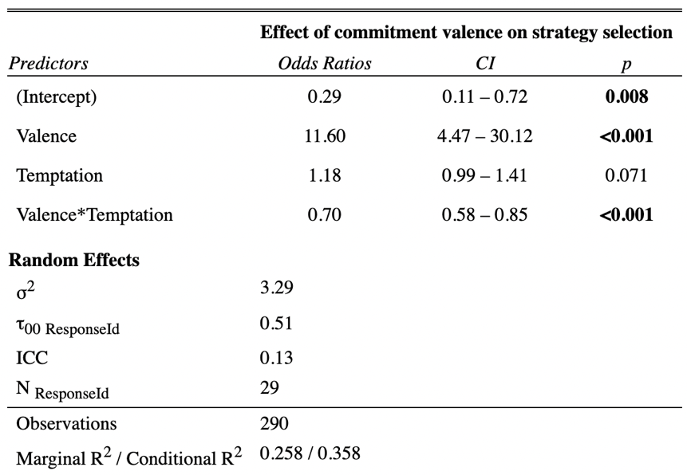

Commitment valence had significant partial effects in the model (β = 2.45, 95% CI[1.55, 3.47], p < .001) and perceived temptation did not (β = 0.16, 95% CI[-0.01, 0.35], p = .07). When compared to immoral vignettes, moral vignettes were 11.6 times more likely to elicit focus strategies. There was a significant interaction between perceived temptation and valence (β = -0.36, 95% CI[-0.55, -0.17], p < .001). Participants were more likely to select focus strategies as perceived temptation increased for immoral vignettes (odds ratio = 0.70, 95% CI[0.58, 0.84]), and more likely to select distract strategies as perceived temptation increased for moral vignettes (odds ratio = 1.43, 95% CI[1.19, 1.74]) (Figure 1).

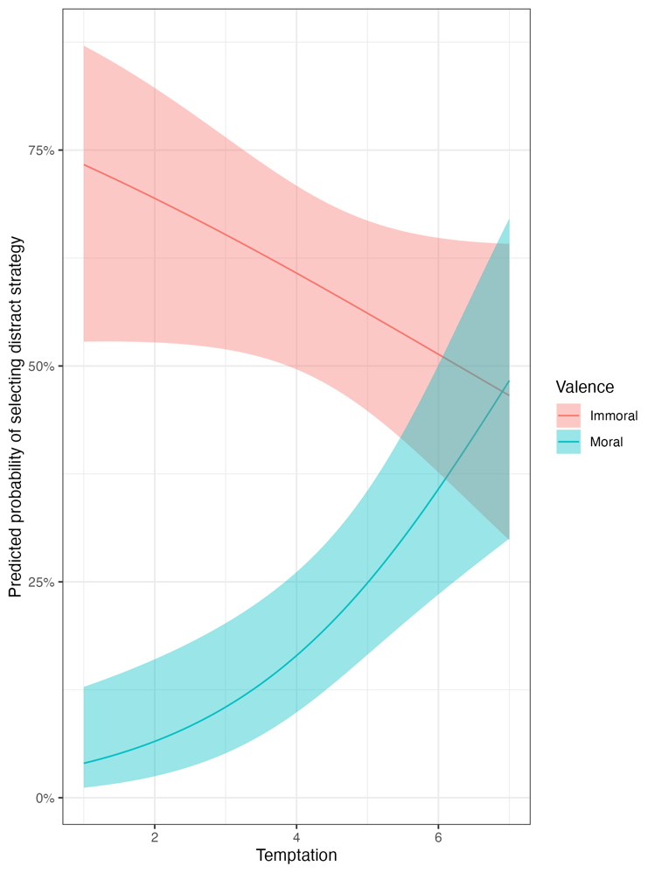
Figure 1. Predicted probability of selecting attentional distraction strategy as a function of perceived temptation strength by moral valence. Ribbon represents 95% confidence intervals.

Discussion
Experiment 1 provided evidence for the Morality hypothesis: participants considered attentional focus strategies more effective for morally good commitments.
Perceived temptation interacted with moral valence. For moral commitments, as perceived temptation increased, the likelihood of selecting attentional distraction strategies to manage temptation also increased. By contrast, for immoral commitments, as perceived temptation increased, the likelihood of selecting attentional distraction strategies to manage temptation decreased. Participants did not consider focus strategies to be more generally effective against strong temptation. Moreover, temptation did not significantly predict strategy selection.
These results suggest that the moral valence of a commitment partly explains the perceived effectiveness of an attentional strategy. One limitation of Experiment 1 is that we did not control for individual differences in self-control tendencies. People with high trait self-control are better at avoiding temptation altogether (Hofmann et al., 2012) and tend to experience fewer temptations (Ent et al., 2015), perhaps because their commitments tend to be more intrinsically motivated (Galla & Duckworth, 2015), which suggests that high trait self-control might influence strategy selection and temptation perception independently of the commitment’s moral valence. Thus, to properly isolate the influence of commitment valence, we needed to control for trait self-control. To account for this limitation and to replicate our initial findings, we conducted another experiment.

Experiment 2

Methods
Participants
60 participants were recruited on Prolific Academic to complete the study. Sample size was determined using the WebPower package in R (Zhang & Yuan, 2018) for logistic regression. Based on results from Experiment 1, if the probability of a focus response in the Immoral condition is 42% and the probability of a focus response in the Moral condition is 77%, then 60 participants are needed for a logistic regression to be 95% powered to detect an effect at standard error thresholds (p < .05). No participants were excluded based on pre-registered exclusion criteria (final N = 60; M_{age} = 38.12, SD = 7.9, 73% female).

Materials and procedure
Materials and procedure were the same as Experiment 1 with one exception. Participants completed the 13-item Brief Self-Control Scale (Tangney et al., 2004) using a 5-pt. scale (1 = Not at all like me; 3 = Somewhat like me; 5 = Very much like me). Trait self-control was calculated by averaging individual responses.

Results
When participants saw immoral vignettes, they recommended distraction strategies (n = 143, 48%) about as often as focus strategies (n = 157, 52%). A chi-squared test for given probabilities found no evidence for a difference between the observed distribution and the distribution expected under chance (χ² (1, N = 60) = 0.65, p = .42, φ = 0.05, 95% CI[0.00, 0.16]). When participants saw moral vignettes, they recommended focus strategies (n = 216, 72%) significantly more often than distract strategies (n = 84, 28%; χ² (1, N = 60) = 58.08, p < .001, φ = 0.44, 95% CI[0.33, 0.55]). A paired-samples t-test found no evidence for a difference in judgments of temptation strength across commitment valence (t(598) = -1.23, p = 0.22), with participants judging that both immoral (M = 4.04, 95% CI[3.82, 4.26]) and moral (M = 4.21, 95% CI[3.99, 4.43]) situations were somewhat tempting.
Hierarchical logistic regression models were fitted to predict focus strategy selection. Commitment valence, perceived temptation, trait self-control and all two-way interactions were included as fixed effects. Participants were coded as random effects. ‘Immoral’ was the reference level for commitment valence and the model predicted the odds of selecting Focus strategies. Table 2 summarizes fixed and random effects for the model.

Table 2. Fixed and random effects for Experiment 2
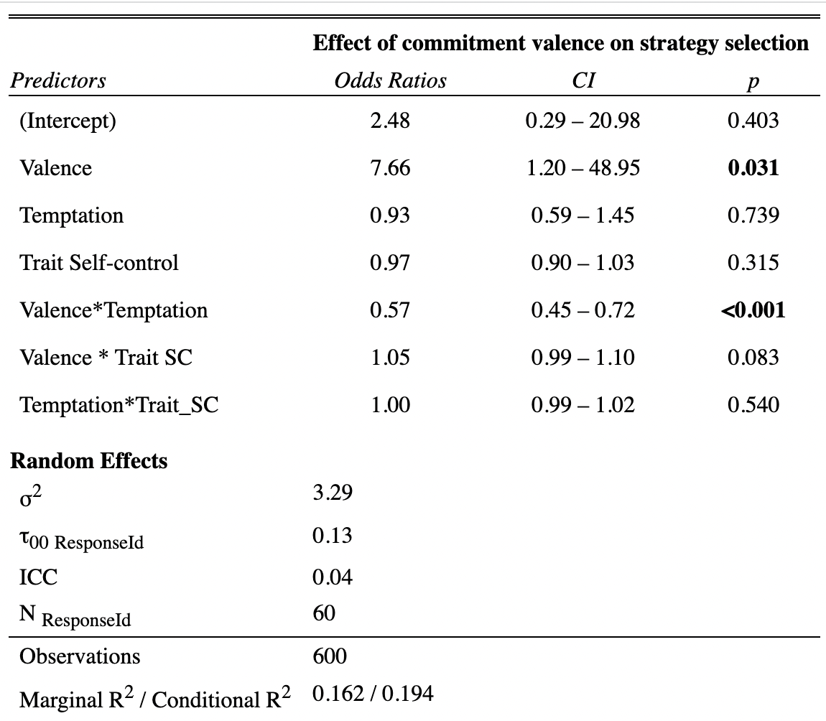

Commitment valence had significant partial effects in the model (β = 2.04, 95% CI[0.21, 3.93], p = .03) and temptation did not (β = -0.08, 95% CI[-0.53, 0.37], p = .74). When compared to immoral vignettes, moral vignettes were 7.7 times more likely to elicit focus strategies. There was a significant interaction between temptation and valence (β = -0.56, 95% CI[-0.79, -0.33], p < .001). Participants were more likely to select focus strategies as perceived temptation increased for immoral vignettes (odds ratio = 0.57, 95% CI[0.45, 0.72]) and more likely to select distract strategies as perceived temptation increased for moral vignettes (odds ratio = 1.75, 95% CI[1.39, 2.20]).

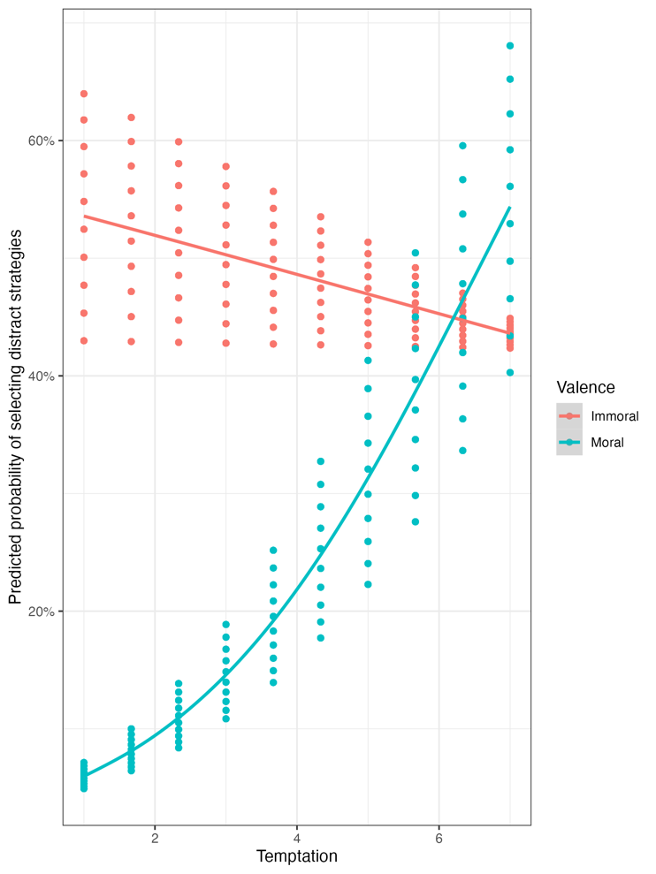
Figure 2. Predicted probability of selecting attentional distraction strategy based on perceived temptation strength by moral valence. Dots represent 95% confidence intervals for predicted probabilities.

Discussion
Experiment 2 provided evidence for the Morality hypothesis. Commitment valence predicted strategy selection for managing temptation. When participants saw moral vignettes, they were significantly more likely to judge that focus strategies are more effective than distraction strategies for maintaining commitments. There was an interaction between commitment valence and perceived temptation strength. For moral vignettes, as perceived temptation increased, participants were less likely to select focus strategies. For immoral vignettes, as perceived temptation increased, participants were more likely to select distract strategies. There was no evidence for an interaction between commitment valence, temptation, and trait self-control.
In Experiments 1 and 2, participants tended to select attentional focus strategies to manage temptation related to moral commitments. This suggests that moralization might alter strategy selection because it changes how people attribute motivation to people pursuing differentially moralized goals (Rozin et al., 1993). This implies two different hypotheses: (1) as the perceived morality of a commitment increases, the probability of selecting attentional focus strategies to manage temptation increases (moralization hypothesis), and (2) changes in attributions of identified motivation mediates the effect of morality on strategy selection (identified regulation hypothesis). To test these hypotheses, we conducted another experiment.

Experiment 3

Methods
Participants
230 participants were recruited on Prolific Academic. We conducted a power analysis using the mixedpower package in R. Using the coefficients of fixed effects from models fitted on pilot data (N = 200; see Supplementary Materials §2), we simulated 1000 models with 25, 50, 75, 100, 125, 175, 200, and 225 participants with strategy selection as the outcome variable. The simulation used z = 2 as the critical threshold for significance. 225 participants would provide 86% power to detect the estimated effect of morality on strategy selection. We over-recruited by 2% based on attrition rates in previous surveys. Per our pre-registered exclusion criteria, 2 participants were excluded for self-reported distracted responding (N = 228; M_{age} = 38.90, SD = 14.9, 47% female).

Materials and procedure
Participants were presented with a vignette that depicted an individual facing some temptation to break a commitment. Participants saw five vignettes in total. Four were used in previous studies (Volunteer, Smoke, Donate, and Job). We added a vignette on vegetarianism because people (in the United States) have widely varying attitudes on the morality of vegetarianism (Feltz & Feltz, 2019; Gruen, 2012; Jalil et al., 2020). Whether people view vegetarianism as moral or amoral might have implications for the motivations people experience toward certain behaviors (Rhee et al., 2019), thereby impacting how people decide to use self-control to manage related temptations (Rozin et al., 1997):

- Vegetarian: Frank is committed to being a vegetarian and eliminating meat from his diet. However, today he sees someone eating a tasty meatball sandwich and is tempted to buy some meat for lunch.

After reading each vignette, participants answered the same strategy selection item as in previous studies and were asked about the moral goodness of the commitment: “To what extent is this a morally good commitment?” Participants rated moral goodness using a 100-pt. scale anchored at the midpoint (0 = Not really a moral commitment, 50 = Somewhat morally good, 100 = Very morally good). To measure perceived motivation, participants also completed a modified version of the Situational Motivations Scale (SIMS; Guay et al., 2000). The SIMS is a 16-item measure with four 4-item subscales measuring intrinsic motivation, identified motivation, external motivation, and amotivational tendencies. Because participants were attributing motivation rather than self-reporting it, items were adapted to a third-personal perspective. Participants responded with a 9-pt. scale to each item (1 = Not at all because of this reason, 5 = Unsure, 9 = Completely because of this reason; anchored at midpoint). The full scale is summarized in the Supplementary Materials (§3). Identified regulation items are as follows: They are doing it for their own good; They think the activity is good for them; They are making a personal choice; They believe the activity is important for them.
Participants also rated temptation strength using the same scale from Experiments 1 and 2. Participants saw one vignette at a time and could not see the next vignette until they answered all questions related to the presented vignette.

Results
Table 3 summarizes strategy selections.

Table 3. Counts for strategy selection across vignette in Experiment 3.
Vignette | Focus | Distract
Job | 193 | 35
Volunteer | 205 | 23
Donate | 201 | 27
Smoke | 98 | 130
Vegetarian | 137 | 91
Note. Estimated marginal means and distribution of valence ratings for each vignette are summarized in Supplementary Materials §4.

Per our pre-registered analyses, a mixed-effects logistic regression model was fitted to predict strategy selection. Perceived morality of commitment and vignette were coded as fixed effects, and participants were coded as random effects. ‘Smoke’ was the reference level for Vignette and the model predicted the odds of selecting Focus strategies. Table 4 summarizes fixed and random effects for the model.

Table 4. Fixed and random effects for Experiment 3

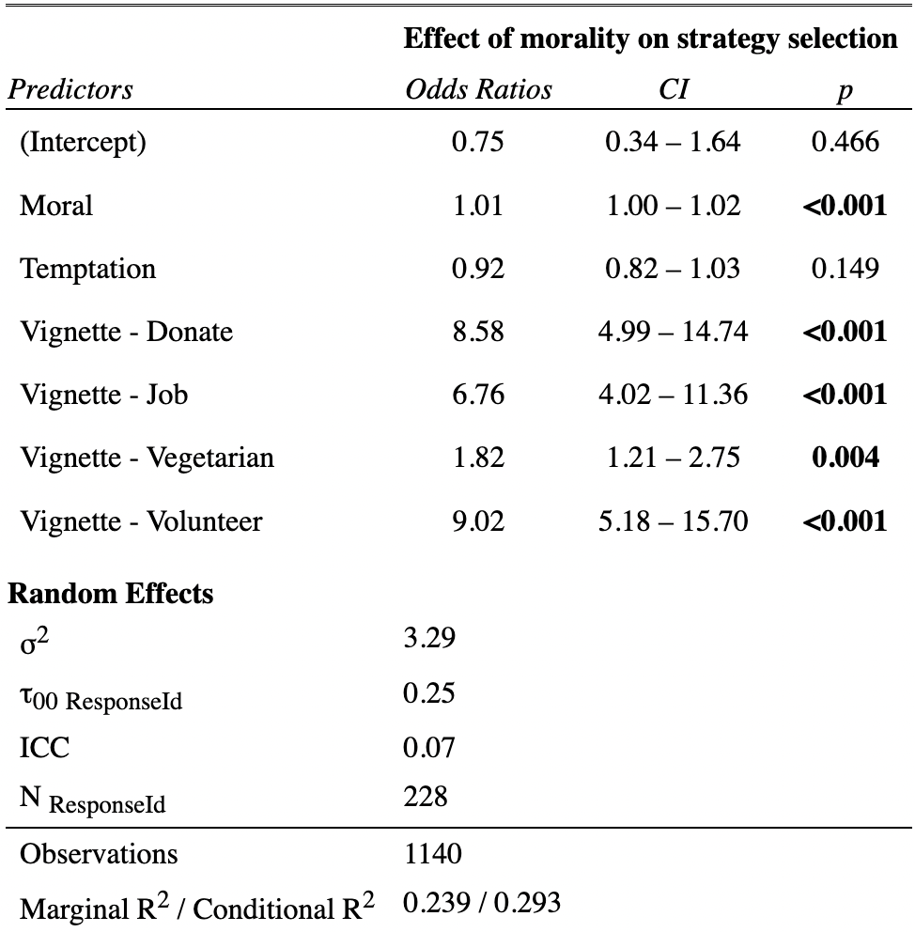

Perceived morality had significant partial effects in the model (β = 0.01, 95% CI[0.005, 0.02], p < .001). Figure 4 shows predicted probabilities for selecting focus strategies based on perceived morality overall and by vignette.

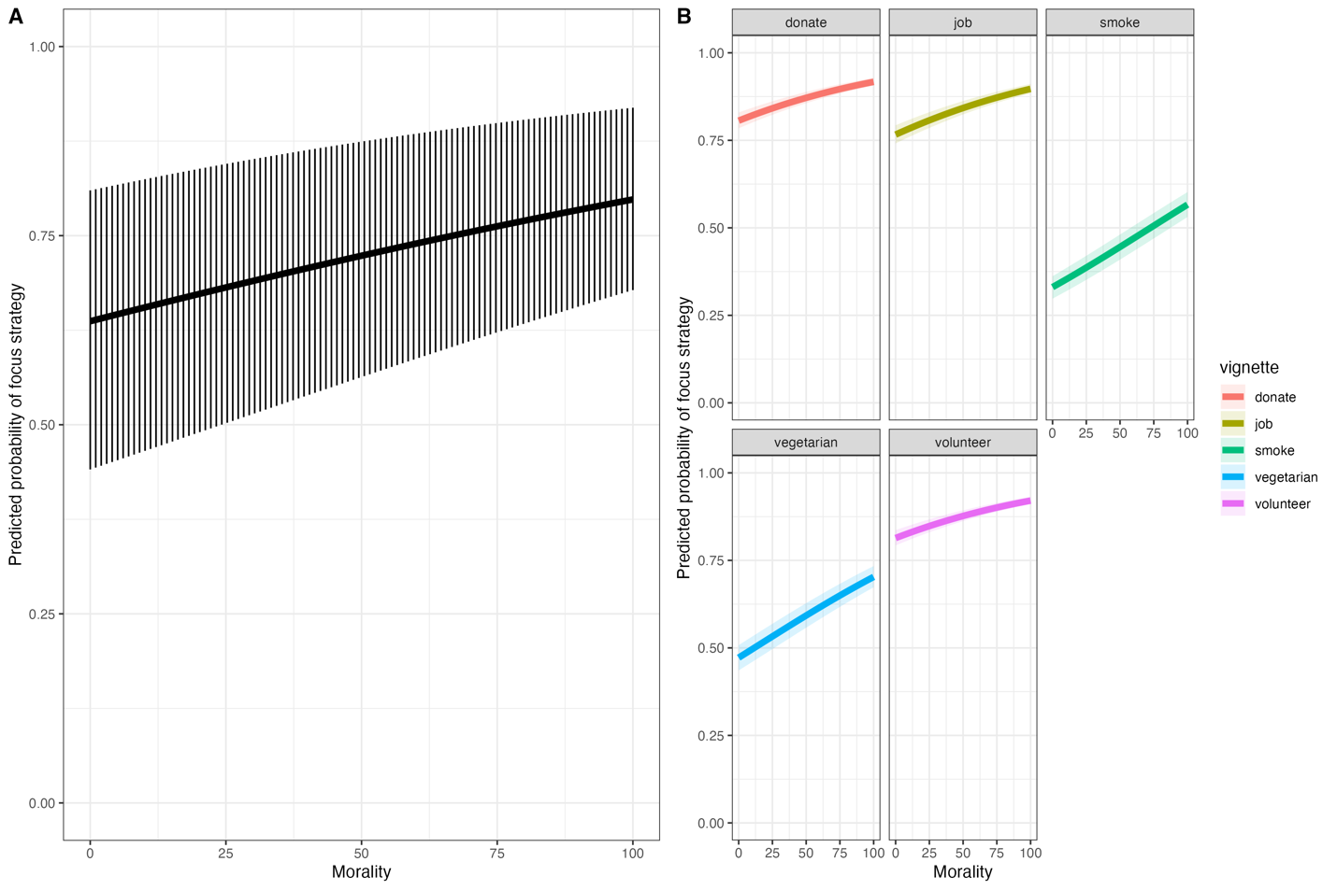
Figure 4. A) The predicted probability of selecting attentional focus strategies as perceived morality increases. Bars depict the range in which 50% of the predicted probabilities fall. B) Predicted probabilities split across different vignettes.

To evaluate the identified regulation hypothesis, we conducted causal mediation analysis. The analysis examined the average causal mediation effect (ACME) of judgments of identified regulation and the average direct effect (ADE) of perceived morality on strategy selection. All predictors were centered prior to fitting the model. Confidence intervals were computed using the quasi-Bayesian Monte Carlo simulation method over 1000 simulations. There was a mediation effect (ACME = 0.01, p < .001, CI[0.008, 0.02], proportion mediated = 0.31) and a direct effect (ADE = 0.09, p = 0.09, CI[-0.02, 0.20]), which indicates that participants’ attributions of identified regulation partly mediated the effect of morality on strategy selection (see Table 5).

Table 5. Causal mediation analysis results for Study 1
Effect | Estimate | 95% CI |  | p
 |  | Lower | Upper
ACMEª | 0.01 | 0.008 | 0.02 | <.001***
ADE^{b} | 0.03 | 0.008 | 0.06 | .01**
Total Effect | 0.05 | 0.02 | 0.07 | <.001***
Prop. Mediated | 0.31 | 0.16 | 0.66 | <.001***
Note. Sample size used = 1140, simulations = 1000. Signif. Codes: ‘****’ <.001 ‘***’ 0.001 ‘**’ 0.01 ‘*’ 0.05.
a = average causal mediation effect of morality on strategy selection mediated by attributions of identified regulation (a*b); b = average direct effect of morality on strategy selection (c’ path)

Discussion
Experiment 3 provided evidence for both the moralization hypothesis and the identified regulation hypothesis: as the perceived morality of a commitment increased, participants were more likely to select attentional focus strategies rather than attentional distraction strategies for managing temptation. As people tended to attribute greater identified regulation to the individuals wanting to resist temptation, commitments were increasingly positively moralized.

General Discussion
The process model of self-control identifies different strategies people can use to manage intrapsychic conflict. An important subset of these strategies requires deploying attention to manage the experience of temptation. Across three experiments, we tested three hypotheses about how the moral valence of some commitment might modulate attentional strategy selection. In support of the morality hypothesis, we found that people tend to see focus strategies as significantly more effective for moral as compared to immoral commitments. In support of the moralization hypothesis, we found that as commitments are positively moralized, people are significantly more likely to select attentional focus strategies as most effective for managing temptation. Finally, in support of the identified regulation hypothesis, we found that the effect of morality on strategy selection is partly mediated by perceived differences in underlying motivation to uphold the commitment.
Positive moralization is associated with stronger attributions of identified regulation, a kind of extrinsic regulation where goal-directed behavior is motivated by a perceived congruence between personal values and goals (Deci & Ryan, 2012; Guay et al., 2000). This explains why positive moralization is associated with attentional focus. When pursuing a moral commitment, people presume that the commitment coheres with the individual’s personal values. Our results suggest that people tend to think that focusing on these values is an effective way to mobilize regulatory processes in the face of temptation. However, this was a partial mediation and other factors might also be relevant. Possible differences in the construal of the activity might incline people toward selecting different strategies (Fujita et al., 2006) and inducing deliberative mindsets might change how people reason about the effectiveness of different strategies (Wieber et al., 2014). Future research should examine other potential cognitive factors that influence strategy selection.
We identified an interaction between temptation strength and moral valence. As perceived temptation strength increased, people tended to consider focus strategies more effective to manage temptations related to immoral commitments. However, the reverse held for moral commitments: as perceived temptation increased, people tended to consider distract strategies as more effective. People might find non-attentional self-control strategies (e.g., situation modification, cognitive reappraisal) more effective as temptation strength increases. Because these options were not provided, participants might have picked randomly at higher levels of temptation. Including more strategy options could assess this possibility. Importantly, we found no evidence for an effect of temptation on strategy selection in Experiment 3, which suggests that the effect of temptation might not be robust. Future work should investigate further how perceived temptation alters self-control strategy selection.
These results indicate that moralization may inform decision-making processes related to self-control strategy selection. However, three limitations should be noted. First, given cultural variability underlying attitudes about morality (Henrich, 2020) and self-control (Wente et al., 2020), we might expect to find differences in how moralization influences self-control across cultural contexts. Second, strategy selection options were limited to simplify the experimental design. Third, participants rated the perceived effectiveness of a strategy for some third party rather than self-implementing a strategy. There might be important asymmetries between judging the effectiveness of some strategy for others and implementing a particular strategy based on an assessment of its effectiveness. However, as mentioned earlier, research indicates that how people think about self-control influences how they exercise it in everyday life (Klinger et al., 2018). This suggests that if people judge strategies to be more effective for some situations, this provides some evidence about how they would make self-control decisions in everyday life.
More generally, these experiments indicate that people tend to think that focusing on the reasons for a commitment will be more effective for resisting temptation for morally good commitments but not morally bad commitments. Reflecting on why someone made a commitment, then, is more motivationally effective for morally good commitments (see Wieber et al., 2014). Of course, this perception might not be accurate, but understanding how morality influences decision-making can be important for crafting effective interventions to prevent self-control failure. This is particularly important if, as some research suggests, achieving the right strategy-situation fit is a skill critical for successful self-control exertion (Bermúdez, 2021; Bonnano & Burton, 2013; Wenzel et al., 2022). If the effect of commitment morality on strategy selection turns out not to help in achieving this fit, then people might risk self-control failure for those commitments they deem to be most important.

References

Bermúdez, J.P., Murray, S., Chartrand, L., and Barbosa, S. In press. What’s inside is all that counts? The contours of everyday thinking about self-control. Review of Philosophy and Psychology. 10.1007/s13164-021-00573-2.

Bermúdez, J. P. (2021). The skill of self-control. Synthese, 199, 6251–6273. https://doi.org/10.1007/s11229-021-03068-w

Bonanno, G. A., & Burton, C. L. (2013). Regulatory flexibility: An individual differences perspective on coping and emotion regulation. Perspectives on Psychological Science, 8(6), 591–612. https://doi.org/10.1177/1745691613504116

Decety, J. and Cacioppo, S. 2012. The speed of morality: a high-density electrical neuroimaging study. Journal of Neurophysiology 108:11, 3068-72.

Deci, E. L., & Ryan, R. M. (2012). Motivation, personality, and development within embedded social contexts: An overview of self-determination theory. In R. M. Ryan (Ed.), The Oxford handbook of human motivation (pp. 85–107). Oxford University Press.

Duckworth, A.L. and Gross, J.J. 2014. Self-control and grit: Related but separable determinants of success. Current directions in psychological science 23:5, 319-25.

Duckworth, A.L., Gendler, T.S., and Gross, J.J. 2016. Situational strategies for self-control. Perspectives on Psychological Science 11:1, 35-55.

Duckworth, A.L., Milkman, K.L., and Laibson, D. 2018. Beyond willpower: Strategies for reducing failures of self-control. Psychological Science in the Public Interest 19:3, 102-29.

Duckworth, A.L., Taxer, J.L., Eskreis-Winkler, L., Galla, B.M., and Gross, J.J. 2019. Self-control and academic achievement. Annual review of psychology 70, 373-99.

Ent, M. R., Baumeister, R. F., & Tice, D. M. (2015). Trait self-control and the avoidance of temptation. Personality and Individual Differences, 74, 12– 15.

Etzioni, A. 1961. A comparative analysis of complex organizations (Glencoe, IL: Free Press).

Feltz, S and Feltz, A. (2019) The knowledge of animals as food scale. Human-Animal Interaction Bulletin 7:19–45.

Fujita, K., Trope, Y., Liberman, N., & Levin-Sagi, M. (2006). Construal levels and self-control. Journal of personality and social psychology, 90(3), 351–367. https://doi.org/10.1037/0022-3514.90.3.351

Galla, B. M., & Duckworth, A. L. (2015). More than resisting temptation: Beneficial habits mediate the relationship between self-control and positive life outcomes. Journal of Personality and Social Psychology 109(3), 508–525. https://doi.org/10.1037/pspp0000026

Gantman, A.P. and Van Bavel, J.J. 2014. The moral pop-out effect: enhanced perceptual awareness of morally relevant stimuli. Cognition 132, 22-29.

Gantman, A., Devraj-Kizuk, S., Mende-Siedlecki, P., Van Bavel, J.J., and Mathewson, K.E. 2020. The time course of moral perception: an ERP investigation of the moral pop-out effect. Social Cognitive and Affective Neuroscience 15:2, 235-46. doi: 10.1093/scan/nsaa030.

Gruen, L. 2012. Ethics and animals (Cambridge: Cambridge University Press).

Guay, F., Vallerand, R. J., & Blanchard, C. (2000). On the assessment of situational intrinsic and extrinsic motivation: The Situational Motivation Scale (SIMS). Motivation and emotion, 24(3), 175-213.

Gui, D.Y., Gan, T., and Liu, C. 2016. Neural evidence for moral intuition and the temporal dynamics of interactions between emotional processes and moral cognition. Social Neuroscience 11, 380-94.

Henrich, J. 2020. The WEIRDest People in the World. New York: Farrar, Straus, and Giroux.

Hofmann, W., Baumeister, R. F., Förster, G., & Vohs, K. D. (2012). Everyday temptations: An experience sampling study of desire, conflict, and self-control. Journal of Personality and Social Psychology, 102(6), 1318–1335. https://doi.org/10.1037/a0026545.

Inzlicht, M., Shenhav, A., and Olivola, C. 2018. The effort paradox: Effort is both costly and valued. Trends in Cognitive Sciences 22:4, 337-49. doi: 10.1016/j.tics.2018.01.007.

Jalil, A. J., Tasoff, J., & Bustamante, A. V. (2020). Eating to save the planet: Evidence from a randomized controlled trial using individual-level food purchase data. Food Policy, 95, 101950.

Katz, D. and Kahn, R.L. 1978. The social psychology of organizations (New York: Wiley).

Klinger, J.A., Scholer, A.A., Hui, C.M., and Molden, D.C. 2018. Effortful experiences of self-control foster lay theories that self-control is limited. Journal of Experimental Social Psychology 78, 1-13. doi: 10.1016/j.jesp.2018.04.006.
Knittle, K. Heino, M., Marques, M.M., stenius, M., Beattie, M., Ehbrecht, F., Hagger, M.S., Hardeman, W., and Hankonen, N. 2020. The compendium of self-enactable techniques to change and self-manage motivation and behaviour v.1.0. Nature Human Behaviour 4:2, 215-23. 10.1038/s41562-019-0798-9.
Kool, W. and Botvinick, M. 2018. Mental labour. Nature Human Behaviour 2:12, 899-908. doi: 10.1038/s41562-018-0401-9.

Kotabe, H.P. and Hofmann, W. 2015. On integrating the components of self-control. Perspectives on Psychological Science 10:5, 618-38. doi: 10.1177/1745691615593382

Lipkus, I.M., Mays, D., Sheeran, P., Pan, W., Cameron, L., & De Brigard, F. 2022. Effects of mental simulation of future waterpipe tobacco smoking on attitudes, perceived harms, and intended use among young adults. Journal of Behavioral Medicine. doi: 10.1007/s10865-021-00245-7.

Martijn, C., Tenbült, P., Merckelbach, H., Dreezens, E., & Vries, N.K. (2002). Getting a grip on ourselves: Challenging expectancies about loss of energy after self-control. Social Cognition, 20, 441-446.

Milyavskaya, M., Saunders, B., and Inzlicht, M. 2021. Self-control in daily life: Prevalence and effectiveness of diverse self-control strategies. Journal of Personality 89:4, 634-51. doi: 10.1111/jopy.12604.

Rhee, J. J., Schein, C., & Bastian, B. (2019). The what, how, and why of moralization: A review of current definitions, methods, and evidence in moralization research. Social and Personality Psychology Compass, 13(12), e12511.

Rosas, A., Bermúdez, J.P., and Cabrera J.A.G. 2018. Is a bad will a weak will? Cognitive dispositions modulate folk attributions of weakness of will. Philosophical Explorations 21:3, 350-63.

Rozin, P., Haidt, J., & McCauley, C. R. (1993). Disgust. In M. Lewis & J. M. Haviland (Eds.), Handbook of emotions (pp. 575–594). The Guilford Press.

Rozin, P., Markwith, M., & Stoess, C. (1997). Moralization and becoming a vegetarian: The transformation of preferences into values and the recruitment of disgust. Psychological Science, 8(2), 67–73. https://doi.org/10.1111/j.1467-9280.1997.tb00685.x

Tangney, J.P., Baumeister, R.F., and Boone, A.L. 2004. High self-control predicts good adjustment, less pathology, better grades, and interpersonal success. Journal of Personality 72, 271-322.

Wente, A., Zhao, X., Gopnik, A., Kang, C., and Kushnir, T. 2020. The developmental and cultural origins of our beliefs about self-control. In A. Mele (ed.) Surrounding Self-Control. Oxford: Oxford University Press.

Wenzel, M., Bürgler, S., Brandstätter, V., Kreibich, A., & Hennecke, M. (2022). Self-regulatory strategy use, efficacy, and strategy-situation-fit in self-control conflicts of initiation, persistence, and inhibition [Preprint]. PsyArXiv. https://doi.org/10.31234/osf.io/p748g.

Wieber, F., Sezer, L. A., & Gollwitzer, P. M. (2014). Asking "why" helps action control by goals but not plans. Motivation and Emotion, 38(1), 65–78. https://doi.org/10.1007/s11031-013-9364-3

Yang, Q., Li, A., Xiao, X., Zhang, Y., and Tian, X. 2014. Dissociation between morality and disgust: an event-related potential study. International Journal of Psychophysiology 94, 84-91.

Yang, Q., Luo, C., and Zhang, Y. 2017. Individual differences in the early recognition of moral information in lexical processing: an event-related potential study. Scientific Reports 7, 1475.

Zhang, Z. and Yuan, K.-H. (Eds). 2018. Practical Statistical Power Analysis Using Webpower and R. Granger, IN: ISDSA Press.

Zhu, R., Wu, H., Xu, Z., et al. 2019. Early distinction between shame and guilt processing in an interpersonal context. Social Neuroscience 14, 53-66.

Exploratory analyses the control for the source of temptation (e.g., environmental stimuli) are summarized in Supplementary Materials (§1). Even when controlling for temptation source, commitment valence had significant partial effects in the model.
The random effects differed from the pre-registered analysis. We planned to include an error term for trait self-control. However, trait self-control and temptation were highly correlated (r = 0.83), and the model failed to converge.

