ITS for Enhancing Training Methodology for Students Majoring in Electricity
Mohammed S. Nassr, Samy S. Abu-Naser
Department of Information Technology,
Faculty of Engineering and Information Technology,
Al-Azhar University - Gaza, Palestine

Abstract: This thesis focuses on the use of intelligent tutoring system for education and training of students specialized in electricity in the field of technical and vocational education. The use of modern systems in training and education will have a great positive impact in improving the level of students receiving training and education; this will improve the level of the local economy by producing students of professionals who are able to engage in society efficiently, especially for those who have specialized in electricity. It is known that students in electrical specialties face many problems because of time and cost. Learning and training is not as easy as you imagine, so intelligence is how to overcome these limitations effectively. Motivating the Intelligent Tutorial System (ITS) for this type of training. This system consists of a student model, which in turn will contain lessons, exercises and examples that will be used by the student in addition to the user interface model which makes the teacher to be able to manage lessons, examples, and questions and make changes to the system. Expert System (ES) model representing the Artificial Intelligence (AI) here has been used to determine the level of the student and gives him the results, directions and levels. The program was implemented and was used by trainees to show the extent of its impact. The students expressed their surprise and admiration in this way of education as the system used focuses on individual education which can be used at any time and without restrictions. After this experience, the dedicated (ITS) system needs to be developed in several ways such as to be used on mobile systems and web systems in addition to linking some of the specialized programs in the field of electricity.

Keywords: Expert System, Artificial Intelligent, Intelligent Tutoring System

Introduction
Due to the vast spread of technology and necessity of creating well trained workers and technicians, TVET is considered the backbone for who aspire to gather theory and practice, because of the importance of this sector of education, we shed light on the methods of teaching and how to improve methodology of learning .As well known, traditional methods of teaching is not adequate for building high efficient abilities in technical fields. The traditional training methods for electricity Science have proven a partial successful for many years. These techniques used are useful and are used by many institutions for a while. These techniques require an experienced and dedicated professionals to conduct them and make the tools useful for your trainees. Some of traditional methods such as Presentation Methods, lectures ,hands on methods, gaming methods, etc. One of the oldest and most traditional training methods is the lecture. Many of us are familiar with this form of learning, since it is a very common way to teach in today's school systems. Various support tools are used, from charts and blackboards to PowerPoint slides and virtual meetings. Human resource associates learn and take notes while instructors present information and administer examinations. Materials are provided for reference, and students often learn in traditional classroom settings. The new methods are Smart method Choosing a traditional training method requires weighing several options, cost of course, travel expenses and time which is considered for the job are among the greatest expenses to consider when choosing a training method. Expected outcomes for the training are also important to consider. Weigh your options and choose the learning method that most closely meets your needs. Not only traditional textbooks impede the creation of well trained and qualified workers but also the variant levels of trainees knowledge is crucial and important. The aim of this research is to enhance the way of self-teaching for most levels of trainees and take in consideration anew technologies approaches to get a new generation of well trained workers. ITS is helpful and effective agent for prosperity of TVET. A software platform designed for this purpose is supposed to find solution for this problem and helpful for improving the abilities of trainees to do better. The software is examined by a considerable sample of trainees who expressed pleasure and comments for evolving the project.
  - Statement of the Problem
Vocational education is one of the vital sectors of education that contributes to the process of comprehensive progress of nations and civilizations, where vocational education tends to training, understanding and practical aspects rather than conservation or storage, therefore it requires more effective and intelligent means than other traditional methods of education became more boring and less effective. Not only is the traditional method is boring but also couldn't convey accurate information to trainees where there are no dimensions, no graphical animations, in addition to absence of dynamicity in the paper books or even the blackboard itself.
Some students learn slowly, they can't follow the teacher synchronously.
Using computer in learning is interesting for most students, and will have the resonant impact on trainees, so with utilizing the new modern technologies using ITS tool, which is software program designed for this purpose ,the information will be easy to get and easy to test, self-teaching will be raised and fill the gap between trainees and trainers. We can make it easier for teachers and students to evolve education by involving computer technology's in the teaching-learning process, and most problems could be solved by the proposed ITS system.
  - Objectives
This thesis aims to:
- Enhance the teaching method in technical schools
- Simulate students to enhance their levels through discussions and explanation
- Help teachers to achieve their duties.
- Minimize the difficulties faced in learning of electricity science, and creating the suitable environment for studying.
  - Significance of the thesis.
The proposed ITS system for teaching electricity science bind artificial intelligence with technical and vocational education especially electric field. This binding will affect the teaching and training positively and will achieve many aspirations. One is matching the special needs of each student, where there exist a distinguished level of students’ abilities which will be deemed by the software during the graduation in difficulty level discussed later. Also the system affords various multimedia techniques of the material to be helpful for trainee and trainers. The system adapts its model according to student’s responses. The student’s privacy is achieved including level.
  - Limitation of the thesis
Intelligent tutoring system proposed at this thesis doesn't take in account the deep learning, which examined by the participation of student. The answers for questions depend in cases for hints which will lead the student to choose hint immediately.
Another criteria of intelligent tutoring system is the failure of the system to ask questions of the students to explain their actions. If the student is not learning the domain language than it becomes more difficult to gain a deeper understanding.
Another demerit of intelligent tutoring system is the failure of the following up students activities and response to insure the saturation of learning.
  - Research Methodology
These steps will be followed:
- Organize lessons.
- Add the lessons to the proposed system.
- Prepare examples to each lesson.
- Prepare questions.
- Prepare the final exam.
- Execute and test the system.
- Let teachers and learners use the system, and take their feedback.
- Check the system again and again depending on the feedback gained from teachers and learners.

Background
Intelligent Tutoring Systems (ITSs) are instructional systems that use artificial intelligence (AI) techniques in computer programs to facilitate learning. These systems are based on cognitive psychology as an underlying theory of learning, which deals mainly with issues such as knowledge representation and organization within the human memory as well as the nature of human errors [1].
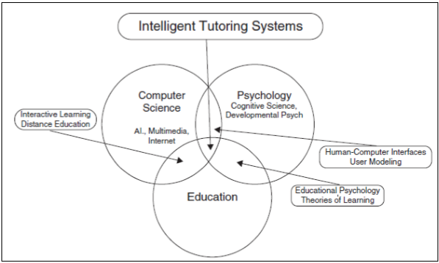
Figure 1: The field of AI and education is grounded in three disciplines: Computer science, psychology, and education[1].
  - Definitions of ITS
An intelligent tutoring system (ITS) is software that aims to provide immediate and specific instruction and feedback to trainees, typically without referring to a human trainer. The goal of ITSs is to facilitate learning in an evocative and efficient way by using different computing techniques. ITSs have proven their abilities in both official education and professional situations. There is a strong association between intelligent tutoring, cognitive learning theories and design. An ITS aims to solve the problem of over dependency of trainees over trainers for superiority education. It intends to offer access to high-class education to every trainee, consequently improving the whole educational system [2].
  - Architecture of ITS
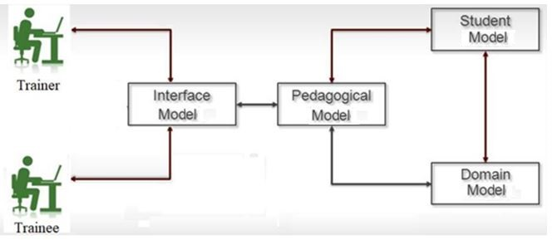
Figure 2 ITS Components[3]

The architecture of its system as shown above is composed of Interface Model, Pedagogical Mode , Student Model and Domain Model[3]
    - Domain Model.
The domain model (also known as the cognitive model or expert knowledge model) is built on a theory of learning, such as the ACT-R theory which tries to take into account all the possible steps required to solve a problem. More specifically, this model "contains the concepts, rules, and problem-solving strategies of the domain to be learned. It can fulfill several roles: as a source of expert knowledge, a standard for evaluating the student's performance or for detecting errors, etc.[4] This model is the heart of ITS and it’s the source of knowledge which is the input for students. It must be arranged and stacked in a simple, repressive way.
    - Pedagogical Model
Pedagogical models are cognitive models or theoretical constructs derived from learning theory that enable the implementation of specific instructional and learning strategies. Examples of pedagogical models include anchored instruction, problem-based learning, cognitive apprenticeship, situated learning, and computer-supported intentional learning environments (CSILE) [5].
    - Student Model
Student modeling is an important technique used in intelligent tutoring systems (ITSs). Student models observe the student’s behaviors in the system, and create quantitative representations of his properties of interest, which inform other modules of the system. The key use of a student model in an ITS is to support making instructional decisions. A good student model that matches student behaviors to student properties of interest can often provide insightful information to both the system and the researchers. Two essential factors are involved in the definition of student modeling: student behaviors and properties of interest. Student behaviors can be viewed as the input of a student model, which include a variety of observations, such as student answers and student actions. Properties of interest represent what about the student is being modeled. Depending on the requirements, the range of things being modeled could be fairly broad: student knowledge, student performance, student emotion and other constructs of interest. Student models create quantitative representations, which are consumable to other modules within a computer system, and most of which are also interpretable to humans outside a computer system. There are two categories of methods for building student models: cognitive science methods and machine learning methods. Different techniques work better or worse for different academic domains. Moreover, two categories of techniques are sometimes used conjunctively to achieve a superior result. My dissertation work lies in the category of machine learning methods; therefore the majority of this chapter is used to discuss the related work in the machine learning methods following a brief description of the related work in the cognitive science methods [6].
    - User Interface Model.
User Interface Model is a development tool used by computer programmers. User interfaces today are software components of various scales and they play an important role in application usage. Therefore, development of the user interface requires visual modeling and a unified observation of this visualization. The term UI modeling is often used in the context of information technology. The user interface model is a representation of how the end user (s) interacted with another computer or device as well as how the system responds. Thus, the task of modeling is to show "aspects with the direct experience of something or device. Modeling user interfaces is a well-established system in itself. For example, modeling techniques can describe interaction objects, tasks, and lower-level dialog boxes in user interfaces. Using forms as part of user interface development can help capture user requirements, avoid premature compliance with specific layouts and tools, and make relationships between the different parts of the interface and their roles explicit.
  - History of ITS
- Early mechanical systems
The possibility of intelligent machines have been discussed for centuries. Blaise Pascal created the first calculating machine capable of mathematical functions in the 17th century simply called Pascal's Calculator [7].
- Early electronic systems.
In the period following the second world war, mechanical binary systems gave way to binary based electronic machines. These machines were considered intelligent when compared to their mechanical counterparts as they had the capacity to make logical decisions. However, the study of defining and recognizing a machine intelligence was still in its infancy. Alan Mathison Turing a mathematician, logician and computer scientist, linked computing systems to thinking. One of his most notable papers outlined a hypothetical test to assess the intelligence of a machine which came to be known as the Turing test. Essentially, the test would have a person communicate with two other agents, a human and a computer asking questions to both recipients. The computer passes the test if it can respond in such a way that the human posing the questions cannot differentiate between the other human and the computer. The Turing test has been used in its essence for more than two decades as a model for current ITS development. The main ideal for ITS systems is to effectively communicate [8].
Microcomputers and intelligent systems
The microcomputer revolution in the late 1970s and early 1980s helped to revive CAI development and jumpstart development of ITS systems. Personal computers such as the Apple 2, Commodore PET, and TRS-80 reduced the resources required to own computers and by 1981, 50% of US schools were using computers.[9] Several CAI projects utilized the Apple 2 as a system to deliver CAI programs in high schools and universities including the British Columbia Project and California State University Project in 1981.[9]remediation is still in use today when programming ITS.A key breakthrough in ITS research was the creation of LISPITS, a program that implemented ITS principles in a practical way and showed promising effects increasing student performance. LISPITS was developed and researched in 1983 as an ITS system for teaching students the LISP programming language.[10] LISPITS could identify mistakes and provide constructive feedback to students while they were performing the exercise. The system was found to decrease the time required to complete the exercises while improving student test.[10]
- Modern ITS
Modern ITS system itself often tries to duplicate the role of a teacher or teaching assistant, and increasingly leads to the automation of educational functions such as problem generation, problem selection, and feedback generation. However, given the current shift towards integrated learning models, the recent work at ITS has begun to focus on ways in which these systems can effectively take advantage of the complementary strengths of teacher-managed education from a teacher
There were three ITS projects that functioned based on conversational dialogue: AutoTutor, Atlas, [11] and Why2. The idea behind these projects was that since students learn best by constructing knowledge themselves, the programs would begin with leading questions for the students and would give out answers as a last resort. Auto Tutor's students focused on answering questions about computer technology, Atlas's students focused on solving quantitative problems, and Why2's students focused on explaining physical systems qualitatively. [12] Other similar tutoring systems such as Andes.[13] tend to provide hints and immediate feedback for students when students have trouble answering the questions. They could guess their answers and have correct answers without deep understanding of the concepts. Research was done with a small group of students using Atlas and Andes respectively. The results showed that students using Atlas made significant improvements compared with students who used Andes.[14] However, since the above systems require analysis of students' dialogues, improvement is yet to be made so that more complicated dialogues can be managed.
  - Advantages of ITS
Spatial efficacy
In a traditional educational setting, providing a tutor for each student may be ideal, but certainly is not plausible in terms of physical space and financial constraints. ITS can provide students with experiences similar to those provided by a tutor, but at a fraction of the cost.
Variety of Uses
One of the advantages of ITS is its ability to deal with different fields. For instance, there are many different microcontroller development platforms available for use in training and prototyping with electronics, used for everything from new musical instruments to intelligent electronics projects, custom input devices and interactive art pieces. These tools attempt to decrease the difficulty of working with electronics and increase the number of people who can experiment with the medium. One of these open source tools is Arduino prototyping platform which makes working with electronic components easy, cheap, and quick [15]
Cost Efficiency
The only cost involved in ITS concerns the purchase of the "hardware" and "software" required to operate the ITS. This is significantly less expensive than funding a traditional classroom, specifically an instructor's wages. The cost efficiency of this technology has led to its widespread use in many different classrooms and occupations. Effects on Learning
Effective ITS
ITS system represents a motive force for students to develop their abilities as revealed by studies and touched on the ground and showed greater satisfaction with learning than students who participated in regular classroom sessions.
Learning Speed
Compared to their counterparts in a face to face setting, ITS students increased their cognition of concepts and moved through the assignments faster.
Emotional aspect
It is a computer to person type of training, so the person who sits in front of the screen will not be embarrassed and not ashamed to answer or participate, on the contrary when you are in a classroom with colleagues.
- Improvement and expansion
ITS is extendable system that can be as a large scale repository of knowledge. In addition to new skills can be adapted for the targeted categories of people.
  - Study Community
There are many providers of education and vocational and technical training services in Palestine. There are many types of vocational education and training systems. Hundreds of institutions in the West Bank and Gaza provide short and long term programs. These include vocational secondary schools, vocational training centers and cultural centers, as well as about 25 community colleges offering different education programs for high school graduates. It is supervised by the public and private sectors, the Ministry of Labor, the Ministry of Social Affairs, UNRWA, charitable and religious organizations, local and international NGOs and private sector institutions. These vocational education institutions mentioned above consist of several disciplines, including electricity, electronics, maintenance, and many other disciplines that need the basics of electricity. In addition, these institutions rely on attracting additional courses for the local community. The intelligent system will be accessible to all those students who wish to learn vocational science particularly electricians and amateurs.

Literature Review
Information technology is rich in many studies on artificial intelligence and intelligent training. In this part of the study, the researcher reviewed what was written in the previous studies, either directly or indirectly. The researcher will present and analyze some of the previous studies that have been obtained, which are relevant to the subject of the current study, and the previous studies were presented according to their importance for the current study.
- The study of (Al-Shawwa et. al, 2019) An Intelligent Tutoring System for Learning Java
Java is one of the most widely used languages in Desktop developing, Web Development and Mobile Development, so there are many lessons that explain its basics, so it should be an intelligent tutoring system that offers lessons and exercises for this language. Why tutoring system? Simply because it is one-one teacher, adapts with all the individual differences of students, begins gradually with students from easier to harder level, save time for teacher and student, the student is not ashamed to make mistakes, and more. In this paper, the authors describe the design of an Intelligent Tutoring System for teaching Java to help students learn Java easily and smoothly. Tutor provides beginner level in Java. Finally, we evaluated our tutor and the results were excellent by students and teachers[22].
- The study of (Bakeer et al., 2019) An Intelligent Tutoring System for Learning TOEFL
An e-learning system is increasingly gaining popularity in the academic community because of several benefits of learning anywhere anyplace and anytime. An Intelligent Tutoring System (ITS) is a computer system that aims to provide immediate and customized instruction or feedback to learners, usually without requiring intervention from a human teacher.(ITSB) is the tutoring system Builder Which designed and improved to help teachers in building intelligent tutoring system in many fields. In this paper, the authors have presented an example and evaluation of building an intelligent tutoring system for teaching TOEFL using ITSB tool[23].
- The study of(Albatish et. al., 2018). ARDUINO Tutor: An Intelligent Tutoring System for Training on ARDUINO.
This paper aims at helping trainees to overcome the difficulties they face when
dealing with Arduino platform by describing the design of a desktop based intelligent
tutoring system. The main idea of this system is a systematic introduction into the concept of Arduino platform. The system shows the circuit boards of Arduino that can be purchased at low cost or assembled from freely-available plans; and an open-source development environment and library for writing code to control the board topic of Arduino platform. The system is adaptive with the trainee's individual progress. The system functions as a special tutor who deals with trainees according to their levels and skills. Evaluation of the system has been applied on professional and unprofessional trainees in this field and the results were good [3].
- The study of(Al-Bastamiet. al., 2017). Design and Development of an Intelligent Tutoring System for C# Language
In this paper, the authors try to help users learn C# programming language using Intelligent Tutoring System. This ITS was developed using ITSB authoring tool to be able to help the user learn programming efficiently and make the learning procedure very pleasing. A knowledge base using ITSB authoring tool style was used to represent the user's work and to give customized feedback and support to users [16].
- The study of (Hamed et. al., 2017). An intelligent tutoring system for teaching the 7 characteristics for living things.
ITS was used in designing a learning system of science for 7th grade user explaining the characteristic of living things [17].
- The study of(Appleton, 2017). Introducing intelligent exercises to support web application programming users.
A prototype system was designed wing the ITS to help user in learning the web language Java Script [18].
- The study of(Mahdi et. al., 2016). An intelligent tutoring system for teaching advanced topics in information security
This intelligent tutoring systems target the users enrolled in Advanced Topics in Information Security in the faculty of Engineering and Information Technology at Al-Azhar University in Gaza. Through which the user will be able to study the course and solve related problems. An evaluation of the intelligent tutoring systems was carried out and the results were good [19].
- The study of(Alhabbash et. al., 2016). An Intelligent Tutoring System for Teaching Grammar English Tenses
In this paper, the authors describe the design of an Intelligent Tutoring System for teaching English language grammar to help users learn English grammar easily and smoothly. The system provides all topics of English grammar and generates a series of questions automatically for each topic for the users to solve. The system adapts with all the individual differences of users and begins gradually with users from easier to harder level. The intelligent tutoring system was given to a group of users of all age groups to try it and to see the impact of the system on users. The results showed a good satisfaction of the users toward the system [20].
- The study of(García et. al., 2016)Intelligent tutoring system to integrate people with down syndrome into work environments.
Multiple staged project was develop using the ITS in order to integrate people with Down Syndrome into work environment [21].
  - Comments about previous studies
Through reading these previous studies, I found that the design of Intelligent Tutoring System is used for a variety of matters and the previous studies above aim to use it in many fields such as programming language (Java, PHP, C#), Algebra, Mathematics and Learning English grammar.
My thesis is different from the previous studies in its goal that it employs the ITS in vocational and technical training that addresses the training issue and it’s a obstacles in order to overcome them by encouraging students enhance and improve their abilities.

Overview of the Proposed System
The study focuses on the adaption of ITS in technical and vocational education particularly in electric field .The shell used is called ITSB which is compatible for this type of education. The suggested educational system is composed of user interface unit, domain model, student mode and pedagogical model, each model is responsible for a specific task. It would help make the training faster and easier .It can help students to improve their abilities and examine them. It would help the specialist for setting up lessons, questions and level of difficulties. By using this portable educator system the learning will become easier without constrains of time and space.
  - Authoring Language Used.
Intelligent Tutoring System Builder (ITSB) is an authoring tool designed and developed to aid teachers in constructing intelligent tutoring systems in multidisciplinary fields. The teacher is needed to create a set of pedagogical fundamentals, which, in line, are inured to automatically build up a broad tutor framework and construct an intelligent tutoring system. In this thesis an explanation of the theory and the architecture of the tool are outlined. A presentation of several system components, the requirements of the different components, integration of these components in ITSB tool are shown. Furthermore, implanting of requirements, cognitive principle, and common design fundamentals in the tool to ease the use of teachers. A variety of design matters, an example of building an intelligent tutoring system for teaching Java language using ITSB tool [2].
  - Architecture of the proposed ITS system
A typical ITS have four fundamental models: Domain model, Student model, Pedagogical Model and user interface. The proposed ITS system uses the typical architecture of ITS. The proposed ITS system used the Intelligent Tutoring System Builder (ITSB) programming language, which was developed by Prof. Dr. Samy S. Abu Naser using Delphi Language [2].
    - Domain Model
The domain model includes the scientific material of the targeted specialization ,the course of electricity fundamentals which will help students to learn electricity from scratch to best level.
The lessons in this course are as follows:
- The atomic structure
This lesson describes the atom and its composition, which consists of the nucleus, in the center of the atom and consists of protons and neutrons. The nucleus revolves electrons. Each unique element has an atomic number equal to the number of protons it contains. There are 94 natural elements and other artificially created elements. Each element also has an atomic weight of the most common isotope. Atomic weight = number of protons + number of neutrons. In a stable / uncharged atom, the number of electrons will equal the number of protons. If the number of electrons changes, the atom will become ionized and gain either positive (less than electrons) or negative (larger electrons).Electric Charges [27].
- Electric Field
This lesson elaborates the notion of the electric field which is defined as the wattage for each unit charge. The direction of the field is taken to be the direction of the force you will perform on a positive test charge. The electric field is externally from a positive charge and from a radial direction towards a negative point charge [28].
- Electric Current
This lesson elaborates the notion of the electrical current which is the flow of electrical charges such as electrons or ions. According to the international system of units, the current strength is measured in amperes. While the electric current is measured by the ammeter, and can be measured by one of the measuring instruments used [28].
- Voltage
This lesson elaborates the notion of the voltage which is the pressure from an electrical circuit's power source that pushes charged electrons (current) through a conducting loop, enabling them to do work such as illuminating a light. In brief, voltage = pressure, and it is measured in volts (V) [28].
- Ohms Law , KCL and KVL
This lesson elaborates the notion of Ohm's law and Kirchhoff's law which describe the way current flows through a resistance and nodes when a different electric potential (voltage) is applied at each end of the resistance. One way to think of this is as water flowing through a pipe. The voltage is the water pressure, the current is the amount of water flowing through the pipe, and the resistance is the size of the pipe. More water will flow through the pipe (current) the more pressure is applied (voltage) and the bigger the pipe is (lower the resistance) [28].
- Capacitors
This lesson elaborates the notion of capacitance which is defined as the ratio of the electric charge on each conductor to the potential difference between them. The unit of capacitance in the International System of Units (SI) is the farad (F), defined as one coulomb per volt (1 C/V). Capacitance values of typical capacitors for use in general electronics range from about 1 Pico farad (pF) (10−12 F) to about 1 mill farad (mF) (10−3 F).
The capacitance of a capacitor is proportional to the surface area of the plates (conductors) and inversely related to the gap between them. In practice, the dielectric between the plates passes a small amount of leakage current. It has an electric field strength limit, known as the breakdown voltage. The conductors and leads introduce an undesired inductance and resistance,[24].
In a way, a capacitor is a little like a battery. Although they work in completely different ways, capacitors and batteries both store electrical energy. If you have read How Batteries Work, then you know that a battery has two terminals. Inside the battery, chemical reactions produce electrons on one terminal and absorb electrons on the other terminal. A capacitor is much simpler than a battery, as it can't produce new electrons it only stores them.
In this article, we'll learn exactly what a capacitor is, what it does and how it's used in electronics. We'll also look at the history of the capacitor and how several people helped shape its progress.
Inside the capacitor, the terminals connect to two metal plates separated by a non-conducting substance, or dielectric. You can easily make a capacitor from two pieces of aluminum foil and a piece of paper. It won't be a particularly good capacitor in terms of its storage capacity, but it will work [25].
- Magnetism
This lesson elaborates the notion of magnetism which is one aspect of the combined electromagnetic force. It refers to physical phenomena arising from the force caused by magnets, objects that produce fields that attract or repel other objects. A magnetic field exerts a force on particles in the field due to the Lorentz force, according to Georgia State University's Hyper Physics website. The motion of electrically charged particles gives rise to magnetism. The force acting on an electrically charged particle in a magnetic field depends on the magnitude of the charge, the velocity of the particle, and the strength of the magnetic field.
All materials experience magnetism, some more strongly than others. Permanent magnets, made from materials such as iron, experience the strongest effects, known as ferromagnetism. With rare exception, this is the only form of magnetism strong enough to be felt by people [29].
- Inductance
This lesson elaborates the notion of magnetism which is Inductance is an effect caused by the magnetic field of a current-carrying conductor acting back on the conductor. An electric current through any conductor creates a magnetic field around the conductor. A changing current creates a changing magnetic field. From Faraday's law of induction any change in magnetic flux through a circuit induces an electromotive force (voltage)across the circuit.[29]
- AC circuits
This lesson elaborates the notion of ac circuits which is alternating current (AC) circuits, instead of a constant voltage supplied by a battery, the voltage oscillates in a sine wave pattern, varying with time as:
.In a household circuit, the frequency is 60 Hz. The angular frequency is related to the frequency, f, by:
.Vo represents the maximum voltage, which in a household circuit in North America is about 170 volts. We talk of a household voltage of 120 volts, though; this number is a kind of average value of the voltage. The particular averaging method used is something called root mean square (square the voltage to make everything positive, find the average, take the square root), or rms. Voltages and currents for AC circuits are generally expressed as rms values. For a sine wave, the relationship between the peak and the rms average is rms value = 0.707 peak value.[30]
- Transformers
This lesson elaborates the notion of transformer which is a static electrical device that transfers electrical energy between two or more circuits. ... Since the invention of the first constant-potential transformer in 1885, transformers have become essential for the transmission, distribution, and utilization of alternating current electric power [30].
- Power Generation
This lesson elaborates the notion of power generation which is the process of generating electric power from sources of primary energy. For electric utilities in the electric power industry, it is the first stage in the delivery of electricity to end users, the other stages being transmission, distribution, energy storage and recovery, using the pumped-storage method.
A characteristic of electricity is that it is not a primary energy freely present in nature in remarkable amounts and it must be produced. Production is carried out in power stations (also called "power plants"). Electricity is most often generated at a power plant by electromechanical generators, primarily driven by heat engines fueled by combustion or nuclear fission but also by other means such as the kinetic energy of flowing water and wind. Other energy sources include solar photovoltaic and geothermal power.[31]
- Safety
This lesson elaborates the notion of safety which is Safety is the condition of a “steady state” of an organization or place doing what it is supposed to do. “What it is supposed to do” is defined in terms of public codes and standards, associated architectural and engineering designs, corporate vision and mission statements, and operational plans and personnel policies. For any organization, place, or function, large or small, safety is a normative concept. It complies with situation-specific definitions of what is expected and acceptable.[26]
Electrically powered equipment can pose a significant hazard to workers, particularly when mishandled or not maintained. Many electrical devices have high voltage or high power requirements, carrying even more risk.
Some general safety tips for working with or near electricity were mentioned.[32]
- Electric Terms
This lesson was as glossary and legend for terms and symbols used in electrical field of work.
The above discussed topics covers the fundamental of the electricity system
    - Student Model
Student modeling is an important technique used in intelligent tutoring systems (ITSs). Student models observe the student’s behaviors in the system, and create quantitative representations of his properties of interest, which inform other modules of the system. The key use of a student model in an ITS is to support making instructional decisions. A good student model that matches student behaviors to student properties of interest can often provide insightful information to both the system and the researchers. Two essential factors are involved in the definition of student modeling: student behaviors and properties of interest. Student behaviors can be viewed as the input of a student model, which include a variety of observations, such as student answers and student actions. Properties of interest represent what about the student is being modeled. Depending on the requirements, the range of things being modeled could be fairly broad: student knowledge, student performance, student emotion and other constructs of interest. Student models create quantitative representations, which are consumable to other modules within a computer system, and most of which are also interpretable to humans outside a computer system. There are two categories of methods for building student models: cognitive science methods and machine learning methods. Different techniques work better or worse for different academic domains. Moreover, two categories of techniques are sometimes used conjunctively to achieve a superior result. My dissertation work lies in the category of machine learning methods; therefore the majority of this chapter is used to discuss the related work in the machine learning methods following a brief description of the related work in the cognitive science methods.[6].In this module, each new student has his or her own account and personal file that allows the student to study the subjects and perform the exercises. The profile contains information about the student such as the last visit date, student name, student number, current score, and overall score. The current score represents the student's score for each level. The total score represents the student of all levels.
    - Expert /Pedagogical Model
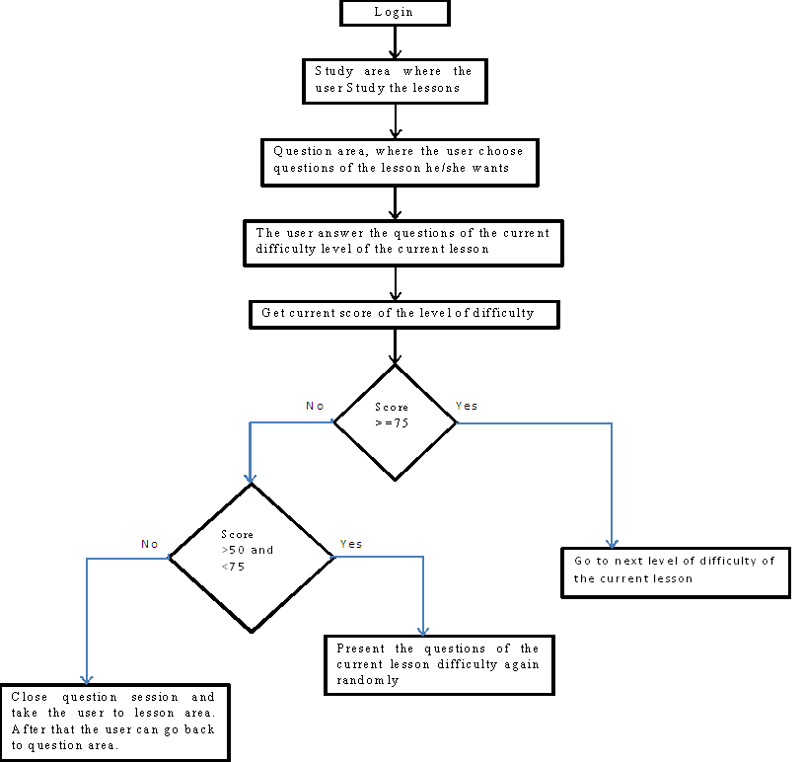
Figure 3: Pedagogical model adaption to user level

    - interface model
This module is divided into two sections:
1. Trainer interface: the admin only can access to this interface and add lessons, examples, exercises, modification and deletion, adding trainees’ accounts, adjusting the color and many other settings of the system.
2. Trainee interface: this section is designed for trainees where each trainee can review the lessons, examples, and solve the exercises.
Figure 5 shows the admin login interface and Figures:7, 9, 10, 11, 12, 13, 14, 15, and 20 shows different snapshots of the admin screens.
  - The Student interface conveys all the commands of teaching process, these commands differs with user's performance level.Figure6 shows the user login interface.Figures:8, 16, 17, 18, and 19 shows the different snapshots of the user/user screens.
    - Screen captures
These are some screen samples for the proposed ITS system.
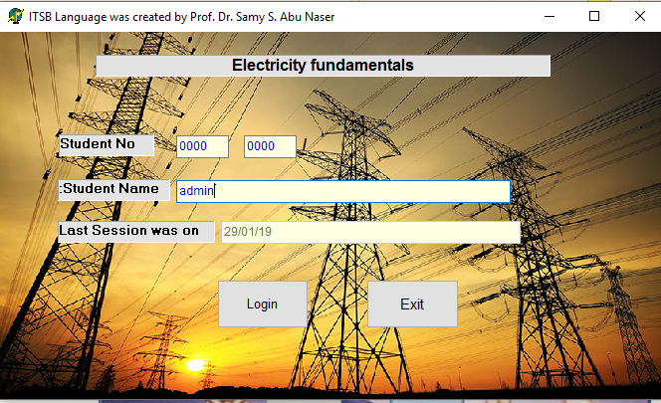
Figure 4Admin login screen
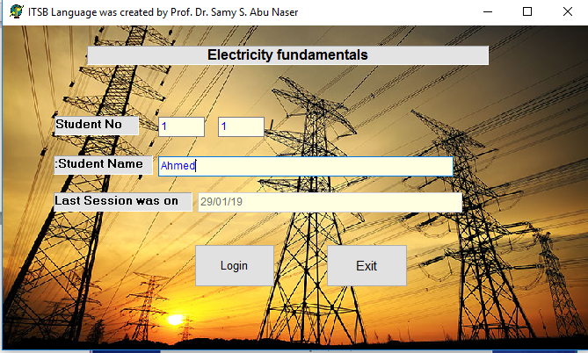
Figure 5 user login screen
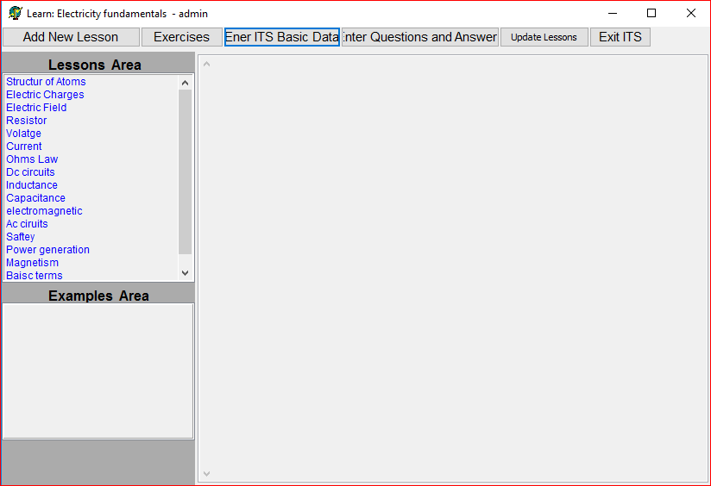
Figure 6 Admin interface
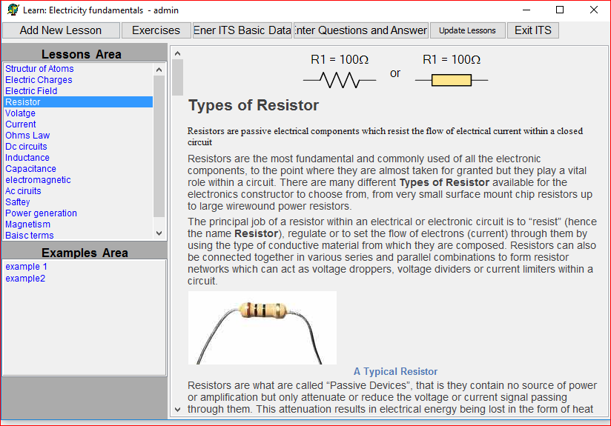
Figure 7User lessons and examples interface
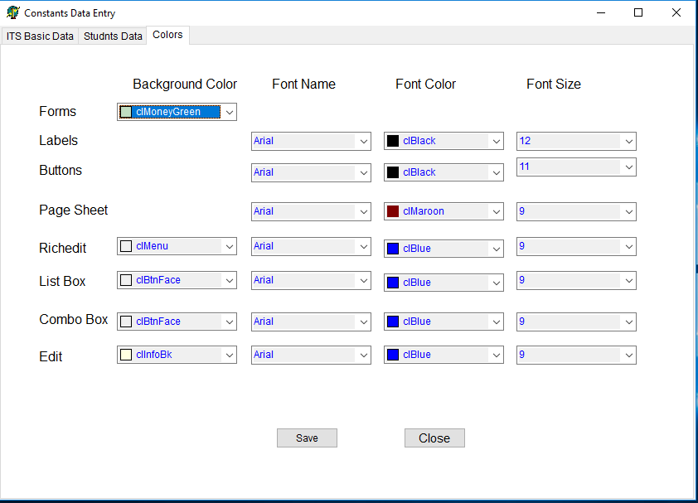
Figure 8 Interface for modifying Fonts of all screens of the system
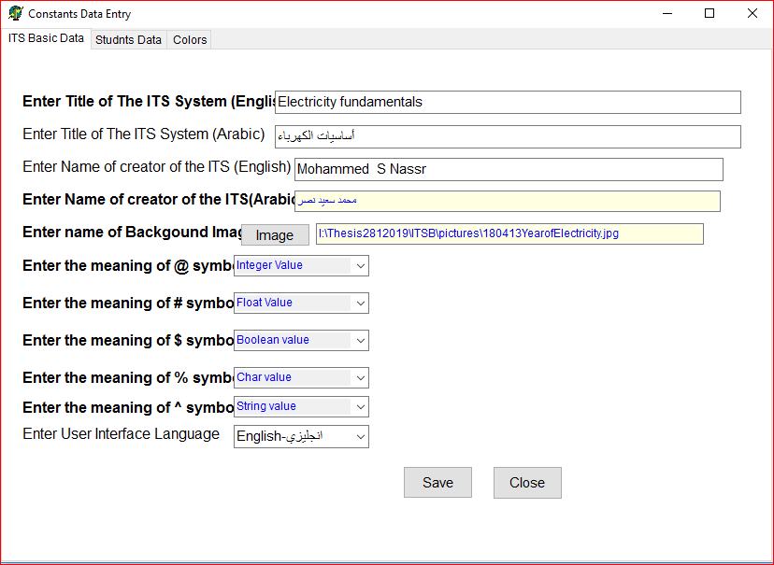
Figure 9Interface for adding constants of the system

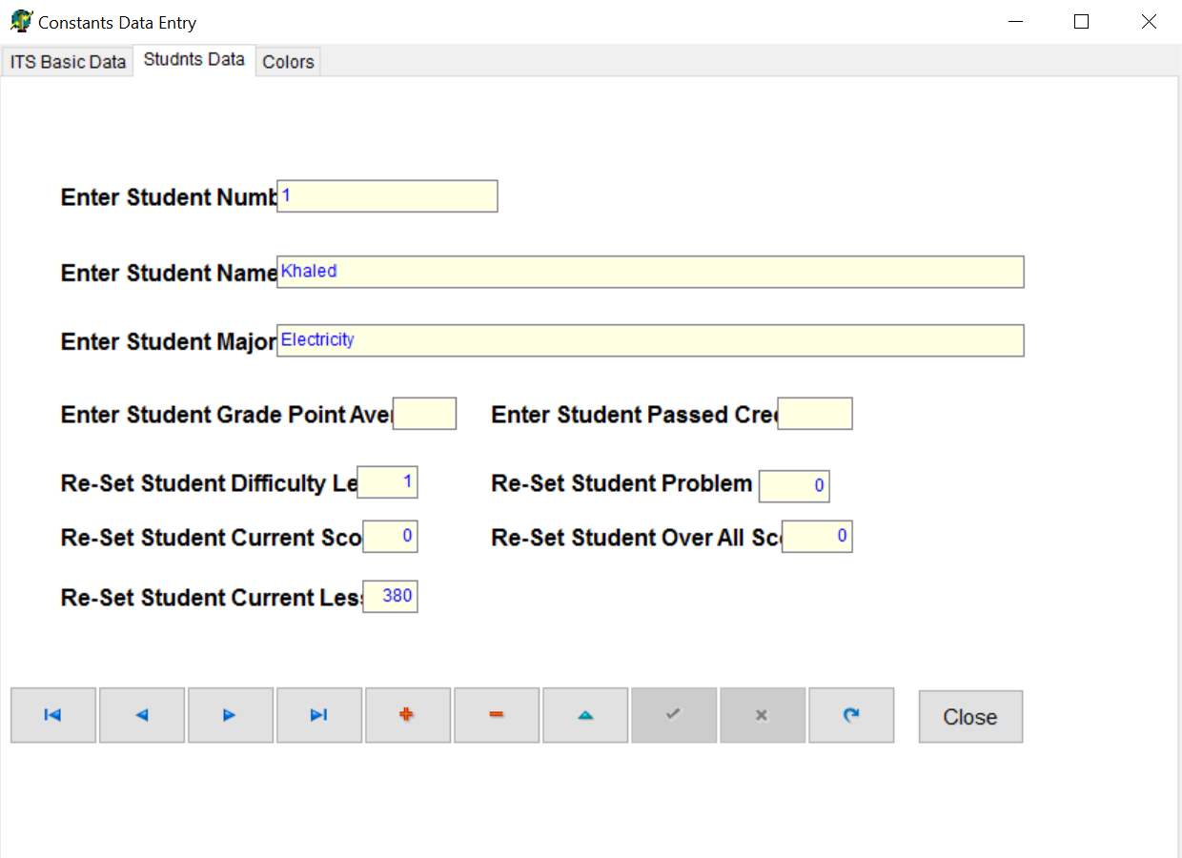
Figure 10 Interface for adding constants of the system

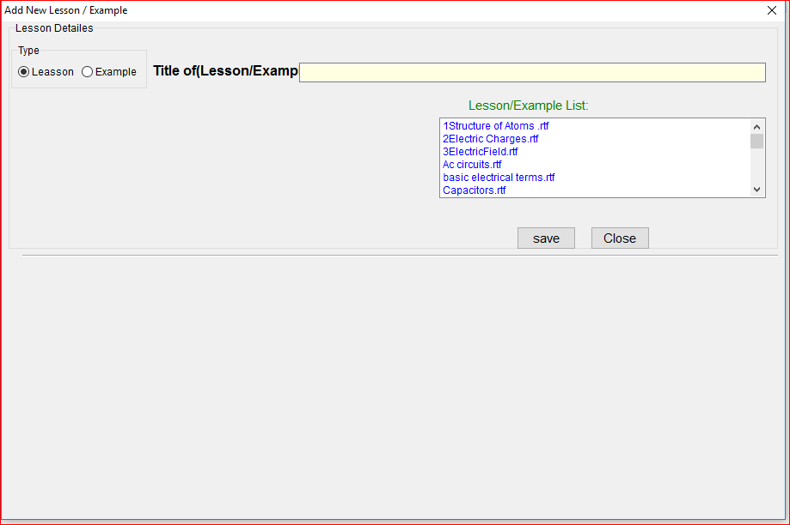
Figure 11Interface for adding Lessons and Examples

Figure 12Interface for adding Lessons and Example

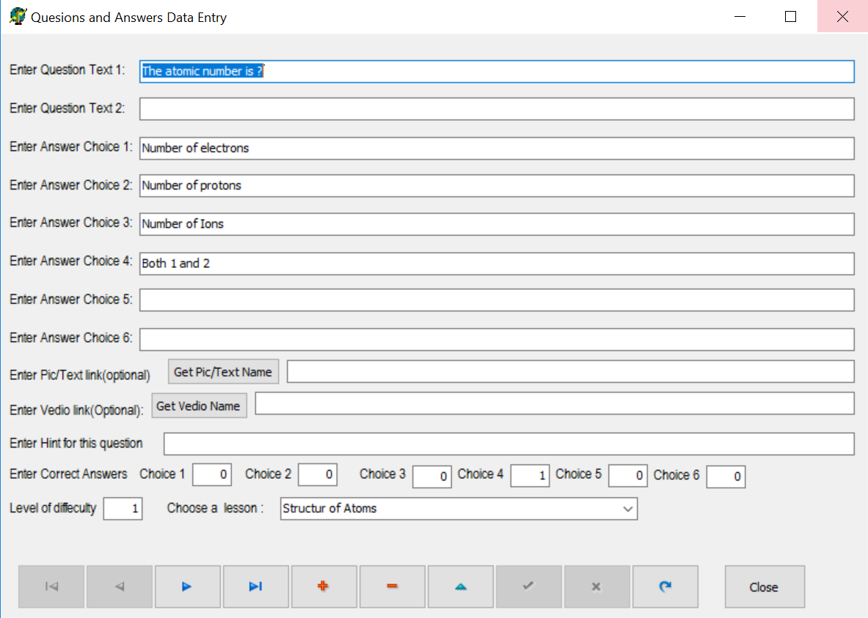
Figure 13Interface for adding questions and answers
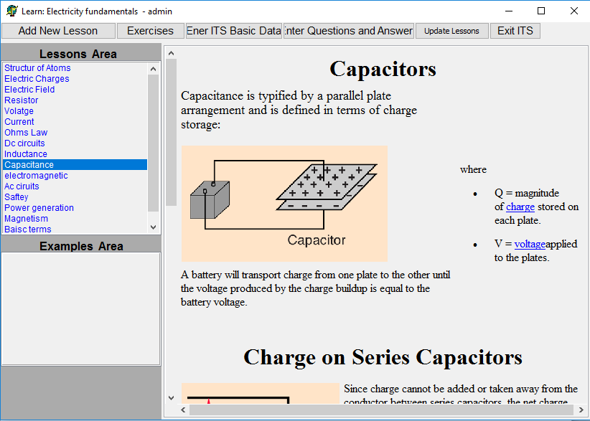
Figure 14User lessons and examples interface

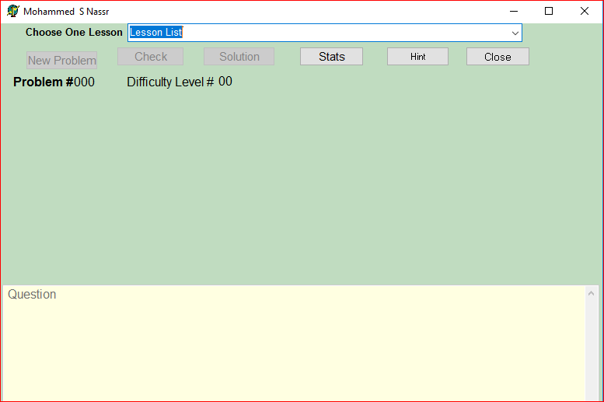
Figure 15User Exercises interface1
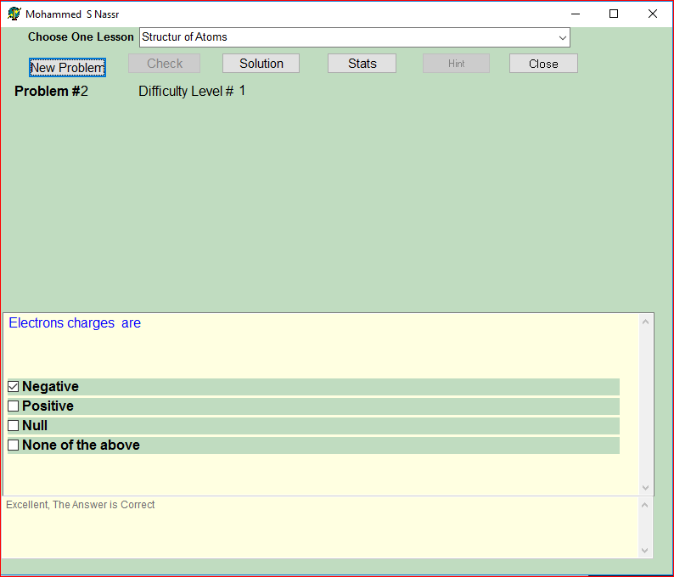
Figure 16User Exercises interface2
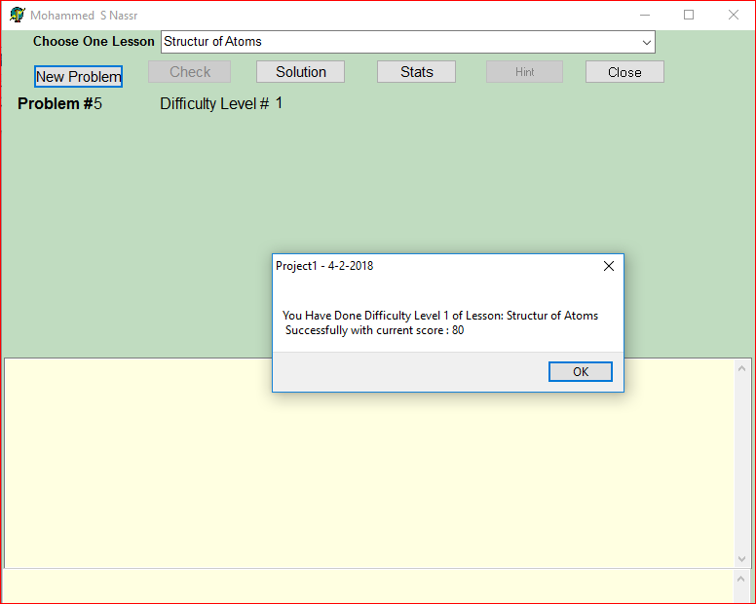
Figure 17The result is good
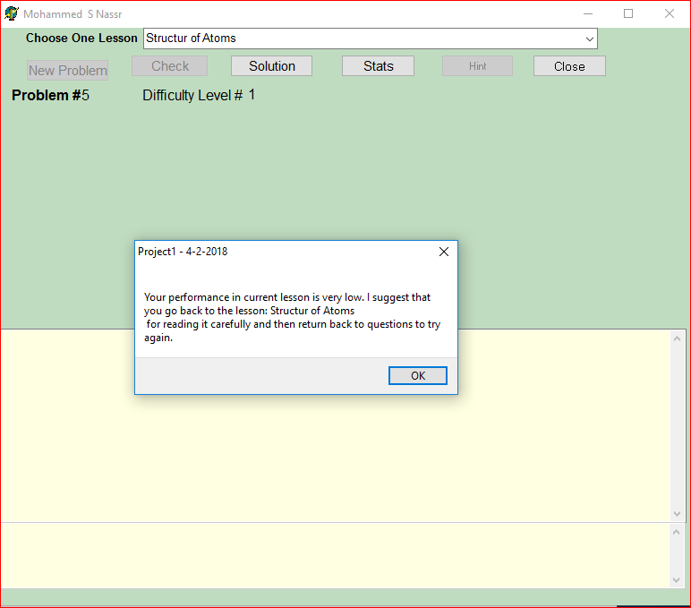
Figure 18The result is not good

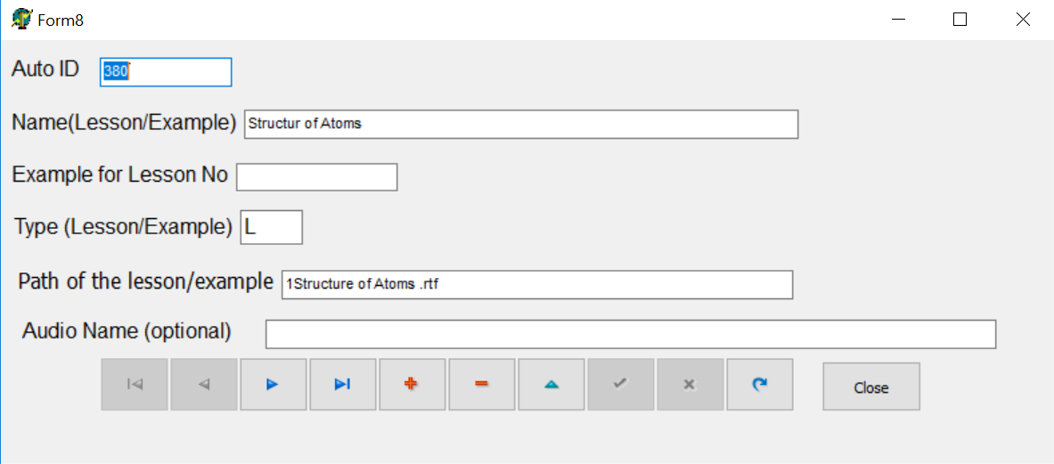
Figure 19Interface for modification Lessons

System Evaluation
System evaluation is devoted to meter the quality of an application regarding efficiency, effectiveness, and user satisfaction to perform tasks by dedicated software and application. Usability assessment is a vital part of the system development process, and a set of questions to assess the ITS system has been developed by people interested in learning about the effectiveness of the Intelligent Tutoring System in water knowledge.
The proposed ITS system was introduced to two groups of people. The first group consists of five specialists in the field of vocational and technical education. The second group consists of 20 students enrolled in technical institutes (TVET) in the Ministry of Education in the Gaza Strip. The two groups were asked to evaluate the proposed Intelligent Tutoring System (ITS) and complete its questionnaire. The questionnaire was prepared by the researcher and approved by the supervisors. The results of the survey of vocational and technical education specialists are presented in Table 1 and Figure 21; moreover, the results of the questionnaire of vocational education students enrolled in vocational institutes in the Gaza Strip are shown in Table 2 and Figure 22.
  - Results of teachers group:
Table 1 outlines each question and its average percentage. Figure 20 shows a bar chart of each question and its percentage.
Table 1 Results of questions asked to the TVET specialists
S.N. | Question | Average%
1 | How easy to use the ITS system? | 98%
2 | How is the Electricity material covered in the ITS system organized? | 90%
3 | How easy to learn using the ITS system? | 88%
4 | How comfortable and pleasant using this system? | 99%
5 | How much friendly is the user interface of this system? | 93%
6 | How much the utilization of the multimedia features benefits you? | 99%

Figure 20The results were obtained by the TVET Trainees

  - Results of Students in group:
Table2.shows each question and its average percentage. Figure 21 shows a bar chart of each question and its percentage.
Table 2 Results of questions asked to Students in TVET group
S.N. | Question | Average%
1 | How easy to use the ITS system? | 95%
2 | How is the electricity material covered in the ITS system organized? | 92%
3 | How easy to learn using the ITS system? | 90%
4 | How comfortable and pleasant using this system? | 97%
5 | How much friendly is the user interface of this system? | 90%
6 | How much the utilization of the multimedia features benefits you? | 96%

Figure 21The results were obtained by the Trainers Students in TVET group
In evaluating the proposed ITS system, evaluators were required to use the proposed ITS system. After that, they were asked to provide their feedback about the proposed ITS system through filling the questionnaire which consisted of the six questions mentioned above.
In this way, effectiveness, efficiency and satisfaction of the proposed ITS system were measured as shown in the above figures. The results were very positive.

Conclusion
In this study, the Intelligent Tutoring System's theory and architecture have been described.
An Intelligent Tutoring System (ITS) was designed and developed for enhancing the training and education for the students who are majored in electricity field in Gaza strip. The ITS system addressed some information about the targeted tutoring subject. The proposed ITS system was presented to two groups of electric departments trainer and specialists and students enrolled in technical and vocational schools in Gaza to test the system and give their feedback through filling a questionnaire. The outcomes of the evaluation were promising.
It is necessary to follow the existing results in the field of the artificial intelligent and TVET sector in parallel in order to produce a reasonable method for effective and efficient educational purposes.

5.1 Future Work
For future work, I am planning to do the following procedures
- Adding interaction Model which will be responsible for interaction sequences of learners by considering the learner’s actions, scores, response time , the contexts in which they occurred, and the learner’s history structures.
- Improve the system to be Team –based intelligent tutorial and group competition system
- Improve the system to be web based system
- Improve the system to be mobile based system
- Focus on applying nonfunctional requirements of the software

REFERENCES
- Naser, S. S. A. (2016). ITSB: An Intelligent Tutoring System Authoring Tool. Journal of Scientific and Engineering Research, 3(5), 63-71.
- Alhabbash, M. I., Mahdi, A. O., & Abu Naser, S. S. (2016). An Intelligent Tutoring System for Teaching Grammar English Tenses. EUROPEAN ACADEMIC RESEARCH, 6(9), 7743-7757.
- State of Victoria (Department of Education and Training, (2018). "THE PEDAGOGICAL MODEL".P6
- Chambers, J., & Sprecher, J. (1983). Computer-Assisted Instruction: Its Use in the Classroom. Englewood Cliffs, New Jersey: Prentice-Hall Inc.
- Freedman, R. 1999. Atlas: A Plan Manager for Mixed-Initiative, Multimodal Dialogue. (1999) AAAI Workshop on Mixed-Initiative Intelligence
- Shelby, R. N.; Schulze, K. G.; Treacy, D. J.; Wintersgill, M. C.; VanLehn, K.; and Weinstein, A. (2001). The Assessment of Andes Tutor.
- Al-Bastami, B. G., & Abu Naser, S. S. (2017). Design and Development of an Intelligent Tutoring System for C# Language. EUROPEAN ACADEMIC RESEARCH, 6(10), 8795.
- Hamed, M. A., & Abu Naser, S. S. (2017). An intelligent tutoring system for teaching the 7 characteristics for living things. International Journal of Advanced Research and Development, 2(1), 31-45.
- Joe Appleton, (2017).Introducing intelligent exercises to support web application programming users. Icicte, 216-225.
- Mahdi, A. O., Alhabbash, M. I., & Abu Naser, S. S. (2016). An intelligent tutoring system for teaching advanced topics in information security. World Wide Journal of Multidisciplinary Research and Development, 2(12), 1-9.
- Jorge García, KarmeleLz. de Ipiña, EloyIrigoyen, Jon A. Elorriaga, Nestor Garay, Ekaitz Zulueta, Jokin Rubio, Celina Vaquero, Mikel Peñagarikano, Jose M. López, Aitzol Ezeiza, Jesús Mª Lz. de Ipiña, (2006). Intelligent tutoring
- Abu-Naser, S., Ahmed, A., Al-Masri, N., Deeb, A., Moshtaha, E., &AbuLamdy, M. (2011). An intelligent tutoring system for learning java objects. International Journal of Artificial Intelligence and Applications (IJAIA), 2(2).
- Bakeer, H. M. S, & Abu-Naser, S. S. (2019). An Intelligent Tutoring System for Learning TOEFL. International Journal of Academic Pedagogical Research (IJAPR), 2 (12), 9-15.
- Duff, Wilmer (1908–1916). A Text-Book of Physics (4th ed.). Philadelphia: P. Blakiston's Son & Co. p. 361. Retrieved 1 December 2016.
- https://electronics.howstuffworks.com/capacitor.htm [2-1-2019]
- Charles G. Oakes, PhD, Blue Ember Technologies, LLC. "Safety versus Security in Fire Protection Planning Archived 2012-03-13 at the Wayback Machine,"The American Institute of Architects: Knowledge Communities, May 2009. Retrieved on June 22, 2011.
- Pullman, Bernard (1998). The Atom in the History of Human Thought. Oxford, England: Oxford University Press. ISBN 978-0-19-515040-7.
- IEEE Dictionary of Electrical and Electronics Terms ISBN 978-0-471-42806-0.
- Du Trémolet de Lacheisserie, Étienne; Damien Gignoux; Michel Schlenker (2005). Magnetism: Fundamentals. Springer. pp. 3–6. ISBN 978-0-387-22967-6.
- New World Record Achieved in Solar Cell Technology (press release, 2006-12-05), U.S. Department of Energy.
- http://www.electrical-installation.org [2-1-2019]
- Hilles, M. M., & Abu Naser, S. S. (2017). Knowledge-based Intelligent Tutoring System for Teaching Mongo Database. EUROPEAN ACADEMIC RESEARCH, 6(10), 8783-8794.
- AbuEl-Reesh, J. Y., & Abu-Naser, S. S. (2018). An Intelligent Tutoring System for Learning Classical Cryptography Algorithms (CCAITS). International Journal of Academic and Applied Research (IJAAR), 2(2), 1-11.
- Marouf, A., Yousef, M. K. A., Mukhaimer, M. N., & Abu-Naser, S. S. (2018). AnIntelligent Tutoring System for Learning Introduction to Computer Science. International Journal of Academic Multidisciplinary Research (IJAMR), 2(2), 1-8.
- Albatish, I., Mosa, M. J., & Abu-Naser, S. S. (2018). ARDUINO Tutor: An Intelligent Tutoring System for Training on ARDUINO. International Journal of Engineering and Information Systems (IJEAIS), 2(1), 236-245.
- Almurshidi, S. H., & Abu Naser, S. S. (2017). Design and Development of Diabetes Intelligent Tutoring System. EUROPEAN ACADEMIC RESEARCH, 6(9), 8117-8128.
- Al-Hanjori, M. M., Shaath, M. Z., & Abu Naser, S. S. (2017). Learning computer networks using intelligent tutoring system. International Journal of Advanced Research and Development(2), 1.
- Abu Hasanein, H. A., & Abu Naser, S. S. (2017). An intelligent tutoring system for cloud computing. International Journal of Academic Research and Development, 2(1), 76-80.
- Elnajjar, A. E. A., & Abu Naser, S. S. (2017). DES-Tutor: An Intelligent Tutoring System for Teaching DES Information Security Algorithm. International Journal of Advanced Research and Development, 2(1), 69-73.
- Aldahdooh, R., & Abu Naser, S. S. (2017). Development and Evaluation of the Oracle Intelligent Tutoring System (OITS). EUROPEAN ACADEMIC RESEARCH, 6(10), 8711-8721.
- Akkila, A. N., & Abu-Naser, S. S. (2018). Rules of Tajweed the Holy Quran Intelligent Tutoring System. International Journal of Academic Pedagogical Research (IJAPR), 2(3), 7-20.
- Al Rekhawi, H. A., & Abu Naser, S. S. (2018). An Intelligent Tutoring System for Learning Android Applications Ui Development. International Journal of Engineering and Information Systems (IJEAIS), 2(1), 1-14.
- Alawar, M. W., & Abu Naser, S. S. (2017). CSS-Tutor: An intelligent tutoring system for CSS and HTML. International Journal of Academic Research and Development, 2(1), 94-98.
- Abu Ghali, M., Abu Ayyad, A., Abu-Naser, S., & Abu Laban, M. (2018). An Intelligent Tutoring System for Teaching English Grammar. International Journal of Academic Engineering Research (IJAER), 2(2), 1-6.
- Abu Naser, S. S. (2006). Intelligent tutoring system for teaching database to sophomore students in Gaza and its effect on their performance. Information Technology Journal, 5(5), 916-922.
- AbuEloun, N. N., & Abu Naser, S. S. (2017). Mathematics intelligent tutoring system. International Journal of Advanced Scientific Research, 2(1), 11-16.
- Abu-Nasser, B. S., & Abu-Naser, S. S. (2018). Cognitive System for Helping Farmers in Diagnosing Watermelon Diseases. International Journal of Academic Information Systems Research (IJAISR), 2(7), 1-7.
- Akkila, A. E.-D. N., & Abu Naser, S. S. (2018). ITS-Tutor for Teaching Rules of Tajweed the Holy Quran. Al-Azhar University, Gaza, Palestine.
- Abu Naser, S. (2008). JEE-Tutor: An Intelligent Tutoring System for Java Expression Evaluation. Information Technology Journal, Scialert, 7(3), 528-532.
- Akkila, A. N., & Abu Naser, S. S. (2017). Teaching the right letter pronunciation in reciting the holy Quran using intelligent tutoring system. International Journal of Advanced Research and Development, 2(1), 64-68.
- Abu Naser, S. S., & Sulisel, O. (2000). The effect of using computer aided instruction on performance of 10th grade biology in Gaza. Journal of the College of Education, 4, 9-37.
- Abu Naser, S., Sulisel, O., Alexandrescu, A., Anderson, J., Skwarecki, E., Anderson, J., . . . Brusilovsky, P. (2005). Growth and Maturity of Intelligent Tutoring Systems. Information Technology Journal, 7(7), 9-37.
- Abu-Naser, S., Kashkash, K., Fayyad, M., Azaab, S., Riley, M., Williamson, M., . . . Maloy, O. (2005). Expert system methodologies and applications-a decade review from 1995 to 2004. Journal of Artificial Intelligence, 1(2), 9-26.
- Al Rekhawi, H. A., & Abu-Naser, S. S. (2018). Android Applications UI Development Intelligent Tutoring System. International Journal of Engineering and Information Systems (IJEAIS), 2(1), 1-14.
- Abu Naser, S., Al-Dahdooh, R., Mushtaha, A., & El-Naffar, M. (2010). Knowledge management in ESMDA: expert system for medical diagnostic assistance. AIML Journal, 10(1), 31-40.
- Al-Ani, I. A. R., Sidek, L. M., Desa, M. M., Basri, N. A., Burns, J., Bhutani, J., . . . Fashokun, A. (2007). Water pollution and its effects on human health in rural areas of Faisalabad. Journal of Environmental Science and Technology, 5(5), 1-17.
- Abu Naser, S., & Akkila, A. N. (2008). A Proposed Expert System for Skin Diseases Diagnosis. INSInet Publication. Journal of Applied Sciences Research, 4(12), 1682-1693.
- Abu Naser, S., Ahmed, A., Al-Masri, N., & Abu Sultan, Y. (2011). Human Computer Interaction Design of the LP-ITS: Linear Programming Intelligent Tutoring Systems. International Journal of Artificial Intelligence & Applications (IJAIA), 2(3), 60-70.
- Abu Naser, S. (2008). An Agent Based Intelligent Tutoring System For Parameter Passing In Java Programming. Journal of Theoretical & Applied Information Technology, 4(7).
- Al-Bayed, M. H., & Abu Naser, S. S. (2017). An intelligent tutoring system for health problems related to addiction of video game playing. International Journal of Advanced Scientific Research, 2(1), 4-10.
- Al-Bayed, M. H., & Abu-Naser, S. S. (2018). Intelligent Multi-Language Plagiarism Detection System. International Journal of Academic Information Systems Research (IJAISR), 2(3), 19-34.
- Abu Naser, S. S. (2001). A comparative study between animated intelligent tutoring systems AITS and video-based intelligent tutoring systems VITS. Al-Aqsa Univ. J, 5(1), 72-96.
- Abu Naser, S., Zaqout, I., Ghosh, M. A., Atallah, R., & Alajrami, E. (2015). Predicting Student Performance Using Artificial Neural Network: in the Faculty of Engineering and Information Technology. International Journal of Hybrid Information Technology, 8(2), 221-228.
- Abu Naser, S., & El Haddad, I. (2016). An Expert System for Genital Problems in Infants. World Wide Journal of Multidisciplinary Research and Development (WWJMRD), 2(5).
- Almurshidi, S. H., & Abu Naser, S. S. (2017). Stomach disease intelligent tutoring system. International Journal of Advanced Research and Development, 2(1), 26-30.
- Al-Nakhal, M. A., & Abu Naser, S. S. (2017). Adaptive Intelligent Tutoring System for learning Computer Theory. EUROPEAN ACADEMIC RESEARCH, 6(10), 8770-8782.
- Atallah, R. R., & Abu Naser, S. S. (2014). Data mining techniques in higher education an empirical study for the university of Palestine. IJMER, 4(4), 48-52.
- Atallah, R. R., & Abu Naser, S. S. (2014). Transformation of E-kanban to BPEL Using Information Retrieval Method For Searching. IOSR Journal of Engineering (IOSRJEN), 4(11).
- Bakeer, H., & Abu Naser, S. S. (2017). Photo Copier Maintenance Expert System V. 01 Using SL5 Object Language. International Journal of Engineering and Information Systems (IJEAIS), 1(4), 116-124.
- Chen, R.-S., Tsai, C.-H., Abu-Naser, S., Bishop, A., Bishop, C., Arbaugh, J., . . . Trent, B. (2008). Evaluating structural equation models with unobservable variables and measurement error. Information Technology Journal, 10(2), 1055-1060.
- El Agha, M. I., Jarghon, A. M., & Abu-Naser, S. S. (2018). SQL Tutor for Novice Students. International Journal of Academic Information Systems Research (IJAISR), 2(2), 1-7.
- El Haddad, I. A., & Abu Naser, S. S. (2017). ADO-Tutor: Intelligent Tutoring System for leaning ADO. NET. EUROPEAN ACADEMIC RESEARCH, 6(10), 8810-8821.
- Hamed, M. A., Abu-Naser, S. S., & Abualhin, K. S. (2018). Intelligent Tutoring System Effectiveness for Water Knowledge and Awareness. International Journal of Academic Information Systems Research (IJAISR), 2(4), 18-34.
- Hasanein, H. A. A., & Abu-Naser, S. S. (2018). Developing Education in Israa University Using Intelligent Tutoring System. International Journal of Academic Pedagogical Research (IJAPR), 2(5), 1-16.
- Khella, R. A., & Abu-Naser, S. S. (2018). An Intelligent Tutoring System for Teaching French. International Journal of Academic Multidisciplinary Research (IJAMR), 2(2), 9-13.
- Li, D., Ghosh, M. M. A., Atallah, R. R., & Naser, S. S. A. (2016). A Novel Distributed Index Method for Cloud Computing. Issues(360).
- Li, L., Chen, N., He, C., Lang, F., Li, H., Wang, H., . . . Gong, P. (2011). Hybrid Quantum-inspired genetic algorithm for extracting association rule in data mining. Information Technology Journal, 12(4), 1437-1441.
- Abu Naser, S. S., Baker, J., Cruz, I., Liotta, G., Tamassia, R., Cooper, M., . . . Feldman, M. (2006). Information Visualization. Information Technology Journal, 7(2), pp: 403-404.
- Abu Naser, S. S., Atallah, R. R., & Hamo, S. (2015). Building an Ontology in Educational Domain Case Study for the University of Palestine. International Journal of Research in Engineering and Science (IJRES), 3(1), 15-21.
- Mosa, M. J., Albatish, I., & Abu-Naser, S. S. (2018). ASP. NET-Tutor: Intelligent Tutoring System for leaning ASP. NET. International Journal of Academic Pedagogical Research (IJAPR), 2(2), 1-8.
- Abu Naser, S. S., Anderson, J., Corbett, A., Koedinger, K., Pelletier, R., Beal, C., . . . Soh, L. (2005). Adaptation of Problem Presentation and Feedback in an Intelligent Mathematics Tutor. Information Technology Journal, 5(5), 167-207.
- Naser, S. (2009). Evaluating the effectiveness of the CPP-Tutor an intelligent tutoring system for students learning to program in C++. Journal of Applied Sciences Research, 5(1), 109-114.
- Abu Naser, S. S. (2012). A Qualitative Study of LP-ITS: Linear Programming Intelligent Tutoring System. International Journal of Computer Science & Information Technology, 4(1), 209.
- Ng, S., Wong, C., Lee, T., Lee, F., Abu-Naser, S., El-Hissi, H., . . . James, A. (2010). Ad hoc networks based on rough set distance learning method. Information Technology Journal, 10(9), 239-251.
- Abu Naser, S. S. (2008). Developing visualization tool for teaching AI searching algorithms. Information Technology Journal, Scialert, 7(2), 350-355.
- Owaied, H. H., Abu-Ara, M. M., Qasem, M. M., Fahmy, H., Douligeris, C., Aha, D., . . . Dillon, T. (2009). Using rules to support case-based reasoning for harmonizing melodies. Journal of Applied Sciences, 11(14), pp: 31-41.
- Abu Naser, S. S. (2008). Developing an intelligent tutoring system for students learning to program in C++. Information Technology Journal, 7(7), 1055-1060.
- Qwaider, S. R., & Abu-Naser, S. S. (2018). Excel Intelligent Tutoring System. International Journal of Academic Information Systems Research (IJAISR), 2(2), 8-18.
- Abu Naser, S. S. (2012). Predicting learners performance using artificial neural networks in linear programming intelligent tutoring system. International Journal of Artificial Intelligence & Applications, 3(2), 65.
- Al-Shawwa, M. , Alshawwa I. A., & Abu-Naser, S. S. (2019). An Intelligent Tutoring System for Learning Java. International Journal of Academic Information Systems Research (IJAISR), 3(1), 1-6.
- Alshawwa, I. A., Al-Shawwa, M., & Abu-Naser, S. S. (2019). An Intelligent Tutoring System for Learning Computer Network CCNA. International Journal of Engineering and Information Systems (IJEAIS), 3(2), 28-36.
- Marouf, A., & Abu-Naser, S. S. (2019). Intelligent Tutoring System for Teaching Computer Science I in Al-Azhar University, Gaza. International Journal of Academic and Applied Research (IJAAR), 3 (3), 31-53.
- Abu Elreesh, J. Y., & Abu-Naser, S. S. (2019). Cloud Network Security Based on Biometrics Cryptography Intelligent Tutoring System. International Journal of Academic Information Systems Research (IJAISR), 3(3), 37-70.

