Predicting Whether a Couple is Going to Get Divorced or Not Using Artificial Neural Networks

Ibrahim M. Nasser
Gaza, Palestine Azhar.ibrahimn@gmail.com

Abstract: In this paper, an artificial neural network (ANN) model was developed and validated to predict whether a couple is going to get divorced or not. Prediction is done based on some questions that the couple answered, answers of those questions were used as the input to the ANN. The model went through multiple learning-validation cycles until it got 100% accuracy.
Keywords: Data Mining; Machine Learning; Deep Learning; Predictive Analysis; Artificial Neural Network; Divorce Prediction

- INTRODUCTOIN
Artificial Neural Networks (ANNs) are mathematical models that motivated by the process of learning in biological animals‟ system. Animals‟ nervous system has cells named neurons. The biological neurons are connected to each other using a connection named synaptic connection. Learning in living creatures is done by the change in the strengths of synaptic links, which happened responding to external stimuli.
This biological mechanism is stimulated in ANNs. An ANN contains computation units named neurons, which are connected to each other through weights that function the same as the synaptic strength mentioned [1]. Neurons are grouped into three layers; input, output, and hidden. The input layer is to receive input data, the output layer sends the output result of the overall calculations, and the hidden layer(s) between the input and output layer is/are for extra complex calculations so more relations between inputs and outputs are discovered. General structure is shown in Figure 1.
In training, weights are initialized with random numbers, then after validation, the weights are adjusted based on validation results. This process keeps repeating until the ANN has a good accuracy [2]. In validation, validation instances must be not the same as the training data so validation is done correctly [3]. In this research, about 80% of the data were used for model training, and about 20% for validation.
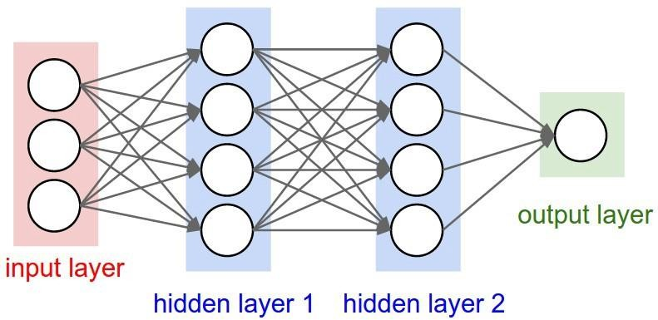

Figure 1: Artificial Neural Network Architecture

- LITERATURE REVIEW
Yöntem, M , Adem, K , İlhan, T , Kılıçarslan, S . Have published a paper titled “divorce prediction using correlation based feature selection and artificial neural networks”. They used the same dataset and they got 98.82% accuracy with their ANN [4].
Nasser, I. M., et al. have published a bunch of works in deep learning applications e.g. Lung Cancer Detection, Diagnose Autism Spectrum Disorder, Predicting Tumor Category, and other applications [5- 11].
Abu Naser, S., et al. have developed many ANNs models that serving predicting and classification purposes, e.g. an ANN model to predict learners performance [32] and many other models [12- 26].
Al-Shawwa, M., et al. also have worked in this field, and have built many ANNs predictions models e.g. birth weight, effect of oxygen consumption of Thylakoid Membranes (Chloroplasts) from Spinach after Inhibition, and temperature and humidity in the surrounding environment [27- 29].

- THE DATASET
The dataset has created by Dr. Mustafa Kemal Yöntem, Dr. Kemal ADEM, Prof. Dr. Tahsin İlhan, and Lecturer Serhat Kılıçarslan, and downloaded from UCI machine learning repository [30]. The dataset is done based on questionnaire; the questionnaire was carried out by using the Divorce Predictors Scale (DPS) based on Gottman couples therapy. 84 of the participants (49%) were divorced and 86 (51%) were married couples. Participants completed the “Personal Information Form” and “Divorce Predictors Scale” [4]. Dataset attributes information are shown below.

- When one of our apologies apologizes when our discussions go in a bad direction, the issue does not extend.
- I know we can ignore our differences, even if things get hard sometimes.
- When we need it, we can take our discussions with my wife from the beginning and correct it.
- When I argue with my wife, it will eventually work for me to contact him.
- The time I spent with my wife is special for us.
- We do not have time at home as partners.
- We are like two strangers who share the same environment at home rather than family.
- I enjoy our holidays with my wife.
- I enjoy traveling with my wife.
- My wife and most of our goals are common.
- I think that one day in the future, when I look back, I see that my wife and I are in harmony with each other.
- My wife and I have similar values in terms of personal freedom.
- My husband and I have similar entertainment.
- Most of our goals for people (children, friends, etc.) are the same.
- Our dreams of living with my wife are similar and harmonious
- We're compatible with my wife about what love should be
- We share the same views with my wife about being happy in your life
- My wife and I have similar ideas about how marriage should be
- My wife and I have similar ideas about how roles should be in marriage
- My wife and I have similar values in trust
- I know exactly what my wife likes.
- I know how my wife wants to be taken care of when she is sick.
- I know my wife's favorite food.
- I can tell you what kind of stress my wife is facing in her life.
- I have knowledge of my wife's inner world.
- I know my wife's basic concerns.
- I know what my wife's current sources of stress are.
- I know my wife's hopes and wishes.
- I know my wife very well.
- I know my wife's friends and their social relationships.
- I feel aggressive when I argue with my wife.
- When discussing with my wife, I usually use expressions such as you always or you never.
- I can use negative statements about my wife's personality during our discussions.
- I can use offensive expressions during our discussions.
- I can insult our discussions.
- I can be humiliating when we argue.

- My argument with my wife is not calm.
- I hate my wife's way of bringing it up.
- Fights often occur suddenly.
- We are just starting a fight before I know what is going on.
- When I talk to my wife about something, my calm suddenly breaks.
- When I argue with my wife, it only snaps in and I do not say a word.
- I am mostly thirsty to calm the environment a little bit.
- Sometimes I think it is good for me to leave home for a while.
- I would rather stay silent than argue with my wife.
- Even if I am right in the argument, I am thirsty not to upset the other side.
- When I argue with my wife, I remain silent because I am afraid of not being able to control my anger.
- I feel right in our discussions.
- I have nothing to do with what I have been accused of.
- I am not actually the one who is guilty about what I am accused of.
- I am not the one who is wrong about problems at home.
- I would not hesitate to tell her about my wife's inadequacy.
- When I discuss it, I remind her of my wife's inadequate issues.
- I am not afraid to tell her about my wife's incompetence.

All questions have values in the range [0- four]. The class attribute is Boolean and represents whether the couples are divorced or not.

- RESULTS
The ANN has done 43501 training-validation cycles, and was successfully developed with zero error and 100% accuracy as shown in figure 2.

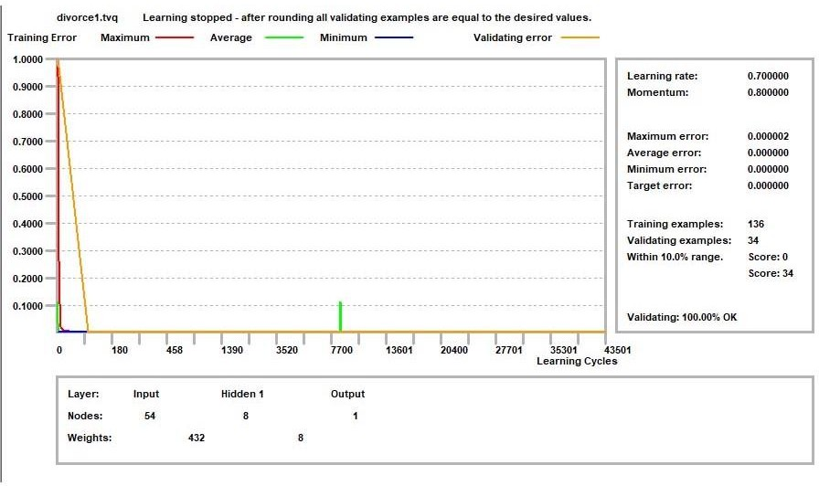

Figure 2: Validation Results

Moreover, results revealed that the question “We are just starting a fight before I know what is going on” is the most important one in the input data, more details are shown in figure 3.
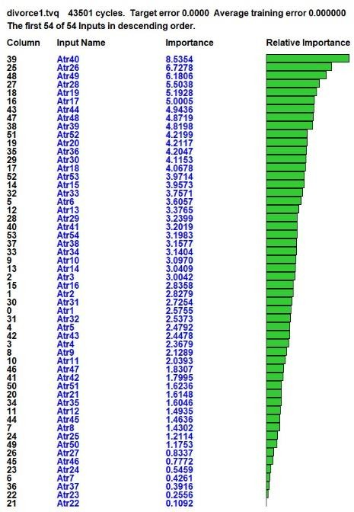

Figure 3: Attribute Importance

Finally, the ANN model that resulted is shown in figure 4.
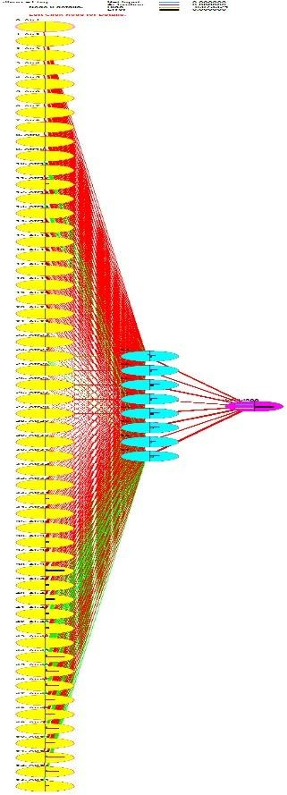
Figure 4: The ANN Model. The full size in Ref. [31]

- CONCLUSION
In this research paper, an Artificial Neural Network was developed that able to predict whether a couple is going to get divorced or not based on questionnaire data about the couple life. Validation showed that the ANN model is able 100% accuracy to do that job. The ANN model is developed, trained and validated using a dataset downloaded from UCI Machine Learning Repository.

REFERENCES
  - C. C. Aggarwal, Neural Networks and Deep Learning. A Textbook, Springer, 2018, pp. 1 - 2.
  - P. Khanale and S. Chitnis, “Handwritten Devanagari Character Recognition using Artificial Neural Network”, Journal of Artificial Intelligence, vol. 4, no. 1, (2011).
  - H. Martin and D. Howard, “Neural Network Design”, 2nd Edition, Martin Hagan (2014).
  - Yöntem, M , Adem, K , İlhan, T , Kılıçarslan, S . (2019). DIVORCE PREDICTION USING CORRELATION BASED FEATURE SELECTION AND ARTIFICIAL NEURAL NETWORKS. Nevşehir Hacı Bektaş Veli Üniversitesi SBE Dergisi , 9 (1) , 259-273 . Retrieved from https://dergipark.org.tr/tr/pub/nevsosbilen/issue/46568/549416
  - Nasser, Ibrahim M., and Samy S. Abu-Naser. "Predicting Tumor Category Using Artificial Neural Networks." (2019).
  - Nasser, Ibrahim M., Mohammed O. Al-Shawwa, and Samy S. Abu-Naser. "Artificial Neural Network for Diagnose Autism Spectrum Disorder." (2019).
  - Nasser, Ibrahim M., and Samy S. Abu-Naser. "Lung Cancer Detection Using Artificial Neural Network." International Journal of Engineering and Information Systems (IJEAIS) 3.3 (2019): 17-23.
  - Nasser, Ibrahim M., and Samy S. Abu-Naser. "Artificial Neural Network for Predicting Animals Category." (2019).
  - Nasser, Ibrahim M., Mohammed O. Al-Shawwa, and Samy S. Abu-Naser. "A Proposed Artificial Neural Network for Predicting Movies Rates Category." (2019).
  - Nasser, Ibrahim M., Mohammed O. Al-Shawwa, and Samy S. Abu-Naser. "Developing Artificial Neural Network for Predicting Mobile Phone Price Range." (2019).

  - Nasser, Ibrahim M., and Samy S. Abu-Naser. "Predicting Books‟ Overall Rating Using Artificial Neural Network." (2019).
  - Afana, M., et al. (2018). "Artificial Neural Network for Forecasting Car Mileage per Gallon in the City." International Journal of Advanced Science and Technology 124:51-59
  - Alghoul, A., et al. (2018). "Email Classification Using Artificial Neural Network." International Journal of Academic Engineering Research (IJAER) 2(11): 8-14.
  - Alkronz, E. S., et al. (2019). "Prediction of Whether Mushroom is Edible or Poisonous Using Back- propagation Neural Network." International Journal of Academic and Applied Research (IJAAR) 3(2): 1-8.
  - Al-Massri, R., et al. (2018). "Classification Prediction of SBRCTs Cancers Using Artificial Neural Network." International Journal of Academic Engineering Research (IJAER) 2(11): 1-7.
  - Al-Mubayyed, O. M., et al. (2019). "Predicting Overall Car Performance Using Artificial Neural Network." International Journal of Academic and Applied Research (IJAAR) 3(1): 1-5.
  - Ashqar, B. A., et al. (2019). "Plant Seedlings Classification Using Deep Learning." International Journal of Academic Information Systems Research (IJAISR) 3(1): 7-14.
  - El_Jerjawi, N. S. and S. S. Abu-Naser (2018). "Diabetes Prediction Using Artificial Neural Network." International Journal of Advanced Science and Technology 121: 55-64.
  - El-Khatib, M. J., et al. (2019). "Glass Classification Using Artificial Neural Network." International Journal of Academic Pedagogical Research (IJAPR) 3(2): 25- 31.
  - Elzamly, A., et al. (2017). "Predicting Critical Cloud Computing Security Issues using Artificial Neural Network (ANNs) Algorithms in Banking Organizations." International Journal of Information Technology and Electrical Engineering 6(2): 40-45.
  - Jamala, M. N. and S. S. Abu-Naser (2018). "Predicting MPG for Automobile Using Artificial Neural Network Analysis." International Journal of Academic Information Systems Research (IJAISR) 2(10): 5-21.
  - Kashf, D. W. A., et al. (2018). "Predicting DNA Lung Cancer using Artificial Neural Network." International Journal of Academic Pedagogical Research (IJAPR) 2(10): 6-13.
  - Metwally, N. F., et al. (2018). "Diagnosis of Hepatitis Virus Using Artificial Neural Network." International Journal of Academic Pedagogical Research (IJAPR) 2(11): 1-7.
  - Sadek, R. M., et al. (2019). "Parkinson„s Disease Prediction Using Artificial Neural Network." International Journal of Academic Health and Medical Research (IJAHMR) 3(1): 1-8.
  - Salah, M., et al. (2018). "Predicting Medical Expenses Using Artificial Neural Network." International Journal of Engineering and Information Systems (IJEAIS) 2(20): 11-17.
  - Zaqout, I., et al. (2015). "Predicting Student Performance Using Artificial Neural Network: in the Faculty of Engineering and Information Technology." International Journal of Hybrid Information Technology 8(2): 221-228.
  - Al-Shawwa, M. and S. S. Abu-Naser (2019). "Predicting Effect of Oxygen Consumption of Thylakoid Membranes (Chloroplasts) from Spinach after Inhibition Using Artificial Neural Network." International Journal of Academic Engineering Research (IJAER) 3(2): 15- 20.
  - Al-Shawwa, M., et al. (2018). "Predicting Temperature and Humidity in the Surrounding Environment Using Artificial Neural Network." International Journal of Academic Pedagogical Research (IJAPR) 2(9): 1-6.
  - Al-Shawwa, M. and S. S. Abu-Naser (2019). "Predicting Birth Weight Using Artificial Neural Network." International Journal of Academic Health and Medical Research (IJAHMR) 3(1): 9-14.
  - "UCI machine learning repository," 24 July 2019. [Online]. Available: https://archive.ics.uci.edu/ml/datasets/Divorce+Predictors+data+set. [Accessed October 2019].
  - https://drive.google.com/open?id=13IbqDA5qm-ZggZLeC-a0zJXlWNDd2tB5
  - Abu Naser, S. S. (2012). "Predicting learners performance using artificial neural networks in linear programming intelligent tutoring system." International Journal of Artificial Intelligence & Applications 3(2): 65.

Author

Ibrahim M. Nasser
Ibrahim joined the Department of Software Engineering at Al-azhar University - Gaza in 2014 and he has graduated recently. Currently he is an independent Researcher. He is interested in Artificial Intelligence Research, in particular applied deep learning research.

