Why/How to study scientific thinking?

Nancy J. Nersessian
Cognitive Science, Georgia Institute of Technology
Learning Sciences, Harvard Graduate School of Education

Abstract
Scientific research is a highly complex and creative domain of human activity. In addition to its intrinsic value, understanding scientific thinking provides insight into the creative potential of human psychological capacities, as they are imbedded in rich social, material, and cultural environments. I discuss findings from my own investigations using two forms of qualitative research suited to studying scientific thinking as situated in context: cognitive-historical and cognitive-ethnographic.

Author Note
Correspondence concerning this article should be addressed to Nancy J. Nersessian. Email: nancy.nersessian@gmail.com

Why/How to study scientific thinking?
“A theory about the nature of science is also a theory of how to study science” (Mitroff, 1974), p. xiii).
Introduction
Scientific thinking provides one demonstration of the creative potential of human cognitive capabilities—what it is possible to accomplish when attempting to solve complex problems in materially, socially, and culturally rich environments with critical and reflective use of those capabilities. By and large our understanding of human cognition has not been informed by thinking of the complexity, sophistication, and reflectiveness seen in science. The study of human cognition has been confined largely to the cognitive development of children. These studies investigate such phenomena as “core” cognition, conceptual change, executive functions, and social cognition. Such investigations comprise mainly experiments that have been rigorously designed to provide robust data on how children reason, represent, imagine, understand, solve problems, learn, and so forth. Experimental research on cognitive development, as well as that on mundane problem-solving (mostly by undergraduates) provides resources to illuminate the more elaborate and consciously refined problem-solving practices of scientists (Nersessian 2008). If we accept the hypothesis that scientific thinking lies on a continuum with mundane cognition, we can, indeed, learn things about the cognitive basis of scientific thinking from such studies (see Nersessian 2008, for more details), but these are not sufficient to understand the nature of scientific thinking.
Scientific investigation requires complex and integrated cognitive processes, though these are most often studied in isolation from one another in psychological research on mundane thinking. It is also highly dependent on creating and using artifacts through which to extend the possibilities for thinking about the world, and often requires coordinated collaboration among members of a research team. As with cognitive development in children, the domain of scientific practice affords an opportunity to study cognitive processes that involve major changes in representation and understanding. Within the cognitive sciences and the philosophy of science, scientific thinking is usually studied in the context of problem-solving, which implicates processes such as how scientists reason, represent, remember, decide, imagine, plan, understand, and learn. Most especially, scientific problem-solving provides significant data on metacognitive thinking, as evidenced in the articulation and reflective refinement of methods, reasoning strategies, and representation issues by scientists. The study of how scientists think, thus, provides a novel window on the mind—on what is possible at the highly creative end of the human continuum.
Within the cognitive science fields that have studied science, cognitive psychology traditionally studies science-like thinking using controlled experimental methods or problem-solving protocol analysis by setting non-scientists or even scientists to work on problems determined by the researcher. In AI, researchers have developed programs that reconstruct logical and heuristic processes used in historical discoveries and have generalized these to develop AI discovery systems. In both fields, such studies, while valuable, have low ecological validity not the least because they leave out the material, social, and cultural constituents of complex and sophisticated scientific thinking. For some time, philosophers of science interested in real-world scientific practices have been mining historical data, for example, examining scientists’ notebooks, to study scientific thinking as it occurs in practice both to determine the actual nature of these practices and to account for contextual factors essential for understanding scientific thinking. More recently, some philosophers of science have begun to avail themselves of qualitative methods of data collection and analysis developed in the social sciences to advance that aim by examining science “in action.” In each instance, researchers usually develop thick descriptions and analytic insights of specific cases that provide exemplars of a kind of practice, for example, conducting interviews with scientists engaged in a specific research effort. These case studies are then examined through the lenses of philosophical concepts and theories to see what insights they provide to both critique and further develop philosophical understanding of science.
The “theory of how to study science” I advance and illustrate in this paper is that scientific thinking should be studied as a system phenomenon, by which I mean it requires an integrative analysis of the cognitive, social, material, and cultural dimensions of authentic problem-solving by scientists. I mark these as “cognitive-cultural” to indicate they are integrated in scientific practice, constituting a single system. Such an integrative analysis can be obtained, to a limited extent, through historical case analysis of the records of past science and, more fully, through in situ studies that use robust ethnographic observational and interview methods of data collection and qualitative data analysis. Each kind of investigation offers specific affordances and limitations. My research on scientific discovery and creativity can be divided into two phases that I have dubbed “cognitive-historical” and “cognitive-ethnographic” research. Although I have examined several dimensions of scientific thinking, this paper is organized around findings on problem-solving leading to conceptual change. These findings from investigations of representational and reasoning practices in physics and in bioengineering sciences provide insight into its the nature and, reflexively, inform our understanding of human cognition, more broadly. Focusing on how scientists create and change scientific concepts underscores the differences in analyses each kind of qualitative approach to studying scientific thinking enables. Further, how to understand conceptual change and the processes that underlie it has been a long-standing problem of central concern both to philosophy of science and to psychology: human development and learning. Both in childhood and in science, conceptual change can radically transform the way the world is understood (e.g., (Carey, 2009)). Although the details are beyond the scope of this paper, the research in philosophy of science has been informing the research in developmental psychology since the 1980’s as part of the move away from Piaget’s maturational account of conceptual change.
Cognitive-historical research: How do scientists create concepts?
My training as a physicist made me skeptical as a philosophy student about the value of using only the tools of abstract philosophical analysis to address problems related to the practice of science, such as the nature and justification of scientific methods. The proposal to “naturalize” epistemology by W.V.O. Quine (Quine, 1969) provided the license to recruit resources from history and the sciences to address epistemic issues in conjunction with philosophical analysis. As I interpret it, the naturalist stance in philosophy of science holds, basically, that 1) a philosophical account needs to be informed by the best available scientific understanding of humans that the biological, psychological, and social sciences offer; 2) it needs to be informed by data on the actual investigative practices, as they are created, used, and justified by scientists; and 3) it needs to make use of appropriate empirical methods for determining these practices. My research began in a context where the problem of conceptual change was a major issue in philosophy of science. The “historicist” philosophers, notably, Thomas Kuhn (Kuhn, 1962) and Paul Feyerabend (Feyerabend, 1962, 1970), were leading the charge against positivist conceptions of science based on logical analysis of the language of science and of “rationally reconstructed” science. They, too, argued that philosophers needed to draw from the records of the history of science and from theories of human psychology. Their approach, while moving in the right direction, seemed limited to me in two ways (Nersessian, 1984). First, their claims about the seriousness of “incommensurability” (the inability of scientists committed to the theory before, and those to the theory after a “revolution” to understand one another) in conceptual change appeared to be based on a decidedly unhistorical approach to the history of conceptual change. For instance, the approach they used was what I call “endpoints” examination that looked at the initial and final products of a major conceptual change in science, rather than the processes through which the change came about. For instance, they examined the nature of Newtonian concepts and how they were understood in context, and then they examined the concepts of the Special Theory of Relativity in that context and noted the non-comparability of these concepts, such as “mass is constant” (Newton) and “mass varies with velocity” (Relativity). But examining endpoints provides no account of the processes of transition from one conceptual structure to the next, i.e., the thinking through which it occurs, creating what I call a “big bang” account. To get to relativity theory, scientists had first to develop electromagnetic theory. They supported their claims about the sudden nature of transition by drawing on the notion of a “Gestalt switch” from the Gestalt psychologists’ theories of human problem solving (Köhler, 1929; Wertheimer, 1959). This approach precluded not only comparability of concepts, but also an account of the arguments and justifications scientists advanced in favor of the new conceptual understanding, and how others became convinced. Although I agreed with the methodological approach of using historical records and theories and data from psychology, I disagreed with the specific ways they were being used and the arguments to which they were applied. Both parts of their approach (the emphasis on endpoints and on the Gestalt switch) served to block attending to a fundamental dimension of conceptual change: how novel concepts are formed.
To carry out a naturalist investigation into the methods of concept formation and change in science, I developed what I dubbed a cognitive-historical method (Nersessian, 1987). On the one hand, to understand the epistemic achievements of scientists requires a fine-grained examination of the processes of discovery as evidenced in historical records. Historical records on conceptual changes provide an important general insight: such creative thinking is best understood not as a single act—an “aha” moment—and not as an attribute of one special individual, but as a problem-solving process, often involving the research of multiple scientists over long periods to come to fruition. These records show, for instance, that, in the fine-grain, incommensurability is not a major issue for scientists as they formulate and solve problems that lead to concept formation and change.
On the other hand, the resources a philosopher of science brings to bear to interpret the historical data depend on the questions being addressed. Historical analysis has long incorporated resources from other disciplines, for instance, from anthropology, economics, psychology, or political science. Cognitive-historical analysis draws from the interdisciplinary cognitive sciences, especially cognitive psychology. The historical dimension involves investigation of the extant records of the scientific practices pertinent to the problem, for instance, those implicated in conceptual change, and examines these over extended periods of time. To the extent possible, it locates scientists within the problem situations (cognitive, social, cultural, material) of their local communities and wider cultural contexts. The cognitive dimension entails determining what and how, given current cognitive science understanding, human cognitive capacities might underlie, facilitate, and constrain scientists’ investigative practices. The cognitive practices scientists have created and developed are understood to be more sophisticated, reflective extensions of the same cognitive strategies humans employ all the time to cope with their environments, and which they use in more mundane forms of problem-solving to meet the challenges of everyday life and work.
The focus of my initial cognitive-historical research was on the development of the concept of field, beginning with the contributions of Michael Faraday and James Clerk Maxwell. The introduction of the novel notion that forces are transmitted continuously, with a time delay, through space and time, rather than acting instantaneously at a distance, was essential in the transition from Newtonian physics to the development of theories of special and general relativity and of quantum mechanics. It required scientists to determine the nature and production of the forces taking place in space free from ordinary matter. Interestingly, psychologists, including the Gestalt theorists and Kurt Lewin (Lewin, 1939), borrowed this notion from physics to develop a notion of field in social psychology. To conduct this research, I examined the archival and published records of scientists involved in the development of the electromagnetic field concept from Faraday through to Albert Einstein (Nersessian, 1984). The data provided by the historical records, especially the more tentative and exploratory archival materials—drafts, letters, diaries, notebooks, and so forth—opened a whole new perspective on creative scientific reasoning. As I investigated these historical records, the question arose as to what role the sketches that filled the margins of Faraday’s diary, the analogies employed in his and Maxwell’s thinking, their thought experiments and those of Einstein were playing in the construction of their field concepts. At the time these heuristics were dismissed by both philosophers and historians of science as ancillary— mere aids—to scientific reasoning, understood as logical manipulations of propositional representations. However, the archival data, coupled with published records, provided evidence to support my claim that these so-called “aids” were the actual reasoning processes through which scientists were solving problems, and this insight led my quest to develop an explanation of how they are generative of concept formation (Nersessian, 1992).
I have examined the role of analogies, visualizations, and thought experiments – generalized to mental simulations – in the various major phases of the construction of the concept of field over nearly a hundred-year period in detail in my cognitive-historical analyses (Nersessian 1984, 2008). This development is too complex to summarize here, but a brief look at an of example from that analysis will serve to motivate my unified account of model-based reasoning. The problem at hand was a representational problem: how to create a viable scientific (read “mathematical”) representation of the propagation of electric and magnetic forces through space. In the 1800’s it was widely assumed that “empty” space was filled with “aether” – a weightless, frictionless “quasi-material” substance. This aether was thought to play a role in the transmission of light through space. Since it was literally inconceivable at the time that forces could be transmitted through empty space, Maxwell made use of the notion of an aether to examine how electric and magnetic forces might be transmitted (“electromagnetic aether”). This was a completely novel problem and there were no ready-to-hand analogies Maxwell could use to think about it. Instead, he cobbled together an analogy, representing the electromagnetic medium as an elastic fluid, that he developed incrementally through several iterations. Here I discuss how the analogy, represented by the diagram in Figure 1, enabled him to examine how electricity and magnetism could be mutually productive in the propagation of the electromagnetic field through the aether.
Maxwell considered this analogy an imaginary system, similar to a thought experiment (“if the field were to be an elastic fluid….”). First, he assumed, on the basis of Faraday’s experimental research and theoretical analyses, that magnetism involved vortex motion in the medium (represented by the hexagonal cross-sections). Next, he represented the movement of electric current with tiny “idle-wheel particles.” He stated that the particles were purely imaginary and did not exist in nature. He introduced them on analogy with fly wheels on mechanical devices solely to solve the problem that friction would cause the vortices to stop if they were in contact with one another. Ingeniously, though, he saw that they could be used to represent the flow of current produced by the motion of the vortices (represented as hexagonal in cross section, rather than circular, so the particles would be tightly packed), and, reciprocally, the movement of the idle wheels would cause the vortices to spin. In sum, the diagram captures the relational structure of the mutual production of electric and magnetic forces (electromagnetic induction). By examining this relational structure (an extended and complex process), Maxwell was able to derive the electromagnetic field equations, and from these he predicted that the transmission of electromagnetic forces would take place at the speed of light. For an analysis of that process, see Chapter 2 in Nersessian 2008. For the purposes at hand, it is only necessary to understand that the diagram in Figure 1 provides a visual representation of an analogy that can be simulated in thought (motions of particles and idle wheels caused by mutual transmission of forces). Although Maxwell imbued this system with some features of electricity and magnetism determined in the experimental research, such as the rotation of the plane of polarization of light by magnetic forces and the orientation electric and magnetic forces at right angles to one another, his analysis focused on the relational structures depicted in the analogy and not on the properties of the imaginary medium. In this way he was able to determine the mathematical representations of those structures. My extended analysis shows that and how this is an instance of model-based reasoning that was productive of concept formation.

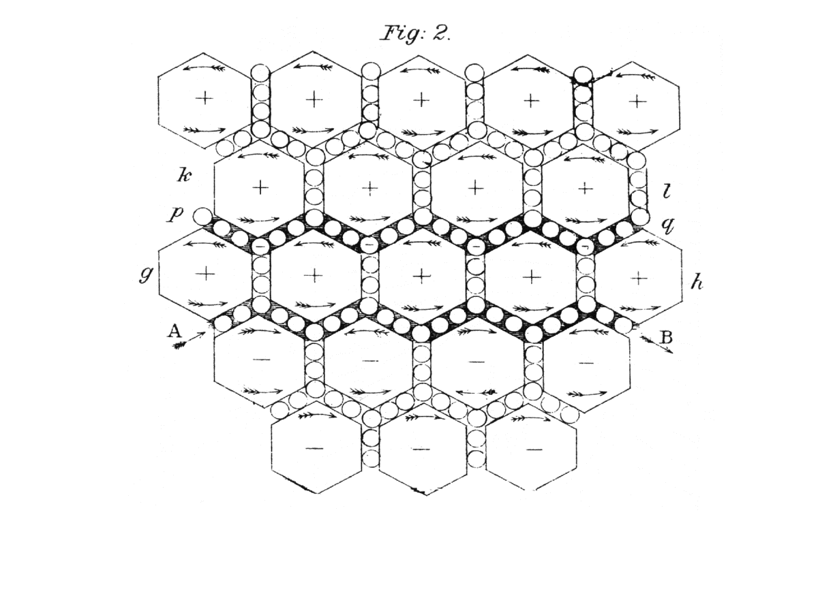
Figure 1: Maxwell’s visual representation of his analogical model of electromagnetic induction by means of the imaginary vortex-idle wheel mechanism. The arrows indicate the direction of motion. Maxwell accompanied this diagram by text to animate it correctly in thought. ((Maxwell, 1890), volume 1, plate VIII, figure 2)

A large literature in psychology and AI examines how these heuristics use by Maxwell are used productively in everyday reasoning, and so a step in the analysis of how they work in science is to determine how they work in the mundane contexts and then use these insights to examine the more complex problem-solving in science, with an eye also to determining in what ways they differ. The cognitive-historical method is reflexive in that it feeds back into cognitive science findings and insights from the historical analysis to critique and enrich the cognitive accounts. There is extensive research in the cognitive sciences on analogical reasoning, visual, especially diagrammatic, reasoning, and reasoning by mental simulation (how I generalize “thought experimental reasoning”) as forms of heuristic reasoning in problem-solving. In the cognitive sciences, these forms of reasoning are customarily investigated in separate areas of research, however the historical data show that in scientific problem-solving they work together. To be true to the phenomena, an integrated examination is needed for science, and likely in mundane thinking as well. Cognitive-historical analysis leads to the interpretation that together these forms of reasoning implicate processes of abstraction and integration that constitute a creative, productive kind of reasoning—“model-based reasoning”—especially suited to conceptual (representational) change (Nersessian, 2008). In model-based reasoning inferences are made through the iterative and incremental construction and manipulation of models (integrative representations) that are structural, behavioral, or functional analogues of target phenomena. In building these models, scientists use various processes of abstraction (e.g., idealization, simplification, limiting case, generic abstraction) from existing representations to create a series of models that conclude in a novel representation.
For instance, an analogy provides a means of understanding and reasoning about one problem solution (target) in terms of another (source), which, in the mundane case, is already understood. The Dunker fortress – tumor is a classic example in cognitive psychology, where the reasoner is expected to solve a problem by representing the challenge of killing a tumor with radiation (“target” problem) as a “divide-and-conquer” situation in a story they are provided about the capture of a fortress (“source” problem). Given the goals and constraints of the problem, the reasoner abstracts a set of features from the target to map to the source and evaluates the fit. There is an important difference with use of analogy in science. In the mundane case, the reasoner is given a solved problem, or can retrieve one from memory, that can serve as a source analogy. For research problems on the frontiers of science there is often no pre-existing analogical source. The scientist has to build the analogical source representation. The target problem, too, is often ill-defined and the analogy and problem definition are refined in interaction with one another to develop a solution. This iterative and incremental process is demonstrated in a wide range of historical data that show how analogical source models are created in interaction with the goals and constraints of the target problem (see, Nersessian, 2008, 19-60, for more details). This kind of bootstrapping process furthers the articulation of the problem as well as its solution. Each iteration of the model provides insights that need to be understood and worked into the next iteration until a satisfactory problem solution is achieved. In this fashion, the modeling process serves to continually improve the creation of the source analogy until a satisfactory mapping is established or shown not to be feasible.
The historical records also show that constructing an analogical source model often involves visual and simulative thinking. Inferences from an analogy can be facilitated by transforming them into a visual format. Diagrams and sketches are common visual tools used to represent analogies in science. A thought experiment involves imagining an analogy and reasoning through simulating changes in future states. Newton’s famous analogy between the moon and a projectile provides a much simpler demonstration than Maxwell’s of how all three—visualization, analogy, and imaginative simulation—can work in combination to arrive at novel inferences. Newton proposed an analogy between the motion of a projectile thrown with successively greater velocity from a mountain rising high above the surface of the earth and the lunar orbit. The analogy functions as a thought experiment in which one can simulate successive paths of the projectile, as its velocity increases, from the mountain to the earth, ending with the escape velocity where it, too, would orbit the earth under the effect of centripetal force. The inference that these forces are the same marks a radical departure from existing representations of earthly and celestial phenomena as different in kind and contributed to Newton’s creation of the mathematical concept of universal gravitation. Figure 2 provides the visual representation he drew of the analogy that guides the reasoner in simulating the motions of a projectile in thought.

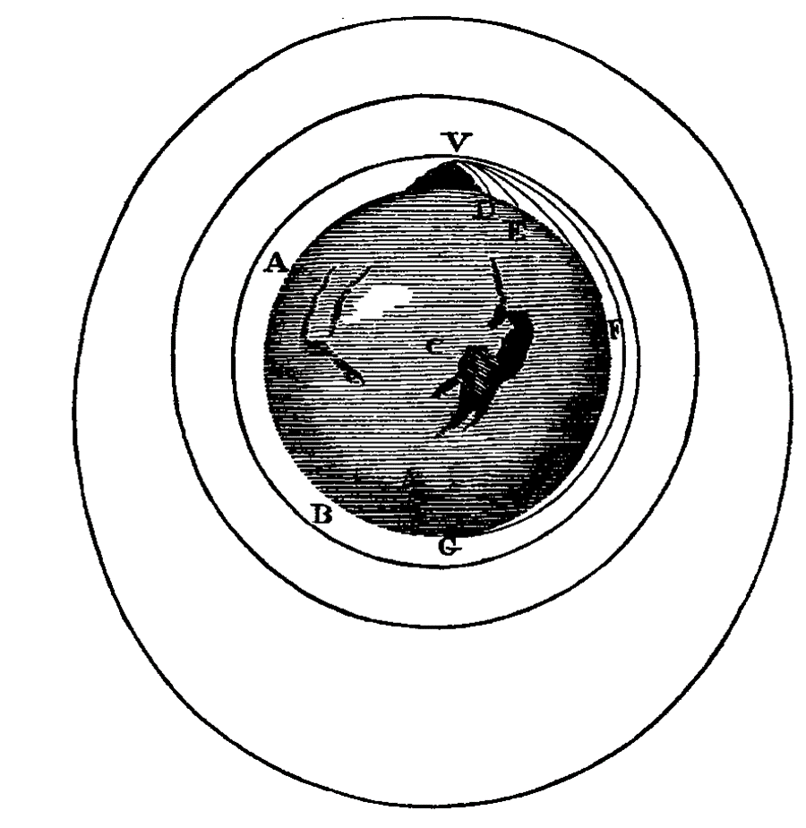
Figure 2: Newton’s rendering of a projectile thrown from a high mountain with increasing velocity. He provided text to direct the reader how to simulate the paths of the moving projectile in thought. Principia vol II, book III, 3 (Newton, 1687).
The historical data across the sciences since their inception provide evidence that the interaction of analogies, visualizations, and imaginative simulations can to lead to novel inferences, and ultimately, conceptual change. It cannot be developed here (see Nersessian, 2008, for more details), but the cognitive-historical analysis of model-based reasoning establishes that this form of reasoning is ampliative and how it can lead to novel scientific insights. Through abstractive processes and changes of representational format, novel structures and behaviors can emerge in the models, and efforts to understand these can lead to the formation of novel concepts.
In sum, the problem addressed in my cognitive-historical research was to understand the nature of “model-based reasoning,” its basis in human cognitive capabilities, and its causal and explanatory role in the epistemic achievements of scientists, in particular, concept formation and conceptual change in science. As a method, cognitive-historical analysis (a qualitative, interpretive method) can be used to identify what human cognitive resources scientists bring to bear in scientific reasoning, provide an account of how these resources afford and constrain scientific reasoning, and examine the ways in which scientists have been extending these to develop critically reflective methods for understanding nature. Studying the science end of this human cognitive continuum can, reflexively, provide deeper understanding of human cognitive capacities and suggest new lines of research into cognition in more ordinary contexts, thus contributing to cognitive science. In particular, this research into model-based reasoning has been incorporated into research on the processes of conceptual change in development (e.g., Carey 2009), and into conceptual change in science learning (e.g., (Manz & Georgen, 2023 (online preview); Smith, Carey, & Wiser, 1985; Smith, Snir, & Grosslight, 1992), including into the National Academy of Science’s Nature of Science component of the Next Generation Science standards (Council, 2012).
Since the inception of what we now know as “science,” scientists have always created artifacts through which to think about and investigate nature (e.g., Newton’s calculus or Galileo’s inclined planes or Maxwell’s analogical diagram). They have also worked together with other scientists, either locally or through correspondence to think about research problems. However, cognitive-historical analysis is quite limited in the extent to which it is possible to examine how cognitive, social, cultural, and material resources that scientists draw upon are integrated in formulating, refining, and solving problems. The material dimension is largely limited to textual and diagrammatic representations, or, for an experimentalist such as Faraday, instruments that might be left behind. As for the social and cultural dimensions, one can locate scientists within their problem situation. For instance, it is possible to situate Maxwell’s problem-solving with respect to a historical problem situation that includes Faraday’s experiments and theories and William Thomson’s analogical approach to developing mathematical formulations of electric and magnetic phenomena. Further, one can establish some of the local cultural resources available to him as he worked within a community of Cambridge University scientists attempting to formulate macrolevel mathematical descriptions of continuous phenomena such as fluid and elastic media (“continuum mechanics”) (Warwick, 2003). One can also discern some of his interactions with others, for instance, Thomson, through correspondence, which can be found in the collection of his works (Harman(Heimann), 1990, 1995). So, in examining historical conceptual change in science, it is possible to understand it, broadly, as a cognitive-cultural product of a problem-solving system distributed in time and across individuals and artifacts. However, richer, contemporaneous data are required to establish how such cognitive-cultural integration takes place in the processes of problem-solving, which can lead to the creation of novel concepts.
Cognitive-ethnographic research: How do scientists create concepts in situ?
The major contribution of cognitive-ethnographic research is that it enables philosophers to establish that and how scientists think with artifacts and together with others in on-going problem-solving processes. In the case of concept formation and change, data collected in situ build a stronger case than historical data for cognitive-cultural integration by providing real-time evidence for how problem-solving is distributed across scientists and artifacts, situated within sociocultural environments. The typical environment today is the research lab, organized to facilitate the development and use of specific practices, which range from methods and technologies to mentoring. In this research, the major cognitive science resources I use are taken from cognitive anthropology and learning sciences, in addition to psychological theories about the embodied, situated, and distributed nature of cognitive processes. What I call “environmental perspectives” (Nersessian, 2005), dating at least to the work of Eleanor and J.J. Gibson (E. J. Gibson, 1969; J. J. Gibson, 1966), maintain that intelligent behavior is a function of the environment. For instance, Jean Lave’s (Lave, 1988) ethnographic research on mathematical problem-solving situated in resource rich contexts, such as the supermarket, shows that people are much more mathematically competent in these contexts than their performance on the typical mathematical word problems given to students shows them to be. The methodological approach of “cognitive ethnography,” named by Edwin Hutchins ((Hutchins, 1995); see also (Hall, Stevens, & Torralba, 2002; Hall, Wieckert, & Wright, 2010; Lave, 1988), which conducts ethnographic research on problem-solving in rich socio-technical environments, provides a model for philosophers of science seeking to study scientific thinking in situ (Nersessian & MacLeod, 2022), especially in the context of the scientific research laboratory.
My research group conducted over fifteen years of cognitive-ethnographic research on four university research labs on the frontiers of the bioengineering sciences with the aim to develop integrated analyses of problem-solving. In addition to making contributions to cognitive science and philosophy of science, this research provided the basis for working with learning scientists and science faculty to develop novel undergraduate and graduate biomedical engineering curricula that reflect the research practices of the field. Bioengineering scientists aim to make fundamental contributions to basic biological research, as well as to create novel artifacts and technologies for application, especially in medicine. As we saw, most of their research is focused on the former as they investigate and attempt to make sense of novel biological phenomena. That sense-making process often involves concept formation and conceptual change. Here I will present an overview of such a case of problem-solving leading to conceptual change in a neuroengineering lab, “Lab D”. The distributed problem-solving system in this case involved the interactions of 3 graduate student researchers, the lab director, and two different kinds of models, an in vitro model-system (with several possible formats) designed with the goal to investigate learning in networks of living neurons and a computational model developed to simulate and examine the behavior of the in vitro model-system.
The science is complex in this case, but it is possible to convey the broad outlines of the interplay between the formation of concepts and the cognitive-cultural research practices in this area, which requires indirect investigation of in vivo biological phenomena by means of physical (in vitro) and computational (in silico) simulation models. Here, as in the historical case, concept formation is situated in the context of analogical, visual, and simulation modeling, where the need to understand and interpret model phenomena drives concept formation and the need to articulate concepts drive the creation of novel models. Importantly, in these contexts, the model is the locus of cognitive-cultural integration. As with lines of a transportation system intersecting at a central hub, the primary model(s) of the lab research are sites of intersection of biological and engineering concepts, methods, and materials and of epistemic values and norms. They are sites where processes of mentoring, identity formation, and learning take place, and the history of the lab is learned and appropriated hands-on in research. So too, they are the basis for the interaction with members of the wider community through presentations and publications, and efforts to gain funding and institutional support for the research. The case I outline here provides an exemplar of how novel concepts form as a distributed problem-system takes shape and develops its modeling practices to understand novel phenomena.
In Lab D, our research group conducted ethnographic research with the aim to uncover the activities, artifacts, and meaning-making that constitute research as it is situated in the ongoing practices of this community of biomedical engineering scientists. We conducted two years of intensive data collection, and three years of targeted follow-up, which included tracking the graduate student researchers through to their graduation. All our research used a “team ethnography” approach where multiple ethnographers (in this case 3) collected data to get broad coverage over the course of the day/week and to provide more than one perspective on the activities in the lab. Together we conducted approximately five hundred hours of observation with field notes, seventy-five interviews (unstructured and multiple targeted follow-up interviews with each participant), and video/audio recorded forty lab meetings we attended. Additionally, our data archive included PowerPoint presentations, paper drafts, grant proposals, dissertation proposals, emails, diagrams/sketches, the contents of the wiki through which the group carried on discussions, and photographs of the lab as it went through transformations in layout and of various writing and drawings on whiteboards. In conducting data analysis, we used a variety of mutually complimentary qualitative methods: interpretive coding, thematic analysis, case study analysis, and cognitive-historical analysis. In particular, we approached coding broadly consistent with the aims of grounded theory (Glaser & Strauss, 1967; Strauss & Corbin, 1998), so as to enable core categories and interpretations to emerge from the data and remain grounded in it while being guided by our initial research questions. As data analysis progressed, we related our findings to appropriate philosophical and psychological theoretical frameworks. Our interdisciplinary research group met weekly to discuss ongoing coding, to scrutinize and evaluate our ethnographic work as it was unfolding, and to continue to triangulate our emerging interpretations with various data. A more detailed discussion of our methods can be found in Nersessian (2022) and in (Osbeck, Nersessian, Malone, & Newstetter, 2011). An important point for this case study is that when the research took an interesting and important turn around year three, we had sufficiently rich data to analyze the entire concept formation and change process as it occurred.
Lab D’s overarching research problem was to understand the mechanisms through which living networks of neurons learn. They hoped that such understanding could lead to the development of aids for neurological disorders and diseases. Prior to this research, studies of neuron learning were conducted either on single neurons or on brain slices, fixed after learning had taken place. The lab director argued that since learning in the brain is a dynamic phenomenon of synaptic growth in response to electrical signals, it needed to be studied in living networks. He worked to further that goal with postdoctoral research in a lab that was developing an in vitro simulation model, “the dish,” which is a hybrid model built using both engineering and biological materials and methods. The dish is composed of embryonic rat cortical neurons (~40K), dissociated and plated on a specially designed grid of 64 electrodes, called a “multi-electrode array” (MEA). The neurons generate new connections to become a living network. At the time the director established Lab D, this was a completely new kind of model-system, and the lab was one of the first to investigate its properties and behavior. They began by developing software to “communicate” with the dish by sending and receiving signals from it (“open-loop physiology”) and proceeded to develop computational and robotic “embodiments” through which the dish might learn from “sensory” feedback, as the brain does from the body ("closed-loop physiology”). The embodiments all constitute different kinds of model-systems, through which the researchers could conduct experiments on the neuron network and were novel to the research field. All of these model-systems were designed to function as source analogies to help solve the target problem of understanding the dynamics of learning in neural networks in the brain. The researchers hypothesized that if they could produce and control learning in the dish, this would provide insights into the neural mechanisms in the dish network that might be transferred and evaluated as mechanisms of learning in the brain in further research in neuroscience.
Over the period of our investigation, the researchers were trying to understand and conceptualize the novel phenomena produced in their experimentation with various dish model-systems. They hoped that this understanding would help them solve the problem of developing a control structure for supervised learning (algorithms) in neuron networks, that is, a system of patterned stimulation through which they could reliably create and control learning in the model-system. Their concept formation processes involved both transfer and modification of concepts from single neuron studies and from engineering, as well as the formation of fundamentally novel concepts to understand neural activity. To formulate their goal, the lab conceptualized “learning” in terms of the Hebbian notion of learning as plasticity (basically, changes in the brain from adding or removing neural connections or adding cells in response to experience), the mathematical formulation known as the Hebbian rule (“neurons that fire together wire together”), and the notion of memory, which is the ability to retain and retrieve experiences. They expected to modify the concept of plasticity and the associated equation, since the original concerns two neurons and they were investigating populations of neurons.
At the start, although the graduate student researchers were always working to explore the problem space through stimulating the neuronal network with different electrical signals and tracking output, they were responsible for different projects. D4 was focused on the open-loop research and D2 and D11 (Lab members are designated by letter and number) were engaged in developing the embodied model-systems that would enable real-time feedback experiments. All the research was discussed in lab meetings with the director, so everyone was aware of the overall research progress and problems. I focus here on the 2-year period in which the major conceptual changes took place. It is also the period in which the group evolved from a lightly coupled to a highly interactive distributed problem-solving system. This is a complex case study, and I select highlights that once again illustrate the generative role of model-based reasoning (analogy, visualization, and simulation) in a research project and environment quite different from the historical case in the prior section. The full details of the case study can be found in Nersessian (2022, pp. 105-144).
As part of the suite of software tools they developed to send, record, and analyze dish electrical signals, the researchers decided to create a visual display of dish electrical activity in a format similar to what would be seen on an oscilloscope, as an 8x8 grid that displays the electrical activity in each individual MEA channel as it is occurring over time (Figure 3).
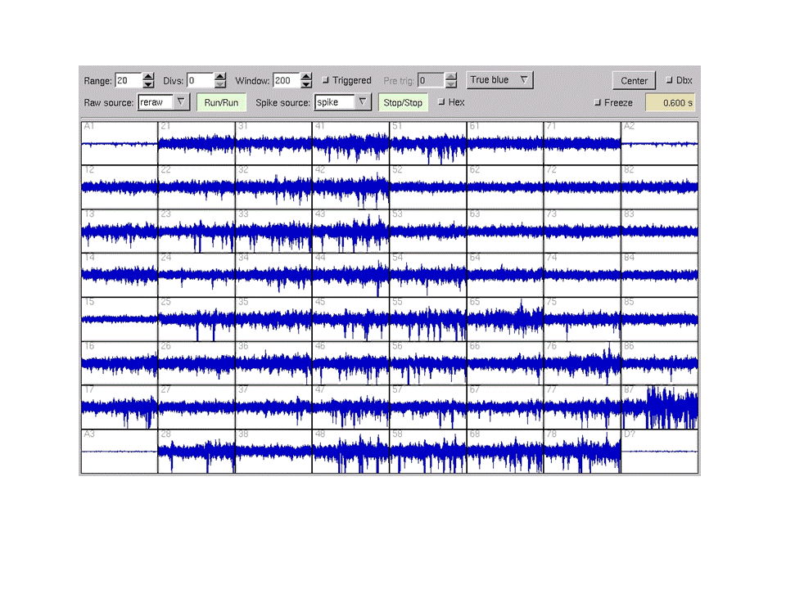
Figure 3: A screen shot of the MEAscope per channel visualization of the in vivo dish activity showing spontaneous bursting (spikes) in the channels of the dish.

Early on they encountered a problem: there appeared to be continual spontaneous electrical activity taking place across the dish. They borrowed the concept of burst (spontaneous electrical activity) from single neuron studies, now generalized to a population of neurons. Figure 3 exhibits a pattern of bursting behavior as electrical spikes in each electrode channel. They initially understood this behavior to create a significant obstacle to their goal of getting the dish to learn. They used the engineering concept of noise to interpret the bursting behavior: “noise in the data – interference, it’s clouding the effects of learning we want to induce.” Such bursting behavior does not occur in a normally functioning adult brain, so D4 focused her research on finding a stimulation pattern (sensory input) that would eliminate bursts. It took a frustrating year, which included numerous failures to quiet the dish, but when she succeeded, a strange thing happened. They still were unable to get the quieted dish to learn, which they understood to be “a lasting change in behavior resulting from experience,” when they tried numerous stimulation patterns. The learning research was at an impasse.
During the period D4 was focused on quieting the dish and then trying to induce plasticity, the other researchers were engaged in largely separate, but interrelated activities (Figure 4, before the dashed line). D2 was working on the embodiment software module, needed to translate signals between the dish and the motor commands to control its computational and robotic embodiments. D11 had been working with him, but early in the burst quieting period he decided to branch away from the work with the in vitro model-system and develop a computational model that could simulate the behavior of the in vitro model. This computational dish model was a second-order model (or second-order analogy) built in order to understand the behavior of the living dish model. Computational modeling had not been part of the practices of the lab, but D11 believed the affordances of this kind of model, in particular that “you can measure everything, every detail of the network,” might provide “some new information about the problem [bursting and control] we could not solve at the time.” In particular, he thought that the computational dish would enable him to “see” the activity at the level of the individual neurons, make precise measurements after every experiment, and run significantly more controlled experiments than were possible with the in vitro dish.

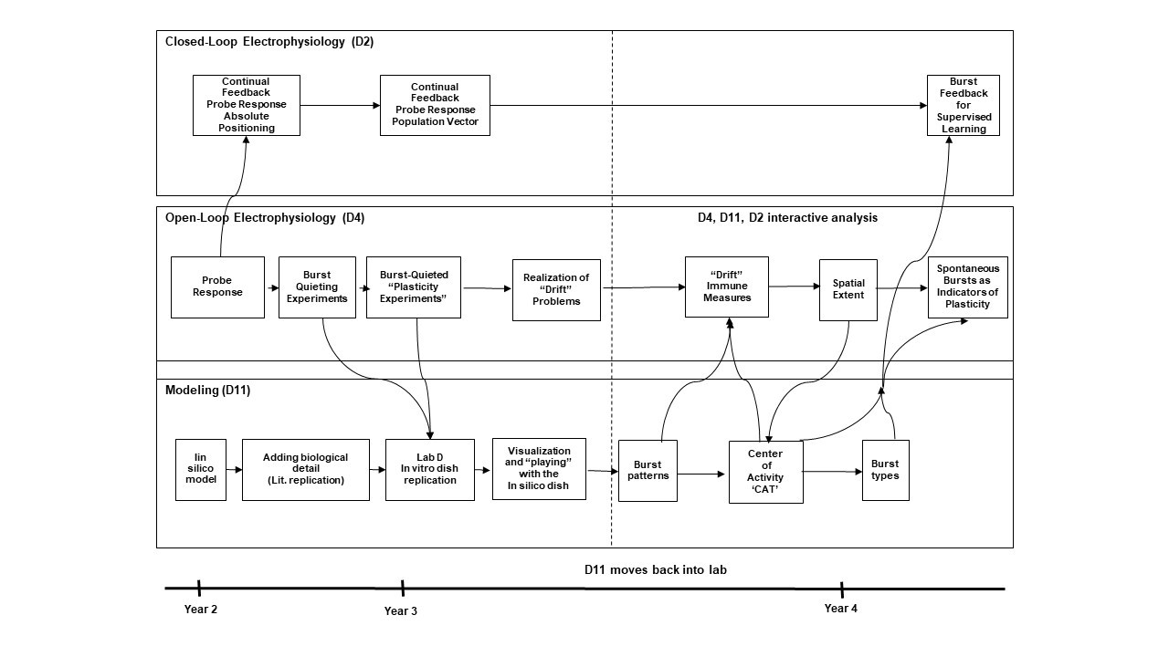
Figure 4: My representation of Lab D as distributed problem-solving system. The boxes represent models or model activity and researcher interactions with them. The arrows indicate interactions among the researchers. The period after the dotted line shows how the in silico model coalesced the researchers into a highly interactive system.

Building the computational model took many iterations and the processes are too complex to detail here. It is important to understand, though, that in developing the model he did not start with data from their dish. Rather he used only the physical design constraints of their MEA dish and used data from the literature on single neuron studies, brain slices, and experiments with in vitro dishes other than their own to build and test the model. Only after the model was able to replicate these behaviors did he begin to use their data to investigate bursting.
One major affordance of computational modeling, which proved quite instrumental to that effort, is its capabilities for dynamic visualization. The modeler has significant discretion about how to visualize the model dynamics, for instance D11 could have used the same kind of grid format they used for the in vitro dish (Fig. 3), however he chose to visualize it the way he imagined it: as electrical propagation in a dynamic network shown in Figure 5.

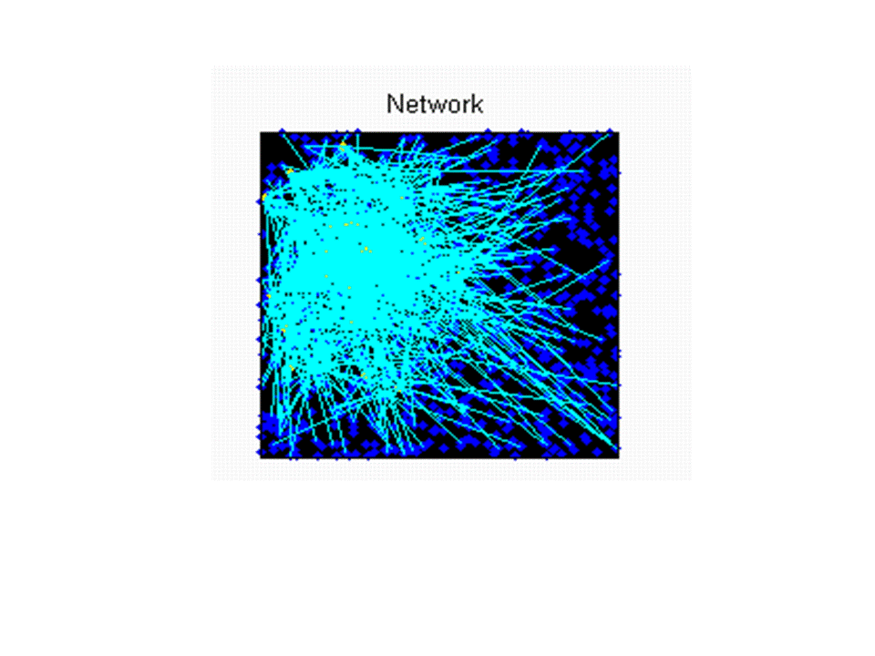
Figure 5. A screen shot of the computational visualization of the electrical activity of the in silico dish displayed on the computer screen as it propagates across the network of neurons. The actual dynamic display would show how the burst activity moves across the computer screen.

As expressed by D11, “I can visualize fifty thousand synapses…so you can see…after you deliver a certain stimulation, you can see those distributions of synaptic weight change.” He also made movies of the visualized behavior and showed them to the others (and to us), so that everyone could see the behavior and come to agreement on what he had discovered was a remarkable feature of bursting behavior. In the process of running numerous simulations, he claimed to have developed a “feel” for the behavior of the model. This is a common claim made by computational modelers after they have run their models through thousands of simulations under different conditions. It indicates that they have developed an intuitive understanding of how the model behaves and can make predictions about future behavior. D11 claimed, “what I feel… is that spontaneous bursts are very stable.” By this he meant that he noticed that there were repeated spatial patterns in the bursting activity. He found that there were “similar looking burst types” that propagated across the network, and only a limited number of what he called “burst types.” The understanding he reached from these findings was that if the bursts were stable, then they might be exploited as signals rather than noise in the data. The others agreed when they watched the videos, and they started working together to develop a way to track and mathematically formulate the activity of possible limited and stable bursts across the network. The implications of this insight were that their understanding of bursts changed from noise in the data to a signal that might be exploited to control the behavior of the dish, and indeed, with considerable further joint problem-solving through mathematical analyses and experimentation on both the in vitro and in silico models, they were able to create and control learning in the in vitro dish model-system. Again, this was a complex and extended problem-solving process, but for our purposes, I only note the conceptual changes it led to.
Their development of the notion that bursts might be signals led to the formation of several interrelated novel concepts:
- burst type: one of a limited number of burst patterns (approximately ten)
- burst occurrence: when a type appears
- spatial extent: an estimation of burst size and specific channel location
- CAT (center of activity trajectory): a vector capturing the flow of activity at the population scale
“CAT” is the most significant new concept in that it provides an entirely novel way to understand neural activity, and, if transferrable to in vivo phenomena, could prove of major importance to neuroscience (as “field” did to physics). CAT tracks the flow of electrical activity (not just activity) at the population scale and provides a “signature” for a burst type because each burst type has a corresponding range of similar-looking CATs. The researchers first developed the CAT notion for the in silico model and then, using that model as a source analogy, they mapped, adapted, and transferred it to the in vitro dish model. In finishing their individual dissertation projects, the researchers were able to combine the CAT analysis and earlier techniques developed in the burst quieting research to formulate a set of stimulation patterns (a control structure) that led to the first instance of supervised learning in a living neuronal network in the field.
In summary, this case, developed in a cognitive-ethnographic analysis, provides novel insights into scientific thinking that go beyond what the cognitive-historical approach can provide. I briefly note a few of them here. First, we had the data to examine the novel bioengineering modeling practices as they were developing and to examine how the models functioned as hubs of cognitive-cultural integration, including interdisciplinary integration. Second, we were able to follow how researchers provisionally transferred concepts from single neuron studies and engineering to understand novel in vitro dish phenomena, with the understanding that they would need revision, and how these both facilitated and impeded the research, and ultimately led to the formation of several novel neuroscience concepts. Third, we had rich data on the problem-solving processes and the role of model-based reasoning in conceptual change, including, especially, a dynamic visual analogy. The computational dish model D11 constructed to examine bursting activity in the in vitro dish model provided a way of envisioning the real-time activity of the network that captures the structure and behavior of the activity. This visualization was significantly different from the per-channel format MEAscope visualization, which does not capture the network features, with which they were working. As D4 later put it, “he [D11] was thinking like a wave, where we were thinking of a pattern.” Of course, because they were investigating learning in a network of neurons, everyone knew the dish activity was network activity. But no one had seen network activity or a representation of it, so the computational visualization was built on a counter factual scenario – a though experiment: “If we were able to see into the dish…” Indeed, the researchers spoke of this visualization as enabling them “to see into the dish.” The new formulations of “burst” and the entirely novel concept of CAT derive from the visualization of the movement patterns and the capacity of the in silico model to run an unlimited number of simulations that could be recorded and played back repeatedly. Together these affordances enabled first D11, and then the research group to notice the similar-looking patterns and seek the formulate their behavior mathematically. The manifest nature of the visualization served to align the mental models of the researchers, enabled them to make and critique joint inferences, and facilitated the group in exploiting the control possibilities of bursts as signals. Finally, the computational model served as a driving force that brought the researchers together to form a highly effective distributed cognitive-cultural system. In particular, the in silico visualization worked as a generator of many types of lab activity, which when put together, created new concepts.
Conclusion
Frontier scientific research is a prime location to study scientific thinking processes as they lead to concept formation and conceptual change, as scientists are often faced with the problem of making sense of novel phenomena. Here I have attempted to demonstrate how qualitative research: cognitive-ethnographic and, to lesser extent, cognitive-historical, shows that such processes are not something that take place just “in the head” of the researchers, but are distributed across researchers, community problem-solving practices, and artifacts (especially models). As the philosopher Daniel Dennett has put the situation succinctly, “Just as there is not much carpentry you can do with your bare hands, there’s not much thinking you can do with your bare mind” (Dennett, 2000), p.17. This is true in general, and even more so in the case of scientific thinking. In the case at hand, to account for concept formation and conceptual change in science requires a fine-grained qualitative analysis of the cognitive, social, material, and cultural dimensions of the actual problem-solving processes implicated in them. The findings and theoretical analyses that derive from investigating real-world scientific practices not only contribute to understanding of the highly creative end of human thinking, but also reflect back on the more mundane end of the spectrum, for example, by opening up new questions such as how analogy, visualization, and mental simulation might work together in ordinary problem solving.
The research presented here, along with other qualitative research in philosophy of science and in psychology of science, demonstrates that scientific thinking is a psychologically rich domain in which to study a range of human psychological processes, including perception, intuition, learning, reasoning, imagining, and emotion.

References
Carey, S. (2009). The Origin of Concepts: Oxford University Press.
Council, N. R. (2012). A Framework for K-12 Science Education: Practices, Crosscutting Concepts, and Core Ideas. Washington, DC: The National Academies Press.
Dennett, D. C. (2000). Making tools for thinking. In D. Sperber (Ed.), Metarepresentations: A Multidisciplinary Perspective (pp. 17--29). New York: Oxford University Press.
Feyerabend, P. (1962). Explanation, reduction and empiricism. In H. Feigl & G. Maxwell (Eds.), Minnesota Studies in the Philosophy of Science (Vol. III). Pittsburgh: University of Pittsburgh Press.
Feyerabend, P. (1970). Against method: An outline of an anarchistic theory of knowledge. In H. Feigl & G. Maxwell (Eds.), Minnesota Studies in the Philosophy of Science (Vol. IV). Minnesota: University of Minnesota Press.
Gibson, E. J. (1969). Principles of perceptual learning and development.
Gibson, J. J. (1966). The senses considered as perceptual systems.
Glaser, B., & Strauss, A. (1967). The Discovery of Grounded Theory: Strategies for Qualitative Research. Piscataway, N. J.: Aldine Transaction.
Hall, R., Stevens, R., & Torralba, T. (2002). Disrupting representational infrastructure in conversation across disciplines. Mind, Culture, and Activity, 9, 179-210.
Hall, R., Wieckert, K., & Wright, K. (2010). How does cognition get distributed? Case studies of making concepts general in technical and scientific work. In M. Banich & D. Caccmise (Eds.), Generalization of Knowledge: Multidisciplinary perspectives (pp. 225-246). NY: Psychology Press.
Harman(Heimann), P. M. (1990). The Scientific Papers and Letters of James Clerk Maxwell (Vol. 1). Cambridge: Cambridge University Press.
Harman(Heimann), P. M. (1995). The Scientific Letters and Papers of James Clerk Maxwell (Vol. 2). Cambridge: Cambridge University Press.
Hutchins, E. (1995). Cognition in the Wild. Cambridge, MA: MIT Press.
Köhler, W. (1929). Gestalt psychology. Oxford, England: Liveright.
Kuhn, T. (1962). The Structure of Scientific Revolutions: International Encyclopedia of Unified Science (Vol. 2 (2)). Chicago: University of Chicago Press.
Lave, J. (1988). Cognition in Practice: Mind, Mathematics, and Culture in Everyday Life. New York: Cambridge University Press.
Lewin, K. (1939). Field theory and experiment in social psychology: concepts and methods. American Journal of Sociology, 44, 468-496.
Manz, E., & Georgen, C. (2023 (online preview)). Interlocking models in classroom science. Science Education, n/a(n/a). doi:https://doi.org/10.1002/sce.21806
Maxwell, J. C. (1890). The Scientific Papers of James Clerk Maxwell. Cambridge: Cambridge University.
Mitroff, I. I. (1974). The Subjective Side of Science: A Philosophical Inquiry Into the Psychology of the Apollo Moon Scientists. The Hague: Elsevier Scientific Publishing.
Nersessian, N. J. (1984). Faraday to Einstein: Constructing Meaning in Scientific Theories. Dordrecht: Martinus Nijhoff/Kluwer Academic Publishers.
Nersessian, N. J. (1987). A cognitive-historical approach to meaning in scientific theories. In N. J. Nersessian (Ed.), The Process of Science (pp. 161-179). Dordrecht: Kluwer Academic Publishers.
Nersessian, N. J. (1992). How do scientists think? Capturing the dynamics of conceptual change in science. In R. Giere (Ed.), Minnesota Studies in the Philosophy of Science (pp. 3-45). Minneapolis: University of Minnesota Press.
Nersessian, N. J. (2005). Interpreting scientific and engineering practices: Integrating the cognitive, social, and cultural dimensions. In M. Gorman, R. D. Tweney, D. Gooding, & A. Kincannon (Eds.), Scientific and Technological Thinking (pp. 17-56). Hillsdale, N. J.: Lawrence Erlbaum.
Nersessian, N. J. (2008). Creating Scientific Concepts. Cambridge, MA: MIT Press.
Nersessian, N. J., & MacLeod, M. (2022). Rethinking Ethnography for Philosophy of Science. Philosophy of Science, 89(4), 721-741. doi:10.1017/psa.2022.8
Newton, I. (1687). Mathematical Principles of Natural Philosophy and His System of the World (A. Motte, Trans.). Berkeley, CA: University of California Press.
Osbeck, L. M., Nersessian, N. J., Malone, K. R., & Newstetter, W. C. (2011). Science as Psychology: Sense-making and Identity in Science Practice. Cambridge, UK: Cambridge University Press.
Quine, W. V. O. (1969). Naturalized Epistemology. In Ontological Relativity and Other Essays (pp. 69-91). Cambridge, MA: Harvard University Press.
Smith, C., Carey, S., & Wiser, M. (1985). On differentiation: A case study of the development of the concepts of size, weight, and density. Cognition, 21, 177-237.
Smith, C., Snir, J., & Grosslight, L. (1992). Using conceptual models to facilitate conceptual change: The case of weight-density differentiation. Cognition and Instruction, 9, 221-283.
Strauss, A., & Corbin, I. (1998). Basics of Qualitative Research Techniques and Procedures for Developing Grounded Theory (2nd ed.). London: Sage.
Warwick, A. (2003). Masters of Theory: Cambridge and the Rise of Mathematical Physics. Chicago: University of Chicago Press.
Wertheimer, M. (1959). Productive thinking. Oxford, England: Harper.

