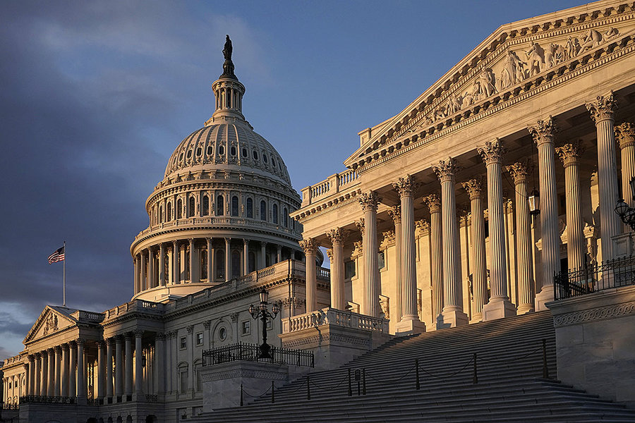

Does a country’s ideal political system depend on its level of economic development?
Isabel O’Connor | 26/09/2020

In short, my answer to this question would be yes. However, there are many ways in which a country’s political system can adapt and change as a direct result of the state of its economy, from the inequalities felt between ‘classes’ of people and how that directly influences their behavior to the voting and rise to power of extremist parties.

One of the ways in which a countries political system may change and evolve with its economic development is the visible change in the allegiance of the people towards the left hand or right-hand wings of the political spectrum, depending on their financial situation at the time. When we see massive divides in the income of the higher and lower earners in a society, we also tend to see a sense of political unrest within the country. This is normally because those in the lower band of income tend to skew towards the left-hand side of the scale, whereas the bourgeoise on the top of the food chain that is society tend to skew towards the right-hand side of the scale. There are many reasons for this, but the main is merely the human instinct for survival. One simply cannot survive without capital due to the state of our society, and to even try to would be completely and utterly foolish, and thus we see the unrest begin. We start to see those on the lower rungs of the societal food chain to vote for more left-wing parties in the hopes of higher taxation for the rich and then the redistribution of those funds raised into things which would benefit the whole of society rather than the individual, and those in the upper income band try to preserve their capital and assets from being taken by the state and relocated. However, due to the way our current political system works, those with more money tend to have more power over the decisions of parliament. This leads to many in the lower and working class to feel angry and betrayed at the biased state of our system, to the point where there may become an uprising of the proletariat in order to right the class divide. We have seen many instances of this happening throughout history, from the French and Russian revolutions, to the civil war in the city of Corcyra between the pro-Athens party of the common people and their oligarchic opposition in ancient Grecian times.

However, we can also see a completely different approach to this in the way that the citizens of a country may respond to the increase in economic inequality in the country they live in. Historically speaking, we have seen a great variety of responses in the forms of voting patterns when citizens are faced with what they consider to be an injustice. One of the most evident is the rise to power of extremist political parties. We can see this in the rise to power of the Nazi party in 1930’s Germany. After the devastating economic impact on Germany after the second world war, and the large amounts of reparations due to be paid to the allies, the country was thrown into economic despair. Regular citizens could not afford to keep living, crime ran rampant, and there was a new kind of hatred directed towards the government and their neglect of the needs of their constituents. This caused the people of Germany to turn to an extremist party, namely, the Nazi party, which in turn lead to the rise of one of the most brutal dictators the world has ever seen. This is just one example of how the neglect of the people during times of economic crisis can lead to a change in political system, with the country turning to more extremist views.

One opposition to this is the opinion that a countries ideal political system is dependent on social construct. Some would argue that one’s ideal political system is based on what they believe to be right, which is in turn impacted by the environment in which they grew up. For example, in some cultures it is believed that animal sacrifice for religious beliefs in morally acceptable, whereas in other cultures it is seen as morally erroneous. It could be said that our personal beliefs are the driving forces behind our behavior and actions, from the way we interact with others to the way we anonymously vote. This in turn could be said to be one of the biggest impacts on a countries ideal political system. However, to this I would say that one’s morals can be impacted by one’s financial situation. For example, whilst ordinarily most people would oppose to stealing and consider it a moral transgression, some may approve of it under certain circumstances when one had no other options and was obligated to commit the act in order to survive. Therefore, if one’s morals are able to undergo changes depending on their economic situation, then that shows us that one’s financial situation is the driving force behind their morals and as a result their ideal political system.

In conclusion, a countries ideal political situation is highly dependent on its economic situation, as I believe one’s financial situation to be the driving force behind their behavior and interactions, along with their stance on what is morally correct and in turn their voting patterns.

