Equality, efficiency, and sufficiency: Resolving tension within values of distributive justice during charitable distribution.

Colin Palmer, Bryan Paton, Linda Barclay, Jakob Hohwy
Cognition and Philosophy Lab, Department of Philosophy, Monash University.

Abstract
Distributive justice decision making tends to require a trade off between different valued outcomes. The present study tracked computer mouse cursor movements in a forced-choice paradigm to examine for tension between different parameters of distributive justice during the decision-making process. Participants chose between set meal distributions, to third parties, that maximised either equality (the evenness of the distribution) or efficiency (the total number of meals distributed). Across different formulations of these dilemmas, responding was consistent with the notion that individuals tend to base decisions in part on the magnitude of these parameters. In addition, dilemmas associated with inconsistent responding across the sample tended to elicit the greatest spatial deviation of the cursor, potentially reflecting dilemma difficulty. One interpretation of these results is that individuals value equality and efficiency in such a way that moral dilemmas are resolved by comparing the perceived value of these qualitatively different parameters, consistent with a value pluralistic framework of decision making. A post-hoc analysis indicated that individuals also incorporated sufficiency concerns during distributive justice decision making. The results are discussed in relation to political philosophy.

Keywords: Distributive Justice; Decision Making; Plurality; Values.

Corresponding author: Colin Palmer (colin.palmer@monash.edu).

This is a penultimate draft of a paper that has been
accepted for publication in Review of Philosophy & Psychology.
1 Introduction

An individual responsible for the charitable distribution of resources must decide how to resolve conflict between separate distribution criteria. These may include, for example, criteria pertaining to the fairness of a distribution, the overall utility achieved by a distribution, and the practical issues involved in resource distribution. This paper deals primarily with the tension between two common principles of distributive justice: equality and efficiency. The former relates to the equal allocation of resources amongst recipients, and can be assessed by comparing the position of each individual. Normative theories that give importance to equality in distribution tend to appeal to the equal moral worth or equal rights of each individual (Temkin 1993). Related ethical positions regarding fairness give higher priority to other criteria, such as the minimum position of individuals (e.g., Frankfurt 1987). Efficiency, in contrast, relates strictly to the sum of the benefit achieved by a distribution (which can be quantified variously in terms of resources, welfare, etc.). An equitable distribution might thus be considered inefficient if the distribution process entails a loss of overall resources: in the case of charitable distribution, administrative and logistical costs can modulate efficiency. Core theories of distributive justice often seem to advocate focus on a particular criterion when such a tension between valued outcomes arises. In practice, it may be common for decision making to be pluralistic, however, with simultaneous reference to multiple values of distributive justice and the potential for context-dependent inconsistency in the criterion maximised during decision making.

In laboratory simulations, individuals asked to make judgements about resource distribution appear to concurrently value overall utility, equality, the fulfilment of needs, and reward for merit (e.g., Rohrbaugh et al. 1980; for review, see Miller 1992). Similarly, ongoing neuroimaging research has thus far revealed that independent regions of the brain typically involved in reward processing are responsive to equality (Tabibnia et al. 2008; Tricomi et al. 2010; Zaki and Mitchell 2011) and efficiency (indexed as the quantity of resources distributed, independent of personal reward; Hsu et al. 2008). In contrast, uneven distributions and the tendency to make choices that minimise inequality are related to activation of the insular cortex (Hsu et al. 2008; Sanfey et al. 2003), a region implicated in negative emotional responding (Phan et al. 2004). These findings raise an interesting question of how cognitive and emotional processes represent distributive justice criteria, and how these processes interact during decision making when it is not possible to simultaneously maximise different distributional values.

To examine decision making in dilemma scenarios, we employed a distributive justice task that requires participants to trade off between equality and efficiency (Hsu et al. 2008). In this task, participants are presented with a series of hypothetical dilemmas in which a number of meals must be taken away from a small group of impoverished recipients. In each dilemma, participants are presented with the names and images of three recipients, and must choose between two distributions of meal loss set by the experimenter. The two distributions differ in both equality (the evenness of the meal loss across the three recipients) and efficiency (the total number of meals distributed). Each dilemma was designed such that one option would maximise efficiency at the cost of equality, while the other option would achieve the opposite. This scenario models a class of dilemma that can arise when, for example, distributing humanitarian aid more widely comes at the cost of resource depreciation and other logistical costs. Individuals differ in their approach to the task, with some favouring more even distributions of meal loss while others appear to prefer that less meals are lost overall (Hsu et al. 2008; [Authors removed for blind review] 2012).

An increasingly common technique for tracking the influence of different attractors during the decision-making process is to analyse computer mouse cursor trajectories in a multiple-choice paradigm (Freeman and Ambady 2010). Response alternatives are presented in the top corners of a computer screen, and participants move the cursor from the bottom centre of the screen to their desired choice. Deviation of the cursor towards the unchosen alternative can provide evidence of competition between response alternatives during the decision-making process. This method is based on behavioural and neurophysiological evidence indicating that motor output is sensitive to changes in processing that occur within the time course of cognitive phenomena (reviewed in Freeman et al. 2011). For example, Freeman and Ambady (2009) asked participants to categorise faces in terms of gender-related stereotypes (e.g., caring versus aggressive). Faces with a mixture of male- and female-typical physical characteristics were associated with greater cursor deviation towards the unchosen categorisation than more sex-typical faces. Similarly, McKinstry, Dale, and Spivey (2008) report that when asked to answer a series of yes/no questions (e.g., “Is murder sometimes justifiable?”), cursor trajectories were more complex for questions that appeared ambiguous than for questions that were consistently answered in the same manner by all participants. These findings suggest that motor responses may be useful for tracking complications in the decision-making process: such as early tendencies towards an unchosen response alternative or uncertainty about the appropriate option to select.

In the present study, participants were required to choose between resource distributions that differed in both equality and efficiency. The aim of the experiment was to characterise how individuals tend to resolve different formulations of these dilemmas and assess the utility of the mouse-tracking method for tracking competition between response alternatives in the distributive justice context. Across trials of the task, we varied the degree of equality and efficiency associated with each of the meal distributions that participants were required to choose between. A basic model of behaviour in this task is that the perceived value of a resource distribution will be proportional to the magnitude of efficiency and equality that it achieves (see Hsu et al. 2008, for a model of perceived utility in the distributive justice task). If it is accurate that individuals tend to value both of these parameters, then is the equality-efficiency trade off resolved differently depending on the magnitudes of equality and efficiency at stake? Similarly, does the difficulty of decision making vary across different formulations of this dilemma-type? Or do individuals solve conflict easily, perhaps by uniformly applying a rule that overrides consideration of parameter magnitudes? It was hypothesised that increasing the magnitude of either equality or efficiency would attract a greater proportion of responses for the relevant distribution. It was similarly predicted that the difficulty of decision making would vary across formulations of the equality-efficiency trade off, with greater difficulty reflected in lower consistency in responses across the sample, greater mouse cursor deviation towards unselected responses, and longer decision times.

2 Method

Twenty-four university students and staff (M = 30.0 years, SD = 12.0 years; 12 male) participated in the experiment. A single testing session (40–60 min) was conducted for each participant. Participants were seated at a desktop computer in a quiet room and completed two decision-making tasks. Task order was counterbalanced across participants.

2.1 Distributive Justice Task

Participants completed a modified version of the computerised distributive justice task described in the Introduction and first employed in Hsu et al. (2008). The task focuses on dilemmas requiring a trade off between equality and efficiency, and the aim here is to compare across formulations of this trade off that vary in the magnitude of equality or efficiency at stake. Each dilemma involves a choice between two options that entail, respectively, maximising the equality of the distribution (at the cost of a certain amount of efficiency) or maximising the efficiency of the distribution (at the cost of a certain amount of equality). Conditions are therefore split up to reflect this in the following way: LowEff-LowEqu dilemmas involve the smallest gains/losses in equality and efficiency; LowEff-HighEqu dilemmas retain a small difference in efficiency between response options but increase the gain in equality afforded by choosing the more even option; MedEff-HighEqu then increase the gain in efficiency afforded by choosing the more efficient option; finally, HighEff-HighEqu increase the gain in efficiency afforded by choosing the more efficient option even further. (See Table 1 and legend for further detail). By comparing across LowEff-LowEqu and LowEff-HighEqu conditions, it was possible to examine for an effect of varying the difference in equality between the two options in a trial (∆G) while the difference in efficiency (∆M) remained constant. Similarly, by comparing across LowEff-HighEqu, MedEff-HighEqu, and HighEff-HighEqu conditions, it was possible to examine for an effect of varying ∆M while ∆G remained constant.

For each participant, the proportion of trials in which the more efficient option was chosen was recorded for each dilemma type. An overall inequality aversion (α) score was also calculated for each participant using a methodology employed by Hsu et al. (2008). This score was an estimate of the weight given to inequality across all trials in the task, calculated by fitting a model of perceived utility to the individual choice data of each participant. For further task details, including complete dilemma list and inequality aversion parameter calculation method, see Electronic Supplementary Material.
Table 1 Types of Distributive Justice Dilemmasª

Dilemma Type^{b} | Option | Meals Lost |  |  | Total Meal Loss (M) | ∆M | Inequality  (G) | ∆G
Dilemma Type^{b} | Option | Recipient 1 | Recipient 2 | Recipient 3
LowEff-LowEqu | 1 | 23 | 0 | 0 | 23 | - 3 | .67 | .13
 | 2 | 0 | 21 | 5 | 26 | - 3 | .54 | .13
LowEff-HighEqu | 1 | 23 | 0 | 0 | 23 | - 3 | .67 | .33
 | 2 | 0 | 13 | 13 | 26 | - 3 | .33 | .33
MedEff-HighEqu | 1 | 23 | 0 | 0 | 23 | - 7 | .67 | .33
 | 2 | 0 | 15 | 15 | 30 | - 7 | .33 | .33
HighEff-HighEqu | 1 | 23 | 0 | 0 | 23 | - 15 | .67 | .33
 | 2 | 0 | 19 | 19 | 38 | - 15 | .33 | .33
ªIn each dilemma, participants were required to choose between two distributions of meal loss set amongst three recipients. Participants were told that each recipient began with 28 meals, but were not given a specific time period for which the allotment of meals was intended to last. The inefficiency of each distribution is quantified as the total number of meals lost (M). ∆M represents the difference in efficiency between the two options in the dilemma. The Gini coefficient (G; Xu 2003) is a measure of the inequality of distribution. Higher G values indicate greater inequality, and G ranges between 0 and 1. ∆G represents the difference in equality between the two options in each dilemma. Option 1 was always both more efficient and less even than Option 2. Eight trials were produced for each dilemma type by varying the meal amounts while keeping ∆M and ∆G constant; hence, the specific values of meal loss shown in this table are representative examples only. ^{b}LowEff-LowEqu = Low ∆M Low ∆G; LowEff-HighEqu = Low ∆M High ∆G; MedEff-HighEqu = Medium ∆M High ∆G; HighEff-HighEqu = High ∆M High ∆G.

2.2 Measures of Mouse Trajectory

Mouse trajectories (x and y co-ordinates of the cursor over time) were recorded during the decision-making task using the MouseTracker software package, version 2.20 (Freeman and Ambady 2010). The task was designed such that participants made their choice between the two options available in each trial by moving the mouse to click on one of two boxes located in opposite top corners of the screen. The right or left location of each option (even option vs. efficient option in the distributive justice task) was counterbalanced across trials. The cursor location was reset to the bottom centre of the screen for each trial. Participants were instructed to start moving the mouse as soon as each trial began. Cursor trajectories were individually recoded into a standard coordinate space and interpolated to 101 normalised time steps. Spatial deviation towards the unselected response in each trial was quantified in reference to a straight-line trajectory between the cursor starting point and the selected response alternative. Maximum deviation (MD) describes the greatest perpendicular distance between the recorded and straight-line trajectories. Area under the curve (AUC) describes the area of standard coordinate space between the recorded and straight-line trajectories. Decision times were recorded from when the participants were first presented with trial stimuli (and able to move the cursor) to when they selected an option. These measures were averaged across trials for each dilemma type in the distributive justice task. The distribution of trajectories was assessed for bimodality for each of the four primary distributive justice dilemma types, as described in Freeman and Ambady (2010). These distributions were found to be unimodal (b < 0.555). For detailed descriptions of the data pre-processing and measures of spatial deviation introduced here, see Freeman and Ambady (2010).

3 Results

3.1 Choices by Dilemma Type

The mean proportion of efficient choices across the four primary distributive justice dilemma types is shown in Figure 1. Across dilemmas in which ∆M remained constant while ∆G varied (LowEff-LowEqu/LowEff-HighEqu), participants made fewer efficient choices when the difference in equality between options was greater. Across dilemmas in which ∆G remained constant while ∆M varied (LowEff-HighEqu/MedEff-HighEqu/HighEff-HighEqu), participants made more efficient choices as the difference in efficiency between options increased.

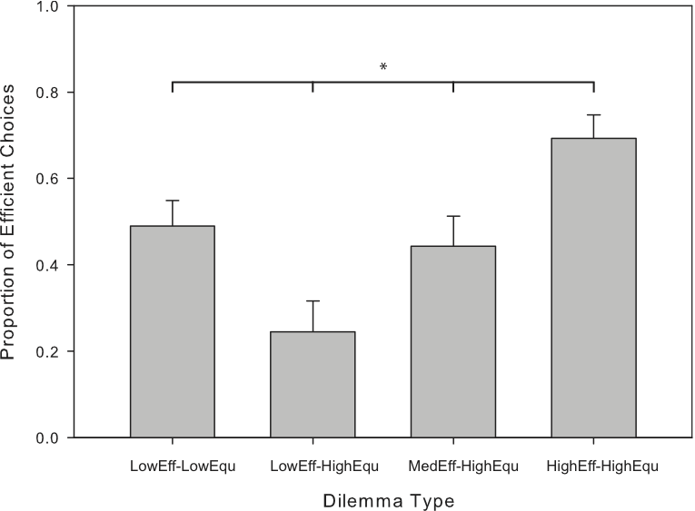

Fig. 1 Mean proportion of efficient choices by distributive justice dilemma type. Error bars indicate standard error. One-way repeated measures ANOVA indicated a significant effect for dilemma type, Wilks’ Lambda = .26, F (3, 21) = 20.40, p < .0005, multivariate partial eta squared = .75. Post-hoc tests were conducted with Bonferroni adjustment. * all dilemmas were significantly different from all other dilemmas (p < .004) except for the LowEff-LowEqu/MedEff-HighEqu pair.

3.2 Mouse Trajectories by Dilemma Type

The means of MD and AUC across the four primary distributive justice dilemma types are shown in Figure 2 and Figure 3, respectively. There was a trend towards trajectories being greatest in the LowEff-LowEqu condition (for MD and AUC) and MedEff-HighEqu condition (for MD). Maximum deviation was significantly greater in the MedEff-HighEqu condition than in the LowEff-HighEqu condition. Thus, an initial increase in ∆M (while ∆G remained constant) was associated with a significant increase in cursor deviation towards the unchosen option, but this trend did not continue as ∆M was increased further in the HighEff-HighEqu condition. Area under the curve was significantly greater in the LowEff-LowEqu condition than in the LowEff-HighEqu condition. Thus, decreasing ∆G (while ∆M remained low) was associated with a significant increase in cursor deviation.

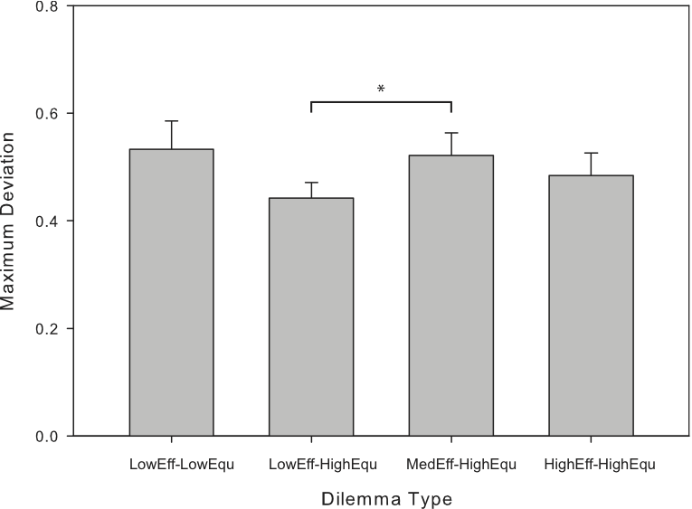

Fig. 2 Mouse cursor trajectory (MD) by distributive justice dilemma type. Error bars indicate standard error. One-way repeated measures ANOVA indicated a significant effect for dilemma type, Wilks’ Lambda = .64, F (3, 21) = 3.99, p < .05, multivariate partial eta squared = .36. Post-hoc tests were conducted with Bonferroni adjustment. * p < .004.

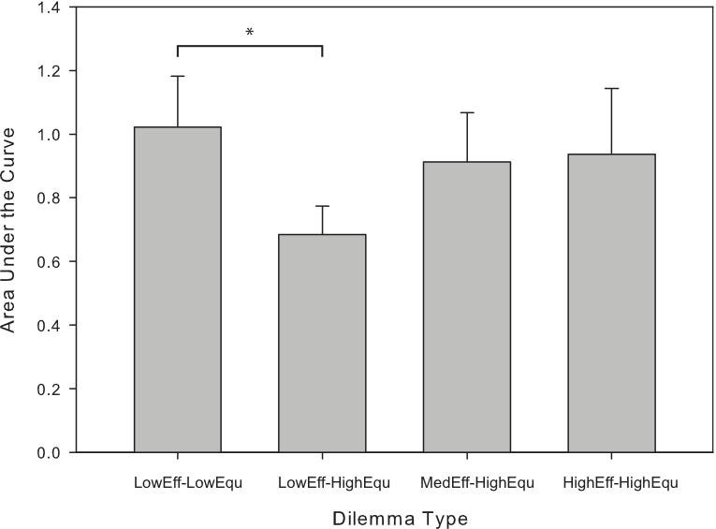

Fig. 3 Mouse cursor trajectory (AUC) by distributive justice dilemma type. Error bars indicate standard error. One-way repeated measures ANOVA indicated a significant effect for dilemma type, Wilks’ Lambda = .63, F (3, 21) = 4.12, p < .05, multivariate partial eta squared = .37. Post-hoc tests were conducted with Bonferroni adjustment. * p < .004.

3.3 Decision Time by Dilemma Type

The means of decision time across the four distributive justice dilemma types are shown in Figure 4. There was a trend towards decision times being longest in the LowEff-LowEqu condition, with a significant difference between this condition and the HighEff-HighEqu condition. Thus, longer decision times occurred when there was the least difference between the available options in terms of both equality and efficiency.

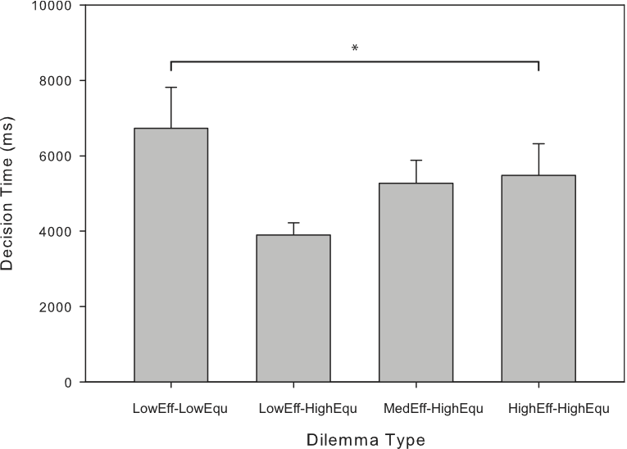

Fig. 4 Decision time by distributive justice dilemma type. Error bars indicate standard error. One-way repeated measures ANOVA indicated a significant effect for dilemma type, Wilks’ Lambda = .58, F (3, 21) = 5.05, p < .01, multivariate partial eta squared = .42. Post-hoc tests were conducted with Bonferroni adjustment. * p < .004.

4 Discussion

Behavioural and neuroimaging evidence indicates that individuals tend to be interested in satisfying multiple criteria when making decisions about resource distribution. The present study recorded responses and cursor trajectories during a series of dilemmas that required a trade off between varying degrees of equality and efficiency. As expected, choices in the distributive justice task varied in response to changes in both of these parameters. Increasing the number of meals saved by a distribution increased the likelihood that participants would choose it over a more even, but less efficient meal distribution. Similarly, increasing the equality of a distribution made it more likely that participants would choose it over a less even, but more efficient distribution. Responding across the sample was consistently equality-favoured for some conditions and consistently efficiency-favoured for other conditions, indicating that participants were willing to alter their choices based on the degree of equality and efficiency at stake. These findings are consistent with a function of behaviour suggested in Hsu et al. (2008), for which the perceived utility of a distribution is proportional to the magnitudes of efficiency and equality gained. Neuroimaging studies of related behavioural tasks suggest that the response to these specific parameters is potentially motivated by the experience of reward in relation to both the equality (Tabibnia et al. 2008; Tricomi et al. 2010; Zaki and Mitchell 2011) and efficiency (Hsu et al. 2008) of resource distributions, and the experience of negative affect in relation to uneven distributions (Hsu et al. 2008; Sanfey et al. 2003).

Some dilemmas also appeared more difficult to resolve than others, marked by both inconsistent responding across the sample and increases in cursor deviation. When the difference in equality between available options was highest (∆G = .33) and the difference in efficiency was lowest (∆M = 1–3 meals), responding was consistently in favour of the more even option (24% efficient choices on average), and there was a trend towards lower cursor deviation compared to other conditions. Similarly, when the difference in efficiency was highest (∆G = .33; ∆M = 11–15 meals), there was relatively consistent responding for the more efficient option (69% efficient choices on average), although cursor deviation did not differ significantly from other dilemma types. Thus, there was evidence that distributive justice dilemmas were straightforward to resolve when one of the available options was associated with a relatively high gain in either equality or efficiency. In contrast, dilemmas with the least difference between the available options in both efficiency and equality (∆G = .07–.19; ∆M = 1–3 meals) were associated with inconsistent responding across the sample (49% efficient choices on average), an increase in cursor deviation towards the unchosen response alternative, and a trend towards longer decision times. When a relatively moderate degree of efficiency was balanced against a highly even option (∆G = .33; ∆M = 5–7 meals), there was a similar inconsistency in responding (44% efficiency choices on average) and greater cursor deviation towards the unchosen alternative compared to the LowEff-HighEqu condition. Thus, there was evidence that specific formulations of the trade off between efficiency and equality that better balanced the magnitude of each parameter were associated with an apparent greater difficulty in decision making.

An interesting feature of the pattern of results described in the previous paragraph is that participants appeared not to consistently favour either equality or efficiency in their decision making throughout the task (see Fig 1). One possibility is that decision makers allot utilities to the gain in equality and efficiency yielded by each available option, and can then resolve the dilemma by weighing the values computed for each option directly against one another. In this manner, inconsistency in responding and greater cursor deviation in some of the moral dilemmas presented in the present study may have been induced by the perceived value of each response alternative being similar. This approach to decision making can be contrasted with, for example, that of employing a normative rule (e.g., ‘always maximise equality’) that is followed irrespective of the magnitude of the different values at stake. Functional MRI has indicated that the difference in utility between response alternatives in a similar distributive justice task (modelled in proportion to equality, efficiency, and preference for equality) is coded for within a region of the brain incorporating the caudate head and septal-subgenual area (Hsu et al. 2008), consistent with the notion that these values are combined during decision making.

A possible objection (raised by a reviewer) is that the differences in reaction time and mouse movements observed across different dilemma types may reflect hesitation due to uncertainty or computational difficulties entailed in appraising the dilemmas. Such difficulties might occur regardless of whether decision making is guided by a unitary value or a plurality of values, and hence interpretation of the results primarily in terms of a value pluralistic framework may not be appropriate.

In contrast, we suggest that the apparent greater difficulty of some dilemma types is likely due to increased conflict between different valued outcomes (particularly efficiency and equality). In support of this interpretation, we note that some dilemma types were more consistently resolved to favour a specific outcome than others: as shown in Figure 1, LowEff-HighEqu dilemmas were most often resolved in favour of the more equitable outcome, HighEff-HighEqu dilemmas were most often resolved in favour of the more efficient outcome, while LowEff-LowEqu and MedEff-HighEqu dilemmas showed a proportion of choices closest to 50%. Importantly, the observed differences in mouse deviation and reaction times (shown in Figures 2–4) tended to indicate greater hesitation for dilemmas resolved with lesser consistency (the LowEff-LowEqu and MedEff-HighEqu dilemmas). Together this suggests that participants are willing to make decisions that are sometimes more equitable and sometimes more efficient (depending on the particular meal distributions that they are required to choose between), and show greatest hesitancy in dilemmas where there is the least consistency in efficiency- or equality-favoured responding. Our interpretation is that inconsistent responding likely indicates that the perceived value of either option is more similar compared to dilemma types that elicit consistently equality- or efficiency-favoured responding, and hence that increased mouse deviations is likely to reflect a specific balance between the perceived value of each option within the dilemmas eliciting inconsistent responding. It is natural to suggest equality and efficiency as contributing to the perceived value as these are the parameters that we vary across dilemmas, and a trade-off between equality and efficiency underlies the framework within which this distributive justice task was originally developed (Hsu et al., 2008).

It is indeed possible that efficiency-favoured or equality-favoured behaviour may not actually be caused by intentional adherence to principles of efficiency or equality. Our results don't exclude the possibility that one overarching value could yield varying behaviour across the different formulations of the distributive justice dilemma that we employ. If a single (unspecified) value was really being computed in distributive justice decisions, it would be more difficult to compare situations in which several parameters that are all important for the computation of this value were varying than to compare situations in which a single parameter is varying. However, it isn't clear what this single value might be or how parameters of importance to it stand to individual kinds of values. Given the existing theoretical framework that identifies equality, efficiency, and sufficiency as potential motivators for decisions regarding resource distribution (e.g., Hsu et al., 2008; Miller, 1992), it therefore seems natural to discuss the results in terms of their consistency with a pluralistic approach. Further empirical and theoretical work is needed to address the distinction between having a plurality of values and having only one value with a plurality of parameters.

Additionally, there is a question of why the specific dilemma types that we find to be associated with greater mouse deviations would be more difficult to resolve than others if uncertainty underlies the observed pattern of results in the manner that the reviewer suggests. It is not clear that forms of uncertainty suggested by the reviewer (uncertainty in why the distribution is occurring, the relationships between distributors and recipients, who the recipients are, etc.) vary across the dilemma types that are employed. Thus, while uncertainty is likely an important component of moral decision-making, an account of how uncertainty is modulated across the dilemmas that we employ would be necessary to explain the inter-dilemma differences in this manner.

The reported differences in mouse cursor deviation across dilemmas are consistent with the notion that the cognitive process of decision making is shared to an extent with the motor system as it unfolds (see Freeman et al. 2011 for a review of behavioural and neurophysiological evidence supporting the use of motor output as a proxy of cognitive processing). A dynamic relationship between cognition and motor performance has been found previously for a separate form of high-level decision making (McKinstry et al. 2008), and for other cognitive functions, such as social categorisation and language processing (reviewed in Freeman et al. 2011). The current findings extend this to social preferences in the distributive justice context. The greatest deviations in cursor trajectory were observed in conditions associated with the least consistency in responding across the sample, suggesting that deviation may be proportional to uncertainty about which option to select. This might reflect a lesser ability to discriminate between response alternatives, greater processing required to calculate the difference between alternatives, uncertainty in how to apply moral principles, or some other factor. Such a measure is potentially useful for a range of studies conducted in moral decision-making research, such as those examining the cognitive inhibition of early impulses during decision making (e.g., Knoch et al. 2006).

4.1 Sufficiency and distribution preferences

While the distributive justice task employed in the present study is designed with a focus on the trade off between equality and efficiency, other considerations may contribute to decision making in such scenarios. An alternative criterion for assessing the fairness of a distribution is whether it leaves each recipient with a sufficient quantity of resources (e.g., enough meals to avoid starvation; see Frankfurt 1987 for a discussion of the sufficiency principle in distributive justice). Previous behavioural research has indicated that, in laboratory simulations of income distribution, individuals tend to satisfy a minimum level for all recipients before distributing any remaining resources according to other criteria (e.g., Frohlich et al. 1987). A post-hoc comparison was thus conducted to examine whether the absolute position of each recipient (in terms of meals lost) influenced choices in the distributive justice task independent of the trade off between equality and efficiency. Including trials from the four primary dilemma types described in Table 1, two further sets of trials were defined for this comparison: those for which the maximum number of meals that could be taken away from any one recipient was (i) 15 meals and (ii) 27 meals.

The proportion of efficient choices was significantly greater in trials that involved taking a maximum of 15 meals away from any one recipient (M = .60, SD = .27) compared to trials that involved taking a maximum of 27 meals away from any one recipient (M = .38, SD = .36), t (23) = 3.66, p < .01 (two-tailed), eta squared = .37. In addition to maximising efficiency at the cost of equality, the more efficient choice in each dilemma involved taking more meals away from any one recipient than the more even option. As such, this result suggests that participants tended to avoid leaving any one recipient with what they judged to be too few meals. An interesting aspect of this finding is that while the context of the task (i.e., meal distribution) lends itself to sufficiency concerns, participants were not given any information regarding the duration for which the distributed meals were required to last. A practical issue with distributing according to a sufficiency criterion is identifying the point at which the minimum standard has been met: in the present study, participants appeared to attempt this even under uncertainty regarding the circumstances of the recipients and how long the allotment was required to last. Further research may be able to better disentangle the interaction and relative influence of the various possible criteria of distributive justice.

4.2 Future directions of study: towards value integration?

The current study looked at resource distribution where the resource in question was food. Discussions of distributive justice within political philosophy consider a much wider range of resources including money, education, housing, health care, etc. It is possible that different choices of resources would give different results on these tasks. In particular, most people are likely to believe that it is not valuable to have more food than you can eat, which may be in contrast to other resources such as money or education. Further studies could therefore usefully test whether the patterns of moral decision making revealed here differ for other types of resources.

Political philosophy is mostly normative rather than descriptive – it tells us what should be done rather than what is actually done. Empirical research is therefore not directly relevant for philosophical theory. However, it is of interest how different actual moral decision making is from morally optimal decision making. The overall picture suggested by the current study is that people employ a range of values when they make moral decisions: equality, efficiency and sufficiency. It also suggests that people are able to weigh these values against each other. Though more research needs to be done, this suggests that people’s moral decision making is pluralistic: we subscribe to a number of moral values at the same time. This contrasts with much political theory, which tends to champion a single value (sufficiency, equality, etc.) at the expense of others; this is often motivated by the idea that these values are incompatible.

This raises the interesting question of whether value pluralism is not only what people adhere to but also what they should adhere to. Rather than viewing values as conflicting people seem able to weigh them against each other so as to obtain reasonable compromises between values. In cases where no unequivocal weighting is desirable – which are the difficult moral dilemmas – many people do not go the way of political theory and favour a single value. Instead, decision making seems to become more random in those dilemmatic cases (as seen for LowEff-LowEqu and MedEff-HighEqu conditions in Figure 1). It is possible to argue that it is at least as rational to behave in a random manner in the face of such dilemmas as it is to favour a single value.

Consistent with previous studies of distributive justice (Hsu et al. 2008; [Authors removed for blind review] 2012), individual variation was found in the extent to which participants appeared to value equality across the distributive justice task (individual α: M = 20.98; SD = 13.94). One factor that may contribute to individual differences in decision making is the magnitude of the weightings that individuals tend to give values like equality and efficiency. An implication of this is that the point at which the more even and more efficient distributions appear most balanced is likely to differ between individuals based upon their prior weightings. To explore this in the present data, we separated the participant group into thirds based on individual inequality aversion parameters (Low α: M = 5.51, SD = 7.27, n = 8; Moderate α: M = 21.45, SD = 3.32, n = 8; High α: M = 35.98, SD = 6.60, n = 8). Only trends are reported here due to the small group sizes and exploratory nature of the analysis. The proportion of efficient choices by dilemma type for each group are shown in Figure 5, and the maximum deviation towards unselected responses by dilemma type are shown in Figure 6. If cursor deviation is taken as an indicator of dilemma difficulty, trends are consistent with the notion that the point at which dilemmas are most difficult is dependent upon the extent to which individuals value equality. Specifically, the most inequality-averse group exhibited the greatest cursor deviation when the number of meals saved by the more efficient option was highest: consistent with the interpretation that a higher gain in efficiency is required to make the dilemma appear balanced to for people who tend to more highly weight equality. In contrast, the other participant groups showed greater mouse deviation when a moderately efficient option was balanced against an option with high equality (and when there was the least difference in both efficiency and equality between options).

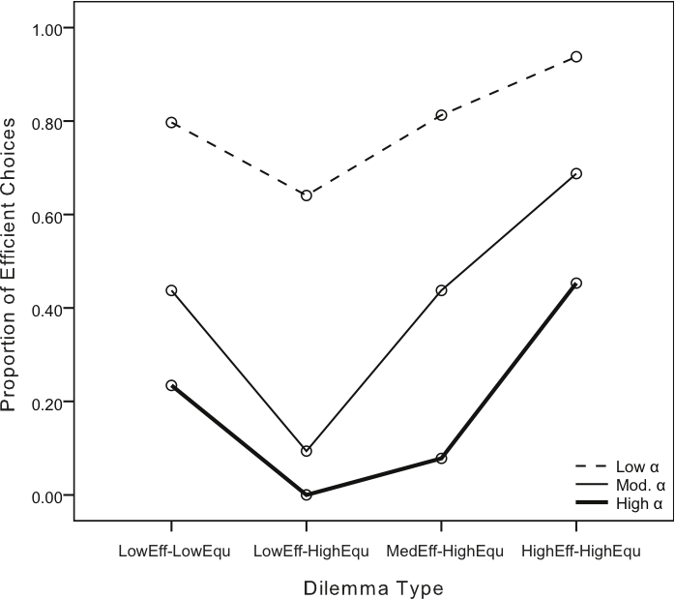

Fig. 5 Grouped mean proportion of efficient choices by distributive justice dilemma type. Higher values of α correspond to a greater tendency to favour equality during the distributive justice task.

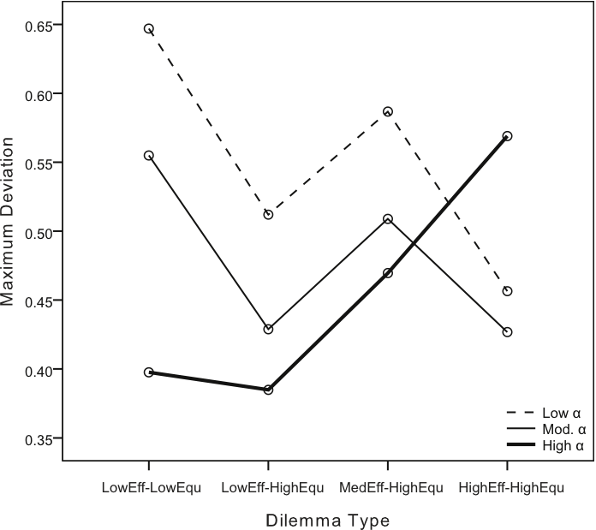

Fig. 6 Grouped mouse cursor trajectory (MD) by distributive justice dilemma type. Higher values of α correspond to a greater tendency to favour equality during the distributive justice task.

It is a question for further theoretical research whether value pluralism (with random choice when values are balanced) is a sustainable normative position. Is it for example rational and right to choose randomly when values are balanced? What are the elements of the set of values that are right to weigh against each other?

It is a question for further empirical research how people in fact weigh different values against each other. Specifically, it is of interest to explore the weighting given to sufficiency (for a range of types of resources): what kinds of trade-offs between sufficiency and efficiency/equality, if any, are people willing to accept, and is this affected by the resource under consideration? More generally, it will be interesting to explore interactions between different values: is the weighting of a given value (e.g., efficiency) dependent on which other value parameters are relevant in the context (e.g., sufficiency)?

The brain is well-suited to weight sensory estimates and arrive at optimal integrated estimates of, for example, spatiotemporal co-location of auditory and visual sources of sensory input (Burr and Alais 2006). Very speculatively, the brain’s predilection for optimal integration of weighted estimates may explain why it falls natural for us to weigh values against each other and arrive at integrated judgements of what is the right decision. Given balanced estimates and a binary choice, this general kind of integration principle predicts the kind of random decision behaviour suggested by the current study for difficult moral dilemmas. Moreover, such a ‘value integration’ view would sit well with a kind of rationalism since people in general weight sensory estimates in an optimal Bayesian fashion. It could therefore be interesting to explore the extent to which people’s moral decision making is analogous to their perceptual decision making.

4.3 Conclusion

The findings presented here suggest that individuals value resource distributions in proportion to the degree of equality and efficiency that is achieved. Moreover, there was evidence that the trade off between these values is most difficult when the gains in equality or efficiency afforded by the available options are most balanced. Sufficiency-considerations were associated with distributive justice decision making in conjunction with equality- and efficiency- concerns. It also appears that mouse cursor movements can be used to track differences in cognitive processing over the time course of distributive justice decision making, with greater spatial deviation potentially associated with more difficult or uncertain decisions.

Further directions for these types of empirical studies were discussed in the context of normative theories in political philosophy. It was speculated that a notion of value integration could describe moral decision making and could also be a candidate for a normative theory.

References

Burr, D., and Alais, D. (2006). Combining visual and auditory information. Progress in Brain Research, 155, 243–258.

Frankfurt, H. (1987). Equality as a moral ideal. Ethics, 98, 21–43.

Freeman, J. B., & Ambady, N. (2009). Motions of the hand expose the partial and parallel activation of stereotypes. Psychological Science, 20, 1183–1188.

Freeman, J. B., & Ambady, N. (2010). MouseTracker: Software for studying real-time mental processing using a computer mouse-tracking method. Behavior Research Methods, 42, 226–241.

Freeman, J. B., Dale, R., & Farmer, T. A. (2011). Hand in motion reveals mind in motion. Frontiers in Psychology, 2, 1–6.

Frohlich, N., Oppenheimer, J. A., & Eavey, C. L. (1987). Choices of principles of distributive justice in experimental groups. American Journal of Political Science, 31, 606–636.

Hsu, M., Anen, C., & Quartz, S. R. (2008). The right and the good: Distributive justice and neural encoding of equity and efficiency. Science, 320, 1092–1095.

Knoch, D., Pascual-Leone, A., Meyer, K., Treyer, V., & Fehr, E. (2006). Diminishing reciprocal fairness by disrupting the right prefrontal cortex. Science, 314, 829–832.

McKinstry, C., Dale, R., & Spivey, M. J. (2008). Action dynamics reveal parallel competition in decision making. Psychological Science, 19, 22–24.

Miller, D. (1992). Distributive justice: What the people think. Ethics, 102, 555–593.

Phan, K. L., Wager, T. D., Taylor, S. F., & Liberzon, I. (2004). Functional neuroimaging studies of human emotions. CNS Spectrums, 9, 258–266.

Rawls, J. (1971). A Theory of Justice. Harvard, MA: Harvard University Press.

Rohrbaugh, J., McClelland, G., & Quinn, R. (1980). Measuring the relative importance of utilitarian and egalitarian values: A study of individual differences about fair distribution. Journal of Applied Psychology, 65, 34–49.

Sanfey, A. G., Rilling, J. K., Aronson, J. A., Nystrom, L. E., & Cohen, J. D. (2003). The neural basis of economic decision-making in the Ultimatum Game. Science, 300, 1755–1758.

Tabibnia, G., Satpute, A. B., & Lieberman, M. D. (2008). The sunny side of fairness: Preference for fairness activates reward circuitry (and disregarding unfairness activates self-control circuity). Psychological Science, 19, 339–347.

Temkin, L. (1993). Inequality. Oxford: OUP.

Tricomi, E., Rangel, A., Camerer, C. F., & O’Doherty, J. P. (2010). Neural evidence for inequality-averse social preferences. Nature, 463, 1089–1091.

Xu K (2003) How has the literature on Gini’s index evolved in the past 80 years? Available via Department of Economics at Dalhousie University Working Papers Archive. http://econpapers.repec.org/RePEc:dal:wparch:howgini. Retrieved 5 Dec 2011

Zaki, J., & Mitchell, J.P. (2011). Equitable decision making is associated with neural markers of intrinsic value. PNAS, 108, 19761–19766.

