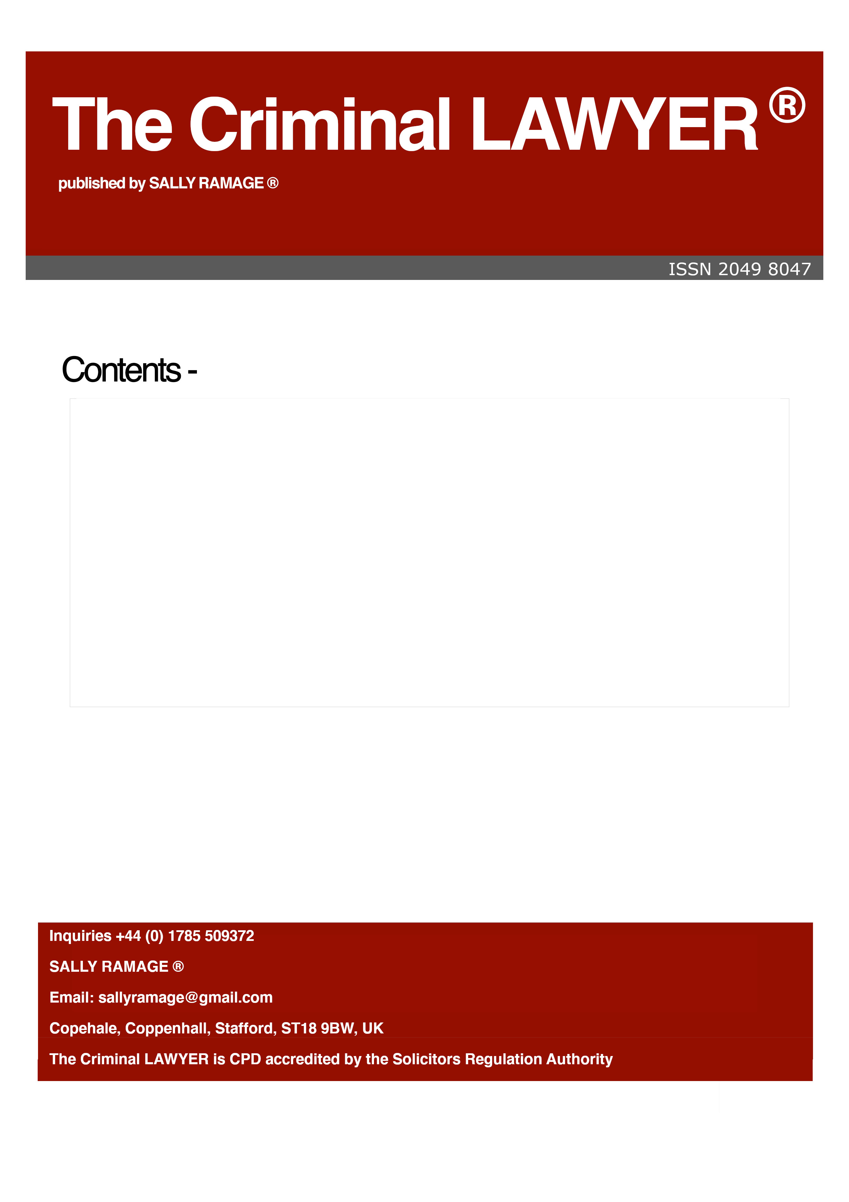

The Criminal LAWYER, Issue 247, September 2020

Fear and foreboding: Trump’s plans pp 2-13

Legal Notice pp 14-14

FEAR AND FOREBODING: TRUMP’S PLANS ARE WORSE THAN ADOLF HITLER’S- FOR THE WHOLE WORLD
SALLY RAMAGE
www.criminal-lawyer.org.uk

Donald Trump of the United States


When I heard Donald Trump say in one of his many unofficial/quasi-official talks that his plan is to win the forthcoming election and be president for 18 more years, I at first thought he spoke in jest. But TRUMP never speaks in jest. He wants to rule the world and his foundation for changing the United States Constitution is based on the black men that police keep killing and the somewhat mild riots and anguished PROTESTS and PICKETING that thousands of people undertook to show their anguish, frustration and emotions. I myself, thousands of miles away, felt like a black slave also.

Drunk with power not alcohol

I can only guess what millions of trauma await people in the whole of the United States. He wants to RULE THE WORLD and can start a NUCLEAR WAR AND KILL US ALL IN THIS WHOLE WIDE WORLD. In my opinion, this person is a lunatic and also drunk with power. The United States government has proposed many amendments to the Amended United States Constitution. These new amendments appear to be a stepping stone to more onerous amendments –as per their drafting. They appear solid but are really a bunch of footnotes stuck to the statements of the new proposed amendments to the U.S. Constitution, without any calibre of fine-tuned statutory or case-law base. They resemble a first year enthusiastic undergraduate law student’s “form over substance” copying of caselaw points without any acumen or fine, high, legal grounding. They appear to resemble a form of EMERGENCY LAW drafting. This takes no account that recent protests and marches since the murder of George Floyd do not in any way constitute terrorism.

Emergency laws: for what purpose?

Because police keep killing black people with their guns??? Or is this evidence of military hunger to “play with” the new and latest United States military toys-to kill millions- as they did in Iraq, under the premise of “non-existent” weapons of mass destruction (WMD)? The Boston, Massassachuttes Criminal Justice System allowed the Tsarnaev murder trial (re “the Boston Bombing” as the local Press named it) to be filed as Tsarnaev’s murdering acts, using “weapons of Mass Destruction”. Two Pressure Cooker Pipe bombs-were laid down as precedent law and names as terrorist “weapons of mass destruction” in United States Federal Law????
If the Criminal Justice System cannot abide by the Rule of Law, we therefore have political anarchic government- not anarchic common citizens but anarchic government officials. Two pressure-cooker pots stuffed with nails and fireworks do not comply with the definition of ‘a weapon of mass destruction’ which, referring to Wikipedia is as follows:

“Weapon of mass destruction (WMD) is a nuclear, radiological, chemical, biological, or any other weapon that can kill and bring significant harm to numerous humans or cause great damage to human-made structures (e.g., buildings), natural structures (e.g., mountains), or the biosphere. The scope and usage of the term has evolved and been disputed, often signifying more politically than technically. Originally coined in reference to aerial bombing with chemical explosives during World War II, it has later come to refer to large-scale weaponry of other technologies, such as chemical, biological, radiological, or nuclear warfare.”

If the author might refresh the reader’s memory of what really constituted mass destruction of millions of people:

* In the year 1915, the vast majority of Armenian people exterminated in the Ottoman assault were defenceless and unarmed Armenians.

*The United States bombing of Indo-China in the 1960s and early 1970s. The United States fought Vietcong and other opponents, murdering the population of the region as a whole. The United States dropped 14 Million tonnes of bombs on this region in these years until 1972. These 14 million tonnes of bombs dropped by the United States bombers on eastern Cambodia, Laos, Hanoi, and Haiphong is a bomb tonnage equivalent to that used in the United States Atom Bomb attacks on Hiroshima and Nagasaki.
This 14 million tonnes of bombs on Vietcong represents SEVEN TIMES THE AMOUNT OF BOMBS dropped among airforces in the whole of the Second World War.

*The United States bombed Vietnam indiscriminately. They killed Vietnamese civilians by the million in a genocidal wipe-out.
This is what ‘weapons of mass destruction’ means.

United States military weapons manufactured with borrowed and securitized money

The only military which has created the powerful arsenal to kill the world is in the United States. Because with borrowed money (since the United States has been on the verge of bankruptcy since 1998 and especially after the mortgage fraud perpetrated by all strata of society including governments who approved the securitization scam for which forthcoming generations will suffer livelihood of hand-to-mouth existence for very many future generations. The United States has manufactured the most devastating arsenal of killer weapons this planet has ever seen and like Adolf Hitler, their present president is mad; of this I personally feel certain of.

Issue of “materiality” to wage anti-terrorist shooting of black people

Some burnt out cars in Portland do not compare with the massive catastrophic destruction of Iraq’s structural resources and it is a sin that fat, greedy, lazy people in a western country like America is, can throw missiles about and kill non-European poverty-stricken races just because they can. Other war-mongers with money in Swiss bank accounts and off-shore laundering banks are in cahoots with this man-our new fear-monger-our modern-day mad Adolf Hitler.

Power-hungry dictators

Tony Blair was another man who wished to rule the world hand-in hand with the United States George Bush. These men know how to WINDOW DRESS-BALANCE SHEETS, COMMITTEE REPORTS and like their ilk they know how to KEEP THE PAPERWORK HAPPY.

Lawyers- like prostitutes- do it for the money

Lawyers find the loopholes in the contracts, conventions, treaties their own profession create and exploit loopholes for money.

Question:
Who drafted the many Enron securitized documents?
Answer:
British Lawyers in London. This has been admitted in academic papers and in the caselaw against Nat West Bank Employees.

What is a lawyer anyway? A person who gains, usually, an average undergraduate degree in law entailing learning by heart a few precedent caselaw in every subject t in the law their degree covers, then making coffee, running errands in a law firm for a year, after which he is successfully signed off. He then must take a book-keeping examination equivalent to GCE Ordinary Level in Book-keeping and hey presto, the licence to print money and play God with people’s lives-is his. Lawyers are the most racist people I have ever known-yet they know what the equality statute; the anti-slavery statute’ the Bribery Act; the Fraud Act; the Six Discrimination Act states. It is unforgivable that lawyers with alleged knowledge of the law, so blatantly walk all across the law. They are but a Trade Union, a monopoly to keep money for themselves and cronies. This is POWER.

TRUMP-EXPLOITED ETHNIC MINORITY BUILDERS OF TRUMP TOWER

In the United States, Donald Trump, President, is not even a lawyer. He was bankrupted three times. He built Trump Tower with the blood and sweat and tears and hard work of ethnic minorities and then robbed them of taxes and insurances he should have paid over, having docked it from their meagre wages. What kind of a man has a multi-billion dollar building built by slavery of ethnic minority workers and skilled builders, with money borrowed from other countries including perhaps Russia, and yet feels NO SHAME at having robbed those workers of their protected workers’rights? A bully who cares only for wealth for himself and relatives, not caring for the greater society.

Narcissistic concerns and the golden pram

But then again, how could he possibly have empathy for the man in the street, black or white, who may by now be unemployed, sick or homeless, whilst Trump’s son by his latest marriage had a pure gold pram manufactured just for Donald Trump? It is the usual fantasy of “me me me me me”; concerned only for his own wealth and just for his own wallet He spent more in travel expenses on one year than Mr Obama spent in eight years. How?

Facilitated by lawyers who know all the legal loopholes
Because lawyers told him that he was entitled to fly with his administration to the State of Florida, if he wished, the United States taxpayers had to foot the bill for millions of dollars for good food, wine and hotel accommodation at the 5-star hotel Trump owns, now probably in one of the hundred shell companies formed to milk the United States taxpayers; and have a good time.
Of course the administration that accompanies him is estatic to have had the privilege of enjoying high class accommodation they would not have enjoyed in a million years, had Trump not brazenly taken his entourage to stay ay his 5-star hotel in Florida. To what purpose? Was there an important meeting in Florida with a severely disabled person unable to travel to the White House? NO.

A president allowed to put himself up for election-yet with three bankruptcies in his curriculum vitae

To become bankrupted three times is to be reckless and gambling, not accountable, staid and deep-thinking and ethical. Of course his administration is loyal. They are loyal and will want these extravagant times to continue. There is a subject titled “business ethics”, Mr President.
The Chilcot Report on the Iraq war
The Chilcot Report at 408 and 409 states:
“408. Mr Powell likewise recognises the importance of having written advice which can be seen before a meeting, allowing all those present to have shared information and the opportunity to digest it and seek further advice if necessary. This allows the time in meetings to be used productively.
409. The Inquiry considers that there should have been collective discussion by a Cabinet Committee or small group of Ministers on the basis of inter-departmental advice agreed at a number of decision points which had a major impact on the development of UK policy BEFORE the invasion of Iraq. Those were:
*Decision to work with President Bush …as part of Phase 2 of the War on Terror…
*The adoption of the position at end of Feb 2002 that Iraq was a threat….
*…the meeting at Chequers on 2 April did NOT explore political and legal implications…..
*….Mr Blair’s long note of 28 July 2002, including telling George Bush ”I WILL BE WITH YOU WHATEVER” The Foreign and Defence Secretaries were not given the opportunity to comment on the draft in advance.
*..offering UK ground forces to the US for planning purposes…NO CONSULTATION WITH ANYONE IN Parliament, Defence or military.
* the decision Blair made to deploy large scale ground forces for operations in southern Iraq….
This goes to show the level to which US and UK will agree, without conscience.

Amendments to the U.S Constitution Amendments drafted in 2020
Amdt1.2.10.1.1 Campaign Finance and Electoral Process
“First Amendment:
Congress shall make no law respecting an establishment of religion, or prohibiting the free exercise thereof; or abridging the freedom of speech, or of the press; or the right of the people peaceably to assemble, and to petition the Government for a redress of grievances.
Government has increasingly regulated the electoral system by which candidates are nominated and elected, requiring disclosure of contributions and certain expenditures, limiting contributions and expenditures, and imposing other regulations. The basic federal legislation regulating campaign finances is spread over several titles of the United States Code. The relevant, principal modern laws are the Federal Election Campaign Act of 1971, 86 Stat. 3, as amended by the Federal Election Campaign Act Amendments of 1974, 88 Stat. 1263, the Federal Election Campaign Act Amendments of 1979, 93 Stat. 1339, and the Bipartisan Campaign Reform Act of 2002. All states, of course, extensively regulate elections. These regulations can restrict freedom of expression and association, which include the rights to join together for political purposes, to promote candidates and issues, and to participate in the political process. In the Federal Election Campaign Act of 1971, as amended in 1974, Congress imposed new and stringent regulation of and limitations on contributions to and expenditures by political campaigns, as well as disclosure of most contributions and expenditures. Similarly, limitations upon the amount of funds a candidate could spend out of his own resources or those of his immediate family were voided. A candidate, no less than any other person, has a First Amendment right to advocate.”

Other amendments drafted out of the blue recently include the following:

Amdt1.2.10.1.1 Campaign Finance and Electoral Process
First Amendment:
Congress shall make no law respecting an establishment of religion, or prohibiting the free exercise thereof; or abridging the freedom of speech, or of the press; or the right of the people peaceably to assemble, and to petition the Government for a redress of grievances.
Government has increasingly regulated the electoral system by which candidates are nominated and elected, requiring disclosure of contributions and certain expenditures, limiting contributions and expenditures, and imposing other regulations.

Bibliography
Bologna, J. and Lindquist, R.J. (1995) Fraud Auditing and Forensic Accounting, New York: John Wiley & Sons.

Chilcot, J. (2016) Chilcot Report, Report of the Iraq Inquiry, London: TSO.
Donnelly, J. (2003) Universal Human Rights in Theory and Practice, U.S: Cornell University Press.

Levene, M. (2008) Genocide in the age of the nation state, London: I.B.TAURIS.

Ramage, S. (2009) “The United States of America: Clinton, Emanuel, Blagojevich, the saving and loans fiasco, Fannie Mae, Bribery, Corruption, and breaches of election laws: the past will always catch up with you”, Criminal Law News, Issue 14, pp 2-5.

Ramage, S. (2010)”Piercing the Corporate Veil”, Criminal Law News, Issue 21, pp 8-9.

Ramage, S. (2010) “United States court limits employer background checks to protect privacy”, Criminal Law News, Issue 25, pp 7-9.

Ramage, S. (2011) “Right to Protest”, Criminal Law News, Issue 35, pp 6-8.

Ramage, S. (Ed.) “Illegal ‘Search and Seizure’ in the United States,
Criminal Law News, Issue 28, pp 5-8.

Ramage, S. (Ed.) (2011) “Directors who commit Financial Shenanigans”, Criminal Law News, Issue 30, pp 4-4.

Ramage, S. (Ed.) (2011) “Analysis of Tottenham’s August Riots”, Current Criminal Law, Volume 4, Issue 1, pp 4-9.

Ramage, S. (Ed.) (2012) “The US/UK Extradition Treaty”, Current Criminal Law, Volume 4, Issue 3, pp 4-5.

Ramage, S. (Ed.) (2012) “Civil Liberties in the United States”, Criminal Law News, Issue 42, pp 10-12.

Ramage, S. (Ed.) (2013) “Government Secrecy; Police Secrecy; Court Secrecy: a step too far?”, Criminal Law News, Issue 53, pp 5.7.

Ramage, S. (Ed.) (2017) “President Trump’s misunderstanding of global environmental issues”, The Criminal LAWYER, Issue 232, pp 3-6.

Wakefield, A. and Fleming, J. (Eds) (2009) The SAGE Dictionary of POLICING, London: SAGE.

Weissinger, S.E. and Mack, D.A. (Eds) (2018) Law Enforcement in the Age of Black Lives Matter, Policing Black and Brown Bodies, New York, U.S: Lexington Books.

Registered as a Newspaper at the Post Office.
SALLY RAMAGE ® 2020.United States Patent and Trademark Office Reg. No. 3,440,915. All Rights Reserved. No part of this publication may be reproduced in any material form including photocopying or storing it in any medium by electronic means and whether or not transiently or incidentally to some others use of this publication) without the written permission of the copyright holder except in accordance with the provisions of the Copyright, Design and Patents Act 1988 or under the terms of a licence issued by the Copyright Licensing Agency, Saffron House, 6-10 Kirby Street, London, England EC1N 8TS. Application for the copyright owner’s written permission to reproduce any part of this publication should be addressed to the publisher. Warning: the doing of an unauthorised act in relation to a copyright work may result in both a civil claim for damages and criminal prosecution. Publisher’s address: Copehale, Coppenhall, Stafford, ST18 9BW, UK.
http://www.criminal-lawyer.org.uk/
Disclaimer: The publisher neither owes nor assumes any form of duty of care or responsibility towards anyone who might consult information in this law journal and cannot accept responsibility for the content or quality of any news item or law report to which a link is provided by way of a footnote or a link. The Criminal Lawyer ISSN 2049-8047. Issue 247 September 2020.

