C-Pattern Theory:
A Close Look at Consciousness
With Substantial Implications

Pablo Rodriguez
Zurich, July 2020
(Final: April 2021)
www.exmosol.com

Abstract
This work deals with the particular nature of consciousness in comparison to matter, as well as with the question of how subjective experience can be possible at all. Based on a step-by-step derivation, a new approach is introduced and a theory for a possible explanation is proposed, named C-Pattern Theory. The statements and implications resulting from C-Pattern Theory reveal new perspectives on elementary aspects of reality and open up new possibilities with regard to fundamental questions.

1. Introduction
Where exactly in the brain is the thought of the ocean? Where the image of the horizon, the sound of the waves and the taste of salt water? Where exactly is the memory of a sunny day at the beach, and where the feeling of lightheartedness? In other words: How does one get from mere brain activity, even in principle, to something so different as subjective experience and consciousness?
The question of where mind and subjective experience or consciousness per se is located in the brain, or how consciousness is supposed to emerge from brain or flesh, is an old riddle that has given rise to a large number of interpretations and debates as the so-called mind-body problem (Lagerlund, 2007). At present, in line with the currently prevailing materialism, consciousness is generally regarded as an automatic, emergent by-product of the neural activity of the brain, although alternative theories are also gaining relevance (Maillé & Lynn, 2020; Revonsuo & Kamppinen, 2013).
While materialism is unquestionably recognized for its numerous contributions to scientific progress, it is unable to explain what consciousness as a by-product of neural activity is exactly and how it is supposed to emerge from the brain. This is not particularly astonishing, since consciousness does not have the same properties as matter and materialism by definition does not allow for non-material things; what is astonishing, however, is the naturalness in materialism with which this contradiction and the associated explanatory gap are consistently ignored.
One reason for this may be the success of materialism so far despite its inconsistencies. Another reason could be based on the problem that consciousness and subjectivity do not seem to be scientifically examinable. Yet another reason may come from the fact that experiencing strongly correlates with neural activity, e.g. between perceived visual stimuli and activity in the visual cortex, in one brain compared to another, or in the case of specific perceptual impairments due to specific brain lesions (Kandel et al., 2000; Karnath et al., 2018).
However, correlation does not imply causation, but only that there is a connection between consciousness and matter. Likewise, inconsistencies of a model, as successful as the model is, remain even if they are suppressed. And just because the investigation of a thing appears difficult or even impossible, this does not mean that the thing can be ignored. How a limited model is to address fundamental questions and the current boundaries of comprehension is not apparent.
Allow me to recall such boundaries: There is a universe that we did not create and do not fully comprehend, there is life in it which we did not create and do not completely understand either, and we perceive ourselves as part of such life in the form of organisms that are born, age and die, and have the ability for experiencing – which is far from easily comprehensible. While in everyday life, possibly as a form of self-protection, we may regard this as nothing special or even repress it, these facts are, however, overwhelming when one truly becomes aware of their mysteriousness.
In fathoming these facts, contemporary logic leads at some point either to inconsistencies, contradictions or absurdity, no matter how much progress materialism makes. The alternative of a theistic world view is not free of inconsistencies either, as can be seen, for example, in the problem of evil or the origin of a creator god. That there is a need for explanation, to say the least, and that the present world view cannot yet be the most accurate, becomes apparent. An updated, more coherent world view therefore seems to be of high relevance. The following is therefore my attempt to make a contribution, in the form of a theory which I call C-Pattern Theory.

2. Derivation and Core Statements
2.1 Consciousness vs. matter
Consciousness is something qualitatively entirely different from matter: The experiencing of the subjective mental world in the form of, among other things, sensory perceptions, emotions, thoughts, meaning, language, knowledge, comprehension, intentionality, memories, self-image and personality is qualitatively incompatible with matter; as such, it cannot be found anywhere in matter, brain or flesh.
The assertion made by materialism that consciousness should emerge as a by-product of matter, brain or flesh is, due to the mentioned striking qualitative difference of consciousness, neither conclusive nor consistent with materialism; moreover, the assertion could never be confirmed.
Consciousness is thus non-material, yet it exists just as real, and to the same extent as matter and the subjective mental world are attributed real existence; consciousness is therefore just as much a fundamental phenomenon of reality as are the fundamental forces of the universe.

2.2 Different neural activity
Although consciousness is something different from matter, it strongly correlates with neural activity and thus with matter; consciousness thus appears to be connected to neural activity or the brain and therefore to matter, implying the existence of a mechanism that enables this connection.
The diversity and degree of consciousness differs between a normal and a damaged brain, between a human and a non-human brain, or between the brains of two people; the reason for this is the difference in neural activity, which stems from the differences in the structural constitution and neural circuitry of the respective brains.
A particular experience thus corresponds to a particular neural activity at a point in time, whereby two points in time differ only in the spatial distribution of this activity; from the spatial arrangement of the positions of all electrical action potentials at a point in time, a complex three-dimensional structure results.

2.3 Regular experience contents
I now postulate that it is the highly specific, three-dimensional geometric form, or composition of all lengths and angles, of this structure out of all action potentials that encodes the entire content of experience at a point in time as a simultaneous whole; I therefore call the structure Content of Experience Encoding Pattern, or c-pattern for short.
The brain is thus connected in such a way that at each point in time, it generates the c-pattern that represents the entire experience content which corresponds to the organism’s physical circumstances at that point in time; a c-pattern therefore not only defines experience contents with regard to the senses, but also for all other modalities such as e.g. self-image, personality or emotions.
Accordingly, objects are, for example, not red, substances not intoxicating, and stimuli not loud, but rather lead through physical interaction with the organism to the brain producing corresponding c-patterns and thus experience contents; in doing so, the relationship between c-pattern and experience content follows certain geometric laws, whereby e.g. two identical c-patterns encode exactly the same experience content across all modalities.

2.4 From c-patterns to consciousness
C-patterns can thus be seen as expressions of a language for describing experience content, which I call c-pattern language; yet since an experience content is only encoded by a c-pattern, the creation of the experience content must take place separately.
If consciousness had the ability to create its own experience content, there would be no necessary reason for a correlation with neural activity and c-patterns, meaning that consciousness can only receive an experience content; I call the non-material place, which is hence able to read c-patterns and to create and transmit the corresponding experience content to consciousness, c-pattern space.
Both c-pattern language and c-pattern space, like consciousness, matter and the fundamental forces of the universe, therefore represent fundamental phenomena of reality: Whenever the brain of an organism generates a c-pattern, the modulation in spacetime is detected by c-pattern space and the c-pattern is read, whereupon c-pattern space creates the corresponding entire experience content of the c-pattern and transmits it to consciousness; consciousness then experiences this content and perceives itself as an organism.

2.5 Constant cycle
Since the experience content of a c-pattern also determines the corresponding understanding, consciousness always understands as the organism; consciousness then acts according to this understanding through the organism, by influencing the nature of the next c-pattern, which is reflected in the organism’s specific action.
This cycle of experiencing, understanding and acting is repeated for each subsequent point in time and thus uninterruptedly for as long as the organism exists; the resulting sequence of discrete c-patterns then forms the familiar subjective perception and quality of consciousness.
Consciousness is therefore non-material, pure potential for experiencing, understanding and acting which interacts with matter, and central to this are electrical c-patterns and their geometric form, which are expressions of c-pattern language and are converted by non-material c-pattern space into experience content; brain, senses and body are thereby means to generate c-patterns and thus to enable the interaction between consciousness and matter.

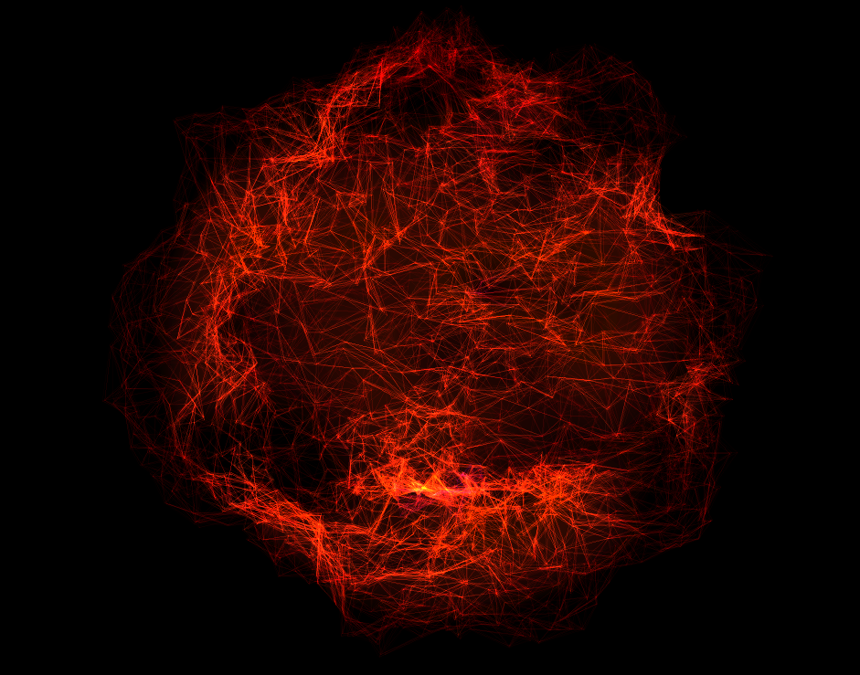
Figure 1: Highly reduced and stylized c-pattern with nodes as action potentials and node connections or edges as lengths; the angles result from their specific arrangement. Created via particleEqualizer (Kim, 2020).

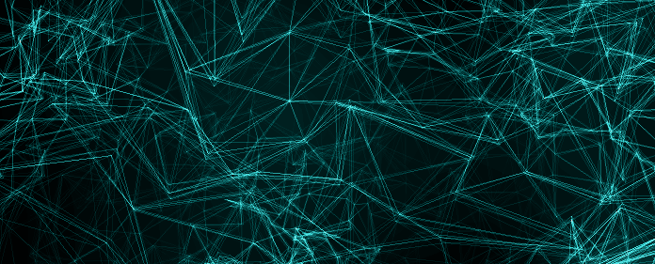
Figure 2: Section of a stylized c-pattern with nodes as action potentials and node connections or edges as lengths. Created via particleEqualizer (Kim, 2020).
Figure 3: Further enlarged section of a stylized c-pattern, again with nodes as action potentials and edges as lengths. From: Molecules (n.d.).

3. Implications and Further Statements
3.1 Brain
Consciousness is mediated by c-patterns and therefore does not necessarily require a brain; c-patterns can thus be generated substrate-independently or non-biologically by any sufficiently developed device in the sense of an artificial brain, provided that it produces c-patterns three-dimensionally and physically.
Areas of the brain such as the visual cortex for seeing or the limbic system for affect and emotions do not possess a special intrinsic nature which would account for the experience contents associated with these areas; instead, it’s the overall neural circuitry resulting from the embedding of these areas that leads to corresponding c-patterns and experience contents, which would not be possible without these areas.
Learning means to act in such a way that through the constant cycle of experiencing, understanding and acting, c-patterns are gradually created whose experience contents are increasingly related to the knowledge about a thing or the correct reproduction of it or the correct performance of an activity; accordingly, learning automatically leads to a more and more correct neural circuitry, which is made possible, among other things, by neural plasticity.

3.2 Experiencing
The geometric laws between c-patterns and experience contents in terms of lengths and angles constitute an exact correspondence in the form of the rules of c-pattern language, and allow exact statements, comparisons and predictions about all aspects of the experience content of c-patterns; the targeted modification of a c-pattern’s geometric form thus leads to specific and selective changes of the experience content and its modalities.
Within c-pattern language, higher-level properties such as symmetry, simplicity, complexity or certain proportions can play a role in relation to experience contents: A higher degree of symmetry may, for example, be equivalent to the experience of greater aesthetics or more pleasant sensations, and a certain level of complexity to the experience of a solution to a problem; this in turn may be triggered by certain stimuli, substances, appearances and contexts, meaning it correlates with their nature and form, leading to them being preferred.
Since a c-pattern encodes the entire experience content of a point in time as a simultaneous whole, it always contains the memory of the experience just before; this creates the impression of movement and continuity, through which time, speaking or thinking, among other things, are experienced as flowing.

3.3 Identity
One is not a physical organism or a brain or flesh or neural activity, but that part of consciousness that is coupled to the c-patterns of the organism as which one perceives oneself; I call this part a beam of consciousness, and as such one has no own nature or personality, but only obtains one’s essence through the coupling to c-patterns.
All beams of consciousness are thus part of consciousness, with each beam being coupled to the c-patterns of another organism: Coupling and uncoupling happen when a new c-pattern signature appears and when an existing signature disappears, i.e. through emergence and death of organisms; thus, one has already been and still will be a huge amount of organisms.
C-patterns therefore always carry a signature, whereby the assignment of c-patterns and thus organisms to beams of consciousness takes place randomly or according to certain principles; the reason why one is currently coupled to the very organism as which one perceives oneself is thus to be found in these laws.

3.4 Consciousness
Experiencing, understanding and acting continuously increase due to the constant cycle, which leads to ever greater knowledge; consciousness can thus be seen as a force that strives for maximum knowledge about itself, the universe and life, or rather about the entire reality, by means of permanent experiencing, understanding and acting.
Type and degree of experiencing, understanding and acting are highly variable: In the case of a bee or fish, for example, this is very specific but also narrowly defined, while c-patterns of more complex organisms allow for both broader and deeper experiencing, understanding and acting; each organism thus possesses its own representation of reality, which always varies in its global accuracy.
The total accumulated knowledge is contained in an abstract manner within the part of consciousness that is not directly coupled to c-patterns, and which I call consciousness net: In addition to transferring the experience content to a beam of consciousness, c-pattern space always transfers the geometric properties of the c-pattern to consciousness net, whereby the entire history of all c-patterns across all organisms remains stored, as well as all extrapolations thereof; in relation to the specific organism, its c-pattern history and all extrapolations thus represent its true memory, to which its neural circuitry allows access.

3.5 Evolution
In addition to natural selection and random mutation, consciousness is a further factor of evolution, at the latest from the appearance of biologically generated c-patterns: Only when the constant cycle of experiencing, understanding and acting is taken into account does an ever better representation of the environment and better interaction with it result, which ultimately leads to organisms that are as optimally adapted as possible, and a large overall diversity; this corresponds to the remaining of correspondingly appropriate c-patterns, and thus of those organisms whose brains and neural characteristics are, at each point in time, able to produce these appropriate c-patterns as a function of context and stimulus.
The neutral, non-progressive character of natural selection is contrasted with the striving of consciousness for maximum knowledge about reality as a process aimed at complexity; likewise, biological evolution is accompanied by an evolution of c-patterns and experience contents, i.e. just as all organisms are related to a certain degree, so are, analogously, their c-patterns and experience contents.
Life – with the enormous number and variety of organisms it has produced since its emergence – is not merely a blind collection of chemical reactions for the pure end in itself of survival, but a means influenced by consciousness to make sense of reality; the currently living organisms, having evolved as a result of countless adaptations, thus allow the most accurate representation of reality presently possible, which however always remains an approximation with corresponding boundaries of comprehension.

3.6 Acting
The understanding resulting from experiencing leads to the subsequent acting: Consciousness seeks to steer the experience content at a point in time in such a way that at the successive point in time, the intended experience content results; this intended experience content follows from the choice that a beam of consciousness, through the lens of the organism at that point in time, is able to make and finally makes, through which free will exists, yet is always constrained by choice-related degrees of freedom.
The choice-related degrees of freedom correspond to the selection options for choosing an experience content, which results from the amount of c-patterns and extrapolations within the organism’s memory; in addition to the choice-related degrees of freedom, there are implementation-related degrees of freedom, which reflect the feasibility of the intended experience content and are calculated by consciousness net, through comparing the current c-pattern with the intended experience content’s c-pattern by means of the accumulated knowledge, resulting in an overlay matrix with, due to the current neural activity, wrongly occupied, correctly occupied and free positions of spacetime.
The choice made is finally realized at the subsequent point in time as part of the next c-pattern: Consciousness net manifests the preliminary stages of neural activity of the intended experience content’s c-pattern at the free positions in spacetime calculated by the overlay matrix, which leads to new experiencing and understanding and thus continues the cycle; not only does this influencing of matter by consciousness and the non-material enable volitional agency in itself, but volitional agency then unfolds seemingly effortlessly and as if by itself.

3.7 Optimum
Although consciousness can only act to a limited extent, acting can be optimized within the organism: On the one hand, an induced increase in degrees of freedom allows for greater freedom, while on the other hand by extrapolation over all c-patterns of all organisms, the information about the optimal choice for each beam of consciousness at each point in time is available within the accumulated knowledge; this optimal choice represents the probabilistically best experience content for the beam of consciousness to acquire maximum knowledge about reality, which is equivalent to the optimal exploitation of the organism's potential and is accompanied by optimal physical and mental functioning and well-being.
The probability of making the optimal choice depends on the extent to which the necessary understanding could previously be manifested, parallel to the manifestation of an intended experience content, as part of the current c-pattern: Since due to the interaction between the organism and the environment there is always a certain understanding as a component of a c-pattern, the vast majority of the positions in spacetime required for the complete manifestation are, however, wrongly occupied at a point in time, which usually results in a very low manifestation; thus the choice made very rarely constitutes the optimal choice.
The normally negligible manifestation of the understanding required for the optimal choice can actively be augmented by, among other things, a reduction of external and internal influences; moreover, there is also a slight passive effect cumulated over time, which, over correspondingly long periods of time and on a global level, has nevertheless likely significantly shaped the emergence of today's world.

3.8 Progress
Fundamental progress should take full account of the existence of consciousness and the implications thereof; in this respect, empirical testing of the validity of C-Pattern Theory and research on c-pattern language can already begin today or in the near future.
The deciphering of c-pattern language would create the basis for the targeted modification of c-patterns: For example, c-patterns or experience contents related to mental disorders, personality disorders or addictions could be attenuated or neutralized, and blind patients could experience real visual perceptions and thus see, or deaf patients hear; likewise, one's own freedom could be increased in a targeted manner, while at the same time novel non-clinical applications would emerge.
By expanding c-patterns towards higher understanding and broader and deeper experiencing, or even by creating artificial c-patterns that exceed human complexity, not only would new answers to fundamental questions emerge, thus gradually crossing the current boundaries of comprehension, but also novel, unprecedented experience contents; for the first time, consciousness would have found a new accelerated way to achieve a more accurate representation of reality by directly influencing c-patterns without the detour of biological evolution, which might even lead to overcoming man's biological nature.

4. Testing
As mentioned, the empirical verification of the validity of C-Pattern Theory can already be started today, despite the current limitations of technology and knowledge. Thus, precursor experiments and corresponding designs are conceivable, which can either already be started or will otherwise be feasible in the not too distant future.
For example, the statement that experiencing is mediated by c-patterns from action potentials and that c-patterns are therefore substrate-independent can be pre-examined by incremental replacement of neurons with artificial components that can emulate the function of neurons. Likewise, new experimental setups with a manipulated overlaying of actions can provide first indications regarding the statements on acting, free will and degrees of freedom.
In the postulated manifestation of c-patterns, increasingly precise measurement methods may lead to results that exclude a purely accidental or causally closed emergence of neural activity. In addition, research on the relationship between an organism’s individual genes and the activity in the early nervous system or brain may provide information on the statements regarding uniquely identifiable c-patterns signatures. Finally, one could also think of experiments related to the statements about learning and the formation of appropriate c-patterns, as well as about the impression of movement and continuity and the perception of time.
However, the major part of the verification and simultaneous application of the theory would probably be a large-scale, systematic effort to decipher c-pattern language – in the sense of an exploration, categorization, classification and testing of the geometric rules. By restricting to and focusing on a tiny area of a precisely confined and controlled modality of an experience content, a first rudimentary detail deciphering can progressively be achieved.
Its veracity, and thus the statements regarding c-pattern language, can then be examined in corresponding experiments. By means of repeated comparative transfer to other modalities, an increasingly comprehensive picture of the laws gradually emerges. Ideally, results can be accelerated by extrapolation, possibly supported by the constantly increasing amount of computing power and improvement of artificial intelligence algorithms.

5. References
Kandel, E., Schwartz, J., & Jessel, T. (2000). Principles of neural science 4th (5th ed.). https://doi.org/10.1086/418007
Karnath, H. O., Sperber, C., & Rorden, C. (2018). Mapping human brain lesions and their functional consequences. In NeuroImage (Vol. 165, pp. 180–189). Academic Press Inc. https://doi.org/10.1016/j.neuroimage.2017.10.028
Kim, S. (2020). avseoul.net. http://avseoul.net/avseoul/
Lagerlund, H. (2007). Introduction: The Mind/Body Problem and Late Medieval Conceptions of the Soul. In Forming The Mind (pp. 1–15). Springer Netherlands. https://doi.org/10.1007/978-1-4020-6084-7_1

Maillé, S., & Lynn, M. (2020). Reconciling current theories of consciousness. In Journal of Neuroscience (Vol. 40, Issue 10, pp. 1994–1996). Society for Neuroscience. https://doi.org/10.1523/JNEUROSCI.2740-19.2020
Molecules. (n.d.). https://wallpaperaccess.com/molecule
Revonsuo, A., & Kamppinen, M. (2013). Consciousness in Philosophy and Cognitive Neuroscience. Taylor and Francis Ltd. https://doi.org/10.4324/9780203773659

