Philosophy is the unborn child of science: looking for a universal common language
- Crisis of conceptual thinking and ways to overcome it
Today it is possible to speak about the deepest crisis of language caused by the fact that speech activity of people, especially in the humanitarian sphere, is carried out by means of such conceptual thinking, in the frames of which not only the fact is true, that one and the same expression acquires different sense in different situations, but even separate words have not only one, but several meanings. As a result, not only the understanding of social reality, most of its meanings becomes unclear, but also communication between people is complicated. This language is not subject to any correction because there are no facts to correspond the most common of its concepts.
We are talking about the language of classification concepts, with the help of which something is called. As a way of reasoning thinking, it is able to reflect only the qualitative diversity of the world, while the scientific reflection of reality is not available to it. And it became obvious that the elimination of the drawbacks of this thinking by its own methods is impossible.
Thinking with the use of classification concepts is dominant in the socio-humanitarian disciplines, which only partially uses a different intelligible type of concepts — specifically-scientific (private) comparative concepts of different kinds, contributing to the transition from an reasoning understanding of the world to mind thinking, manifesting itself in the modern natural Sciences. And as the beginning of all specific Sciences are considered the well-known comparative concepts of gradation type, such as long and short, rich and poor, and similar concepts — concepts of practical mind (Rotenfeld 2023, 269-274).
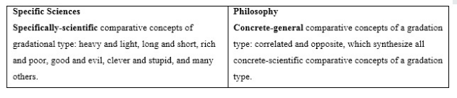
Concepts of practical mind Categories of pure mind
Examples of comparative concepts of gradation type
More complex relationships, causing cyclic processes, I call comparative concepts of orthogonal form. This potential and kinetic, electrical and magnetic and the like concepts, many of which reflect the relationship of the parties, separated from each other in the cyclic process, not by one hundred eighty degrees, as is the case ща opposites, but by a quarter of the period, i.e., ninety degrees.
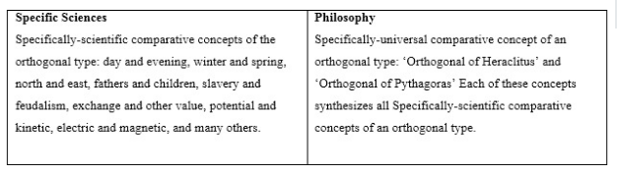
Concepts of practical mind Categories of pure mind
Examples of comparative concepts of orthogonal form
In addition to these kinds can be identified specifically-scientific comparative concepts of additional and similar type.
The language of specifically-scientific (private) comparative concepts is the most optimal variant of the scientific language suitable for unambiguous expression of meanings.
To the same extent, it can be used in both Natural sciences and Humanities. And although the specifically-scientific comparative concepts of different types are still not collected into separate groups, but it is safe to say that the use of these thinking instruments has excluded the ambiguity in the natural scientific knowledge and as a consequence led to their rapid development. Hence appeared the split between social-humanitarian and natural scientific knowledge, which can be overcome only by the use of specifically-scientific comparative concepts in the Humanities.
The transition from reason and mind to wisdom is carried out at the expense of the third type of thinking instruments — specifically-universal comparative concepts of different types — categories of pure mind. The simplest of them are «four types of opposition» coming from Aristotle, as the author of «Metaphysics" called comparative concepts (Aristotle 1975, 121-168).
Forming from these concepts the Matrix as the embryo of the future universal philosophical language — categories of pure mind, we find objective points of view, which are equal for all, which leads not only to an understanding of the original natural and social relations, but also to the beginning of mutual understanding.
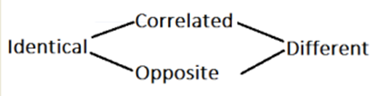
Figure 1. The Aristotle-Rotenfeld Philosophical Matrix
Continuing along the same path, we find two more complex concepts of Pythagoras and Heraclitus, as well as in modern natural Sciences, and supplement the Matrix with them. So there is a formation of a cumulative number of concrete-universal comparative concepts, starting with an abstract identity and ending with an abstract difference.
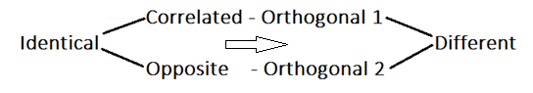
Figure 2. The cumulative number of comparative concepts
Continuing to go the same way, we supplement this series with other, even more complex concrete-universal comparative concepts that reveal the idea of «philosophical theory of everything».
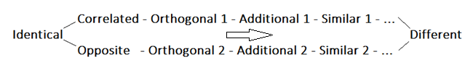
Figure 3. Philosophical «Theory of Everything’
Specifically-scientific and specifically-universal comparative concepts of different types, as concepts of practical and pure reason, raise the intellectual thinking two levels higher, that is, to the level of mind and the level of wisdom, understood in no other way, than «the knowledge of the universal».
And specifically-scientific comparative concepts, allow translating Humanities from the level of opinions to the level of specific scientific objective knowledge, as is the case in the Natural Sciences, while specifically-universal comparative concepts, incorporating similar specific scientific concepts of different types, raise philosophy to the level of cumulative objective science.
As a result, we have a universal method of ascent from reason to mind and wisdom, characterized by the ascent from the set of subjective opinions to unambiguous knowledge through the use in the thinking process not only of classification concepts, but also of the specifically-scientific and specifically-universal comparative concepts. In one case, we have a variety of specific Sciences, including Humanities. In another case — metaphysics as «the science of the first causes and principles», as Aristotle understood philosophy (Rotenfeld 2017, 62-70).
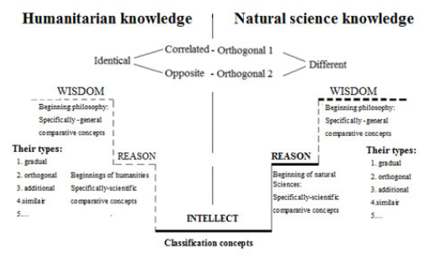
Figure 4. Three stages in the development of the mind

2. Mission of concrete sciences, mathematics and philosophy
According to Aristotle, philosophy is meant to be engaged not just into the search for the elements and principles — all concrete sciences are engaged into this by searching for specifically-scientific comparative concepts of gradation type, such as heavy and easy for physics, long and short for geometry, rich and poor for the economy, healthy and sick for medicine, etc.
The mission of philosophy is the search for the most common principles in the form of specific-universal comparative concepts — categories of pure mind. The philosophy was created to reduce the diversity of specific scientific knowledge to similar, but extremely common primary causes-metaprocesses.
The philosophers did not succeed in this. Therefore, philosophy is not «the mother of all Sciences’, as it is commonly believed, but «their unborn child’.
None of the Sciences in their generalizations strive to go so far as philosophy, which can arise only when it learns to generalize the principles of the specific Sciences. Each of her concepts — categories of pure mind — is a generalization of all specifically-scientific comparative concepts of a similar kind.
As an example, we can consider one of the simplest concrete-universal concepts of gradation type, namely, «correlated». And we see how this concept incorporates all the specifically-scientific comparative concepts of the same kind, such as hard and soft, rich and poor, as well as all the other concepts considered relative to each other. The same applies to all other specific universal comparative concepts, which makes them scientific.
Mathematics, claiming to be the Queen of Sciences, because with the help of numbers it can describe everything existing is in our world in the most accurate way — it is though special, but still a specific science. Its first principle is a quantitative concept representing the comparative concepts of gradation. Mathematics does not conceive the Universal, as it was supposed to be performed by philosophy, it reflects in numbers only the conclusions of this or that particular science.
Therefore, mathematics is not the Queen of all Sciences, as is commonly believed today, but their conscientious servant.
The Sciences, D.E.Gasparyan writes, «are interested in the reduction of knowledge in the limited areas. The distinctive feature of philosophy is that its subject is the entire reality, and therefore the law to which the philosophy will reduce its contemplation should be the ultimate metalaw — integral and primary. Therefore, philosophy is metaphysics (above physics) (Gasparyan 2014, 71-85).
Mathematics cannot give a quantitative description of the whole world, because the reality is split according to the subject principle. With the help of its means, mathematics is able to give a quantitative description only within the framework of a particular subject, while philosophy with the help of a universal language is created to cover everything.
The trouble of philosophy is that these most common principles aimed at creating of the General scientific picture of the world, were searched for by the philosophers not among the specifically-universal comparative concepts of different types, but among the utmost general classification concepts: Being and Nothing, Matter and Consciousness, Good and Evil and others. This turned the emerging discipline into a collection of abstract-general opinions — into philodoxy.
Therefore, from the set of opinions arising in the social and humanitarian disciplines on the basis of thinking classification concepts, we must separate not only specifically-scientific knowledge, with its specific specifically-scientific comparative concepts, including numbers, but also specifically-universal knowledge, i.e. philosophy as yet unborn Queen of Sciences.
As a result, we have:
— a lot of different subjective opinions about the world and man, due to the intellectual thinking with the help of classification concepts;
— a lot of different specific scientific knowledge about the surrounding reality, obtained through rational thinking with the help of concrete scientific comparative concepts of different types, including numbers and other mathematical abstractions;
— holistic specifically-universal (philosophical) knowledge about the world and man, received by us through thinking with specifically-universal comparative concepts of different types — concepts of practical and pure reason.

- On the ambiguity on the language of specific sciences
Translation of the laws of nature into the language of specifically-scientific comparative concepts of the gradation type began in the Ancient times, when people learned to distinguish the concepts of long and short, heavy and light, strong and weak, etc. Taking the smaller of these concepts as a unit of measure, they learned to understand the largest in numbers as a relationship between quantities.
It turns out that the concord between the language of specific Sciences and the language of mathematics became possible because the Natural Sciences and mathematics took specifically-scientific comparative concepts of the same gradation type, as their principles. In one case, it was the concept of «more or less» in the other case as the numbers used to be the principles, each of which in relation to any other number was a comparative concept of gradation. As a result, mathematics turned out to be the universal concrete scientific language, which allowed to measure in numbers the world divided by the subject principle, i.e. each of its separate parts.
As for cyclic processes, their purely scientific understanding begins only in the late 14th century, when Jean Buridan and Nikolai Orezm began to investigate the oscillations of the pendulum and the movement of bodies in a circle. Since that time, the science began to form an understanding of specific scientific orthogonal relations, and, therefore, of specifically-scientific comparative concepts of orthogonal type, such as potential and kinetic energy, electric and magnetic field, exchange and consumer values, and others.
At the same time, to describe any of the cyclic processes mathematicians had already formed adequate comparative concepts of orthogonal form, namely, a sine and a cosine. And only then for a more accurate understanding of reality appeared analytical geometry of Descartes, integral and differential calculus of Newton and Leibniz. Thus was prepared and fulfilled a revolution in physics, which passed to the world contemplation with the help of the specifically-scientific comparative (private) concepts of orthogonal type — concepts of practical mind (Rotenfeld 2023, 269-274).
While the Humanities development stopped at the level of Socrates’ and Plato’s thinking, that is, comprehending the world and man with the help of classification concepts. This is what determines the thinking of humanitarians as a reasonable thinking that can not generate objective knowledge, but only a variety of subjective opinions.
The transition from the language of classification, quantitative and specifically-scientific comparative concepts to the language of specifically-universal comparative concepts — categories of pure mind, which gives objective points of view for all observers, solves the problem of the emergence of a universal language that determines the cumulative nature of philosophy. This means that the problem of the unity of knowledge is solved, because the universal language, like numbers, brings the same meaning into observations made in the different areas of reality.

- To separate the philosophy from philodoxia
The dream of philosophers about the creation of a universal language, uniquely describing the world as a process of language with a strictly defined and unchanging structure remains unfulfilled till now. This is the fault of those who did not follow Aristotle, but followed Socrates and Plato and did not consider philosophy as the objective science of the most general natural and social processes, and therefore considers the pluralism of opinions as the merit of philosophy.
But «lovers of wisdom» cannot think so, but rather «lovers of opinion» simulating the image of a philosopher — philodoxes, used the language of classification concepts to understand the reality.
Whereas Aristotle, accusing the philosophy of Socrates and Plato of the imaginary wisdom, expressed origination and destruction processes, not by the way of the general classification concepts, but by definite specific-universal comparative concepts of «opposites», interpreted in no other way than «both the excess and deficiency related to medium». Aristotle included this concept in the very first principles — in the «four types of opposition» (Aristotle 1975, 121-168).
I continue the work started by Aristotle on the creation of a universal philosophical language, consisting of specifically universal comparative concepts, which, in my opinion, are only able to bring philosophy out of the maze of subjective opinions on the operational scope of an objective science of general significance. For this reason, I propose to divide philosophical knowledge into two stages — philodoxia, which uses the language of classification concepts, and philosophy, which includes in its arsenal of thinking instruments specifically-universal comparative concepts of different types — categories of pure mind.
Therefore, I mean by philosophy the language, i.e. the system of specifically- universal comparative concepts about the world and the man — almost in the same way philosophy was understood by Soviet philosophers. The only difference is that in Marxist philosophy were considered extremely general classification concepts, such as «matter», «consciousness», «movement», etc., while I’m talking about the concepts lying between the abstract identity and the abstract difference of specific universal comparative concepts.

5. Conclusion
As for the universal common language we are looking for, in addition to classification concepts, as is the case, it should include two other types of thinking instruments: specifically-scientific and specifically-universal comparative concepts that form three stages in the mind development: reason (rassudok), mind (razum) and wisdom. Their trinity, in my opinion, is only able to bring the language out of the crisis.
WORKS CITED
1. Aristotel'. Metafizika // Aristotel'. Soch. V 4 t. T. 1. Red. V. F. Asmus. — M., «Mysl'», 1975. S. 121-168.
2. Gasparyan D. Est' li v filosofii razlichiya svoya metafizika: ZH. Delez i ZH. Derrida // Filosofskie nauki, 2014, №9. S.71-85.
3. Rotenfeld YU. A. PALETS ARISTOTELYA: Protiv vsekh mnenii /Yurii Rotenfel'd. — [b.m.]: Izdatel'skie resheniya, 2017. — S. 62-70.
4. Rotenfeld Yuriy. Philosophical Matrix as a System of Categories of Pure Mind// Philosophy Study, June 2023, Vol. 13, No. 6, 269-274.

