Yuriy Rotenfeld
The philosophy of pure mind: human and animal intelligence
"We cannot solve our problems with the same thinking we used to create them". A. Einstein
1. Two stages in the development of the intelligence: mind and reason
When the conversation turns to what is intelligence, learning, cooperation, generalization, psychologists begin to argue, especially since the dispute flares up when the assessment of these abilities concerns animals. Scientists often adopt different definitions of these terms, which focus on behavioral or physiological reactions that need to be seen in an animal. However, different definitions of terms imply different assumptions and consequences. And the way we use our terms in comparative cognition is far from being neutral from a normative point of view, as it affects research. Therefore, "the way the terms are used in science is the starting point for understanding the theoretical and value load of science, says Kristin Andrews [3].
My definition of what intelligence or mind is will come from the understanding that it is a multi-valued classification concept expressing the general ability to cognition and problem solving. This gift unites the cognitive abilities of organisms, such as sensation, perception, representation, imagination, memory, reason, mind, thinking and who knows what else. Animals have the rudiments of intelligence. Their behavior is not only programmed by genes and formed as a result of natural selection, but is also the result of activity as the ability to respond purposefully to environmental changes. The same applies to the development of intelligence in humans, which distinguished him from the animal kingdom.
"Comparative cognitive research studies what animal behavior is cognitive and what cognitive mechanisms or processes provide such behavior. Questions include: what representations do animals need to solve specific tasks; do they have mental maps, metacognition, or numerical concepts? Do animals have beliefs? Which animals have consciousness? What is the connection between language and thinking? Are animals rational? [3]. I will try to answer some of these questions in the proposed article.
However, more acute discussions, in my opinion, flare up when it comes to such a multi-valued classification concept as mind. In some philosophical teachings, mind is separated from the word reason, understood as the second stage in the development of the mind. Therefore, it is believed that reason and mind, expressing certain ways of theoretical thinking, are two completely different philosophical categories.
The comprehension of the content of what the mind is and how it differs from reason began to be engaged in ancient philosophy, and continue to do so at the present time. Moreover, the mind is always spoken of as a higher stage in the development of the intelligence. But if today the essence of reason seems more or less clear, since it is used every day, then the definition of what mind is in doubt. It is still unclear what its essence is, how mind is similar, and how it differs from reason.
According to I. Kant, for example, the main function of the reason in cognition is the mental ordering of phenomena. Mind strives to comprehend the essence of things, but does not achieve this goal. G. Hegel interpreted reason as a necessary moment of rational thinking. The dialectical method, according to Hegel, appears at its highest stage as "rational reason or to reason mind". Hegel identified reason with the metaphysical understanding of reality, contrasting it with the dialectic of mind. On this occasion, F. Engels wrote that "Hegel's distinction between mind and reason, according to which only dialectical thinking is reasonable, has a certain meaning."
From the point of view of dialectical materialism, the process of development of theoretical thinking presupposes the relationship of mind and reason. The ability to skillfully operate with concepts, correctly classify facts and phenomena of reality, bring knowledge into a certain system is connected with reason, the importance of which is beyond doubt. Through the mind, thinking synthesizes the results of cognition, creates new ideas. Relying on reason, mind reveals the essence of reality. However, neither dialectical materialism nor other philosophical teachings give an answer to the question of what this essence is.
As a result, mind and reason are perceived as two types of human mental activity, the mutual relationship of which is understood differently in various philosophical teachings. At the same time, in comparison with reason, mind has always and everywhere been recognized as the highest form of mental activity aimed at cognizing the orderliness, harmony of the universe, at identifying cause-and-effect relationships that reveal the essence of reality, its mind. However, as correctly noted at the time Kant, the mind using the means of reason, is not able to comprehend the essence of natural and social phenomena, therefore it remains within the boundaries of reason.
This remark of I. Kant is especially relevant in relation to the social sciences and humanities, the further development of which requires the discovery of mental means that determine the essence of mind, separating its means from the means of reason, identifying the similarities and differences of these means. Therefore, the interpretation of mind and reason in the teachings of Kant, Hegel and other thinkers does not work. Therefore, in the light of their reasoning, I want to present a clearer concept of mind and reason.
2. Nonverbal intelligence as the ability of organisms to think intelligently
I proceed from the understanding that each person relies on sensations and perceptions in their thinking process. In addition, he is able to think with words. Thus, people use two ways of thinking – nonverbal and verbal.
Receiving information about the surrounding world in the form of various natural and social influences, the human or animal brain compares them, notes between them both a measure of similarity and many specific differences. Therefore, the mind is formed before the development of language. This means that preverbal thinking is aimed at comprehending sensually perceived phenomena – sensations and perceptions, including concrete relations of reality. The new way in which philosophy should be connected with the study of the mind of animals and humans should be due to the fact that thinking in such concepts that reveal the essence of environmental influences on organisms should be embedded in the practice of comparative research. And these are comparative concepts with which I represent the mind, which gets the opportunity to assess the degree of difference and similarity not only of visual images of objects, but also of many other relations of reality. For example, the relationship "A and not-A", the relationship "more - less" or the relationship between different opposites as the relationship of converging and diverging pairs of them.
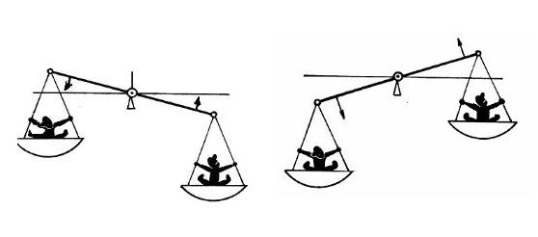
Opposite: converging and diverging pairs
As a "measure of all things" – the body perceives the opposite of the effects directed at it – hot and cold, good and evil, heavy and light, etc. And the occurrence of a sensation or perception is determined by an irritant having a certain amount of intensity, which is determined by the strength of the acting stimulus and the functional state of the receptor. No wonder they say: "everything is known in comparison."
In order to diagnose the level of nonverbal intelligence, specialists do not use speech, but use only visual materials. However, the purpose of this article is to comprehend the nonverbal thinking of animals and humans with the help of language, i.e. with the help of verbal thinking. To do this, I use a special language that reflects the impact of the environment on a living organism. This language is the language of specifically scientific and specifically universal comparative concepts of gradation, orthogonal, additional and other types [ 7, 8, 9, 10, 11], which I have been using for many years.
Therefore, in my opinion, the essence of the mind consists in the ability to identify the different and distinguish the identical, which is achieved with the help of verifiable concrete scientific (private) comparative concepts of different types. Whereas the categories of "pure reason" are concretely universal comparative concepts that determine, in addition to mind and reason, the third stage in the development of the mind - wisdom. It is not by chance that Aristotle wrote on this occasion that knowledge of the general makes a person wise, because "the wise, as far as possible, knows everything, although he does not have knowledge about each subject individually" [1, p. 68]. Therefore, lovers of wisdom were called philosophers.
3. The phenomenon of "pure mind" and verbal intelligence
As it is commonly believed, "pure mind" is knowledge that is not derived directly from experience, i.e. obtained without strict empirical verification. However, it concerns all the most general relations of reality – natural and social.
Whereas the knowledge received by the organism about the set of relations of its environment, programmed by genes and formed as a result of natural selection, is tested experimentally (Animal Minds). Therefore, it is expressible in the language of concrete scientific comparative concepts – it is "big and small", "hard and soft", "dry and wet", "good and evil" and many others. With the help of these initial relations, Nature forms its harmony and communicates not only with itself with all its parts, but also conducts a conversation with many living organisms, forming their brains.
Therefore, the mind is the same in humans, dolphins, dogs, ants, etc. At the same time, it has different levels formed in response to environmental influences. It is surprising that Aristotle was able to generalize and highlight the basic, i.e. the most basic concepts as categories of "pure mind", calling them "types of opposition". He has four of these concepts – these are "contradictory", "correlated", "opposite", "deprivation and possession" [1, 121-168].
Using these comparative concepts, I begin the construction of a philosophical psychological and pedagogical Matrix. Its task is to collect the conceptual apparatus of nonverbal intelligent thinking aimed at an extremely general knowledge of the world. Its cutting off from reason thinking, due to the emergence of a language of classification concepts that can lead us into the "fantasy world", obscuring the mind [10].
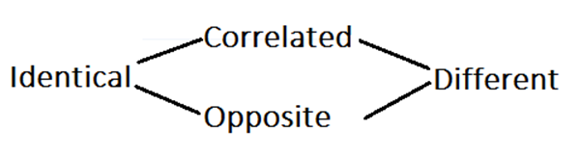
Scheme 1. The Aristotle–Rotenfeld Philosophical Matrix
I would like to draw the reader's attention to the fact that the famous German-American philosopher and logician Rudolf Carnap divided the language into three types of concepts – these are classification, comparative and quantitative concepts [5]. However, quantitative concepts – numbers, in my opinion, are not a separate type of linguistic means, since they belong to specifically scientific (arithmetic) comparative concepts of a gradational type. Two different numbers are similar to other concrete scientific comparative concepts, such as "long and short" (geometry), "heavy and light" (physics), "good and evil" (ethics) and similar concepts. Therefore, the language consists not of three, but of two types of concepts – comparative and classification. Thinking with the first type of concepts determines mind nonverbal intelligence, whereas thinking in natural language, most of the words of which consist of classification concepts, gives reason, verbal intelligence.
The basis of the verbal type of mental activity is speech. It can be carried out in the process of internal or external reflection on the objective world in verbal form. People with well-developed verbal and logical thinking can easily switch from one task to understanding another problem. They have a rich imagination and can freely operate with concepts, judgments and conclusions. They can analyze, generalize, build theories and hypotheses. At the same time, individuals with a verbal type of mental activity experience difficulties in solving tasks that require operating with visual images and tools such as a wedge, lever, scales, bow, lyre, related to thinking with comparative concepts.
Philosophical research is concerned not only with questions about whether animals have thinking abilities or only humans are capable of thinking, but also with questions about the nature of these abilities. Descartes, for example, argued that the absence of language in animals gives us reason to believe that they have no form of thinking or rationality. In the twentieth century, Descartes' view was supported by other thinkers, for example, the philosopher Donald Davidson, for whom attributing thought to animals is not just an epistemological problem. For him, the very idea that animals can think is problematic. Only people can think, because, like Descartes, Davidson connects the ability to think with language proficiency. Davidson insists that language is not designed to describe reality, but to communicate.
Both types of thinking – mind and reason – contribute to the transfer of information from one person to another. Today, nonverbal communication is carried out using sign language, facial expressions and movements. However, comparative concepts are able to translate nonverbal thinking into verbal-speech or other linguistic form, at least they help to understand what mind is, to give it an explanation.
4. The struggle between mind and reason in Ancient philosophy
I hope it has already become clear to readers that I distinguish two stages in the development of intelligence: mind and reason. Reason is conditioned by thinking in terms of classification, whereas mind is determined by thinking in terms of comparative concepts.
Perfecting consistent reason thinking, the ancient Greek philosophers Parmenides and Zeno could not understand Pythagoras and Heraclitus, who represented the surrounding world as an oscillatory process. On this occasion Heraclitus wrote: "Everything is exchanged for fire and fire for everything, just as goods are exchanged for gold and gold for goods" [11, 26-57].
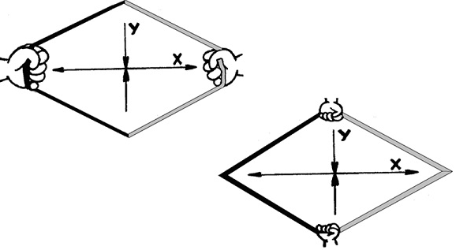
Exchange in society and nature
In addition, Heraclitus found images with which he interpreted the reasonableness of nature as "the harmony of the bow and lyre." These are two pairs of opposites placed perpendicular to each other – divergent (emergence) and convergent (destruction) pairs expressing the exchange process. Whereas Pythagoras, comprehending the "music of the spheres", saw only part of the same process, describing it with the help of two cathets inextricably linked at right angles.
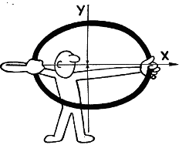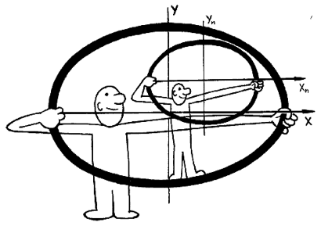
Harmony of the bow and lyre
The fact that the teaching of Parmenides was directed against the mind thinking of Pythagoras and Heraclitus is evidenced by two paradoxes of Zeno – "Achilles" and "Dichotomy". The first one was directed against the processes of destruction, and the second paradox was directed against the processes of emergence expressed by Pythagoras through the trigonometric functions sine and cosine. The same applies to the concept of Heraclitus "converging-diverging", reflecting the "harmony of the bow and lyre".
Having severed the processes of destruction and emergence, Parmenides and Zeno showed their commitment to strictly logical reason thinking and their complete inability to comprehend the world as a process from the standpoint of mind, whereas these paradoxes had to be perceived only in the frame of a single picture [9, 40].
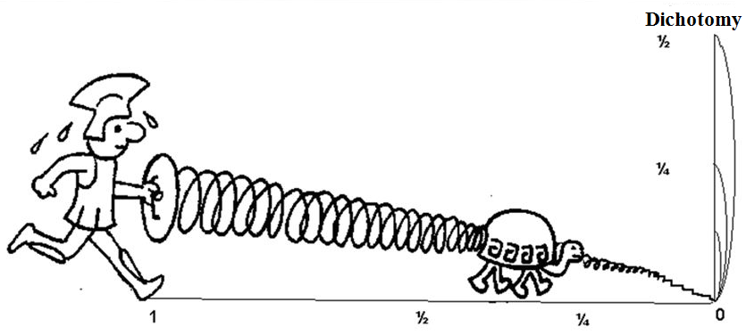
A single plot: "Achilles" and "Dichotomy"
I must say that Aristotle, who read the book of Heraclitus "On Nature", failed to understand the main idea of its author – why two pairs of opposites are needed in the "one". On this occasion , Aristotle wrote: "If, in the presence of four [principles], there are two [pairs] of opposites, then along with each of them there must be a beginning of some special intermediate nature; and if two [pairs] of opposites can be generated from each other, then one of them will be superfluous. At the same time, it is impossible that there are several primary [pairs] of opposites" [2, 74].
That is why, in order to supplement nonverbal thinking with concepts, I have to use two more complex comparative concepts – "Orthogonal 1 of Pythagoras" and "Orthogonal 2 of Heraclitus", which, by deepening the mind, we embed into the Matrix of pure mind. But if the "Orthogonal 1 of Pythagoras" is formed by two correlated concepts, then the "Orthogonal 2 of Heraclitus" is formed by two pairs of opposites.
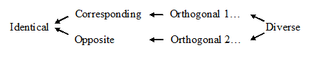
Scheme 2. The Philosophical Matrix: Categories of Pure mind
The upper row shown in the diagram is a metaphysical row of concretely universal comparative concepts of gradation and orthogonal form, while the lower row is formed by concretely universal dialectical concepts of gradation and orthogonal form. Metaphysical concrete scientific concepts allow us to calculate reality, since taking "less" as a unit of measurement, we can comprehend "more" in numbers. Whereas dialectical concepts allow us to understand reality as natural and social processes.
5. The level of the preverbal concept
It is known that visual-imaginative thinking is characteristic of young children, that is, the nonverbal component inherent in them from birth prevails. This is how animals and even some quite reasonable adults think, who cannot express their thoughts in words, because they do not have such concepts at their disposal, and they have not yet formed adequate images. Therefore, the earlier the formation of children's thinking in comparative concepts begins, the easier it will be for the child to assimilate knowledge about the scientific picture of the world and its unity [8].
The actions and speech of the child are formed under the influence of communication with others, which is a process of exchange captured by Pythagoras and Heraclitus with the help of orthogonal relationships. However, not only people, but also many living organisms enter into communication with each other. At the same time, current research notes that communication should not be limited to the verbal domain. Communication can occur through gestures and other bodily movements, touching, and in some species, scientists note, through the release of chemicals.
A communicative approach to intentional communication requires communication partners to be able to understand that others have goals. And this means that partners must have a thought, and as we saw above, thought is possible without language at the level of orthogonal relationships that help us see how children and animals who lack language can still communicate. This is also indicated by the opinion of Noam Chomsky cited by Christina Andrews [3] that animals can have communication systems, but do not have anything that could be called a language (Chomsky 1980: 430).
In order to understand intentional communication as an exchange of resources, I propose a language of comparative concepts in which communication, as well as learning, are designated by the concept of "orthogonal". At the same time, I want to note that, being a manifestation of exchange, learning is inherent in almost all animals, with the exception of the most primitive. It provides flexibility of behavior and is one of the prerequisites for obtaining a more developed intelligence. Whereas the result of the exchange, the gain from it, I designate by the concept of "additional", which is shown below by means of a cumulative series of comparative concepts: Identical – gradation – orthogonal – additional – like, ordinal... - Different
Moreover, I present the same categories of pure reason as metaphysical and dialectical series of relations expressed through the concepts of symmetry, asymmetry and antisymmetry:
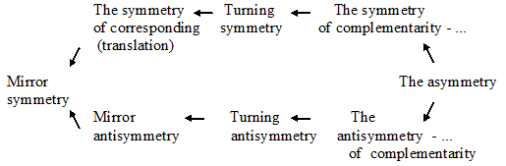
Scheme 3. Concepts of pure mind in symmetric categories
As for generalizations, only higher animals can transfer the formed generalizations to stimuli of other categories. They are able to form abstract concepts of similarity and difference, which corresponds to comparative concepts of different types and subsequently apply them even to stimuli that have no physical similarity between the sample and stimuli of other categories and other modalities. This is a manifestation of pure mind, by which I mean knowledge that is not directly derived from experience, but is reproduced by consciousness after generalizing concrete data that is verified by experience.
The level of generalization in animals was called the level of the preverbal concept, because the information is given in abstract form. Animals in this case move from the visual-figurative to a more abstract, albeit non-verbal form of processing and storing information. And the reflection of reality is at the level of concepts that are not mediated by the word.
Instead of applying a set of particular rules for individual sets of stimuli, animals use a single abstract relation of similarity and difference that does not depend either on the category of stimuli or on such secondary parameters as the color or shape of the object. And this ability of animals to grasp the relationships between objects and phenomena of reality, and to operate on these relationships in a new situation for them in order to adapt to it, means that intelligence is the same acquisition for all. Therefore, it is possible to assert the reasonableness of all living beings, taking into account its different degrees.
Although the level of the preverbal concept is not related to words, it is this level of generalization that is now considered by psychologists as the highest degree of brain development and mental abilities that served as the basis for the emergence of speech in humans at the earliest stages of anthropogenesis. Therefore, the question became whether animals have the ability to master at least the rudiments of human language. And studies conducted by psychologists have shown that great apes have this ability.
All of the above is directed in favor of the mental identity of humans and animals, which is confirmed by the arguments of Charles Darwin, given in his book "The Origin of Man" in 1871, and zoologist Donald R. Griffin, in a series of books which proves the existence of animal thinking and animal consciousness. While other scientists, in particular neuroscientist Raymond Tallis, on the contrary, tries to substantiate the essence of the cognitive difference between animals and humans from their positions [6].
The human mind develops gradually, reaching its apogee in the natural sciences and practical achievements, the philosophical foundations of which are specifically scientific comparative concepts of gradation, orthogonal and other types as their empirical foundations. Whereas reason develops on the basis of the language of classification concepts arising on the basis of the ultimate abstractions of identification and distinction A = A and A and not-A, which animals also naturally possess. It follows that the problems of someone else's mind are solved on the basis of tests (for example, success in the task of understanding the identical and different, correlated and opposite, orthogonal Pythagoras and orthogonal Heraclitus, reasoning tasks). Such experiments will help to unambiguously answer the question of which animals are smarter than others, which is the best solution to the problem of someone else's mind. Instead, scientists "are more interested in how well an animal has evolved to thrive in the environment, rather than how smart it is. This way of thinking about intelligence, Christina Andrews believes, makes the comparison of intelligence between species controversial" [3].
As for the problems of artificial intelligence, which is completely similar to human, the available programs do not reveal the essence of mind, since the difficulty faced by scientists is that on the one hand, the world consists of only objective processes, while on the other hand, mindful is generated by subjective experience in the first person. The solution may consist in the fact that in all real cases, subjective experience manifests itself equally for each of all organisms in the form of nonverbal comparative concepts due to the same impact on them from the environment. An artificial intelligent being, in my uninitiated opinion, should be the result of such a computer program, which includes the processes of identification and discrimination in the form of non-verbal mental means presented here. The only question is whether such a being will distinguish between good and evil, which means whether we – the majority of humanity - need it?
6. Conclusion
The philosophy of pure mind is a system that forms a matrix of concretely universal comparative concepts about the world and man, the thinking of which I define as the third stage in the development of the mind – wisdom.
The second stage is formed by thinking with concrete scientific comparative concepts underlying the natural sciences. These are such concepts as "long and short", "heavy and light", "dry and wet" and others. Taking the smaller of the sides as a unit of measurement, we get the opportunity to comprehend the larger side in numbers. I call this kind of thinking " mind thinking."
The first stage is formed by thinking with multivalued classification concepts that make up the majority of natural language words – this is verbal "reason thinking".
As a result, we have three stages in the development of the mind – reason, mind and wisdom, due to the existence of three types of linguistic means – classification, concrete scientific and concrete universal comparative concepts. The philosophy of the animal mind and the related philosophy of language, enriched with the language of comparative concepts and illustrations, in my opinion, should become the threshold of a cumulative, verifiable by concrete sciences, strictly scientific "philosophy of pure mind", asserting a fundamentally new view of the problem of society, man and his place among other beings. And in order to introduce mind and wisdom into the daily life of society, I propose to duplicate the original concepts of psychological and pedagogical knowledge, such as "teach" and "learn", "learning" and "learning outcome", "communication", with strictly scientific comparative concepts - "correlated", "opposite", "orthogonal", which will bring pedagogy and psychology closer to the strict natural sciences [10].
Thanks
I express my sincere gratitude to David Chalmers, who, with his speeches and articles on the Internet, prompted me to deal with the problem of "failure in explaining consciousness", which then developed into an "apology for pure mind". And I also express my gratitude to David Bourget, who, in response to my request, helped me to place my philosophical works in PhilArchive and PhilPapers – their joint philosophical project. I would be glad if both Davids would pay attention and comment on this article of mine.
Literature
1. Aristotel'. Sochineniya. V 4 t. T. 1. – M., «Mysl'», 1975.
2. Aristotel'. Soch. v chetyrekh tomakh. T. 3. M.: Mysl', 1981. 613 c.
3. Andrews Kristin. The animal mind. First published on Monday, March 8, 2021 in the Archive of free access.
4. Kant I. Kritika chistogo razuma / Per. s nem. N.O. Losskogo s variantami per. na rus. i evrop. yazyki. M.: Nauka, 1999.
5. Carnap Rudolph. Philosophical foundations of physics; an introduction to the philosophy of science. New York, Basic Books, Inc. 1966.
6. Meline Caroline. Human and Animal Minds: Against the Discontinuity Thesis. - 2014 - Philosophy in the Contemporary World 21 (2):39–51.
7. Rotenfel'd Yurii. Kumulyativnaya filosofiya kak verifitsiruemaya strogaya nauk. Ekaterinburg: Izdatel'skie resheniya, 2023. - 218 s.
8. Rotenfel'd Yurii. Mudraya shkola: «Trilogiya umA» kak novyi metod umstvennogo razvitiya detei. Ekaterinburg: Izdatel'skie resheniya, 2018. - 292 s.
9. Rotenfel'd Yurii. Palets Aristotelya: protiv vsekh filosofskikh mnenii. Ekaterinburg: Izdatel'skie resheniya, 2019. - 192 s.
10. Rotenfel'd YU. Filosofsko-pedagogicheskaya matritsa i sistema novykh didakticheskikh kategorii // Otechestvennaya i zarubezhnaya pedagogika №6 (88) tom 1. 2022. S. 58–72.
11. Rotenfel'd Yurii. Filosofiya, ili ten' mudrosti: Al'ternativnoe tolkovanie rannei grecheskoi filosofii. 2-e izdanie. Ekaterinburg: Izdatel'skie resheniya, 2017. – 184 s.

Not knowing enough English, I do not find adequate concepts in it for a clear separation of mind from reason. If I made a mistake in my choice, then I ask native English speakers to correct me in this.
The main meaning of Immanuel Kant's work "Critique of Pure Reason" [4] is the study of the cognitive possibility of reason, in isolation from the knowledge obtained empirically. Behind the phenomena accessible to experience, there is a world of objects "by themselves", which, according to Kant, we are not able to know. Therefore, the forms that appear to us are the essence of the construction of the mental activity of the subject, that is, our ideas that do not exist at all. At the same time, Kant does not specify what reason is and what reason is, how they differ from each other.
In his book, Rudolf Carnap paid special attention to comparative concepts, emphasizing their importance for a number of sciences.
For example, a female great ape allows a male to approach her in exchange for his protection.

