https://www.the-tls.co.uk/articles/the-great-guide-julian-baggini-book-review-david-hum-paul-russell/

September 24, 2021|No. 6182

THE GREAT GUIDE
What David Hume can teach us about being human and living well
328pp. Princeton University Press. £20 (US $24.95).
History of philosophy|Book Review

Self-help on the go

Sketches of ‘le bon David’ and the good life
By Paul Russell
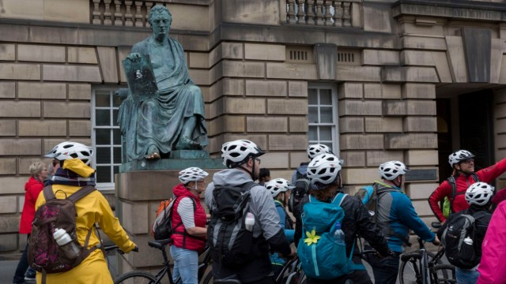
The statue of David Hume, Edinburgh, 2019|© Richard Baker/In Pictures/Getty
September 24, 2021
Read this issue

IN THIS REVIEW
THE GREAT GUIDE
What David Hume can teach us about being human and living well
328pp. Princeton University Press. £20 (US $24.95).
Julian Baggini
According to Julian Baggini, although David Hume (1711–76) ranks among the very greatest philosophers, he “remains relatively obscure outside academia”. What has been lost, Baggini suggests, is a proper appreciation of Hume as “a practical philosopher”, a thinker who can provide us with a model of how to live “the good life”. With this in mind, Baggini aims to bring “Scotland’s Hidden Gem” back to life for a popular, non-specialist audience. His method is “to approach [Hume’s] life and work together”, following his “biographical footsteps” with a view to showing his readers “why we would be wise to follow his philosophical ones too”. By the end of the book Baggini has extracted a set of 145 “maxims” which are then gathered together in an appendix.
The most successful aspect of The Great Guide is the “Hop-On Hop-Off” intellectual tour that it offers. The reader is taken around the various locations where Hume’s life and ideas developed, moving from country to country, city to city, and stopping off at a few stately homes en route. This tour begins with Hume’s birthplace and early education in Edinburgh and the Scottish Borders, moves on to La Flèche in France (where Hume composed much of his Treatise of Human Nature), then back to London and England, and carries on from there. As we travel around with Hume, Baggini provides his readers with a steady commentary and description of his subject’s various friendships and controversies, along with brief sketches of Hume’s core ideas and contributions. All this is lively and engaging.
But there are limitations to Baggini’s method and approach. His account of the details of Hume’s life, character and relationships relies heavily on Ernest Mossner’s standard biography, which was published almost seven decades ago. This material is lightly updated and sprinkled with the occasional reference to more recent studies. According to this account, Hume was a man of mild and moderate temperament, conservative by nature and certainly no radical. These features of Hume’s character are, we are told, firmly grounded in Hume’s empiricist philosophical orientation and attitudes. All this is the familiar face of “le bon David”, recycled by several generations of Hume scholars and intellectual historians.
Although there is doubtless some truth in this picture of Hume, a great deal is lost or overlooked. There is little in Baggini’s account to give the reader a sense of the importance of the specific philosophical debates in the Borders of Scotland during Hume’s most formative intellectual period in the late 1720s and early 30s. Key figures in Hume’s life and work, such as Lord Kames and William Warburton, go unmentioned. Related to this, Baggini’s tour bus sweeps past the Radical Enlightenment and the hugely influential theological debates involving Newtonian thinkers such as Samuel Clarke, and the battles that were being waged against the “atheism” of thinkers such as Hobbes and Spinoza. Although no one should expect a work of popular philosophy to be exhaustive, these missing elements constitute the very spine of Hume’s thought and intellectual development, and there is a real cost to neglecting them.
Perhaps the most unsatisfactory aspect of Baggini’s book is his effort to turn Hume’s life and philosophy into a self-help manual. It is true that there is much about both Hume’s character and philosophy to admire, but it is not obvious that this is usefully packaged into a set of 145 “maxims” guiding us towards “the good life”. Many of the maxims that Baggini cites are, no doubt, edifying to some extent, especially those directly lifted from Hume. But when Baggini moves away from direct quotation and extrapolates or invents his own maxims in the name of Hume, things get worse. A number of those generated in this way verge on the trite, such as: “You can only follow your dreams if you’re completely awake”. It does Hume little service to present his thought like this.
One maxim that Baggini mentions in passing is of particular relevance: “An author is little to be valued, who tells us nothing but what we can learn from every coffee-house conversation”. I am inclined to the view that The Great Guide leaves us sitting in the coffee house. Even so, the seating is comfortable, the company congenial and the coffee entirely drinkable.
Paul Russell is Professor of Philosophy at the University of British Columbia and Lund University

