Is The Complex Oscillation Related to Observation Limit?
M. I. Sanduk
School of Engineering, Faculty of Engineering and Physical Science, CORA,
University of Surrey, Guildford Surrey GU2 7XH, UK
m.sanduk@surrey.ac.uk

Mathematically, the oscillation can be related to circular motion; whereas complex oscillation (De Moivre's) can not be related to a mechanical model.
A mechanical bevel gear of two different wheels radii is proposed. The position vector of the point is a real quantity. But when the small wheel can not be recognized (observed) within the system, the position vector becomes of a complex feature. The analysis shows that the complex oscillation is a microscopic phenomenon and can be occurred in the following conditions: 1- There should be a gear system. 2- There should be an observation limit.

Keywords: De Moivre's formula, Complex function, bevel Gear, polar form, Complex vector, Random vibrations.
PACS: 46.56+g, 45.40.Bb, 33.20.Vq,

1. INTRODUCTION
Physics normally deals with real quantities. But since the unification of James Clerk Maxwell in 1869 for the Electromagnetic theory, physics used a complex representation for wave. This usage is of technical nature; in other word the electromagnetic wave is of real nature. So till the beginning of quantum physics era, physics did not deal with complex quantity, and it is hard to accept such a physical quantity. But quantum physics introduced the concept of Complex wave function or De Broglie wave.
De Broglie wavelength is not an ordinary space segment; it is the wavelength of a complex wavefunction ($ψ\left(x\right)$). According to Max Boron interpretation this space is a space of probability of particle existence.
This space ($x$) is the space of the probable ($P\left(x\right)$) existence of the particle (point) in micro scale.

$P\left(x\right)=\int{ψ\left(x\right)ψ^{}\left(x\right)\text{dx}}$ (1-1)

where $ψ\left(x\right)$ is the wavefunction associated with the particle. The smallest dimension of this space for electron that has a high probability is the so called Bohr radius ($a_{B}$). The complex phase of the wavefunction is composed of wave vector ($k_{B}=1/{a_{B}}$) and angular frequency ($ω$),

$ψ≈\text{exp}i\left(k_{B}x−ωt\right)$ (1-2)

In this phase space, the wave vector does not obey Lorentz transformation, whereas the angular frequency ($ω$) does.
However, Max Boron interpretation did not solve the problem of this complexity. The explanation tries to find interpretation for the squared quantity which is a real quantity. There is no direct natural (Physical) interpretation for complex quantity [1]. "Now it is believed that real numbers correspond to physical measurable quantities, and complex calculus in physics is supposed to be of a formal-mathematical, auxiliary nature. But both mathematics and physics are two branches of one and the same process of cognition by a human of the outward things; it is quite possible that mathematical concepts involve information about the deepest properties of these things" [2].

However, the present work is not interested neither in wavefunction problem nor in quantum mechanics. The complex function in physics is of wave form. So the present attempt tries to simulate the complex function using real dimensions mechanical system. The attempt is a classical approach to get a relationship between the classical physics and complex wave. A mechanical model (real system) is presented. A polar form for an oscillatory motion is considered then transformation to a complex form may be obtained.

1.2 Wave forms
Pedagogically, the oscillatory motion can be related mathematically to the projection of circular motion:
$x=A\text{cos}ωt$, or $y=A\text{sin}ωt$ (1-3)
Where $x$, $y$, $A$, and $ω$ are the projected trajectory on $x$coordinate, the projected trajectory on $y$coordinate, amplitude, and the angular frequency.
The amplitude, $A$, of the motion is given by the radius of the circular motion since this defines the maximum distance from the origin along either the horizontal or vertical axis. This form is a polar and real mathematical form. Physics and engineering are dealing with real quantities, which have physical meaning.
The other form of oscillation in two dimensional space is of complex feature. The trigonometric and exponential functions are related by Euler form (De Moivre's) [3]:
(1-3) $r=A\left(\text{cos}ωt+i\text{sin}ωt\right)={\text{Ae}}^{iωt}$ (1-4)
This complex form is quite efficient tool in dealing with wave applications (e.g. Maxwell's equations). In this type of applications the real part is considered or the complex form may refer to two real perpendicular components. But in other side the complex quantities have serious meaningful problem in physics. The problem of wavefunction in quantum mechanics is the most famous problem.

2. THE GEAR SYSTEM
One of the models that can be described using polar form is gear model. A simple gear is composed of two touched wheels. The proposed system is of two perpendicular touched circler units (like bevel gear) of radii $a_{1}$ and $a_{2}$ (where $a_{1}≤a_{2}$ ) is proposed; as in Fig.(2-1). The units are attached or associated (supported each other), and rotate around each other. The system is in three dimensions.
The wheel of large radius is the guiding wheel. The ratios of the angular velocities and the radii are:
$\frac{a_{2}}{a_{1}}=\frac{ω_{1}}{ω_{2}}=\frac{τ_{2}}{τ_{1}}=−μ$ (2-1)
where $ω=\frac{2π}{τ}$ . The limit of $μ$ is $1≤μ<∞$. The negative sign is related to opposite rotation of wheels; in this work the absolute ratio will be considered. $μ$ is the characteristic-coupling constant of the two wheels. The linear velocity is:
$ω_{1}a_{1}=ω_{2}a_{2}=v$ (2-2)
The absolute angular velocity ($ω$ ) of the perpendicular two wheels (relative to an inside observer) is:
${\left(ω_{1^{2}}+ω_{2^{2}}\right)}^{\frac{1}{2}}=±ω$ (2-3-a).
So as:
${\left(a_{1^{2}}+a_{2^{2}}\right)}^{\frac{1}{2}}=±a$ (2-3-b).

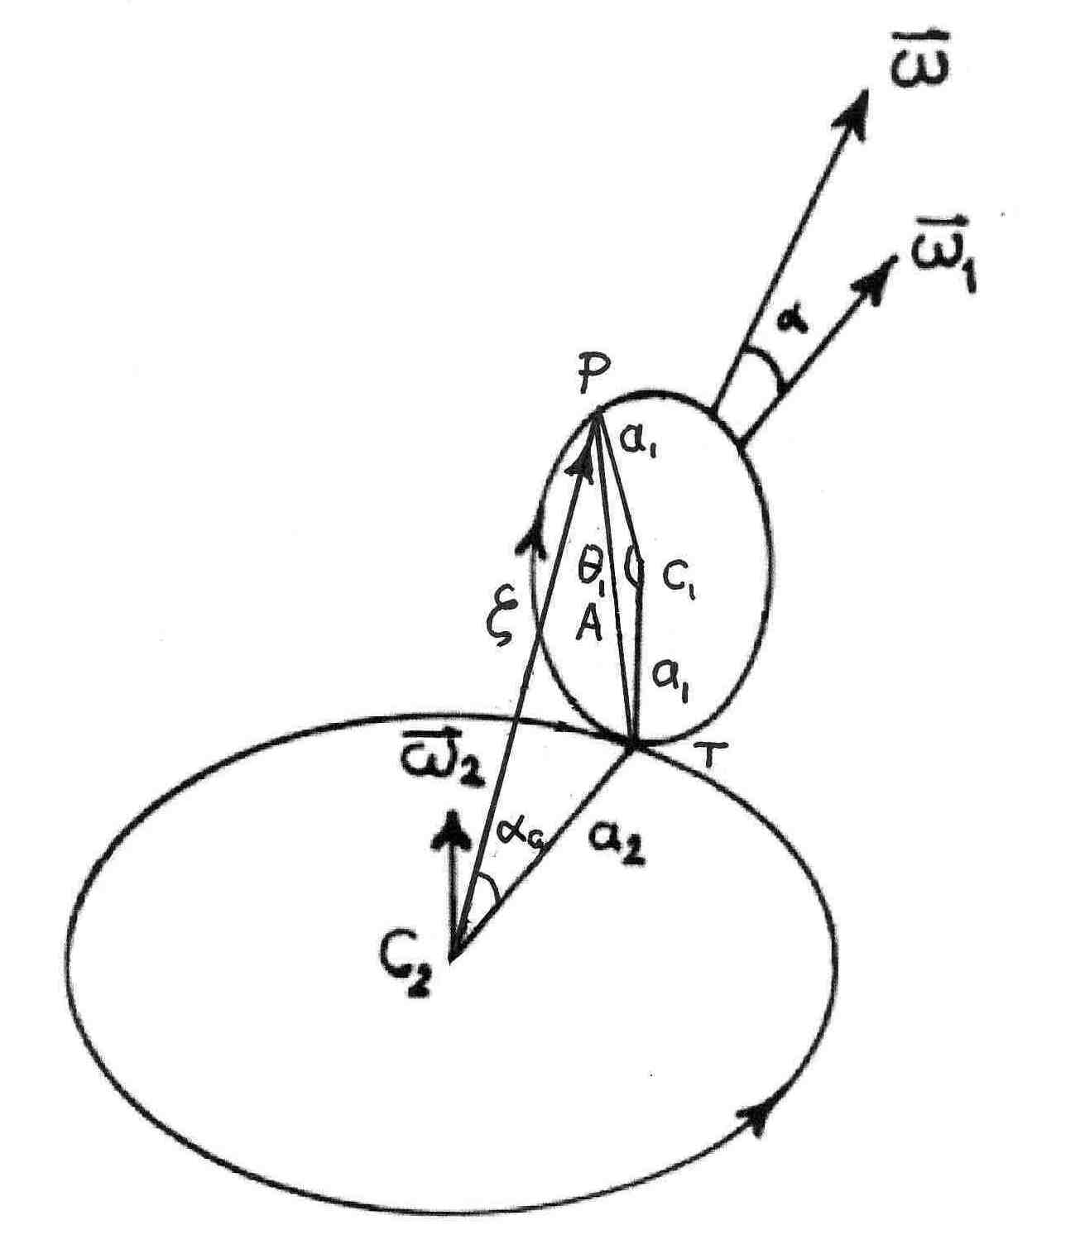
Fig. 2-1 Gear System

The gear may form a compound circular motion.
3. POSITION FUNCTION
To follow the position of a point P in the small wheel, let the position vector of point P is $ζ$relative to C₂ (note Fig.(2-1)). In relative to C₂ the angular displacement of the point is $α_{c}$.
With aid of Eqs.(2-3-a) and (2-1), the angular displacement is :

$α_{c}={\text{tan}}^{−1}\frac{1}{μ}\sqrt{2\left(1−\text{cos}θ_{1}\right)}$ (3-1)
where $θ_{1}=ω_{1}t$
The derivation with time:
$ω_{α}=ω_{1}\frac{\text{cos}\frac{θ_{1}}{2}}{μ+\frac{4}{μ}{\text{sin}}^{2}\frac{θ_{1}}{2}}$ (3-2)
where $ω_{α}=\frac{{dα}_{c}}{\text{dt}}$ is the relative angular velocity. Rearrange Eq.(3-2) :
$ω_{α}=ω_{1}\frac{\text{cos}\frac{θ_{1}}{2}}{μ(1+\frac{4}{μ^{2}}{\text{sin}}^{2}\frac{θ_{1}}{2})}$ (3-3).
With aid of Eq.(2-1):
$ω_{α}=ω_{2}\frac{\text{cos}\frac{θ_{1}}{2}}{1+\frac{4}{μ^{2}}{\text{sin}}^{2}\frac{θ_{1}}{2}}$ (3-4),
and let:
$\frac{\text{cos}\frac{θ_{1}}{2}}{1+\frac{4}{μ^{2}}{\text{sin}}^{2}\frac{θ_{1}}{2}}=Λ$ (3-5)
$ω_{α}=ω_{2}Λ$ (3-6).
Eq. (3-6) shows the relationship between the relative angular frequency and the frequency of second wheel.
The position vector ($\vec{A}$) of point P in terms of the large wheel parameters is:
$\left|\vec{A}\right|=A=\sqrt{{\left|{\vec{a}}_{2}\right|}^{2}+{\left|\vec{ζ}\right|}^{2}−2\left|{\vec{a}}_{2}\right|\left|\vec{ζ}\right|\text{cos}α_{c}}$ (3-7).
Where$α_{c}=±ω_{c}t$, and it is a function: $θ=θ(θ_{1},ω_{2})$. $A$ in terms of the first wheel parameters is:
$A=2a_{1}\text{sin}\frac{θ_{1}}{2}=a_{1}\sqrt{2\left(1−\text{cos}θ_{1}\right)}$ (3-8).
From equating both equations of $A$(Eqs. (3-7) and (3-8)) one gets the following quadratic equation:
${\left|\vec{ζ}\right|}^{2}−\left|\vec{ζ}\right|B+C=0$ (3-9).
Where:
$B=−2a_{2}\text{cos}α_{c}$ (3-10),
and
$C=a_{2^{2}}−2a_{1^{2}}\left(1−\text{cos}θ_{1}\right)$ (3-11).
The roots of this (Eq.(3-9)) quadratic equation are:
${\left|\vec{ζ}\right|}_{1,2}=ζ_{1,2}=a_{2}\text{cos}α_{c}±a_{2}{\left\{−{\text{sin}}^{2}α_{c}+\frac{2a_{1^{2}}}{a_{2^{2}}}\left(1−\text{cos}θ_{1}\right)\right\}}^{\frac{1}{2}}$ (3-12)
or in term of $α_{c}$:
${\left|\vec{ζ}\right|}_{1,2}=ζ_{1,2}=a_{2}\text{cos}α_{c}±a_{2}\text{sin}α_{c}{\left\{−1+\frac{1}{{\text{cos}}^{2}α_{c}}\right\}}^{\frac{1}{2}}$(3-13).
It is obvious that the position vector ($ζ$) is real quantity.

4. The observation limit
In physical world the size, shape color of observed objects can be recognized using an observation toll; the light. In pure geometry there is no consideration for observation process. In geometry, point, line, and plane are ideal concepts. Practically, the dimensions are recognized by using light (for simplicity). So in consider any segment of materialistic line ($x$), and a light of wavelength ($λ$) (or monochromatic laser) is used, for observation. The resolving power of line segment depends on the wavelength, refractive index of the medium, the aperture of observing system, and the geometrical arrangement. The power resolution is high as long as $λ$ is smaller than the measured length ($xλ$), and the measurement is more accurate. For that reason the macroscopic entities are well resolved [4].
In this case, there is an interaction between the line and the incident light, which may cause a scattered ray to the observer. Other wise ($x$) there is no line can be recognized but a point size object ($x=0$).
For microscopic realm, the situation is different. In addition to that the wavelength is in somehow has same order as that of the system ($x≈λ$), the observation disturbs observed system.
The considered gear is regarded as a macroscopic system, and all the dimensions are larger than the detecting light wave length ($xλ$). For the gear above $λ$.This case is in macroscopic level. The observer can recognize both wheels and the trajectory of the point.

4.1 The complex phase
Let us consider the case of that the wavelength satisfies $a_{1}$ (or $a_{2}/a_{1}=μ1$ ), the line segment $a_{2}$is well recognized as in previous case, whereas $a_{1}$is with too poor resolution. So $a_{1}$may be considered as an undistinguishable segment of line or $a_{1}=0$. No parameters in equation (3-12) can be affected by this problem of observation except $a_{1}$. So when the quantity $a_{1}=0$ ,the discriminate of Eq. (3-12) is negative then it becomes:
${\left|\vec{ζ}\right|}_{1,2}=ζ_{1,2}=a_{2}\text{cos}α_{c}±a_{2}{\left\{−{\text{sin}}^{2}α_{c}\right\}}^{\frac{1}{2}}={\left|ζ\right|}_{a_{1}=0}$ (4-1)
The condition $a_{1}=0$ , led to exhibit a complex feature for the function $ζ_{1,2}$.

Accordingly, ${\left|ζ\right|}_{a_{1}=0}$ becomes a complex oscillation. Eq. (4-1) can be rewritten as :
${\left|ζ\right|}_{a_{1}=0}=a_{2}\text{exp}±{iα}_{c}$(4-2).
So the solutions are complex and conjugate. It is a conversion from three dimensions to two dimension space. Using a dimensionless definition ($η$):
$η_{1,2}=\text{exp}±i(α_{c})$ (4-3),
where:
$η_{1,2}=\frac{{\left|ζ\right|}_{a_{1}=0}}{a_{2}}$ (4-4).

With aid of Eq. (3-6), Eq.(4-3) can be reformulated as:
$η_{1,2}=\text{exp}±i(ω_{α}t)=\text{exp}±i\left(ω_{2}Λt\right)$ (4-5),
or
$η_{1,2}=\text{exp}±i\left(ω_{2}Λt\right)={\left[\text{exp}±i\left(ω_{2}t\right)\right]}^{Λ}$ (4-6).
Then
$η_{1,2}=Ψ_{{1,2}^{Λ}}$ (4-7)
where
$Ψ_{1,2}=\text{exp}±i\left(ω_{2}t\right)$ (4-8).
Since
$ω_{2}t=\frac{s}{a_{2}}$ (4-9)
where $s$ is the curved trajectory ($s=a_{2}θ_{2}$), so Eq. (4-8) becomes:
$Ψ_{1,2}=\text{exp}±i\left(\frac{s}{a_{2}}\right)$ (4-10).
Using the property of perpendicular wheels, and with aid of Eq.(2-3-a),
Eq. (4-8) can be rewritten as
$Ψ_{1,2}=\text{exp}±i[±(ω^{2}t^{2}−ω_{1^{2}}t^{2})^{1/2}]$ (4-11).
Eq. (4-11) does not reflect any feature of gear structure.

5. CONCLUSION
The complex feature is owing to:
- The wheels are perpendicular (three dimensional system).
- The wheels are not equals ($a_{2}/a_{1}=μ1$).
- The observation is with respect the large wheel.
- One of the system can not be recognized experimentally ($a_{1}$).
Since the observation depends on the microscopical dimension of the probing light, so the size of the gear is in microscopical level.
References
1-Pillai S. O., Solid State Physics, New Age Publications (Academic), 2005.
2- Lyahov V. V. & Nechshadim V. M., Complex Numbers and Physical Reality,
http://arxiv.org/html/physics/0102047
3-Hassani S., Mathematical methods, Springer-Verlag New York Inc, 2003.
4- Oldfied R. J., Light Microscopy, Mosby, 1993.

