**Assessing the needs of healthcare information for assisting family caregivers in cancer fear management: A mindsponge-based approach**

Ni Putu Wulan Purnama Sari 1,\*, Minh-Phuong Thi Duong 2, Made Mahaguna Putra 3, Pande Made Arbi Yudamuckti 4, Minh-Hoang Nguyen 5, Quan-Hoang Vuong 5,6

1 Faculty of Nursing, Widya Mandala Surabaya Catholic University, East Java, Indonesia

2 Faculty of Social Sciences and Humanities, Ton Duc Thang University, Ho Chi Minh City, Vietnam

3 Faculty of Medicine, Universitas Sebelas Maret, Surakarta, Central Java, Indonesia

4 Installation of Central Surgery and Anesthesia, Regional Public Hospital of Bali Mandara, Denpasar, Bali, Indonesia

5 Centre for Interdisciplinary Social Research, Phenikaa University, Hanoi, Vietnam

6 A.I. for Social Data Lab (AISDL), Vuong & Associates, Hanoi, Vietnam

\*Corresponding Email: [wulanpurnama@ukwms.ac.id](mailto:wulanpurnama@ukwms.ac.id)(Ni Putu Wulan Purnama Sari)

Un-peer-reviewed (v.2)

January 24, 2024

\* \* \*

# Abstract

Fear of cancer is mostly related to cancer recurrence, metastasis, additional cancer, and diagnostic tests. Its legacy as a lethal disease has raised fear of approaching death. Currently, cancer’s total suffering and the worsening phenomena have raised fear, especially among female patients. Family caregivers (FCGs) who are responsible for the day-to-day cancer care at home need to help the patients deal with this fear frequently. Due to the limited care competencies, they need supportive care from healthcare professionals in cancer fear management. This study aims to assess how types of demanded healthcare information affect the FCG’s role in reducing the fear of female cancer patients. The mindsponge theory was used in conceptual development and interpretation. Bayesian Mindsponge Framework (BMF) analytics were used for statistical analysis on a dataset of 48 spouses (husbands) and 12 other family members in five congested communities of Surabaya, Indonesia. Results showed that among the six types of healthcare information, FCGs with higher demand on cancer-specific information and information on cancer physical needs were more likely to need support in reducing the fear of female cancer patients. Meanwhile, FCGs with a higher demand for information on support services were less likely to need support to reduce cancer patients’ fear. Other types of healthcare information have ambiguous effects on the need for support in reducing cancer-induced fear. This study reveals that the demanded cancer-specific information, e.g., cancer’s prognosis or likely outcome and information on cancer physical needs, need to be met in priority to assist FCG’s role in cancer fear management.

**Keywords:** cancer; fear; family caregiver; healthcare information; mindsponge theory; Bayesian Mindsponge Framework.

“[…] under good care and continuing using the panacea, Kingfisher’s appetite for fish had returned. The birds brought tasty fat carp, and so he recovered quickly.”

In: “Kingfisher’s No-Fish Dietary”; *The Kingfisher Story Collection* (2022)

# 1. Introduction

Cancer, a disease in the cell regeneration process that damages and grows abnormally, has been feared for its legacy as a lethal disease (Else-Quest & Jackson, 2014). Cancer recurrence, metastasis, additional cancer, and diagnostic tests are some possible etiology of cancer-induced fear besides fearful death (Sari, 2020a). Cancer incidence rates are highest in Asia among all continents (48% of all cases worldwide), twice as high as in Europe (24.4%) and the Americas (20.5%). In Asia, caring for a sick family member is a part of its culture. Similarly, in low-income countries, family caregivers (FCGs) are expected to be actively involved in the cancer care process, even during hospitalization (Kristanti et al., 2021).

Cancer impacts patients with the disease and their families caring for them psychologically. A study on female cancer patients in congested communities of Surabaya, Indonesia, found that fear was not significantly different between breast and cervical cancer and between survivorship stages in both cases (Sari, 2020a). Another study on cancer caregivers found that their perception of cancer as a fatal disease can affect the intimacy between them and the patients, thereby causing distress (Kang et al., 2021). Cancer-induced fear raises cancer stigma, a negative meaning attached to the word cancer, among patients, their caregivers, and mostly in common people (Holland et al., 2010). Organizationally, the bad impact of fear-induced cancer stigma is its role in becoming a major barrier to quality palliative care, especially in home-based care settings (Holland et al., 2010), not only in the cancer treatment process but also in far-reaching public health consequences (Lebel & Devins, 2008; in Else-Quest & Jackson, 2014).

As the life expectancy of patients with advanced cancer increases, the role of nurses who provide comprehensive support becomes more critical. One of which is the role of providing healthcare information related to cancer care to the FCG. Caring for cancer patients is associated with a substantial physical, mental, and financial burden for their FCG. It is essential to understand the impact of caregivers’ awareness of cancer prognostic on their quality of life and emotional state (Kang et al., 2021). Numerous studies have consistently underlined the essential supportive care needed by cancer caregivers from healthcare professionals (Kusi et al., 2020; Bechthold et al., 2023). FCG of cancer patients reported the primary unmet needs of healthcare and illness-related needs, which mostly include healthcare information needs (Sari, 2020b). These needs are significant due to the prospective support of FCG’s psychosocial care competencies, especially in managing emotional and psychological issues among cancer patients, e.g., cancer-induced fear.

There are challenges in addressing the unmet healthcare information needs among FCG of cancer patients and recognizing the importance of addressing their supportive care needs. However, there is a noticeable gap in understanding the association between the types of demanded healthcare information and the role of FCG in reducing the fear among cancer patients, particularly in the context of breast and cervical cancers. Limited insight exists into how specific types of healthcare information needs may either alleviate or contribute to the fear experienced by female cancer patients.

Understanding the impact of different types of demanded healthcare information on the role of FCGs in reducing fear among female cancer patients is crucial. In this study, we examined various types of demanded healthcare information among FCG, encompassing insights into breast and cervical cancers, treatment details, and support services guidance. This study aims to assess how types of demanded healthcare information affect the FCG’s role in reducing fear among female cancer patients (i.e., cancer-specific information, caregiver-specific information, therapy-specific information, information on cancer physical needs, information on alternative therapies, and information on support services). Through this assessment, we aimed to analyze how providing the right information or the specific information types can assist FCG’s role in reducing cancer-induced fear, especially among female cancer patients. Findings may provide valuable insights to improve the supportive care of healthcare information for FCG of cancer patients from healthcare professionals.

# 2. Method

## **2.1. Theoretical Foundation**

Mindsponge theory (MT) was used in conceptual development and result interpretation (Vuong, 2023). MT views the human mind as an information collection-cum-processor that filters, processes, and accepts or rejects new information or values into or out of the mindset or core values, respectively. MT uses the human mind’s information-processing approach to explain not only various mental products, e.g., fear, but also complex human behavior, e.g., adaptation. MT considers the human mind’s filtering system to be the key factor of the whole information-processing mechanism (Mantello et al., 2023). In filtering new information or values, subjective cost-benefit judgments play an important role, and these may be influenced and be meaningful only if considering the sociocultural context of the individuals (Vaughn, 2019). As the information filtering process can be energy- and time-consuming, the human mind may employ trust in information sources as the gatekeeper of prioritized information channels to catalyze new information reception and interpretation (Le, Nguyen, & Vuong, 2022). The new trusted information may be used as a reference in subsequent information-filtering processes toward other new healthcare information available in the social environment.

In cancer patients, subjective judgments influenced by educational attainment, values, norms, culture, and religion are the core of formed perceptions among individuals, including fear perception. Fear of cancer may happen due to the core view of cancer as an unpredictable and indestructible enemy. Cancer may raise four types of fear: its proximity, the (lack of) strategies to keep it at a distance, the personal and social implications of succumbing, and dying from the disease (Vrinten et al., 2017). For women living with cancer, whatever the type of cancer is (breast or cervical cancer), cancer-related fear is similar, even if there is no significant improvement in the long run of cancer survivorship or cancer trajectories (Sari, 2020a). These indicate a very slow improvement in fear tolerance in female patients. Cancer patients who had fear, especially towards cancer recurrence, frequently used emotion-focused coping (Sari, 2020a). A higher fear of cancer recurrence has made the patients use fewer coping skills, being passive, implementing distraction or avoidant coping styles (Thewes et al., 2016; De Vries et al., 2014). It is clear that female cancer patients need assistance in overcoming cancer-induced fear, making FCG’s role in providing psychosocial care significantly important in home-based cancer care settings.

Dealing with the fear experienced by female cancer patients in a home-based cancer care setting is not an easy task. Due to the limited resources available, FCG needs to be independent at some point. There are various barriers to integrating psychosocial care into routine cancer care identified, one of which is the fear-induced cancer stigma (Holland et al., 2010). FCG of cancer patients need to have a correct mindset related to cancer caregiving to avoid cancer stigma. In cancer caregivers, sufficient and trusted healthcare information may be a solution for assisting the patients in reducing cancer-induced fear, as one of the FCG’s roles is providing healthcare information to the patients.

This study considers the FCG’s mind and social environment in the community setting as the main spectrums. MT views the caregiving mindset as a set of core values that contain cancer care-related values in the human mind. New healthcare information related to cancer caregiving can be absorbed and internalized into the mindset if the results of subjective cost-benefit judgments are positive, subsequently updating the FCG’s mindset. FCG may employ trust in healthcare professionals, especially nurses (Emler & Bornstein, 2023), as information sources to foster information processing. Trust is the key to enhancing effective communication with stakeholders (Tanemura et al., 2022). Trust among stakeholders must be ensured, especially in risk communication, such that the message from public agencies, e.g., the Public Health Centre (PHC), is accepted by the public (Kinoshita, 2016). FCG is inherently responsible for risk management in cancer, including the adverse events arising from cancer-induced fear, e.g., symptoms worsening. FCGs can protect themselves by avoiding unexpected events during cancer caregiving by using preventive measures that utilize healthcare information. Therefore, sufficient information will be beneficial for effective decision-making in life-crisis situations. In this study, FCG’s role in cancer fear management may be assisted by meeting their needs on demanded healthcare information.

## **2.2. Study Design and Samples**

This was a cross-sectional study. Five communities in Surabaya, Indonesia, were involved as study sites among 63 communities under the health management of respectable Public Health Centre (PHC) across the city. Firstly, cluster random sampling was implemented to select the five communities. Secondly, simple random sampling was implemented to select the respondents. 60 FCGs of female cancer patients, consisting of 48 spouses (husbands) and 12 other family members, participated in this study. There were no specific sample’s criteria required in this study. As long as the in-site PHC confirmed the cancer diagnosis of care recipients and the cancer patients confirmed that the prospective respondents were the primary FCG at home, then these individuals were eligible to be study respondents.

## **2.3. Data Collection Procedure**

All respondents were well-informed about this study’s purposes, benefit-risk potencies, data collection procedure, and incentives prior to study participation. Exclusion criteria were rejection on filling out the consent form. This study protocol was reviewed by the Ethical Committee of the Faculty of Medicine, Widya Mandala Surabaya Catholic University, in accordance with the Declaration of Helsinki, with an ethical clearance registered certificate of 082/WM12/KEPK/DOSEN/T/2020. Data were collected in February-March 2020. Enumerators collected the data by door-to-door approach. Respondents were asked to read and answer the question/statement in the instrument themselves, but assistance was provided for those in need. No conflict of interest between authors and study funder was declared regarding this study and publication.

## **2.4. Study Instrument**

The demography questionnaire was used to collect data on demography characteristics. It consisted of seven items identifying personal information of age, gender, marital status, education level, occupation, Gross Domestic Product (GDP) in Indonesian Rupiah (IDR), and house-mate. The instrument SCNS-P&C45 (Supportive Care Needs Survey – Partners and Caregivers 45) was used to collect data on FCG’s supportive care needs. This is a specific instrument for assessing the unmet needs of partners and caregivers of people diagnosed with cancer (Centre for Health Research & Psycho-Oncology / CHeRP, The Cancer Council New South Wales, 2009). It could comprehensively assess the range of caregivers’ supportive needs across the cancer trajectory. The instrument can be used by researchers and clinicians to determine caregivers’ unmet needs, prioritize healthcare resources, and tailor supportive cancer care services accordingly.

SCNS-P&C45 comprises four domains in 45 items. Factor analysis revealed four domains of supportive care needs, such as 1) health care and illness-related needs (11 items), 2) emotional and relational needs (16 items), 3) work and social needs (11 items), and 4) practical needs (7 items). For each item of SCNS-P&C45, respondents were asked to indicate their level of supportive care needs over the last month as a result of caring for people with cancer by using the following response options:

1. No need: consists of “not applicable” (score 1) and “satisfied” (score 2).
2. Some need: consist of “low need” (score 3), “moderate need” (score 4), and “high need” (score 5).

Based on the Likert scale above, the unmet needs of FCG were divided into four categories such as no need (total score: 45-90), low need (total score: 91-135), moderate need (total score: 136-180), and high need (total score: 181-225). Based on the results of instrument testing on 30 FCG of female cancer patients in different communities, SCNS-P&C45 was proved to be a valid and reliable instrument for this study (r = 0.277–0.761; Chronbach Alpha = 0.965).

## **2.5. Model Construction and Analysis**

### *2.5.1. Variable selection and rationale*

Among all aspects, the unmet needs of healthcare information from the domain of healthcare and illness-related needs may affect FCG’s role in addressing fears about the person with cancer’s physical or mental deterioration from the domain of emotional and relational needs. In the current study, seven variables were employed for statistical analysis, namely: *FearManagement, Information\_Caregiver, Information\_Cancer, Information\_SupportServices, Information\_AlternativeThe, Information\_PhysicalNeed,* and *Information\_SideEffects* (see Table 1)*.* To measure the FCG’s needs in cancer fear management, we employed the *FearManagement* variable, which reflects the FCG’s unmet needs of emotional and relational needs in addressing fears about the person with cancer’s physical or mental deterioration. The six types of demanded healthcare information that may affect the FCG’s role in addressing the fear of female cancer patients (i.e., cancer-specific information, caregiver-specific information, therapy-specific information, information on cancer physical needs, information on alternative therapies, and information on support services) were represented by variables of *Information\_Caregiver, Information\_Cancer, Information\_SupportServices, Information\_AlternativeThe, Information\_PhysicalNeed,* and *Information\_SideEffects.*

**Table 1.** Variable Description

|  |  |  |  |
| --- | --- | --- | --- |
| **Variable’s Name** | **Description** | **Data type** | **Value** |
| *FearManagement* | The needs for addressing fears about the person with cancer’s physical or mental deterioration | Numerical | 1 = not applicable  2 = satisfied  3 = low need  4 = moderate need  5 = high need |
| *Information\_Caregiver* | The needs for accessing information relevant to your needs as a carer/partner | Numerical |
| *Information\_Cancer* | The needs for accessing information about the person with cancer’s prognosis, or likely outcome | Numerical |
| *Information\_SupportServices* | The needs for accessing information about support services for carers/partners of people with cancer | Numerical |
| *Information\_AlternativeThe* | The needs for accessing information about alternative therapies | Numerical |
| *Information\_PhysicalNeed* | The needs for accessing information on what the person with cancer’s physical needs are likely to be | Numerical |
| *Information\_SideEffects* | The needs for accessing information about the benefits and side effects of treatments | Numerical |

### *2.5.2. Statistical Model*

In this study, we positioned the types of demanded healthcare information as predictors of the FCG’s needs in addressing the fear of female cancer patients. We constructed the analytical model based on the theoretical foundation of MT as presented below:

$FearManagement \sim normal\left(μ,σ\right)$ (1)

$μ_{i}=β_{0}+β_{Information_Caregiver_FearManagement}*{Information_Caregiver}_{i}+β_{Information_Cancer_FearManagement}*{Information_Cancer}_{i} + β_{Information_SupportServices_FearManagement}*{Information_SupportServices}_{i} + β_{Information_AlternativeThe_FearManagement}*{Information_AlternativeThe}_{i} + β_{Information_PhysicalNeed_FearManagement}*{Information_PhysicalNeed}_{i} + β_{Information_SideEffects_FearManagement}*{Information_SideEffects}_{i}$ (2)

$β \sim normal\left(M,S\right)$ (3)

The probability around $μ$ is determined by the form of normal distribution, with the standard deviation $σ$. The degree of unmet needs in reducing the stress of female cancer patients of FCG $i$ is indicated by $μ_{i}$. ${Information_Caregiver}_{i}$, ${Information_Cancer}_{i}$, ${Information_SupportServices}_{i}$, ${Information_AlternativeThe}_{i}$, ${Information_PhysicalNeed}_{i}$, and ${Information_SideEffects}_{i}$ are the types of demanded healthcare information of FCG $i$. The model has an intercept $β_{0}$ and six coefficients of $β_{Information_Caregiver_FearManagement}$, $β_{Information_Cancer_FearManagement}$, $β_{Information_SupportServices_FearManagement}$, $β_{Information_AlternativeThe_FearManagement}$, $β_{Information_PhysicalNeed_FearManagement}$, and $β_{Information_SideEffects_FearManagement}$. The probability around $β$ is also in the form of normal distribution.

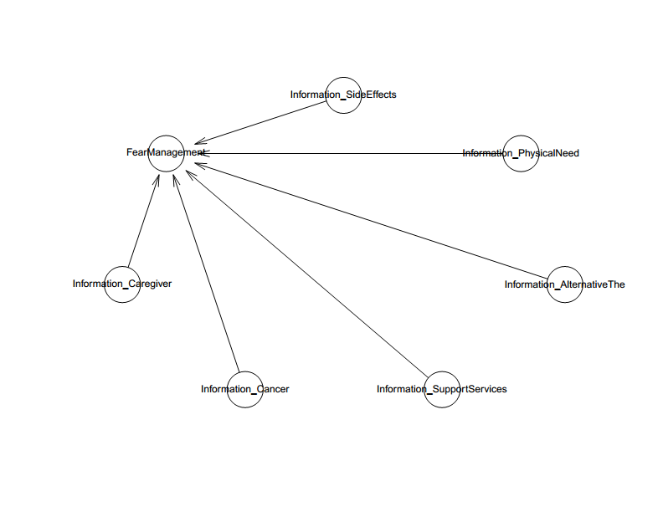

**Figure 1.** Model 1’s logical network

### *2.5.3. Analysis and Validation*

Bayesian Mindsponge Framework (BMF) analytics was employed in the current study for several reasons (Nguyen et al., 2022; Vuong, Nguyen, & La., 2022). First, the analytical method integrates the logical reasoning capabilities of MT with the inferential advantages of Bayesian analysis, exhibiting a high degree of compatibility (Nguyen et al., 2022). Second, Bayesian inference is a statistical approach that treats all the properties (including the known and unknown ones) probabilistically (Csilléry et al., 2010; Gill, 2015), enabling reliable prediction of parsimonious models. Nevertheless, utilizing the Markov chain Monte Carlo (MCMC) technique still allows Bayesian analysis to deal effectively with various intricate models, such as multilevel and nonlinear regression frameworks (Dunson, 2001). Third, Bayesian inference has various advantages in comparison to the frequentist approach. One notable advantage is the ability to utilize credible intervals for result interpretation instead of relying solely on the dichotomous decision based on *p*-values (Halsey et al., 2015; Wagenmakers et al., 2018). The Bayesian analysis was performed on R using the **bayesvl** open-access package, which provides good visualization capabilities (La & Vuong, 2019).

In Bayesian analysis, selecting the appropriate prior is required during the model construction process. Due to the exploratory nature of this study, uninformative priors or a flat prior distribution were used to provide as little prior information as possible for model estimation (Diaconis & Ylvisaker, 1985). The Pareto-smoothed importance sampling leave-one-out (PSIS-LOO) diagnostics was employed to check the models’ goodness-of-fit (Vehtari & Gabry, 2019; Vehtari, Gelman, & Gabry, 2017). LOO is computed as follows:

$$LOO=-2{LPPD}_{loo}=-2\sum_{i=1}^{n}{\log{\int{p\left(y_{i} | θ\right)p_{post\left(-i\right)}(θ)dθ}}}$$

$p_{post\left(-i\right)}(θ)$ is the posterior distribution calculated through the data minus data point 𝑖. The *k*-Pareto values are used in the PSIS method for computing the LOO cross-validation in the R **loo** package. Observations with *k*-Pareto values which greater than 0.7 are often considered influential and problematic for accurately estimating LOO cross-validation. When a model’s *k* values are less than 0.5, it is typically regarded as being fit.

If the model fits well with the data, we will proceed with the convergence diagnoses and result interpretation. In the current study, we validated the convergence of Markov chains using statistical values and visual illustrations. Statistically, the effective sample size (*n\_eff*) and the Gelman–Rubin shrink factor (*Rhat*) can be used to assess the convergence. The *n\_eff* value represents the number of iterative samples that are not auto-correlated during stochastic simulation, while the *Rhat* value is referred to as the potential scale reduction factor (Brooks & Gelman, 1998). If *n\_eff* is larger than 1000, it is generally considered that the Markov chains are convergent, and the effective samples are sufficient for reliable inference (McElreath, 2018). As for the *Rhat* value, if the value exceeds 1.1, the model does not converge. The model is considered convergent if *Rhat* = 1. Visually, the Markov chains’ convergence was also validated using trace plots, Gelman–Rubin–Brooks plots, and autocorrelation plots.

# 3. Results

Most respondents were middle-aged (41-50 years old: 36.67%), male (80%), married (78.33%), high school graduated (63.33%), private employee (60%), living with a spouse (cancer patients) and children (80%) with maximum GDP of IDR 5 million per month (68.34%) (see Table 2).

**Table 2.** Demography Characteristic

|  |  |  |  |
| --- | --- | --- | --- |
| **No.** | **Characteristic** | **Frequency** | **Percentage** |
| 1 | Age [years old]:  a. <21  b. 21-30  c. 31-40  d. 41-50  e. 51-60  f. 61-70 | 2  7  15  22  10  4 | 3.33  11.67  25.00  36.67  16.67  6.67 |
| 2 | Gender:  a. Male  b. Female | 48  12 | 80.00  20.00 |
| 3 | Marital status:  a. Single  b. Married  c. Separated  d. Divorced  e. Widowed | 4 47  2  1  6 | 6.67  78.33  3.33  1.67  10.00 |
| 4 | Education level:  a. Primary school  b. Secondary school  c. High school  d. University graduates | 6  8  38  8 | 10.00  13.33  63.33  13.33 |
| 5 | Occupation:  a. Housewife  b. Entrepreneur  c. Civil servant  d. Private employee  e. Jobless/retire | 12  2  6  36  4 | 20.00  3.33  10.00  60.00  6.67 |
| 6 | Gross Domestic Product (GDP) [IDR]:  a. Less than minimum wage  b. Minimum wage – 5 million  c. More than 5 million  d. No income | 16  25  15  4 | 26.67  41.67  25.00  6.67 |
| 7 | House mate:  a. Spouse  b. Child  c. Sibling  d. Parents | 48  48  8  9 | 80.00  80.00  13.33  15 |

In Table 3, almost all respondents reported unmet needs at various levels (98.33%), but the majority reported low levels of unmet needs (46.67%).

**Table 3.** The Level of Unmet Needs among FCG

|  |  |  |  |
| --- | --- | --- | --- |
| **No.** | **Categories** | **Frequency** | **Percentage** |
| 1 | No need (45-90) | 1 | 1.67 |
| 2 | Low need (91-135) | 28 | 46.67 |
| 3 | Moderate need (136-180) | 21 | 35.00 |
| 4 | High need (181-225) | 10 | 16.67 |

Before interpreting the results of BMF analytics, it is necessary to evaluate how well Model 1 fits the data. As can be seen in Figure 2, almost all estimated *k*-values are below the 0.5. There is one *k*-value that is higher than 0.5 but it is still lower than 0.7 threshold; indicating a good fit signal between the model and the data.

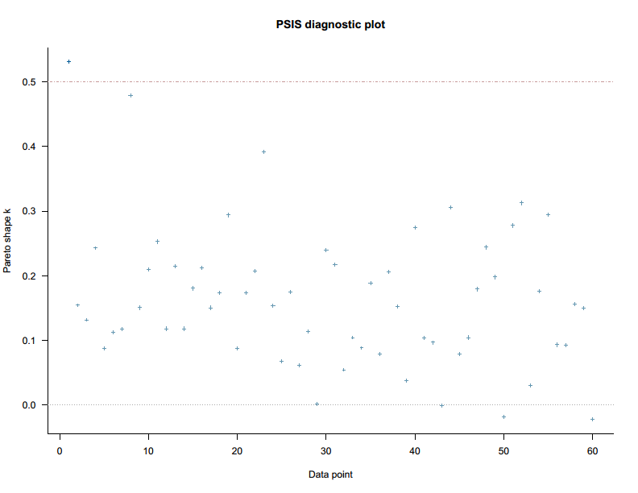

**Figure 2.** Model 1’s PSIS-LOO diagnosis

The posterior distribution statistics of Model 1 are shown in Table 4. All *n\_eff* values are greater than 1000, and *Rhat* values are equal to 1, so it can be assumed that Model 1’s Markov chains are well-convergent. The convergence of Markov chains is also reflected in the trace plots of Figure 3. In particular, after the 2000th iteration, all chains’ values fluctuate around the central equilibrium.

**Table 4:** Estimated results of Model 1

|  |  |  |  |  |
| --- | --- | --- | --- | --- |
| **Parameters** | **Mean** | **SD** | **n\_eff** | **Rhat** |
| *a\_FearManagement* | 2.43 | 0.56 | 11073 | 1 |
| *b\_Information\_Caregiver\_FearManagement* | -0.06 | 0.24 | 10064 | 1 |
| *b\_Information\_Cancer\_FearManagement* | 0.41 | 0.25 | 10498 | 1 |
| *b\_Information\_SupportServices\_FearManagement* | -0.33 | 0.22 | 11809 | 1 |
| *b\_Information\_AlternativeThe\_FearManagement* | -0.17 | 0.21 | 10969 | 1 |
| *b\_Information\_PhysicalNeed\_FearManagement* | 0.32 | 0.21 | 11623 | 1 |
| *b\_Information\_SideEffects\_FearManagement* | -0.04 | 0.19 | 11343 | 1 |

**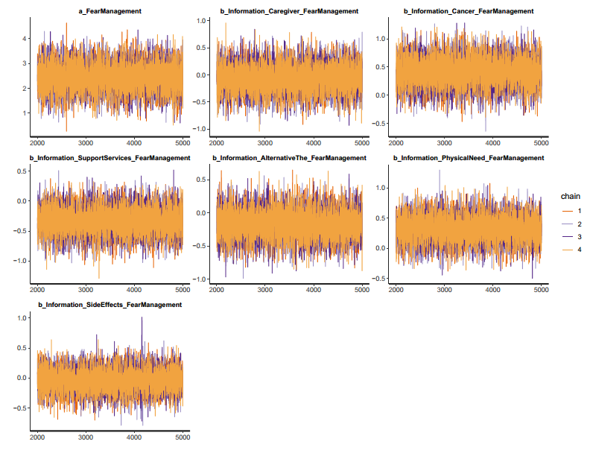Figure 3.** Model 1’s trace plots

The Gelman-Rubin-Brooks plots and autocorrelation plots also show that the Markov chains have good convergence. Gelman-Rubin-Brooks plots are used to evaluate the ratio between the variance between Markov chains and the variance within chains. The y-axis demonstrates the shrinkage factor (or Gelman-Rubin factor), while the x-axis illustrates the iteration order of the simulation. In Figure 4, the shrinkage factors of all parameters rapidly decrease to 1 before the 2000th iteration (during warm-up). This manifestation indicates that there are no divergences between Markov chains.

|  |  |
| --- | --- |
|  |  |

**Figure 4.** Model 1’s Gelman-Rubin-Brooks plots

The Markov property refers to the memoryless property of a stochastic process. In other words, iteration values are not auto-correlated with the past iteration values. Autocorrelation plots are used to evaluate the level of auto-correlation between iteration values. The plots in Figure 5 show the average auto-correlation of each Markov chain along the y-axis and the delay of these chains along the x-axis. Visually, after several delays (before 5), the auto-correlation levels of all Markov chains swiftly drop to 0, indicating that the Markov properties are preserved and the Markov chains converge well.

|  |  |
| --- | --- |
|  |  |

**Figure 5.** Model 1’s autocorrelation plots

Since all the diagnostics confirm the convergence of Markov chains, the simulated results are eligible for interpretation. The estimated results of Model 1 show that among the six types of healthcare information, FCG with higher demand for cancer-specific information and information on cancer physical needs are more likely to need support in reducing the fear of female cancer patients. Meanwhile, FCGs with a higher demand for information on support services are less likely to need support in cancer fear management. Other types of information have ambiguous effects on the need for support in reducing cancer patients’ fear. The posterior distributions of the two coefficients in Figure 6 lie entirely on the negative or positive side of the x-axis, indicating the high reliability of the results.

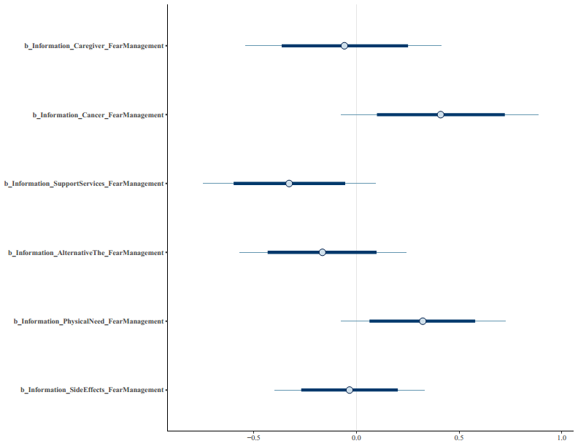

**Figure 6.** Model 1’s posterior distributions

# 4. Discussion

In employing BMF analytics, this study delves into the relationship between demanded healthcare information and the role of FCGs in alleviating fear among female cancer patients. The examination of six types of information, spanning from cancer-specific details to support services, reveals insights for supporting FCGs through information provision.

The positive impact coefficient associated with the demand for cancer-specific information signifies a profound correlation between caregivers’ desire for comprehensive knowledge and their ability to manage fear effectively. This aligns with the intuitive understanding that a deeper understanding of cancer empowers caregivers, fostering confidence and competence (Gómez-Zúñiga et al., 2021). The effective integration of caregivers into cancer care is crucial, promoting empowerment and self-management (Ugalde et al., 2021). Studies underscore the close link between caregiver burden, distress, and quality of life, emphasizing the imperative to address these issues as cancer evolves into a chronic disease (Cruz-Oliver, 2017; Özönder Ünal and Ordu, 2023).

A deep understanding emerges as a crucial foundation in the caregiver’s journey, facilitating informed decisions across diverse facets of patient care (Reinhard et al., 2008). This comprehension empowers caregivers to make well-informed choices regarding the patient’s care, treatment, and overall well-being. Additionally, it assists caregivers in anticipating potential challenges and proactively addressing them (Schulz et al., 2016). The empowerment derived from staying informed becomes more than just a tool; it transforms into a source of resilience and confidence - essential elements for enhancing the quality of care provided to loved ones (Hazelwood et al., 2012).

The positive relationship between a profound understanding of cancer and heightened confidence and competence suggests a notable impact on caregivers’ experiences. Equipped with knowledge, caregivers assume a role with increased self-assurance, effectively mitigating uncertainties and anxieties inherent in caregiving within the context of a serious illness. This correlation is substantiated by research linking greater perceived self-competency and a sense of meaning to improved psychological outcomes for caregivers (Teo et al., 2019). Grounded in factors like self-efficacy and healthcare decision-making capabilities, this perspective seamlessly aligns with the principles of patient-centered care (Chen et al., 2016; Kwame and Petrucka, 2021).

The observed positive coefficient suggests a connection between caregivers actively seeking information and their ability to address the physical needs of cancer patients (Li et al., 2020). Caregivers frequently express specific information needs related to providing direct care for cancer patients, underscoring the crucial role of knowledge in fulfilling caregiving responsibilities (Longacre, 2013). Further studies highlight the intimate link between caregiver burden, distress, and the quality of life with the physical health of cancer patients, underscoring the importance of addressing these needs (Özönder Ünal and Ordu, 2023). As cancer increasingly transitions into a chronic disease, understanding and meeting long-term palliative care requirements become vital for sustaining the quality of life for both patients and caregivers. The positive impact also extends to the psychological well-being of both cancer patients and their caregivers (LeSeure and Chongkham-Ang, 2015).

The relationship between caregivers actively seeking comprehensive information about the cancer diagnosis and its physical implications and grappling with challenges in managing the emotional aspects of patients’ fear is complex. Initially, delving into the specifics of cancer and its physical effects enhances caregivers’ awareness of associated challenges, contributing to an increased emotional burden as they grasp the potential impact on the patient’s well-being (Johansen et al., 2018). Furthermore, caregivers dedicated to understanding the intricacies of cancer may cultivate a deeper sense of empathy and concern for the patient’s struggles, heightening their emotional connection and response to the patient’s fear (Kilic and Oz, 2019).

In contrast to traditional notions regarding the connection between information-seeking and the need for emotional support in caregiving, the surprising negative correlation disrupts prevailing assumptions (Bangerter et al., 2019). Typically, one might assume that individuals actively seeking information about available support services would likely have a greater need for additional support, particularly in handling fears or concerns related to their caregiving responsibilities. However, the unexpected finding indicates an opposite correlation: family caregivers with higher demands for information on support services seem less likely to require additional support in fear management.

The noted negative correlation, as evidenced by the negative impact coefficient (Teixeira et al., 2020), triggers a thorough examination of the underlying factors that could clarify this unforeseen relationship. The study pinpoints various potential contributing factors, including minority status, shorter durations of caregiving, and a higher stress burden. These elements are crucial in unraveling the intricacy of the correlation between family caregivers’ information-seeking behavior regarding support services and their perceived need for additional support in fear management. For example, the consideration of shorter durations of caregiving acknowledges the substantial influence that the length of caregiving can wield over the caregiver’s experience level and coping mechanisms. Shorter durations of caregiving often signify a novice status for caregivers, shaping their approach to information-seeking and emotional management (LeSeure and Chongkham-Ang, 2015), and inexperienced caregivers may face difficulties in coping and may struggle with efficient information processing (Uren and Graham, 2013). The emotional impact of caregiving, influenced by the caregiver’s duration, is pivotal as it correlates with caregiver burden and depression (Schulz and Sherwood, 2008).

The analysis of an elevated stress burden recognizes stress’s crucial role in influencing how caregivers perceive and react to support services (Mason et al., 2019). Healthcare professionals, contending with high stress and burnout rates, encounter impediments in patient care, underscoring the influence of stress on professionals and, consequently, on fear management (Rink et al., 2023)

Exploring an increased stress burden is essential for comprehending how caregivers perceive and react to support services. Stress significantly shapes the efficacy of support services in fear management for caregivers (Liu et al., 2020). Caregiver burden, often encountered by long-term caregivers, is linked to stressors and may result in depressive moods (Schulz and Sherwood, 2008). Early life stress in caregivers can notably influence their responsiveness, impacting the dynamics of caregiving (Schulz and Sherwood, 2008). Stress also induces muscle tension as a reflex reaction, illustrating the intricate interplay between stress levels and physical responses (Schulz and Sherwood, 2008). The support offered by families can either alleviate or worsen caregiver stress, underscoring the importance of a holistic understanding of stress in caregiving situations (Stevenson et al., 2022).

The results of the study establish a groundwork for crafting precise interventions and support services, especially in the field of cancer care. It emphasizes the significance of understanding the distinct information requirements of family caregivers, including their need for cancer-specific information and details regarding physical needs. This knowledge is essential for healthcare professionals to customize their support adeptly.

The difficulties caregivers encounter in obtaining information from healthcare professionals underscore the pressing necessity for improved communication and support systems. Employing principles from patient-centered care, as elucidated in nursing literature, becomes imperative. This approach highlights the importance of cultivating meaningful relationships with caregivers and thoroughly grasping their concerns and needs (Kwame and Petrucka, 2021). Recognizing that the information needs of family caregivers evolve throughout the cancer journey, it becomes essential to harness diverse information sources to address their changing requirements (Chen, 2014). This enhanced understanding of the dynamic nature of caregiver dynamics has significant potential to enhance caregiver support and positively influence patient outcomes.

The complexities inherent in the caregiving experience, especially in fear management, highlight the need for customized information provision that considers caregivers’ individual needs and preferences (Slatyer et al., 2019). Embracing a multifaceted approach aligns with the acknowledgment that caregiving roles are varied and intricate, necessitating readiness for intellectual, emotional, and physical challenges (Sherman, 2019). Applying the basic psychological need theory, which centers on autonomy, competence, and relatedness, significantly contributes to effective caregiving (Slatyer et al., 2019). This comprehensive perspective underscores the importance of a thorough understanding in shaping the caregiving experience and ensuring the well-being of both caregivers and patients.

Though the study offers valuable insights, it is crucial to recognize certain limitations (Vuong, 2020). The cross-sectional design imposes constraints on establishing causal relationships, and longitudinal studies could offer a more nuanced understanding of the dynamic caregiving process. Furthermore, the study’s focus on a specific geographical location may limit the generalizability of the findings. Future research endeavors could explore cultural variations in healthcare information needs and fear management among FCGs of cancer patients, further enriching our understanding of this complex and evolving phenomenon.

**Funding Declaration**

This study was funded by the Centre for Research and Community Service, Widya Mandala Surabaya Catholic University, East Java, Indonesia, with grant registered number of 4514/WM01/N/2019.

**REFERENCES**

Bangerter, L. R., Griffin, J., Harden, K., and Rutten, L. J. (2019). Health information–seeking behaviors of family caregivers: analysis of the health information national trends survey. *JMIR aging* **2**, e11237.

Bechthold, A. C., Azuero, A., Puga, F., Ejem, D. B., Kent, E. E., Ornstein, K. A., Ladores, S. L., Wilson, C. M., Knoepke, C. E., and Miller-Sonet, E. (2023). What Is Most Important to Family Caregivers When Helping Patients Make Treatment-Related Decisions: Findings from a National Survey. *Cancers* **15**, 4792.

Brooks, S. P., & Gelman, A. (1998). General methods for monitoring convergence of iterative simulations. *Journal of computational and graphical statistics*, *7*(4), 434-455.

Centre for Health Research and Psycho-oncology (CHeRP), The Cancer Council New South Wales, Australia. (2009). The Supportive Care Needs Survey – Partners and Caregivers. Retrieved from: https://www.researchgate.net/publication  
/312701763\_SCNS-PC45-with\_revised\_new\_items-2009\_VERSION\_FOR\_ALL\_NEW\_STUDIES

Chen, J., Mullins, C. D., Novak, P., and Thomas, S. B. (2016). Personalized strategies to activate and empower patients in health care and reduce health disparities. *Health Education & Behavior* **43**, 25-34.

Chen, S.-C. (2014). Information needs and information sources of family caregivers of cancer patients. *Aslib Journal of Information Management* **66**, 623-639.

Cruz-Oliver, D. M. (2017). Palliative care: an update. *Missouri medicine* **114**, 110.

Csilléry, K., Blum, M. G. B., Gaggiotti, O. E., & François, O. (2010). Approximate Bayesian Computation (ABC) in practice. *Trends in Ecology &amp; Evolution*, 25(7), 410–418. https://doi.org/10.1016/j.tree.2010.04.001

De Vries, J., Den Oudsten, B. L., Jacobs, P. M. E. P., & Roukema, J. A. (2013). How breast cancer survivors cope with fear of recurrence: a focus group study. Supportive Care in Cancer, 22(3), 705–712. https://doi.org/10.1007/s00520-013-2025-y

Diaconis, P., & Ylvisaker, D. (1985). Quantifying prior opinion. In J. M. Bernardo, M. H. DeGroot, D. V. Lindley, & A. F. M. Smith (Eds.), *Bayesian Statistics* (Vol. 2, pp. 133-156). North Holland Press.

Dunson D. B. (2001). Commentary: Practical advantages of Bayesian analysis of epidemiologic data. *American Journal of Epidemiology*, 153(12), 1222–1226. https://doi.org/10.1093/aje/153.12.1222

Else-Quest, N. M., & Jackson, T. L. (2014). Cancer stigma. In P. W. Corrigan (Ed.), The stigma of disease and disability: Understanding causes and overcoming injustices (pp. 165–181). American Psychological Association. [https://doi.org/10.1037/14297-009](https://psycnet.apa.org/doi/10.1037/14297-009" \t "_blank)

Emler, A. C., & Bornstein, B. H. (2023). Trust in the medical profession: Reflections from the COVID-19 pandemic. In Miller, M. K. The Social Science of the COVID-19 Pandemic: A Call to Action for Researchers, pp. 234. Oxford University Press.

Gill, J. (2015). *Bayesian Methods: A Social and Behavioral Sciences Approach* (3rd Ed.). Florida: CRC Press.

Gómez-Zúñiga, B., Pulido, R., Pousada, M., and Armayones, M. (2021). The role of parent/caregiver with children affected by rare diseases: navigating between love and fear. *International journal of environmental research and public health* **18**, 3724.

Halsey, L. G., Curran-Everett, D., Vowler, S. L., & Drummond, G. B. (2015). The fickle P value generates irreproducible results. *Nature Methods*, 12, 179-185. <https://doi.org/10.1038/nmeth.3288>

Hazelwood, D. M., Koeck, S., Wallner, M., Hoehn Anderson, K., and Mayer, H. (2012). Patients with cancer and family caregivers: management of symptoms caused by cancer or cancer therapy at home. *HeilberufeScience* **3**, 149-158.

Holland, J. C., Kelly, B. J., & Weinberger, M. I. (2010). Why Psychosocial Care is Difficult to Integrate into Routine Cancer Care: Stigma is the Elephant in the Room. Journal of the National Comprehensive Cancer Network, 8(4), 362–366. https://doi.org/10.6004/jnccn.2010.0028

Johansen, S., Cvancarova, M., and Ruland, C. (2018). The effect of cancer patients’ and their family caregivers’ physical and emotional symptoms on caregiver burden. *Cancer nursing* **41**, 91-99.

Kang, E. K., Keam, B., Lee, N. R., Kang, J. H., Kim, Y. J., Shim, H. J., Jung, K. H., Koh, S. J., Ryu, H., Lee, J., Choo, J., Yoo, S. H., & Yun, Y. H. (2021). Impact of family caregivers’ awareness of the prognosis on their quality of life/depression and those of patients with advanced cancer: a prospective cohort study. *Supportive Care in Cancer*, *29*(1), 397–407. https://doi.org/10.1007/S00520-020-05489-8/FIGURES/5

Kilic, S. T., and Oz, F. (2019). Family caregivers’ involvement in caring with cancer and their quality of life. *Asian Pacific journal of cancer prevention: APJCP* **20**, 1735.

Kinoshita, T. (2016). Risk Communication Thought and Technology: Techniques of Contemplation and Trust (in Japanese). Nakanishiya Shuppan, Kyoto

Kristanti, M. S., Vernooij-Dassen, M., Utarini, A., Effendy, C., & Engels, Y. (2021). Measuring the Burden on Family Caregivers of People With Cancer: Cross-cultural Translation and Psychometric Testing of the Caregiver Reaction Assessment–Indonesian Version. *Cancer Nursing*, *44*(1), 37. https://doi.org/10.1097/NCC.0000000000000733

Kusi, G., Boamah Mensah, A. B., Boamah Mensah, K., Dzomeku, V. M., Apiribu, F., Duodu, P. A., Adamu, B., Agbadi, P., and Bonsu, K. O. (2020). The experiences of family caregivers living with breast cancer patients in low- and middle-income countries: a systematic review. *Systematic reviews* **9**, 1-18.

Kwame, A., and Petrucka, P. M. (2021). A literature-based study of patient-centered care and communication in nurse-patient interactions: barriers, facilitators, and the way forward. *BMC nursing* **20**, 1-10.

La, V.-P, Vuong, Q.-H. (2019). *Bayesvl: Visually learning the Graphical Structure of Bayesian Networks and Performing MCMC with ‘Stan.’* Available at: <https://doi.org/10.31219/osf.io/wyc6n>

Le, T.-T., Nguyen, M.-H., & Vuong, Q.-H. (2022). Chapter 4: Trust in mindsponge: a new perspective on information reliability. The Mindsponge and BMF Analytics for Innovative Thinking in Social Sciences and Humanities, 67–86. https://doi.org/10.2478/9788367405119-009

LeSeure, P., and Chongkham-Ang, S. (2015). The experience of caregivers living with cancer patients: a systematic review and meta-synthesis. *Journal of personalized medicine* **5**, 406-439.

Li, J., Luo, X., Cao, Q., Lin, Y., Xu, Y., and Li, Q. (2020). Communication needs of cancer patients and/or caregivers: a critical literature review. *Journal of Oncology* **2020**.

Liu, Z., Heffernan, C., and Tan, J. (2020). Caregiver burden: A concept analysis. *International journal of nursing sciences* **7**, 438-445.

Longacre, M. L. (2013). Cancer caregivers information needs and resource preferences. *Journal of Cancer Education* **28**, 297-305.

Mantello, P., Ho, M.-T., Nguyen, M.-H., & Vuong, Q.-H. (2023). Machines that feel: Behavioral determinants of attitude towards affect recognition technology—upgrading technology acceptance theory with the mindsponge model. *Humanities and Social Sciences Communications*, 10(1). https://doi.org/10.1057/s41599-023-01837-1

Mason, A. E., Adler, J. M., Puterman, E., Lakmazaheri, A., Brucker, M., Aschbacher, K., and Epel, E. S. (2019). Stress resilience: Narrative identity may buffer the longitudinal effects of chronic caregiving stress on mental health and telomere shortening. *Brain, behavior, and immunity* **77**, 101-109.

McElreath, R. (2018). *Statistical Rethinking: A Bayesian Course with Examples in R and Stan*. Chapman and Hall/CRC Press.

Nguyen, M. H., La, V. P., & Le, T. T. (2022). Introduction to Bayesian Mindsponge Framework analytics: An innovative method for social and psychological research. *MethodsX,* 9, 101808, doi: <https://doi.org/10.1016/j.mex.2022.101808>

Özönder Ünal, I., and Ordu, C. (2023). Decoding Caregiver Burden in Cancer: Role of Emotional Health, Rumination, and Coping Mechanisms. *In* “Healthcare”, Vol. 11, pp. 2700. MDPI.

Reinhard, S. C., Given, B., Petlick, N. H., and Bemis, A. (2008). Supporting family caregivers in providing care. *Patient safety and quality: An evidence-based handbook for nurses*.

Rink, L. C., Oyesanya, T. O., Adair, K. C., Humphreys, J. C., Silva, S. G., and Sexton, J. B. (2023). Stressors Among Healthcare Workers: A Summative Content Analysis. *Global Qualitative Nursing Research* **10**, 23333936231161127.

aSari, N. P. W. P. (2020). Stress and fear in women living with cancer: An argumentation towards the adaptation theory. *International Journal of Public Health Science (IJPHS)*, *9*(3), 272–280. <https://doi.org/10.11591/IJPHS.V9I3.20413>

bSari, N. P. W. P. (2020). Study Report: Needs Analysis of Palliative Care Stakeholders in  
Community Setting: The Patients, Families, Professionals, and Volunteers. Surabaya, Indonesia: Faculty of Nursing, Widya Mandala Surabaya Catholic University.

Schulz, R., Eden, J., National Academies of Sciences, E., and Medicine (2016). Family Caregivers’ Interactions with Health Care and Long-Term Services and Supports. *In* “Families Caring for an Aging America”. National Academies Press (US).

Schulz, R., and Sherwood, P. R. (2008). Physical and mental health effects of family caregiving. *AJN The American Journal of Nursing* **108**, 23-27.

Sherman, D. W. (2019). A review of the complex role of family caregivers as health team members and second-order patients. *In* “Healthcare”, Vol. 7, pp. 63. MDPI.

Slatyer, S., Aoun, S. M., Hill, K. D., Walsh, D., Whitty, D., and Toye, C. (2019). Caregivers’ experiences of a home support program after the hospital discharge of an older family member: a qualitative analysis. *BMC health services research* **19**, 1-10.

Stevenson, C., Wakefield, J. R., Kellezi, B., Stack, R. J., and Dogra, S. (2022). Families as support and burden: A mixed methods exploration of the extent to which family identification and support predicts reductions in stress among disadvantaged neighbourhood residents. *Journal of Social and Personal Relationships* **39**, 886-907.

Tanemura, N., Kakizaki, M., Kusumi, T., Onodera, R., & Chiba, T. (2022). Levels of trust in risk-only negative health messages issued by public agencies: a quantitative research-based mindsponge framework. Humanities and Social Sciences Communications, 9(1). https://doi.org/10.1057/s41599-022-01415-x

Teixeira, M. J. C., Abreu, W., Costa, N., and Maddocks, M. (2020). Understanding family caregivers’ needs to support relatives with advanced progressive disease at home: an ethnographic study in rural Portugal. *BMC palliative care* **19**, 1-11.

Teo, I., Baid, D., Ozdemir, S., Malhotra, C., Singh, R., Harding, R., Malhotra, R., Yang, M. G., Neo, S. H.-S., and Cheung, Y. B. (2019). Family caregivers of advanced cancer patients: self-perceived competency and meaning-making. *BMJ Supportive & Palliative Care*.

Thewes, B., Lebel, S., Seguin Leclair, C., & Butow, P. (2015). A qualitative exploration of fear of cancer recurrence (FCR) amongst Australian and Canadian breast cancer survivors. Supportive Care in Cancer, 24(5), 2269–2276. https://doi.org/10.1007/s00520-015-3025-x

Ugalde, A., Winter, N., Sansom-Daly, U. M., Rhee, J., Jongebloed, H., Bergin, R. J., and Livingston, P. M. (2021). Effective integration of caregivers and families as part of the care team for people with cancer. *Australian journal of general practice* **50**, 527-531.

Uren, S. A., and Graham, T. M. (2013). Subjective experiences of coping among caregivers in palliative care. *Online Journal of Issues in Nursing* **18**, 88.

Vaughn, L. (2019). *Psychology and Culture: Thinking, Feeling and Behaving in a Global Context.* Retrieved from: https://books.google.co.id/books?hl=en&lr=&id=AtqMDwAAQBAJ&oi=fnd&pg=PP1&dq=culture+and+human+thinking+or+human+behavior&ots=yK9ooc3eYf&sig=Icy3xvi4kbl3qFOEwSdJ3SjCAQo&redir\_esc=y#v=onepage&q=culture%20and%20human%20thinking%20or%20human%20behavior&f=false

Vehtari, A., & Gabry, J. (2019). *Bayesian Stacking and Pseudo-BMA weights using the loo package*. In (Version loo 2.2.0). <https://mc-stan.org/loo/articles/loo2-weights.html>

Vehtari, A., Gelman, A., & Gabry, J. (2017). Practical Bayesian model evaluation using leave-one-out cross-validation and WAIC. *Statistics and Computing*, 27(5), 1413-1432. <https://doi.org/10.1007/s11222-016-9696-4>

Vrinten, C., McGregor, L. M., Heinrich, M., von Wagner, C., Waller, J., Wardle, J., & Black, G. B. (2016). What do people fear about cancer? A systematic review and meta‐synthesis of cancer fears in the general population. Psycho-Oncology, 26(8), 1070–1079. Portico. <https://doi.org/10.1002/pon.4287>

Vuong, Q. H. (2020). The limitations of retraction notices and the heroic acts of authors who correct the scholarly record: An analysis of retractions of papers published from 1975 to 2019. *Learned Publishing*, 33(2), 119-130. <https://doi.org/10.1002/leap.1282>

Vuong, Q. H. (2023). *Mindsponge Theory.* Berlin: Walter de Gruyter. <https://books.google.com/books?id=OSiGEAAAQBAJ>

Vuong, Q. H. (2022). *The Kingfisher Story Collection*. <https://www.amazon.com/dp/B0BG2NNHY6>

Vuong, Q. H., Nguyen, M. H., & La, V. P. (2022). *The Mindsponge and BMF Analytics for Innovative Thinking in Social Sciences and Humanities*. Berlin: Walter de Gruyter. <https://books.google.com/books?id=EGeEEAAAQBAJ>

Wagenmakers, E.-J., Marsman, M., Jamil, T., Ly, A., Verhagen, J., Love, J., Selker, R., Gronau, Q. F., Šmíra, M., Epskamp, S., Matzke, D., Rouder, J. N., & Morey, R. D. (2017). Bayesian inference for psychology. Part I: Theoretical advantages and practical ramifications. *Psychonomic Bulletin & amp; Review*, 25(1), 35–57. <https://doi.org/10.3758/s13423-017-1343-3>