ADVICE FROM AN APE
Two Keys to Being and Time

Hanuman the ape is sitting on a stack of books by Darwin. He holds his chin in one hand. In his outstretched other hand, he holds a human skull. Hanuman gazes into the empty eyes of the skull. Is he pondering the meaning of time?
Hanuman is going nowhere. Not of his own accord. He is made of clay, glazed with bronze.
He’d been with me for graduate school and two decades of teaching. I left him at The Peace Abbey, then departed Boston, spending twenty years in Philadelphia.
I came back to New England, owning nothing but what I could pack into the new Outback; and just before the Abbey disappeared as a physical structure, I spent some days there; and lo: Hanuman sat on the stack of books by Darwin, still gazing into the empty eyes of the skull.
We found a home in Salem, about a mile from the sea.

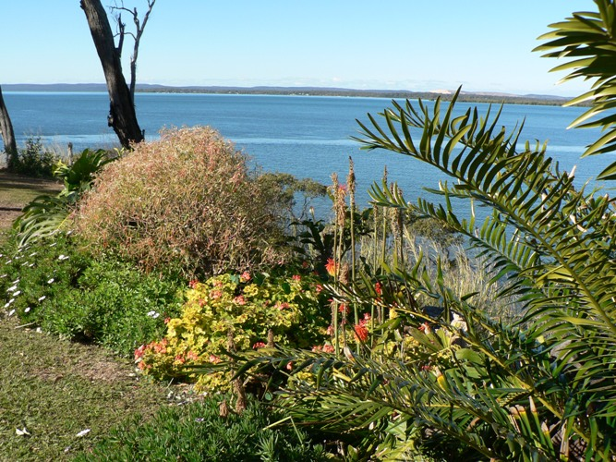

Tonight, Hanuman still mimics Rodin’s “Thinker” while evoking Hamlet’s ghost.
I gaze at him gazing at the skull, and I too think of time. And this is my conclusion: It’s a miracle there is anything – or any thing – at all.
The only constant is flux, strung with fluctuating melodies of interpenetrating intensities.
Quality and intensity are the double-helix of being and time.

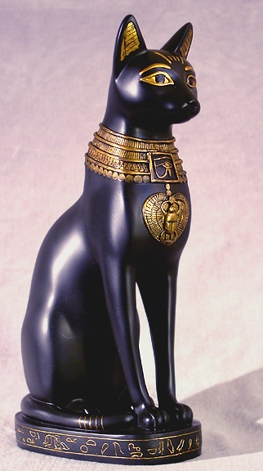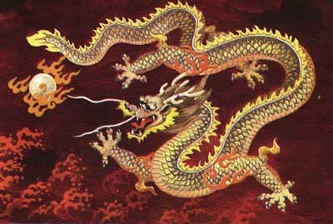

Amidst the daily whirl of living, Hanuman reminds me: Death is our wisest advisor.
The archway to enlightenment is the inward turn. Slowing the swirl of what The Lotus Sutra calls “monkey mind.”
Monkey mind veils the secret of time, and therefore of being and becoming.
The mind is too often like a chimpanzee on acid. Plato offers the image of prisoners in a cave, their thoughts leaping from one shadow to the next on the wall lit by the fire kept by the puppeteers.
A Zen inspired scientist said: “There’s nothing quite like geology to put the passing moment – indeed, present history – in perspective.”
Enlightenment sees opposites as interpenetrating. The truth of paradox is deeper than the logic of either/or.
“Paradox is the passion of thought,” says Kierkegaard. Those who agree include Pythagoras, Plato, Buddha, Lao Tzu, Eckhart, Emerson, and Heisenberg.
Emerson notes: “There are no enclosing walls. Beyond every circle we draw, a larger circle is being drawn.”
We live in nothing but circles – patterns in the flux, overlapping horizons, undulating ovals of experience – and this is the way it has to be, in order for there to be anything (a world), or any thing (identity and evolution), at all.
Emerson concludes: “If I spend enough time with this caterpillar, I’ll never have to write another sermon.”
Does the miracle of metamorphosis mirror our own angelic essence?
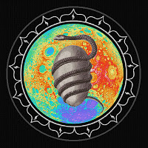

Perhaps humans are droplets of divinity. “Words of God,” according to Eckhart. “Songs of God,” say The Vedas.
In postmodern New Age aphoristic: We’re not so much humans having a spiritual experience, as spirits having a human experience.
Collective lack of this realization leads Joyce to pray that he awaken from the nightmare of history. I pray the same daily myself. Don’t you?

Einstein and Tagore
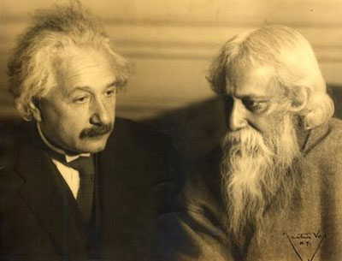
H. G. Wells: “History is now a race between education and catastrophe.”
Gandhi: “An eye for an eye only makes the whole world blind.”

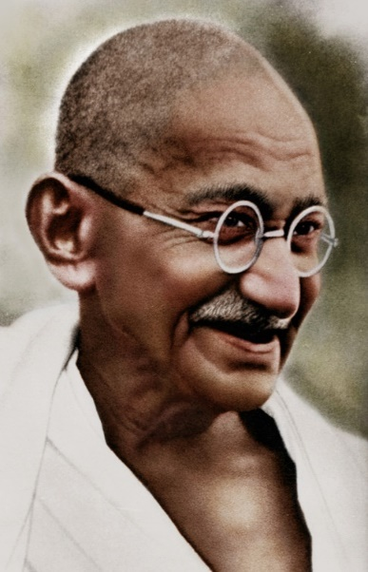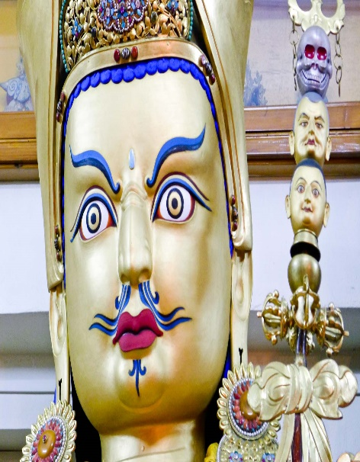

Camus: “Happiness and the absurd are two sons of the same earth. The struggle toward the heights is enough to fill a man’s heart.”
Maintaining serenity amidst so much frenzy – finding space to experience and give birth to beauty and goodness amidst so much folly – is a task Herculean, often seemingly Sisyphean: Socratic and Zen to its core.

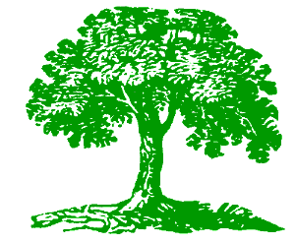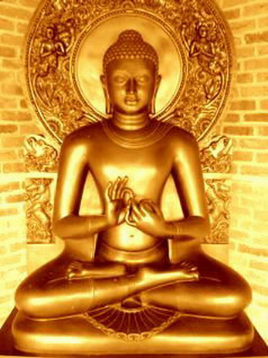
Voluntary simplicity is the key; the Way to awakening; an underground world current now, and our brightest hope for survival.

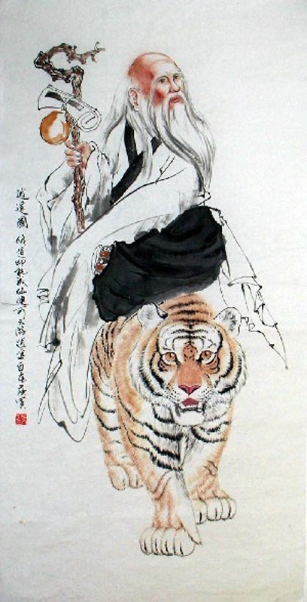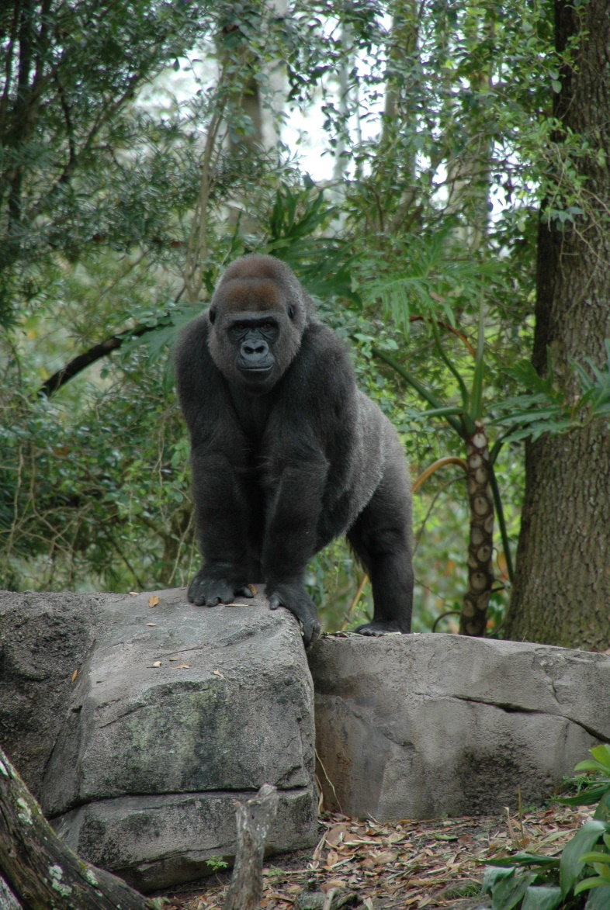

Stefan Schindler
stefanschindler@comcast.net

