THE CALL, THE QUEST, AND THE CROSS

An Interfaith Narrative on Symbolism and Self-Realization

Stefan Schindler

The quest for redemptive wisdom often begins with personal tragedy. When a broken heart becomes an open heart, one learns compassion for the world. The Buddhist word for compassion is karuna. When karuna becomes universal, it mirrors the Judeo-Christian notion of agape.

The quest for enlightenment (nirvana understood as redemptive wisdom) entails what Buddhism calls samvega – a deep agitation of the heart, indicating an empathic and profoundly broken-hearted awareness of the pervasiveness of suffering. Samvega signifies intense cognition of dukkha, Buddha’s First Noble Truth: there is far too much suffering in the world, and most of it is rooted in ignorance, driven by untamed passion, and completely unnecessary.

Buddhism calls the start of the quest sotapatti – “entering the stream,” so as to return to “the source.” A “stream-enterer” is called sotapanna. A sotapanna “enters the stream” – embarks on the path of knowledge – in order to overcome ignorance, achieve freedom, and diminish suffering.

In Mahayana Buddhism, a sotapanna is a bodhisattva in becoming. A bodhisattva is a person whose life is devoted to learning and service. This devotion is sustained by faith in, and increasing glimpses of, “the source,” understood as something sublime and divine – the ineffable source of life, the Life Force itself – which Buddhism calls Dharma, Suchness, or Buddha-nature, and which might be described as a fusion of Love, Wisdom, and Bliss (maitri, prajna, and ananda). The Western religious tradition calls it God or Grace, archetypally symbolized by the Holy Grail.

Carl Jung and Joseph Campbell speak of “responding to the call” – hearing at last “the whisper of spirit,” and responding with a heartfelt quest for the “redemptive promise” implicit in “the sacred voice.” Plato defines it as escape from “the cave” – liberation from the existential prison of cultural conditioning and distraction.

There are multiple variations on this theme, which Joseph Campbell explores in The Hero With A Thousand Faces. Campbell defines the spiritual-heroic journey as occurring in three archetypal stages: Departure, Initiation, Return.

Responding to “the call” indicates a “Departure” from ordinary egoic concerns. “Initiation” is communion with the divine – fulfillment of the journey “from ego to spirit.” This is the culmination of “the stairway to heaven” detailed in Socrates’ discourse in Plato’s Symposium. The Socratic aspirant on the path of knowledge, achieving communion with “Beauty,” is subsequently thrown back into the world to give birth to art, virtue, and awakening. This is what Campbell means by “Return.” Rooted in sublimity, the sage is obliged to be of service to the world. This is mirrored in the two wings of Buddhism: prajna and karuna (wisdom and compassion). Thus, in the famous Chinese Ox-Herding pictographs illustrating the journey from ego to spirit, the tenth and climactic illustration shows the sage returning to the village, sharing the fruits of wisdom with a newly departing aspirant on the path of knowledge.

In Buddhism, equanimity – even amidst suffering, sorrow and distress – is called upeksha. Upeksha is one of the four brahma-viharas (“divine abodes” or “sublime attitudes”) characteristic of bodhisattvas. The other three are: kindness (metta), compassion (karuna), and sympathetic joy (mudita). Sympathetic joy means celebrating the happiness of others, instead of being envious of that happiness. Another term for equanimity, often used in the Zen tradition, is samadhi (usually translated as “tranquility” or “peace”).

The enlightenment adventure – the journey from ego to spirit – requires courage and faith. It typically entails more than one “dark night of the soul” – a series of crucifixional struggles with what Jung calls “the Shadow,” esoteric psychology names “The Dweller on The Threshold,” and Buddhism refers to as Mara (the Tempter).

It is indeed a heroic journey, beginning with Departure, illumined by Initiation, and climaxing in Return to altruistic service.

In quest of an interfaith parallel to the Buddhist nirvanic adventure, we may now suggest a few symbolic meanings of The Cross, offered here as a quaternity of helpful hints.

Our purpose is to clarify theory with indications for practice.

Let us name this quaternity of helpful hints:

1) The Ethical Trinity
2) The Five Archetypal Stages
3) The Circle of Care
4) The Four Virtues

1 – The Ethical Trinity. Siddhartha Gautama, the Buddha, offers three recommendations for the actualization of spirit in egoic life: “Think kindly, speak kindly, act kindly.” Thus Tenzin Gyatso, the 14th Dalai Lama and winner of The Nobel Peace Prize, suggests that all we really need, in order to heal all of the world’s woes, is to embrace “a common religion of kindness.” This is, of course, the very heart of the life, ministry, and teachings of Jesus.

2 – The Five Archetypal Stages. One way of interpreting the Cross is to see it as suggesting five archetypal stages on the spiritual path. These stages are embodied in the life of Christ. They are: birth, baptism, illumination, crucifixion, resurrection.

- The birth of Jesus represents what Jung and Campbell term “the call.” This is the invitation to spiritual maturity: the call to the heroic adventure of spiritual evolution.

- The baptism of Jesus – which, for the aspirant on the path of knowledge, is often accompanied by a flood of tears, with a consequent cleansing effect – represents broken-hearted awareness of the pervasiveness of pain and suffering in the world. When spiritually informed, “a broken heart is an open heart.” In Buddhism, the appropriate term here is samvega. Samvega is the existential realization of Buddha’s First Noble Truth: dukkha, understood as pervasive pain caused by avoidable and utterly unnecessary greed, hatred, delusion, selfishness, hostility, and violence.

- The illumination of Jesus refers to his epiphantic experience on the mountain top. Having been “cleansed” by the waters of baptism, the aspirant on the path of knowledge is flooded with the light of wisdom, infused with the fire of courage, faith, and devotion.

- The crucifixion of Jesus indicates return to service in the world, altruistically showing the path to peace despite the obstacles, and even at the cost one’s life.

- The resurrection of Jesus existentially signifies that every “dark night of the soul,” every sacrificial enduring of the “slings and arrows” of outrageous fate, is followed by renewed and joyful communion with the bliss-wisdom-grace beyond time and space, which lovingly supports – despite the evidence of our senses – every aspect of finite life.

3 – The Circle of Care. Envision the cross as encompassed by a circle. The circle is care. The four points of the cross are: self, others, animals, and the planet. The enlightened life, the spiritually informed life, the life which embodies Christ-consciousness and Buddhahood now, treats all life as precious and sacred, and therefore cares for self, others, animals and the planet with unconditional kindness and compassion.

4 – The Four Virtues. There is a spiritual tradition, often associated with Qabalah and “esoteric psychology,” which posits four primary virtues on the path of knowledge (the spiritual quest). These are: To Know, To Will, To Dare, To Keep Silent. The four points of the cross indicate these four fundamental virtues.

- To Know is to realize that there is “a call” to respond to, and that the journey – the enlightenment adventure – is the most important, challenging and rewarding of all.
- To Will is to persevere with faith, willingly undergoing the multiple metamorphoses which dismantle egocentric clinging and release the butterfly of soul within. The crucible is the chrysalis of the butterfly’s flight.
- To Dare is to have the courage to be different, to challenge authority and tradition, and to explore the unknown.
- To Keep Silent is to cultivate “infinite inwardness” through meditative stillness, and to have the wisdom to refrain from idle chatter and futile discourse.

This quaternity – Knowing, Willing, Daring, Keeping Silence – symbolically indicates the four elements – air, fire, earth, water – inherent in the four cardinal signs of the zodiac: Aquarius, Leo, Taurus, Scorpio.

The Four Virtues (the four points of the cross) also signify the Four Evangelists – Matthew, Mark, Luke, and John; or, equally, the four primary Archangels: Michael, Gabriel, Raphael, and Uriel. The Virtues, Apostles, and Archangels are associated with, and illustrated by, animal icons: angelic human (Aquarius, Air, Mind); lion (Leo, Fire, Spirit), bull (Taurus, Earth, Body), and eagle (Scorpio, Water, Emotion).

Numerologically, fourness signifies completion; and completion is the start of something new. (Esoterically: time sets matter in motion, for the sake of conscious evolution; a cryptic statement, whose elaboration is beyond the purview of this discourse.) Perhaps more to the point: the Four Virtues and their associations include reference to the anglicized Hebrew letters: YHVH – God as Yahweh, later known as Jehovah.

We should now pause a moment to clarify Aquarius and Scorpio. Aquarius is pictured as a human-faced angel. The Aquarian angel is a “water-bearer,” pouring divine nectar from the stars (or gods) as a fructifying blessing upon the earth. Some folk, accordingly, think that Aquarius is therefore a water sign; but this is a mistake. Aquarius is an air sign (like Gemini and Libra), air being a symbol of intelligence (mentality and imagination) as the angelic quality of humans: the divine gift which lifts humans above animals in the evolutionary scheme (the slow and karmic march toward the self-awareness of our divine spark and the actualization of our potential for creative and ethical sublimity). Scorpio is a water sign (like Cancer and Pisces). Yet Scorpio is pictured as an eagle. There is a potent myth here, indicating metamorphosis. When the scorpion stings itself, death occurs in the form of fire, from which the phoenix arises. The phoenix is a magical bird, signifying rebirth (death and resurrection), and the eagle is, quite simply, a symbol for the phoenix.

We should now say a word about “tetramorph.” Tetra means four; morph means form. Metamorphosis is a change in form, and the spiritual quest entails a multiplicity of archetypal transformations: the ongoing metamorphosis of one’s mode of being-in-the-world, as one evolves toward spiritual maturity.

Loosely speaking, tetramorph refers to the four animal icons: angelic-human, lion, bull (or ox), and eagle. Speaking more precisely, a tetramorph is a glyph – actually, a hieroglyph: “sacred sign” – in which the four animals are fused into a single creature, exhibiting attributes of all four.

We should also note that Four-ness – embodied in the four points of the cross and their various associations (animals, evangelists, archangels, elements, zodiacal signs, Hebrew letters) – includes symbolic reference to the four directions and the four seasons. We may observe, in conclusion, that “tetragrammaton” indicates “the grammar of the Fourfold” as a progressive, transformative process, culminating in unity and rebirth. One plus two plus three plus four equals ten.

The cross as Fourfold is a polymorphous symbol, and – like its predecessor, the Egyptian ankh – it signifies the four fundamental constituents of the human person: body, heart, mind, and soul – matter, emotion, intelligence, and spirit (earth, water, air, and fire). Note the animal icons in the picture below, where Jesus is “the one,” the unifying “Lamb of God” who gives his life like the pelican who pierces her breast to feed her chicks with the blood of life.

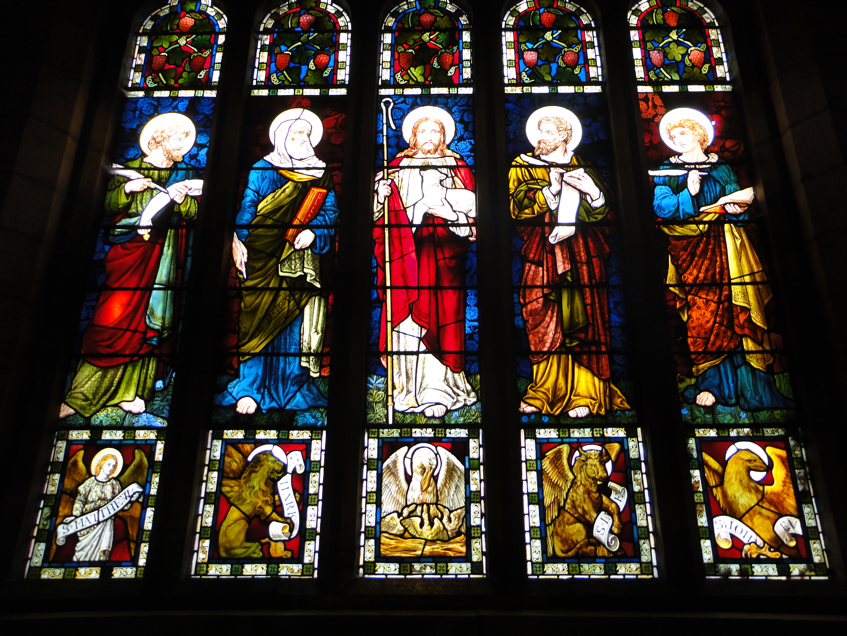
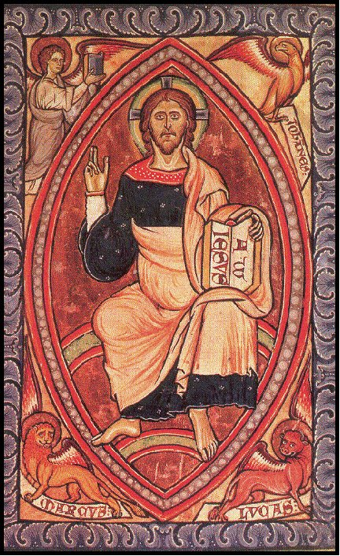
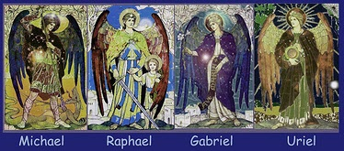
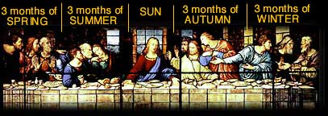
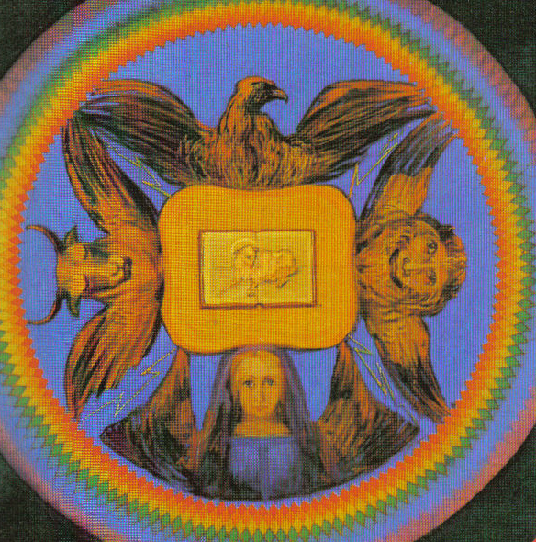
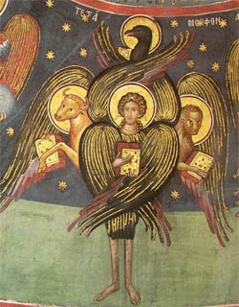
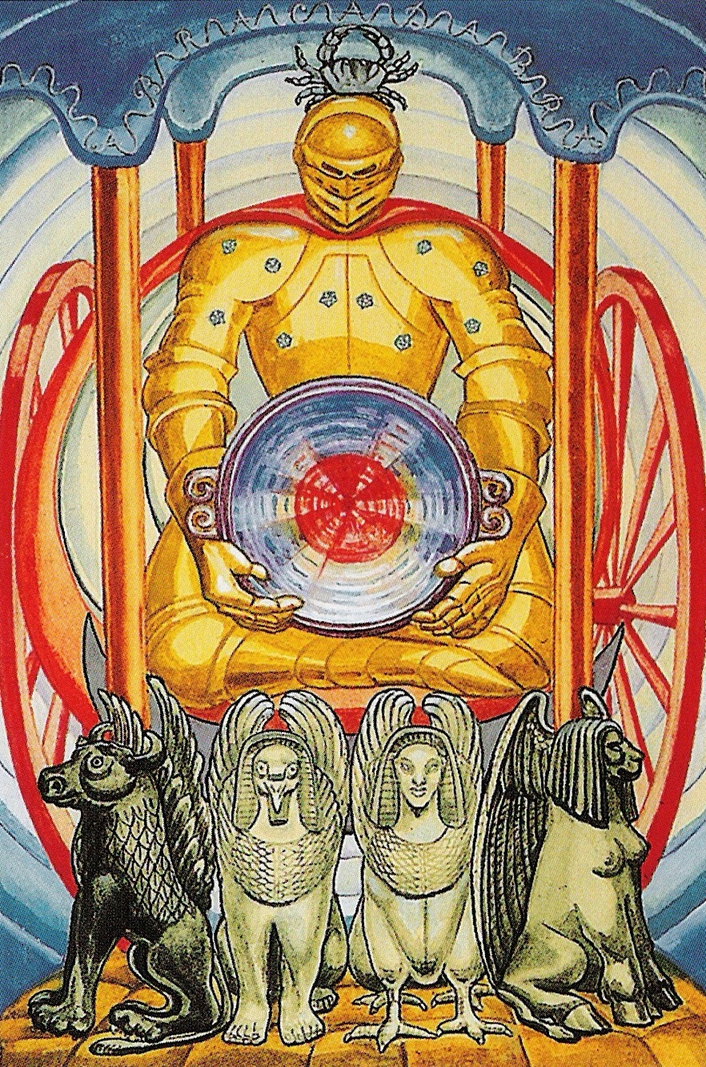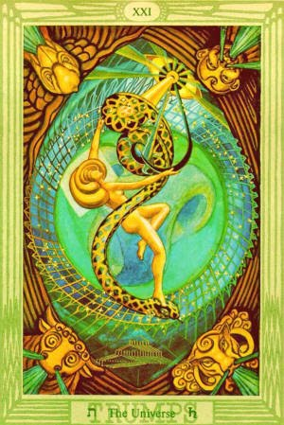
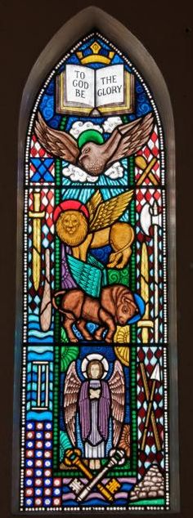
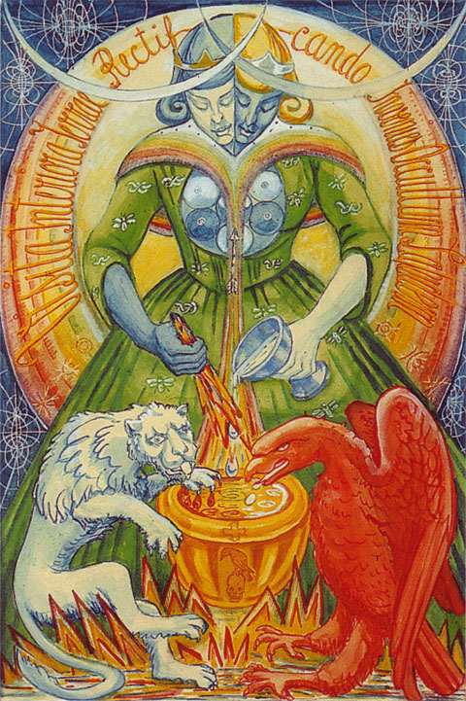

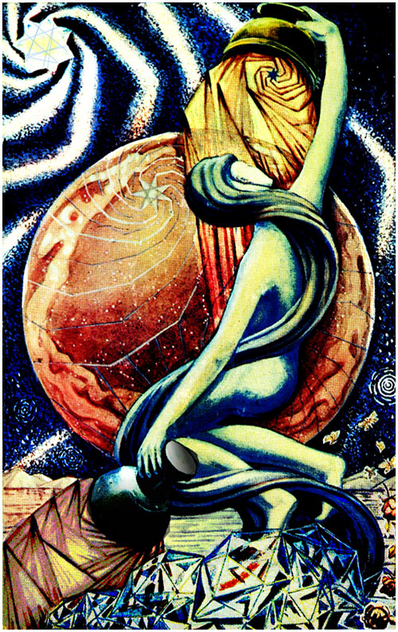
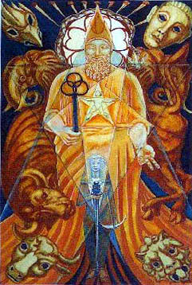

Here’s a chart which exhibits some of the ideas applied to the cross as an archetypal symbol of The Four Virtues:

TO KNOW TO WILL TO DARE TO KEEP SILENT

Aquarius Leo Taurus Scorpio
Angel Lion Bull Eagle
Air Fire Earth Water
Matthew Mark Luke John
Michael Gabriel Raphael Uriel

Now, in this esoteric scheme, the center of the cross is conceived as a circle (an open portal), indicating a fifth virtue, “ire,” signifying “motion” and “going.” When the four virtues are adequately actualized – harmonized in a functioning psychosynthesis of body, heart, mind and soul – the cross becomes a wheel, the wheel turns, and one is mysteriously drawn through the central portal and into Christ-consciousness, nirvana in samsara, “eternal life” here and now.

Let us end, then, with encouraging words from two of Western culture’s most famous poets:

Not from life have I been taken;
this is genuine life and this alone –
which now I live in peace eternal;
where desire and joy together
move in fellowship without end.

William Wordsworth

We shall not cease from exploration,
and the end of all our exploring
will be to arrive where we started
and know the place
for the first time.

T. S. Eliot

