The internet has been a phenomena unlike any other when it comes to changing how we live our lives. By the “internet” of course, I also mean all the other technologies which have converged in order to make it what it is: a virtual reality. This includes computers, smartphones and virtual reality devices.
Until now, however, we have only really ever used the word “internet” to describe this technology and never “virtual reality”, which is what it really is if one thinks about it; we interact, exchange, buy, sell, work and play online- all things which used to be thought of as things we do in person. Now it is our minds alone who do these things. Somehow though, the “metaverse”, signifying a metaphysical universe, is a term that could bring people into the awareness that our own “base reality” may not really be so basic after all. Was it ever? Blurring the lines between what is real and what is surreal or metaphysical, could have some profound impact on the human psyche. What starts to feel real becomes more way more subjective than objective in this kind of place.
In order to understand the depth of what this could mean, think about how our power as individuals has increased to a God-like ability; by using the internet, we can see and speak to each other in real-time from anywhere on the planet. We can send each other money in an instant, share documents, pictures, videos, and more. We can control and use devices from anywhere we want, like home security camera systems for example. We can create music, art, films, and virtual spaces. We can design, build, and draw- all from the comfort of our homes, using only a small screen, a few keys, and a touchpad. To the people of 1980, telling them what we will be able to do as we do today, would have them thinking that we are indeed, playing like Gods.
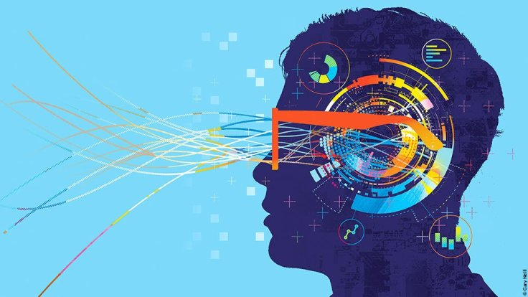
With all this in mind, is it any stretch of the imagination to see how the very near future will expand our capabilities exponentially so? Virtual reality is still crude, needing devices like goggles, haptic feedback suits, and sensors- but thinking back to only 15 years ago, when we only then got smartphones, it’s easy to see how immersive the technology could become in the next 15. Circling back to the idea that we have God-like abilities already, is it really ridiculous to think that we will need to behave like Gods?
Imagine a place where everything looks almost photorealistic, but more aesthetically pleasing (because why re-create the same reality we are trying to improve in the first place?). Now picture yourself teleporting from one place to another- from your mother’s forest-sized gardens, where you just had tea, to your friend’s underwater restaurant in the sea of Japan number 47, to attend his grand opening. Then, imagine flying out to the moons of Jupiter, with whom you will orbit around the massive planet about 3 times while listening to calm music before you fall asleep for your daily nap. Ring, ring, you are gently woken up by your personalized A.I assistant, reminding you that you have a cute date to get ready for.
Now, what if this kind of lifestyle were happening in your own universe or “verse”? You were not visiting your mother in the metaverse, but rather, it was she who used the metaverse to enter your own, private universe, where you create, erase and modify the construct in whichever way you want. You can choose to begin with the universe as we know it, as a baseline to work from, or start from scratch with a white-room-like void. Either way, people who you allow, access your universe, just as your mother did to enjoy some quality time in the forest gardens you built her. You can then leave your universe and enter the metaverse, a public place where your friend decided to open his restaurant in the 47th version of the metaverse’s seas of Japan. Because why not have several same places if they are that popular? We do not need to be slaves to overcrowded hotspots anymore.
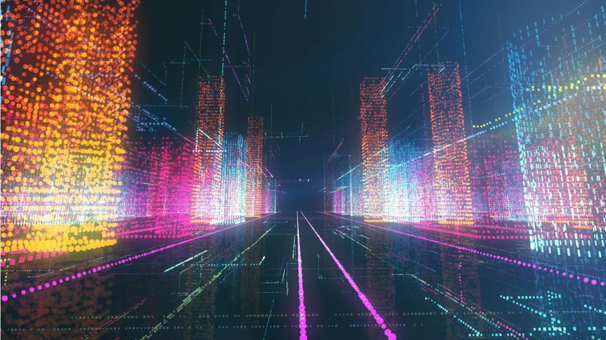
These images may not be so accurate as to describe what the metaverse is going to be exactly, but a clear understanding of the scope of power we will have should emerge relatively well. It sounds pretty fantastical, doesn’t it? Exhilarating and full of possibilities. Total freedom. Should we not, however, concern ourselves with what this means when it comes to our abilities to even handle this kind of reality? How many people would be truly comfortable with the responsibility of governing a universe (never mind building one)? We may very well be able to change the laws of physics, invent new games, explore new worlds and work by creating what we want to create, but how long will it take before we get bored? Or overwhelmed? How long will it take before people face the existential crisis brought on by lack of ultimate purpose for their verse, and the metaverse, and finally: our base reality? Will people hold on to their traditional religions and philosophies? How could they, in such a drastically changing reality, where many of the structures of meaning and morality no longer apply?
Where there is more freedom there is an even greater constraint of an abstract kind. As the mind or soul is liberated across space and time, the experience a conscious mind will have could very well be hellish more than it is heavenly. With this in mind, it is more likely that people will spend their time recreating our current reality in their own image partially, while living under the same religious and social constraints they always had- at least at first. These constraints it will be realized, are necessary for humans to feel free, never mind being free. This is because higher degrees of freedom come with greater demands and loneliness- all one has to do is ask the rich, the wise, and the powerful.
For the following generations however, it is conceivable that they could begin to create verses that have a very different structure than we can imagine today. Social standards could be very bizarre, physical laws off-kilter, and a morality that goes beyond our current predilections. It is not certain whether the fabric of societies can emerge organically and achieve stability, like that of our societies in history, when it comes to the metaverse. This would be because of how fast individuals could build and play in their verses. There may be a need for philosophical frameworks which could achieve the stability required for a person to feel happy and fulfilled in the world of their own making. This means a philosophy for creating philosophies would need to be built, so as to instruct a creator on how to come up with the necessary things one needs to run this kind of world.
What could this philosophy be? What is essential for humanity is already made pretty clear in philosophy. People need a metaphysical foundation for truth, an explanation of the origin of existence, a purpose from which to derive meaning, and a moral framework to live by. Would these essential elements have catalogs of the various possibilities from which a creator would build their world’s philosophy? It is not clear whether it is that simple; to begin with, these things are abstract enough to cause inconsistencies in the religious and social structures that emerge from them. Secondly, there may be some unforeseen philosophical needs that come with this kind of technology.
All-in-all, if the projection is accurate enough, the metaverse itself will surely need some kind of philosophy, never mind a person’s personal verse. This is because, unlike the internet, a metaverse could be a space wherein people directly interact at various locations, inviting the similar needs we have in base reality: governments, judiciary systems, and economic regulation. This is not simple, however- it is not the case that we just import these structures from our reality, as if it would work there. This is because the very fabric of the metaverse intends to maximize individual and societal creativity and productivity, which runs contrary to simplistic laws and economics. How do we create a stable society in a metaverse, where growth is exponential, possibilities are literally limitless and the proliferation of ideologies is potentially devastating? These are the challenges to be met going forward if we are to be responsible with our not so arbitrary minds.
Here, it is important to be reminded how complex, dangerous, and painful our reality already is; do we really believe we can invite an exponentially evolving reality in our collective and individual minds without knowing the answers to some of these questions?
James Sirois

