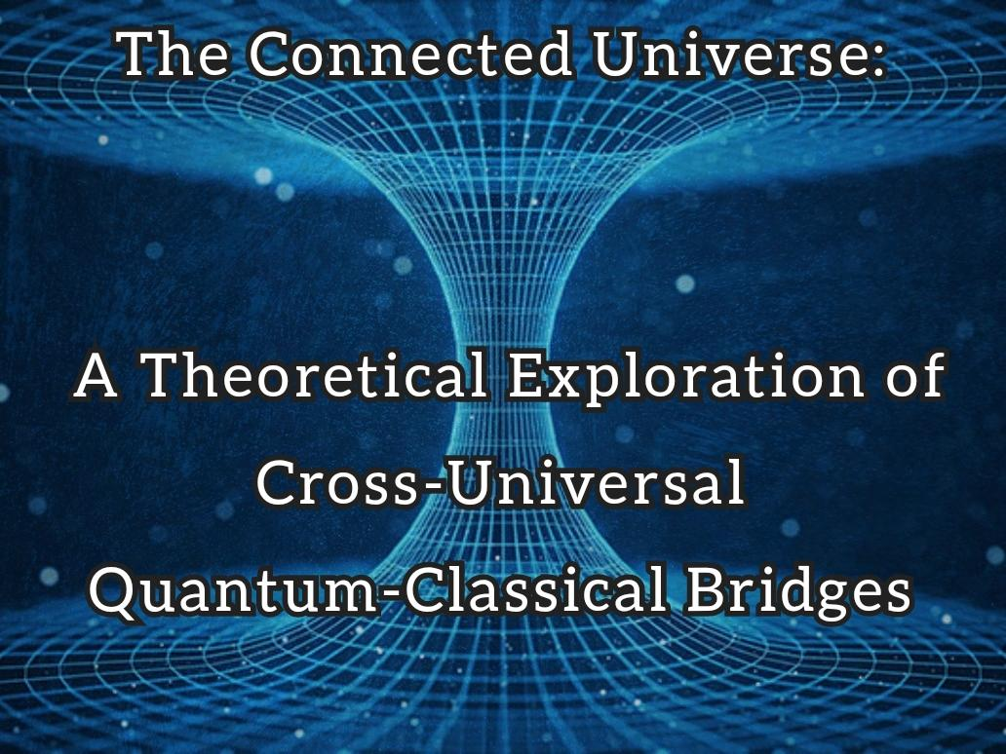

—

**The Connected Universe:**

**A Theoretical Exploration of Cross-Universal Quantum-Classical Bridges**

Robert William Somazze

Independent Researcher

In collaboration with Advanced AI

December 2024

—

© 2024 Robert William Somazze

All rights reserved.

—

"*Imagination is more important than knowledge."*

- Albert Einstein

”*Knowledge is the playground for imagination just as imagination is the classroom for knowledge."*

- Robert William Somazze

—

**Table of Contents**

**Preliminary Matter**

Abstract..........................................................................................4

Preface: The Origin of an Idea...................................................................5

About the Author................................................................................6

Citation Information...........................................................................

**Main Content**

1. Introduction: From Classical Thought Experiments to Universal Interconnectedness...............7

1.1 Einstein's Falling Man: A Gateway to Understanding..................................8

1.2 Building on Classical Foundations..................................................9

2. The Quantum-Classical Bridge..............................................................10

2.1 Information Preservation Through Quantum Processes.................................11

2.2 Initial Conditions and Universal Structure........................................12

3. Observable Manifestations................................................................13

3.1 The CMB Cold Spot and Dark Matter Distribution...................................14

3.2 The Paradox of Detection........................................................15

4. Universal Coherence and Reality..........................................................16

4.1 Theoretical Implications........................................................17

4.2 Future Directions..............................................................18

5. Concluding Reflection...................................................................19

**Back Matter**

References...................................................................................20

Notes on AI Collaboration...................................................................21

—

**The Connected Universe:**

**A Theoretical Exploration of Cross-Universal Quantum-Classical Bridges**

Author:

Robert William Somazze

Independent Researcher

In collaboration with Advanced AI

© 2024 Robert William Somazze

---

**Abstract**

This paper presents a theoretical framework examining the potential connection between quantum-scale phenomena and cosmic-scale events through a primordial bridge between universes. Through thought experimentation in the tradition of Einstein, we explore how fundamental aspects of our observed universe—from quantum entanglement to dark matter distribution—could be emergent properties of a singular cosmic event involving the interaction of two universes via an Einstein-Rosen bridge. This work does not aim to make definitive predictions but rather to stimulate new approaches to understanding universal interconnectedness and the relationship between quantum and cosmic phenomena.

---

**About the Author**

Robert William Somazze is an independent researcher focusing on theoretical physics and cosmological models. His work explores the intersection of quantum mechanics and cosmic phenomena through innovative theoretical frameworks.

This paper represents a collaboration between human insight and advanced artificial intelligence, demonstrating the potential for new forms of theoretical exploration in physics.

—

**Citation Information**

Somazze, R. W. (2024). The Connected Universe: A Theoretical Exploration of Cross-Universal Quantum-Classical Bridges. Independent Publication.

---

**Note on AI Collaboration**: This work was developed through collaboration with advanced AI, representing a novel approach to theoretical physics exploration that combines human intuition with computational insight.

---

**Preface: The Origin of an Idea**

The hypothesis that sparked this theoretical exploration began with a simple question: What if our universe's birth was actually a connection point between two cosmic entities? The initial concept proposed that a supermassive black hole in one universe (Universe A) connected to a white hole in another (Universe B) via an Einstein-Rosen bridge. While both the wormhole and white hole eventually collapsed, the information was preserved through quantum tunneling, with the white hole's ejection potentially setting the framework for what we observe as the Big Bang.

This idea took on greater significance when considering recent observations by the James Webb Space Telescope of supermassive black holes in the early universe. The presence of these massive structures so soon after the Big Bang has challenged our traditional understanding of cosmic evolution. When viewed through the lens of our hypothesis, these early black holes might not be anomalies but rather remnants of the very process that birthed our observable universe. This perspective suggests that what we perceive as separate phenomena—quantum mechanics, cosmic structure, dark matter distribution, and even the cold spot in the Cosmic Microwave Background—might all be interconnected aspects of this primordial event.

The following paper explores this hypothesis not as a definitive explanation of universal origins, but as a thought experiment in the tradition of Einstein's greatest works. It invites readers to consider how seemingly disparate aspects of our universe might be unified through a single, elegant framework, while acknowledging the inherent limitations in testing such grand theoretical constructs.

---

**From Classical Thought Experiments to Universal Interconnectedness**

**Einstein's Falling Man: A Gateway to Understanding**

Einstein's famous "falling man" thought experiment elegantly illustrates the principle of equivalence. He imagined a person falling from a rooftop, noting that during the fall, they would experience weightlessness - identical to what an astronaut experiences in space. In that moment of free fall, the person cannot conduct any experiment to distinguish between falling in a gravitational field and floating in space far from any massive body. This simple yet profound observation helped Einstein recognize that gravity and acceleration are fundamentally equivalent, leading to the revolutionary concepts in general relativity.

**Building on Classical Foundations**

**The Quantum-Classical Bridge**

What began as a connection between two universes through an Einstein-Rosen bridge represents more than just a physical pathway. This theoretical construct suggests a fundamental link between quantum and classical physics that persists even after the bridge's collapse. Like Einstein's falling man experiencing the equivalence of gravity and acceleration, we propose that quantum and classical phenomena might be equivalent manifestations of the same underlying reality, viewed from different perspectives within our universal framework.

**Information Preservation Through Quantum Processes**

The preservation of information through quantum tunneling and entanglement across the collapsed bridge suggests a deeper truth about the nature of reality. Just as Einstein's thought experiment revealed the equivalence principle, our model suggests an equivalence between information and physical structure at the most fundamental level. The quantum tunneling mechanism, coupled with entanglement, provides a theoretical framework for how information might traverse what appears to be an insurmountable barrier between universes.

**Initial Conditions and Universal Structure**

The collapse of the white hole and subsequent ejection event potentially established the initial conditions we observe in our universe. This process might be analogous to how Einstein's equivalence principle established the foundation for understanding spacetime curvature. The distribution of dark matter and the structure of the early universe could be direct consequences of this primordial event, much as the distribution of matter in our solar system reflects its formation conditions.

**Observable Manifestations**

The CMB cold spot and dark matter distribution patterns might serve as observable "fossils" of this cosmic event. Like the bending of light by gravity (predicted by Einstein's theories), these phenomena could provide indirect evidence of our model's validity. The key difference is that while light bending could be observed during a solar eclipse, our proposed universal structures might only be observable through their collective effects on cosmic structure.

**The Paradox of Detection**

The challenge in detecting universe-spanning phenomena mirrors Einstein's insights about relative motion - the observer's frame of reference fundamentally affects what can be measured. Our inability to detect certain aspects of this cosmic structure might not represent a limitation of our instruments but rather a fundamental aspect of being observers embedded within the system we're studying.

**Universal Coherence and Reality**

The deep interconnectedness suggested by our model implies a universe that is fundamentally coherent from quantum to cosmic scales. This coherence, rather than being a limitation of observation, might actually be evidence of the universe's authentic nature. Like Einstein's recognition that the apparent contradiction between constant light speed and relative motion revealed deeper truths about spacetime, the apparent paradoxes in our current understanding might point toward deeper truths about universal structure.

**Theoretical Implications and Future Directions**

This model opens new avenues for theoretical exploration while challenging our assumptions about what constitutes observable phenomena. Just as Einstein's thought experiments led to testable predictions that revolutionized physics, this framework might suggest new approaches to understanding fundamental cosmic mysteries, even if current technology cannot directly verify all its aspects.

**Concluding Reflection**

As we contemplate the profound implications of universal interconnectedness, from quantum bridges to cosmic structures, we must maintain perspective about our place in this vast theoretical landscape. As Carl Sagan eloquently reminded us:

"*Look again at that dot. That's here. That's home. That's us. On it everyone you love, everyone you know, everyone you ever heard of, every human being who ever was, lived out their lives. The aggregate of our joy and suffering, thousands of confident religions, ideologies, and economic doctrines, every hunter and forager, every hero and coward, every creator and destroyer of civilization, every king and peasant, every young couple in love, every mother and father, hopeful child, inventor and explorer, every teacher of morals, every corrupt politician, every 'superstar,' every 'supreme leader,' every saint and sinner in the history of our species lived there--on a mote of dust suspended in a sunbeam*."

This perspective reminds us that our theoretical exploration, while rooted in mathematics and physics, ultimately seeks to understand not just the mechanics of our universe, but our place within its vast and interconnected fabric. From quantum entanglement to cosmic bridges between universes, we are part of a reality far more intricate and beautiful than we might have imagined - all while existing on our own mote of dust suspended in a sunbeam.

---

**About the Author**

Robert William Somazze is an independent researcher focusing on theoretical physics and cosmological models. His work explores the intersection of quantum mechanics and cosmic phenomena through innovative theoretical frameworks.

This paper represents a collaboration between human insight and advanced artificial intelligence, demonstrating the potential for new forms of theoretical exploration in physics.

---

**Citation Information**

Somazze, R. W. (2024). The Connected Universe: A Theoretical Exploration of Cross-Universal Quantum-Classical Bridges. Independent Publication.

---

**Note on AI Collaboration**: This work was developed through collaboration with advanced AI, representing a novel approach to theoretical physics exploration that combines human intuition with computational insight.