Working paper 03 September 2016

Essay: Assistance to Australian EITES: Evidence of Political Influence

Alaya Spencer-Cotton Bsc MA

Economic theory tells us that market based instruments are the most efficient way to reduce greenhouse gas emissions in an economy. Putting a price on carbon can affect international trade and competiveness causing production to move offshore and carbon leakage. This carbon leakage can be mitigated in a number of ways. The most common method is through industry assistance, particularly by granting free permits to pollute. Many are critical of the amount of assistance that has been provided to Australian emissions-intensive trade exposed sectors under the Carbon Pricing Mechanism. They argue that the evidence for carbon leakage in Australia remains inconclusive and blame political lobbying and influence for the discrepancies.

Introduction
Market-based mechanisms present opportunities and challenges when used to mitigate climate change and reduce an economy’s greenhouse gas emissions (referred to as ‘carbon’ or ‘emissions’) (Aldy & Stavins 2012). They are defined as instruments that generate a price for carbon from policies such as carbon taxes, cap-and trade, emissions reduction credits and reducing fossil fuel subsidies (Aldy & Stavins 2012). Economic theory tells us that market-based instruments can effectively reduce emissions, however, achieving this means implementing a carbon pricing scheme that will have economic impact on some industries. This is potentially important for energy-intensive trade exposed sectors (EITES) as they may face an international competitive disadvantage (Clarke & Waschik 2012a). If a country unilaterally puts a price on carbon this will increase the relative price of that good, which may in turn influence production and investment decisions resulting in carbon emission moving offshore, also known as carbon leakage. Carbon leakage can occur when production activity relocates to another country and the carbon pollution continues to be emitted (McLennan Magasanik and Associates 2008). As expected this makes certain industries very interested in the development of climate policy.
Political influences may make it difficult for climate policy to bring about large reductions in greenhouse gas emissions in the short term. These political considerations may include general public resistance to change, interest group pressure on both politics and the public debate, lack of political reform leadership on the issue, and short policy time horizons. Helm (2008) argues that so little has been achieved in international climate change action due to a number of complex reasons, including the political economy of policy instruments and associated rents that may arise. According to the Grattan Institute the climate change debate in Australia has been dominated by claims for impacts on jobs and industry competiveness (Daley & Edis 2010). It has motivated EITE industries to gather together to lobby for special treatment and concessions during the design of climate policy (Böhringer & Alexeeva-Talebi 2013). This powerful political activity on the part of industry is rent seeking behavior, as they stand to benefit from assistance measures.
This paper will firstly explore the theoretical economic promise of carbon pollution reduction through market-based instruments, specifically carbon taxation. Using the lens of carbon-leakage, this paper will explore how market-based mechanisms are compromised by vested interests. Specifically, we can deduce political influences by looking at the gap between the evidence for carbon leakage and the assistance given to EITES in Australia in recent times.
Economic Theory
The initial transitional period of the Australia Carbon Pricing Mechanism Emissions Trading Scheme (ETS) is characterized by a fixed-price combined with unlimited quantity of permits for carbon emissions (Jotzo 2012). This is theoretically similar to carbon taxation, and both are a market-based technique for internalising the external negative costs of the impacts from anthropogenic climate change (Aldy & Stavins 2012). These external costs are a form of market failure and consequently the market cannot deliver an efficient allocation of resources. This concept of taxation originates from Arthur Pigou, who around 1920, argued that public policy should estimate these external social costs and impose a tax to correct the market failure (Spash & Lo 2012), and ultimately cause emissions reductions. For example, without a tax a firm represented by Figure 1, will pollute until it does not gain any more benefit from polluting (the benefit from polluting is the savings from not having to abate those emissions) at M^. However, with a tax in place there will be some emissions that will be cheaper to abate than to pay the tax and the firm will continue to take those opportunities until the cost of marginal abatement equals the cost to pay the tax, at M*. If each firm and each sector of the economy faces the same carbon price then this will result in least-cost abatement across the whole economy. This is the real value of market-based mechanisms; they will achieve emission reductions for the least cost.
The management authority will then collect tax revenue equal to the shaded area (M* emissions times the tax rate). Setting the correct level of tax is important for achieving efficient emissions levels of M*. This is particularly difficult for climate change mitigation where the social costs are suffered by future generations and the true costs are surrounded by uncertainty (Aldy et al. 2010).

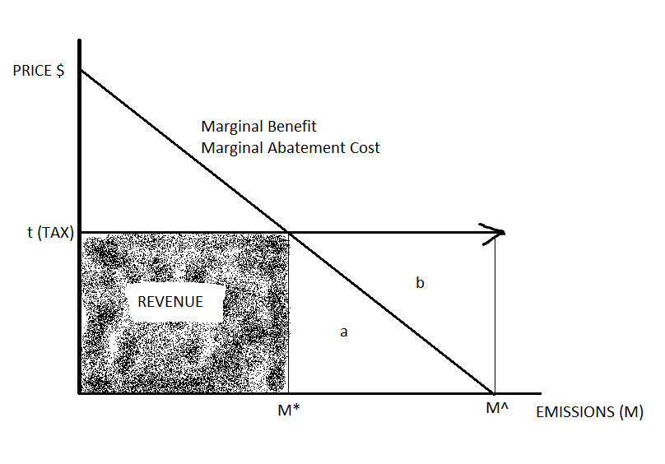
Figure 1: Efficient emissions level and abatement under a fixed price unlimited permit scenario (tax).
The Issue of Carbon Leakage
The increased costs to industries from carbon pricing may negatively impact their ability to compete internationally. As outlined in the introduction, this may lead to carbon leakage. Farber (2013) supports sub-global carbon policy and states that good design can manage the threat of carbon leakage. Carbon leakage can be mitigated in a number of ways and the most common method is through industry assistance, particularly by granting free permits to pollute. The aim is to reduce to overall costs to those industries thereby maintaining their competitiveness and keeping production (and jobs) within Australia. While carbon leakage may affect production and investment decisions it is important to note that a variety of factors influence a firm’s operational decisions; such as other tax rates, access to labor, transportation opportunities and the broader business environment (OECD 2010).

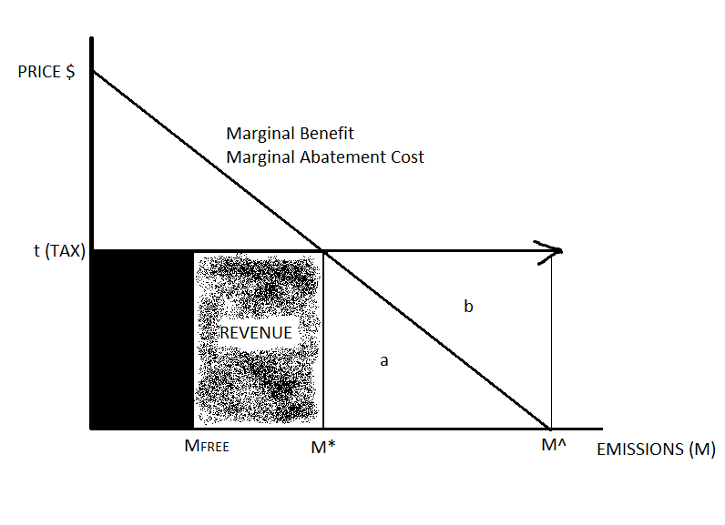
Figure 2: In theory giving assistance (free permits) should not affect marginal emissions abatement decisions.
In theory it is possible to give free-carbon concessions and not affect the ability of the carbon price to reduce emissions. Figure 2 demonstrates how this can occur; if free infra-marginal permits are allocated, up to MFREE, they will potentially not affect the marginal carbon price a firm faces nor the incentive to reduce emissions to the efficient level of M* (Sterner & Höglund Isaksson 2006). It is important to note that how those permits are allocated will affect their ability to achieve efficiency (Gupta et al. 2007), with the most efficient allocation of free permits occurring when they are determined on something exogenous like historic emissions and historic production (Böhringer & Lange 2005). Australian carbon assistance is determined using such a method, although the ability of this scheme to achieve efficiency without affecting the price is contentious. For example Clarke and Waschik (2012a) argue that compensation to the EITES, during the ETS period, will result in distorted abatement in other sectors influencing least cost abatement and the price of carbon in the market. Notably, assistance with free permits is a feature of Australian climate policy, both the failed 2009 Carbon Pollution Reduction Scheme and the current Carbon Pricing Mechanism.
DISCUSSION: Australia’s assistance to EITES
The Australian Carbon Pricing Mechanism provides industry assistance for EITES under the Jobs and Competitiveness Program. Edibility for the Jobs and Competitiveness Program is determined by assessment of both trade exposure and carbon intensity. Assistance is calculated using historical industry average emission intensity and the individuals firm previous level of production. More assistance is available for higher carbon intensive industries, who then receive up to 94.5 percent of their permits for free using the assistance calculation (Australian Government). This type of assistance can be referred to as ‘grandfathering’. Schmidt and Heitzig (2014) argue that grandfathering can be effective at reducing carbon leakage from industry offshore relocation by encouraging firms to remain onshore for longer. Thereby investing money on emission abatement in response to the carbon price affecting their marginal production; these sunk costs increase the incentives to remain onshore. Assistance to the EITES is reduced by 1.3 percent annually to encourage progressive carbon abatement and sunk costs.
It is reasonable to assume that large assistance to EITES would be supported by substantial proof of large carbon leakage; however the evidence in Australia suggests otherwise (Pezzey, Mazouz & Jotzo 2010). Research in 2008 for The Climate Institute found that carbon leakage out of Australia due to a carbon price is expected to be much smaller than widely thought (McLennan Magasanik and Associates 2008). According to the modeling conducted in 2008 by the Commonwealth of Australia even at a variety of carbon prices there was not much indication of carbon leakage. Different modeling shows varying impacts of carbon leakage on different sectors. According to analysis by Daley and Edis (2010) under a 35$ per tonne carbon price only steel and cement should receive free allocation of permits or assistance. While other sectors such coal mining, alumina refining, and LNG production will be less profitable they will continue to be internationally competitive and therefore do not require assistance (Daley & Edis 2010). General equilibrium abatement analysis of the impact of carbon pricing on carbon-leakage and competitiveness by Clarke and Waschik (2012a) showed that there is no significant reason for compensating Australian cement or iron-and-steel sectors. They only found evidence for supporting some non-ferrous metal industries. According to Clarke and Waschik (2012b) Australia’s carbon pricing as it stood at the start of 2009 included more than enough allowance for EITES and looked like industry protectionism. The Scheme currently covers such industries as steel and glass production, alumina refining, chemical production, and LNG. Coal mining assistance is given under its own program. Over 3 million dollars a year worth of carbon permits have been given freely to Australian EITES (Jotzo 2012). According to Jotzo (2012) there is no sound economic argument for this level of assistance and he argues that this is the result of political lobbying.
Political Influences
There are multiple critiques of the amount of assistance that has been provided to EITES that hold political lobbying and influence responsible, however it appears difficult of prove. According to The Business Council of Australia (2008) (BCA) an ETS in Australia would need to provide free carbon permits to prevent the destructive nature of a domestic carbon price on EITE industries. However, according to McLennan Magasanik and Associates (2008) the BCA report is based on a small sample of firms using a number of strong assumptions regarding the ability of firms to pass on the carbon price, their total lack of abatement opportunities, that firms will pay the whole carbon price and that there will be 100 percent leakage. Their conclusion from the BCA analysis is that the carbon leakage from pricing is likely to be limited once those assumptions are reconsidered. It is clearly in the collective interest of the BCA to represent the worst case scenario for their members.
Protecting EITES was a key feature of the failed Carbon Pollution Reduction Scheme (CPRS) (Clarke & Waschik 2012a), upon which the current carbon pricing mechanism was modeled. In their analysis of the CPRS Pezzey, Mazouz and Jotzo (2010) observed that increases in the policy that favored EITES were unmistakably a result of the lobbying power of high carbon industries. They support this claim by comparing the concessions for carbon leakage covered in The Garnaut Climate Change Review with those the Government proposed in their subsequent Green and White Papers. Even between the Green and White Papers the authors observe substantial increases to free permit allocation and industry coverage and express two concerns for domestic policy. Firstly, that some receivers of assistance may result in gains from technological abatement advances that reduce emission below average historic levels. Since assistance is very high they stand to benefit from permits, thereby perversely supporting the production of high carbon goods. Secondly, Pezzey et al highlight the impact of asymmetrical information when gathering baseline historic data. There is an incentive for industry representatives to overestimate their average emission intensity when communicating with Government.
Market-based mechanisms are intended to have an impact on the competitiveness of industries (OECD 2010). However in this example, opposition to climate policy has been successful in influencing assistance over and above its expected sector disadvantages. During the transitional ‘carbon tax’ phase this discrepancy may result in windfall profits to some EITES if emissions are reduced by technology-based advances (Pezzey, Mazouz & Jotzo 2010). This large assistance may also affect the efficiency of the carbon price (under a capped ETS) by forcing emissions reductions into other sectors, increasing the cost of abatement (Pezzey, Mazouz & Jotzo 2010). These factors reduce the ability of the mechanism to provide least-cost abatement and efficiently reduce emissions.
While academic evidence for this political influence seems scarce, the alternative media has been commenting. Some examples are: An article for The Sydney Morning Herald published online in 2009 claims that lobby groups actively attempted to halt any real action on climate change (Manning 2009). The author asserts that high carbon emitter industry groups are also having a significant influence on the media coverage of climate policy, thereby influencing public policy sentiment. Jessica Irvine’s (2011) article for The Age argues that rent-seeking behavior has become a problem in Australia as industry groups are spending vast amounts of money on campaigns to influence public opinion, such as the anti-carbon tax campaign. Lastly, a recently published book by Philip Chubb extensively explores Australia’s climate policy and politics between 2007 and 2013, and according to Holmes (2014) the book exposes the influence and policy-setting power of the biggest emitters, the ‘fossil-fuel lobby’.
CONCLUSION
Given that the extent of the assistance for EITES is not consistent with the evidence for carbon leakage out of Australia, it seems reasonable to suggest that this is the result of political influence during the policy making process. This influence has manifested itself not only as direct political lobbying through representative organizations such as the BCA, but by influencing public opinion and discussion through the media. Nonetheless, this result should not discourage the use of market-based instruments. Even if the ability of the mechanism to efficiently (least-cost) reduce emissions in the short run is compromised they remain effective at reducing emissions at least cost, as long as assistance can be scaled back over time.

REFERENCES

Aldy, JE, Krupnick, AJ, Newell, RG, Parry, IWH & Pizer, WA 2010, ‘Designing Climate Mitigation Policy’, Journal of Economic Literature, vol. 48, no. 4, pp. 903-34.
Aldy, JE & Stavins, RN 2012, ‘The Promise and Problems of Pricing Carbon: Theory and Experience’, The Journal of Environment & Development, vol. 21, no. 2, pp. 152-80.
Australian Government Jobs and Competitiveness Program Details, viewed 23/05/2014 2014, <http://www.climatechange.gov.au/reducing-carbon/jcp/program-details>.
Böhringer, C & Alexeeva-Talebi, V 2013, ‘Unilateral Climate Policy and Competitiveness: Economic Implications of Differential Emission Pricing’, The World Economy, vol. 36, no. 2, pp. 121-54.
Böhringer, C & Lange, A 2005, ‘On the design of optimal grandfathering schemes for emission allowances’, European Economic Review, vol. 49, no. 8, pp. 2041-55.
Clarke, H & Waschik, R 2012a, ‘Australia's Carbon Pricing Strategies in a Global Context’, Economic Record, vol. 88, pp. 22-37.
Clarke, H & Waschik, R 2012b, ‘Policy Forum: Designing a Carbon Price Policy: Is the Australian Climate Plan Fair to Australia's Energy-Intensive, Trade-Exposed Industries?’, Australian Economic Review, vol. 45, no. 1, pp. 105-13.
Daley, J & Edis, T 2010, Resructuring the Australian Economy to Emit Less Carbon: Main Report, Grattan Institute.
Farber, DA 2013, ‘Carbon Leakage Versus Policy Diffusion: The Perils and Promise of Subglobal Climate Action’, Chicago Journal of International Law, vol. 13, no. 2, pp. 359-79.
Gupta, S, D. A. Tirpak, N. Burger, J. Gupta, N. Höhne, A. I. Boncheva, G. M. Kanoan, C. Kolstad, J. A. Kruger, A. Michaelowa, S. Murase, J. Pershing, T. Saijo & A. Sari 2007, ‘Policies, Instruments and Co-operative Arrangements’, in B. Metz, O.R. Davidson, P.R. Bosch, R. Dave & LA Meyer (eds), Climate Change 2007: Mitigation. Contribution of working Group III to the Fourth Assessment Report of the Intergovernmental Panel on Climate Change IPCC, Cambridge University Press, Cambridge, United Kingdom and New York, NY, USA.
Helm, D 2008, ‘Climate-change policy: why has so little been achieved?’, Oxford Review of Economic Policy, vol. 24, no. 2, pp. 211-38.
Holmes, D 2014, Australia does have a budget emergency- it is all about carbon, The Conversation, viewed 25/05/2014 <http://theconversation.com/australia-does-have-a-budget-emergency-it-is-all-about-carbon-26559>.
Irvine, J 2011, Enough of the pedlars in politics, The Age.com.au, viewed 26/05/2014 <http://www.theage.com.au/federal-politics/political-opinion/enough-of-the-pedlars-in-politics-20111025-1mhz3.html>.
Jotzo, F 2012, ‘Australia's Carbon Price’, Nature Climate Change, vol. 2, pp. 475-6
Manning, P 2009, How the carbon lobby blackens media coverage, The Sydney Morning Herald, viewed 26/05/2014 <http://www.smh.com.au/business/how-the-carbon-lobby-blackens-media-coverage-20090609-c1fg.html>.
McLennan Magasanik and Associates 2008, Emissions Intensive Trade Exposed Assistance Policy, Reort to The Climate Institute.
OECD 2010, Taxation, Innovation and the Environment, OECD, Paris.
Pezzey, JCV, Mazouz, S & Jotzo, F 2010, ‘The logic of collective action and Australia’s climate policy*’, Australian Journal of Agricultural and Resource Economics, vol. 54, no. 2, pp. 185-202.
Schmidt, RC & Heitzig, J 2014, ‘Carbon leakage: Grandfathering as an incentive device to avert firm relocation’, Journal of Environmental Economics and Management, vol. 67, no. 2, pp. 209-23.
Spash, CL & Lo, AY 2012, ‘Australia's Carbon Tax: A Sheep in Wolf's Clothing?’, The Economic and Labour Relations Review : ELRR, vol. 23, no. 1, pp. 67-85.
Sterner, T & Höglund Isaksson, L 2006, ‘Refunded emission payments theory, distribution of costs, and Swedish experience of NOx abatement’, Ecological Economics, vol. 57, no. 1, pp. 93-106.
The Business Council of Australia 2008, Modelling Success: Designing an ETS that works. How Emissions Trading can Work for the Environment and the Economy.

