What It’s Like to Chill Out With Whom the Rest of the World Considers As The Most Ruthless Men: Ratko Mladic, Goran Hadzic and Radovan Karadzic (+) Confessions of a Female War Crimes Investigator

A lot of evidence will come out during my defence case as to how the Americans wanted to secure a long-lasting war in Bosnia and instigated violations of the UN arms embargo, even in close cooperation with Iran, and how they supported and supplied the Bosnian Muslims to justify what they were doing to Muslims elsewhere. --By Radovan Karadzic

What It’s Like to Chill Out With Whom the World Considers the Most Ruthless Men : Ratko Mladic, Goran Hadzic and Radovan Karadzic Confessions of a Female War Crimes Investigator

Delicious Digg Facebook Reddit Stumble Upon Technorati Mixx Sphinn Twitter SphereIt Propeller Gmarks Newsvine Yahoo! My Web Live Journal Blinklist E-mail

Confessions of a Female War Crimes Investigator
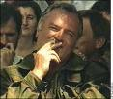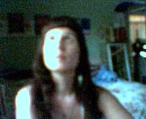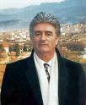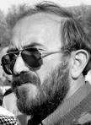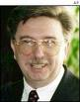
Retrospectively, it was all so simple, natural and matter of fact being on a boat restaurant in Belgrade, sitting with, laughing, drinking a two hundred bottle of wine and chatting about war and peace while Ratko Mladic held my hand. Mladic, a man considered the world’s most ruthless war criminal since Adolf Hitler, still at large and currently having a five million dollar bounty on his head for genocide by the international community. Yet there I was with my two best friends at the time, a former Serbian diplomat, his wife, and Ratko Mladic just chilling. There was no security, nothing you’d ordinarily expect in such circumstances. Referring to himself merely as, Sharko; this is the story of it all came about.
It all began as former United States President Bill Clinton spearheaded NATO’s war against Serbia, Montenegro and Slobodan Milosevic (March 1999). Thirty-five years old, conducting graduate study work at the New School for Social Research in New York City in political science, I planned graduating spring 1999 with an area study emphasis in international law and human rights. I was naive then, still believing strongly in democratic liberal concepts such as freedom of academic thought. Hence, I never anticipated my political views would impede either my graduation or completing my master’s thesis work on whether NATO member states committed gross violations of customarily accepted international criminal law in launching military aggression against Serbia and Montenegro owing to not acquiring United Nations Security Counsel approval prior.
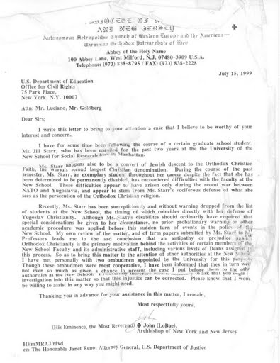
Then as hit with the identical smart bomb dropped on Milosevic’s presidential palace in Serbia the night of April 22nd 1999, political science chairperson then at the New School, Professor David Plotke, summoned me into his office before class that evening and dismissed me from the master’s program at the New School owing to what he considered my possessing unsavory political science opinions.
Only having to complete two more classes to graduate, I always thought my future in political sciences as wide open with innumerous possibilities; unfortunately this proved untrue. Plotke told me in no uncertain terms that I was not the type of person the New School wanted walking around with a degree stating the New School’s prestigious name on it.
Ironically, the New School was an institution I attended only owing to its’ placing great pride and emphasis on allowing students complete academic freedom of thought without dictating what is and what is not politically correct to discuss. Yet surprisingly, dismissal from the program and blow to my graduate work should not been completely unexpected since the semester immediately prior, the school refused allowing me to conduct my graduate thesis work on the subject of whether the NATO and Bill Clinton committed war crimes against the former Yugoslavia during the Kosovo war (1999) and internally suggested I write about infringement of Muslim human rights in France.
I suppose with the likes of Hillary Clinton and Tony Blair hanging about the fourth floor of the school at the renown World Policy Institute in 1999, I should have expected the university would not take kindly to student‘s speaking out critically against Bill Clinton and the Kosovo war (1999) he went down in history for advocating. Then again, in 1999 I still believed in the school’s core ideals of academic freedom, especially since I was paying no less than one thousand United States dollars a credit to attend. My civil rights lawsuit against the college is another story in and of itself not deserving extended amounts of space here, except what I already mentioned.
Dismissal from graduate school left me in a complete state of scholarly anomie seeking empathy and solace from my few friends and confidants at the time including many diplomats I studied with at the New School for several years. The list included but was not limited to ambassadors from Iran, Oman and a newly appointed First Secretary of the Bosnian Mission to the United Nations in New York, Darko Trifunovic.
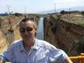
Noteworthy of mentioning, both the ambassadors from Iran and Oman both confided in me their own extreme dissatisfactions and the scholarly problems they themselves currently encountered at the New School for Social Research. On the last day attending the school, both aforementioned men explicitly complained to me the school was holding them back from graduating owing to their own so-called extremely unsavory political viewpoints. In particular the Iranian ambassador, Amir, was writing his master’s thesis on the Iranian contra affair and the UN Ambassador from Oman told me, for years he was being held back from graduating because Greek Professor Addie Pollis strongly disdained his Islamic religious and cultural views insofar as human rights and multiple marriage partners by Muslim sultans in his country of origin. It was May (1999).
Riddled with uncertainty about my future scholarly status, I immediately applied for graduate study at Farleigh Dickinson University in New Jersey where I studied an additional two years before encountering similar problems with the graduate school faculty there. Ironically it was only FDU professors whom formerly studied themselves at the New School still in touch with the faculty there, who were later responsible for my having to leave the graduate program at FDU in early 2002.
Between the time of my dismissal from the New School and my dismissal from FDU in the fall (2002), I stayed in touch with many scholars and other politically active persons sharing similar anti-war views as myself regarding NATO’s 1999 Kosovo war including: Professor Barry Lituchy (NYC), Ramsey Clark’s people at the International Action Center, and a couple of new acquaintances I’ve chanced meet online in Serbian political activist forums.
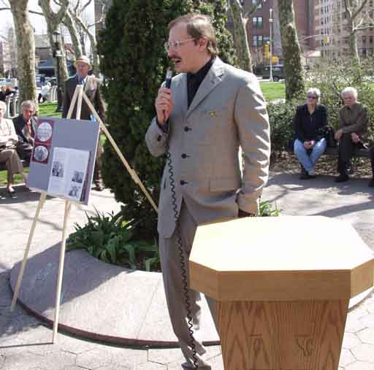
One of those people was, Darko Trifunovic. Darko and I were e-mailing each other regularly by early spring (1999) at which time he informed me that he became the newly appointed First Secretary of the Bosnian Mission to the United Nations in New York City and wondered whether I would pick him up at JFK airport when he arrives in a few weeks; I acceded.
Another event in my life occurring in Manhattan in late spring (1999) was chance meeting Nikola Sainovic; Slobodan Milosevic’s former Deputy Serbian Prime Minister. It just so happened I was in the city attending Ramsey Clark’s anti-NATO lectures immediately after NATO’s bombing campaign against the former Yugolsavia began. I was walking up to the main lecture building and paused at the door momentarily to examine how to enter and where to go when Nikola walked up for me , surprising me from behind, he said “hello, are you here for the lecture also“? I replied “yes.” I was shy, but Nikola kept the conversation going as we walked into the building together discussing the horrendous actions the NATO was currently undertaking against his country in Serbia. Although I did not know then who exactly he was, he was handsome, educated and he wore a very sharp brown suit, tie and wore glasses. His identity is unmistakable to me now viewing the photos of him sitting in the Hague currently awaiting his own trial for complicity in war crimes. During the lecture intermission he again came over to speak with me and asked me my telephone number stating he’d like to get together and talk sometime with me while he was in town; I acceded.
It was not long after Ramsey Clark’s lecture that Nikola called me and we agreed to have dinner together at the Peking House in Butler NJ on Route 23. He met me at the restaurant and we enjoyed a great dinner and lively conversation regarding American diplomacy and politics between the United States, NATO and Serbia. After dinner he asked me if there was somewhere quite we both could go to continue talking and being shy about men and their intentions, I told him since it was a beautiful summer’s evening, I suggested we drive up 23 North into West Milford NJ where there was a lovely “rest stop” where we could sit down on the picnic table chairs and continue our conversation together.
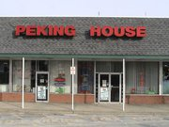
He offered to drive me up to the spot in his fancy brown Jaguar. I had never really been in a Jaguar before and it drove really smooth. Nikola and I spent several hours just chatting about Serbia and the illegal NATO actions undertaken against his country and when we commenced, he drove me back to my car waiting by the restaurant and we decided we would meet again for lunch in about a week; he would give me call soon.
I was attending Montclair State University for one semester that summer so when Nikola call me in about a week for lunch I recommended we meet at about 4pm at the 6 Brothers Diner on Route 46 by the university. Nikola never made any unwanted advances towards me and we just like to chat about war and peace. He told me, ‘Jill, I like to come talk with you because I can trust you. I can let down my hair so to speak with you and not worry about you wire tapping me or stabbing me in the back.” I thanked him for his compliment and company. He told me his daughter lived in Tarrytown New York and when we parted that day, he told me this is where he was headed. He gave me his business card bearing his name, Nikola Sainovic. I forget the business it listed, it might have just said Prime Minister but I think it said something else politically related but I can’t remember now. I took it and thanked him. Whomever I did meet, they also gave me photos and showed me a brief portfolio of their news ideas in the space saving architecture and additionally gave me some photos of their work and a business card for what I remember as a German PASSOS company. It had to be be Nikola. We actually had a great chat about what I thought about his new architectural ideas. I loved them telling Nikola I believed he would be extremely successful in his new endeavors. I think we may have had lunch one additional time and then I never heard from him again.
Darko arrived first, his very beautiful wife, Bojana, arrived as expected about one month later after he was settled. Darko greatly impressed me at the time. Being a former political advisor to the to the former female President of the Republic of Srpska in Bosnia, he had a degree in international law, diplomatic immunity, was a writer, handsome, was extremely brilliant and fun to just hang-out with and work. The three of us became extremely close friends and confidants.
Darko arrived first, his very beautiful wife, Bojana, arrived as expected about one month later after he was settled. Darko greatly impressed me at the time. Being a former political advisor to the to the former female President of the Republic of Srpska in Bosnia, he had a degree in international law, diplomatic immunity, was a writer, handsome, was extremely brilliant and fun to just hang-out with and work. The three of us became extremely close friends and confidants.
Between the time, I was dismissed from the New school for Social Research in New York City, and, the time, Darko, arrived in full diplomatic capacity in to work in the Bosnian Mission to the United Nations in New York City, I had lots of spare time on my hands. Before I met Darko, I had fallen whimsically in love with a monk living at the Abbey of the Holy Name Monastery, where I attend Orthodox Christian Mass weekly. His name was Momcilo Pantovic.
Being familiar with encryption and codes, I noticed an Orthodox Christian Ikon has gave to me seemed to read “I have the NATO codes.” I ignored this at first. A few weeks later, I was speaking with Bishop John at the monastery and I went upstairs into the dinette to get something, and I noticed a piece of paper lying on the table. I could not help but seeing what was written on this paper. On one side it had names of insurance companies and numbers, and when I looked on the other, becoming curious, it had the names of the Serbian shot down non-invisible Stealth Fighter Jet F-117A on it and the names of various American companies such as “Boeing” and “Locheed,”
Upon seeing this piece of paper I became immediately alarmed because a week or so before while at Sunday Mass, one of my Serbian friends living at the monastery, a former Serbian air force serviceman back in the Former Yugoslavia, had asked me to help him input some numeric codes into the Bishops computer upstairs on a ‘Karaoke’ site called ‘Sing Out.” Thinking back on that experience, it seemed I could have helped him input NATO air codes he transferred via the Bishops computer to another contact that was somehow connected in the NATO Stealth being shot down. I will never know for sure; I it seems this way. The day after I entered the numbers for him, the Stealth was shot down and someone unknown to me send me the photos of the downed NATO stealth I have posted on my website.
I even became voted in as the executive director of the Law Projects Center Yugoslavia in New York . The Law Projects Center was a United Nations accredited NGO and offshoot of the Yugoslav Coalition to Establish and international criminal court. Darko and some political people originally founded the organization in Belgrade Serbia prior his arrival in New York City in diplomatic capacity.
http://members.fortunecity.com/lpca1/
I worked fervently legally registering the organization in New Jersey as a legally filed non-profit successfully. The Law Projects Center and its activities demanded Darko, his wife and I often stayed the night over each others’ apartments often; many times working days at a time with very little sleep. From winter (1999) until fall (2002), Darko, his wife and I worked daily at the Bosnian Mission to the United Nations in New York City co-authoring two books: 1) The Bosnian Model of Al-Qaeda Terrorism and; 2) The Srebrenica Massacre. As a young student of war and peace in the former Yugoslavia, I was in scholarly heaven accessing the United Nations to work with Darko daily. This enabled my meeting many of the most fascinating people in the world. I vividly remember Senator Bill Richardson at the time giving nightly press interviews on television about meeting with OPEC members states, “setting them straight about lowering oil prices in 2000.” Yet when I’d chit-chat with the Iranian ambassador in the city before class asking him about it he would say to me something to the effect as,” We at OPEC are so angry about former colonialism by England and America, OPEC will continually attempt bringing both the United States and England to their financial knees on energy issues…And by the way Jill, Russia does not in any manner intend to halt weapon sales to Iran.” You can read about this incident at my blog here http//sites.google.com/site/jillstarrsite/Home/bill-richardson-revealed-as-weak-and-ineffective-diplomat-in-1999-when-dealing-with-opec-by-jill-starr
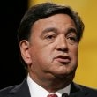
http://www.slobodan-milosevic.org/documents/srebrenica.pdf
http://www.analyst-network.com/profile.php?user_id=240
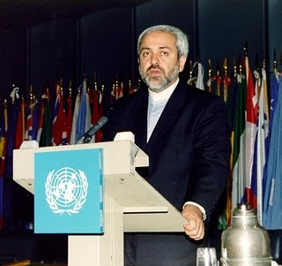
In fact Amir and I, notwithstanding our theological differences, got alone well. We’d often sit together before class acceding on a great many matters. In particular I remember us sitting one night and looking me square in the eye stating, “You know Jill, I will never believe that Jesus Christ is the Son of God.” I replied, “And I Amir will never convert to Islam.” Now that we got that out of the way, we both smiled at one another getting down to discussing real issues.
The Bosnian mission to the United Nations in New York City in 2001 was an extremely interesting place. Reflecting the rotating ethnic presidency existing in Bosnia unto present, Mission employees were comprised of people of completely bipolar ethnic, theological and politically ideological viewpoints.
The Head Ambassador of the Mission post 9-11 was then combating rumors of his soon becoming persona non grata in the United States for allegedly giving Osama Bin Laden a visa to travel through Bosnia illegally when previously stationed in Italy in 1993. There were also rumors he confessed to the United States Department of State of running international arms trades in connection with Al-Qaeda.
Darko Trifunovic confided in me that Al Qaeda Algerian militant Abu Mali, worked in the Bosnian mission to the UN in Manhattan 2001-2002 after the war under a Bosnian name, Safet Catovic. Darko Trifunovic and I worked together at the Bosnian Mission to the United Nations in NYC in 2001-2002 together and I, Jill Starr,l verify I used to work on Mali's computer at the Mission because it always was getting fouled up with computer viruses at his request.
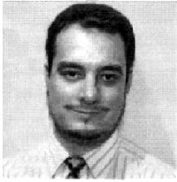
The number two man at the Bosnian mission, the First Ambassador was Serbian, Orthodox Christian and a doctor of medicine by university degree. The First Secretary of the Mission was my friend Darko, the Consulate department was headed by an ethnic Muslim lady from Bosnia, and there was an ethnic Croatian woman floating around with other various diplomats being of Roman Catholic Croatian descent. He became extremely suspicious of who Catovic really was because he spoke poor Bosnian. As a result, Trifunovic said he lost a job in the mission and moved to Belgrade.
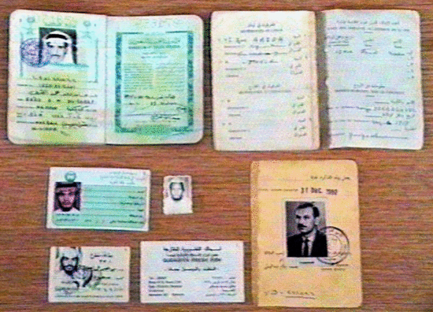
The number two man at the Bosnian mission, the First Ambassador was Serbian, Orthodox Christian and a doctor of medicine by university degree. The First Secretary of the Mission was my friend Darko, the Consulate department was headed by an ethnic Muslim lady from Bosnia, and there was an ethnic Croatian woman floating around with other various diplomats being of Roman Catholic Croatian descent.
My time at the Mission was primarily spent fixing Darko’s laptop computer which became daily infected with computer viruses he continually claimed emanated from other employees at the Mission who were allegedly trying to sabotage him because of his ethnic Serbian background. I vividly recall the constant bickering between all the mission employees; always accusing each other of committing war crimes and giving each other computer viruses making it virtually impossible for any of them to get along. The Croatian diplomat usually stayed to herself with her office door shut while the others present usually just listened to Led Zeppelin rock music on their personal CD-ROM players. They told me repeatedly they had nothing else to do with their time at the United Nations beyond an occasional meeting except for listening to music and playing computer games.
Sad and ironic was the few things I noticed all the Bosnian mission employees agreeing upon was their undying love for the rock band, Led Zeppelin.
A year had come and gone while I totally immersed myself into political inquiry as to just who was guilty of committing war crimes in the former Yugoslavia. My favorite subjects of inquiry included:
NATO, Kosovo & Metohia, Serbia, Montenegro, Bosnia and persons of interest such as Mladic and Hacim Thaci (Albanian Leader of the Kosovo Liberation Army). It was not enough for my merely taking in nightly news reports from CNN and other mainstream American media; to conduct an investigation for inquiry of social fact, I needed to go to Serbia and investigate for myself.
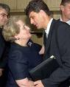
Only after seeing firsthand the goings on in the Balkans could I make a discriminate determination of guilty parties insofar as genocide there. After my fateful month long trip to Serbia and Montenegro in the fall 2002 I later concluded all warring parties involved had blood on their hands (Croats, Serbs, Muslims and the NATO); there are no innocents. But in 2001, neither my finances nor busy schedule allowed such a trip. Moreover, not speaking fluent Serbian coupled with the anti-American sentiment existing in Serbia then listed on the United States Department of State travel warning website caused going to there an unfeasible option. Hence, my life and studies went on as usual.
Several seasons went by and now it was spring 2001. Darko and his wife Bojana had time off which they spent visiting friends and family in Serbia for about two weeks. Because of this Darko was unable to function in full diplomatic capacity. In spring 2001 there was a preparatory commission meeting of plenipotentiaries to establish an international criminal court at the United Nations in New York City. Topics of the meeting included but were not limited to defining interstate acts of aggression, court financing etc.. Darko asked me if I would sit in for him at the meeting taking as many notes possible owing to the Law Projects Center possessing United Nations accreditation as a NGO (non governmental organization) with full observer status at the United Nations; I acceded.
Darko faxed me all necessary paperwork enabling my application attendance at this crucial meeting; I filled out the necessary forms and faxed them to the appropriate United Nations office for approval. It was an extremely exciting time for me. My close friend and colleague, Arnold Stark (History professor and Columbian University PhD) drove me into Manhattan walking me through the United Nations main entrance and security the day of attendance.
Professor Stark himself was an old foreign service man from way back in the day and he told me I never looked as professionally sharp as I did on that day; I wore a navy blue pin striped suit. I must admit, I looked good.
Only post attending that day did I truly understand the total lapse of security existing then at the United Nations in New York City. I say this owing to the social fact that the Law Projects Center was indeed registered as an United nations accredited NGO it is true. However, closed meetings of this sort meant attendance was strictly limited to head ambassadors of valid United Nations member state missions and non governmental organizations possessing observer status were not allowed.
Unto present, I’ve yet understood whereby I gained entrance into this privy closed meeting consisting of only United Nations ambassadors, but I did. Walking to the basement floor of the United Nations building that day, I merely wore a visitors badge given to me at the front desk in no manner indicating that I was an ambassador of a United Nations mission; least of all the Bosnia mission as required for entrance. Totally unaware I didn’t possess necessary credentials to enter the meeting, I walked confidently towards the entrance door and past the guard stationed outside it. The guard never bothering to examine the type of badge I wore around my neck simply said “good day Madame” and urged me into the meeting; it was just about time to begin.
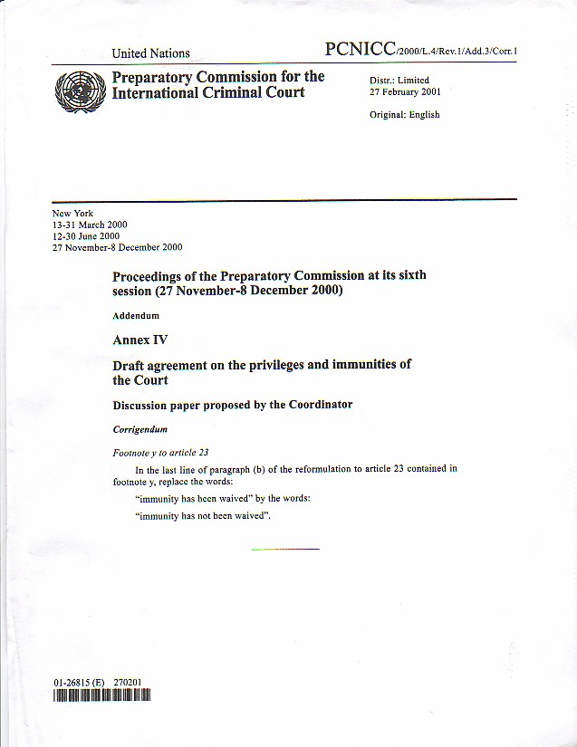
I immediately sensed something wrong once through the door past the guard. First, I was uncertain where to sit. Everyone else had a sign in front of their seat stating their country of origin. The Israeli ambassador sat in front of the Israel sign, the Spanish lady sat in front of the seat indicating she represented, Spain etc..
I looked fervently around the room seeing no seats indicating seats for United Nations observers anywhere. The last thing I wanted to do was to embarrass myself by taking the seat of an important ambassador; I noticed a couple of men seeming from some African state grabbing some meeting paperwork nearby so I inquired of them.
I told them I was a newbie and inquired where to sit and what I should do. With heavy African accents one of them said, “just grab a bunch of these papers, sit there and look like you are busy,” so I did. In fact, I grabbed as many extra copies as I could without looking conspicuous when noticing another peculiarity.
The meeting papers indicated they were for restricted for the eyes of state mission heads’ only (chief ambassadors of countries) and allowing other persons and/or United Nations employees to view them was a punishable offense. Uncertain what to do, and with the meeting beginning, I merely sat there stunned. My seat and the one the African gentleman next to me took seemed extras because they neglected having any indication regarding country origin in front of them on the table; I felt safe.
As totally immersed and interesting as I found the topics, the African ambassador seated found boring. I say this owing to noticing during the entire meeting he was merely doodling nonsensical pictures on some legal pad. I think that no one took more notes that day than me. I was especially interested in the interstate bickering about financing the international criminal court should and when it came about. Spain was particularly forceful in vocalizing its opinion that the countries giving the most monetary contributions to the court itself ought have more power over both its staffing and its innocent and guilty verdicts as well as judges appointed. My suspicions’ equally shared by scholars such as Noam Chomsky and former attorney general, Ramsey Clark were now fully justifiably confirmed. The court itself was a great travesty of justice and I was actually witnessing quarrels between countries insofar as controlling the courts judges and verdicts based on financial contributions rather than on law and true international justice.
The most shocking point of the meeting for me was when the Israeli ambassador admitted openly to the other attendees that Israel was indifferent to war crimes, crimes against humanity and would in no manner support any international structure limiting its’ ability for practicing war and peace against any other state and/or party it considered a threat to its national interest.
The ambassador representing the United States that day strongly and equally explicitly backed the Israeli position making clear American attendance was more for information gathering purposes and show than true concern for international law, world peace and social justice. When the meeting ended I slipped quickly out the front entrance of the United Nations; notes and papers in hand; I would read them in detail later that evening. When I attended these Preparatory Meetings at the end, the First Ambassador to the Bosnian Mission in NYC (The Serbian Doctor with glasses) came in but only stayed a short while as my witness to my being there. (Noteworthy of mentioning was this man being a doctor, when returning from a trip to the Former Yugoslavia once, was nice enough to bring me some alternative medicine (a liquid lemon mixture) back with him and gave it to me to help me withdrawal from all the American narcotics I was on). Darko insisted because he was worried about me overdosing on all my American medications). I always wondered if Doctor Radovan Karadzic had made the elixir himself for me--I will never truly know but it is not out of the question because Darko told me it was an "alternative medication and a liquid mixed with herbs and lemons sliced").
It must have amazed Darko upon returning from Serbia I actually gained entrance to the ICC preparatory closed meeting because within a week he invited me to the city to attend another important meeting at the United Nations comprised of diplomats from some very selective and prestigious NATO member states. I don’t recall the date but by his return fully I understood the definition of a closed meeting. Upon approaching the meeting door I became at once cognizant the meeting stated “closed meeting,” on the door. I did my best to point this fact out to Darko who told me to go in with him anyway; we did. Darko obviously thought because I gained entrance to the ICC meeting I ought not have in his absence, perhaps if I were with him, he covertly could gain access this closed NATO meeting; no dice. Upon entering the room, immediately some important looking man called him over and diplomatically informed him that “Serbia was not invited.” Darko pointed to me explaining that he was with the American lady but he was asked politely to leave; I followed him out the door embarrassed.
The following year was mundane. Filled with activities like shuttling back and forth to FDU for graduate school, fund raising for the Law Projects Center and co-authoring two book with Darko. The fateful day of 9/11 and the attacks by Al-Qaeda on the World Trade Center Towers in New York City changed my venue forever.
Post 9/11 Darko became a man on a personal mission seemingly unrelated to the Bosnian mission itself.
He told me it was the utmost importance to publicize the alleged fact that the head ambassador of the Bosnian mission was in his estimation involved with Al-Qaeda.
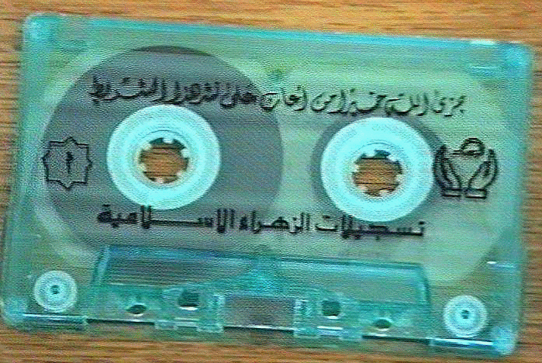
Darko had a seemingly ton of secret documentary evidence emanating from the ministry of internal affairs in Belgrade and Bosnia seeming true bolstering his allegations in my eyes then.

Asking me to fervently work on editing a book on which topic was meant for exposing the head ambassador of the Bosnian mission at that time; I acceded. The publication was later published by the Repubika Srpska information agency in Bosnia. The Serbian government in the Republika Srpska in Bosnia then was seriously pressing Darko for a fast publication so we stayed up many nights over his apartment in Forest Hills, New York working to do so. The book was entitled, ”The Bosnia Model of Al-Qaeda Terrorism. It can probably still be found and read online. Last time I checked it was posted on the website: http://www.analyst-network.com/profile.php?user_id=240.
Darko always told me I possessed full rights to this and other publications we worked on together. Although I edited and co-authoring the Al-Qaeda work, a few years back I noticed Darko removed my name on the inner front cover page as editor replacing it with the name of a Serbian editor. When questioned about it Darko told me he kept my name from being published because of the death threats and dangers to my life that he himself encountered because of its publication. I do vividly remember Darko receiving a great many death threats and threats towards his wife at the time, Bojana, so it is possible he was telling me the truth.
Even prior completing our work on the Al-Qaeda book together Darko was obsessed with manifesting the Bosnian Chief ambassador at the time as a terrorist. At the time I had no reason to doubt Darko’s word and assisted him in rabidly writing an open letter to all the United Nations member state missions exposing him as such. I surmise this is when Darko’s job at the United Nations as First Secretary of the Bosnian mission became jeopardized.
Today I surmise Darko’s employment at the United Nations genuinely became compromised owing not only to the inter-ethnic conflicts existing between him and the head ambassador then, a proud Muslim man, but also owing to the fact he forged birth certificates to acquire his position in the first place later becoming a social fact from the interior ministry in Bosnia. It was an emotional shock when Darko informed me a by summer 2001 that he lost his job and he and Bojana had to immediately return to Belgrade to work out the matter in court. This was also a great emotional blow to me also owing to the fact that I always possessed a crush on Darko and he knew it. This was a social fact I never publicly admitted previously to writing this book. I once even asked Darko if he wanted to have an affair with me but he declined stating he would never be unfaithful to his beautiful wife, Bojana. This left me in an extreme morally uncomfortable position because Bojana was my best friend. I continually told myself being attracted to her husband Darko was a non-option. Working so closely with him on an almost daily basis however made my attraction to him difficult to overcome.
I was also engaged to Professor Arnold Stark at the time and wore the ten thousand diamond ring he bought me on my finger. Arnold became increasingly jealous of Darko in time and eventually forbid me to work with him altogether. Notwithstanding, I continued working with Darko against Arnold’s wishes. This coupled with my trip to Serbia and Montenegro in 2002 eventually led to my breakup with Professor Stark and after almost an entire decade, my relationship with Arnold never fully recovered.
Darko tried keeping his job in diplomatic capacity at he UN as long as possible but the bipolar friction and hate existing between himself and the chief ambassador at the mission proved too much. The chief ambassador in contact with the Bosnian government at the time in Sarajevo eventually had Darko dismissed as first secretary of the mission. To the best of my recollection Darko was no longer receiving a monthly salary from Sarajevo by spring or summer 2002 (approximately).
I often came visiting Darko and Bojana’s apartment in Manhattan then situated on a side street within walking distance from the UN to help them out financially by buying them inexpensive dinners and such in Manhattan and chauffeuring them around (they did not own a car for the majority of their stay in the States).
In July 2002 as I remember the three of us spent many memorable moments going to the beaches outside the city and just spending time talking etc.. At the time and owing to my being in graduate school at FDU, I had plenty of extra money to burn owing my taking the maximum GSL student loans totaling about twenty thousand dollars a semester. Then one day that summer Darko informed me he and Bojana were only awaiting the Bosnian government to wire them a sum of five thousand dollars to pay off their American bills, last month rent and they would make a hasty exit back to Belgrade permanently. I was emotionally crushed.
Desperate not to lose contact with Darko because of my personal feelings towards him, I told him my summer classes at FDU were about to end August 2002 and although the fall semester was about to begin, I wanted to visit him in Serbia as soon as possible. Soon for me meant as soon as I received a check from the United States government for the total of that semesters’ student loan money in the amount of about ten thousand dollars.
Darko, hesitant at first soon gave in to my constant petitions to visit him. The day I brought them both to JFK to return to Serbia permanently, Bojana whispered something in Darko’s ear as we hugged saying our goodbyes all three of trying to hold back tears of parting and Darko looking me in the eye said something to the effect, “Jill, don’t worry as soon as you can afford it call me and we’ll arrange your visit.” Darko never could stand to see me cry which on many occasion I did owing to the loss of my two children and other personal challenges in my life. They turned and boarded their plane to Belgrade as I drove back to New Jersey.
Driving home I felt an odd combination of extreme sadness at the loss of my two best friends mixed with the cheerful prospect I would shortly be boarding a plane myself destined for Serbia and Montenegro by mid August 2002 when my student loan check arrived. Upon arriving home I immediately began making all necessary arrangements for my forthcoming trip.
The day following Darko ‘s departure, I bought a great many prepaid phone cards for the purpose of calling him owing to both my missing him and also my primarily wanting to began making all necessary arrangements facilitating my forthcoming visit from JFK to Beograd. I had countless questions such as: how much money will I need, how will I obtain a VISA being an American citizen with all the US State Department warnings against US citizenry traveling to the region, etc., etc., etc.. I had already obtained a valid United States passport many years ago which I always carried with me. I’ve always held the strong opinion that having a valid passport with you at all times is just a good idea. It enables one the necessary freedom to go to the airport and catch a plane going anywhere at anytime.
Darko told me that I need not worry about all the complicated VISA requirements listed on Serbian government website required of other Americans that he would handle everything. I was told merely to bring with me about five thousand United States dollars in cash spending money and it was a done deal. I went to buy some new suitcases and clothes for my trip in Wayne, New Jersey during the first two weeks in August 2002 in preparation. Packing was always a problem for me as Darko can attest to owing to my medically diagnosed attention deficit disorder. I had a difficult time deciding what to bring, so I tried to bring everything I thought I needed. The day of my departure my suitcases weighed way over the weight limit restrictions indicated by the airline.
Getting to JFK for departure in mid August 2002 proved to be an almost insurmountable task in and of itself owing to my heavy luggage and everyone I asked to drop me at the airport that day had strongly held views against my going.
Arnold Stark declined to bring me owing to his personal jealousies insofar as Darko and everyone else had one or another excuse rooted in the anti-American sentiment in Serbia at that time and danger involved.
Undeterred, I finally convinced Archbishop John LoBue, my priest and confessor at the Holy Name Orthodox Christian Church in West Milford, New Jersey to take me as far as the Port Authority in Manhattan; from there I took a bus to JFK managing myself.
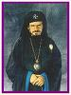
Post 9/11, JFK was supposedly safe beyond reproach insofar as security; this proved untrue. I had not traveled outside America in many years so I was unfamiliar with the new travel restrictions on such items as nail scissors etc., being illegal to bring onboard flights and carried several very sharp ones right passed JFK security inspection inside my purse on board out of my own ignorance of new flight rules. It was not until I arrived on my stopover in Paris, France that I was boarding onto a JAT (Yugoslav Air Travel) flight for Belgrade that the security officer of JAT told me that he had to confiscate the aforementioned items owing to new security precautions implemented post 9/11.
I informed him upon boarding my initial flight at JFK in New York, the security guards at the gate allowed me to board my flight to Paris carrying them in my purse. The JAT security employee merely shook his head in amazement mentioning something insofar as his seriously questioning American security in general stating that Jugosalv Air Travel obviously took airline and passenger security much more seriously.
I loved flying JAT! Not only was I completely satisfied the flight from Paris to Belgrade was many times more secure since JAT searched boarding passengers more thoroughly than JFK, the hospitality, food and drink was excellent. I say this owing to my being a well seasoned traveler having previously visited places such as Indonesia, Thailand and Hong Kong, etc.. It was extremely laid back on the flight. People moved around switching seats and chatting with good friends and the food was the best!
My favorite Serbian food and drink were served and all airline employees shoed me the highest level of hospitality. I was extremely pleased with the professionalism and service on JAT I later began an online blog about it on Yahoo360.
Upon my flight arriving in Beograd, all passengers left the plane in the usual manner except Serbian citizens were shuffled through customs quickly merely showing their passport. All others including myself were asked to relinquish their passports and told to wait an unspecified amount of time in a holding area at the airport. An airport security officer went around confiscating our passports afterward leaving us merely standing there not knowing what to expect next. No other announcements were made; I did the only thing possible I relinquished my passport to the Serbian custom official along with the other western Europeans and/or Americans (if there were any) which I surmised like myself were attempting to enter Serbia from countries that were NATO allies in the Kosovo war against Slobodan Milosevic in 1999. There must have been about twenty persons with me just waiting.
All types of nagging thoughts plagued me such as “perhaps my friends were correct that I ought not have taken this trip…was it really too dangerous to travel to Serbia with all the anti-American sentiment and what would happen if Serbian customs decided I was an American spy, kept my passport and I ended in some unknown jail and/or murdered….who would find me…what could I do about it etc., etc., etc..”
It seemed nearly an hour passed; me and the others were still standing there waiting. I didn’t want to seem scared or overly curious by asking either Serbian custom officials or anyone else waiting with me anything as to not cause unnecessary attention to myself. I also kept checking my watch wondering if Darko knew I was here waiting. I had hoped with his government connections he would at least inquire about my arrival since he told me he would pick me up. I drew comfort from the fact Darko was always very punctual picking up and bringing himself and others to airports.
On numerous occasions I gave him and others rides to and from them. These and other thoughts plagued me when suddenly I heard a voice on the loud speaker call my name, Jill Starr, asking me to go to a customs area to claim my passport.
I was the first person called so I don’t know what happened to the others standing there still waiting. I hurriedly went to obtain my passport and was told that I cleared; the guard pointed the direction for me to go claim my luggage. You have no idea what a relief that was!
I took in my new surroundings pleased that I made it into the country successfully. As a young child my father took me with him traveling the world when he was an active nuclear engineering consultant for Chas T Main, USAID and the IMF. I had been in Indonesia during the turmoil in East Timor so I was used to being in war zones surrounded by soldiers with guns. I was presently older, but still I found such travel extremely exciting more than dangerous and looked forward to enjoying the rest of my vacation with Darko and Bojana.
Making it to the baggage claim area successfully I was relieved seeing Darko standing their waiting for me. I was not fluent in Serbian and didn‘t want to publicize it by asking people questions in English manifesting I was American. I hurried towards him, giving him a large hug.
I was so glad to see Darko. I noticed upon my arrival at the Belgrade airport that there were many female police officers equipped with guns wearing short mini skirts and extremely high heels. I asked Darko how they apprehended criminals in such high heels and he replied smirking that they don’t have to run, they merely shot those not halting in the back and that stopped them.
Like a dream come true, there I was in Beograd Serbia against all odds and complaints from my friends. Darko helped me get my luggage to his friend’s vehicle telling me we could talk about everything I had to say later because we had to hurry.
Darko‘s friend, a German man living in Serbia for years and an important military employee of the Serbian government in a grayish older large SUV vehicle with what seemed a special license plate was impatiently waiting at the front gate of the airport for us.
Darko’s friend did not speak fluent English but he did speak fluent German and Serbian. Upon writing the first edition of my book I still wondered who this man really was because Darko pointed out to me proudly, while placing my luggage in the vehicle of his car, this car “specifically bore special Serbian military license plates;“ Darko pointed this out to me at the airport and I was greatly impressed to be in a Serb military vehicle.
The man picking me up at the Serbia, Beograd airport with Darko also referred to himself merely by a nickname. If my memory serves me correct he said to call him, “Babic or Babo” or something like that. “Babic” is not probably not 100% correct because my memory is kind of fuzzy on this. However, in coming across a BBC website with a photograph of Dragan Dabic, the male construction worker whom apparently Dr. Radovan Karadzic was assuming the identity of before he was arrested and transferred to the Hague in 2008; it does look about 90% correct in my memory that it was Mr. Dragan Dabic who picked me up at the Beograd Serbia airport that day. Even his glasses look the same and he told me he used to work as a military mercenary for the Serbs during war time and he was originally from Germany. Whoever it was, he was a relatively short man in height with salt and pepper hair.
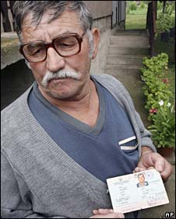
He said he worked in the military during “ the war/s” but (I forget which war he meant now), did say currently since all “the military business ended, he now worked construction and was building a second house himself outside of Beograd because his girlfriend was having a child. He told me he had several children but was not married. I saw him also my first night in Beograd at Bojana’s parents residence visiting as well as a day or so before I departed Beograd Serbia.
We drove all around the city of (Beograd) in his large van type SUV again; he gave me a large tour of the entire city area pointing out everything.
It seems almost surreal to me actually chance meeting so many fascinating and exciting people, I almost didn’t want to mention possibly meeting, Dragan Dabic, too in the second edition of my book.
But, I decided to write the best and most truthful testimonies of my memories as possible about my super cool vacation in Serbia & Montenegro in 2002.
Anyway, so Darko told whomever this man was to please help lift my luggage into the trunk in Serbian and he did. Darko always liked to brag and as usual he introduced me to his friend giving me the details of his being an important man in the Serbian military etc.. We went straight from the Beograd airport to the home of Bojana’s family in the suburbs of Belgrade and all became reacquainted. Whomever it was, he was a relatively short man in height with salt and pepper hair and muscular with that triangle type of nose.
Bojana and I hugged; she introduced me to her family (father, mother and brother who was a high school student in Beograd). Afterward, Darko showed me the room upstairs where I would sleep which was actually Bojana’s room also informing me of our three week itinerary; he had it all planned out. Darko told me we would all spend the night over Bojana’s house, the next day sleep at his apartment outside Beograd and later explained the next day we would stop at his father’s family’s house for dinner and leave from there making our way into Montenegro for a ten day vacation staying at his friend’s resort on Budva’s seaside coast. Along the way Darko told me he would give me the best tour I could ask for and he did. He showed me military installations and one of my favorite stops was the NATO bombed Chinese embassy which I stood in front of only several yards from.
My night at Bojana’s residence was wonderful. I was never showed as much love and hospitality as I did from her family. Although it was late in the evening (about 11pm Serbian time) when we arrived, Bojana’s mother, a wonderful woman, treated me as her own daughter. She insisted that Darko, Bojana and I enjoy what seemed a 10 course home cooked meal. She was still cooking while she served us a variety of cooked steaks, vegetables and pastries. And like many Italian families she insisted I tried and ate everything. To top the night off before bed Bojana and her father performed an accordion duet live in the kitchen for me. Apparently, Bojana and her father were professional accordion players and Bojana explained that her father’s employment consisted of playing nightly in a local bar. Thereafter, we went to bed with full stomachs.
The next morning we all enjoyed an equally exquisite breakfast. Bojana’s family had livestock in the backyard and her mother cooked us a fresh eggs and steak for breakfast like never before experienced. We said our parting goodbyes and left for Darko’s apartment in the hills of Beograd. We brought my suitcases in and upon entering I noticed there were lots of stray dogs around the apartment entrance. One in particular was very cute and Darko explained that the various residents fed it because it was so adorable. I found it interesting that so many old men were just hanging about the entrance to the apartment building drinking and just sitting there with seemingly nothing to do. They remained there throughout my entire trip.
Even when Ratko Mladic came to see me on my final day in Serbia in full military regalia giving me a parting gift (a book he inscribed to me entitled Serbija) while Darko took pictures of Mladic with his arm around me, the men remained there merely looking like old bums. Retrospectively, I wonder if they weren’t some watchmen and/or guards. Unto this day I always wondered what Darko did with those photos.
I was surprised what a very large apartment Darko owned. He showed me into his guest room and I unpacked my suitcases in just enough time to inform me I was to consolidate all my truly necessary items for Montenegro into one small bag that would reasonably fit into his trunk in the morning because he needed enough room for his and Bojana’s luggage also. He laughed at all the things I brought with me to Beograd telling me that I had no idea how to pack.
By the time I was done with that task Darko told me it was time to go meet some friends at a local café for coffee. It was late summer and the outside café’s in Beograd were the best !
We met up with a few friends in some restaurant in Beograd; there was about five of us sitting there just chatting and drinking coffee when I noticed an older gentleman sitting a few seats down with feathered salt and pepper colored hair not saying much except for an occasional laugh and nod at us. I wondered wherefore Darko a man about thirty would associate with such an older person, as for me being several years older than Darko, I thought to myself, what a cute guy. Then upon closer inspection, I realized it was doctor Radovan Karadzic. I knew he was a psychiatrist. By no means was this to be our last meeting. Throughout the time I spent in Serbia Darko met with Karadzic on many occasions in Beograd. The meetings were usually brief; only to exchange oral information and/or a few papers with Darko and whisper something or other in Darko‘s ear. He looks as the news media portrays him dressed in his gray wrinkled suit and tie and salt and pepper colored hair. A couple of times I saw him walk around Beograd in his infamous hat like in the photo posted below. Radovan was always a master of disguise because he was always dressed different every time I saw him (in Ostrog and many times in Beograd). He was a perfect gentleman all times I met him with Darko. After finishing our coffee, Darko said we ought leave and get a good nights rest because we had to leave early the next day for Montenegro.

The next morning we all got into Darko’s blue Audi (car) and left for his Father’s house. I remember arguing with Darko about wanting to bring lots of luggage with me and he replied I didn’t need all that stuff and I could only bring one normal sized bag with me and I had to leave the rest of my things at his apartment; I did. On the way to his father’s, Darko made a few important stops for the purpose of giving me the grand tour.
We only stopped briefly at some military installations; we didn’t get out of the car. We drove up to the gates and Darko pointed out, “look Jill, this is an important military facility.” Darko always sarcastically smirked as he pointed out these places to me. The only place we got out was in front of the bombed out Chinese embassy in Beograd. There were Serbian military officers in front of the embassy. I was amazed owing to I always had thought bombed out buildings were totally demolished. But standing in front of the Chinese embassy that was bombed by the NATO in 1999 taught me the definition of a “smart bomb.”
Only the portion of the building hosting the embassy employees on the upper level of the building itself was demolished and in particular the window where the Chinese embassy officials worked. I could see in the window and I even got a sad glimpse of the Victorian styled chair IT WAS PINK IN COLOR , merely sitting there empty in the bombed out window. I wondered who used to sit there and if they were dead or alive. No other parts of the building was seriously damaged. There were even flowers and trees still growing untouched in front of the building. I strongly believe that NATO knew exactly what they aimed at when they bombed the building.
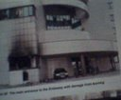
I brought a digital camera with me on my trip but upon returning to the United States, all the film Darko claimed to snap for me was returned by my local film developer as blank. I wondered if Darko told me the truth about snapping photos for me at all. Throughout my trip he insisted on taking all the photos I wanted claiming I take poor pictures.
It since crossed my mind he may have removed the film from my camera prior my departing Serbia so I could not take it back with me. One thing I am sure of is both Darko and Bojana refused having any photos taken of them throughout my entire stay. After leaving the scene at the Chinese embassy, we made our way to the home of Darko’s father driving through a beautiful park not dissimilar to Central Park in Manhattan along the way. I can’t be certain what park it was because I didn’t know the geographical area; we soon arrived at our destination.
Darko’s father lived in the most incredibly beautiful green hills in an area of Serbia existing somewhere between Beograd and Montenegro. Immediately upon entering and meeting his father, stepmother and grandmother who recently passed away, I felt part of the family. Although his family did not speak English, Darko and Bojana translated for me.
Darko’s grandmother was an extraordinarily warm and wise woman in whose presence I felt comfortable and happy the entire time. Before dinner there was the customary libation of grappa (a Serbian hard liquor of incredible potency). If only I could find grappa here in America. After another dinner that would give Manhattan’s top chefs a run for their money, Darko brought me upstairs into a guest room to take a nap.
I told him I was not tired but he insisted I nap saying we would be driving all night before reaching Montenegro and I need my rest. I must have slept an hour before he awakened me to say our parting goodbyes and begin our journey. I was extremely excited; Darko promised me a three week Adriatic holiday allowing me swimming privileges at every beach from Hercegovni to an area he said was only ten meters from Kosovo’s border. We couldn’t go into Kosovo Darko said because it was too dangerous. I knew Darko had been shot several times and almost killed in Kosovo previously so I didn’t push the issue. As a former lifeguard and avid swimmer, I couldn‘t wait for my vacation to start and Darko delivered it to me as promised.
The onset of our journey began at sunset; still adjusting to the time zone differential I dozed off in Darko’s backseat; for how long I’m uncertain. I dozed on and off until sunrise when we reached the Montenegrin border. I mean, there wasn’t much to see driving in the dark cover of night. The wider well lit highway we initially set out upon gradually narrowed as the highway lights became fewer. Eventually there were no highway lights at all. My body continuously shifted from one side of Darko’s backseat to the other making sleep difficult.

It was obvious the road we traversed was analogous to Pacific Coast Highway in California driving through Big Sur. It was mountainous, dangerously ridden with hairpin turns and no guardrails. In Montenegro, inexperienced travelers could almost mistake the scenery for Big Sur with the beautiful blue Adriatic sea hugging the bottoms of the cliffs we not so cautiously traveled. I asked Darko to slow down because he was driving like speed racer. He replied not to worry explaining he could drive these roads blindfolded he knew them well. I thought to myself, better safe than sorry buddy.
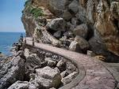
It is a good thing I had some prescription Xanax with me, I popped one, maybe two just to relax while simultaneously trying to hide this act from Darko since he hated drugs in general. He especially hated my taking the prescription medications my doctor gave me saying I didn’t need them, they were addicting and poison. He also strongly disdained cigarettes; Bojana smoked covertly.
The sun was just rising when Darko awakened me excitedly pointing out the tunnel we were driving through. I think he said at the other end we’d be entering Montenegro. Driving to the Budva Riviera in Montenegro we drove through some similar tunnels; the scenery was unbelievably breathtaking. There is no other place in the world I’d rather be than in Budva Montenegro and I recommend everyone vacation there. We were making our way to a seaside resort a friend of Darko owned. Still driving like speed racer around the hairpin turns and mountainous cliffs compromising the road, we finally arrived at our destination safely. I admit Darko is an excellent driver; his driving is reminiscent of agent 007 in James Bond movies.
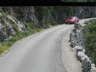
Because of the Kosovo war, there was not one functional ATM in either in Serbia and Montenegro. To be safe I split the five thousand dollars we had between Darko and I. I held onto half and he the other. One of my favorite stories I tell people of my trip is how I swam with my money throughout the trip; it made me feel secure always keeping some cash on me at all times; even when I was swimming a quarter mile out in the Adriatic sea. Darko told me not to; I did anyway.
Owing to that, the cash I held was often wet. One particular time we went to a bank in Montenegro.
The banks there are so remarkably careful of counterfeiting, they refused exchanging my United States dollars for Euros because my money was wet; the three of us returned to the hotel using my blow dryer to evaporate the dollar bills until dried. The three of us henceforth joked about this saying we laundered the money.
Upon arriving at the resort, Darko introduced me to his friend and we worked out the financial gratuities for our stay. We paid him eight hundred United States dollars for ten days; meals included. Unlike hotels in America, meals meant an extremely large home cooked breakfast consisting of large varieties of meat, coffee and juice. Lunch and dinner consisted of many course meals where main dishes consisted of either freshly caught seafood or meat. Our accommodation consisted of two medium sized rooms with separate entrances; one for myself and another for Darko and Bojana. To reach the beach we only needed to walk across the street and down a small path; one could see Italy at the other end of the horizon on a clear day. I was ecstatic loving to swim. Since Bojana didn’t swim, Darko couldn’t always accompany me to the beach so I‘d just walk to it myself for periodic swims throughout the day; August was a very hot month. Of any country I’ve visited, Serbia and Montenegro wins my top prize for fun, food, beauty and hospitality.
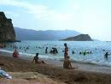
Everyone is friendly, warm, the atmosphere is relaxed and laid back and most persons speak some English owing to children learning English as a second language in school at a young age. Unfortunately, American school children do not grow up learning another language other than native English which leaves them I feel at an intellectual disadvantage.
Each day Darko took us to another beach for a day enjoying food, drink, music, perhaps some shopping and primarily, swimming. As long as I could swim for hours each day I was happy. By the time nighttime rolled in all of us were so tired each day we usually had dinner and retired early, except for one night. This just happened to be the one night of my entire vacation I was overly exhausted wanting to retire early at any cost. Inversely, this was the one evening both Darko and Bojana incredibly excited informed me to take a shower, dress and get ready for a big surprise.
When I asked Darko what this surprise was and its great importance being I was so tired; he merely insisted I go get ready for it. Darko was always very bossy in my estimation constantly telling us when to sleep, awakening Bojana and I up early, limiting our time before breakfast for dressing, blow drying our hair etc. which the two of us always complained about privately to each other. I always accepted this as part of his personality but this night it annoyed me to no end; I simply wanted sleep, surprise or not.
As usual I gave into to Darko’s demands by hurrying to my room, showering, changing, and preparing myself for a night out. If you’re a woman, you understand when you have a crush on someone as I did Darko, you usually give into his demands easily; so I did.
Upon changing, Dark and Bojana were waving me to hurry to the car; exhausted I got in and slammed the door. Less than ten minutes up the pitch black road Darko pulled the car over and we got out. Darko and Bojana said, “Hurry Jill look down there.” At the bottom of the cliffs was the most beautiful city of lights I’ve ever seen.

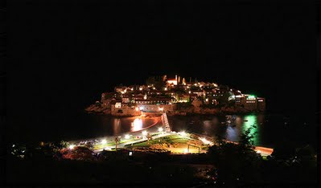
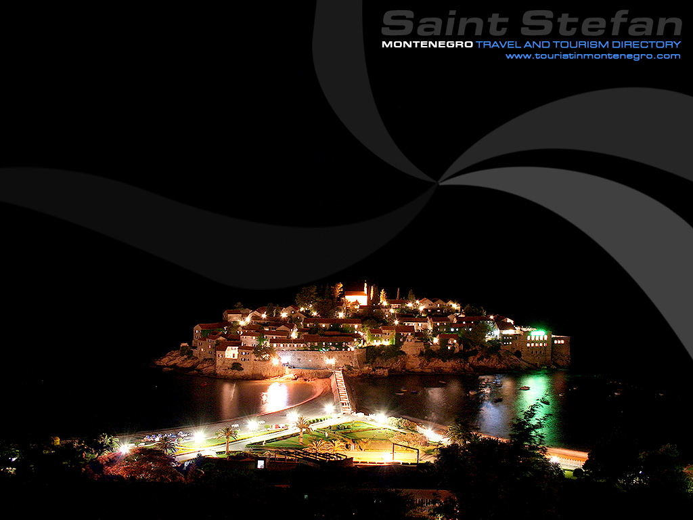
Darko said proudly, “this is Budva Jill, that‘s where we are going.” It was many times more beautiful that Paris or Manhattan at night and situated in a valley about a mile and a half wide forcing the Montenegrin peninsula farther out. It was a remarkably amazing sight, Budva itself being lit up with a wide variety of bright lights surrounded by an aura of pitch black. By this time Bojana started complaining to Darko to move his car in more because someone may come around the sharp turn in the darkness sideswiping it. Darko never worried much about illegal parking or his speed limit owing to whenever getting pulled over, he just made manifest to the officer his huge governmental badge and they let him go; the badge was at least three times larger than the usual American police officer badge and was gold in color.
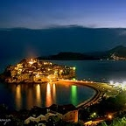
Darko became annoyed with Bojana’s complaints so we returned to the car, got in and descended about five minutes down the treacherously dark road into Budva and parked. I couldn’t believe it! It was like a dream, We walked down around Budva, Darko pointing out everything.
We stopped to have a drink at one of the many outdoor bar/café’s and listened to the live entertainment while we sipped our drinks. Then I went to buy another bathing suit at a small shop when Darko told me to follow him and Bojana into the most amazing bar I’ve ever seen, anywhere in the world. The bar itself was actually a small island rocky island; to reach it one had to walk underground below the Adriatic Sea maybe a little less than one quarter mile. Upon entering the bar it had many levels; all outside surrounded by the roaring nighttime surf of the sea and live entertainment.
I saw a few people illegally swimming and asked Darko if I could swim there too. He informed me the swimming was closed for the evening. We ordered drinks and sat there chilling for a while. On the walk back Darko showed me all the gambling casinos along the Riviera. It looked like anyone could get whatever they wanted in Budva if they had the correct amount of money with them.
Montenegro was to me akin to a luxurious playground for the ultra rich, famous as well as infamous. We then walked back via way of the tunnel, stopped at a small outdoor restaurant all ordering a type of delicious pancake we enjoyed by dipping it in chocolate syrup and drove back to the hotel to get some rest.
The next day Darko took merely us to another gorgeous beach. It was reminiscent of Greece. The water was sapphire blue, clear and warm. The beach itself was not large, but completely hidden by huge rocky cliffs. The three of us took a kind of small craft about a quarter of a mile out into the Adriatic; Darko and I jumped in for a swim. Bojana was partially nude sunbathing at the time on the boat and since she was unable to swim, Darko teased her by stealing her clothes, pretending not to give them back to her. She immediately became upset demanding Darko return her clothes; Darko soon complied with her demands. Thereafter, we ended the day with lunch and drinks. The following day was one of my vacation high points. We visited the Ostrog monastery.
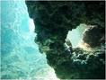
Driving to the Ostrog monastery was long, hot and boring. It lied somewhere deep beyond the Montenegrin coastline inland. We drove a long windy road without even so much as a store on it. After a couple of hours, Darko stopped for lunch at the only restaurant I noticed the entire trip. You’d think it would be small being situated in the middle of what I considered, “nowhere.” However, this was not the case.
There was actually a long line and tons of people there having lunch. I could only imagine like us they were on their way to visit Ostrog. The restaurant itself was classy and I can only liken it to seeing a luxurious restaurant in the middle of the Mohave desert. While I was visiting Ostrog monastery in Montenegro, Darko introduced me to a Serbian priest asking me if I wanted confession. The man looked almost verbatim to Karadzic in his monks getup. I mean the way the latest news photos of Karadzic in his monk getup looks. I only became cognizant of this recently since the photos of him since his arrest have been made publicly manifest.
In particular I remember the priest’s large darker curl on the top of this priest’s head like in the recent Karadzic photos; I wondered who would make their monks hair like that. This priest blessed me and told Darko in Serbian he could not hear my confession owing to his not understanding English well. He gave me a gift, a book about the monastery itself which I gave to Archbishop John LoBue in West Milford (my priest).
While visiting Ostrog, we venerated the holy relics leaving an offering of either food or money at the door leading to the holy relics; I can’t remember which now. Leaving, we looked around the gift shop, had coffee at the small Ostrog monastery café and Darko gave me a tour where the monks sleep and shower. Then we made the long drive back to the hotel. We had the usual dinner at which time Bojana was overcome with a terrible toothache. I told her I’d pay for the filling tomorrow; Darko knew a dentist 10 meter from Kosovo‘s border. Tomorrow we‘d swim there and have Bojana‘s tooth looked at. The town we went to the next day possessed an ethnic Albanian majority and organized crime was everywhere.

There is one more sough of significant event that occurred to me during my stay on the Budva coast. Darko was extremely insistent one friend of his “read my palm.” You guys just aren’t going to believe this, and I can’t be 100% certain because I only met this man who read my palm once, but I could swear it was Goran Hadzic (!) He was dressed like an old 1960s “hippie” with some old ripped blue jeans and old dirty T-shirttoo. He had long straggly hair but I( could never forget his tall drawn out thin pail nose and face. I did not want anyone to “read my palm” because as a staunch Orthodox Christian chick, it was against my religion to do have my palm read. But I gave in to Darko’s persistence for this man to “read my palm.” I really did not agree with much of which he told me, he took a long time to read my palm, like about for 45 minutes and I really wanted to go across the street swimming instead. But this man told me I had a “strong lifeline” on my palm. After that I never saw him again.
And I think he also gave me a business card; the same one that the BBS displays on their website of
“quantum energy practice/ alternative medicine,” and I definitely remember the care bearing three Greek Letters “Alpha or Delta” like on the card (like a triangle, that letter. in the internet news media. I lost it a long time ago.
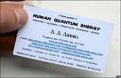
Before retiring for the evening I went for a small walk around the corner from the hotel to buy some snacks; there was a small store there. I never felt endangered at any time by anyone. During my stay in Montenegro I walked to the store myself almost daily buying drinks and other items I could enjoy privately in my room at night. I never noticed previously to that evening’s walk just how many persons actually were vacationing from Western Europe in Budva the fall 2002 like me.
After promenading to the store, upon returning to the hotel, a German man sitting outside the hotel and speaking in broken English introduced himself. When I told him that I was from New Jersey in the United States he became extremely interested and warmly said he is pleased I was able to enjoy the area. I replied, “I was tired and needed to retire.” Saying he understood he returned to his card game.
We had the usual dinner at which time Bojana was overcome with a terrible toothache. I told her I’d pay for the filling tomorrow; Darko knew a dentist ten meters from Kosovo‘s border. Tomorrow we‘d swim there and have Bojana‘s tooth looked at. The town we went to the next day possessed an ethnic Albanian majority and organized crime was everywhere.

We awoke early as to get Bojana to the dentist. This is actually where the Montenegrin bank had refused to exchange our money for Euros. Managing cash was difficult in Serbia and Montenegro owing to that the national currency in Serbia was still dinars and in Montenegro it was Euros. Most businessman preferred either Euros or American dollars, but one never knew which.
Upon parking, Darko led the way down the busy street towards the dentist who I remember being an ethnic Albanian man. Apparently, they visited this dentist previously and he was extremely friendly. Not at any time did any ethnic Albanians cause me, Darko or Bojana any problems because I was American and they were Serb. The dentist was going to take a while and since the bank would not exchange our American dollars for Euros, we could buy neither lunch nor anything else and we all possessed a ravenous hunger for lunch.
Ignoring Darko’s warnings not to go wondering myself, I left the dentist office under the pretense of going for a walk while Bojana had her dental work completed. Before Darko could catch me I was gone. I walked up the main street about one mile and began asking people in English where I could exchange United States currency for Euros. I came upon a well dressed ethnic Albanian high school student, a girl speaking perfect English who told me to walk up the street about another half mile and when I see men selling the cigarettes outside on a bridge table, ask them to do the deed; I did.
The girl asked me about America saying her greatest wish was to study in New York City one day. When I told her about my experience at the New School for Social Research, being dismissed for my anti NATO views on the Kosovo war she replied to me, “maybe she was wrong about wanting to study in Manhattan.”
I made my way to the table with about five ethnic Albanian men hanging about selling cigarettes and asked them in English if they could exchange money for me; they did. They were definitely organized crime. They took my wet cash, examined the bills, one man walked into an apartment building with my cash while I merely waited. He didn‘t rob me and returned with my Euros.
Surprisingly, I found everyone in both Serbia and Montenegro very honorable in their business dealings; even if those dealings are organized crime.
Upon receiving my Euros from the men, I walked away back to see if Bojana was through with the dentist; she was. I excitedly told Darko that I had successfully managed to exchange American dollars for Euros thinking he’d be pleased with me; he wasn’t. Darko was always very protective of me. Instead of commending me he immediately got very angry; scolding me he said exchanging money illegally in the streets of Montenegro was both illegal and dangerous. You can’t change the past so I diplomatically apologized and Darko soon forgot his anger I lieu of the fact that now we all could have lunch. Afterward, Darko brought us to a beautiful beach nearby. The majority of the sunbathers were ethnic Albanian and again no one harassed us based on our ethnicity. I tried pushing Darko into driving into Kosovo but he flatly refused. I found it interesting that the international news at this time was reporting that there were hundreds of thousands of homeless ethnic Albanians being ethnically cleansed to Albania, I did not see one ethnic Albanian or Roma homeless on the streets anywhere. All seemed normal only ten meters from the Kosovo border. After a day of swimming and partially nude sunbathing, we returned to the hotel.
Insofar as sequence of events, at this junction in time it was the last few days I spent in Montenegro; it’s difficult now to remember the exact timeline of events. In other words, I remember visiting Old Town and Podgorica also in Montenegro but uncertain of which locations we visited first.
During the last two days, Darko took me one day to Old Town in Montenegro for dinner; there we greatly enjoyed an expensive seafood meal after which we walked around. Darko got a parking ticket that night in Old Town and greatly complained about its five dollar fee; for some, five dollars is equal to an entire week pay in Serbia. I think I offered him the five dollars for the ticket feeling guilty because it was only for my benefit he parked there at all. Darko wanted to show me Old Town; he already knew what the beautiful cobble stone streets looked like.
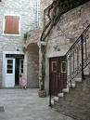
We also went to the Montenegrin capital, Podgorica. I really don’t remember much of Podgorica except for walking around the streets one night. Since we didn’t swim there so it wasn’t a high point for me. When our ten day stay in Montenegro was finished we all packed and returned the way we came in Darko’s car. The day before we left, Darko’s car required maintenance. We didn’t have enough cash on hand left to pay for the needed repairs so I called Arnold Stark, my fiancée in the states, asking him to please wire us five hundred dollars cash to Montenegro; he did. This is a fact that Arnold himself can verify being that he alone possesses the charge card receipt for wiring us the money through Western Union to a town not far from Budva. With Darko’s car repairs complete, we returned home for Beograd.
On the way back to Beograd we made two more important stops. One was Hercegovni where we met up with Darko’s cousin, a soon to be freshman college student and her friends. We had a couple of drinks, snapped some photos and Darko and I went for a quick swim in the sea. When it began to rain, we called it a day. The other stop was somewhere on the way back, where I have no idea. We pulled up to a large lake. Darko pulled his car onto a large ferry boat. There were some people on the ferry, but primarily soldiers from the Serbian military fully armed with guns; I felt 100% safe with them. Reaching the other side we drove around but I can’t remember much.
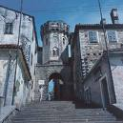
Returning on the ferry, we piled into Darko’s car and appeared at his apartment several hours later. We were all extremely exhausted and passed out as soon as possible in our separate rooms. Again, we walked past the same old men sitting in front of Darko’s apartment building seeming to do nothing; they waved at us. 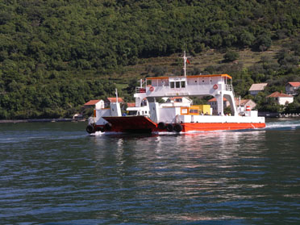
There were only two days left of my vacation at this point; I didn’t feel like doing much of anything. I’d come down with terrible stomach symptoms that began in Budva several days prior. This was probably owing to my ignoring Darko and Bojana’s warning not to drink tap water but only bottled; a lesson I ought have learned in Indonesia as a young girl.
We were all feeling tired and slightly under the weather merely wanting to recuperate. Notwithstanding, Darko, always an avid early morning riser, insisted we promenade Beograd’s renown indoor marketplace; an extremely large indoor flea market. We walked approximately an hour or two. I tried on several dresses before finally buying myself one; the type I can’t recall. Bojana bought herself Serbian brand makeup after which Darko informed us it’s time to leave.
Shopping was always boring to Darko unless it was for himself and during his stay in the United States Darko, Bojana and I hit many malls in New York and New Jersey such as Willow brook in Wayne, New Jersey. Other favorite stores we often visited were Daffy’s and Macy’s in Forest Hills, Queens, New York. I vividly remember the Republika Srpska diplomatic contact, Dejan Miletic,
to the Hague court in the Netherlands visiting. Me, Darko, he whose name was, Dan, Dejan Miletic (he gave me his busines card at the restaurant), in English, along with my daughter little Jill went to Macy’s at the Willow brook Mall in Wayne NJ allowing Dan to buy some gifts for his girlfriend back in Bosnia. Afterwards, we all enjoyed a wonderful lunch at Six Brothers Diner on Route 46 not to far from Montclair State University in New Jersey.
I can’t recall whether it was prior to vacationing in Budva or after, but close to the Beograd marketplace we visited the apartment of a Serbian basketball player and his disc jockey roommate (the walls of the apartment were covered with music CD’s from around the world). It was a very impressive CD collection. He said he often spent time in Manhattan studying when not having to compete.
I became increasingly sad during this time owing that in another day I’d again be saying goodbye to the man I loved, Darko; perhaps leaving Serbia forever. I wanted to stay and live in Beograd permanently but I had duties to my graduate studies at FDU in Hackensack, New Jersey. Had I known the university (FDU) would be soon dismissing me from their graduate program similarly to the New School for Social Research, I would have stayed in Beograd. I always told Darko my greatest desire was to live in Serbia and/or Montenegro. He always replied, “Jill you have your children and your studies now. After your children leave and you complete your graduate degree, then you can come reside in my country.” After the New School discriminated against me and I was recently receiving poor grades at FDU from professors that had formerly studied and graduated from the New School themselves, I felt I wanted to leave America thinking strongly I would have more academic freedom in Serbia. In fact during my entire Serbian trip, I discovered that myself and others freely spoke our minds on a myriad of subjects such as politics and theology without being badgered. This was my personal experience and I know allegedly not all Serb citizenry under previous regimes enjoyed such privilege.
Upon leaving the marketplace we enjoyed lunch at Darko’s which Bojana prepared; she was an excellent cook! My favorite Serbian food is Gibanica (I think this is the correct spelling). Gibanica is an exquisite main dish comprised of Greek filo dough, beef, cheese and sometimes spinach baked in layers similarly to Italian lasagna. After lunch, I decided to walk by myself to a local store for purchasing some items. I wanted some air alone outside not wanting Darko to see me cry. As aforementioned, I became extremely sad about returning to the United States the following day. When returning to the apartment, Darko suggested I nap a while so I did. I don’t remember what time it was when Darko knocked on my door waking me up. He informed me we were heading out soon to meet up with a friend of his named, Sharko, he wanted to introduce me. Darko made a few cell telephone calls and told me, he was calling his friend to meet us, and it would be about ten minutes and he said he would be there to meet us; sure enough, in about ten minutes, Ratko Mladic appeared walking towards me in the Boat restaurant!! Although Darko and I never discuss the incident anymore, I always assumed that Ratko and Darko were extremely close friends being that Darko had the personal cell telephone number of, Ratko Mladic. It was obvious to me at that time, on the way to meet, Ratko, Darko was speaking directly to Ratko on his cell phone; several times after short conversations on his cell, Darko, told me his friend said he was apologetic he was running a little late and would be here in a moment. Darko and Ratko must have become extremely close during the Bosnian war where later Darko confided to me that he was an army officer and worked in the Yugoslav Army / Air Force in some capacity. Darko recently told me, he was deeply hurt by the Bosnian War; he told me he had a daughter (I never knew this before 2010 when he told me he had a daughter), in which during the time he was apparently drafted into the army, he each day feared for his life, never knowing IF, he would ever return alive to see his daughter again.
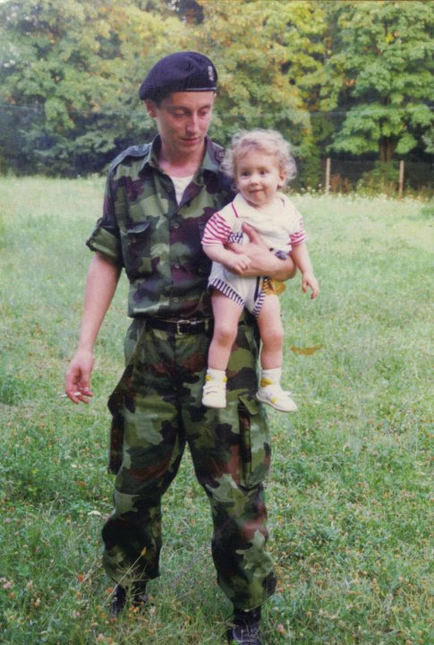
We left Darko’s apartment after dusk and about ten minutes later parked nearby a beautiful green park lined with trees along the river, somewhere in Beograd.
Uncertain exactly where we were going, I allowed Darko and Bojana to lead. Strolling down the narrow paved path a few feet wide cutting into a grassy hill, we headed directly towards a boat restaurant. Traversing the small shaky wooden bridge, we boarded. The place was empty; we were the only persons present besides one waitress.
We sat as follows; Darko and Bojana sat next to each other as in American restaurant booth’s and I sat alone across vis-à-vis. The boat itself was very luxurious resembling the interior of several large boats formerly owned by the late Aristotle Onassis. I have several books on Aristotle Onassis so I have seen photos of the interior of his large boats. The waitress came over to take our order; there was no menu. We verbally told her which libation we wanted; as she walked away Sharko came in. Sharko was Ratko Mladic; he wore old faded blue jeans sagging a bit around his waist.
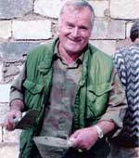
I wasn’t scared at all. When first shaking hands with Mr. Mladic I thought quietly, this couldn’t possibly be happening; but it in objective reality it was really happening. I’ve met many interesting people since graduating WPUNJ in New Jersey in 1997. I personally coined the term, extreme sociologist which I consider myself. I may not be rich, but achieved my scholarly goals notwithstanding either FDU or the New School for Social Research in Manhattan dismissing me from their graduate study programs. Since completing my undergraduate degree, I’ve desired to better understand our world by meeting with and talking with the world’s most controversial individuals. I believe in traveling to hidden and seemingly remote places around the world, partaking in local cultural activities for better understanding wherefore people behave as they do.
Mladic first seated himself across from me, in a separate chair the right of Darko. The waitress returned asking Mladic what he preferred to drink; he ordered expensive wine saying jokingly it was “two hundred dollars a bottle,” smiling. I was already drinking an alcoholic beverage of some sort I can’t remember along with Bojana. Darko rarely drank and sipped on something non-alcoholic. Extolling me to Mladic,
Darko explicated whereby I was the only American college student standing firm on grave issues pertaining to international justice insofar, the NATO and the former Yugoslavia.
Darko finished boasting about me to Mladic after which I in an extremely forceful forthright manner explained to Mladic my political views insofar as NATO’s breaching international law by launching military aggression against the former Yugoslavia, by bombing the Chinese embassy in Beograd, and, by purposely bombing other civilian targets in Serbia and Montenegro in 1999. I have a film of when NATO bombed a newborn baby hospital unit in Beograd; disgraceful!
Mladic seemed impressed with my viewpoints on war and peace. He was very warm friendly man; very relaxed and laid back. He smiled the entirety we were chilling out just enjoying each other’s company and drink. Hanging out with Mladic was no different than chilling with my other friends back in America. I ordered another drink with Darko’s disapproval. As aforementioned, Darko strongly disdained mind altering substances, always trying to help me overcome my craving for them. Then, Mladic opened his wallet, showing me photos of his wife and children; he had a very attractive family as portrayed in his wallet sized photos. I think he missed them, perhaps empathizing to the loss I felt being estranged with my own two children for so many agonizing years.
Like General Mladic, I possess very few photos of my own children. The photos Mladic had in his wallet were obviously very old because his children were still very young in the pictures. It was evident he didn’t have any recent photos of his family in many years; I sympathized with him in this respect. After reminiscing over family photos he got up sitting next to me across from Darko and Bojana. I let him hold my hand gently massaging it. He kissed my hand, inviting me to spend the night with him in the hills of Beograd; I declined on account of my strong Orthodox Christian theological convictions. I admit Mladic having warm inviting hands and greatly enjoying the manner in which he touched me. I did consider him an attractive man; yet as aforementioned I declined his invitation.
He accepted my decision although he did ask me again; again I replied the same answer. It was getting late and I was departing Serbia the following day in the afternoon. Still sipping my drink, I began urging Darko to return to America with me making a life for himself teaching as a professor at a university.
In retrospect, I now feel tremendous guilt and shame because of my advances towards Darko owing to Bojana my best friend sitting there with me vis-à-vis. Feeling a bit tipsy from drinking, Mladic continued making sexual advances towards urging me to go home with him. Darko laughed seemingly thinking Mladic’s advances towards me were cute stating, “go ahead Jill, spend the night with Sharko, it’s fine…Sharko‘s a good friend of mine…don‘t worry if you want to…I promise you’ll not miss your flight back to America tomorrow…“ I continued declining the advances and when it became obvious I wouldn’t change my mind, Darko said we had to leave because I had to finish packing for my flight and get a good nights sleep.
We all departed identically to boarding the boat restaurant, crossing the small narrow wooden bridge; Sharko/ Mladic departed with us. After exiting, Mladic and I stood in front of the boat restaurant for several minutes. I began crying because I loved Serbia not wanting to leave the next day. Mladic pulled me close to him and embracing me, he kissed both my cheeks. I kissed his cheeks also embracing him.
In examining photos online of the Topcider Serbian military barracks in Beograd recently, the photo scenes look identical to where I met Ratko that night. Even the photos of the trees, walkways and benches/Gazebo and river where we met look exactly the same. I remember the shape of the trees there that night even. The scene that night when we met looks very much identical as seen in the newly released Mladic home videos.
I wonder if Mladic did not have any security when he met me because Darko had brought me in the Topcider military barracks to meet Mladic that night; I believe he did. I would not have known the difference since it seemed merely a beautiful park.
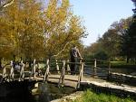
Darko and Bojana were walking ahead towards the car leaving me and Mladic alone. Knowing, I’d continue crying, I broke our embrace saying “goodbye.” Mladic promised to visit me the next day dressed in his full military uniform before I left Serbia. I didn’t want to part; but I did. I saw Darko and Bojana walking towards their car up the grassy hill and followed. I walked briskly catching up with them; I was exhausted and still had to finish packing back at Darko‘s apartment. Once more I turned and saw Mladic drive away in an old brown Mercedes Benz on its left front side. I was surprised to see it was scratched and slightly dented. Arriving back at Darko’s place, I completed preparations for departing the following day and fell fast asleep.
The next day I woke up around mid morning feeling depressed so I went for a walk to a local store picking up some things. Returning to Darko’s, we were standing outside his apartment discussing something when I turned seeing Mladic approaching me in full military regalia. We shook hands glad seeing each other. Of all photos I’ve seen online, Mladic never looked better than he did then.
His military uniform was clean, ironed and he wore every military metal ever earned it seemed to me. He was as honorably decorated as any of the American Joint Chief’s of Staff; even wearing his gold colored in sigma upon his green military cap. He had many gold colored metals hanging from his uniform on the left side by his chest. I was privileged to see him this way; I confess being impressed.
I was surprised to say the very least. Darko said to stand next to Mladic insisting on snapping some photos of the two of us. Mladic placed his arm around my shoulder and I his; we both smiled as Darko snapped some photos. When finished Mladic presented me with a gift. The book I posted online for you all to view, signing it to me under the alias name, Sharko thanking me for beautiful times spent together in Beograd. We embraced and he left as Darko interjected saying we had to hurry to the airport before I miss my flight.
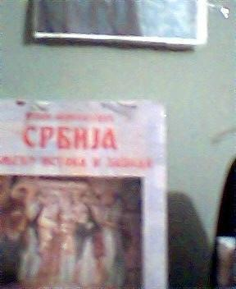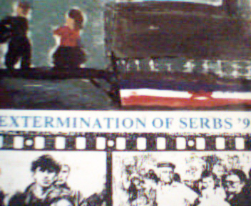
Darko’s German friend delivered me back to Beograd airport the same manner as picked up. There was little time, my flight was actually locking the gate and about to depart without me. Darko ran up to someone important showing his governmental badge as I recall, asking them to hold the flight until I board. There was hardly time for JAT to weigh my luggage; they did however inform me it weighed over the limit allowed. Darko said there was no time to be picky about what I was bringing back to the States ; I obeyed leaving one full suitcase behind with him as to not miss my flight. Quickly helped me through customs and the gate, I tried prolonging our goodbye. Darko didn’t want seeing him cry and urged me on as the Serbian flight attendant waved me to hurry. The gate was closed up and I had to run with my carry on to board the plane. One last time I turned briefly to see Darko; he tried hiding the tears swelling in his eyes as I.
I took my seat on the JAT flight back home to America. Upon reaching JFK my luggage was lost and it was delivered over the weekend to my home in Bloomingdale New Jersey. This is what it’s like to chill with the most ruthless men in the world. No biggie really. THE END
NOTES BY AUTHOR 2011
============================
(1) Later a few years after, Darko came to visit me for about one week, and stayed at my house in Bloomingdale, New Jersey. This was the trip where Darko and I, both drive down to meet United States Senator Tim Nicholson
(see my blog on terrorism when me and Darko met with Senator Nicholson (Republican) http://sites.google.com/site/jillstarrsite/the-law-projects-center-information-the-cia-us-department-of-state-ignored-that-could-have-prevented-the-9-11-terrorist-attacks-on-the-twin-towers-in-nyc in Washington D.C.). Darko stayed at Senator Nicholson's home and I in a local hotel nearby)...Darko at that time, gave me two friendly diplomatic presents from Serbia, thanking me again for all I have done for him and his life, personally over the years, and also for his country, Serbia and Republika Srpska. These were the gifts Darko gave to me below.
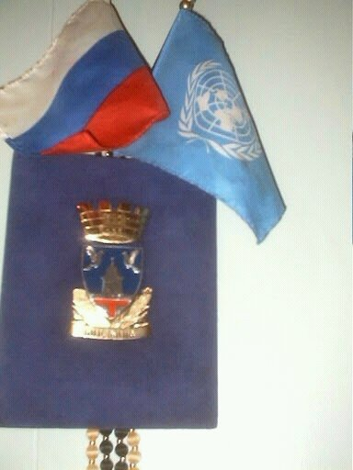

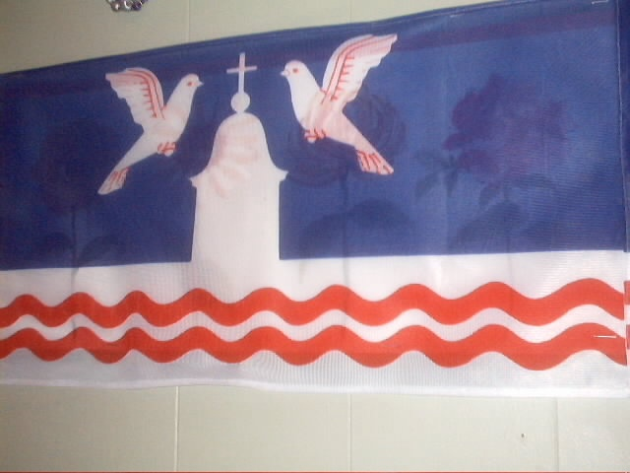
http://sites.google.com/site/jillstarrsite/jillstarrinternationalnews
http://members.fortunecity.com/lpca1/lpc.htm
(2) The only person's photo who is mentioned in my true story (this book), has always been, Professor Arnold Stark's. This is 0wing to his constant threatening me NOT to ever post his photo here. I am posting it now (threats OR not). He and I were engaged in 2001 when I traveled to Serbia. Owing to that trip, he considered me a traitor to both the United States, and him personally and broke out engagement to be married. He teaches at both Kean College and William Paterson Univesrity of New Jersey and we are still pesonally close friends and colleagues. He was just here the other day. He sent Darko Trifunovic , Bojana and I near Kosovo (by the Kosovo border) as stated in my book , cash for $500- to a Montenegro Western Union to fix Darko's car around the Kosovo border area. He tells me he still has his AMERICAN EXPRESS RECEIPT FOR THAT MONETARY TRANSACTION.
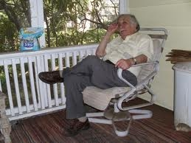

I might also add, of anyone accused of "war crimes" by the ICTY housed at the Hague in the Netherlands, only Mr. Arnold Stark has threatened me in any manner about my printing this true account of history as stated in this book I wrote. And for the sake of Radovan Karadzic, Ratko Mladic and ALL the Bosnian Serbs obtaining a FAIR TRIAL at the ICTY which I am telling you is impossible as I claim, I personally have heard and seen more curse words and violence in the local Bloomingdale New Jersey Bars then I have ever seen or heard in the presence of any Serb accused of genocide and/or war crimes by the ICTY, Prsoecutor Brammertz, and the Hague !
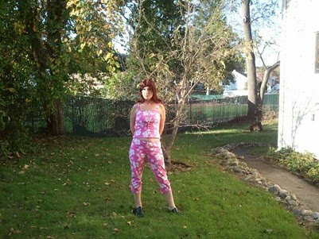
(3) This book was only made possible by a communication error between, Darko Trifunovic and myself. I would never want to publish matgerial making Darko (my friend) uncomfortable. Early in January 2009, I e-mailed, Darko, asking him if he minded me publishing this book. He never replied for several months. When he di dnot reply to such an important question, from my knowing Darko well over the years we have worked closely together, I merely published it, assuming it was alrlight according to, Darko. When he replied to me, several months after it gone viral online, it was too late for me to vanish all the posts it was online. So I decided to move forward and leave it. At first, Darko, was not happy with the book when we finally communicated about it. At first, Darko, said "Jill, I only introduced you too another high ranking officer named, Sharko, but not Mr, Mladic...I became EXTREMELY ANGRY with Darko, because he had always been forthright and never lied to me previously. I told him that what he told me was a bunch of BULLSHIT owing to the fact I could prove I met Mr., Mladic anyway because I had his signature on the books that he gave me, and his fingerprints etc..in my house and to stop his lying about the incident. Darko thentold me, he apologized and that "Just he did not want to be implicated in all this by the ICTY and he was not being harassed, he was not going to lose his job over the book and that yes, it is true that he introduced me to, Ratko Mladic that night we were in Beograd together in 2001. He said he would basically, live with it and it was true to me. We have not really discussed the matter since.
The original reason for my printing my book I told him was too shut down the ICTY and I needed this book to get the international community's attention, and, once I had that attention, they would have to investigate the proof that I possessed, that neither Radovan Karadzic, Ratko Mladic or any other person at the ICTY awaiting trial was going to receive a FAIR TRIAL. My intentions were always pure in writing this book andc I never did it for profit. I had always told, Darko, IF, andonly IF, I had it ever published and profited from it, I would give him half the proceeds, and also give the other 50% of profits to the Republika of Srpska to help them rebuild from the BOsnian War.
Law Projects Center Int’l [Beograd / New York]
Miss Jill Louise Starr [Director of LPC New York]
138-A Hamburg Tpk.,
Bloomingdale, N.J.
07403 U.S.A.
Lpcyu@optonline.net
To: All Interested Parties
Date: March 11th 2001
Subject: Int’l Criminal Court Preparatory Commission Meeting Report [Draft Documents on
Establishing a Permanent ICC]
March 1st – March 9th 2001
United Nations, N.Y.C.
Dear Friends and Colleagues,
In the true spirit of former United States President, Woodrow Wilson’s American Democratic
Ideals#, I hereby forward you draft documents from the recent United Nations meetings held
in New York City on establishing a permanent International Criminal Court.
I strongly believe, if all countries in our world will soon be submitting both themselves and
their citizenry to a new ICC establishment possessing exclusive international legal jurisdiction
over the entire world, that you should fully comprehend its meaning and raison d’etat.
Hence, I believe that all persons possessing a strong commitment to enhancing democracy,
internationally applying equitable social justice and peace for our perpetual human survival and for our posterity [without prejudice], should read these documents.
Respectfully Yours,
Miss Jill Louse Starr
PS: I probably have other documents I’ll have to check. Start reading these including a scanned photo image of the secret Richard Holbrook and Radovan Karadzic Immunity Agreement.
http://sites.google.com/site/jillstarrsite/what-it-s-like-to-chill-with-the-most-ruthless-men-in-the-world-ratko-mladic-and-radovan-karadzic-confessions-of-a-female-war-crimes-investigator
http://www.facebook.com/home.php#/jill.starr2?ref=profile
http://shops.half.ebay.com/raretofindreads
(MY RARE USED BOOK STORE ON HALF.COM/EBAY)
Jill Starr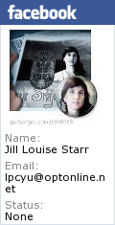Create your badge
Create your own Web Document
Print
Edit
A Web Document from Box.net

Attachments (0)

Comments
Jill Starr - Sep 23, 2010 7:28 AM - Remove
Watch for my my updated book edition.
I have many items to add to my book.
Jill Starr - Oct 21, 2010 12:08 PM - Remove
A few months ago, I swear that I received a telephone call from Ratko Mladic.
I never answer my telephone but on my caller ID was a Serbian country and City Code.
I immediately recognized the voice. They said they "Just wanted to tell me that they were O.K. with my book, and they kept telling me "they feel me." And, "they wanted to me to not worry about my writing my book."
They said, "they had not spoken to me in 10 years and, "they wanted to call me to tell me "everything was Ok."
JIll Starr NJ USA
Jill Starr - Oct 21, 2010 12:08 PM - Remove
I swear this is true
Jill Starr - Oct 21, 2010 12:13 PM - Remove
I will never forget his handsome voice (+)
Jill Starr - Oct 21, 2010 12:15 PM - Remove
I never told anyone about this before
Jill Starr - Nov 16, 2010 12:30 PM - Remove
Some U.S. generals came to Serbia as guests, to check how the Serbian Army has progressed and is it eligible to join NATO. After the official talks, one of the visiting generals approached a Serbian general and asked him: - "Well, tell me how was it to fight against the strongest army in the world?" The Serbian general answered- " No idea, colleague, we have never waged war against Russia!"

