Transcendental imaging and augmented reality



Figure 1: Black Trapezoid. Stott 2010.

In titling this picture ‘Black Trapezoid’ (fig.1), the artist puts forward an alternative future for Modern Art, in contrast to the declared abstraction of Malevich’s ‘Black Square’ painting. In Malevich’s work, the square really is there on the canvas; as such it is non-representational, outside of what it signifies. In the case of ‘Black Trapezoid’, the realism of the work of art is its capacity to represent something specific, in an illusionistic sense. Here, the black square is an accurate figurative representation of an imaginary black trapezoid, in an imaginary perspectival projective pictorial space. The 2D shape and the 2D picture plane are transcended, to become an illusion of something 3D. However, this transcendental state of illusion is virtually impossible to imagine, because our basic sense instinct is to successfully negotiate the visual/external world. The identification with the square as a 2D shape is very difficult to overcome, on a cognitive level.
‘Black Trapezoid’ serves as a useful icon for contemplating the fact that there is a transcendental image realm, the imaginary image realm where the trapezoid resides outside of ordinary cognitive access. The square is the ultimate 2D shape, it’s about as anti-‘3D spatial’ as one could get. As such, it is an ideal shape to utilize in any dialogue about defining a transcendental image realm because there is a quantifiable mental differentiation between a square and a trapezoid. The hurdle of the square is always there, but here there is something specific to think about, that lies beyond that hurdle, one knows what’s there and how it’s there, as such, one knows something a priori about the transcendental image realm.

However, the transcendental binds that necessarily keep us fully located in an external world; stop us imagining the transcendental. Up until now it’s been a case of ‘access denied’ to the transcendental image realm, on account of our ordinary cognitive limitations. Man’s sensory and cognitive capacities are logical points on a scale of possibility. Theoretically there are greater pictorial perceptions to be had, according to the vast amount of untapped pictorial data out there, of which we comprehend but a portion.
But to return to basic shape, we can’t ordinarily access a full cognition of a projected trapezoid when we look at a square and yet that pictorial potential resides within all shapes. Because that transcendental capacity is geometric it is ripe for exploration via computers, so man has the potential to extend his pictorial experience via an external articulation of transcendental perception. The square, as a basic example of a 2D shape, has the capacity to be articulated as a projective form. Surface and depth cues could be added to define its spatial location and orientation. This is how augmented reality can enact transcendental imaging and embody the image with pictorial form. There is a need for something to be added and there is a priori a way that something could be added, to augment the image, to facilitate a vision of transcendental imagery.
The tone of each part of the image could also be subtly altered to change the aerial perspective according to how the transcendental pictorial image space is mapped out. That is the further information that could be added to fully act out a transcendental conceptualization so that it might be seen.
The thing about a 2D shape is that there is actual pictorial acreage; there is a place where one can add extra visual information, so that an illusion of a transcendental embodiment can occur, as a representation of the place in virtual space, where the 3D modeling can exist, as a projection from the shape. On a pedantic level, one could argue that something was covering over something else, if something were added, though, in terms of augmenting an image. When something comes into focus, it is true, that there is a change to the image content. However, the change of image content which brought about the coming-to of focus; is generally considered to be an improvement in image quality. With transcendental imaging and augmented reality, the extra information will bring about an extra resolution, in the creation of transcendental pictorial form, in that sense; it will represent a coming-to, of perfect sense.
The most subtle and probably greatest model of augmented reality; is actually ubiquitous. When a short-sighted person puts on their glasses, they suddenly see another layer of detail that is intrinsic; it doesn’t conflict with the previous visual state, it enhances it. This shows that it is possible to pack another level of information into an image without losing sight of the original visual information. Bimber and Raskar (2005:2), define AR as a visual environment where the original visual information is ‘not completely suppressed, but instead plays a dominant role’. Their concept of art and AR is that of edutainment. They envisage that extra information will be projected onto works of art (fig.2), where the work of art itself is the information display. This article presumes the original image to be in a digitized format, so that all the additional information is added in the computer, to produce a hybrid digital artwork. This bypasses the issue of projector technology.
With transcendental imaging and augmented reality, a visual clarification will take place but it will be a false clarification, it will be an entirely computer-generated fiction and yet one that will a priori work, owing to its intrinsic placement, bringing into transcendental focus, perhaps, novel imagery from any amount of visual matter.
With a digital image, the file size can always be increased, to allow for extra visual information to be applied, so that a coming-to of transcendental focus can occur, on a pictorial level.

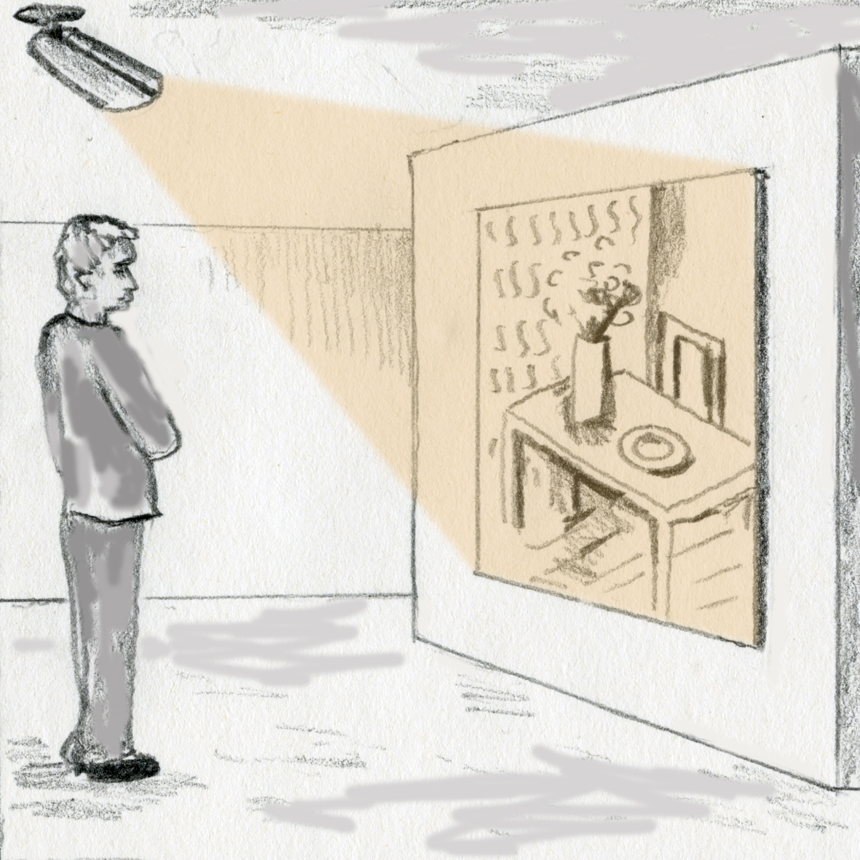

Figure 2: AR concept based on cover illustration

The technical word for the pictorial facility that allows ‘Black Trapezoid’ to function is ‘anamorphosis’. The Oxford Dictionary of English (2005:55), describes anamorphosis as:

A distorted projection or drawing which appears normal when viewed from a particular point or with a suitable mirror or lens-origin18th century: from Greek anamorphosis ‘transformation’ from ana-‘back again’ + morphosis ‘a shaping’ (from morphoun ‘to shape’, from morphe ‘shape, form’).

Another technical word relating to this is ‘isomorphic’, whose ODE definition is:

Corresponding or similar in form and relations.

‘Black Trapezoid’ is an anamorphic projection within the isomorphic mould of the 2D square. From a perpendicular perspective, the square and the trapezoid both have exactly the same shape. On one level they are the same thing but on another level they are completely different. This is how something can be something else, architectonically, at a pictorial level.
The current state of anamorphic art is exemplified in the extraordinary work of the artist Julian Beaver, who paints incredible anamorphic distortions on pavements, which, when viewed from a specific angle, make sense as 3D illusions of buildings, waterfalls, computers, or whatever takes the artist’s fancy. It works exactly the same way as the skull in Holbein’s famous painting ‘The Ambassadors’.
Holbein’s painting of ‘The Ambassadors’ has puzzled people for centuries with its enigmatic anamorphic skull at the feet of the diplomats. One sees the distorted shape, when looking straight at the picture, but from the side, the distortion makes sense as a skull.
There is a possibility that this pictorial trickery is actually an esoteric message about visual perception because it transmits knowledge of how transcendental imaging actually works. If one contemplates the everyday state of an image or indeed, image space, as if it were an anamorphic distortion that only looks like the ordinary world from the position of the viewer, then one can begin to intuit an otherness. The theory is a bit like ‘The Emperor’s New Clothes’, but instead it’s more like ‘The Clothes’ New Emperor’, where reality is to be viewed as if it were the clothing of another thing, an object that is usually invisible. That is the pictorial secret, to prise open the projective space of the transcendental image realm, the esoteric secret the ambassadors guard, using an array of worldly fixations as a distraction to the main event…and it comes straight through customs disguised as a novelty.
However there is a problem with that speculation because paradoxically, the thing that allows for Holbein’s anamorphic skull to work; is the very same thing that stops one from seeing the transcendental image realm of ‘Black Trapezoid’. Ordinarily one can’t see a square as a projected trapezoid but one can see a projected trapezoid as a square. Anamorphic art is seeing the projected trapezoid as a square, whereas transcendental imaging is seeing the trapezoid projected from the square, as a sort of anamorphosis in reverse, but back to the virtual perspective of ‘The Clothes’ New Emperor’. Ordinarily one can’t see ‘The Clothes’ New Emperor’; one sees the reality clothing of the external world, on surfaces and textures that are on the actual objects where they’re situated, not some other object. However, one can still see Holbein’s anamorphic skull because of one’s powerful identification with objects, so powerful that one can even recognize form and space on the flat surface of an image, or even on a surface at an angle, but the form and space recognizable from the external world, not imagery from the pictorial realm of virtual perspective, which is made up of objects we ordinarily don’t recognize and understand, owing to our necessary identification with the external world. One recognizes a square because it really looks like that, even when it’s a projected trapezoid. But one doesn’t recognize the trapezoid projected from a square because it doesn’t look like a trapezoid, it looks like a square. One ordinarily can’t see the transcendental image realm because it doesn’t look like what it is; it’s fully disguised as something else. Holbein’s anamorphic skull looks like a skull, so one recognizes it, even though one knows that it is an illusion.
Another reason one doesn’t recognize ‘The Clothes’ New Emperor’ is because the image of the ‘emperor’ is from an extremely peculiar angle of perspective, so peculiar in fact, that it looks like the ordinary external world, from the viewer’s position. As such, it is an incredibly far-fetched proposition to the mind. This is why it needs to be articulated with CGI, for us to have any real hope of understanding it. The transcendental object is almost impossible to imagine because ordinarily the viewer doesn’t know what a transcendental object is, or looks like, nor does the viewer fully know how any such form could materialize from pictorial matter.
Transcendental imaging with AR will also differ from anamorphic art in that it will be an integrated modeling of forms, working with the visual matter that is already there, as opposed to an arbitrary obliteration of one set of visual information with another. A transcendental way of looking at a Julian Beaver picture, for example, is to view the whole of the image or visual field as a representation not of a computer or a waterfall, but something else, the transcendental form, an unfamiliar object made up of the verisimilitude of a ‘computer’ illusion etc. a pavement, a shopping centre, or whatever was in the field of view. If one is seeing a waterfall image on a pavement, one is not seeing the transcendental object, which is an anamorphic projection from that and everything else, although this is not to deny the magic of the pictorial objects depicted. If one has never had a revelation of a transcendental object, though, it is highly unlikely that the viewer will be able to realize a transcendental vision, even with a priori knowledge of virtual perspective, for it is ordinarily beyond the mind’s capacity to bring into cognition. One really needs computer-generated help or very powerful drugs to access the transcendental image realm, or divine serendipity as a pictorial manifestation.

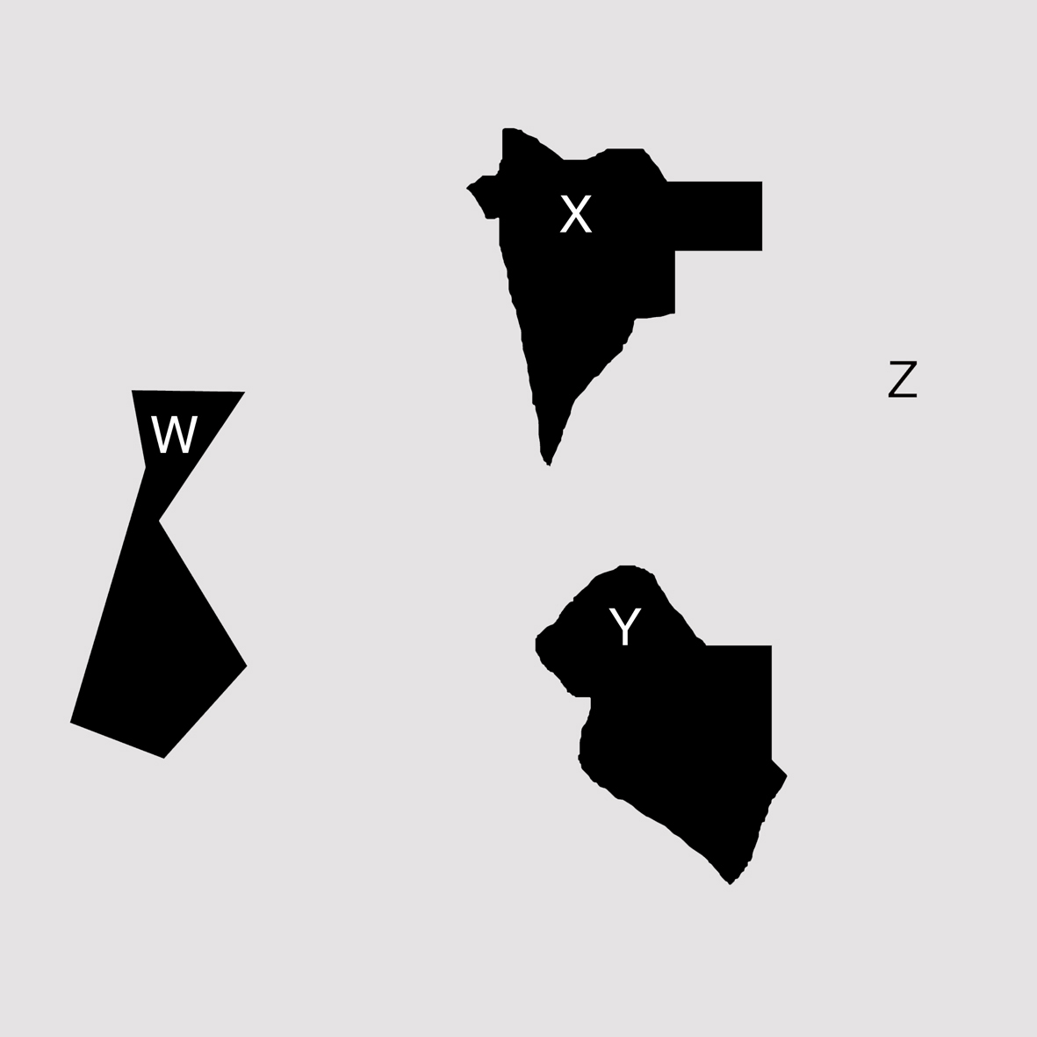

Figure 3: Black & White Polyhedron WXYZ. P.Stott 2010

Another aspect of how our cognitive faculties are limited, which augmented reality could help us extend, is how we perceive one shape’s relationship with another. If one looks at fig.3, there are four 2D shapes, W, X, Y and Z. Ordinarily one would comprehend it as three shapes, W, X and Y, surrounded by a space Z. If one imagines the three shapes to be 3D form silhouettes suspended in a 3D space, then one can make some interesting assumptions about them. If shape Y was ascribed spatial co-ordinates so that it represented something half a mile wide, that was three miles distant and one mile higher than shape X in the 3D illusion, then what that shape Y represented as a 3D form, would be entirely different than if, say, Y represented something that was only 10 metres wide and 50 metres below form X. In this way, one can see the potentiality of the image to represent a myriad of possible 3D pictorial relations that we, with our limited cognitive faculties, ordinarily have very little access to. Shapes W, X and Y appear to be more or less the same size and yet there are a plethora of possible scenarios where each shape/represented form could be near and small or big and far away. This is very difficult to imagine, in fact one can easily appreciate one’s cognitive limitations with the following exercise. Pick three objects in your visual field, say, a TV, some slippers, a magazine on a table. Can you see them as representing different 3D objects in differing relationships to each other, occupying different pictorial spaces, varying to extremes of near and far pictorial space? No, ordinarily not and yet ‘ceci n’est pas un pipe’ at an anamorphic projective pictorial level.
Let’s now imagine shape Z, not as the space in between, but as a form in between, where shapes X, Y and Z are now 3D component parts of a greater transcendental object, form WXYZ, as opposed to a collection of individual transcendental objects. As such, one can attempt to view all the visual matter as being entirely form-descriptive, so that the entire image makes full sense, as a representation of a form WXYZ, more likely a detail of it, though, according to the perfectly square picture edge, framing the subject matter. The conjecture is whether each shape has a value somewhere that relates to its neighbouring shape/shapes, in terms of it all making collective sense as something recognizable as a form. All the shapes have individual architectonic value, and at least one collective value, as a cohesive collection of shapes adding up to a something, a collection of forms in a single projective space. As such, there is a priori at least one transcendental order, in any collection of shapes, therefore it seems possible that random order might be able to be seen in any pictorial matter. This has profound implications, regarding the idea of visual chaos resolving to visual order, as a transcendental gestalt. It suggests that there is in actual fact, no abstraction at a transcendental level, because at that level everything is a representation of something. It is open to question, though, as to whether that transcendental order extends to the creation of a single form, from any amount of visual chaos. One of the peculiarities of perspective is that we usually obtain absolute spatial order from irregular shape information. How far that extends to all irregular shape information, is currently unknown.
Wittgenstein (1974:82), seems to believe that some sort of order can be created from any kind of visual chaos, when he writes that:

What does characterize the picture is that it can be described completely by a particular net with a particular size of mesh.

‘No More Random Shapes’ (fig.4) is an attempt at an artless arbitrary creation of shapes and lines; as such it is meaningless apart from the attendant personality of the thing-in-itself. The visual chaos is good or bad, aesthetically according to the personal tastes of the viewer. That is the ordinary interpretation of the shapes and lines, as a disparate mass of visual content. However, according to the rationale of transcendental imaging theory, there is something for the viewer to look for, beyond the chaotic front, a fully accurate 3D form representation. In terms of seeing something as something else, there is a specific differentiation between the notion of 2D chaos and 3D order, an order known a priori to exist. Any such vision is bound to be a revelation of something novel, a vision of something that one ordinarily can’t access, owing to the limited cognitive faculties of the mind.
Tart’s (1971:59), survey of Cannabis use, identifies specific areas where the experiencer’s visual cognition was extended beyond their ordinary parameters to reveal new visual realms, in fact in a response to a questionnaire up to 37 per cent of users indicated that they could:

See patterns, forms, figures, meaningful designs in visual material that does not have any particular form when I’m straight, that is just a meaningless series of shapes or lines when I’m straight.

Up to 30 per cent of users also said that when looking at pictures (1971:61):

They may acquire an element of visual depth, a third-dimensional aspect that they don’t have when straight.

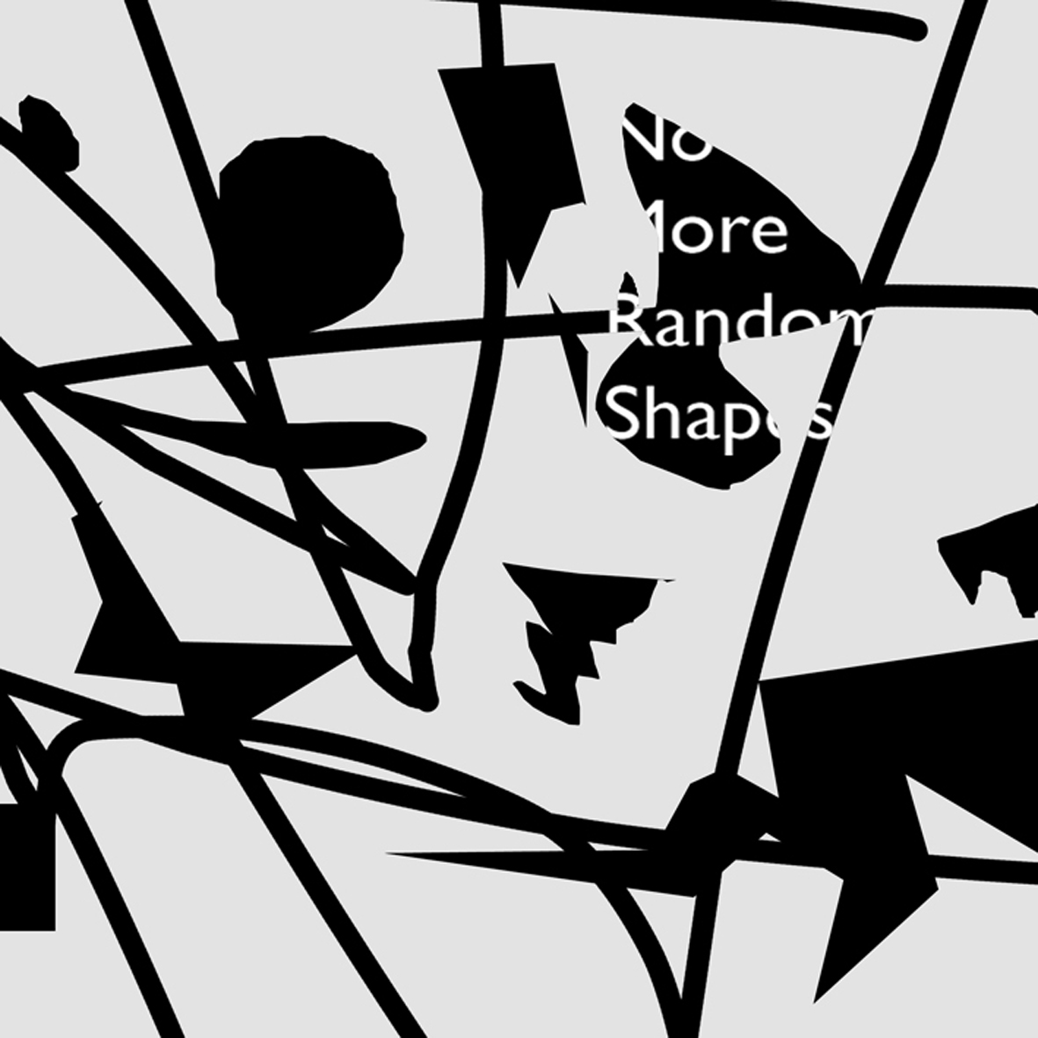

Figure 4: No More Random Shapes. P.Stott 2010

Both these witnessed phenomena sound like experiences that fit with having had a witness of transcendental order/imagery according to the rationale of transcendental imaging, which provides the theoretical basis for the potential manifestation of such visual phenomena i.e. if their object identification faculty were to alter and/or if they became aware of the world-as-image according to the phenomenological nature of visual sense mediation, then there was indeed a cognitive space, anamorphic projective space that was there to be intuited, a space full of architectonically perfect pictorial form, but experienced as a necessarily fleeting vision that was bound to disappear, leaving no trace of its presence.
Niederee and Heyer (2003:87), describe transcendental space as virtual space. This is their attempt to describe it:

Given a retinal image, there is an indefinite number of equivalent possible scenes (seen from a fixed viewing position) that could have generated this proximal stimulus. If perception is understood as generating a scene-representation then the question arises, which of these possible scenes should be represented. These scenes might be called the possible virtual spaces associated with the proximal stimulus.

Note here, that he refers to the ‘equivalent possible scenes’ as virtual spaces, not virtual forms.
Stephen Pinker (1997:215), has said that:

Any retinal image could have been produced by an infinite number of arrangements of three-dimensional surfaces in the world. Of course we don’t perceive infinite possibilities.

Wittgenstein wrote that (1974:69):

Whatever we see could be other than it is. Whatever we describe at all could be other than it is.

The consensus seems to be with visual content, that an image may represent lots of different 3D forms and spaces and that we generally see only one of these forms and spaces, the one that coincides with the external world. It is the latter form and space that seems to be the fundamental research interest, as opposed to the fictional possible worlds of the former.
Visual research in general seems to be directed by the question as to how we see the world as it is, how do we pick out the truth, from a well of possible fictions? With transcendental imaging, the question is, how can we articulate all the possible pictorial forms and spaces that we ordinarily can’t see?
One direction of research aims for everything but the truth and the other aims for nothing but the truth, yet the goals of each research direction remain elusive.
This seems to be the big discrepancy in visual research, this peculiar paradox. Instead, the only evident goal of the fact-finders is to extract a complete set of facts about a single 3D world of form and space, the one that was thought to be representative of the actual world. All the science research seems to be fact directed as such, rather than fiction directed, which is the goal of pictorial art. With exploring fiction, the aim is still to extract a complete set of facts about a single 3D world of form and space, only in this case, a fictitious set of facts creating a fictitious pictorial world. The task is to bring about an imaginary transcendental realm that looks like a real world, in order to bring about greater visions in art, greater than could ordinarily be made, owing to the limits of the mind. As such, using augmented reality to extend art through embodying images as transcendental form, could be the most important thing for image research, in terms of CGI and its development, in fact it could be the 2D art form of the 21st century, as the ultimate extension of the computer graphic revolution.
However, researchers into computer vision have come up against some serious problems in image analysis. NASA’s Institute of Advanced Concepts have a research group called 2020 that is trying to extract 3D facts from 2D images. It’s called the 2020 Research Group because they reckon it will take till 2020 just to work out one strand of the mathematical computation. One of the big problems is distinguishing between chiaroscuro and local colour. Marr has written (1982:43):

The illumination of a scene can only rarely be described in simple terms: Diffuse illumination, reflections, multiple light sources (only some of which are visible) create very complex illumination conditions, which will probably never be solved analytically.

Another problem has been trying to separate objects out from one another. Marr writes (1982:270):

What is an object and what makes it so special that it should be recoverable as a region in an image? Is a nose an object? Is a head one? Is it still one if it is attached to a body? What about a man on horseback? These questions show that the difficulties in trying to formulate what should be recovered as a region from an image are so great as to amount almost to philosophical problems. There really is no answer to them-all these things can be an object if you want to think of them that way, or they can be part of a larger object (my italics).

Yet another problem is edge detection (Marr)(1982:16):

Edges that are of critical importance from a three-dimensional point of view often cannot be found at all by looking at the intensity changes in an image. Any kind of textured image gives a multitude of noisy edge segments; variations in reflectance and illumination cause no end of trouble and even if an edge has clear existence at one point, it is likely as not to fade out quite soon, appearing only in patches along its length in the image. The common and almost despairing feeling of the early investigators like B.K.P. Horn and T.O. Binford was that practically anything could happen in an image and furthermore that practically everything did.

All these problems are connected with trying to extract facts about the real world, from images, but with transcendental imaging, what are problems to the fact-finders, could be doorways to new imagery, for those that want to explore fiction. This comes back to the question of what can be created from what. The first point, with respect to this, is that there is only a certain amount of constructive information in a 2D shape; for example, it might be very difficult to fully model a Maserati, simply from its silhouette. As such, there may only be limited possibilities with which to reconstruct any human witness of transcendental form manifesting, upon looking at images or across the visual field. On the other hand, there are a plethora of possibilities inherent not only in each shape, but in all conglomerations of shape, and the computer has vast capacities to apply to constructing transcendental image realms out of this visual matter, way beyond ordinary access.
The second point is that, from empirical witness of transcendental imagery resolving, the forms are very specific. They are as much a recognizable object, as a Ford Cortina or a Windsor chair, but unfortunately the visions last for only a fraction of a second, hence the need for computers to realize the vision. Any such specific pictorial forms, may be made up of geometries that are very difficult to locate. Also, not all assigned projective geometries may be of visual interest, outside of their interest, as a variation of projective data. This comes back to the question of meaning, regarding the transcendental image realm. If one has never had a transcendental revelation, then one would ordinarily presume that all other possible interpretations of an image represent nothing at all, but visual noise; that there was no ‘emperor’ to be seen. This is the difficulty in convincing others that transcendental imaging with augmented reality; is actually a worthwhile direction of research.
The third point; is that the pictorial outcome is likely to be largely dependent on the quality of the digital surface information used to augment the image; in terms of whatever scale and orientation cues need to be added, in order for the image to make full sense-as-form, at a transcendental level, to the human eye. However, even with the greatest of augmentations, certain augmented images may still be difficult to read, according to the power of the identification with whatever is ordinarily there. The poignancy and subtlety between the original image and its augmentation; may be critical to the success of the digital creation.
Transcendental imaging with AR has yet to happen though, the pictorial realm of transcendental form; remains to be fully articulated. Augmented reality-as-art is still embryonic.
Because of this, I have attempted to define a computational model of transcendental imaging with AR. This is basically an outline, in twelve points, of how a transcendental image realm might be created from 2D shape information, using virtual perspective. This is how I think augmented reality can work, to extend art. This computational model can also be used as a cognitive framework for looking at images with the human eye. The points are described in such a way, so that transcendental imaging and AR theory can be intellectually accessible to all. No actual algorithms to make the thing work; have been described. I’ve endeavoured to think of every possible permutation, regarding 2D shapes in an image. I have written these in the form of a series of claims, which derive from a patent application for an artificial imagination. I have also identified seven other areas for further research that are not covered by the claims. The claims and the points not covered by the claims are as follows:

The claims

1. A 3D visualization method for computers where a 2D shape has anamorphic projective spatial values ascribed to it so that a 3D mesh can be attached to the projected shape at the points on the projection where the anamorphic projective spatial values have thus been ascribed.
2. A 3D visualization method for computers as in claim 1 where the initial 3D mesh attachment does not transgress the 2D shape on the picture plane.
3. A 3D visualization method for computers as in the above claims where the 3D mesh may differ in form according to differing spatial values ascribed to the 2D shape.
4. A 3D visualization method for computers as in the above claims where various different mesh formation images may be put together in an image sequence to create an animation.
5. A 3D visualization method for computers as in the above claims where the edge of the 2D shape is entirely spatially coordinated with the adjacent shape or shapes along the entire edge of the shape.
6. A 3D visualization method for computers as in the above claims where the edge of the 2D shape shares spatial co-ordinates with the adjoining shape or shapes, only at specific points or lengths along the shape edge.
7. A 3D visualization method for computers as in the above claims where the edge of the 2D shape is entirely independent from any neighbouring shape or shapes.
8. A 3D visualization method for computers as in the above claims where an image contains an amalgam of shape relationships according to claims 6 and 7 combined together or claims 5, 6 and 7 combined together or claims 5 and 7 combined together.
9. A 3D visualization method for computers as in the above claims where the 3D mesh is planar, as if representing a planar surface in space, or that it is volumetrically convex or concave or a mixture of convexity and concavity.
10. A 3D visualization method for computers as in the above claims where the 2D shape/shapes is/are considered to be made up of a single line or a series of interconnecting lines that either share spatial co-ordinates where they connect or where they do not share spatial co-ordinates at the point where they appear to connect to form the 2D shape/shapes. NB. This claim is to cover the issue of false attachment.
11. A 3D visualization method for computers as in the above claims where if the image is made up of pixels of whatever shape or some other base unit of whatever shape, the above claims are valid all the way down to the base unit.
12. A 3D visualization method for computers as in the above claims where all the 2D shapes and all anamorphic projective values ascribed, are representations of a single object or a detail of a single object or a number of objects in whatever arrangement or detail.

Things not covered by the claims

1. The claims do not explain where to get the projective values. They only describe the ways projective form could exist.
2. The claims do not explain how an image, such as a photograph, can be broken down into the component parts to which the claims can be applied, although, of course, digital images are already broken down into pixels.
3. The claims do not explain any relationship anamorphic projective 3D modeling might have with the future development of stereoscopy, holography, 3D movies or VR.
4. The claims do not explain what to put on the 3D mesh i.e. how to computer-generate surface textures to provide the necessary visual (spatial orientation and spatial depth) cues in order for the image to be read architectonically, at a transcendental pictorial level.
5. The claims to not explain how to integrate the computer-generated surface textures, with the colour or tone of the original shape. NB. Bimber and Raskar (2005:255), refer to radiometric compensation, in relation to projected extra information, as a process whereby the original pigments of the image to be augmented, need to be neutralized in order for the new information to register effectively.
6. The claims don’t concern themselves with the actual structure of the 3D mesh.
7. The claims don’t concern themselves with the application of aerial perspective.

If transcendental imaging with AR (transcendental CGI) can be developed, then we might be able to explore the fundamental mysteries of art, for example I think that modernist artworks intuitively function as a chaotic foil with which to differentiate the otherness of the all-perfect nature of ‘God’. I think that this is how modernist artworks function in terms of the art working, where there is a differentiation between the ‘out of perspective’ nature of visual ‘chaos’ and its potential transcendental resolution to an all-encompassing greater perspectival order. I think that this might also be the case, with medieval art and early (and later) church interiors. Willats has written (2003:132):

The anomalies that are so characteristic of Byzantine mosaics are not ‘mistakes’ but may have served quite specific theological purposes. Orthodox paintings and mosaics were not intended to look optically realistic; rather, they were intended to depict a spiritual world, as opposed to a material world of the senses. Moreover, the flattening of the pictorial space that resulted from the use of such anomalous devices as inverted perspective and false attachment drew attention to the picture as a physical object so that the union of the depicted spiritual world and its material support provided a metaphor for the incarnation.

The specific pictorial function of such art as early church interiors; may not only be metaphorical, but also practical, as an intuitive vehicle for secretly and yet overtly providing a revelation of the transcendental imagery of the pictorial dimension where everything makes sense, made out of images of Jesus and angels etc. sense as a representation of the greater transcendental object. Like ‘No More Random Shapes’, there is a differentiation between the ‘out of perspective’ appearance of an early church interior, with all its painted decoration, and the perfection of the immaterial holistic perspectival resolution to a greater ‘God’, a god inevitably just out of reach of the ordinary viewer, in an ever-impending state of becoming. Nevertheless, the differentiation provides the cognitive space for a revelation of a transcendental embodiment, as an ultimate gestalt. The viewer might have an experience of everything making sense as transcendental form, at any moment, because of the ubiquitous possibility of anamorphic projective spatial extension.
It may also be the same with such things as cubist art, where the aesthetic structure underpinning the radical cohesion of the various visual matter, theoretically makes perfect perspectival sense, at a transcendental level, only instead of it being an image of tables and guitars and bottles, in a confused order, it is an image of a greater transcendental form, made up of the verisimilitude of bottles and tables etc. That is how the puzzle is solved, where the seeming disorder functions as a catapult, so that transcendental visions can be obtained out of an overseeing resolution to the order of perspective. The buzz is the resolution, the satisfaction of the puzzle of the mess, resolving to a ‘higher’ order, out of the seeming chaos or at least, giving the viewer optimism in terms of an impending resolution, as a visual tease. That is the work of art in action, performing its pictorial function for the viewer, a pictorial function so valuable, as to be worth millions of pounds, according to the value of the Modern Masters.
Various people have attempted to describe some sort of pictorial ‘higher order’, the following descriptions, I think, are probably intuitive descriptions of a greater transcendental object, existing in transcendental pictorial space. Golding writes that (2000:62):

Concepts of the fourth dimension differed, but all of its advocates agreed that it represented a space outside sensory perception and that it reversed the dialogue as to what was real and unreal, or logical and illogical, in our perception of the three-dimensional universe around us, which is in fact illusory.

Is this not a description of the actual pictorial space that resides outside of ordinary sensory perception, transcendental pictorial space? There seems to be something out there (or in there) that has been witnessed by a lot of people, something that is at the core of art. There is in fact, something out (in) there; it is the transcendental image realm. If one has a transcendental visual experience, though, it is probably not a manifestation magically appearing externally across the visual field, but an inner transfiguration of the sense information, as a modification of the external world, in consciousness. It was consciousness, for it being an internal image of the external world, not the external world itself, consciousness of something seen as something else. There’s always a simultaneous representation of at least two things; the thing being looked at and the thing doing the looking, both of them melded together, as image. How does that apply to art, in terms of augmented reality, though? There will be the original image and a perception of it-as, melded together as one.
The Hindu, an online Indian newspaper page, specifically entitled as ‘The transcendental form’ (2008), says that there are in existence, scriptures that:

Attempt to describe the cosmic form of the Lord to emphasize the Supreme Being’s omniscience, omnipotence and omnipresence.

It says that the transcendental form is:

Beyond all human cognizance, transcending all measures and subsuming movable and immovable objects.

Ecco writes of Bruno’s cosmological vision (1995:132):

The master idea of an infinite number of worlds was compounded with the notion that every earthly object can also serve as the Platonic shade of the other ideal aspects of the universe. Thus every object exists not only in itself but also as a possible sign, deferral, image, emblem, hieroglyph of something else.

These descriptions seem to fit with the concept of a greater transcendental object, which subsumes everything into it, where every part of the image field plays a pictorial role as a representation of a component part of a greater object. As such, each object obtains a new meaning, at a transcendental level.
With regard to transcendental imaging and augmented reality, however, all we have are pre-history signifiers, such as mirror imaging and projection/superimposition techniques, which intuitively aim at facilitating transcendental imagery. Mirror images reveal the pictorial possibility inherent in visual language and suggest the well of pictorial potential inherent in all visual matter. They are not however, the apotheosis of creation, regarding that well of potentiality. What they do is reveal the visual potential of visual language outside of the ordinary cognitive identification with scene and objects, recognized out of the overall fabric of the visual field, for example the spaces in between forms in the mirrored image, become as important in the pictorial structure of the mirror image, as the forms themselves. The mirror image technique aims to reveal the pictorial image content within each part of the image; it shows the disparate parts to be of equal visual value, as visual language components of a greater pictorial structure. A kaleidoscope, of course, performs this function admirably, as everything is turned to pattern.
However if one returns to the source image of a kaleidoscopic picture and one looks for a transcendental pictorial form, it would not be seen to be the flat symmetrical

)(
) 0 0 (
)(

pattern-type structure of the mirror-image. Its other self would be something else, for example if one were to take a photograph of a leaf on a pavement, the transcendental form that might manifest from that visual data, would not be that leaf repeated in a mirrored pattern, it would be an intrinsic transformation of the leaf itself, where it is situated in the image. There were no multiple mirrored leaf forms around the leaf on the pavement when the photograph was taken; the transcendental transcended what was there, where it was. Similarly with projection/superimposition, the transcendental augmentation of the leaf and pavement would not be a translucent fog of information and counter-information; it would be the concreteness of the original visual information and more some, as an extra resolution intrinsically placed.
The greater transcendental object is also ubiquitously and intuitively sought after in cinematography, for example the blending of one scene with another through transparency and superimposition, as one scene fades to another, or with projection, like the opening title sequence to the James Bond film ‘Goldfinger’, which features a gold-painted female model in a black space, lit entirely by imagery from the film, projected onto the female form.
I’ve listed eight (the list is not exhaustive) other methods that aim unwittingly or otherwise, to facilitate transcendental pictorial imagery. They are as follows:

1. The blending of foreground and background, so that false attachments may occur, thus creating novel interaction between various visual matter.
2. Through the use of chiaroscuro to reduce things to ‘abstraction’, as in the film ‘Girl with a Pearl Earring’ as an example of an exposition of this now ubiquitous technique, previously skillfully employed by the likes of Caravaggio.
3. Through ‘unorthodox’ camera angles that aim to mimic the peculiar perspective angle of the transcendental image realm.
4. Camouflage, which aims at disguising something, so that it might be seen as something else, for example Andy Warhol’s ‘Camouflage Last Supper’ painting.
5. The use of shapes and forms that suggest something else, for example, the ‘critical paranoia’ of Salvador Dali.
6. Heath-Robinson-type constructions, such as the Ames Room. One could construct a trapezoid in physical space, as an embodied anamorphic projection, but such things as the above-mentioned methods are mere pointers to the transcendental image realms that Transcendental CGI may be able to realize, although this is not to deny the clever work that has been created using these means.
7. The whole culture of patterns, for example the textile designs of William Morris, which aim intuitively to represent a greater transcendental object, through everything pictorially fitting into a ‘scheme’. Such patterns are ripe for articulation with transcendental CGI.
8. Chance methods also attempt to realize something that is ordinarily beyond the wit and skill of the artist, on an intuitive understanding that there is some kind of random order inherent in chaos, and that there is a greatness to describe, outside of the individual skill and wit of the artist.

However, all these methods, to a large extent, rely on the limited cognition of the artist, as creator. Transcendental CGI might be able to go the next step and fully realize ‘beyond ordinary cognition’ transcendental pictorial form. The permeation of any such thing in culture, though, has untold consequences, at the behest of the forces of chance and fortune, according to who is in power of what, at any particular moment.
As an ever-more unstoppable phenomenon, the computer graphic revolution continues to develop, heading into an increasingly unknown future, at an ever-increasing rate. Any realization of transcendental CGI; is liable to be an inevitable aspect of that revolution, on account of it being a utilization of a fundamental geometric method of visual transcendence. However, for now, it remains a futurology of CGI.

References

Anon (2005), Oxford Dictionary of English, Oxford: Oxford University Press.
Bimber, Oliver & Raskar, Ramesh (2005), Spatial Augmented Reality: Merging Real and Virtual Worlds, Wellesly, Massachusetts: A.K. Peters Ltd.
Eco, Umberto (1995), The Search for a Perfect Language, Oxford: Blackwell.
Golding, John (2000), Paths to the Absolute, London: Thames & Hudson.
Hecht, Heiko, Schwartz, Robert, Atherton, Margaret (2003), Looking into Pictures: An Interdisciplinary Approach to Pictorial Space, Cambridge, Massachusetts: MIT Press.
http:www.the hindu.com/2008/12/4/stories/2008120455411200.htm
Marr, David (1982), Vision- A Computational Investigation into the Human Representation and Processing of Visual Information, San Francisco: W.H. Freeman.
Pinker, Stephen (1997), How the Mind Works, London: Penguin.
Tart, Charles T. (1971), On Being Stoned: A Psychological Study of Marijuana Intoxication, Palo Alto, California: Palo Alto.
Wittgenstein, Ludwig (1974), Tractatus Logico-Philosophicus, London: Routledge and Kegan Paul.

