Why Did Leibniz Invent Binary?

Lloyd Strickland, Manchester Metropolitan University, Manchester, M15 6LL, U.K.
l.strickland@mmu.ac.uk

1. Introduction
Many scholars have wondered what led Leibniz to his independent invention of binary arithmetic in the late 1670s. Oddly, in every case, the question that scholars ask is: “who influenced Leibniz?”, as though Leibniz had to have taken or adapted the idea for binary from someone else. Some scholars have thought that John Napier was Leibniz’s influence, some have claimed that Erhard Weigel was, but neither of these suggestions stands up to scrutiny. What I am going to suggest right at the outset is that we be open to the idea that “who influenced Leibniz?” might be the wrong question to ask. Perhaps a better question would be: “why did Leibniz invent binary?” There are two ways to answer this question: by looking at Leibniz’s own answer to it, and by looking at his earliest manuscripts on binary. In this short paper, I shall do both, suggesting that binary was developed as an aid to a variety of mathematical problems Leibniz was dealing with in the late 1670s. But let’s start with Leibniz’s own account.

2. Leibniz’s Own Explanation
It was only in 1696 that Leibniz started to offer his own explanation as to how he had invented binary, and by this time almost twenty years had elapsed since the invention had occurred. In his own retrospective narrative, from which he never deviated, Leibniz claimed that it was conscious reflection on other nondecimal number systems that led him to think of binary, as “the simplest and most natural” base. He sometimes identified the duodecimal (base 12) and the quaternary (base 4) as the other nondecimal bases that had led him to think of binary.
However, the manuscript evidence available to us does not support Leibniz’s retrospective narrative. For one thing, there is no evidence that Leibniz paid any attention to the quaternary system prior to encountering Erhard Weigel’s defence of it in 1683, which was several years after Leibniz had invented binary. As for duodecimal, there is, as far as I know, only one early writing in which Leibniz treats binary as an alternative to duodecimal: a manuscript entitled “Thesaurus mathematicus” [Mathematical Thesaurus], probably written in either 1678 or 1679. In this text, Leibniz works through various topics in arithmetic, geometry, and mechanics; near the end, he outlines how positional notation works in the decimal and duodecimal number systems before identifying binary as an alternative:

“From this outline it is clear that only these ten digits are needed: 0, 1, 2, 3, 4, 5, 6, 7, 8, 9. Those in the first position signify the equivalent number of 1s, namely no 1s, one 1, two 1s, three, four, five, six, seven, eight, nine 1s. Those in the second position signify the equivalent number of 10s, that is, 1s taken ten times; in the third position, the equivalent number of 100s, that is, 10s taken ten times, or the squares of 10; in the fourth position, the equivalent number of 1000s, that is, 100s taken ten times, or the cubes of 10, and so on. And in place of 10 one would be able to put any other number, for example, 12. For just as when the base a is 10, the square a² signifies 100 and the cube a³ signifies 1000, so when a is 12, a² will be 12 times 12, that is, 144, and a³ will be 12 times 144. But on this method, instead of the digits mentioned above—0, 1 etc. 9—two new digits would be needed in addition, one which would represent ten, the other which would represent eleven; but [the digits] 10 would signify twelve, and 100 would signify one hundred and forty four. And there are some who prefer to use this method of calculating over the common method, because 12 can be divided by 2, 3, 4, and 6; in addition, a calculation is completed with fewer digits. But the difference is not so great as to be worth abandoning the decimal progression. If anyone should want to use the binary progression, he would not need any digits except 0 and 1... But the calculation would be longer, albeit easier.”

To the best of my knowledge, this is the only writing from the 1670s in which Leibniz mentions both binary and duodecimal. And his remarks in it do not support his later narrative that he devised binary after reflecting upon duodecimal; rather, binary is simply presented as an alternative to bases 10 and 12. Moreover, at the time of writing this manuscript, Leibniz must have already developed a good understanding of binary, given his remarks about the length and ease of calculations in base 2. Quite how good his understanding was at the time is unclear: in a marginal comment, Leibniz added, “We shall say more things about the binary progression below,” though this promise is not fulfilled and the manuscript contains nothing further on the subject.
The lack of supporting evidence is one good reason to be cautious about Leibniz’s retrospective narrative as to how he came to invent binary. A second reason is that his narrative presents his invention of binary as detached from and independent of the other mathematical problems with which he was dealing at the time, as though binary emerged sine contextu, in what can only be described as a eureka moment. This is enough for us to be cautious about Leibniz’s narrative.

3. Leibniz’s Early Writings on Binary
Let’s now consider an alternative hypothesis, that Leibniz’s invention of binary—or at least binary notation—occurred in response to his work on three problems that exercised him in the mid-to-late 1670s. These problems were: devising methods and formulae to determine the divisibility of composite numbers, primality, and perfect numbers. This hypothesis not only has the virtue of showing that binary developed in response to and as an aid for mathematical work with which he was already engaged, but is also supported by manuscript evidence. To illustrate, we shall consider three manuscripts, all written c.1677–1678, featuring some of Leibniz’s earliest uses of binary notation. At the heart of all three manuscripts is the powers of 2 geometric sequence—1, 2, 4, 8, 16, 32, 64 etc. This sequence was at the forefront of Leibniz’s mind at the time because of his investigations into the problems of number composition and primality. In the late 1670s, these would lead him to formulate and prove the primality test known as Fermat’s little theorem: 2^{n–1} – 1 ≡ 0 (mod n). On his way to that, Leibniz investigated numbers of the form 2^{n} – 1 (these would later be dubbed “Mersenne numbers”), as for example in the first of our three early manuscripts, a series of remarks about the divisibility of numbers written on the back of an envelope probably in 1678. Leibniz begins by stating the formulae 2^{n} – 1, 3^{n} – 2, 4^{n} – 3 etc.:

“Every number exactly divides any number of the double geometric progression diminished by one.
Every number exactly divides any number of the triple geometric progression diminished by one or two.
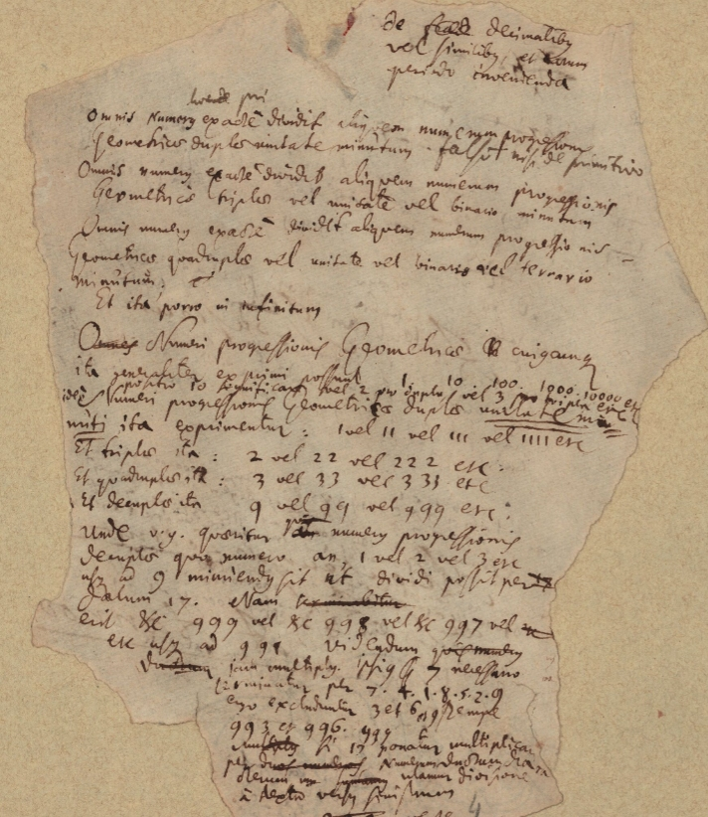
LH 35, 12, 2 Bl. 4r.
Every number exactly divides any number of the quadruple geometric progression diminished by one or two or three.
And so on ad infinitum.”

(To the first statement, Leibniz later added: “false, except about a prime [number].”) The manuscript continues:

“The numbers of any geometric progression can be expressed generally thus: 1, 10, 100, 1000, 10000 etc. Putting 10 means either 2 for the double [geometric progression] or 3 for the triple [geometric progression] etc. Therefore the numbers of the double geometric progression diminished by one can be expressed thus: 1 or 11 or 111 or 1111 etc.
And of the triple [geometric progression] thus: 2 or 22 or 222 etc.
And of the quadruple [geometric progression] thus: 3 or 33 or 333 etc.
And of the decuple [geometric progression] thus: 9 or 99 or 999 etc.”

Here, Leibniz uses binary numeration as an alternative way of expressing the numbers of a base (or “geometric progression”), noting that the numbers 1, 10, 100, 1000, 10000 etc. have different values depending on which base one is using. His use of binary here is purely illustrative and binary plays no further role in his analysis (in the rest of the manuscript, Leibniz concerns himself with devising a method to determine which decimal number ending ...991 to ...999 is divisible by 17).
The second manuscript deals with a related matter: perfect numbers, that is, positive integers that are equal to the sum of their divisors (including 1 but excluding the number itself), such as 6 (= 3 + 2 + 1) and 28 (= 14 + 7 + 4 + 2 + 1). From the time of Euclid, investigations in this area of number theory have concentrated upon the powers of 2 geometric sequence, since Euclid’s theorem of generating perfect numbers (or rather, even perfect numbers) is this: “if any number of numbers are set out successively in a double proportion [starting] from one, until the whole sum becomes prime, and this sum multiplied into the last [number] makes some number, then the [number] made will be perfect.” That is, if 2^{n} − 1 is prime, then 2^{n−1}(2^{n} − 1) is perfect. Leibniz was reminded of this theorem when reading a 1678 dissertation on perfect numbers by Johann Wilhelm Pauli (1658–1723), who had used Roman letters to stand for the numbers of the powers of 2 geometric sequence in order to investigate the parts of perfect numbers via a sort of rudimentary algebraic calculus. Upon reading Pauli’s book, Leibniz copied out Euclid’s theorem then illustrated it in binary notation: “If 111 is prime, 11100 (that is, 111 by 100) is perfect (assuming 10, 100, 1000 are 2, 4, 8), production of the same thing by a different route”. There is no indication here of Leibniz using binary notation to compute unknown perfect numbers, nor would that have been a realistic prospect in any case: the first five perfect numbers are 6, 28, 496, 8128, and 33550336, so using binary notation to represent any except the first two would obviously require unmanageably long strings of digits.
Given the central role of powers of 2 in Leibniz’s work on number composition, primes, and perfect numbers in the mid-to-late 1670s, it is easy to see why binary notation would have appealed to him. Take, for example, the number 7 expressed in binary: 111. A striking feature of this notation is that it displays the component powers of 2, as there is a 1 in the 4’s position, a 1 in the 2’s position, and a 1 in the 1’s position. Thus the binary value 111 is not just an alternative way of writing the decimal number 7, it’s one that shows the three calculation steps—(1 × 2²) + (1 × 2¹) + (1 × 2⁰), that is, 4 + 2 + 1—required to produce the number through powers of 2. In this vein, in 1686 Leibniz claimed that binary numeration is more perfect than decimal because in decimal there is no way to demonstrate from the digits 3 and 9 that 3 × 3 = 9, whereas in binary it is apparent (with a little working out) that 11 × 11 = 1001. And in the 1690s, when Leibniz started to provide detailed accounts of binary to some of his mathematician correspondents, he often made the point that a unique feature of binary notation is that it shows how any number can be represented as the sum of distinct powers of 2.
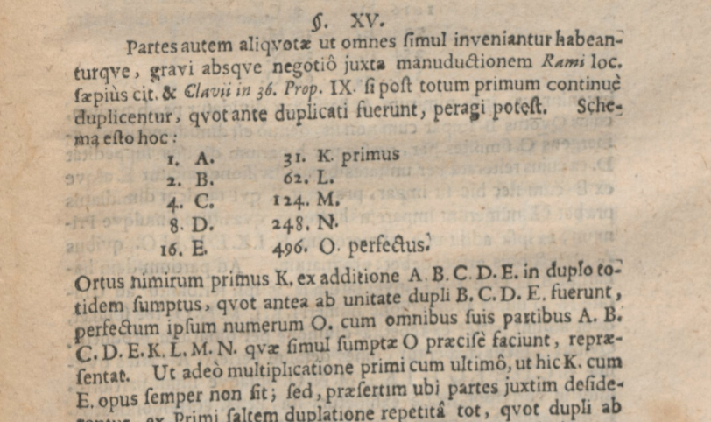
From Pauli (1678)

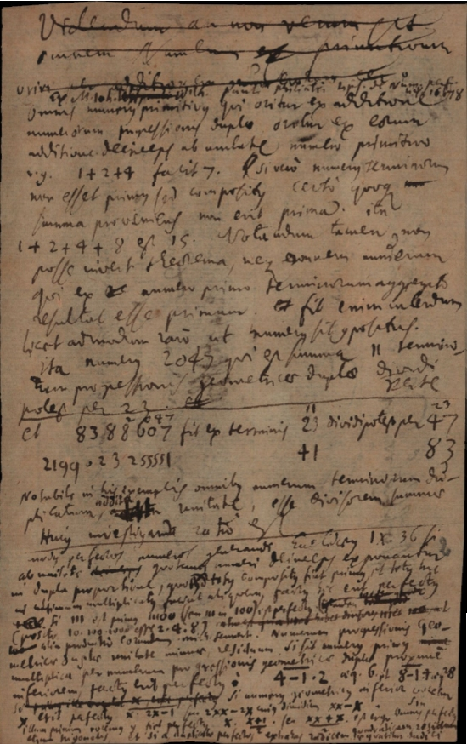

LH 35 3 B 17, Bl. 2r.
Moreover, binary notation is convenient for expressing the numbers of the powers of 2 geometric sequence because these always consists in a 1 followed by 0s, e.g. 2 = 10, 4 = 100, 8 = 1000 etc. And as Leibniz acknowledged in the first of our three early manuscripts above, binary notation is just as convenient for expressing the values of the Mersenne numbers, 2^{n} – 1, because these always consist in 1s with no 0s, e.g. 2¹ – 1 = 1; 2² – 1 = 11; 2³ – 1 = 111 etc. (In contemporary terminology, every Mersenne number is a binary repunit.) Therefore, binary numeration serves as a very convenient and very informative shorthand if one is working with various powers of 2, or the values of 2^{n} – 1, especially for the lower values thereof, the very ones Leibniz tended to favour when illustrating his formulae.
And indeed, in our third manuscript, entitled “Calculus” [Calculation], written sometime after 1676 (but probably before 1680), Leibniz uses binary notation as one of the various ways of expressing the powers of 2. In this manuscript, Leibniz outlines elementary arithmetic terms and operations, and when he comes to “powers” he offers this:

Powers. bb is b², bbb is b³ etc. b^{r}b^{z} is b^{r+z}, thus b²b³ is b²⁺³, that is, b⁵.
1  b⁰  1  1 | 2  b¹  b  10 | 4  b²  bb  100 | 8  b³  bbb  b²b  1000 | 16  b⁴  b³b  b²b²  10000 | 32  b⁵  b³b²  100000 | 64  b⁶  b^{3·2}  b³b³  1000000 | 128  b⁷  b⁴⁺³  b⁴b³  10000000 | 256  b⁸  100000000
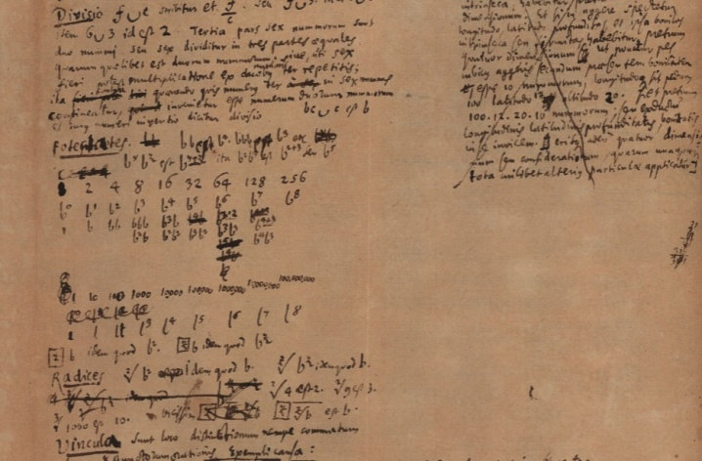

The three manuscripts surveyed share a number of notable features. First, while binary notation may be present in all three, binary arithmetic is not; instead, Leibniz performs all his arithmetic in decimal or algebra. Second, binary notation is used for illustration rather than for calculation. These common features suggest that at the time of writing these three manuscripts, Leibniz was not thinking beyond the notation, and this in turn would support the hypothesis that he developed this notation as a tool to assist his investigations in mathematical problems that were exercising him at the time. Of course, given the difficulty in dating Leibniz’s earliest writings on binary with great accuracy, the hypothesis just sketched about binary’s origins must remain speculative. But on the face of it, it does seem to be better supported by manuscript evidence than the explanation Leibniz himself gave as to how he came to invent binary!

See for example Louis Couturat: La logique de Leibniz, Paris 1901, p. 473; Hans J. Zacher (ed.): Die Hauptschriften zur Dyadik von G. W. Leibniz, Frankfurt 1973, pp. 9–33; Johannes Tropfke: Geschichte der Elementarmathematik. Band 1: Arithmetik und Algebra, Berlin 1980, 4th ed., p. 12; Luigi Ingaliso: “Leibniz e la lettura binaria dell’I Ching”, in Giancarlo Magnano San Lio and Luigi Ingaliso (eds.): Alterità e Cosmopolitismo nel Pensiero Moderno e Contemporaneo, Soveria Mannelli 2017, pp. 109–132, especially pp. 111–112.
Such a question cannot, of course, be asked of Thomas Harriot, who was, as far as we know, the first to invent binary, though as he did not publish his work it did not influence anyone else. For more on Harriot’s invention of binary, see Lloyd Strickland: “Why did Thomas Harriot invent binary?”, in The Mathematical Intelligencer (2023). Available here: https://link.springer.com/article/10.1007/s00283-023-10271-9
Other suggested influences, such as Francis Bacon and Juan Caramuel y Lobkowitz, are equally untenable. For a discussion about these possible influences, see Lloyd Strickland: “Leibniz on Number Systems”, in Bharath Sriraman (ed.), Handbook of the History and Philosophy of Mathematical Practice, Cham 2023, section 1.
See Lloyd Strickland and Harry Lewis: Leibniz on Binary: The Invention of Computer Arithmetic, Cambridge, Mass. 2002, p. 138; see also p. 110, pp. 127–128.
See A VI 4, 1162–1163.
LH 35, 1, 25 Bl. 3v.
This work yielded his first publication in mathematics in February 1678, namely the short journal article “A new observation about the way of testing whether a number is prime”; see Gottfried Wilhelm Leibniz: “Extrait d’une lettre ecrite d’Hanovre par M. de Leibniz à l’Auteur du Journal, contenant une observation nouvelle de la maniere d’essayer si un nombre est primitif”, in Journal des sçavans (1678), pp. 75–76. English translation: http://www.leibniz-translations.com/prime.htm For details of Leibniz’s work on primes, see Dietrich Mahnke: “Leibniz auf der Suche nach einer allgemeinen Primzahlgleichung,” in Bibliotheca Math. 13 (1912–13), pp. 29–61.
In the manuscript entitled “Formarum reductio ad simplices,” written 12 September 1680: “Therefore, 2^{z–1} – 1 will be divisible by z, if z is prime” (LH 35, 3 A 4 Bl. 14r). During these investigations, Leibniz also glimpsed Wilson’s theorem: (n – 2)! ≡ 1 (mod n), or in Leibniz’s words: “The product of continuous [integers] up to the number which anteprecedes the given integer, when divided by the given integer, leaves 1, if the given integer is prime. If the given integer is derivative, it will leave a number which, since it has a common measure with the given integer, is greater than one” (LH 35 3 B 11 Bl. 21r). However, when testing his articulation of the theorem, Leibniz made a miscalculation that led him to add the false statement “(or the complement of 1)” after “leaves 1.”
LH 35, 12, 2 Bl. 4r.
In a slightly later manuscript, from 1679 (LH 35, 8, 30 Bl. 148), Leibniz again uses binary notation to illustrate his (still immature) formulation of a prime number theorem, namely 2^{n} – 1: “Let = 111111, = 1111, ♀ = 111, ♂ = 11. = ♀A, = ♂B. Now ♀ and ♂ are prime among themselves, because their exponents are such, that is, their indices, or the numbers 2 and 3. Therefore A and B are not prime among themselves and necessarily will become A = ♂C and B = ♀C, and will become = ♀♂C. Z^{z} – 1 is divisible by Z if Z is prime, and I have demonstrated this as follows: 2² – 1 by 3 and 2⁴ – 1 by 5, therefore 1111 is divisible by 5 and 11 by 3 and 111111 by 7. But 11111 cannot be divided by 6, for since 11 can be divided by 3, 11111 and 11 have a common divisor, yet they are prime among themselves. And hence we have the sought-for demonstration of a reciprocal property of a prime number.”
Euclid, Elements, IX.36. That is, if p is a positive integer and 2^{p} – 1 is prime, then 2^{p-1} (2^{p} − 1) is perfect.
Johann Wilhelm Pauli: Disputatione mathematica numerum perfectum perfectissimi, Leipzig 1678.
LH 35 3 B 17, Bl. 2r.
Perhaps because of this, in another manuscript on the subject, probably written in 1678, Leibniz sought to demonstrate perfect numbers using a mixture of binary numeration and algebra based thereon (so unrelated to Pauli’s algebra), eventually reaching the conclusion “2^{2z+1} – 2^{z} will be a perfect number if 2^{z+1} – 1 is prime. Likewise, 2^{z–1} – 1 will be divisible by z, if z is prime” (LH 35, 3 B 17 Bl. 1).
A VI 4, 800.
See for example A II 3, 452; Strickland and Lewis: Leibniz on Binary, p. 111; p. 195
Leibniz explicitly acknowledged these features, at least in the 1680s onwards. For example: “The very last digits of a number of the double geometric progression can be easily obtained like this: if 1 is subtracted from it, then it is written in binary: etc.1111111, that is, 1 + 2 + 4 + 8 + 16 + 32 etc.” (LH 35, 3 B 11 Bl. 10r; cf. LH 35, 8, 30 Bl. 75; LH 35, 13, 3 Bl. 33; LH 35, 15, 5 Bl. 10r; LH 35, 3 B 5 Bl. 51r).
LH 35, 4 11 Bl. 8r. A similar table is found in other manuscripts, such as LH 35, 4, 11 Bl. 10r, though this was likely written in 1681.
Another writing in this vein is printed in Strickland and Lewis: Leibniz on Binary, pp. 41–43.
Leibniz did not affix a date to them, and the paper contains no watermarks that could be used to determine a dating, so they have to be dated using internal evidence.

