Pretend play with objects. An Ecological Approach

Final draft.
Approved for publication in Phenomenology and Cognitive Science, on June 23rd, 2021

Agnes Szokolszky1 Catherine Read2, 3
1Department of Cognitive and Neuropsychology, Institute of Psychology, University of Szeged, Szeged, Hungary
2Department of Psychology, Ithaca College, New York, NY, United States
3 Plant Biology, Rutgers University, New Jersey, NJ, United States
Corresponding Author
Agnes Szokolszky
szokolszky.agnes@edpsy.u-szeged.hu

The ecological approach to object pretend play, developed from the ecological perspective, suggests an action- and affordance based perspective to account for pretend object play. Theoretical, as well as empirical reasons, support the view that children in pretense incorporate objects into their play, in a resourceful and functionally appropriate way based on the perception of affordances. Therefore, in pretense children are not distorting reality but rather, they are perceiving and acting upon action possibilities. In this paper, we argue for the viability of an ecological theoretical framework to pretend object play which has been traditionally understood as a representational and metarepresentational ability. We discuss the origins and basic assumptions of the ecological approach to pretense. We layout details by presenting a qualitative analysis of a pretend play episode and discuss the results of an experimental study inspired by the ecological assumptions. We discuss pretend object play in the context of ecological work on tool use. We address the relationship between the enactive and the ecological approaches to pretend play, pointing out similarities as well as differences. We conclude that ecological and enactive approaches have shown that it is possible to challenge accepted interpretations and seek explanatory frameworks that could move the field in new directions.

Keywords: ecological account of pretense, enactive account of prertense, pretend object play, non-representational account of pretend play, Ecological Psychology

1. Introduction

Pretend play – to use an often cited example, when a child says „I am making a phone call” and holds a banana to her ears - has been cause for a perplexing „representational abuse” problem:

"If a representational system is developing, how can its semantic relations tolerate distortion in these more or less arbitrary ways? ... Why does pretending not undermine their representational system and bring it crashing down? ... The perceiving, thinking organism ought, as far as possible, to get things right. Yet pretense flies in the face of this fundamental principle. In pretense we deliberately distort reality" (Leslie, 1987, 412).

We can also ask: How is it that in their pretend play children would distort reality when play should be adaptive and preparing for reality? Traditional answers to these questions find remedy in the development of higher order representational and metarepresenttional abilities. Psychologists including Piaget (1962) and Vygotsky (1976) were interested in pretend play exactly because they thought that it involved the increasing symbolic capacity to treat objects representationally. On this view pretend play is developmentally useful because it requires symbolic thinking that makes up for the deficiencies of perception, therefore it is a valuable practice of higher order cognitive skills. The puzzle, nevertheless remains: how is it that cognitive development is achieved at the expense of perception and a better grasp of reality?
Currently there are two approaches that challenge the assumption that representational thinking is the driving force of pretense and propose an alternative. The ecological approach to object pretend play was developed from the 1980’s on, based on work in direct perception by J.J. Gibson (Zukow, 1984; Dent-Read;1987; Szokolszky, 1996, 1997, 2006, 2013). Gibson has played a foundational role in developing a profound nonrepresentational approach to psychology, as noted by van Dijk and Myin (2019, 975), and his efforts are „as instructive today as they were in Gibson’s time”. In the 1980's and the 1990's the ecological programme was gaining strength. The ecological approach to pretense was part and parcel of the strive to extend the ecological research programme. Theoretical and empirical foundations exist for the view that children in pretending incorporate objects into their play, in a resourceful and functionally appropriate way, based on the perception of affordances. Therefore, in pretense children are not distorting reality, but, rather, they are perceiving and acting upon action possibilities of objects over and above their usual uses.
In the 2010’s an enactive (also called „interactionist”) approach to pretense surfaced with aspirations to „de-intellectualize” explanations of pretend play and show that pretend play could be accounted for by non-representational processes (Rucinska, 2014, 2016, 2017, 2019, Rucinska and Rejmijmers, 2014, 2015). The enactivitst account builds upon O’Regan and Noë’s (2001) sensorimotor theory of perception and the concept of affordances. This approach suggests, along the lines of „4E” cognitive science, that cognition is co-constituted by the dynamic interactions between the brain, the body, and the physical and the social environment.
The ecological and the enactive approaches to pretense are in agreement in many ways. Both offer a critique of the representational approaches to pretend and an affordance -based alternative. There is considerable common ground but differences also exist. In the current climate of interest regarding pretend play it is important to examine more closely what these two approaches propose and how they relate to each other regarding the topic of pretend play.
In this paper we argue for the viability of an ecological theoretical framework to preted object play on theoretical and empirical grounds. We restrict our discussion to object pretend play because we think that it is a paradigmatic case of pretense, and the clear formulation of the approach is best achieved with a focus on the paradigmatic case. We begin by discussing the origins and the basic assumptions of the ecological approach to pretense. We lay out details by presenting a qualitative analysis of a pretend play episode and the results of an experimental study inspired by the ecological assumptions. In order to highlight certain characteristics of pretense we relate it to unconventional tool use. Next we examine common ground as well as differences between the ecological and the enactive approaches to pretense. As a final conclusion we point out in what ways these two approaches to pretend play are mutually supportive and what advantages they have over representational accounts.
2. The ecological approach to object pretend play – an early alternative to representational accounts
2.1. What is rejected and on what general theoretical basis

In the late 1980’s and early1990’s the cognitivist account was „the only game in town” regarding pretend play (using Fodor’s, 1975, expression that referred to the role of the computational theory of mind in general). It was considered to be „a fact” that pretending is based on mental representation (Lillard, 1993, 373). Mental projection was taken to be an essential feature of pretense: „In pretending that a block is a horse, for example, one employs one's own mental representation of a horse and applies that representation to the block. .... Mental representation is a defining feature of pretense; in the absence of such mental representations, pretense does not occur” (Lillard, 1993, 373).
The representationist account had its anomalies, recognized by its proponents. It was suggested the representational abuse problem (how the developing representational system is able to tolerate more or less arbitrary distortions in semantic relations, cf. Leslie, 1987) was „solved” metarepresentationally: by making a duplicate representation of the concept which is temporarily decoupled from the original representation. Others suggested an episode-based "flagging" process. „Once the episode is completed, the flags associated with it cease to be read. The props are liberated from their stipulated identity " (Harris and Kavanaugh, 1993, 64). Another contradiction, based on the assumption that pretense requires understanding mental representations, came from research indicating that children do not understand mental representation until at least around age 4, whereas they engage in pretend play by age 2. To resolve this problem that we can call the symbolic ability paradox, Lillard (1993, 373) suggested that young children „initially conceptualize pretense as its commonly associated external features such as action, and do not come to appreciate its mental representational underpinnings until at least the age of sixth”.
The idea that representational thinking is the driving force and explanatory principle of pretense has remained axiomatic over time. The mere occurrence of pretend object play - using an object as if it were another – was taken as evidence for the role of mental representations: “All authors agree”, claim Musatti and Mayer (1987, 226), “that this behavior is definite evidence of the child’s acquisition of representative capacity in the narrow sense, i.e., that expressed through the use of symbols”. Pretend play has been described as an exemplar for counterfactual thinking (serving children a similar function as the Twin Earth construct serves for philosophers: it enables them to imagine and explore an alternative world, Lillard, 2001), divergent thinking (Fehr and Russ, 2016), and creative problem solving (Amabile, 1996, Hoff, 2013). It has been explained as imaginative transformation with decentering as a main cognitive process (Currie, 2006) and as following mental scripts that detail how situations typically unfold (Nichols & Stich, 2003). In early education its value is seen in aiding cognitive development by practicing representational, metarepresentational and reasoning skills (e.g. Gopnik and Walker, 2013). Some authors discuss pretend play from an evolutionary developmental point of view but maintain that when a child uses a shoe as a telephone, for example, the object is used as a symbol (Bjorklund and Gardiner, 2010).
The above approaches treat representational cognitive processes as primary and perception and action as subsidiary processes because of the long held assumption that perception is based on the deliverances of the senses and needs cognitive enrichment to lead to meaningful percepts and action. Cognitive development is, first and foremost, the development of representational skills, because complex mental representations are considered to be the essential link between the inside individual mind and the outside world, including other social minds. As promoted by early theorists (Piaget and lnhelder, 1969; Vygotsky, 1981) and endorsed later, with development there is less and less reliance on perception and more and more reliance on symbolic thought. The representational account assumes that object substitution initially relies on similarity of form and function, but with development more and more arbitrary substitutions occur. Pretending that a toothbrush is a pencil is based on similarity of form. Pretending that a toothbrush is a fish is a more advanced level of pretense since there is less similarity and more arbitrariness involved. Advanced pretend play is the ability to treat objects in such an arbitrary, decontextualized way, in accordance with a predefined action plan, with less and less reliance on perceptual support (cf. Piaget, 1962; Vygotsky, 1976; Lillard, 2015). Although action is frequently involved in pretense, „it is not one of its defining features” - the core process is mental. (Lillard, 1993, 373).
Ecological Psychology, in stark contrast, posits that action is always perceptually guided, and that perception of meaningful action positibilities is the basis of adaptive living in one’s surround. The axiomatic primary assumption is organism – environment mutuality: that a symbiotic relationship exists between the environment and an agent who is actively seeking out and realizing familiar and novel functional relations, and therefore is constantly changing the functional environment and is being changed by this environment (cf. e.g. Shaw, Turvey, and Mace, 1982, Mace, 2005; Turvey, Shaw, Reed, and Mace, 1981; Witherington and Heying, 2013). According to ecological theory directly meaningful relations exist in an econiche and are nonrepresentationally accessible for evolved and developing organisms (J. J. Gibson, 1967, 1979/2014; Shaw, Turvey and Mace, 1982, Read and Szokolszky, 2018). For example, J.J. Gibson (1979/2014) presents an account of ecological optics in which he details the structures in ambient light caused by the layout of surfaces in the surround in relation to a moving perceiver. These structures, which are both variant and invariant over time, include relations such as looming, point of contact and edges at which texture is accreted and deleted as the organism moves. Organisms with the appropriate visual systems (note that this does not refer to senses, but to whole organisms with systems that coordinate with the surround) are sensitive to these structures, and can resonate to the variants and invariants in the surround in the course of acting and living. That is, ambient light is structured over time, and it specifies the surround for organisms with perceptual systems (whole body systems) that are sensitive, i.e., that resonate to, the structure.
The term of „affordance” was coined by James J. Gibson to capture the rich, open ended, relational character of action and perception in the ambient environment at the ecological level (Gibson, 1979/2014). Affordances are action-relevant, organism-dependant, directly meaningful aspects of the environment that allow adaptive actions without the need to represent the environment. The concept has evolved in Gibson’s theory and generated a constant flow of theorizing and empirical research. Its relational character was made clear by Gibson (1979/2014): affordances are not properties of either the environment or the animal but are real and perceivable relations between them (Chemero, 2003, Costall, 2012; Dijk and Myers, 2019). Affordances are understood as social and cultural (Good, 2007, Costall, 1995) and their value-realization aspects have been repeatedly emphasized (Hodges, 2014). Within the ecological framework affordance perception was investigated as intentional constraint and as a resource for the control of action (Kugler, Shaw, Vincente, and Kinsella-Shaw, 1990, Heft, 1990, Fajen, 2007). The dynamic field character of affordance perception and affordance-based actions have been deliniated (Rietveld and Kiverstein, 2014). Canonical affordances were distinguished, these being conventional and normative affordances of artifacts, as opposed to the open-ended manifold of non-normative affordances (Costall, 2012).
For the ecological approach “perceiving the world does not, indeed cannot, depend on first having a representation, but having a representation does depend on first having direct access to that which is to be re-presented” (Shaw, 2011, 179). The ecological approach has grown from a theory of perception into a encompassing theory of an ecology of agency (Costall 2003). Applying this framework defines what to look for, in studying any psychological phenomena: what opportunities the environment offers to act and how the organism is willing and equipped to make use of these opportunities. Not mental representations but action and perception are the primary driving force and explanatory principles. These foundations lead to a picture of pretend play that is significantly different from the classical approach.

2.2. The ecological account of pretend object play

Qualitative analysis of a pretend play episode

At this point, we examine a real pretend sequence as the focus of a microanalysis. In a diary study the parent described and documented by photographs of the following pretend event (cf. Szokolszky, 2006):

One evening I was playing with my 2.5 year old son in the bedroom. Suddenly he he grabbed a pillow from the bed, put it on the ground and said: „I am cooking soup”. He paused as if looking for something,- there were some play pots around, but then he said: „I am making bread” and he started to knead the pillow. Actually, we were baking bread together the previous day. After a while I asked: don’t you need sour cream? Water? In response he grabbed his pyjamas laying on the bed, put it in the center of the pillow and went on “kneading the dough”. “We need water”, he said and run to the reading lamp, turned it on and held a play pot under the light, as if the light was water coming from a faucet. He “poured the water” into the “dough”, was kneading it a bit more and said now he puts it into the “oven” – thereby he pushed the pillow under the bed. After a while he said that the bread was baked and it needed to be cut. He picked up another pillow right away and holding it vertically, imitated cutting (for a partial photographic documentation see Figure 1,a, b, c, d).

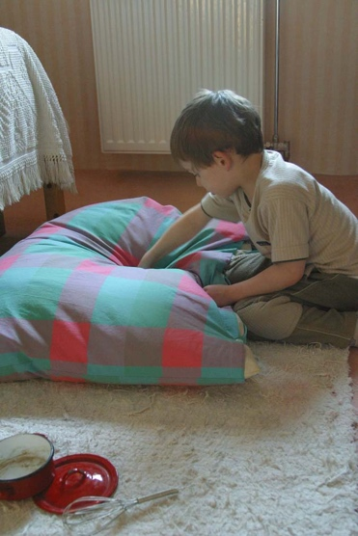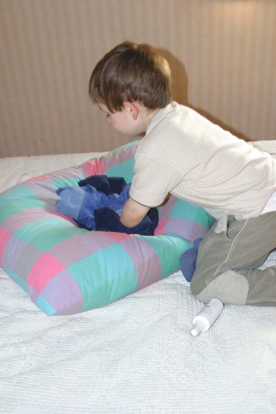
Figure 1a. Kneading the dough; Figure 1.b. Putting sour creme into the dough

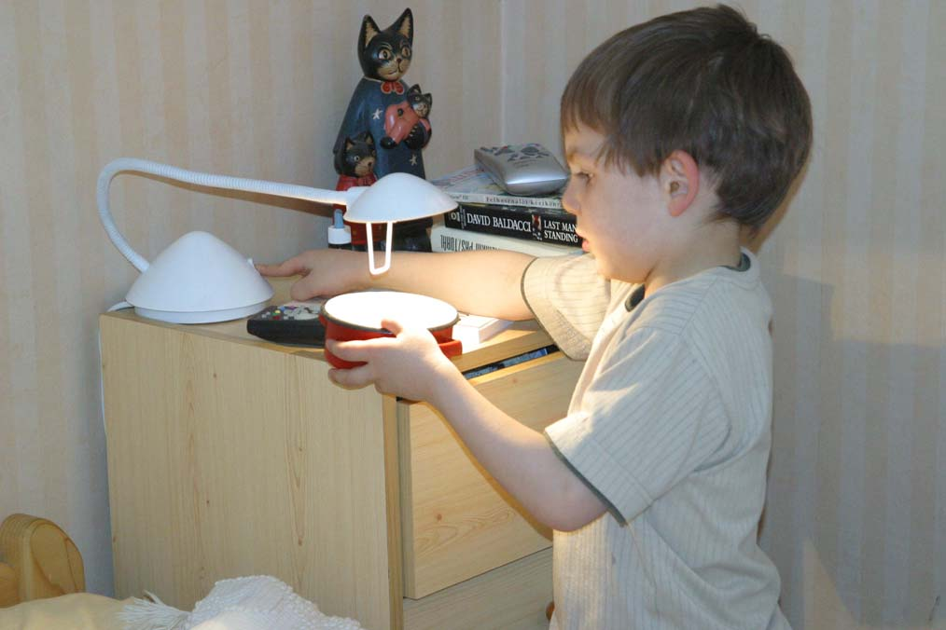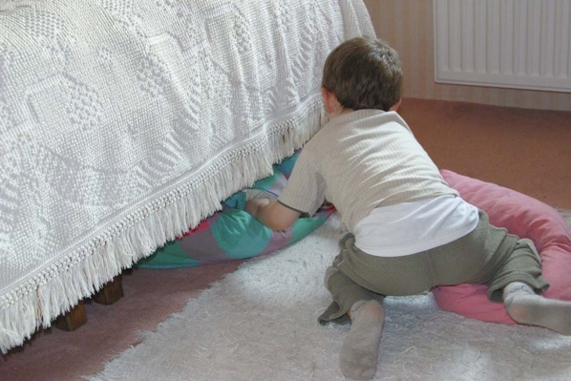
Figure 1c. Pouring „water” Figure 1d. Putting the breaad into the oven

What is happening in this play episode, rich in pretend details? The child starts out by the idea to play “cooking” when he is in the bedroom with his mother. He has some toy kitchen tools around but grabs a pillow, puts it on the ground and wants to “make a soup”. As he has the pillow on the ground, however, he changes his mind and decides to “bake bread” - enacting an experience he had the previous day with his mother. It might be the feeling of the softness and the “knead-ability” of the pillow that reminded the child to baking the previous day, when he was allowed to knead the dough. He is “kneading” with care and focused attention. In response to the prompting of the mother he elaborates the pretend baking by adding “sour crème” and “water”. By an insightful move he uses the lamp as if it were a faucet and treats the light coming from the lamp as if it were water coming from the faucet. He realizes that the gap under the bed could serve as an “oven” – an opening where he can put the dough into. Finally, he wants to cut the dough, and without hesitation he uses a smaller pillow for this purpose, by holding it vertically and moving it back and forth, so as the edge of the pillow would “cut” the dough.
How is this flexible, creative flow of action best explained? The representational account would posit that the child faces a series of representational and/or metarepresentational problems, with the choices for the substitute objects in the focus. The child has a plan (a script) in mind and to realize it he needs a substitute for stove, bread dough, sour creme, water, oven, and, all in an „unfavourable” environment (the bedroom). In each case he has to resort to a mental act of disregarding and redefining the estabished meaning of the objects, relying on perceptual features like similarity of form, color and function as much as possible. In case there is no similarity, the child can still solve the problem by a fully arbitrary substitution. Since in the above episode most substitute objects were highly dissimilar regarding simple features, the representationist account would treat these substitutions as precedents of a high level of symbolism based on an action plan defined by the representational script of „bread baking”. However, it is not likely that the child at this age has this highly advanced representational and metarepresentational skills. This contradiction can be be solved by assuming that pretense was carried out by activating „commonly associated external features such as action” Lillard (1993, 373). Action is, in this case not a rich engagement with the environment but a mental script executed with little or no perceptual support.
The ecological view offers a different interpretation. What is prevalent throughout this play sequence is the intentional, goal oriented yet spontaneous stream of action, re-creating a previous joint activity with the mother. The child is motivated to act out this experience and „in the heat of the moment” he looks around to invent how to carry out this intention. He is looking at nearby objects that seem and feel appropriate to carry out the desired actions. He is looking for affordances that enable the action, but the focal point is not the object but the action with the object. The child knows and disregards fetures of the substitute objects with ease because appropriate affordances are there and offer perceptual support for the pretend actions. The child acutely perceives and creatively exploits these action possibilities. The whole action sequence is smooth and flowing. There is no sign of problem solving or any kind of mental perplexity while pretending.
The ecological account places action and affordances in the focus of the analysis of pretend play episodes. Whereas this conceptual framework serves well to explain how the event flexibly unfolds, the representationist account has no conceptual tools to account for perceiving the knead-ability of the pillow, the put-in-ability of the „dough” under the bed and the usability of a lamp as a faucet. The representationist approach would suggest that the child acts without perceptual support, by the guidence of representations and an action plan based on a mental script. This style of explanation is not in accordance with the fluent, creative and appropriate character of object choices and adapted actions in the aboove pretend play event.
In the above sequence not all object choices are based on optimal affordances. A pillow works well for pretend kneading but much less well for pretend cutting. This, however, does not disturb the child who holds it sideways and imitates cutting. Two points are important: First, that the object gains its identiy in the action, by the action. Second, that even in this case the substitute object does offer affordances that minimally support the pretend action: the pillow can be held sideways so that its its edge is over the „bread” and it can be pulled back and forth as if cutting. Here, again, the action itself is important in granting situational identity to the object.

An experimental study of pretend object play based on ecological theory

An experimental study (Szokolszky, 1996, 2006) also pointed out that children use substitute objects in pretend play based on functional fitness best characterized as affordances. In this study 3-5 year old children played individually with the experimenter who modeled a brief story with sets of realistic objects, then put away the realistic target objects and asked the child to choose pretend substitutes and act out the story. She showed, for example, how a small doll took a boat ride in a toy boat either in real water in a tank or on a mat which was „water”. Then she put away the toy boat and offered three substitute objects that differed in affordance-based fitness to be a substitute, and also differed in having definite conventional identity (the ones without definite identity were called „blank objects”). For the boat, the pretend objects were a wooden shoe (fit definite object), an oval shaped plastic container with holes on it (moderately fit blank object), and a toy skate board (unfit definite object, see Figure 2. Degree of fitness of the objects were ranked by adults beforehand and it was made sure that they knew the identities of the objects when applicable). The child had to present first, second and third choices for substitute objects and show how the object could be used as the target object (how the doll could take a boat ride in the shoe, in the oval container and on the skateboard). Thereafter the child was free to play with the substitute objects.

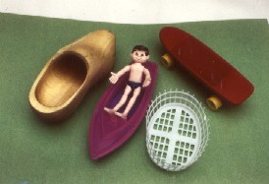

Figure 2. Object set with toy boat as realistic target object.

Children generally perceived the degree of affordance - based fitness of the objects in accordance with adult judgements and this happened even if the object had a conventional identiy. The boat-potential of the wooden shoe was, for example, overwhelmingly detected even by younger children, even though they knew it was a shoe and therefore it was supposedly difficult to „decontextualize”. The shoe was chosen also over the oval container even though it was „blank” and therefore it was supposedly easier to „decontextualize” than the shoe. As expected, the skate board was picked as the last choice by younger and older children, as well. Older children did not show a tendency to disregard object fitness any more thn young children. These findings were in contrast to expectations that would have been based on the symbolic approach. The affordance-based explanation works by assuming that children have the early ability to perceive relevant affordances in novel contexts. Thus, they can, for example, easily see the boat-rifding affordance of the wooden shoe
Studies on pretend play often ask children to rank and choose substitute objects but rarely pay attention to what children actually do when they use pretend objects. The above study analyzed pretend acts in detail. Specifically, it looked at the relationship between object fitness and qualitative aspects of actions. Three main types of pretend actions were differentiated: Integrated actions are smooth and adequate, similar to the proper use of the realistic target object. An example is kneading the pillow - the pillow is highly fit for kneading, thus the movements of pretend kneading are very much like real kneading. Discrepant actions are jerky and fragmentary, different from what it would be with the proper use of the realistic target object. An example is pretend cutting with the small pillow – the object is minimally fit, thus the movement is kind of a compromise. Bridging actions involve a special effort to make the object fit for the task. An example is holding the oval container object at the surface of the water in the watertank, or wrapping the blanket around a toy car to make it an acceptable pillow. Here the child actively modifies the affordance of the object so as to make it an acceptable substitute.
In the experimental study distinct patterns of adaptive actions emerged depending on degree of object fitness. When using the fit definite objects, children performed a high number of integrated actions, a low number of discrepant actions, and virtually no bridging. When using the unfit definite objects they performed an insignificant number of integrated actions, a high number of discrepant actions and a relatively high number of bridging. When using the moderately fit blank objects, they performed a relatively high number of integrated actions, as well as discrepant actions, and an increased number of bridging in some cases. An object could be ideally suited to the pretend task, yet used discrepantly for the pretend action, and vice versa, depending on the skills, intentions and current motivational state of the child (how much s/he cared about playing out the situation). Functional fitness constrained actions but children could, and sometimes did, change functional fitness in order to optimize performance and create better support for the action.
In sum, the above experimental study showed that children were sensitive to affordance-based functional fitness of the substitute objects. Pretend actions themselves were
influenced by affordance-based fitness, showing that children performed adapted actions in these pretend situations. In symbolic accounts the focus on decontextualized mental representations obscures the fact that pretend play involves first and foremost pretend actions, along with functional adaptation and coordination with objects in basic ways. The results suggested that pretend object play involves a flexible and subtle reliance on perceptual support and not an increasing disregard of it.

Conclusions based on the ecological study of pretend object play

The ecological agenda refocuses research by looking at actions in pretense and what perceptual support they get in pretense situtions. It is assumed that the primary drive is doing, preforming the pretend act. In the spontaneous flow of play the child wants to act out an emotionally valenced experience which typically is a socially established routine (like cooking, fighting or driving). The intention to act makes the child grab a „good” or „good-enough” object at hand – an object that affords to act out the scene in a meaningful way. Objects are important part of the process, however, the main point is not „object substitution” but the re-living of the act by the support of the object and the given environment, including people present. Objects gain situational identity in the action, by the action. Pretend acts have the power to incorporate stronger and weaker affordance-based support, as long as the substitute object is at least minimally supportive.
This does not mean that in advanced pretend object play „anything can stand for anything else”. Affordances constrain actions. As put forth by Costall (2002, 89) „although we can do many things with any single thing, we cannot do anything with any thing”. Many objects can be used, for example, as a pretend sword, a revolver or a bow for a child who likes to play pretend fighting. But even if the use of the object is based on a stretch of imagination, there are affordance-based constraints in the use of the object. What can or cannot be a substitute in a given pretend situation depends on the particulars of the available objects in relation to the intentions, action skills and motivations of the child. A Stanley measurement tape can be a pretend revolver (Figure 3a), and even a piece of socks can be a revolver if incorporated in the proper action (Figure 3b). A coat hanger can be a good bow (Figure 3c), but not any coat hanger – there are objects that do not even have the minimal affordance (Figure 3.d.; unpublished examples from spontaneous pretend play).
Objects used in pretense need to support pretend actions; a pretend knife only needs to do pretend cutting. Therefore, pretend actions are often messy and fragmentary. However, they allow creative freedom exactly because they need not be real. The child reenacts the scence with as much realistic precision as to make it feel real but s/he does not have to bother about details or outcomes. When you salt the pretend dinner with sand you cannot over-salt it.

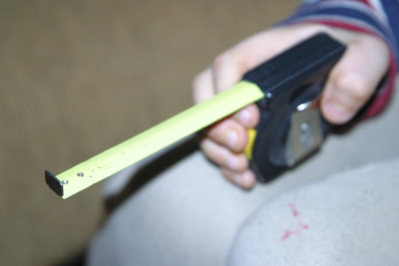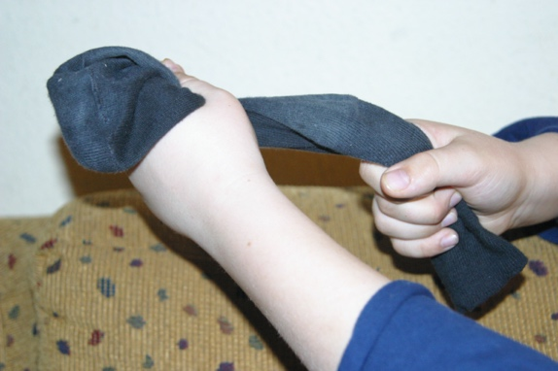

Figure 3a. Stanley tape as revolver Figure 3.b. Socks as revolver

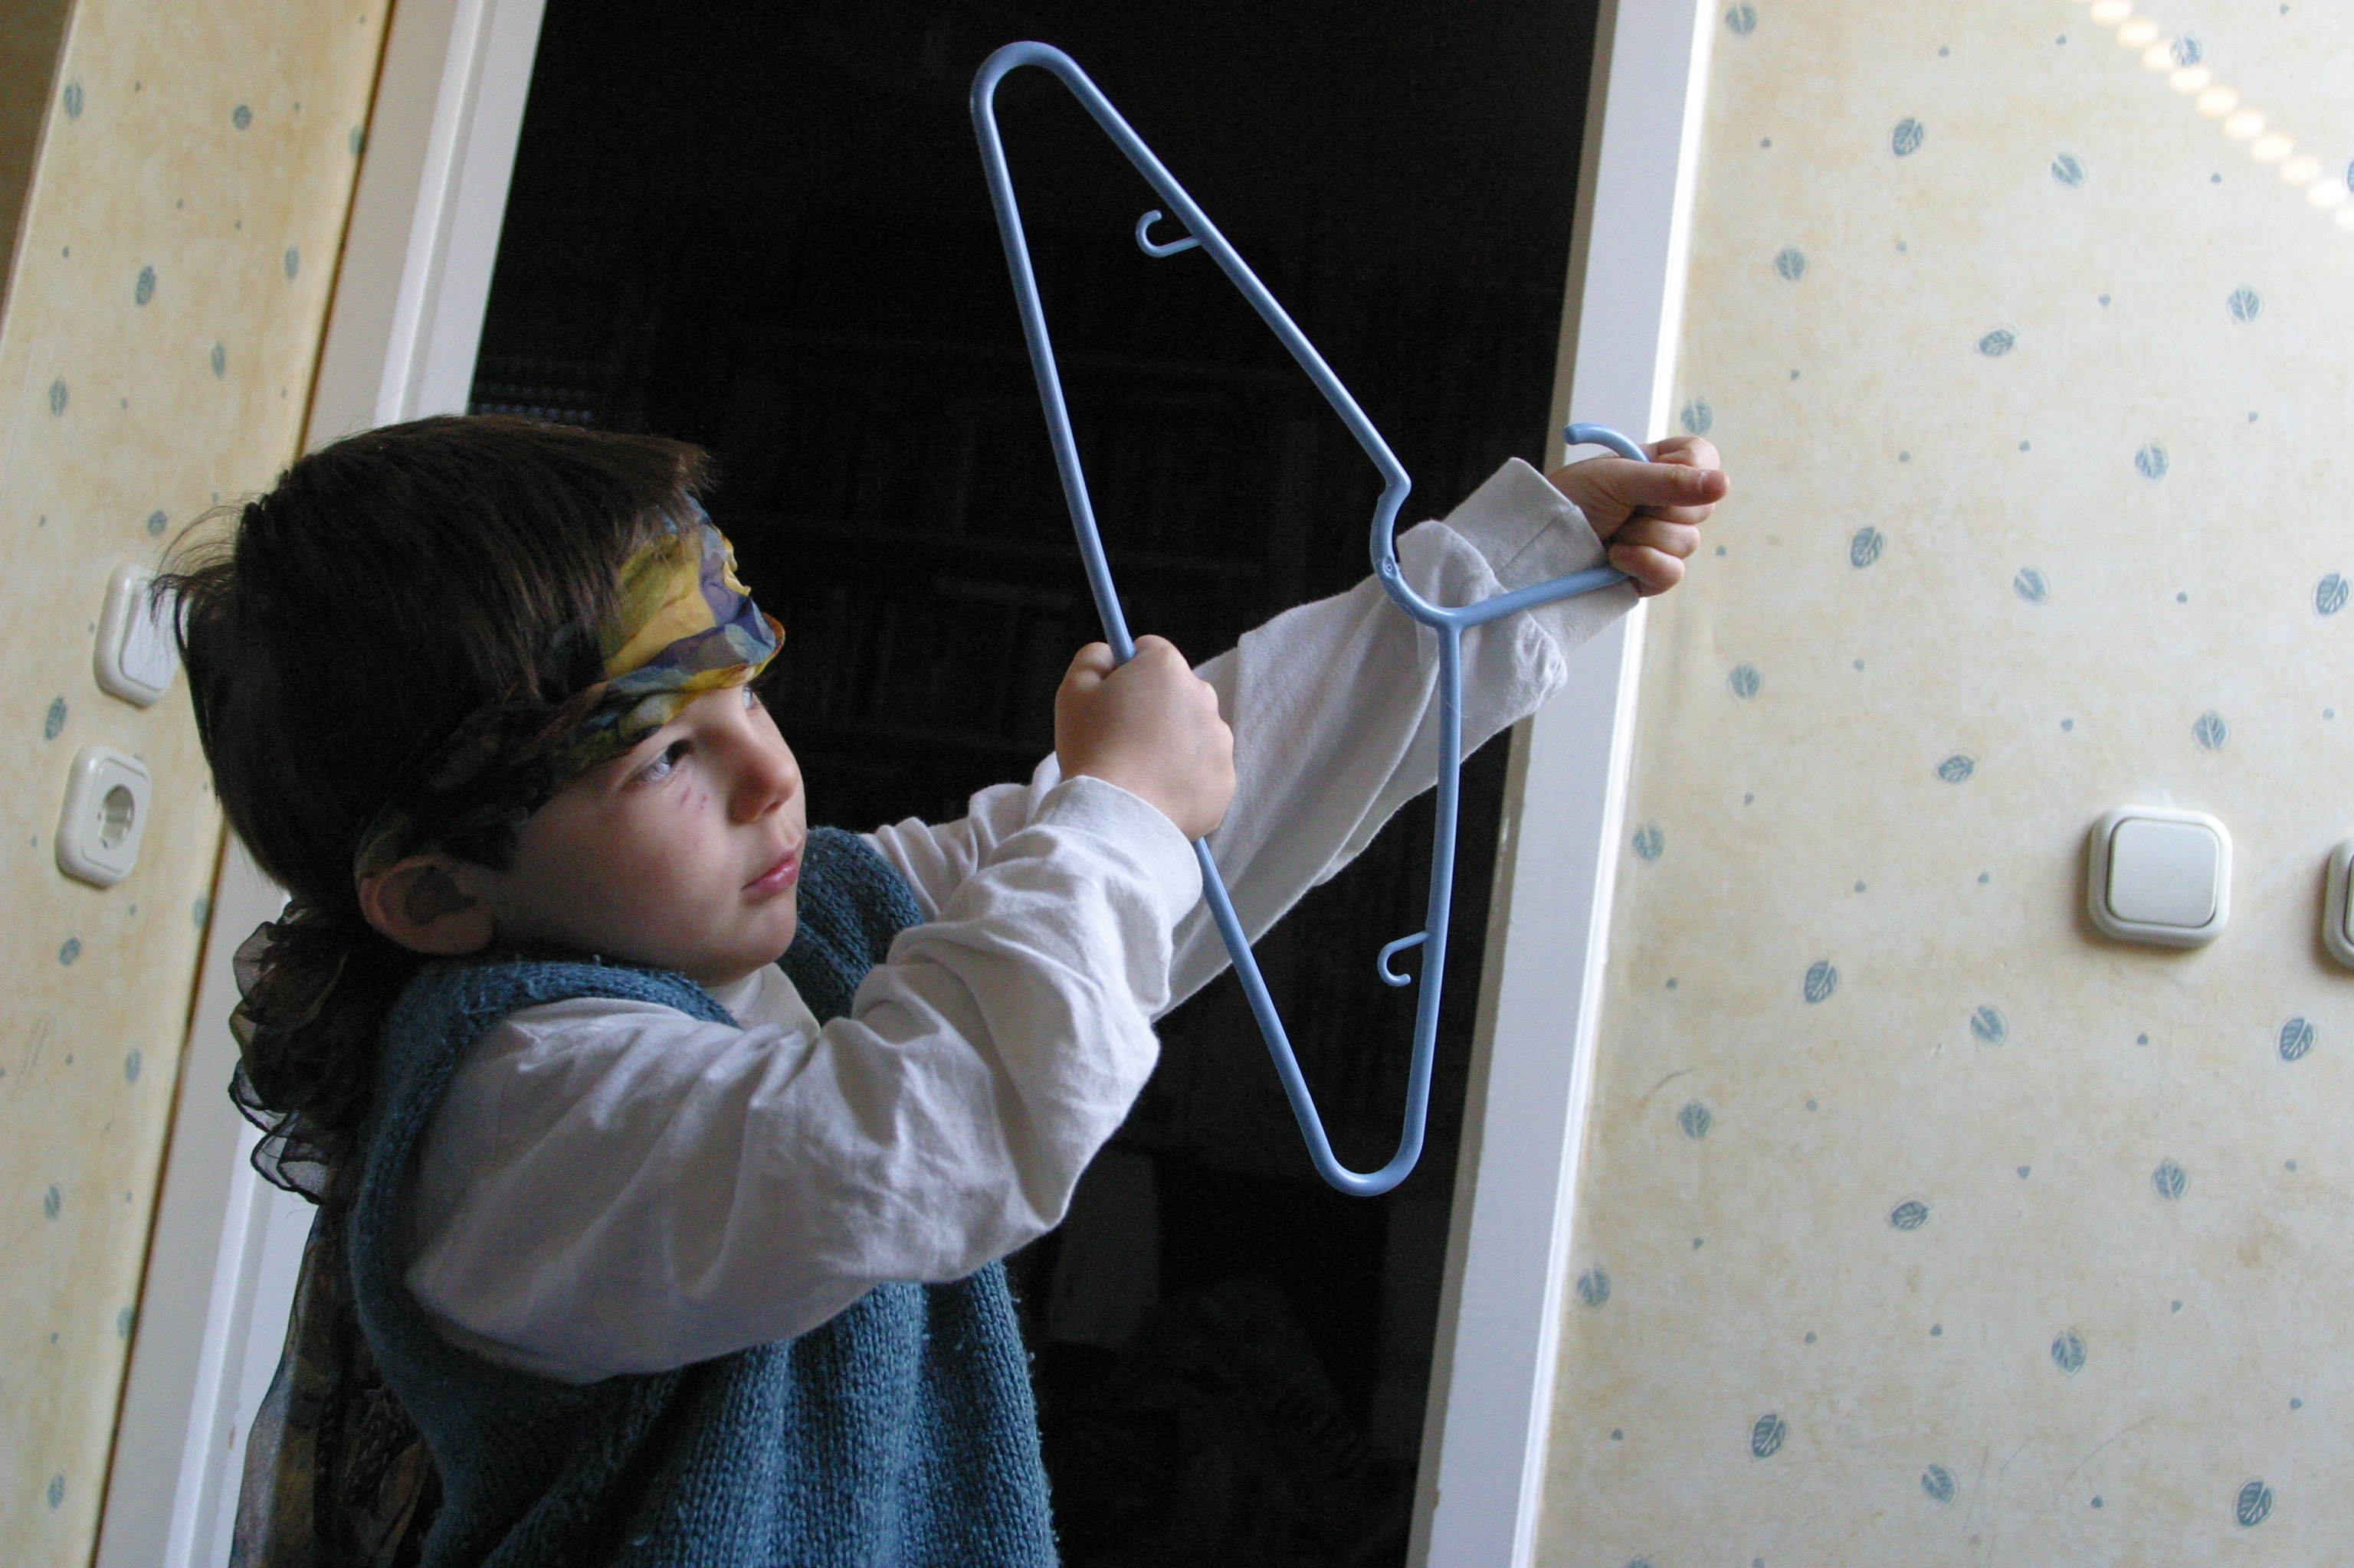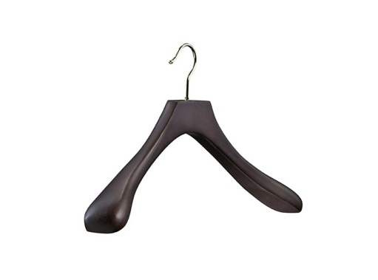

Figure 3c. Coat hanger as arch Figure 3.d. Unfit coat hanger

The ecological framework is an apt theory to account for the flexible, „opportunistic” and coordinated nature of pretend actions and their dependence on the particulars of the situation. The affordance concept is especially useful in accounting for these qualities of pretend object play. James Gibson argued already in his first book (The perception of the visual world, 1950) that physical properties such as color, shape, motion and distance of things are of no interest in themselves for actors. What is important are „use-meanings” of objects that invite actions (cited by Costall, 2012, 86). The concept of affordances makes it possible to account for value-oriented object choices and a fine level of action control in pretense.
Pretend actions take shape as the engagement with pretend objects and play mates unfolds. Pretend object play is embodied and situated and is rooted in prior experience of social routines that have significance for the child. Inasmuch as there is an „action plan” it is not a mental script containing predefined actions but an intention which guides the unfolding of the actions in a situated way (cf. Suchman, 2007). Pretend play is compromise between „how things should be” and „how things can be”. In this tension the child's understanding of the world emerges as perceptually available affordances are taken advantage of, in the particulars of the situation.

3. Pretense and tool use
Pretend object use and tool use have some features in common inasmuch as both employ objects to achieve goals. Conventional tools are artifacts that aid us in achieving a specific material goal that would be otherwise difficult to achieve. Pretend play also relies on objects that aid the child in achieving a goal that would be more difficult to achieve without obects. Objects canalize and support actions, even when not the „proper” object is used. In that regard pretend object use is analogous to unconventional tool use, when, for example, a kitchen tool is used to hammer in a nail. In pretend acts, however, as noted above, it is the action itself, not the result that counts.
Tool use is also a research area that has been dominated by a cognitivist interpretation. Developmental theory conceptualized tool use as a discontinuous developmental achievement requiring a new level of representational skills involving causal thinking (Bates, 1979; Piaget, 1952). In the 1970’s researchers pointed out a connection between object pretend play and subsequent tool use, suggesting that pretense provides opportunities for spontaneous problem solving with minimal frustration what prepares for tool use (Smith and Dutton, 1979). Tool use by humans and animals is generally seen as requiring higher level cognitive abilities. This presents, however, a paradox: the now well documented fact that many primate and nonprimate species demonstrate a high level of tool use would require a high level of cognitive capacity, this is, however, an assumption not easily to be accepted (Lockman and Kahrs, 2017). This is similar to the symbolic ability paradox mentioned earlier (the contradiction that research indicates that children do not understand mental representation until at least around age 4, whereas they engage in pretend play by age 2).
In the 1990’s an ecological action perspective was introduced in research on tool use which took action and action systems as the starting point (cf. (Leuween, Smistman Leuween, 1994; Smistman, 1997; Smitsman and Bongers, 2000). James J. Gibson (1979) elaborated the idea (in line with Merleau-Ponty, 1945/2014) that tools are exemplars of how environmental entities may become part of the behavioral organization of actors. Objects are tools not because of belonging to a semantic category and a linguistic label but because, they extend the capacity of perceiving and acting, when in use. Thereby tools change the boundary between body and environment and enhance the capacities of the action system.
Research along these lines focused on how tool use involves affordance perception embedded in perceiving the complex relationships among actor, tool and target. (Bongers, 2001; Lockman, 2000). Tools focus behaviors and promote the fit of actors to their task environments in more visible ways than tool independent behaviors (Shaw, Flascher, and Kadar, 1993). Studies showed that a tool can change the dynamics of the action system, and new patterns of behavior emerge when the dynamics in the action system change due to a tool (cf. Smitsman and Bongers, 2000).
By showing that there is no need to resort to cognitive problem solving when accounting for tool use, the action perspective offers a way to resolve the tool use paradox.
Rather than considering tool use across species as stemming from a shared set of cognitive abilities, the origins of tool use are to be found in affordance learning (cf. Lockman and Kahrs, 2017). Neither is tool use a discontinuous achievement in ontogenetic development requiring a cognitive leap. Rather, it is a developmental process involving synergy between affordance detection and motor learning. As babies continually explore affordances in their surroundings, they tune their actions that will be incorporated into tool use over developmental time (Kahrs, Jung, and Lockman, 2013; Lockman, 2000).
Conceptualizing tool use as a problem of action development can inform our understanding of pretend object play, as well. Young infants learn to perceive endless possibilities for action with objects while they also learn culturally proper object use. Unconventional object use is arbitrary only when extrinsically viewed, from the intrisic viewpoint of the action it is proper. Objects create new opportunities for action by enhancing, extending, or restoring the action capabilities of the actor and children learn to take advantage of these opportunities. Pretend objects as unconventional tools help focus behavior and this may explain why pretense without objects occurs much less often than pretense with objects: the difficulty lies not in the lack of external cues that would activate the right representation, but in that there is no material basis that would guide and focus the activity.
4. The ecological and the enactive accounts of pretense
The enactivist approach to pretense surfaced in the 2010’s independently of the ecological approach to pretend play, also building on the concept of affordances and with a focus on action (Rucinska, 2014, 2016, 2017, 2019, Rucinska and Reijmers, 2015). Common ground between the ecological and enactive approaches to pretense is evident but incompatibilities also follow from differences in the theoretical fundations.

The ecological and the enactive - two frameworks of embodied cognitive science

Some authors currently suggest that radical embodied cognitive science is split into two camps: the ecological and the enactive (Baggs and Chemero, 2018). These approaches stare at eachother over an „uncanny valley”: in many ways their main proposals are strikingly similar, however, their understanding of action, perception and cognition turn out to be different upon closer inspection (diPaolo, 2016). Major points of divergence relate to the interpretation of the role of sensation and perception as the basis of action and the interpretation of organism-environment relations (elaborated in Read and Szokolszky, 2020).
Enactivism has roots in phenomenology and takes sensorimotor capacities and contingencies as the basis for action. On the enactivist account perception is based on physical changes in sensors (subpersonal level) that are then acted upon as internal states. For example, in the case of a frog seeing and targeting a fly as prey there is an internal correlation between “the place where the retina receives a given perturbation and the muscular contractions that move the tongue, the mouth, the neck, and, in fact, the frog's entire body” (Maturana and Varela, 1988, 126, cited and analyzed in Read and Szokolszky, 2020). This correlation is termed “sensorimotor coordination.” O’Regan and Noe¨ (2001) emphasize that seeing is a way of acting and laws of sensorimotor contingency govern the co-variation between the actions of the organism and resulting changes in the sensory input. Perceptual experience is based on the law of sensorimotor contingency and actors master the sensorimotor know-how of skillfully moving around in the world utilizing these contingencies. Cognitive structures emerge from recurrent sensorimotor patterns (O’Regan and Noe¨, 2001, Preester, 2012).
James J. Gibson was pioneering the idea since the 1960’s that perception is tied to action and gets us in directly meaningful practical touch with the world (a root idea coming from pragmatist philosophy, cf. Van Dijk and Myin, 2019). He emphathetically claimed that perception is not based on the physiological level of sensations and presented a detailed critique of sensation-based approaches. On the ecological account physiology does not constitute perception, it supports it (cf.Shaw and Mace, 2005; Read and Szokolszky, 2018, 2020). Gibson was also careful not to theorize actions as motor responses (Gibson, 1966, 1979). The concept of affordances was introduced to account for directly meaningful, value oriented, organismic level actions – a job sensorimotor capacities are doubtful ever to do. As emphasized, again, by Read and Szokolszky (2020), if perception is defined as a sensorimotor process, then it is carried out by cells. But if perception is defined as direct resonance to relational information, as suggested by the ecological approach, then it is carried out by organisms with the appropriate perceptual and action systems that explore and resonate to useful, directly meaningful relational structures in the world. Also, according to Ecological Psychology perceptual guidence of action and the resultant emergence of cognition is possible not because of sensorimotor dependencies but because of ecological structures specifying affordances in the organism-environment system (Gibson, 1979, 1986; Witt and Riley, 2014).
There are, however, various kinds of enactive approaches and there is growing understanding that ecological psychology and certain kinds of enactivism are mutually supportive (e.g. Chemero, 2003, 2009; Kiverstein and Rietveld, 2018; van Dijk and Myin, 2019a; Szokolszky, Read, Palatinus and Palatinus, 2019). Several embodied and enactive cognition theorists rely on affordances as explanatory tools what shows that the sensorimotor framework is not considered uniformly as a fully satisfactory account for non-representational perception and action. Next we examine how the ecological and enactive approaches to pretense are related and how they can work together in the future.

The enactivist account of pretend play, from the ecological point of view

The enactive view has been formulated over the past years and has been extended to various forms and contexts, such as object pretend play, social pretense, imaginary friends and play therapy (Rucinska, 2014, 2016, 2017, 2019; Rucinska and Rejmijmers, 2014, 2015). The most relevant point is that it builds on affordances, in fact, in recent formulations it seems to assign central importance to affordances when seeking an alternative to representational explanations (Rucinska, 2017). Considering various conceptions of affordances the author argues for a mutualist stance and rejects Varela et al.’s enactivist interpretation which assumes „unequal partnership” between the actor and the environment, with the former being more dominant, and proposes that affordances come into existence only when there is a self-sustaining organism present.
The enactivist proposal emphasizes that affordances are not features of the environment but relational properties that exist for animals as potentials to act, whether or not an actual animal is present (Rucinska, 2017). The concept of „invitation” is introduced in line with recent proposals that add „solicitation” / „invitation” to affordance theory claiming that without these affordances are „mere possibilities for action” (Withagen et al., 2012, 255 ). The idea of solicitation is used in Rietveld and Kiverstein’s (2014) distinction between affordances in the context of the kind of animal (a “form of life”) and its ways of living (its practices). The landscape of affordances encompasses all the action possibilities for a form of life, the field of affordances entails the relevant, available and „inviting” affordances to a particular animal in a given situation.
The enactivist account makes use of these concepts by suggesting that pretense is a re-enactment of established social practices, offered by the human landscape of canonical actions and affordances (culturally preferred functions). Children are enculturated into these routines (e.g. the „talking on the phone”) and acquire a know-how of how to enact them. In the course of play – that is, acting in the field of affordances - the know-how is applied to a novel objects (e.g. a banana used as a phone). It is suggested that „affordances do not specify meanings or contents with conditions of satisfaction (for example, banana’s affordance to be picked up does not directly guide one to play ‘phone’ with it) affordances of the banana dispose us to play ‘phone’ with it due to their affording lifting and placing to one’s ear” (Rucinska, 2016).
The enactivist account also introduces the concept of effectivities defined as dispositions of the actor shaped by histories of interactions: „Affordances have no soliciting power on their own; it is our histories of interacting that form our dispositions, or effectivities, that allow affordances to invite actions” (Rucinska, 2017). Finally, the enactive account adds intersubjective „actualizing contexts” that include other people (adult or child playmates) who may influence, invite or drive behaviors. In sum, to the question, what aspects constitute specific „invitations” in specific pretense siuations, the answer is „multiple agential, environmental and social factors” (ibid., xx), in particular cultural routines, affordance- effectivity pairs, and intersubjective context.
Th enactivits approach to pretense lays out a complex theoretical account that operates with ecological concepts. On the other hand, it builds on O’Regan and Noë’s (2001) sensorimotor theory of perception as a foundation. Even Gibson’s affordances are understood as involving sensorimotor abilities (Rucinska 2014, 2016). Imagination is also included in the nonrepresentational explanatory framework: „The relevant work might be done by sensory imaginings (understood as on-line perceptual activities), which are augmented by sensorimotor skills (O’Regan & Noë 2001)” (Rucinska, 2016, 17). This is in line with sensorimotor theory in which perception is conceived of as a skillful activity partly constituted by implicit knowledge of the correlation between changes in movement and changes in sensation (Noe¨ and Thompson, 2004; O’Regan and Noe¨, 2001). Perception, as well as imagining is dependent on the so-called sensorimotor laws of contingency between movement and sensory input. These laws are suggested to govern the co-variation between actions of the organism and resulting changes in sensory input (cf. De Preester, 2012).
Considering the above, there are clear disagreements between the ecological and the enactive account of pretend which reflect different theoretical roots. In the ecological framework affordances are defined at the ecological level of organism-environment mutuality, not at the sensomotor level. Treating the sensorimotor level as explanatory implies connections among elementary, originally meaningless sensations and motor responses that are irrelevant for the concept of affordances at the ecological level. According to the ecological view sensorimotor skills and contingencies are not up to the job of playing an explanatory role in accounting for directly meaningful perception. Thus, the ecological concepts of affordances and action-perception are not compatible with sensorimotor foundations (Fultot et al, 2016; Read and Szokolszky, 2020).
The enactive account introduces affordances to account for direct perception: „In seeing the banana, we do not impose meaning ‘banana’ on it, but directly see it as affording: eating, grabbing, playing phone with. As such, the banana “means” all these things: it is a food, an object, a toy, with respect to the possibilities of the animal” (Rucinska, 2017 .. ). It seems that enactivism needs the affordance concept to give a coherent embodied accout of nonrepresentational direct perception, however, no coherent theory can be built by attempts to combine the affordance concept and sensorimotor foundations.
Beyond this root difference in theoretical foundations the enactive and the ecological accounts seem to be complementary and mutually supportive in many ways. The enactive view has done a thorough job at challanging various versions of the representational approach (Rucinska, 2014, 2017, 2019) – a task the ecological approach also took upon itself earlier (Szokolszky, 1996, 2006). It has also made advances in laying out several important aspects of pretense, such as its creative and inherently social nature (Rucinska, 2019) – aspects not developed by the ecological account. The enactive account has emphasized the re-enactment of culturally established routines, the ecological approach elaborated the role of intentional actions and noncanonical affordances in accounting for pretend situations. The ecological and the enactive accounts of pretense are staring over the „uncanny valley” from different points but with the positive potential to further promote the articulation of embodied, nonrepresentational theory building, in the area of pretend play.

4. Summary and outlook for nonrepresentational accounts of pretense

Traditionally, pretense is a „representation hungry” problem: it requires that the person thinks that something is something else that is not present. To develop a nonrepresentational approach to pretense is part of the ‘Representation-Hungry Challenge’ defined by Kiverstein and Rietveld (2018). The challenge is to explain how someone could think about things that are not concretely present in their environment other than by means of an internal mental representation. In the case of pretense, what makes it possible to provide explanation without the recourse to mental representations?
The ecological and the enactivist approach agree that we have to look at actions and affordances available in the field and the landscape of affordances. We have to consider the particulars of the socio-material situation that enable pretend actions to unfold under the guidance of the intentions of the child to pretend. These are nascent approaches which need considerable further elaboration both theoretically and empirically. However, they show that it is possible to build theories along these lines which have certain advantages over the representationist approaches. These advantages are as follows.
Puzzles and paradoxes created in the representationist approaches are dissolved. The representational abuse problem is invalid as it is actual only if we assume a conceptual system which is threatened by the flexibility of one concept „arbitrarily” substituted by another. The child does not need to „bypass” correct representations and then apply special mechanisms to keep track of meanings, since relevant meanings and contexts are present in the pretend situation and come forth as pretend actions unfold. Therefore, „the problem of absence” is also dissolved as the child is not responding to absence but presence of context and action possibilities (Rucinska, 2019, see also arguments in the present paper).
The symbolic ability paradox is also eased out since there is no need for a cognitive leap in represetational abilities in explaining genuin and competent pretend play at a young age. Young children are comfortable with dealing functionally with their environment. They are able to see what objects are good for while they have a clear understanding of what their culturally preferred functions are and what semantic categories they belong to.
What we may call the „epistemix paradox” of pretense also becomes moot. The representationist view claims that the more advanced pretense is, the more detached it becomes from perception – and thereby the real world itself. However, if we see pretense not as decontextualization but as creative and imaginative recontextualitzation then it does not remove from the real world but gets in touch with it in flexible ways. Children „get it right” in pretense, because the environment is open ended.
What we may call the „action problem in pretense” is also solved. The representationist approach cannot account for how and why smooth coordination and appropriate choice is possible with unfit substitute objects. In advanced pretend play where object choice is „arbitrary” the child is supposed to act on the basis of mentally stored scripts without perceptual support. This does not explain how adapted action is possible to actual objects in pretense. In natural pretend play there is no sign of problem solving. Inasmuch as actions are smooth and prompt it is, arguably, because affordances present perceptual support for the actions. Affordances also solve the unconstrained arbitrariness problem. The representionist view does not suggest any limit on arbitrariness – the more arbitrary object choice is the more advanced is pretend play. However, even „arbitrary” object choices are constrained by affordances and action skills. Even a sock can be a revolver (as in the example above, Figure 3b), if rightly held, however, a ball or a chair cannot be a revolver. A theory that relies on dynamic affordance based actions has conceptual resources to deal with constraints on substitute actions.
Both the ecological and the enactive approaches to pretense are part of larger concerted efforts in the direction of nonrepresentational cognitive science. Pretense is a limited, nonetheless important area of academic interest which received extensive theoretical and empirical treatment in past decades. Ecological and enactive approaches have shown that it is possible to challange accepted interpretations and seek explanatory frameworks that could move the field in new directions.

REFERENCES

Amabile, T. (1996). Creativity in context: Update to “the social psychology of creativity”. Cambridge, MA.: Harvard University Press

Baggs, E., and Chemero, A. (2018). Radical embodiment in two directions. Synthese, 1-16.

Bates, E. (1979). The biology of symbols: Some concluding thoughts. In E. Bates, I. Benigni, L. Camaioni, and V. Volterra (Eds.), The emergence of symbols: Cognition and communication in infancy (pp. 315–370). New York: Academic Press

Chemero, A. (2003). An outline of a theory of affordances. Ecological psychology, 15(2), 181-195.

Chylińska, M., and Gut, A. (2020). Pretend play as a creative action: On the exploratory and evaluative features of children’s pretense. Theory & Psychology, (30)4, 548-566.

Costall, A. (1995). Socializing affordances. Theory & Psychology, 5(4), 467-481.

Costall, A. (2012). "Canonical affordances in context." AVANT. Vol.III no.2. 85-93.

Costall, A. (2003). From direct perception to the primacy of action: A closer look at James Gibson's ecological approach to psychology. In G. J. Bremner, A.M. Slater, Eds.Theories of infant development: 70-89. Oxford: Blackwell.

Costall, A., Dreier, O. (2006). Introduction. A. Costall, O. Dreier, (Eds.), Doing things with things: The design and use of everyday objects: 1-12. London: Ashgate.

Costall, A. and Dreier. O (Eds.), (2006). Introduction Doing things with things: The design and use of everyday objects (pp.1-12 ) London, UK: Ashgate Publishing�.

Currie, G. (2006). Rationality, decentring, and the evidence for pretence in non-human animals. In Hurley, S., Nudds, M. (eds.) Rational Animals? Oxford University Press, Oxford

Dent-Read, C. H. (1997). A naturalistic study of metaphor development: Seeing and seeing as. In C. E. Dent-Read & P. E. Zukow-Goldring (Eds.), Evolving explanations of development: Ecological approaches to organism–Environment systems (255–296). Washington, DC: American Psychological Association.

De Preester, H. (2012). The sensory component of imagination: The motor theory of imagination as a present-day solution to Sartre's critique. Philosophical Psychology, 25(4), 503-520.

Di Paolo, E. A. (2016). Across the Uncanny Valley: The Ecological, the Enactive, and the Strangely Familiar. Constructivist Foundations, 11 (2) 327-329.

Fajen, B. R. (2007). Affordance-based control of visually guided action. Ecological Psychology, 19(4), 383-410.

Fehr, K. K., & Russ, S. W. (2016). Pretend play and creativity in preschool-age children: Associations and brief intervention. Psychology of Aesthetics, Creativity, and the Arts, 10(3), 296-301.

Fultot, M., Nie, L., & Carello, C. (2016). Perception-action mutuality obviates mental construction. Constructivist Foundations, 11(2). 298-307.

Gibson, J.J. (1962-64). On Exploratory vs. Performatory Manipulation and the Experiments being Performed to Distinguish Them Purple Perils, Cornell University https://commons.trincoll.edu/purpleperils/1962-1964/on-exploratory-vs-performatory-manipulation-and-the-experiments-being-performed-to-distinguish-them/ (Accessed Nov.01.2020.)

Gibson, J. J. (1966). The Senses Considered as Perceptual Systems. Boston, MA: Houghton Mifflin.

Gibson, J. J. (1982). Notes on affordances. In: Reasons for realism: Selected essays of James J. Gibson. Lawrence Erlbaum Assoc Incorporated. Hillsdale, N.J.: Erlbaum

Gibson, J. J. (1979/2014). The Ecological Approach to Visual Perception. (Boston, MA: Houghton Mifflin).

Gibson, E. J., and Pick, A. (2000). An Ecological Approach to Perceptual Learning and Development. New York, NY: Oxford University Press.

Heft, H. (1990). Perceiving affordances in context: A reply to Chow. Journal for the Theory of Social Behaviour, 20(3), 277-284.

Heras-Escribano, M. (2019). The philosophy of affordances. London, United Kingdom: Palgrave Macmillan.

Hodges, B. H., & Baron, R. M. (2007). On making social psychology more ecological and ecological psychology more social. Ecological psychology, 19(2), 79-84.

Hoff, E. V. (2013). The relationship between pretend play and creativity. The Oxford handbook of the development of imagination, 403-416.

Hopkins, E. J., Smith, E. D., Weisberg, D. S., and Lillard, A. S. (2016). The development of substitute object pretense: the differential importance of form and function. Journal of Cognition and Development, 17(2), 197-220.

Kahrs, B. A., Jung, W. P., and Lockman, J. J. (2013). Motor origins of tool use. Child development, 84(3), 810-816.

Kiverstein, J. D., and Rietveld, E. (2018). Reconceiving representation-hungry cognition: an ecological-enactive proposal. Adaptive Behavior, 26(4), 147-163.

Kiverstein, J., van Dijk, L., & Rietveld, E. (2019). The field and landscape of affordances: Koffka’s two environments revisited. Synthese, 1-18.

Koffka, K. (1935). Principles of Gestalt psychology New York: Harcourt, Brace, & World.

Kugler, P. N., Shaw, R. E., Vincente, K. J., & Kinsella-Shaw, J. (1990). Inquiry into intentional systems I: Issues in ecological physics. Psychological Research, 52(2-3), 98-121.

Lillard, A. S. (2015). The development of play. In Lerner (Ed.) Handbook of child psychology and developmental science, Ch.11., 425-468.

Lillard, A. S. (1993). Young children's conceptualization of pretense: Action or mental representational state? Child Development, 64, 372-386.

Lillard, A. S., Lerner, M. D., Hopkins, E. J., Dore, R. A., Smith, E. D., Palmquist, C. M. (2013). The Impact of Pretend Play on Children’s Development: A Review of the Evidence. Psychological Bulletin, 139, 1–34.

Lillard, A. (2001). Pretend play as twin earth: A social-cognitive analysis. Developmental Review, 21(4), 495–531.

Lobo, L., Heras-Escribano, M., and Travieso, D. (2018). The history and philosophy of ecological psychology. Frontiers in Psychology, 9, 2228.

Lockman, J. J. (2000). A perception–action perspective on tool use development. Child development, 71(1), 137-144.

Lockman, J. J., & Kahrs, B. A. (2017). New insights into the development of human tool use. Current directions in psychological science, 26(4), 330-334.

Loveland, K. A. (1991). Social affordances and interaction II: Autism and the affordances of the human environment. Ecological psychology, 3(2), 99-119.

Mace, William M. "James J. Gibson's ecological approach: Perceiving what exists." Ethics and the Environment 10, no. 2 (2005): 195-216

Merleau-Ponty, M. (1945/2014). Phenomenology of Perception. Milton Park, Routledge

Noë, A., & Thompson, E. (2004). Are there neural correlates of consciousness?. Journal of Consciousness studies, 11(1), 3-28.

Nichols, S., & Stich, S. (2003). Mindreading: An Integrated Account of Pretence, Self-Awareness and Understanding of Other Minds. Oxford, UK: Oxford University Press.

O’Regan, J. K., and Noë, A. (2001). A sensorimotor account of vision and visual consciousness. Behavioral and Brain Sciences, 24(5), 939–1031.

Piaget, J. (1952). The origins of intelligence in children. New York, NY: W.W. Norton

Piaget, J. (1962). Play, dreams and imitation in childhood. New York: Norton.

Read, C., and Szokolszky, A. (2016). A developmental ecological study of novel metaphoric language use. Language Sciences, 53, 86-98.

Read, C., and Szokolszky, A. (2018). An emerging developmental ecological psychology: future directions and potentials. Ecological Psychology, 30(2), 174-194.

Read, C., and Szokolszky, A. (2020). Ecological Psychology and Enactivism: Perceptually-Guided Action vs. Sensation-Based Enaction. Frontiers in Psychology, 11.

Rietveld, E., & Kiverstein, J. (2014). A rich landscape of affordances. Ecological Psychology, 26(4), 325-352.

Rucinska, Z. (2014). Basic pretending as sensorimotor engagement?. In Contemporary sensorimotor theory (pp. 175-187). Springer, Cham.

Rucińska, Z. (2016a). Enactive mechanism of make-belief games. In Digital make-believe (pp. 141-160). Springer, Cham.

Rucińska, Z. (2016b). What guides pretence? Towards the interactive and the narrative approaches. Phenomenology and the Cognitive Sciences, 15(1), 117-133.

Rucińska, Z. (2017). The role of affordances in pretend play. Embodiment, enaction, and culture: Investigating the constitution of the shared world, 257-278.

Rucinska, Z., and Reijmers, E. (2015). Enactive account of pretend play and its application to therapy. Frontiers in Psychology, 6, 175.

Rucińska, Z. (2019). Social and Enactive Perspectives on Pretending. AVANT. Pismo Awangardy Filozoficzno-Naukowej, (3), 1-27.

Shaw, R. (2011). Ecological realism as a reaction to new realism: Holt’s legacy to Gibson. In E. P. Charles (Ed.), A new look at new realism: The psychology and philosophy of EB Holt (pp. 157–190). New Brunswick, NJ: Transaction.

Shaw, R., and Mace, W. (2005). “The value of oriented geometry for ecological psychology and moving image art,” in Moving Image Theory: Ecological Considerations, eds A. Anderson and B. Anderson (Carbondale, IL: Southern Illinois University Press).

Shaw, R. E. Turvey, M. T., & Mace, W. (1982). Ecological psychology: The con- sequences of a commitment to realism. In W. Weimer & D. Palermo (Eds.), Cognition and the symbolic processes (Vol. 2.). Hillsdale, N.J.: Erlbaum

Singer, D. G., and Singer, J.L. (1990). The house of make-believe: Children’s play and the developing imagination. Cambridge, MA: Harvard University Press.

Smith, P. K., and Dutton, S. (1979). Play training in direct 84 and innovative problem solving. Child Development, 50, 85 830–836.

Smitsman, A. W. (1997). The development of tool use: Changing boundaries between organism and environment In: Dent-Read, C. E., & Zukow-Goldring, P. E. (1997). Evolving explanations of development: Ecological approaches to organism–environment systems (297-330). American Psychological Association. 301-330.

Smitsman, A., and Bongers, R. (2003). Tool use and tool making: A developmental action perspective. Handbook of developmental psychology, 172-193.

Stapleton, M. (2016). Enactivism embraces ecological psychology. Constructivist Foundations, 11, 325-327.

Suchman, L. A. (2007). Plans and situated actions: The problem of human-machine communication. Cambridge university press.

Szokolszky, A. (1996). Using an object as if it were another: The perception and use of affordances in pretend object play. CT, USA: University of Connecticut. UNI order number: AAM9605501 Dissertation Abstract International: SectionB: The Sciences and Engineering.

Szokolszky, A. (1997). Using An Object As If It Were Another: The Perception And Use Of Affordances In Pretend Object Play. In Schmuckler, M. A., & Kennedy, J. M Studies in Perception and Action IV: Ninth Annual Conference on Perception and Action (p. 153). Psychology Press.

Szokolszky, A. (2006). Object use in pretend play: Symbolic or functional? In A. Costall & O. Dreier (Eds.), Doing things with things: The design and use of everyday objects (pp. 67–86).London, UK: Ashgate Publishing�.

Szokolszky, (2013). Schmuckler, M. A., and Kennedy, J. M., May). Using An Object As If It Were Another: The Perception And Use Of Aﬁ ‘ordances In Pretend Object Play. In Studies in Perception and Action IV: Ninth Annual Conference on Perception and Action (p. 153). Psychology Press.

Szokolszky, A. (2019). Perceiving metaphors: An approach from developmental ecological psychology. Metaphor and Symbol, 34(1), 17-32.

Szokolszky, A., and Read, C. (2018). Developmental ecological psychology and a coalition of ecological–relational developmental approaches. Ecological Psychology, 30(1), 6-38.

Szokolszky, A., Read, C., Palatinus, Z., & Palatinus, K. (2019). Ecological approaches to perceptual learning: learning to perceive and perceiving as learning. Adaptive Behavior, 27(6), 363-388.

Turvey, M. T. (1992). Affordances and prospective control: An outline of the ontology. Ecological psychology, 4(3), 173-187.

Turvey, M. T., Shaw, R. E., Reed, E. S., & Mace, W. M. (1981). Ecological laws of perceiving and acting: In reply to Fodor and Pylyshyn (1981). Cognition, 9(3), 237-304.

Van Dijk, L., and Myin, E. (2019). Reasons for pragmatism: affording epistemic contact in a shared environment. Phenomenology and the Cognitive Sciences, 18(5), 973-997.

Webster, D. (2020). Prefatory Notes to Kiverstein, van Dijk and Reitveld (2019) "The field and landscape of affordance: Koffka's two environments revisited” Online at: www.academia.edu/39221865 Date retrieved 4/21/2020

Weimer, W. B., & Palermo, D. S. (Eds.) (1982). Gibson-Shaw Discussion. Cognition and the Symbolic Processes, Vol. 2, 229. Hillsdale, NJ: Erlbaum, 227-239.

Withagen, R., De Poel, H. J., Araújo, D., & Pepping, G. J. (2012). Affordances can invite behavior: Reconsidering the relationship between affordances and agency. New Ideas in Psychology, 30(2), 250-258

Van Leeuwen, L., Smitsman, A., and van Leeuwen, C. (1994). Affordances, perceptual complexity, and the development of tool use. Journal of Experimental Psychology: Human Perception and Performance, 20(1), 174.

Varela, F.J., Thompson, E.and Rosch, E. (1991).The embodied mind: Cognitive science and human experience, Boston: . MIT Press.

Vygotsky, L. S. (1976). Play and its role in the mental development of the child. In J. S. Bruner, A. Jolly, & K. Sylva (Eds.) Play - Its role in development and evolution . New York: Basic Books, Inc. 538-554.

Witt, J. K., & Riley, M. A. (2014). Discovering your inner Gibson: Reconciling action-specific and ecological approaches to perception–action. Psychonomic Bulletin & Review, 21(6), 1353-1370.

Zukow, P. G. (1984). Criteria for the emergence of symbolic conduct: When words refer and play is symbolic. In L. Feagans, C. Garvey and R. Golinkoff (Eds.), The origins and growth of communication. New York: Ablex.

Agnes Szokolszky’s PhD dissertation, titled „Using an object as if it were another: The perception and use of affordances in pretend object play” was submitted at the Center for the Ecological Study of Perception and Action (CESPA), at the University of Connecticut, in 1996. Her thesis advisor was Catherine Read.
Gibson used the term “information” for the structure in ambient light, but this is unfortunate due to the semiological implications of this term (cf., Jones and Read, in press). Therefore, we do not use this term which implies coding and communication.
The full sequnce was not described in this publication.
(Various points of convergenes and divergences were discussed in the 2016 special issue of Constructivist Foundations and, in an issue of Frontiers of Psychology, Theoretical and Philosophical Psychology, in 2020).
Withagen et al. (2012) – this is move beyon Gibson, however, it is going back to Lewin ...

