On the Reconciliation Between Infinity and Zero

Or, Would a Model of Creation Based Principally on ‘General Uncertainty’ Describe Another ‘Theory of Everything’ Based upon Nothing?

by Louis Charles Taylor

July 25th, 2016 Amended August 18th, 2016, Further Amended October 11th, 2016, December 19th, 2016, January 13th, 2017, January 20th, 2017, Further Amended August 2/3/5/6/9, 2019, Further Amended August 15, 2019, Further Amended August 20/21/22, 2019, Further Amended May 14, 2020, Further Amended November 22nd and 23rd, 2021, February 28th , March 1st, March 9th/10th/11th, March 15th/16th/17th and 28th, April 4th/5th, 8th, 15th, 22nd, 25th, May 23rd, 24th, 26th and 30th and June 3rd, 15th/16th/17th, October 24th, November 22nd/23rd and December 14th and 29th, 2022 and March 9th and 16th, 2023 and September 17th, 2023 and October 4th and 23rd/25th, 2023 and February 12th, 2024 and March 13th, 15th, and 25th, 2024.

[Truly, you are a God who hides himself, O God of Israel, the Savior.](https://www.biblegateway.com/passage/?search=Isaiah+45%3A15&version=ESV)

Isaiah 45:15 ESV

[It is the glory of God to conceal things, but the glory of kings is to search things out.](https://www.biblegateway.com/passage/?search=Proverbs+25%3A2&version=ESV)

Proverbs 25:2 ESV

[And to bring to light for everyone what is the plan of the mystery hidden for ages in God, who created all things,](https://www.biblegateway.com/passage/?search=Ephesians+3%3A9&version=ESV)

Ephesians 3:9 ESV

“[Can you find out the deep things of God? Can you find out the limit of the Almighty?](https://www.biblegateway.com/passage/?search=Job+11%3A7&version=ESV)“

Job 11:7 ESV

"[God is an infinite sphere, whose center is everywhere, and whose circumference is nowhere](http://www.artandpopularculture.com/God_is_an_infinite_sphere_whose_center_everywhere_and_whose_circumference_is_nowhere)."

Is the cosmos really empty? How should we view the realm in which we exist?  Are the natures of mass and energy, their compositions and relationships with each other the fundamental key to the understanding of everything or is it something else?

Some thoughts from a curious skeptic’s point of view on the true nature of the realm we really inhabit with some basic mathematical description of the relationship between the finite and the absolute as we are capable of understanding it.

Forward:

With respect to the precedence of the concepts presented and discussed below some credit needs to be given to author Lyle D Jacobson for his book 'discovery of nothing' published in 1998. He was the first person I had heard of who was suggesting that the key to understanding everything wasn't based upon either matter or energy but motion. The earliest proponent of this line of theoretical reasoning that I know of was Dewey B Larson whose pioneering work, 'The Structure of the Physical Universe' first proposed his fundamental unifying thought-model of the universe and Creation based around motion back in 1959. This was elaborated upon in his later works, 'Nothing But Motion' (1979) and 'The Universe of Motion' (1984) which expounded his 'Reciprocal System of Physics and Philosophy'. These ideas have since been developed further by other like-minded, intrepid theoreticians in the development of a '[New System of Physical Theory'](http://www.lrcphysics.com/larsons-new-system-of-physical/).

The work I present here is not so elaborate as to expound on any existing theoretical constructs and ideas that have already been established within this or any other alternative models. I would contribute only in suggesting a fundamental re-evaluation of basic concepts such as the assumptions as to what is being referred to as 'motion' and 'time'. This paper does not thoroughly establish the mathematical proof for another alternative theory, it only suggests what the basic concepts that form the Foundation for any correct theoretical framework *should* be based upon along with the basic mathematical relationships that seem to support them. Perhaps the theoretical construct which constitutes the foundation of the Reciprocal System hasn't been reduced sufficiently in that system of thought to find the correct fundamental concept to base everything on? If I might suggest, "hasn't that model grown a bit more obtuse than it should have?" "Why do you still need to represent 'time' and 'space' as separate entities?" "Aren't they the same thing?" "How about 'motion' and 'time'?" "How does their distinction represent a better way of describing the world than using 'Space' vs 'Matter'?" "Maybe those are equivalent as well?" How about Uncertainty? Perhaps that is what carries inherently the key to distinguish and subdivide everything all the way up to infinity into finite values..

I don't mean to engage petty criticism over trivial details. Basing everything on motion is at least a step in the right direction as far as it goes. Having the number 'one' be The fundamental irreducible value would also *seem* like a great idea. Seems natural, right? "It is a fundamental unit conceptually as well as physically which also fits it's mathematical representation." Seems like a great idea. But that's where the problems start. In the real world, when you get down to the granular level in our universe you don't find a bunch of hard 'ones' and 'zeros'. Instead, things become fuzzy and uncertain. You begin to no longer speak of zero and one but of probability and quantum mechanics. Does this system really represent the best way of successfully resolving the Xeno paradoxes as far as subdivision is concerned? By just putting a hard stop at the number one? That's like simply saying, "Sorry Xeno, can't go past this number in our model.." Xeno would probably just draw a perpendicular slash right through the one dimensional representation of that number’s segment on the number line where it is represented and remark, "Rules are meant to be broken.."

Where the Reciprocal System also fails in representing a theoretical composition that is consistent with critical reason is in saying everything in the finite universe is, in fact, Absolute. Absolute? Seriously?? Even I can figure out how this could mess up the mathematical representations of certain major concepts big time. Just from a personal standpoint, the whole purpose I began this range of inquiry followed my taking Pre-Calculus back in 1992. In one lecture, I learned the true mathematical relationship between the finite and the infinite which I always thought of as the quantitative expression of God. I learned that no matter how big the finite gets, no matter how close to infinity it grows it will always be finite and the ratio will never be more than the limit as x approaches zero in direct comparison with the absolute value of infinity. This was wholly consistent with the concept of our relationship with the divine as conveyed in my religious instruction and my understanding of this fundamental truth merely confirmed and reinforced this concept. I can’t believe that we would really want to callously discard this profound truth from our mathematical model. Instead I would say, “Theoreticians, unburden yourselves of unnecessary complications. Free yourselves from the false intellectual tyranny of 'false dichotomies'.” The only meaningful dichotomy is between zero and infinity because all physical theory is finally going to be based on the language of mathematics and the final quantitative dichotomy in math is between zero and infinity. That's it. That's all the dichotomy for explaining ‘the Everything’ that you need. The only thing left is to decide how to divide it and create finite segments. That is what Uncertainty is for..

Proposal:

The conceptual framework upon which all that exists is based should not be defined by Mass or Energy but Motion and relative state of motion in all four dimensions in which we directly inetract. But Motion, in turn, is a spatial representation of what I will refer to for this discussion as ‘Uncertainty’ which manifested as the change in location in our three spatial dimensions over time. Motion is appreciated as a discrete distance traveled in any of the spatial dimensions generally regarded as Distance (D) with respect to a discrete elapsed period of time (T) in the fourth dimension:

D / T = the separation between points or the physical measure of the *discrepancy* between two points in 3D space / 4th Dimensional Uncertainty = Active Motion in the 3rd/4th dimensions described as Velocity

The Principle Dichotomy of Creation

Imagine a single infinitely small point of value zero. If it is Absolute and constitutes all of creation then it is the same as Infinity. Both are Absolutes and in this context of the same magnitude.

You can think of the Absolute as Zero and Infinity combined (pretty much God)

If the condition of Certainty in this realm is 100% then it is static and non-changing like a sculpture. There is no such thing as time.

Now imagine you introduce what I’m going to term **General Uncertainty**. How does it manifest itself?

In space:

You now have point A Zero * ----------- * point B Infinity

Where the distance between zero and infinity on the line or the Separation between them is General Uncertainty. The greater the separation, the greater the uncertainty.

Now you have separated Infinity and Zero by this uncertainty and created. In this realm a point can occupy any hypothetical location within this range of positions.

The Realm of the Finite, or The Realm of the Conditional

To further develop these concepts from a point of Genesis, imagine a single point. Imagine that point represents everything and nothing; both infinitely small and all inclusive. That is the nature of an Absolute.



Now imagine that you throw in ***general uncertainty***; the *possibility* of something beyond..

🡨general uncertainty

Now you can conceptualize that point as having an imaginary field of something beyond to expand into.

Then we decide that there is more than that point, how do we represent it? We decide to draw a line extending from the (origin) that we arbitrarily specified: 0__?)

Then we define that distance or line segment as The fundamental unit of finite measure. We call it: one

0______1 With what we just created we have everything we need to describe what we call a dimension. Conceptually, we’ve created a distinction and said the difference between points zero and one are this line segment. This line segment, as well as the finite point one by itself, we might think of as representing ‘certainty’ to the extent that we can say, something finite equals itself mathematically, or 1 = 1, This is the closest we get to identifying anything ‘absolute’ within our finite realm and unfortunately, the ‘point’ ‘1’ is entirely conceptual. Nothing within our actual physical realm approaches this finality of definition, certainly not the particles that are supposed to physically define our material ‘existence’.

|  |  |
| --- | --- |
|  | The behavior as finite values go from one to zero between these two values can be expressed as the equation f(x) = 1 / x. If we look at it’s behavior as values of x go from plus or minus 1 towards zero using the limits lim as x -> 0+ and the lim as x -> 0- we can observe on a graph how the y values diverge to both positive and negative infinity. |

In mathematics this divergence indicates that the value is ‘undefined’.. In this discussion I would prefer to label this divergence a measure of General Uncertainty.

This fundamental finite increment that we created we may call 'one'. It may be 'bigger' or 'smaller' but we settle on it as the basis of how we segment everything else in our finite realm.

We can now extend that increment of separation or 'line' indefinitely in order to represent the relationship between that origin point and infinity that was separated initially by uncertainty. This now defines a simple spatially defined numeric relationship between the finite and the Absolute in its most basic form: the number line

________________________________> Just keep multiplying that fundamental increment indefinitely >

0 1 2 3 4 5 6 7 8 9 10 11 12 .etc to the maximum of general uncertainty that this 3 1/2 dimensional realm allows (we will be discussing this universal limit of the magnitude of general uncertainty further on)

You now have (point A = Zero) * ---------🡪 * (point B = Limit as x increases without bound) where the line between them is General Uncertainty

Now you have separated Infinity and Zero by this general uncertainty and created The Realm of the Finite, The Realm of the Conditional. You also have a general uncertainty in your realm or condition of existence that you and I literally experience 'cumulatively': This is 'Time'. This can be the General Uncertainty in whatever dimension lies 'above' your realm of 'spatial' existence.

Positive and Negative Dichotomy vs Polarity?

“Oh no, aren’t we forgetting something? What about the negative side of the graph? Doesn’t it’s relationship with respect to the positive side represent a second fundamental dichotomy?”

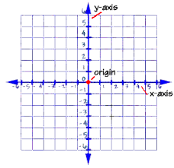

We can see that when we draw a graph and then intersect it to specify the arbitrary zero point that we designate as our origin that we get an identical line in the opposite direction. This does not represent another dichotomy however, but only an extension of the polarity of the origin that we defined. If we approach the origin from the left all values are negative. If we approach the origin from the right, all values are positive. So what is the origin, Positive or Negative?

I would suggest that when the Absolute that we specified above was split macrocosmically we also split zero as well since they are the same when they are the Absolute. This means that the division must also be expressed microcosmically at each and every origin that can be specified. That means that the granular origin should in fact be polarized and have a positive and negative side. This extension of Uncertainty all the way down to zero should be reflected at granular level of the finite realm in which we inhabit as a polarization of individual bits of ‘empty’ space as well as the fundamental particles that we define or observe such as ‘preons’ or whatever term for the smallest granular bit of material existence there is. Polarity is an expression of the effect of uncertainty in its most fundamental and miniscule form upon it. **Not** necessarily *polarity of charge* but rather *a fundamental distinction across a single dimension*.

We see this polarity manifested more plainly into the macrocosm in certain forces such as magnetism where you have a ‘positive’ and ‘negative’ side. As with the number line, this polarity is amplified when all the bits are ordered and aligned with respect to each other. In the case of a magnet the bits or ‘domains’ are all aligned in 3 dimensions with the north poles and south poles all pointing in the same directions along parellell axes so that their collected polarities are directed in unison.

<*********************************************************************************************************************>

Summary Notation for these General Concepts/Constructs:

1. The condition of the Absolute is reached when Infinity and Zero are equivalent and unified
2. The separator of this Absolute condition in which Infinity and Zero are unified I refer to as being General Uncertainty
3. The condition created when Infinity and Zero are separated by General Uncertainty is the realm of finite values, our finite universal realm within Creation.
4. The manifestations that we see of General Uncertainty are three dimensions of motion and another dimension of motion that we experience as ‘time’
5. **Additionally, it is suspected that all other manifestations of the ‘granularity’ of our universe, all of its particles and fields are representations of this motion in accordance with the theories of the so-called ‘aether’. In any case, each of these granular bits that make up our cosmic realm has an inherent polarity/*’property of separation’* across any dimension reflecting the fundamental division that General Uncertainty affected all the way down to the most finely specified detail.

<*********************************************************************************************************************>

Definition of the Absolutes as Quantitative Values: 0 and Infinity

Both are inversely related to each other. For us finite beings we often use limits to describe and determine the behaviours of the Absolutes of Creation.

It is the relationship between these that we deal with the nature of Xeno's paradoxes of infinity and infinite subdivision.

lim 1 / x lim 1 / x Therefore we might say lim 1 / x = 0 + Δ(plus a little bit extra)

x -> +∞ approaches zero x -> -∞ also approaches zero mathematically x -> ∞

But this is like saying finite values are next to nothing compared to the absolute magnitude of infinity. The fact that even in the face of the absolutes we finite creatures *exist*. None of us are equivalent to the quantitative inverse value of absolute magnitude zero. In this case, even though the limits converge we cannot say if the little extra remaining is positive or negative. Therefore we say the actual value of 1 / ∞ is *indeterminate*

We can demonstrate the applicability of this with another limit equation that demonstrates the limit of applicability of the ‘*determined*’ value for 1 / ∞

If you think about what the value of ∞ X 0 should be you think that it’s just adding nothing an unlimited number of times which should add up to 0. But if we try and use the above limit to determine it we get

lim 1 / x lim x However, lim x times 1 / x = x / x = 1

x -> ∞ approaches zero x -> ∞ approaches ∞ mathematically x -> ∞ not zero

At first, you would think 0 times ∞ is equal to 0 since counting something NO times will equal nothing, however that depends on the equation that you use to try and determine the limit from:

Lim x times 1/x2 Lim x times 1 / xLim x times 1 / x2 (the square root of X)

X -> ∞ approaches 0 X -> ∞ approaches 1 X -> ∞ approaxches ∞

In the first case the count approaches 0, in the second it approaches 1 and in the third it approaches ∞. The only difference here is in the pattern of the counting or in exactly *how* the counting is done.

It is in this context that we evaluate the following relationships:

Constant/Conditional/Finite value Constant/Conditional/Finite value

--------------------------- Approaches ---> Zero Approaches --> Infinity ------------------------------

Limit as X --> Infinity Limit as X --> Zero

However... There is literally and mathematically an *absolute distinction* between 0 and the Limit as X ---> 0 and Infinity and the Limit as X approaches --> Infinity.

The Limit as X approaches--> Infinity

------------------------------------- = *approaches* Zero *approaches* represents the finite uncertainty from our

(Absolute) Infinity finite point of view

*Approaches* is in the *numerator* and commuted to the result. *Absolute* is infinite and in the *denominator* and is Not commuted. The remaining difference is the remaining uncertainty that finite values represent when compared with the absolute magnitude of infinity.

The Limit as X approaches--> Zero

-------------------------------- *approaches* Infinity. Again, *approaches* is finite and commuted in the numerator

(Absolute) Zero

Again, *approaches* is commuted in the numerator to the result. The important distinction in both of these limit equations is the relationship between the finite and the absolute. They are both completely distinct. Any result of an equation that contains an Absolute is determined by the nature of that Absolute, whether it be Zero or Infinity. However whether the result we get from it is some finite value is based on the amount of uncertainty of how different the limit as x approaches zero is from Zero or the difference between the limit as x approaches 0 or ∞ when they are in the numerator and Absolute 0 or ∞ when they are in the denominator:

General Uncertainty

The Basic Concepts: ---------------------------------------- = General Uncertainty Finite/conditional value

Absolute

Meanwhile: when the Absolute is in the *numerator* it is commuted to the result.

(Absolute) Infinity

Absolute ------------------------------------------------ = (Absolute) Infinity

----------------- = Absolute The Limit as X approaches--> Infinity

Conditional (Absolute) Zero

-------------------------------------------------- = (Absolute) Zero

The Limit as X approaches--> Infinity

Now in attempting to discuss a concept like the ‘Absolute’ in terms of a polarity of absolute magnitudes, to say that zero and infinity are the same thing is the same thing as saying that 'Nothing is Everything' and 'Everything is Nothing' which just sounds like bibble babble rather than an observation on quantitative unity when spoken out of its proper context. Indeed, this has been the problem with the establishment of a complete and rational set of rules regarding the fundamental structure of Creation in general; the rules, as they exist, tend to defy rational thought. It is for this reason that I would state at this point for the record that all of the foregoing I say Not to sound flippant, clever or idiotic but merely state because this is where the very implication of the proposed unification of these opposites ultimately leads. However, since these opposites provide the very basis upon which rational thought is based: the ideas of the two polar opposites of magnitude being separate and all finite quantitative values in between them being distinct and equal to themselves and only themselves, all of which existing in contrast to the absolute value of zero, to speak of the overall structure that unifies these fundamental distinctions is to speak beyond the bounds of critical reason by necessity.

*Please note, my use of the term Absolute should be considered completely separate from the term 'absolute' as normally recognized in mathematics that specifies the ‘magnitude’ of the value of a finite/conditional number beyond the specification of its sign (+/-).*

Comparing my definition of ‘General Uncertainty’ to Measurement Uncertainty or Delta (uppercase Δ)

I would like to take the opportunity to further define the nature and concept of General Uncertainty, its true scope and nature as it relates to measured uncertainty as follows:

Measurement Uncertainty is the degree to which a separation in the approach to mathematically defining any particular value occurs. Now that is a vague definition. More specifically, it is defined mathematically as (+/-) half of the smallest measurable digit of precision either way. If this number is an entire digit, then the uncertainty would be plus or minus 5 of the next decimal digit to the left of the most precise digit that can be measured (in the decimal system of numbers.) In between these two limits we have a small segment that we generally consider our margin for error. We also might think of this as a minor *divergence*. The form of general uncertainty in which it appears in are in divergences involving limits where the graphs on either side of zero for an equation diverge. But what about the Absolute? How is this notion of ‘*general* uncertainty’ expressed with respect to the limit as X approaches infinity or zero? In the above equations general uncertainty was expressed by the qualifier 'approaches' and was part of those equations in that form. This ‘qualifier’ for finite limits was not commuted in terms of the result for both equations.

In real world physical equations, general uncertainty frequently appears in a discrete, finite form specified by a variable such as time or a constant such as the value for the speed of light (which itself does indeed vary slightly) in Prof. Einstein's Special Theory for Relativity.

In my enquiry into the nature of uncertainty and what I call ‘General Uncertainty’ I will want to investigate it where it’s presence and effect is greatest. This as we know is at the microcosmic level where quantum mechanics and probability become more and more directly applicable. But how do I investigate this from muy macrocosmic level? The easiest way is to merely use a simple equation that inverts values, that is, make big values small and small values big so that I can observer their behaviors. The most basic is the equation 1/X. If we take a look at what happens at the origin for this graph we see something very interesting. Both sides of the graph as they approach zero on the X axis approach divergent infinities on the Y axis. In mathematics, the limit as X approaches 0 from both directions for this equation is usually described as 'undetermined'. We can also conclude that the separation between the limits as x approaches zero and infinity will also be finite since it could be determined to be half of the magnitude as the separation between positive and negative infinity as described above. Based upon the above definition of measurement uncertainty I would propose then the following, The form of general uncertainty in which it appears in its greatest magnitude are in divergences involving limits where the graphs on either side of zero for an equation diverge. The value of f(x) for the limit as X approaches--> zero from both left and right side should be define as twice the limit of General Uncertainty in our finite realm. This value I might wish to define here as 2 GU or Two Units of General Uncertainty. f(0) = 1 / X = 2 times General Uncertainty: 2 UGU The general unit of uncertainty is a value that can be anywhere on the Y(x) axis between the limits as Y approaches positive or negative infinity and the origin (but we really don’t know where it is.)

If we wish to we could additionally specify that we can make the origin anything we want to anywhere on the graph that we want to merely by adding two constants on either side of the inversion. We can say 1/(x (+ or -) Nx) (+ or -) NY where NX is some number from 0 to infinity that we add or subtract within the inversion and NY is some number from 0 to infinity that we add or subtract outside the inversion in order to locate the point of divergence or uncertainty anywhere on the graph with respect to the X or Y axis.

This definition makes this usage of what I term ‘General Uncertainty’ at least analogous if not quantitatively equivalent to the usage of the standard definition of *measurement uncertainty* when it’s used to define half the amount of the smallest measurable digit of precise measurement. In this instance however, we are using an equation to invert our smallest possible values into the maximum values so that we can see how uncertainty behaves as values are reduced microcosmically.

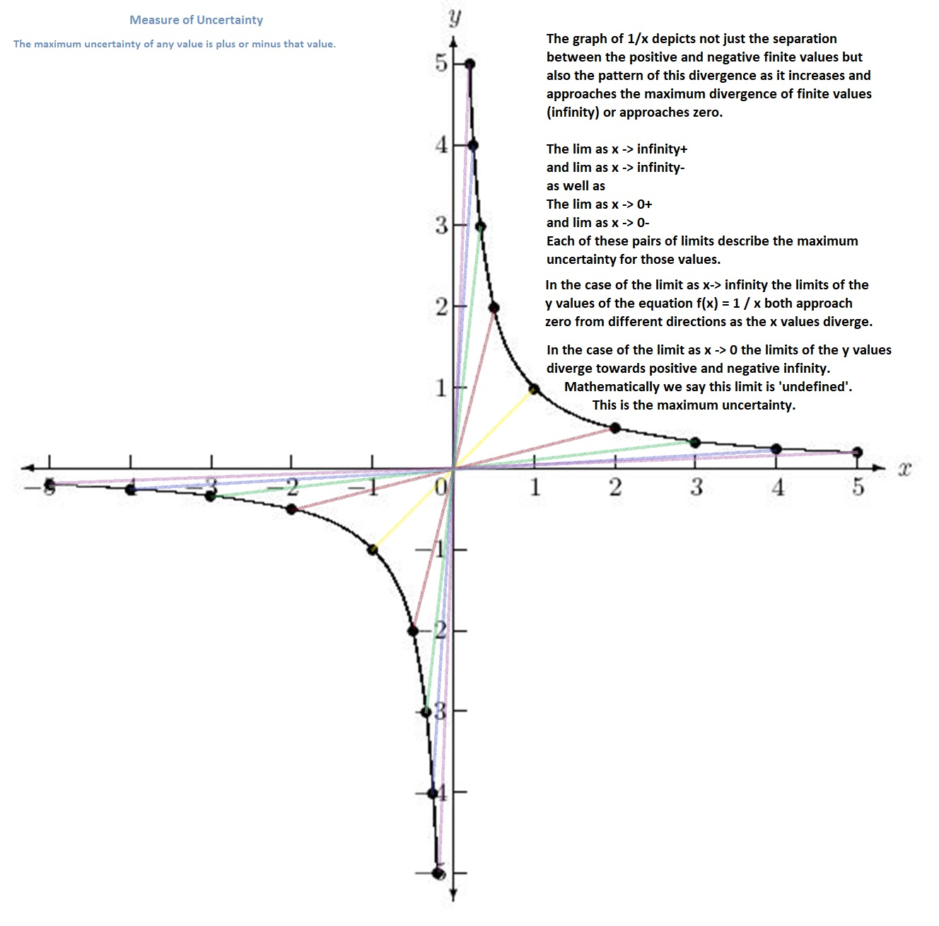

At the point where x is zero or whatever point that we choose to call the origin based upon what values we assign to NX or NY that value can be pretty much any one of the values on that y axis extending off indefinitely in the positive and negative directions. As the value of x gets closer to the arbitrarily chosen point of origin that we have defined by these coordinates the actual value of the function f(x) becomes less and less certain depending upon which direction it is approached from (+ or -). This provides a good representation of how the property of polarity manifests itself in our universe, the closer we get to the point of origin, the more and more pronounced it becomes.

In any case, as crucial and fundamental to all Creation as uncertainty is, it is still a finite property and represents The finite property defining all of our finite realm. Given the above representation of uncertainty. Taking the right side of the equation of 1/x as x -> 0+ (from the right) we can say that the General Uncertainty for our universe from a finite perspective is the (finite) limit as x approaches infinity (big surprise..)

Further Quantification of Uncertainty: The Case of Zero / Zero

Strictly speaking, zero over zero is said to be indeterminate. This is because depending on which equation we use of which approach we use to get to this value we wind up with a different result. However, there is I believe a factor that has not been factored into these equations that I wish to introduce and define. This I believe can be used to further quantify and understand in practical terms the property that I am trying to describe that I believe to be a form of *uncertainty*.

If we look at the pattern of the equation X/X = Y we can see that all values are 1 and so we would expect the value at X = 0 to be consistent with the rest of the graph but according to our math rules no, it isn’t, there’s actually a tiny hole there:

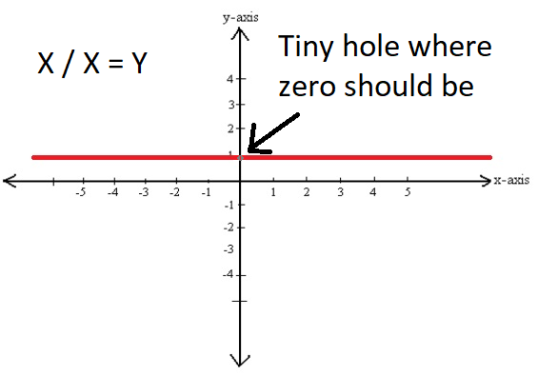

<pause>.. looks stupid, doesn’t it. Someone should probably try to fill that in..

The reason that there’s a stupid hole there is because we can come up with a different equation and get a different result. If we use the equation 0 / X = Y we get another stupid looking graph with an equally stupid little hole at the origin::

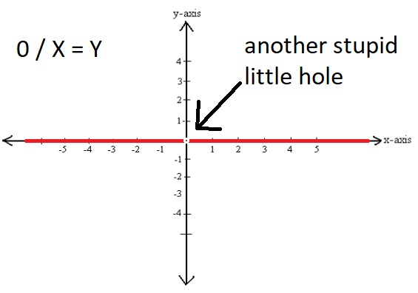

In this case we find two rules in math coming into conflict and pointing to two different solutions for the same equation. On the one hand, in the case of X/X, any value divided by itself will always equal 1. In the case of 0/X the rule is that any value multiplied by zero must also be zero. The problem is, when X = 0, both of these equations are exactly the same expression even though the equations are different. So for one of the graphs the value should be 1 and the other the value should be zero. But they both should be equal, right? Well, maybe the eqiuations actually aren’t and maybe something else has to be factored in. Generally it is said that the values at these points could have more than one solution. In generally, the solutions for these equations are described as ‘indeterminate.’

Based upon how I have defined uncertainty up to now I would propose that Uncertainty be explicitly factored into the above two equations in order to fill in the holes in our reasoning with respect to results that are described as ‘indeterminate’ both literally and figuratively. In the first graph we are saying that the numerator and denominator are exactly the same with no other conditions affecting the values in both the numerator and denominator. They are completely identical, absolutely the same with complete certainty. In the second equation we are saying that only the denominator varies, the numerator is Absolutely 0 with Absolute certainty. We entered an Absolute into that equation that does not, cannot change. That ‘Absolute’ condition Always gets commuted to the right side of the equation in the equations when it is in the numerator that have been discussed above and it should be commuted here as well. This time, the result should also be an absolute and if we look at the graph we can see that it should be zero.

Defining the Minimal and Maximum Limits of Uncertainty in the Finite Realm

As we specified earlier, Maximum Uncertainty can be seen in the case of *divergence* as in the graph of F(x) = 1/X where the value of the function at the origin can be anything between positive and negative infinity on the Y axis, we don’t know. If we were to factor the zero to the other side of the equal sign we would be saying that something times nothing equals 1 which is considered impossible. That is why the value of 1/X is evaluated as ‘undefined.’ There is no value there. There is just that much uncertainty. On page 8 we defined this value as General Uncertainty which we expressed as the total uncertainty between the value 0 and the value as X approaches infinity.

As we saw from the graph back on page 9 we have two separate asymptotes that have completely separate values. One asymptote is entirely comprise of negative values while the other is comprised of only positive numbers. So what is the difference between the values of the closest point to zero in the negative asymptote and the positive asymptote when the numerator reaches the limit as X approaches 0? At that point we could say that Y for the positive asymptote is 0+ while for the negative asymptote it is -0. Then we can just say the the Minimal Uncertainty UM at this point is the diference between the number 0 and -0 or 0+ which might also be expressed as (0+ - -0) / 2 = UMU .

If we look at the equation F(x) = 0/X we see a similar difference in uncertainty. Here the zero in the numerator is stated as being zero, period. The value of X in the denominator on the other hand can be any number between negative and positive infinity. Here we can see 0 in a context of both positive and negative values on either side. In the equation X/X we know that X is always the same as X as long as the uncertainties are identical but for 0/X that isn’t the case so we’re left with just a tiny bit of extra uncertainty in the denominator. As the X in the denominator approaches 0 from the left where the limit as X -> -0 it is always negative. If we approach it from the right, limit as X -> 0+ it is always positive. So the ratio between the two numbers doesn’t factor out the sign so we can’t ever really be completely be sure what the polarity of the result is. “Is it positive or negative zero?” In this case we have a Minimum Uncertainty which should be half the distance between -0 and 0+ where -0 is the lim X -> -0 and 0+ = the limit as X approaches 0 from the right. We might express this Minimum Uncertainty UMU as UMU = ABS| -0 or 0+ | - 0 or just UMU = ABS| -0 or 0+ | which is the absolute value of the difference between 0 and the limit as X approaches 0 from the negative values and is still negative or the limit as X approaches 0 from the positive values and is still positive. All this says is that the Minimum Uncertainty in our finite realm is the difference between 0 without a polarity and 0 with a polarity either positive or negative.

What is Time?

Time is something we only know of by patterns of behavior. What we do know about time is that it always seems to flow in the direction of greater uncertainty and its effect is to diminish that uncertainty. Once the future becomes the present the possibilities reduce to a single definite event. In considering the present we can see that it represents a point at which the specific organization and arrangement of uncertainty and the *change in this arrangement of uncertainty* is reduced to its minimal detectable value. This point seems to be some quantum granular threshold in which one outcome can be distinguished from another and the uncertainty of that outcome can no longer be measured. These outcomes occur locally and their effects propogate cumulatively. Physically it is like the distinction that the surface of a finite object that defines it represents in contrast to the space beyond it that this surface distinguishes it from. This surface represents the organization and arrangement of this particular part of uncertainty.

We tend to conceive of everything around us in terms of points or particles since we then use these to build and make up our world. That makes sense practically as far as how we build things on our scale of existence. But is that really how things are defined in this finite realm?

Say you have Points A, B and C next to each other: A B C

With the model that I am attempting in this paper, B is not a particle, it is the difference between A and C such that; B = C - A or -B = A – C It's just a gap. It can't be 0 because 0 is an Absolute but it is close to 0, as close as we can get in the finite realm.

If we think about it we can say B is the limit as A's distance from C in the positive direction is reduced to zero: Lim C -> A+ which is the same thing as the Limit as C's distance from A in the negative directionLim A -> C- which should just be equal to Minimal Uncertainty: UM.

If B isn't anything but a minimum unit of uncertainty between A and C no wonder it changes. It's like an animated pixel, changing from A to C or C to A and so are all the little pixels around it so we should expect everything to change which physically means move in space and cumulatively means a volume of changes moving. On our macrocosmic 3 dimensional scale and perhaps in relation to higher coordinate systems of the 4th dimension and beyond the accumulated displacement of these changes is seen as time. For all practical purposes, what we measure as time is just the consistent set of successive changes in our world like a clock ticking steadily, the clock hand moving consistently from one number to the next, to the next and to the next. From this 3 dimensional point of view it seems that there is no such thing as 'reverse' time. All change is change and there is no such thing as 'reverse change' but from the point of view of a higher dimension this might not be so. There might be cumulative movement for our realm and therefore the possibility of counter movement to that movement but to where? Does the past 'change version' of our finite realm exist as a snapshot somewhere stored in some cosmic cloud warehouse that anyone can go back to? Sure, history happens and is definite from the present but physically is that instant of the universe stored anywhere, carved in stone permanently? Once that 'set of changes' has happened it's gone. How can you go back to it even using higher dimensions? There was no absolute instant at which everything was literally set in stone 'this way'. When everything around you is in a constant state of change how are you supposed to go back to a previous state? It was transitory to begin with.

The revolutionary aspect of the uncertainty principle that Werner Heisenberg first proposed back in 1927 was that uncertainty was not merely a projection of the limits of our ability to perceive and understand. His proposal was that there were actual physical limits to our ability to know the exact location and inertia of a particle. In this way he first proposed the idea that uncertainty itself was a physical property with some physical form however abstract or 'non discrete'. I propose not only does it exist in special cases but that it exists as the foundation or fundamental basis for all changes in distinction of all that exists in our physical universe and the greater realm of all that is finite from the distance/difference between two different points to the occurrence of 'time' as a collection of the inexactness on a granular scale of all points/convergences around us in the physical three dimensional world. Inexactness in our realm we experience as 'change'. Progressively we experience this as time in the context of the three dimensions in which we perceive. I don't know if an expression: uncertain = finite has meaning as a mathematical equation but I would propose such a statement as fundamentally sound at least philosophically.

Specifying Unit Uncertainty Between Two Individual Points Within Maximum/General Uncertainty and Minimum Uncertainty

If the following material is actually correct then I propose that this be dubbed **‘Mad Math’**.

As we noted on pages 10 and 11 above we have these two functions where the value simply disappears into uncertainty when the value of X hits zero. This is very precise. For X/X the value is 1 and for 0/X the value of X is 0. OK, lets indulge ourselves and see where this goes.. The whole point of this is the fact that it doesn’t make any sense that X/X should be 1 And 0/X should be 0 since 0 and 1 don’t equal each other. So let’s see if we can expand upon the contradiction and try to come up with something that works. Let’s hypothetically try to define and establish a single base unit of uncertainty UBU based upon this contradiction and add it in. If we consider the equation of X/X we know that the value of X should be 1 but can be zero so we have a base unit of 1 in the direction of zero. So we can say that the uncertainty of X/X is –UBU. With the equation of 0/X we have the mirror uncertainty. The value of 0/X should be 0 everywhere except at X = 0 where it suddenly can be 1 in the positive direction. For this we can say the uncertainty for 0/X is +UBU .

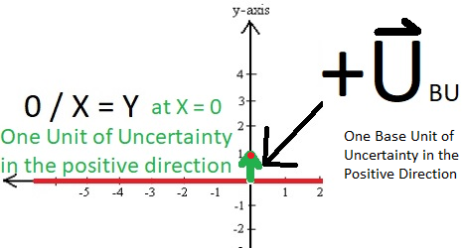

We should at least be able to say +UBU = - ( -UBU ) So yeah, monopole uncertainty is for real apparently. Each of these has its own distinct polarity as we should expect. Now given the properties of UBU that we have specified above it would seem reasonable to say that this form of Uncertainty that I am identifying here is a what is called a vector in that it is a value that has both magnitude and direction. This we could define as: BU = <x value, y value> or <u1, u2> = <0, 1>

In that case the vector for the Uncertainty derived from the value of the equation of X / X where X equals 0 should be: BU = <x value, y value> or <v1, v2> = <0, -1>

At this point it is worth further considering the distinction between:

the vector BU , (point A = Zero) * ---------🡪 * (point B = One)

and the line segment from 0 to 1 UBU, (point A = Zero) * --------- * (point B = One)

The line segment only has a magnitude and the difference between points zero and one is the same whether you consider their relationship from either point A or point B. Point A is a distance of one from point B. Point B is a measure of one unit of uncertainty from point A. This value we could think of as our ‘Base Unit of Uncertainty’, UBU. With the vector uncertainty it is different. Rather than a static unit, the vector uncertainty describes a value that is dynamic rather than just a static magnitude. The uncertainty is pointing in the direction of point B from point A. From the reference of point A you can say that the uncertainty of point B seems to be *increasing* with respect to point A as the vector is heading away from it. From the reference point of point B the uncertainty seems to be *decreasing* because the vector is heading towards it. That is to say, from point B, point A seems to be becoming more similar to point A and the uncertainty/distance between them seems to be shrinking by a unit of one. This vector indicates a polarity or change in the uncertainty vector that the static magnitude of uncertainty does not possess.

For the Unit Vector Uncertainty we can specify an equation for all finite values of Vector Uncertainty by throwing in a constant comprising any finite integer. Let’s just call it C. If we want to specify any quantity of Uncertainty based upon the base quantity that we just specified we should multiply the first ratio by C and then just say:

+C*BU = -C*( -BU ) = |C * UBU| Makes sense, right? So now looking at them as scalars, let’s say for the equation of F(x) = X/X you have this additional uncertainty when X = 0 such that X/X = 0 rather than 1. So we can write X/X = 1 - +UBU = X/X = 1 + -UBU  *where X = 0*

If we want to extend this for any range of integers we can factor in a constant C just like we did above and say: C* X/X = C*1 - +C*UBU  = C*1 + -C*UBU *where X = 0.* We can also say *when X = 0*  C*0/X = C*0 + +C*UBU .

What About Differences and Sums? How Do Uncertainties of Opposite or Common Polarities Resolve?

If we take another look at the matter of X/X we might ask, “what happens if we reverse the sign?” For the equation –X/X = Y we can see that all values for Y are -1 except for the tiny hole at X = 0. Now if we consider the Unit Uncertainty in this case we can see that it has also flipped and is now a base unit of Uncertainty of magnitude one pointing in the positive direction: +UBU which looks to be the same as the positive base unit of Uncertainty that we found for the equation of 0/X when X equals zero.

For the total equation we have: -X/X + +UBU = Y

At this point we can then ask, “what happens at X = 0 if we add the equations X/X and –X/X together?”

When we do this: -X/X + +UBU + X/X + -UBU we can look at the graphs individually and see how they combine to see the results. The equations themselves are going to combine and cancel each other out as we would expect: X/X – X/X = 0. If we look at the graph we can see that the units of vector uncertaintyresolve themselves just as tidily:

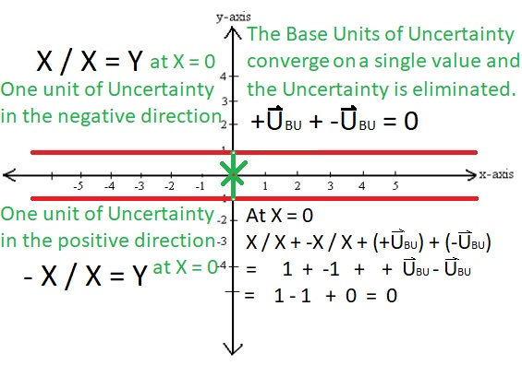

Because the two base units of Uncertainty converge at the same point we can then say that there is no Uncertainty here, both values resolve to the number zero, and remove the UBU values entirely.

It wouldn’t matter if we changed the equation by adding a constant C so that

Y = X/X + -X/X + +UBU + -UBU + C the values of UBU in the equation would stiil converge and cancel each other out except that they would converge on the Y value equal to constant C.

From this we can make the following declaration: *Base units of uncertainty of opposite polarity and equal magnitude cancel each other out and reslolve to zero.*

Now if we look at this Uncertainty equation again as a couple of vectors we would have: BU - BU = : BU + -BU <u1-v1, u2-v2> = < 0 - 0, 1 – 1 > = < 0, 0 > which is exactly how we expect Vectors to behave. Given how these Uncertainty Vectors behave in a single dimension we can predict that they should operate the same way in 2 dimensions or 3 dimensions or however many we wished to use them in and just use the usual rules that apply to vectors in math.

I might care to go even further and say that the magnitudes of vectors of uncertainty pointed in the opposite directions will aggregate rather than cancel and the result will represent an increase in the magnitude of uncertainty between them. If I go by my own proposal that I made back on page four of this paper I defined the line segment as the extent to which the two points that I created at zero and one are different. A hypothetical line segment UBU specifically represents the *discrepancy* that distinguishes all of the points in the distance between point A and point B. For this so-called ‘Unit Vector Uncertainty’ that I just came up with it describes not just the difference between the two points but actually the changes in difference between two points. In the case where the two vectors cancel each other out the equation actually describes the decrease in uncertainty between them and in fact the *similarity* between them rather than the difference or discrepancy between them. Between the two individual distinct points, one consistent with a particular graph and one not, the Uncertainty BU represents the magnitude and direction of the deviation from the rest of the graph at that point X = 0 of the *change* in the discrepancy between those two distinct points (in the case of vectors that cancel, extent to which the two points are actually the same).

This might have more specific and special application in quantum physics where you have an electron in orbit around an atomic nucleus and you don’t know where it is. This value might be useful in representing the possible locations where it might be or related to something like the path integral formula in quantum mechanics. Base unit vectoring might be a useful way to quantify Quantum Superpositioning which is used to describe how something like a particle can be in more than one states or positions at the same time. I’m more of an investigator as opposed to an expert in quantum physics but it would seem reasonable. I understand my limitations and have gone about as far as I can in this line of inquiry. I’m not a mathematician and the speculative proposals that I make with respect to indeterminate numbers in what I refer to as ‘Mad Math’ may very well be incorrect. However, even if they likely are I would still propose that there will at some point be proposed such a theory that includes the basic features that I have described:

1. Describes the change in uncertainty incrementally as a vector that is resolved through the summation or cancellation of vectors dependingon their magnitude and direction.
2. Represents a property that describes both the inherent similarity and inherent separation or difference between points within the concept of General Uncertainty that I have outlined in this paper. In this conceptual framework this ‘Base Unit Vector Uncertainty’ would describe how two separate points are both distinct and alike or even to a certain extent the same point.

To state succinctly my thoughts regarding what I have termed ‘Mad Math’ in this section of the paper, I believe that if we have a term that can express the incremental quantitative change in a discrepancy, in particular the decrease in a discrepancy, then we should be able to use it to at least quantify indeterminate values if not resolve them and this is what I would propose that the expression I term *base unit vector uncertainty* be used for.

If we further contemplate what the unit vectors BU and -BU that I have presented above represent we might think that they in some way actually cancel out the distance between the points +1 and -1 and the number zero. If these actually do serve as a conceptual means to teleport/jump across or even to negate the distance between points A and B in a line segment then such a working mathematical theorem using these principals could be useful in describing phenomenon related to the shortening and warping of space which could then potentially be useful in applications involving faster than light travel.

Regardless of the correctness of my model, it is my hope that the thoughts that I have presented might further assist in achieving a better understanding of these and related concepts.

COSMIC IMPLICATIONS

The compositions, structure and relationships of various forms of 'matter', 'energy' and their constituents around which our physical existence is based and about which so much specificity and complex precision of mathematical description is necessary should not blind or distract us from a couple of basic truths upon which the realm within which they exist is based:

From our finite point of view, all of Creation is physically an Infinity based on Nothing with General Uncertainty thrown in to act as the condition of separation. Ultimately, all uncertainty we experience not as a concrete substance but representing an abstract quality of distinction by which we can appreciate and measure our finite realm.

THEREFORE

If our experience of Uncertainty is based on the lengths and distances within each of the dimensions of space ‘animated’ by the actively perceived uncertainty of the fourth dimension in the form of 'time' which we experience in the other 3 dimensions as motion from point A to point B, then our finite realm is based on next to Nothing in Motion. That is, the relative state of motion of minimal uncertainty. However, from within our finite realm we can only perceive this within the finite limits of uncertainty as it exists between ∞ and 0.

My final reasoning for stating this is based upon the following relationship:

Back on page 6 we went into a discussion of the equation of what the finite approximations of 0 times ∞ is equal to. The answer would seem to depend upon what equation I use when I determine the solution. However, all of the results were still finite: lim as x -> 0 , 1 (or some arbitrary real number n *times* 1) and lim as x -> ∞ and could equal all finite values instead.

This is the key, it actually can equal numerical representations of all values in our finite realm instead when all reason would tell us that it *should* be the closest approximation of zero we can represent in the finite realm. Then when we think of what lies beyond this limit of minimal uncertainty we realize that the only thing smaller is zero in the realm of the absolute. That’s they key right there. That’s where the ‘something seemingly out of nothing’ comes from. When I discussed this back on that page I articulated my belief that this finite value is coming from the difference between real numbers as we understand them and terms like zero and infinity which we understand as absolute. Infinity is magnitude without bound, zero is total absence of any value. The range between the finite limits that approach them is part of what I’ve tried to address in this paper and what I’ve referred to here by the term, ‘General Uncertainty’ while the difference between 0 at least, and finite limit that approaches it I describe as ‘minimal uncertainty’. Even if I haven’t succeeded in articulating the exact nature and structure of what they represent in our finite realm we inhabit I have hopefully managed to convey a better understanding of the part they play.

Beyond this finite realm, it is extremely important to understand that there really is no zero or infinity separately. These values are only meaningful within. Outside, there is only The Absolute. Its value is 0 and ∞ and everything in between. From the perspective of the Absolute, everything that we experience is not based on zero because 0 and ∞ are not separate but one value. Everything we experience is ultimately based on something in the realm of the Absolute that is both zero and infinity at the same time. So everything that we experience in our *finite* realm is neither zero or infinity but something in between, something within the grey area of General Uncertainty within the Absolute.

This brings up a question that theologians have debated for centuries about the direct presence of the Absolute in the finite realm. If we contemplate a direct association with respect to the universal microcosm, from the standpoint of the finite, the single equation that best represents the limits of the Absolute is ∞ times 0 as this realm is one composed of emptiness multiplied an unlimited number of times. But, in fact, this is not the case. The finite universe isn't just an infinity of zeros in the same way that any finite number n/0 doesn't equal infinity. It is undefined because the limits of the positive and negative axes at n diverge to positive and negative infinity. What we really have is described as 'undefined'. This I've referred to as maximum or 'General Uncertainty'. It is no surprise of accident we find this whenever we try and divide the absolute because that is what the absolute is actually divided by so that is what we should expect to find from where we sit in the middle of the finite realm. Rhetorically from this finite point of view, one would then say that everything is an illusion and that God is just a magician who is using 'sleight of hand' to make it appear as if all divine manifestation has been set in motion. That ‘sleight of hand’ we would perceive as *uncertainty*. That is the curtain that has been drawn above the gritty, empty details of what actually constitutes a whole bunch of nothing and how He manifests His ***indirect*** presence in all of our affairs. Oh well, if that’s the case then it doesn’t look like we have anything to complain about I guess. It’s not like we’re really missing much..

I would also note that one of God's best tricks is based on the fact that, since zero takes up literally no space he can overlap them indefinitely so that all the zeros in infinity can occupy the same position. They can all be stored at a single point. The fact that they can infinitely overlap forms the very real physical basis for the concept that everything is ultimately interconnected at the Absolute level. Of course, at the Absolute level you don't need Any points, any space to store an infinity of zeros since they take up no space at all. For our finite realm to exist you need a minimum of 1 + n points where n can be any number including zero.

If this is in fact true then this would suggest that physical existence itself, the existence of anything and everything, material and otherwise, could best be categorized as anomalistic and a phenomena in a very real sense. If one thinks this notion to be facile or unjustified then I would say that our entire supposed 'common sense' world view needs to be changed. The real implication of this model of all Creation that I have attempted to describe in this paper is as follows: the Only Absolute Certainty, the only thing that definitely Exists is God. The only thing that you can take for granted is God's existence. That is the single mundane incontrovertible fact of all Creation. By comprising both zero and infinity He is able to comprise and reconcile the Everything and Nothing beyond our finite, hopelessly bifurcated version of ‘everything and nothing’.

Perhaps God would be perplexed and frustrated with our doubts and lack of faith in Him but for us it is a natural response to the uncertainty of the realm we inhabit. For finite beings, faith itself might be best suited as the ideal mechanism for reconciling their experiences of conditionality and uncertainty and doubt with the reality of the reliability of the Absolute/God. Faith in anything finite, even that which is 'certain' is still based inherently on uncertainty whereas faith in God is based on the Absolute and therefore naturally without any basis for doubt. The real question therefore isn’t, ‘does God exist?’ The actual question is, "do *we* exist?" Heading towards the microcosmic minutia of our realm all we see is Uncertainty. Beyond that we got nothing but zero as far as our final substance is concerned in the Realm of the Absolute. So do we exist? The 'common sense' response obtained from direct observation would tend to say yeah. From where I sit I can gaze at my hand in front of me and say that I have faith that I exist. I can then slam it into the wall next to me and feel the pain and profess to having even more faith. But when we look at the world and see things that we consider to exist they actually don't to some extent. Nothing that we see ever stays the same. Everything is constantly changing so the thing that existed at this moment no longer exists and something nearly like it has taken its place at the next. This is a reflection of general uncertainty on the microcosmic scale. The smallest increment of time acts merely as a measure of the uncertainty of whether we are at point A or point B in 3 dimensional space within that smallest interval. As some critics of Xeno’s paradoxes have commented, there is no Absolute moment where time is zero and can stand still where we can say *this* object is Absolutely incontrovertibly ‘at *this* position’, ‘at *this* particular time’. So this supposed paradox is based upon an invalid and unrealistic assumption that violates the basic conditions of our finite realm based upon General Uncertainty in which all is limited, nothing is absolute.

We also know that everything around us might exist now but at some point it won't. Everything has a lifespan. Nothing lasts forever. We live and we die. This is a reflection of General Uncertainty on the macrocosmic scale. And beyond that, there is the Absolute realm constituting an infinity of nothing. No wonder people question God’s existence. From where we stand it looks to be nothing but a big illusion. Samuel Clemens was right to comment despairingly regarding such matters in his 'Mysterious Stranger'. Are we but thoughts and emptiness with only laughter to defend ourselves from the realization of our own cosmic absurdity? If so, it is a weak defense to be sure. After all, laughter is nothing more than an irrational response from a broken mind, a malfunction. Is that really our strength?

In his history of the Macrocosm and Microcosm, Robert Fludd described God using the Hebraic abbreviation of YHWH which was a mnemonic representation derived from Hebraic Kabbalah of our finite concept of God the Absolute.[1] This representation was based partly on the idea that the full name cannot be spoken by finite beings such as us any more than the Absolute itself can be fully comprehended. In the 'Primeval Duality', Fludd commented on the foundation of the complexity of all things in our finite realm of existence describing them as an extension of God as being both 'dark' and 'light' but predominantly light due to the prevalence of harmony and light in our universe.[2] While I might disagree with Fludd's perception of the relative measure of light versus darkness in our realm I would agree at least with the idea that God fundamentally represent the light and only uses darkness as a necessary contrast to his light in order to define fundamentally the basis for complexity. Darkness might then represent the uncertainty that was necessary for the Genesis of all things in our finite realm.

"Let there be Darkness and Light.."?!

It may be a reflection of the mortal bias of the author of the Book of Genesis that he took the point of view that for the Absolute there must have been a beginning. A more descriptive opening phrase might be, “In *our* beginning..” Not that this should be in any way interpreted as criticism of the account of Creation offered by Moses. Investigations into the origins of the universe up to the present day have confirmed the events described as ‘cosmic expansion’ followed by a ‘big bang’ which fit reasonably well with his account of the creation of our universe given in the Book of Genesis. The questions would be what preceded ‘the beginning’ and where the void came from. If all before was only the Absolute/God without shape or form without scale to distinguish His greatness and fineness of detail nor contrast to His radiance to even provide the distinction between the light and the dark perhaps it was uncertainty that provided the basis for all of these. All *we* can see within the boundaries of what we can determine would then be no more than the General Uncertainty that makes up our finite realm that God created with just the wave of His hand.

1. Robert Fludd Hermetic Philosopher and Surveyor of Two Worlds by Jocelyn Godwin, p. 13
2. op cit, p. 30