**HUMAN PHOTO-ENERGETIC TRANSDUCTION**

**(Research letter: The Eco-Medical Point of View)**

The methodical goal of this photo-medical synopsis is to provide a brief insight into the scientific currents of photo-energetic transduction in the human organism and its future potential for medical prevention and prognostics.

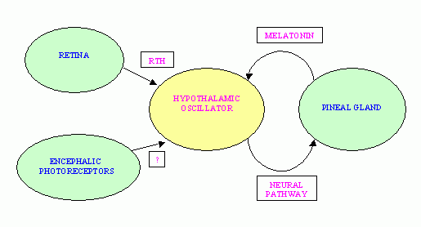

It is a geriatric fact that human ageing is directly connected with a progressive loss of circadian photoreception; the stimuli or signal-processing chain of the ocular photoreceptor system works as a direct energetic path of the optic nerve as a neural cascade of the photo-neuron-endocrine system (PNES) via encephalic photoreceptors (EPRs). The structure of the pineal gland serves as a parietal eye and circadian generator via clock genes for neuron-endocrine secretion of local specialized nuclei in functional organs, i.e. the photoreceptors of the retina transduce certain stimuli/signals via neuron-endocrine channels into the human organism although we do not know about a photo-pigment in the human eye that transduces light (for circadian and neuron-endocrine regulation). However, in learning about synesthesia, we know that sound waves can stimulate special light and color perceptions in certain people, i.e. there exists at least a dual feedback system in the human body that interprets ocular and acoustic waves or frequencies. The photo-energetic transduction channel is most likely the dominant signal processor, followed by acoustic signals, pertaining evolutionary to the neural brain hierarchy of the 5 basic human senses in general and other specific channels of sensing, according to the standard physiology of human behavior.

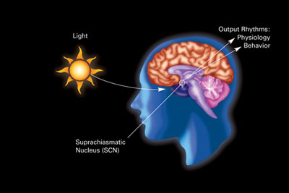

*Lux agitat molem?* It is safe to assume a vital pre-dominance of the photo-energetic channel in the human organism, operating in very close dual feedback connection with acoustic signal-processing of external physical (e.g. photonic, acoustic) stimuli into internal psycho- neuron-endocrine responses. It is also interesting to note an exact circadian and psychophysical restoral of the immunological biochemistry in the human organism at sleep, between 22/23h-3/4h, depending on the yearly photonic rhythm of light as Zeitgeber for the integral health of the human mind-body; the human brain registers these light differentials in scalar potentials of photonic electrodynamics, i.e. light wave behavior is changing the photonic frequency variations of the human organism as electromagnetic field (energy level=rate of time flow/cause-effect-relation). A relative quantum efficiency of light waves entering the human organism via the ocular pathway (and the skin) determines the health of the photo-neuron-endocrine recovery system.



Understanding disease, from the viewpoint of human systems medicine and applying the philosophical approach of photo-energetic circadianity, does not provide for acute technical interventions, but enables the practicing physician to personalizing health care for a better diagnostics and therapy of chronic dis-eases, thus improving prevention and prognostics. The human organism works as a light-mind-body, transducing external physical information stimuli by relative quantum efficiency into internal psychic neuron-endocrine responses; this information-energy-field is driven by photonic electrodynamics, i.e. electromagnetic field variations (e.g. additional important parameters of signal processing are the quality of the inhaled air and average temperature of the habitat, concerning optimal blood circulation). Applying a new translational epistemology and ontology of medical cybernetics (information science/quantum theory) will make it easier to methodically reduce and understand the complex inter-connections of the living human organism. There is no need for a medical metaphysics, but a societal need to better comprehend the interplay of body and environment (eco-medicine); such a cognitive extension of medical professional knowledge can serve as advanced input for improved health care; this is truly a professional and societal challenge and innovation.

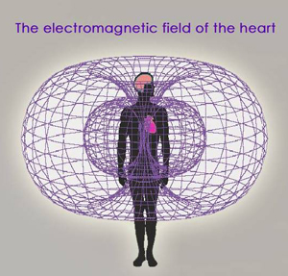

Advancing medical cybernetics is naturally not the road to immortality, but the sane way to life style improvement, health consciousness and longevity quality, thus providing existing medical technologies with a deeper understanding of the human light-mind-body, i.e. a precise cognition of the quantum energy flow in the living organism (e.g. the heart-brain neuronal response dialectics and its direct interplay with the respiratory system). Such a higher direction of medical research will ultimately result in a clear separation of humanistic and veterinary medicine in the history of science. In cybernetic terms, it is safe to assume that the direct photo-energetic pathway of the ocular-optic nerve into the human brain-body is the most powerful of all senses and this is quite in opposite to the underestimation of ophthalmology in professional significance and unfortunately also monetary salary of these physicians. The human organism is not an assembly structure of mechanical machinery or a dead tissue factory, but a medical information-energy network that functions in quantum-equipotentiality (only living tissue can absorb, transduce and emit light=dead cells are no more light responsive). Certain light (sound) waves and frequencies do definitely correspond to the health of specific structural functions in the human organs; these are measurable quantities and qualities, giving technical proof for new medical treatments of dis-eases, probably with newly elaborated (eco-medical) light and sound therapy techniques and technology.

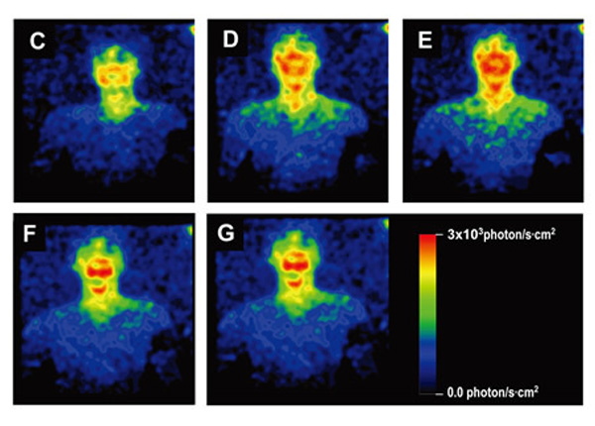

Human photo-energetic transduction processes are the initial basis of the psycho-neuron-endocrine system that keeps us healthy by the organic translation into immunological (biochemical) responses. The human light-brain-body works as a sensible psychophysical network that converts external signals into internal responses; illness and dis-ease are rooted in the pathological disturbance of this physiological signal transfer from the environment into the body; this eco-medical point of view perceives, observes and measures medical pathologies as a communication disorder (entropy) in the human body; the retro-causal restoration of communicative order (syntropy) in the human organism is therefore the radical aim of eco-medical health care (healthy health care); by gaining a deeper understanding of the material universe, we can wisely and creatively extend our limited temporal momentum in time-space.

*Bibliography*

Boscovich RJ. 1763 (1922). A Theory of Natural Philosophy (Latin-English). Chicago: Open Court.

Hanifin JP/Brainard GC. 2007. Photoreception for Circadian, Neuroendocrine and Neurobehavioral Regulation. J Physiol Anthropol. 26:87-94.

Hollwich F. 1979. The Influence of Ocular Light Perception on Metabolism in Man and Animal. NY: Springer.

Korf HW (et al). 1952. The Pineal Organ, its Hormone Melatonin and the Photoendocrine System. Berlin: Springer.

Ternyik S.2014. Beyond Biomedical Ontology (forthcoming: Palermo: Epekina).

Whipple H (Ed). 1964. Photo-Neuro-Endocrine Effects in Circadian Systems. NY: Aca Sci Annals (Vol.117)

[www.international-light-association.org](http://www.international-light-association.org)

[www.photobiology.info](http://www.photobiology.info)

[www.photomedicine.org](http://www.photomedicine.org)

[www.science.gov/topicpages/p/photoneuroendocrine+circadian+system.html](http://www.science.gov/topicpages/p/photoneuroendocrine+circadian+system.html)

Stephen I. Ternyik

Social Scientist/researcher & entrepreneur

Techno-Logos, Inc. (-1985)

[StephenJehucal@web.de](mailto:StephenJehucal@web.de)