International Conference on Industry 4.0 and Smart Manufacturing (ISM 2019)
Designing Smart Operator 4.0 for Human Values: A Value Sensitive Design Approach
Lucia Gazzaneoª, Antonio Padovano^{a*}, Steven Umbrello^{b}
ªUniversity of Calabria, Via Pietro Bucci, Rende, 87036, Italy
^{b}University of Turin, Via Sette Comuni 45, Turin, 10127, Italy
* Antonio Padovano. Tel.: +39-0984-494891. E-mail address: antonio.padovano@unical.it
Abstract
Emerging technologies such as cloud computing, augmented and virtual reality, artificial intelligence and robotics, among others, are transforming the field of manufacturing and industry as a whole in unprecedent ways. This fourth industrial revolution is consequentially changing how operators that have been crucial to industry success go about their practices in industrial environments. This paper briefly introduces a novel way of conceptualizing the human operator necessarily implicates human values in the technologies that constitute it. Similarly, the design methodology known as value sensitive design (VSD) is drawn upon to discuss how these Operator 4.0 technologies can be designed for human values.

© 2020 The Authors. Published by Elsevier B.V.
This is an open access article under the CC BY-NC-ND license (http://creativecommons.org/licenses/by-nc-nd/4.0/)
Peer-review under responsibility of the scientific committee of the International Conference on Industry 4.0 and Smart Manufacturing.
Keywords: Value Sensitive Design; Factory of the Future; Industry 4.0; Smart Operator; Human-Centered Design; Operator 4.0 Compass

- Introduction
  - The context
Over the last few years, technology-oriented manufacturing paradigms, such as computer-integrated manufacturing and cyber-physical systems (CPS), have been shaping the image of industrial production [1]. Although a rampant automation has reduced costs and improved productivity of manufacturing systems, it has also widened “low-skill/low-pay” and “high-skill/high-pay” segments in the labour market, generated greater social inequality and elicited inexorably a higher job displacement rate. In order to curb this phenomenon, policy makers and institutions are ascribing greater priority to human-centred and responsible innovation in the ‘factories of the future’ (see for example the roadmap until 2030 elaborated by the European Commission in collaboration with EFFRA - European Factories of the Future Research Association) [2]. Recent research studies recognize the vital role of human operators as part of Human-Centric Cyber-Physical Production Systems [3] and a better integration of human factors into the engineering design of industrial systems and work processes is gaining more importance [4]. Nevertheless, little attention is still paid to the correct integration of humans in the emerging context of Smart Factories [5] and the long-term sociotechnical impacts of technologies are generally neglected by researchers [6], perhaps because the initial drivers of the 4th Industrial Revolution were mostly technology- and solution-oriented professions rather than social sciences and humanities scholars [7]. While there is a growing interest towards the idea of “augmentation” – as opposed to automation – of the human capacities through manifold technologies [8], the 4th Industrial Revolution is inevitably changing not only what the human operators do and how they do it, but also who they are, their identity and all the ethical issues associated with their practice.
  - Motivation
As we embrace the automation age and technologies becomes further enmeshed in society, new ethical challenges arise, calling for new regulatory practices and the broad inclusion of multiple stakeholders. Rethinking the processes of technological development is needed, asking first what long-term future is wanted and then how to orient technological development towards achieving it. The World Economic Forum is also pioneering a future-oriented agenda by taking seriously the roles of values and ethics in technological development [9]. They also suggest that values and ethics should be embedded into the technological development process by designing a value-oriented technical architecture. Despite the tendency to think of technologies as objects or tools, they inevitably embody the value of their creators and designers and shape how the people using them can realize their potential, identities, relationships and goals [10]. The 4th Industrial Revolution also compels computer scientists and designers, industrial engineers, philosophers and legal experts to focus on how technology within industrial systems can be designed with and for ethical values [11]. This is the case of the assemblage and networking of multiple converging technologies within the Operator 4.0 paradigm that has shown to provide obvious benefits for manufacturing systems [12]. This moral role of technologies within the Operator 4.0 paradigm must be addressed at this critical moment in history. Although part of the challenge is that the sociotechnical impact of technologies on to the Operator 4.0 is difficult to ascertain while this concept is still emerging, such impacts of the decisions of designers have been argued to be existential [13] and are difficult to change when technologies are mature and embedded in social and economic infrastructure. The cost-benefit analysis that designers and design teams usually have to tangle with have generally created a discourse where, for example, safety and efficacy are at odds, typically ascribing safety as the cost. Given the lack of ethical and moral considerations about the values implicated by the Operator 4.0 paradigm, the imperative now (which drives the motivation of this study) is to consider ethical values during its design and development stages, when safety (or any other value) is not regarded as a cost, but rather as a design requirement. What is required then is a principled framework that is capable of providing designers with salient guidelines to adopt a human value-centered perspective when designing the converging technologies enabling the Operator 4.0 paradigm and to understand how such technologies can support or constrain those values at play. Norms and design requirements are needed to guide technological development in industrial settings based on values and ethics and to craft technologies towards positive ends for human operators in industry and society as a whole.
  - Contribution
This short paper aims to highlight some of the issues of how the Operator 4.0 (O4.0) paradigm can be designed with human values in mind. A new framework, called O4.0 Compass, has been developed in the context of this study to show how the Industry 4.0 key enabling technologies match and extend the O4.0 capabilities. This paper is comparatively unique in that, rather than providing a solely conceptual framework, we also provide some preliminary results of the application of the value sensitive design (VSD) methodology to the individual technologies that converge to form the O4.0 paradigm. The VSD methodology is selected rather than other approaches given its anticipatory and transdisciplinary approach towards the principled inclusion of human values in the design of technologies.
The following section dives into the concept of the O4.0, while Section 3 presents the Operator 4.0 Compass and how the Industry 4.0 key enabling technologies match and extend the Operator 4.0 capabilities. Section 4 draws upon the Responsible Innovation topic, outlines the VSD methodology as a whole and begins to sketch how it can be applied to the concept in question. Later, Section 5 discusses how VSD can be applied to the design of the O4.0 for human values. Conclusions and further insights are provided in Section 6.
- The Operator 4.0
After generations of operators that keep pace with the first three industrial revolutions, the Operator 4.0 (O4.0) came up as a new concept in the Industry 4.0 framework [14]. Since debate around the O4.0 is still emerging, the definitions that can be found in the recent literature are neither yet completely comprehensive nor exhaustive but represent good starting points for discussion. [15] defines the O4.0 “as a smart and skilled operator who performs not only cooperative work with robots but also “work aided” by machines if and as needed”. In this sense, the O4.0 is considered as a hybrid agent established as a symbiotic relationship between the human and the machine, where the focus is on treating automation as a further enhancement of the human’s physical, sensorial and cognitive capabilities. They postulated an O4.0 typology as well as explored a set of key enabling technologies that can support the development of a human-automation symbiosis in the Factory of the Future. As pointed out in [16], technology is expected:

- to support operators performing tasks within a process/workflow;
- to support understanding and decision-making;
- to learn from the activity of operators to predict specific situations, optimize the process and better organize the smart factory.

Based on the technologies in place, one operator could incorporate one or several of the proposed types. Recently, [17] presented four case studies that show the possibility of how to implement operator’s typologies in real scenarios. Research groups have started working on technologies for operators, from virtual reality and augmented reality [18], through exoskeletons [19] and collaborative robots [20], up to production support via social networks [21]. Visual computing technologies have also an important role in smart factories of the future [16]. Many authors explicitly identify augmented reality as one of the main empowering technologies in combination to support from knowledge-based and intelligent systems. Softbots – software robots defined as a virtual system deployed in a given computing environment that automates and helps humans in the execution of some tasks with variable levels of intelligence and autonomy – have been also theorized to be crucial for achieving a human-machine symbiosis [22] and deployed in real manufacturing environments [12] with benefits on production and maintenance performance. Several enabling technologies are already daily being used by many workers such as personal activity trackers and smart watches [23]. However, despite the crucial role of data is acknowledged by several projects – see for example the EU-funded project “FACTorieS for WORKERS” – this abundance of data has not been yet fully exploited in a production environment [24].
  - Identified gaps
The analysis of the scientific literature and of the current meaning that the O4.0 concept has for companies revealed the following three main gaps:

- The O4.0 definition is still blurred and the framework is still evolving, especially with reference to the technologies that need to be implemented to transform a traditional industrial operator into an Operator 4.0;
- There are no clear implementation guidelines for the companies, which have to walk in the darkness, trust forward-looking managers or be supported by Industry 4.0 experts to implement the O4.0 concept.
- There is no reference to human values in the definition of the O4.0 concept. In the light of the human-centred design approach in the Industry 4.0, the O4.0 concept should embed human values.
- Scientific literature only considers three human capabilities (namely cognitive, sensorial and physical). The operator’s capability to interact with the environment is largely neglected but it is one of the main capabilities of the human operators and the one the most of the technologies supports the most.
- The Operator 4.0 Compass
In order to integrate and fill the technologies used by/connected to the O4.0 up with human values, it was needed to define clearly the boundaries of such paradigm. For this reason, this paper introduces the Operator 4.0 Compass, a tool that has been designed with the ultimate goal to give a clear description of the meaning of O4.0 in relation to the full and comprehensive set of technologies connected to the industrial workers’ activity and their capabilities. This tool, illustrated in Figure 1, implies a definition of the O4.0 as “an industrial worker whose cognitive, sensorial, physical and interaction capabilities are enhanced by the close interplay with Industry 4.0 technologies”. While the Boston Consulting Group identifies nine Industry 4.0 key enabling technologies, a deep analysis of how the industrial workers’ capabilities can be enhanced led to the considering twenty O4.0 key enabling technologies, which have been classified according to the specific capability it (mainly) enhances. As such, the classification is the following:

Technologies enhancing the operator’s cognitive capabilities

- Cloud Computing enables the O4.0 to use, in an intuitive manner, third-party computing power and storage and to have access to a “greater intelligence” through cloud services;
- Simulation enables the O4.0 to quickly analyze different scenarios and carry out what-if analysis, thus supporting decision-making;
- Virtual Reality enables the O4.0 to interact and engage in an immersive way with a fictitious scenario where they can practice and learn faster compared to the traditional methods;
- Artificial Intelligence endows the O4.0 with a “greater intelligence”, which means the capability to process information (and get the results) as a computer does.

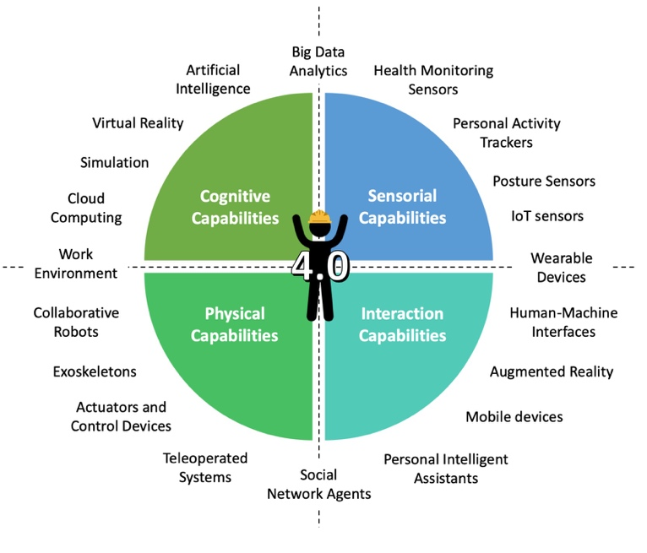

Figure 1: The Operator 4.0 Compass – How the Industry 4.0 key enabling technologies match and extend the Operator 4.0 capabilities
Technologies enhancing the operator’s sensorial capabilities

- Health Monitoring Sensors provide a continuous monitoring of the health-related data of the industrial worker, thus enabling a faster intervention in case of anomalies and precise analysis of the workers’ wellness;
- Personal Activity Trackers monitor the O4.0 activity level, location and task progress, thus providing a clear view on the work advancement and to allow quick real-time adjustments;
- Posture Sensors provide a continuous monitoring of the industrial worker’s posture during a given task, thus permitting to notify in real-time the O4.0 to adjust the posture and enabling an analysis of the workers’ wellness;
- Internet of Things (IoT) Sensors monitor relevant parameters within the production system and enhance the O4.0 capability.

Technologies enhancing the operator’s physical capabilities

- Collaborative Robots directly interact with the O4.0 to carry out a complex task within a defined collaborative workspace;
- Exoskeletons empower the O4.0, who is coated with it, with greater physical capabilities (strength, agility, speed, power, etc.) and represent a sort of “artificial musculature”;
- Actuators and Control Devices enable the O4.0 to act on a (usually mechanical) physical system by generating force, motion, heat, flow, and so forth
- Teleoperated Systems enable the O4.0 to control and operate remotely (i.e. at a distance) a physical system or a machine.

Technologies enhancing the operator’s interaction capabilities

- Human-Machine Interfaces represent the element that enables the interaction between the human operator and the physical system (such as a computer or a machine);
- Augmented Reality endow the O4.0 with the capability to interact with the physical world in a more intuitive manner where the real objects are “augmented” by computer-generated perceptual information;
- Mobile devices endow the O4.0 with a ubiquitous computing power which enables to interact with the cyber world (such as smartphones or tablets);
- Personal Intelligent Assistants represent a new kind of interface that enables the O4.0 to engage with the cyber world through vocal interaction.

In addition to the technologies above, some of them locate themselves in between two groups. In particular:

- Big Data Analytics can be located between the technologies enhancing the operator’s cognitive and sensorial capabilities. Indeed, IoT sensors generate extremely large datasets about the operator itself (e.g. health-related data) or about the environment (e.g. a machine operating temperature) that can be computationally analyzed only by a “greater intelligence” powered by artificial intelligence, simulation and cloud computing to reveal patterns, trends, and associations;
- Wearable Devices can be located between the technologies enhancing the operator’s sensorial and interaction capabilities. On one hand, wearable devices are equipped with computing power which enables them to process information (such as smartwatches or smart glasses); on the other hand, such devices also collect data about the user or the environment through embedded sensors;
- the Work Environment, here considered as a set of workplace conditions, exposures and ergonomic principles, can be located between the technologies enhancing the operator’s cognitive and physical capabilities. Methodologies and technologies should be implemented to create a proper work environment where the O4.0 operates efficiently, thus leading to the concept of the Workplace of the Future.
- the Social Network Agents can be located between the technologies enhancing the operator’s physical and interaction capabilities. They represent a novel way for the O4.0 to interact with each other within the production floor, to have constant updates about their work (thus enhancing communication in the workforce) and to request support and activate collaboration patterns in case it is needed (which means that the workload is shared to some extent and the task is executed more quickly).

The definition of the Operator 4.0 Compass represents the first step towards a more comprehensive framework that embeds human values. While this version of the Operator 4.0 Compass provides a greater understanding of how the Industry 4.0 key enabling technologies match and extend the Operator 4.0 capabilities, future work should be devoted to provide clear guidelines of how to implement the Operator 4.0 in a human-centered perspective. This basically means that it is needed to identify the ethical issues behind the Operator 4.0 concept and implement a design-for-values methodology. The next section explores the main methodologies related to the Responsible Innovation body of knowledge. It is later discussed how the Value Sensitive Design (VSD) approach can be applied to the design of the O4.0 for human values and how the O4.0 can then be used to design other Industry 4.0-related technologies with human values also.
- Responsible Research and Innovation
Several approaches have been proposed that account for the social embeddedness of technologies and their impacts. Particular emphasis in these methodologies is the involvement and elicitation of stakeholders, either those directly or indirectly implicated by technology design. Approaches such as universal design [25], inclusive design [26], sustainable design [27], participatory design [28], and values sensitive design [29–31] among others have been theorized.
These design approaches to technology engineering arise from the broader discourse on responsible research and innovation (RRI) which aims to assess and direct how research and innovation impacts society and the environment [32]. Currently used by the European Union's Framework Programmes for describing these effects, RRI arose from predecessor frameworks such as technology assessment and the Ethical, Legal and Social Aspects (ELSA) among others. In a word, RRI runs contrary to the two most commonly held positions on technology: (1) that technology is a neutral tool that can be used for multiple means, and (2) that the progress of technological development is deterministic and thus not influenced by human interaction. RRI is founded on an interactionist principled that technology and humans co-construct and co-vary one another [9]. To this end, Value Sensitive Design (VSD) is then becoming one of the most popular approaches over the last 20 years to guide the design and development of technologies [33].
  - Value Sensitive Design
Originating from studies in human-computer interaction, VSD begins with the premise that technology is not value-neutral, instead technologies are sensitive to stakeholder values, be they either direct stakeholders such as users and designers or indirect such as industry CEO’s and governments [34]. As a consequence, the VSD approach aims to embed stakeholder values both early on and throughout the design process in order to steer the design of the technology in such a way as to successfully map the values [31,35].
More pointedly, VSD functions on the basis that technologies are inextricably interconnected within society, contingent on various actors and environments and within such a milieu they have emergent properties as a result of this socio-contextual relationality [29]. As such, its goal is to enroll stakeholders directly into the design process by eliciting their values in to design technologies that embody them.
There are numerous established methods from the social sciences for eliciting such values such as the use of stakeholder tokens, value source analysis, value scenarios, among others [36,37]. Research using VSD has provided various lists of human values that have been shown to be important in technology design, some such values as (among others): Welfare; Ownership and Property; Privacy; Freedom from Bias; Universal Usability; Trust; Autonomy; Informed Consent; Accountability; Courtesy; Identity; Calmness; Environmental Sustainability.
The list is not exhaustive seeing as certain values are technology-specific and some emerge over the design process and, in many cases, after the deployment of the technology. To this end, the VSD methodology aims to be fundamentally proactive and anticipatory, engaging with stakeholders in to direct technological development from an early stage and recursively self-improve throughout the design process as new values or tensions surface. This reflexivity towards beneficial development is the product of the approach’s tripartite structure. Not only this, but VSD encourages designers to consider always building mailable and flexible architectures into technologies to permit post-deployment augmentations to be possible as new values and issues emerge [35].
  - Tripartite Methodology
The VSD approach is typically described in the literature as consisting of three parts: conceptual, empirical and technical investigations. These three investigations are described as being part of a feedback cycle, continually informing one another throughout the design process. In conceptual investigations, designers are encouraged to consult the existent philosophical literature that may be relevant on the topic and aim to discern possible values and issues that may arise from design, as well as to give working definitions of what these values mean within the context of the technology itself. Initial explorations are also made to determine who the potentially affected stakeholders of such a technology would be. Empirical investigations build on these initial investigations by enrolling these stakeholders through a variety of methods including questionnaires, surveys and other elicitation techniques to determine the relationship of these stakeholders to the technological design and how well the identified values map on to the current design architecture [34]. Technical investigations look at the technology itself to determine how the technical constraints of the technology can support or restrict the values distilled in the previous investigations. An example would be how can the architecture of a system, such as smart wearable systems, balance the users’ needs for information about a production process advancement over data privacy.

The methodology follows 8 considerations provided in [38] to put this approach into practice (it should not be construed as a concrete step-by-step or waterfall method though):
- Begin by considering (1) value, (2) a technology, or (3) the context of use. Any of these three core aspects easily motivates VSD. Ideally one would begin with any of the three that is most explicitly and obviously critical to the designers work or interests.
- Systematically identify direct and indirect stakeholders. Direct stakeholders are those individuals who interact directly with the technology or with the technology’s output – i.e. the human operator itself; indirect stakeholders are those individuals who are also impacted by the Operator 4.0 concept, though they never interact directly with it.
- Identify Harms and Benefits for Each Stakeholder Group. Each category of direct and indirect stakeholders can be indeed positively or negatively affected by the technology under consideration.
- Map Harms and Benefits onto Corresponding Values. At times the mapping between harms and benefits and corresponding values will be one of identity; at other times the mapping will be multifaceted (that is, a single harm might implicate multiple values, such as both security and autonomy).
- Conduct a Conceptual Investigation of Key Values. Develop careful working definitions for each of the key values. Designers draw on the philosophical literature in order to more accurately define these values and the potential issues that already exist with certain conceptualizations of these values.
- Identify Potential Value Conflicts. For the purposes of design, value conflicts should usually not be conceived of as ‘either/or’ situations, but as constraints on the design space [39]. Typical value conflicts include accountability vs. privacy, trust vs. security, environmental sustainability vs. economic development, privacy vs. security, and hierarchical control vs. democratization among others.
- Technical Investigation Heuristic and Value Conflicts. Technical mechanisms will often adjudicate multiple if not conflicting values, often in the form of design trade-offs. Hence, designers here should aim to make explicit how a design trade-off maps onto a value conflict and differentially affects different groups of stakeholders [40].
- Technical Investigation Heuristic and Unanticipated Consequences and Value Conflicts. In order to be positioned to respond agilely to unanticipated consequences and value conflicts, when possible, design flexibility into the underlying technical architecture to support post-deployment modifications.
- Designing the Operator 4.0 technologies with values: some considerations
The VSD methodology, as discussed, aims to anticipate and incorporate human values early on and throughout the design process. Traditionally, applications of the VSD methodology to technologies have generally, in the literature, been done in a speculative, ex post facto way; asking the question, ‘how would x have been done if VSD was employed’, typically done in the event of an accident or failure of a particular technology. These studies provide salient ways of envisioning how potential futures could be brought about if a VSD framework was applied, many of which project generally optimal futures (more optimal then without VSD). Still, the potency of VSD lies not in this retrospective way, but in its actual application early in the design process of an emerging technology. Thus, framed within the larger space of the RRI discourse, VSD does not only seek for backwards-looking responsibility (who is responsible for the emerging values ex post facto), but primarily forward-looking responsibility through design (prospective/anticipatory responsibility).
The notion of the Operator 4.0 that has been proposed in this paper offers a potent way for not only VSD to be adopted, but the technology itself extends how the three investigations critical to VSD can operate. Particularly, the O4.0 can not only be informed by VSD but also informs the methodology itself, enabling it to become more effective. As mentioned, conceptual investigations begin with a priori values and elicited stakeholder values of new technologies. Empirical investigations aim to determine how those values can be translated through socio-cultural norms into design requirements that drives future implementation projects of the Operator 4.0 concept in the context of a Smart Factory. Eventually, technical investigations aim to determine how the technology in question either supports or constrains those values. The application of the VSD method in the case of the Operator 4.0 will eventually result into a Bi-directional Value-Driven Design Hierarchy illustrated in Figure 2.
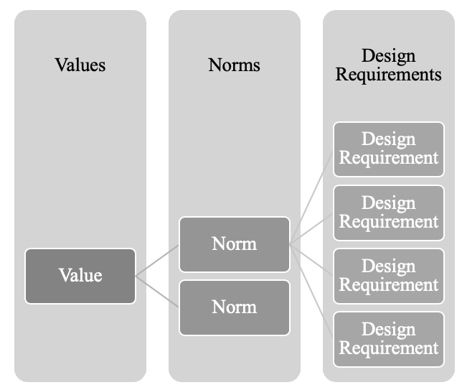

Figure 2. Bi-directional Value-Driven Design Hierarchy for the Operator 4.0
Doing this appears prima facie abstract and meta-level, and for this reason some salient examples are provided hereunder to illustrate how designers can begin to conceptualize the bi-directional process. We provide two examples with diagrams, one beginning with a value and the other beginning with a technology.
  - Starting with values
As mentioned, values can often be abstract, philosophical concepts that are difficult to conceptualize in terms of concrete engineering demands. VSD holds that values are ends in themselves, meaning that they are of intrinsic value. Because of this, VSD aims at the embodiment of values that extend beyond – but not exclude – economic value, which is what is traditionally designed for. Norms, which are situated in the transition point between values and design requirements are the contextual designations of those values and can be understood as the design objectives of any given project (i.e., ‘maximize safety/usability/efficiency’ or ‘minimize cost’). The norms of any given value are established on the basis of the context-of-use in which the designers and the technology are or will eventually be deployed. To this end, the norms of any particular context can be used to derive specific design requirements that the technology can embody to support any given set of norms. To illustrate this, we employ the example of the value of accessibility to the AR/VR headsets used by the O4.0. Figure 3 lays out one potential (not exhaustive but just illustrative) way to translate values, through norms and into design requirements that embody the value of accessibility.
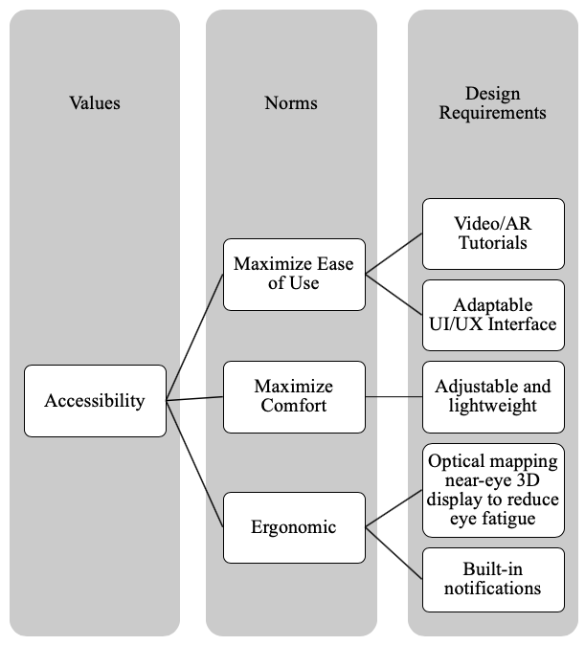

Figure 3. A potential simplified translation of the “Accessibility” value. The design requirements for ergonomics are based on the EU Directive 90/270/EEC regarding display screen equipment in the workplace.
  - Starting with design requirements
In many design spaces, the successful construction of a value hierarchy, to better specify each of the three parts will almost certainly need to be conducted in both directions. Figure 4 illustrates simply how certain design requirements (i.e., client demands) can be translated into norms and again into a value. Each of the norms and design requirements are not inextricably exclusive to any single value. Any of the below design requirements can just as easily satisfy other norms which in turn can satisfy other values. What engineering teams need to do is to specify as best as possible how different design requirements, norms and values relate to one another in any given design project and determine how to most aptly satisfy them.
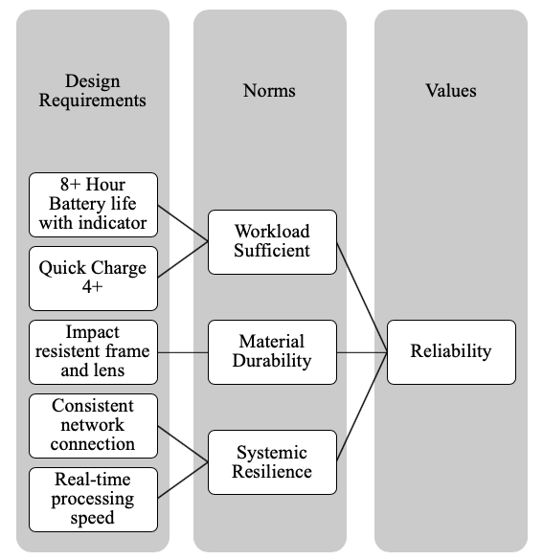

Figure 4: Bi-directional values hierarchy beginning with design requirements towards the value of “reliability”
- Conclusions and future research avenues
Although the O4.0 is still in its infancy, it is the perfect environment for converging technologies in industry to be designed for human values. To this end, this paper introduces the concept of the Operator 4.0 Compass representing the full and comprehensive set of technologies connected to the industrial workers’ activity and their capabilities. This tool implies a definition of the O4.0 as “an industrial worker whose cognitive, sensorial, physical and interaction capabilities are enhanced by the close interplay with Industry 4.0 technologies”. In order to anticipate and incorporate human values early on and throughout the design process of an O4.0 and provide clear guidelines for companies that want to implement such concept in their daily processes, the Value Sensitive Design (VSD) methodology is proposed as one such way that O4.0 technologies can be designed for these human values. What further research needs to investigate are applied examples of VSD in Industry 4.0 practices and environments and what novel results are yielded. Along a similar note, both academic and industry leaders that are designing technologies that constitute the O4.0 should adopt a VSD methodology, both for their own sake, but to better understand the dynamic nature of value change as technologies converge and impact unforeseen stakeholders and environments. This of course applies for designers who are explicitly employing O4.0 systems given that they are built on previously existing technologies. This paper also raises another discussion. Similarly to [41], there is a significant need of optimizing the rest breaks configurations in technology- and human-intensive working activities. For example, the prolonged use of the technologies in the O4.0 Compass (e.g. Virtual Reality) may have relevant consequences on the worker’s psychophysical health, and ultimately reliability. We argue that a new generation of tools and simulators for human reliability analysis (an example of which is given in [42]) is urgently needed. In general, further work will be devoted to extend the Operator 4.0 Compass and incorporate human values as a result of the application of the VSD to provide clear guidelines to the companies that want to transform their worker into an O4.0.

Author Contributions

Authors are listed in alphabetic order. The conception, writing, and proofing of this paper was undertaken equally by all authors.
Acknowledgements
The views expressed in this paper do not necessarily reflect those of the Institute for Ethics and Emerging Technologies.
References
[1] L. Monostori, B. Kádár, T. Bauernhansl, S. Kondoh, S. Kumara, G. Reinhart, O. Sauer, G. Schuh, W. Sihn, K. Ueda, Cyber-physical systems in manufacturing, CIRP Ann. 65 (2016) 621–641. https://doi.org/10.1016/j.cirp.2016.06.005.
[2] R. Jardim-Goncalves, D. Romero, A. Grilo, Factories of the future: challenges and leading innovations in intelligent manufacturing, (2017).
[3] M. Krugh, L. Mears, A complementary Cyber-Human Systems framework for Industry 4.0 Cyber-Physical Systems, Manuf Lett. 15 (2018) 89–92. https://doi.org/10.1016/j.mfglet.2018.01.003.
[4] J. Petronijevic, A. Etienne, J.Y. Dantan, Human factors under uncertainty: A manufacturing systems design using simulation-optimisation approach, Comput Ind Eng. 127 (2019) 665–676. https://doi.org/10.1016/j.cie.2018.11.001.
[5] M.P. Pacaux-Lemoine, D. Trentesaux, G. Zambrano Rey, P. Millot, Designing intelligent manufacturing systems through Human-Machine Cooperation principles: A human-centered approach, Comput Ind Eng. 111 (2017) 581–595. https://doi.org/10.1016/j.cie.2017.05.014.
[6] D. Trentesaux, P. Millot, A human-centred design to break the myth of the ‘‘Magic Human” in intelligent manufacturing systems, in: T. Borangiu, D. Trentesaux, A. Thomas, M. D. (Eds.), Serv Orientat Holonic Multi-Agent Manuf, Springer, Cham, 2016: pp. 103–113. https://doi.org/10.1007/978-3-319-30337-6_10.
[7] V. Özdemir, N. Hekim, Birth of Industry 5.0: Making Sense of Big Data with Artificial Intelligence, “The Internet of Things” and Next-Generation Technology Policy, Omi A J Integr Biol. 22 (2018) 65–76. https://doi.org/10.1089/omi.2017.0194.
[8] J. Hooker, T.W. Kim, Ethical Implications of the Fourth Industrial Revolution for Business and Society, in: K.T. Wan (Ed.), Bus Ethics, Emerald Publishing Limited, 2019: pp. 35–63. https://doi.org/10.1108/S2514-175920190000003002.
[9] T. Philbeck, N. Davis, A.M. Engtoft Larsen, Values, Ethics and Innovation - Rethinking Technological Development in the Fourth Industrial Revolution, 2018. http://www3.weforum.org/docs/WEF_WP_Values_Ethics_Innovation_2018.pdf.
[10] A.H. Kiran, N. Oudshoorn, P.P. Verbeek, Beyond checklists: toward an ethical-constructive technology assessment, J Responsible Innov. 2 (2015) 5–19. https://doi.org/10.1080/23299460.2014.992769.
[11] A.F. Winfield, K. Michael, J. Pitt, V. Evers, Machine ethics: The design and governance of ethical ai and autonomous systems, Proc IEEE. 107 (2019) 509–517. https://doi.org/10.1109/JPROC.2019.2900622.
[12] F. Longo, L. Nicoletti, A. Padovano, Ubiquitous knowledge empowers the Smart Factory: The impacts of a Service-oriented Digital Twin on enterprises’ performance, Annu Rev Control. 47 (2019) 221–236. https://doi.org/10.1016/j.arcontrol.2019.01.001.
[13] S. Umbrello, S.D. Baum, Evaluating future nanotechnology: The net societal impacts of atomically precise manufacturing, Futures. 100 (2018) 63–73. https://doi.org/10.1016/j.futures.2018.04.007.
[14] D. Romero, O. Noran, J. Stahre, P. Bernus, Å. Fast-Berglund, Towards a human-centred reference architecture for next generation balanced automation systems: Human-automation symbiosis, in: IFIP Adv Inf Commun Technol, 2015. https://doi.org/10.1007/978-3-319-22759-7_64.
[15] D. Romero, J. Stahre, T. Wuest, O. Noran, P. Bernus, Å. Fast-Berglund, D. Gorecky, Towards an Operator 4.0 Typology: A Human-Centric Perspective on the Fourth Industrial Revolution Technologies, in: Int Conf Comput Ind Eng Proceedings, 2016.
[16] J. Posada, M. Zorrilla, A. Dominguez, B. Simoes, P. Eisert, D. Stricker, J. Rambach, J. Dollner, M. Guevara, Graphics and Media Technologies for Operators in Industry 4.0, IEEE Comput Graph Appl. 38 (2018) 119–132. https://doi.org/10.1109/MCG.2018.053491736.
[17] I. Zolotová, P. Papcun, E. Kajáti, M. Miškuf, J. Mocnej, Smart and cognitive solutions for Operator 4.0: Laboratory H-CPPS case studies, Comput Ind Eng. (2018). https://doi.org/10.1016/j.cie.2018.10.032.
[18] A. Syberfeldt, O. Danielsson, M. Holm, L. Wang, Visual Assembling Guidance Using Augmented Reality, in: Procedia Manuf, 2015. https://doi.org/10.1016/j.promfg.2015.09.068.
[19] M.H. Rahman, M. Saad, J.P. Kenné, P.S. Archambault, Control of an exoskeleton robot arm with sliding mode exponential reaching law, Int J Control Autom Syst. (2013). https://doi.org/10.1007/s12555-011-0135-1.
[20] P.J. Koch, M.K. van Amstel, P. Dębska, M.A. Thormann, A.J. Tetzlaff, S. Bøgh, D. Chrysostomou, A Skill-based Robot Co-worker for Industrial Maintenance Tasks, Procedia Manuf. 11 (2017) 83–90. https://doi.org/10.1016/j.promfg.2017.07.141.
[21] L. Atzori, A. Iera, G. Morabito, M. Nitti, The social internet of things (SIoT) - When social networks meet the internet of things: Concept, architecture and network characterization, Comput Networks. (2012). https://doi.org/10.1016/j.comnet.2012.07.010.
[22] R.J. Rabelo, D. Romero, S.P. Zambiasi, Softbots supporting the operator 4.0 at smart factory environments, in: IFIP Adv Inf Commun Technol, 2018: pp. 456–464. https://doi.org/10.1007/978-3-319-99707-0_57.
[23] T. Ruppert, S. Jaskó, T. Holczinger, J. Abonyi, Enabling Technologies for Operator 4.0: A Survey, Appl Sci. 8 (2018) 1650. https://doi.org/10.3390/app8091650.
[24] D. Romero, S. Mattsson, Å. Fast-Berglund, T. Wuest, D. Gorecky, J. Stahre, Digitalizing occupational health, safety and productivity for the operator 4.0, in: IFIP Adv Inf Commun Technol, 2018: pp. 473–481. https://doi.org/10.1007/978-3-319-99707-0_59.
[25] L. Ruzic, J.A. Sanfod, Universal Design Mobile Interface Guidelines (UDMIG) for an Aging Population, in: Mob E-Health, Springer, 2017: pp. 17–37.
[26] A.F. Newell, P. Gregor, M. Morgan, G. Pullin, C. Macaulay, User-Sensitive Inclusive Design, Univers Access Inf Soc. 10 (2011) 235–243. https://doi.org/10.1007/s10209-010-0203-y.
[27] T. Bhamra, V. Lofthouse, Design for sustainability: a practical approach, Routledge, 2016.
[28] K. Bødker, F. Kensing, J. Simonsen, Participatory IT design: designing for business and workplace realities, MIT press, 2009.
[29] J. Davis, L.P. Nathan, Handbook of ethics, values, and technological design: Sources, theory, values and application domains, in: J. van den Hoven, P.E. Vermaas, I. van de Poel (Eds.), Handb Ethics, Values, Technol Des Sources, Theory, Values Appl Domains, 2015: pp. 12–40. https://doi.org/10.1007/978-94-007-6970-0.
[30] S. Umbrello, Beneficial Artificial Intelligence Coordination by Means of a Value Sensitive Design Approach, Big Data Cogn Comput. 3 (2019) 5. https://doi.org/10.3390/bdcc3010005.
[31] S. Umbrello, Atomically Precise Manufacturing and Responsible Innovation: A Value Sensitive Design Approach to Explorative Nanophilosophy, Int J Technoethics. 10 (2019). https://doi.org/10.2139/ssrn.3141478.
[32] H. van Lente, T. Swierstra, P.B. Joly, Responsible innovation as a critique of technology assessment, J Responsible Innov. 4 (2017) 254–261. https://doi.org/10.1080/23299460.2017.1326261.
[33] T. Winkler, S. Spiekermann, Twenty years of value sensitive design: a review of methodological practices in VSD projects, Ethics Inf Technol. (2018). https://doi.org/10.1007/s10676-018-9476-2.
[34] B. Friedman, D.G. Hendry, A. Borning, A Survey of Value Sensitive Design Methods, Found Trends® Human–Computer Interact. 11 (2017) 63–125. https://doi.org/10.1561/1100000015.
[35] B. Friedman, D.G. Hendry, Value Sensitive Design: Shaping Technology with Moral Imagination, Mit Press, Cambridge, MA, 2019.
[36] D. Yoo, Stakeholder Tokens: a constructive method for value sensitive design stakeholder analysis, in: Proc 2017 ACM Conf Companion Publ Des Interact Syst, ACM, 2017: pp. 280–284.
[37] L.P. Nathan, P. V Klasnja, B. Friedman, Value Scenarios: A Technique for Envisioning Systemic Effects of New Technologies, in: CHI ’07 Ext Abstr Hum Factors Comput Syst, ACM, New York, NY, USA, 2007: pp. 2585–2590. https://doi.org/10.1145/1240866.1241046.
[38] B. Friedman, P.H. Kahn Jr., A. Borning, Value Sensitive Design and Information Systems (PREPRINT), Human-Computer Interact Manag Inf Syst Found. (2006) 1–27. https://doi.org/10.1145/242485.242493.
[39] I. van de Poel, Conflicting Values in Design, in: J. van den Hoven, P.E. Vermaas, I. van de Poel (Eds.), Handb Ethics, Values, Technol Des Sources, Theory, Values Appl Domains, Springer Netherlands, Dordrecht, 2014: pp. 1–23. https://doi.org/10.1007/978-94-007-6994-6_5-1.
[40] S. Umbrello, The moral psychology of value sensitive design: the methodological issues of moral intuitions for responsible innovation, J Responsible Innov. 5 (2018) 186–200. https://doi.org/10.1080/23299460.2018.1457401.
[41] V. Di Pasquale, S. Miranda, R. Iannone, S. Riemma, Simulative analysis of performance shaping factors impact on human reliability in manufacturing activities, 27th European Modeling and Simulation Symposium, (2015), pp. 93.
[42] V. Di Pasquale, S. Miranda, R. Iannone, S. Riemma, A Simulator for Human error in industrial maintenance: A systematic literature review, Proceedings of the Summer School Francesco Turco, (2017) pp 164.

