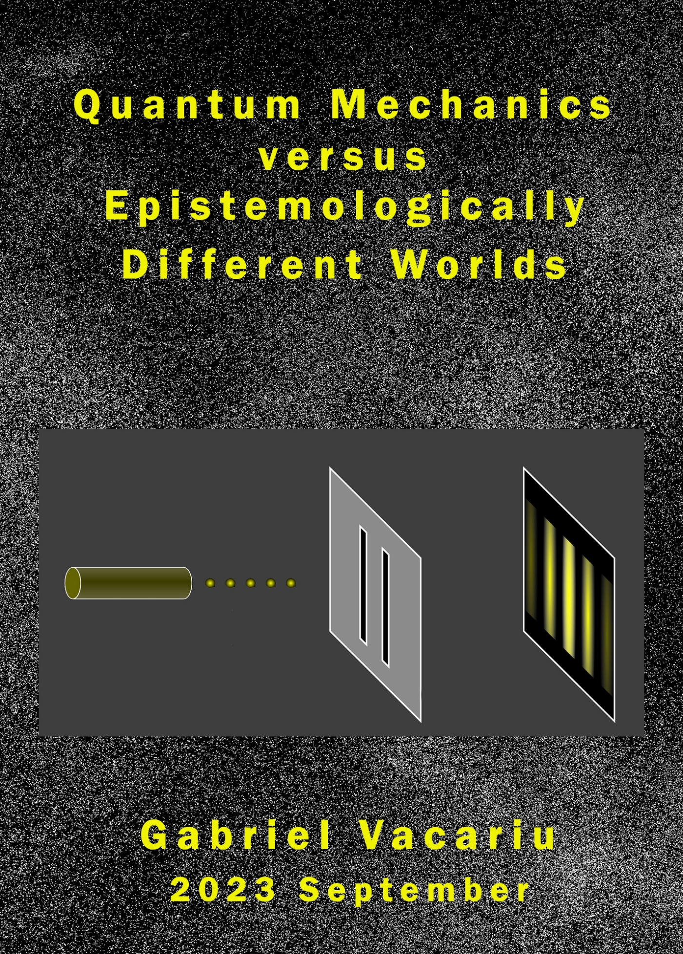

**Quantum Mechanics**

**versus**

**Epistemologically Different Worlds**

**2023 September**

**Content**

Introduction

Chapter 1 The epistemologically different worlds” (EDWs) versus the unicorn world

(universe/world)

Chapter 2 The pre-historical context of quantum mechanics: Newton’s „light as

particles” (18th Century) and thermodynamics (19th Century)

Chapter 3 Light as electromagnetic wave versus the EDWs perspective: Young’s

double-slit experiment (1800-3) and Maxwell’s field equations for light (1861/2)

Chapter 4 The discovery of “microparticles” (Thomson’s electrons 1897) and a great

problem, the black body radiation, related to light as “packets of energy” (Planck’s “quanta”, 1900) versus microparticles (Einstein and the photoelectric effect, 1905)

Chapter 5 Rutherford’s „microparticles-model” (1909-1911) versus Bohr’s bright line

spectra (1913)

Chapter 6 Three interpretations of quantum mechanics: de Broglie’s “matter-wave

duality” (1924), Schrödinger’s wave function (1925/6), and Heisenberg’s “matrix” (1926)

Chapter 7 Four mysteries of quantum mechanics: „entanglement”, „nonlocality”,

“electron spin”, and “superposition”

Chapter 8 “Probability” and “uncertainty”: ontological or epistemological principles in

the “quantum world”? Born’s “probability of wave function” (1926) and

Heisenberg’s „uncertainty principle” (1927) versus Dirac’s combination of quantum mechanics and special relativity (1927)

Chapter 9 Two very famous thoughts experiments in quantum mechanics,

Schrödinger’s cat thought experiment (1935) and Einstein, Podolsky, Rosen’s

thought experiment (1935), related to the strange notion of “decoherence” (never „observed”)

Chapter 10 Other four interpretations of quantum mechanics: Bohr’s

„complementarity” (1927), Feynman’s “sum over histories” (1948), Bohm’s “hidden variables theory” (1952), and Everett’s “many worlds” (“parallel worlds” and “multiverse”) (1957)

Chapter 11 Bell’s inequality (1964) and the strange Wheeler’s “delayed-

choice experiment” (1980) (related to Young’s experiment)

Chapter 12 A few details about some phenomena of quantum mechanics: quantum

tunneling, laser and bulb light, the electromagnetic field (the field-EW), from “micro” to “macro”, the brain and quantum mechanics, Einstein’s special relativity and EDWs, Penrose’s reductionism, other approaches in quantum mechanics

Conclusion “Vacariu’s mind thought experiment”: all theories/approaches/concepts of

quantum mechanics have been constructed within the unicorn world

Bibliography[1]

“It seems clear that the present quantum mechanics is not in its final form. Some further changes will be needed, just about as drastic as the changes made in passing from Bohr's orbit theory to quantum mechanics. Some day a new quantum mechanics, a relativistic one, will be discovered, in which we will not have these infinities occurring at all. It might very well be that the new quantum mechanics will have determinism in the way that Einstein wanted.”

(Paul Dirac)

“I am now convinced that theoretical physics is actual philosophy“.

(Max Born)

“If you think you understand quantum mechanics, you don't understand quantum mechanics.”

(Richard Feynman)

**Introduction**

In the middle of 2022, after writing around 15 books (and many articles), and have solving all the great problems of philosophy and some particular sciences (cognitive neuroscience, physics and biology), I was wondering if I could write anymore, in the future. I was wondering about any more topic on which I had to work on. Nevertheless, until September 2023, I have been already writing four new books (each book covering totally different topics/domain than the other three works):

(1) Metaphysics: *Metaphysics* [Big Bang, nothing, EDWs], Amazon

(2) Art: *Dedublarea Fiintei si Eterna Reintoarcere: Constantin Brancusi, Cristi Puiu, Wong Kar-Wai, Andrei Tarkovski*, Revista Timpul [four artists: three directors of movies and one sculptor]

(3) Literature (a novel): *Mr. G. riding the Dragon - a story about shit* [the dragon/shit being SS], Amazon

(4) Quantum Mechanics: *Quantum Mechanics versus EDWs*.[2](this book)

In this work, I will introduce more details about quantum mechanics versus “epistemologically different worlds” perspective. In the title, I use “versus” because, as I have indicated in my previous works and here, all theories, interpretations, and important concepts have been created in a wrong framework, the “Universe”/world or, as I called, the unicorn world. Therefore, as I will show in this work (furnishing more details than in my previous works), all the interpretations (not all concepts) and many “principles” have been quite wrong.[3]I try to grasp a very short history referring to the main concepts, principles and interpretations in quantum mechanics in relationship to my EDWs perspective, that is, I have tried, at least partially, to follow the *historical appearances* of these concepts/principles/interpretations. I am neither a physicist, nor a “historian of physics”, therefore, I am sure there are some mistakes in my work and, inevitable, I have avoided (not intentionally) the accomplishments of some important physicists, i.e. some essential concepts, theories, interpretations, etc. Therefore, the reader has to pay attention that this work is not an “historical analysis” of quantum mechanics realized by a “specialist”; on the contrary, it is my interpretation of some works realized by some (very important or less important) physicists in relationship to my EDWs perspective, no more. I “interpret” some notions, principles, and interpretations of quantum mechanics just to indicate how “quantum mechanics” has to be re-written by physicists (working in this area) under my EDWs perspective.

I start with a short chapter about my EDWs perspective (for more details, see my previous works). Next chapter is about the “pre-historical context” (the classical physics with (Newton, Maxwell and thermodynamics – in which “the Age of Reason has became the age of certainty!”[4], McEvoy and Zarate 2013, p. 4). Chapter 3 is about light as “wave”: Young experiment and Maxwell’s field equations for “light”. Chapter 4 is about light as “particle”: the discovery of microparticles (Thomson’s electron 1897) the great problem of “blackbody radiation” and light as Planck’s “quanta”/“packets of energy” (1900) versus Einstein’s interpretation of photoelectric effect (1905) (light is composed of “microparticles”). In Chapter 5, I investigate Rutherford’s model of atom (1909-11) versus Bohr’s bright light spectra (1913). In Chapter 6 and Chapter 10, I investigate several essential “interpretations” of quantum phenomena: de Broglie’s “matter-wave duality” (1926), Schrödinger’s wave function (1924), Heisenberg’s “matrix” (1925/6), Bohr’s „complementarity” (1927), Feynman’s “sum over histories” (1948), Bohm’s “hidden variables theory” (1952), Everett’s “many worlds” (“parallel worlds” and “multiverse”) (1957). In Chapter 7 and 8, I analyse certain mysteries of quantum mechanics. In Chapter 9, I discuss two very famous thought experiments in relationship to a very strange notion, “decoherence”. In Chapter 11, I relate Bell’s inequality to the correspondence between the wave and two microparticles which had interact before to be placed to a long distance. Also, I reject Wheeler’s “delayed-choice experiment” (related to Young’s experiment). In Chapter 12, I furnish, very shortly, some details about quantum tunneling, laser and bulb light, some details about electromagnetic field (the field-EW), from “micro” to “macro”, the brain and quantum mechanics, Einstein’s special relativity and EDWs, Penrose’s reductionism, other approaches in quantum mechanics. In Conclusion of this work, I introduce a thought experiment in which I indicate that all theories/approaches/concepts of quantum mechanics have been constructed within a wrong framework of thinking: the Universe/world, or, as I called it in my previous works, the “unicorn world”.[5]

This investigation would be available for all other approaches/ concepts/experiments of quantum mechanics which have been published/realized in the last 20-25 years.[6] Again, I believe some historians of physics will write much better works regarding the evolution of quantum mechanics (all great physicists working within the wrong framework, the unicorn world) in relationship to my EDWs perspective in the next decades… Just few paragraphs (re-written, anyway) of this book are from my previous works, the majority of paragraphs are new. So, this book is a totally new book the topic being only “quantum mechanics versus my EDWs”.

For Einstein, 1905 was an incredible year: he graduated his PhD and published four articles: Brownian motion, two about special relativity, E = mc2. Trying to show, in last decades of his life, that quantum mechanics was “incomplete”, Einstein was partially (not completely) right. However, Einstein did not have my courage to think quantum mechanics is wrong. For me, 2023 has been an incredible year since I have been writing/publishing four books on very different topics. In my previous works, I have showed that all the interpretations of quantum mechanics were not “incomplete” but totally wrong. Anyway, in my work 2016, I indicated “spacetime” could not have any ontology, therefore, I re-wrote both the special and the general relativity without spacetime (using only motions and physical entities in EDWs). Discovering the existence of EDWs (existences of ED entities/processes), I have changed completely the entire framework of human thinking (the wrong framework one was “unicorn world”, i.e, the “universe/world”). In this way, I have demolished (partially or totally) all the great scientific theories and philosophical approaches. I have changed everything in human knowledge and this has been the main reason thousands and thousands of “academic professors” (US, Germany, Canada, etc.) have plagiarized my ideas. (see my “dark list” on the Internet) For the next 200 years (probabilistically speaking), the scientists and philosophers would do nothing new, only realizing certain experiments which confirm my EDWs.[7] Nevertheless, there are thousands of experiments (physics, cognitive neuroscience, biology) who have already confirmed my EDWs perspective.

**The book (online) here:**

Gabriel Vacariu (Septembrie 2023), *Quantum Mechanics and Epistemologically Different Worlds*, Editura Revista Timpul <https://editurarevisteitimpul.ro/p/quantum-mechanics-versus-epistemologically-different-worlds/?fbclid=IwAR20abFcSLPstDUgeLk_Eo9kYSbcKcr6_UHQLnr3LhZM_29fdGNUQax8hUc>

1. The cover is realized by Filip Iacob - there are three EDWs: micro, wave (Young experiment), macro…
2. In 2007, the staff of UNSW (Sydney, Australia) posted my Phd thesis on their official site. Working in each day from morning utill night, after 16 years (6 years as student and ten years as assistent-professor), I have published my first book in 2008. In 2014, I have already published five books. Until now, I have writing/publishing 19 books: philosophy, cognitive (neuro)science, physics, art, and three novels. (If I add the manuscript (very, very long!) about those who have published “unbelievable similar” ideas to my ideas, there would be 20 books (and many articles/chapters) in 15 years.) Obviously, there are not completely different works (some chapters appear, more or less modified, in different works), but there are, nevertheless, different books. In the history of human thinking, I do not know any other thinker who has created such a “monumental oeuvre” which represents a completely new philosophical “paradigm of thinking” and its applications to the main topics from cognitive neuroscience, physics and biology.
3. As I will show during the entire book, many of these essential principles/concepts can be considered just epistemological, but NOT ontological principles, as many great physicists (mainly, but not the only ones, those from Copenhagen interpretation) have thought until the appearance of my EDWs perspective.
4. The classical physics: Archimedes, Kepler, Galileo, Newton, Faraday, Maxwell. (McEvoy and Zarate 2013, p. 10) As the reader will notice, in this work, I show that the scientists and philosophers have to return to this classical view: the “uncertainty” of quantum mechanics is just an epistemological, not ontological principle. The quantum laws, as the classical laws, are certain but the human being is not able to grasp these laws exactly… Just an “epistemological gap”, not ontological…
5. In this footnote, I mention an important aspect of this book. In my carreer, I had been simultaneously working on topics from different particular sciences and philosophy. In general, in each of my book, I have investigated, under my EDWs perspective, topics from different particular sciences and philosophy. On the contrary, for the first time, in this book, I have been working only on quantum mechanics. At the beginning of this manuscript, I introduced some paragraphs (partially re-written) referring to my EDWs perspective from my previous works (mainly, from Vacariu and Vacariu 2019).
6. I mention, because my English is not my native language, in this book (as in all my books) I have introduced quite many quotations. I have also done this to same time… Moreover, any italics from a quoted paragraph is realized by the author(s). Therefore, I will not mention “his/their italics” anymore.
7. Recall the persons who received Nobel for physics in 2022: three physicists (their teams) working on certain empirical experiments which proved “entanglement/nonlocality” (one of the greatest mystery) of quantum phenomena. However, nobody explained correctly “entanglement” and nonlocality just because everybody had been working within the unicorn world until 2006 when the first professors (in my dark list there have been tens, but I am sure there would be, at least, hundreds) plagiarized my ideas. I explained entanglement with the EDWs. The confirmation of my approach? So many “academic professors” (scientists from physics, cognitive neuroscience and biology and philosophers from philosophy) have plagiarized my ideas. Since 2014, I have been continuously fighting with those who have plagiarized my ideas even if I have discovered many of them in the last six years. Because of the Internet, PLAGIARISM has become a normal act for humans (bastards, according to the species evolution), therefore, any publishing company has to add the month (not only the year) in which any book has been published. It has to be VERY clear in the academic environment: a great idea cannot appear simultaneously in the minds of two persons at the same time! The rule “against plagiarism” has to be the following (abide by all publishing companies and journals): only the author who has published firstly an important idea has to be quoted, all the others to be forbidden to be quoted. This rule will exclude PLAGIARISM (which, because of the Internet, has become so common and can take place even after two months) at the international level today. “Victory is always possible for the person who refuses to stop fighting.” (Napoleon Hill) I have never stopped fighting, I would never stop fighting for my ideas. Only one person in at least five centuries could change completely the largest framework of human thinking (the unicorn world, i.e., the universe/world, in my case). Obviously, „we are what we repeatedly do. Excellence, then, is not an act, but a habit.” (Aristotle)