**Is Time an Axiom? Rethinking Its Foundations in Metaphysics and Physics**

**Abstract.**

This study investigates the nature of time, proposing that it emerges as a property of interactions between living organisms and their environment. The research challenges the conventional view of unified space and time, arguing that significant contradictions arise when applying this framework to phenomena at extremely small scales. The author examines the relationship between biological memory, entropy, and physical symmetry, drawing conceptually on Eric Kandel’s research on memory and Ilya Prigogine’s studies on entropy. This perspective integrates ‘subjective’ and ‘objective’ time into a unified framework through a derived equation.

**Keywords:** Cognition; Scale; Memory; Geometry; Time; Entropy; Quantum; Mathematics; Reality.

“*…one cannot be a subject of an environment, one can only be a participant. The very distinction between self and nonself breaks down: the environment surrounds, enfolds, engulfs, and no thing and no one can be isolated and identified as standing outside of, and apart from, it“* (Ittelson 1973)

**Introduction**

Reflections on the **topic of time** often adopt specific frameworks without acknowledging the existence of fundamentally distinct and ununified concepts of time. The most prevalent distinction is between **subjective (biological)** and **objective (physical)** time. A widely accepted view in cognitive science and neuroscience holds that subjective time arises from neural information processing, whereas in physics, physical time is understood as an independent structural parameter that organizes external information processes For instance, on a very large scale, as illustrated in the famous twin paradox subjective time flows uniformly for both individuals, yet their objective times diverge significantly. (Luminet 2011) Conversely, on an extremely small scale, our notion of objective time proves inconsistent with observable phenomena, such as quantum entanglement and superposition principle. What drives us to label these very different concepts as "time" is their shared property of describing intervals. However, the limitation of this generalization lies in the fact that intervals, while measurable, do not constitute the essence of time itself.

This study aims to reconcile subjective time (an internal clock regulated by neural oscillations), with objective time, (a parameter or dimension), by seeking a deeper unifying principle that reveals the true nature of temporality. From this perspective, the distinction between physical reality and cognitive faculties becomes increasingly blurred, given that consciousness is considered a complex manifestation of a shared underlying reality. Consequently, abstract mathematical entities are interpreted as emerging directly from this foundational reality. This viewpoint emphasizes entropy as the underlying "cause" of the arrow of time and posits the quantum mechanical wave function as having an ontological status. The research is structured as follows:

1. The analysis will focus on memory as a physical characteristic. This approach enables to integrate consciousness as a physical phenomenon embedded within time and space, thereby offering a basis for reconciling “subjective” and “objective” notions of time, both of which, as this study contends, ultimately depend on memory formation.
2. This exploration will focus on the relationship between the physical entropy and biological memory. I argue that this perspective is crucial, as it integrates biological memory with physical symmetry, addressing how we, as conscious living beings, are inherently connected to the invariant laws of reality. The key insight is that by introducing Boltzmann’s equation, which describes entropy in thermodynamics $S=k_{B}lnΩ$, and is interpreted as corresponding to 'objective time' in physical terms, and Shannon’s equation for informational entropy: $H\left(X\right)=-\sum_{i=1}^{n}{p(x_{i }})\log_{b}p(x_{i})$, which corresponds to 'subjective time' within living systems, we uncover a formal equivalence between these two frameworks. This equivalence suggests a deeper principle underlying the two notions of time.
3. Finally, I will shift the focus to extremely small scales to explore the emergence of time from probabilistic laws, emphasizing the dependence of time on the presence and perspective of an embedded observer. This view naturally leads to the conclusion that time and space cannot be fully understood as a unified framework of reality. Importantly, this argument does not imply that reality itself is a product of consciousness; rather, it posits that consciousness arises as a consequence of the underlying physical reality.

Before proceeding in detail, I would like to emphasize the necessity of four fundamental premises, which are essential to the validity of the proposed hypothesis.

***The first*** premise defines "objective reality" as the aggregate of all actual events, conceptualized as a set within the framework of Set Theory, wherein the property of repetition is not permitted. $S=\left\{a_{1}\right., a_{2}, a_{3},…,\left.a_{n}\right\}$, where $a_{n}≠a_{m }$ for all $n≠m$. For example: $S=\left\{1,2,2,3\right\}$ is equivalent to $S=\left\{1,2,3\right\}$, because set do not allow repetition. Conversely, "subjective reality" refers to events organized into sequence within the same theoretical framework, where the property of repetition is now applied. $T=\left\{a_{1},a_{2},a_{3},…, a_{n}\right\}$, where $a_{n}$ may equal to $a_{m}$ for $n≠m$. For example $T=\left\{1,2,2,3\right\}$ remains as is because sequense allow repeated elements, thus permitting uncertainty, i.e., information.

***The second*** premise involves the acceptance of the concept of entropy as a factor that determines the direction of time.

***The third*** premise posits memory as a mechanism for entropy reduction, enabling the transformation of ‘objective reality’ into ordered structures and thereby altering the direction of time, such that a low-entropy state is inherently identical with memory.

***The fourth*** premise acknowledges the evolution of the biological world. I interpret evolution not as a process of creating new life forms but as one that increases the complexity of those already existing over time. An important note: complexity allows the emergent of completely new properties trough accumulation. For example, consider one line. We have a line, and that is all. Now consider two lines. We have 1 + 1 lines, but we also observe the emergence of completely new properties, such as symmetry + angle + vector + plane. With three lines, we have 1 + 1 + 1 lines, along with symmetry + angles + vector + planes + space + triangle, and so on.

*„evolution does not produce innovations from scratch. It works on what already exists, either transforming a system to give it a new function or combining several systems to produce a more complex one.“* (Kandel 2012, 235)

THESIS

1. **Biological Memory as a Property Distinguishing Living from Non-Living Nature and Enabling Continuity**

* *This section will explore the idea that bilogical memory, as a complex form of memory, serves as a distinguishing factor between living and non-living systems, thereby influencing and shaping the concept of time.*
* *This capability enables the emergence and application of structures where none previously existed. For example, memory allows organisms to perceive patterns and repetitions, creating the illusion of continuity in a world where each event is unique.*

Imagine a single reality. Despite its immense diversity, it remains coherent due to two fundamental characteristics: time and space. Every event in this reality exists within the shared framework of unified time and space, and every event in this reality is unique and cannot be identical to another, because if two events share the same coordinates in this continuum, they are one and the same. This leads to the conclusion that every event is new, and repetitions do not exist in this reality.

Now, imagine that a very small fraction of this described world, tending toward zero, constitutes what we define as "living nature." Living nature is distinguished from the rest of reality by a unique physical property that only it possesses - complex memory. The complex memory enables organisms to interact with their environment by retaining traces of past events that no longer exist. This process of retention occurs through "engrams" or imprints of past moments, applied to the very brief present moment. The definition of the complex memory is "a set of processes and structural changes for encoding, storing, and subsequently retrieving information. "

(For a detailed analysis of findings on memory and the connection between molecular biology and cognitive science, see (Kandel 2012) This comprehensive work highlights how short-term memory depends on functional synaptic changes, whereas long-term memory involves structural modifications in organisms with neural systems, significantly advancing our understanding of learning and memory processes)

Preserving moments in a reality without repetitions implies that certain structures retain specific configurations, even as they change or evolve.

For illustration, let us consider a hypothetical scenarios. Imagine a person with severe memory impairments. What you would observe, and what clinical studies commonly reveal, is a person unable to link their current location with the events that brought them there. This leads to complete disorientation in time and space. For such a person, time and space do not exist as a continuum, in the way they are perceived by others. (Wilson, Baddeley, and Kapur 1995) When they look in the mirror, they do not recognize their own reflection but see each time there, a new and unfamiliar person.

Now, imagine another individual who is entirely devoided of memory. The question arises: should this person be regarded as part of the living world, or merely as a physical object? The second option holds, as without complex memory, their actions would be entirely dictated by external factors, lacking any self-directed behavior.

If we follow this line of reasoning, we arrive at the conclusion that in the absence of complex memory, which enables the retention of repetitions and patterns, life must be reduced to a single moment - a single breath or a single heartbeat.

Through complex memory, we alter one of the fundamental conditions of reality that we began with and that forms the described framework - time. Here, time is neither uniform nor consistently increasing but elastic and symmetrical, encompassing something that does not exist- the past. This allows for the continuity we consider as something given due to logical necessity. This "other" reality is consciousness.

Events within consciousness do not follow the linear sequence of events in the ‘objective reality’. It seems as if consciousness moves through time in ways that this reality cannot. Memory, of course, does not erase ‘objective’ time but rearranges it, thereby reorganizing reality. The concept of ‘order’ and its relevance to understanding time will be clarified in Part II of this text.

I suppose that if complex memory serves as the foundational structure underpinning all cognitive processes and creates an illusion of time distinct from ‘objective’ time, it could illuminate several profound aspects of human understanding. These include perceiving ourselves as separate from the environment, our conceptualization of life after death, our intuitive belief in a world beyond reality, our tendency to separate the mind from the body, and our inclination to imagine a transcendent purpose.

1. **Memory Reduces Entropy, Thus Altering Time: Time as an Emergent Property**

* *This section reflects time, as an aspect of reality, emerges simultaneously with it and can be understood as a spatial dimension through Minkowskian geometry.*
* *Entropy, derived from probability theory and explored through the works of Boltzmann and Shannon, serves as a key concept in understanding the nature of time. Memory, as a factor in reducing entropy, plays a fundamental role in alterning time.*
* *Studies on time reveal a distinction between subjective and objective interpretations. I argue that their unification should be considered within a coherent and comprehensive framework.*
* *A general equation is derived as a formal unification of ‘subjective’ and ‘objective’ time.*

To maintain conceptual consistency into the text, let us consider time as an objective characteristic that emerged simultaneously with the reality itself, in order to understand the principle through which memory alters it. In this context, time possesses a geometric nature, while the asymmetry between the past and the future arises from the continuous expansion of the reality, which can be described through increasing entropy. (Earman 2011; Mrugala et al. 1990) Entropy itself is inherently geometric. (Amari 2016; Mrugala et al. 1990) In this universal framework, history does not yet exist, as time in this context is inherently stochastic in nature. To establish relationships between events, it is essential to impose a structure or sequence. This process requires conscious interpretation and organization, heavily dependent on the formation and sustenance of complex memory, which, in turn, relies on the availability of free energy.

It is at this point that the notions of ‘subjective’ and ‘objective’ time become distinct. ‘Objective time’ is defined as a measure of the physical progression of states, governed by thermodynamic laws and the geometric structure of reality. (Earman 2011; Mrugala et al. 1990) In contrast, ‘subjective time’ is a construct shaped by the observer’s cognitive processes. (Derdikman and Knierim 2011)

**‘Subjective time’** or as an internal clock regulated by neural oscillations,arises from brain activity, as it provides the necessary structure for organizing events. The nature of these proceses is exlicitly shown in studies on "**time cells**" and the theta (**Θ**) rhythm in the brains of complex organisms.

‘these cells represent the flow of time in specific memories and have therefore been dubbed 'time cells'. The firing properties of time cells parallel those of hippocampal place cells; time cells thus provide an additional dimension that is integrated with spatial mapping.*’* (Eichenbaum, MacDonald, and Tiganj 2011)

and

‘These findings indicate that phase precession is a very robust effect, distributed across the entire hippocampal population, and that it is likely to be inherited from the fascia dentata or an earlier stage in the hippocampal circuit, rather than generated intrinsically within CA1. [1] It is hypothesized that the compression of temporal sequences of place fields within individual theta cycles permits the use of long-term potentiation for learning of sequential structure, thereby giving a temporal dimension to hippocampal memory traces.’

(O’Keefe and Recce 1993)

The above studies highlight the functioning of time as an additional spatial dimension in the brain's representation of ‘objective reality.’ Central to this process are **time cells**, which fire at specific moments to create temporal "maps," and **grid cells**, which encode both spatial and temporal dimensions. Neural oscillations provide a rhythmic framework, segmenting time into intervals and organizing it into structured timelines. These mechanisms converge in the hippocampus and associated networks, forming cognitive maps that naturally integrate time and space. For comprehensive and detailed information, see (Derdikman and Knierim 2011) Subjective time, in this context, aligns with the understanding of memory as a structure that remains unchanged through evolutionary processes or transformations affecting the system as a whole.

Remarkably, the observations aligns well with Hermann Minkowski's classical concept of the space-time continuum, as formulated in his seminal work, *"Raum und Zeit"* (Minkowski 1908) This explicit uniformity between Minkowskian physical time, where “objective” time emerges as a dimension of space, and brain-constructed “subjective” time, where time emerges as a function of complex memory (with trajectories functioning as dimensions of spatial sequences), has inspired studies suggesting that the brain itself can be conceptualized as a relativistic object within the space-time continuum. Constrained by the constant speed of action potentials (the electrochemical signals of neurons) and obeying principles analogous to the diffusion principle in relativity theory, the brain exhibits a form of functional curvature see (Le Bihan 2019). Naturally, these studies raise doubts about whether the distinctions between ‘subjective’ and ‘objective’ time are as clear-cut as they are often assumed to be.

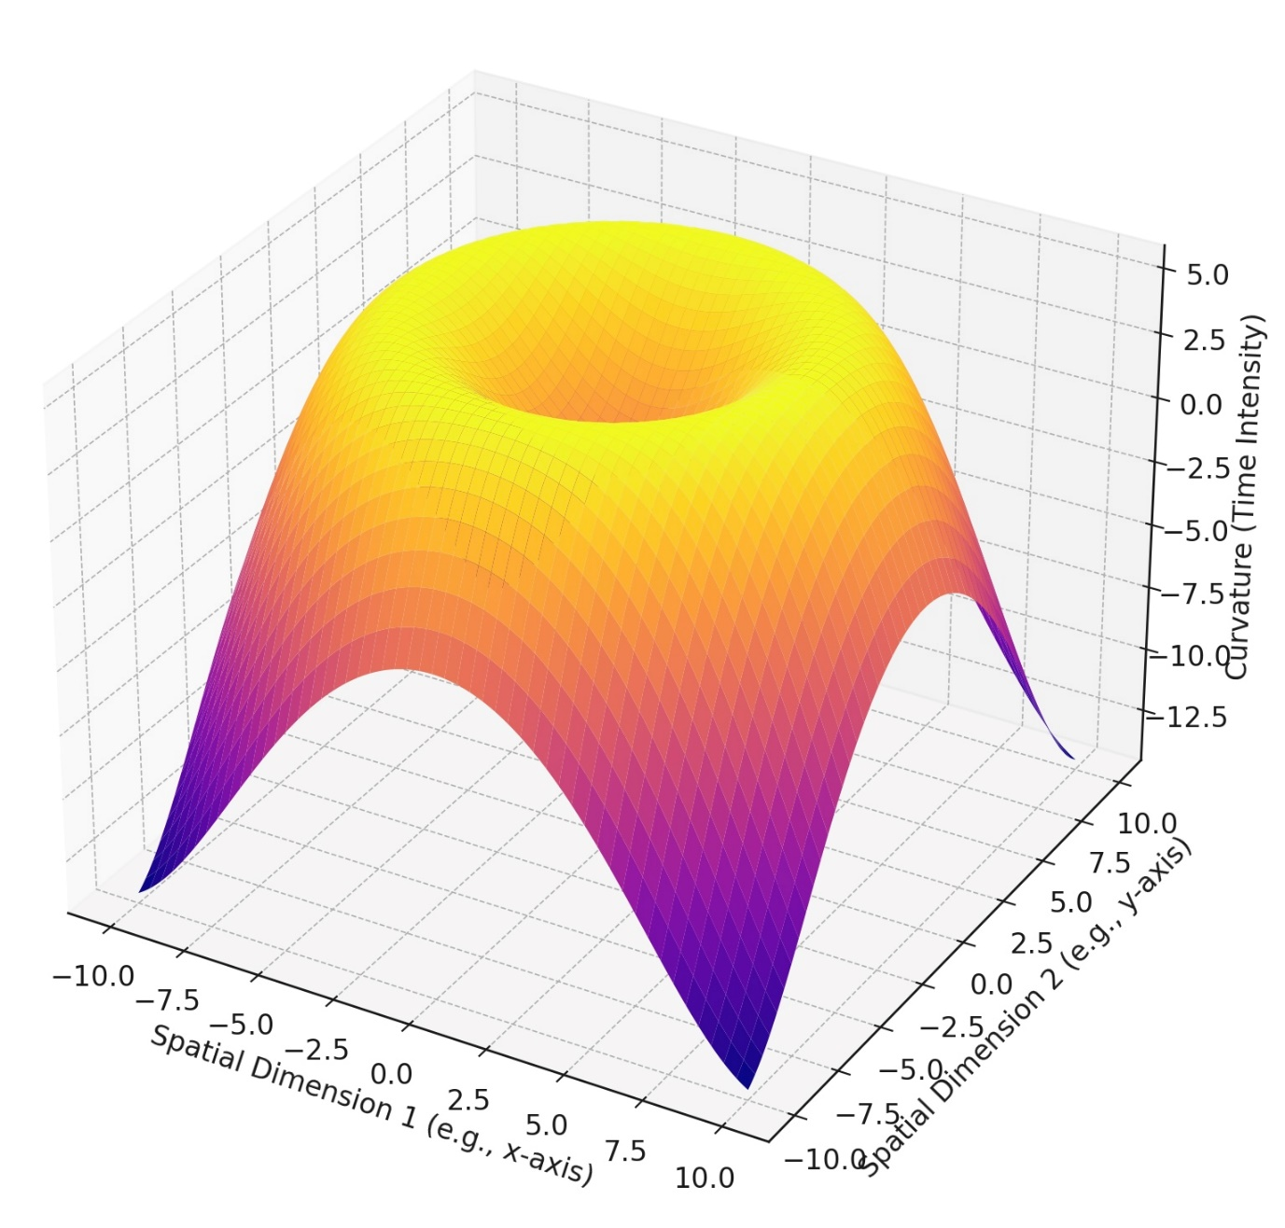

*Fig. 1: Time as a Spatial Dimension*

Let us now consider the concept of **objective time,** which, in physics, is treated as a parameter or a dimension and is characterized by entropy - a fundamental concept in probability theory. Entropy is a measure of disorder, uncertainty, or randomness across different disciplines. In thermodynamics, it quantifies the irreversibility of processes and the degree of disorder. In statistical mechanics, it measures the number of possible microstates corresponding to a system's macroscopic state. In information theory, entropy reflects the uncertainty or average information content in a source of data. (Robinson 2008) Broadly, entropy governs the relationship between reality and the events within it as the universe expands, reflecting the intrinsic nature of time. In our world, entropy can only increase, a process that determines the direction of time, often referred to as the "arrow of time."

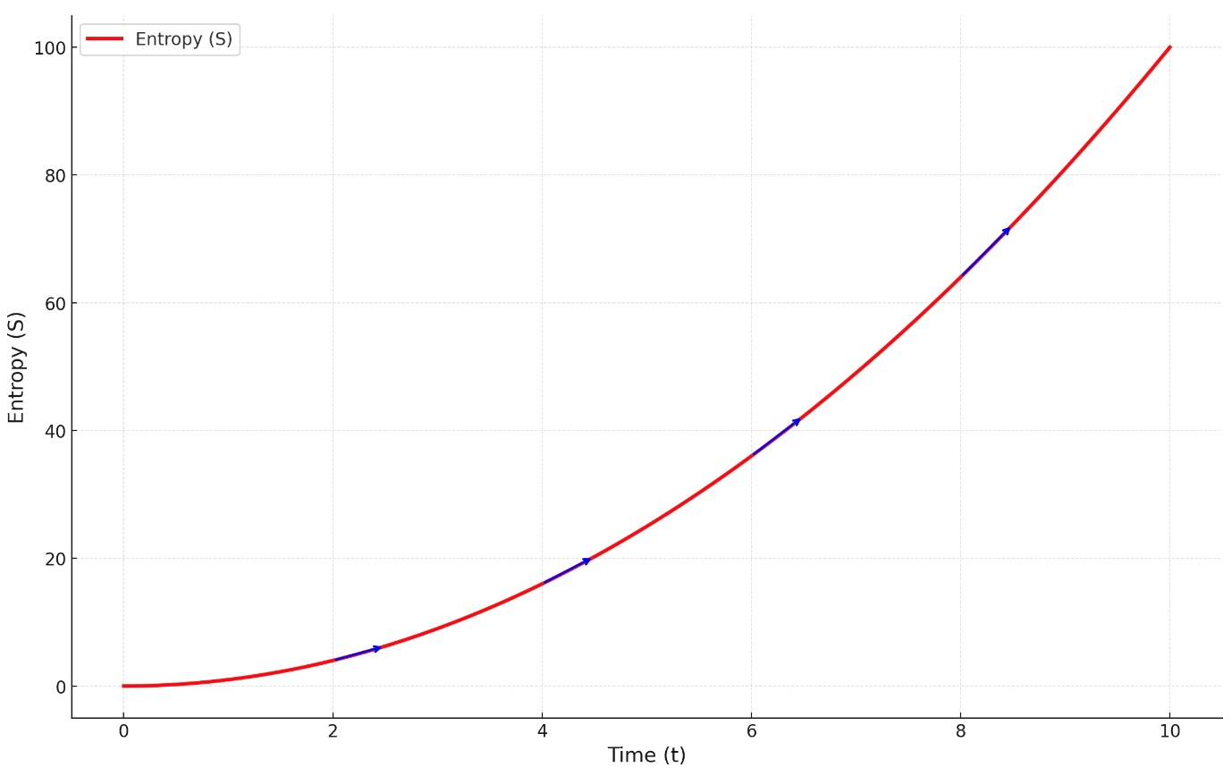

*Fig.2: Entropy Governing the Direction of Time*

The most fundamental equation describing entropy is that of Ludwig Boltzmann: $S=k_{B}lnΩ$

, where ***S*** *is the total entropy of the system,* ***kB*** *​ is Boltzmann's constant, which links the kinetic energy to the temperature of the particles,* ***Ω*** *represents the number of microstates in the system.*

It is important to note that, unlike this entropy, which is time-asymmetric and consistently increases in accordance with the Second Law of Thermodynamics, most fundamental equations describing reality are time-symmetric.This implies that they operate equally effectively in maintaining the laws of reality, regardless of the direction of time. It is the constant increase of thermodynamic entropy that gives time its directional character, aligning with our experience and intuitive understanding, following a simple logarithmic function: **у=logb (x)** or  **by=x**. For detailed consideration see (Earman 2011).

In cognitive sciences, the interaction between the constantly expanding world and the organism is widely described through Claude Shannon's equation for information entropy: $H\left(X\right)=-\sum_{i=1}^{n}{p(x_{i }})\log_{b}p(x_{i})$ or $H\left(X\right)=\sum_{i=1}^{n}{p(x_{i }})\log_{b}\frac{1}{p(x_{i)}}$, *where:* ***H(X)*** *is the entropy of the variable* ***X, p(xi****) is the probability of the outcome* ***xi*** *(commonly measured in 2 or 1 bit).*

A key distinction between Boltzmann's thermodynamic entropy and Shannon's informational entropy lies in the fact that Boltzmann's equation is time-asymmetrical, reflecting the irreversible progression of physical systems, while Shannon's equation is time-independent and symmetrical. This contrast provides a framework for conceptualizing "subjective time" and "objective time," if time is viewed as an entropy function.

Boltzmann's equation describes the physical world independently of any observer, serving as the foundation for time governed by physical laws, and is therefore classified as "objective."

Shannon's equation, unlike Boltzmann's, quantifies uncertainty through probabilities, connecting it to cognitive processes and thus making it observer-dependent. Time and uncertainty (uncertanity is by definition information) are deeply connected: time provides a dimension for information to unfold, or conversely, information defines the dimension through which time emerges. In the brain, high information content (high entropy) slows subjective time due to increased processing demands, while predictable (low-entropy) situations make time appear to move faster. (Tse et al., 2005).

Building on the previously raised doubts about the clarity of distinctions between ‘subjective’ and ‘objective’ notions of time, I argue that "objective time," as derived from Boltzmann entropy, could itself be considered a conceptual construct. This perspective further blurs the divide between "subjective" and "objective" time. Moreover, "subjective" elements can acquire "objective" status when they demonstrate measurable properties, as exemplified in Claude Shannon’s seminal work, *A Mathematical Theory of Communication* (Shannon 1948).

This becomes clear if we recognize that uncertainty, i.e., information, is a key element in both equations and is a cognitive construct. Paradoxically, this deep connection suggests that, in terms of the complexity involved in processing information, Shannon’s ‘subjective’ and time-independent equation may offer a more overarching framework for understanding the nature of time than Boltzmann’s ‘objective’ equation, which explicitly defines the directionality of time.

These insights are allowed by the formal equivalence between the already considered Boltzmann equation for thermodynamic entropy ( $S=k_{B}lnΩ$), and Shannon's equation for informational entropy ($H\left(X\right)=-\sum_{i=1}^{n}{p(x_{i }})\log_{b}p(x_{i})$). This equivalence strongly suggests an underlying unity between the two concepts of time.

In formal mathematical terms, one can see the equivalence between Boltzmann’s and Shannon’s entropy equations as follows:

Boltzmann’s equation $S=k_{B}lnΩ$ can be expressed in terms of equal probabilities when the system has $Ω$ microstates corresponding to a given macrostate. Specifically, each microstate has probability $\frac{1}{Ω}$*.* Then: $S=-k_{b}\sum_{i=1}^{Ω}{\frac{1}{Ω}}ln\left(\frac{1}{Ω}\right)$, *where $k_{b}$ is Boltzmann’s constant****,****, $\sum_{i=1}^{Ω}{\frac{1}{Ω}}$*  **= 1***, and $ln\left(\frac{1}{Ω}\right)$*  = - $ln(Ω)$, *and* ***S*** *is entropy.*

If we set $\frac{1}{Ω}$ **= $p(x_{i})$,** then $S=-k_{b}\sum_{i}{p(x_{i})}\left[ln p(x_{i})\right]$.

Shannon’s equation contains probability by definition: $H\left(X\right)=-\sum_{i=1}^{n}{p(x_{i }})\left[\log_{b}p(x_{i})\right]$, *where where $p(x_{i})$ ​**, is the probability of the outcome $(x_{i})$* , ***H*** *is entropy*.

By definition also the logarithm of any base **b** can be expressed in terms of the natural logarithm **ln** as follows: $\log_{b}(x)=\frac{\ln_{(x)}}{\ln_{(b)}}$.

Substituting,

$H\left(X\right)=-\sum_{i=1}^{n}{p(x_{i }})\log_{b}\left[p(x_{i})\right]$ = $-\sum_{i=1}^{n}{p(x_{i }})\frac{\ln_{\left[p(x_{i})\right]}}{\ln_{(b)}}$

Factoring out the constant $\frac{1}{\ln_{b}}$ gives $H(X)= \frac{1}{\ln_{b}} \left[-\sum_{i=1}^{n}{p(x_{i }})ln p(x_{i})\right]$

From the above, both Boltzmann’s and Shannon’s entropy equations can be expressed in a unified form:

$S=-λ\sum_{i=1}^{n}{p\left(x_{i}\right)ln \left[p(x_{i})\right]}$,

where $λ$*is s the scaling factor ( $k_{b}$ ​ for Boltzmann’s entropy, $\frac{1}{\ln_{b}}$*  *for Shannon’s entropy), $p(x_{i})$* *is the probability of the i-th state​. $\left(x_{i}\right)$****, $ln \left[p(x_{i})\right]$*** *is the natural logarithm of $p(x_{i})$* ***. S*** *is entropy.*

I propose in more general terms that the scaling factor $λ$ can be expressed as $λ(Δt)=f(Δt)$**,** where $Δt$ is the measured time loss, and **f** determines how $λ$ varies with respect to $Δt$**.** This interpretation reflects the limitations of comprehending time. A high $λ$ would indicates greater sensitivity to uncertainty, where even minor time losses significantly impact cognition. Conversely, a low $λ$ would signifies tolerance to uncertainty, allowing for approximate understanding or generalization that minimizes the impact of missing details.

Accordingly, we can write a time-dependent entropy function as:

$S(t)=-λ\left[Δt(t)\right]\sum_{i=1}^{n}{p\left(x_{i},t\right)ln \left[p(x_{i}, t)\right]}$,

*where $Δt(t)$* *is the time loss evaluated at time* **t**, $λ(Δt)$*is the scalling factor for the uncertainty based on how much time is lost, $p\left(x_{i},t\right)$* *is the probability of state $x_{i}$ at time $t$, and $\sum_{i=1}^{n}{p\left(x_{i},t\right)}$* ***=* 1**. *The function $S(t)$* *thus measures the total uncertainty or missing information in the system at time $t$, with $ln$* *denoting the natural (bease* **e***) logarithm.*

As this analysis primarily focuses on abstract hypotheses, empirical evidence is necessary. This can be achieved by the connections between free energy, memory, entropy reduction, and their relationship to time. For insights into the interplay between these phenomena and, see Prigogine’s works on dissipative structures (Prigogine 1977), (Prigogine and Stengers 1984). For a comprehensive analysis of Prigogine’s contributions see (Kondepudi, Petrosky, and Pojman 2017)

These studies on dissipative structures reveals how systems far from equilibrium can spontaneously organize into complex and ordered states by dissipating energy. His work challenges the conventional understanding of thermodynamics, showing that entropy processing does not always lead to disorder. Instead, it can drive the formation of new structures and behaviors across physical, chemical, and biological systems, provided free energy is available. Prigogine highlights the importance of nonlinearity, fluctuations, and feedback mechanisms in enabling transitions between states of order and disorder. His insights offer a foundational framework for studying the **emergence of complexity** within reality. This idea can be formally represented by mathematical Markov model, which enables the prediction of the next states of a system based on its current state, without reliance on previous events. This constitutes a minimal condition for constructing sequences in a stochastic environment. For example, similarly, DNA replication carries information by using its current state to predict and maintain genetic sequences, independent of specific past events. Formally speaking, this simplest form of repetition may represent the fundamental distinction between life and the rest of the physical world. This model is self-sufficient in that it: **1) creates, 2) preserves, and 3) transmits information.**

Building on Ilya Prigogine's concept of dissipative structures, Carlo Rovelli derives an equation that establishes a connection between low-entropy states and information. This formulation highlights how the organization inherent in low-entropy conditions aligns with the principles of information theory. (Rovelli 2022)

Ceteris paribus, these principles are extended to the study of cognition and living organisms, viewed as dissipative structures that inherently self-organize and adapt to external instabilities. This parallels how living organisms and cognitive systems adjust to environmental stimuli. For instance, in biology, the formation of intricate patterns within ecosystems and the synchronization of neural oscillations during cognitive tasks both exemplify the importance of the complexity. For further exploration, see (Bräuer et al. 2020)*.*

An important argument from the thermodynamic studies discussed above, is that a low-entropy state is essential for memory formation. This frames memory as a passive byproduct of physical processes that indiscriminately record traces of the past, independent of any observer, i.e. an inherently 'objective' property.

However, I argue that biological memory, being far more complex, represents a profoundly overarching property that underpins cognitive processes and consciousness itself. It plays a critical role in maintaining continuity and discreteness by enabling the creation and application of structures necessary for encoding and replicating events, i.e., uncertainty (information). Without the complex memory, the reality would consist of isolated, disconnected events, impairing the foundation of physical states and rendering the very concept of entropy meaningless.

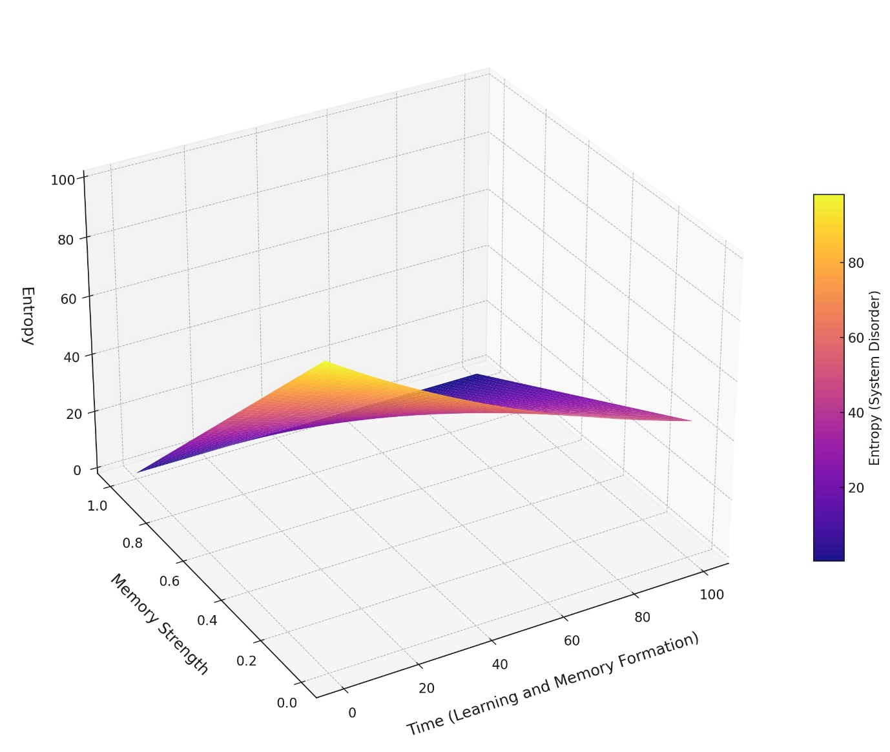

*Fig.3. Reduction of Entropy Trough Complex Memory Formation*

Thus, if time is understood as an entropy-driven phenomenon, as I propose, the 'subjective' and 'objective' concepts of time should not be regarded as distinct or separate processes. Instead, they reflect different levels of complexity within a unified phenomenon. This perspective aligns with the Second Law of Thermodynamics, providing a meaningful convergence between these two views and leading to two implications.

*First*, it positions consciousness within the invariant laws of physical reality, fundamentally dependent on memory.

*Second*, it supports the notion that the emergence of new properties, such as time, emerges through the progressive increase in complexity of pre-existing systems.

*The latter* aligns straightforwardly with the definition of evolution (Kandel 2012, 235), making it probable that time is a result of adaptive processes rather than an a priori condition for them.

To validate this notion, there would need to exist organisms that either do not experience or "live in" time, or that operate within a fundamentally different concept replacing time, as their interactions with the environment do not necessitate the development of a temporal framework.

Empirical evidence supporting this view comes from studies on organisms with underdeveloped nervous systems, which engage with and adapt to their environment solely through responses to physical stimuli such as light, chemical signals, gravity, or water. (Liu et al. 2018; Bloch et al. 2013)

*Reflecting on the first implication,* that consciousness is inherently subject to the invariant laws of physical reality*, we can ask a fundamental question:* Is the emergence of time an intrinsic property of the environment, or is it a cognitive construct unique to nervous systems? I propose that nervous systems, cognitive constructs, and consciousness itself are physical phenomena that emerge through increasing complexity. In this view, the traditional distinctions between "physical" and "cognitive" properties become blurred, since cognition arises from complex, natural interactions within the environment. Moreover, no phenomenon exists in isolation within an organism; rather, every process is deeply influenced and shaped by interactions with the broader system and environment. See (Ittelson 1973)

The complexity concept supports the notion that cognition is formed by mechanisms that process environmental stimuli. It is important to emphasize that this seemingly trivial observation reveals a profound symmetry between cognition and the environment; an alignment that is crucial for cognition to function effectively as an instrument for interaction and adaptation. Without this symmetry, cognition would be misaligned with the dynamic nature of the environment, leaving living systems unable to interpret and respond to changes effectively. As a result, this misalignment would undermine the adaptive responses necessary for survival, ultimately threatening the continued existence of these organisms within their environments.

1. **Scales of Reality and the Emergence of Time**

* *In this section, I will explore how the scales affects the concept of time.*
* *We will enter a mathematical realm where numbers and equations constitute the foundation of reality, raising the question about the nature of time.*
* *Mathematics allows to explore time through measurements, rates of change, periodicity, invariances, and its role as a dimension.*

If living systems are inherently embedded in their environment and cognition is a product of evolutionary development, it follows that their their cognitive abilities are not universally pertinent to all scales of reality, especially those far removed from the scale at which they exist. These systems evolved to interact within their immediate surroundings and have not adapted to engage with vastly distant scales, limiting their ability to comprehend phenomena at such extremes.

I argue that this limitation is particularly clear when tools expand our observational range from familiar scales, such as **102** to **10-2** meters, to vastly larger or smaller scales, such as **8.8x1026** *(cosmic scale)*to **1.6x10-36** *(Plank’s length)* meters. This span encompasses approximately **63 orders of magnitude**. I argue that this limitation applies to the concept of time as well, as time is an emergent cognitive framework arising from interactions within reality, as indicated in Section II.

Following this line of reasoning, imagine that the orthodox geometric reality in which we have always existed begins to undergo significant revisions due to advancements in observational methods. Abstract mathematical concepts, once regarded as purely theoretical, are now emerging as fundamental components of reality. For instance, on a very large scale, non-Euclidean geometries reveal the intrinsic curvature of space-time, someting that traditional Euclidean frameworks cannot. (Einstein et al. 1952)

Yet, the critical shift occurs at extremely small scales of observation. A discrepancy becomes evident at electromagnetic wavelengths between **10-8**and **4×10-7** meters, corresponding to the ultraviolet spectrum of light. According to Maxwell's equations (which are time-symmetric), when calculating the radiant energy of a perfect black body (a theoretical object) at ultraviolet wavelengths or smaller, the calculations approach a limit where infinite radiant energy is predicted. Clearly, this is not the case. If such radiation were real, the Universe would be unstable and collapse in what is known as the ultraviolet catastrophe.

This discrepancy marks a turning point in our understanding of energy in the realm of very small scales (note that energy is equivalent to mass, as described by **E=mc2**). Max Planck resolved this issue by proposing that energy is not emitted continuously, as assumed in classical physics, but in discrete packets called "quanta."

The energy of these quanta is proportional to the frequency of the electromagnetic wave and can be expressed by the equation: **E=hv**, *where* ***E*** *is the energy,* ***h*** *is Planck's constant* *(****h = 6.62607015 × 10 -34Js****), and* ***v*** *is the frequency of the electromagnetic wave.*

This equation is fundamental for understanding the behavior of the particles that constitute matter. It lays the groundwork for numerous principles in the micro-world, such as wave-particle duality, superposition, quantum entanglement, Heisenberg's uncertainty principle, Born's rule, Pauli's exclusion principle, and quantum tunnelling. All these concepts are based on the quantization of energy.

Multiple interpretations of quantum mechanics exist (Snoke 2024, 62–74), each ascribing a different ontological status to time, whether it is treated as emergent, fundamental, an external parameter, relational, or governed by deterministic constraints. The present discussion adopts the Copenhagen (classical) interpretation as a baseline, in which time is treated as an external parameter, because it is supported by the most conclusive experimental evidence to date and remains the most widely taught and utilized framework. Consequently, examining time within this framework, and comparing it with several relevant alternative approaches, is likely to provide the most comprehensive foundation for investigating the nature of time.

Considering how we interact with reality at this scale, one might argue that, while physical experiments in this domain are undoubtedly real, the underlying reality could be viewed as fundamentally mathematical, given that mathematics provides the *essence* for interpreting and understanding experimental data. In this sense, mathematics cannot be seen as any less real than the experiment itself. From this perspective, the more abstract the exploration, the broader its potential applicability.

This view partially aligns with Max Tegmark’s metaphysical stance in *The Mathematical Universe* (Tegmark 2008). However, it diverges from the Mathematical Reality Hypothesis (MRH) by refraining from definitive claims about the ultimate structure or substance of reality and by maintaining that mathematics itself is inherently incomplete, thereby preventing it from serving as the sole basis of reality.

To illustrate the reality of mathematics in this context, consider the principle of superposition, which allows a particle to exist in multiple states or positions simultaneously. This is possible because the wave functions describing different states are linear, enabling them to be added algebraically: $ψ$**(x)=f(x)+g(x)**. Thus, if a particle can exist in states $ψ$ ***1***​ and $ψ$ ***2*** it can also exist in a combined state $ψ$ ***=a $ψ$ 1+b $ψ$ 2***,*where* ***a*** *and* ***b*** *are coefficients that determine the probability of each state.*

Similarly, quantum entanglement, often referred to as "the spooky property of the Universe," is mathematically described and made possible by vector products in linear algebra. In Hilbert space, the tensor product of the spatial states of particles allows a larger space that encompasses and unifies all possible states of its components. This larger space enables the emergence of states in which particles are inseparably linked regardless of the distance between them, with their states remaining correlated and unified in a single, shared quantum state: $H=H_{А}⊗H_{B}$, w*here $H$ represents a Hilbert space, and $⊗$ represents the tensor product*

In addition, it is striking that when classical physics fails to explain the results of observations, the introduction of an entirely new class of numbers becomes necessary to describe reality at scales significantly remote from our perceptions. These are the complex numbers, which combine both real and imaginary parts, allowing us, for instance, to express two fundamental characteristics of a wave - amplitude and phase, using just one number. Moreover, imaginary numbers enable the extension of the concept of taking roots to include negative numbers. I contend that without this discovery, which occurred relatively late in the history of mathematics, the formulation and advancement of quantum theory at its current level of sophistication might not have been achievable.

Taking into account the above idea that mathematical concepts are the sole key to understanding the quantum scale of reality, we must examine the fundamental Schrödinger’s equation and its relationship to the nature of time. It defines a quantum system and describes its evolution over time. Broadly speaking, the Schrödinger equation is the quantum analogue of Newton’s, $F=ma$, *where* ***F*** *is force,* ***m*** *is mass and* ***a*** *is acceleration.* The main difference is that the Schrödinger equation involves first-order derivatives with respect to time, while Newton's equation includes second-order derivatives, i.e. ***a.***

The Schrödinger’s equation is expressed as: $iℏ\frac{∂ψ(r,t)}{∂t}=\hat{H}ψ(r,t)$, *where* ***i*** *is the imaginary unit, $ℏ$ is the reduced Planck constant, $ψ(r,t)$**) is the wave function, which depends on position $r$ and time $t$, $\hat{H}$* *is the Hamiltonian operator representing the total energy of the system (kinetic and potential), and $\frac{∂ψ(r,t)}{∂t}$ ​ is the time derivative of the wave function.*

The equation, which is symmetrical and linear with respect to time, is entirely deterministic and describes the behavior of a single fundamental particle or a single pair in a state of quantum entanglement. It introduces an infinite number of amplitudes for the possible states of the system as solutions. Due to the continuous nature of the wave function, we can determine which states are more likely by calculating the integral under the curve of the function. However, at this scale, time is neither an intrinsic property nor a quantum operator, as it is not an observable quantity. Instead, time functions as an external parameter, dependent on the assumptions of the framework within which the system is analyzed. (Hilgevoord and Atkinson 2011, 437–454)

For convenience, the wave function $ψ(r,t)$ can be represented as a vector in Hilbert space: **∣ $ψ$⟩*.*** This representation compactly encodes all the information about the state of the system, simplifying the mathematical formalism. The specifics of this notation will not be explored in detail here.

Here arises the fundamental question concerning the nature of time: what occurs when we attempt to connect the purely mathematical and abstract wave function $ψ(r,t)$ or state vector **∣ $ψ$⟩** , which describes phenomena such as an electron, with the tangible world around us? The connection occurs during the act of observation or measurement of the microscopic system. Paradoxically, the act of measurement creates the very reality we aim to observe $∣ψ⟩ →∣ϕ⟩$; time and space emerge as we perceive them. *($∣ϕ⟩$* *is eigenstate that corresponds to the observed outcome in Hilbert space).* I propose that, the collapse of the wave function can be understood as the moment at which time emerges. This emergence aligns with the transition from potentiality $\sum{c_{i}∣ϕ_{i}⟩}$*(quantum superposition, where $c_{i}$ are probability amplitudes and $∣ϕ_{i}⟩$* *are the possible eigenstates)* to actuality $∣ϕ⟩$*(a definite eigenstate)*. Prior to this, there was no clear distinction between "past" and "future" within the system but just potential outcomes. The measurement, however, introduces a temporal distinction: "before" (the state of superposition) and "after" (the observed collapsed state) and time emerges irreversibly in our world, where time can only move forward.

This perspective aligns with recent developments involving the Page-Wootters formalism, wherein time is not treated as an external parameter but rather as an emergent property rooted in the correlations between the clock and the system. A rigorous example is the “magnetic clock,” employed to track and characterize the dynamics of a quantum harmonic oscillator. By using a magnetic subsystem as a clock and correlating its degrees of freedom with those of the oscillator, one obtains a physically meaningful notion of time entirely derived from within the quantum description itself. This provides a compelling demonstration of how the concept of time can emerge purely through entanglement and the choice of suitable algebraic structures, linking measurement-induced collapse to temporality (Coppo, Cuccoli, and Verrucchi 2024).

From a broad perspective, this experiment provides substantive support for the ontological status of the wave function.

Imagine now a sand hourglass where the sand is initially gathered in one half, separated by a mechanism in the middle so precise that it breaks down every grain of sand into its fundamental particles. When the hourglass is turned, and the sand moves into the other half, it appears as though the hourglass is completely empty. However, if the hourglass is turned again and the mechanism magically begins reassemble the previous state, it would seem as though the sand appears from nowhere, in a manner that cannot be predicted. The only thing you can do is count the grains, for instance, 500 per minute, and conclude that the seemingly empty half actually contains at least 500 "entities" in relation to a one-minute time interval.

This analogy reflects the paradox of attempting to study objects that are the fundamental carriers of information within us. By extension, imagine that time and space, typically assumed to be given a priori, are instead the result of interactions between fundamental particles and a mechanism, like the separation of grains in an hourglass.

Formally, if we wish to describe how the sand "appears as if from imagination," we can apply Born's Rule. This rule converts complex numbers, which represent quantum amplitudes, into real numbers, which represent probabilities. Born's Rule states that to find a probability, we square the modulus of a complex number. In terms of Hilbert space: **2**, w*here is the probability of the system collapsing into eigenstate , and* **2** *is the square of the projection of the state vector* **∣ $ψ$⟩** *onto the eigenstate $ϕ_{k}$;* In simpler wave function notation: **2**, w*here is the probability, and $ψ\left(x\right)$* *is the complex wave function.*

This rule transforms the abstract quantum amplitude into a probability, i.e. converting it into a measurable reality. For those inspired by mathematics, this operation highlights the elegance of the theory. Born’s Rule acts as a mathematical bridge, linking the abstract quantum realm to observable phenomena. Connecting Born’s Rule to Shannon’s entropy reveals a parallel between quantum systems and living organisms: both use probabilistic frameworks to transition from disorder to structured realities. This shared reliance emphasizes the emergent nature of time and suggests the overarching power of emergent properties arising from the increasing complexity of interactions within reality.

However, Born's rule (or the "magical" mechanism in the hourglass analogy) does not arise from the internal coherence of the system; it is introduced as an axiom (in the classical interpretation). How and why it works, remains unknown, and the challenge of understanding how emergence occurs stays unsolved.

According to the reasoning above, could the very act of postulating the existence of time be considered an axiom; an assumption we accept without fully understanding? If so, perhaps we could challenge old assumptions and create new models, much like how non-Euclidean geometries emerged by breaking the assumption that the sum of angles in a triangle equals $π$ radians. This could lead to a new "geometry of time."

This raises the question of whether we can comprehend the concept of time at distant scales, where the fundamental axioms of time may differ, or even cease to exist, necessitating entirely new mathematical or philosophical frameworks.

This perspective aligns with Wheeler-DeWitt equation: $\hat{H}ψ\left[h_{ij},ϕ\right]=0$, w*here $\hat{H}$ is the Hamiltonian operator representing the total energy (gravity + matter) of the universe, and $ψ\left[h_{ij},ϕ\right]$* *is the wave function corresponding to the geometry of space $h_{ij}$* *(3x3 metric tensor) and any field $ϕ$*

This equation suggests that the fundamental state of the reality does not depend on time as a distinct property but rather all moments coexist simultaneously. (Anderson 2012; Kiefer 2004)

The Wheeler–DeWitt equation and the Page–Wootters (PaW) mechanism (Coppo, Cuccoli, and Verrucchi 2024) share a common conceptual foundation: they both describe a universe in which time is not a fundamental variable. Rather than positing an external clock, these approaches recover the familiar notion of time evolution by identifying intrinsic correlations within the system. In each framework, one subsystem effectively serves as a clock, providing a temporal reference for the evolution of another subsystem. Thus, the apparent flow of time emerges from the entangled states of the entire system, rather than being imposed as an external parameter.

*Remarkably, these rigorous descriptions of time at a fundamental level correspond to the properties of the complex memory outlined in Section I (p. 6): namely, preserving moments in a reality without repetitions implies that certain structures retain specific configurations even as they change or evolve. Moreover, I argue that the stationary distribution of a Markov chain and the maximization of Shannon’s entropy can be formally represented as equivalent to the Wheeler-DeWitt equation and the Page-Wootters mechanism, thus we can formally relate complex memory formation to the emergence of time.*

It is essential to note that the primary purpose of these descriptions is to emphasize the significance of mathematics in exploring the concept of time at these vastly distant scales of reality, rather than to establish mathematical inferences. Since the exploration of the mathematical foundations of reality goes far beyond the scope of this text, as well as my own capabilities, I offer these examples and questions to illustrate the profound connection between the concept of time, the structure of the microscopic world, purely mathematical frameworks, and our cognitive faculties. For a more in-depth analysis, see Sir Roger Penrose's book *The Road to Reality* (Penrose 2004).

I imagine that if reality on an extremely small scale is independent of time as our conventional concept defines it, this notion fundamentally challenges the understanding of causality. For example, causal theories suggest that spatiotemporal relations are fundamentally identical to causal relations​, implying that the fabric of spacetime directly corresponds to causal interactions. I contend that this assumption may be profoundly shaped by how complex memory structures our understanding of reality, thereby creating an effective but perhaps illusory framework. In contrast, Le Bihan and Baron, proposed that causal relations serve as the underlying structure from which spatiotemporal relations emerge. This perspective views spacetime as a derivative phenomenon, arising from causal networks that serve as its foundational framework, rather than defining an equivalence between the two (Le Bihan and Baron 2024)

**Conclusion**

Bridging seemingly incompatible notions, such as physical entropy and biological memory, allows us to expand our conception of time as an axiom. The connection between memory and a low-entropy state, which preserves structure within the surrounding environment, establishes a unifying principle for understanding time retention and loss across various domains. This principle defines the boundaries of our comprehension of phenomena across vastly different scales.

Concepts such as scale and dimension are deeply embedded in the geometric framework of reality as we comprehend it. However, even these fundamental notions may not necessarily apply to aspects of reality far beyond the bounds of our experience.

I deeply believe that in searching for reality, we must recognize consciousness as an integral component of that very reality: an operator that actively interacts within it. Consequently, when we observe, describe, compute, and formulate theories about reality, we must acknowledge that these tools constitute only one side of a symmetrical equation. To achieve a precise understanding, it is necessary to extend our analysis to the other side of the equation, namely, our cognitive faculties. Only through this dual perspective, which accounts for both the structure of reality and the cognitive mechanisms through which we engage with it, can reality be adequately defined.

Regarding the concept of time, I affirm that time is indeed axiomatic in nature, insofar as its very definition relies on the assumption that repetitions are permitted. Without this fundamental property of repetition, enabled by what is termed complex memory, the notion of time would lose its meaning.

**Some Follow-Up Questions**

1. Are mathematical concepts fundamental elements of the fabric of reality?
2. Does the quantum world exist independently of human consciousness?
3. Could the quantum domain represent the scale at which consciousness originates?
4. Why do some scientists consider consciousness a physical property rather than a purely psychological phenomenon?
5. Could we hypothetically create a machine operating under different axioms, and what insights could it provide?
6. Can the classical mind-body problem be examine as a geometric issue. The question would then be formulated as follows: Do the opposing concepts of symmetry and asymmetry, aligned with the ‘subjective’ and ‘objective’ nature of time, form the foundation for perceiving consciousness and the body as fundamentally distinct entities, thereby indicating their unification logically impossible?

**Bibliography**

Amari, Shun-ichi. *Information Geometry and Its Applications.* Vol. 194 of *Applied Mathematical Sciences.* Tokyo: Springer Japan, 2016. <https://doi.org/10.1007/978-4-431-55978-8>.

Edward Anderson, "Problem of Time in Quantum Gravity," *Annalen der Physik* 524, no. 12 (2012): 757, https://doi.org/10.1002/andp.201200147.

Bloch, Guy, Brian M. Barnes, Menno P. Gerkema, and Barbara Helm. "Animal Activity Around the Clock with No Overt Circadian Rhythms: Patterns, Mechanisms, and Adaptive Value." *Proceedings of the Royal Society B: Biological Sciences* 280, no. 1765 (2013): 20130019. <https://doi.org/10.1098/rspb.2013.0019>.

Bräuer, T., M. Signorelli, S. Dündar-Coecke, and Z. Wang. "Dissipative Structures, Organisms, and Evolution and Dissipative Structures, Machines, and Organisms: A Perspective." *Entropy* 22, no. 8 (2020): 889. <https://doi.org/10.3390/e22080889>.

Coppo, Alessandro, Alessandro Cuccoli, and Paola Verrucchi. "Magnetic Clock for a Harmonic Oscillator." *Physical Review A* 109, no. 5 (2024): 052212. <https://doi.org/10.1103/PhysRevA.109.052212>.

Derdikman, David, and James J. Knierim, eds. *Space, Time and Memory in the Hippocampal Formation.* Vienna: Springer, 2011. <https://doi.org/10.1007/978-3-7091-1292-2>.

Eichenbaum, Howard. *The Hippocampus as a Cognitive Map: Past, Present, and Future.* Oxford: Oxford University Press, 2017.

Earman, John. "Sharpening the Electromagnetic Arrow(s) of Time." In *The Oxford Handbook of Philosophy of Time,* edited by Craig Callender, 485–527. Oxford: Oxford University Press, 2011. <https://doi.org/10.1093/oxfordhb/9780199298204.001.0001>.

Eichenbaum, Howard, Christopher J. MacDonald, and Zoran Tiganj. "Temporal Coding in the Hippocampus: Neuronal Sequences along Time." In *Space, Time and Memory in the Hippocampal Formation,* edited by David Derdikman and James J. Knierim, 273–301. Vienna: Springer, 2011. <https://doi.org/10.1007/978-3-7091-1292-2>.

Einstein, Albert, Hendrik A. Lorentz, Hermann Minkowski, and Hermann Weyl. *The Principle of Relativity: A Collection of Original Memoirs on the Special and General Theory of Relativity.* New York: Dover Publications, 1952.

Hilgevoord, Jan, and David Atkinson. "Time in Quantum Mechanics." In *The Oxford Handbook of Philosophy of Time,* edited by Craig Callender, 437–454. Oxford: Oxford University Press, 2011. https://doi.org/10.1093/oxfordhb/9780199298204.003.0018.

Ittelson, William H. *Environmental Perception and Contemporary Perceptual Theory.* New York: Holt, Rinehart, and Winston, 1973.

Kandel, Eric R. *In Search of Memory: The Emergence of a New Science of Mind.* Kindle edition. New York: W. W. Norton & Company, 2012.

Kiefer, Claus. *Quantum Gravity.* Oxford: Oxford University Press, 2004.

Kondepudi, Dilip, Tomio Petrosky, and John Pojman. "Dissipative Structures and Irreversibility in Nature: Celebrating 100th Birth Anniversary of Ilya Prigogine (1917–2003)." *Chaos: An Interdisciplinary Journal of Nonlinear Science* 27, no. 10 (2017): 104501. <https://doi.org/10.1063/1.5008858>.

Le Bihan, Denis. "Is the Brain Relativistic?" *arXiv,* August 10, 2019. <https://arxiv.org/abs/1908.04290>.

Le Bihan, Baptiste, and Sam Baron. "Causal Theories of Spacetime." *Noûs* 58, no. 1 (2024): 202–224. https://doi.org/10.1111/nous.12449.

Liu, Mochi, Anuj K. Sharma, Joshua W. Shaevitz, and Andrew M. Leifer. "Temporal Processing and Context Dependency in *C. elegans* Mechanosensation." *eLife* 7 (2018): e36419. <https://doi.org/10.7554/eLife.36419>.

Luminet, Jean-Pierre. "Time, Topology, and the Twin Paradox." In *The Oxford Handbook of Philosophy of Time*, edited by Craig Callender, 528–545. Oxford: Oxford University Press, 2011. <https://doi.org/10.1093/oxfordhb/9780199298204.003.0018>.

Mrugala, Ryszard, James D. Nulton, J. Christian Schön, and Peter Salamon. "Statistical Approach to the Geometric Structure of Thermodynamics." *Physical Review A* 41, no. 6 (1990): 3156–3160. https://doi.org/10.1103/PhysRevA.41.3156.

Minkowski, Hermann. "Raum und Zeit." *Physikalische Zeitschrift* 10 (1908): 104–11.

O’Keefe, John, and Michael L. Recce. "Phase Relationship between Hippocampal Place Units and the EEG Theta Rhythm." *Hippocampus* 3, no. 3 (1993): 317–30. <https://doi.org/10.1002/hipo.450030307>.

Penrose, Roger. *The Road to Reality: A Complete Guide to the Laws of the Universe.* New York: Alfred A. Knopf, 2004.

Prigogine, Ilya. *Thermodynamic Theory of Structure, Stability, and Fluctuations.* New York: Wiley, 1977.

Prigogine, Ilya, and Isabelle Stengers. *Order Out of Chaos: Man’s New Dialogue with Nature.* New York: Bantam Books, 1984.

Robinson, Derek W. "Entropy and Uncertainty." *Entropy* 10, no. 4 (2008): 493–506. https://doi.org/10.3390/e10040493.

Rovelli, Carlo. "Memory and Entropy." *Entropy* 24, no. 8 (2022): 1022. <https://doi.org/10.3390/e24081022>.

Shannon, Claude E. "A Mathematical Theory of Communication." *The Bell System Technical Journal* 27, no. 3 (1948): 379–423. <https://doi.org/10.1002/j.1538-7305.1948.tb01338.x>.

Snoke, David W. "Decoherence and Collapse." In *Interpreting Quantum Mechanics: Modern Foundations*, 62–74. Cambridge: Cambridge University Press, 2024. <https://doi.org/10.1017/9781009261562.006>.

Tegmark, Max. "The Mathematical Universe." *Foundations of Physics* 38, no. 2 (2008): 101–150. https://doi.org/10.1007/s10701-007-9186-9.

Tse, Peter Ulric, James Intriligator, Josée Rivest, and Patrick Cavanagh. "Attention and the Subjective Expansion of Time." *Psychonomic Bulletin & Review* 12, no. 1 (2005): 146–151. <https://doi.org/10.3758/BF03196844>.

Wilson, B. A., A. D. Baddeley, and N. Kapur. "Dense Amnesia in a Professional Musician Following Herpes Simplex Virus Encephalitis." *Cognitive Neuropsychology* 12, no. 6 (1995): 621–644. https://doi.org/10.1080/01688639508405157.

1. CA1 refers to a specific region of the hippocampus, which is a critical structure in the brain involved in memory formation, spatial navigation, and learning. (Eichenbaum 2017, 89–93)