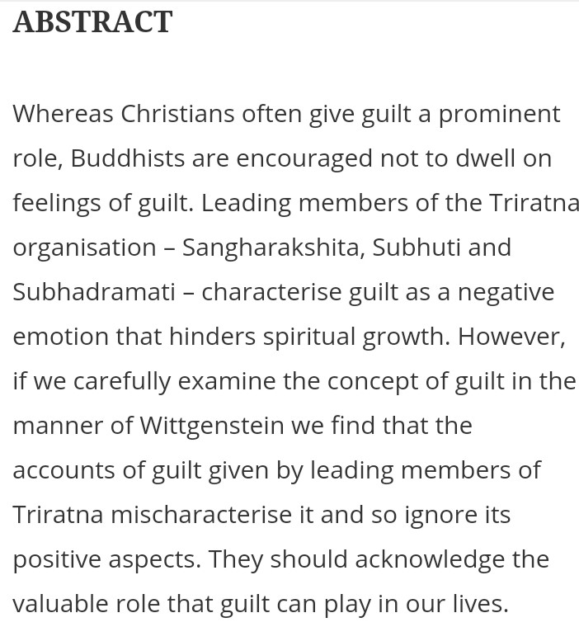

50 free copies of the article available through this link: https://www.tandfonline.com/eprint/TMEVH4GE57HSVDFJ3XDK/full?target=10.1080/14639947.2021.1965298

