Could God have set up Darwinian accidents?
John S. Wilkins, University of Sydney
Forthcoming in Zygon
What I am really interested in, is knowing whether God could have created the world in a different way; in other words, whether the requirement of logical simplicity admits a margin of freedom.
Although in relation to the foreknowledge and decree of God, the first cause, all things come to pass immutably and infallibly, yet by the same providence he ordereth them to fall out, according to the nature of second causes, either necessarily, freely, or contingently. (Westminster Confession chap V. sect II)

Abstract
Charles Darwin, in his discussions with Asa Gray and in his published works, doubted whether God could so arrange it that exactly the desired contingent events would occur to cause particular outcomes by natural selection. In this paper I argue that even a limited or neo-Leibnizian deity could have chosen a world that satisfied some arbitrary set of goals or functions in its outcomes, and thus answer Darwin’s conundrum. In more general terms, this supports the consistency of natural selection with providentialism, and makes “theistic evolutionism” a coherent position to hold.

Introduction
One of the enduring objections to evolution of the Darwinian variety is that it is based on chance, and so for theists who believe God is interventionist, it suggests that God is subjected to chance, and hence not onmi-something (-present, -potent or –scient, and most of all -benevolent). Darwin debated this issue in correspondence with his friend Asa Gray, and it ended up as the final pages of his 1868 Variation. Effectively, Darwin argued that we cannot “reasonably maintain” that God intended for chance events to occur that are useful to humans or to the species concerned .
Darwin makes an argument by analogy, comparing natural selection with a builder. He argues that, if the builder uses found materials, then the builder is responsible for the outcome of the building’s design and manufacture, not the forces that made the stones the shapes they are. By analogy, we cannot credit God with the results of natural selection. But as God is omniscient, and hence could foresee the outcomes, there appears to be a conundrum, which we shall call Darwin’s conundrum. First, let’s look at the text in question. The relevant passages are emphasized, but the whole passage is worth reproducing:
... the long-continued accumulation of beneficial variations will infallibly lead to structures as diversified, as beautifully adapted for various purposes, and as excellently co-ordinated, as we see in the animals and plants all around us. Hence I have spoken of selection as the paramount power, whether applied by man to the formation of domestic breeds, or by nature to the production of species. I may recur to the metaphor given in a former chapter: if an architect were to rear a noble and commodious edifice, without the use of cut stone, by selecting from the fragments at the base of a precipice wedge-formed stones for his arches, elongated stones for his lintels, and flat stones for his roof, we should admire his skill and regard him as the paramount power. Now, the fragments of stone, though indispensable to the architect, bear to the edifice built by him the same relation which the fluctuating variations of each organic being bear to the varied and admirable structures ultimately acquired by its modified descendants.
Some authors have declared that natural selection explains nothing, unless the precise cause of each slight individual difference be made clear. Now, if it were explained to a savage utterly ignorant of the art of building, how the edifice had been raised stone upon stone, and why wedge-formed fragments were used for the arches, flat stones for the roof, &c.; and if the use of each part and of the whole building were pointed out, it would be unreasonable if he declared that nothing had been made clear to him, because the precise cause of the shape of each fragment could not be given. But this is a nearly parallel case with the objection that selection explains nothing, because we know not the cause of each individual difference in the structure of each being.
The shape of the fragments of stone at the base of our precipice may be called accidental, but this is not strictly correct; for the shape of each depends on a long sequence of events, all obeying natural laws; on the nature of the rock, on the lines of deposition or cleavage, on the form of the mountain which depends on its upheaval and subsequent denudation, and lastly on the storm or earthquake which threw down the fragments. But in regard to the use to which the fragments may be put, their shape may be strictly said to be accidental. And here we are led to face a great difficulty, in alluding to which I am aware that I am travelling beyond my proper province. An omniscient Creator must have foreseen every consequence which results from the laws imposed by Him. But can it be reasonably maintained that the Creator intentionally ordered, if we use the words in any ordinary sense, that certain fragments of rock should assume certain shapes so that the builder might erect his edifice? If the various laws which have determined the shape of each fragment were not predetermined for the builder’s sake, can it with any greater probability be maintained that He specially ordained for the sake of the breeder each of the innumerable variations in our domestic animals and plants;— many of these variations being of no service to man, and not beneficial, far more often injurious, to the creatures themselves? Did He ordain that the crop and tail-feathers of the pigeon should vary in order that the fancier might make his grotesque pouter and fantail breeds? Did He cause the frame and mental qualities of the dog to vary in order that a breed might be formed of indomitable ferocity, with jaws fitted to pin down the bull for man’s brutal sport? But if we give up the principle in one case,—if we do not admit that the variations of the primeval dog were intentionally guided in order that the greyhound, for instance, that perfect image of symmetry and vigour, might be formed,—no shadow of reason can be assigned for the belief that variations, alike in nature and the result of the same general laws, which have been the groundwork through natural selection of the formation of the most perfectly adapted animals in the world, man included, were intentionally and specially guided. However much we may wish it, we can hardly follow Professor Asa Gray in his belief “that variation has been led along certain beneficial lines,” like a stream “along definite and useful lines of irrigation.” If we assume that each particular variation was from the beginning of all time preordained, the plasticity of organisation, which leads to many injurious deviations of structure, as well as that redundant power of reproduction which inevitably leads to a struggle for existence, and, as a consequence, to the natural selection or survival of the fittest, must appear to us superfluous laws of nature. On the other hand, an omnipotent and omniscient Creator ordains everything and foresees everything. Thus we are brought face to face with a difficulty as insoluble as is that of free will and predestination.
This is a passage of great subtlety, dealing with several concerns raised against his view of evolution. It has significance today because there is widespread agreement that Darwinian evolution is incompatible with a providential creator deity, both by atheists and many theists writing on the subject. For example, intelligent design proponents hold that “theistic evolution”, in which God is, as Asa Gray held, the ultimate reason for the variations on which natural selection works, is as inadmissible for a theist as the “chance evolution” of atheists (or more properly, of Epicureans). Darwin had written to Gray on May 22nd 1860, after the publication of the Origin:
With respect to the theological view of the question; this is always painful to me.— I am bewildered.— I had no intention to write atheistically. But I own that I cannot see, as plainly as others do, & as I sh^{d} wish to do, evidence of design & beneficence on all sides of us. There seems to me too much misery in the world. I cannot persuade myself that a beneficent & omnipotent God would have designedly created the Ichneumonidæ with the express intention of their feeding within the living bodies of caterpillars, or that a cat should play with mice. Not believing this, I see no necessity in the belief that the eye was expressly designed. On the other hand I cannot anyhow be contented to view this wonderful universe & especially the nature of man, & to conclude that everything is the result of brute force. I am inclined to look at everything as resulting from designed laws, with the details, whether good or bad, left to the working out of what we may call chance. Not that this notion at all satisfies me. I feel most deeply that the whole subject is too profound for the human intellect. A dog might as well speculate on the mind of Newton.— Let each man hope & believe what he can.—
Certainly I agree with you that my views are not at all necessarily atheistical. The lightning kills a man, whether a good one or bad one, owing to the excessively complex action of natural laws,—a child (who may turn out an idiot) is born by action of even more complex laws,—and I can see no reason, why a man, or other animal, may not have been aboriginally produced by other laws; & that all these laws may have been expressly designed by an omniscient Creator, who foresaw every future event & consequence. But the more I think the more bewildered I become; as indeed I have probably shown by this letter.
Darwin's argument is roughly this: unless we want to ascribe meaning to every random event, which seems to make God a micromanager of monumental proportions and undercuts the raîson d’étre for there being natural law at all (and hence the foundation of science itself), we cannot maintain that God would have chosen the random variations on which both artificial and natural selection operate. Hence, natural selection is inconsistent with the notion that God is responsible for everything. The problem with which Darwin is struggling is clearly related to the problem that Leibniz discussed in his Monadology and Théodicée:
53. Now, as in the Ideas of God there is an infinite number of possible universes, and as only one of them can be actual, there must be a sufficient reason for the choice of God, which leads Him to decide upon one rather than another. …
54. And this reason can be found only in the fitness [convenance], or in the degrees of perfection, that these worlds possess, since each possible thing has the right to aspire to existence in proportion to the amount of perfection it contains in germ. …
55. Thus the actual existence of the best that wisdom makes known to God is due to this, that His goodness makes Him choose it, and His power makes Him produce it. …
This was the view satirized by Voltaire in Candide as the view of Doctor Pangloss, that all is for the best, in this best of all possible worlds. Note, however, that Leibniz only requires that the world be the best of all possible worlds, and not that all events within it be the best possible events. So the crucial question is how God chooses which world to create.
Theist creationisms (i.e., views that God is the creator of all that physically is) come in a number of forms. One is the Deist or Platonic view under which God once set the world in motion, and thence abandoned it to its lawlike fate. God here is the primum mobile, the primary cause of motion and causation, and is uninvolved in subsequent events. The deist account of Aristotle, however, puts God on an ontological par with the world created (figure 1). Judeo-Christian theisms treat God as of a higher ontological order (figure 2), outside time and space, a point that will become significant. On the deist account, God is part of the causal order, and sets off a chain of causal processes of which she, it or he is a part. On the traditional theist view, however, God is not part of the [secondary] causal order, but is the [primary] cause of there being one. When the Aristotelian tradition of the primum mobile was amalgamated with the theological traditions of Christianity and Judaism, it was substantially revised in this way. Asa Gray is taking the traditionalist view of creation and supposing that God makes sure things stay on-track according to the Plan when secondary causes either go off-track or fail to realize the Planned outcomes, and it is this view that Darwin is objecting to. I shall introduce two other conceptions in which creationisms take distinct forms later.
[Figures 1 and 2 here]
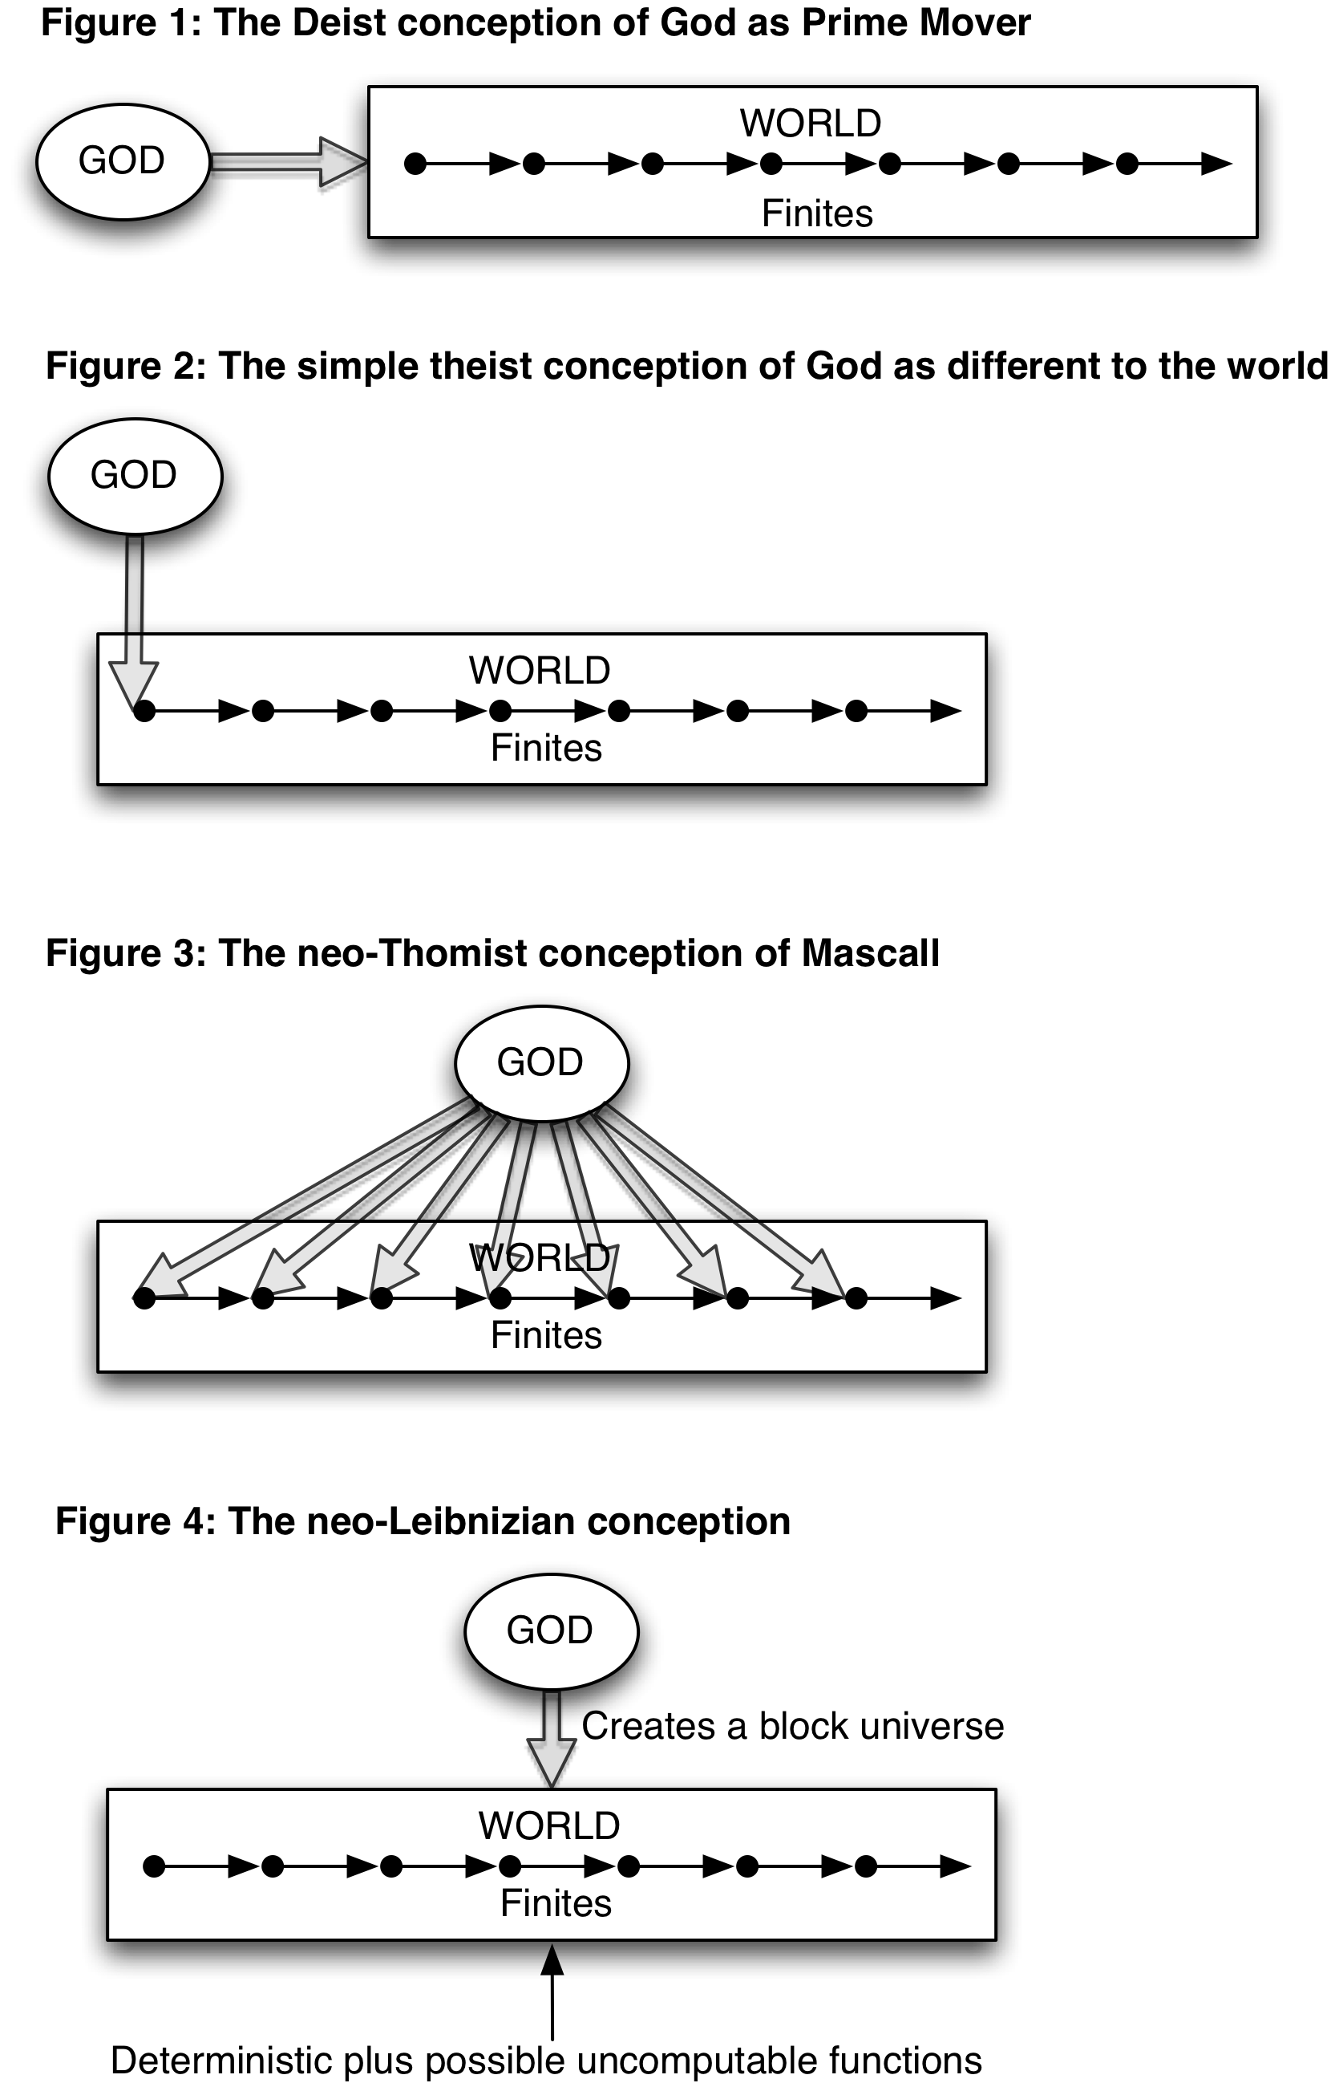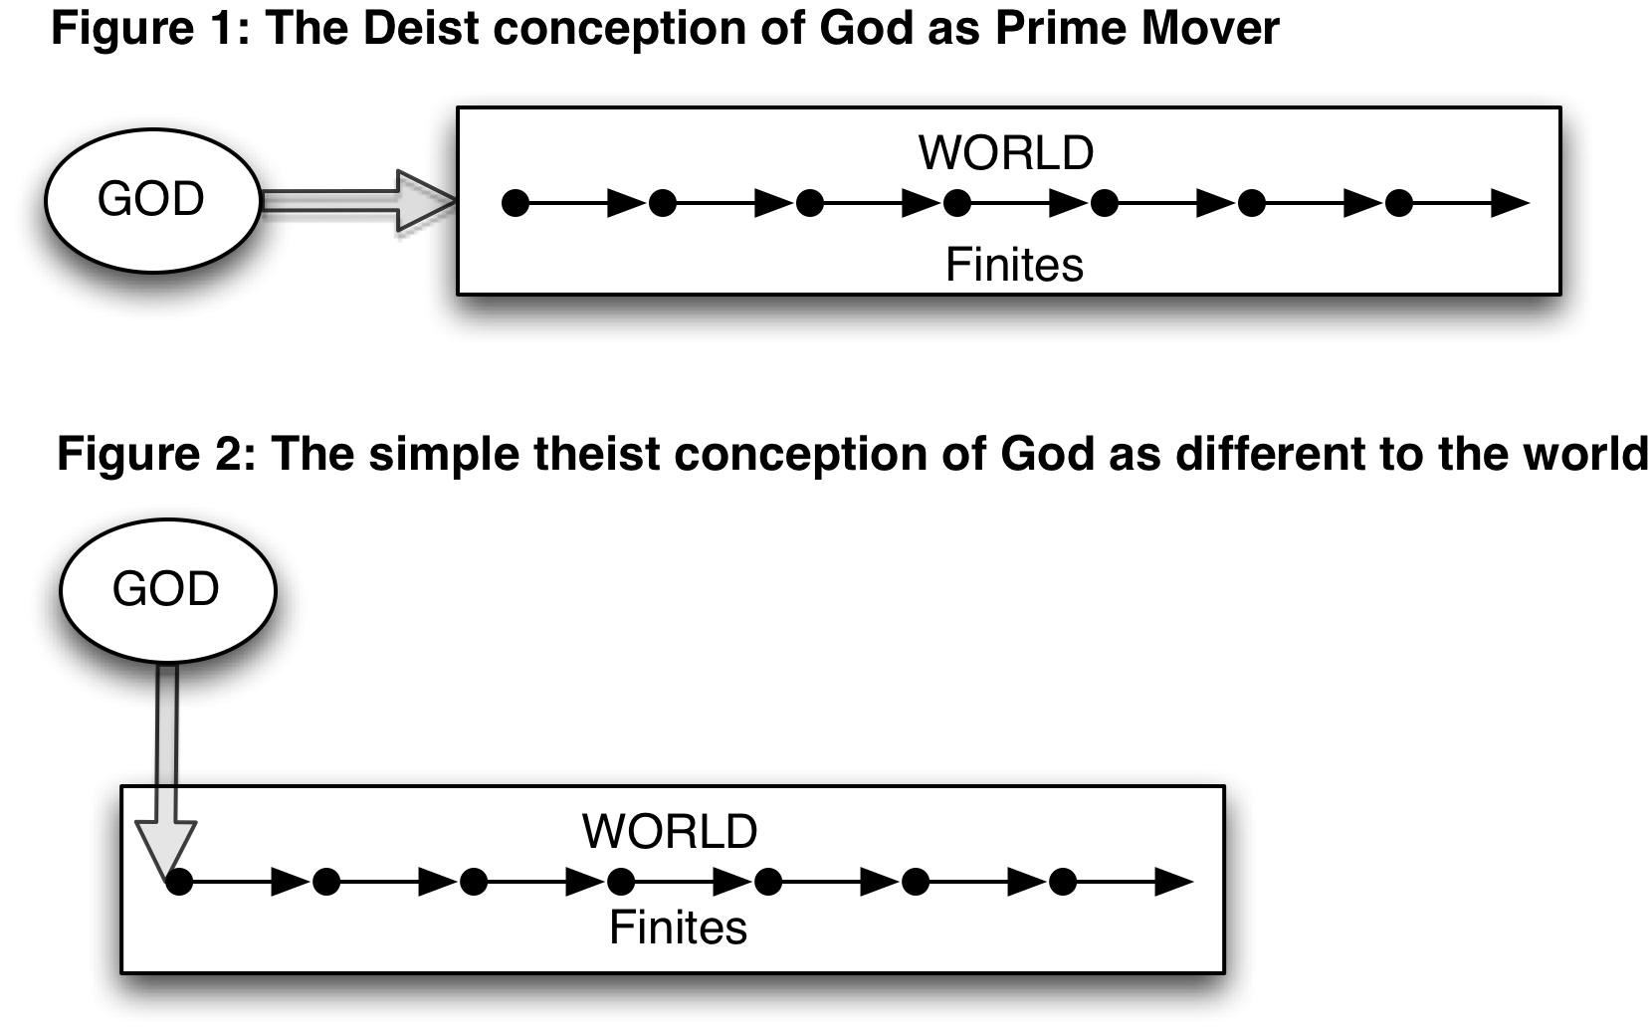

Choosing the world
To answer Darwin’s condundrum, let us consider a less-than-omni-something creator deity, a “toy god”, or a neo-Leibnizian God, who has some set of utility functions or goals, and seeks to fulfill these using only what theologians used to call secondary powers – see the epigram from the Westminster Confession for an example; also Summa contra Gentiles III.70.5–8 – and which we now call natural laws. I choose this approach on the understanding that if the solution offered works for a limited and constrained being capable of instantiating a universe, then the problem should be soluble for an unlimited and physically unconstrained being. However, there are problems that omniscience, omnibenevolence and omnipotence jointly generate that do not apply in the case of the limited neo-Leibnizian deity; and which I do not consider here.
This God chooses merely the best world of which he, she or it knows, in which the events occur that satisfy whatever utility functions such deities have when creating worlds. A neo-Leibnizian God need not have even beneficence as a goal or utility function (he, it or she may be malevolent, as in the Manichaean, Gnostic and Zarathustran dualisms, according to which the creator god has deliberately made an imperfect world). All that this entity requires is the capacity to simulate possible worlds, and not even all of those, but only a large enough subset to find a world that satisfies the goals he, she or it has. A Leibnizian deity would have all eternity, and an infinite degree of simulation power, to find a best possible world. In contrast, our neo-Leibnizian deity need have only the opportunity (which might be time, or if time is a meaningless concept in connection with creator deities, sufficient degrees of logical freedom to represent enough worlds) and the computational capacity to find a satisficing world; that is, a world which satisfies the relevant utility functions . It need not be the best world. In fact it may overall be a very poor world in many other respects; just so long as it satisfies the utility functions.
To give an illustration of this, consider the Avida simulation program developed by Chris Adami and colleagues . Avida simulates a process of evolution by selection on “animats”, or cellular automata, that simulate organisms in an environment. Suppose I want a particular outcome, and I have plenty of time – not an infinite amount, but enough to run many simulations of “worlds” that will approach my utility function. After running several millions of simulations, I find the “universe” that serves my needs, and build it to the specifications drawn from that (or, in theological language, actualize it). If my needs include allowing a home builder to make a house from rocks off a cliff, then I ensure that the universe I choose includes that outcome. In this way, everything within the universe is the result of secondary causes, while the Neo-Leibnizian God remains the primary cause of the particular universe so actualized, which by definition includes each event that satisfies God’s utility functions. So Darwin is not correct in saying that one cannot reasonably maintain that the outcome is designed by the deity. However, Darwin is entirely correct about the secondary causes – God is not a micromanager. Instead, on this view, God has chosen the best available, or most satisfactory, world to create (note that this doesn’t require that God is omniscient, or choose the best of all possible worlds; in fact it may even be that to choose that world God might have to abandon some of His/Her goals, unless the two are identical – that is, unless what God wants just is the best of all possible worlds by definition). So we have a difference of levels of causes here, not unlike the distinction made by some Neo-Thomists , between creation as the instigation of each individual event (called “occasionalism”), which they rejected, and creation as the subsistence of every event as they unfold according to secondary causes (figure 3).
[INSERT FIGURE 3]
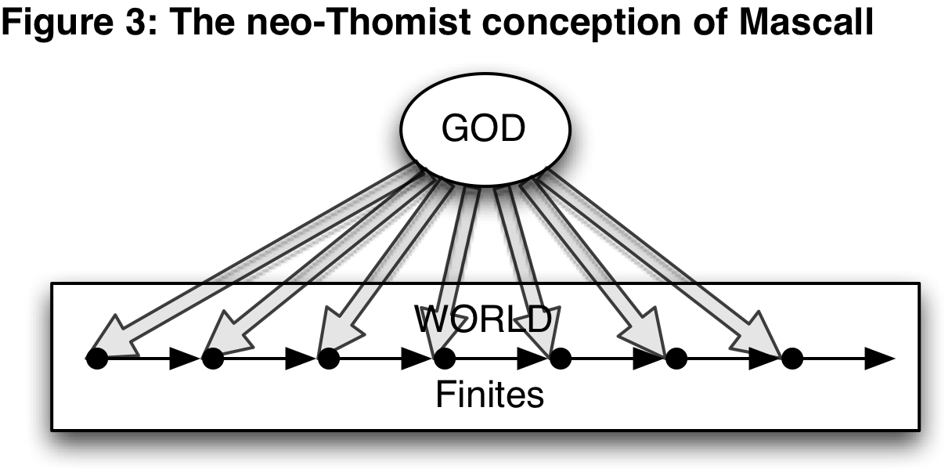
It may be objected that God cannot create a deterministic universe such that the outcomes will arise via secondary powers from the initial conditions, but this may be overcome if God is a block theorist or four-dimensionalist (a view also known as “eternalism”), and who constructs the entire universe from start to end in a single act such that every event within it occurs according to the laws of nature (figure 4). Quantum indeterminacy and other confounding factors will not prevent the world from occurring just as the simulation predicted, because the simulation is the plan of creation, as it runs. This is not a deist conception of a God who starts things and then lets them run, but a God who actualizes in every respect a world that is simulated as a formal possibility. God doesn’t even need to predetermine each event in the world-simulation, so long as once that simulation is “run” and achieves the utility functions, it, she or he can pour the “ontological cement” into the mold. Another solution is that offered by Hume’s Philo in the Dialogues, in which God is like an apprentice builder who tries to make a large number of actual universes, learning from trial and error until he gets the universe he wants, a solution recently also proffered by Michael Ruse . The difference here is whether God merely simulated or actually made the universes; in either case, quantum indeterminacy is a brute fact of these universes God did not need to foresee. A third solution is that quantum events are determined by God, a kind of sub-Planck occasionalism.
[INSERT FIGURE 4]
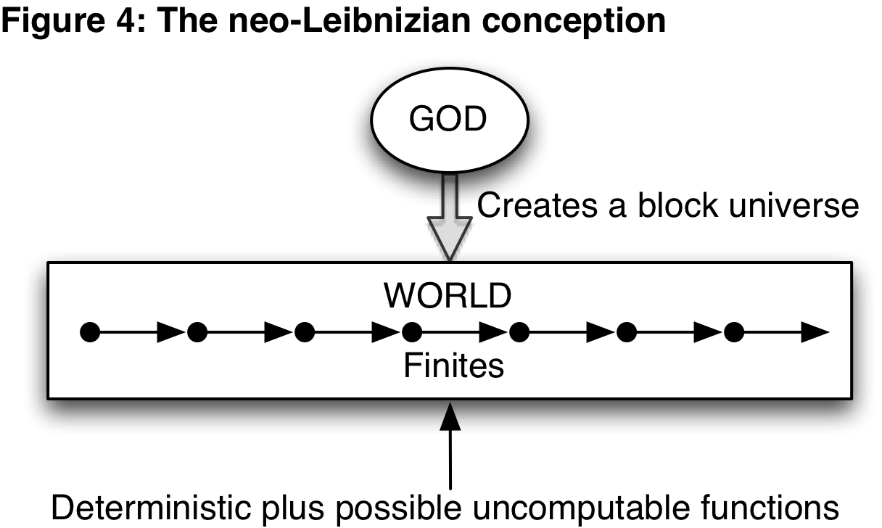

Implications
Critics of theistic evolution claim that theistic evolutionists are being inconsistent: that they hold on the one hand to a view of God as creator and as providential, and on the other hand to a view that humans evolved by chance; they hold that it is “Darwinism with a tinge of faith” . The sense of chance here is ambiguous, and a solution lies in Darwin’s own discussion above. He said, “The shape of the fragments of stone at the base of our precipice may be called accidental, but this is not strictly correct; for the shape of each depends on a long sequence of events, all obeying natural laws; ... But in regard to the use to which the fragments may be put, their shape may be strictly said to be accidental.” The notion of “accident” that a Darwinian view of evolution requires is that the events occur without reference to their subsequent utility for the species in which they occurred. Under a more recent formulation of evolution as a process of “blind variation and selective retention” , the “blindness” here is in the lack of foresight of mutations for the future usefulness of the organisms that bear them. It is not required that there be some truly uncaused randomness, nor that these events even be in-principle unpredictable.
We need to understand what we mean by “theistic evolution”. Contrary to common opinion it need not mean that God intervened in the natural process to cause evolution to go the way he wants, the view that Asa Gray seems to have held, and to which Darwin was objecting. To take this slant means that God must prevent secondary causes from working out as they would have done naturally. Instead we charitably interpret “theistic evolution” to be the following sort of thesis:
Theistic Evolution: God uses secondary powers (natural laws) to achieve his plan. His method for creating life and humans is Darwinian evolution;
where “Darwinian evolution” means something like “Natural Selection+drift+whatever mechanisms operate in evolutionary biology” according to our best possible science. The view that God intervenes, or did intervene in natural processes at some past time, is in contrast roughly the view of Intelligent Design. There is clearly no conflict between any scientific theory and religious belief if God is able to suspend the processes posited by the scientific theory at any time at whim, but this puts the whole of the scientific enterprise at risk (the implications of which some theologians happily embrace). Consequently, however, one also loses the explanatory power of the theory, since no methodology can be available to identify when and where and how many times God may have intervened, and in particular how those interventions occurred (were there miraculous creations of particular genes, or did God reuse existing genes in ways indistinguishable from mutation?). For example, looking at a genome, one cannot tell which parts are divinely “front loaded” according to his plan, and which parts are the result of Darwinian evolution. It is almost as if Darwinian evolution and divine intervention are indiscernible. At any rate the problem only arises when one simultaneously holds the following theses:
- All natural events follow the laws or mechanisms of some ideal theory for that domain (e.g., physics or biology);
- Darwinian evolution and other physical theories require the operation of chance events, such as probability distributions and contingent factors;
- God is capable of predicting all things in that domain; and
- God will act in creation to ensure his plan is realized.
If chance interferes with God’s plan, then unless some way can be found to reconcile chance with his plan, it seems that this places a constraint upon God, and hence if one holds that God is providential, one must reject either the ubiquity of the idealized theory, that is, deny that it explains everything in its domain, and assert that no other theory can either, or one must claim that God must be an interventionist in order to realize her, its, or his plan. In short, either the theory is limited, or God is a micromanager.
The solution we offer here is that a neo-Leibnizian God may be able to choose a possible world that realizes her, its or his plan and satisfies its, his or her goals without direct, or primary, intervention in secondary causes. If this is true for that limited kind of deity, it is even more the case that an omniscient, omnipotent and omnibenevolent deity would be able to select the best of all possible worlds in which natural selection realizes his plan. Hence, the claim that theistic evolutionism is incoherent is not undermined, and religious believers of most stripes ought to feel that their religion does not force them to reject any scientific theory that involves chance – not merely evolutionary biology but also modern physics, chemistry, and the social sciences, all of which involve contingency, randomness and undirected variety.
It is uncontroversial that the bulk of Christian and Jewish organizations and denominations accept that evolution occurs. Objections to Darwinian evolution have always been the minor part of these religions’ reactions to new science , but it has not always been clear how they can achieve a rapprochement. Some, within and without these “orthodox” denominations, deny that one can fully adopt a Darwinian perspective and remain orthodox; something has to give somewhere to reconcile Providence and evolution, and so the final reconciliations of evolution and religion are often not fully “Darwinian”, whatever one may take that to mean. It is a merit, we believe, of this approach that it permits the traditional deity to create just the universe in which Providential goals are realized, without that deity needing to act like a nanny or micromanager. Darwin’s conundrum can be resolved this way.
Moving now to a traditional theistic conception of God, it is possible that for God, all possible worlds are able to be instantly or nontemporally compared, as Leibniz held, and also that the act of simulation and creation are not distinct; if God simulated, say, a quantum world in which uncertainty was a fundamental property of the secondary causes of that world, then rather than creating a concrete world with those initial conditions and expecting it to run the same way as the nonconcrete simulation, which requires a deterministic physics, God could choose to instantiate that simulation as a temporal block. To observers within the block universe, it would look as if the laws proceeded unimpeded with quantum indeterminacy and full physical causality.
The choice of God’s goals are necessarily opaque to us except insofar as they have been revealed; knowledge of God’s plan from natural science is regarded as unlikely by most theologians, and Darwinism has contributed to the fall of that project of natural theology by removing the need for the kinds of interventionist providentialism that Gray believed in. But, assuming God has goals, and that they are physically possible and not mutually exclusive, a world that meets those goals ought to be much easier for the triply-omni deity to create than the restricted neo-Leibnizian deity Dowe and I envisage. Some worlds might not be creatable for the lesser deity. However, that deity may still be able to create a world in which a builder finds exactly the materials needed for an arbitrary design for a building at the base of a cliff; and by analogy also to produce exactly the raw materials, genetic and otherwise, that will inevitably lead to a given outcome through the ordinary processes of evolution. This does not mean that humans are the inevitable outcome of evolution, contrary to the views of some , but only that they are inevitable in that world, which God has created. Nor does it mean that God designed or intended every event of evolution, such as the parasitic Ichnumenon wasps, but only that the entire biosphere as realized meets the providential goals God really does have.
I have no dog in this hunt – as an agnostic it matters not at all if this solution saves the providentialist view of God or not; but apart from the intuition-testing nature of concepts like gods, it is important to me that intelligent people of a religious bent are able to accept the results of modern science without needing to modify it to suit their religious doctrines, which leads ultimately to a subordination of science to religion. For example, Catholic teaching on evolution insists that God created souls in one hominid species, and that before that they had none. This is quite acceptable if the having of souls is empirically undemonstrable, but the available evidence suggests that morality, reason and tool use, for example, are traits that existed well before there was a human species, and so from our perspective, it would be unacceptable to employ souls as explanations for these capacities. If this is not how the notion of soul is employed, then there is no reason to reject either the Catholic view of humanity or to modify science to subserve it, but if it were, then so much the worse for the doctrine. Likewise, this Accidental Designer argument avoids the need for theists to assert contrary-to-fact claims, and thus to do damage to science. If, as Aquinas said, there is one truth (Summa contra Gentiles I, 7), then naturally-arrived-at truths had better not conflict with what are claimed to be revealed truths; “That which we hold by faith as divinely revealed, therefore, cannot be contrary to our natural knowledge”. If they are, then so much the worse for revealed truths, or at least, and this is the traditional view of nearly all Christian schools of thought, something has to be wrong with how we interpret revealed truths.
I am not proposing a solution to the problem of evil, however. It remains a problem for theological thought that a deity that is capable of anything and wills only the Good permits evil in the world. All that I am suggesting here is that Darwin’s Ichneumon wasps and all the other apparent evils of evolution do not raise any more significant problems than already exist from a single act or event of evil, and that a creator God is as consistent with the operation of Darwinian secondary causes as with any others that involve some randomness.

Acknowledgments
I wish to thank the audience at the University of Queensland where I presented this argument with Phil Dowe, and the commenters on my blog, for criticisms. Michael Ruse made some useful comments in reviewing the paper for Zygon. And of course I am grateful to Phil Dowe for pointing out the problem, and bringing Darwin’s passage to my attention, as well as the discussion from which this paper developed.

References
Aquinas, Thomas. 1976. Summa Contra Gentiles Vols1-4: Translated from Latin. Translated by A. C. Pegis. Notre Dame, IN: University of Notre Dame Press.
Augustine, Saint, Bishop of Hippo. 1982. The literal meaning of Genesis. Translated by J. H. Taylor, Ancient Christian writers; no. 41-42. New York, N.Y.: Newman Press.
Brooke, John Hedley. 1991. Science and Religion: Some Historical Perspectives: Cambridge University Press.
Burkhardt, Frederick, and Sydney Smith, eds. 1985-. The correspondence of Charles Darwin. Cambridge: Cambridge University Press.
Campbell, Donald T. 1987. Blind variation and selective retention in creative thought as in other knowledge processes. In Evolutionary Epistemology, Rationality, and the Sociology of Knowledge, edited by G. Radnitzky and W. Bartley III. La Salle IL: Open Court. Original edition, 1960.
Campbell, Gordon. 2007. Bicycles, centaurs and man-faced ox-creatures: instability in Lucretius. In Classical Constructions: Papers in Memory of Don Fowler, Classicist and Epicurean, edited by S. J. Heyworth, P. G. Fowler and S. J. Harrison. Oxford, New York: Oxford University Press:39-62.
Clark, Brett, John Foster, and Richard York. 2007. The critique of intelligent design: Epicurus, Marx, Darwin, and Freud and the materialist defense of science. Theory and Society 36 (6):515-546.
Conway Morris, S. 2003. Life's solution: inevitable humans in a lonely universe. Cambridge: Cambridge University Press.
———. 2008. The deep structure of biology: is convergence sufficiently ubiquitous to give a directional signal? West Conshohocken, PA; Edinburgh: Templeton Foundation; Alban.
Darwin, Charles Robert. 1859. On the origin of species by means of natural selection, or The preservation of favoured races in the struggle for life. London: John Murray.
———. 1868. The variation of animals and plants under domestication. 2 vols. London: John Murray.
Dowe, Phil. 2005. Galileo, Darwin, and Hawking: the interplay of science, reason, and religion. Grand Rapids, MI: W.B. Eerdmans Pub. Co.
Foster, John Bellamy, Brett Clark, and Richard York. 2008. Critique of intelligent design: materialism versus creationism from antiquity to the present. New York: Monthly Review Press.
Griffin, David Ray. 1976. God, power, and evil: a process theodicy. Philadelphia: Westminster Press.
Harrison, Edward R. 1995. The Natural Selection of Universes Containing Intelligent Life. Royal Astronomical Society Quarterly Journal 36 (3):193-203.
Jammer, Max. 1999. Einstein and Religion. Princeton NJ: Princeton University Press.
Leibniz, Gottfried Wilhelm. 1925. The monadology and other philosophical writings. Translated by R. Latta. London, New York: Oxford University Press.
Mascall, Eric L. 1967. Existence and analogy. Hamden, CN: Archon Books.
Nelson, Paul A. 2002. Life in the big tent: Traditional creationism and the intelligent design community. Christian Research Journal 24 (4).
O'Leary, Denyse. 2004. By design or by chance? Minneapolis, MN: Augsburg Books.
Ofria, C., and C. O. Wilke. 2004. Avida: A Software Platform for Research in Computational Evolutionary Biology. Artificial Life 10 (2):191-229.
Paul, Harry W. 1979. The edge of contingency: French Catholic reaction to scientific change from Darwin to Duhem. Gainesville: University Presses of Florida: A University of Florida Book.
Ruse, Michael. 2010. Science and spirituality: making room for faith in the age of science. Cambridge: Cambridge University Press.
Sedley, David N. 2007. Creationism and its critics in antiquity, Sather classical lectures. Berkeley, CA; London: University of California Press.
Sider, Theordore. 2003. Four-Dimensionalism: An ontology of persistence and time. Oxford: Oxford University Press.
Simon, Herbert A. 1972. Theories of Bounded Rationality. In Decision and Organization: A Volume in Honour of Jacob Marschak, edited by C. McGuire and R. Radner. Amsterdam: North-Holland Publishing Company:161-176.
———. 1981. The sciences of the artificial. 2nd rev. and enl. ed. Cambridge, Mass.: MIT Press.
Smolin, Lee. 1997. The life of the cosmos. London: Weidenfeld and Nicolson.
Tegmark, Max. 1998. Is “the theory of everything” merely the ultimate ensemble theory? Annals of Physics 270 (1):1–51.
Wiker, Benjamin. 2002. Moral Darwinism: How We Became Hedonists. Downer's Grove IL: InterVarsity Press.
Wilkins, John S., and Wesley R. Elsberry. 2001. The advantages of theft over toil: the design inference and arguing from ignorance. Biology and Philosophy 16 (November):711-724.

Epicurus famously held that a “swerve” caused all subsequent contingent events via natural processes operating on the atoms. Epicurus was not an atheist, although he was accused of it at the time and ever since; he merely held that the gods are too lofty to concern themselves with human or terrestrial affairs (Campbell 2007). Epicureanism has been a favorite whipping boy of theology for a long time (cf. Clark, et al. 2007, Foster, et al. 2008, Sedley 2007), and still is (Wiker 2002).
Darwin frequently worries about the lack of beneficence shown by these parasitic wasps, which lay their eggs into live hosts, which are then eaten alive as the larvae hatch. They are the exemplars of an argument against design cf. Darwin 1859: 472.
“Creationism” is a highly charged term. In this paper we mean it in the sense in which David Sedley uses it to mean a theology or theodicy in which God is seen as the creator of all that is (Sedley 2007). The more restricted sense of “creation science” or antipathy to evolutionary and geological science is a special case of creationism, and is not definitive of it.
Sedley op cit. has argued that Socrates via Plato is the ancestral creationist view. Modern deism, however, takes the Aristotelian primum mobile and makes of it what Aristotle, who was an eternalist, did not, that God’s creation is the process that set all things in motion. Thanks to Michael Ruse for pointing this out to me.
It is directly relevant to the argument made by Darwin in the letter to Gray that Aquinas is presenting here the doctrine of secondary and primary causes (terms that are later additions in theology) in the context of the problem of evil. In some ways Aquinas’ solution, that God can be both totally the primary cause and yet the secondary causes can be the total causes of the event, is similar to ours (Griffin 1976: 81f).
A similar view, often associated with Lee Smolin (Smolin 1997), is that the current universe is itself the outcome of a process of spawning pocket universes with constants that increasingly permit the outcomes desired; in this case intelligent life (Harrison 1995). Similarly, Max Tegmark (Tegmark 1998) proposes that all universes that can exist with different constants do exist, and some are capable of realizing intelligent systems like us.
Philosophy of time contrasts several views, usually known as A-theory and B-theory. A-theory (“presentism”) holds that time is only real once it has occurred, while B-theory (“block theory”) holds that all time that could ever be “exists” as a single object, and is merely a dimension of the physical universe. Hence “four dimensionalism” is the view that the space-time continuum contains a universe that exists (“perdures”) from start to finish, and which we perceive ourselves to be traversing. See Sider 2003. Given Augustine’s ideas on God being “in eternity” and hence outside time in the Confessions, we may take it to be a relatively uncontroversial view that God may be a four-dimensionalist.
Advocates of intelligent design often assure their readers that they are not presupposing God is the Designer. It might be aliens. Of course, the Designer they require is capable of not only planning outcomes simply by rational reflection, but also predicting, sometimes millions of years in advance, what effects the designs will have upon the organisms in novel environments. If that is not a deity, it is pretty damned close to one (Wilkins and Elsberry 2001).
“Ea igitur quae ex revelatione divina per fidem tenentur, non possunt naturali cognitioni esse contraria.”
A view held by Augustine in De Genesi ad Litteram (Augustine 1982), and repeated in the case of the acceptance of heliocentrism by the Church.

