An Expert System for Diagnosing Shortness of Breath in Infants and Children

Jihan Y. AbuEl-Reesh, Samy S. Abu-Naser
Department of Information Technology,
Faculty of Engineering & Information Technology, Al-Azhar University, Gaza, Palestine abunaser@alazhar.edu.ps

Abstract: Background: With the coming of the Industrial Revolution, the levels of pollution grow significantly. This Technological development contributed to the worsening of shortness breath problems in great shape. especially in infants and children. There are many shortness breath diseases that infants and children face in their lives. Shortness of breath is one of a very serious symptom in children and infants and should never be ignored. Objectives: Along these lines, the main goal of this expert system is to help physician in diagnosing and describe some common causes of shortness of breath in infants and children by diagnosing their cases through our expert system. Moreover, this system which we are presenting will give patient the appropriate diagnosis of disease and the treatment required. Methods: In this paper the strategy of the expert system for diagnosing a number of the existed shortness of breath in infants and children diseases such as (Asthma , Bronchiolitis, Viral Pneumonia, cough, Shortness of breath' dyspnea ', Epiglottitis, Croup, ABSCESS in the tonsil 'peritonsillar abscess', Bronchitis, Viral Bronchitis, Wheezing, sudden infant death syndrome 'SIDS' ) is introduced, an overview about the shortness of breath in children and infants diseases are delineated, the cause of diseases are sketched and the treatment of disease whenever conceivable is given . SL5 Object Expert System language was utilized for designing and implementing the proposed expert system. Results: The proposed shortness of breath in children and infants diseases diagnosis expert system was estimated by Medical students and they were satisfied with its result. Conclusions: The Proposed expert system is very useful for Respiratory physician, pediatrician, recently graduated physician, and for children's parents with shortness of breath problem.

Keywords: Expert Systems, SL5 Object, shortness of breath in infants and children

INTRODUCTON

All the childcare manuals and classes on the planet won't set you up for the delight and stress of the primary night home with another infant. You understand then that you're all alone, and that can be a staggering feeling, especially with regards to agonizing over your infants child's relaxing. All children make odd commotions while breathing-snuffles and shrieks and what sounds like sporadic admission of breath however normally these clamors don't show anything irregular. There are a few signs to watch and tune in for, however, that may show breathing issues in infants. When a kid is shy of breath, it can be troublesome for him to get the oxygen his body needs to work accurately. Side effects may incorporate nostril flaring, snorting and fast or shallow breaths. Doctors caution guardians to consider breathing issues important, regardless of the cause. Since shortness of breath is regularly a flag of a genuine therapeutic issue, it is vital to comprehend conditions that cause it. To discover the reason for your shortness of breath, your specialist may arrange a trunk X-beam or an electrocardiogram (ECG). Amid this test, your specialist will have you rests so your heart can be checked. The ECG machine makes a photo called a following that demonstrates your heart's electrical signs. Your specialist may quantify your breathing and the oxygen level in your blood. You additionally may need a blood test. In serious instances of trouble breathing, hospitalization might be required. A wide range of pharmaceuticals, gone for treating the reason for breathing trouble, might be utilized as a part of treatment. In circumstances where the blood oxygen level is essentially low, supplemental oxygen is useful. High measurements of supplemental oxygen might be risky for a few patients, nonetheless, and is redundant in all instances of shortness of breath [1]. Shortness of breath is an intense manifestation in child and ought to never be disregarded. Knowing a specialist has analyzed and is treating the issue ought to bring solace, however in the event that manifestations turn out to be more terrible, dependably summon your child's specialist right or go to the crisis room. The figure below shows shortness of breath in infants and children. Take your child to your specialist immediately. Shortness of breath in babies and child infections in many spots are not treated by Respiratory doctor or pediatrician authorities. To be sure, the nearness of specialists and specific habitats for the treatment of shortness of breath in infants and children is uncommon in a significant part of the world. Shortness of breath in babies and child illnesses are exceptionally normal nowadays [2].

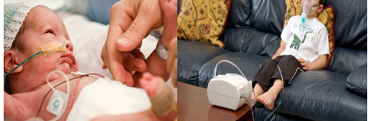

Figure 1: The figure shows shortness of breath in infants and children disease [3][4].
Analysis of shortness of breath in infants and children contaminations is an extreme in light of the way that the shortness of breath is a dangerous symptom in children and should never be slighted. Knowing an authority has broke down and is treating the issue should bring comfort, yet if indications end up being more lamentable, constantly summon your tyke's master right or go to the emergency room. This expert structure depicts some ordinary explanations behind shortness of breath in children. Take your child your master quickly. This expert structure to help Respiratory specialist, pediatrician, starting late graduated specialist, and for children's people with shortness of breath issue. , with a particular true objective to embrace the correct treatment [5]. expert System is a PC utilization of Artificial Intelligence (AI) [6,7,8,36-60]; which contains a data base and a deducing engine ; the guideline fragments and unpretentious components are addressed in figure 2.

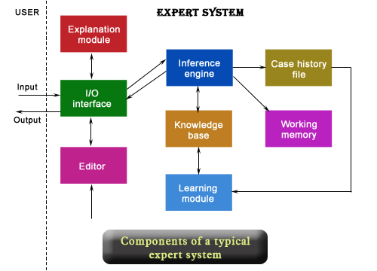

Figure 2: The figure presents the Main Components of Typical Expert System [9].

The proposed Expert System for shortness of breath in infants and children Diseases Diagnosis was executed utilizing, SL5 Object dialect which remains for Simpler Level 5 Object [10]. It is a forward chinning reasoning master framework that can make deductions about realities of the world utilizing tenets, protests and take proper activities accordingly. The SL5 Object motor is executed in Delphi Embarcadero RAD Studio XE6 [11]. SL5 Object executes any Expert System like frames . It's simple for the information architect to assemble the Expert System and for the end clients when they utilize the system.

MATERIALS AND METHODS

The proposed expert system performs diagnosis for twelve different possible shortness of breath in infants and children diseases of the stages between human life starting with infants to the twelve years old by asking yes or no questions. The proposed expert system will ask the user to select the correct answer in each screen. At the end of the dialogue session, the proposed expert system provides the diagnosis and recommendation of the disease to the user. Figure 3 shows a sample dialogue between the expert system and the user. Figure 4 shows how the users get the diagnosis and recommendation.
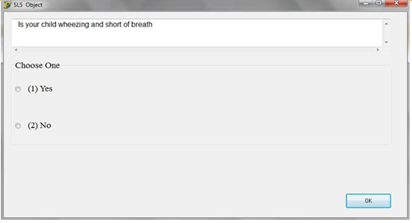
Figure 3: The figure shows when the system asks the user.
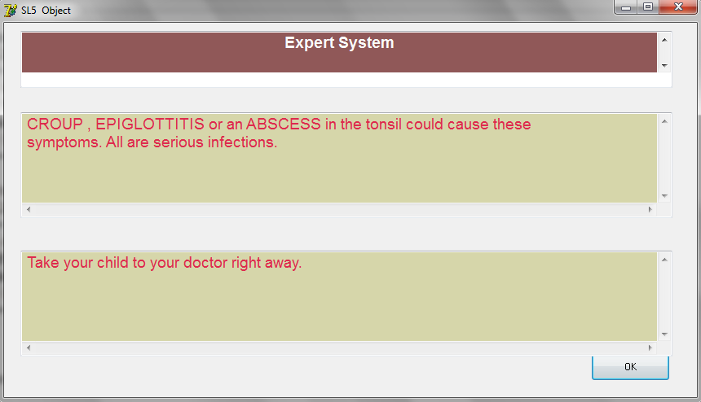
Figure 4: The figure shows diagnosis and recommendation of the expert system.

LITERATURE REVIEW
There is a lot of Expert System that were designed to diagnose diseases such as Eye, Endocrine, skin and other types of disease [12]-[16] But there is no specialized expert system for diagnosis of shortness of breath in children and infants diseases available free. MYCIN is a well-known expert system for diagnosing bacterial infections [17]. Some of these expert Systems are specialized in one specific disease. but the current proposed expert system is specialized in the diagnosis of twelve shortness of breath in children and infants diseases : Asthma, Bronchiolitis, Viral Pneumonia, cough, Shortness of breath' dyspnea ', Epiglottitis, Croup, ABSCESS in the tonsil 'peritonsillar abscess', Bronchitis, Viral Bronchitis, Wheezing, and sudden infant death syndrome 'SIDS'.

KNOWLEDGE REPRESENTATION

The master sources of the knowledge for this expert system are shortness of breath in children and infants diseases and specializes websites for shortness of breath in children and infants diseases. The captured knowledge has been transformed into SL5 Object Knowledge base syntax (Facts, Rules and Object) . Currently the expert system has seven rules which cover twelve shortness of breath in children and infants diseases:

ASTHMA is an unending provocative ailment of the lungs described by a narrowing of the aviation routes and assaults of wheezing, hacking, and shortness of breath that are instigated by triggers, for example, allergens, exercise, contaminations,

and stress. Around 235 million individuals presently experience the ill effects of asthma. It is the most widely recognized perpetual illness among kids, repetitive asthma side effects regularly cause restlessness, daytime weariness, lessened action levels and school non-appearance.
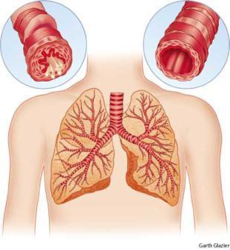
Figure 5: The figure shows the left: inflamed bronchial tube with contracted muscles and mucus discharge right: normal bronchial tube [18].

Bronchiolitis is an acute viral infection of the small air passages of the lungs called the bronchioles, It occurs most often in children between the ages of two and 24 months, with peakinfection occurring between three and six months of age. About 25% of infants have bronchiolitis during their first year, and 95% have had the disease by their second birthday. Children who attend daycare or who live in crowded conditions and those who are exposed to second-hand smoke at home are more likely to develop bronchiolitis [19].
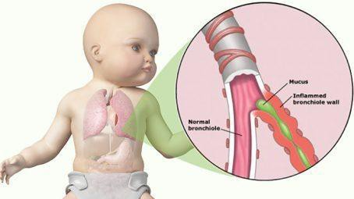

Figure 6: The figure shows Bronchiolitis disease [20].

Viral Pneumonia is a provocative state of the lung influencing fundamentally the tiny air sacs known as alveoli. Common signs and manifestations incorporate a shifting seriousness and mix of beneficial or dry hack, trunk agony, fever, and inconvenience breathing, contingent upon the fundamental cause. Pneumonia is normally brought about by contamination with infections or microscopic organisms and less regularly by different microorganisms, certain drugs and conditions, for example, immune system maladies. Viral Pneumonia Is Commonly Caused by Many Viruses Such As: Adenovirus, Influenza, Rhinoviruses, Coronaviruses, Parainfluenza infection, Respiratory Syncytial Virus (RSV) .
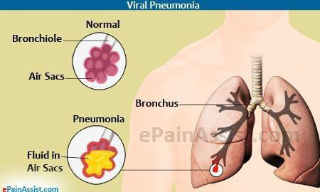
Figure 7: The figure shows Viral Pneumonia disease [21].
cough is a sudden and often repetitively occurring, protective reflex, which helps to clear the large breathing passages from fluids, irritants, foreign particles and microbes. The cough reflex consists of three phases: an inhalation, a forced

exhalation against a closed glottis, and a violent release of air from the lungs following opening of the glottis, usually accompanied by a distinctive sound. Coughing is either voluntary or involuntary .
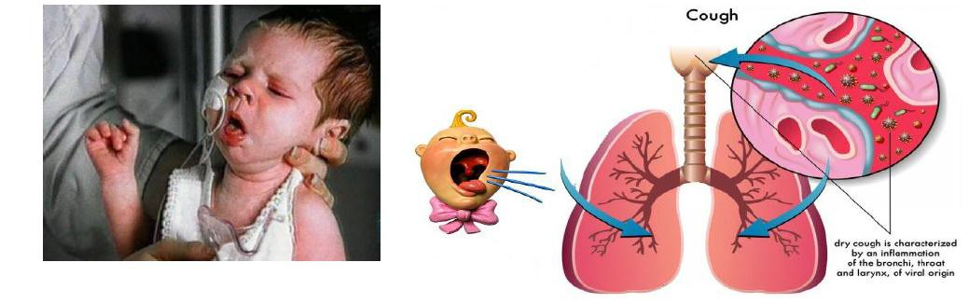
Figure 8: The figure shows Viral cough disease [22]
Shortness of breath, or dyspnea, is a sentiment troublesome or toiled breathing that is out of extent to the patient's level of physical action. It is an indication of an assortment of various ailments or clutters and might be either intense or perpetual . The American Thoracic Society characterizes it as "a subjective experience of breathing inconvenience that comprises of subjectively unmistakable vibes that fluctuate in power".
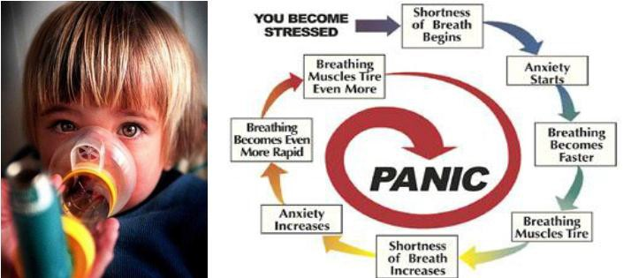
Figure 9: The figure shows coping with Shortness of Breath: Controlling Stress [23][24].

Epiglottitis is inflammation of the epiglottis—the fold at the base of the tongue that shields nourishment from going into the trachea (windpipe). Manifestations are generally fast in a bad position gulping which can bring about dribbling, changes to the voice, fever, and an expanded breathing rate. As the epiglottis is in the upper aviation route, swelling can meddle with relaxing. Individuals may lean forward with an end goal to open the aviation route. As the condition declines stridor and somewhat blue skin may happen.
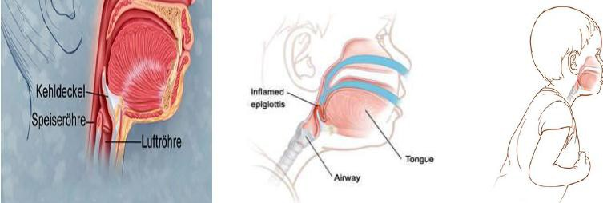
Figure 10: The figure shows Epiglottitis disease [25][26].

Croup is a typical youth affliction. Ordinarily, it emerges from a viral contamination of the larynx (voice box) and is related with gentle upper respiratory side effects, for example, a runny nose and hack. The key manifestation is an unforgiving yelping hack.

Croup is generally not genuine and most kids recoup inside a couple days. In a little rate of cases, a tyke creates breathing challenges and may require therapeutic consideration

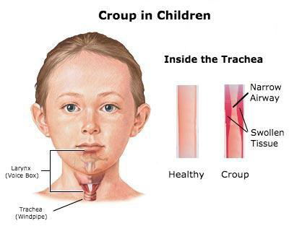
Figure 11: The figure shows Croup in children [27].

Abscess in the tonsil (peritonsillar sore) is a disease of tissue between the tonsil and pharynx, ordinarily after intense follicular tonsillitis. The indications incorporate dysphagia, torment transmitting to the ear, and fever. Redness and swelling of the tonsil and neighboring delicate sense of taste are available. Treatment incorporates anti-toxins, warm saline arrangement water system, cut and waste with suction if there is no unconstrained break of the canker, and here and there tonsillectomy. Likewise called quinsy. Think about parapharyngeal canker, retropharyngeal ulcer. See additionally tonsillitis.
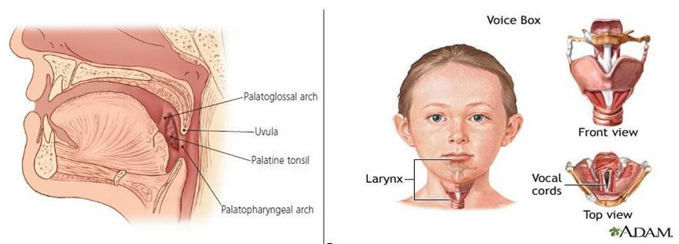
Figure 12: Normal anatomy of the palatine tonsils and their surrounding tissue [28][29].

Bronchitis is an inflammation of the air passages between the nose and the lungs, including the windpipe or trachea and the larger air tubes of the lung that bring air in from the trachea (bronchi). Bronchitis can either be of brief duration (acute) or have a long course (chronic). Acute bronchitis is usually caused by a viral infection, but can also be caused by a bacterial infection and can heal without complications. Chronic bronchitis is a sign of serious lung disease that may be slowed but cannot be cured.
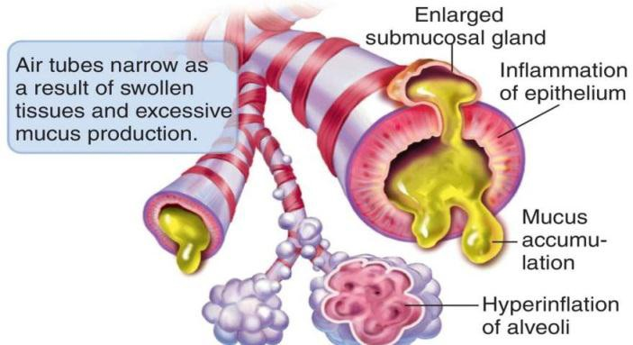

Figure 13: The figure shows chronic bronchitis disease [30].
Viral Bronchitis is an aggravation of the air entries between the nose and the lungs, including the windpipe or trachea and the bigger air containers of the lung that get air from the trachea (bronchi). Bronchitis can either be of brief term (intense) or have a long course (interminable). Intense bronchitis is typically brought about by a viral disease, yet can likewise be created by a bacterial contamination and can recuperate without intricacies. Perpetual bronchitis is an indication of genuine lung infection that might be impeded yet can't be cured.
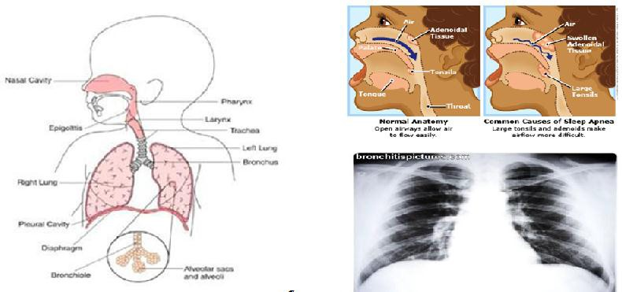
Figure 14: The figure shows Clinical features of severe bronchiolitis in an infant [31][32][33].

Wheezing is a piercing shrieking sound related with worked breathing, it happens when a kid or grown-up tries to inhale profoundly through air sections that are limited or loaded with bodily fluid subsequently of:
  - allergy
  - infection
  - illness
  - Irritation .
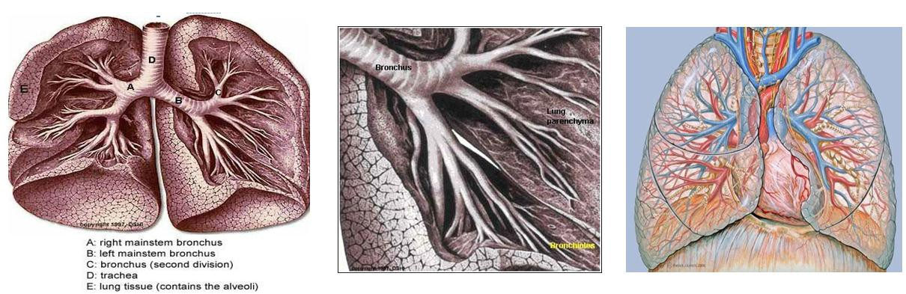
Figure 15: The figure shows the causes of wheezing [34].
Sudden infant death syndrome (SIDS) is the sudden and unforeseen passing of an evidently sound baby, not clarified via cautious posthumous reviews. It normally happens amongst birth and age 9 months, with the most noteworthy rate at 3 to 5 months. Called likewise bunk demise or bed passing in light of the fact that the infants child frequently is discovered dead in the lodging.
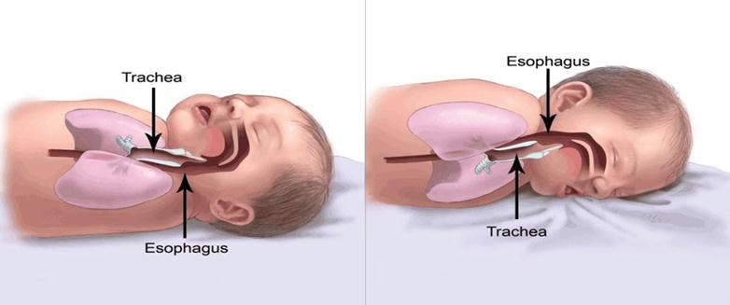
Figure 16: The figure shows the causes of wheezing [35].
- DECISION TREE FOR THE KBS SHORTNESS OF BREATH IN CHILDREN AND INFANTS DIAGNOSIS

Decision tree, each internal node is a tree that contained the question with a finite number of answers . For example, Tue/False question has the answers true or false and can be used as yes or no question or as multiple choice question. Figure 17 diagnoses shortness of breath in infants and children problems using AT trees, based on the response from the user, it then includes questions that appears through the appropriate node for of children decision tree which shows the problem with this node. In this way, according to the response of the end user, we move from the root of the tree to the leaves. When it reaches a leaf node, the conclusion will be provided for the end user.

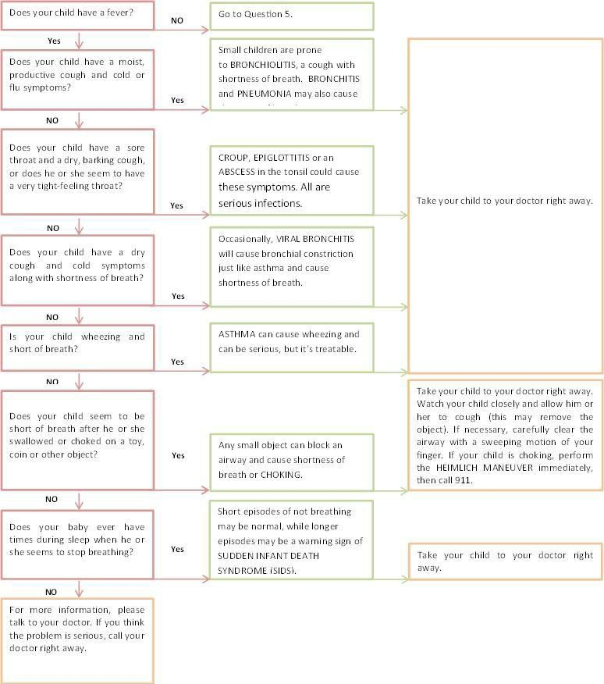
Figure 17: Decision tree for the Knowledge Based System of shortness of breath in children and infants Diagnosis

LIMITATIONS

The current proposed expert system is specialized in the diagnosis only the following twelve shortness of breath in infants and children diseases : Asthma , Bronchiolitis, Viral Pneumonia, cough, Shortness of breath' dyspnea ', Epiglottitis, Croup, ABSCESS in the tonsil 'peritonsillar abscess', Bronchitis, Viral Bronchitis, Wheezing, and sudden infant death syndrome 'SIDS'.

SYSTEM EVALUATION

Accordingly a preliminary evolution, Medical students tested this proposed Expert System and they were satisfied with its performance, efficiency, accuracy, reliability, user interface, ease of use, and they expressed the severity of the convenience of this Expert System

CONCLUSION

In this paper, a proposed expert system was presented for helping Respiratory physician, pediatrician, recently graduated physician, and children's parents in diagnosing infants and children patients with twelve different possible shortness of breath in infants and children diseases, they are can get the diagnosis faster and more precise than the conventional diagnosis. This expert system does not need strong training to be used; it is simple to use and has user ease interface. The system was developed using SL5 Object expert system language with a simple user interface to use so doctors and children's parents can use this system easily without any complication or any complexity.

FUTURE WORK

This expert system is considered to be a major of future ones; more shortness of breath in infants and children diseases are planned to the expert system for future work and to make it more accessible to users from anywhere at any time, and modify additional enhancement to the system based on the patients’ needs.

EXPERT SYSTEM SOURCE CODE
ATTRIBUTE Does your child have a fever? COMPOUND Yes, No
ATTRIBUTE Does your child have a moist productive cough and cold or flu symptoms? COMPOUND Yes, No
ATTRIBUTE Does your child have a sore throat and a dry barking cough or does he or she seem to have a very tight feeling throat? COMPOUND
Yes, No
ATTRIBUTE Does your child have a dry cough and cold symptoms along with shortness of breath? COMPOUND Yes, No
ATTRIBUTE Is your child wheezing and short of breath? COMPOUND Yes, No
ATTRIBUTE Does your child seem to be short of breath after he or she swallowed or choked on a toy coin or other object? COMPOUND Yes, No
ATTRIBUTE Does your baby ever have times during sleep when he or she seems to stop breathing? COMPOUND Yes, No
ATTRIBUTE start SIMPLE
INSTANCE the domain ISA domain WITH start := TRUE
INSTANCE the application ISA application WITH title display := introduction WITH conclusion display := Conc WITH numeric precision := 8
WITH simple query text := "Is it true that:
- is
*"

WITH numeric query text := "What is(are):
- of
*"

WITH string query text := "What is(are):
- of
- *"WITH time query text := "What is(are):
- of
*"

WITH interval query text := "What is(are):

- of
*"
WITH compound query text :="
- of
*"

WITH multicompound query text := "What is(are):
- of
*"
INSTANCE introduction ISA display WITH wait := TRUE
WITH delay changes := FALSE
WITH items [1 ] := textbox 1 INSTANCE textbox 1 ISA textbox WITH location := 10,10,800,350
WITH pen color := 333,555,888 WITH fill color := 100,2,45 WITH pen color := 250,250,250 WITH justify IS left
WITH font := "Arial" WITH font style IS bold WITH font size := 14 WITH text "=:
Shortness Of Breath In Infants And Children Diagnoses Expert System Written By Jihan Abu El-Reesh
This Expert system is an example of Simpler Level 5 Object (SL5 Object) that Demonstrate the use of some of the System classes, Instances, Rules, etc.
This Expert System diagnoses Shortness of Breath in Infants and Children Problems through a dialogue between the System and the End User.

The Conclusion of the finding is displayed and an Advise is given for the End User to solve the problem". INSTANCE Conc ISA display
WITH wait := TRUE
WITH delay changes := FALSE WITH items [1] := title textbox WITH items [2 ] := problem textbox
WITH items [3 ] := advise textbox INSTANCE title textbox ISA textbox WITH location := 20,10,800,70
WITH pen color := 250,250,250 WITH fill color := 400,600,600 WITH justify IS center
WITH font := "Arial" WITH font style IS bold WITH font size := 14
WITH text := " The Conclusion of the Shortness Of Breath In Infants And Children Diagnosis Expert System"

INSTANCE problem textbox ISA textbox WITH location := 20,110,800,130

WITH pen color := 222,555,333 WITH fill color := 470,470,170 WITH justify IS left WITH font := "Arial" WITH font size := 14 WITH text:="--===-- "
INSTANCE advise textbox ISA textbox WITH location := 20,280,800,130
WITH pen color := 222,555,333 WITH fill color := 470,470,170 WITH justify IS left WITH font := "Arial" WITH font size := 14 WITH text:="--===-- "
RULE R0
IF start
THEN ASK Does your child have a fever ?

RULE R1
IF Does your child have a fever? IS Yes
THEN ASK Does your child have a moist productive cough and cold or flu symptoms?

RULE R1a
IF Does your child have a fever? IS No
THEN ASK Is your child wheezing and short of breath?

RULE R2
IF Does your child have a moist productive cough and cold or flu symptoms? IS Yes
THEN text OF problem textbox := "Small children are prone to BRONCHIOLITIS , a cough with shortness of breath. BRONCHITIS
and PNEUMONIA may also cause shortness of breath"
AND text OF advise textbox := "Take your child to your doctor right away".

RULE R2a
IF Does your child have a moist productive cough and cold or flu symptoms? IS No
THEN ASK Does your child have a sore throat and a dry barking cough or does he or she seem to have a very tight feeling throat?

RULE R3
IF Does your child have a sore throat and a dry barking cough or does he or she seem to have a very tight feeling throat? IS Yes
THEN text OF problem textbox := "CROUP , EPIGLOTTITIS or an ABSCESS in the tonsil could cause these symptoms. All are serious infections" .
AND text OF advise textbox := "Take your child to your doctor right away".

RULE R3a
IF Does your child have a sore throat and a dry barking cough or does he or she seem to have a very tight feeling throat? IS No THEN ASK Does your child have a dry cough and cold symptoms along with shortness of breath?

RULE R4
IF Does your child have a dry cough and cold symptoms along with shortness of breath? IS Yes
THEN text OF problem textbox := "Occasionally, VIRALBRONCHITIS will cause bronchial constriction just like asthma and cause shortness of breath" .
AND text OF advise textbox := "Take your child to your doctor right away".

RULE R4a
IF Does your child have a dry cough and cold symptoms along with shortness of breath? IS No THEN ASK Is your child wheezing and short of breath?

RULE R5
IF Is your child wheezing and short of breath? IS Yes
THEN text OF problem textbox := "ASTHMA can cause wheezing and can be serious but it’s treatable". AND text OF advise textbox := "Take your child to your doctor right away".

RULE R5a
IF Is your child wheezing and short of breath? IS No
THEN ASK Does your child seem to be short of breath after he or she swallowed or choked on a toy coin or other object?

RULE R6
IF Does your child seem to be short of breath after he or she swallowed or choked on a toy coin or other object? IS Yes THEN text OF problem textbox := "Any small object can block an airway and cause shortness of breath or CHOKING".
AND text OF advise textbox := "Take your child to your doctor right away. Watch your child closely and allow him or her to cough (this may remove the object). If necessary, carefully clear the airway
with a sweeping motion of your finger. If your child is choking, perform the HEIMLICH MANEUVER immediately" .

RULE R6a
IF Does your child seem to be short of breath after he or she swallowed or choked on a toy coin or other object? IS No
THEN ASK Does your baby ever have times during sleep when he or she seems to stop breathing?

RULE R7
IF Does your baby ever have times during sleep when he or she seems to stop breathing? IS Yes
THEN text OF problem textbox := "Short episodes of not breathing may be normal, while longer episodes may be a warning sign of SUDDEN INFANT DEATH SYNDROME (SIDS (.
AND text OF advise textbox := "Take your child to your doctor right away" .

RULE R7a
IF Does your baby ever have times during sleep when he or she seems to stop breathing? IS No THEN text OF problem textbox := " "
AND text OF advise textbox := "For more information, please talk to your doctor. If you think the problem is serious ,call your doctor right away" . .
END

REFERENCES
- http://www.livestrong.com/article/130116-causes-kids-breathing-problems/, date visited 11-5-2017
- http://www.mayoclinic.org/symptoms/shortness-of-breath/basics/causes/SYM-20050890, date visited 21-5-2017
- http://www.momjunction.com/baby/safety/page/6/, date visited 11-5-2017
- http://www.allergiesasthmahelp.com/allergies-asthma-articles/pediatric-asthma.html, date visited 12-5-2017
- Durkin J, Expert system: Catalog of applications: Intelligent Computer Systems, Inc., Akron, OH. First Edition. ISBN 0-12- 670553- 7;1993.
- Giarratano, J. and Riley G.,. Expert Systems: Principles and Programming, Fourth Edition. Boston, MA, Thomson/PWS Publishing Company. ISBN: 0534937446. 2004.
- Durkin J., Expert Systems: Design and Development, ISBN 0-02-330970-9, Prentice Hall, Englewood Cliffs, N.J. 1994.
- http://www.universalteacherpublications.com/univ/ebooks/ai/Ch10/page4.htm
- Abu Naser, S. S. (2015). Sl5 Object: Simpler Level 5 Object Expert System Language. International Journal of Soft Computing, Mathematics and Control (IJSCMC), 4(4), 25-37.
- E. Shortliffe et al.;1982. Expert Systems Research: Modeling the Medical Decision Making Process.
- Embarcadero Technologies, Inc., Users Manual, Version 20.0.15596.9843. 2014.
- Abu-Naser, S., El-Hissi, H., Abu-Rass, M., & El-Khozondar, N. (2010). An expert system for endocrine diagnosis and treatments using JESS. Journal of Artificial Intelligence; Scialert, 3(4), 239-251.
- Abu Naser, S., Al-Dahdooh, R., Mushtaha, A., & El-Naffar, M. (2010). Knowledge management in ESMDA: expert system for medical diagnostic assistance. AIML Journal, 10(1), 31-40.
- Abu Naser, S. S., & Abu Zaiter, O. A. (2008). An Expert System For Diagnosing Eye Diseases Using Clips. Journal of Theoretical & Applied Information Technology, 4(10).
- Abu Naser, S. S., Baraka, M. H., & Baraka, A. (2008). A Proposed Expert System For Guiding Freshman Students In Selecting A Major In Al-Azhar University, Gaza. Journal of Theoretical & Applied Information Technology, 4(9).
- Abu-Naser, S., Kashkash, K., & Fayyad, M. (2010). Developing an expert system for plant disease diagnosis. Journal of Artificial Intelligence; Scialert, 3(4), 269-276.
- Russell, S. and P. Norvig,. Artificial Intelligence: A Modern Approach, Prentice Hall, Englewood Cliffs, NJ, Second Edition. ISBN 0-13-103805-2. 2002.
- http://www.thefreedictionary.com/asthmatic, date visited 12-5-2017
- http://medical-dictionary.thefreedictionary.com/Bronchiolitis%2c+viral, date visited 20-5-2017
- http://medifitbiologicals.com/bronchiolitis/, date visited 21-5-2017
- https://www.epainassist.com/chest-pain/lungs/chest-pain-caused-by-viral-pneumonia, date visited 20-5-2017
- http://www.nambuccahealthcarecentre.com.au/ , date visited 22-5-2017
- https://www.annahar.com/article/112816, date visited 22-5-2017
- http://www.veteranshealthlibrary.org/LivingWith/COPD/, date visited 22-5-2017
- http://www.apotheken-umschau.de/Epiglottitis, date visited 22-5-2017
- http://www.fairview.org/HealthLibrary/Article/88965, date visited 23-5-2017
- http://www.earnosethroat.com.au/children-otolaryngology/croup/, date visited 23-5-2017
- http://www.lymphedemapeople.com/wiki/doku.php?id=anatomy_of_the_lymphatic_system, date visited 23-5-2017
- http://tryingtobesomebody.blogspot.com/, date visited 23-5-2017
- http://medical-dictionary.thefreedictionary.com/Bronchitis, date visited 23-5-2017
- http://bronchitispictures.com/Bronchitis-Treatments.php, date visited 23-5-2017
- http://www.seattlechildrens.org/kids-health/parents/, date visited 23-5-2017
- http://bronchitispictures.com/Bronchitis-Cure.php, date visited 23-5-2017
- http://www.keyword-suggestions.com/cmlnaHQgcHJpbWFyeSBicm9uY2h1cw/,, date visited 23-5-2017
- http://www.rcfirststeps.org/wp-content/uploads/2014/10/baby_anatomy_sleep.jpg, date visited 23-5-2017
- Abu Naser, S. (1993). A methodology for expert systems testing and debugging. (Ph.D.), North Dakota State University, USA, USA.
- Akkila, A. N., & Abu Naser, S. S. (2016). Proposed Expert System for Calculating Inheritance in Islam. World Wide Journal of Multidisciplinary Research and Development, 2(9), 38-48.
- Abu Naser, S. S. (1999). Big O Notation for Measuring Expert Systems complexity. Islamic University Journal - Gaza, 7(1), 57-77.
- Azaab, S., Abu Naser, S., & Sulisel, O. (2000). A proposed expert system for selecting exploratory factor analysis procedures.
- Abu Naser, S. S., & Abu Hasanein, H. A. (2016). Ear Diseases Diagnosis Expert System Using SL5 Object. World Wide Journal of Multidisciplinary Research and Development, 2(4), 41-47.
- Almurshidi, S. H., & Abu Naser, S. S. (2017). Design and Development of Diabetes Intelligent Tutoring System. EUROPEAN ACADEMIC RESEARCH, 4(9), 8117-8128.
- Abu Naser, S. S., & Akkila, A. N. (2008). A Proposed Expert System for Skin Diseases Diagnosis. Journal of Applied Sciences Research; www.aensiweb.com/JASR/, 4(12), 1682-1693.
- Qwaider, S. R., & Abu Naser, S. S. (2017). Expert System for Diagnosing Ankle Diseases. International Journal of Engineering and Information Systems (IJEAIS), 1(4), 89-101.
- Abu Naser, S. S., & Alawar, M. W. (2016). An expert system for feeding problems in infants and children. International Journal of Medicine Research, 1(2), 79-82.
- Bakeer, H. M., & Abu Naser, S. S. (2017). Photo Copier Maintenance Expert System V.01 Using SL5. International Journal of Engineering and Information Systems (IJEAIS), 1(4), 116-124.
- Abu Naser, S. S., & Al-Bayed, M. H. (2016). Detecting Health Problems Related to Addiction of Video Game Playing Using an Expert System. World Wide Journal of Multidisciplinary Research and Development, 2(9), 7-12.
- El Agha, M., Jarghon, A., & Abu Naser, S. S. (2017). Polymyalgia Rheumatic Expert System. International Journal of Engineering and Information Systems (IJEAIS), 1(4), 125-137.
- Abu Naser, S. S., & AlDahdooh, R. M. (2016). Lower Back Pain Expert System Diagnosis And Treatment. Journal of Multidisciplinary Engineering Science Studies (JMESS), 2(4), 441-446.
- Mrouf, A., Albatish, I., Mosa, M., & Abu Naser, S. S. (2017). Knowledge Based System for Long-term Abdominal Pain (Stomach Pain) Diagnosis and Treatment. International Journal of Engineering and Information Systems (IJEAIS), 1(4), 71- 88.
- Abu Naser, S. S., & Alhabbash, M. I. (2016). Male Infertility Expert system Diagnoses and Treatment. American Journal of Innovative Research and Applied Sciences, 2(4).
- Khella, A. R., & Abu Naser, S. S. (2017). Expert System for Chest Pain in Infants and Children. International Journal of Engineering and Information Systems (IJEAIS), 1(4), 138-148.
- Abu Naser, S. S., & Al-Hanjori, M. M. (2016). An expert system for men genital problems diagnosis and treatment. International Journal of Medicine Research, 1(2), 83-86.
- Abu Ghali, M. J., Mukhaimer, M. N., Abu Yousef, M. K., & Abu Naser, S. S. (2017). Expert System for Problems of Teeth and Gums. International Journal of Engineering and Information Systems (IJEAIS), 1(4), 198-206.
- Abu Naser, S. S., & ALmursheidi, S. H. (2016). A Knowledge Based System for Neck Pain Diagnosis. World Wide Journal of Multidisciplinary Research and Development (WWJMRD), 2(4), 12-18.
- Al Rekhawi, H. A., Ayyad, A. A., & Abu Naser, S. S. (2017). Rickets Expert System Diagnoses and Treatment. International Journal of Engineering and Information Systems (IJEAIS), 1(4), 149-159.
- Abu Naser, S. S., & Al-Nakhal, M. A. (2016). A Ruled Based System for Ear Problem Diagnosis and Treatment. World Wide Journal of Multidisciplinary Research and Development, 2(4), 25-31.
- Nabahin, A., Abou Eloun, A., & Abu Naser, S. S. (2017). Expert System for Hair Loss Diagnosis and Treatment. International Journal of Engineering and Information Systems (IJEAIS), 1(4), 160-169.
- Abu Naser, S. S., & Bastami, B. G. (2016). A Proposed Rule Based System for Breasts Cancer Diagnosis. World Wide Journal of Multidisciplinary Research and Development, 2(5), 27-33.
- Abu Naser, S. S., & El Haddad, I. A. (2016). An Expert System for Genital Problems in Infants. EUROPEAN ACADEMIC RESEARCH, 4(10).
- Abu Naser, S. S., & El-Najjar, A. E. A. (2016). An expert system for nausea and vomiting problems in infants and children. International Journal of Medicine Research, 1(2), 114-117.
- Abu Naser, S. S., & Hamed, M. A. (2016). An Expert System for Mouth Problems in Infants and Children. Journal of Multidisciplinary Engineering Science Studies (JMESS), 2(4), 468-476.
- Abu Naser, S. S., & Hilles, M. M. (2016). An expert system for shoulder problems using CLIPS. World Wide Journal of Multidisciplinary Research and Development, 2(5), 1-8.
- Abu Naser, S. S., & Mahdi, A. O. (2016). A proposed Expert System for Foot Diseases Diagnosis. American Journal of Innovative Research and Applied Sciences, 2(4), 155-168.
- Abu Naser, S. S., & Shaath, M. Z. (2016). Expert system urination problems diagnosis. World Wide Journal of Multidisciplinary Research and Development, 2(5), 9-19.
- Abu Naser, S. S., & Zaqout, I. S. (2016). Knowledge-based systems that determine the appropriate students major: In the faculty of engineering and information technology. World Wide Journal of Multidisciplinary Research and Development, 2(10), 26-34.
- Abu Naser, S. S., Alamawi, W. W., & Alfarra, M. F. (2016). Rule Based System for Diagnosing Wireless Connection Problems Using SL5 Object. International Journal of Information Technology and Electrical Engineering, 5(6), 26-33.
- Abu Naser, S., & Aead, A. M. (2013). Variable Floor for Swimming Pool Using an Expert System. International Journal of Modern Engineering Research (IJMER), 3(6), 3751-3755.
- Abu Naser, S. S. (2016). ITSB: An Intelligent Tutoring System Authoring Tool. Journal of Scientific and Engineering Research, 3(5), 63-71.

